STATE AIR POLLUTION CONTROL BOARD
Title of Regulation: 9 VAC 5-91-10 et seq. Regulations for the Control of Motor Vehicle Emissions in the Northern Virginia Area (amending 9 VAC 5-91-20, 9 VAC 5-91-30, 9 VAC 5-91-50, 9 VAC 5-91-70, 9 VAC 5-91-120, 9 VAC 5-91-160 through 9 VAC 5-91-230, 9 VAC 5-91-260, 9 VAC 5-91-270, 9 VAC 5-91-290 through 9 VAC 5-91-340, 9 VAC 5-91-370, 9 VAC 5-91-380, 9 VAC 5-91-410 through 9 VAC 5-91-450, 9 VAC 5-91-480 through 9 VAC 5-91-580, 9 VAC 5-91-600 through 9 VAC 5-91-620, 9 VAC 5-91-650, 9 VAC 5-91-680, 9 VAC 5-91-700, 9 VAC 5-91-710, 9 VAC 5-91-720, 9 VAC 5-91-740, 9 VAC 5-91-790, and 9 VAC 5-91-800; repealing 9 VAC 5-91-41, 9 VAC 5-91-460, 9 VAC 5-91-470, 9 VAC 5-91-770, and 9 VAC 5-91-780) (Rev. MG).
Statutory Authority: § 46.2-1180 of the Code of Virginia.
Public Hearing Date: November 13, 2001 - 10 a.m.
Public comments may be submitted until 4:30 p.m., January 7, 2002.
(See Calendar of Events section
for additional information)
Agency Contact: Mary E. Major, Environmental Program Manager, Office of Air Regulatory Development, Department of Environmental Quality, P.O. Box 10009, Richmond, VA 23240, telephone (804) 698-4423, FAX (804) 698-4510, toll free 1-800-592-5482 or (804) 698-4021/TTY.
Basis: Sections 46.2-1176 through 46.2-1187.3 of the Virginia Air Pollution Control Law authorize the State Air Pollution Control Board to promulgate regulations for the control of motor vehicle emissions and for the testing process.
Purpose: The purpose of the regulation is to require that motor vehicles undergo periodic emissions inspection and be maintained in compliance with emission standards for (i) the protection of public health and welfare and (ii) the attainment and maintenance of the air quality standards. The proposed amendments are being made to conform to state law and federal Clean Air Act requirements for the testing of emissions from motor vehicles located or primarily operated in Northern Virginia.
Substance:
1. Modify definition of “motor vehicle “ to reflect statutory changes.
2. Add definition of “authorized personnel” to provide more flexibility to station owners.
3. Add definitions related to EPA requirement for on-board diagnostic testing, including “OBD system,” “OBD test,” and “OBD vehicle.”
4. Modify exhaust emission standards for two-speed idle (TSI) emissions test (9 VAC-5-91-160).
5. Modify exhaust emission standards for ASM emissions test (9 VAC-5-91-170).
6. Modify exhaust emission standards for remote sensing emissions test (9 VAC-5-91-180).
7. Repeal requirements for evaporative system purge test (9 VAC-5-91-200 and 9 VAC-5-91-460).
8. Add provisions for visible emissions standards (9 VAC-5-91-210).
9. Modify reporting requirements for fleet inspection stations according to EPA requirements (9 VAC 5-91-370).
10. Add provisions for conducting OBD tests for 1996 and newer gasoline and diesel powered vehicles equipped with OBD systems (9 VAC 5-91-420).
11. Eliminate provisions setting waiver phase-in amounts for dates that have already passed (9 VAC 5-91-420).
12. Add provisions that provide more flexibility in ASM test procedure (9 VAC 5-91-430).
13. Modify regulatory language to more closely reflect software specifications for test procedures (9 VAC 5-91-440).
14. Repeal requirements for warranty eligibility (9 VAC 5-91-470).
15. Modify table of major violations to reflect additional flexibility incorporated in the regulation language for test procedures (9 VAC 5-91-620).
16. Repeal provisions addressing federal facilities to comply with EPA requirements (Part XIII).
Issues:
1. Public: The primary advantage to the general public is that air quality will improve due to the technical changes to program operation. The change to the definition of motor vehicle, for example, will result in a more effective program with the need to inspect fewer vehicles. Changes in testing procedures will result in faster yet more thorough inspections which translates into shorter lines at the testing facilities. Changes in certification requirements will mean repairs to vehicles that fail the test will be more effective.
Changes have been made to tighten the two-speed idle (TSI) test standards. This will impact a small number of vehicle owners whose vehicles would fail the new standards, but would pass the existing standards. According to current test data, this change will affect fewer than 1.0% of the 1990 and newer vehicles that receive the TSI test. As these vehicles age, the fail rate is expected to increase somewhat. Although it is a disadvantage that there will be expenses for repairs, there are also advantages to the vehicle owners in that needed repairs will increase vehicle fuel efficiency and enhance vehicle life, not to mention the improvement in air quality. Currently, vehicles with known faults can pass the existing standards and that is unacceptable for proper program operation.
Changes have been made to allow DEQ to set less stringent ASM test standards than those currently recommended by EPA. DEQ believes the EPA final standards may be too strict for some vehicle classes and will result in these vehicles being difficult or impossible to repair to the standards. The current regulation requires that the EPA enhanced I/M performance standards be met and that the EPA final standards be implemented.
Changes have been made with respect to the testing of federal fleet vehicles. As currently written, there is a separate section for federal fleets. The regulation has been amended to treat federal fleets the same as private fleets as required by law. As a result of this requirement, some additional reporting requirements for non-federal fleets are necessary; however, DEQ believes this reporting will be minimal. Non-federal fleet vehicle test information is on the DEQ electronic data base and can be accessed directly by DEQ. Thus, the additional reporting requirements would affect only fleets of vehicles not registered with DMV.
Changes have been made regarding OBD testing. As currently written, OBD testing was to be added as a requirement for passing the I/M test beginning January 3, 2000. The proposed amendments postpone this until such time as the department deems appropriate. This will allow the department time to conduct a pilot test to evaluate OBD testing in conjunction with ASM testing. EPA anticipates that, once the fleet turns over and most vehicles are equipped with the correct equipment, OBD tests will eliminate the need for tail-pipe or ASM testing. Since the OBD test only takes a few minutes while the ASM test takes about 15 minutes, this will be a considerable advantage to both the vehicle owner and the inspection station.
OBD systems identify faults that are not necessarily detected with an ASM or TSI test. This may be perceived as a disadvantage by the public as there may be a cost for a vehicle repair that otherwise would go undetected. The associated advantage is that the vehicle owner will be alerted to these emission component faults before they could cause extensive collateral damage. For example, an expensive catalytic converter can be quickly damaged by an excess rich mixture condition even though the converter may still be operating well enough to pass a tailpipe test. In addition, with each vehicle repair less pollution is emitted.
Similar advantages and disadvantages will occur to owners of light duty diesel vehicles which will also be subject to OBD testing. Diesel vehicles have not been tested in the I/M program in the past because such testing requires completely different testing equipment. However, beginning with model year 1997, all light duty diesel vehicles certified for sale in the US are required to be equipped with OBD systems similar to that of gasoline fueled vehicles. The testing of both OBD systems is the same.
Due to OBD testing, equipment will need to be upgraded at all inspections stations, i.e. approximately 400 testing stations. The cost of this upgrade will range from $1,500 to $3,000 per unit depending on the existing equipment currently installed in the test facility. This additional cost is expected to be offset by the time savings of OBD testing; the OBD test is expected to reduce the time to complete a full inspection sequence by at least 10 minutes.
2. Department: Most of the issues affecting the department are a result of either technical changes in program operation or federal requirements. Amendments due to technical changes in program operation include: (i) changes in the wording of some definitions, (ii) changes in the order and some elements of the testing procedure, (iii) changes in the timing and flexibility of some test standards and (iv) changes in some permitting and licensing procedures. Amendments due to federal requirements include: (i) deletion of special treatment of federally owned or controlled vehicles and (ii) changes in some enforcement procedures to reduce redundancy and overlap.
Few disadvantages are associated with these regulatory changes. There will be additional data management as a result of the information generated by OBD testing; however, the current computer capabilities are more than adequate to address this issue.
The overwhelming advantage from OBD testing is the increased emission reductions and cleaner air for Virginia citizens and continued EPA approval of the Commonwealth’s I/M program. Tightening the TSI and ASM standards will have a similar advantageous effect.
Localities Particularly Affected: The geographic coverage of the program consists of the counties of Arlington, Fairfax, Loudoun, Prince William, and Stafford; and the cities of Alexandria, Fairfax, Falls Church, Manassas, and Manassas Park.
Public Participation: The department is seeking comment on the proposed regulation and the costs and benefits of the proposal. The department is also seeking comment on the impacts of the proposed regulation on farm and forest lands.
Department of Planning and Budget's Economic Impact Analysis: The Department of Planning and Budget (DPB) has analyzed the economic impact of this proposed regulation in accordance with § 2.2-4007 G of the Administrative Process Act and Executive Order Number 25 (98). Section 2.2-4007 G requires that such economic impact analyses include, but need not be limited to, the projected number of businesses or other entities to whom the regulation would apply, the identity of any localities and types of businesses or other entities particularly affected, the projected number of persons and employment positions to be affected, the projected costs to affected businesses or entities to implement or comply with the regulation, and the impact on the use and value of private property. The analysis presented below represents DPB’s best estimate of these economic impacts.
Summary of the proposed regulation. The Air Pollution Control Board proposes over 140 amendments to the current regulations for motor vehicle emissions in northern Virginia. The most significant changes are the following:
1. Exemption from emissions testing will be changed from 1968 and older model year vehicles to 25-year-old and older vehicles.
2. On-board diagnostic system test will replace the other emissions tests and diesel vehicles will be subject to the emissions inspection.
3. Two-speed-idle emissions test standards will be tightened.
4. Acceleration-simulation emissions test standards will be relaxed, and procedural requirements for the testing will be removed.
5. Remote sensing emissions test standards will be relaxed, and the agency will be provided more flexibility in using various pollutants as test criteria.
Estimated economic impact. Vehicle owners in northern Virginia, as well as regular commuters into the area are subject to the emissions inspection/maintenance (I/M) program. Vehicle emissions contain pollutants that contribute to the formation of ozone such as hydrocarbons (HC) and nitrogen oxides (NO_{X}), and other pollutants such as carbon monoxide (CO). The emissions originate from the exhaust when the car is running, and from the fuel system when the fuel evaporates due to high temperatures during the day or vapor escapes during refueling. Four general approaches to reduce emissions from motor vehicles include improvements in motor vehicle technology, improvements in fuels, transportation controls, and I/M programs. (Calvert et al., 1993) These regulations describe the procedures and set standards for the Virginia I/M program.
The effectiveness of the current I/M programs has been subject to debate. Early evidence indicates that the large number of vehicles, varying emission characteristics of vehicles, the behavior of drivers who have an incentive to avoid regulations, and the costs of the program limited its effectiveness in reducing actual emissions. (Harrington et al., 1999:1, Hubbard, 1997, Anderson, 1992, McConnel, 1990) However, there is a general agreement that the effectiveness of the I/M programs can be improved significantly by new technology such as on-board diagnostic systems and remote sensing.
Vehicles are a significant source of emissions. (Anderson, 1990, Rueff, 1992) Most of the nearly 1.2 million affected vehicles in northern Virginia have emissions control equipment. Newer vehicles are typically much cleaner than the old ones. The total amount of vehicle emissions in northern Virginia is decreasing very slightly.¹ This is because the increase in the number of vehicle miles traveled on highways offsets much of the technological progress in vehicle emissions control over the same two decades.
The emissions inspection program helps ensure that vehicles operate as cleanly as possible. The program identifies vehicles that have high emissions as a result of one or more malfunctions and requires repairs. Minor malfunctions in the emissions control system can increase emissions significantly. The average car can emit three to four times the carbon monoxide and hydrocarbons, and NO_{X} allowed by the new standards if emission control systems are malfunctioning. It is usually not obvious which vehicles have malfunctions as the emissions themselves may not be noticeable and emission control malfunctions do not necessarily affect vehicle drivability. The program provides a way to check whether the emission control systems on a vehicle are working correctly. The program is designed to ensure that vehicles stay clean during actual use. This, in turn, can substantially reduce the amount of pollutants emitted to the air, thereby reducing the formation of ozone and contributing toward attainment of the ambient air quality standards.
The Virginia program covers 24-year-old or newer gasoline-powered cars and trucks, with up to 10,000 pounds gross vehicle weight rating. Exempt vehicles from the inspection include diesels, motorcycles, registered antique vehicles, and fire and rescue equipment. An emissions inspection is required every two years at a permitted inspection station. The station may charge up to $20. In addition, the Department of Motor Vehicles (DMV) collects a $2 per year administrative fee at the time of registration. This fee is used to cover the administrative costs of the program including program staff salaries, computer equipment and support, emissions inspector and technician training, program evaluation studies, and pilot projects. Thus, the inspection cost to the vehicle owners associated with the test is approximately $24 every two years. Most inspections take at least 13 minutes, which does not include the time spent waiting in line or traveling to and from the inspection station. The inspector issues a vehicle inspection report after the appropriate tests are performed. If the vehicle does not pass the inspection, necessary repairs are required. After the repairs, the vehicle must be re-inspected. Re-inspection is free if performed within 14 days at the facility that performed the initial inspection. The owner of a vehicle that does not pass the re-inspection may obtain a waiver if a specified amount (i.e., currently $460) has been spent on emissions-related repairs for the vehicle.
Currently, two types of tests are used to measure emissions. The acceleration simulation mode (ASM) test is required from most 1981 and newer vehicles with a gross vehicle weight rating up to 8,500 pounds. ASM test is performed on the majority of vehicles subject to the emissions inspection program. This test is performed on a dynamometer or a treadmill, which allows the inspector to run the vehicle at 15 mph and 25 mph. Some vehicles may not be able to receive the ASM test due to mechanical features such as all-wheel drive, full-time four-wheel drive, or traction control that cannot be turned off. These vehicles are tested using the two-speed idle (TSI) test. TSI test is required for 1980 and older model year vehicles, and all vehicles with a manufacturer's designated gross vehicle weight rating of 8,501 to 10,000 pounds. This test measures emissions when the vehicle is idle and at 2,500 rpm.
Most vehicles receive an emissions control component inspection and a visible smoke check as a part of each inspection. The inspector checks for emissions control systems that were originally installed on the vehicle by the manufacturer and visible smoke. Also, most vehicles receive a gas cap pressure test to detect excessive vapor leakage. In addition, random testing of vehicles will be accomplished in near future using either roadside pullovers or a remote sensing device next to the roadway.
The proposed amendments make a number of revisions to conform to changes in Virginia law and federal regulations, as well as to conform to current testing procedures and to enhance program enforcement.
Change in the Model Year Coverage: One of the main changes affecting the vehicle owner is a change in the model year coverage: from the testing of model year 1968 and newer to a rolling exemption for vehicles 25 years and older. This change actually has been in effect since July 1, 2000 in accordance with the changes in the Virginia statute. The impact of this change has been and will be a decrease in the number of cars required to have an emission inspection. The Department of Environmental Quality (the agency) estimates that about 12,042 vehicles in 2000 would not have required testing had the exemption been in effect throughout the whole year, and about 15,725 vehicles in 2002 and 19,408 vehicles in 2004 will no longer be required to be inspected. Estimates are not available for the years beyond 2004. The agency expects this number to increase because each year another model year will be added to the exempted vehicles. Since the inspection costs about $24 biennially, it is indicated in Table 1 that the owners will experience approximately $1,132,200 until 2004 in emissions test cost savings and are likely to continue to realize similar savings beyond 2004.²
Table 1: Expected Benefits
Benefit Category | 2000 | 2002 | 2004 | Total
Savings in Test Fees | $298,008 | $377,400 | $465,792 | $1,132,200
Savings in Travel Time | $75,865 | $99,067 | $122,270 | $297,202
Savings in Vehicle Operating Costs | $31,670 | $41,357 | $51,043 | $124,070
Savings in Waiting Time at the Station | $75,865 | $99,067 | $122,270 | $297,202
Savings in Repair Costs | $370,832 | $968,660 | $1,195,502 | $2,534,994
Total Quantified Savings | $843,240 | $1,585,551 | $1,956,877 | $4,385,668
Savings in Travel Time for Repairs and Retest | na | na | na | na
Savings in Vehicle Operating Costs for Repairs and Retest | na | na | na | na
Savings in Waiting Time at the Repair Facility and the Station for Retest | na | na | na | na
The affected vehicle owners will no longer be required to travel to and from the inspection station, and to wait for the inspection. Based on the reports in Harrington et al., 1999:2, it is assumed that round trip travel to the station is about 9 miles, and completed in 27 minutes.³ Motorist’s travel time can be valued by the average wage rate in Virginia manufacturing sector, which was $14 in December of 2000.⁴ Thus, as Table 1 indicates, about $297,202 is likely to be saved by affected vehicle owners by 2004, and similar savings are expected to be realized beyond that. Based on the same report, vehicle-operating cost is assumed 29 cents per mile, or $2.63 in current dollars per round trip.⁵ It is expected that the vehicle owners will realize about $124, 070 by 2004 and will keep realizing similar vehicle operating cost savings beyond 2004. The affected vehicle owners will also not wait for the inspection, which include the time waited in line and the time it takes to complete the test. It is reported that the average total waiting time at the station is about 27 minutes. (Harrington et al., 1999:2) These savings in waiting time may represent an additional $297,202 cost savings to the vehicle owners by 2004.
Older vehicles are more likely to fail the emission test and repair costs are likely to be higher relative to newer vehicles. (Ando et al., 1999) Of the newly exempt vehicles about 2,408 have failed the test since July 2000 and the agency expects that 40 percent will fail the test and incur additional repair costs.⁶ This means 2,408 vehicles in 2000 avoided repair costs, and about 6,290 vehicles in 2002, and 7,763 vehicles in 2004 will not require additional repair costs.⁷ Thereafter, some vehicles will continue to avoid repair costs, but an estimate is not available. The agency expects the fail rate for exempt vehicles to remain the same. The Virginia data indicate that the fail rate remains constant for vehicles over 20 years old. According to Ando et al., 1999, average cost of repairs for failing 14-year-old vehicles is $154 in current dollars.^{8, 9} Thus, with the proposed changes, the owners of these vehicles will realize about $2,534,994 from 2000 to 2004 in repair cost savings and are likely to continue similar savings beyond 2004.¹⁰ In addition, the owners of vehicles failing the test are expected to save in travel time, vehicle operating costs, and waiting time associated with repairs and retests. Expected cost savings for these items are not available at this time. However, it is reported that the costs associated with retests are approximately 8.0% of the total smog check costs in California. (Schwartz, 2000)
There may be additional benefits to the local governments in northern Virginia and additional costs to adjacent localities from this exemption. The research indicates that dirty vehicles move outside the I/M region to avoid costs associated with inspection and repairs. (Stedman et al., 1998) The proposed exemption is expected to eliminate the incentive to move vehicles to adjacent counties outside the northern Virginia nonattainment area. The motor vehicle property taxes are collected by the locality where the vehicle is registered. Thus, the property taxes collected in northern Virginia may increase while a corresponding reduction may take place in adjacent localities if these taxes remain in place.
Also, very small savings are expected in the agency’s administrative costs due to handling less data.
The increased number of exempted vehicles will result in increased emissions from those vehicles. The emissions from exempted vehicles are likely to contribute to lower air quality because vehicles will not be required to meet emission standards. The agency estimates that HC emissions will increase by approximately 0.55 tons per day in 2002, or approximately 201 tons of HC emissions annually from exempting vehicles 25 years and older. This is approximately 3.5% of the total HC emission reductions expected from the program. The potential impact on CO emissions cannot be calculated because the northern Virginia region is in attainment for CO emissions and the necessary information on CO inventory does not exist. However, CO emissions will also increase and that represents additional costs. No loss in reductions is calculated for NO_{X} emissions because the TSI inspection performed on all vehicles 1980 and older does not test NO_{X} emissions. However, beginning in 2005 vehicles subject to the ASM test will become exempt and there will be a loss in expected NO_{X} reductions as well. The agency expects emissions to slightly increase because of the vehicles exempted each year.
Other costs of the proposed changes will accrue directly to the vehicle owners. The improvements in fuel economy resulting from emission repairs are expected to be forgone. It is reported that improvements in fuel economy average about 3.5% compared to pre-repair levels. (Harrington et al., 1999:2) Estimated dollar effect of fuel improvement is about $40.95 in current dollars per vehicle repaired over two years.¹¹ Thus, the vehicle owners are expected to forgo $98,608 between 2000 and 2002, $257,576 between 2002 and 2004, and $317,895 between 2004 and 2006 in fuel economy savings.¹² Similar losses are expected beyond 2006. Moreover, the repairs are likely to extend vehicle life, improve the overall performance of the vehicle, and provide some satisfaction to the owner. These forgone improvements in performance and vehicle life span should be counted as costs to the vehicle owners, but no reliable estimate of the economic value of these forgone improvements is available at this time.
On-Board Diagnostic Systems: Another major change is related to the implementation of on-board diagnostic systems (OBD) testing. OBD devices are made of sensors, computer diagnostics, and warning lights to alert the driver and the inspection personnel for emission problems. An OBD check consists of a visual check of the dashboard indicators and an electronic examination of the OBD computer itself. The requirement for OBD testing is not new. As currently written, OBD testing was to be started as an additional test along with the other two emissions tests beginning January 3, 2000. Failing an OBD test will result in mandatory repairs even if the other tests are passed. EPA now recommends doing only the OBD test in lieu of the ASM or TSI tests.
According to EPA, the OBD test is more effective in achieving emission reductions. The effectiveness of OBD testing is generally accepted. Due to the technical problems, OBD testing has not started yet. In accordance with changes in federal regulations, proposed amendments will require OBD testing for vehicles of model year 1996 and newer beginning January 1, 2002. However, the agency may not be able to implement this testing by the specified date because of the availability of the equipment. The proposed amendments postpone the implementation until the agency deems appropriate. This will allow the agency time to conduct a pilot test to evaluate OBD testing in conjunction with ASM testing. According to the agency, EPA anticipates that once the fleet turns over and most vehicles are equipped with the correct equipment, OBD tests will eliminate the need for TSI or ASM testing. The proposed changes will substitute OBD test for ASM or TSI emission tests when the agency completes transition.
Substitution of OBD test for other tests is likely to have significant economic consequences. About 397,595 vehicles in 2002, and 569,634 vehicles in 2004 are expected to use OBD testing in lieu of ASM or TSI test. Beyond 2004, more vehicles are expected to phase into OBD testing requirements as new models being produced with OBD equipment. The vehicle owner will still be required to go to the inspection station. In most cases an emission problem does not affect the drivability of a vehicle. The owners may keep using their vehicles when the OBD system indicates an emission problem. The proposed inspection requirement will prevent the emission problems from extending beyond two years. The current test fee will apply to OBD tests and no changes in costs associated with inspection such as vehicle operating costs, travel time, waiting for inspection are expected.
Proposed changes will remove the requirement for the other two tests. On average vehicle service time for ASM test is about 8.7 minutes.¹³ Thus, it is expected that about 57,651 hours in 2002, and about 82,597 hours in 2004 will be realized in timesaving not only by the vehicle owner but also by the inspection station. This will be a considerable advantage to both the vehicle owner and the inspection station. When quantified by the wage rate in Virginia manufacturing sector, the projected timesaving represent $1,614,236 in 2002, and $2,312,714 in 2004 for 392 inspection stations and the affected vehicle owners combined.
Under the current regulations, diesel powered vehicles are not subject to OBD testing. With the proposed amendments, OBD testing will also be required for diesel-fueled vehicles so equipped; model year 1997 and newer, using the same testing equipment used for gasoline-powered vehicles. Diesel vehicles have not been tested in the program in the past because such testing requires completely different equipment. However, beginning with model year 1997, all light duty diesel vehicles certified for sale in the U.S. are required to be equipped with OBD systems similar to that of gasoline fueled vehicles. OBD test is capable of measuring emissions from both diesel and gasoline powered vehicles. OBD testing of light duty diesel vehicles is expected to include only two passenger vehicle models, Volvo and Mercedes, and some light duty diesel trucks. Most diesel-powered trucks are believed to have GVWR greater than 8,500 lbs. and would be exempt from testing.
Diesel powered vehicles will be subject to OBD testing two years after these regulations become effective. About 1,514 diesel-fueled vehicles in 2004 are expected to be subject to emission tests in addition to all other vehicles. Beyond 2004, more diesel vehicles are likely to be subject to emission testing. Thus, the owners of these vehicles are expected to incur about $36,336 in test and registration fee costs biennially. As for the gasoline powered vehicle owners, associated costs categories are the same for the owners of diesel powered vehicle owners. Extrapolating the results from gasoline-powered vehicles provides a rough estimate for some of the cost categories. These are summarized in Table 2, which indicates about $59,394 additional costs to diesel vehicle owners in 2004. Similar, but probably higher, costs are expected to be realized by affected vehicle owners beyond 2004 due to a larger number of vehicles with OBD equipment.
Table 2: Expected Costs in 2004
Cost Category | Estimate
Test Fees | $36,336
Travel Time | $9,538
Vehicle Operating Costs | $3,982
Waiting Time at the Station | $9,538
Total Quantified Costs | $59,394
Repair Costs | na
Travel Time for Repairs and Retest | na
Vehicle Operating Costs for Repairs and Retest | na
Waiting Time at the Repair Facility and the Station for Retest | na
Data for diesel vehicle OBD failures is not available since OBD equipped diesel vehicles are still relatively new, limited to model year 1997 and newer, and there is no data for these vehicles. However, the fail rate is expected to be small.¹⁴ Thus, some vehicles will fail the test and be required to spend some money and time for repairs and for retests. These additional costs are likely to provide incentives to register the vehicles out of the nonattainment area.
The impact on emissions is expected to be beneficial because emissions from failing vehicles will be reduced, but no data is available to estimate the size of the emission reductions. The owners of vehicles failing the test are likely to realize additional benefits in terms of improved fuel efficiency, longer vehicle life, and improved vehicle performance.
Two Speed Idle Test: Emissions standards for TSI test will be tightened for some vehicles of 1990 vintage and newer. According to the agency, the revised standards were determined by an analysis of fail rates in the Virginia program and a review of standards from other state programs. The revised standards reflect the advanced technology of 1990 and newer vehicles. Previously these vehicles only had to meet the standards set for 1981 vehicles. Currently, vehicles with known faults can pass the existing standards and that poses a problem for proper program operation. The agency expects that about five percent of the total vehicle population will be subject to reduced cut points for TSI emission test. There will be no change in the testing costs for the owners. Of the five percent, a larger number of vehicles are expected to fail this test due to stricter standards. The agency estimates that about 548 additional vehicles in 2002, and about 800 additional vehicles in 2004 will fail the test and will have to incur repair costs. Thereafter, the fail rates are expected to increase since the vehicles will be older, but an estimate is not available. This means about $84,392 in 2002, and about $123,200 in 2004 in additional repair costs are likely to be incurred by vehicle owners. In addition to that, time losses, and operating costs associated with repairs and retests should be considered as additional costs. On the other hand, required repairs are expected to increase fuel efficiency, extend vehicle life, and improve overall performance of the vehicle. The proposed change will also reduce the emissions by a small amount from these affected vehicles and improve air quality.
Acceleration Simulation Mode Test: For the ASM test, the regulation is being revised to allow the agency to have the flexibility to set standards less stringent than the federal "final" ASM standards. Currently the regulation allows only either EPA phase-in standards or EPA final standards. The revised language will allow the agency to determine standards based on an analysis of fail rates. This would enable the agency to set stricter standards than the current levels in order to meet EPA emission reduction requirements. But these standards are expected to be less stringent than the final levels. Currently, ASM test standards are being phased into more stringent levels. The agency believes that the final ASM standards might be too strict for some vehicle classes and will result in these vehicles being difficult or impossible to repair to the standards. According to the agency, EPA is also aware of this possibility and have been warning states about final standards for failing tests falsely. The agency indicated that the ASM test standards are being proposed to be lowered relative to the current phase in levels, but increased relative to the current standards. In other words, the proposed standard is more stringent than the current level but not as much as what it would be in the final stage if phase in continues.
According to the agency, the change in the standards is likely to reduce the number of failures by 18,607 vehicles in 2002, and by 24,097 vehicles in 2004. Thus, the proposed changes are likely to reduce repair costs for vehicle owners by $2,865,478 in 2002, and $3,710,938 in 2004. In addition to these the vehicle owners will realize timesaving and vehicle operating cost savings associated with repairs and retests.
On the other hand, the proposed changes are expected to allow higher emissions, which will contribute to air quality problems. However, the agency expects only minor increases in emissions because the proposed standards are expected to affect mainly those vehicles that would be difficult or impossible to repair. These vehicles likely would have received a waiver and continue to emit the same amount of pollutants.
In addition, changes have been made to ASM testing procedures. According to the agency, the ASM test is complicated and the test results depend on factors such as vehicle type, weight, etc. The proposed amendments eliminate many procedural requirements during the test. The agency believes that these requirements were instructing the owners specifically how to do the elements of the test, which are not related to the amount of emissions released from the exhaust. For example, a specific level of tire pressure is required prior to performing the test. The agency indicated that the recent scientific evidence shows no relationship between the tire pressure and the amount of emissions released. Once allowed, technicians are expected to perform the emission tests in the most efficient manner given their resources.
Remote Sensing: The current regulations include standards for remote sensing. Remote sensing works by reading the emissions of a passing vehicle through a sensor. If a vehicle’s emissions are found to be above the standards at least twice within 90 days than the vehicle owner may be required to have an out-of-cycle emissions test; i.e. the owner may have to get an additional test before the next scheduled biennial emissions test. The agency believes that the standards for remote sensing are too strict and increase the chance that a vehicle fails the test falsely. There is a great deal of uncertainty associated with appropriateness of standards used in remote sensing. Not only the readings from remote sensing equipment are believed to be less accurate, but also the actual emissions from a vehicle on road are found to be above the emissions produced during an inspection. (Harrington et al., 1999:1, Calvert et al., 1993) Emissions on actual use may vary significantly due to road conditions, location, speed etc. Thus, the assessment of the true standards for remote sensing is a difficult task.
When a vehicle fails the test falsely, the owner incurs additional costs for the vehicles that have no emission problems. Thus, the determination of the appropriate standards with adequate margin of error is critical for this program. The proposed changes revise the remote sensing standards table to be less stringent and provide flexibility to allow the agency to use CO or HC or any combination as criteria for remote sensing. Due to the uncertainty on the appropriateness of the current remote sensing standards, it is not known whether false failures would be prevented, or vehicles with emission problems would go unnoticed. The agency plans to conduct a pilot program before fully implementing the remote sensing program. The pilot program is likely to provide necessary information to evaluate potential problems and appropriate solutions. The proposed changes will allow incorporation of some of the additional information into criteria for remote sensing.
If appropriate remote sensing criteria are established, considerable benefits may be realized because this is a very cost effective program. It is reported that costs per measurement are considerably low; i.e. lower than 50 cents. (Harrington et al., 1999:1, Hubbard, 1997, Rueff, 1992) Appropriate implementation of the standards is expected to avoid false failures and help identify truly dirty vehicles. In addition, remote sensing with correct standards will help identify vehicles that pass the inspection but may in fact be dirty due to tampering with the emission systems after the inspection, the test may be done by incompetent inspectors, or the system may start failing right after the test due to misfueling. In the past, use of cheap or leaded gas instead of unleaded gas was common. (Calvert et al., 1993) A few tankfuls of leaded gasoline has the potential to poison the catalyst and make its use obsolete.
The remote sensing has not yet been performed in Virginia while the enhanced inspection maintenance program has been in effect. Thus, no data is available either to estimate the impact on air quality or to estimate the number of vehicles that may avoid falsely failing the test, and the associated benefits from avoiding potential false failures. However, costs may include increase in HC and CO emissions while benefits may include timesavings, travel cost savings, and savings in additional fees associated with out-of-cycle tests.
Other Changes: Implementation of the evaporative system pressure test will be left to the agency’s discretion. The pressure test is a physical test to measure fuel evaporation between the fuel tank and the engine to ensure that the emissions are not released into the ambient air. This is a very difficult task and is to be conducted during a regular emissions inspection. Under the current language, pressure test should have been implemented in 1998, but it has not been due to technical problems. The proposed changes delay the implementation to a future date to be determined by the agency and require the agency to notify the station owners one year in advance if the test is to be implemented. The agency does not believe that this test is a necessary component to have the program approved by EPA. In addition, evaporative tests have not been found workable and cost effective. (Harrington et al., 1999:1) Thus, allowing the agency to implement the test at its discretion is likely to avoid potential problems that may arise if the agency is unprepared and forced to implement the test. Such a case would almost certainly produce costs exceeding benefits associated with this test.
It is proposed to remove the requirement for the purge test which measures the instantaneous purge flow from the canister to motor intake manifold. Under the current language, the purge was to be performed in conjunction with ASM test starting in 1999. The agency has never enforced this test because EPA has determined that the test may be damaging to vehicles and no longer requires enforcement. Given this information, this change is expected to be beneficial.
Changes have been made with respect to the testing of federal fleet vehicles. Under the current language, there are compliance reporting requirements for the federal fleets, but not for private fleets. The requirement that federal fleet administrator make sure fleet vehicles comply with the emission standards and submit reports to the agency will be removed. The regulation will be amended to treat federal fleets the same as private fleets as required by the statue and impose new reporting requirements for all fleets. The agency has been provided the compliance information for the private fleets. Thus, there will be no changes in reporting requirements for federal or private fleets. The proposed changes will have an impact on federal fleets as the agency has been receiving $2 per vehicle per year from this category. The agency will no longer receive the two-dollar fee from 20,000 federal fleet vehicles not registered with DMV. This will translate into $40,000 revenue losses for the agency annually.
For reciprocity of vehicles that received an emissions inspection in another state, a waiver will no longer be sufficient. If a vehicle owner has a waiver from another state, he will be required to take the test first, and if the vehicle cannot pass the test, the owner will be required to get repairs or obtain a waiver from the Commonwealth. The agency does not know how many vehicles are in this category. Some of the repair expenditures that would have taken place in other states are expected to take place in Virginia. Also, it is likely that the repair costs incurred by the vehicle owners moving into nonattainment area will increase. There may be small air quality benefits from the additional repairs.
Non-conforming vehicles, which are not manufactured for sale in the United States to conform emission standards, may be granted an exemption at the agency’s discretion. According to the agency non-conforming vehicles are required to have a permission to enter the United States. The agency stated that the permission issued by EPA to enter into the country, in general, justifies the permission to enter the Commonwealth. The agency’s records indicate that there have been less than five such cases in the past.
It is proposed that sensitive mission vehicle emissions fleet inspection stations will be allowed to apply for an inspection station permits. This proposed change will allow certain agencies such as the Central Intelligence Agency, the Federal Bureau of Investigation to establish inspection stations of their own. This change is not likely to have an impact on emissions, but is likely to contribute to the national security efforts, which may indirectly benefit the Commonwealth.
Proposed changes allow the inspection station to use internet in lieu of required reference material to make a determination for the proper test type. This represents an additional option for the station owner to reach information and is likely to be used by the owners who anticipate savings from this option.
Summary of Monetary Effects: This section intends to summarize the monetary impact on affected entities without completely considering all associated benefits and costs that may accrue to somebody else. For example, figures in Table 3 do not take into account any air quality benefits and costs. The table identifies the monetary savings and losses from the perspective of an individual entity. The net monetary impact of proposed changes on different entities will be different and is difficult to measure due to the unquantified items. However, quantified components can be netted out and a qualitative assessment can be provided to understand the impact.
All of the items affecting inspection stations are quantified. It appears from Table 3 is that the net impact on stations are negative in 2000 but move into positive territory in 2002 and probably beyond. Losses in test revenues due to exempting older vehicles are increasing over time and the increase in time savings due to OBD testing for diesel-powered vehicles does not start until 2004. The reason driving the savings up relative to losses for the station owners is the large time savings from the OBD testing.
Repair facilities are likely to bear the most of the negative impact. Only two items affecting these facilities are not quantified. These items include the expected increases in repair expenditures in Virginia due to new diesel OBD failures and due to no longer accepting waivers from other states. Although these two items are likely to increase revenues of repair facilities and help mitigate the overall losses, it is unrealistic to expect a large impact. The jump in the losses in 2002 and beyond is because of lowering ASM standards. Less stringent standards will reduce the failures and consequently repair costs.
The agency’s losses are composed of losing $2 administrative fee from newly exempt older vehicles and changes associated with federal fleets. Although expected fees from diesel vehicles in 2004 represent an increase, the expected sum from that category is not nearly as much.
The numbers summarizing the effect on the vehicle owner does not include three categories. The first category includes the value of traveling time, vehicle operating costs, and waiting time associated with repairs. The second category includes the value of fuel economy changes, performance changes in vehicle operation, and changes in vehicle life span. Note that these two categories are not quantified in this analysis, but they tend to balance each other. Other items not included are the expected additional expenditures for repairs associated with diesel-powered vehicles and eliminated reciprocity waiver. Additional repair expenditures are likely to take out some of the projected savings from vehicle owners, but unlikely to reverse the direction of the overall impact. The repair cost savings from lower ASM failure rates, and from exemption of older vehicles from testing, and time savings from OBD testing are the three major factors for the significant jump in 2004 and beyond.
Table 3: Quantified Monetary Effects
Entity | 2000 | 2002 | 2004
Inspection Stations | -$238,840 | $494,620 | $800,481
Repair Facilities | -$368,832 | -$3,747,744 | -$4,781,236
The Agency | -$46,168 | -$100,898 | -$109,572
Vehicle Owners | $745,632 | $4,956,179 | $6,363,683
Businesses and entities affected. Approximately 1.2 million vehicles are subject to the I/M program in the Northern Virginia area. There are currently 392 permitted emissions inspection stations, 1690 licensed emission inspectors, 440 certified emission repair facilities and 1226 certified emission repair technicians.
Localities particularly affected. The localities participating in the program are in northern Virginia and include the counties of Arlington, Fairfax, Loudoun, Prince William and Stafford, and the cities of Alexandria, Fairfax, Falls Church, Manassas and Manassas Park.
Projected impact on employment. This analysis indicates that the inspection stations and repair facilities are likely to demand less labor because the number of required tests and repairs are expected to decrease, and OBD testing will reduce the required labor from the inspection stations. On the other hand reduced testing and repairs, and time savings from OBD testing are likely to increase the vehicle owners’ leisure time. Some of this ample time are likely to be supplied in the labor market. Lower labor demand combined with higher labor supply will have an indeterminate effect on employment.
Effects on the use and value of private property. It is expected that the proposed changes will have a positive impact on inspection stations in and after 2002, but a negative impact on repair stations. To the extent the changes in operating costs and revenues affect the profitability, a small increase in the value of inspection stations and a decrease in the value of emission repair business are expected.
The price of affected vehicles is likely to reflect the expected costs or savings from emissions repairs. For example, expected repair savings from test exemption are likely to increase the price of older vehicles while expected repair costs for diesel vehicles are likely to reduce the price.
Although it is highly uncertain what the overall air quality impact would be, noticeable changes are likely to be reflected in property prices in northern Virginia.
References:
Anderson, Robert, 1990. Reducing Emissions from Older Vehicles. Research Study #053. American Petroleum Institute.
Anderson, Robert, Lareau, Thomas J., 1992. The Cost Effectiveness of Vehicle Inspection and Maintenance Programs. Research Study #067. American Petroleum Institute.
Ando, Amy, McConnel, Virginia, Harrington, Winston, 1999. Costs, Emissions Reductions, and Vehicle Repair: Evidence from Arizona. Discussion Paper 99-23-REV. Resources for the Future.
Calvert, J. G., Heywood, J. B., Sawyer, R. F., and Seinfeld, J. H., 1993. Achieving Acceptable Air Quality: Some Reflections on Controlling Vehicle Emissions. Science. Vol. 261. pp.37-45.
Harrington, Winston, McConnel, Virginia D., 1999:1. Coase and Car Repair: Who Should be Responsible for Emissions of Vehicles in Use? Discussion Paper 99-22. Resources for the Future.
Harrington, Winston, McConnel, Virginia, Ando, Amy, 1999:2. The Enhanced I/M Program in Arizona: Costs, Effectiveness, and a Comparison with Pre-regulatory Estimates. Discussion Paper 99-37. Resources for the Future.
Harrington, Winston, McConnel, Virginia, Ando, Amy, 2000. Are Vehicle Emission Inspection Programs Living up to Expectations? Transportation Research Part D 5. pp. 153-172.
Hubbard, Thomas N., 1997. Using Inspection and Maintenance Programs to Regulate Vehicle Emissions. Contemporary Economic Policy. Vol. 15:2. pp.52-62.
McConnel, Virginia D., 1990. Costs and Benefits of Vehicle Inspection: a Case Study of the Maryland Region. Journal of Environmental Management. Vol. 30. pp. 1-15.
Rueff, Roger M., 1992. The Cost of Reducing Emissions from Late-Model High-Emitting Vehicles Detected Via Remote Sensing. Air & Waste Management Association. Vol. 42:7. pp.921-925.
Schwartz, Joel, 2000. Smog Check II Evaluation, Part IV: Smog Check Costs and Cost Effectiveness. California Inspection and Maintenance Review Committee.
Stedman, Donald H., Bishop, G. A., Slott, R. S., 1998. Repair avoidance and Evaluating Inspection and Maintenance Programs. Environmental Science and Technology. Vol. 32:10. pp. 1544-1545.
Agency's Response to the Department of Planning and Budget's Economic Impact Analysis: The department has reviewed the economic impact analysis prepared by the Department of Planning and Budget and has no comment.
Summary:
The proposed amendments make a number of revisions to conform to changes in Virginia law and federal regulations, as well as to conform to current testing procedures and to enhance program enforcement. One of the primary changes affecting the vehicle owner is a change in the model year coverage: from the testing of model year 1968 and newer to a rolling exemption for vehicles 25 years and older. This change actually has been in effect since July 1, 2000, in accordance with the Virginia statute.
Another major change involves implementation of OBD testing. In accordance with changes in federal regulation, OBD testing will be performed for vehicles of model year 1996 and newer beginning January 1, 2002. OBD testing will also be required for diesel-fueled vehicles so equipped (model year 1997 and newer) using the same testing equipment used for gasoline-powered vehicles.
Emissions standards for the two-speed idle (TSI) test are being tightened for some vehicles 1990 and newer, and the regulation is being revised to correct the order in which the TSI test modes are performed.
For the acceleration simulation mode (ASM) test, which is the test performed on the majority of vehicles subject to the emissions inspection program, the regulation is being revised to allow DEQ the flexibility to set standards less stringent than the federal "final" ASM standards. In addition, changes have been made to various permitting, licensing and enforcement procedures to reduce redundancy.
9 VAC 5-91-20. Terms defined.
"Access code" means the security phrase or number which allows emissions inspectors authorized station personnel, the department, and analyzer service technicians to perform specific assigned functions using the certified analyzer system, as determined by the department.
"Actual gross weight" means the weight of a motor vehicle as registered with the Department of Motor Vehicles and which may encompass the empty weight (EW), motorist-declared gross weight (GW), or gross vehicle weight rating (GVWR). For the purpose of determining applicability of emissions test procedures and standards, the GVWR shall be used, if available. If GVWR is unavailable, the GW shall be used. If neither is available, the EW shall be used department may make a determination based on the best available evidence including manufacturer reference, information coded in the vehicle identification number, or other available sources of information from which to make the determination.
"Administrator" means the administrator of the U.S. Environmental Protection Agency (EPA) or an authorized representative.
"Affected motor vehicle" means any motor vehicle which:
1. Was manufactured for the 1968 model year or a more recent model year including the most recent model year or designated by the manufacturer as a model year less than 25 calendar years prior to January 1 of the present calendar year according to the formula, the current calendar year minus 24;
2. Is designed for the transportation of persons or property;
3. Is powered by an internal combustion engine; and
4. For the Northern Virginia Emissions Inspection Program, has an actual gross weight a GVWR of 10,000 pounds or less.
The term "affected motor vehicle" does not mean any:
1. Vehicle powered by a clean special fuel as defined in § 58.1-2101 of the Code of Virginia, provided the federal Clean Air Act (42 USC § 4701 et seq.) permits such exemptions for vehicles powered by clean special fuels;
2. Motorcycle;
3. Vehicle which, at the time of its manufacture, was not designed to meet emissions standards set or approved by the federal government;
4. Any antique motor vehicle as defined in § 46.2-100 of the Code of Virginia and licensed pursuant to § 46.2-730 of the Code of Virginia;
5. Firefighting equipment, rescue vehicle, or ambulance; or
6. Vehicle for which no testing standards have been adopted by the board.; or
7. Tactical military vehicle.
"Air intake systems" means those systems which allow for the induction of ambient air (to include preheated air) into the engine combustion chamber for the purpose of mixing with a fuel for combustion.
"Air pollution" means the presence in the outdoor atmosphere of one or more substances which are or may be harmful or injurious to human health, welfare or safety; to animal or plant life; or to property; or which unreasonably interfere with the enjoyment by the people of life or property.
"Air Pollution Control Law" means Chapter 13 (§ 10.1-1300 et seq.) of Title 10.1 of the Code of Virginia.
"Air system" means a system for providing supplementary air into a vehicle's exhaust system to promote further oxidation of hydrocarbons and carbon monoxide gases and to assist catalytic reaction.
"Alternative fuel" means an internal combustion engine fuel other than (i) gasoline, (ii) diesel, or (iii) fuel mixtures containing more than 15% volume of gasoline.
"Alternative evaporative system purge and pressure test" means a method and equipment, as approved by the administrator or the department, which performs evaporative system purge testing and evaporative system pressure testing by pressurizing and testing the evaporative system by means of introducing gases to the system at the fuel filler inlet, and detecting pressure integrity and exhaust gas concentrations, and by testing the integrity of the fuel filler cap.
"Alternative fuel" means an internal combustion engine fuel other than (i) gasoline, (ii) diesel, or (iii) fuel mixtures containing more than 15% volume of gasoline.
"Alternative method" means any method of sampling and analyzing for an air pollutant that is not a reference method, but that has been demonstrated to the satisfaction of the board, in specific cases, to produce results adequate for its determination of compliance.
"ASM" means Acceleration Simulation Mode testing which is a dynamometer-based emissions test performed in one or more, discreet, simulated road speed and engine load modes, and equipment which can be used to perform any such test.
“Authorized personnel” means department personnel, individual designated by analyzer manufacturer, station owner, licensed emissions inspector, station manager or other person as designated by the station manager.
"Basic engine systems" means those parts or assemblies which provide for the efficient conversion of a compressed air and fuel charge into useful power to include but not limited to valve train mechanisms, cylinder head to block integrity, piston-ring-cylinder sealing integrity and post-combustion emissions control device integrity.
"Bi-fuel" means any motor vehicle capable of operating on one of two different fuels, usually gasoline and an alternative fuel, but not a mixture of the fuels. That is, only one fuel at a time.
"Board" means the State Air Pollution Control Board or its designated representative.
"Calibration" means establishing or verifying the total response curve of a measurement device using several different measurements having precisely known quantities.
"Calibration gases" means gases of precisely known concentrations which that are used as references for establishing or verifying the calibration response curve of a measurement device.
"Canister" means a mechanical device capable of adsorbing and retaining hydrocarbon vapors.
"Catalytic converter" means a post combustion device which oxidizes hydrocarbons, carbon monoxide gases, and may also reduce oxides of nitrogen.
"Certified enhanced analyzer system" or "analyzer system" means the complete system which samples and reads concentrations of hydrocarbon, carbon dioxide, nitrogen oxides and carbon monoxide gases and which is approved by the department for use in the Enhanced Emissions Inspection Program in accordance with Part X (9 VAC 5-91-640 et seq.). The system includes the exhaust gas handling system, the exhaust gas analyzer, evaporative system pressure and purge test equipment, associated automation hardware and software, data media, the analyzer system cabinet, the dynamometer and appurtenant devices, vehicle identification equipment, and associated cooling and exhaust fans and gas cylinders.
"Certificate of emissions inspection" means a document, device, or symbol, whether recorded in written or electronic form, as prescribed by the director and issued pursuant to this chapter, which indicates that (i) an affected motor vehicle has satisfactorily complied with the emissions standards and passed the emissions inspection provided for in this chapter; (ii) the requirement of compliance with the emissions standards has been temporarily waived; or (iii) the affected motor vehicle has failed the emissions inspection.
"Certified emissions repair facility" means a facility, or portion of a facility, that has obtained a certification in accordance with Part VII (9 VAC 5-91-500 et seq.) to perform emissions related repairs on motor vehicles.
"Certified emissions repair technician" means a person who has obtained a certification in accordance with Part VIII (9 VAC 5-91-550 et seq.) to perform emissions related repairs on motor vehicles.
"Certified enhanced analyzer system" or "analyzer system" means the complete system that samples and reads concentrations of hydrocarbon, carbon dioxide, nitrogen oxides and carbon monoxide gases and that is approved by the department for use in the Enhanced Emissions Inspection Program in accordance with Part X (9 VAC 5-91-640 et seq.). The system includes the exhaust gas handling system, the exhaust gas analyzer, evaporative system pressure test equipment, associated automation hardware and software, data media, the analyzer system cabinet, the dynamometer and appurtenant devices, vehicle identification equipment, and associated cooling and exhaust fans and gas cylinders.
"Certified thermometer" means a laboratory grade ambient temperature measuring device with a range of at least 20°F through 120°F, and an attested accuracy of at least 1°F with increments of 1°, with protective shielding.
"Chargeable inspection" means an initial a completed inspection, or a reinspection that occurs 15 days or later after the initial inspection, on an affected motor vehicle, for which the station owner is entitled to collect an inspection fee. No fee shall be paid for (i) inspections for which a vehicle certificate of emissions inspection report has not been issued, (ii) inspections that are conducted by the department for referee purposes, (iii) inspections which were ordered due to on-road test failures but which do not result in a failure an emissions inspection "pass" at an inspection station, or (iv) the first reinspection done at the same station that performed the initial inspection within 14 days. An inspection ordered by the department due to an on-road test failure and that results in an emissions inspection failure at the emissions inspection station is a chargeable inspection.
"Consent order" means a mutual agreement between the department and any owner, operator, emissions inspector, or emissions repair technician that such owner or other person will perform specific actions for the purpose of diminishing or abating the causes of air pollution or for the purpose of coming into compliance with this chapter. A consent order may include agreed upon civil charges. Such orders may be issued without a formal hearing.
"Curb idle" means vehicle operation whereby the transmission is disengaged and the engine is operated with the throttle in the closed or idle stop position with the resultant engine speed between 300 400 and 1,100 1,250 revolutions per minute (rpm), or at another idle speed if so specified by the manufacturer.
"Data handling system" means all the computer hardware, software and peripheral equipment used to conduct emissions inspections and manage the enhanced emissions inspection program.
"Data medium" or "data media" means the medium contained in the certified analyzer system and used to electronically record test data.
"Day" means a 24-hour period beginning at midnight.
"Dedicated alternate fuel vehicle" means a vehicle that was configured by the vehicle manufacturer to operate only on one specific fuel other than (i) gasoline, (ii) diesel, or (iii) fuel mixtures containing more than 15% by volume of gasoline.
"Dedicated-fuel vehicle" means a vehicle which was designed and manufactured to operate and operates on one specific fuel.
"Department" means any employee or other representative of the Virginia Department of Environmental Quality, as designated by the director.
"Director" means the director of the Virginia Department of Environmental Quality or a designated representative.
"Dual fuel" means a vehicle which operates on a combination of fuels, usually gasoline or diesel and an alternative fuel, at the same time. That is, the mixed fuels are introduced into the combustion chamber of the engine.
"Emissions control systems" means those parts, assemblies, equipment or systems originally installed by the manufacturer in or on a vehicle for the sole primary purpose of reducing emissions.
"Emissions inspection" means an emissions inspection of a motor vehicle performed by an emissions inspector employed by or working at an emissions inspection station or fleet emissions inspection station, using the tests, procedures, and provisions set forth in this chapter.
"Emissions inspection station" means a facility or portion of a facility which has obtained an emissions inspection station permit from the director authorizing the facility to perform emissions inspections in accordance with the provisions of this chapter.
"Emissions inspector" means a person licensed by the department to perform inspections of vehicles required under the Virginia Motor Vehicle Emissions Control Law and is qualified in accordance with this chapter.
"Emissions repair facility" means a facility, or portion of a facility, which has obtained a certification in accordance with Part VII (9 VAC 5-91-500 et seq.) to perform emissions related repairs on motor vehicles.
"Emissions repair technician" or "emissions repair mechanic" means a person who has obtained a certification in accordance with Part VIII (9 VAC 5-91-550 et seq.) to perform emissions related repairs on motor vehicles.
"Emissions standard" means any provision of Part III (9 VAC 5-91-160 et seq.) or Part XIV (9 VAC 5-91-790 et seq.) which prescribes an emission limitation, or other emission control requirements for motor vehicle air pollution.
"Empty weight (EW)" means that weight stated as the EW on a Virginia motor vehicle registration or derived from the motor vehicle title or manufacturer's certificate of origin. The EW may be used to determine emissions inspection standards.
"Enhanced emissions inspection program" means a motor vehicle emissions inspection including procedures, emissions standards, and equipment required by 40 CFR Part 51, Subpart S or equivalent and consistent with applicable requirements of the federal Clean Air Act. The director shall administer the enhanced emissions inspection program. Such Under the Virginia Motor Vehicle Emissions Control Law, the program shall require requires that affected motor vehicles, unless otherwise exempted, receive biennial inspections at official emissions inspection stations, which may be test and repair facilities, in accordance with this chapter. Nothing in this program shall bar enhanced emissions inspection stations or facilities from also performing vehicle repairs.
“EPA” means the United States Environmental Protection Agency.
"Equivalent test weight (ETW)" or "emission test weight" means the weight of a motor vehicle as automatically determined by the emissions analyzer system based on vehicle make, model, body, style, model year, engine size, permanently installed equipment, and other manufacturer and aftermarket supplied information, and used for the purpose of assigning dynamometer resistance and exhaust emissions standards for the conduct of an exhaust emissions inspection.
"Evaporative system pressure test" or "pressure test" means a physical test of the evaporative emission control system on a motor vehicle to determine whether the evaporative system vents emissions of volatile organic compounds from the fuel tank and fuel system to an on-board emission control device, and prevents their release to the ambient air under normal vehicle operating conditions. The feasibility and practicality of conducting such testing shall be determined by the director and contingent upon the availability and installation of equipment necessary for conducting the test.
"Evaporative system purge test" or "purge test" means a test which measures the instantaneous purge flow in standard liters per minute from the canister to the motor intake manifold, based upon computation of the total volume of the flow in standard liters over a prescribed driving cycle, or an equivalent procedure approved by the department.
"Exhaust gas analyzer" means an instrument which is capable of measuring the concentrations of certain air pollutants in the exhaust gas from a motor vehicle.
"Facility" means something that is built, installed or established to serve a particular purpose; includes, but is not limited to, buildings, installations, public works, businesses, commercial and industrial plants, shops and stores, apparatus, processes, operations, structures, and equipment of all types.
"Federal Clean Air Act" means 42 USC § 7401 et seq.
"Federal employee" means civilian or military personnel employed or stationed at a federal facility, including contractor personnel, for more than 60 days in a calendar year.
"Federal facility" means a facility or complex that is owned, leased, or operated by a United States government agency, including parking areas provided to federal employees at the facility.
"Fleet" means 20 or more motor vehicles which are owned, operated, leased or rented for use by a common owner.
"Fleet emissions inspection station" means any inspection facility operated under a permit issued to a qualified fleet owner or lessee as determined by the director.
"Flexible-fuel vehicle" means any motor vehicle having a single fuel tank and capable of operating on two or more fuels, either one at a time or any mixture of two or more different fuels.
"Formal hearing" means a board or department process which that provides for the right of private parties to submit factual proofs as provided in § 9-6.14:12 2.2-4020 of the Administrative Process Act in connection with case decisions. Formal hearings do not include the factual inquiries of an informal nature provided in § 9-6.14:11 2.2-4019 of the Administrative Process Act.
"Fuel control systems" means those mechanical, electro-mechanical, galvanic or electronic parts or assemblies which regulate the air-to-fuel ratio in an engine for the purpose of providing a combustible charge.
"Fuel filler cap pressure test" or "fuel filler cap test" or "gas cap test" means a test of the ability of the fuel filler cap to prevent the release of fuel vapors from the fuel tank under normal operating conditions.
"Gas span" means the adjustment of an exhaust gas analyzer to correspond with known concentrations of gases.
"Gas span check" means a procedure using known concentrations of gases to verify the gas span adjustment of an analyzer.
"Gross vehicle weight rating (GVWR)" means the maximum recommended combined weight of the motor vehicle and its load as prescribed by the manufacturer and is (i) expressed on a permanent identification label affixed to the motor vehicle; (ii) stated on the manufacturer's certificate of origin; or (iii) coded in the vehicle identification number. If the GVWR can be determined it shall be one element used to determine emissions inspection standards and test type.
"Gross weight (GW)" means the weight stated as GW on a Virginia motor vehicle registration and has been declared by the customer at the time of registration, based on the empty weight and the maximum weight the vehicle may legally carry under such registration.
"Heavy duty vehicle" means any affected motor vehicle (i) which is rated at more than 8,500 pounds GVWR or (ii) which has a loaded vehicle weight or GVWR of more than 6,000 pounds and has a basic frontal area in excess of 45 square feet.
"Idle mode" means a condition where the vehicle engine is warm and running at the rate specified by the manufacturer's manufacturer as curb idle, where the engine is not propelling the vehicle, and where the throttle is in the closed or idle stop position.
"Ignition systems" means those parts or assemblies which are designed to cause and time the ignition of a compressed air and fuel charge.
"Informal fact finding" means an informal conference or consultation proceeding used to ascertain the fact basis for case decisions as provided in § 9-6.14:11 2.2-4019 of the Administrative Process Act.
“Initial inspection” means the first complete emissions inspection of a motor vehicle conducted in accordance with the biennial inspection requirement and for which a valid vehicle emissions inspection report was issued. Any test following the initial inspection is a retest or reinspection.
"Inspection area" means the area that is occupied by the certified analyzer system and the vehicle being inspected.
"Inspector access code" means the security phrase or number issued by the department to an emissions inspector.
"Inspection fee" means the amount of money that the station owner may collect from the motor vehicle owner for each chargeable inspection.
"Inspector number" means the alpha or numeric identifier issued by the department to every emissions inspector at the time of licensing.
"Light duty truck" means any affected motor vehicle which (i) has a loaded vehicle weight or GVWR of 6,000 pounds or less and meets any one of the criteria below; or (ii) is rated at more than 6,000 pounds GVWR but less than 8,500 pounds GVWR and has a basic vehicle frontal area of 45 square feet or less; and meets one of the following criteria:
1. Designed primarily for purposes of transportation of property or is a derivation of such a vehicle.
2. Designed primarily for transportation of persons and has a capacity of more than 12 persons.
3. Equipped with special features enabling off-street or off-highway operation and use.
"Light duty truck 1" or "LDT1" means any affected motor vehicle which meets the criteria above and is rated at 6,000 pounds GVWR or less. LDT1 is a subset of light duty trucks.
"Light duty truck 2" or "LDT2" means any affected motor vehicle which meets the criteria above and is rated at greater than 6,000 pounds GVWR. LDT2 is a subset of light duty trucks.
"Light duty vehicle" means an affected motor vehicle that is a passenger car or passenger car derivative capable of seating 12 passengers or less.
"Loaded vehicle weight (LVW)" or "curb weight" means the weight of a vehicle and its standard equipment; i.e., the empty weight as recorded on the vehicle's registration or the base shipping weight as recorded in the vehicle identification number, whichever is greater; plus the weight of any permanent attachments, the weight of a nominally filled fuel tank, plus 300 pounds.
"Locality" means a city, town, or county created by or pursuant to state law.
"Mobile fleet emissions inspection station" means a facility or entity which provides emissions inspection equipment or services to a fleet emissions inspection station on a temporary basis. Such equipment is not permanently installed at the fleet facility but is temporarily located at the fleet facility for the sole purpose of testing vehicles owned, operated, leased or rented for use by a common owner.
"Model year" means, except as may be otherwise defined in this chapter, the motor vehicle manufacturer's annual production period which includes the time period from January 1 of the calendar year prior to the stated model year to December 31 of the calendar year of the stated model year; provided that, if the manufacturer has no annual production period, the term "model year" shall mean the calendar year of manufacture. For the purpose of this definition, model year is applied to the vehicle chassis, irrespective of the year of manufacture of the vehicle engine.
"Motor vehicle" means any motor vehicle as defined in § 46.2-100 of the Code of Virginia as a motor vehicle and which that:
1. Was manufactured for the 1968 model year or more recent model year;
2. 1. Is designed for the transportation of persons or property; and
3. 2. Is powered by an internal combustion engine.
"Motor vehicle dealer" means a person who is licensed by the Department of Motor Vehicles in accordance with §§ 46.2-1500 and 46.2-1508 of the Code of Virginia.
"Motor vehicle inspection report" or "vehicle inspection report (VIR)" means a printed certificate of emissions inspection that is a report of the results of an emissions inspection, indicating. It indicates whether the motor vehicle has (i) passed, (ii) failed, (iii) been rejected, or (iv) (iii) obtained an a temporary emissions inspection waiver. It may also indicate whether the emissions inspection could not be completed due to an exhaust dilution or an engine condition that prevents the inspection from being completed. The report shall accurately identify the motor vehicle and shall include inspection results, recall information provided by the department, warranty and repair information, and a unique identification number.
"Motor vehicle owner" means any person who owns, leases, operates, or controls a motor vehicle or fleet of motor vehicles.
“Nonconforming vehicle” means a vehicle not manufactured for sale in the United States to conform to emissions standards established by the federal government.
"Normal business hours" for emissions inspection stations, means a daily eight-hour period Monday through Friday, between the hours of 8 a.m. and 6 p.m., with the exception of national holidays, state holidays, temporary closures noticed to the department and closures due to the inability to meet the requirements of this chapter. Nothing in this chapter shall prevent stations from performing inspections at other times in addition to the "normal business hours." Emissions inspection stations may, with the approval of the department, substitute a combined total of eight hours, between 8 a.m. and 6 p.m., over a weekend period for one weekday as their “normal business hours” for conducting emission inspections. Emissions inspection stations shall post inspection hours.
"Northern Virginia emissions inspection program" means the emissions inspection program required by this chapter in the Northern Virginia program area.
"Northern Virginia program area" or "program area" means the territorial area encompassed by the boundaries of the following localities: the counties of Arlington, Fairfax, Loudoun, Prince William, and Stafford; and the cities of Alexandria, Fairfax, Falls Church, Manassas, and Manassas Park.
“On-board diagnostic system” or “OBD system” means the computerized emissions control diagnostic system installed on model year 1996 and newer light duty vehicles and light duty trucks.
“On-board diagnostic system test” or “OBD system test” means an evaluation of the OBD system pursuant to 40 CFR 86.094-17 according to procedures specified in 40 CFR 85.2222 and this chapter.
“On-board diagnostic vehicle” or “OBD vehicle” means a model year 1996 and newer model gasoline powered vehicle or light duty truck equipped with an on-board diagnostic system and meeting the requirements of 40 CFR 85.2231.
"On-road testing" means tests of motor vehicle emissions or emissions control devices by means of roadside pullovers or remote sensing devices.
"Operated primarily" means the area within which the affected motor vehicle is primarily driven. A vehicle is primarily driven in the program area if the vehicle is operated in the program area for an amount of annual mileage equal to or greater than (i) 50% of its annual mileage or (ii) 6,000 miles, whichever is greater, or routinely driven vehicle operation that constitutes a significant use in the program area. For the purpose of this definition, significant use shall be (i) mileage in excess of 6,000 miles per year or (ii) routine operation into or within the program area as determined evidenced by recordation of travel in the program area more than at least three times in a two-week period by remote sensing or on-road testing.
"Order" means any decision or directive of the board or the director, including orders, consent orders, and orders of all types rendered for the purpose of diminishing or abating the causes of air pollution or enforcement of this chapter. Unless specified otherwise in this chapter, orders shall only be issued after the appropriate administrative proceeding.
"Original condition" means the condition of the vehicle, parts, and components as installed by the manufacturer but not necessarily to the original level of effectiveness.
"Original Equipment Manufacturer (OEM) dedicated fuel vehicle" means a vehicle which was configured by the vehicle manufacturer to operate only on one specific fuel other than (i) gasoline, (ii) diesel, or (iii) fuel mixtures containing more than 15% by volume of gasoline.
"Owner" means any person who owns, leases, operates, controls or supervises a facility or motor vehicle.
"Party" means any person who actively participates in the administrative proceeding or offers comments through the public participation process and is named in the administrative record. The term "party" also means the department.
"Person" means an individual, corporation, partnership, association, a governmental body, a municipal corporation, or any other legal entity.
"Pollutant" means any substance the presence of which in the outdoor atmosphere is or may be harmful or injurious to human health, welfare or safety, to animal or plant life, or to property, or which unreasonably interferes with the enjoyment by the people of life or property.
"Referee station" means those facilities operated or used by the department to (i) determine program effectiveness, (ii) resolve emissions inspection conflicts between motor vehicle owners and emissions inspection stations, and (iii) provide such other technical support and information, as appropriate, to emissions inspection stations and motor vehicle owners.
"Reference method" means any method of sampling and analyzing for an air pollutant as described in Appendix A of 40 CFR Part 60.
"Reinspection" or "retest" means a type of inspection selected by the department or the emissions inspector when a request for an inspection is accompanied by a completed motor vehicle inspection report indicating due to a previous failure. Any inspection that occurs 120 days or less following the most recent chargeable inspection is a retest.
"Rejected" or "rejected from testing" means that the vehicle cannot be inspected due to conditions in accordance with 9 VAC 5-91-420 C or 9 VAC 5-91-420 G 3.
"Remote sensing" means the observation, measurement, and recordation of motor vehicle exhaust emissions from motor vehicles while travelling on roadways or in specified areas by specialized equipment which is not connected to the vehicle. Such equipment may use light sensing and electronic stimuli in conjunction with devices, including videographic and digitized images, to detect and record vehicle identification information, such as registration or other identification numbers.
“Sensitive mission vehicle” means any vehicle which, for law enforcement or national security reasons, cannot be tested in the public inspection system and must not be identified through the fleet testing system. For such vehicles, an autonomous fleet testing system may be established by agreement between the controlling agency and the director.
"Span gas" means gases of known concentration used as references to adjust or verify the accuracy of an exhaust gas analyzer that are approved by the department and are so labeled.
"Standard conditions" means a temperature of 20°C (68°F) and a pressure of 760 mm of H_{g} (29.92 inches of H_{g}).
"Standardized instruments" means laboratory instruments calibrated with precision gases traceable to the National Institute of Standards and Technology and accepted by the department as the standards to be used for comparison purposes. All candidate instruments are compared in performance to the standardized instruments.
"State Implementation Plan" means the plan, including any revision thereof, which has been submitted by the Commonwealth and approved in Subpart VV of 40 CFR Part 52 by the administrator under § 110 of the federal Clean Air Act, or promulgated in Subpart VV of 40 CFR Part 52 by the administrator under § 110(c) of the federal Clean Air Act, or promulgated or approved by the administrator pursuant to regulations promulgated under § 301(d) of the federal Clean Air Act and which implements the relevant requirements of the federal Clean Air Act.
"Tactical military vehicle" means any motor vehicle designed to military specifications or a commercially designed motor vehicle modified to military specifications to meet direct transportation support of combat, tactical, or military relief operations, or training of personnel for such operations.
"Tampering" means to alter, remove or otherwise disable or reduce the effectiveness of emissions control equipment on a motor vehicle.
"Test" means an emissions inspection of a vehicle, or any portion thereof, performed by an emissions inspector at an emissions inspection station, using the procedures and provisions set forth in this chapter.
"Test and repair" means motor vehicle emissions inspection stations which perform emissions inspections and may also perform vehicle repairs. No provision of this chapter shall bar emissions inspection stations from also performing vehicle repairs.
"Thermometer, certified" means a laboratory grade ambient temperature measuring device with a range of at least 20°F through 120°F, and an attested accuracy of at least 1°F with increments of 1°, with protective shielding.
"Thermostatic air cleaner" means a system that supplies warm temperature regulated air to the air intake system during cold engine operation and is active during cold engine warm-up only.
"Tier 1" means new gaseous and particulate tail pipe emission standards for use in certifying new light duty vehicles and light duty trucks which began to be phased in with the 1994 model year and are completely phased-in during the 1996 model year, as promulgated by the U.S. Environmental Protection Agency at 40 CFR Part 86, as amended in the Federal Register, Volume 56, Number 108, page 25724, on June 5, 1991.
"True concentration" means the concentration of the gases of interest as measured by a standardized instrument which has been calibrated with 1.0% precision gases traceable to the National Bureau of Standards.
"Two-speed idle test" or "TSI" means a vehicle exhaust emissions test, performed in accordance with paragraph (II) of 40 CFR Part 51, Appendix B to Subpart S, which measures the concentrations of pollutants in the exhaust gases of an engine (i) while the motor vehicle transmission is not propelling the vehicle and (ii) while the engine is operated at both curb idle and at a nominal engine speed of 2,500 rpm.
"Virginia Motor Vehicle Emissions Control Program" means the program for the inspection and control of motor vehicle emissions established by Virginia Motor Vehicle Emissions Control Law.
"Virginia Motor Vehicle Emissions Control Law" means Article 22 (§ 46.2-1176 et seq.) of Chapter 10 of Title 46.2 of the Code of Virginia.
“Visible smoke” means any air pollutant, other than visible water droplets, consisting of black, gray, blue or blue-black airborne particulate matter emanating from the exhaust system or crankcase. Visible smoke does not mean steam.
"Zero gas" means a gas, usually air or nitrogen, which is used as a reference for establishing or verifying the zero point of an exhaust gas analyzer.
9 VAC 5-91-30. Applicability and authority of the department.
A. The provisions of this chapter, unless specified otherwise, apply to the following:
1. Any owner of an affected motor vehicle, including new motor vehicles, specified in subsection B of this section (i) on October 9, 1997, or (ii) later upon written notification of the emissions inspection requirement by the Department of Environmental Quality or the Department of Motor Vehicles.
2. Any owner of an emissions inspection station or fleet emissions inspection station under the auspices of the enhanced emissions inspection program.
3. Any person who conducts an emissions inspection under the auspices of the enhanced emissions inspection program.
4. Any owner of an emissions repair facility performing emissions repairs on motor vehicles affected by this chapter.
5. Any emissions repair technician performing emissions repairs on motor vehicles affected by this chapter.
B. The provisions of this chapter, unless specified otherwise, apply to the following affected motor vehicles:
1. Any affected motor vehicle, including new motor vehicles, registered by the Virginia Department of Motor Vehicles and garaged within the Northern Virginia program area.
2. Any affected motor vehicle, including new motor vehicles, registered by the Virginia Department of Motor Vehicles and garaged outside of the Northern Virginia program area but operated primarily in the Northern Virginia program area.
3. Any affected motor vehicle, including new motor vehicles, (i) owned or operated by a United States government agency located within the Northern Virginia program area, (ii) operated on or commuting to a federal facility within the Northern Virginia program area, or (iii) owned or operated by a United States government agency located outside the Northern Virginia program area not registered by the Department of Motor Vehicles but operated primarily in the Northern Virginia program area.
4. Any affected motor vehicle, including new motor vehicles, (i) owned or operated by a state or local government agency located within the Northern Virginia program area, (ii) operated on or commuting to a state or local government facility within the Northern Virginia program area, or (iii) owned or operated by a state or local government agency fleet located outside the Northern Virginia program area but operated primarily in the Northern Virginia program area.
C. As provided in the Virginia Motor Vehicle Emissions Control Law, affected motor vehicles shall be submitted for biennial emissions inspections and comply with this chapter.
1. Motor vehicles having obtained a valid enhanced emissions inspection pass or waiver from another program area or another state within the most recent 12 months may be determined by the director to have complied with the enhanced emissions inspection required by this chapter for initial registration in Virginia. The valid period for such emissions inspection shall be determined by the director, not to exceed one year. The subject motor vehicle and proof of emissions inspection results from an enhanced emissions inspection program shall be presented to the Department of Motor Vehicles in such cases. The vehicle and proof of compliance may be presented to the department for verification purposes in order to resolve questions or disputes. Such vehicles are subject to all other provisions of this chapter.
2. The director may temporarily defer the emissions inspection requirement for motor vehicles registered in but temporarily located outside the program area at the time of such requirement based on information including, but not limited to, the location of the vehicle, the reason for and length of its temporary location, and demonstration that it is not practical or reasonable to return the vehicle to the program area for inspection. All such information shall be provided by the registered owner and is subject to verification by the department.
C. D. Motor vehicles being titled for the first time shall be considered to have an enhanced emissions inspection valid for two years. Such vehicles are not exempt from the emissions inspection program and are subject to all other provisions of this chapter.
D. E. Pursuant to § 46.2-1180 B of the Motor Vehicle Emissions Control Law, motor vehicles of the current model year and the four immediately preceding model years, held for sale in a licensed motor vehicle dealer's inventory, may be registered for one year upon sale without obtaining an emissions inspection in accordance with conditions enumerated below.
1. The vehicle must be registered in the program area.
2. The vehicle has not failed nor received a waiver during its most recent emissions inspection.
3. The vehicle has not previously been registered under the provisions of this subsection.
4. The motor vehicle dealer guarantees in writing to the customer and to the department that the emissions equipment on the motor vehicle is operating in compliance with the warranty of the manufacturer or distributor, or both if applicable, at the time of sale.
a. The document supplied must describe the method by which this compliance was determined and provide a copy of any emissions readings obtained from the vehicle for the purpose of making this showing.
b. The document must state in prominent or bold print that the certification in no way warrants or guarantees that the vehicle complied with the emission standards used in the Virginia enhanced emissions inspection program, or similar language approved by the department and that the customer has a right to request an emissions inspection, which may be at the expense of the customer, in lieu of the one year emissions validation period authorized by this subsection.
5. A written request, including the documentation cited above, must be presented to the department not more than 30 days prior to the date of sale so that the department can record such temporary emissions validation period and furnish it to the Department of Motor Vehicles.
6. Such temporary validation period shall not be granted more than once for any motor vehicle.
7. For the purposes of this subsection D of this section, any used motor vehicle will be considered to be one model year old on the first day of October of the next calendar year after the model year described on the vehicle title or registration, and shall increase in age by one year on the first day of each October thereafter.
F. Owners or operators of fleets, including fleets of government vehicles and sensitive mission vehicles, shall provide a report to the department annually containing information regarding vehicles operated in the program area sufficient to determine compliance with this chapter. The report shall contain information deemed necessary by the department to determine compliance. Such information shall include, but not be limited to, (i) number of vehicles, (ii) compliance method, and (iii) results of any inspections. Reports shall be in a format and according to a schedule acceptable to the department.
E. G. Manufacturers and distributors of emissions testing equipment are prohibited from directly or indirectly owning or operating any emissions testing facility or having any direct or indirect financial interest in any such facility other than the leasing of or providing financing for equipment related to emissions testing.
F. H. The provisions of this chapter, unless specified otherwise, apply only to those pollutants for which emission standards are set forth in Part III (9 VAC 5-91-160 et seq.) and Part XIV (9 VAC 5-91-790 et seq.).
G. I. Applicants for inspection station permits and emissions repair facility certificates shall have a Virginia business license and the application shall only be for a facility in Virginia.
H. J. By the adoption of this chapter, the board confers upon the department the administrative, enforcement and decision making authority enumerated herein.
9 VAC 5-91-41. Review and evaluation of chapter. (Repealed.)
A. By January 24, 2000, the department shall perform an analysis of this chapter and provide the board with a report on the results. The analysis shall include (i) the purpose and need for the chapter; (ii) alternatives which would achieve the stated purpose of this chapter in a less burdensome and less intrusive manner; (iii) an assessment of the effectiveness of this chapter; (iv) the results of a review of current state and federal statutory and regulatory requirements, including the identification and justification of requirements of this chapter which are more stringent than federal requirements; and (v) the results of a review as to whether this chapter is clearly written and easily understandable by affected entities.
B. Upon review of the department's analysis, the board shall confirm the need to (i) continue this chapter without amendment, (ii) repeal this chapter or (iii) amend this chapter. If the board's decision is to repeal or amend this chapter, the board shall authorize the department to initiate the applicable regulatory process to carry out the decision of the board.
9 VAC 5-91-50. Documents incorporated by reference.
A. The Administrative Process Act and Virginia Register Act provide that state regulations may incorporate documents by reference. Throughout this chapter, documents of the types specified below have been incorporated by reference.
1. United States Code.
2. Code of Virginia.
3. Code of Federal Regulations.
4. Federal Register.
5. Technical and scientific reference documents.
Additional information on key federal regulations and nonstatutory documents incorporated by reference and their availability may be found in subsections subsection E and F of this section.
B. Any reference in this chapter to any provision of the Code of Federal Regulations (CFR) shall be considered as the adoption by reference of that provision. The specific version of the provision adopted by reference shall be that contained in the latest revision to the CFR in effect on July 1, 1996 2001. In making reference to the Code of Federal Regulations, 40 CFR Part 35 means Part 35 of Title 40 of the Code of Federal Regulations; 40 CFR 35.20 means § 35.20 in Part 35 of Title 40 of the Code of Federal Regulations.
C. Failure to include in this part section any document referenced in the regulation this chapter shall not invalidate the applicability of the referenced document.
D. Copies of materials incorporated by reference in this part section may be examined by the public at the headquarters central office of the Department of Environmental Quality, Air Division, Eighth Floor, 629 East Main Street, Richmond, Virginia, between 8:30 a.m. and 4:30 p.m. of each business day.
E. Information on federal regulations and nonstatutory documents incorporated by reference and their availability may be found below in this subsection.
E. 1. Code of Federal Regulations.
1. a. The provisions specified below from the Code of Federal Regulations (CFR) are incorporated herein by reference:
a. (1) 40 CFR Part 51 - Requirements for Preparation, Adoption and Submittal of Implementation Plans, specifically Subpart S (Inspection and Maintenance Program Requirements).
b. (2) 40 CFR Part 85 - Control of Air Pollution from Motor Vehicles and Motor Vehicle Engines, specifically Subpart W (Emission Control System Performance Warranty Short Tests).
2. b. Copies may be obtained from: Superintendent of Documents, U.S. Government Printing Office, Washington, D.C. 20402; phone (202) 783-3238.
F. 2. Environmental Protection Agency, Motor Vehicle Emissions Laboratory.
1. a. The following document from the Environmental Protection Agency is incorporated herein by reference: Environmental Protection Agency technical report, "EPA Recommended Practice for Naming I/M Calibration Gas," EPA-AA-TSS-83-8-B, September 1983.
2. b. The following document from the Environmental Protection Agency is incorporated herein by reference: Environmental Protection Agency technical guidance, Acceleration Simulation Mode Test Procedures, Emission Standards, Quality Control Requirements, and Equipment Specifications," EPA-AA-RSPD-IM-96-2, July 1996.
3. c. Copies may be obtained from: Environmental Protection Agency, Motor Vehicle Emissions Laboratory, 2565 Plymouth Road Office of Transportation and Air Quality, 2000 Traverwood, Ann Arbor, MI 48105.
G. 3. California Bureau of Automotive Repair.
1. a. The following document from the California Bureau of Automotive Repair is incorporated herein by reference: BAR 97, Test Analyzer System Specifications, 1996.
2. b. Copies may be obtained from: Department of Consumer Affairs, Bureau of Automotive Repair, California Vehicle Inspection Program, 3116 Bradshaw Road, Sacramento, California 95827.
9 VAC 5-91-70. Appeal of case decisions.
A. Any owner, emissions inspector, emissions repair technician, or other party significantly affected by any action of the director or the department taken without a formal hearing may request a formal hearing in accordance with § 9-6.14:12 2.2-4020 of the Administrative Process Act, provided a formal hearing has not been waived and a petition requesting such formal hearing is filed with the director within 30 days after notice of the action is mailed or delivered to such owner, emissions inspector, emissions repair technician, or party requesting notification of such action.
B. In cases where the director or the department fails to make a case decision within the time frame specified by §§ 9-6.14:11 and 9-6.14:12 2.2-4021, the owner, emissions inspector, emissions repair technician, or other party significantly affected, may provide written notice to the director that a decision is due in accordance with § 9-6.14:11 or § 9-6.14:12 2.2-4021 of the Administrative Process Act. Appeals thereafter shall be in accordance with the Administrative Process Act.
C. Prior to any formal hearing, an informal fact finding shall be held pursuant to § 9-6.14:11 2.2-4019 of the Administrative Process Act, unless the named party and the director consent to waive the informal fact finding and go directly to a formal hearing.
D. Any decision of the director resulting from a formal hearing or from an informal fact finding wherein the parties have agreed to waive a formal hearing shall constitute the final decision appealable to court.
E. Judicial review of any final decision shall be afforded in accordance with § 9-6.14:16 2.2-4026 of the Administrative Process Act.
F. Nothing in this section shall prevent disposition of any case by consent.
G. Any petition for a formal hearing or any notice or petition for an appeal by itself shall not constitute a stay of decision or action.
9 VAC 5-91-120. Export and import of motor vehicles.
A. A person may remove The catalyst and fuel filler inlet restrictor may be removed from, installed or reinstalled on used motor vehicles scheduled for shipment to or from a foreign country provided that:
1. The export or import of the motor vehicle meets the provisions of subsection B of this section; and
2. The removal of the emissions control equipment does not take place prior to 10 days before the vehicle is turned over to the port authorities and the reinstallation of the emissions control equipment takes place within 10 days after receipt of the vehicle by the motor vehicle owner from the port authorities in the United States if such equipment is required for the vehicle configuration.
B. To be exempted under the provisions of subsection A of this section, the motor vehicle must:
1. Be exported or imported under a U.S. Environmental Protection Agency approved catalyst control program;
2. Be exported or imported under a Department of Defense privately owned vehicle import control program; or
3. Be entered through U.S. Customs under cash bond and formal entry procedures, (19 CFR Part 12 - Special classes of merchandise) and be modified to bring it into conformity with applicable federal motor vehicle emission standards (40 CFR Part 86 - Control of air pollution from new motor vehicle engines: Certification and test procedures).
C. Nonconforming vehicles may be granted an exemption from the emissions inspection requirement upon (i) submittal and subsequent verification, at the department’s discretion, of nonconformity documentation, or (ii) department observation of the vehicle that verifies its status as a nonconforming vehicle.
9 VAC 5-91-160. Exhaust emission standards for two-speed idle testing in enhanced emissions inspection programs.
A. No motor vehicle subject to the two-speed idle test shall discharge carbon monoxide (CO), or hydrocarbons (HC) in its exhaust emissions in excess of standards set forth in Table III-A when measured with a certified analyzer system and in accordance with the two-speed idle inspection procedures prescribed in Part VI (9 VAC 5-91-410 et seq.).
B. The measured concentration of CO plus CO₂ shall be greater than or equal to 6.0%.
C. The standards in Table III-A may be adjusted by no more than one percentage point for CO and 100 150 ppm for HC in order to meet the requirements of the Environmental Protection Agency or the federal Clean Air Act.
D. During a transitional period, not to exceed 90 days prior to the date described in 9 VAC 5-91-30 A 1, the emissions standards in Table III A, the analyzer system operations in this chapter, and appropriate test procedures as determined by the director, may be applied to all motor vehicles subject to 9 VAC 5-90-10 et seq. in lieu of the standards and procedures contained therein, and the analyzer system operations contained in 9 VAC 5-100-10 et seq.
TABLE III-A.
EXHAUST EMISSION STANDARDS FOR TWO-SPEED IDLE EMISSIONS INSPECTIONS TESTS.
Model Year | HC (ppm) | CO (%)
For idle test and 2500 RPM test for vehicles up to 8500 pounds GVWR:
1994 1996 & later Tier 1 | 220 110 | 1.2 0.75
1990-95 | 125 | 1.0
1981 & later-89 | 220 | 1.2
1980 | 220 | 2.0
1975-79 | 400 | 4.0
1970-74 | 600 | 6.0
1968-69 | 800 | 8.0
For vehicles from 8501 to 10000 pounds GVWR:
1994 & later Tier 1 | 220 | 1.2
1997 & later | 125 | 0.75
1991-1996 | 150 | 1.0
1981 & later -1990 | 220 | 1.2
1980 | 220 | 2.0
1975-79 | 400 | 4.0
1970-74 | 800 | 6.5
1968-69 | 1000 | 8.0
9 VAC 5-91-170. Exhaust emission standards for ASM testing in enhanced emissions inspection programs.
A. No motor vehicle shall discharge carbon monoxide (CO), hydrocarbons (HC), or oxides of nitrogen (NO_{X}) in its exhaust emissions in excess of standards set forth in tables in Part XIV (9 VAC 5-91-790 et seq.) when measured with a certified analyzer system and in accordance with the ASM inspection procedures prescribed in Part VI (9 VAC 5-91-410 et seq.).
B. The director may determine, based on results of emissions inspections verified by the department and in consultation with vehicle manufacturers, EPA or appropriate research organizations that emissions standards for affected or specific vehicle models, model years, or weight classifications shall remain at the phase-in level as specified in 9 VAC 5-91-790 rather than or be set at interim standards for a period of time determined by the department according to analysis of fail rates before being adjusted automatically to the final standards specified in 9 VAC 5-91-800.
9 VAC 5-91-180. Exhaust emissions standards for on-road testing through remote sensing.
A. No motor vehicle shall exceed the emissions standard for carbon monoxide (CO), the emission standard for hydrocarbons (HC), whichever is selected for use, or both, set forth in Table III-B when measured with a remote sensing device and in accordance with the inspection procedures prescribed in Part XII (9 VAC 5-91-740 et seq.).
B. Any motor vehicle determined to have exceeded any emissions standards in Table III-B at least twice within 90 days when measured by a remote sensing device in accordance with the procedures of Part XII (9 VAC 5-91-740 et seq.) may be subject to an emissions inspection at an emissions inspection station in accordance with Part XII (9 VAC 5-91-740 et seq.) or a civil charge in accordance with § 46.2-1178.1 B of the Code of Virginia, or both.
C. The department may adjust the standards in Table III-B by no more than two percentage points if it is determined that the standard is causing a false failure rate in excess of 20% or less than 5.0% as measured by the results of emissions inspections at emissions inspection stations. Such adjustments may be for specific model years within each model year group based on manufacturer's emissions control technology.
TABLE III-B.
EXHAUST EMISSION STANDARDS FOR REMOTE SENSING.
Model Year | CO (%) | HC (ppm)
1968-74, 4 cyl. engines and fewer | 6.30
1968-74, more than 4 cyl. | 5.90
1975-78 1977-79, 6000 lb. and less | 4.80 10.0 | 1600
1975-78 1977-79, more than 6000 lb. | 5.10 12.0 | 2000
1979 and newer 1980-95, 8500 lb. and less | 4.80 4.8 | 880
1979 and newer 1980-95, more than 8500 lb. | 5.10 6.0 | 880
1996 and newer-98, 6000 lb. and less | 3.80 3.6 | 660
1996 and newer-98, more than 6000 lb. | 5.10 5.0 | 660
1999 and newer, 6000 lb. and less | 3.60 | 440
1999 and newer, more than 6000 lb. | 5.0 | 440
D. For any 30-day period, up to 5.0% of the number of vehicles measured three times which have been detected as having the cleanest measurements, based on an average of three measurements using on-road testing equipment within the period, may, at the discretion of the director, be recorded as having passed an emissions inspection and such result shall be entered into the emissions inspection record for that vehicle.
E. Remote sensing measurements used for such purposes shall be from at least two different on-road testing locations.
F. Remote sensing measurements obtained while a vehicle is decelerating shall not be used for the purpose described in this section.
9 VAC 5-91-190. Emissions control systems standards.
A. In accordance with § 46.2-1048 of the Code of Virginia and 9 VAC 5-40-5670, no motor vehicle manufactured for the model year 1973 or for subsequent model years shall be operated on the highways of the Commonwealth unless it is equipped with an emissions control system or device, or combination of such systems or devices, such as a crankcase emissions control system or device, exhaust emissions control system or device, fuel evaporative emissions control system or device, or other, no owner or other person shall cause or permit the removal, disconnection, disabling or intentional alteration that reduces the effectiveness of an emissions control system or device which that has been installed on a motor vehicle in accordance with federal laws and regulations.
B. In accordance with 9 VAC 5-40-5670, Applicability of and Compliance with Air Quality Standards, no motor vehicle or engine shall be operated if No owner or other person shall attempt to defeat the purpose of any such motor vehicle emissions control system or device has been defeated or replaced by installing any part or component which that is not (i) a standard factory replacement part or component or factory equivalent and of the device or (ii) a part or component certified by the U.S. Environmental Protection Agency to comply with the Federal Motor Vehicle Control Program requirements.
C. In accordance with 40 CFR 51.357 (b)(2), The installation of any aftermarket parts approved by the U.S. Environmental Protection Agency or by the California Air Resources Board for installation as a part of a vehicle's emissions control equipment shall not be considered tampering a violation of this section.
D. In accordance with 9 VAC 5-40-5670, No owner or other person shall operate a motor vehicle or engine shall be operated with the motor vehicle emissions control system or device removed or otherwise, rendered inoperable or effectiveness reduced through intentional alteration.
E. The provisions of this section shall not prohibit or prevent shop adjustments or replacement, or both, of equipment for maintenance or repair, or the conversion of engines to low polluting fuels such as, but not limited to, natural gas or propane.
9 VAC 5-91-200. Evaporative emissions systems standards.
A. Standards for evaporative emissions inspections shall be those described in 9 VAC 5-91-450 and 9 VAC 5-91-460 for applicable motor vehicles.
B. Evaporative system fuel filler cap (gas cap) standards shall apply beginning January 5, 1998.
C. Evaporative system pressure test testing standards shall apply beginning July 1, 1998 provided a demonstration, based upon the results of testing performed by the department, other states’ programs or emissions inspection stations, shows that such testing is applicable to and can be accurately performed on a majority of the vehicles subject to the enhanced emissions inspection program. The director shall determine whether such demonstration is valid and shall notify all permittees, licensees and certificate holders of the decision to implement evaporative system pressure testing standards no later than one year in advance of the anticipated implementation date.
D. Evaporative system purge testing standards shall apply January 4, 1999, unless a demonstration, based on the results of voluntary testing performed by the department or emissions inspection stations, shows that such testing is applicable to and can be accurately performed on less than a majority of the vehicles subject to the enhanced emissions inspection program. The director shall determine whether such demonstration warrants the delay of evaporative system purge test standards, and shall notify all permittees, licensee, and certificate holders of the decision to delay implementation no later than July 1, 1998.
9 VAC 5-91-210. Visible emissions standards.
In accordance with 9 VAC 5-40-5670, no motor vehicle shall discharge visible air pollutants for longer than five consecutive seconds after the engine has been brought up to operating temperature.
A. No owner or other person shall cause or permit the emission of visible air pollutants from gasoline and other nondiesel fuel-powered motor vehicles for longer than five consecutive seconds after the engine has been brought up to operating temperature.
B. No owner or other person shall cause or permit the emission of visible air pollutants from diesel-powered motor vehicles of a density equal to or greater than 20% opacity for longer than 10 consecutive seconds after the engine has been brought up to operating temperature.
C. Compliance with opacity standards in this part shall be determined by conducting observations in accordance with Reference Method 9 or any alternative method. Opacity readings of portions of plumes that contain condensed, uncombined water vapor shall not be used for purposes of determining compliance with opacity standards.
9 VAC 5-91-220. General provisions.
A. The director shall issue, suspend, revoke or deny permits and establish procedures and other instructions for the operation of emissions inspection stations.
B. An emissions inspection station permit is valid only for the facility and owner identified on the permit and is not transferable to any other owner or facility. No facility shall be represented as an emissions inspection station unless the owner holds a valid permit issued by the director.
C. Any permit transfer due to a change in ownership, transfer or sale of business, partnership or address is prohibited. The emissions inspection station permit holder shall inform the department of any transfer or sale of the business or change in the name of the station, ownership, partnership, or name of leasee lessee or operator within 10 days of such change.
D. All documents, permits, data media and other inspection related materials shall revert to the ownership of the department if the emissions inspection station is abandoned or if the emissions inspection business is discontinued by the permit holder.
E. Emissions inspection stations shall inspect all subject vehicles, which they are required by permit to inspect, in a timely manner and without prior repair or adjustment except to remedy rejection conditions for which the vehicle is rejected from testing under the provisions of 9 VAC 5-91-420 C.
F. All emissions inspections, including retests, except for aborted tests, shall be conducted in their entirety according to the phase-in schedules for emission standards and test components contained in Parts III (9 VAC 5-91-60 9 VAC 5-91-160 et seq.) and, VI (9 VAC 5-91-410 et seq.) and XIV (9 VAC 5-91-790 et seq.) of the this chapter.
9 VAC 5-91-230. Applications.
A. Applications for permits shall be made to, and in accordance with procedures approved by, the department.
B. Applications for permits shall be signed by the corporate president or by another an officer of the corporation or by a duly authorized agent of the corporation; or by an equivalently responsible officer in the case of organizations other than corporations; or in other cases, by the owner; or in the case of governmental entities, by the highest executive official of such entities or his designee. A person is a duly authorized agent only if the authorization is made in writing by the corporate president an officer of the corporation or by an equivalently responsible officer in the case of organizations other than corporations. Such signature shall constitute personal affirmation that the statements made in the application are true and complete to the best of the knowledge and belief of the signer.
C. An application for permit shall identify the facility for which application is made to become an emissions inspection station. A separate application is required for each facility and each facility requires a separate permit.
1. More than one inspection lane may be included in a single permit but, in such case, any enforcement action taken in regard to that permit shall apply to all lanes contained in the permit.
2. In the case of mobile fleet emissions inspection station permits, the application shall identify the fleet that will be tested as well as the planned dates and times of operations.
D. Applications for permits shall include such information as may be required by the department to determine compliance with applicable requirements of this chapter. The information required shall include, but is not limited to, the following:
1. The name of the applicant.
2. The street and mailing address of the facility or the permittee, or both, as determined by the department, and number of inspections lanes planned.
3. Demonstration that the analyzer system used by each facility for which a permit is requested complies with the provisions of Part X (9 VAC 5-91-640 et seq.).
4. Proof of business ownership, articles of incorporation, partnership agreements, and lease agreements and proof of conformity with local zoning, use, or business licensing laws, ordinances or regulations.
E. The applicant shall provide any other information that the department deems necessary to determine conformity with this chapter.
F. The applicant shall provide any subsequent changes to the information required under subsection B of this section within 30 days of such change.
G. Application for a permit to test fleet vehicles using mobile testing equipment shall be made at least 30 days prior the commencement of any testing and must be signed by appropriate responsible persons of each party.
9 VAC 5-91-260. Emissions inspection station permits, categories.
A. A permit shall be issued to a qualified applicant in the following categories, as determined by the department.
1. Emissions inspection station.
2. Fleet emissions inspection station meeting the requirements of 9 VAC 5-91-370.
3. Sensitive mission vehicle emissions fleet inspection station.
B. In accordance with § 46.2-1180 A 5 4 of the Code of Virginia, the director may issue special permits for the operation of emissions inspections facilities in geographic areas which have been determined by the department, based on the number of available emissions inspection facilities or lanes relative to vehicle population density, to be inadequately provided for covered. Such stations may have special permit conditions which restrict their operational hours, geographic location, data connection, quality control or other processes in order to effectively address the need and the intent of the Virginia Motor Vehicle Emissions Control Law.
B. C. A permit shall be valid only for the emissions inspection station and operator, owner or leasee lessee to which it is issued and shall not be valid for any other emissions inspection station nor any other operator, owner or leasee lessee.
C. D. A permit shall be valid for time periods determined by the department, not to exceed three years from the end of the month in which the permit or permit renewal was issued.
D. E. Upon expiration of the permit, the emissions inspection station shall no longer be authorized to perform inspections.
E. F. A permit shall expire whenever the owner voluntarily discontinues the operation of an emissions inspection station. Remaining emissions inspection materials shall be returned to the department immediately.
F. G. A permit shall expire and documents or data media related to emissions inspections, reinspections, waivers and audits shall become the property of the department when the owner of record abandons the place of business and cannot be located.
9 VAC 5-91-270. Permit renewals.
A. Renewals of permits shall be subject to the same provisions of this chapter as are original permits.
B. It is the responsibility of the emissions inspection station to have a current valid permit. The department will endeavor to notify emissions inspection stations prior to the expiration of their permit.
C. When supported by justification which the department deems adequate, the director may, upon request by a station owner, extend the expiration date of a permit by a period not to exceed 90 days three months beyond the original expiration date for the purpose of allowing sufficient time for a station owner to correct such deficiencies in the application as have been identified by the department and to allow completion of the application review by the department.
D. It is the responsibility of the emissions inspection station to notify the department of the expiration of a suspension period.
9 VAC 5-91-290. Emissions inspection station operations.
A. Emissions inspection station operations shall be conducted in accordance with applicable statutes and this chapter.
B. Emissions inspection stations shall cooperate with the department during the conduct of audits, investigations and complaint resolutions.
C. Emissions inspection stations, except fleet emissions inspection stations permitted under 9 VAC 5-91-370, shall conduct emissions inspections during normal business hours and shall inspect every vehicle presented for inspection within a reasonable time period.
D. Emissions inspection stations which that have performed a chargeable initial inspection that resulted in a test failure shall provide one free reinspection on the same vehicle upon request within 14 calendar days of the first initial inspection test failure or failed invalid result.
E. Emissions inspection stations finding it necessary to suspend inspections due to analyzer system malfunction or any other reason shall refund any inspection fee collected when a station cannot accommodate a customer's request for a free reinspection in accordance with subsection D of this section and 9 VAC 5-91-420 M.
F. Emissions inspection stations shall notify the department when they are unable to perform emission inspections for any reason and shall notify the department when they are able to resume inspections.
G. Emissions inspection stations shall:
1. Employ at least one emissions inspector.
2. Have an emissions inspector on duty during posted emissions inspection hours, if applicable except for fleet emissions inspection stations permitted under 9 VAC 5-91-370.
3. Only allow licensed emissions inspectors to conduct inspections.
H. Emissions inspection stations shall provide to emissions inspection customers any information which has been provided to the emissions inspection station by the department and which is intended to be provided to the customer.
I. Emissions inspection stations shall allow emissions inspection customers to have viewing access to the inspection process.
9 VAC 5-91-300. Emissions inspection station records.
A. Emissions inspection stations shall have records available at the station for inspection by the department any time during normal business hours.
B. Test, waiver, and repair records, as appropriate, shall be maintained by the permittee for 12 months or until transferred to the department.
C. Certificates of vehicle emissions inspection and motor vehicle inspection reports shall be issued only by emissions inspection stations holding valid permits issued by the department.
D. Documents and data pertaining to emissions inspections and waivers shall be kept in a secure location and only be available to emissions inspectors or authorized personnel, as approved by the department.
E. Missing or stolen emissions inspection data or other official documents shall be reported to the department within 24 hours.
F. Emissions inspection stations shall be accountable for all documents and media issued to them by the department. Emissions inspection stations shall be subject to quality assurance and control procedures as defined in 40 CFR 51.363.
G. Emissions inspection stations shall maintain a file of the name, address, and inspector number of all currently employed emissions inspectors authorized by the permittee to perform emissions inspections at that emissions inspection station and shall notify the department of any changes within 10 days of such changes. The emissions inspection station shall provide the file to the department upon request.
9 VAC 5-91-310. Sign and permit posting.
A. Emissions inspection stations shall post a sign, approved or provided by the department, which conforms to local ordinances or codes, designating the location as a Virginia Motor Vehicle Emissions Control Program Inspection Station in a conspicuous location on the permitted premises, within view of the public.
B. Emissions inspection station permits shall be posted in a frame, in a conspicuous place on the permitted premises, within view of the public and approved by the department.
C. Emissions inspection stations shall post the following in a conspicuous location on the permitted premises, within view of the public, and in a manner approved by the department:
1. Notice of availability of the applicable exhaust emissions standards prescribed in Part III (9 VAC 5-91-160 et seq.) and Part XIV (9 VAC 5-91-790 et seq.);
2. 1. The fees charged for emissions inspections; and
3. 2. The hours of operation for emissions inspections;
D. Emissions inspection stations shall post all signs required by this chapter in a location approved by the department and in a manner that does not violate local sign ordinances or codes.
E. Fleet emissions inspection stations and mobile fleet emissions inspection stations permitted under 9 VAC 5-91-370 shall be exempt from the sign posting requirements in subsections A and C of this section.
9 VAC 5-91-320. Equipment and facility requirements.
A. Emissions inspection stations shall have adequate facilities and equipment, including all current reference and application guides, as specified in subsection D of this section to perform all elements of the emissions inspection.
B. Emissions inspection stations shall be equipped in accordance with this chapter and applicable statutes.
C. Emissions inspection stations which no longer meet the requirements of this part shall cease inspection operations and may be subject to enforcement actions in accordance with Part IX (9 VAC 5-91-590 et seq.).
D. Emissions inspection stations shall be equipped with the following equipment, tools and reference materials at all times. Fleet and mobile fleet emissions inspection stations shall be so equipped during inspection periods reported to the department.
1. A certified analyzer system in accordance with Part X (9 VAC 5-91-640 et seq.) capable of conducting OBD testing as specified in 9 VAC 5-91-420 G 3.
2. Span gases approved by the department and equipment for performing gas span checks.
3. Hand tools and equipment for the proper performance of all inspections as approved by the department.
4. Suitable nonreactive exhaust hoses.
5. 4. A current emissions control systems application guide which contains a quick reference for emissions control systems and their uses on specific make, model, and model year vehicles. This may be in an electronic form.
6. 5. Analyzer manufacturer's maintenance and calibration manual.
7. 6. Certified thermometer.
8. 7. Suitable nonreactive exhaust hoses or a ventilation system which conforms to the Building Officials and Code Administrators (BOCA) mechanical code for automotive service stations and for facilities in which vehicle engines are operated in excess of 10 continuous seconds and which conforms to the applicable local building or safety code, zoning ordinance, or OSHA requirement.
a. The ventilation system shall discharge the vehicle exhaust outside the building.
b. The flow of the exhaust collection system shall not cause dilution of the exhaust at the sample point in the probe.
9. 8. A cooling fan, used to ventilate the engine compartment, which is capable of generating at least 3,000 standard cubic feet per minute of air flow directed at the vehicle's cooling system at a distance of 12 inches.
10. 9. This regulation (9 VAC 5-91-10 et seq.).
11. 10. Telephone.
12. 11. Dedicated phone line for use by the analyzer system in emissions inspection stations except fleet emissions inspection stations which have been authorized by the director to use a nondedicated phone line pursuant to an agreement between the director and the fleet emissions inspection station, based on vehicle maintenance or registration cycles.
13. 12. Department approved paper for use in the analyzer system printer.
13. Reference material suitable for making a determination, as applicable, of the proper exhaust emissions test type to be administered. This may include the emissions inspection station having regular access to the Internet.
E. Emissions inspection stations shall maintain equipment, tools, and reference materials in proper working order and available at the emissions inspection station at all times.
F. It is the responsibility of the permit holder to maintain a safe and healthy working environment for the conduct of emissions inspections.
9 VAC 5-91-330. Analyzer system operation.
A. Emissions inspection stations shall maintain the analyzer in such a manner that will permit the proper operation in accordance with the requirements of the manufacturer, this chapter, applicable statutes, and any procedures developed by the department.
B. The analyzer shall be gas spanned and leak checked according to 40 CFR Part 51, Appendix A to Subpart S or other procedure as approved by the department.
C. No additions or modifications shall be made to the analyzer unless approved by the analyzer manufacturer and the department.
1. All repairs to the analyzer system must be performed by an authorized manufacturer representative according to 9 VAC 5-91-670 B and C.
2. No analyzer replacement parts shall be used that are not original equipment replacement, or equivalent, as approved by the department.
D. No person shall tamper or circumvent any system or function of the analyzer.
E. Emissions inspection stations shall be responsible for preventing any tampering or unauthorized use of the analyzer or its functions.
F. Analyzer lockout conditions shall be removed only by authorized service or department personnel.
G. The analyzer system shall be capable of electronically transmitting to and receiving data from the department computer network related to the administration of the Virginia Vehicle Emissions Control Program.
9 VAC 5-91-340. Motor vehicle inspection report; certificate of emissions inspection.
A. Emission inspection stations and emissions inspectors shall be responsible for ensuring that all motor vehicle inspection reports are legible, and properly completed and printed with all correct information appearing in the correct location on the form and shall notify immediately the department and the vehicle operator of any incorrect information appearing on the form.
B. Emissions inspectors and emissions inspection stations shall be responsible for ensuring that all emissions inspection results are properly communicated to the department and to the vehicle operator. The use of the vehicle inspection report may serve as proper communication to the vehicle operator.
C. Certificates of vehicle emissions inspection shall be used only for documentation of official test results and registration of vehicles as appropriate.
D. Certificates of emission inspections and motor vehicle inspection reports shall be issued only by licensed emissions inspectors employed by permitted emissions inspection stations.
9 VAC 5-91-370. Fleet emissions inspection stations; mobile fleet emissions inspection stations.
A. A person by whom there are 20 or more vehicles commonly owned, operated, leased or rented The owner of a fleet may be permitted issued a permit as a fleet emissions inspection station and may conduct inspections of that fleet or contract to have such inspections conducted. As a fleet inspection station, inspections shall be conducted only on vehicles commonly owned, operated, leased, or rented by that person or political subdivision and not for employees or the general public. A fleet emissions inspection station shall comply with all applicable requirements for emissions inspection stations except those from which they are specifically exempted by this chapter or by special terms or conditions of a special permit issued according to 9 VAC 5-91-260 A 3.
B. Fleet emissions inspections stations may, upon application and granted permit, have fleet vehicles inspected through the use of mobile emissions inspection stations which have obtained a permit from the director to conduct inspections of that fleet.
C. Fleet emissions inspection stations using mobile fleet emissions inspections equipment shall notify the department of the planned dates, times and location of intended inspections not later than two weeks prior to testing and, upon request by the department, shall provide a list of vehicles to be inspected.
D. Each fleet emissions inspection station is responsible for all vehicle emissions inspection records and data for vehicles inspected in that facility.
E. Fleets and fleet emissions inspection stations shall provide a list that includes vehicle compliance status, updated annually, of affected vehicles not registered in the program area but otherwise subject to this chapter.
9 VAC 5-91-380. Emissions inspector licenses and renewals.
A. The director shall issue, suspend, revoke or deny licenses, and establish procedures and other instructions for emissions inspectors.
B. Applicants shall qualify under 9 VAC 5-91-390 and shall demonstrate to the department proof of identification and the ability to properly conduct vehicle emissions inspections according to this chapter prior to being issued an emissions inspector license.
C. Application for licenses shall be made to, and in accordance with procedures approved by, the department.
D. Licenses are shall be valid for time periods determined by the department, not to exceed three years from the end of the month in which issued.
1. Upon expiration of the license, the emissions inspector shall no longer be authorized to perform emissions inspections.
2. Upon expiration of the license, the applicant shall be required to pass the testing requirements in 9 VAC 5-91-390 before being relicensed.
E. When supported by justification which the department deems adequate, the director may, upon written request by an emissions inspector, extend the expiration date of a license by a period not to exceed 90 days three months beyond the original expiration date for the purpose of allowing sufficient time for an inspector to correct such deficiencies in the application, such as completion of the required instruction, as have been identified by the department and to allow completion of the application review by the department. Such application for license extension may require demonstration of the applicant's ability to perform an emissions inspection at an emissions inspection or referee facility to the satisfaction of the department.
F. No person shall represent themselves as an emissions inspector without holding a valid emissions inspector license issued by the director and a valid motor vehicle driver’s or operator’s license.
1. All required licenses shall be made available to department personnel upon request.
2. It is the responsibility of the emissions inspector to have both a current valid emissions inspector and a valid motor vehicle driver’s or operator’s license. The department will endeavor to notify inspectors prior to the expiration of their emissions inspector license.
3. Licenses are shall be valid only for the person to whom they are issued.
4. Emissions inspector access codes are valid only for the person to whom they are issued. Emissions inspectors shall not provide access codes to anyone.
G. Upon notification of revocation, the inspector shall surrender to the department all licenses issued by the director. It is the responsibility of the emissions inspector to notify the department of the termination of a suspension period.
H. Emissions inspectors shall keep their current mailing address and place of employment on file with the department and must notify the department of any changes in employment or mailing address.
I. Emissions inspectors may perform emissions inspections at more than one permitted emission inspection station after notification to the department and with the authorization of the emissions inspection station owners.
J. The provisions of this part apply to both initial licenses and any renewals current license holders and applicants for initial, renewal or reinstatement of licenses.
K. Requalification may be required at any time by the department based on the results of monitoring of the performance of the emissions inspector or based on changes in applicable vehicle emissions control or inspection technology. Inspectors may be required to complete instruction or testing to satisfy any deficiencies identified by the department and, if necessary, require demonstration of the inspector’s ability to perform an emissions inspection at an emissions inspection station or referee facility. Failure to requalify within three months of notification shall result in expiration of the emissions inspector’s licenses.
9 VAC 5-91-410. General.
A. The key steps in the emissions inspection procedure are as follows:
1. Preliminary inspection of the vehicle to determine whether to accept the vehicle for testing or reject it, as approved by the department and according to 9 VAC 5-91-420 C, based on safety and health concerns as related to the safe performance of an emissions inspection. If the vehicle is rejected, the results of such preliminary inspection shall be provided to the customer.
2. Advise the customer of the ability of the emissions inspection station to perform emissions related repairs including the availability of certified emissions repair technicians and necessary equipment. If the vehicle failed the test, inform the customer of their right to seek repairs elsewhere.
3. An agreement between the customer and the emissions inspection station, oral or written, that an emissions inspection will be performed and the requisite fee paid.
4. Determination of the type of exhaust emissions test required, either ASM or two-speed idle test, or OBD system test for OBD vehicles.
5. The inspection of emissions control equipment and an evaluation for the presence of visible smoke.
6. The test of exhaust emissions levels, or the vehicle’s on-board diagnostic system if applicable, using a certified analyzer system.
7. The evaporative system pressure test, or pressure test of the fuel filler cap, and evaporative system purge test or both, as applicable and according to the procedure determined automatically by the analyzer system.
8. The distribution of documents and emissions inspection results. The emissions inspector shall sign each motor vehicle emissions inspection report for each emissions inspection performed by that inspector. The inspector’s identification number and access code, or the inspector’s signature, or both, shall be an endorsement that all aspects of the emissions inspection were performed by the inspector in accordance with this chapter.
9. Advise customers of emissions inspection results, options for waiver if applicable, and the obligation of the station to perform a free retest within 14 days for failed vehicles and the conditions placed on the motorist in regard to free retests.
10. Conduct free retest, if necessary, within 14 days of original a chargeable initial test.
B. The emissions inspection station may charge a fee not to exceed the amount specified in § 46.2-1182 of the Code of Virginia.
9 VAC 5-91-420. Inspection procedure; rejection, pass, fail, waiver.
A. All aspects of the inspection shall be performed by an emissions inspector, using the instructions programmed in the certified analyzer system and procedures approved by the department, within the designated inspection area, and on the permitted premises.
B. The emissions inspection station shall notify the customer prior to initiating an emissions inspection that the emissions inspection station is either able or unable to perform the emission related repairs required by 9 VAC 5-91-480 for that particular vehicle should that vehicle fail the inspection. The emissions inspector shall not conduct an inspection on a motor vehicle unless the customer gives approval after being so notified.
C. The emissions inspector shall not conduct an inspection on a motor vehicle if the vehicle is in an unsafe condition for testing according to the following conditions. The customer shall be informed of any such condition.
1. The vehicle shall not have holes or detectable leaks in the exhaust system. The inspector may check the system for leaks by listening or visually inspecting for such leaks or by measuring carbon dioxide. The presence of leaks shall cause the vehicle to be rejected from testing.
2. The motor vehicle shall be evaluated for the presence of visible smoke emissions. Those vehicles exhibiting any visible smoke emissions from the engine crankcase or exhaust system or both, shall be rejected from testing.
3. The vehicle shall not have any mechanical problems, such as engine, brake, or transmission problems or engine, radiator, or transmission fluid leaks which would create a safety hazard for the applicable test, or bias test results. Such conditions shall cause the vehicle to be rejected from testing.
4. For vehicles receiving a test while operating on a dynamometer, the vehicle shall be rejected from testing if drive wheel tire tread wear indicators, tire cords, bubbles, cuts, or other damage are visible. Such vehicles shall be rejected from testing if space-saver spare tires are being used on a drive axle or if they do not have reasonably sized tires on the drive axle or axles based on dynamometer manufacturer safety criteria or if the set of tires is a mixture of radial and bias ply. Vehicles may be rejected if they have different sized tires on the drive axle or axles. Drive wheel tires shall be checked with a gauge for appropriate tire pressure and adjusted as necessary as recommended by the tire or vehicle manufacturer.
5. The vehicle shall be rejected from testing if the fuel filler cap (gas cap) is missing or cannot be removed.
6. The vehicle shall be rejected from testing if a known, emissions-related, manufacturers recall has not been satisfied according to Part XI (9 VAC 5-91-720 et seq.).
7. Vehicles which that are overheated shall be rejected from testing. Vehicles that indicate that an overheated condition will be achieved during testing may be rejected from testing at the discretion of the inspector.
8. Provided the provisions of subsection G of this section are being implemented, OBD vehicles shall be rejected from testing for any of the following:
a. The OBD data link cannot be accessed physically or electronically.
b. The testing equipment indicates that the OBD system is in a “not ready” status. Unless information discovered in this or other state programs or received from motor vehicle manufacturers or the EPA indicates otherwise, a “not ready” status shall be indicated by the following:
(1) For model year 1996 through 2000, three or more monitors indicate “not ready.”
(2) For model year 2001 and newer, two or more monitors indicate “not ready.”
D. The emissions inspection procedure shall be performed under the following conditions:
1. For vehicles subject to exhaust emissions testing, the entire vehicle shall be in normal operating condition as indicated by a temperature gauge or touch test on the radiator hose. If ASM testing is performed, a cooling fan shall be directed at the engine cooling system if the ambient temperature exceeds 72°F.
2. The inspection shall be performed with the transmission in park or neutral for two-speed idle testing, or in drive (if automatic), second or third or the appropriate gear to achieve necessary RPM range (if manual), as appropriate, for ASM testing; and with all accessories off.
3. All electronic and mechanical testing equipment shall be properly attached according to vehicle and analyzer manufacturer requirements and instructions.
4. For the purpose of conducting the evaporative system pressure test and, or gas cap test, or both, the vehicle shall may be turned off unless the vehicle manufacturer has instructed otherwise.
5. For vehicles subject to exhaust emissions testing, the analyzer probe shall be properly inserted into the exhaust system.
a. The analyzer probe shall be inserted into the tailpipe as recommended by the analyzer manufacturer for a quality sample, or at least 10 inches if not specified by the manufacturer.
b. If a baffle or screen prevents probe insertion to an adequate depth, a suitable probe adapter or extension boot which effectively lengthens the tail pipe must be used.
c. If the vehicle is equipped with multiple unique exhaust outlets, a suitable analyzer manufacturer recommended adapter or other apparatus shall be used in order to provide a single supply of the sample exhaust to the analyzer.
d. Vehicle exhaust shall be vented safely out of the inspection area and facility.
6. If the vehicle stops running or the engine stalls during the test it shall be started as soon as possible and, for vehicles subject to exhaust emissions testing, shall be running for at least 30 seconds prior to the restart of the test.
7. For vehicles subject to exhaust emissions testing, the exhaust test shall be terminated upon reaching the overall maximum test time for the applicable test, or if CO plus CO₂ concentration falls below 6.0% as determined by the analyzer system.
8. Each emissions inspection, whether initial or retest, shall be conducted in its entirety with the exception of: (i) conditions which require that the vehicle be rejected from testing in accordance with 9 VAC 5-91-420 C, (ii) invalid test conditions, or (iii) conditions beyond the emissions inspector’s control that cause the test to be aborted.
E. In consideration of maintaining inspection integrity:
1. The temperature of the inspection area shall be between 41°F and 110°F during the inspection. Inspection area temperatures shall be accurately measured in a well-ventilated location away from vehicle engine and exhaust heat sources and out of direct sunlight. The analyzer shall not be operated when the temperature of the inspection area is not within the range stated above.
2. The analyzer system shall be kept in a stable environment which affords adequate protection from the weather and local sources of hydrocarbons or other pollutants that may interfere with analyzer performance or accuracy of test results, or both.
3. The electrical supply to the analyzer system shall be able to meet the manufacturer's requirements for voltage and frequency stability.
4. The inspection location shall meet all applicable zoning requirements.
5. The analyzer system shall be operated according to quality assurance procedures and other procedures approved by the department.
F. The emissions inspector shall accurately identify and enter vehicle and owner information, visual component and visible smoke inspection results as required applicable for vehicle emissions inspection records. The data entered into the certified analyzer system and recorded on the certificate of vehicle emissions inspection shall be the data from the vehicle being inspected and must be obtained from that vehicle.
G. For 1973 and newer model year vehicles, The emissions inspector shall perform an inspection of the emissions control systems. The inspection shall include:
1. Examination of the emissions control information decal (sticker) under the hood, reference manual, and applications guide to determine if the vehicle, as manufactured or certified for sale or use within the United States, should be equipped with a catalytic converter system, air injection system, fuel evaporative emissions control system, positive crankcase ventilation system, exhaust gas recirculation valve, on-board diagnostic system, or thermostatic air cleaner system, as appropriate.
2. Based on the determinations made in 9 VAC 5-91-420 G 1, a visual inspection for the presence and operability of the catalytic converter system and, for vehicles subject to exhaust emissions testing, the air injection system, catalytic converter system, fuel evaporative emissions control system, positive crankcase ventilation system, exhaust gas recirculation valve, system and thermostatic air cleaner system based on determinations made in 9 VAC 5-91-420 G 1. If any of these parts or systems are inoperable, or have been removed or damaged, or rendered inoperable, the vehicle will not qualify for a certificate of an emissions inspection approval or waiver. If systems are missing which the reference manual or applications guide indicates should be present, the motor vehicle manufacturer's emissions control information provided for that vehicle shall apply. The inspector shall enter the result of the visual inspection, “pass,” “fail,” or “not applicable” as appropriate into the certified analyzer system.
The department may issue a temporary waiver for the unavailability of component parts listed in subdivision 2 of this subsection if it is determined that the subject components or parts are not available provided the following conditions have been met:
a. The owner of the vehicle obtains a signed statement from the manufacturer’s dealer or automotive parts source that supplies parts for the vehicle model indicating the nonavailability of such parts.
b. The statement submitted must be on letterhead or other official form or document and signed by an officer, owner or other responsible official of the automotive parts source.
c. The statement must identify the parts by description and part number and must indicate whether the parts are not currently stocked, have been superseded by other parts, or are out of production.
d. The department may conduct an independent investigation to locate any such parts or to verify the information on the statement prior to the issuance of any vehicle inspection report. The vehicle shall be held to all applicable inspection parameters, test type and standards or other conditions with the exception of the emissions control components and parts that have been verified as unavailable.
e. Any additional requirements to repair the vehicle to meet the applicable emissions standards or to qualify for an emissions inspection waiver under 9 VAC 5-91-420 N shall apply.
f. If the department is able to determine that (i) the unavailable part, or parts, is the only method of controlling the emissions for which the vehicle has failed an emissions inspection or (ii) no other repairs will be effective in reducing such emissions, the department may issue a temporary waiver notwithstanding the provisions of 9 VAC 5-91-420 N.
3. For 1996 and newer OBD vehicles so equipped, an electronic inspection of the applicable on-board diagnostic (OBD) system according to manufacturer specifications and procedures approved by the EPA. The exhaust emissions test may also be performed on a limited basis as specified by the department for quality control or program evaluation purposes.
a. Beginning January 4, 1999 Pending availability and installation of necessary hardware and software, emissions-related results of sensing of OBD phase II systems for OBD vehicles shall be recorded in the inspection record in addition to the exhaust emissions test procedures and reported to the customer. The OBD results shall not cause the vehicle to be rejected from testing or to fail the emissions inspection.
b. Beginning January 3, 2000 (effective date), or later date as determined by the department pending availability and installation of necessary hardware and software, emissions-related failure codes that cause the malfunction indicator lamp to be commanded “on” provided by OBD phase II systems of vehicle model years 1996 and newer OBD vehicles shall cause the vehicle to fail the emissions inspection. If testing equipment or visual inspection indicates that the malfunction indicator lamp is inoperable, the vehicle shall fail the emissions inspection. If the testing equipment indicates that the OBD system is in a “not ready” status, the vehicle shall be rejected from testing according to 9 VAC 5-91-420 C 8.
c. Beginning (effective date plus 2 years), or later date as determined by the department pending availability and installation of necessary hardware and software, emissions related failure codes which cause the malfunction indicator lamp to be commanded “on” as provided by OBD systems of light duty diesel powered vehicles of model years 1997 and newer shall cause the vehicle to fail the inspection. In addition, if the testing equipment or visual examination indicates that the malfunction indicator lamp is inoperable, the vehicle shall fail the emissions inspection. The department may set standards for the number of “not ready” monitors allowed based on an analysis of the program data, data from other state’s programs and the EPA.
d. The department may exempt vehicle models or some classes of vehicles from OBD testing due to known OBD system problems or anomalies associated with such vehicles. If exempted from OBD testing, such vehicles shall receive the ASM or TSI test as applicable.
H. For vehicles otherwise subject to ASM testing based on model year and weight classification, the department may determine, due to complications identified in this or other state programs, or consultation with vehicle manufacturers, that certain vehicle makes or models shall be tested using the two-speed idle test in lieu of the ASM test or using a mixture of test modes such as an ASM 2525 coupled with an idle test.
I. For 1981 model year and newer vehicles with a GVWR up to and including 8,500 pounds, the exhaust emissions inspection procedure, if applicable, shall be an ASM, two-mode (ASM 5015 plus ASM 2525), loaded test, performed while the vehicle is operating on the analyzer system dynamometer. The test shall be preceded by a 30-90 second preconditioning period, as determined by the department, using the ASM 2525 load simulation.
J. The exhaust emissions inspection procedure, if applicable, shall be a two-speed idle test as specified in paragraph (II) of Appendix B of 40 CFR Part 51, Subpart S, and 9 VAC 5-91-440 for the following affected vehicles:
1. Vehicles with a GVWR greater than 8,500 pounds and up to and including 10,000 pounds,
2. Vehicles of model years 1968 through 1980 and older,
3. Vehicles which employ full-time four wheel drive systems,
4. Vehicles which have traction control or anti-lock brake systems which have been determined by the manufacturer, or the department to permanently interfere with proper ASM testing; or
5. Vehicles which have some other configuration which has been determined by the department to permanently interfere with proper ASM testing.
K. For vehicles originally factory equipped with an evaporative emissions control system, the vehicle's evaporative emissions control system shall be checked by performing (i) an evaporative system pressure test, (ii) or a fuel filler cap pressure test, (iii) an evaporative system purge test, or (iv) any combination thereof or both, as applicable and according to the phase-in of testing specified in 9 VAC 5-91-200.
1. Beginning January 5, 1998, the evaporative system pressure test shall be performed on vehicles of model year 1973 and newer and the results recorded in the inspection record and reported to the customer. Beginning July 1, 1998, a failure of the evaporative system pressure test shall cause the vehicle to fail the inspection.
2. A separate fuel filler cap pressure test shall be performed on vehicles of model year 1973 and newer unless the evaporative system pressure test will be performed and the method employed includes a test of the fuel filler cap.
3. Beginning July 1, 1998, unless determined to the contrary by the director by March 1, 1998, the evaporative system purge test shall be performed on vehicles of model year 1981 and newer which receive ASM exhaust emissions testing, according to the phase-in standards in Part III (9 VAC 5-91-160 et seq.) and the test results recorded in the record and reported to the customer. Beginning January 4, 1999, a failure of the evaporative system purge test shall cause the vehicle to fail the emissions inspection.
L. In order to obtain a vehicle registration from the Department of Motor Vehicles, a certificate of emissions inspection shall be issued by an emissions inspector or the department indicating that the vehicle has either passed the emissions inspection or has received a waiver as specified below. A motor vehicle shall pass the emissions inspection and a certificate of vehicle emissions inspection and a motor vehicle inspection report indicating the vehicle has passed shall be issued if:
1. The motor vehicle meets the applicable emissions control systems inspection requirements;
2. For vehicles subject to exhaust emissions testing, the vehicle emissions levels are the same as or less than the applicable exhaust emission standards in Part III (9 VAC 5-91-160 et seq.) and Appendix A Part XIV (9 VAC 5-91-790 et seq.), as applicable;
3. There are no visible smoke emissions visible from the vehicle engine crankcase or tail pipe, or both; and
4. The vehicle passes the applicable evaporative system pressure and purge tests test or fuel filler cap pressure test as or both; and
5. The vehicle passes the OBD test if applicable.
M. If the vehicle fails the initial emissions inspection, a certificate of emissions inspection and a motor vehicle inspection report shall be issued indicating a failure, and the owner shall have 14 days in which to have repairs or adjustments made and return the vehicle to the emissions inspection station which performed the initial inspection for one free reinspection.
N. A certificate of vehicle emissions inspection waiver may be issued if all of the following conditions are met:
1. The vehicle passes the emissions control systems inspection (1973 and newer model year vehicles only) described by subsection G of this section if applicable.
2. There are no visible smoke emissions visible from the vehicle engine crankcase or exhaust system, or both.
3. The vehicle passes the applicable evaporative system pressure test or fuel filler cap pressure test, or both.
3. 4. The vehicle continues to exceed applicable emissions standards after emissions related repairs required by 9 VAC 5-91-480 have been performed.
4. 5. An amount equal to or greater than the adjusted waiver cost for enhanced emissions inspection programs, listed below, has been spent on emissions related repairs as specified in 9 VAC 5-91-480 and according to 40 CFR 51.360 (a) (1) (as amended in 60 Federal Register 20934, April 28, 1995) provided that (i):
a. Proof that appropriate emission related repairs have been accomplished and costs for that specific vehicle have been provided to the emissions inspection station in the form of an itemized bill, invoice, paid work order, or statement in which emissions related parts or repairs, or both, are specifically identified, (ii) and to the extent practical, the inspector can confirm the repairs by visual examination;
b. The emissions inspector has confirmed been provided with a properly completed emissions repair data form indicating that the repair work was performed or approved by at a certified emissions repair facility and that the repairs were performed by or under the supervision or approval of a certified emissions repair technician at a certified emissions repair facility,; and
(iii) c. The repair work was performed no earlier than 60 days prior to the initial inspection.
5. 6. Beginning January 1 [after the effective date of the regulation], the repair cost requirements for waiver eligibility for the enhanced emissions inspection program shall be adjusted annually to reflect the increase in the Consumer Price Index (CPI), as described at 40 CFR 51.360(a)(7), and shall be phased-in as follows $450 unless delayed by an action of the director. The director may delay each phase-in by up to 12 months if it is determined that such a delay will not cause the waiver rate to exceed 3.0% of failed vehicles.
a. Through January 4, 1998, the amount shall be $250 multiplied by the CPI as provided by the Environmental Protection Agency (EPA) according to the Clean Air Act.
b. From January 5, 1998, through June 30, 1998, the amount shall be $350 multiplied by the CPI as described above.
c. From July 1, 1998, and henceforward, the amount shall be $450 multiplied annually by the CPI as described above.
6. 7. A waiver shall not be issued for a vehicle which is eligible for the emissions control systems performance warranty, under the provisions of § 207(b) of the federal Clean Air Act. In accordance with the provisions of § 207(b) of the federal Clean Air Act, the repair costs necessary for compliance with emissions standards specified in Part III (9 VAC 5-91-160 et seq.) and Part XIV (9 VAC 5-91-790 et seq.) will be borne by the vehicle manufacturer or authorized dealer representative.
O. The analyzer system shall generate an electronic record of the certificate of emissions inspection and transmit the appropriate data to the department and the emissions inspector shall make distribution of the vehicle inspection report to the customer.
P. The emissions inspector shall advise the customer shall be advised as specified below upon completion or termination of the inspection procedure.
1. If the test is terminated prior to completion, explain reasons for failure of the problem with the vehicle or equipment and, if applicable, advise of free retest and time limit, if applicable.
2. If the vehicle passes or receives a waiver, provide a motor vehicle inspection report and advise motorist of registration requirement and process, including the process to be used in case of interruption of the electronic data transfer system.
3. If the vehicle fails:
a. Give vehicle inspection report of failure to customer;
b. Advise of type of failure;
c. Advise of free retest and time limit;
d. Advise of repair facility information as provided by the department; and
e. Advise of waiver requirements, if applicable.
Q. In cases of complaints or disputes between the emissions inspector or emissions inspection station and the customer, the customer shall be advised of the location and phone number of a department representative to be contacted to obtain assistance in resolving disputes.
9 VAC 5-91-430. ASM test procedure.
A. The ASM equipment shall be in proper operating condition according to manufacturers instructions prior to initiating a test.
1. The vehicle shall be maneuvered onto the dynamometer with the drive wheels positioned on the dynamometer rolls. Prior to test initiation, the rolls shall be rotated until the vehicle laterally stabilizes on the dynamometer. Vehicles that cannot be stabilized on the dynamometer shall be rejected from testing. Drive wheel tires shall be dried if necessary to prevent slippage.
2. Prior to initiating the ASM exhaust test procedure:
a. Vehicles which that are also required to receive OBD or evaporative emissions testing shall be connected to the appropriate test equipment according to 9 VAC 5-91-450 and vehicle and analyzer manufacturer instructions.
b. The OBD test, evaporative emissions pressure test and, or fuel filler cap test, or both, including second chance fuel filler cap test if required, shall be performed prior to the ASM test.
c. The evaporative emissions pressure test and fuel filler cap test shall only be performed while the vehicle is not running unless the vehicle manufacturer has instructed otherwise.
d. Vehicles which are required to receive the evaporative system purge test shall be connected to the appropriate test equipment according to 9 VAC 5-91-460 and vehicle and analyzer manufacturer instructions.
3. When ambient temperatures exceed 72°F, testing shall not begin until the cooling fan is positioned and activated. The cooling fan shall be positioned to direct air to the vehicle cooling system, but shall not be directed at the catalytic converter.
4. Testing shall not begin until the vehicle is properly restrained according to the instructions provided by the analyzer equipment manufacturer. In addition, the parking brake shall be set for front wheel drive vehicles prior to the start of the test, unless parking brake functions on front axle or if is automatically disengaged when in gear for ASM testing.
5. Testing shall not begin until the exhaust ventilation system is properly functioning and attached or positioned as necessary.
6. To ensure that the motor vehicle and the dynamometer are in a warmed-up condition prior to official testing, a 30-90 second preconditioning, as determined by the department, shall be performed using the ASM 2525 load simulation.
7. Prior to each test or mode of a test, the system shall automatically select the load setting of the dynamometer.
8. Engine speed shall be monitored by means of an RPM sensor and recorded in the test record.
B. The test sequence shall consist of first chance and, if applicable, second chance tests in both ASM modes described in this section. Vehicles that fail the first chance test as described within 150% of the standard shall receive a second chance test. The department may increase this percentage to 200% when interim or final standards take effect according to 9 VAC 5-91-170 B. The second chance test shall consist of a repetition of the mode or modes that were failed in the first chance test. The department may eliminate the need to do a second chance test if the vehicle has already failed an emission component check.
C. The ASM 2525 mode timer shall start when the dynamometer speed (and corresponding power) are maintained at 25 ±1.0 miles per hour for five continuous seconds. If the acceleration simulation exceeds the tolerance specified by the analyzer equipment manufacturer for more than five consecutive seconds after the mode timer is started, the test mode timer shall be reset. Should this happen a second third time, the test shall be aborted and another started. The dynamometer shall apply the required torque load for 25.0 mph at any testing speed within the tolerance of 25 ±1.0 miles per hour (i.e., constant torque load over speed range). The torque tolerance shall be ±5.0% of the correct torque at 25 mph.
1. The analyzer shall automatically select the proper load setting for the dynamometer and test standards, based on the Equivalent Test Weight (ETW) and the look-up table in Part XIV (9 VAC 5-91-790 et seq.), using vehicle identification information. Vehicles for which a load setting is not automatically selected, and for which a test weight is not available shall be tested using the following default settings:

DEFAULT ASM 2525 DYNAMOMETER HORSEPOWER SETTINGS FOR 8.6" ROLLERS BASED ON NUMBER OF ENGINE CYLINDERS
VEHICLE TYPE | 3 CYL. | 4 CYL. | 5 & 6 CYL. | 8 CYL. | > 8 CYL.
SEDAN | 6.9 | 9.5 | 11.5 | 13.7 | 13.3
STATION WAGON | 6.8 | 9.7 | 11.5 | 13.4 | 13.3
MINI-VAN | 8.8 | 11.7 | 13.2 | 14.9 | 15.3
PICKUP TRUCK | 8.0 | 10.9 | 13.6 | 16.0 | 17.8
SPORT/UTILITY | 8.8 | 11.2 | 12.9 | 16.1 | 17.8
FULL VAN | 9.0 | 11.6 | 14.7 | 16.3 | 17.2
DEFAULT ASM 2525 DYNAMOMETER HORSEPOWER SETTINGS FOR 20" ROLLERS BASED ON NUMBER OF ENGINE CYLINDERS
VEHICLE TYPE | 3 CYL. | 4 CYL. | 5 & 6 CYL. | 8 CYL. | > 8 CYL.
SEDAN | 6.9 | 10.1 | 12.3 | 14.5 | 14.3
STATION WAGON | 7.0 | 10.4 | 12.2 | 14.2 | 14.4
MINI-VAN | 8.9 | 12.5 | 14.0 | 15.9 | 16.3
PICKUP TRUCK | 8.1 | 11.4 | 14.4 | 16.9 | 18.8
SPORT/UTILITY | 8.9 | 11.8 | 13.6 | 17.1 | 18.8
FULL VAN | 9.1 | 12.5 | 15.5 | 17.3 | 18.3

The department may revise these settings based upon EPA guidance.
2. If the dynamometer speed or torque falls outside the speed or torque tolerance for more than two consecutive seconds, or for more than five seconds total, the test mode time shall reset to zero and resume timing. The minimum mode length shall be 45 seconds. The maximum mode length shall be 90 seconds elapsed time.
3. During the 10 second period used for the pass/fail decision, dynamometer speed shall not fall more than 0.5 mph (absolute drop, not cumulative). If the speed at the end of the 10 second period is more than 0.5 mph less than the speed at the start of the 10 second period, testing shall continue until the speed stabilizes enough to meet this criterion.
4. The pass/fail analysis shall begin after an elapsed time of 30 seconds, which may include up to 15 seconds of the preconditioning time period if the ASM 2525 torque and speed tolerances are maintained. A pass or fail determination shall be made for the vehicle and the mode shall be terminated as follows:
a. The vehicle shall pass the ASM 2525 mode and the mode shall be immediately terminated if, at any point between an elapsed time of 30 seconds and 90 seconds, the 10 second running average measured values for each pollutant are simultaneously less than or equal to the applicable test standards described in Part XIV (9 VAC 5-91-790 et seq.).
b. The vehicle shall fail the ASM 2525 mode and the mode shall be terminated if subdivision C 4 a of this section is not satisfied by an elapsed time of 90 seconds.
5. Upon termination of the ASM 2525 mode, the vehicle and dynamometer shall immediately begin a transition to the speed required for the ASM 5015 mode. The dynamometer torque shall smoothly transition during the transition period and shall automatically reset to the load required for the ASM 5015 mode as specified in subdivision D 1 of this subsection.
D. The ASM 5015 mode timer shall start when the dynamometer speed (and corresponding power) are maintained within 15 ±1.0 miles per hour for five continuous seconds. If the acceleration simulation exceeds the tolerance specified by the analyzer system manufacturer for more than five consecutive seconds after the mode timer is started, the test mode timer shall be reset. Should this happen a second third time, the test shall be aborted and another started. The dynamometer shall apply the required torque for 15.0 mph at any testing speed within the tolerance of 15 ±1.0 miles per hour (i.e., constant torque load over speed range). The torque tolerance shall be ±5.0% of the correct torque at 15 mph.
1. The analyzer shall automatically select the proper load setting for the dynamometer and test standards, based on the ETW and the look-up table in Part XIV (9 VAC 5-91-790 et seq.), using vehicle identification information. Vehicles for which a load setting is not automatically selected, and for which a test weight is not available shall be tested using the following default settings:

DEFAULT ASM 5015 DYNAMOMETER HORSEPOWER SETTINGS FOR 8.6" ROLLERS BASED ON NUMBER OF ENGINE CYLINDERS
VEHICLE TYPE | 3 CYL. | 4 CYL. | 5 & 6 CYL. | 8 CYL. | > 8 CYL.
SEDAN | 7.9 | 11.4 | 13.8 | 16.4 | 16.0
STATION WAGON | 8.1 | 11.7 | 13.8 | 16.1 | 16.1
MINI-VAN | 10.2 | 14.1 | 15.8 | 17.9 | 18.2
PICKUP TRUCK | 9.6 | 13.1 | 16.4 | 19.2 | 21.1
SPORT/UTILITY | 10.1 | 13.4 | 15.5 | 19.4 | 21.1
FULL VAN | 10.3 | 13.9 | 17.7 | 19.6 | 20.5
DEFAULT ASM 5015 DYNAMOMETER HORSEPOWER SETTINGS FOR 20" ROLLERS BASED ON NUMBER OF ENGINE CYLINDERS
VEHICLE TYPE | 3 CYL. | 4 CYL. | 5 & 6 CYL. | 8 CYL. | > 8 CYL.
SEDAN | 8.1 | 11.8 | 14.3 | 16.9 | 16.6
STATION WAGON | 8.3 | 12.1 | 14.2 | 16.6 | 16.6
MINI-VAN | 10.4 | 14.5 | 16.3 | 18.5 | 18.7
PICKUP TRUCK | 9.8 | 13.4 | 16.8 | 19.8 | 21.7
SPORT/UTILITY | 10.5 | 13.8 | 15.9 | 19.9 | 21.7
FULL VAN | 10.8 | 14.4 | 18.2 | 20.2 | 21.1

The department may revise these settings based upon EPA guidance.
2. If the dynamometer speed or torque falls outside the speed or torque tolerance for more than two consecutive seconds, or for more than five seconds total, the mode timer shall reset to zero and resume timing. The minimum mode length shall be 40 seconds. The maximum mode length shall be 90 seconds elapsed time.
3. During the 10 second period used for the pass/fail decision, dynamometer speed shall not fall more than 0.5 mph (absolute drop, not cumulative). If the speed at the end of the 10 second period is more than 0.5 mph less than the speed at the start of the 10 second period, testing shall continue until the speed stabilizes enough to meet this criterion.
4. The pass/fail analysis shall begin after an elapsed time of 30 seconds. A pass or fail determination shall be made for the vehicle and the mode shall be terminated as follows:
a. The vehicle shall pass the ASM 5015 mode if, at any point between an elapsed time of 30 seconds and 90 seconds, the 10-second running average measured values for each pollutant are simultaneously less than or equal to the applicable test standards described in Part XIV (9 VAC 5-91-790 et seq.). If the vehicle passed the ASM 2525 mode, the ASM 5015 mode shall be terminated upon obtaining passing scores for all three pollutants.
b. The vehicle shall fail the first chance ASM 5015 mode if subdivision D 4 a of this section is not satisfied by an elapsed time of 90 seconds.
E. The inspector shall perform a second chance test on vehicles which fail either mode of the previous test sequence as follows:
1. If the vehicle fails the first-chance test, the test timer shall reset to zero and a second-chance test shall be performed, except as noted below. The second-chance test shall have an overall maximum test time of 145 seconds if one mode is repeated, an overall maximum time of 290 seconds if two modes are repeated.
2. If the vehicle failed only the ASM 2525 mode of the first chance test, then that mode shall be repeated upon completion of the first chance ASM 5015 mode. The repeated mode shall be performed as described in this section except that the provisions of subdivision C 5 of this section shall be omitted.
3. If the vehicle failed only the ASM 5015 mode of the first chance test, then the first chance ASM 5015 mode shall not end at 90 seconds but shall continue for up to 180 seconds.
4. If the vehicle failed both ASM 5015 and ASM 2525 modes of the first chance test, then the vehicle shall receive a second-chance test for the ASM 2525 mode immediately following the first chance ASM 5015 mode. If the vehicle fails the second-chance ASM 2525 mode, then the vehicle shall fail the test, otherwise the vehicle shall also receive a second-chance ASM 5015 mode test.
9 VAC 5-91-440. Two-speed idle test procedure.
A. The emissions inspection procedure shall be a two-speed idle test as specified in paragraph (II) of Appendix B of 40 CFR Part 51, Subpart S.
1. The two-speed idle test shall consist of a test of the vehicle's exhaust emissions at idle and at 2500 rpm while the vehicle's gear selector is in neutral or park.
2. The idle test shall be administered prior to after the 2500 rpm test. The tests shall be run consecutively.
3. The complete test shall consist of a first chance idle 2500 RPM mode test; followed by a first chance 2500 RPM idle mode test;. If either first chance mode fails, the first chance shall be followed by a preconditioning at 2500 RPM for up to three minutes and a second chance 2500 RPM mode test if the first one was failed; followed by a second chance idle mode if the first one was failed and if the 2500 RPM mode test was passed. The department may eliminate the need to repeat a mode that passed the first chance test.
4. If the vehicle fails the first chance test, the second chance test and preconditioning shall be omitted if no exhaust hydrocarbon concentration less than 1800 ppm is detected within an elapsed time of 30 seconds. The department may eliminate the need to do a second chance test if the vehicle has already failed an emission component check.
5. Motor vehicle manufacturers and the Environmental Protection Agency may issue special test instructions for specific vehicle models which shall be followed in lieu of the test procedures specified in this section if such instructions are provided through the administrator.
6. In order to pass the two-speed idle test, the vehicle's exhaust shall not exceed the standards listed in 9 VAC 5-91-160.
7. Prior to initiating the two-speed idle exhaust test procedure:
a. Vehicles which are required to receive OBD or evaporative emissions testing shall be connected to the appropriate test equipment according to 9 VAC 5-91-450 and vehicle and analyzer manufacturer instructions.
b. The OBD test, evaporative emissions pressure test and or fuel filler cap test, or both, including second chance fuel filler cap test if required, shall be performed prior to the two-speed idle test.
c. The evaporative emissions pressure test and fuel filler cap test shall only be performed while the vehicle is not running unless the vehicle manufacturer has instructed otherwise.
B. The idle test mode shall be performed as follows:
1. The vehicle transmission shall be in neutral or park and the parking brake applied; the engine shall be operating at curb idle according to manufacturer specifications, and there shall not be any manipulation of the engine throttle mechanism.
2. The engine speed (RPM) shall be obtained and shall be between 350 400 and 1100 1250 RPM for the duration of the test mode.
3. The pass/fail analysis shall begin after an elapsed time of 10 seconds.
4. The minimum idle mode elapsed time shall be 30 seconds and the maximum idle mode elapsed time shall be 90 seconds.
5. The exhaust concentrations shall be measured as percent carbon monoxide and parts per million hydrocarbons after stabilized readings are obtained or and averaged over the last five seconds at the end of 30 seconds, whichever occurs first the idle test mode.
C. The 2500 RPM test mode shall be performed as follows:
1. The vehicle transmission shall be in neutral or park.
2. The vehicle engine speed shall be increased from idle to between 2200 and 2800 RPM and maintained at that level.
3. If the engine speed varies outside the parameters of 2200 to 2800 RPM for more than two seconds during a sampling period, the value 2500 RPM mode shall be invalid and the 2500 RPM test duration extended to allow another sampling shall be restarted. If the engine speed varies outside such parameters more for more than a cumulative total of 10 seconds, the 2500 RPM test mode shall be invalid and another initiated.
4. The pass/fail analysis shall begin after an elapsed time of 10 seconds.
5. The minimum 2500 RPM mode elapsed time shall be 30 seconds, unless the vehicle failed the first chance idle mode, and the maximum first chance 2500 RPM mode elapsed time shall not exceed 90 seconds. If the vehicle failed the first chance idle mode the 2500 RPM mode shall continue for 90 seconds.
6. If a second chance 2500 RPM mode is conducted immediately thereafter, the maximum total 2500 RPM mode elapsed time shall not exceed 180 seconds.
7. 6. The exhaust concentrations shall be measured as percent carbon monoxide and parts per million hydrocarbons after stabilized readings are obtained or and averaged over the last five seconds at the end of 30 seconds, whichever occurs first the 2500 RPM test mode.
9 VAC 5-91-450. Fuel system evaporative pressure test and gas cap pressure test procedure.
A. The evaporative pressure test and or fuel filler cap pressure test, or both, shall be performed according to the requirements of 40 CFR 51.357(a)(10) and (b)(3), or according to alternate procedures approved by the Environmental Protection Agency and approved by the department as part of a certified analyzer system.
B. If the certified analyzer system uses the procedures in 40 CFR 51.357(a)(10), the test shall be performed as follows:
1. The gas cap shall be removed and the appropriate adapter connected to the fuel filler inlet.
2. The gas cap shall be connected to an appropriate adapter, either as part of the adapter connected to the fuel filler inlet or as part of a separate gas cap test rig.
3. The vapor hose or line in the fuel system connecting the evaporative canister to the fuel tank shall be clamped as close as possible to the canister. If the vapor line cannot be clamped to prevent vapor passage, it shall be disconnected from the canister and plugged to prevent vapor passage.
4. The fuel tank shall be pressurized with ambient air, or a suitable, equivalent gas, to a pressure of 14 inches, ±0.5 inches, of water.
5. The flow shall be turned off and the decay of pressure monitored for up to two minutes.
6. If at any time during the two minutes the fuel tank vapor system is being monitored the pressure drops from the starting pressure by more than six inches of water, the test shall be terminated and the vehicle shall be determined to fail the evaporative pressure test.
7. After two minutes, the clamp shall be removed from the vapor line or the line shall be unplugged and the system monitored for a drop in pressure. If a pressure drop is detected, and the fuel tank vapor system did not fail the conditions in step 6 above, the vehicle shall pass the fuel tank portion of the evaporative pressure test. If the gas cap is also connected to the fuel filler neck adapter during the fuel tank evaporative pressure test then the gas cap shall also pass and the vehicle shall pass the evaporative system pressure test.
8. If no pressure drop was detected after unclamping or unplugging the vapor line, the fuel tank, and cap if attached to the fuel inlet adapter, shall be pressurized to a pressure of 28 inches, ±1.0 inches, of water, and steps 5, 6, and 7 above repeated.
9. If the gas cap was connected to an adapter on a separate gas cap test rig, the gas cap shall be pressurized to a pressure of 28 inches, ±1.0 inches, of water.
10. The flow shall be turned off and the decay of pressure monitored for up to two minutes.
11. If at any time during the two minutes the gas cap test rig is being monitored the pressure drops from the starting pressure by more than six inches of water, the test shall be terminated and the vehicle shall be determined to fail the evaporative pressure test; otherwise the vehicle shall pass the gas cap test.
12. If both the fuel tank and gas cap pressures tests are passed, the vehicle shall pass the evaporative system pressure test.
13. At the termination of the test, the vapor hose and gas cap shall be reinstalled.
C. If the vehicle fails the evaporative system pressure test solely because of the failure of the gas cap test, a new gas cap may be installed and a second chance gas cap test performed. Any failure and subsequent pass under this second chance testing must be recorded as part of the emissions inspection and reported to the customer.
D. Vehicles equipped with more than one functional fuel tank shall have all gas caps tested.
9 VAC 5-91-460. Fuel system evaporative purge test procedure. (Repealed.)
A. The evaporative purge test shall be conducted only on vehicles receiving the ASM exhaust emissions test and shall be conducted in conjunction with that test.
B. The evaporative purge test shall be performed according to the requirements of 40 CFR 51.357(a)(9) and (b)(3), or according to alternate procedures approved by the Environmental Protection Agency and approved by the department as part of a certified analyzer system.
C. If the certified analyzer system uses the procedures in 40 CFR 51.357(a)(9), the test shall be performed as follows:
1. Prior to initiating the ASM exhaust emissions test, the vapor hose or line between the evaporative canister and the engine shall be disconnected at one end and the purge flow meter installed, reconnecting the system.
2. The vehicle shall undergo the ASM test and the evaporative purge flow shall be monitored.
3. If the purge flow meter indicates a total flow volume of over one liter at any time over the course of the ASM exhaust emissions test, the vehicle shall pass the evaporative purge test.
4. If the ASM exhaust emissions test ends prior to a purge of one liter, and the vehicle did not receive a second chance ASM test, the vehicle shall be operated up to an additional 90 seconds in the ASM 2525 mode in order to detect a purge exceeding one liter. Otherwise, the vehicle shall be determined to have failed the evaporative purge test.
5. At the termination of the test the flow meter shall be disconnected and the vapor hose reconnected.
D. If the evaporative purge test is conducted by introducing an inert gas to the evaporative system and determining its presence in the exhaust, the test shall be conducted as follows:
1. Prior to initiating the ASM exhaust emissions test, the gas cap shall be removed and an appropriate fuel filler inlet adapter installed.
2. Helium or a suitable inert gas shall be introduced into the fuel tank according to the specifications of the analyzer system manufacturer.
3. The exhaust shall be monitored for the flow of the gas used.
4. At the end of ASM exhaust emissions test, if the helium concentration has at no time exceeded 25 ppm, the vehicle shall be determined to have failed the evaporative purge test; except that if the vehicle passed or failed the ASM exhaust emissions test without requiring a second chance test in either mode, the vehicle shall be operated the additional time periods allowed for whichever second-chance test modes have not been performed in order to obtain a passing concentration of 25 ppm. Otherwise, the vehicle shall fail the evaporative purge test.
5. At the termination of the test, the gas cap shall be properly reinstalled.
9 VAC 5-91-470. Short test standards for warranty eligibility. (Repealed.)
A. For 1981 and newer model year light-duty vehicles for which any of the test procedures described in 9 VAC 5-91-420 are utilized to establish Emissions Performance Warranty eligibility, (i.e., 1981 and newer model year light-duty vehicles at low altitude and 1982 and newer model year vehicles at high altitude certification standards of 1.5 grams per mile HC and 15 grams per mile CO or less) short test emissions for all tests and test modes for HC shall not exceed 220 parts per million as hexane and 1.2% CO.
B. For 1981 and newer model year light-duty trucks for which any of the test procedures described in 9 VAC 5-91-420 are utilized to establish Emissions Performance Warranty eligibility, (i.e., 1981 and newer model year light-duty trucks at low altitude and 1982 and newer model year trucks at high altitude certification standards of 2.0 grams per mile HC and 26 grams per mile CO or less) short test emissions for all tests and test modes for HC shall not exceed 220 parts per million as hexane and 1.2% CO.
9 VAC 5-91-480. Emissions related repairs.
A. Emissions related repairs generally include only those adjustments to and maintenance and repair of the motor vehicle components and systems which are directly related to the reduction of exhaust and evaporative emissions necessary to comply with the applicable emissions standards. The expenditure for emissions related repairs does not include the inspection fee as specified in § 46.2-1182 of the Virginia Motor Vehicle Emissions Control Law, the expense of emissions related adjustments, repairs or replacements required by subdivision G 2 of 9 VAC 5-91-420 or the expenses associated with the adjustments to and maintenance, replacement, and repair of emissions control equipment on the vehicle if the need for such adjustment, maintenance, or repair is due to obvious disconnection of, tampering with, or abuse to such emissions control equipment. Emissions control equipment means any part, assembly or system originally installed by the manufacturer for the sole or primary purpose of reducing emissions.
B. Repairs and maintenance including but not limited to the following systems may qualify as emissions related repairs insofar as the purpose is to reduce exhaust or evaporative emissions:
1. Air intake systems.
2. Ignition systems.
3. Electrical systems.
4. Fuel control systems.
5. Emissions control systems.
6. Basic engine systems.
7. Engine cooling systems for microprocessor based air and fuel control systems.
8. On-board diagnostic systems.
C. The cost of emissions related repairs may qualify for repair costs applicable toward the waiver cost threshold under 9 VAC 5-91-420 N 5 only if performed at a certified emissions repair facility. The repairs shall be performed by or under the supervision or approval of a certified emissions repair technician.
9 VAC 5-91-490. Engine and fuel changes.
A. For those vehicles in which the original engine has been replaced, the following conditions shall apply:
1. The emissions standards and applicable emissions control equipment for the year and model of the vehicle body or chassis, or the engine, whichever is newer, according to the registration or title, shall apply.
2. For those diesel powered vehicles which have been converted to operate on fuels other than diesel, the emissions standards and applicable emissions control equipment for the year, make and model of the gasoline equivalent for the vehicle chassis, according to the registration, shall apply.
3. Exceptions and final determinations regarding this section may be granted by the department provided information is verifiable by inspection of the vehicle engine and emissions control equipment by the department.
B. For those vehicles titled or registered as model year 1973 and newer, that were assembled by other than a licensed manufacturer, such as kit cars, the applicable emissions control equipment and emissions standards shall be based upon a determination of the year of the vehicle engine. The year of the engine shall be presumed to be that stated by the vehicle owner unless it is determined by the department, after physical inspection of the vehicle engine, that the year of the engine is other than stated by the owner. The emissions standards for a vehicle of this classification shall be determined by the year of manufacture of the engine.
C. For those vehicles which have the capability or are equipped to operate on either gasoline or an alternative fuel, and are subject to emissions inspections, the vehicle shall be tested while operating on gasoline containing less no more than 85% 15% ethanol or methanol.
D. In order to provide for the accurate inspection and registration coordination of motor vehicles in which the original engine has been replaced, questions shall be referred to the department for resolution.
9 VAC 5-91-500. Applicability and authority.
A. The director shall issue, deny, suspend or revoke certification and establish procedures and other instructions for the operation of vehicle emissions repair facilities where vehicle emissions related repairs will apply toward a vehicle emissions inspection waiver.
B. The provisions of this part apply to current certified facilities and applicants for initial certifications, renewals of certification, reinstatements and requalifications.
C. The director shall issue a certification for any emissions repair facility qualified or requalified under 9 VAC 5-91-510 except facilities whose suspension period has not expired.
9 VAC 5-91-510. Certification qualifications.
A. Application for certification shall be made to the department in accordance with procedures approved by the department.
B. Applicants shall demonstrate to the department the ability to conform to this chapter.
C. Certifications shall be valid only to the emissions repair facility, owner, or leasee lessee for which it is issued and may not be transferred or used at any other emissions repair facility nor by any other owner.
D. Transfer or sale of business, or changes in partnership name or location will shall require notification to the department and may shall require new certification.
E. The department may require proof of business ownership, articles of incorporation, partnership agreements and lease agreements prior to certification of an emissions repair facility.
F. All emissions repair facility certification documentation shall be posted in a conspicuous place on the certified premises, within view of the public and approved by the department.
G. Certification is valid for time periods determined by the department, not to exceed three years from the end of the month in which certified. The director may extend such certification once, for up to 180 days six months from the original expiration date, if shown that the availability of training or equipment prevent recertification prior to expiration.
H. Equipment, tools, and reference materials, including but not limited to the following list, are required to be available in certified emissions repair facilities contingent on commercial availability.
1. For vehicles subject to the Northern Virginia emissions inspection program and serviced by that emissions repair facility, current reference material, either in manual or electronic form, to include:
a. Emissions control systems and application guides.
b. Emissions related repair guides.
2. Necessary tools and equipment, either as components or as a complete system, for emissions related repairs as listed below:
a. A four-gas exhaust emissions analyzer capable of analyzing exhaust emissions from vehicles on which emissions repairs are being performed.
b. Oscilloscope or other automotive analyzer capable of displaying ignition patterns, cylinder power contributions, and square wave and injection patterns of vehicles.
c. Ammeter, DC.
d. Ohmmeter.
e. Voltmeter, AC/DC.
f. Tachometer, RPM meter.
g. Fuel pressure gauge capable of fuel injection diagnosis.
h. Cam-angle dwell meter.
i. h. Ignition timing light with timing advance meter and adjustment.
j. i. Compression test gauge and cylinder leak-down tester.
k. j. Vacuum pump with gauge for applying simulated manifold vacuum to emissions control devices.
l. Temperature gauge (32° to 300°F) for measuring engine coolant temperature.
m. k. Scan tools, supplemental analyzer provisions, or detailed reference materials sufficient to allow the extraction and interpretation of computer fault codes from any vehicle being repaired that is equipped with an exhaust gas oxygen sensor and malfunction indicator light.
l. OBD scan tool designed to interface with OBD vehicles meeting the requirements of 40 CFR 85.2231.
9 VAC 5-91-520. Expiration, reinstatement, renewal, and requalification.
A. Upon expiration, temporary inactive status due to inability to conform to the qualifications for certification, suspension, or revocation of certification, vehicle emissions related repairs henceforth performed by the emissions repair facility shall no longer be applicable toward a vehicle emissions inspection waiver as described in 9 VAC 5-91-420 N until such time as the facility’s certification is reinstated or the facility’s status is reactivated.
B. A new application is required after revocation or expiration of the certification.
C. The director shall reinstate an emissions repair facility certification at the end of a suspension period upon notification by the facility that the suspension period has ended.
D. Requalification may be required at any time by the department based on the results of monitoring of emissions repair facility performance or changes in applicable vehicle emissions control or repair technology.
E. If an emissions repair facility fails to become requalified within 90 days after notice of requalification requirement by the department, the certification shall expire.
F. The department will endeavor to notify facilities prior to the expiration of certification. However, it is the responsibility of the emissions repair facility to have a current valid certification.
G. Expiration of certification or revocation of certification shall require reapplication.
H. Upon expiration or notification of revocation, the emissions repair facility shall surrender to the department all certification documents issued by the department.
I. Any applicant whose certification has been revoked shall make a showing to the director that the condition causing the revocation has been corrected to the satisfaction of the director.
9 VAC 5-91-530. Emissions repair facility operations.
A. Emissions repair facilities shall maintain applicable repair and certification related records available for inspection and audit by the department any time during normal business hours for 12 months.
B. Emissions repair facilities shall employ at least one certified emissions repair technician during posted emissions repair station hours. Facilities shall immediately notify the department if repairs applicable toward a waiver are unable to be performed for any reason.
C. Emissions repair facilities facility operations shall be conducted in accordance with applicable statutes and this chapter.
D. Emissions repair facilities shall provide emissions repair data and other such information related to repair effectiveness as required by the department in accordance with 9 VAC 5-91-530 subsection A of this section for the purposes of emissions related repair performance monitoring. The facilities shall ensure that emissions repair data forms (i) are properly and completely filled-out, (ii) are signed by the certified emissions repair technician employed by that facility who performed, supervised or approved the repairs, and (iii) are provided to the customer along with a receipt, invoice or repair order for the work performed.
E. No facility shall be represented as a certified emissions repair facility unless a valid certification has been issued for that facility by the director.
F. Emissions repair facilities shall cooperate with the department during the conduct of audits, investigations and complaint resolutions.
G. Equipment, tools, and reference materials must be maintained in proper working order.
H. Emissions repair facilities shall maintain a file of the name, address, and identification number of all currently employed certified emissions technicians and shall provide such information to the department upon request.
I. Repairs to qualify toward the waiver cost threshold shall be conducted in accordance with 9 VAC 5-91-420 N, 9 VAC 5-91-480 C and 9 VAC 5-91-580 D.
9 VAC 5-91-540. Sign and certificate posting.
A. Emissions repair facilities performing emissions related repairs for the public shall post a sign approved or provided by the department designating the location as a certified vehicle emissions repair facility in a conspicuous location on the premises, in view of the public and approved by the department.
B. Emissions repair facilities performing emissions related repairs for the public inspection station certificates shall post the applicable waiver cost requirements be posted in a frame, in a conspicuous location place on the permitted premises, in within view of the public, and approved by the department.
C. Emission repair facilities performing emissions related repairs for the public shall post all signs in a manner consistent with local sign ordinances or codes.
9 VAC 5-91-550. Applicability and authority.
A. The director shall issue, deny, suspend or revoke certifications to perform emissions related adjustments and repairs which are intended to apply towards a vehicle emissions inspection waiver.
B. The provisions of this part apply to current certified technicians and applicants for initial certifications, renewals, requalifications and any reinstatement of certification.
C. The director shall issue a certification to any person qualified or requalified under 9 VAC 5-91-560 except persons whose suspension period has not expired.
9 VAC 5-91-560. Certification qualifications for emissions repair technicians.
A. Application for certification under this part shall be made to the department and in accordance with procedures approved by the department.
B. Applicants shall demonstrate to the department the ability to conform with applicable motor vehicle laws and this chapter.
C. Certification is valid only for the person to whom it is issued.
D. Emissions repair technicians may be certified to perform emissions related repairs at more than one certified station.
E. Certification is valid for a time period determined by the department, not to exceed three years from the end of the month in which issued. The director may extend such certification once, for up to 180 days six months from the date of original expiration, if shown that the availability of training or equipment prevent recertification prior to expiration.
F. The requirements for emissions repair technician certification are as follows:
1. The certification process shall be administered by the department or its agent according to procedures of the department. Before applicants are certified, they must comply with the requirements of this section. The department will notify applicants of the certification requirements prior to testing.
2. An applicant shall demonstrate knowledge, skill, and competence concerning the adjustment and repair of vehicle emissions control systems. Such knowledge, skill and competence shall be demonstrated by passing a qualification test and certification process, which may include training, as approved by the department. Such demonstration may include knowledge of the following:
a. Operation and purpose of emissions control systems.
b. Relationship of hydrocarbon, oxides of nitrogen and carbon monoxide emissions to timing and air-to-fuel ratio control and vehicle load as applicable to the emissions inspection required.
c. Adjustment and repair to manufacturers' specifications.
d. Contemporary diagnostic and engine tune-up procedures.
e. Emissions related adjustment and repair requirements for all vehicles failing an emissions inspection, in particular, the adjustment and repair of those systems described in 9 VAC 5-91-480.
f. Other such relevant emissions related repair criteria, as determined by the department.
g. Other provisions of this chapter applicable to emissions related repair.
G. Any applicant whose certification has been revoked shall make a showing to the director that the condition causing the revocation has been corrected to the satisfaction of the director.
9 VAC 5-91-570. Expiration, reinstatement, renewal and requalification.
A. Upon expiration, suspension, or revocation of the certification, the emissions repair technician shall no longer be authorized to perform emissions related repairs and have them apply toward emissions inspection waivers as described in 9 VAC 5-91-420 N.
B. Certification of an emissions repair technician is required as a result of revocation or expiration of the certification.
C. The director shall reinstate certification of an emissions repair technician at the end of a suspension period upon notification by the emissions repair technician that the suspension period has ended.
D. Requalification may be required at any time by the department based on the results of monitoring of the performance of the emissions repair technician or based on changes in applicable vehicle emissions control or repair technology. Failure to requalify within 90 days three months of notification shall result in expiration of the emissions repair technician certification.
E. The department will endeavor to notify technicians prior to the expiration of their certification. However, it is the responsibility of the emissions repair technician to maintain a current certification.
F. Upon expiration or notification of revocation or suspension, the technician shall surrender to the department all certification documents issued by the department.
G. Requalification requirements for all emissions repair technicians.
1. When necessary to update the technical qualifications of emissions repair technicians, or when technician performance monitoring indicates a need for additional training or other action, holders of emissions repair technician certifications shall be required to requalify.
2. Emissions repair technicians shall be required to requalify within 90 days from the date of written notification by the department. Notice of this requirement shall be mailed to the address of record as maintained by the department. The notice shall inform the person of the necessity of requalification and the nature of such skills, systems, and procedures requiring the training for the continued performance as an emissions repair technician. The notice shall give the name and location of training sources approved or accredited for purposes of retraining, the necessity of requalification by a certain date, and the nature and evidence of documentation to be filed with the department evidencing such requalification.
9 VAC 5-91-580. Certified emissions repair technician responsibilities.
A. No person shall claim to be represent himself as a certified emissions repair technician without holding a valid certification issued by the director.
B. Certification documents shall be available on the premises where the emissions repair technician is performing emissions related repairs and available to department personnel upon request.
C. Emissions repair technicians shall keep their current mailing address and place of employment on file with the department.
D. Certified emissions repair technicians shall properly complete and sign forms, including but not limited to the repair section of the vehicle emissions inspection report, indicating the diagnosis or reason for failure of the emissions inspection, the type of emissions related repair work performed, the itemized and total cost of such repairs, and provide other data the department requires for consideration of emissions inspection waiver requests. The technician shall sign only repair data forms for repairs that were performed or supervised by the technician while on duty at the repair facility.
E. All emissions repair technicians shall cooperate with the department during the conduct of audits, investigations and complaint resolution.
9 VAC 5-91-600. General enforcement process.
A. Upon issuance of a notice of violation, attempts shall be made to negotiate a consent order. The negotiation process may take the form of two tiers, the first involving negotiations with the department field staff. The second tier involves subsequent negotiations with the department's management personnel for regional compliance, mobile sources operations, or enforcement if the first tier negotiations are unsuccessful and the alleged violator wishes to continue negotiations.
B. If the parties cannot agree on a consent order, an informal fact finding shall be held after reasonable notice in accordance with § 9-6.14:11 2.2-4019 of the Virginia Administrative Process Act. Upon consent of all parties, the informal fact finding may be waived and a formal hearing shall be held after reasonable notice in accordance with § 9-6.14:12 2.2-4020 of the Virginia Administrative Process Act. During these proceedings, the department and the alleged violator may present facts and circumstances surrounding the alleged violation in accordance with the Virginia Administrative Process Act.
C. A formal hearing shall be held to suspend emissions inspection station permits, unless the parties agree to hold an informal fact finding and waive a formal hearing and agree that the decision from the informal fact finding is the final decision appealable which may be appealed to court. An emissions inspection station permit may be suspended pursuant to an informal fact finding, provided the department holds a formal hearing within 10 days from the date of suspension in accordance with § 46.2-1185 of the Virginia Motor Vehicle Emissions Control Law.
D. As provided in § 46.2-1185 of the Virginia Motor Vehicle Emissions Control Law, the director can summarily suspend an emissions inspection station permit without a formal hearing and require the permit holder to immediately cease performing emissions inspections. Within 10 days of such action, the director shall hold a formal hearing to affirm, modify, amend, or cancel the suspension unless the affected party agrees to waive the formal hearing and allow the suspension to remain in effect.
E. For all formal hearings, the department shall issue a prehearing order which shall indicate the manner in which the hearing will be conducted and shall address issues regarding witnesses, the prefiling of exhibits, and proposed findings of fact and conclusions of law.
F. With respect to appeals of penalties imposed pursuant to an informal fact finding, the presiding officer shall be a designee of the director other than the regional emissions inspection program manager or any emissions inspection program staff member.
G. Any case decision made pursuant to an informal fact finding must be in writing, must inform the alleged violator of the penalty being imposed and the basis for any adverse decision, and must inform the named party of his right to appeal.
1. Any affected party has the right to request a formal hearing to appeal an adverse decision from an informal fact finding unless the parties agree before the decision is rendered to waive the formal hearing and that the decision shall be considered a final decision appealable which may be appealed to court.
2. A written informal fact finding decision shall contain a statement that the affected party has the right to request a formal hearing in order to appeal the decision within 10 days of notification of the decision or, if previously agreed by the parties, that the decision is final and the affected party has the right to appeal the decision to court.
3. Any request for a formal hearing shall be made within 10 days of notification of the decision by the affected party, in writing, to the department representative who made the informal fact finding decision.
H. Case decisions made pursuant to a formal hearing shall be made by the director or a designated representative. They must be in writing and contain findings of fact and conclusions of law that set forth the basis for any adverse decision, inform the alleged violator of the penalty being imposed and inform the named party of his right to appeal that decision to court.
I. All permits, licenses and certifications shall be surrendered to the department upon notice of revocation. Emissions inspection stations and emissions repair facilities shall also surrender to the department all forms, data media and documents issued by or purchased from the department.
J. If the case decision is a final decision appealable which may be appealed to court, the department need not act further except to enforce any penalty or order issued pursuant to the decision.
K. If the director determines that a permittee, licensee, or holder of a certification is not complying with the Virginia Motor Vehicle Emissions Control Law, this chapter, any case decision, penalty or consent order issued pursuant to this chapter, the director may seek appropriate criminal or civil judicial enforcement, or both, in accordance with §§ 46.2-1187 and § 46.2-1187.2 of the Code of Virginia.
9 VAC 5-91-610. Consent orders and penalties for violations.
A. Penalties for violations of the Virginia Motor Vehicle Control Law, this chapter, permits, licenses, certifications, and orders include letters of reprimand, probation, suspension, and revocation.
B. Penalties may be imposed as a result of an informal fact finding or formal hearing, and may be negotiated by the parties for inclusion in consent orders.
C. A consent order shall contain an agreed-to penalty in the form of a letter of reprimand, probationary period, or suspension, or a civil charge, a combination thereof, or other agreed upon actions.
D. For any minor violation, as described in 9 VAC 5-91-630, the director may negotiate or impose pursuant to an informal fact finding or formal hearing:
1. A letter of reprimand.
2. For the second minor violation within 24 months, a letter of reprimand and a probationary period not to exceed 12 months.
E. For any major violation, as described in 9 VAC 5-91-620, the director may negotiate or impose pursuant to an informal fact finding or formal hearing:
1. A letter of reprimand.
2. A letter of reprimand and a probationary period not to exceed 12 months.
3. A suspension of a permit, license or certification followed by a probationary period not to exceed 12 months.
4. A revocation of a permit, license or certification.
F. Suspensions shall be for a period not to exceed one year.
G. In the case of multiple violations, suspensions may run concurrently.
H. No application for a permit, license, or certification from a person whose permit, license, or certification has been revoked shall be considered by the director until (i) 12 months have elapsed from the date of revocation and (ii) until the conditions of 9 VAC 5-91-240 D, 9 VAC 5-91-390 D, 9 VAC 5-91-520 I or 9 VAC 5-91-560 G have been satisfied.
I. Emissions inspectors and, certified emissions repair technicians and certified emissions repair facilities are subject to the same penalties that may be imposed on emissions inspection station permit holders. Such penalties shall be imposed separately on each affected party only as part of a consent order or through an informal fact finding or formal hearing. The director shall consider a party's level of responsibility for the violation in negotiating a consent order or in imposing a particular level of penalty pursuant to an informal fact finding or a formal hearing.
J. Any intentional falsification of an emissions inspection shall result in a revocation; or in a suspension of the inspector's license, or the station permit for not less than six months, or an equivalent civil charge, or both.
K. As a condition of probation, terms may be imposed during the probationary period that must be complied with by the violator. The terms may include a requirement that the permittee, licensee, or certified repair technician perform additional or periodic demonstrations of competency or obtain additional training. Completion of such terms to the satisfaction of the department may serve as a basis for reducing the probationary period.
9 VAC 5-91-620. Major violations.
A. Major violations are considered the most serious of offenses resulting from unacceptable performances in the conduct of emissions inspections, the operation of emissions analyzer systems, and the conduct of emissions related repairs. Such violations are of a nature that would directly affect the integrity, credibility, and emissions reduction effectiveness of the vehicle emissions inspection program.
B. A violation of the following provisions of this chapter by any person or facility whether or not permitted, licensed or certified, shall constitute a major violation:
Permittee: Licensee: Emissions Repair Emissions Repair Facility: Technician:
9 VAC 5-91-220 B, C 9 VAC 5-91-290 B 9 VAC 5-91-510 C, 9 VAC 5-91-560 C
9 VAC 5-91-260 B, D 9 VAC 5-91-330 H 9 VAC 5-91-570 F
9 VAC 5-91-280 9 VAC 5-91-340 9 VAC 5-91-520 H 9 VAC 5-91-580 A,
9 VAC 5-91-290 B, 9 VAC 5-91-360 C, E 9 VAC 4-91-530 A D, E
G, H 9 VAC 5-91-370 through G
9 VAC 5-91-300 B, 9 VAC 5-91-380 F, I
C, D, F 9 VAC 5-91-400
9 VAC 5-91-320 A, D 9 VAC 5-91-410,
9 VAC 5-91-330 420, 430, 440,
9 VAC 5-91-340 450, 460
9 VAC 5-91-360 B, 9 VAC 5-91-480, 490
C, E
9 VAC 5-91-370
9 VAC 5-91-410,
420, 430, 440,
450, 460
9 VAC 5-91-480, 490
9 VAC 5-91-220 B, C, E, F
9 VAC 5-91-290 B, C, D, E, G
9 VAC 5-91-300 B, C
9 VAC 5-91-320 A, D
9 VAC 5-91-330
9 VAC 5-91-340 A, D
9 VAC 5-91-360 B, C, E
9 VAC 5-91-370 A, C
9 VAC 5-91-380 F, I
9 VAC 5-91-400
9 VAC 5-91-410
9 VAC 5-91-420 (except D 4)
9 VAC 5-91-430 A 1, 2, 3, 5, 8
9 VAC 5-91-440 A 1, 7
9 VAC 5-91-450 A, C, D
9 VAC 5-91-480 A
9 VAC 5-91-490 A, B, C
9 VAC 5-91-510 C, H
9 VAC 5-91-530 A, B, D, E, F, G
9 VAC 5-91-560 C
9 VAC 5-91-580 A, D, E
9 VAC 5-91-640 B
C. Obtaining a permit, license or certification by false statement or misrepresentation or operating under a permit, license or certification while not in compliance with the conditions for such permit, license, or certification is a major violation and shall be grounds for revocation.
D. Use of alcohol or illegal drugs while performing emissions inspections or emissions-related repair, or performing emissions inspections or emissions-related repair while under the influence of alcohol or illegal drugs, shall be considered a major violation and shall be grounds for revocation of the license, permit or certificate.
E. Any third and subsequent minor violation within 24 months shall be considered a major violation.
F. Any violation of the Virginia Motor Vehicle Emissions Control Law and this chapter that is not specifically identified in this section may be treated as a major violation if the director determines on a case-by-case basis that the violation fits the criteria for major violations set forth in subsection A of this section.
9 VAC 5-91-650. Design goals.
A. The analyzer system shall be designed for maximum operational simplicity with a minimum number of operational decisions required by the emissions inspector in the performance of a complete emissions analysis including exhaust tests, evaporative emissions or fuel filler cap tests, other emissions-related electronic or mechanical tests, or a combination of such tests.
B. The analyzer system shall be unaffected by ambient conditions in a typical emissions inspection station environment and its use shall be primarily for compliance inspection purposes. It shall be capable of providing emissions characteristics, independent of the inspection function, which can be used for vehicle diagnostic work as well.
C. The analyzer system shall be of a design which can perform ASM testing using a BAR 97 analyzer with the addition of (i) a dynamometer, (ii) a NO_{X} analyzer, (iii) evaporative emissions control system pressure test equipment, (iv) fuel filler cap test equipment, and (v) a two-dimensional bar code reader and laser printer.
D. The analyzer shall be readily upgradable, without replacing the existing central processing unit, to incorporate on-board diagnostic (OBD) phase II testing equipment, evaporative system purge test equipment, and additional electronic vehicle identification equipment such as video and audio processes.
9 VAC 5-91-680. Certification of analyzer systems.
A. No analyzer system may be installed, sold or represented as a certified enhanced analyzer system without prior written certification by the department.
B. The analyzer system must have a certificate from the manufacturer that it meets the specifications of 40 CFR Part 85, Subpart W. This certification is necessary so that inspections performed using that analyzer will qualify applicable vehicles for warranty repair coverage according to the provisions of the Emissions Control System Performance Warranty (§ 207(b) of the federal Clean Air Act).
C. A person requesting the certification of an emissions analyzer system for use in the Virginia Motor Vehicle Emissions Control Program shall make application to the department using procedures approved by the department.
D. The analyzer system, in order to become certified for use and be used for emissions inspections, shall conform to the equipment specifications and quality control requirements of EPA Technical Guidance document EPA-AA-RSPD-IM-96-2 unless requirements contained therein are excluded or superseded by requirements of this chapter as enumerated below.
1. Vehicles powered by a fuel other than gasoline are not covered by this program ASM testing and references to emissions standards and correction factors to test such vehicles do not currently apply to this program ASM testing. (Ref. EPA-AA-RPSD-IM-92-2 § 85.1(b)(1)(iv)).
2. The emissions inspection equipment is not required to incorporate vehicle brake sensing. (Ref. EPA-AA-RPSD-IM-92-2 § 85.2(a)(5)).
3. The preconditioning period for all vehicles undergoing an ASM test shall may be up to 90 seconds. System prompts regarding queuing time are unnecessary. (Ref. EPA-AA-RPSD-IM-92-2 § 8521(b)(10)(i) and (ii)(C)).
4. All OBD vehicles of model year 1996 and newer equipped with the SAE standardized OBD connection shall have engine RPM and emissions-related information read through the OBD connection beginning January 4, 1999 pending availability and installation of necessary hardware and software or January 1, 2002, whichever first occurs. Emissions inspection equipment shall have the necessary equipment to perform such testing by this date, or as specified in 9 VAC 5-91-420 G 4. (Ref. EPA-AA-RPSD-IM-92-2 § 85.1(c)(9) and § 85.3(c)(5)).
5. Vehicles subject to ASM testing shall receive the ASM 2525 and ASM 5015 modes in that sequence, followed by any second chance testing for which the vehicle is eligible in the same sequence. Second chance tests shall only be performed on vehicles which failed the first chance test within 150% the software specifications of all applicable standards. (Ref. EPA-AA-RPSD-IM-92-2 § 85.2(d) and (e)).
6. Dynamometers shall be calibrated through a coast-down procedure every 72 hours. (Ref. EPA-AA-RPSD-IM-92-2 § 85.4(b)(1)).
7. The allowable tolerances for the low-range audit gas in § 85.4(d)(2)(iii)(B) shall be: ±10 ppm HC, ±0.025% CO, ±0.36% CO₂, and ±28 ppm NO. For the time period in which phase-in exhaust emissions standards are in use, analyzers shall not lock out unless the low-range gas audit has been out of tolerance for more than 72 hours. However, for any reading out of tolerance with the low-range audit, the system shall prompt the inspector to have the analyzer serviced.
8. Analyzer calibration gas bottles shall be bar-coded or have bar-coded labels providing the specifications of the gas contained within and the analyzer system shall require a reading of these specifications, through the system bar code reader, whenever the bottles are changed. The calibration gases, therefore, may have up to a 5.0% blend tolerance. (Ref. EPA-AA-RPSD-IM-92-2 § 85.4(d)(2)(iv)).
9. The analyzer shall prompt for gas audits to be performed quarterly. (Ref. EPA-AA-RPSD-IM-92-2 § 85.4(d)(3)(i)).
10. 9. Analyzer audit gas bottles shall be bar-coded or have bar-coded labels providing the specifications of the gas contained within and the analyzer system shall require a reading of these specifications, through the system bar code reader, whenever the audit is conducted. The calibration gases, therefore, may have up to a 5.0% blend tolerance. (Ref. EPA-AA-RPSD-IM-92-2 § 85.4(d)(3)(iv)).
9 VAC 5-91-700. Calibration of exhaust gas analyzers.
The department shall use, and require for use, gases and containers meeting the following parameters, blends, and specifications in the calibration of exhaust gas analyzers:
1. The calibration gases for standardizing instruments shall conform to the provisions outlined in EPA-AA-RSPD-IM-96-2.
2. Analyzers shall automatically perform and pass a three-point two-point gas calibration for HC, CO, and CO₂ and a two-point calibration for NO, within 72 hours before each test.
3. Analyzers shall require and pass a five-point gas audit for HC, CO, CO₂, and NO at least every 180 days two times within 12 months, and each time an analyzer emissions measurement system, sensor, or other electronic components are repaired or replaced in response to an audit failure.
9 VAC 5-91-710. Upgrade of analyzer system.
A. Any requirement to upgrade a certified emissions analyzer system beyond the specifications and requirements described in this chapter and EPA-AA-RSPD-IM-96-2 shall apply to all such systems certified under this chapter and shall require an amendment to this chapter.
B. Such upgrade may include, but not be limited to, enhanced on-board diagnostic (OBD) testing equipment, any evaporative emissions control system pressure test or purge test equipment not already in use, and electronic vehicle identification systems such as video and audio processes.
9 VAC 5-91-720. Vehicle manufacturer recall.
A. Motor vehicles subject to the enhanced emissions inspection program shall have any known emissions-related, vehicle manufacturer recall requirement satisfied prior to testing, as feasible and practicable pending the availability of an emissions recall database, installation of necessary hardware and software, and on a schedule as determined by the director.
B. Manufacturers' emissions-related recall requirements may be pursuant to either a "Voluntary Emissions Recall" as defined at 40 CFR 85.1902(d) or to a remedial plan determination made pursuant to 42 USC § 7541(c).
C. The motor vehicle owner shall provide proof of compliance with such recall requirement to the emissions inspector or to the department.
1. Such proof shall consist of dated receipts from a motor vehicle dealer or repair facility authorized by the vehicle manufacturer to perform such repair or adjustment required by the recall.
2. The motor vehicle owner is responsible for obtaining satisfactory resolution of any such recall requirement and retaining all pertinent records and data.
D. Notification by mail to the motor vehicle owner of an emissions-related manufacturer recall at least 60 days prior to the requirement for an emissions inspection shall constitute adequate notice. Such notice may be provided through motor vehicle registration renewal notification, motor vehicle dealer notification, notification by the department, or other means.
9 VAC 5-91-740. General requirements.
A. The on-road testing program shall conform, at a minimum, to the requirements of 40 CFR 51.371 and § 46.2-1178.1 of the Code of Virginia applicable to the program area in which it is employed.
B. The emissions standards for the on-road remote sensing program are those contained in Table III-B in 9 VAC 5-91-180.
C. The on-road testing program and the emissions standards applicable thereto shall apply to all affected motor vehicles registered in the program area and any affected motor vehicles operated in the program area.
9 VAC 5-91-770. General requirements. (Repealed.)
A. Federal facilities located within the Northern Virginia program area shall be subject to the Northern Virginia Vehicle Emissions Control Program, and administrators of such facilities shall ensure compliance with all applicable program requirements, according to § 118 of the federal Clean Air Act.
B. The program applies to affected motor vehicles (i) operated on or commuting to the federal facility regardless of where the vehicles are registered, and (ii) affected motor vehicles owned, leased, or operated by the federal government or federal employees.
C. This requirement shall not apply to vehicles which operate on or commute to federal facilities less than 60 calendar days per year.
9 VAC 5-91-780. Proof of compliance. (Repealed.)
A. Each federal facility administrator or his designee shall provide the department with proof of compliance with this chapter by March 31 of each year, covering the preceding calendar year.
B. Such proof shall consist of a report, in a format approved by the department, which identifies, at a minimum:
1. A listing of each affected motor vehicle that has complied with all requirements of this chapter, its date of compliance, and the means of compliance as described in subsection C of this section;
2. A listing of each affected motor vehicle that has not complied with all requirements of this chapter and the reasons therefor; and
3. A plan for action necessary to ensure that vehicles in noncompliance with this part are brought into compliance within 90 days.
C. The federal facility administrator shall use one of the following means to establish proof of compliance:
1. Presentation of a valid vehicle inspection report showing compliance with any enhanced emissions inspection program;
2. Presentation of proof of Department of Motor Vehicles registration identifying a garaged address within the Northern Virginia program area; or
3. Any other means approved by the department.
D. Each federal facility administrator or his designee shall collect and remit to the department a fee of $2.00 per vehicle per year of registration, as required by § 46.6-1182.1 of the Code of Virginia for vehicles commuting to and operated on the facility as described in this part and operated primarily in but not registered in the program area. Such remittance shall occur annually by March 31 of each year, covering the preceding calendar year.
E. Failure to comply with this part shall cause a notice of violation to be issued to the facility administrator.
9 VAC 5-91-790. ASM start-up standards.
The following standards shall apply upon implementation of the emissions inspection program. The exhaust emissions standards for the following model years are cross-referenced by using the number in the column in Table 14.1 to locate the column that lists the appropriate standards in the tables in 9 VAC 5-91-810. Each column reference below corresponds to two columns, one for the ASM 5015 and one for the ASM 2525, in 9 VAC 5-91-810. The test standards are then listed in the appropriate column according to the Equivalent Test Weight.
TABLE 14.1
Light Duty Vehicles.
Model Years | Hydrocarbons  9 VAC 5-91-810 A | Carbon Monoxide  9 VAC 5-91-810 B | Oxides of Nitrogen  9 VAC 5-91-810 C
1994+ Tier 1 1996 and later | 1 | 21 | 41
1991-1995 | 2 | 22 | 42
1983-1990 | 4 | 23 | 43
1981-1982 | 4 | 26 | 43
1980 | 4 | 26 | 48
1977-1979 | 11 | 30 | 48
1975-1976 | 11 | 30 | 50
1973-1974 | 13 | 34 | 50
1968-1972 | 13 | 34 | 51
Light Duty Trucks 1 (less than 6000 pounds GVWR).
Model Years | Hydrocarbons  9 VAC 5-91-810 A | Carbon Monoxide  9 VAC 5-91-810 B | Oxides of Nitrogen  9 VAC 5-91-810 C
1994+ Tier 1 1996 and later
(< ≤ 3750 LVW) | 1 | 21 | 41
(> 3750 LVW) | 2 | 22 | 42
1991-1995 | 5 | 26 | 43
1988-1990 | 7 | 29 | 44
1984-1987 | 7 | 29 | 49
1979-1983 | 11 | 31 | 49
1975-1978 | 12 | 32 | 50
1973-1974 | 13 | 34 | 50
1968-1972 | 13 | 34 | 51
Light Duty Trucks 2 (greater than 6000 pounds GVWR).
Model Years | Hydrocarbons  9 VAC 5-91-810 A | Carbon Monoxide  9 VAC 5-91-810 B | Oxides of Nitrogen  9 VAC 5-91-810 C
1994+ Tier 1 1997 and later
(< ≤ 5750 LVW) | 2 | 22 | 42
(> 5750 LVW) | 5 | 26 | 45
1991-1995 1996 | 5 | 26 | 46
1988-1990 | 7 | 29 | 47
1984-1987 | 7 | 29 | 49
1979-1983 | 11 | 31 | 49
1975-1978 | 12 | 32 | 50
1973-1974 | 13 | 34 | 50
1968-1972 | 13 | 34 | 51
9 VAC 5-91-800. ASM final standards.
The following standards shall apply beginning one year after program implementation unless specifically determined according to 9 VAC 5-91-170 to apply at a later date. The exhaust emissions standards for the following model years are cross-referenced by using the number in the column in Table 14.2 to locate the column that lists the appropriate standards in the tables in 9 VAC 5-91-810. Each column reference below corresponds to two columns, one for the ASM 5015 and one for the ASM 2525, in 9 VAC 5-91-810. The test standards are then listed in the appropriate column according to the equivalent test weight.
TABLE 14.2
Light Duty Vehicles.
Model Years | Hydrocarbons  9 VAC 5-91-810 A | Carbon Monoxide  9 VAC 5-91-810 B | Oxides of Nitrogen  9 VAC 5-91-810 C
1994+ Tier 1 1996 and later | 1 | 21 | 41
1983-1995 | 1 | 21 | 41
1981-1982 | 1 | 23 | 41
1980 | 1 | 23 | 45
1977-1979 | 6 | 27 | 45
1975-1976 | 6 | 27 | 48
1973-1974 | 10 | 32 | 48
1968-1972 | 10 | 32 | 49
Light Duty Trucks 1 (less than 6000 pounds GVWR).
Model Years | Hydrocarbons  9 VAC 5-91-810 A | Carbon Monoxide  9 VAC 5-91-810 B | Oxides of Nitrogen  9 VAC 5-91-810 C
1994+ Tier 1 1996 and later
(< ≤ 3750 LVW) | 1 | 21 | 41
(>3750 LVW) | 1 | 21 | 41
1988-1995 | 3 | 24 | 42
1984-1987 | 3 | 24 | 46
1979-1983 | 8 | 28 | 46
1975-1978 | 9 | 29 | 48
1973-1974 | 10 | 32 | 48
1968-1972 | 10 | 32 | 49
Light Duty Trucks 2 (greater than 6000 pounds GVWR).
Model Years | Hydrocarbons  9 VAC 5-91-810 A | Carbon Monoxide  9 VAC 5-91-810 B | Oxides of Nitrogen  9 VAC 5-91-810 C
1994+ Tier 1 1997 and later
(< ≤ 5750 LVW) | 1 | 21 | 41
(>5750 LVW) | 1 | 21 | 41
1988-1995 1996 | 3 | 24 | 44
1984-1987 | 3 | 24 | 46
1979-1983 | 8 | 28 | 46
1975-1978 | 9 | 29 | 48
1973-1974 | 10 | 32 | 48
1968-1972 | 10 | 32 | 49
NOTICE: The forms used in administering 9 VAC 5-91, Regulations for the Control of Motor Vehicle Emissions in the Northern Virginia Area, are listed below. Any amended or added forms are reflected in the listing and are published following the listing.
FORMS
Application for Official Emissions Inspection Station, MSOS 101 (rev. 12/00)
Application for Official Virginia Certified Emissions Repair Facility, MSOS 201 (rev. 1/01)
Vehicle Emissions Inspector License Application, MSOS 1001 (rev. 7/98)
Inspector License Extension Request, MSOS 1101 (12/00)
National Institute for Automotive Service Excellence Transcript Request Form (9/01)
Field Inspection Report (9/01)
Inspection Station Notice of Violation (6/99)
Consent Order (9/01)
Letter of Reprimand (9/01)
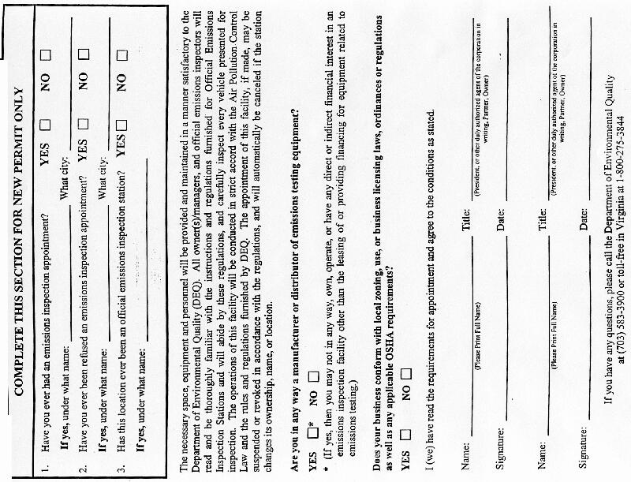
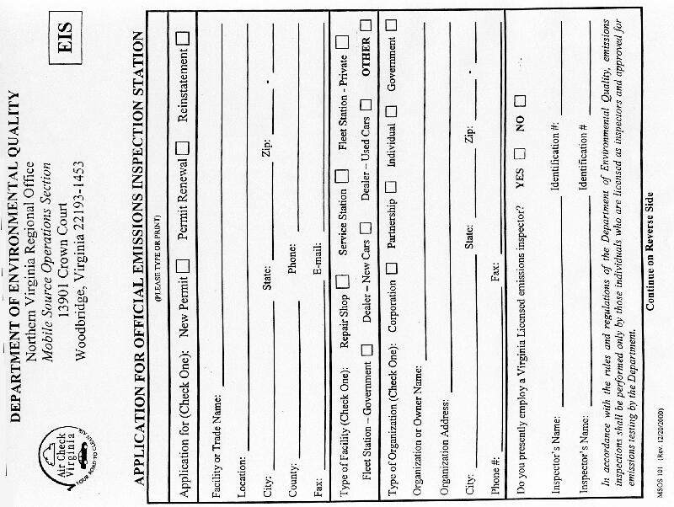
Vehicle Emissions Inspection Report (1998)
Notice of Rejection from Vehicle Emissions Testing (9/01)
Request for Deferral of Vehicle Emissions Inspection Requirement, MSOS 1 (rev. 8/00)
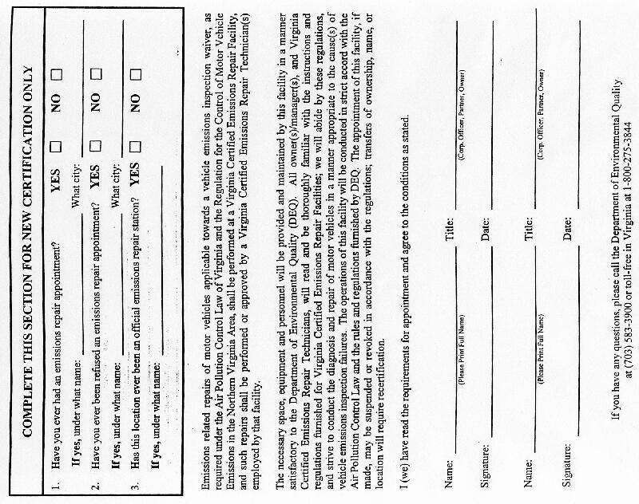
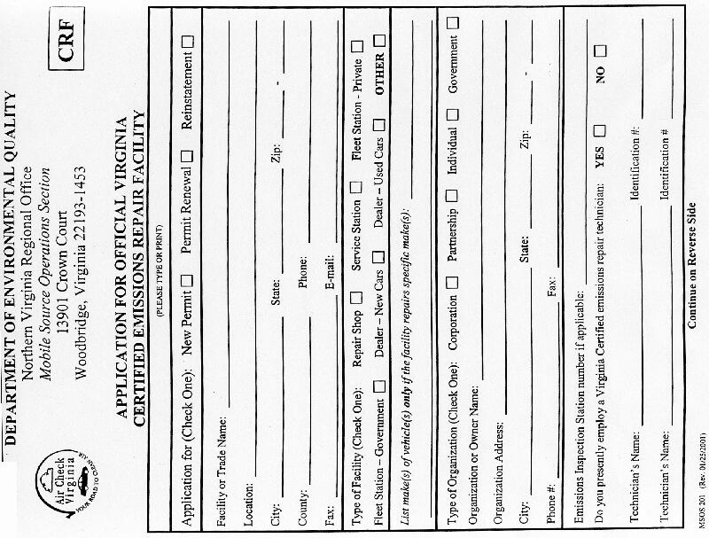
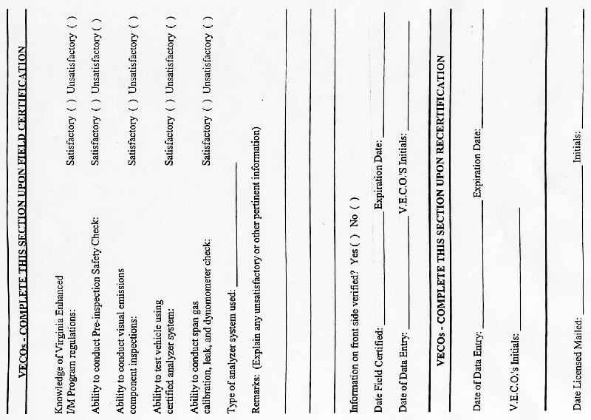
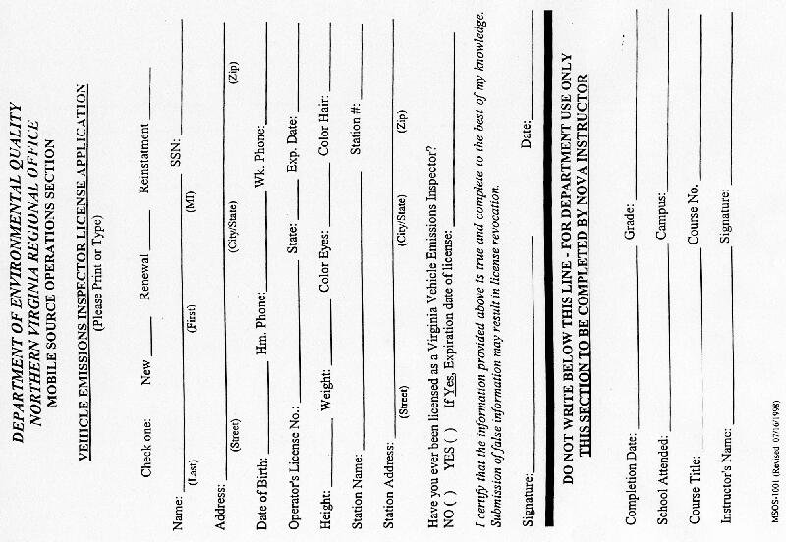
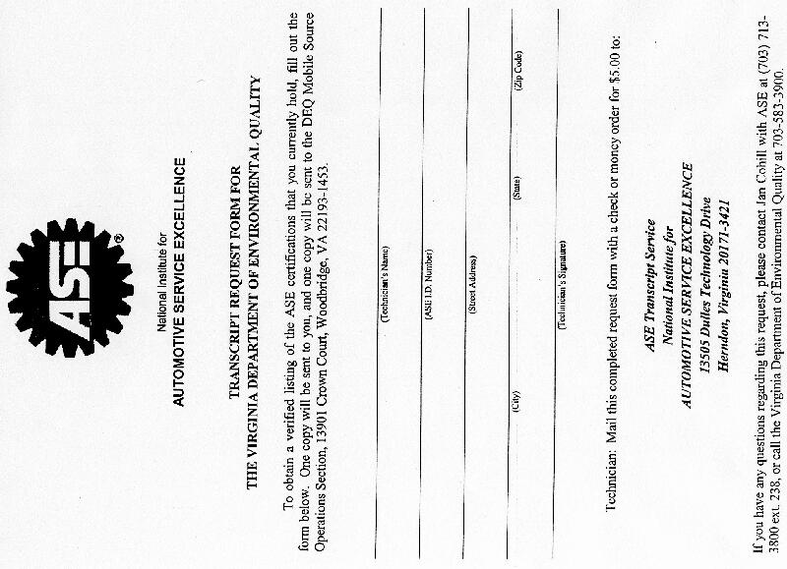
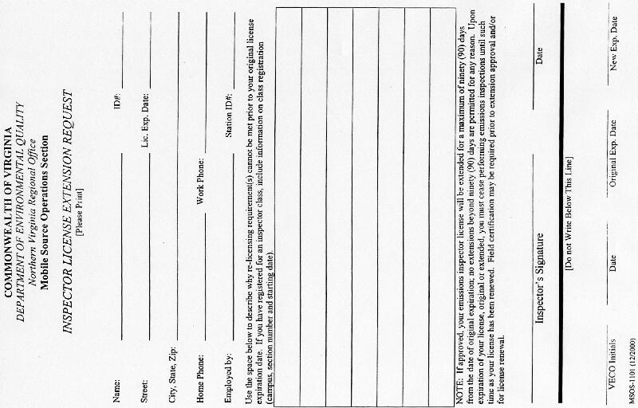
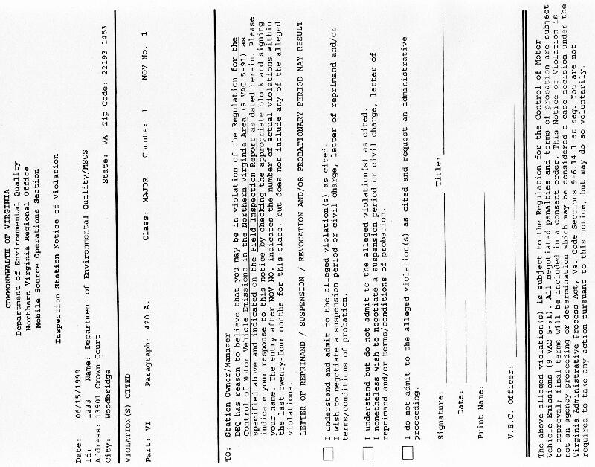
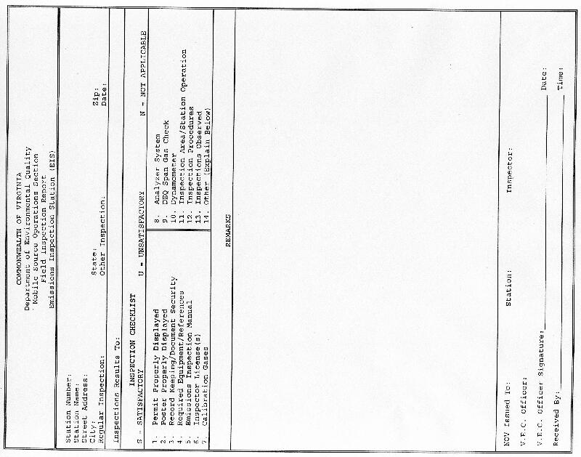
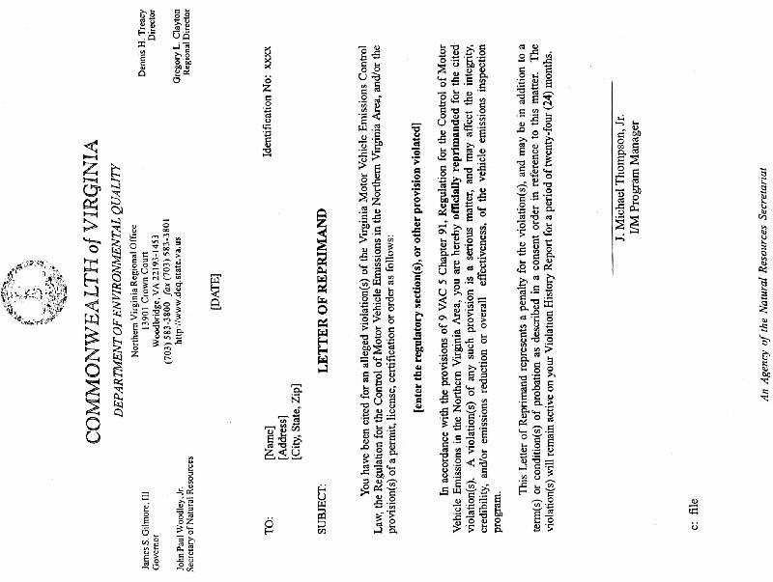
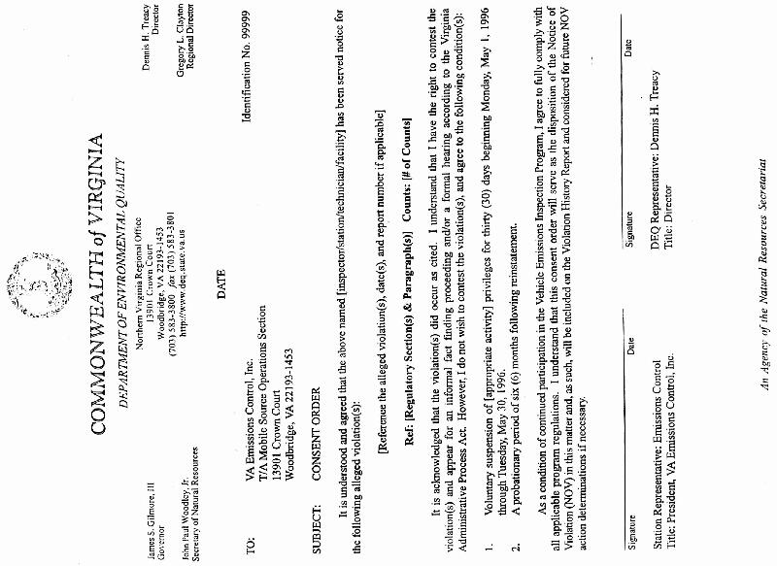
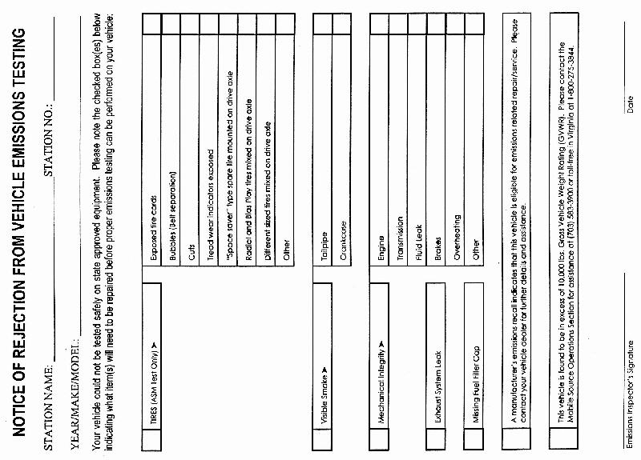
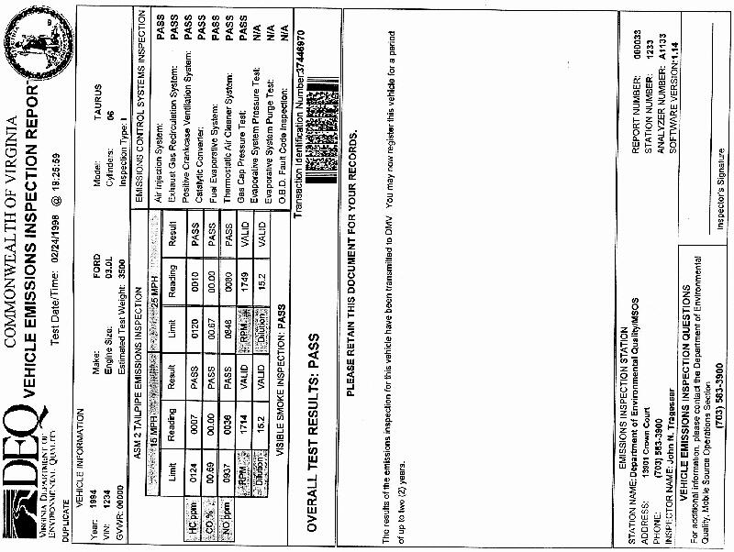
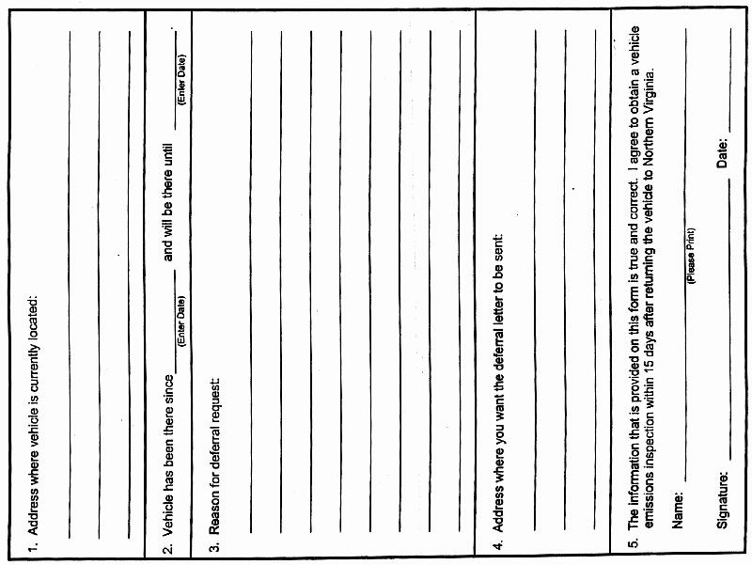
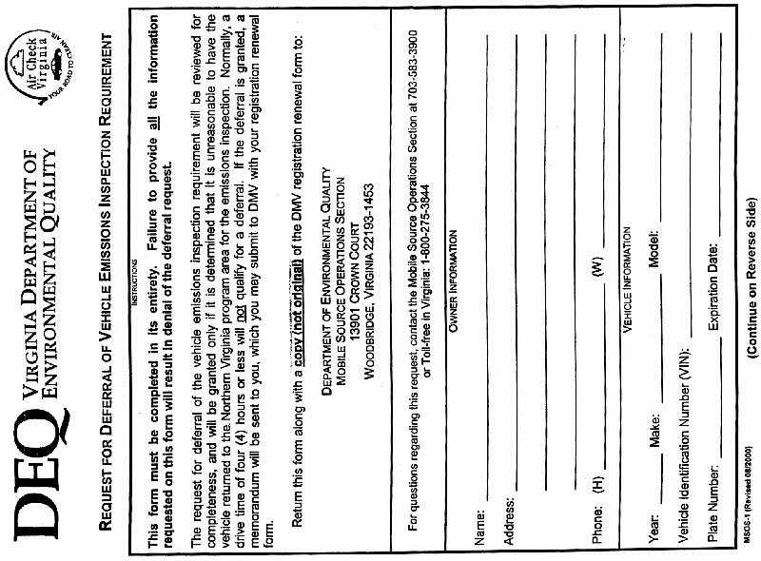
VA.R. Doc. No. R01-20; Filed September 19, 2001, 9:04 a.m.

1 Source: The agency
2 Figures in Table 1 are not discounted.
3 These estimates may vary slightly for northern Virginia due to geographic differences.
4 Source: Virginia Economic Indicators, Fourth Quarter 2000 Data.
5 Reported 25 cents in Harrington et al., 1999:2 is adjusted for Consumer Price Index.
6 The probability that a vehicle will fail the test monotonically increases with the age. Ando et al., 1999 report that failure rate for 14-year-old vehicles were 45.4% in Arizona. Since the proposed amendments provide an exemption for vehicles between the ages 25 and 32, the failure rate is expected to be even higher. Thus, there is a chance that 40 percent expected failure rate may be biased downward and may underestimate expected cost savings.
7 Some of the owners may repair their vehicles even if it is not required. The estimates provided here do not account for these cases.
8 The estimated $132 in 1995 dollars is adjusted for Consumer Price Index to convert into current dollars. No adjustments are made for potential cost of repair differences between Arizona and Virginia.
9 Repair costs are generally higher for older vehicles. Using the estimates for 14-year-old vehicles for 25 to 32 year old vehicles may underestimate expected costs.
1⁰ Some repairs may be covered by manufacturers warranty.
1¹ Reported $35 in 1995 dollars is adjusted for Consumer Price Index.
1² The vehicle owner may always choose to repair the car even if it is not required. These estimates do not account for these cases.
1³ Source: Harrington et al. 1999:2.
1⁴ Source: The Agency

