STATE BOARD OF HEALTH
Title of Regulation: 12 VAC 5-475. Regulations Implementing the Virginia Organ and Tissue Donor Registry (adding 12 VAC 5-475-10 through 12 VAC 5-475-90).
Statutory Authority: § 32.1-292.2 of the Code of Virginia.
Public Hearing Date: October 30, 2001 - 10 a.m.
Public comments may be submitted until December 21, 2001.
(See Calendar of Events section
for additional information)
Agency Contact: Eileen Guertler, Director, Virginia Transplant Council, Virginia Department of Health, P.O. Box 2448, Richmond, VA 23218, telephone (804) 786-5589, FAX (804) 786-0892 or e-mail eguertler@vdh.state.va.us.
Basis: Section 32.1-292.2 of the Code of Virginia requires an Organ and Tissue Donor Registry for the Commonwealth to be administered by the Department of Health. The Board of Health, in consultation with the Virginia Transplant Council, is directed to promulgate regulations to administer the organ and tissue donor registry.
Purpose: The purpose of this action is to establish regulations to administer the newly established Virginia Organ and Tissue Donor Registry in order to: (i) provide a means of recovering an anatomical gift for transplantation or research and (ii) collect data to develop and evaluate the effectiveness of educational initiatives promoting organ, eye and tissue donation. The lives of Virginians, particularly those in need of organs and tissues, will be enhanced or saved by organ and tissue donation through use of the registry.
Substance: The regulations regarding the creation of the donor registry as proposed are identical to the emergency regulations approved by the Board of Health in January 2001. The donor registry maintains, and updates as needed, pertinent information on all Virginians who have indicated a willingness to donate their organs, eyes, and tissues for transplantation or research. The registry records the donor's full name, address, sex, birthdate, age, driver's license number or unique identifying number, and other pertinent identifying personal information. The Virginia Transplant Council analyzes registry data to promote and increase donation within the Commonwealth. Also, any Virginian may have his name removed from the registry by filing an appropriate form with the Virginia Transplant Council.
Issues: These regulations will create a legitimate donor registry, which will expedite the identification of potential organ and tissue donors. These regulations will also provide the agency with data to evaluate the effectiveness of VTC's educational initiatives. Although the registry will maintain data that includes unique identifiers of individuals, inclusion in the registry is voluntary and provisions are in place for the removal of names from the registry at the request of the individual.
The agency has long recognized the problem of citizens not being aware of their right/opportunity to become a donor, the confusion of how individuals may legitimately and legally declare their decision to donate, and the difficulty of identifying individuals who have now consented to be a donor.
Presently, citizens may designate to be a donor on a donor card, through an advance medical directive, or on their driver's license when they go to a DMV Customer Service Center to either obtain or renew a Virginia license. While the population is most easily reached through contact with DMV, the driver's license/record is not advertised as being part of a recognized Virginia Donor Registry. Any change to the license results in a $5.00 charge to the citizen, which does not allow for easy entry or exit in making a donor decision.
The Code of Virginia does not permit DMV to release the name, address, or specific age of the citizen--only the gender and age group category in which the citizen is placed. These data are too vague to be utilized for educational purposes by the agency. Also, at the hospital setting and in the absence of a license, an organ procurement organization (OPO) must contact the State Police to access the driver's record to discover if the citizen was a donor. No other information, such as an address, may be obtained from the driver's record.
These regulations will enable a one-stop shop for donor registration and designation with easy entry and exit for citizens and easy access to donation intent by OPOs and eye banks. The registry as established by these regulations would allow for quicker, more streamlined donor identification; an increase in organ and tissue recovery; improvements in organ and tissue usage; and better targeted education efforts by the agency. Both the public and the Commonwealth will greatly benefit from these regulations.
One disadvantage to the agency and the Commonwealth could be the public perception of the state attempting to create a database that further invades the right of privacy for citizens. However, persons entered into the registry will be done so according to their wishes and on a voluntary basis. Persons in the registry will have the option to have their name removed at any time and therefore there is no disadvantage to the public.
Department of Planning and Budget's Economic Impact Analysis: The Department of Planning and Budget (DPB) has analyzed the economic impact of this proposed regulation in accordance with § 2.2-4007 G of the Administrative Process Act and Executive Order Number 25 (98). Section 2.2-4007 G requires that such economic impact analyses include, but need not be limited to, the projected number of businesses or other entities to whom the regulation would apply, the identity of any localities and types of businesses or other entities particularly affected, the projected number of persons and employment positions to be affected, the projected costs to affected businesses or entities to implement or comply with the regulation, and the impact on the use and value of private property. The analysis presented below represents DPB’s best estimate of these economic impacts.
Summary of the proposed regulation. Legislation passed by the 2000 Session of the General Assembly established an Organ and Tissue Donor Registry and directed the Department of Health (VDH) to promulgate regulations to administer the registry. The proposed regulation includes provisions regarding:
1. Access to the registry;
2. Registry membership;
3. Data to be recorded;
4. Removal from the registry; and
5. Use and dissemination of registry information.
Estimated economic impact. Currently, citizens may designate themselves to be an organ and tissue donor on a donor card, through an advance medical directive, or on their driver’s license. VDH notes several problems with the current system, including the minimal level of data the Department of Motor Vehicles is allowed to release on donors, the fact that any changes to a driver’s license are subject to a $5.00 fee which affects the ease of changing donor designations, and the difficulty in certain settings of identifying individuals who have consented to be donors.
By implementing the new Virginia Organ and Tissue Donor Registry, the proposed regulation can be anticipated to expedite the identification of potential organ and tissue donors and provide data to evaluate and improve education efforts by the Virginia Transplant Council. Cost for the initial development and implementation of the registry is estimated at $75,000 and support and maintenance of the registry is estimated at $21,488 annually. Members of the Virginia Transplant Council authorized to use the registry will be required to report data regarding their use of the registry. The cost of these reports cannot be determined at this time but are unlikely to outweigh the benefits provided by the registry to these organizations.
One potential disadvantage noted by VDH could be the public perception of government attempting to create a database that further invades the right of privacy for citizens. If this view is held by many, the new registry could possibly reduce participation and the availability of donated organs. However, since inclusion in the registry is voluntary, individuals have the option to remove themselves at any time, and the registry will be considered confidential and available only to authorized members of the Virginia Transplant Council, the likelihood of strong negative public opinion is small.
The following table summarizes the anticipated effects resulting from promulgation of this regulation. While the overall net economic impact is not measurable at this time, it is likely to be positive.
Estimated Economic Impact of the Proposed Virginia Organ and Tissue Donor Registry (12 VAC 5-475)
Expected Effect | Estimated Cost | Estimated Benefit
Initial development of the registry | $75,000
Support and maintenance of the registry | $21,588 per year
Reporting requirements for users of the registry | not known at this time but unlikely to outweigh the benefits provided by the registry to these organizations
Increase in organ and tissue donations resulting from quicker identification of potential donors and improved education efforts |  | not quantifiable, but likely very significant
Businesses and entities affected. The proposed regulation will affect any Virginian who indicates a willingness to donate his organs, eyes, and tissue for transplantation or research. Inclusion in the registry is voluntary and members may remove themselves at any time. Members of the Virginia Transplant Council authorized to use the registry will also be affected by the proposed regulation.
Localities particularly affected. The proposed regulation is not expected to uniquely affect any particular localities.
Projected impact on employment. The proposed regulation is not expected have any impact on employment in Virginia.
Effects on the use and value of private property. The proposed regulation is not expected to have any effects on the use and value of private property in Virginia.
Agency's Response to the Department of Planning and Budget's Economic Impact Analysis: The department concurs substantially with the economic impact assessment dated June 22, 2001, prepared by the Department of Planning and Budget regarding the proposed chapter (12 VAC 5-475).
Summary:
This regulatory action creates a statewide organ and tissue donor registry that will maintain, and update as needed, pertinent information on all Virginians who have indicated a willingness to donate their organs, eyes, and tissues for transplantation or research. The registry will record the donor's full name, address, sex, birthdate, age, driver's license number or unique identifying number, and other pertinent identifying personal information. The Virginia Transplant Council will analyze registry data to promote and increase donation within the Commonwealth. Also, any Virginian may have his name removed from the registry by filing an appropriate form with the Virginia Transplant Council.
CHAPTER 475.
REGULATIONS IMPLEMENTING THE VIRGINIA ORGAN AND TISSUE DONOR REGISTRY.
PART I.
DEFINITIONS AND GENERAL INFORMATION.
12 VAC 5-475-10. Definitions.
The following words and terms when used in this chapter shall have the following meanings, unless the context clearly indicates otherwise:
“Agent” means an adult appointed by the declarant under an advance directive, executed or made in accordance with the provisions of § 54.1-2983 of the Code of Virginia, to make health care decisions for him, including decisions relating to visitation, provided the advance directive makes express provisions for visitation and subject to physician orders and policies of the institution to which the declarant is admitted. The declarant may also appoint an adult to make, after the declarant's death, an anatomical gift of all or any part of his body pursuant to Article 2 (§ 32.1-289 et seq.) of Chapter 8 of Title 32.1 of the Code of Virginia.
“Anatomical gift” or “organ donation” means a donation of organs, tissues, or eyes or all or any part of a human body to take effect upon or after death.
“Board” means the State Board of Health.
“Commissioner” means the State Health Commissioner or his duly designated officer or agent.
“Decedent” means a deceased individual and includes a stillborn infant or fetus.
“Department” means the State Department of Health.
“Document of gift” means a card, a statement attached to or imprinted on a motor vehicle driver’s or chauffeur’s license or the record of the individual’s motor vehicle driver’s or chauffeur’s license, a will, an advance directive, or other writing used to make an organ donation or an anatomical gift. “Document of gift” also includes a record of the donor’s gift stored in a registry.
“Donor” means an individual who makes a donation of organs, tissues, or eyes or an anatomical gift of all of his body.
“Disseminate” means to release, transfer, or otherwise communicate information orally, in writing, or by electronic means.
“Eye bank” means an agency accredited by the Eye Bank Association of America operating in the Commonwealth.
“Guardian” means a person appointed by the court who is responsible for the personal affairs of an incapacitated person, including responsibility for making decisions regarding the person's support, care, health, safety, habilitation, education, and therapeutic treatment, and, if not inconsistent with an order of commitment, residence. Where the context plainly indicates, the term includes a "limited guardian" or a "temporary guardian." The term includes a local or regional program designated by the Department for the Aging as a public guardian pursuant to Article 2 (§ 2.2-711 et seq.) of Chapter 7 of Title 2.2 of the Code of Virginia.
“Informed consent” means the knowing and voluntary agreement, obtained without undue influence or any use of force, fraud, deceit, duress, or other form of constraint or coercion, of a person who is capable of exercising free power of choice.
“Organ procurement organization” means an agency certified by the United States Health Care Financing Administration as an organ procurement organization.
“Part” means an organ, tissue, eye, bone, artery, blood, fluid or other portion of a human body.
“Personal information” means all information that describes, locates or indexes anything about an individual, as defined in § 2.2-3801 of the Code of Virginia.
“Procurement” means the recovery of any donated part by a physician licensed, accredited, or approved under the laws of any state.
“Registry” means the Organ and Tissue Donor Registry for the Commonwealth, which shall be administered by the Department of Health in accordance with § 32.1-292.2 of the Code of Virginia. The registry shall maintain and update, as needed, the pertinent information on all Virginians who have indicated a willingness to donate.
“Tissue bank” means an agency accredited by the American Association of Tissue Banks operating in the Commonwealth.
“UNOS” means the United Network for Organ Sharing.
“VTC” means the Virginia Transplant Council, a program within the Virginia Department of Health that exists to promote and coordinate educational and information activities as related to the organ, tissue, and eye donation process and transplantation in the Commonwealth of Virginia.
12 VAC 5-475-20. Purpose.
These regulations are designed to accomplish the tasks listed in § 32.1-292.2 C 1 and 2 of the Code of Virginia by establishing procedures for the administration of the registry.
12 VAC 5-475-30. Administration.
A. The board has the responsibility for promulgating regulations, in consultation with the VTC, pertaining to the administration of the organ and tissue donor registry.
B. The commissioner is the executive officer for the State Board of Health with the authority of the board when it is not in session, subject to the rules and regulations of and review by the board.
C. The VTC, as delegated by the board pursuant to § 32.1-292.2 D 2 of the Code of Virginia, is responsible for analyzing registry data under research protocols directed toward determination and identification of means to promote and increase organ, eye, and tissue donation within the Commonwealth.
D. Confidentiality. All persons responsible for the administration of the organ and tissue donor registry shall ensure that the registry and all information therein shall be confidential in accordance with § 32.1-127.1:03 of the Code of Virginia and applicable federal law.
12 VAC 5-475-40. Access.
The registry and all information therein shall be accessible 24 hours a day and only to the department and the specific designees of accredited organ procurement organizations, eye banks and tissue banks operating in or serving Virginia and which are members of the VTC, for the purpose of identifying a potential donor according to the provisions of §§ 32.1-127.1 and 32.1-292.2, and subsection F of § 46.2-342.
The name of such designees shall be provided to the VTC. All other persons or entities shall be prohibited from having access to the registry. If at any time the designee is unable to carry out his responsibilities with respect to the registry, a replacement shall be selected and the VTC shall be notified of such replacement.
All accredited organ procurement organizations, eye banks, and tissue banks with authorized access to the registry shall be required to report annually to the VTC the following outcome data: (i) the number of times the registry is accessed; (ii) the number of times access to the registry results in an unsuccessful search (i.e., the individual is not a member of the registry); (iii) the number of times an organ, tissue or eye procurement proceeds solely from accessing the registry; (iv) the number of times the next of kin’s consent is obtained in addition to a successful search of the registry; (v) the number of times donation of organs, tissue, or eyes occurred as a result of alternative donation designation documentation; and (vi) the number of times the next of kin’s consent is obtained without accessing the registry.
PART II.
REGISTRY INFORMATION.
12 VAC 5-475-50. Registry membership.
Those persons 18 years and older who have indicated a willingness to donate in accordance with § 32.1-290 of the Code of Virginia and have completed the required registration form (VTC-1) shall be recorded in the registry. Persons under the age of 18 may enter the registry upon completion of the registration form and only with the written consent of his parent or legal guardian. No person may enter another person in the registry.
Those persons who have indicated a willingness to donate on their driver’s license or personal identification card as authorized by the Department of Motor Vehicles will be automatically entered into the registry. Through inter-agency agreement, the Department of Motor Vehicles will assist the department by electronically providing this information to the registry on a daily basis. The VTC shall contact any such self-identified persons by United States mail regarding notification of membership to the registry and request the completion of the registration form (VTC-1).
12 VAC 5-475-60. Data to be recorded.
The following information shall be recorded in the registry: the donor’s full name, address (including county or independent city of residence with zip code), telephone number, date of birth, age, sex, race, and driver’s license number or unique identification number. If the donor is under the age of 18, the name, telephone number, address, and unique identification number of the donor’s parent or legal guardian shall be recorded.
Information shall be recorded by completing the Virginia Organ and Tissue Donor Registry Form (VTC-1).
12 VAC 5-475-70. Removal from the registry.
A person who has joined the registry may have his name removed by filing an appropriate form (VTC-0) with the VTC or in accordance with subsections E and F of § 32.1-290 or subsection G of § 46.2-342.
The name of a person entered in the registry who has died shall be removed from the registry within 90 days of notification of death by the Virginia Office of Vital Records and Health Statistics.
PART III.
USE AND DISSEMINATION OF REGISTRY INFORMATION.
12 VAC 5-475-80. Use.
The designees of accredited organ procurement organizations, eye banks and tissue banks with authorized access to the registry shall have an organizational or individual pass code, or both, assigned by the VTC to gain entry to the registry via the VTC website.
Once entry to the registry has been established, the designees shall enter the decedent's full name, the decedent’s date of birth, the decedent’s driver's license number, the decedent’s unique identification number, or any combination thereof, to verify whether the decedent made a donor designation in the registry. Once the decedent’s donor designation has been verified, the designees shall include the intent to donate as part of the donor record maintained by the accredited organ procurement organization, eye bank and tissue bank.
If the decedent is not in the registry, the designees shall exit the registry. Designees shall not perform a search of the registry on any other person other than the decedent.
12 VAC 5-475-90. Dissemination.
The accredited organ procurement organizations, eye banks and tissue banks with authorized access to the registry may disclose the decedent’s documented donation designation to the decedent’s next of kin, the nearest available relative, a member of the decedent’s household, an individual with an affinity relationship, and the primary treating physician, in order to demonstrate the decedent’s wish to donate in accordance with §§ 32.1-290, 46.2-342, 54.1-2984, and 54.1-2986 of the Code of Virginia.
The VTC may disclose to the DMV the donor designation on those persons who are recorded in the registry in order that the driver’s record accurately reflect those persons’ wishes to donate pursuant to subsections E and F of § 46.2-342 of the Code of Virginia.
NOTICE: The forms used in administering 12 VAC 5-475, Regulations Implementing the Virginia Organ and Tissue Donor Registry, are listed below. Any amended or added forms are reflected in the listing and are published following the listing.
FORMS
Virginia Organ and Tissue Donor Registry Removal Form (VTC-0) (eff. 7/00).
Virginia Organ and Tissue Donor Registry Form (VTC-1) (eff. 7/00).

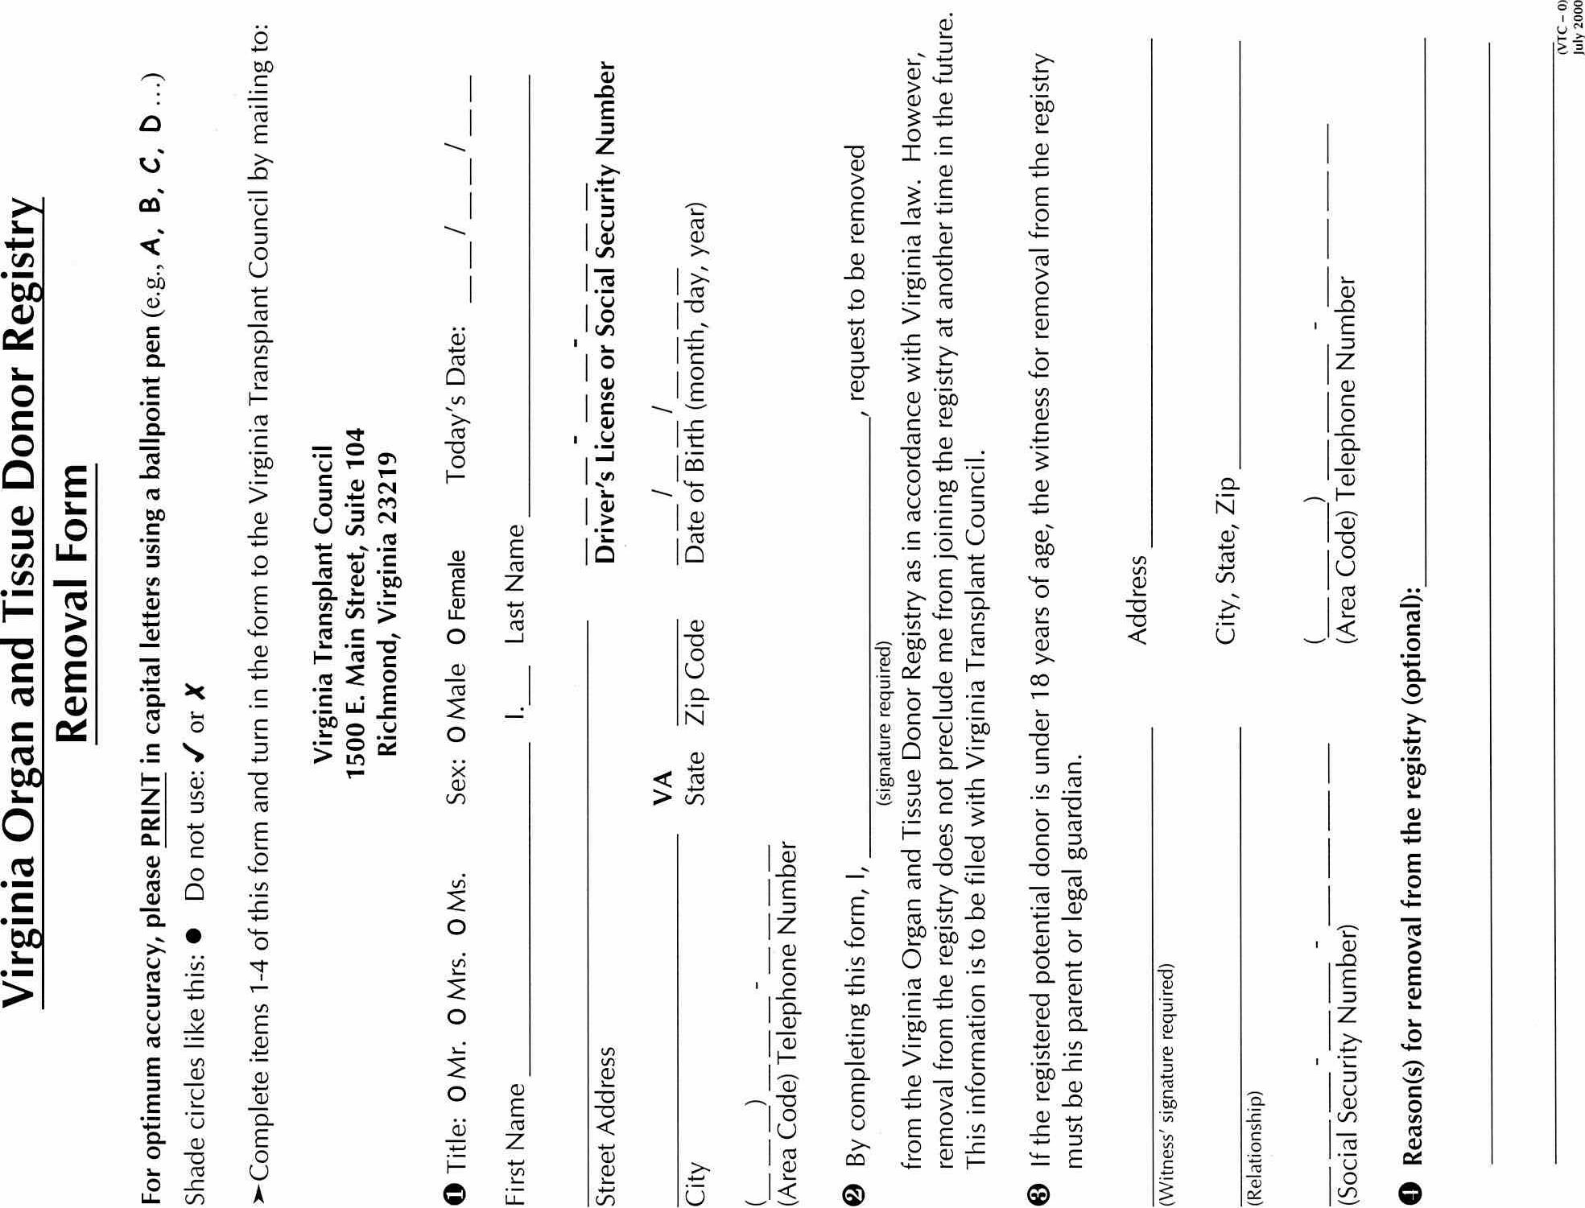
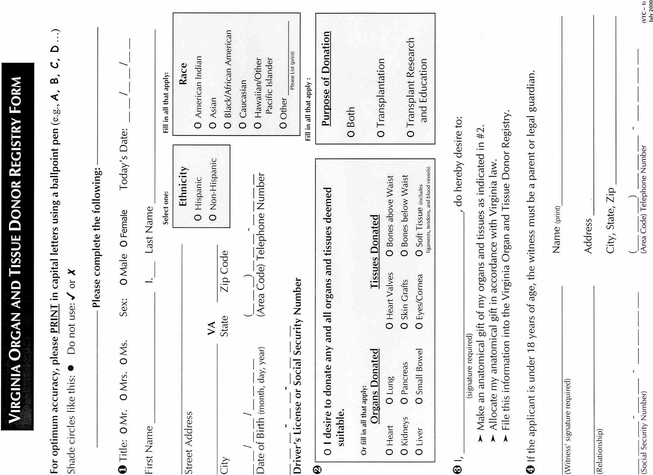
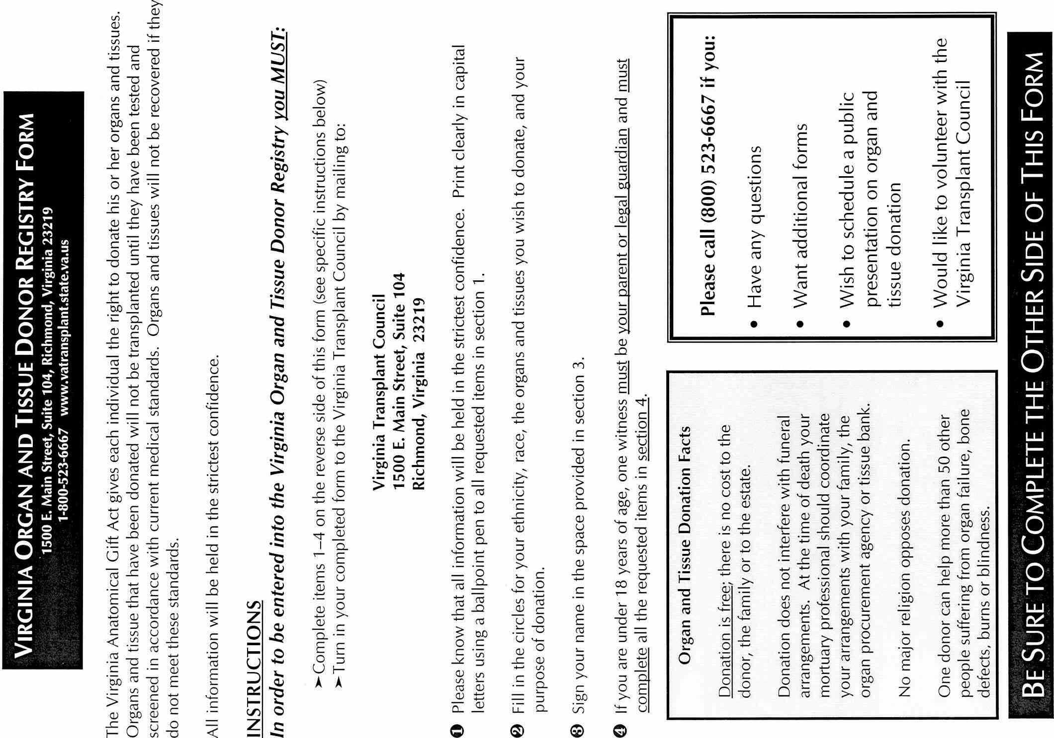
VA.R. Doc. No. R01-93; Filed October 2, 2001, 10:23 a.m.

