STATE CORPORATION COMMISSION
REGISTRAR'S NOTICE: The State Corporation Commission is exempt from the Administrative Process Act in accordance with § 2.2-4002 A 2 of the Code of Virginia, which exempts courts, any agency of the Supreme Court, and any agency which by the Constitution is expressly granted any of the powers of a court of record.
Title of Regulation: 14 VAC 5-200. Rules Governing Long-Term Care Insurance (amending 14 VAC 5-200-20, 14 VAC 5-200-30, 14 VAC 5-200-40, 14 VAC 5-200-70, 14 VAC 5-200-80, 14 VAC 5-200-160, and 14 VAC 5-200-175; adding 14 VAC 5-200-75).
Statutory Authority: §§ 12.1-13 and 38.2-5202 of the Code of Virginia.
Agency Contact: Bob Wright, Special Projects Coordinator, Life and Health Division, Bureau of Insurance, P.O. Box 1157, Richmond, Virginia 23218, telephone (804) 371-9074 or e-mail rwright@scc.state.va.us.
Summary:
The purpose of the revisions to the rules is to carry out those provisions of Chapter 114 of the 2001 Acts of Assembly that amended § 38.2-5202 of the Code of Virginia to permit the commission to adopt standards regarding the rating practices of insurers to consumers. In addition, these amendments clarify that advertisements must be filed with the commission, clarify the disclosure that must be made in connection with the renewability of long-term care policies, and provide that the Bureau of Insurance may amend the forms attached to these rules.
Significant revisions include the following: (i) clarification of the disclosure to be made in connection with policy renewability in 14 VAC 5-200-70 A, (ii) provision of requirements for disclosure of rating practices to the consumer in 14 VAC 5-200-75, and (iii) clarification that advertisements must be filed with the commission.
AT RICHMOND, SEPTEMBER 21, 2001
COMMONWEALTH OF VIRGINIA
At the relation of the
STATE CORPORATION COMMISSION
CASE NO. INS010248
Ex Parte: In the matter of
Adopting Revisions to the Rules
Governing Long-Term Care Insurance
ORDER TO TAKE NOTICE
WHEREAS, § 12.1-13 of the Code of Virginia provides that the Commission shall have the power to promulgate rules and regulations in the enforcement and administration of all laws within its jurisdiction, and § 38.2-223 of the Code of Virginia provides that the Commission may issue any rules and regulations necessary or appropriate for the administration and enforcement of Title 38.2 of the Code of Virginia;
WHEREAS, § 38.2-5202 of the Code of Virginia also provides that the Commission shall promulgate such regulations regarding long-term care insurance policies and certificates as it deems appropriate;
WHEREAS, the rules and regulations issued by the Commission pursuant to § 38.2-223 of the Code of Virginia are set forth in Title 14 of the Virginia Administrative Code;
WHEREAS, the Bureau of Insurance has submitted to the Commission proposed revisions to Chapter 200 of Title 14 of the Virginia Administrative Code entitled "Rules Governing Long-Term Care Insurance," which amend the rules at 14 VAC 5-200-20, 14 VAC 5-200-30, 14 VAC 5-200-40, 14 VAC 5-200-70, 14 VAC 5-200-75, 14 VAC 5-200-80, 14 VAC 5-200-160, and 14 VAC 5-200-175, add new Forms A and E, and designate current Forms A, B, and C to be Forms B, C, and D, respectively, as well as amend the newly designated Form B;
WHEREAS, the proposed revisions reflect amendments which clarify disclosure requirements in connection with policy renewability, provide disclosure requirements in connection with rating practices, clarify that copies of advertisements must be provided to the Commission, and provide that the Bureau of Insurance may amend the forms attached to these Rules; and
WHEREAS, the Commission is of the opinion that the proposed revisions should be considered for adoption with a proposed effective date of February 1, 2002;
THEREFORE, IT IS ORDERED THAT:
(1) The proposed revisions to the "Rules Governing Long-Term Care Insurance," which amend the rules at 14 VAC 5-200-20, 14 VAC 5-200-30, 14 VAC 5-200-40, 14 VAC 5-200-70, 14 VAC 5-200-75, 14 VAC 5-200-80, 14 VAC 5-200-160, and 14 VAC 5-200-175, add new Forms A and E, and designate current Forms A, B, and C to be Forms B, C, and D, respectively, as well as amend the newly designated Form B, be attached hereto and made a part hereof;
(2) All interested persons who desire to comment in support of or in opposition to, or to request a hearing to oppose the adoption of, the proposed revisions shall file such comments or hearing request on or before October 31, 2001, in writing with the Clerk of the Commission, Document Control Center, P.O. Box 2118, Richmond, Virginia 23218 and shall refer to Case No. INS010248;
(3) If no written request for a hearing on the proposed revisions is filed on or before October 31, 2001, the Commission, upon consideration of any comments submitted in support of or in opposition to the proposed revisions, may adopt the revisions proposed by the Bureau of Insurance;
(4) AN ATTESTED COPY hereof, together with a copy of the proposed revisions, shall be sent by the Clerk of the Commission to the Bureau of Insurance in care of Deputy Commissioner Gerald A. Milsky, who forthwith shall give further notice of the proposed adoption of the revisions to the rules by mailing a copy of this Order, together with a draft of the proposed revisions, to all insurers licensed by the Commission to write long-term care insurance in the Commonwealth of Virginia; and by forwarding a copy of this Order, together with a draft of the proposed revisions, to the Virginia Registrar of Regulations for appropriate publication in the Virginia Register of Regulations; and
(5) The Bureau of Insurance shall file with the Clerk of the Commission an affidavit of compliance with the notice requirements of paragraph (4) above.
14 VAC 5-200-20. Contracts effective prior to December 1, 2000 February 1, 2002.
Except as otherwise specifically provided, each long-term care policy delivered or issued for delivery in this Commonwealth prior to December 1, 2000 February 1, 2002, shall be subject to this chapter as it existed at the time the policy was issued or issued for delivery.
14 VAC 5-200-30. Applicability and scope.
Except as otherwise specifically provided, this chapter applies to all long-term care Insurance policies delivered or issued for delivery in this Commonwealth, on or after December 1, 2000 February 1, 2002, by insurers, fraternal benefit societies, health services plans, health maintenance organizations, cooperative non-profit life benefit companies or mutual assessment life, accident and sickness insurers.
14 VAC 5-200-40. Definitions.
The following words and terms when used in this chapter shall have the following meanings, unless the context clearly indicates otherwise:
"Applicant" means in the case of an individual long-term care insurance policy, the person who seeks to contract for such benefits, or in the case of a group long-term care insurance policy, the proposed certificateholder.
"Certificate" means any certificate or evidence of coverage issued under a group long-term care insurance policy, which policy has been delivered or issued for delivery in this Commonwealth.
"Commission" means the Virginia State Corporation Commission.
"Expected loss ratio" means the ratio of the present value of future premiums to the present value of future benefits over the entire period of the contract.
"Group long-term care insurance" means a long-term care insurance policy which complies with § 38.2-3521.1 or § 38.2-3522.1 of the Code of Virginia delivered or issued for delivery in this Commonwealth.
"Insurer" means any insurance company, health services plan, fraternal benefit society, health maintenance organization, cooperative non-profit life benefit company, or mutual assessment life, accident and sickness insurer.
"Long-term care insurance" means any insurance policy or rider primarily advertised, marketed, offered or designed to provide coverage for not less than 12 consecutive months for each covered person on an expense incurred, indemnity, prepaid, or other basis, for one or more necessary or medically necessary diagnostic, preventive, therapeutic, rehabilitative, maintenance, personal care, mental health or substance abuse services, provided in a setting other than an acute care unit of a hospital. Such term includes group and individual annuities and life insurance policies or riders which provide directly or which supplement long-term care insurance whether issued by insurers, fraternal benefit societies, health services plans, health maintenance organizations, cooperative non-profit life benefit companies or mutual assessment life, accident and sickness insurers. Such term also includes a policy or rider which provides for payment of benefits based upon cognitive impairment or the loss of functional capacity. Long-term care insurance shall not include any insurance policy which is offered primarily to provide basic Medicare supplement coverage, basic hospital expense coverage, basic medical-surgical expense coverage, hospital confinement indemnity coverage, major medical expense coverage, disability income or related asset-protection coverage, accident only coverage, specified disease or specified accident coverage, or limited benefit health coverage. With regard to life insurance, this term does not include life insurance policies which accelerate the death benefit specifically for one or more of the qualifying events of terminal illness, medical conditions requiring extraordinary medical intervention, or permanent institutional confinement, and which provide the option of a lump-sum payment for those benefits and in which neither the benefits nor the eligibility for the benefits is conditioned upon the receipt of long-term care. Notwithstanding any other provision contained herein, any product advertised, marketed or offered as long-term care insurance shall be subject to the provisions of this chapter. Health maintenance organizations, cooperative non-profit life benefit companies and mutual assessment life, accident and sickness insurers shall apply to the commission for approval to provide long-term care insurance prior to issuing this type of coverage.
"Policy" means any individual or group policy of insurance, contract, subscriber agreement, certificate, rider or endorsement delivered or issued for delivery in this Commonwealth by an insurer, fraternal benefit society, health services plan, health maintenance organization, cooperative non-profit life benefit company, or mutual assessment life, accident and sickness insurer.
14 VAC 5-200-70. Required disclosure provisions.
A. Renewability. Individual long-term care insurance policies that contain renewability provisions shall contain disclose the terms of renewability in a renewability provision.
1. Such provision shall be appropriately captioned, shall appear on the first page of the policy, and shall clearly state the duration, where limited, of renewability and the duration of the term of coverage for which the policy is issued and for which it may be renewed that the coverage is guaranteed renewable or noncancellable. This provision shall not apply to policies which do not contain a renewability provision, and under which the right to nonrenew is reserved solely to the policyholder.
2. A long-term care insurance policy or certificate, other than one where the insurer does not have the right to change the premium, shall include a statement that the premium rates may change.
B. Riders and endorsements. Except for riders or endorsements by which the insurer effectuates a request made in writing by the insured under an individual long-term care insurance policy, all riders or endorsements added to an individual long-term care insurance policy after date of issue or at reinstatement or renewal which reduce or eliminate benefits or coverage in the policy shall require signed acceptance by the individual insured. After the date of policy issue, any rider or endorsement which increases benefits or coverage with a concomitant increase in premium during the policy term must be agreed to in writing signed by the insured, except if the increased benefits or coverage are required by law. Where a separate additional premium is charged for benefits provided in connection with riders or endorsements, such premium charge shall be set forth in the policy, rider or endorsement.
C. Payment of benefits. A long-term care insurance policy which provides for the payment of benefits based on standards described as "usual and customary," "reasonable and customary" or words of similar import shall include a definition of such terms and an explanation of such terms in its accompanying outline of coverage.
D. Limitations. If a long-term care insurance policy or certificate contains any limitations with respect to preexisting conditions, such limitations shall appear as a separate paragraph of the policy or certificate and shall be labeled as "Preexisting Condition Limitations."
E. Other limitations or conditions on eligibility for benefits. A long-term care insurance policy or certificate containing any limitations or conditions for eligibility other than those prohibited in § 38.2-5205 A of the Code of Virginia shall set forth a description of such limitations or conditions, including any required number of days of confinement prior to receipt of benefits, in a separate paragraph of the policy or certificate and shall label such paragraph "Limitations or Conditions on Eligibility for Benefits."
F. Disclosure of tax consequences. With regard to life insurance policies which provide an accelerated benefit for long-term care, a disclosure statement is required at the time of application for the policy or rider and at the time the accelerated benefit payment request is submitted that receipt of these accelerated benefits may be taxable, and that assistance should be sought from a personal tax advisor. The disclosure statement shall be prominently displayed on the first page of the policy or rider and any other related documents.
G. Benefit triggers. Activities of daily living and cognitive impairment shall be used to measure an insured's need for long-term care and shall be described in the policy or certificate in a separate paragraph and shall be labeled "Eligibility for the Payment of Benefits." Any additional benefit triggers shall also be explained in this section. If these triggers differ for different benefits, explanation of the trigger shall accompany each benefit description. If an attending physician or other specified person must certify a certain level of functional dependency in order to be eligible for benefits, this too shall be specified.
14 VAC 5-200-75. Required disclosure of rating practices to consumer.
A. This section shall apply as follows:
1. Except as provided in subdivision 2 of this subsection, this section applies to any long-term care policy or certificate issued in this Commonwealth on or after August 1, 2002.
2. For certificates issued on or after February 1, 2002, under a group long-term care insurance policy as defined in 14 VAC 5-200-40, which policy was in force on February 1, 2002, the provisions of this section shall apply on the policy anniversary on or after February 1, 2003.
B. Other than policies for which no applicable premium rate or rate schedule increases can be made, insurers shall provide all of the information listed in this subsection to the applicant at the time of application or enrollment, unless the method of application does not allow for delivery at that time. In such a case, an insurer shall provide all of the information listed in this section to the applicant no later than at the time of delivery of the policy or certificate.
1. A statement that the policy may be subject to rate increases in the future;
2. An explanation of potential future premium rate revisions, and the policyholder’s or certificateholder’s option in the event of a premium rate revision;
3. The premium rate or rate schedules applicable to the applicant that will be in effect until a request is made for an increase;
4. A general explanation for applying premium rate or rate schedule adjustments that shall include:
a. A description of when premium rate or rate schedule adjustments will be effective (e.g., next anniversary date, next billing date, etc.); and
b. The right to a revised premium rate or rate schedule as provided in subdivision 2 of this subsection if the premium rate or rate schedule is changed.
5. a. Information regarding each premium rate increase on this policy form or similar policy forms over the past 10 years for this Commonwealth or any other state that, at a minimum, identifies:
(1) The policy forms for which premium rates have been increased;
(2) The calendar years when the form was available for purchase; and
(3) The amount or percentage of each increase. The percentage may be expressed as a percentage of the premium rate prior to the increase, and may also be expressed as minimum and maximum percentages if the rate increase is variable by rating characteristics.
b. The insurer may, in a fair manner, provide additional explanatory information related to the rate increases.
c. An insurer shall have the right to exclude from the disclosure premium rate increases that only apply to blocks of business acquired from other nonaffiliated insurers or the long-term care policies acquired from other nonaffiliated insurers when those increases occurred prior to the acquisition.
d. If an acquiring insurer files for a rate increase on a long-term care policy form acquired from nonaffiliated insurers or a block of policy forms acquired from nonaffiliated insurers [on or before the later of the effective date of this section] or the end of a 24-month period following the acquisition of the block or policies, the acquiring insurer may exclude that rate increase from the disclosure. However, the nonaffiliated selling company shall include the disclosure of that rate increase in accordance with subdivision 5 a of this subsection.
e. If the acquiring insurer in subdivision 5 d of this subsection files for a subsequent rate increase, even within the 24-month period, on the same policy form acquired from nonaffiliated insurers or block of policy forms acquired from nonaffiliated insurers referenced in subdivision 5 d of this subsection, the acquiring insurer shall make all disclosures required by subdivision 5 of this subsection, including disclosure of the earlier rate increase referenced in subdivision 5 d of this subsection.
C. An applicant shall sign an acknowledgement at the time of application, unless the method of application does not allow for signature at that time, that the insurer made the disclosure required under subdivisions B 1 and 5 of this section. If due to the method of application the applicant cannot sign an acknowledgement at the time of application, the applicant shall sign no later than at the time of delivery of the policy or certificate.
D. An insurer shall use Forms B and E dated February 1, 2002, or as later modified by the Bureau of Insurance, to comply with the requirements of subsections A and B of this section.
E. An insurer shall provide notice of an upcoming premium rate schedule increase to all policyholders or certificateholders, if applicable, at least 60 days prior to the implementation of the premium rate schedule increase by the insurer. The notice shall include the information required by subsection B of this section when the rate increase is implemented.
14 VAC 5-200-80. Prohibition of post-claims underwriting.
A. All applications and enrollment forms for long-term care insurance policies or certificates except those which are guaranteed issue shall contain clear and unambiguous questions designed to ascertain the health condition of the applicant.
B. Requirements for applications or enrollment forms:
1. If an application or enrollment form for long-term care insurance contains a question which asks whether the applicant has had medication prescribed by a physician, it must also ask the applicant to list each medication that has been prescribed.
2. If the medications listed in such application or enrollment form were known by the insurer, or should have been known at the time of application, to be directly related to a medical condition for which coverage would otherwise be denied, then the policy or certificate shall not be rescinded for that condition, even if such condition is not otherwise disclosed in the application or enrollment form.
C. Except for policies or certificates which are guaranteed issue:
1. The following language shall be set out conspicuously and in close conjunction with the applicant's signature block on an application or enrollment form for a long-term care insurance policy or certificate:
Caution: If your answers on this application or enrollment form are incorrect or untrue, [company] has the right to deny benefits or rescind your [policy] [certificate].
The agent and the applicant must sign this section.
2. The following language, or language substantially similar to the following, shall be set out conspicuously, in bold face type, on the long-term care insurance policy or certificate at the time of delivery:
Caution: This policy may not apply when you have a claim! Please read! The issuance of this long-term care insurance [policy] [certificate] is based upon your responses to the questions on your application [enrollment form]. A copy of your [application] [enrollment form] [is enclosed] [was retained by you when you applied]. If your answers are incorrect or untrue, the company has the right to deny benefits or rescind your [policy] [certificate]. The best time to clear up any questions is now, before a claim arises! If, for any reason, any of your answers are incorrect, contact the company at this address: [insert address].
3. Prior to issuance of a long-term care policy or certificate to an applicant age eighty (80) or older, the insurer shall obtain one of the following:
a. A report of a physical examination;
b. An assessment of functional capacity;
c. An attending physician's statement; or
d. Copies of medical records.
D. A copy of the completed application or enrollment form (whichever is applicable) shall be delivered to the insured no later than at the time of delivery of the policy or certificate unless it was retained by the applicant at the time of application.
E. Every insurer selling or issuing long-term care insurance benefits shall maintain a record of all policy or certificate rescissions, both state and countrywide, except those which the insured voluntarily effectuated, and shall annually by March 1 furnish this information to the commission in the format prescribed by the National Association of Insurance Commissioners.
14 VAC 5-200-160. Filing requirements for advertising.
A. Every insurer providing long-term care insurance or benefits in this Commonwealth shall provide a copy of any long-term care insurance advertisement, as defined in 14 VAC 5-90-30, intended for use in this Commonwealth whether through written, radio or television or other electronic medium to the commission for review or approval by the Commission. To the extent that it may be required or permitted under state law the laws of this Commonwealth, the commission may review or review for approval all such advertisements. In addition, all advertisements shall be retained by the insurer for at least three years from the date the advertisement was first used.
B. The commission may exempt from these requirements any advertising form or material when in the commission's opinion, this requirement may not be reasonably applied.
14 VAC 5-200-175. Suitability.
A. This section shall not apply to life insurance policies that accelerate benefits for long-term care.
B. Every insurer, health care service plan or other entity marketing long-term care insurance (the "issuer") shall:
1. Develop and use suitability standards to determine whether the purchase or replacement of long-term care insurance is appropriate for the needs of the applicant;
2. Train its agents in the use of its suitability standards; and
3. Maintain a copy of its suitability standards and make them available for inspection upon request by the commission.
C. 1. To determine whether the applicant meets the standards developed by the issuer, the agent and issuer shall develop procedures that take the following into consideration:
a. The ability to pay for the proposed coverage and other pertinent financial information related to the purchase of the coverage;
b. The applicant's goals or needs with respect to long-term care and the advantages and disadvantages of insurance to meet these goals or needs; and
c. The values, benefits and costs of the applicant's existing insurance, if any, when compared to the values, benefits and costs of the recommended purchase or replacement.
2. The issuer, and, where an agent is involved, the agent shall make reasonable efforts to obtain the information set out in subdivision 1 of this subsection. The efforts shall include presentation to the applicant, at or prior to application, of the "Long-Term Care Insurance Personal Worksheet." The personal worksheet used by the issuer shall contain, at a minimum, the information in the format contained in Form A B dated February 1, 2002, or as later amended by the Bureau of Insurance, in not less than 12-point type. The issuer may request the applicant to provide additional information to comply with its suitability standards. A copy of the issuer's personal worksheet shall be filed with the commission for approval as required for a policy pursuant to § 38.2-316 of the Code of Virginia.
3. A completed personal worksheet shall be returned to the issuer prior to the issuer's consideration of the applicant for coverage, except the personal worksheet need not be returned for sales of employer group long-term care insurance to employees and their spouses.
4. The sale or dissemination outside the company or agency by the issuer or agent of information obtained through the personal worksheet in Form A B is prohibited.
D. The issuer shall use the suitability standards it has developed pursuant to this section in determining whether issuing long-term care insurance coverage to an applicant is appropriate.
E. Agents shall use the suitability standards developed by the issuer in marketing long-term care insurance.
F. At the same time as the personal worksheet is provided to the applicant, the disclosure form entitled "Things You Should Know Before You Buy Long-Term Care Insurance" shall be provided. The form shall be in the format contained in Form B C dated February 1, 2002, or as later amended by the Bureau of Insurance, in not less than 12-point type.
G. If the issuer determines that the applicant does not meet its financial suitability standards, or if the applicant has declined to provide the information, the issuer may reject the application. In the alternative, the issuer shall send the applicant a letter similar to Form C D dated February 1, 2002, or as later amended by the Bureau of Insurance. If a letter similar to Form C D is sent, it may be in lieu of a notice of adverse underwriting decision as set forth in § 38.2-610 of the Code of Virginia. However, if the applicant has declined to provide financial information, the issuer may use some other method to verify the applicant's intent. Either the applicant's returned letter or a record of the alternative method of verification shall be made part of the applicant's file.
H. The issuer shall report annually by June 30 to the commission the total number of applications received from residents of this state Commonwealth, the number of those who declined to provide information on the personal worksheet, the number of applicants who did not meet the suitability standards, and the number of those who chose to confirm after receiving a suitability letter.
NOTICE: The forms used in administering 14 VAC 5-200, Rules Governing Long-Term Care Insurance, are listed below. Any amended or added forms are reflected in the listing and are published following the listing.
FORMS
Recission Reporting Form, Form A (eff. 02/02).
Long-Term Care Insurance Personal Worksheet, Form A B (eff. 12/01/00 rev. 02/02).
Things You Should Know Before You Buy Long-Term Care Insurance, Form B C (eff. 12/01/00 rev. 02/02).
Long-Term Care Insurance Suitability Letter, Form C D (eff. 12/01/00 rev. 02/02).
Potential Rate Increase Disclosure Form, Form E (eff. 02/02).

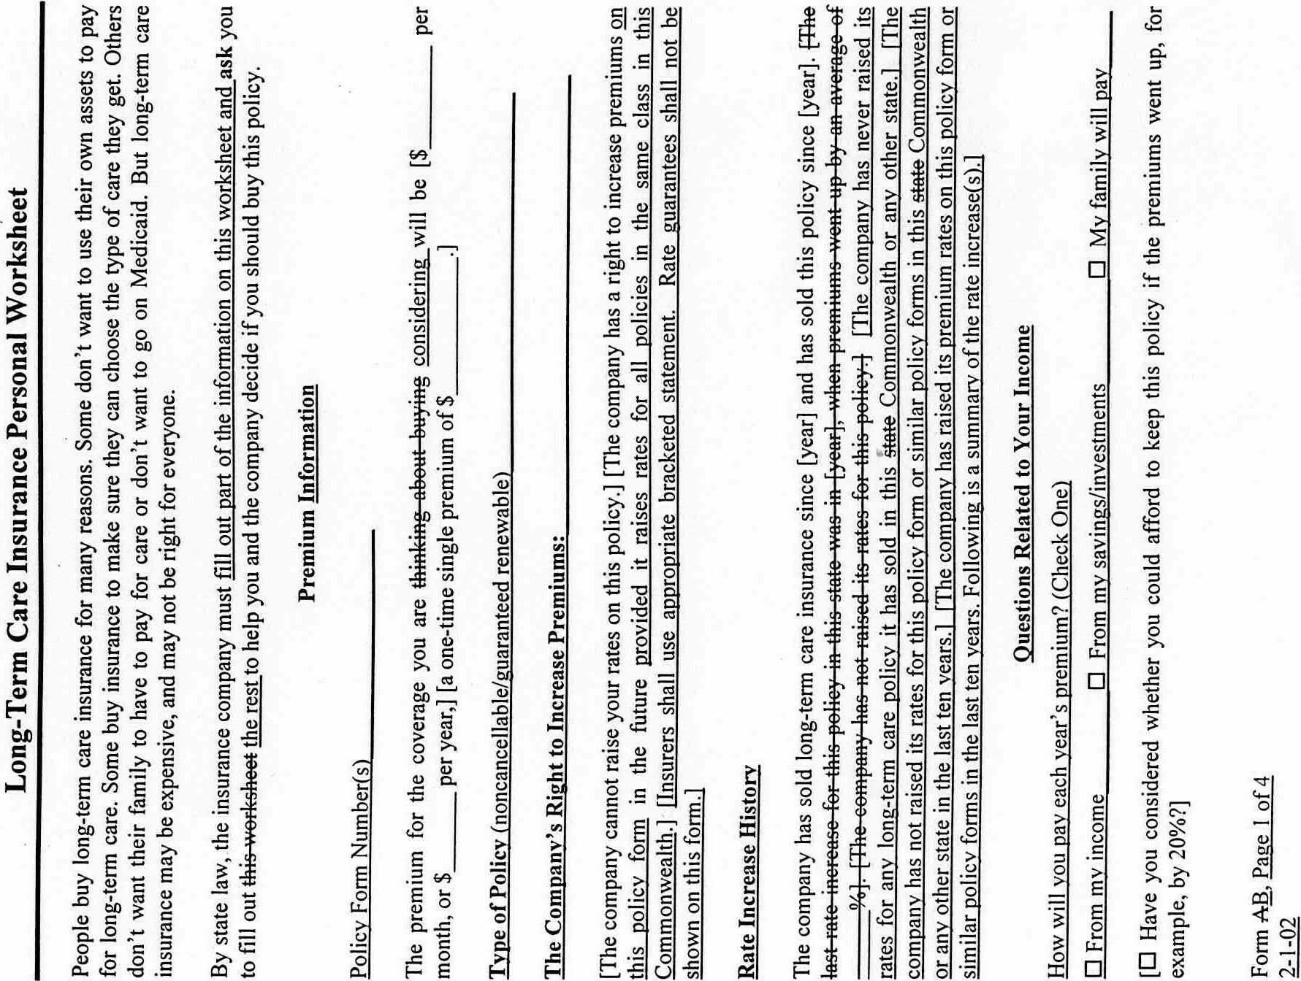
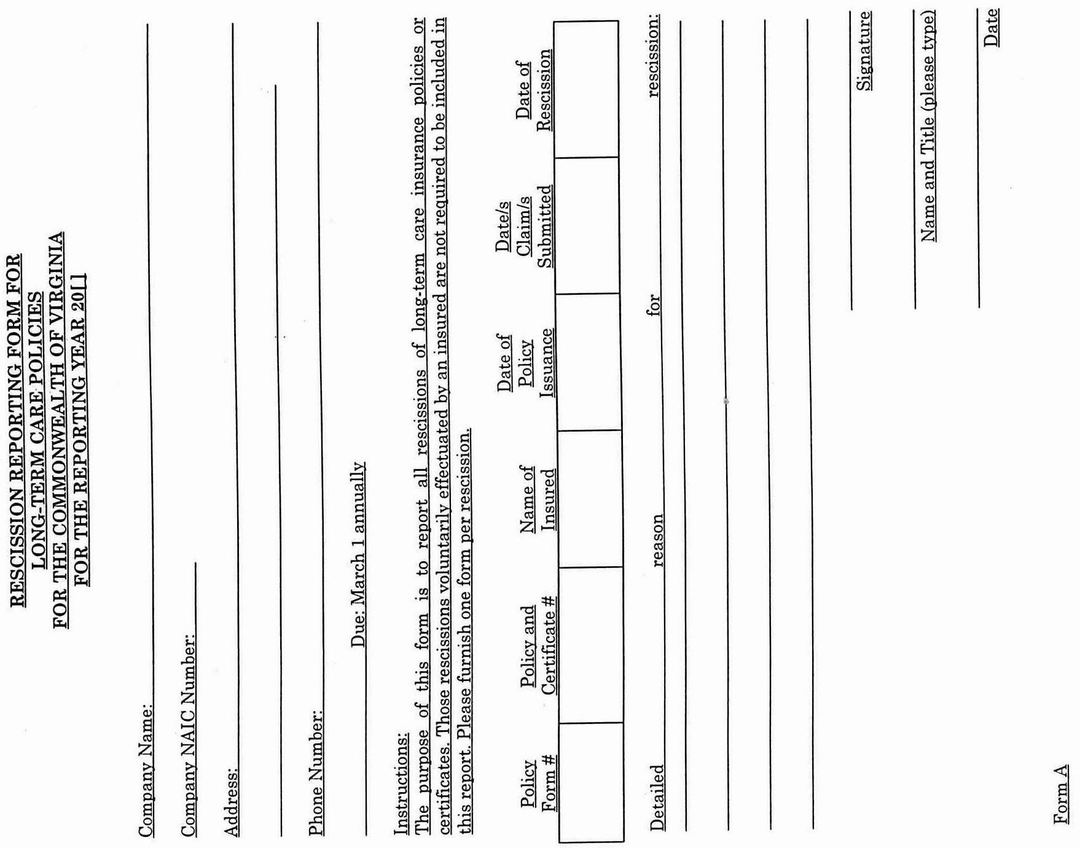
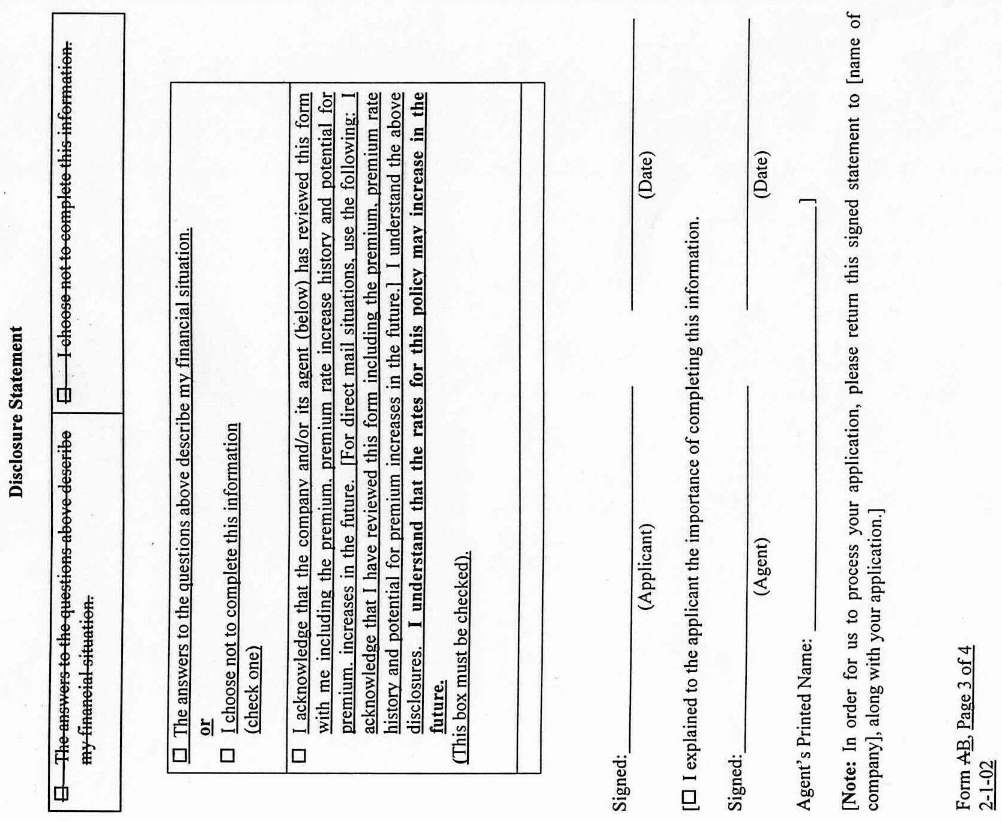
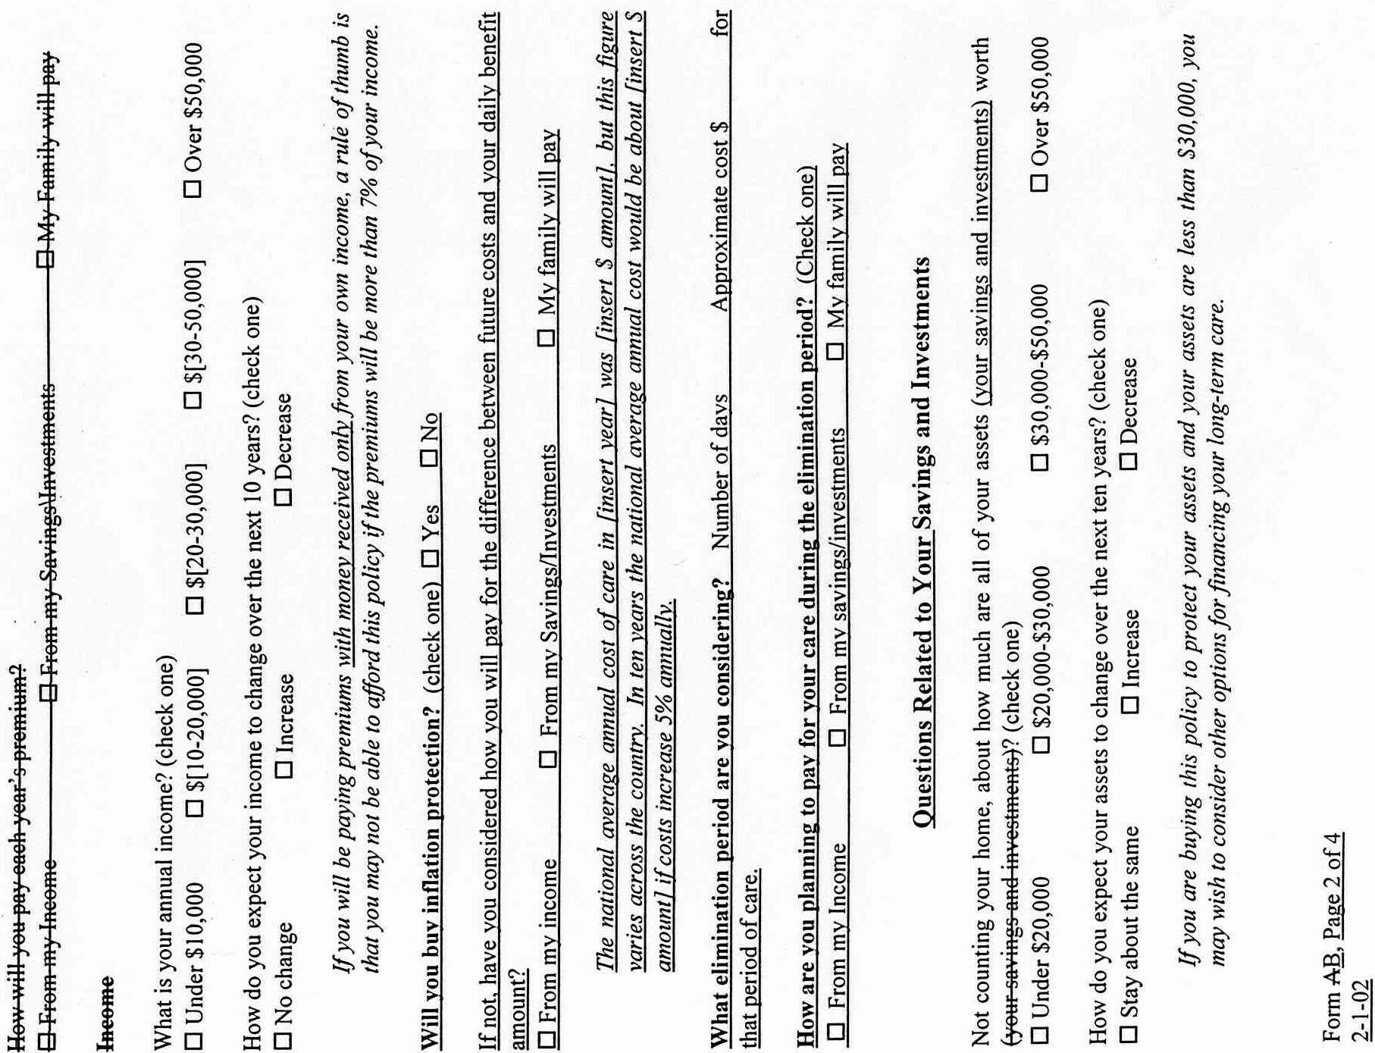
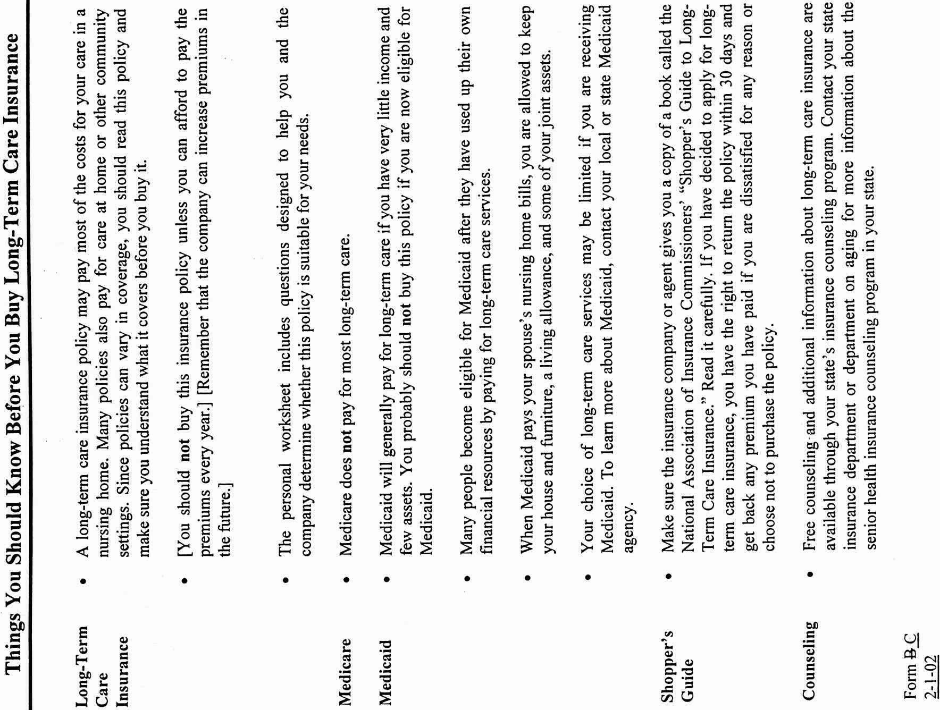

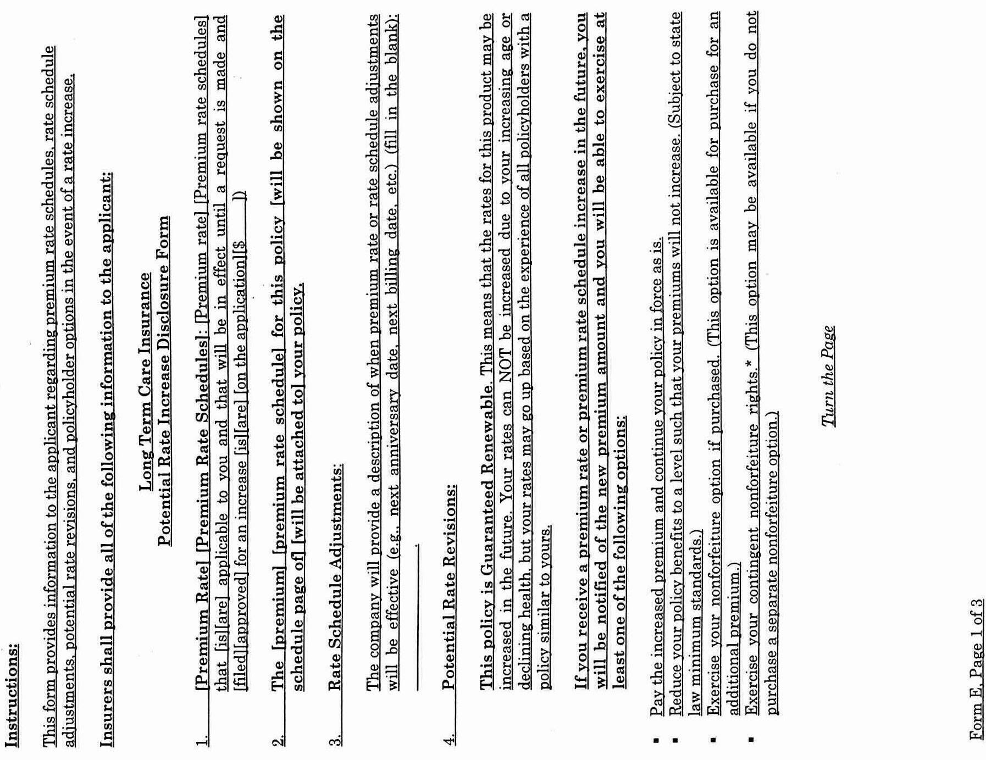
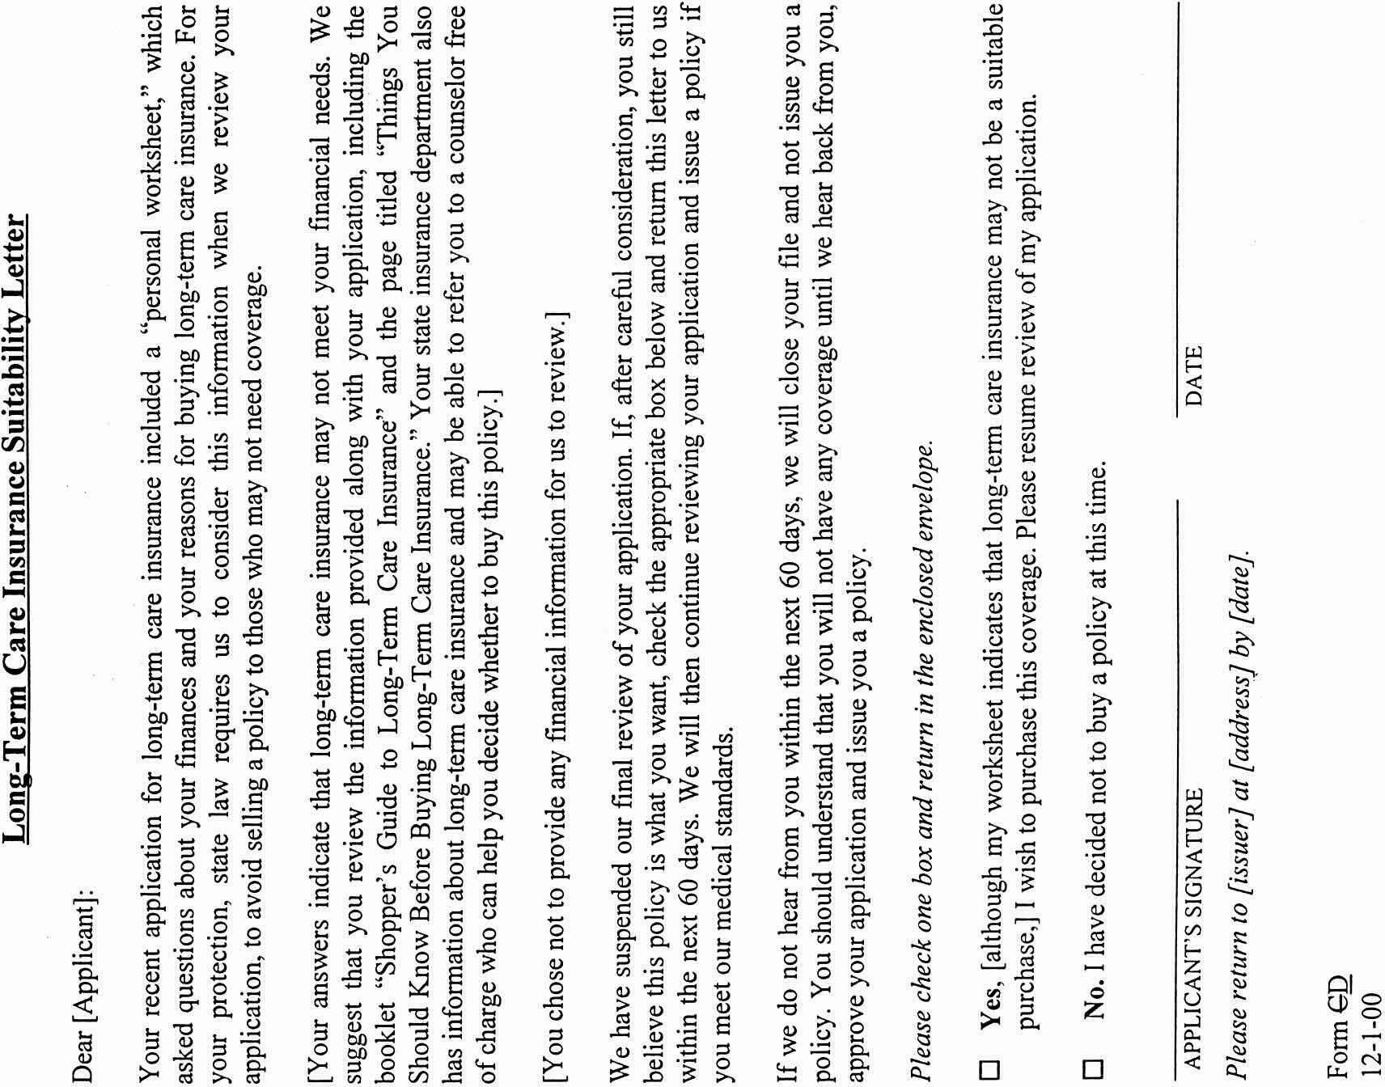
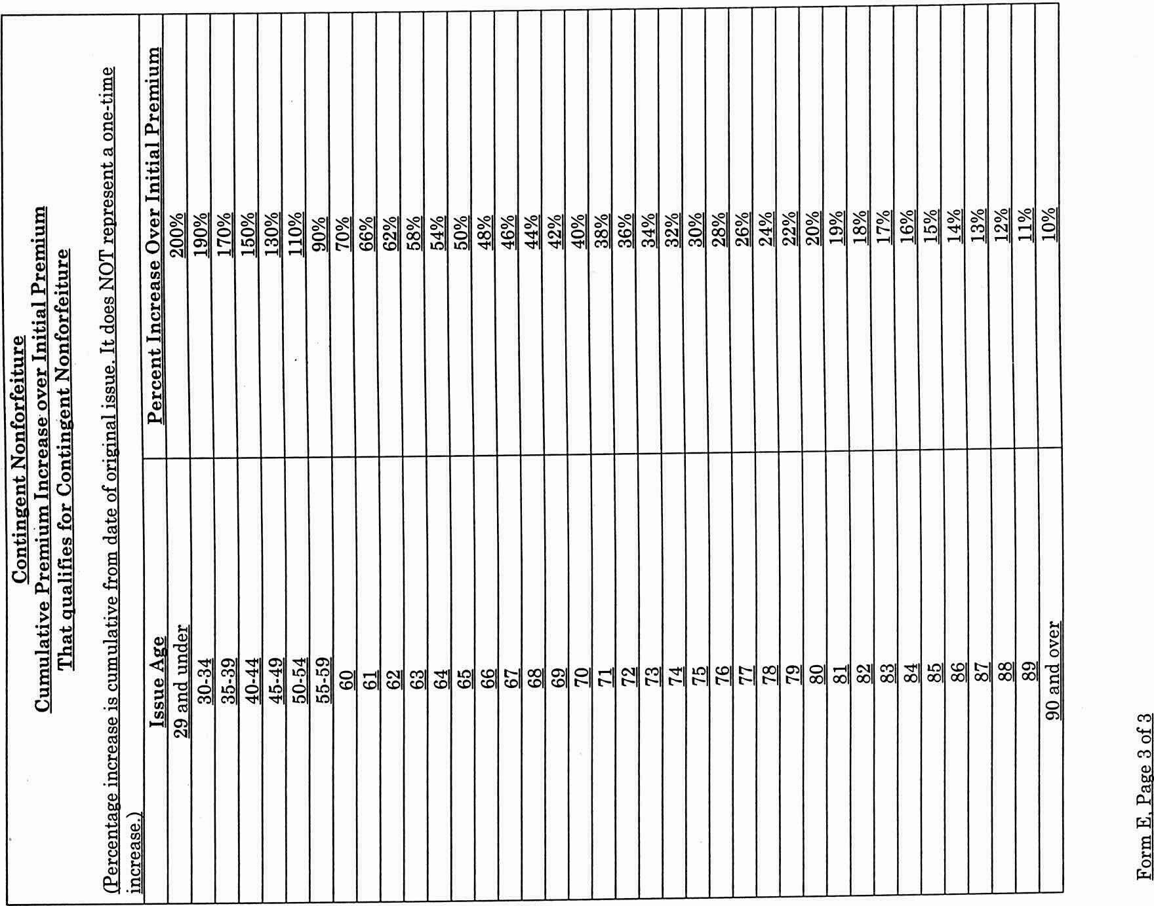
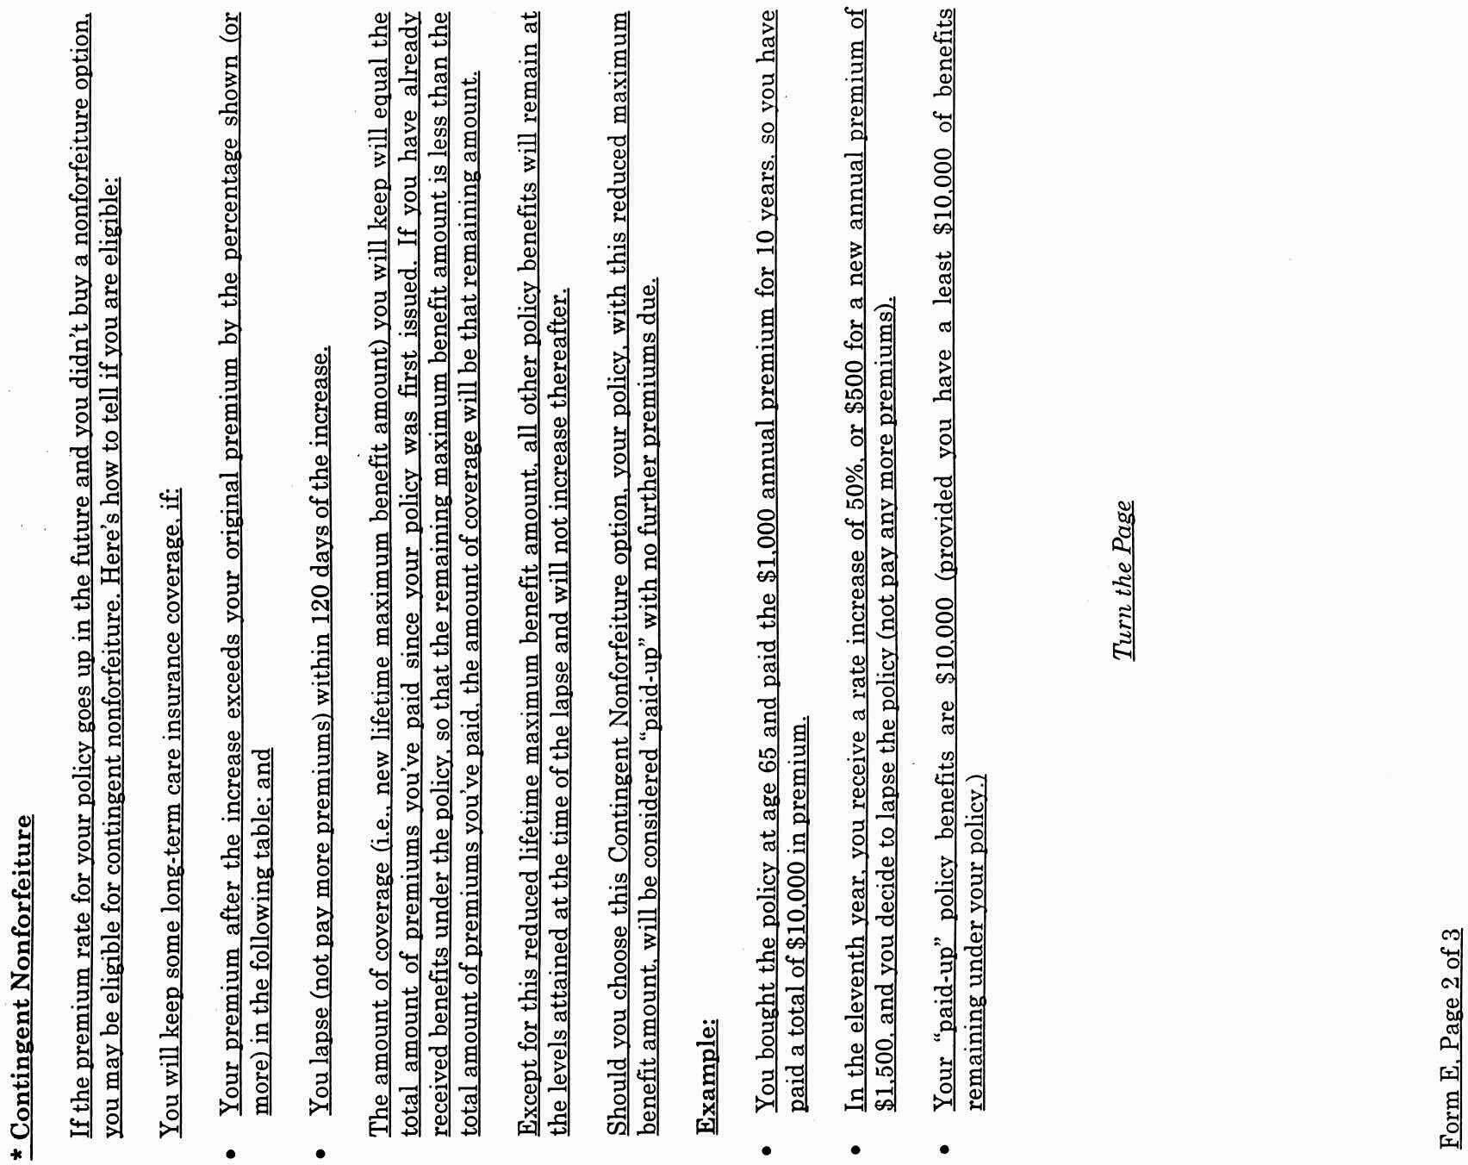
VA.R. Doc. No. R02-31; Filed September 26, 2001, 1:03 p.m.

