BOARDS OF NURSING AND MEDICINE
Title of Regulation: 18 VAC 90-30. Regulations Governing the Licensure of Nurse Practitioners (amending 18 VAC 90-30-20, 18 VAC 90-30-100, and 18 VAC 90-30-220; adding 18 VAC 90-30-105).
Title of Regulation: 18 VAC 90-40. Regulations for Prescriptive Authority for Nurse Practitioners (amending 18 VAC 90-40-20, 18 VAC 90-40-50, 18 VAC 90-40-60, and 18 VAC 90-40-130; adding 18 VAC 90-40-55).
Statutory Authority: §§ 54.1-103, 54.1-2400, 54.1-2912.1, and 54.1-2957.01 of the Code of Virginia.
Public Hearing Date: November 7, 2001 - 9 a.m.
Public comments may be submitted until 5 p.m. on December 5, 2001.
(See Calendar of Events section
for additional information)
Agency Contact: Nancy K. Durrett, R.N., Executive Director, Department of Health Professions, 6606 W. Broad Street, 4th Floor, Richmond, VA 23230-1717, telephone (804) 662-9909, FAX (804) 662-9512 or e-mail ndurrett@dhp.state.va.us.
Basis: Section 54.1-2400 of the Code of Virginia establishes the general powers and duties of health regulatory boards including the responsibility to promulgate regulations, levy fees, administer a licensure and renewal program, and discipline regulated professionals.
Section 54.1-2912.1 of the Code of Virginia provides the specific statutory mandate for the Board of Medicine to adopt regulations for practitioner continued competency.
The boards are also authorized by § 54.1-103 of the Code of Virginia to specify additional training for licensees seeking renewal.
Section 54.1-2957.01 of the Code of Virginia mandates the Board of Nursing to promulgate regulations that shall include, at a minimum, such requirements as may be necessary to ensure continued nurse practitioner competency which may include continuing education, testing, or any other requirement, and shall address the need to promote ethical practice, an appropriate standard of care, patient safety, the use of new pharmaceuticals, and appropriate communication with patients.
Purpose: With nurse practitioners assuming increasing responsibilities for patient care and an expanding authority to prescribe certain schedules of drugs, the Boards of Medicine and Nursing concur that some evidence on continued competency is essential to protect public health and safety.
The purpose of any regulation of a profession is "for the exclusive purpose of protecting the public interest" (§ 54.1-100 of the Code of Virginia). According to the Code of Virginia, regulation is necessary to protect the health, safety or welfare of the public when the potential for harm is recognizable. In the practice of a nurse practitioner, there exists a clearly recognized potential for harm and a need to protect the public.
Regulation is further authorized when the practice of the profession requires specialized skills and assurances of initial and continuing professional and occupational ability. The Boards of Nursing and Medicine do not believe that current regulations provide such assurances, and that regulations requiring mandatory continuing competency are in keeping with its statutory responsibility to protect the public.
In its discussion of the need to require evidence of continued competency, the Committee of the Joint Boards identified three reasons why it is essential: (i) there is a statutory mandate as described above; (ii) it is unprofessional conduct for a practitioner to continue treating patients without updating his knowledge and skills - some experts estimate that the half-life of medical knowledge is seven years; others estimate that it is outdated in three to five years; and (iii) in disciplinary cases before the joint boards, there is evidence that nurse practitioners who are guilty of practicing outside the scope of their training and certification have not maintained current or continued competency.
The Committee of the Joint Boards also determined that some evidence of current knowledge of new pharmaceuticals and appropriate prescribing practices is necessary. Legislation passed by the General Assembly expanded the prescribing authority for nurse practitioners to include Schedule V and VI drugs in 2000, Schedules IV, V and VI drugs in 2002 and Schedules III through VI in 2003. It is likely that knowledge acquired by a nurse practitioner in order to initially meet the requirements for prescriptive authority has become out-dated and may not have included drugs in schedules other than Schedule VI.
The boards have reviewed mandatory continuing competency as required for other professions in Virginia and in regulations by other states. Among those professions whose regulations currently require continuing education or continued national certification for renewal of licensure in Virginia are doctors of medicine, osteopathy, podiatry and chiropractic, pharmacists, dentists, dental hygienists, optometrists, nursing home administrators, veterinarians, veterinary technologists, physician assistants and licensed acupuncturists. Audiologists, speech-language pathologists, psychologists and social workers are in the process of promulgating proposed regulations for continuing competency. Among other states, there are only seven that have no requirement for continued competency for advanced practice nurses. As the growth of technology and scientific knowledge escalates, it is essential for health care practitioners who make crucial decisions about the care of patients to stay abreast in their profession. Licensing boards have a statutory responsibility to not only assure minimal competency as a person enters a profession with initial licensure but to continue to provide assurance of continued competency for practitioners who renew licensure over a period of years.
Among the other states, there are 10 that have some specific requirement for continued education for advanced practice nurses who have prescriptive authority or a specific hour requirement for continuing education in pharmacology. As the new drugs come on the market and new information about drug interactions and efficacy becomes known, it is essential for health care practitioners who make crucial decisions about the care of patients to stay current. Licensing boards have a statutory responsibility to not only assure minimal competency for a practitioner who is initially authorized to write prescriptions but to continue to provide assurance of continued competency for practitioners who renew that authorization over a period of years.
Substance: The substance of the proposed amendments for 18 VAC 90-30, Regulations Governing the Licensure of Nurse Practitioners is a requirement that evidence of continuing competency be provided in order to renew licensure. After the effective date of the regulation, newly licensed nurse practitioners will be required to maintain current professional certification. Nurse practitioners licensed prior to that date will be required to maintain current professional certification or acquire a minimum of 40 hours of continuing education each biennium in the area of specialty practice in which they hold licensure.
The substance of the proposed amendments for 18 VAC 90-40, Regulations for Prescriptive Authority for Nurse Practitioners is a requirement for at least eight hours of continuing education each biennium in pharmacology or pharmacotherapeutics. Further, there is a proposal to require at least four hours of continuing education for each year in which a practitioner license has been lapsed, not to exceed 16 hours.
Other amendments in both regulations provide for compliance requirements, requests for extensions or exemptions from all or part of the regulations, and retention of records.
Issues: Advantages to the licensees: The proposed continuing competency requirements are intended to provide some assurance to the public that licensees of the board are maintaining current knowledge and skills, while providing the maximum amount of flexibility and availability to licensees. Members of the boards estimate that the vast majority of practitioners already maintain professional certification or engage in enough continuing education to meet the requirements and should only have to maintain documentation of that certification and/or hours. The resources for earning the hours and engaging in the required learning are numerous and readily available in all parts of Virginia.
Disadvantages to the licensees: For a small minority of practitioners who do not currently engage in any continuing learning in their profession, these requirements will represent an additional burden. However, it was determined by enactment of the statute and by the boards’ concurrence that those practitioners and their patients would greatly benefit from continuing education requirements, and that the public is better protected if there is some assurance of that effort.
Advantages or disadvantages to the public: There are definite advantages of the proposed amended regulations to the public, which will have greater assurance that the licensees for the board are engaged in activities to maintain and improve their knowledge and skills in providing care to their patients.
Advantages or disadvantages to the agency: With the adoption of these regulations, the agency will be in compliance with a statutory mandate for evidence of continued competency for nurse practitioners. By recognizing the certifying bodies already named in regulation, it will not be necessary for the boards to engage in the review and approval of continuing education courses and providers. Such an activity can be very time-consuming and costly to a board. The primary disadvantage lies in the need to verify compliance for a percentage of licensee selected in a random audit and the potential effect on non-compliance on the disciplinary caseload of the Committee of the Joint Boards.
Department of Planning and Budget's Economic Impact Analysis: The Department of Planning and Budget (DPB) has analyzed the economic impact of this proposed regulation in accordance with § 2.2-4007 G of the Administrative Process Act and Executive Order Number 25 (98). Section 2.2-4007 G requires that such economic impact analyses include, but need not be limited to, the projected number of businesses or other entities to whom the regulation would apply, the identity of any localities and types of businesses or other entities particularly affected, the projected number of persons and employment positions to be affected, the projected costs to affected businesses or entities to implement or comply with the regulation, and the impact on the use and value of private property. The analysis presented below represents DPB’s best estimate of these economic impacts.
Summary of the proposed regulation. Section 54.1-2912.1 of the Code of Virginia mandates that the Board of Medicine establish continuing education requirements for regulated practitioners which include nurse practitioners. Section 54.1-2957.01 specifically mandates that the Board of Medicine and the Board of Nursing promulgate regulations to ensure continued competency of licensed nurse practitioners with prescriptive authority. Therefore, the Boards of Medicine and Nursing (“the boards”) are proposing the following new requirements in order to renew a license each biennium.
Nurse Practitioners (18 VAC 90-30). Current professional certification in the area of specialty practice for all nurse practitioners licensed after the effective date of the regulations. If licensed prior to the effective date, the licensee must either hold current certification or obtain at least 40 hours of continuing education in the area of specialty practice as approved by one of the certifying agencies designated by the boards.
Nurse Practitioners with Prescriptive Authority (18 VAC 90-40).
1. At least eight hours of continuing education each biennium in pharmacology or pharmacotherapeutics.
2. For reinstatement of prescriptive authority, at least four hours of continuing education in pharmacology or pharmacotherapeutics will be required for each year in which a license has been lapsed, not to exceed a total of 16 hours.
In addition, the proposed regulations require retention of records for four years, include provisions for random audits by the board, and delegate the Executive Director of the Board of Nursing the authority to grant an extension or exemption from all or part of the continuing competency requirements.
Estimated economic impact.
Biennial Renewal of Active License. The most significant change proposed to the current regulations is the addition of continuing education (CE) requirements for the renewal of an active license. The existing rules do not require any proof of continuing competency in the profession. The economic costs of this provision are the costs of any courses offered for the purposes of meeting the requirements of this regulation (whether paid for by the practitioner, his employer, or professional association).
Compliance costs for meeting the CE requirements will differ across licensees. Some licensees may already be obtaining CE hours during hospital or medical center in-service training sessions or for professional credentialing. For these individuals, the proposed requirements will not result in any additional costs aside from those associated with the documentation and maintenance of records. For other practitioners, however, the proposed CE requirements can be expected to represent a new cost. Based on information provided by the agency, the monetary costs for earning the required CE hours could range from $0 to several hundred dollars per biennium for each of the 3,900 licensees.¹ Additionally, practitioners would incur the cost of the time spent on pursuing such activities, whether in lost income or lost leisure time, and any costs associated with the documentation and maintenance of the records.
The Boards of Nursing and Medicine will also incur costs related to enforcement of the proposed CE requirements. Based on experience with other professions, the biennial audits of licensees can be expected to result in an estimated 20 cases settled with a pre-hearing consent order ($100 per case) and less than five cases requiring informal conference committee proceedings ($500 per case). Enforcement of the proposed requirements will increase compliance, and if the requirements themselves result in a net economic benefit, then the enforcement costs are also justified.
Reinstatement of Lapsed Licenses. For nurse practitioners with prescriptive authority that allow their licenses to lapse, four hours of continuing education in pharmacology or pharmacotherapeutics will be required for each year in which a license has been lapsed, not to exceed a total of 16 hours. The existing regulations governing nurse practitioners already require proof of current national certification for reinstatement of lapsed licenses.
Inactive Licensure. Legislation sought by DHP, and passed by the 1998 General Assembly, gives authorization to all boards to issue inactive licenses, which exempts practitioners who are either retired or out-of-state, and do not intend to engage in active practice in Virginia, from continuing education requirements. By taking inactive status, the licensee is not required to maintain certification or complete required CE, but is likewise not permitted to practice. Recognizing that there needs to be some assurance that a practitioner with an inactive license has maintained or relearned some of the minimal knowledge and skills necessary to practice with safety, documentation of current certification or of taking the required continuing education hours is required to reactivate an inactive license. According to the “Principles for Fee Development” adopted by DHP, the renewal fee for inactive licensure is half that of active licensure. Taking inactive status also eliminates the need for the practitioner to reapply for reinstatement of an expired license, which may be complicated and costly.
In the proposed regulations, the Board of Medicine and Board of Nursing elected not to institute an inactive license, reasoning that, even if a nurse practitioner is not currently practicing, he should maintain national certification if he intends to be rehired and resume practice at some point in the future. This position, however, is inconsistent with the position of other boards in the Department of Health Professions (DHP) that include inactive licensure provisions for professions with continuing education requirements. For example, in its Statement of Reasoning for proposed amendments establishing inactive licensure for physician assistants, the Board of Medicine noted that “for someone who is not planning to actively practice for a period of time, it may be unnecessarily burdensome to have to take the continuing education hours required…to maintain certification.”
According to DHP, the Board of Nursing is beginning to study the need for inactive licensure for its regulated professions. However, under the regulations as proposed, nurse practitioners not intending to practice in Virginia for a period of time will either have to maintain active licensure (including continuing competency requirements) or let their license expire. For those practitioners licensed prior to the effective date of these regulations who choose to let their licenses expire, the option of taking continuing education hours will no longer be available since the regulations require proof of national certification in order to reinstate an expired license.
Conclusion. With nurse practitioners assuming increasing responsibilities for patient care and an expanding authority to prescribe certain schedules of drugs, the proposed CE requirements can be expected to provide some beneficial results by providing some assurance to the public that nurse practitioners are maintaining their knowledge, skills, and competencies and that those nurses with prescriptive authority are maintaining current information on new drugs and drug interventions. However, there is no empirical evidence currently available on how effective continuing education is on improving the quality of care provided by nurse practitioners nor is there any data on the economic value of incremental benefits in that quality of care. Thus, no conclusions can be drawn at this time about the net economic impact of the proposed CE requirements.
Businesses and entities affected. There are 3,900 nurse practitioners currently licensed in Virginia, 1,800 of which hold authorization to prescribe controlled substances, who would be affected by the proposed changes to this regulation.
Localities particularly affected. The proposed changes to this regulation are not expected to uniquely affect any particular localities.
Projected impact on employment. The proposed changes to this regulation are not expected to have any significant impact on employment in Virginia.
Effects on the use and value of private property. The proposed changes to this regulation are not expected to have any significant effects on the use and value of private property in Virginia.
Agency's Response to the Department of Planning and Budget's Economic Impact Analysis: The board concurs with the economic impact analysis prepared by the Department of Planning and Budget.
Summary:
The proposed amendments require that evidence of continuing competency be provided in order for nurse practitioners to renew licensure. After the effective date of the regulation, newly licensed nurse practitioners will be required to maintain current professional certification. Nurse practitioners licensed prior to that date will be required to maintain current professional certification or acquire a minimum of 40 hours of continuing education each biennium in the area of specialty practice in which they hold licensure.
For nurse practitioners with prescriptive authority, the proposed amendments require at least eight hours of continuing education each biennium in pharmacology or pharmacotherapeutics. Further, there is a proposal to require at least four hours of continuing education for each year in which a practitioner license has been lapsed, not to exceed 16 hours.
Other amendments provide for compliance requirements, requests for extensions or exemptions from all or part of the regulations, and retention of records.
18 VAC 90-30-20. Delegation of authority.
A. The boards hereby delegate to the executive director of the Virginia Board of Nursing the authority to issue the initial licensure and the biennial renewal of such licensure to those persons who meet the requirements set forth in this chapter and to grant extensions for compliance with continuing competency requirements as set forth in subsection E of 18 VAC 90-30-105. Questions of eligibility shall be referred to the Committee of the Joint Boards of Nursing and Medicine.
B. All records and files related to the licensure of nurse practitioners shall be maintained in the office of the Virginia Board of Nursing.
18 VAC 90-30-100. Renewal of licensure.
A. Licensure of a nurse practitioner shall be renewed biennially at the same time the license to practice as a registered nurse in Virginia is renewed.
B. The application for renewal of the license shall be mailed by the committee to the last known address of each nurse practitioner.
C. The licensed nurse practitioner shall complete the application and return it with his signature attesting to compliance with continuing competency requirements prescribed in 18 VAC 90-30-105 and the license renewal fee prescribed in 18 VAC 90-30-50.
18 VAC 90-30-105. Continuing competency requirements.
A. In order to renew a license biennially, a nurse practitioner initially licensed on or after [insert effective date of regulation] shall hold current professional certification in the area of specialty practice from one of the certifying agencies designated in 18 VAC 90-30-90.
B. In order to renew a license biennially on or after January 1, 2004, nurse practitioners licensed prior to [insert effective date of regulation] shall meet one of the following requirements:
1. Hold current professional certification in the area of specialty practice from one of the certifying agencies designated in 18 VAC 90-30-90; or
2. Complete at least 40 hours of continuing education in the area of specialty practice approved by one of the certifying agencies designated in 18 VAC 90-30-90.
C. The nurse practitioner shall retain evidence of compliance and all supporting documentation for a period of four years following the renewal period for which the records apply.
D. The boards shall periodically conduct a random audit of at least 1.0% to 2.0% of its licensees to determine compliance. The nurse practitioners selected for the audit shall provide the evidence of compliance and supporting documentation within 30 days of receiving notification of the audit.
E. The boards may grant an extension of the deadline for continuing competency requirements for up to one year for good cause shown upon a written request from the licensee prior to the renewal date.
F. The boards may delegate to the committee the authority to grant an exemption for all or part of the requirements for circumstances beyond the control of the licensee, such as temporary disability, mandatory military service, or officially declared disasters.
18 VAC 90-30-220. Grounds for disciplinary action against the license of a licensed nurse practitioner.
The boards may deny licensure or relicensure, revoke or suspend the license, or place on probation, censure or reprimand a nurse practitioner upon proof that the nurse practitioner:
1. Has had his license to practice nursing in this Commonwealth or in another jurisdiction revoked or suspended or otherwise disciplined;
2. Has directly or indirectly held himself out or represented himself to the public that he is a physician, or is able to, or will practice independently of a physician;
3. Has exceeded his authority as a licensed nurse practitioner;
4. Has violated or cooperated in the violation of the laws or regulations governing the practice of medicine, nursing or nurse practitioners;
5. Has become unable to practice with reasonable skill and safety to patients as the result of a physical or mental illness or the excessive use of alcohol, drugs, narcotics, chemicals or any other type of material; or
6. Has violated or cooperated with others in violating or attempting to violate any law or regulation, state or federal, relating to the possession, use, dispensing, administration or distribution of drugs.; or
7. Has failed to comply with continuing competency requirements as set forth in 18 VAC 90-30-105.
18 VAC 90-40-20. Authority and administration of regulations.
A. The statutory authority for this chapter is found in §§ 54.1-2957.01, 54.1-3303, 54.1-3401, and 54.1-3408 of the Code of Virginia.
B. Joint boards of nursing and medicine.
1. The Committee of the Joint Boards of Nursing and Medicine shall be appointed to administer this chapter governing prescriptive authority.
2. The boards hereby delegate to the Executive Director of the Virginia Board of Nursing the authority to issue the initial authorization and biennial renewal to those persons who meet the requirements set forth in this chapter and to grant extensions for compliance with continuing competency requirements as set forth in subsection E of 18 VAC 90-40-55. Questions of eligibility shall be referred to the committee.
3. All records and files related to prescriptive authority for nurse practitioners shall be maintained in the office of the Board of Nursing.
18 VAC 90-40-50. Renewal of prescriptive authority.
An applicant for renewal of prescriptive authority shall:
1. Renew biennially at the same time as the renewal of licensure to practice as a nurse practitioner in Virginia.
2. Submit a completed renewal application along with his signature attesting to compliance with continuing competency requirements set forth in 18 VAC 90-40-55 and the renewal fee as prescribed in 18 VAC 90-40-70 of this chapter.
3. Submit a new practice agreement which meets the requirements of 18 VAC 90-40-90 with the renewal application if there has been a change since the last practice agreement was filed.
18 VAC 90-40-55. Continuing competency requirements.
A. In order to renew prescriptive authority, a licensee shall meet continuing competency requirements for biennial renewal as a licensed nurse practitioner. Such requirements shall address issues such as ethical practice, an appropriate standard of care, patient safety, and appropriate communication with patients.
B. In addition to the minimal requirements for compliance with subsection B of 18 VAC 90-30-105, a nurse practitioner with prescriptive authority shall obtain eight hours of continuing education in pharmacology or pharmacotherapeutics for each biennium.
C. The nurse practitioner with prescriptive authority shall retain evidence of compliance and all supporting documentation for a period of four years following the renewal period for which the records apply.
D. The boards shall periodically conduct a random audit of at least 1.0% to 2.0% of its licensees to determine compliance. The nurse practitioners selected for the audit shall provide the evidence of compliance and supporting documentation within 30 days of receiving notification of the audit.
E. The boards may grant an extension of the deadline for continuing competency requirements for up to one year for good cause shown upon a written request from the licensee prior to the renewal date.
F. The boards may delegate to the committee the authority to grant an exemption for all or part of the requirements for circumstances beyond the control of the licensee, such as temporary disability, mandatory military service, or officially declared disasters.
18 VAC 90-40-60. Reinstatement of prescriptive authority.
A. A nurse practitioner whose prescriptive authority has lapsed may reinstate within one renewal period by payment of the current renewal fee and the late renewal fee.
B. A nurse practitioner who is applying for reinstatement of lapsed prescriptive authority after one renewal period shall:
1. File the required application and practice agreement as required for renewal in 18 VAC 90-40-50;
2. Provide evidence of a current, unrestricted license to practice as a nurse practitioner in Virginia;
3. Pay the fee required for reinstatement of a lapsed authorization as prescribed in 18 VAC 90-40-70; and
4. If the authorization has lapsed for a period of five two or more years, the applicant shall provide proof of:
a. Continued practice as a licensed nurse practitioner with prescriptive authority in another state; or
b. Continuing education, in addition to the minimal requirements for current professional certification, consisting of 30 four contact hours in pharmacology or pharmacotherapeutics for each year in which the prescriptive authority has been lapsed in the Commonwealth, not to exceed a total of 16 hours.
C. An applicant for reinstatement of suspended or revoked authorization shall:
1. Request a hearing pursuant to the provisions of the Virginia Administrative Process Act (§ 9-6.14:1 2.2-4000 et seq. of the Code of Virginia) to be held before the committee;
2. Present evidence of competence to resume practice as a nurse practitioner with prescriptive authority;
3. Pay the fee for reinstatement of a suspended or revoked authorization as prescribed in 18 VAC 90-40-70; and
4. Meet the qualifications and resubmit the application required for initial authorization in 18 VAC 90-40-40.
18 VAC 90-40-130. Grounds for disciplinary action.
The boards may deny approval of prescriptive authority, revoke or suspend authorization, or take other disciplinary actions against a nurse practitioner who:
1. Exceeds his authority to prescribe or prescribes outside of the written practice agreement with the supervising physician;
2. Has had his license as a nurse practitioner suspended, revoked or otherwise disciplined by the boards pursuant to 18 VAC 90-30-220 and 18 VAC 85-70-220.
3. Fails to comply with requirements for continuing competency as set forth in 18 VAC 90-40-55.
NOTICE: The forms used in administering 18 VAC 90-40, Regulations for Prescriptive Authority for Nurse Practitioners, are listed below. Any amended or added forms are reflected in the listing and are published following the listing.
FORMS
Application for Prescriptive Authority for Nurse Practitioner (rev. 11/99).
Practice Agreement (rev. 6/22/00).
Application for Controlled Substances Registration (eff. 5/00).
Renewal Notice and Application, C-31728 (rev. 6/22/00 2001).
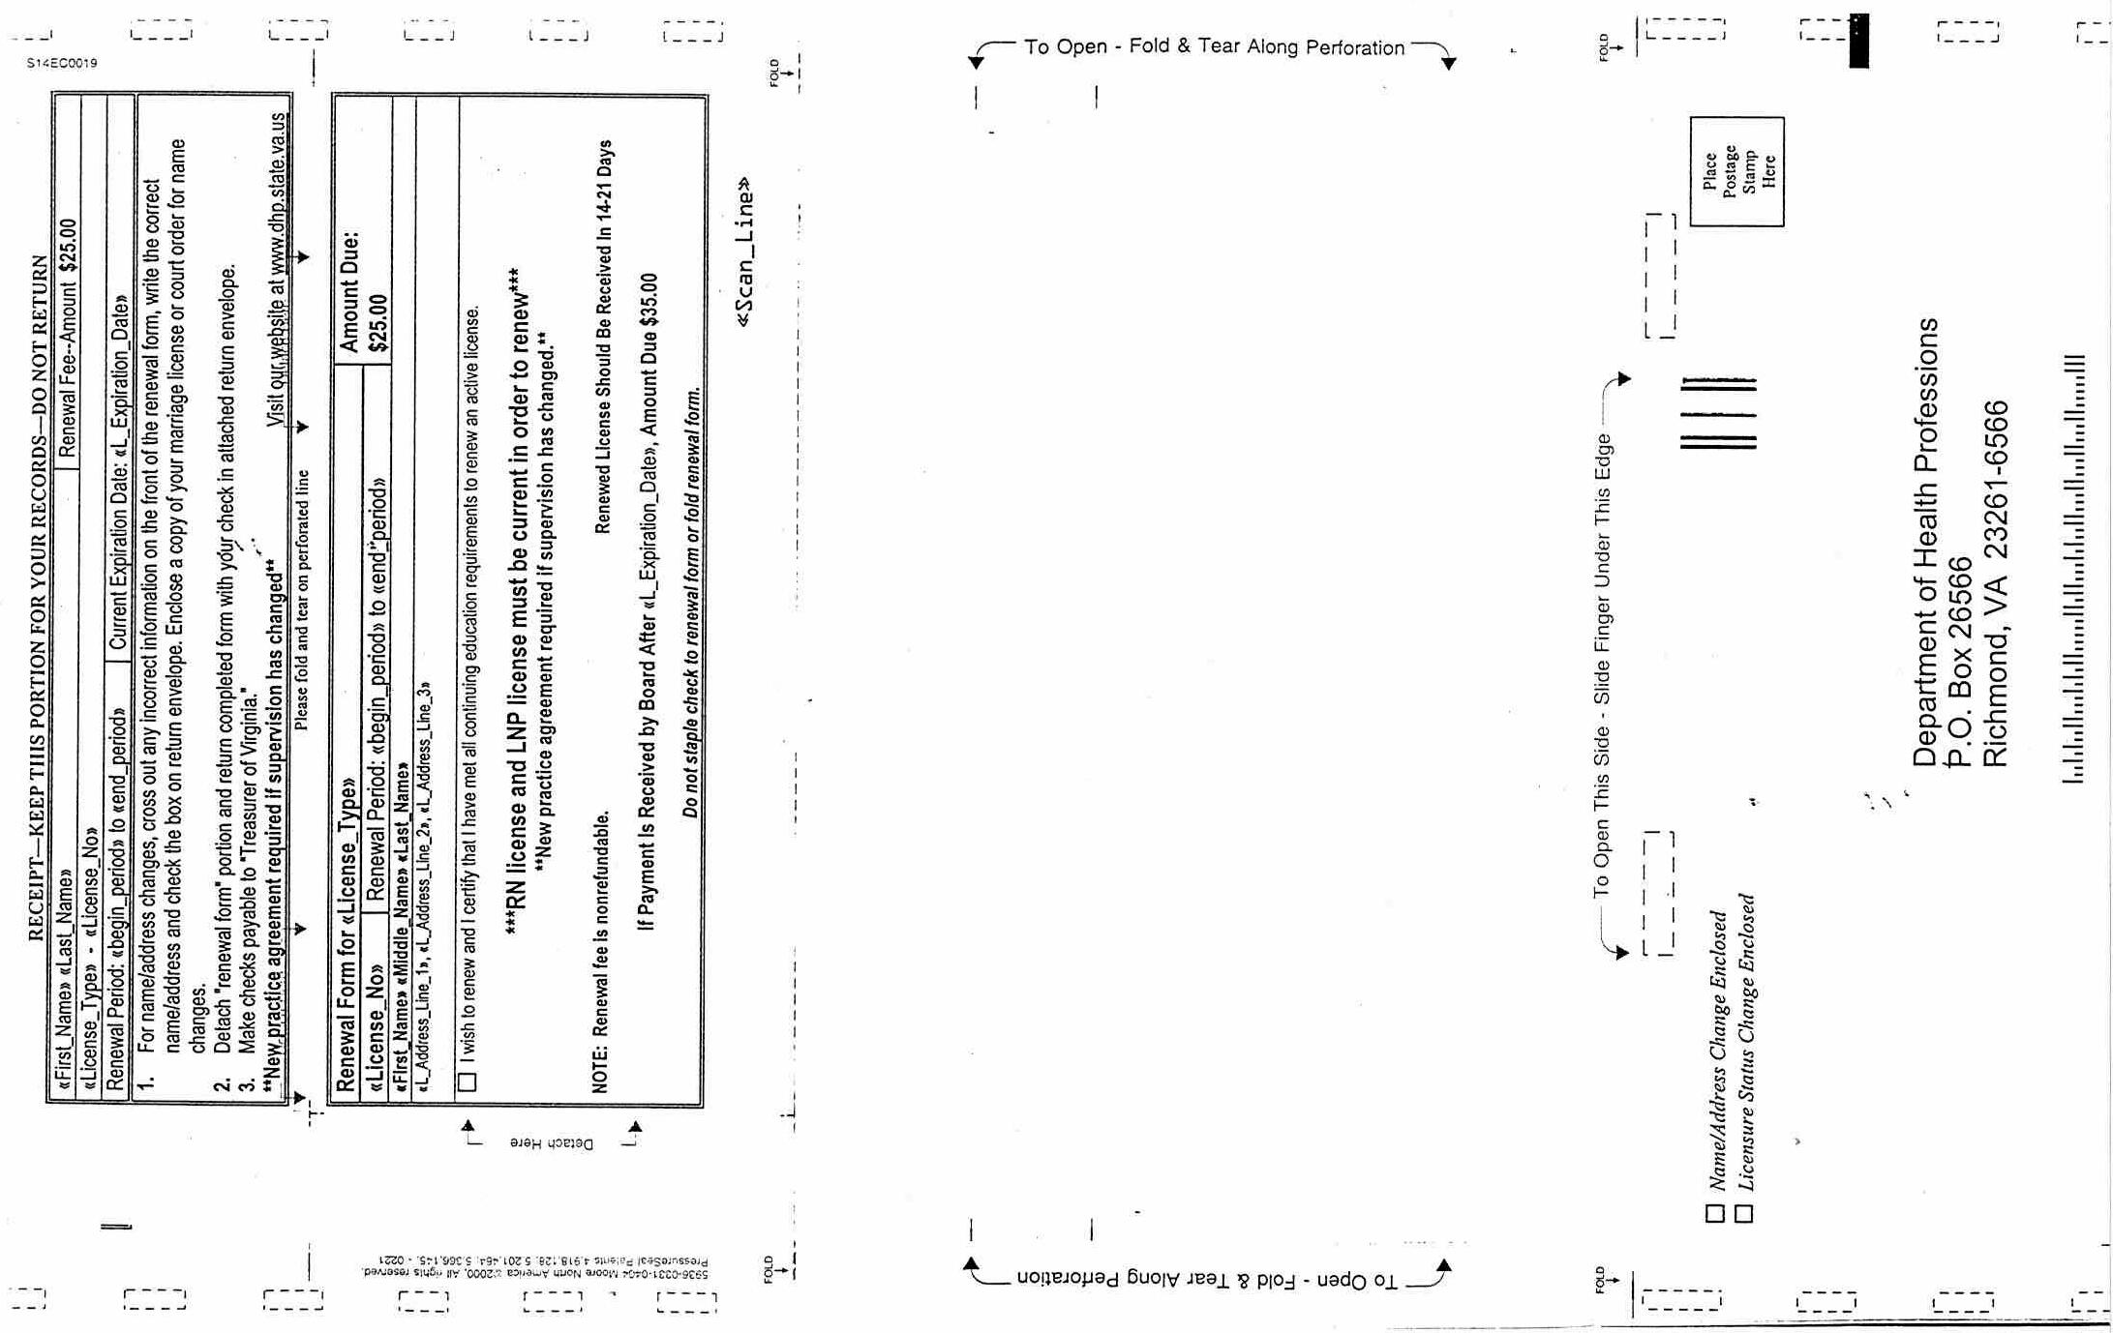
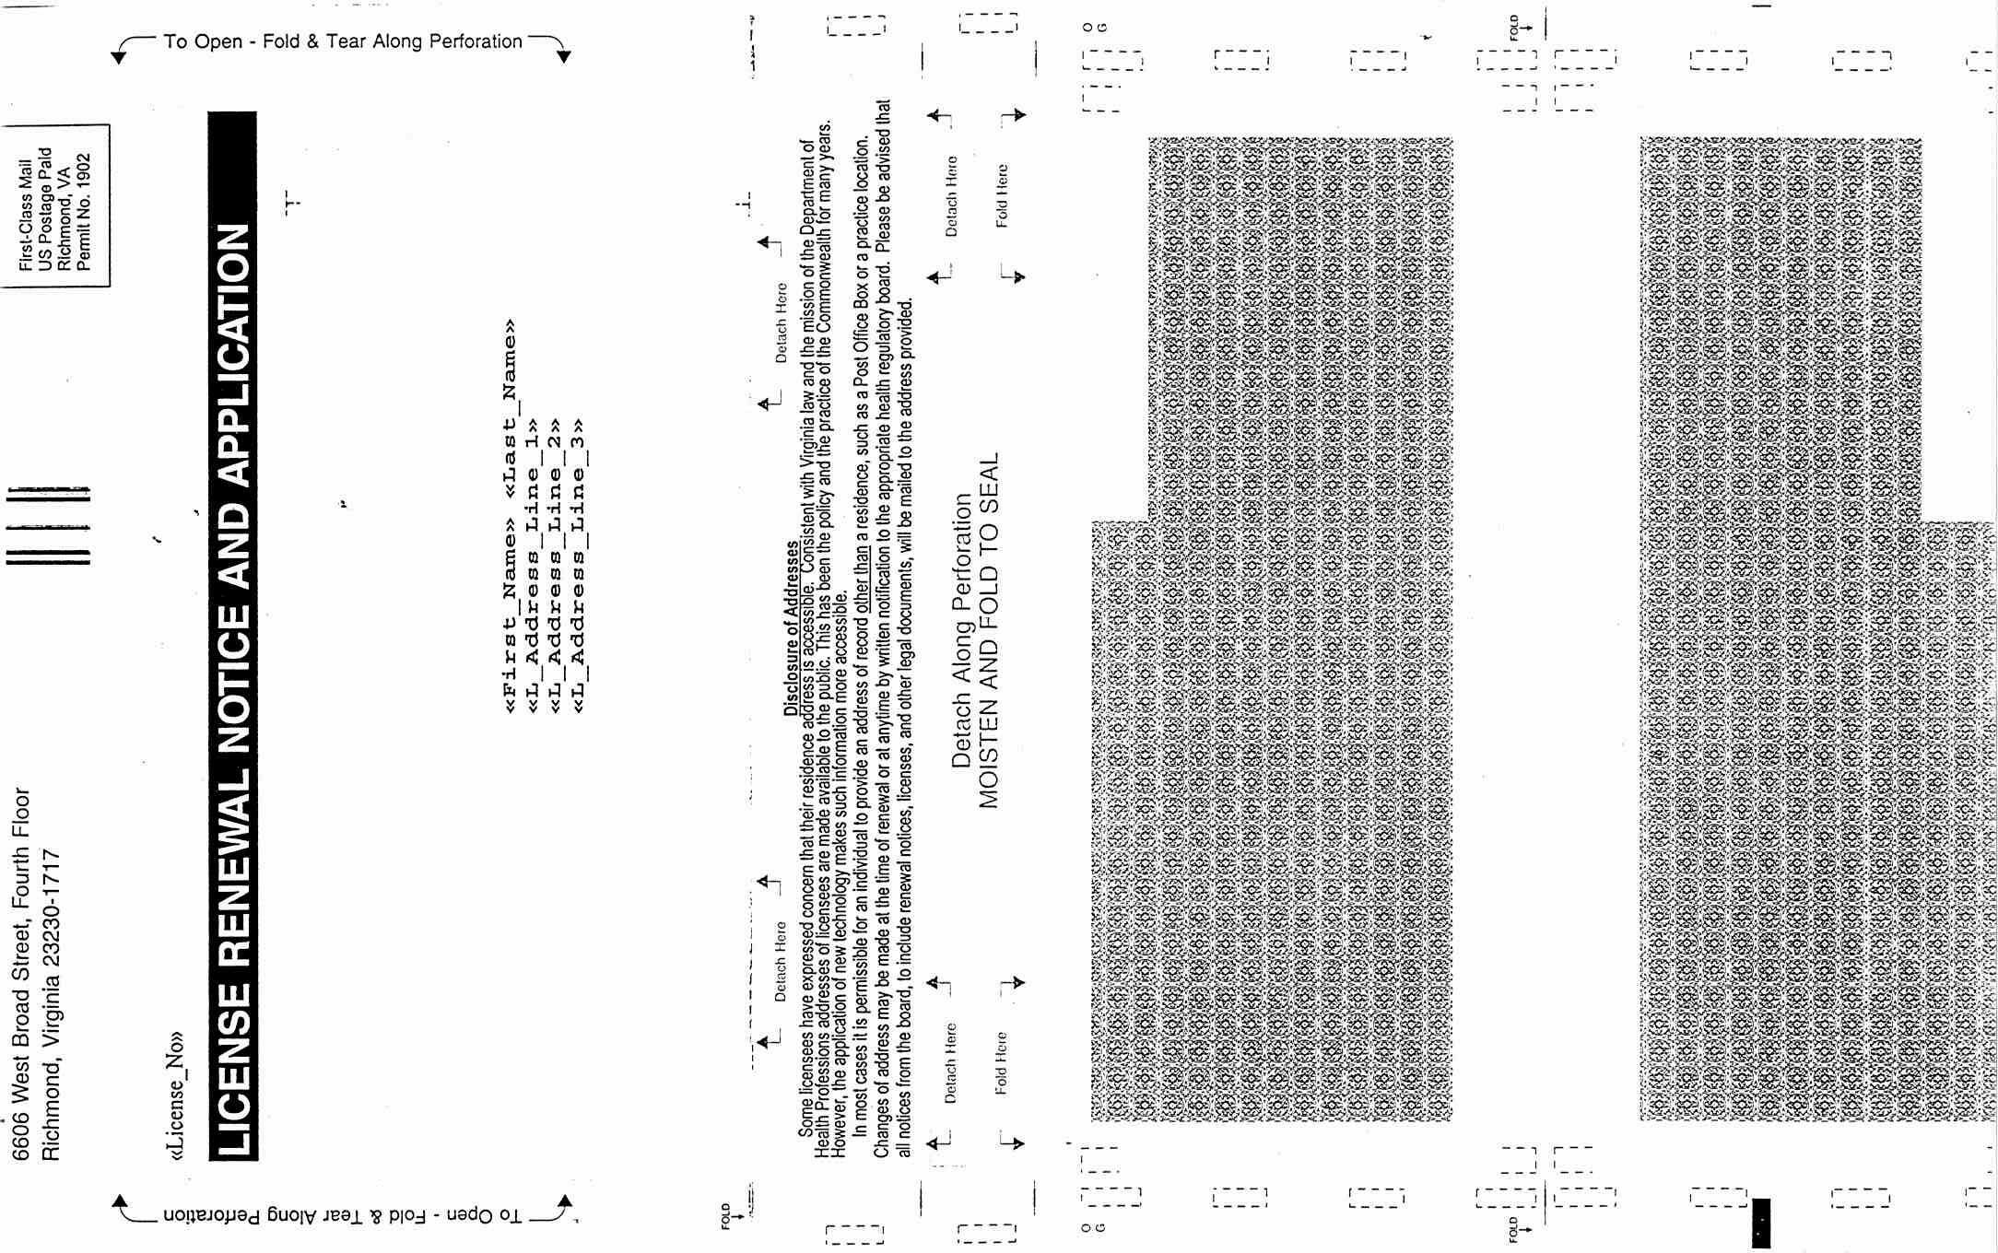
VA.R. Doc. Nos. R00-279 and R00-280; Filed October 16, 2001, 4:36 p.m.

1 Estimates are based on information from DHP regarding re-certifying and re-examination costs from approved organizations. Opportunities for continuing education hours include courses offered by the American Nurses Credentialing Center (ANCC) via the Internet ($0 to $15 for approximately 2 hours of CE) and state conferences sponsored by the Virginia Nurses Association.

