COMMONWEALTH TRANSPORTATION BOARD
REGISTRAR'S NOTICE: The Commonwealth Transportation Board is claiming an exemption from the Administrative Process Act in accordance with § 2.2-4006 A 3 of the Code of Virginia, which excludes regulations that consist only of changes in style or form or corrections of technical errors. The Commonwealth Transportation Board will receive, consider and respond to petitions by any interested person at any time with respect to reconsideration or revision.
Title of Regulation: 24 VAC 30-71. Minimum Standards of Entrances to State Highways (amending 24 VAC 30-71-160).
Statutory Authority: §§ 33.1-12, 33.1-197 and 33.1-198 of the Code of Virginia.
Effective Date: December 19, 2001.
Summary:
This regulation contains entrance design illustrations containing the following note: “Entrance details shown on this sheet may be modified to meet specific site requirements as directed or approved by the Resident Engineer, when based on sound engineering principles.” When the regulation was last amended in 1998, one of the main purposes for the action was to give flexibility to resident engineers at the field level in reviewing and approving entrance permit applications. To achieve this purpose, it was decided during the 1998 action that the note should be added to all entrance design illustrations. At the same time, it was also determined that the regulation should contain an entrance design illustration for standard private subdivision road entrances. The two private entrance illustrations differ only in the units specified: one is in English units and the other is in metric units.
This note was intended to be included on all entrance design illustrations in the regulation but inadvertently was left off the Standard Private Subdivision Road/Street Entrance illustrations. This action is intended to correct the regulation to include the notes as intended.
Agency Contact: Steve D. Edwards, Department of Transportation, Traffic Engineering, 1401 East Broad Street, 2nd Floor, Richmond, VA 23219, telephone (804) 786-1021.
24 VAC 30-71-160. Commercial/private entrance illustrations.
EDITOR'S NOTE: There are no changes to the first 14 commercial/private entrance illustrations contained in this section; therefore, the unchanged illustrations are not set out. The last two illustrations, Standard Private Subdivision, Road/Street Entrance, are amended and are printed below.
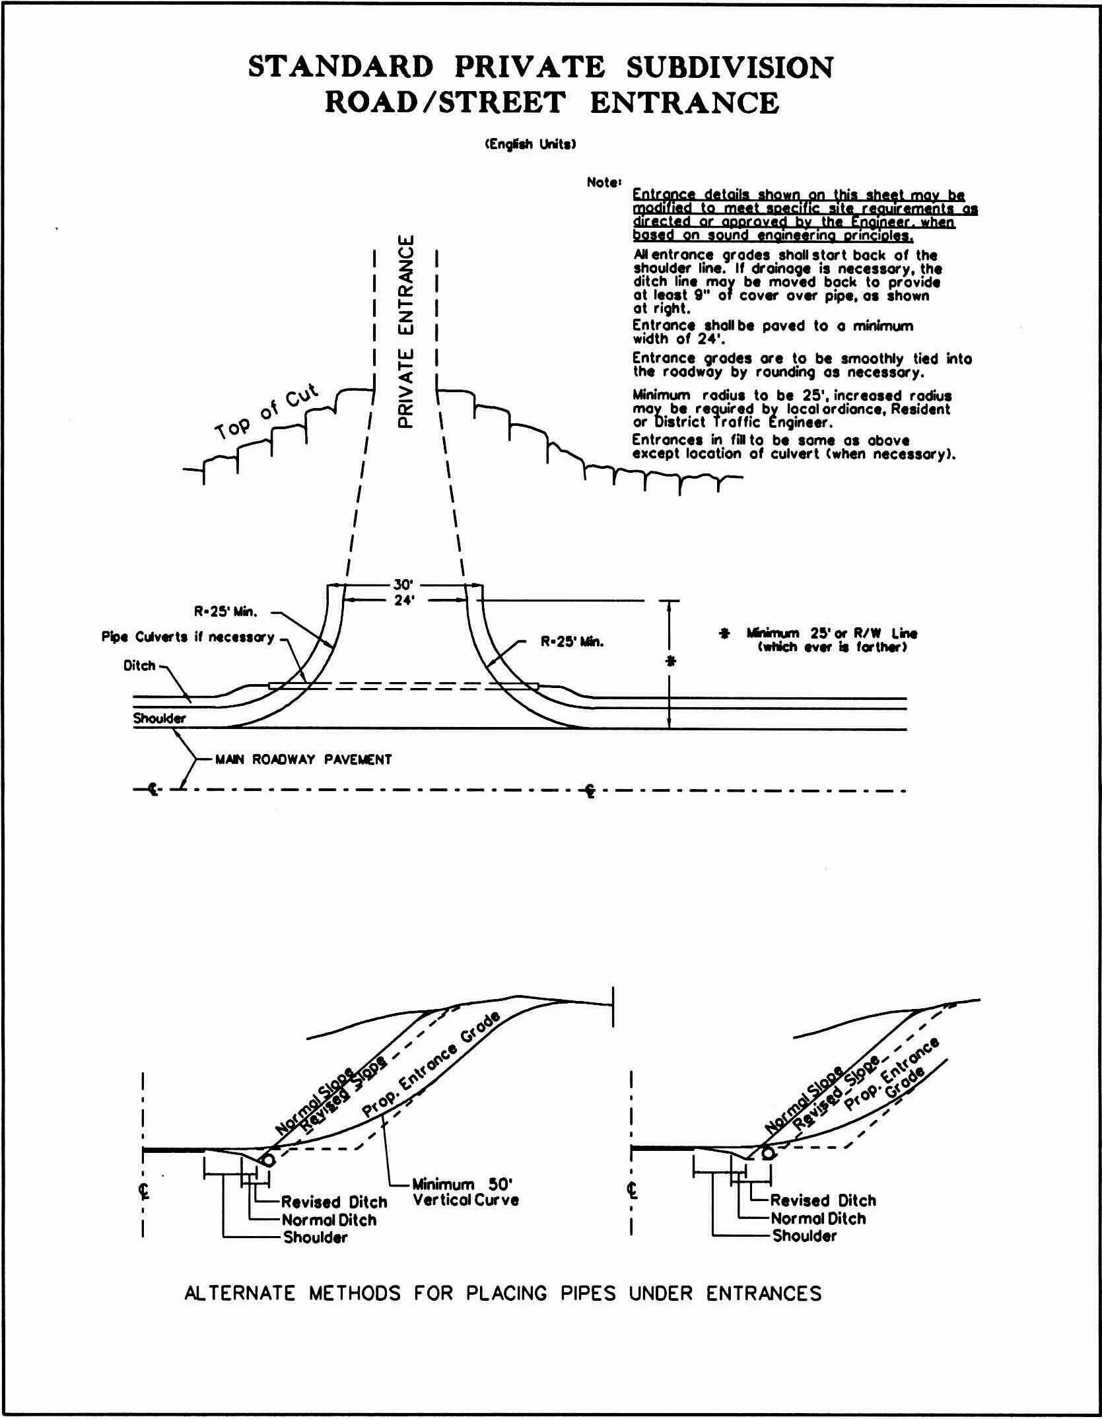
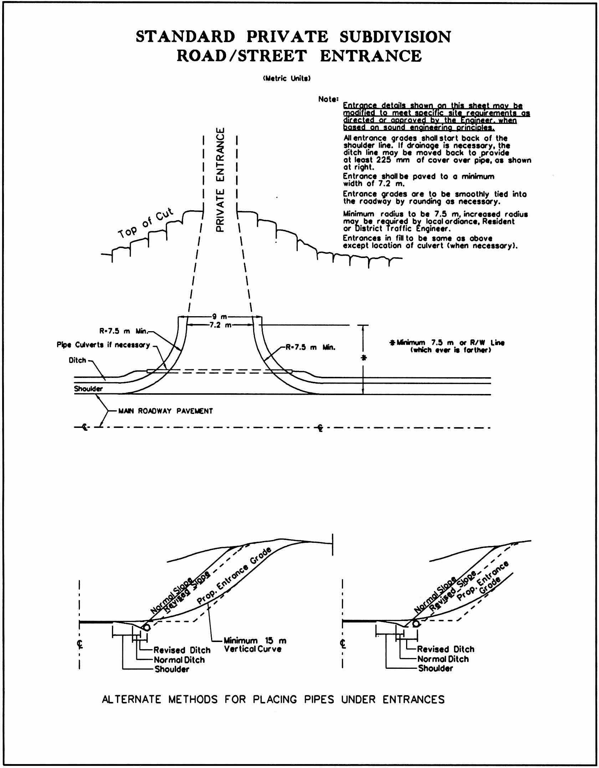
VA.R. Doc. No. R02-63; Filed October 30, 2001, 11:22 a.m.

