STATE BOARD OF HEALTH
Title of Regulation: 12 VAC 5-65. Rules and Regulations Governing Emergency Medical Services Do Not Resuscitate Program (REPEALING).
Title of Regulation: 12 VAC 5-66. Regulations Governing Durable Do Not Resuscitate Orders (adding 12 VAC 5-66-10 through 12 VAC 5-66-110).
Statutory Authority: § 54.1-2987.1 of the Code of Virginia.
Public Hearing Date: N/A--Public comments may be submitted until January 18, 2002.
(See Calendar of Events section
for additional information)
Agency Contact: David E. Cullen, Jr., Regulation and Compliance Manager, State Board of Health, 1538 East Parham Road, Richmond, Virginia 23228, telephone (804) 371-3500, FAX (804) 371-3543 or toll-free 800-523-6019.
Basis: Section 54.1-2991 of the Code of Virginia contains mandatory language authorizing the State Board of Health to promulgate emergency regulations. Specifically, the Code states "[t]hat the Board of Health shall promulgate regulations to implement the provisions of this act related to Durable Do Not Resuscitate Orders to be effective within 280 days of its enactment."
Section 54.1-2987.1 C of the Code of Virginia specifies that qualified emergency medical services personnel and licensed health care practitioners in any facility, program or organization operated or licensed by the Board of Health or by the Department of Mental Health, Mental Retardation and Substance Abuse Services or operated, licensed or owned by another state agency are authorized to follow Durable Do Not Resuscitate Orders that are issued in accordance with statute and regulations promulgated by the Board of Health and available to them in a form approved by the board.
Purpose: The purpose of these regulations is to provide required oversight of the use of the Durable DNR Order. The goal of these regulations is to provide a consistent manner throughout the health care system for physicians and qualified health care personnel to use and honor DNR's. By providing for this consistency throughout the health care system, the health, safety and welfare of patients are ensured. These new regulations are required as the previous Code section authorizing EMS Do Not Resuscitate Orders has been repealed and replaced with § 54.1-2897.1 of the Code of Virginia. The emergency regulations for the Durable Do Not Resuscitate Orders expired on January 3, 2001.
Substance: Section 54.1-2987 C of the Code of Virginia specifies that qualified emergency medical services personnel and licensed health care practitioners in any facility, program or organization operated or licensed by the Board of Health or by the Department of Mental Health, Mental Retardation and Substance Abuse Services or operated, licensed or owned by another state agency are authorized to follow Durable Do Not Resuscitate Orders that are issued in accordance with statute and regulations promulgated by the Board of Health.
The proposed regulations establish a Durable Do Not Resuscitate (DDNR) Order that follows the patient throughout the entire health care setting. Once issued by a physician for his patient, the DDNR Order would apply wherever that patient may be - home, emergency vehicle, adult care residence, nursing home or hospital.
Issues: An advantage to citizens with this regulation is the ability of a citizen, in advance of an emergent or immediate need, to decide whether to request that life-sustaining measures be taken. It allows the citizen to make the choice instead of qualified health care providers. This regulation also advantages the health care system and health care personnel as it allows the desire of the patient to be known in cases where the patient cannot express his opinion.
There are no identified disadvantages to the public or the agency in this regulation.
Department of Planning and Budget's Economic Impact Analysis: The Department of Planning and Budget (DPB) has analyzed the economic impact of this proposed regulation in accordance with § 2.2-4007 G of the Administrative Process Act and Executive Order Number 25 (98). Section 2.2-4007 G requires that such economic impact analyses include, but need not be limited to, the projected number of businesses or other entities to whom the regulation would apply, the identity of any localities and types of businesses or other entities particularly affected, the projected number of persons and employment positions to be affected, the projected costs to affected businesses or entities to implement or comply with the regulation, and the impact on the use and value of private property. The analysis presented below represents DPB’s best estimate of these economic impacts.
Summary of the proposed regulation. The Virginia Department of Health proposes to promulgate permanent regulations to replace emergency regulations that implemented the provisions of Senate Bill 1174 (1999) regarding the creation of a Durable Do Not Resuscitate Order (DDNR). DDNR orders will replace Emergency Medical Services DNR (EMS/DNR) orders that only applied in emergency settings outside of a hospital. The DDNR orders, by contrast, will apply wherever a patient happens to be: in one's home, an emergency vehicle, adult care residence, nursing home, hospital, or elsewhere, and are intended to be honored by physicians and other medical practitioners, in addition to EMS personnel. Significant changes from the past EMS/DNR regulations include the following:
1. Addition of new definitions consistent with the Code of Virginia to address key terms covered in the regulation, such as DDNR order, informed consent, persons authorized to consent on the patient's behalf, persistent vegetative state, and qualified medical personnel;
2. Replacement of the requirement that an "attending physician" must issue DNR orders with new language specifying that a DDNR Order may be issued by "a physician for his patient with whom he has a bona fide physician/patient relationship as defined in the guidelines of the Board of Medicine";
3. Removal of the requirement that the patient be diagnosed as terminal in order to initiate a DDNR order;
4. Elimination of annual expiration dates, allowing DDNR orders to be valid until revoked by the patient;
5. Addition of a provision allowing the issuance of DDNR orders for minors; and
6. Authorization of alternate forms of DDNR order identification.¹
Estimated economic impact. Do Not Resuscitate orders allow individuals, in advance of emergency situations, to make decisions regarding life-extending treatment and care. The Commonwealth created the EMS/DNR program in the early 1990s in order to provide an official, state-approved form for notifying emergency response personnel of do-not-resuscitate wishes. The proposed changes to this regulation are intended to improve the program by creating a standardized form for use in all health care settings to be honored by all qualified health care providers.
VDH reports that approximately $21,000 per year was spent for the EMS/DNR order program. This includes the cost of printing forms and staff time devoted to providing information and processing orders of the form.² The proposed changes to the program are expected to increase orders by 35,000 to 40,000 forms annually, resulting in an additional cost of approximately $1,500 per year.³ Aside from an initial increase in information requests, staff time required for the program is not expected to change.
The DDNR order program will give citizens the ability to choose how they are to be cared for in certain medical situations, regardless of where they occur. This benefits not only the patient, by allowing their desires to be known in cases where they cannot express their own opinion, but also provides clear guidelines for health care providers to follow in emergency situations. Savings in medical expenditures associated with the avoidance of unwanted resuscitation efforts are likely significant for the health care system, but are, at present, not quantifiable to any reliable degree.
In conclusion, while it is not possible to estimate the monetary value of the benefits expected from the proposed changes to the DNR program, they are likely to outweigh the expected costs.
Table 1: Estimated Economic Impact of the Proposed Changes to 12 VAC 5-65
 | Total Annual Costs | Total Annual Benefits | Annual Net Benefit
Implementing and enforcing the changes to the regulations | $0
Increase in number of forms requested | ($1,500)
Improvement in the program:  Standardized form for use in all health care settings  Allowing alternative forms of identification  Patient's wishes may be more likely to be honored |  | Not monetarily quantifiable
Savings from avoidance of unwanted resuscitation efforts |  | Unknown but possibly very significant
 | ($1,500) | Not monetarily quantifiable | Unknown but most likely positive
Businesses and entities affected. Any individual in the Commonwealth may choose to establish a DDNR order. Approximately 20,000 forms were completed each year under the EMS/DNR program. VDH expects that number to increase to approximately 60,000 per year under the proposed regulation.
Localities particularly affected. No localities are particularly affected by the proposed changes to this regulation.
Projected impact on employment. The proposed changes to this regulation are not anticipated to have any effect on employment in Virginia.
Effects on the use and value of private property. The proposed changes to this regulation are not anticipated to have any effect on the use and value of private property.
Agency's Response to the Department of Planning and Budget's Economic Impact Analysis: The Department of Health, Office of Emergency Medical Services (EMS) concurs with the Economic Impact Analysis from the Department of Planning and Budget regarding the proposed 12 VAC 5-66, Regulations Governing Durable Do Not Resuscitate Orders.
Essentially, while it is not possible to estimate the monetary value of the benefits expected from the proposed changes to the Do Not Resuscitate program, the benefits are likely to outweigh the expected costs.
Summary:
The Virginia General Assembly adopted new legislation creating a Durable Do Not Resuscitate Order to replace the Emergency Medical Services Do Not Resuscitate Order. The proposed action repeals the Emergency Medical Services Do Not Resuscitate Order and establishes a Durable Do Not Resuscitate (DDNR) Order that follows the patient throughout the entire health care setting. This creates a document that will depend less on the situation in which declarants find themselves and will be more likely to be honored. Once issued by a physician for his patient, the DDNR Order would apply wherever that patient may be - home, emergency vehicle, adult care residence, nursing home or hospital.
Patients in consultation with physicians determine advanced directives concerning terminal illness and/or life sustaining measures. With a Durable Do Not Resuscitate Order, the affected patient is allowed to have some measure of control over his or her illness and/or injury through determination not to employ life-sustaining measures. These regulations establish a process that enables qualified health care providers to respond more appropriately to the expressed desires and needs of certain patients. The regulations will also provide an appropriate framework to guide the operation of this important program.
CHAPTER 66.
REGULATIONS GOVERNING DURABLE DO NOT RESUSCITATE ORDERS.
PART I.
DEFINITIONS.
12 VAC 5-66-10. Definitions.
The following words and terms when used in this chapter shall have the following meanings unless the context clearly indicates otherwise:
"Agent" means an adult appointed by the declarant under an advance directive, executed or made in accordance with the provisions of § 54.1-2983 of the Code of Virginia to make health care decisions for him.
"Board" means the State Board of Health.
"Cardiac arrest" means the cessation of a functional heartbeat.
"Commissioner" means the State Health Commissioner.
"Durable Do Not Resuscitate Order" or "Durable DNR Order" means a written physician's order issued pursuant to § 54.1-2987.1 of the Code of Virginia in a form authorized by the board to withhold cardiopulmonary resuscitation from an individual in the event of cardiac or respiratory arrest. For purposes of this chapter, cardiopulmonary resuscitation shall include cardiac compression, endotracheal intubation and other advanced airway management, artificial ventilation, and defibrillation and related procedures. As the terms "advance directive" and "Durable Do Not Resuscitate Order" are used in this article, a Durable Do Not Resuscitate Order is not and shall not be construed as an advance directive. When used in these regulations, the term "Durable DNR Order" shall include any authorized alternate form of identification issued in conjunction with an original Durable DNR Order form.
"Emergency Medical Services" or "EMS" means the services rendered by an agency licensed by the Virginia Office of Emergency Medical Services, an equivalent agency licensed by another state or a similar agency of the federal government when operating within this Commonwealth.
"Emergency medical services agency" or "EMS agency" means any person, licensed to engage in the business, service, or regular activity, whether or not for profit, of transporting and/or rendering immediate medical care to such persons who are sick, injured, wounded or otherwise incapacitated or helpless.
"Incapable of making an informed decision" means the inability of an adult patient, because of mental illness, mental retardation, or any other mental or physical disorder that precludes communication or impairs judgment and that has been diagnosed and certified in writing by his physician with whom he has a bona fide physician/patient relationship and a second physician or licensed clinical psychologist after personal examination of such patient, to make an informed decision about providing, withholding or withdrawing a specific medical treatment or course of treatment because he is unable to understand the nature, extent or probable consequences of the proposed medical decision, or to make a rational evaluation of the risks and benefits of alternatives to that decision. For purposes of this article, persons who are deaf, dysphasic or have other communication disorders, who are otherwise mentally competent and able to communicate by means other than speech, shall not be considered incapable of making an informed decision.
"Person authorized to consent on the patient’s behalf" means any person authorized by law to consent on behalf of the patient incapable of making an informed decision or, in the case of a minor child, the parent or parents having custody of the child or the child's legal guardian or as otherwise provided by law.
"Physician" means a person licensed to practice medicine in the Commonwealth of Virginia or in the jurisdiction where the treatment is to be rendered or withheld.
"Qualified emergency medical services personnel" means personnel as defined by § 32.1-111.1 of the Code of Virginia when acting within the scope of their certification.
"Qualified health care personnel" means any qualified emergency medical services personnel and any licensed healthcare provider or practitioner functioning in any facility, program or organization operated or licensed by the State Board of Health, or by the Department of Mental Health, Mental Retardation and Substance Abuse Services or operated, licensed or owned by another state agency.
"Respiratory arrest" means cessation of breathing.
PART II.
PURPOSE AND APPLICABILITY.
12 VAC 5-66-20. Authority for regulation.
Section 54.1-2987.1 of the Code of Virginia vests authority for the regulation of Durable DNR Orders in the State Board of Health and directs the board to prescribe by regulation the procedures, including the requirements for forms to authorize qualified health care personnel to follow Durable DNR Orders. All EMS DNR Orders issued or in effect between July 1, 1999, and the effective date of this regulation are to be considered Durable DNR Orders and shall remain valid until revoked.
12 VAC 5-66-30. Purpose of regulations.
The board has promulgated these regulations in order to carry out the intent of Virginia law that a person shall have the opportunity to execute a Durable DNR Order that comports with his wishes.
PART III.
REQUIREMENTS AND PROVISIONS.
12 VAC 5-66-40. The Durable Do Not Resuscitate Order Form.
The Durable DNR Order Form shall be a unique document printed on distinctive paper, as approved by the board, and consistent with these regulations. The following requirements and provisions shall apply to the approved Durable DNR Order Form.
1. Content of the Form – A Durable DNR Order Form shall contain, from a physician with whom the patient has a bona fide physician/patient relationship, a do not resuscitate determination, signature and the date of issue, the signature of the patient or, if applicable, the person authorized to consent on the patient’s behalf.
2. Effective Period for a Signed Durable DNR Order Form – A signed Durable DNR Order shall remain valid until revoked.
3. Original Durable DNR Order Form – An original Durable DNR Order or an alternate form that complies with 12 VAC 5-66-50 shall be valid for purposes of withholding or withdrawing cardiopulmonary resuscitation by qualified health care personnel in the event of cardiac or respiratory arrest. The original Durable DNR Order or an alternate form that complies with 12 VAC 5-66-50 shall be maintained and displayed at the patient’s current location or residence in one of the places designated on the form, or should accompany the patient, if traveling. Photocopies of the Durable DNR Order may be given to other providers or persons for information, with the express consent of the patient or the patient’s designated agent or the person authorized to consent on the patient’s behalf. However, such photocopies of the Durable DNR Order are not valid for withholding cardiopulmonary resuscitation.
4. Revocation of a Durable DNR Order – A Durable DNR Order may be revoked at any time by the patient (i) by physical cancellation or destruction by the patient or another in his presence and at his direction of the Durable DNR Order Form and/or any alternate form of identification; or (ii) by oral expression of intent to revoke. The Durable DNR Order may also be revoked by the patient’s designated agent or the person authorized to consent on the patient’s behalf.
5. Distribution of Durable DNR Order Forms - Authorized Durable DNR Forms, with instructions, shall be available only to physicians.
12 VAC 5-66-50. Authorized alternate forms of Durable DNR Order identification.
The board authorizes the issuance of alternate forms of Durable DNR Order identification in conjunction with the issuance of Durable DNR Orders. These alternate forms shall be uniquely-designed and uniquely-identifiable bracelets and necklaces that are available from a vendor approved by the Virginia Department of Health. These alternate forms of identification must be purchased from the approved vendor by the person to whom a Durable DNR Order applies, or that person authorized to consent on the patient’s behalf, and in conjunction with a Durable DNR Order. Such a necklace or bracelet may be utilized either to validate the Durable DNR Order or in place of an original Durable DNR Order in the event that the original order is not readily available at the site where the person to whom the order applies is found. In order to be honored by qualified health care personnel in place of the original Durable DNR Order, this alternate form of identification must contain the minimum information approved by the State Board of Health.
12 VAC 5-66-60. Other DNR Orders.
A. Nothing in these regulations shall be construed to preclude licensed health care practitioners from following any other written orders of a physician not to resuscitate a patient in the event of cardiac or respiratory arrest.
B. Additionally, nothing in these regulations or in the definition of Durable DNR Orders provided in § 54.1-2982 of the Code of Virginia shall be construed to limit the authorization of qualified health care personnel to follow Do Not Resuscitate Orders other than Durable DNR Orders that are written by a physician, with whom the patient has a bona fide physician/patient relationship, for the duration of the patient’s transfer to another facility. Such other DNR Orders issued in this manner shall be valid until a Durable DNR Order or other valid DNR Order is issued by the physician assuming responsibility for the treatment and care of the patient, but not to exceed 24 hours. Such other DNR Orders issued in this manner shall contain the information listed in subdivision 1 of 12 VAC 5-66-40 and the time of issuance by the physician.
C. Nothing in these regulations shall prohibit qualified health care personnel from following any direct verbal order issued by a licensed physician not to resuscitate a patient in cardiac or respiratory arrest when such physician is physically present in attendance of such patient.
PART IV.
IMPLEMENTATION PROCEDURES.
12 VAC 5-66-70. Issuance of a Durable DNR Order.
A. A Durable DNR Order may be issued to a patient by a physician, with whom the patient has established a bona fide physician/patient relationship, as defined by the Board of Medicine in their current guidelines, only with the consent of the patient or, if the patient is a minor or is otherwise incapable of making an informed decision regarding consent for such an order, upon the request of and with the consent of the person authorized to consent on the patient's behalf.
B. The physician shall explain to the patient or the person authorized to consent on the patient’s behalf, the alternatives available, including issuance of a Durable DNR Order. If the option of a Durable DNR Order is agreed upon, the physician shall have the following responsibilities:
1. Obtain the signature of the patient or the person authorized to consent on the patient’s behalf.
2. Execute and date the Physician Order on the Durable DNR Order Form.
3. Issue the original Durable DNR Order Form.
4. Explain how to, and who may revoke the Durable DNR Order.
C. The person to whom a Durable DNR order applies or the person authorized to consent on the patient’s behalf must present the following information to the approved vendor in order to purchase and be issued an approved Durable DNR necklace or bracelet. The necklace or bracelet must contain the following information:
1. The patient’s full legal name;
2. The Durable DNR number on the Virginia Durable DNR form or a number unique to the patient that is assigned by the vendor;
3. The physician’s name and phone number; and
4. The Virginia Durable DNR effective date.
12 VAC 5-66-80. Durable DNR Order implementation procedures.
A. Qualified health care personnel shall comply with the following general procedures and published Virginia Durable DNR Order Implementation Protocols when caring for a patient who is in cardiac or respiratory arrest and who is known or suspected to have a Durable DNR Order in effect.
B. Initial assessment and intervention. Perform routine patient assessment and resuscitation or intervention until the Durable DNR Order or other DNR Order validity status is confirmed, as follows:
1. Determine the presence of a Durable DNR Order Form or an approved alternate form of Durable DNR identification.
2. Determine that the Durable DNR item is not altered.
3. Verify, through driver’s license or other identification with photograph and signature or by positive identification by a family member or other person who knows the patient, that the patient in question is the one for whom the Durable DNR Order or other DNR Order was issued.
4. If no Durable DNR Order or approved alternate form of identification is found, ask a family member or other person to look for the original Durable DNR Order Form or other written DNR order.
5. If the Durable DNR Order or approved alternate form of identification is not intact or has been altered or other DNR Order is produced, the qualified health care personnel shall consider the Durable DNR Order to be invalid.
C. Resuscitative measures to be withheld or withdrawn. In the event of cardiac or respiratory arrest of a patient with a valid Durable DNR Order under the criteria set forth above, the following procedures should be withheld or withdrawn by qualified health care personnel unless otherwise directed by a physician physically present at the patient location:
1. Cardiopulmonary Resuscitation (CPR);
2. Endotracheal Intubation or other advanced airway management;
3. Artificial ventilation;
4. Defibrillation;
5. Cardiac resuscitation medications; or
6. Continuation of related procedures, as prescribed by the patient’s physician or medical protocols.
D. Procedures to provide comfort care or to alleviate pain. In order to provide comfort care or to alleviate pain for a patient with a valid Durable DNR Order or other DNR Order, the following interventions may be provided, depending on the needs of the particular patient:
1. Airway management (excluding intubation or advanced airway management);
2. Suctioning;
3. Supplemental oxygen delivery devices;
4. Pain medications or intravenous fluids;
5. Bleeding control;
6. Patient positioning; or
7. Other therapies deemed necessary to provide comfort care or to alleviate pain.
E. Revocation.
1. These regulations shall not authorize any qualified health care personnel to follow a Durable DNR Order for any patient who is able to, and does, express to such qualified health care personnel the desire to be resuscitated in the event of cardiac or respiratory arrest.
If the patient is a minor or is otherwise incapable of making an informed decision, the expression of the desire that the patient be resuscitated by the person authorized to consent on the patient's behalf shall so revoke the qualified health care personnel’s authority to follow a Durable DNR Order or other DNR Order.
2. The expression of such desire to be resuscitated prior to cardiac or respiratory arrest shall constitute revocation of the order; however, a new order may be issued upon consent of the patient or the person authorized to consent on the patient's behalf.
3. The provisions of this section shall not authorize any qualified emergency medical services personnel or licensed health care provider or practitioner who is attending the patient at the time of cardiac or respiratory arrest to provide, continue, withhold or withdraw treatment if such provider or practitioner knows that taking such action is protested by the patient incapable of making an informed decision. No person shall authorize providing, continuing, withholding or withdrawing treatment pursuant to this section that such person knows, or upon reasonable inquiry ought to know, is contrary to the religious beliefs or basic values of a patient incapable of making an informed decision or the wishes of such patient fairly expressed when the patient was capable of making an informed decision.
F. Documentation. When following a Durable DNR Order or other DNR Order for a particular patient, qualified health care personnel shall document in the patient's medical record the care rendered or withheld in the following manner:
1. Use standard patient care reporting documents (i.e. patient chart, pre-hospital patient care report).
2. Describe assessment of patient’s status.
3. Document which identification (Durable DNR Order Form or other DNR Order or alternate form of identification) was used to confirm Durable DNR status and that it was intact, not altered, not canceled or not officially revoked.
4. Record the Durable DNR Order Number and name of patient’s physician.
5. If the patient is being transported, keep the Durable DNR Order with the patient.
G. General considerations. The following general principles shall apply to implementation of Durable DNR Orders.
1. If there is misunderstanding with family members or others present at the patient’s location or if there are other concerns about following the Durable DNR Order or other DNR Order, contact the patient’s physician or EMS medical control for guidance.
2. If there is any question about the validity of a Durable DNR Order, resuscitative measures should be administered until the validity of the Durable DNR Order is established.
FORMS
Durable Do Not Resuscitate Order Form, eff. 1/01.
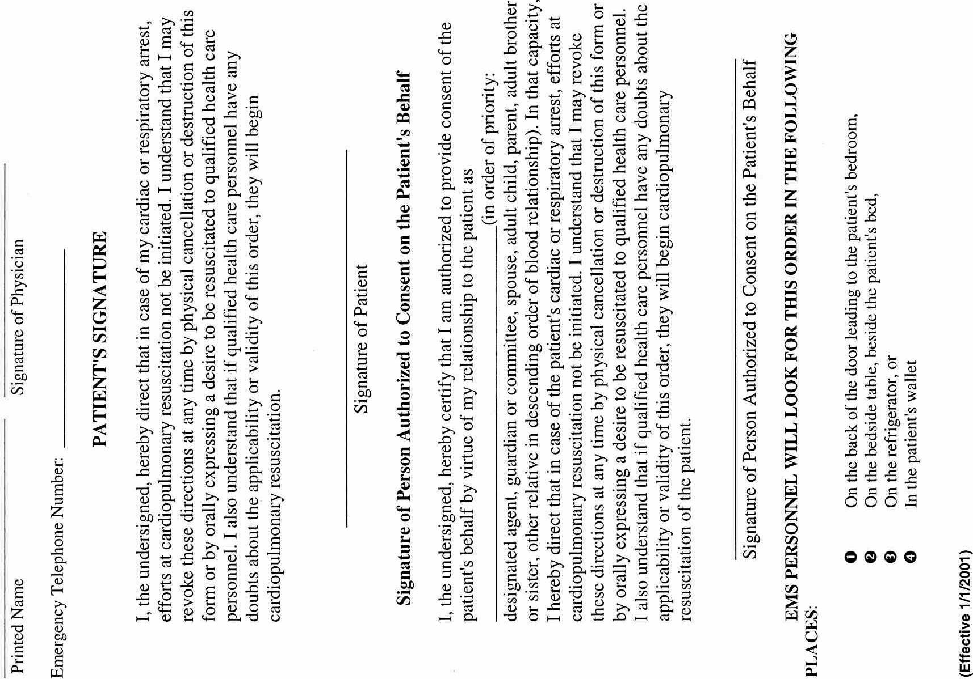
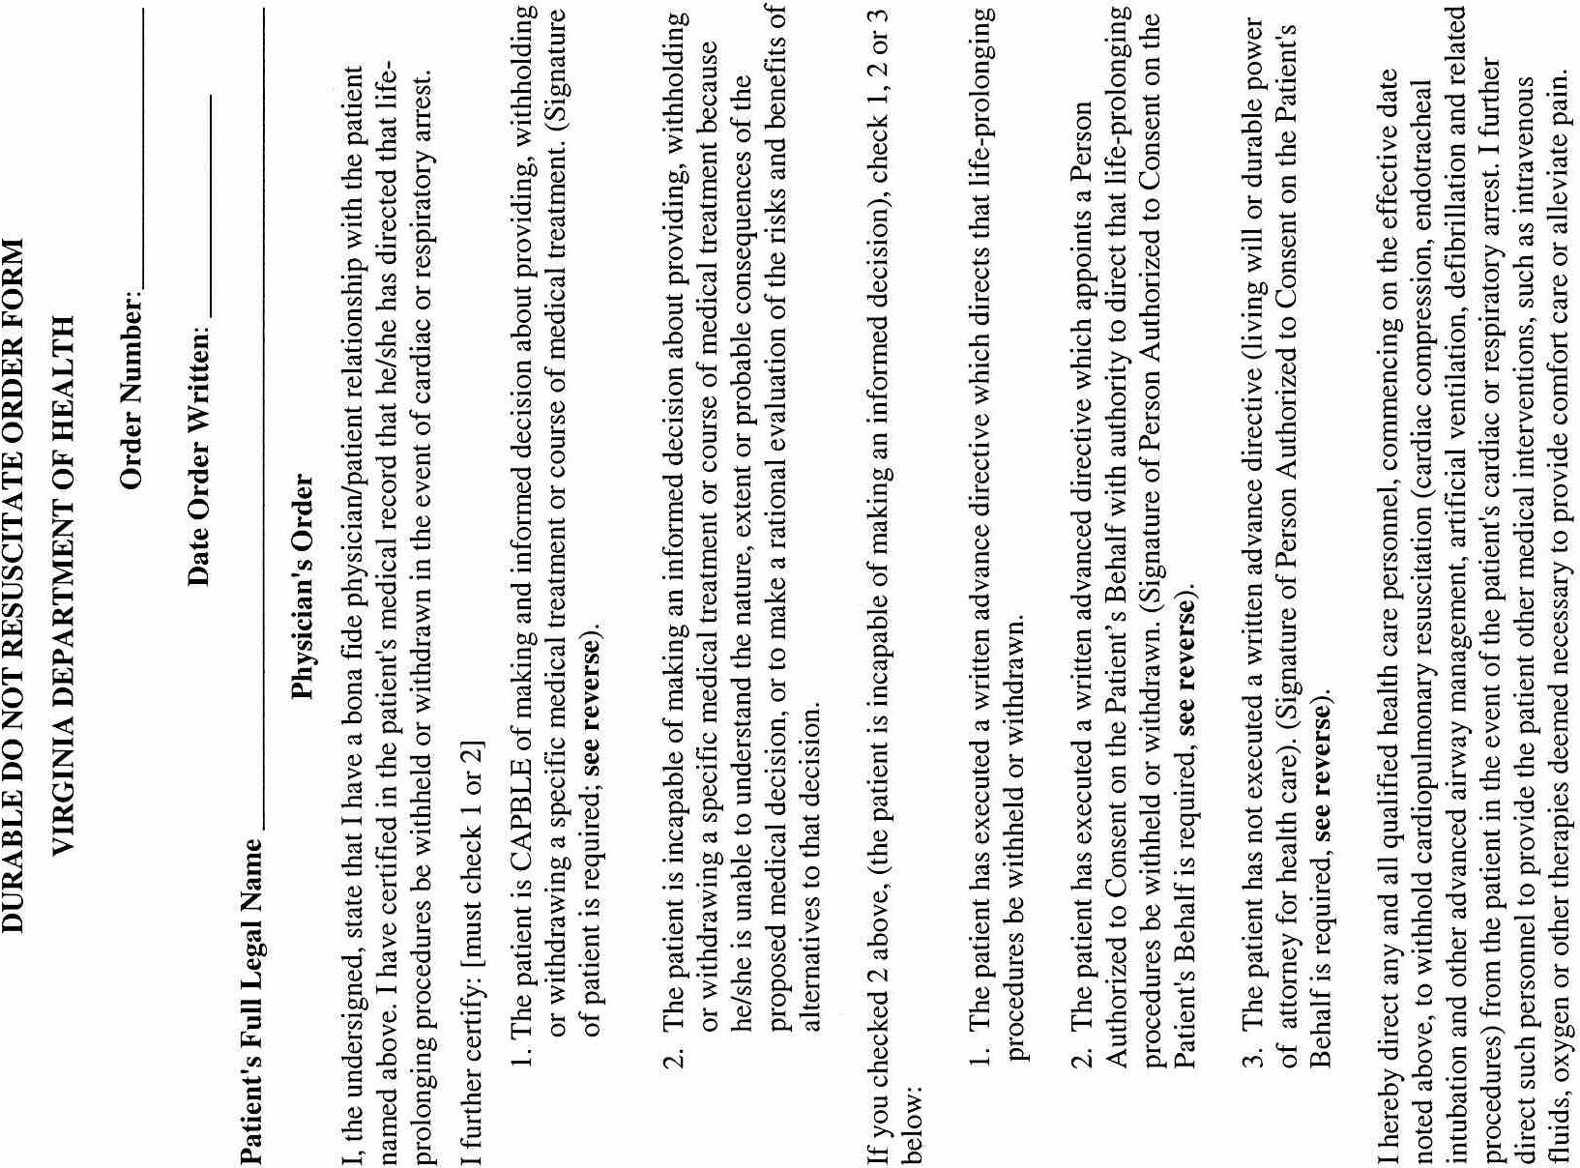
VA.R. Doc. No. R00-213; Filed October 22, 2001, 2:56 p.m.

1 Currently, individuals must carry the DDNR order with them at all times. This document must be viewed by the health care provider prior to withholding any treatment. The alternate forms of identification approved by the Board of Health include identification bracelets and necklaces and will be available from vendors approved by the Department of Health.
2 Gary Brown, Director, Office of Emergency Services, Virginia Department of Health.
3 VDH pays $.04 for the printing of each form.

