MARINE RESOURCES COMMISSION
REGISTRAR’S NOTICE: The following regulation filed by the Marine Resources Commission is exempt from the Administrative Process Act in accordance with § 2.2-4006 A 12 of the Code of Virginia; however, the commission is required to publish the full text of final regulations.
Title of Regulation: 4 VAC 20-398. Ballast Water Discharge Reporting.
Statutory Authority: §§ 28.2-103 and 28.2-209 of the Code of Virginia.
Effective Date: November 1, 2001.
Summary:
The regulation sets forth the requirements and procedures for the distribution and filing of Ballast Water Control Report forms with the Virginia Marine Resources Commission, and establishes the guidelines governing voluntary ballast water management practices to be followed by the operators of commercial vessels in Virginia’s territorial waters. The regulation adopts the federal guidelines governing voluntary ballast water management practices and the Ballast Water Control Report form that has been adopted by the United States Coast Guard as set forth in 33 CFR Part 151. This regulation fulfills the mandated requirement that the commission adopt guidelines and forms consistent with the authority conferred by Chapter 312 of the 2001 Acts of Assembly.
CHAPTER 398.
BALLAST WATER DISCHARGE REPORTING.
4 VAC 20-398-10. Purpose.
This regulation establishes the guidelines governing voluntary ballast water management practices to be followed by the operators of commercial vessels in Virginia waters. It also sets forth the requirements and procedures for the distribution and filing of ballast water control report forms with the commission.
4 VAC 20-398-20. Definitions.
The following words and terms when used in this regulation shall have the following meanings unless the context clearly indicates otherwise:
"Ballast tank" means any tank or hold that carries ballast water regardless of design.
"Ballast water" means any water or matter taken on board a vessel, United States or foreign, to control or maintain trim, draft, stability or stresses of the vessel, without regard to the manner in which it is carried. In order to qualify under this regulation, the ballast water must have been taken on the vessel in an area lying within 200 nautical miles of any shore or in waters less than 2,000 meters in depth.
"Ballast Water Control Report form" means the form adopted by the commission to monitor compliance with the federal guidelines. This form shall be consistent with the form adopted by the United States Coast Guard and set forth in 33 CFR Part 151, Subpart D, Appendix.
"Captain of the Port (COTP)" means the United States Coast Guard officer designated as the COTP of Hampton Roads.
"Commercial vessel" means a self-propelled ship, United States or foreign, in commerce of 300 gross tons or more. The term "commercial vessel" does not include a vessel of the United States Department of Defense or United States Coast Guard subject to the requirements of § 1103 of the National Invasive Species Act of 1996, or any vessel of the Armed Forces, as defined in 33 USC § 1322 (A)(14), that is subject to the uniform national discharge standards for vessels of the Armed Forces under 23 USC § 1322 (N).
"Commission" means the Marine Resources Commission.
"Commissioner" means the Commissioner of the Marine Resources Commission.
"EEZ" means the United States Exclusive Economic Zone.
"Exchange" means to replace the water in a ballast tank using one of the following methods:
1. Flow through exchange means to flush out ballast water by pumping in mid-ocean water at the bottom of the tank and continuously overflowing the tank from the top until three full volumes of water have been changed; this is done to minimize the number of original organisms remaining in the tank.
2. Empty/refill exchange means to flush out the ballast water taken on in ports, estuarine, or territorial waters until the tank is empty, then refilling it with mid-ocean water; masters/operators should pump out as close to 100% of the ballast water as is safe to do so.
"Federal guidelines" means the provisions of 33 CFR Part 151, Subpart D, "Ballast Water Management for Control of Nonindigenous Species in Waters of the United States."
"HRMA" means the Hampton Roads Maritime Association.
"IMO guidelines" means the International Maritime Organization Guidelines for the Control and Management of Ships’ Ballast Water to Minimize the Transfer of Harmful Aquatic Organisms and Pathogens (IMO Resolution A.868 (20), adopted November 1997).
"Innocent transit" means the transit of Virginia’s territorial waters by a commercial vessel, United States or foreign, that is not destined to enter into or depart from a Virginia port.
"NANCPA" means the Nonindigenous Aquatic Nuisance Prevention and Control Act of 1990.
"NBIC" means the National Ballast Water Information Clearinghouse operated by the United States Coast Guard and the Smithsonian Environmental Research Center as mandated under the National Invasive Species Act of 1996.
"NISA" means the National Invasive Species Act of 1996, which reauthorized and amended the NANCPA.
"Operator" means any person who owns, operates, charters, rents or otherwise exercises control over or responsibility for a vessel.
"Territorial waters" means the Virginia waters lying within the Chesapeake Bay and its tributaries, and a belt, three nautical miles wide, that is adjacent to Virginia’s coast and seaward of the mean low water mark.
4 VAC 20-398-30. Voluntary ballast water management guidelines.
A. Masters, owners, operators, or persons-in-charge of vessels equipped with ballast water tanks that operate in Virginia’s territorial waters are requested to take the following voluntary precautions to minimize the uptake and release of harmful aquatic organisms, pathogens, and sediments:
1. Avoid the uptake of ballast water from areas within marine sanctuaries, marine preserves, marine parks or coral reefs.
2. Minimize or avoid uptake of ballast water in the following areas and situations:
a. Areas known to have infestations or populations of harmful organisms and pathogens (e.g., toxic algal blooms).
b. Areas near sewage outfalls.
c. Areas near dredging operations.
d. Areas where tidal flushing is known to be poor or times when a tidal stream is known to be more turbid.
e. During periods of darkness when bottom-dwelling organisms may rise up into the water column.
f. Areas where propellers may stir up the bottom sediment.
3. Clean the ballast tanks regularly to remove sediments. Dispose of the sediments in accordance with applicable regulations.
4. Discharge only the minimal amount of ballast water essential for safe vessel operations while in Virginia waters.
5. Rinse anchors and anchor chains when the anchor is retrieved to remove organisms and sediments at their place of origin.
6. Remove fouling organisms from hull, piping, and tanks on a regular basis and dispose of any removed substances in accordance with applicable regulations.
7. Maintain a ballast water management plan that was developed specifically for the vessel.
8. Train the master, operator, person-in-charge, and crew, on the application of ballast water and sediment management and treatment procedures.
B. In addition to the foregoing recommendations, vessels carrying ballast water into Virginia waters that was loaded in an area outside the EEZ are requested to employ at least one of the following ballast water management practices:
1. Exchange ballast water beyond the EEZ in an area at least 200 nautical miles from shore and in waters greater than 2,000 meters in depth before entering Virginia’s territorial waters.
2. Retain the ballast water on board the vessel.
3. Use an alternative environmentally sound method of ballast water management that has been approved by the United States Coast Guard.
4. Discharge ballast water to an approved reception facility.
5. Under extraordinary circumstances, conduct a ballast water exchange within an area and agreed to by the COTP.
4 VAC 20-398-40. Mandatory filing requirements.
A. The operator, or a ship agent on behalf of the operator, of a commercial vessel that enters into Virginia’s territorial waters shall file a Ballast Water Control Report form with the commission.
1. Within 72 hours of the completion of the discharge of ballast water if the commercial vessel discharges ballast water into Virginia waters, or
2. Prior to the commercial vessel’s departure from Virginia waters if the commercial vessel does not discharge ballast water into Virginia waters.
B. The HRMA shall act as the commission’s designated agent and shall be responsible for the receipt and compilation of all Ballast Water Control Report forms filed in Virginia in compliance with this regulation. A Ballast Water Control Report form shall be deemed to have been filed when it has been hand delivered to the HRMA, sent electronically or by facsimile transmission and received by the HRMA, or sent to the HRMA by registered or certified mail, return receipt requested.
C. For commercial vessels whose point of origin is located outside the United States EEZ and whose first port of call within the United States is within Virginia waters, submittal to the HRMA of a copy of the completed form the operator filed with the NBIC, shall be deemed compliance with the reporting requirements of this regulation.
D. The HRMA shall provide the commission with copies of all Ballast Water Control Report forms received from operators of commercial vessels and ship agents acting on behalf of operators of commercial vessels on a monthly basis. The commission shall submit copies of the forms received with the NBIC on a quarterly basis.
4 VAC 20-398-50. Exceptions.
The operator, or ship agent of an operator, shall not be required to file a Ballast Water Control Report form if:
1. The commercial vessel’s point of origin is located from within the United States EEZ,
2. The commercial vessel is engaged in innocent transit, or
3. The vessel is a passenger vessel equipped with a functioning treatment system designed to kill aquatic organisms in the ballast water.
4 VAC 20-398-60. Ballast Water Control Report form.
A. The Ballast Water Control Report adopted by the commission is consistent with the form adopted by the United States Coast Guard and set forth in 33 CFR Part 151, Subpart D, Appendix.
B. The Ballast Water Control Report form and instructions may be obtained in an electronic format from the HRMA. Report forms and instructions are also available electronically via the internet and may be downloaded through the NBIC link on the SERC web page at http://invasions.si.edu/bwforms.htm.
4 VAC 20-398-70. Mandatory recordkeeping requirements.
A. Unless specifically exempted from this regulation, the master, owner, operator, or person in charge of a vessel carrying ballast water into Virginia waters, after having operated outside the EEZ, shall keep records in written form that include the following information:
1. Vessel Information
a. Name;
b. Vessel type;
c. IMO number (official number if IMO number not issued);
d. Port of registry (Flag);
e. Owner or operator;
f. Gross tonnage;
g. Call sign; and
h. Agent.
2. Voyage information. Include the date and port of arrival, vessel agent, last port and country of call, and next port and country of call.
3. Total ballast water information. Include the total volume of ballast water capacity, total volume of ballast water on board, and total number of ballast water tanks in ballast.
4. Ballast water management. Include the total number of ballast tanks/holds that are to be discharged into Virginia waters or to a reception facility. If an alternative ballast water management method is used, please note the number of tanks that were managed using an alternative method, as well as the type of method used. Indicate whether the vessel has a ballast water management plan and IMO guidelines on board, and whether the ballast water management plan is used.
5. Information on ballast water tanks to be discharged into Virginia waters or to a reception facility. Provide the origin of the ballast water, including the dates, locations, volumes and temperatures of the ballast water when loaded for each tank. Provide the particulars of ballast water exchange if conducted, including the date, location, volume exchanged, thoroughness of exchange (i.e. percent of tank volume exchanged), the sea height at the time of exchange, and the expected date, location, volume and salinity of any ballast water to be discharged into Virginia waters.
6. Certification of accurate information. Include the master, owner, operator, or responsible person in charge’s printed name, title and signature attesting to the accuracy of the information and certifying compliance with the requirements of this regulation.
B. The master, owner, operator or person in charge of a commercial vessel subject to this regulation shall make the required records available to the commission for inspection upon request for a period of two years.
4 VAC 20-398-90. Enforcement and compliance monitoring.
A. Any operator of a commercial vessel who knowingly fails to file a Ballast Water Control Report form with the commission within the applicable time period set forth in this regulation, or who knowingly makes any false statement in a Ballast Water Control Report form submitted to the commission, shall be guilty of a Class 1 misdemeanor.
B. The commission may take samples of ballast water and sediment, examine documents, and make other appropriate inquiries to assess the compliance of any vessel subject to this regulation while that vessel is in Virginia waters.
NOTICE: The forms used in administering 4 VAC 20-398, Ballast Water Discharge Reporting, are listed below. Any amended or added forms are reflected in the listing and are published following the listing.
FORM
Ballast Water Reporting Form (eff. 11/01).
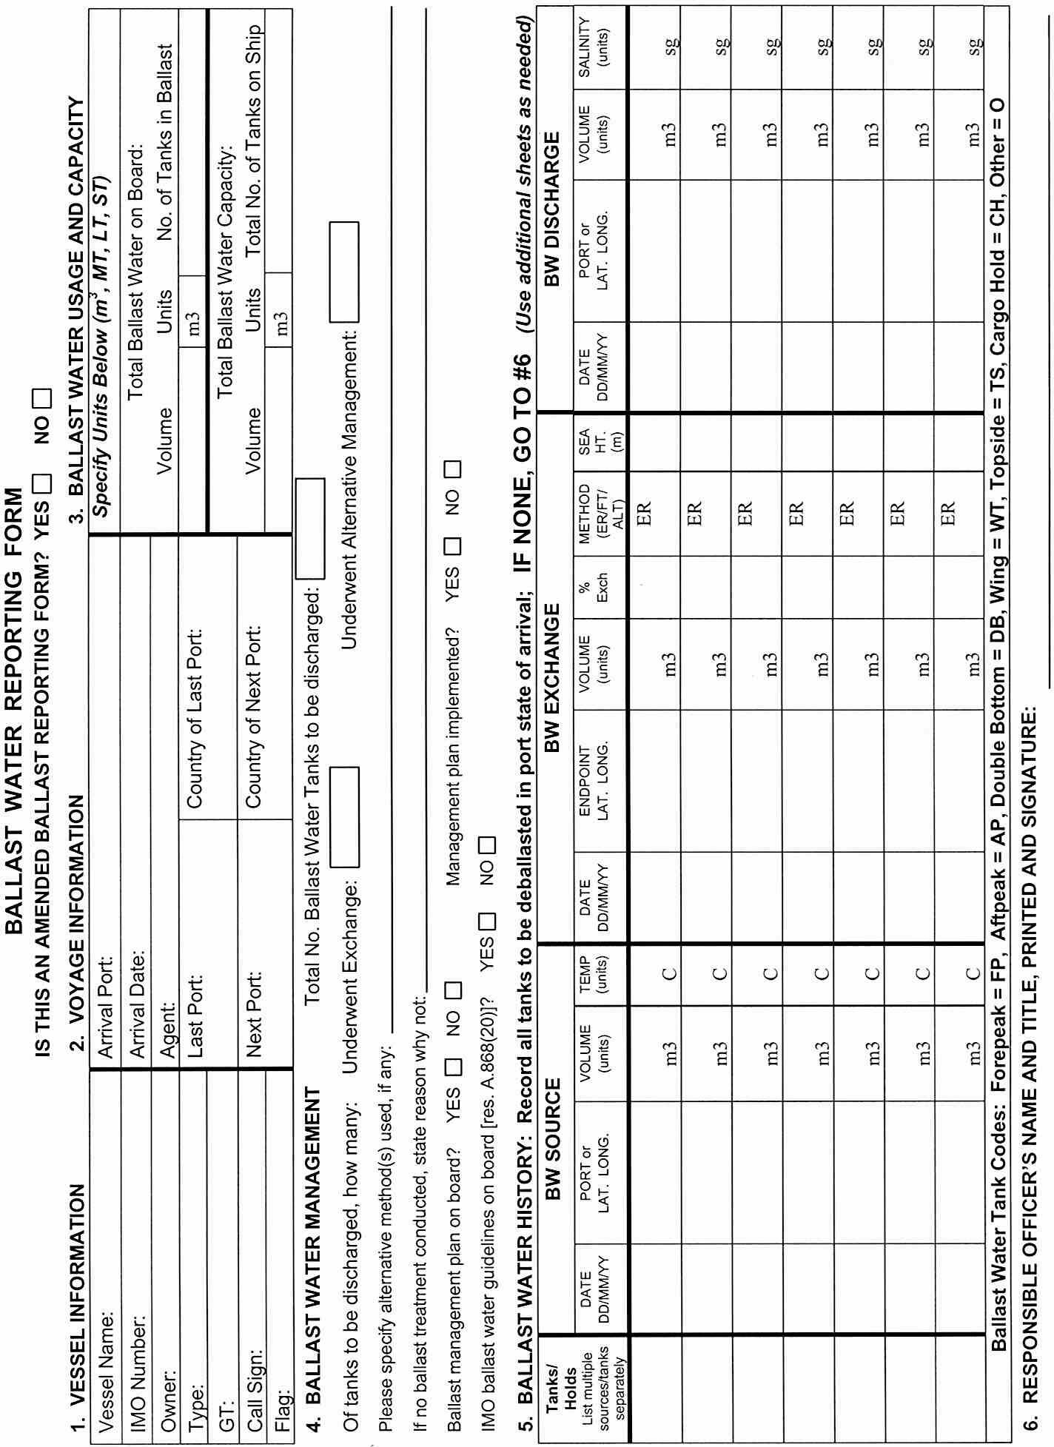
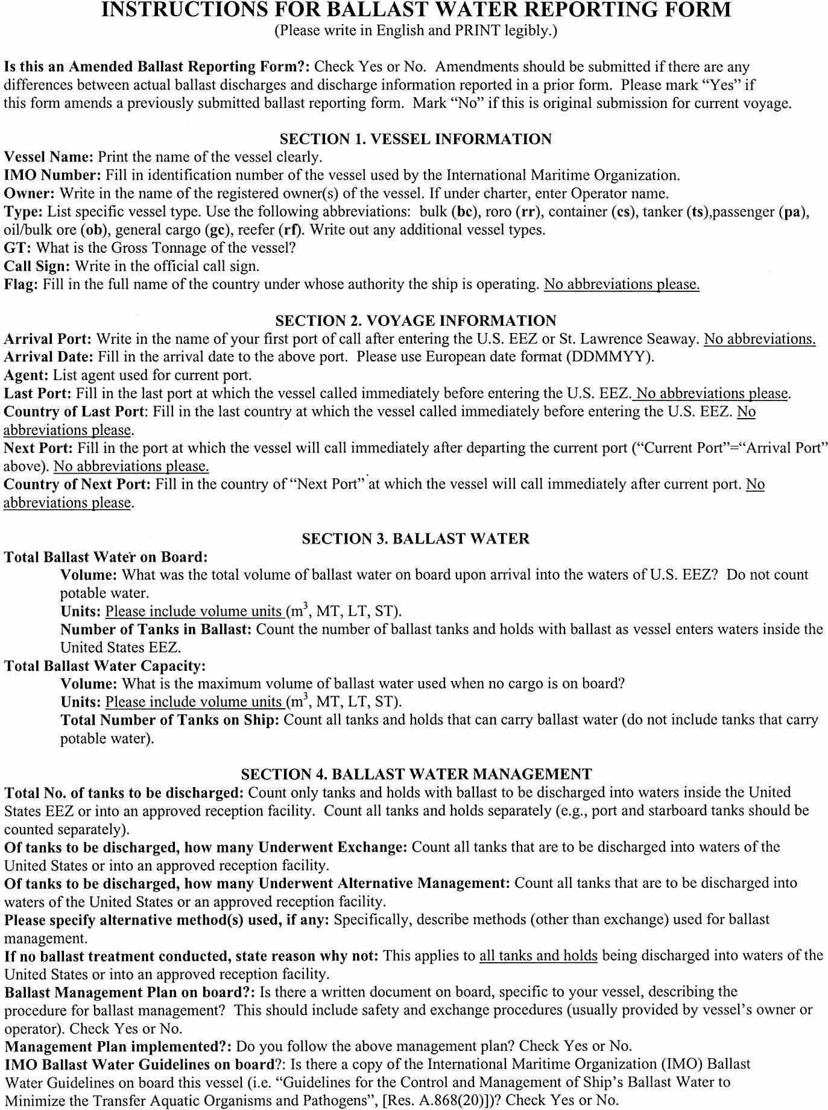
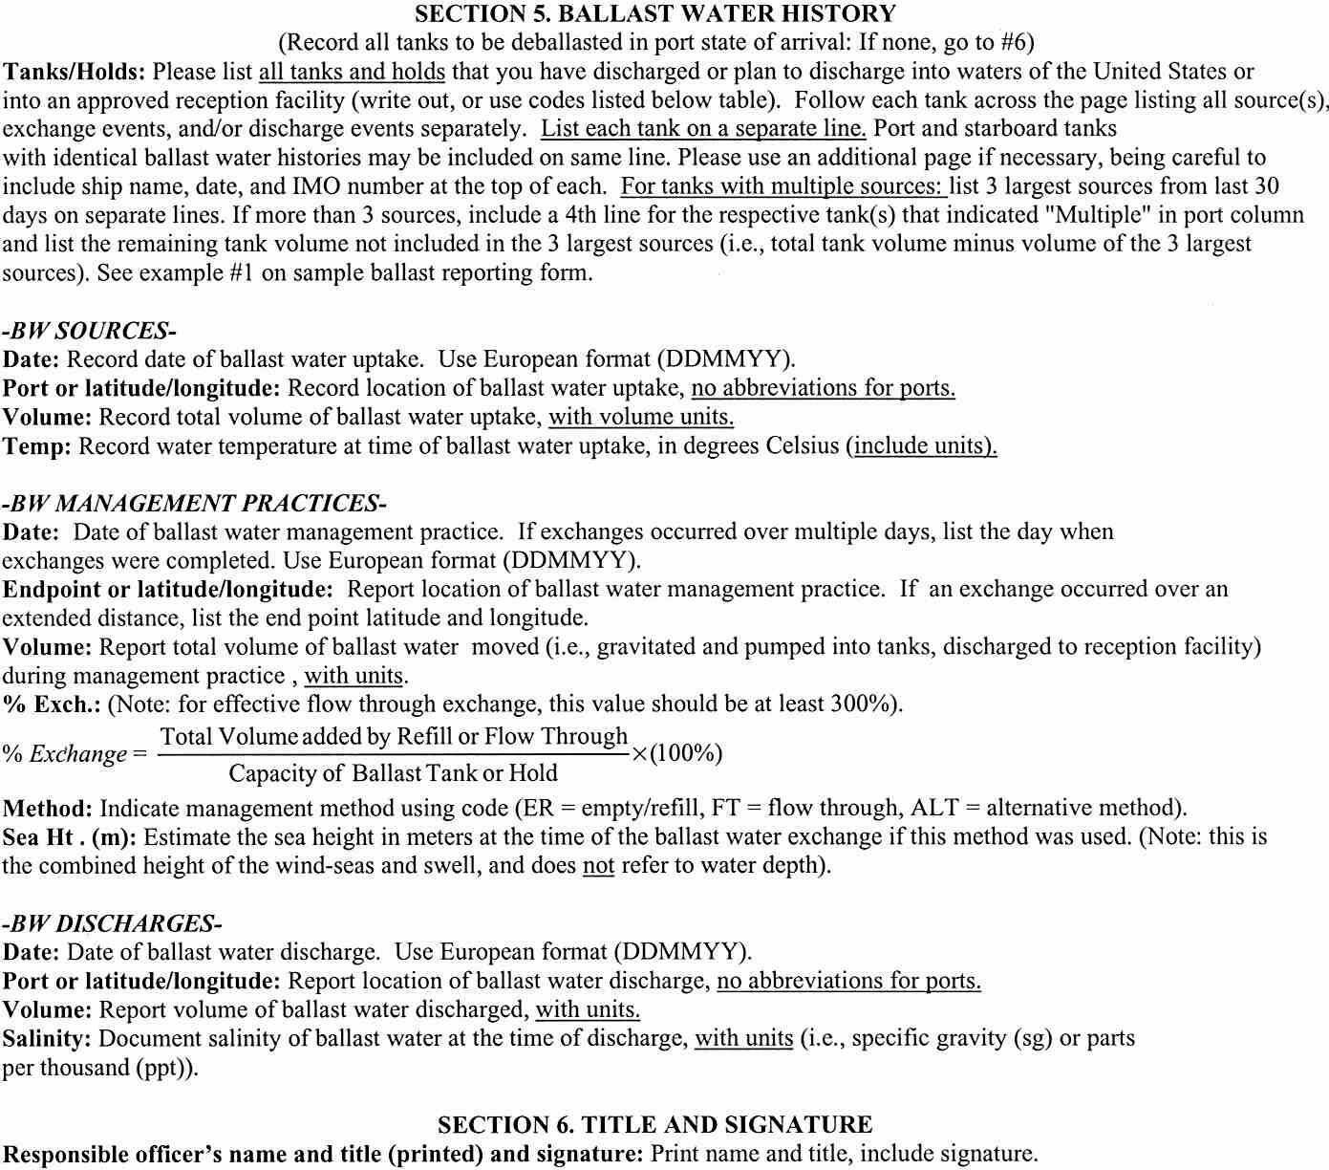
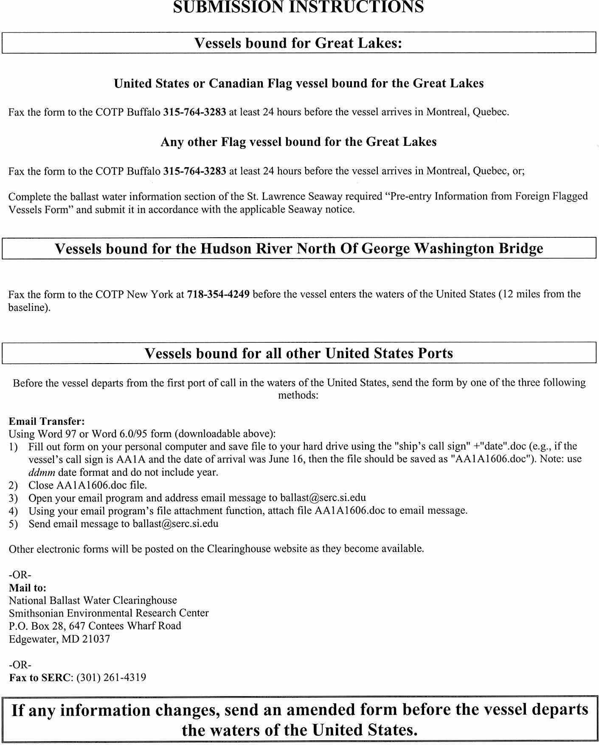
VA.R. Doc. No. R02-70; Filed November 1, 2001, 9:49 a.m.

