STATE BOARD OF HEALTH
Title of Regulation: 12 VAC 5-615. Authorized Onsite Soil Evaluator Regulations.
Statutory Authority: §§ 32.1-163.5 and 32.1-164 of the Code of Virginia.
Effective Date: July 1, 2002.
Summary:
These regulations allow the agency to accept private site evaluations and designs, in compliance with the Board of Health's regulations for onsite sewage systems, designed and certified by an authorized onsite soil evaluator (AOSE) or a licensed professional engineer (PE) in consultation with an AOSE.
Amendments made to the proposed regulations are as follows:
1. Language was added to provide that the Virginia Department of Health (VDH) may accept evaluations and designs for proprietary pre-engineered systems that have been deemed by VDH to comply with the board's regulations; however, these are not subject to time limits or deemed approval.
2. The "sunset date" was changed from December 31, 2002, to December 31, 2005.
3. Language has been added to emphasize that VDH has discretion in choosing whether to initiate permit revocation proceedings and to encourage VDH to modify approvals, with the owner's consent, rather than revoke them.
4. Amendments provide that the AOSE is not required to modify a permit if the owner damages the approved site.
5. The requirements for inspecting sewage systems at the time of installation are changed. VDH may, but is not required to, perform such final inspections of AOSE/PE designed systems.
6. Traditional systems have been defined to include provisional, general, proprietary pre-engineered and other systems contained in 12 VAC 5-610 (the Sewage Handling and Disposal Regulations).
7. Amendments eliminate the requirement that all currently certified AOSEs pass written and field tests by the "sunset date."
8. VDH employees are required to pay the AOSE application fee.
9. Requests for professional courtesy reviews must include a statement from the owner giving VDH permission to enter the property.
Summary of Public Comments and Agency's Response: A summary of comments made by the public and the agency's response may be obtained from the promulgating agency or viewed at the office of the Registrar of Regulations.
Agency Contact: Donald J. Alexander, Director, Division Onsite Sewage Water Services, Department of Health, Office of Environmental Health Services, Room 115, P.O. Box 2448, Richmond, VA 23218, telephone (804) 786-1620 or FAX (804) 225-4003.
REGISTRAR'S NOTICE: The proposed regulation was adopted as published in 18:2 VA.R. 140-159 October 8, 2001, with the additional changes shown below. Therefore, pursuant to § 2.2-4031 A of the Code of Virginia, the text of the final regulation is not set out at length; however, the changes from the proposed regulation are printed below.
CHAPTER 615.
AUTHORIZED ONSITE SOIL EVALUATOR REGULATIONS.
PART I.
GENERAL PROVISIONS.
12 VAC 5-615-10. Authority for regulations.
Section 32.1-164 of the Code of Virginia provides that the State Board of Health has the duty to qualify individuals as authorized onsite soil evaluators (AOSEs) and establish procedures for utilizing the work of AOSEs and professional engineers (PEs) in consultation with AOSEs when issuing construction permits, certification letters, and subdivision approvals. Section 32.1-163.4 of the Code of Virginia provides that the department shall contract with an AOSE for the field evaluation of backlogged application sites and that the department shall only accept private evaluations from AOSEs. Section 32.1-163.5 of the Code of Virginia provides that the department shall accept private evaluations and designs for residential development from an AOSE or a PE in consultation with an AOSE and that the department is not required to perform a field check of such evaluations and designs prior to issuing an approval [ . ; the department may, although it is not required to, accept evaluations and designs from an AOSE or a PE in consultation with an AOSE for a proprietary, pre-engineered system that has been deemed by the department to comply with the board's regulations. ]
12 VAC 5-615-20, 12 VAC 5-615-30, and 12 VAC 5-615-40. [ No change from proposed. ]
12 VAC 5-615-50. Authorized Onsite Soil Evaluator Advisory Committee.
The commissioner shall appoint an Authorized Onsite Soil Evaluator Advisory Committee consisting of up to [ 14 15 ] appointed members and one ex officio member. The commissioner shall appoint members to the Authorized Onsite Soil Evaluator Advisory Committee as follows: four AOSEs from four different regions of the Commonwealth, one or more of whom must be a member of the Virginia Association of Professional Soil Scientists; four individuals currently employed by the department as Environmental Health Specialist Senior (these may or may not also be AOSEs); two persons actively engaged in the installation of onsite sewage systems; one professional engineer; [ one person who is a realtor licensed in Virginia; ] and three discretionary voting positions intended to provide substantive expertise, when needed, from the following categories (but not limited to these categories): Homebuilder/Developer, Well Driller, Local Government, Lending Institution, Surveyor. Each member of the advisory committee may be appointed to serve a term of two years; however, the commissioner, when making initial appointments, shall designate seven of the members to serve terms of three years. The appointment, renewal and removal of each advisory committee member lies in the sole discretion of the commissioner. The commissioner should seek to ensure that one or more members of the advisory committee is a homeowner with experience with onsite sewage systems so that homeowner’s interests may be represented on the committee. The director of the division, or a designee, shall serve as an ex officio member of the advisory committee. The commissioner shall designate [ that ] the chairman of the committee and members shall serve at the discretion of the commissioner. The committee shall make recommendations to the commissioner regarding AOSE/PE policies, procedures, and programs. The committee shall meet at least annually. The committee shall establish its rules of order.
12 VAC 5-615-60. Scope of regulations.
A. This chapter describes the content and form of site and soil evaluation reports submitted to the department by an AOSE/PE pursuant to an application filed for an approval under the Sewage Handling and Disposal Regulations (12 VAC 5-610-20 et seq.). The department will accept applications from owners (or their agents) without any site evaluation work (bare applications), with complete supporting documentation from an AOSE/PE, and until December 31, [ 2002 2005 ], with complete supporting documentation from non-AOSE/PE consultants. After December 31, [ 2002 2005 ], the department will [ continue to accept bare applications from owners (or their agents) and will ] only accept site evaluation reports and designs from AOSE/PEs.
B. The provisions of local ordinances regarding onsite wastewater systems that are more restrictive than, and not inconsistent with, the Sewage Handling and Disposal Regulations are not affected by this regulation unless a locality indicates in writing to the commissioner that it wants the department to apply its more restrictive ordinances in concert with the provisions of this chapter. When such a request is made, the department will require all AOSE/PE reports submitted in the locality to be certified as complying with both the Sewage Handling and Disposal Regulations and the more restrictive local requirements and implement the provisions of the more restrictive ordinances pursuant to this chapter. In those localities with more restrictive ordinances where the local government has not indicated to the commissioner in writing that it desires that the provisions of this chapter be applied to the more restrictive ordinances, the department will review all applications for compliance with state law and regulations only. Such applicants then must obtain a certification of compliance with local ordinances from a local official. The department shall maintain a list of all localities that have notified the commissioner in writing pursuant to this section.
C. The department may accept evaluations and designs from AOSE/PEs in accordance with this chapter that include a certification as to the suitability of sites for the construction of private wells in accordance with the Private Well Regulations (12 VAC 5-630 [ -10 et seq. ] ).
12 VAC 5-615-70. Roles and responsibilities.
A. An AOSE/PE must certify that a site meets or does not meet the requirements of either the Sewage Handling and Disposal Regulations (12 VAC 5-610 [ -20 et seq. ] ), the Private Well Regulations (12 VAC 5-630 [ -20 et seq. ] ), or both, and may design [ certain ] traditional systems in accordance with the same regulations. Responsibility for assuring that site evaluations and designs comply with the Sewage Handling and Disposal Regulations or the Private Well Regulations rests with the AOSE/PE submitting the work.
B. The Department of Health shall have the following responsibilities:
1. The department’s role in evaluating an AOSE/PE submission will be to review the materials submitted with an application [ for as it deems necessary to assure ] compliance with this chapter, the Sewage Handling and Disposal Regulations, the Private Well Regulations and the department’s policies prior to approval or disapproval of an application.
2. The department is not required to conduct a field check of any evaluation and/or design submitted pursuant to this chapter prior to issuing the appropriate approval; however, it will conduct such field reviews as it deems necessary to protect public health and the environment and to assess the performance of AOSE/PEs.
3. When requested by an AOSE/PE prior to the filing of an application for a construction permit or certification letter, the department may provide a site-specific field review consultation. Such requests shall not be included in any calculation of backlogs nor shall they be subject to the time limits contained in 12 VAC 5-615-80 or to deemed approval. The department may limit the number of such professional courtesy reviews provided to any individual AOSE/PE as it deems reasonable and as its resources allow. The professional courtesy review shall not be considered to be a case decision.
4. The department may provide professional courtesy reviews as it deems reasonable and as its resources allow when requested by an AOSE/PE in conjunction with a proposed subdivision, provided such field reviews are general in nature (not site-specific) and provided the developer or owner has generated a base map or preliminary plat of the proposed subdivision and provided that the request for review is made prior to any submission of a subdivision package to the local government for consideration under local subdivision ordinances. Such professional courtesy reviews shall be voluntary and within the sole discretion of the department and shall not be subject to any time limits. Professional courtesy reviews shall not be considered to be case decisions.
5. Whenever the department has approved a permit, certification letter, or subdivision approval in reliance upon an AOSE/PE certification and later has reason to believe that the site or sites or system design submitted by the AOSE/PE does not substantially comply with the minimum requirements of the Sewage Handling and Disposal Regulations, the department [ shall may ] initiate proceedings, in accordance with the Sewage Handling and Disposal Regulations, to revoke [ or modify ] its approval. Such approvals, when revoked, shall be deemed to be permit denials and may be appealed by the aggrieved named party to the Sewage Handling and Disposal Appeal Review Board in accordance with § 32.1-166.6 of the Code of Virginia. All requests for appeals to the Appeal Review Board must be in writing and received by the commissioner within 30 days of receipt of notice of the revocation. [ With the written consent of the owner, the department may revise a permit, certification letter, or subdivision approval to substantially comply with the Sewage Handling and Disposal Regulations. The owner may be required to file a new application and to provide formal or informal plans if such plans are required under the Sewage Handling and Disposal Regulations. ]
C. An AOSE/PE must make minor revisions that are discovered to be necessary at any time, including, but not limited to, during the installation of the system, to a permit, certification letter or subdivision approval issued in reliance on the evaluations and/or designs of an AOSE/PE. [ This subsection shall not be construed to require an AOSE to make revisions, minor or major, that result from actions taken by the owner including, but not limited to, improper site grading, improper location of structures, removal, compaction or other damages to soils. ]
1. Minor revisions do not include changes in design flow or substantive changes in square footage of absorption area.
2. All revisions must fully comply with the Sewage Handling and Disposal Regulations and must be approved by the department before the issuance of the operation permit.
3. Whenever major revisions, such as changes in system design or location, are required, a new application in accordance with Part [ III IV ] (12 VAC 5-615- [ 210 340 ] et seq.) of this chapter shall be required.
D. Whenever a construction permit has been issued pursuant to a design certified by an AOSE/PE, the certifying AOSE/PE shall inspect that system at the time of installation and provide an inspection report [ , including an "as-built" drawing, ] and completion statement to the [ owner and the ] local health department. The inspection report and completion statement shall be in a form approved by the division and shall state that the AOSE/PE has inspected the installation. It shall state any deficiencies discovered and identify the methods of correction, and it shall state that the system was installed in accordance with the construction permit, approved plans where appropriate, and the requirements of 12 VAC 5-610 [ -20 et seq ] . The local or district health department [ shall also may, but is not required to, ] perform an inspection of such systems as required under 12 VAC 5-610-320. Whenever an AOSE/PE is unable to conduct an inspection under this section, the owner may provide an inspection report and completion statement executed by another AOSE or PE. An Operation Permit (12 VAC 5-610-340) shall not be issued for any system until the appropriate report and completion statement have been received by the local or district health department.
E. When the department has issued a construction permit for a private well only (no onsite sewage system), in reliance on a certification by an AOSE/PE, the construction inspection required by 12 VAC 5-630-320 will be performed by the local or district health department. In such cases, the owner shall provide to the local or district health department a written inspection statement signed by the AOSE/PE stating that the private well was installed in accordance with the permit and the Private Well Regulations. Whenever an AOSE/PE is unable to conduct an inspection under this section, the owner may provide an inspection report and completion statement executed by another AOSE or PE.
12 VAC 5-615-80. Processing time limits and deemed approval.
A. The provisions of this section apply only to applications for residential development [ and do not apply to any application for a proprietary, pre-engineered system that has been deemed by the department to comply with the board's regulations. The department may accept evaluations and designs for proprietary, pre-engineered systems in accordance with this chapter; however, the processing time limits and deemed approval shall not apply to any such application ].
B. The department shall review applications submitted with AOSE/PE documentation in the form specified in this chapter and shall issue a written approval or denial within the time frames specified in Table 1 of this subsection. In the event the application is denied, the department shall set forth in writing the reasons for denial.
Table 1
Type of Application Time Limit
Individual Permit Application 15 working days
Individual Certification Letter 20 working days
Multiple Lot Certification Letter 60 days
Subdivision Review 60 days
C. If the department does not approve or disapprove an AOSE/PE application or a request for a subdivision review properly submitted in accordance with this chapter within the time limits specified in Table 1, the application [ or request for subdivision review ] shall be deemed approved and the appropriate letter, permit, or approval shall be issued.
12 VAC 5-615-90, 12 VAC 5-615-100, and 12 VAC 5-615-110. [ No change from proposed. ]
12 VAC 5-615-120. Definitions.
The following words and terms when used in this chapter shall have the following meanings unless the context clearly indicates otherwise:
"AOSE/PE" means an authorized onsite soil evaluator or a professional engineer working in consultation with an authorized onsite soil evaluator.
"Authorized onsite soil evaluator (AOSE)" means a person currently listed by the board as possessing the qualifications to evaluate soils and soil properties in relationship to the effects of these properties on the use and management of these soils as the locations for traditional onsite sewage disposal systems.
"Backlog" is deemed to exist when the processing time for more than 10% of a local or district health department’s complete bare applications for construction permits exceeds a predetermined number of working days (i.e., a 15-day backlog exists when the processing time for more than 10% of permit applications exceeds 15 working days). When calculating backlogs, only applications for construction permits shall be counted. [ Working days characterized by severe weather conditions shall not be included in any backlog calculation. ]
"Bare application" means an application for a construction permit or a certification letter submitted without supporting documentation from an AOSE/PE.
"Board" means the State Board of Health.
"Certification letter" means a letter issued by the department, in lieu of a construction permit, that identifies a specific site and recognizes the appropriateness of the site for an onsite wastewater disposal system.
"Complete application" means an application for a construction permit or certification letter that includes all necessary information needed to process the application as specified in 12 VAC 5-610-250 including a site plan as specified in 12 VAC 5-610-460.
"Deemed approved" or "deemed approval" means that the department has not taken action to approve or disapprove an application for a permit, an individual lot certification letter, multiple lot certification letters, or subdivision approval for residential development within the time limits prescribed in §§ 32.1-163.5 and 32.1-164 H of the Code of Virginia. In such cases, an application submitted in proper form pursuant to this chapter is deemed approved and the appropriate letter or letters, permit, or approval shall be immediately issued by the department. Deemed approval applies only to applications for single-lot construction permits, subdivision review, and single or multiple-lot certification letters submitted with evaluations and designs certified by an AOSE/PE in accordance with the provisions of the Code of Virginia, the Sewage Handling and Disposal Regulations, and this chapter. Sites that have been previously denied by the department [ and proprietary, pre-engineered systems deemed by the department to comply with the board's regulations ] are not subject to the provisions of deemed approval. An application “deemed approved” means that it is approved only with respect to the Board of Health’s regulations. In accordance with 12 VAC 5-615-60 B a local government may authorize the department in writing to implement the provisions of any local ordinance that are more restrictive than the Sewage Handling and Disposal Regulations through the provisions of this chapter.
"Multiple lot certification letters” means two or more applications for certification letters filed by the same owner for existing or proposed lots to serve detached, individual dwellings.
"Professional courtesy review” means a site-specific field review requested by an AOSE/PE prior to the submission of an application for a construction permit or certification letter or a general field consultation (not site-specific) regarding a proposed subdivision.
"Professional engineer in consultation with an AOSE” means that a professional engineer has communicated with an AOSE regarding the site and soil conditions present where the system is proposed, in a manner sufficient to assure compliance with the Sewage Handling and Disposal Regulations and this chapter.
"Processing time” means the number of working days from the date a complete, bare application is received by a local or district health department to the date a permit or certification letter is issued. [ Working days characterized by severe weather conditions shall not be included in any calculation of processing time. ]
"Residential development” means development, including repair or replacement systems in accordance with 12 VAC 5-610-280 C 2, using single family homes, which utilize individual onsite sewage systems for each structure. Mass drainfields and other cluster systems that serve more than one dwelling are not considered residential development for the purposes of this chapter.
"Single lot construction permit/certification letter” means one application filed by an owner for a sewage disposal system construction permit or certification letter to serve an individual dwelling on one lot or parcel of land.
"Subdivision review” means the review of a proposed subdivision plat by a local health department for a local government pursuant to a local ordinance or ordinances and pursuant to §§ 15.2-2242 and 15.2-2260 of the Code of Virginia and 12 VAC 5-610-360 of the Sewage Handling and Disposal Regulations for the purposes of determining and documenting whether an approved sewage disposal site is present on each proposed lot.
"Traditional systems” means onsite wastewater treatment and disposal systems [ , including proprietary, pre-engineered systems deemed by the department to comply with the board's regulations, that have received provisional or general approval under, or ] for which design criteria are contained in [ , ] the Sewage Handling and Disposal Regulations, except as noted below. [ At present, traditional systems include gravity, pumped, and low-pressure distribution (lpd) septic effluent drainfields, and Wisconsin-type mound systems. For the purposes of this chapter, ] traditional systems [ as defined in this regulation ] do not include experimental permits, conditional permits issued for temporary, intermittent or seasonal use, septage stabilization systems, or systems permitted under a soil drainage management plan. Conditional construction permits issued for limited occupancy or the use of permanent water saving fixtures are not excluded (see 12 VAC 5-610-250 J).
PART II.
COMPLIANCE WITH ADMINISTRATIVE PROCESS ACT.
12 VAC 5-615-130 through 12 VAC 5-615-200. [ No change from proposed. ]
PART III.
AOSE CERTIFICATION REQUIREMENTS.
12 VAC 5-615-210. Persons holding a valid certificate on [ the effective date of these regulations July 1, 2002 ].
Any person holding a valid certificate as an AOSE on [ the effective date of these regulations who has not passed the AOSE written and field tests dated January 2000 or later must do so on or before December 31, 2002. Any such person whose AOSE certification expires prior to passing the AOSE written and field test July 1, 2002, ] may apply for renewal in accordance with 12 VAC 5-615-270 [ ; however, . ] Such individuals [ must will not be required to ] pass the written and field tests [ on or before December 31, 2002 ].
12 VAC 5-615-220. [ Construction permit in lieu of field test (Reserved) ].
[ Any AOSE required to pass the field portion of the AOSE test pursuant to 12 VAC 5-615-210 may submit to the department a construction permit application package that he prepared that was approved for issuance of a permit and was satisfactorily reviewed in the field by a representative of the department in lieu of taking and passing the field test. ]
12 VAC 5-615-230 and 12 VAC 5-615-240. [ No change from proposed. ]
12 VAC 5-615-250. Fees for applications, training, and testing.
A. The following fees will be assessed. All fees due the department shall be paid by check or money order.
B. Any person making application for certification as an AOSE or applying for renewal of an AOSE certification shall pay an application fee of $100. [ Those persons currently employed by the department shall not be required to pay the application fee. ]
C. Those persons taking a department-sponsored training course or courses as specified in 12 VAC 5-615-230 shall pay the fee for such course as determined by the department. Fees for such course or courses will be based on the department’s actual expenses in preparing course materials and conducting the training. This section is not intended to prevent or discourage training courses recognized by the department and offered by entities other than the department. In the case of training that is not directly sponsored by the department, applicants will pay appropriate fees to the sponsoring entity.
D. Those persons taking written and field tests specified in 12 VAC 5-615-230 shall pay a fee for such testing as determined by the department based on the actual costs of preparing and administering the tests.
12 VAC 5-615-260 through 12 VAC 5-615-290. [ No change from proposed. ]
12 VAC 5-615-300. Application for reinstatement of AOSE certification.
Any person whose AOSE certification has been revoked pursuant to 12 VAC 5-615-290 may apply to the department for reinstatement as an AOSE no sooner than 12 months after the effective date of the revocation. Any person making application for [ reimbursement reinstatement ] of an AOSE certification pursuant to this section shall:
1. File a complete application in a form approved by the division and pay the application fee in accordance with 12 VAC 5-615-250. The AOSE application for reinstatement must also include a certification that the AOSE has not engaged in AOSE activities after his certification was revoked [ . ; and ]
2. Provide documentation that the applicant has satisfactorily completed any remedial actions required as a result of the revocation. Remedial actions including, but not limited to, additional training courses, additional testing, and reevaluation of a site and/or redesign of an onsite sewage system may be specified as conditions for reinstatement.
12 VAC 5-615-310. Appeal of suspension or revocation.
In accordance with 12 VAC 5-615-180, any person whose AOSE certification has been suspended or revoked shall have the right to review by the appropriate circuit court.
12 VAC 5-615-320. AOSE/PE cannot certify a site that has been previously denied by the department.
No AOSE/PE shall certify a site as meeting the minimum requirements of the Sewage Handling and Disposal Regulations (12 VAC 5-610-20 et seq.) if the department has previously denied that site.
[ Exception Exceptions ]:
[ 1. ] An AOSE/PE may certify a previously denied site as meeting the requirements of the Sewage Handling and Disposal Regulations if the board’s regulations or policies have changed in such a way that the site is suitable for a system that was not allowed by the board’s prior regulations or policies at the time of the original denial [ .; and
2. ] An AOSE/PE may certify as meeting the requirements of the Sewage Handling and Disposal Regulations a site located on the same property as a site previously denied by the department if the site being certified is not the same one that was denied by the department.
12 VAC 5-615-330. [ No change from proposed. ]
PART IV.
PROCEDURES AND REPORTS.
12 VAC 5-615-340. Application processing.
A. All applications that are submitted with evaluation and design documentation by an AOSE/PE shall contain the minimum required information necessary to complete the application and shall be accompanied by the required fees. Such applications when submitted for residential development will be processed within specified time limits in 12 VAC 5-615-80.
B. When such an application is found to be complete an approval may be issued without field review.
C. Applications that are found to be incomplete or defective in any manner shall be denied and the owner and AOSE/PE will be notified of deficiencies. If an application has been denied, the owner or [ their his ] agent may submit a new application to correct the deficiency or deficiencies contained in [ their his ] first application. If the application is received within 90 days, the department will waive all state fees associated with the new application. This waiver may be granted not more than once per site.
12 VAC 5-615-350. Documentation requirements for AOSE/PE reports.
A. Applications may be submitted for a single lot construction permit, a single lot certification letter, multiple lot certification letters, and subdivision reviews. The minimum requirements for each type of application are listed below. Additional information may be submitted when an AOSE/PE believes it may be in the [ client’s ] interest [ to provide additional information of public health, the environment, or the client ].
B. A complete application for a construction permit shall consist of the following:
1. A complete application for a Sewage Disposal System Construction Permit (CHS 200), signed, dated, and with all pertinent information supplied;
2. The appropriate fee for the application as per the Code of Virginia;
3. A site evaluation report in accordance with 12 VAC 5-615-360 and the department’s policies;
4. A proposed well site (when a private water supply is proposed);
5. Construction drawings and specifications for the recommended system in accordance with 12 VAC 5-615-380 and the department’s policies; and
6. A statement in accordance with 12 VAC 5-615-70, 12 VAC 5-615-280, and 12 VAC 5-615-380 C certifying that the site and soil conditions and design conform with the Sewage Handling and Disposal Regulations (12 VAC 5-610) ].
C. A complete application for certification letter differs from an equivalent application for a construction permit in that a complete design is not required. It is, however, necessary to assure a system meeting the requirements specified on the application can be supported by the proposed site. Therefore, the requirements for a single certification letter are:
1. A complete application for a Sewage Disposal System Construction Permit (CHS 200), signed, dated, and with all pertinent information supplied;
2. The appropriate fee for the application;
3. A site evaluation report in accordance with 12 VAC 5-615-360 and the department’s policies;
4. A proposed well site (when a private water supply is proposed);
5. An abbreviated system design for the type of system proposed in a form approved by the division; and
6. A statement in accordance with 12 VAC 5-615-70, 12 VAC 5-615-280, and 12 VAC 5-615-380 C certifying that the site and soil conditions and design conform with the Sewage Handling and Disposal Regulations.
D. Applications for multiple certification letters may be used as the method for reviewing proposed subdivisions in localities that do not require the local health department to review proposed subdivisions. Each application submitted must contain the following:
1. Complete applications for Sewage Disposal System Construction Permits (CHS 200), signed, dated, and with all pertinent information supplied;
2. The appropriate fee for each site to be reviewed;
3. Site evaluation reports in accordance with 12 VAC 5-615-360 and the department’s policies;
4. Proposed well sites (when a private water supply is proposed);
5. Abbreviated system designs for the type of system proposed in a form approved by the division;
6. A statement in accordance with 12 VAC 5-615-70, 12 VAC 5-615-280, and 12 VAC 5-615-380 C for each proposed site certifying that the site and soil conditions and design conform with the Sewage Handling and Disposal Regulations; and
7. If the multiple certification letters are intended to establish the suitability of soils for a proposed subdivision, the information specified in subdivision E 3 c of this section is to be submitted by the applicant.
E. Section 32.1-163.5 of the Code of Virginia provides that the department shall accept private site evaluations and designs, for subdivision review for residential development, designed and certified by a licensed professional engineer in consultation with an AOSE or by an AOSE. The following shall apply to all requests for subdivision review and approval:
1. All requests for subdivision reviews must be submitted to the local health department with a request from the local government entity specifically asking for review of the proposed lots for onsite wastewater system approvals pursuant to the local ordinance governing such proposals (cite reference to local ordinance).
2. In localities where there is no subdivision ordinance, subdivisions should be handled using applications for multiple certification letters (see subsection D of this section).
3. All requests submitted by local governments for review and approval must contain the following minimum information:
a. A letter requesting subdivision review and certification by the locality that the subdivision package has been determined to be complete.
b. Individual site and soil evaluation reports in accordance with 12 VAC 5-615-360 for each proposed lot in the subdivision. These individual reports must be identified as to the subdivision and the proposed lot number.
c. A preliminary subdivision plat that provides the information specified in 12 VAC 5-610-360. This includes all information required by the local ordinance, and includes the following if not required by local ordinance: proposed streets, utilities, storm drainage, water supplies, easements, lot lines, existing and proposed water supplies for each proposed lot and within 200 feet of any proposed or existing sewage system, and original topographic contour lines by detail survey. The plat shall be prepared according to suggested scales and contour intervals contained in Appendix L of the Sewage Handling and Disposal Regulations.
4. Abbreviated system designs in a form approved by the division for the type of system proposed.
5. A statement in accordance with 12 VAC 5-615-70, 12 VAC 5-615-280, and 12 VAC 5-615-380 C for each proposed site certifying that the site and soil conditions and design conform to the Sewage Handling and Disposal Regulations.

Table [ 3 2 ]
Types of Applications
 | Single Lot Construction Permit | Single Lot Certification Letter | Multiple Lot Certification Letters | Subdivision
Application | X | X | X
Fee | X | X | X
Site Evaluation | X | X | X | X
Proposed Well Site | X | X | X | X
Construction Drawings | X
Construction Specifications | X
Design Calculations | X
Abbreviated Design calculations |  | X | X | X
Certification of Compliance | X | X | X | X
Local Government Request |  |  |  | X
Preliminary Subdivision Plat |  |  | X (as necessary) | X
Max. Time to Process | 15 Working Days | 20 Working Days | 60 Days | 60 Days
Rec. Time to Process | 5 Working Days | 10 Working Days | 45 Days | 45 Days

12 VAC 5-615-360. [ No change from proposed. ]
12 VAC 5-615-370. Access to information.
When requesting information from the department’s official records, an AOSE/PE shall clearly and accurately identify property locations, using tax map numbers when possible, and specify the information requested on a form approved by the division. The department shall, as resources permit, provide the requested information in as timely a manner as possible, and shall in all cases comply with the Virginia Freedom of Information Act (§ 2.2-3700 et seq. of the Code of Virginia [ ) ].
12 VAC 5-615-380. [ No change from proposed. ]
12 VAC 5-615-390. Professional courtesy review.
A. Any AOSE/PE may request a site-specific professional courtesy review, prior to the submission of an application for a construction permit or certification letter, where he has determined that the site and soil conditions in a specific area proposed for an onsite sewage system are marginal or where he has not been able to determine with certainty that the conditions comply with the requirements of the Sewage Handling and Disposal Regulations [ (12 VAC 5-610) ]. A request for review shall be in a form approved by the division and shall include [ written authorization from the owner giving the department permission to enter the property and ] a complete evaluation report as described in 12 VAC 5-615-360, with the exception of the certification statement. In place of the certification statement required under 12 VAC 5-615-360 the AOSE/PE shall provide a brief description of the particular site and soil features or characteristics that the AOSE/PE has identified as marginal or questionable and which form the basis for the request for review and a preliminary opinion as to whether the site meets the requirements of the Sewage Handling and Disposal Regulations. Professional courtesy reviews are not intended to replace the AOSE/PE’s responsibility to exercise professional judgement in determining whether a site meets the minimum requirements of the Sewage Handling and Disposal Regulations. The department is not required to perform such reviews but may do so in its sole discretion.
B. In accordance with 12 VAC 5-615-70 B 3, the department may limit professional courtesy reviews for construction permits and certification letters. Whenever the department determines that it will not provide a requested review, it shall notify the AOSE/PE and the applicant in writing within a reasonable time. When the department elects to provide professional courtesy reviews, it shall do so in a reasonable time.
C. Any AOSE/PE may request a general (not site-specific) professional courtesy review, prior to the submission of a proposal for subdivision approval to a local government entity, where he has determined that the site and soil conditions in an area proposed for a subdivision with onsite sewage systems are marginal or where he has not been able to determine with certainty that the conditions comply with the requirements of the Sewage Handling and Disposal Regulations. A request for review shall be in a form approved by the division and shall include [ written authorization from the owner giving the department permission to enter the property and ] a summary evaluation report that generally comports with the requirements of 12 VAC 5-615-360, with the exception of the certification statement. In place of the certification statement required under 12 VAC 5-615-360, the AOSE/PE shall provide a brief description of the particular site and soil features or characteristics that the AOSE/PE has identified as marginal or questionable and which form the basis for the request for review and a preliminary opinion as to whether the area generally meets the requirements of the Sewage Handling and Disposal Regulations. Such requests are intended to allow the department to consult with AOSE/PEs in a nonsite-specific manner where the local health department’s knowledge of general site and soil conditions and the requirements of the Sewage Handling and Disposal Regulations can assist the AOSE/PE and local governments in the planning stages of subdivision approval. Professional courtesy reviews are not intended to replace the AOSE/PE’s responsibility to exercise professional judgment in determining whether a specific site meets the minimum requirements of the Sewage Handling and Disposal Regulations.
D. In accordance with 12 VAC 5-615-70 B 4, the department may limit professional courtesy reviews for proposed subdivisions. Whenever the department determines that it will not provide a requested review, it shall notify the AOSE/PE and the applicant in writing within a reasonable time. When the department elects to provide professional courtesy reviews, it shall do so in a reasonable time.
E. Professional courtesy reviews shall not be construed as case decisions.
12 VAC 5-615-400. [ No change from proposed. ]
PART V.
CONFLICT OF INTEREST AND DISCLOSURE.
12 VAC 5-615-410 through 12 VAC 5-615-470. [ No change from proposed. ]
NOTICE: The forms used in administering 12 VAC 5-615, Authorized Onsite Soil Evaluator Regulations, are listed below. Any amended or added forms are reflected in the listing and are published following the listing.
FORMS
Application to Become an Authorized Onsite Soil Evaluator, eff 9/01.
Renewal Application-Authorized Onsite Soil Evaluator, eff. 9/01.
[ Continuing Education Classes attended in the previous two years (eff. 7/02). ]
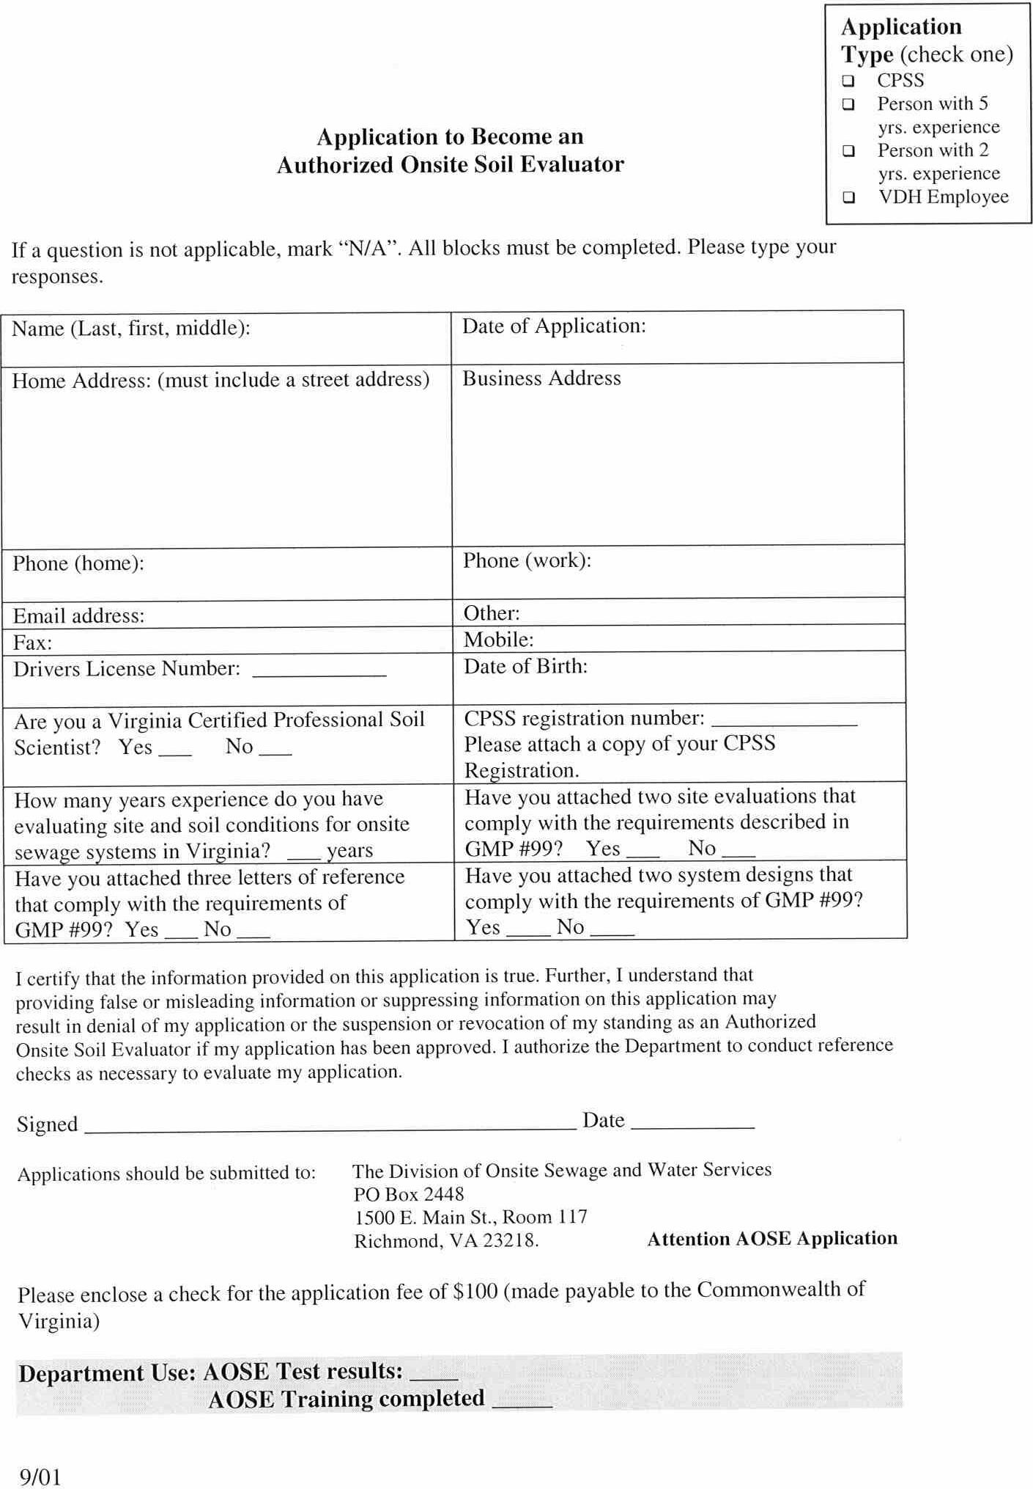
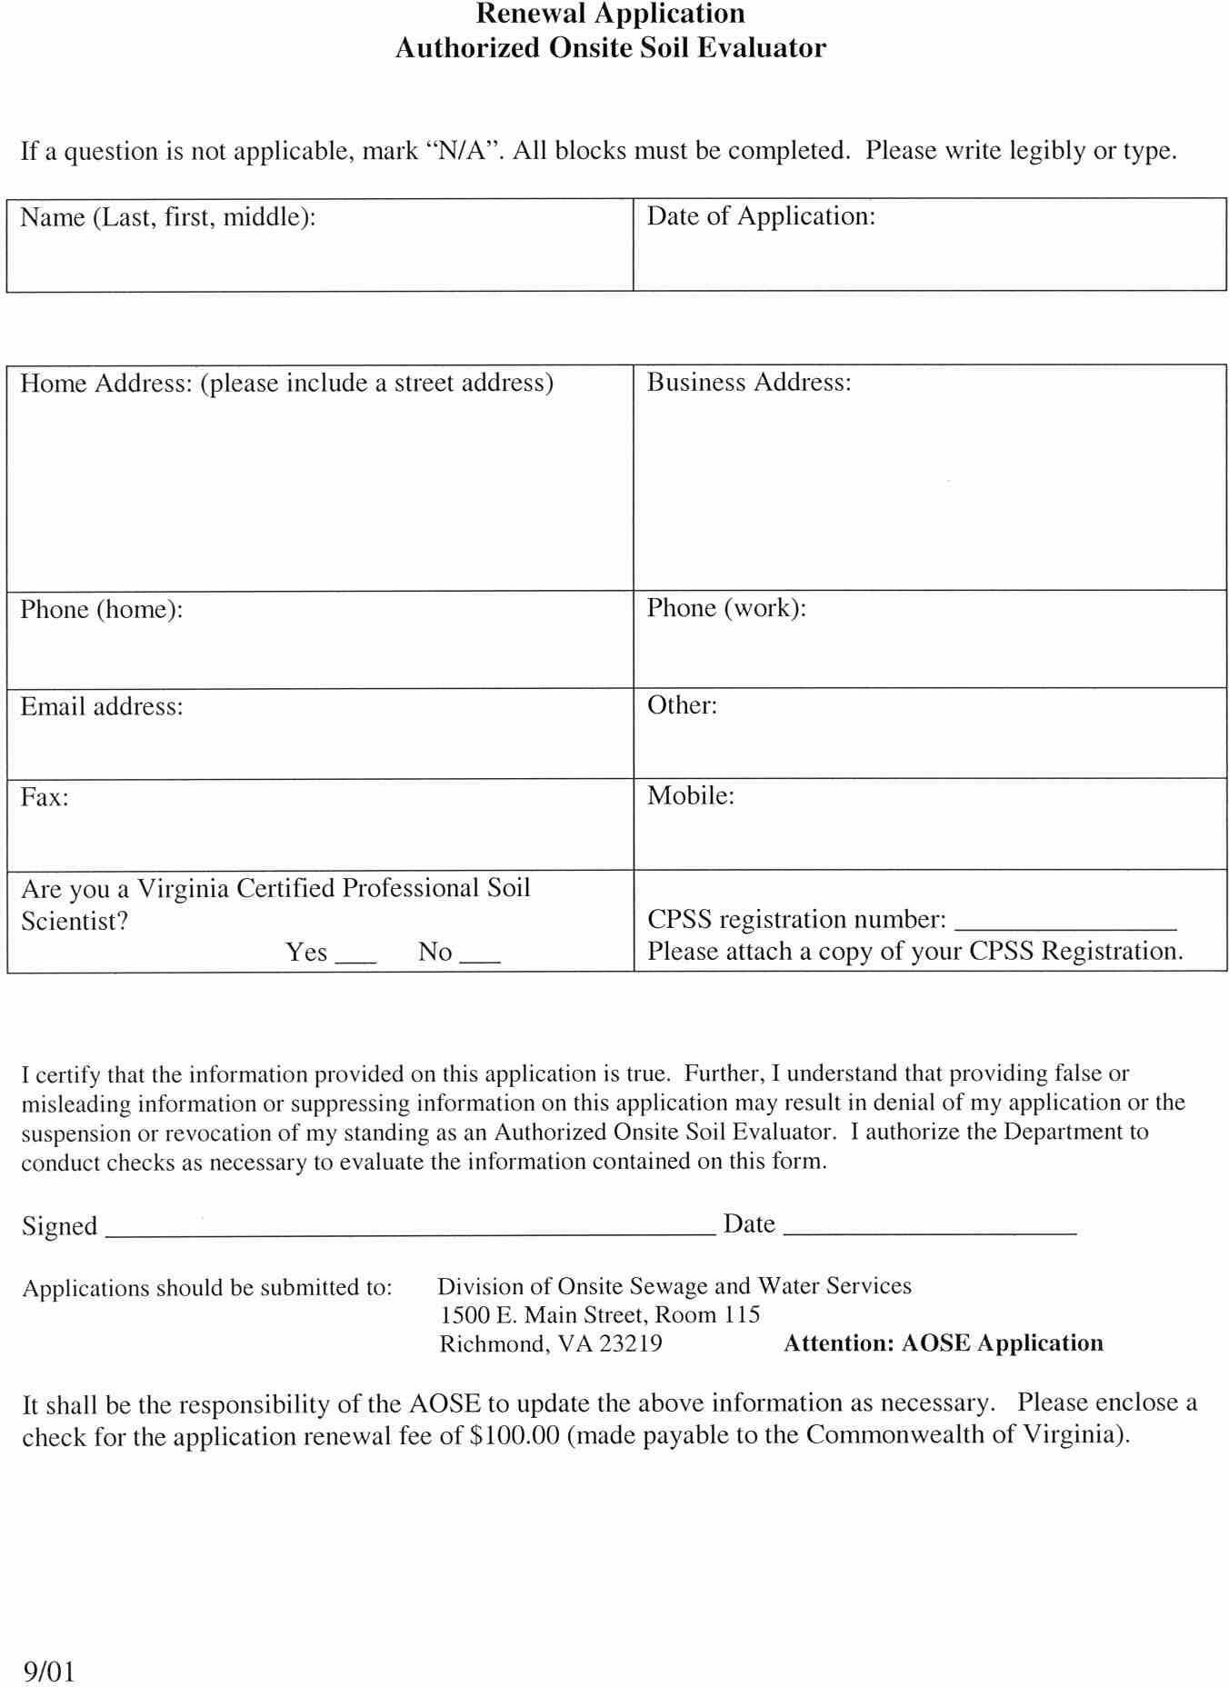
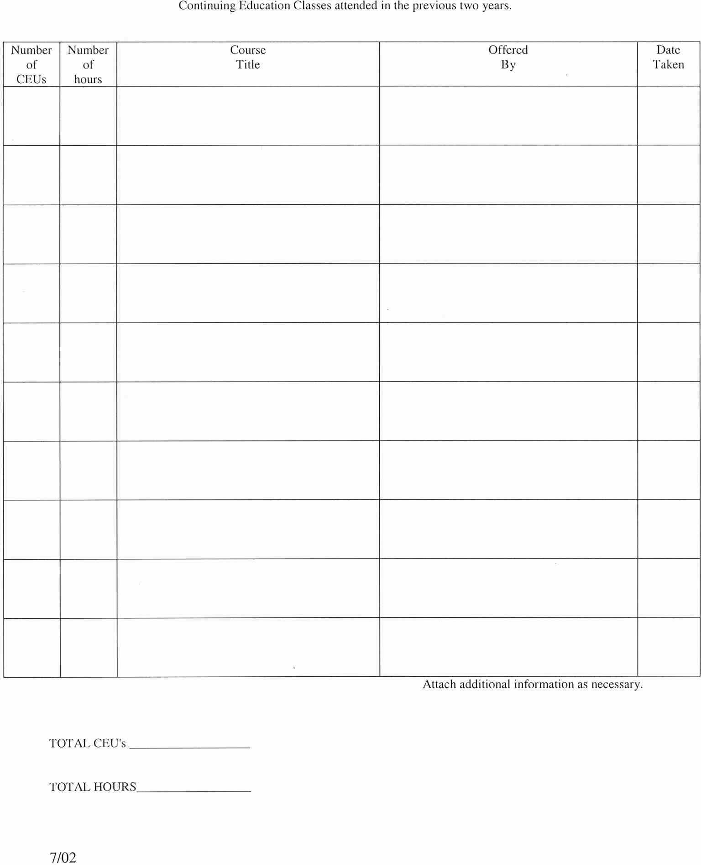

VA.R. Doc. No. R00-225; Filed April 30, 2002, 3:08 p.m.

