BOARD OF PHYSICAL THERAPY
Title of Regulation: 18 VAC 112-20. Regulations Governing the Practice of Physical Therapy (amending 18 VAC 112-20-10, 18 VAC 112-20-130, 18 VAC 112-20-135, and 18 VAC 112-20-140; adding 18 VAC 112-20-131 and 18 VAC 112-20-136).
Statutory Authority: §§ 54.1-2400, 54.1-3474 and 54.1-3480.1 of the Code of Virginia.
Public Hearing Date: July 12, 2002 - 9 a.m.
Public comments may be submitted until July 19, 2002.
(See Calendar of Events section
for additional information)
Agency Contact: Elaine J. Yeatts, Agency Regulatory Coordinator, Department of Health Professions, 6606 W. Broad Street, 4th Floor, Richmond, VA 23230, telephone (804) 662-9918, FAX (804) 662-9114, or e-mail elaine.yeatts@dhp.state.va.us.
Basis: Section 54.1-2400 of the Code of Virginia establishes the general powers and duties of health regulatory boards including the responsibility to promulgate regulations, levy fees, administer a licensure and renewal program, and discipline regulated professionals.
Section 54.1-3474 of the Code of Virginia mandates the board to promulgate regulations establishing requirements to ensure continuing competency of physical therapists and physical therapist assistants, which may include continuing education, testing, or such other requirements as the board may determine to be necessary.
Section 54.1-3480.1 of the Code of Virginia requires the board to prescribe criteria for approval of courses of study and credit hour requirements.
Purpose: Chapters 858 and 315 of the 2001 Acts of the Assembly amended the physical therapy practice act by mandating that the board promulgate regulations for the establishment of continuing competency requirements. To carry out that mandate, the board established an advisory committee to study the type and amount of continuing education to be required, review what other states require, and develop a recommendation for the adoption of emergency regulation.
In promulgating regulations for continued competency of physical therapy licensees, the board considered the mandate of the General Assembly to adopt regulations that would address (i) the need to promote ethical practice, (ii) an appropriate standard of care, (iii) patient safety, (iv) application of new medical technology, (v) appropriate communication with patients, and (vi) knowledge of the changing health care system.
The goal of the board was to develop requirements that would: (i) encourage learner-directed continuing education through which a practitioner can identify a practice question or problem, seek the learning activity which provides needed information or teaches a new skill, and thereby, enhance his expertise or ability to practice; (ii) offer a choice of content and form that is flexible enough to meet the needs of physical therapists and physical therapist assistants in a variety of practice settings in any location in Virginia; and (iii) assure the public that therapists have maintained their skills and competencies in order to protect the public health, safety and welfare.
Substance: The Ad Hoc Advisory Committee recommended and the board adopted amendments that require a total of 30 contact hours per biennium as follows: (i) physical therapists must have at least 15 hours and physical therapist assistants at least 10 hours of Type 1, face-to-face continuing education, which must be offered by an approved sponsor or organization that provides documentation of hours to the practitioner. The hours may include formal course work, in-service training, or other educational experience and (ii) no more than 15 hours required for physical therapists and no more than 20 hours required for physical therapist assistants may be in Type 2 continuing learning activities, which may or may not be approved by a sponsor or organization but shall be activities considered by the learner to be beneficial to practice or to continuing learning; therapists document their own participation on forms provided by the board.
There are also rules for maintaining documentation of continuing education, auditing, extensions and exemptions. Evidence of continuing competency hours would be required for reinstatement of a lapsed license or reactivation of an inactive license.
Issues:
Advantages to the licensees. The continuing competency requirements are intended to provide some assurance to the public that licensees of the board are maintaining current knowledge and skills, while providing the maximum amount of flexibility and availability to licensees. The board believes that the majority of PTs and PTAs already obtain sufficient hours of continuing competency activities or courses in a biennium. Physical therapists who work for organizations are often required to take in-service training or continuing education for employment. Only 15 of the hours for PTs and only 10 of the hours for PTAs must be offered by a recognized sponsor, the other hours may be acquired by the practitioner on his own time and schedule. The resources for earning the hours and engaging in the required learning are numerous and readily available in all parts of Virginia.
Disadvantages to the licensees. For a small minority of practitioners who do not currently engage in any continuing learning in their profession, these requirements will represent an additional burden. However, it was determined by enactment of the statute and by the board’s concurrence that those practitioners and their patients would greatly benefit from continuing learning requirements, and that the public is better protected if there is some assurance of that effort.
Advantages or disadvantages to the public. There are definite advantages of the proposed amended regulations to the public, who will have greater assurance that the licensees for the board are engaged in activities to maintain and improve their knowledge and skills in providing care to their patients. The public is also better served by a continuing competency requirement for licensees who have allowed their license to lapse or have been inactive.
Advantages or disadvantages to governmental agencies. Government agencies that employ physical therapists may incur additional costs if they elect to hire individuals to present workshops or seminars to their staff or to pay for continuing education. The board will incur additional costs to monitor compliance of licensees and to hold additional disciplinary hearings for individuals who do not comply with the requirement.
Department of Planning and Budget's Economic Impact Analysis: The Department of Planning and Budget (DPB) has analyzed the economic impact of this proposed regulation in accordance with § 2.2-4007 G of the Administrative Process Act and Executive Order Number 25 (98). Section 2.2-4007 G requires that such economic impact analyses include, but need not be limited to, the projected number of businesses or other entities to whom the regulation would apply, the identity of any localities and types of businesses or other entities particularly affected, the projected number of persons and employment positions to be affected, the projected costs to affected businesses or entities to implement or comply with the regulation, and the impact on the use and value of private property. The analysis presented below represents DPB’s best estimate of these economic impacts.
Summary of the proposed regulation. Sections 54.1-3474 and 54.1-3480.1 of the Code of Virginia mandate that the Board of Physical Therapy establish continuing education requirements for practitioners whom it licenses. The proposed regulations are identical to and will replace emergency regulations that went into effect on November 1, 2001. The proposed regulations require 30 hours of continuing education per biennium for the renewal of an active license. Physical therapists must have at least 15 hours, physical therapist assistants at least 10 hours of Type 1, face-to-face continuing education that must be offered by an approved sponsor or organization. The remaining hours may be gained by consultation, self-study or other activities considered by the learner as valuable to continued learning in his practice.
The regulations also address the retention of records, random audits, extensions and exemptions, and continuing education requirements for the reactivation of an inactive or lapsed license.
Estimated economic impact. The most significant change proposed to the current regulations is the addition of continuing education (CE) requirements for the renewal of an active license. The existing rules do not require any proof of continuing competency in the profession. The monetary costs of this provision are the costs of any courses offered for the purposes of meeting the requirements of this regulation (whether paid for by the practitioner, his employer, or professional association).
Compliance costs for meeting the CE requirements will differ across licensees. Some licensees may already be obtaining CE hours during employer in-service training sessions or for professional credentialing. For these individuals, the proposed requirements will not result in any additional costs aside from those associated with the documentation and maintenance of records. For other practitioners, however, the proposed CE requirements can be expected to represent a new cost. Based on information provided by the agency, the monetary costs for earning the required CE hours could range from $0 to several hundred dollars per biennium for each of the 5,600 licensees.1 Additionally, practitioners would incur the cost of the time spent on pursuing such activities, whether in lost income or lost leisure time, and any costs associated with the documentation and maintenance of the records.
Reinstatement of Inactive and Lapsed Licenses
Requirements are set forth that the reactivation of an inactive license or reinstatement of a lapsed license include documentation of having completed continued competency hours equal to the requirement for the length of time, not to exceed four years, that the license has been inactive. In addition, practitioners who have not engaged in active practice (at least 320 hours of professional practice within the previous 48 months) must serve a board-approved practice under the supervision of a licensed physical therapist.
Conclusion
The proposed CE requirements and license reactivation criteria can be expected to provide some beneficial results. The proposed rules would provide some assurance to the public that licensees of the Board of Physical Therapy are maintaining their knowledge, skills, and competencies. While there is no empirical evidence currently available with which to estimate the potential benefits resulting from the proposed requirements, even just a few instances of serious injury avoided due to additional safeguards to assure the competency of practitioners would justify the anticipated costs of this regulation.
The Board of Physical Therapy will also incur costs related to enforcement of the proposed CE requirements. Based on experience with other professions, the board estimates that the biennial audits of licensees will result in approximately 20 cases settled with a pre-hearing consent order ($100 per case) and 3 cases requiring informal conference committee proceedings ($500 per case). Enforcement of the proposed requirements will increase compliance, and if the requirements themselves result in a net economic benefit, then the enforcement costs are also justified.
Businesses and entities affected. There are 4,136 physical therapists and 1,503 physical therapist assistants currently licensed in Virginia who would be affected by the proposed changes to this regulation.
Localities particularly affected. The proposed changes to this regulation are not expected to uniquely affect any particular localities.
Projected impact on employment. The proposed changes to this regulation are not expected to have any significant impact on employment in Virginia.
Effects on the use and value of private property. The proposed changes to this regulation are not expected to have any significant effects on the use and value of private property in Virginia.
Agency's Response to the Department of Planning and Budget's Economic Impact Analysis: The Board of Physical Therapy concurs with the analysis of the Department of Planning and Budget for 18 VAC 112-20.
Summary:
The proposed amendments require 30 contact hours of continuing education, within the two years immediately preceding renewal. Physical therapists must have at least 15 hours and physical therapist assistants at least 10 hours of Type 1, face-to-face continuing education, which must be offered by an approved sponsor or organization. The remaining required hours may be in self-learning (Type 2) activities that are considered by the therapist or therapist assistant to be beneficial to practice or to continued learning. Proposed amendments also provide for documenting continuing education hours, retention of records, random audits, extensions and exemptions, and continuing education requirements for the reactivation of an inactive or lapsed license.
18 VAC 112-20-10. Definitions.
The following words and terms when used in this chapter shall have the following meanings, unless the context clearly indicates otherwise:
"Approved program" means an educational program accredited by the Commission on Accreditation in Physical Therapy Education of the American Physical Therapy Association.
"Board" means the Virginia Board of Physical Therapy.
"CLEP" means the College Level Examination Program.
"Contact hour" means 60 minutes of time spent in continuing learning activity exclusive of breaks, meals or vendor exhibits.
"Direct supervision" means a physical therapist is present and is fully responsible for the activities performed by the nonlicensed physical therapy personnel.
"Evaluation" means the carrying out by a physical therapist of the sequential process of assessing a patient, planning the patient's physical therapy treatment program, and recording appropriate documentation.
"Face-to-face" means learning activities or courses obtained in a group setting or through interactive, real-time technology.
"FCCPT" means the Foreign Credentialing Commission on Physical Therapy.
"General supervision" means a physical therapist shall be available for consultation.
"Nonlicensed personnel" means any individual not licensed or certified by a health regulatory board within the Department of Health Professions who is performing patient care functions at the direction of a physical therapist or physical therapist assistant within the scope of this chapter.
"Physical therapist" means a person qualified by education and training to administer a physical therapy program.
"Physical therapist assistant" means a person qualified by education and training to perform physical therapy functions under the supervision of and as directed by a physical therapist.
"TOEFL" means the Test of English as a Foreign Language.
"Trainee" means a person undergoing a traineeship.
1. "Foreign educated trainee" means a physical therapist or physical therapist assistant who graduated from a school not approved by an accrediting agency recognized by the board and who is seeking licensure to practice in Virginia.
2. "Inactive practice trainee" means a physical therapist or physical therapist assistant who has previously been licensed and has not practiced for at least 320 hours within the past four years and who is seeking licensure or relicensure in Virginia.
3. "Unlicensed graduate trainee" means a graduate of an approved physical therapist or physical therapist assistant program who has not taken the state licensure examination or who has taken the examination but not yet received a license from the board.
"Traineeship" means a period of full-time activity during which an unlicensed physical therapist or physical therapist assistant works under the direct supervision of a physical therapist approved by the board.
“Type 1” means face-to-face continuing learning activities offered by an approved organization as specified in 18 VAC 112-20-131.
“Type 2” means continuing learning activities which may or may not be offered by an approved organization but shall be activities considered by the learner to be beneficial to practice or to continuing learning. In Type 2 activities, licensees document their own participation on the Continued Competency Activity and Assessment Form and are considered self-learning activities.
18 VAC 112-20-130. Biennial renewal of license.
A. A physical therapist and physical therapist assistant who intends to continue practice shall renew his license biennially during his birth month in each even-numbered year and pay to the board the renewal fee prescribed in 18 VAC 112-20-150.
B. A licensee whose licensure has not been renewed by the first day of the month following the month in which renewal is required shall pay a late fee as prescribed in 18 VAC 112-20-150.
C. In order to renew an active license, a licensee shall be required to:
1. Complete a minimum of 320 hours of practice in the preceding four years shall be required for licensure renewal.; and
2. Comply with continuing competency requirements set forth in 18 VAC 112-20-131.
18 VAC 112-20-131. Continued competency requirements for renewal of an active license.
A. In order to renew an active license biennially after December 31, 2003, a physical therapist or a physical therapist assistant shall complete at least 30 contact hours of continuing learning activities within the two years immediately preceding renewal. In choosing continuing learning activities or courses, the licensee shall consider the following: (i) the need to promote ethical practice, (ii) an appropriate standard of care, (iii) patient safety, (iv) application of new medical technology, (v) appropriate communication with patients, and (vi) knowledge of the changing health care system.
B. To document the required hours, the licensee shall maintain the Continued Competency Activity and Assessment Form that is provided by the board and that shall indicate completion of the following:
1. A minimum of 15 of the contact hours required for physical therapists and 10 of the contact hours required for physical therapist assistants shall be in Type 1 face-to-face courses. For the purpose of this section, "course" means an organized program of study, classroom experience or similar educational experience that is directly related to the clinical practice of physical therapy and approved or provided by one of the following organizations or any of its components:
a. The Virginia Physical Therapy Association;
b. The American Physical Therapy Association;
c. Local, state or federal government agencies;
d. Regionally accredited colleges and universities;
e. Health care organizations accredited by the Joint Commission on Accreditation of Healthcare Organizations (JCAHO);
f. The American Medical Association - Category I Continuing Medical Education course; and
g. The National Athletic Trainers Association.
2. No more than 15 of the contact hours required for physical therapists and 20 of the contact hours required for physical therapist assistants may be Type 2 activities or courses, which may or may not be offered by an approved organization but which shall be related to the clinical practice of physical therapy. Type 2 activities may include but not be limited to consultation with colleagues, independent study, and research or writing on subjects related to practice.
3. Documentation of specialty certification by the American Physical Therapy Association may be provided as evidence of completion of continuing competency requirements for the biennium in which initial certification or recertification occurs.
C. A licensee shall be exempt from the continuing competency requirements for the first biennial renewal following the date of initial licensure in Virginia.
D. The licensee shall retain his records on the completed form with all supporting documentation for a period of four years following the renewal of an active license.
E. The licensees selected in a random audit conducted by the board shall provide the completed Continued Competency Activity and Assessment Form and all supporting documentation within 30 days of receiving notification of the audit.
F. Failure to comply with these requirements may subject the licensee to disciplinary action by the board.
G. The board may grant an extension of the deadline for continuing competency requirements for up to one year for good cause shown upon a written request from the licensee prior to the renewal date.
H. The board may grant an exemption for all or part of the requirements for circumstances beyond the control of the licensee, such as temporary disability, mandatory military service, or officially declared disasters.
18 VAC 112-20-135. Inactive license.
A. A physical therapist or physical therapist assistant who holds a current, unrestricted license in Virginia shall, upon a request on the renewal application and submission of the required renewal fee of $70 for a physical therapist and $35 for a physical therapist assistant, be issued an inactive license. From January 31, 2002, to January 1, 2004, the inactive renewal fee shall be $30 for a physical therapist and $15 for a physical therapist assistant.
1. The holder of an inactive license shall not be required to meet active practice requirements.
2. An inactive licensee shall not be entitled to perform any act requiring a license to practice physical therapy in Virginia.
B. A physical therapist or physical therapist assistant who holds an inactive license may reactivate his license by:
1. Paying the difference between the renewal fee for an inactive license and that of an active license for the biennium in which the license is being reactivated; and
2. Providing proof of:
a. Active practice hours in another jurisdiction equal to those required for renewal of an active license in Virginia for the period in which the license has been inactive. If the inactive licensee does not meet the requirement for active practice, the license may be reactivated by meeting the traineeship requirements prescribed in subsection B of 18 VAC 112-20-140.; and
b. Completion of the number of continuing competency hours required for the period in which the license has been inactive, not to exceed four years.
18 VAC 112-20-136. Reinstatement requirements.
A physical therapist or physical therapist assistant whose Virginia license is lapsed and who is seeking reinstatement shall:
1. Practice physical therapy in another jurisdiction for at least 320 hours within the four years immediately preceding applying for reinstatement or successfully complete 480 hours as an inactive practice trainee as specified in 18 VAC 112-20-140; and
2. Complete the number of continuing competency hours required for the period in which the license has been lapsed, not to exceed four years.
18 VAC 112-20-140. Traineeship required.
A. A physical therapist or physical therapist assistant seeking reinstatement who does not hold a license in Virginia and who has not practiced physical therapy in another jurisdiction for at least 320 hours within the four years immediately preceding applying for licensure and who wishes to resume practice shall apply for reinstatement and shall first successfully complete 480 hours as an inactive practice trainee.
B. The 480 hours of traineeship shall be in a facility that (i) serves as a clinical education facility for students enrolled in an accredited program educating physical therapists in Virginia, (ii) is approved by the board, and (iii) is under the direction and supervision of a licensed physical therapist.
1. The physical therapist supervising the inactive practice trainee shall submit a report to the board at the end of the 480 hours on forms supplied by the board.
2. If the traineeship is not successfully completed at the end of the 480 hours, as determined by the supervising physical therapist, the president of the board or his designee shall determine if a new traineeship shall commence. If the president of the board determines that a new traineeship shall not commence, then the application for licensure shall be denied.
3. The second traineeship may be served under a different supervising physical therapist and may be served in a different organization than the initial traineeship. If the second traineeship is not successfully completed, as determined by the supervising physical therapist, then the application for licensure shall be denied.
NOTICE: The forms used in administering 18 VAC 112-20, Regulations Governing the Practice of Physical Therapy, are listed below. Any amended or added forms are reflected in the listing and are published following the listing.
FORMS
Application for a License to Practice Physical Therapy (Examination) (rev. 8/00).
Application for a License to Practice Physical Therapy (Endorsement) (rev. 8/00).
Application for Reinstatement of Licensure (rev. 8/00).
Instructions for Licensure by Endorsement to Practice as a Physical Therapist or Physical Therapist Assistant (Graduate of an Approved Program) (rev. 12/01).
Instructions for Licensure by Endorsement to Practice as a Physical Therapist or Physical Therapist Assistant (Graduate of a Nonapproved Program) (rev. 12/01).
Instructions for Licensure by Examination to Practice as a Physical Therapist or Physical Therapist Assistant (Graduate of an Approved Program) (rev. 12/01).
Instructions for Licensure by Examination to Practice as a Physical Therapist or Physical Therapist Assistant (Graduate of a Nonapproved Program) (rev. 12/01).
Instructions for Completing Reinstatement of Licensure Application for Physical Therapist/Physical Therapist Assistant (rev. 12/01).
The FSBPT Score Transfer Service, National Physical Therapy Examination (PT/PTA), Score Transfer Request Application (rev. 7/99 7/00).
Traineeship Application, Statement of Authorization (rev. 8/00).
Traineeship Application, Statement of Authorization (1,000-hour traineeship) (rev. 8/00).
Traineeship Application, Statement of Authorization, Relicensure (480-hour traineeship) (rev. 8/00).
Relicensure Traineeship Certification (rev. 8/00).
Form #A, Claims History Sheet (rev. 7/00).
Form #B, Employment/Practice Verification of Physical Therapy (rev. 8/00).
Form #C, Verification of State Licensure (rev. 8/00).
Form #L, Certificate of Physical Therapy Education (rev. 7/00).
Renewal Notice and Application (rev. 12/01).
Continued Competency and Assessment Form (rev. 9/01).
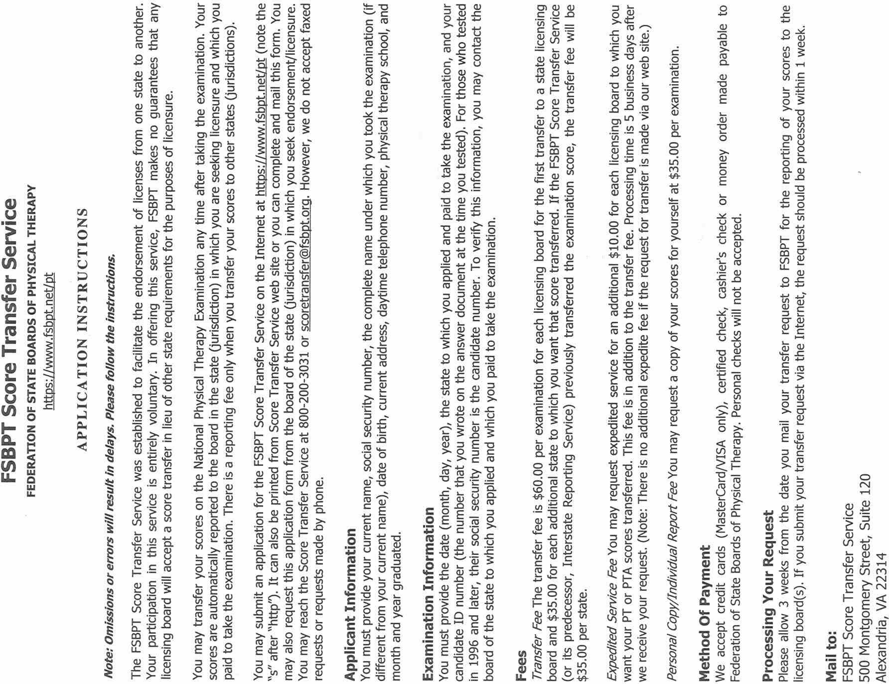

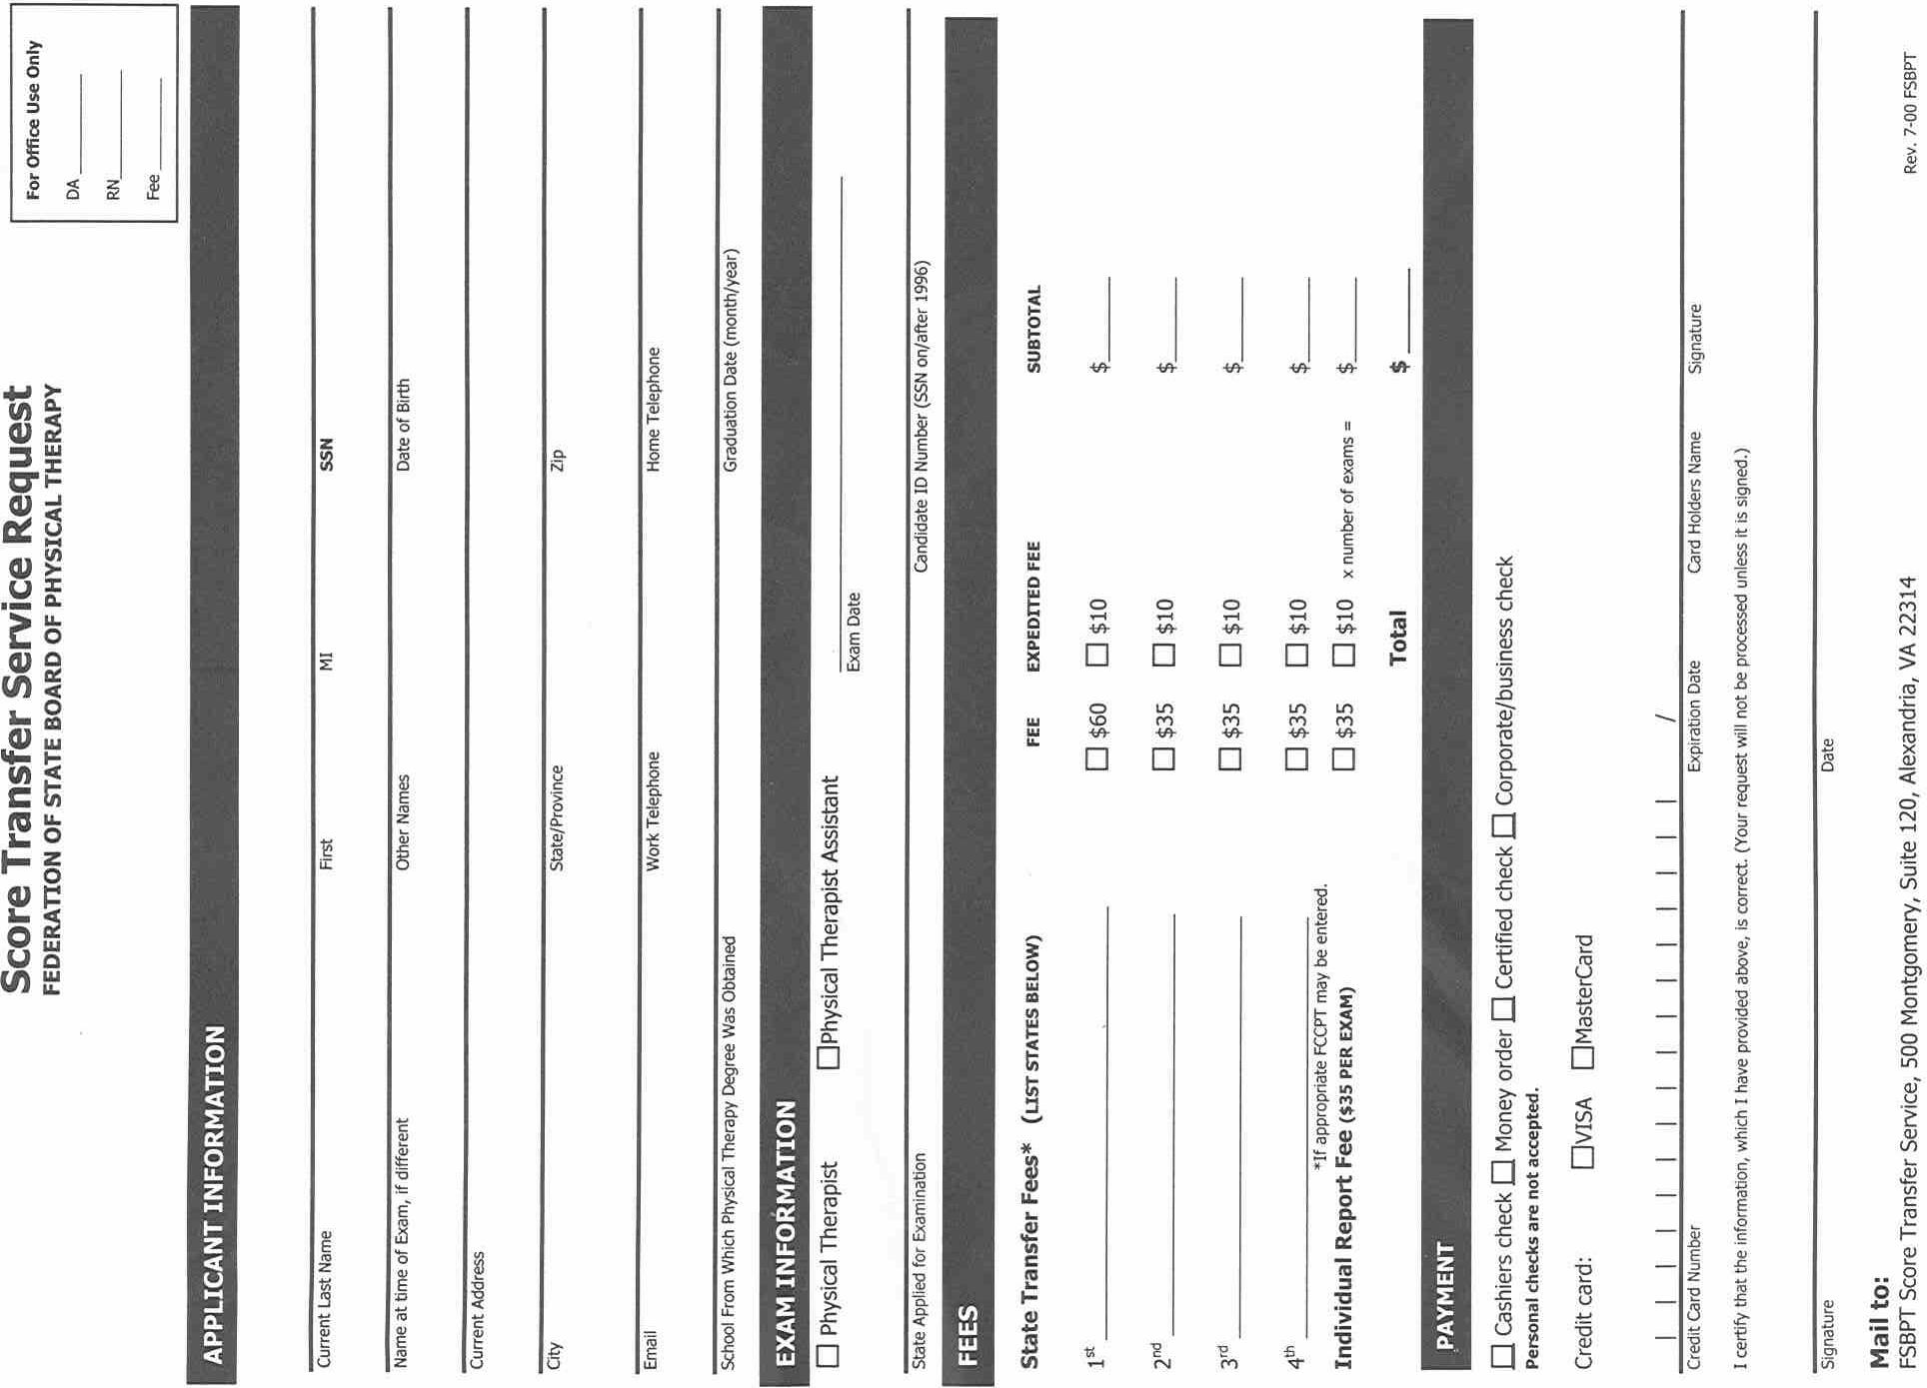
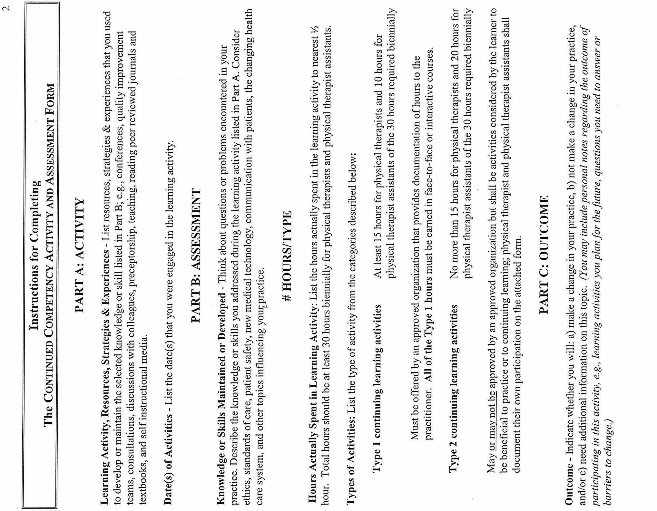

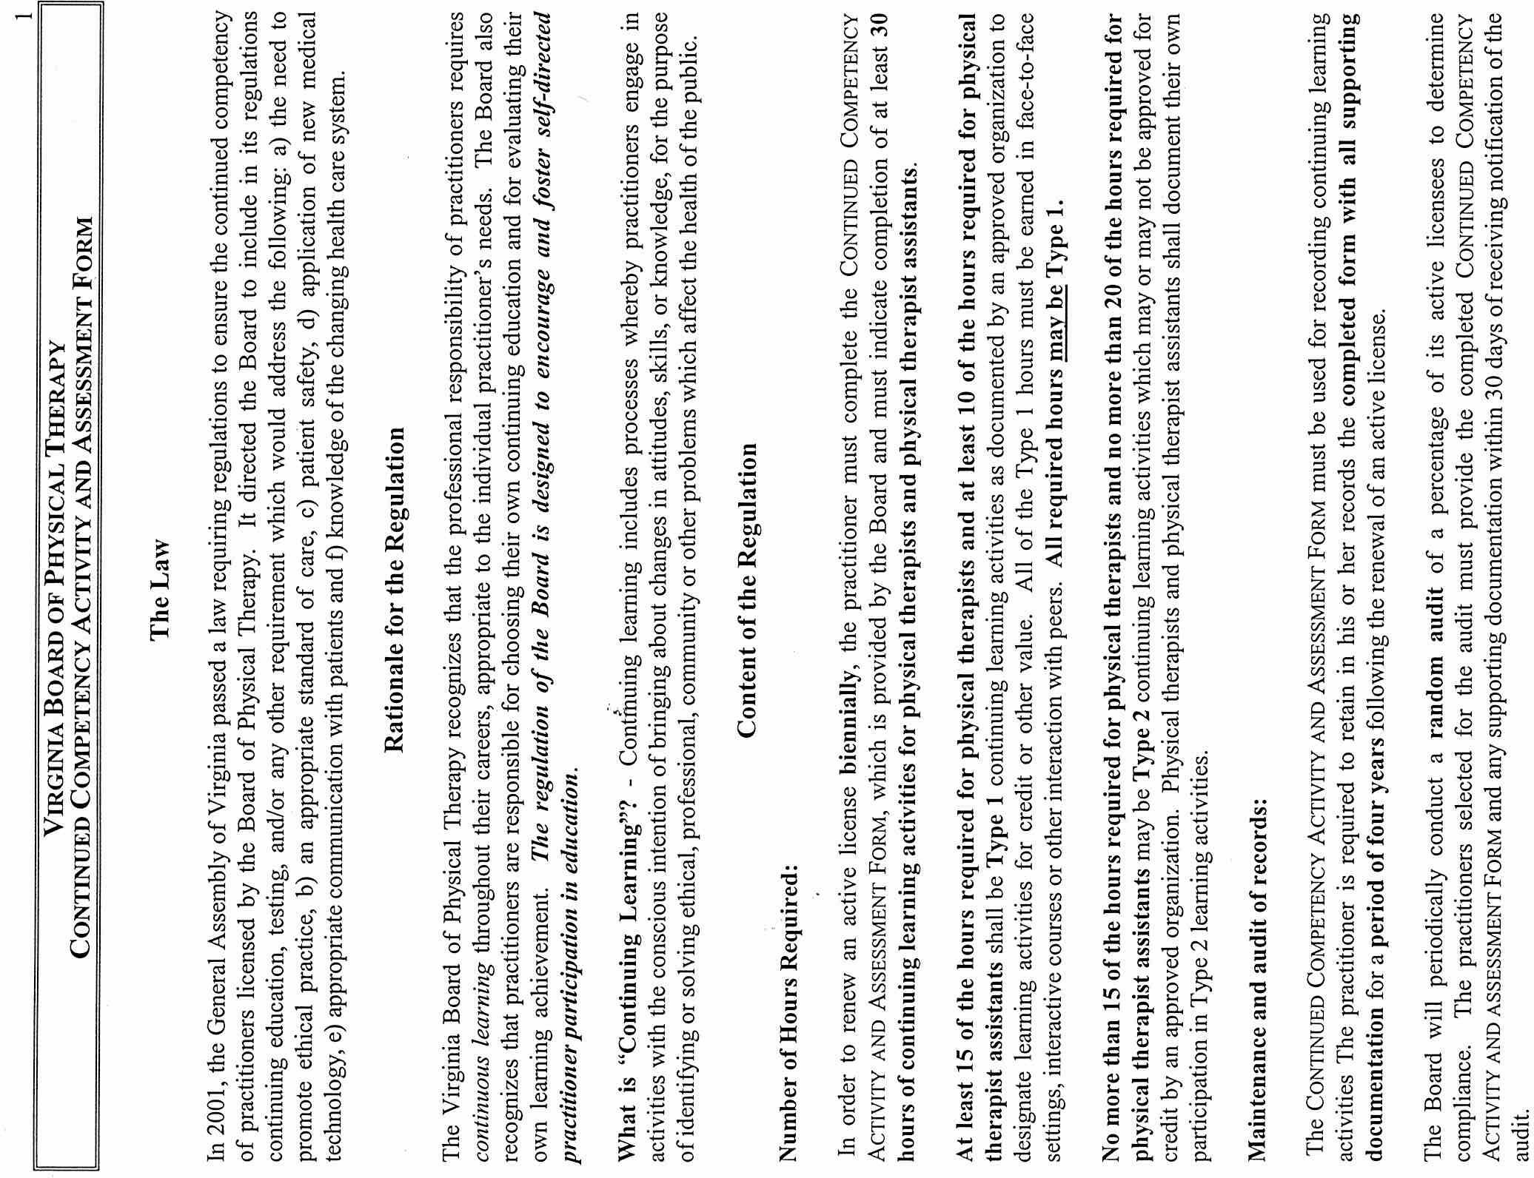
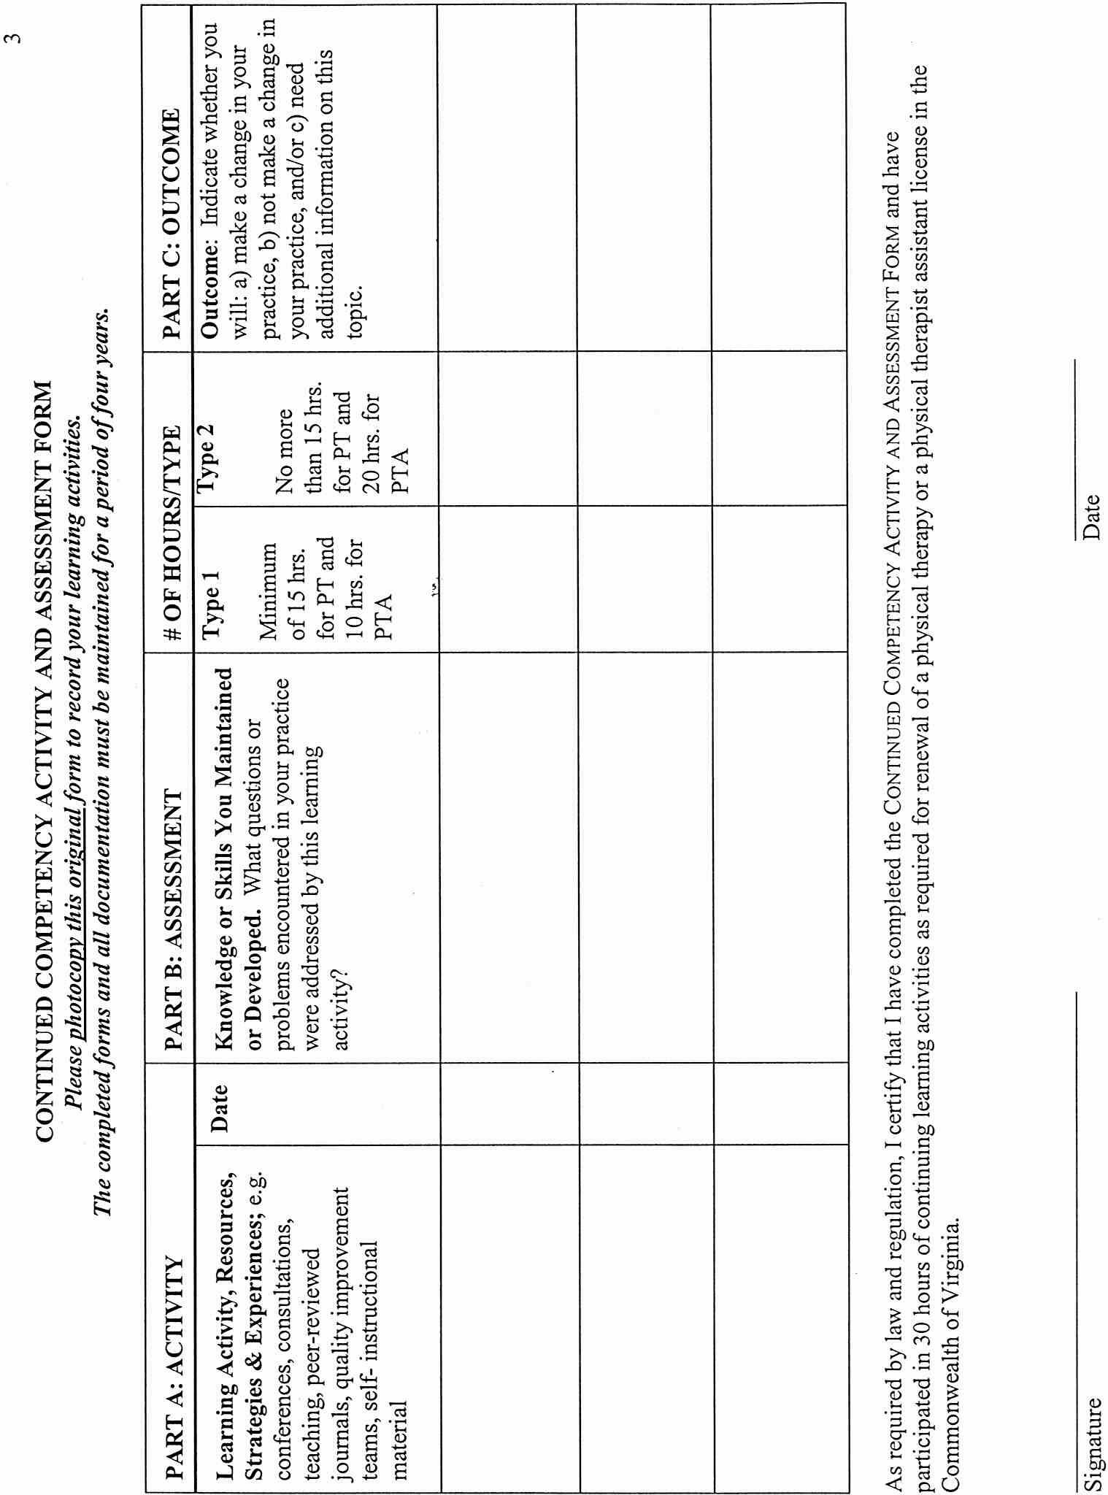
VA.R. Doc. No. R02-29; Filed May 1, 2002, 10:41 a.m.

1 Opportunities for continuing education hours include courses offered during the Virginia Physical Therapy Association (VPTA) annual conference ($300 for 15 to 18 hours CE) and courses offered by medical facilities (e.g. the regional medical center in the Harrisonburg area offers 11.5 hour courses for $200).

