BOARD OF NURSING
Title of Regulation: 18 VAC 90-50. Regulations Governing the Certification of Massage Therapists (amending 18 VAC 90-50-10, 18 VAC 90-50-40, 18 VAC 90-50-50, 18 VAC 90-50-70, 18 VAC 90-50-80, and 18 VAC 90-50-90; adding 18 VAC 90-50-75; repealing 18 VAC 90-50-60).
Statutory Authority: §§ 54.1-2400, 54.1-103 and 54.1-3005 of the Code of Virginia.
Public Hearing Date: July 16, 2002 - 1:45 p.m.
Public comments may be submitted until August 31, 2002.
(See Calendar of Events section
for additional information)
Agency Contact: Elaine J. Yeatts, Agency Regulatory Coordinator, Department of Health Professions, 6606 W. Broad Street, Richmond, VA 23230, telephone (804) 662-9918, FAX (804) 662-9114 or e-mail elaine.yeatts@dhp.state.va.us.
Basis: Section 54.1-2400 of the Code of Virginia establishes the general powers and duties of health regulatory boards including the responsibility to promulgate regulations, levy fees, administer a licensure and renewal program, and discipline regulated professionals.
Section 54.1-103 of the Code of Virginia authorizes health regulatory boards to impose additional requirements on certificate holders seeking renewal.
Chapter 30 (§ 54.1-3000 et seq.) of Title 54.1 of the Code of Virginia authorizes the Board of Nursing to regulate massage therapists.
Purpose: The purpose of the amended regulation is to clearly state in regulation the qualifications necessary for a person to become certified as a massage therapist and the requirements necessary to demonstrate continuing competency. The qualifications for initial certification are set forth in the Code of Virginia, but the board determined that persons practicing massage therapy are still uncertain or unaware of the need to be certified. Therefore, it is proposed that the requirements be specified in regulation and that the provisions for "grandfathering" be deleted since those avenues to certification expired in June of 1998. It has not been required for certification by endorsement that applicants have credentials substantially equivalent to those required in Virginia. Without such a regulation, the board had no criteria on which to base a decision on endorsement, so it was possible for less qualified individuals to become certified in Virginia. To assure the public that massage therapy is being delivered ethically and competently by persons certified by the board, regulations must consistently provide minimal education and examination standards.
As an emerging profession, massage therapy is being utilized more and more for therapeutic purposes to alleviate the symptoms of disease or injury. Patients are seeking relief from symptoms of fibromyalgia, cancer, arthritis and other conditions. It is essential for public safety for massage therapists to remain current in their knowledge and technique to appropriately treat consumers and to be able to recognize the indications that a person should be referred to a health care practitioner. Virginia requires only 500 hours of education for certification whereas some states have adopted 1,000 hours as the minimum requirement. In addition, many massage therapists were initially certified under a "grandfather" provision that required only 200 hours of training and practice or 20 hours of training and at least 10 years of practice prior to July 1, 1997. Since the initial education of a certified massage therapist may have been minimal, the Massage Therapy Advisory Committee with the board’s concurrence recommended some evidence of continuing competency for renewal of certification as means of protecting the public health and safety.
Substance: Amendments specify in regulation the qualifications for certification that are currently in the Code of Virginia and delete the provisions for "grandfathering" that are no longer applicable. The amendments clarify that to be certified by endorsement, a massage therapist must have met requirements substantially equivalent to those in Virginia. An unnecessary section on provisional certification is repealed. If a person practices massage therapy without using the designation of "massage therapist" or "certified massage therapist, " he may do so without certification by the board; so there is no need for provisional certification.
The board proposes as a condition of renewal that massage therapists demonstrate evidence of continuing competency by holding current certification from the National Certification Board for Therapeutic Massage and Bodywork, the credentialing body for the profession, or complete at least 25 hours of continuing education or learning activities within the biennium. Finally, the Standards of Practice and the Code of Ethics of the NCBTMB are incorporated by reference into this chapter.
Issues: Issues in the regulation of massage therapists and the alternatives to dealing with those issues were addressed by the Massage Therapy Advisory Committee and the board as follows:
1. Limitations of certification. The major issue for massage therapy in Virginia involves the potential risk to the public of massage therapy services being delivered by persons with little or no training and no regulatory oversight. Legislation passed in 1997 instituted a certification program with title protection for "massage therapist" or "certified massage therapist." Certification does not ensure that an insufficiently trained person cannot perform the service; it only protects the use of certain titles. Therefore, experience has shown that persons with considerably less training have adopted other titles, such as "massage therapy practitioner" and are engaged in practicing massage therapy on the public.
There were a number of alternatives discussed by the committee, none of which involve a change in regulations since this is primarily a statutory issue. Without a change in the Code, the board has no authority to restrict the practice of massage therapy to only those persons it certifies. The Code would need to be amended to provide for licensure or mandatory certification for the practice of massage therapy, as it is currently defined in § 54.1-3000 of the Code of Virginia. A legislative initiative is not being recommended by the Board of Nursing at this time, but may be undertaken by other interested parties. In addition, massage therapists are working with the localities to restrict the practice of massage therapy to those persons who hold certification from the Board of Nursing. That has already occurred in the City of Richmond, and the effort to expand those restrictions is underway.
2. Continuing competency requirements. Comments received on the periodic review raised the issue of continuing competency for practitioners. Massage therapists, as with other health care practitioners, need to learn new information and techniques in order to remain minimally competent to treat the public. Massage therapists benefit from learning experiences that improve their skills, further their knowledge about the clinical indicators that suggest a referral to a physician, and remind them of ethical dilemmas. In the opinion of the advisory committee and others in the profession, the basic 500-hour course required for certification is not adequate to ensure that a practitioner continues to be competent throughout his profession.
Alternatives discussed include:
a. Continued certification or recertification by the national certifying body, the National Certification Board for Therapeutic Massage and Bodywork. Continued certification requires 50 hours of continuing education, both approved and nonapproved courses, over a four-year period.
b. Hours of continuing education similar to that required by the certifying agency or 25 hours for each biennial renewal cycle. A further issue with this alternative would be the determination of approved courses. To avoid having the board become the accrediting body for all continuing education in massage therapy, regulations would need drafted to recognize the NCBTMB or other credentialing bodies.
c. Other types of learning experiences or requirements that would provide some assurance that certified massage therapists continue to be minimally competent. That could include practical experience, re-examination, or self-directed learning.
It was suggested that NCBMTB recertification be the standard for demonstrating continuing competency, but the board determined that other alternatives must be available for those who had allowed their national certification to lapse or had been initially certified by the board without NCBMTB certification. Based on review of the requirements of NCBMTB, the board determined that a combination of the alternatives was the most reasonable and least burdensome approach. Regulations offer the massage therapist a variety of options including recertification by either retesting or acquiring continuing education or participation in approved and nonapproved CE courses or activities.
3. Type and amount of continuing competency requirements. It was suggested during comment on the regulations that the board adopt one standard for demonstrating continuing competency for those who held NCBMTB certification and another standard for those who were certified with lesser credentials during the "grandfathering" period prior to 1998. Such a differential standard would be impossible to enforce without tagging the records of all certified therapists with some indication of their credentials for certification. That methodology has never been adopted by the board and would discriminate against those who are legitimately certified, albeit by a less stringent standard. Therefore, the board chose to offer options for recertification or CE, based on what the practitioner determines is the most advantageous method for maintaining his skills and competencies.
The massage therapist who holds national certification by NCBTMB may choose to maintain that certification that would suffice to demonstrate continued competency for renewal of a Virginia certificate. He may do so by acquiring 50 hours of CE over a four-year period - half in Category A from approved sponsors and half in Category B from nonapproved sponsors. He also has the option of being recertified by NCBTMB by retesting to determine currency in massage technique and knowledge.
For those who do not want to recertify with NCBTMB, the board requires 25 hours divided into two types: (i) in Category A continuing learning activities, the 12.5 hours required biennially must be offered by a sponsor or organization that is sanctioned by the NCBTMB and that provides documentation of hours to the practitioner; and (ii) in Category B continuing learning activities, a maximum of 12.5 hours earned biennially may or may not be offered by an approved sponsor or organization but must be activities that expand the skills and knowledge related to the clinical practice of massage therapy; certificate holders document and record their own participation. Examples of Category A activities would be conferences, workshops, home study, video or computer programs with a required examination. Category B activities may include formal programs by nonapproved sponsors, teaching or authoring an article.
The NCBTMB requires two hours of professional ethics during each four-year certification period. The board believes that ethical principles are essential for public health and safety in the practice of massage therapy. Topics such as boundary issues, client confidentiality, and legal guidelines are accepted for hours in ethics and may be incorporated into other courses, provided there is documentation from the provider stating the amount of time that was devoted to the topic.
Advantages to massage therapists. The proposed continuing competency requirements are intended to provide some assurance to the public that certified massage therapists are maintaining current knowledge and skills, while providing the maximum amount of flexibility and availability to certificate holders. Massage therapists believe that many of their colleagues are currently certified by NCBTMB or already engage in enough learning activities to meet the requirements and should only have to maintain documentation of those activities and hours. Half of the 25 hours may be earned by the practitioner on his own time and schedule and may be hours that are useful to the therapist but not accredited or documented by an organization. The resources for earning the hours and engaging in the required learning are numerous and readily available in all parts of Virginia.
Disadvantages to massage therapists. For those practitioners who do not currently engage in any continuing learning in their profession, these requirements will represent an additional burden. While opportunities for obtaining continued competencies exist that are at a minimal cost, there will be some additional expense associated with renewal of a certificate. However, it was determined by enactment of the statute and by the board’s concurrence that those practitioners and their patients would greatly benefit from continuing learning requirements, and that the public is better protected if there is some assurance of that effort.
Advantages or disadvantages to the public. There are definite advantages of the proposed amended regulations to the public, who will have greater assurance that the massage therapists certified by the board are engaged in activities to maintain and improve their knowledge and skills in providing care to their patients. There are also definite advantages to the public that at least one hour in ethics is required as a part of the continuing education. That requirement coupled with the Standards of Practice and Code of Ethics incorporated by reference will give the public assurance that persons who hold the title of certified massage therapist have a high standard by which they should conduct their practice.
Advantages or disadvantages to the agency. As with the regulation of other health professions, there is some additional burden for the department in administering a continuing education requirement. After each renewal cycle, there may be an audit of a percentage of the certificate holders, who will be required to submit documentation of compliance. Those documents (NCBTMB certification, certificate of completion from a provider, or transcript from a massage therapy education program) must be reviewed to determine hours of completion in each category. For those who are found out of compliance or who have not indicated compliance on their renewal form, some remedial action will be required. If the practitioner fails to comply with requirements within a given time frame, a disciplinary action will begin.
Department of Planning and Budget's Economic Impact Analysis: The Department of Planning and Budget (DPB) has analyzed the economic impact of this proposed regulation in accordance with § 2.2-4007 G of the Administrative Process Act and Executive Order Number 25 (98). Section 2.2-4007 G requires that such economic impact analyses include, but need not be limited to, the projected number of businesses or other entities to whom the regulation would apply, the identity of any localities and types of businesses or other entities particularly affected, the projected number of persons and employment positions to be affected, the projected costs to affected businesses or entities to implement or comply with the regulation, and the impact on the use and value of private property. The analysis presented below represents DPB’s best estimate of these economic impacts.
Summary of the proposed regulation. The Board of Nursing is proposing to (i) incorporate in the regulation the statutory requirements on initial certification for massage therapists and delete the obsolete "grandfathering" rule currently included in the regulations, (ii) establish continuing education requirements for certification renewal, (iii) change requirements for licensure by endorsement, and (iv) delete the provisional certification requirements.
Estimated economic impact. The qualifications for initial certification for massage therapy are established in § 54.1-3029 of the Code of Virginia. The code specifies two ways for certification. The first way is obtaining at least 500 hours of training from an approved program and passing the national certification exam. In addition to that, the Board of Nursing (the board) may have certified an applicant before July 1998, (a) who had completed 200 hours of training and had been practicing massage therapy prior to July 1, 1997, (b) who had completed 20 hours of training and had had at least 10 years of practice prior to July 1, 1997. The second way, known as the "grandfathering" rule, expired in June 1998. Although expired, the current regulations still contain a list of the requirements in the regulation for certification through this rule. Also, the current regulations do not list the original qualifications for certification, but only reference the Code of Virginia. According to the Department of Health Professions (the agency), this has been creating some confusion among the applicants. Although the qualifications for certification are included in the Code of Virginia, some of the applicants have been falsely assuming that the current certification requirements were those listed in the regulations for certification under the obsolete grandfathering rule.
The proposed amendments will add in the regulations the qualifications for certification that are in the Code of Virginia and delete the provisions for the grandfathering rule that are no longer valid. Also, new language is added to clarify that those persons who had fulfilled the criteria for certification under the grandfathering rule must have submitted an application to the board prior to June 30, 1998. These proposed changes will likely improve the clarity of the regulation and reduce the confusion on the eligibility criteria.
Another proposal will establish continuing education requirements for certification renewal. According to the agency, massage therapy is an emerging profession and being utilized more and more for therapeutic purposes to alleviate the symptoms of disease or injury. Massage therapy is known to provide relief from symptoms of fibromyalgia, cancer, arthritis, and other health conditions.1 Because of its widespread use and the potential effects on customer’s health, the board believes that it is important for massage therapists to remain current in their knowledge and techniques to appropriately treat consumers and to be able to recognize the indications that a person should be referred to a health care practitioner. Additionally, current initial certification requirements and the requirements for certification under the grandfathering rule are believed to be significantly less than what may be appropriate. For example, the agency indicates that Virginia requires only 500 hours of education for certification whereas some states have adopted 1,000 hours as the minimum requirement. The requirements for certification under the grandfathering rule were even lower. The advisory committee that suggested the proposed changes determined that qualifications for initial certification are not adequate to ensure continuous competency throughout a therapist’s practice.
Since the initial education of a certified massage therapist is believed to have been minimal, the board is proposing to establish new continuing education requirements to keep the massage therapists updated in their professional knowledge. The proposed amendments will offer two options to satisfy the continuing education requirements, which will allow the practitioner to choose the preferred method for maintaining his skills and competencies. The board is proposing as a condition of renewal that massage therapists demonstrate evidence of continuing competency by holding a current certification from the National Certification Board for Therapeutic Massage and Bodywork (NCBTMB), the credentialing body for the profession, or complete at least 25 hours of continuing education or learning activities within the biennium. According to the agency, the combination of these two alternatives was the most reasonable alternative.
As mentioned, one way to satisfy the proposed continuing education requirements is to hold a current certification from NCBTMB. This certification is maintained current if a therapist obtains 50 hours of continuing education over a four-year period, which means 25 credit hours for each biennium on average. Maintaining NCBTMB certification does not require an overall exam, but there may be a post-test following a continuing education course on the material covered in the class. This option is likely to be used by those who already hold NCBTMB certification. Maintaining the national certification will suffice to demonstrate continued competency for renewal of a Virginia certificate. Under this option, therapists may satisfy the proposed requirement by taking half of the required 25 hours of credits from approved sponsors and the other half from nonapproved sponsors. The therapist also has the option of being recertified by NCBTMB through retesting to determine adequacy of current knowledge in massage techniques and knowledge.
Another way to fulfill the continuing education requirement is to obtain 25 hours of education every biennial renewal cycle from other providers. This option is likely to be chosen by those who do not want to be certified by NCBTMB. This may include therapists who were initially "grandfathered" without national certification, or those who have allowed the national certification to lapse. Similar to the first option, half of the required hours can be completed at an approved institution and the other half can be fulfilled by various other ways that does not require approval. The credits offered primarily for NCBTMB certification may also be used under this option. At least 12.5 hours must be offered by a sponsor or an organization approved by NCBTMB and documentation of hours must be provided to the practitioner. Examples of activities for the first half of the required credits are conferences, workshops, home study, video, or computer programs with a required examination. For the remaining part, up to 12.5 hours can be earned in a variety of different ways. These credits may or may not be taken from an approved sponsor or organization, but must be activities that expand the skills and knowledge related to the clinical practice of massage therapy, and the certificate holder must document and record their own participation. Examples of the activities in this category include formal programs by nonapproved sponsors, teaching or authoring an article, practical experience, or self-directed learning. These activities promote learning in the profession but may not be accredited. The board is also proposing to accept credit for the courses on ethics and incorporate the regulations on ethical standards by reference. Topics such as boundary issues, client confidentiality, and legal guidelines will be accepted for hours in ethics and may be incorporated into other courses provided there is documentation from the provider stating the amount of time devoted. The main difference between the two options is that courses are offered as a package for NCBTMB certification whereas the therapists are responsible for making the arrangements for each credit to renew their certification through the second method.
The proposed continuing education requirements will impose additional costs on some massage therapists. These courses may be offered by Virginia chapters of the American Massage Therapy Association, NCBTMB, and other professional organizations. There will be dollar costs associated with acquiring the required credits. For example, an all-day ethics workshop and a workshop on arms, hands, and carpal tunnel were offered at an average cost of about $13 per credit hour.2 This suggests that fulfilling the continuing education requirement may cost up to $325 for an individual therapist and $824,200 for all of the therapists in Virginia every two years.
Another and more significant cost of the proposed continuing education requirements is the opportunity cost of the therapist’s time devoted to take the credits. The opportunity cost concept may not be as obvious as the other types of costs at first; nonetheless, it must be accounted for. In simple terms, the opportunity cost of something is the next best thing given up for it. Just like everyone else, the therapists make decisions on how many hours to work and how many hours to reserve as leisure time. The opportunity cost of an hour of leisure is one hour of work, or equally one hour of wages given up. Since the proposed regulations will reduce the amount of therapists’ work or leisure hours by an amount equal to fulfill the required continuing education credits, these work or leisure hours given up must be counted as additional costs and can be valued at the therapist’s wage rate.
The proposed amendments will require that each therapist devote 25 hours to continuing education every biennium, which add up to 63,400 hours of therapy time in the state. The therapists will have to either give up an equal amount of work hours, leisure time, or a combination of both. The ongoing rate for an hour of massage therapy is about $45 to $50 in less populated areas and may be about $70 to $80 in cities.3 Since both work hours and leisure time can be valued in terms of lost wages, the opportunity cost of the proposed requirement for massage therapists is estimated to be between $3 million and $4.7 million per biennium.
However, these estimates are likely to significantly overstate the additional costs to therapists and should be regarded only as potentially the highest costs because many therapists have already been continuously involved in a variety of activities as a part of their profession and will likely get credits for those activities. The agency believes that many therapists already engage in enough learning activities to meet the requirements and should only have to maintain documentation of those activities and hours. Half of the required hours may be earned by the practitioner on his own time and schedule and may be hours that are useful to the therapist but not accredited or documented by an organization. The agency believes that the resources for earning the hours and engaging in the required learning are numerous and readily available in all parts of Virginia. Thus, the proposed regulations will impose additional costs on only those practitioners who do not currently engage in enough continuing learning in their profession. Since the number of therapists who do not engage in activities that may be counted as credit is not known, the amount of actual costs to therapists cannot be determined. In short, while some of the current activities of a large number of therapists may be counted toward the required continuing education credits at minimal or no additional cost, there will be additional expenses associated with renewal of a certificate for some therapists.
Furthermore, therapists who choose to keep NCBTMB certification current will incur an additional $50 for each biennium in recertification fees. This is in addition to the costs of obtaining credits. Since it is not known how many therapists will utilize this option, the total costs to some regulants in NCBTMB recertification fees cannot be determined.
There will also be recordkeeping requirements. With the promulgation of these regulations, the board will send each certificate holder the required form for maintenance of records. The form is a checklist for the agency and the massage therapist to indicate completion of the required hours. It is a chart showing the type of activity or class, whether it is earned toward the first or the second category of the continuing education requirements, and the number of hours obtained. Since a certificate is unlikely to be issued for some credits, the form will be a way to document those credits. The form will be available on the board’s website and may be downloaded into the individual’s personal computer. The massage therapist will have to maintain that form and the documentation of continuing learning activities for a period of four years. Thus, some very minimal costs involved with maintaining records of continuing education credits are expected, but the form will also facilitate documenting the credits that may not otherwise be documented.
There will be some additional costs for the agency in administering the continuing education requirement. After each renewal cycle, about 1% to 2% of the certificate holders will be audited. An audit procedure is needed to enforce compliance because the agency uses an electronic system to issue renewals without receiving any physical documents. The applicant only has to claim that he/she completed the continuing education requirements. The audits will be done at the agency without any travel because each practitioner selected for the audit will be required to submit the required documentation of continuing learning activities. Those documents including NCBTMB certification, certificate of completion from a provider, or transcript from a massage therapy education program will be reviewed to determine hours of completion in each category. There will be some staff time involved in review of the documentation and in communicating with certified massage therapists about their deficiencies. A random audit can be completed in approximately 15 minutes. Current personnel will absorb the staff time required to conduct about 25 to 50 random audits every two years.
For those who are found out of compliance or who have not indicated compliance on their renewal form, some remedial action will be required. If the practitioner fails to comply with requirements within a given time frame, a disciplinary action will be initiated. It is expected that a small percentage of massage therapists selected for audit will result in a disciplinary case being opened. Cost estimates for disciplinary cases related to the failure to comply with continuing competency regulations range from $100 for a case resulting in pre-hearing consent orders to $500 per case for those that result in an informal conference committee. These costs are mainly in terms of travel expenses and per diem for the board members and the costs for the services provided by the agency to administer proceedings. The experience with similar programs at the agency indicates that about five to 10 cases per biennium will probably be settled with a pre-hearing consent order costing about $500-$1,000 to the agency. It is estimated that about one or two cases would result in an informal conference committee proceeding. This is expected to cost the agency an additional $500 to $1,000 per biennium.
On the benefits side, the proposed continuing competency requirements will provide some assurance that certified massage therapists are acquiring the most recent knowledge and skills, are updated about the clinical indicators that suggest a referral to a physician, and are aware of ethical considerations. Improved knowledge and skills may slightly reduce potential health risks to the customers seeking relief from various symptoms. For instance, therapists’ knowledge and their ability to identify certain diseases such as blood clots may be improved and appropriate therapy can be provided. The education requirements may also improve the service provided and reduce the number of customer complaints by a small margin. The agency received 8 complaints in 1999 and 17 complaints in 2000 that were related to practice of massage therapists. Furthermore, these education requirements may also help slightly reduce the number of cases that would otherwise occur. For example, some of the cases the agency investigated were related to sexual misconduct, unlicensed practice as a midwife, drugs, and indecent exposure.
Finally, it should be noted that "massage therapist" or "certified massage therapist" titles identify the therapists with and without a certification, and may signal the quality of service that will be provided. Given that the massage therapy can be practiced by anyone in Virginia as long as the reserved titles are not used, the option to signal the quality of service has an economic value. If everyone could use these titles, there would be no chance to differentiate between the two groups of therapists, and there would be no financial benefits from certification for massage therapists. This expected benefit is the main reason that some therapists choose to be certified even if the certification introduces additional costs. The proposed regulations will increase the costs for those therapists who wish to differentiate themselves from other therapists without a certification and likely increase the value of signaling. For those therapists who choose to incur additional costs to maintain their certification, the value of the option to signal the quality of their services must exceed the costs of obtaining continuing education credits.
With another amendment, the board is proposing to clarify that an applicant who is licensed or certified in another state or country must have met qualifications substantially equivalent to those currently required in Virginia. Currently, there is no such requirement. The board has no criteria on which to base a decision on endorsement. Consequently, it is currently possible for less qualified individuals to become certified in Virginia.
The proposed substantial equivalency requirement may introduce additional burden on some therapists moving to Virginia while making sure that more competent professionals are delivering massage therapy.
The last proposed amendment will remove the provisional certification. Under the current regulations, eligible candidates are allowed to practice provisional message therapy on a temporary basis. For example, an applicant may practice massage therapy for up to 90 days between completion of an education program and the receipt of the certification exam result. The current regulations also specify that massage therapist or certified massage therapist titles shall not be used during provisional certification. In practice, the provisional certification has never been used because anyone in Virginia can practice massage therapy as long as they do not use "massage therapist" or "certified massage therapist" titles. The statutory requirements protect these titles, but do not prohibit the massage practices under other titles. Since the massage therapist or certified massage therapist designation cannot be used during provisional certification anyway, there was no interest in obtaining a provisional certification. Since provisional certification has not been used in practice, the proposed elimination of provisional certification is not expected to have any significant economic impact.
Businesses and entities affected. The entities that are likely to be affected by the proposed regulations are 2,536 certified massage therapists.
Localities particularly affected. The proposed changes apply throughout the Commonwealth.
Projected impact on employment. Some of the therapists may not or may not be able to satisfy the proposed continuing education requirements due to additional costs and/or various other reasons. These therapists will not be able to renew their certification and practice massage therapy under the designated titles. Although most therapists may depend on being able to present themselves as a "certified massage therapist" as indicated by the agency, some of those who are not able to renew their certification can continue to practice massage therapy under other titles that are not designated. They may also seek employment and get jobs elsewhere. Furthermore, any potential negative impact on employment will likely be balanced by the increase in additional demand for continuing education providers.
Effects on the use and value of private property. To the extent that the proposed regulations introduce additional costs on massage therapy businesses and reduce their profitability, the value of their businesses may decline. However, the decline in value of massage therapy businesses is likely to be very minor as most of the therapists are believed to be currently involved in sufficient continuing education activities and are not expected to incur large costs to comply with the proposed requirements. On the other hand, providers of continuing education for massage therapists may see a small increase in their profits and, consequently, an increase in the value of their businesses to the extent the proposed regulations increase the demand for their services.
Agency's Response to the Department of Planning and Budget's Economic Impact Analysis: The Board of Nursing concurs with the analysis of the Department of Planning and Budget for 18 VAC 90-50.
Summary:
The proposed amendments address concerns about the competency of certificate holders by requiring recertification by the National Certification Board for Therapeutic Massage and Bodywork (NCBTMB) or the obtaining of at least 25 hours of continuing education in the biennium before renewal. The amendments further specify the requirements for licensure by endorsement, delete outdated "grandfathering" provisions and unnecessary rules for provisional certification, and incorporate by reference the code of ethics and standards of practice of the NCBTMB.
18 VAC 90-50-10. Definitions.
The following words and terms "board," "certified massage therapist" and "massage therapy," when used in this chapter, shall have the following meanings ascribed to them in § 54.1-3000 of the Code of Virginia. unless the context clearly indicates otherwise:
"Board" means the Board of Nursing.
"Category A" means continuing education courses or programs offered by an organization or individual approved as a provider by the NCBTMB.
"Category B" means continuing education courses, programs or experiences that are related to the clinical practice of massage therapy but which may not be offered by a provider approved by the NCBTMB.
"Certified massage therapist" means a person who meets the qualifications specified in this chapter and who is currently certified by the board. Only someone who is certified by the board as a massage therapist may use any designation tending to imply that he is a certified massage therapist or massage therapist.
"Massage therapy" means the treatment of soft tissues for therapeutic purposes by the application of massage and bodywork techniques based on the manipulation or application of pressure to the muscular structure or soft tissues of the human body. The terms "massage therapy" and "therapeutic massage" do not include the diagnosis or treatment of illness or disease or any service or procedure for which a license to practice medicine, nursing, chiropractic therapy, physical therapy, occupational therapy, acupuncture, or podiatry is required by law.
"NCBTMB" means the National Certification Board for Therapeutic Massage and Bodywork.
18 VAC 90-50-40. Initial certification.
A. An applicant seeking initial certification shall submit a completed application and required fee and verification of meeting the requirements of § 54.1-3029 A or B of the Code of Virginia. as follows:
1. Is at least 18 years old;
2. Has successfully completed a minimum of 500 hours of training from a massage therapy program, having received programmatic approval from the Virginia Board of Education, Division of Proprietary Schools, or been certified or approved by the Virginia Board of Education, Division of Proprietary Schools; the State Council of Higher Education; or an agency in another state, the District of Columbia or a United States territory that approves educational programs, notwithstanding the provisions of § 22.1-320 of the Code of Virginia;
3. Has passed the National Certification Exam for Therapeutic Massage and Bodywork or an exam deemed acceptable to the board leading to national certification; and
4. Has not committed any acts or omissions that would be grounds for disciplinary action or denial of certification as set forth in § 54.1-3007 of the Code of Virginia and 18 VAC 90-50-90.
B. An applicant who does not meet the education and examination requirements of § 54.1-3029 A of the Code of Virginia shall provide satisfactory evidence that the applicant:
1. Is at least 18 years old;
2. Has not committed any acts or omissions that would be grounds for disciplinary action or denial of certification as set forth in this chapter; and
3. Has competed at least 200 hours of training in a massage therapy education program as provided in § 54.1-3029 B of the Code of Virginia and has been practicing massage therapy prior to July 1, 1997, or has completed 20 hours of such training and has at least 10 years of practice in massage therapy, or has passed the National Certification Exam for Therapeutic Massage and Bodywork prior to 1994.
Applicants for certification under the provisions of § 54.1-3029 B of the Code of Virginia shall have met all requirements and paid the required fee prior to July 1, 1998. A completed application shall be postmarked on or before June 30, 1998.
B. No application for certification under provisions of § 54.1-3029 B of the Code of Virginia shall be considered unless submitted prior to July 1, 1998.
C. An applicant who has been licensed or certified in another country and who, in the opinion of the board, meets the educational requirements shall take and pass the national certifying examination as required in subsection A of this section in order to become certified.
18 VAC 90-50-50. Certification by endorsement.
A. A massage therapist who has been licensed or certified in another U.S. jurisdiction with requirements substantially equivalent to those stated in 18 VAC 90-50-40, and who is in good standing or is eligible for reinstatement, if lapsed, shall be eligible to apply for certification by endorsement in Virginia.
B. An applicant for certification by endorsement shall submit a completed application and required fee to the board and shall submit the required form to the appropriate credentialing agency in the state of original licensure or certification for verification. Applicants will be notified by the board after 30 days if the completed verification form has not been received from that state.
C. An applicant who has been licensed or certified in another country shall take a national certifying examination and become nationally certified as required by § 54.1-3029 of the Code of Virginia.
18 VAC 90-50-60. Provisional certification. (Repealed.)
A. An eligible candidate who has filed an application for certification in Virginia may practice massage therapy in Virginia for a period not to exceed 90 days between completion of the education program and the receipt of the results of the candidate's first certifying examination.
B. The designation of "massage therapist" or "certified massage therapist" shall not be used by the applicant during the 90 days of provisional certification.
C. An applicant who fails the certifying examination shall have his provisional certification withdrawn upon the receipt of the examination results and shall not be eligible for certification until he passes such examination and becomes nationally certified.
18 VAC 90-50-70. Renewal of certification.
A. Certificate holders born in even-numbered years shall renew their certificates by the last day of the birth month in even-numbered years. Certificate holders born in odd-numbered years shall renew their certificates by the last day of the birth month in odd-numbered years.
B. The certificate holder shall complete the application and return it with the required fee and attest that he has complied with continuing competency requirements of 18 VAC 90-50-75.
C. Failure to receive the application for renewal shall not relieve the certified massage therapist of the responsibility for renewing the certificate by the expiration date.
D. The certificate shall automatically lapse by the last day of the birth month if not renewed; and use of the title "massage therapist" or "certified massage therapist" is prohibited.
18 VAC 90-50-75. Continuing competency requirements.
A. In order to renew a certificate biennially on and after (insert date that is two years after the effective date of regulation), a certified massage therapist shall:
1. Hold current certification by the NCBTMB; or
2. Complete at least 25 hours of continuing education or learning activities with at least one hour in professional ethics. Hours chosen shall be those that enhance and expand the skills and knowledge related to the clinical practice of massage therapy and may be distributed as follows:
a. A minimum of 12.5 of the 25 hours shall be in Category A activities or courses provided by an NCBTMB-approved provider and may include seminars, workshops, home study courses, and continuing education courses.
b. No more than 12.5 of the 25 hours may be Category B activities or courses that may include consultation, independent reading or research, preparation for a presentation or other such experiences that promote continued learning.
B. A massage therapist shall be exempt from the continuing competency requirements for the first biennial renewal following the date of initial certification in Virginia.
C. The massage therapist shall retain in his records the completed form with all supporting documentation for a period of four years following the renewal of an active certificate.
D. The board shall periodically conduct a random audit of certificate holders to determine compliance. The persons selected for the audit shall provide evidence of current NCBTMB certification or the completed continued competency form provided by the board and all supporting documentation within 30 days of receiving notification of the audit.
E. Failure to comply with these requirements may subject the massage therapist to disciplinary action by the board.
F. The board may grant an extension of the deadline for continuing competency requirements, for up to one year, for good cause shown upon a written request from the certificate holder prior to the renewal date.
G. The board may grant an exemption for all or part of the requirements for circumstances beyond the control of the certificate holder, such as temporary disability, mandatory military service, or officially declared disasters.
18 VAC 90-50-80. Reinstatement of lapsed certificates.
A. A massage therapist whose certificate has lapsed may reinstate his certification within one renewal period by attesting to completion of continuing competency requirements for the period and payment of the current renewal fee and the late renewal fee.
B. A massage therapist whose certificate has lapsed for more than one renewal period shall file a reinstatement application, attest to completion of continuing competency requirements for the period in which the certificate has been lapsed, not to exceed four years, and pay the reinstatement fee.
C. A massage therapist whose certificate has been suspended or revoked may apply for reinstatement by filing a reinstatement application and paying the fee for reinstatement after suspension or revocation.
D. The board may require evidence that the massage therapist is prepared to resume practice in a competent manner.
18 VAC 90-50-90. Disciplinary provisions.
The board has the authority to deny, revoke or suspend a certificate issued by it or to otherwise discipline a certificate holder upon proof that the practitioner has violated any of the provisions of § 54.1-3007 of the Code of Virginia or of this chapter or has engaged in the following:
1. Fraud or deceit which shall mean, but shall not be limited to:
a. Filing false credentials;
b. Falsely representing facts on an application for initial certification, or reinstatement or renewal of a certificate; or
c. Misrepresenting one's qualifications including scope of practice.
2. Unprofessional conduct which shall mean, but shall not be limited to:
a. Performing acts which constitute the practice of any other health care profession for which a license or a certificate is required or acts which are beyond the limits of the practice of massage therapy as defined in § 54.1-3000 of the Code of Virginia;
b. Assuming duties and responsibilities within the practice of massage therapy without adequate training or when competency has not been maintained;
c. Failing to acknowledge the limitations of and contraindications for massage and bodywork or failing to refer patients to appropriate health care professionals when indicated;
d. Initiating or engaging in any sexual conduct involving a patient;
e. Falsifying or otherwise altering patient or employer records;
f. Violating the privacy of patients or the confidentiality of patient information unless required to do so by law;
g. Employing or assigning unqualified persons to practice under the title of "massage therapist" or "certified massage therapist"; or
h. Engaging in any material misrepresentation in the course of one's practice as a massage therapist.; or
i. Failing to practice in a manner consistent with the standards of practice and the code of ethics of the NCBTMB, as incorporated by reference into this chapter.
DOCUMENT INCORPORATED BY REFERENCE
NCBTMB National Certification Examination Candidate Handbook (eff. 8/00).
NOTICE: The forms used in administering 18 VAC 90-50, Regulations Governing the Certification of Massage Therapists, are listed below. Any amended or added forms are reflected in the listing and are published following the listing.
FORMS
Instructions for Filing Application for Certification as a Massage Therapist (rev. 10/00).
Application for Certification -- Massage Therapist (rev. 10/00 4/01).
Instructions for Filing Application for Certification as a Massage Therapist by Endorsement (rev. 10/00).
Application for Certification by Endorsement -- Massage Therapist (rev. 10/00).
Massage Therapist Certification/Licensure Verification Form (rev. 10/00).
Application for Reinstatement of Certificate as a Massage Therapist (rev. 1/99 4/01).
Renewal Notice and Application (rev. 10/00 6/02).
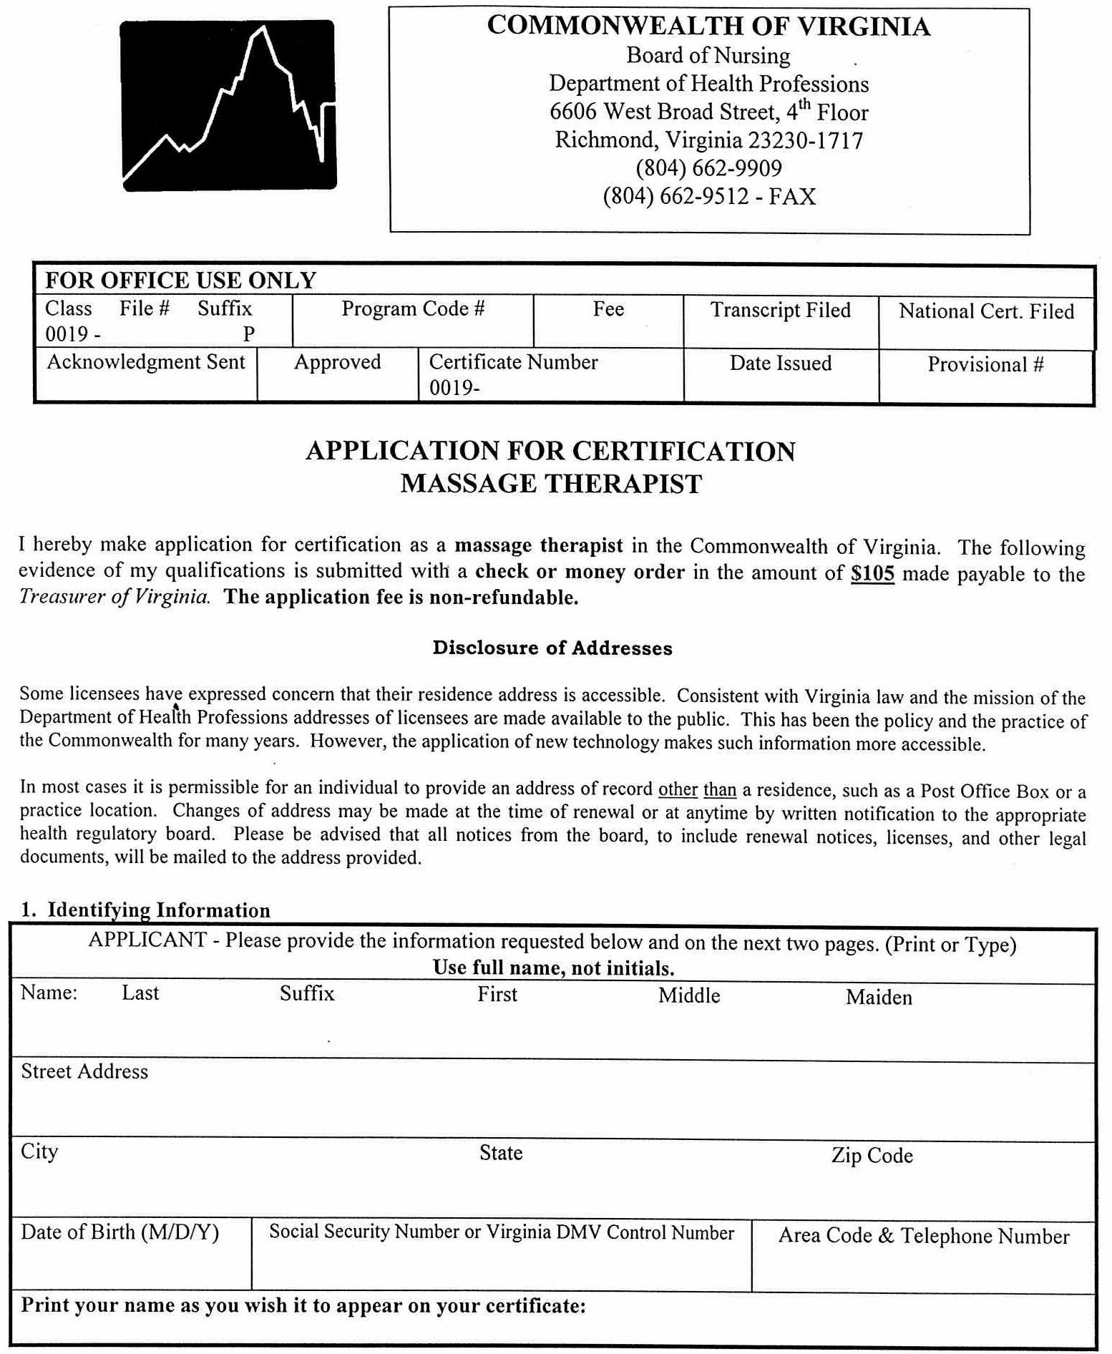
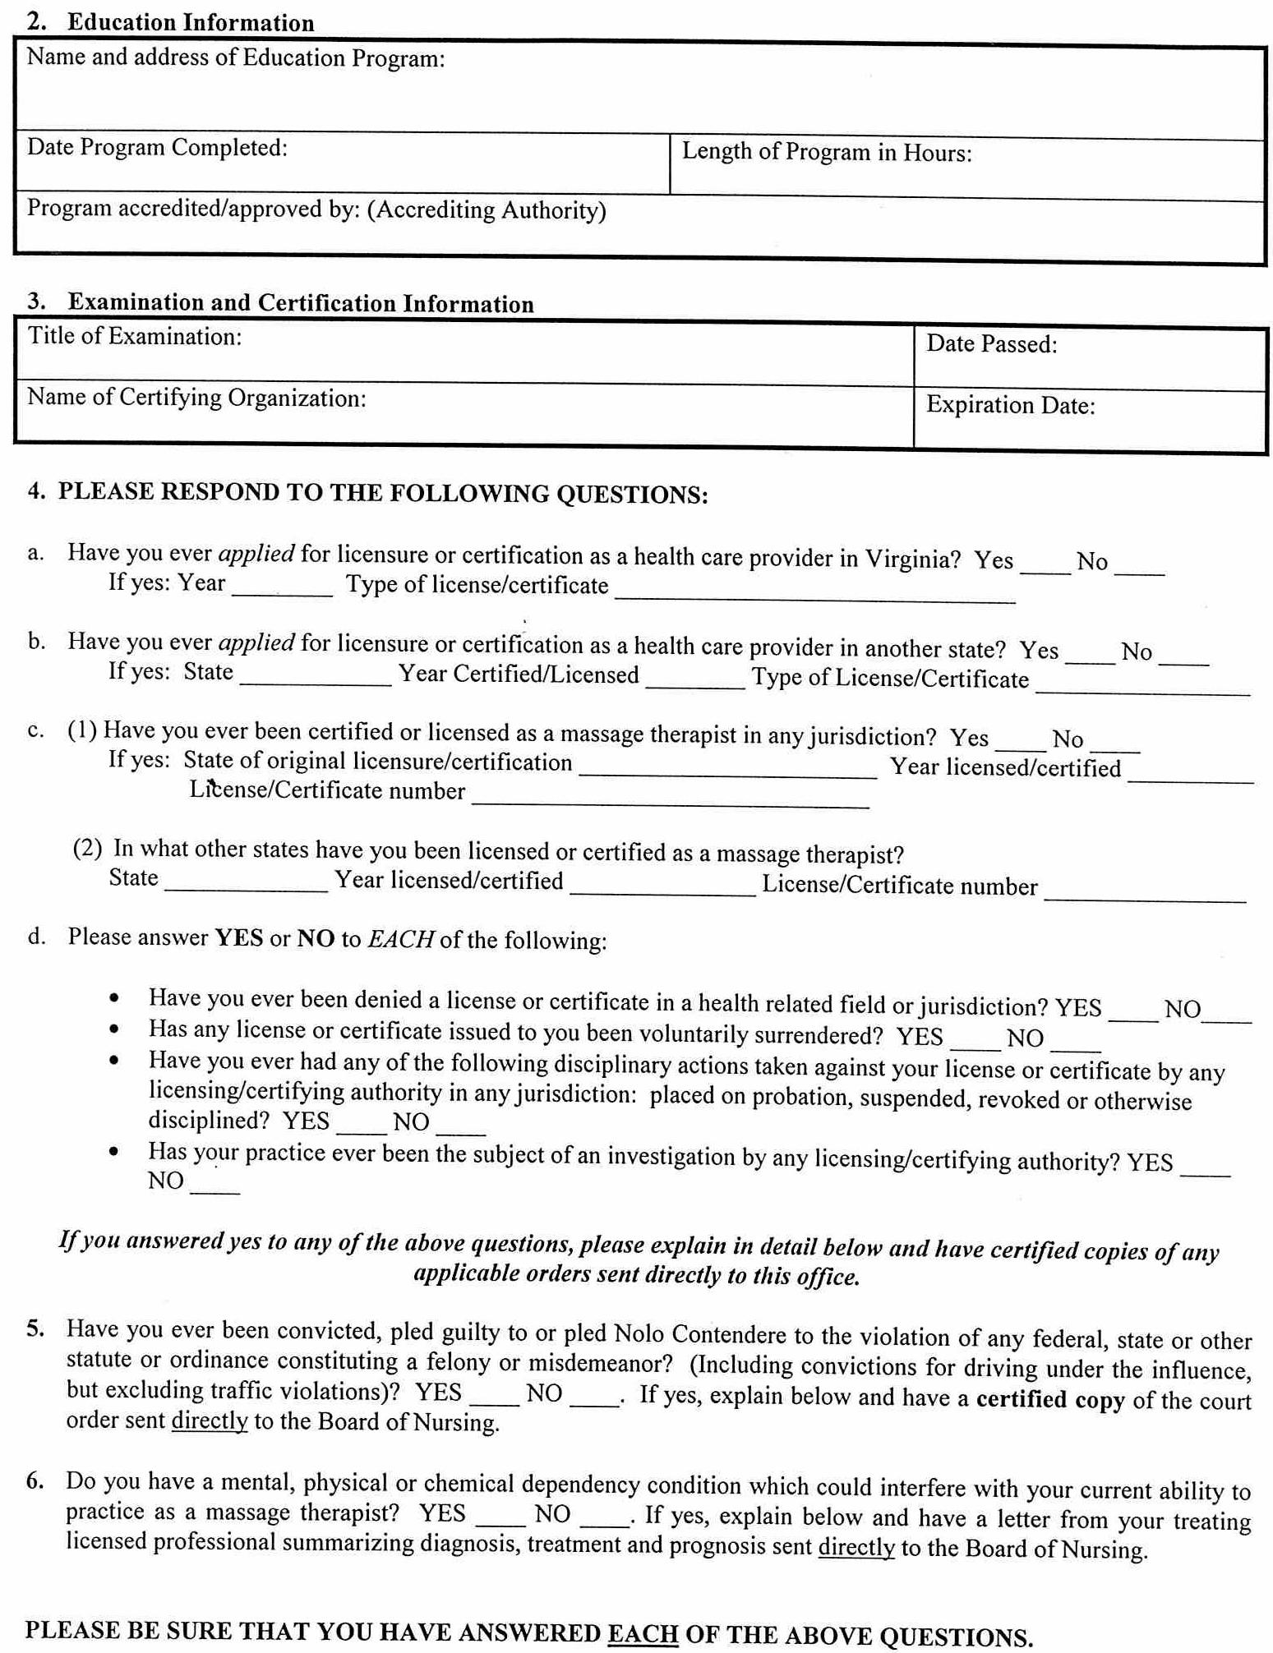
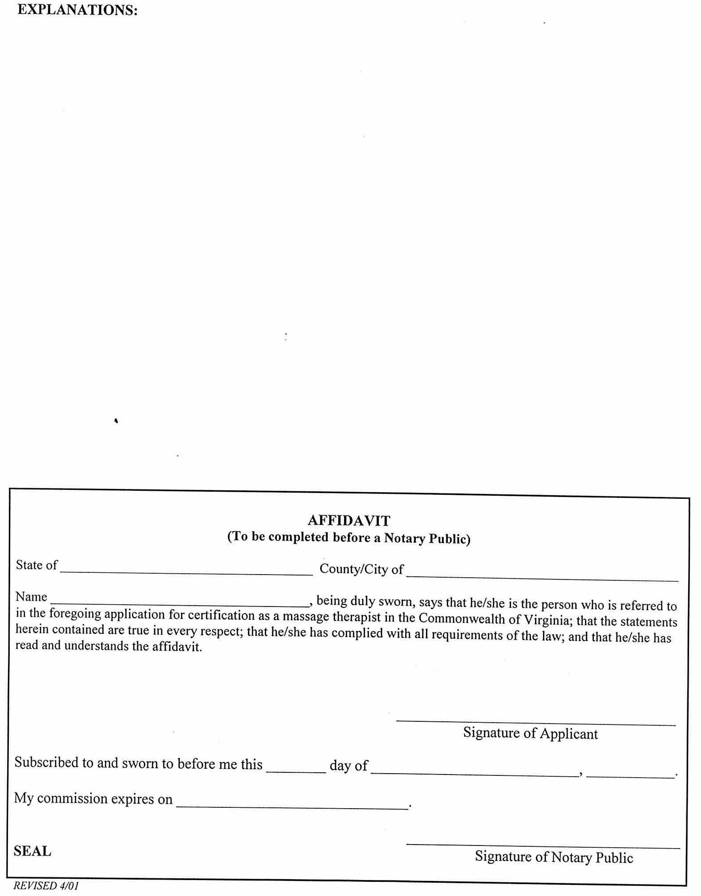
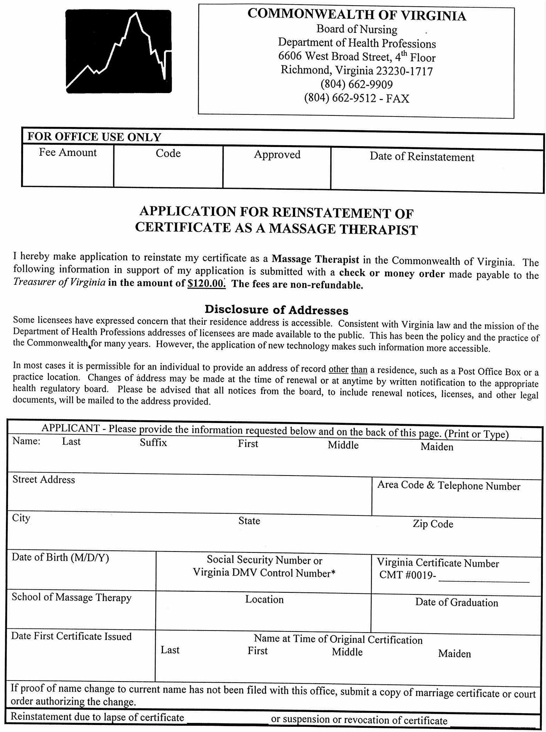
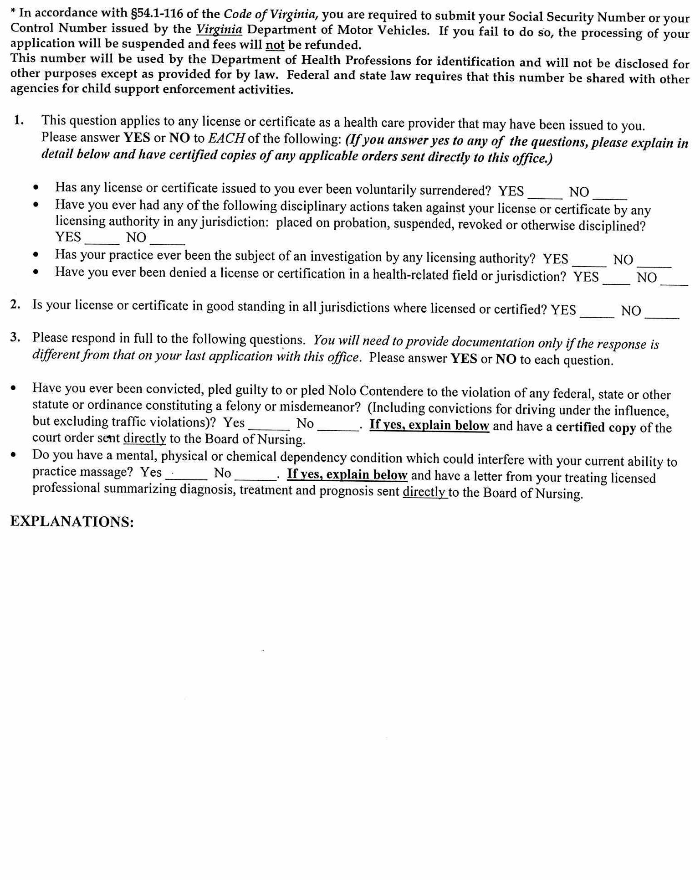
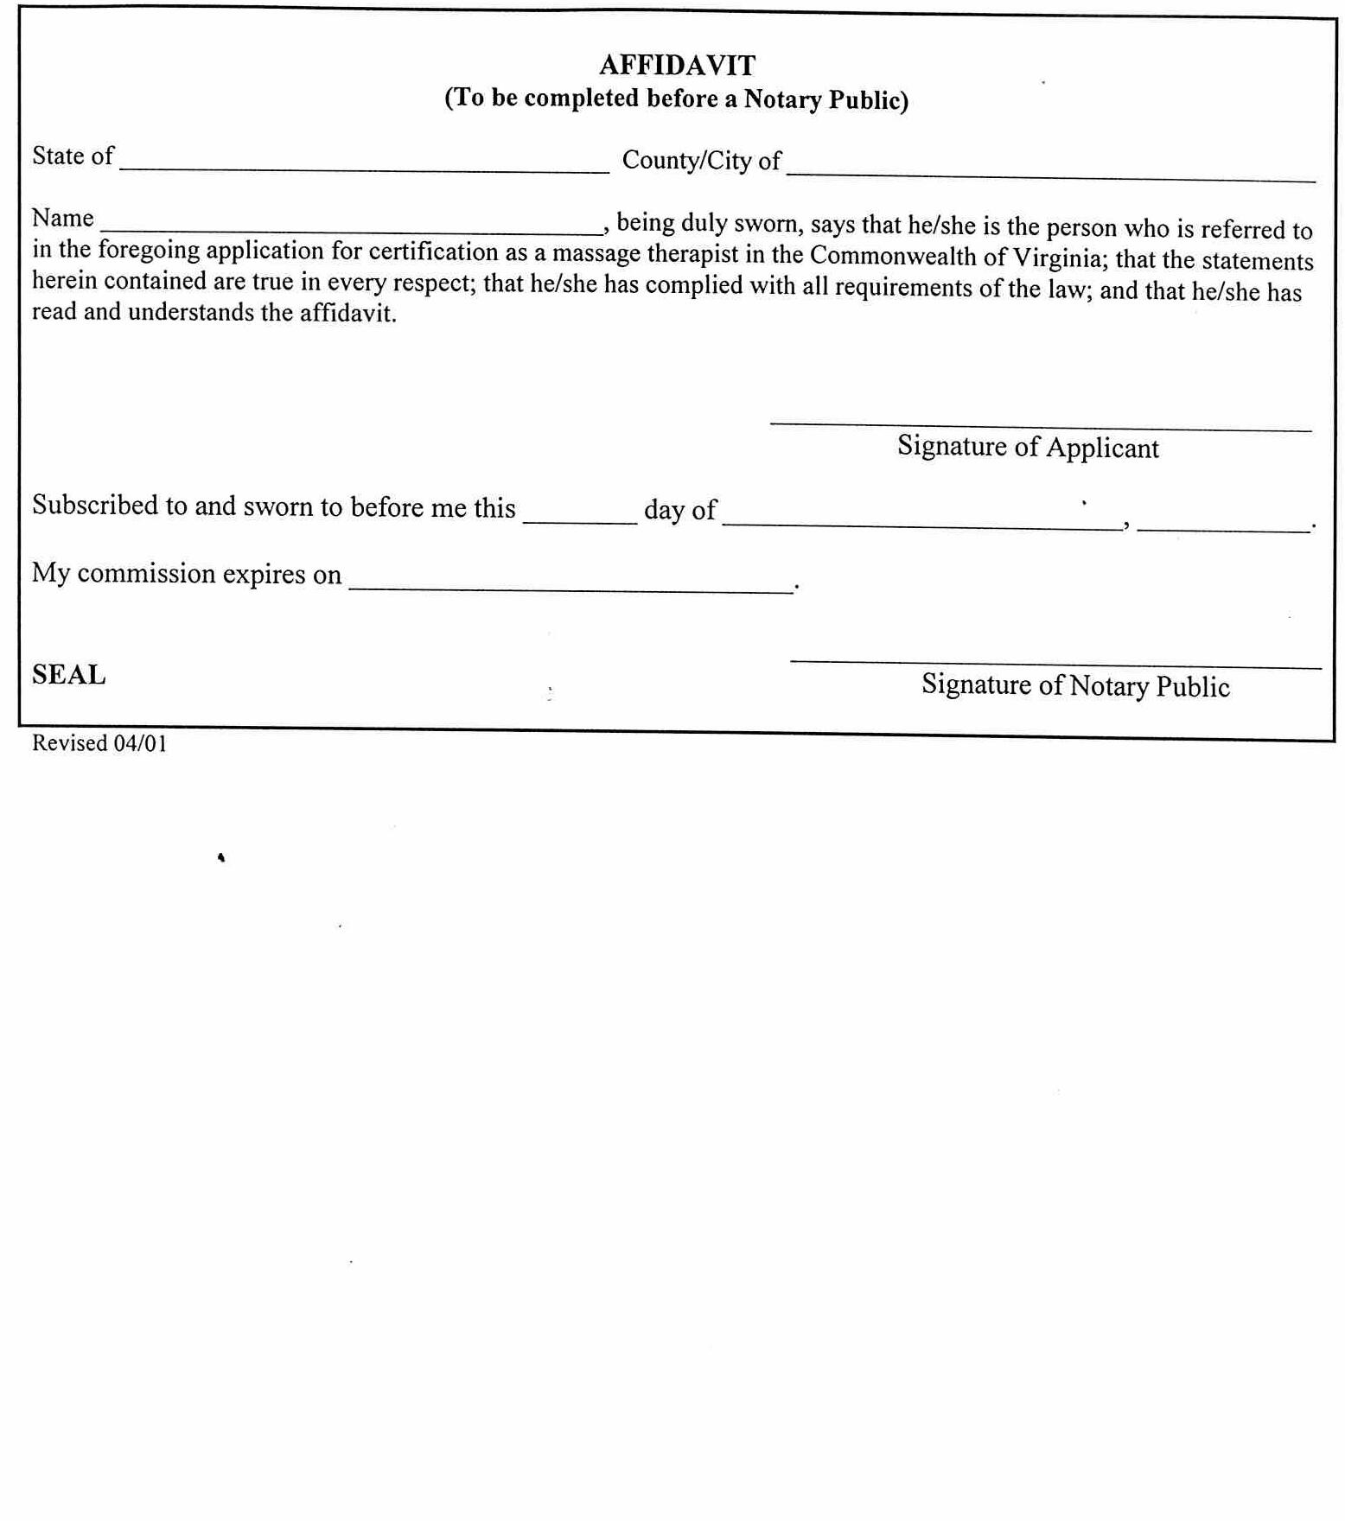
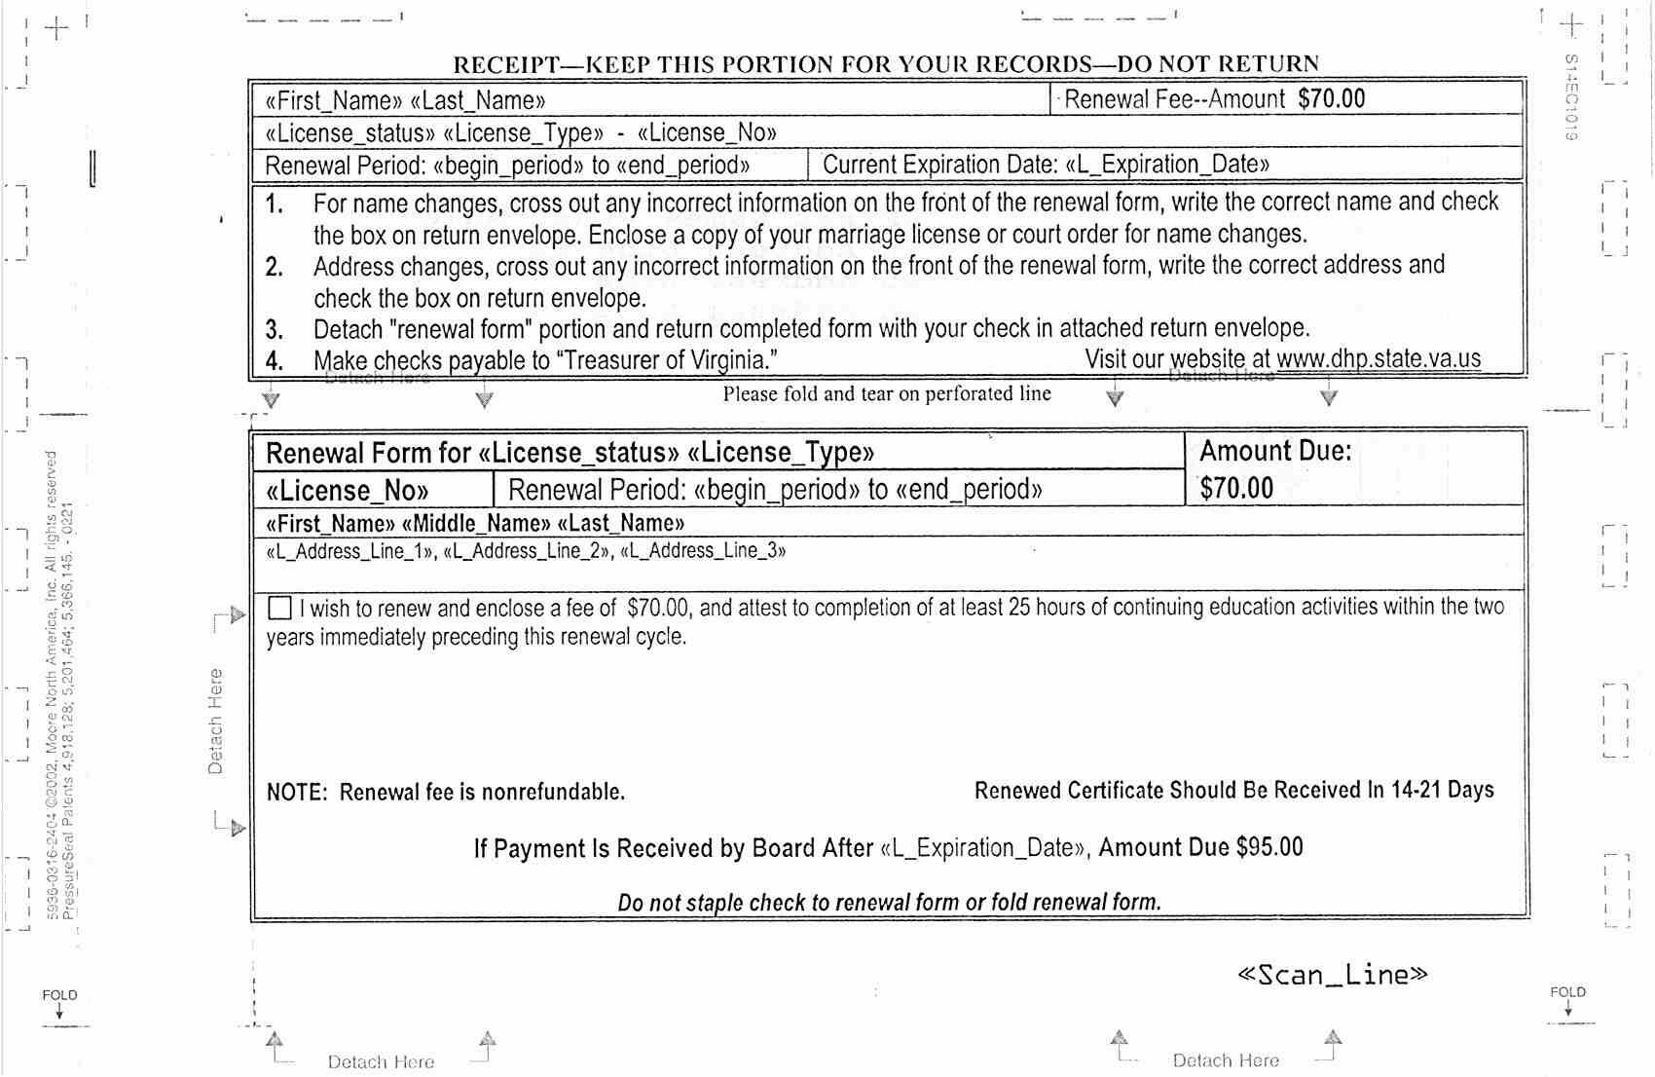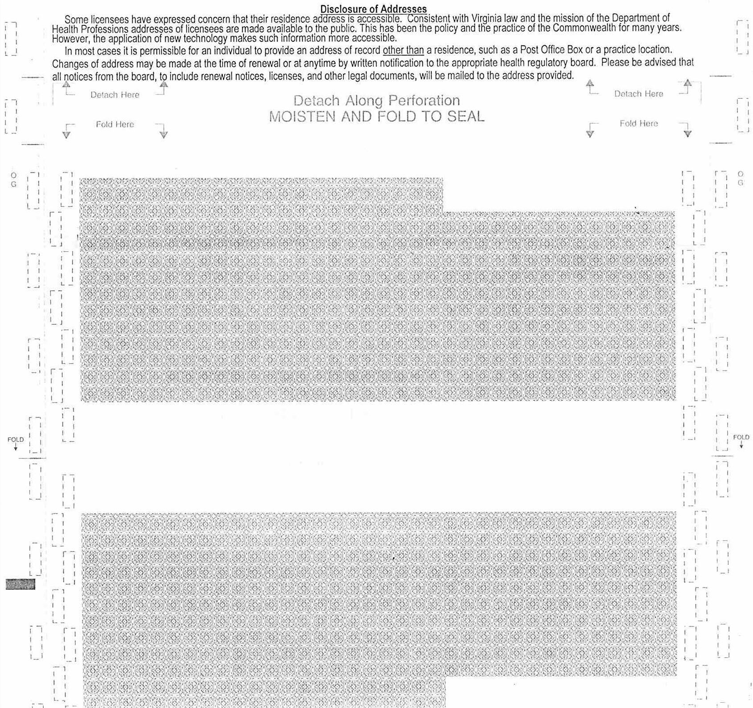
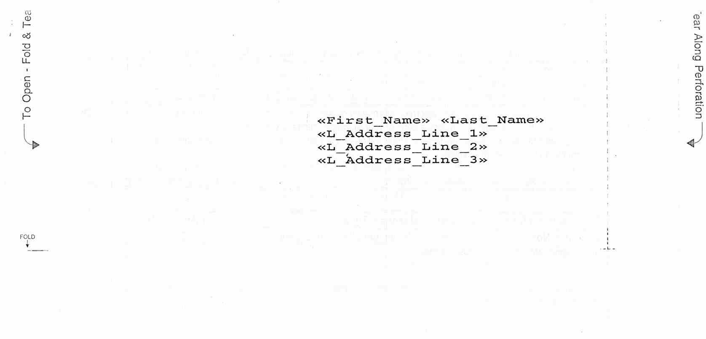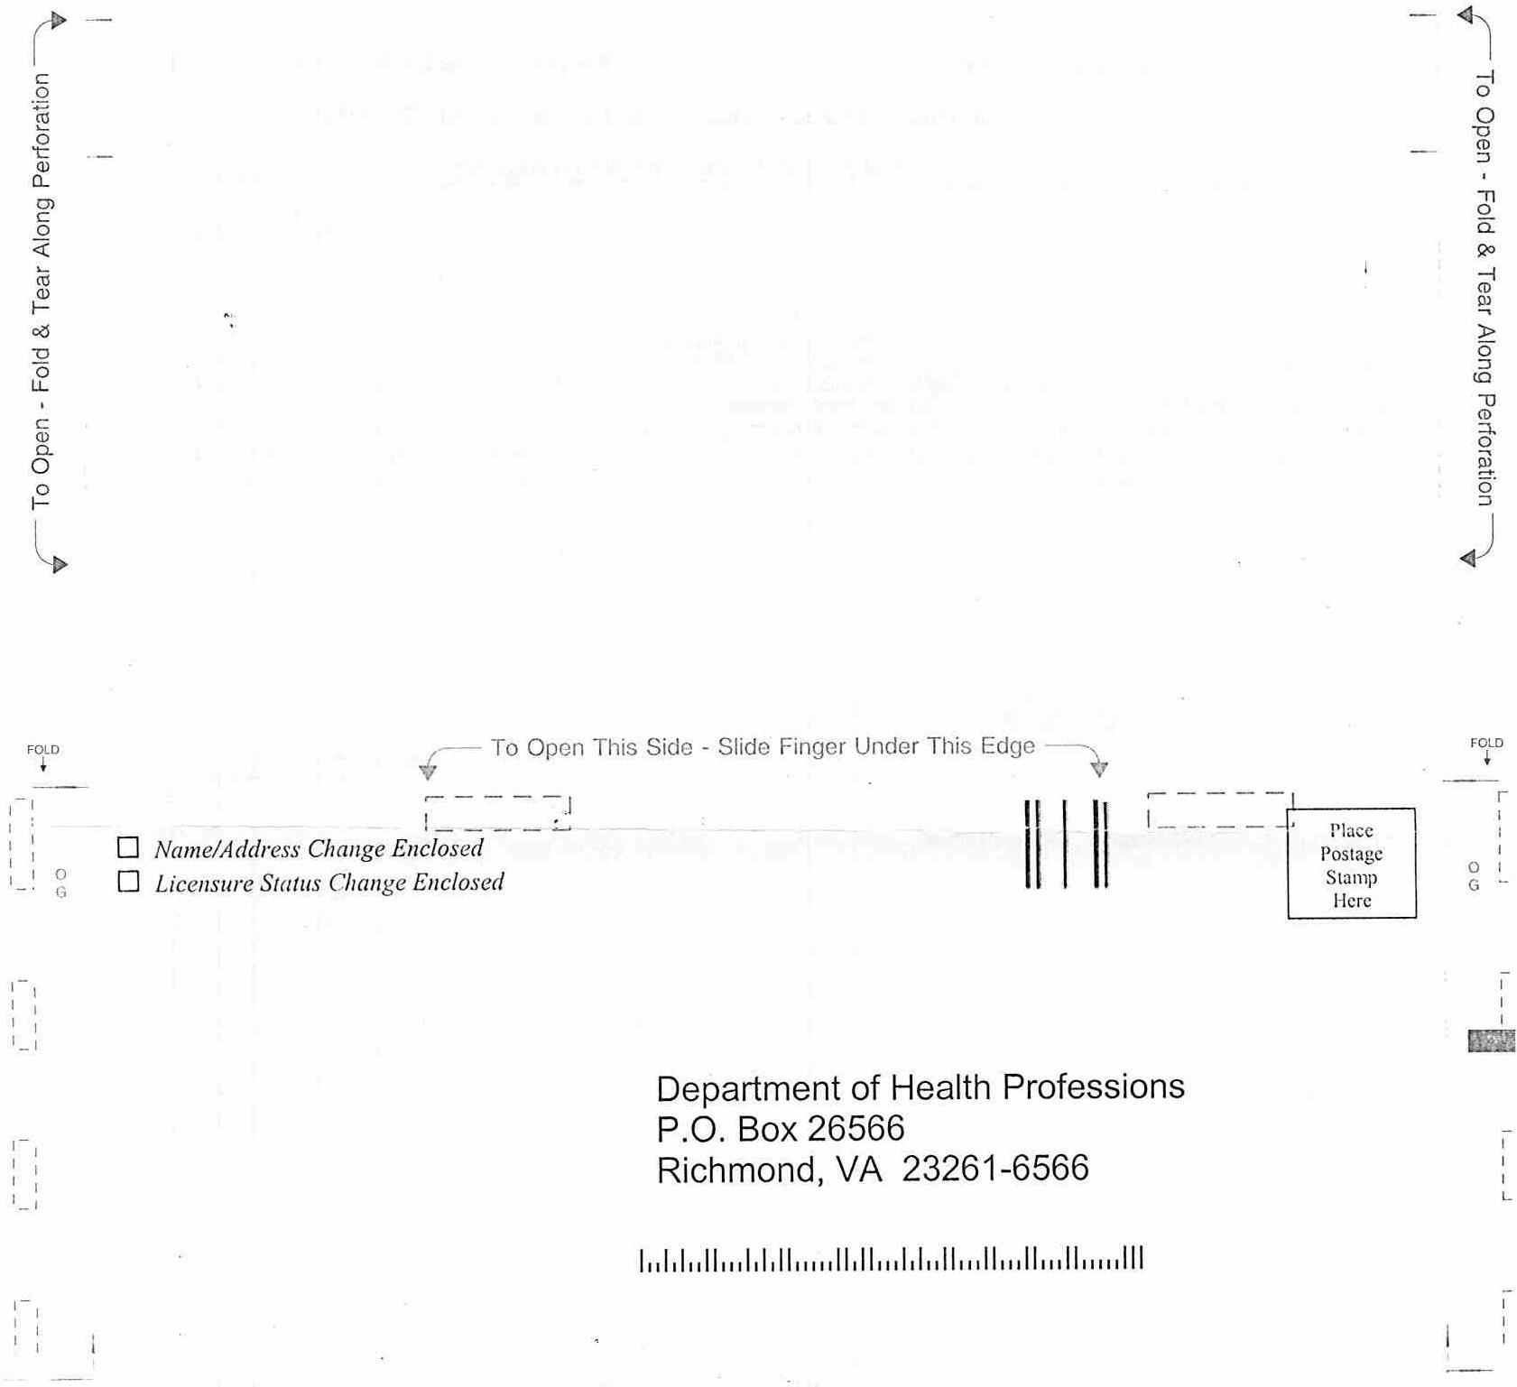
VA.R. Doc. No. R01-188; Filed June 11, 2002, 1:37 p.m.

1 Source: The agency.
2 Source: Ibid.
3 Conversations with certified massage therapists.

