BOARD OF DENTISTRY
Title of Regulation: 18 VAC 60-20. Regulations Governing the Practice of Dentistry and Dental Hygiene (amending 18 VAC 60-20-90; adding 18 VAC 60-20-106).
Statutory Authority: §§ 54.1-2400, 54.1-2701 and 54.1-2715 of the Code of Virginia.
Effective Dates: July 19, 2002, through July 18, 2003.
Preamble:
Chapter 740 of the 2002 Acts of Assembly mandates that the board promulgate regulations within 280 days for an out-of-state practitioner to be licensed to volunteer his services to a nonprofit organization that has no paid employees and offers health care to underprivileged populations throughout the world. Regulations set forth the information and documentation that must be provided prior to such service to ensure compliance with the statute.
Chapter 549 of the 2002 Acts of Assembly expands the use of temporary permits to allow eligible graduates to serve as clinicians in public and charitable dental clinics.
Agency Contact: Elaine J. Yeatts, Senior Policy Analyst, Department of Health Professions, 6606 W. Broad Street, Richmond, VA 23230, telephone (804) 662-9918, FAX (804) 662-9114 or e-mail elaine.yeatts@dhp.state.va.us.
18 VAC 60-20-90. Temporary permit, teacher's license, and full-time faculty license.
A. A temporary permit shall be issued only for the purpose of allowing dental and dental hygiene practice as limited by §§ 54.1-2715 and 54.1-2726 of the Code of Virginia until the release of grades of the next licensure examination given in this Commonwealth, after the issuance of the temporary permit.
B. A temporary permit will not be renewed unless the permittee shows that extraordinary circumstances prevented the permittee from taking the first licensure examination given immediately after the issuance during the term of the temporary permit. Such permit reissuance shall expire seven days after the release of grades of the next examination given.
C. A full-time faculty license shall be issued to any dentist who meets the entry requirements of § 54.1-2713 of the Code of Virginia, who is certified by the dean of a dental school in the Commonwealth and who is serving full time on the faculty of a dental school or its affiliated clinics intramurally in the Commonwealth. A full-time faculty license shall remain valid only while the license holder is serving full time on the faculty of a dental school in the Commonwealth. When any such license holder ceases to continue serving full time on the faculty of the dental school for which the license was issued, the licensee shall surrender the license, which shall be null and void upon termination of full-time employment. The dean of the dental school shall notify the board within five working days of such termination of full-time employment.
D. A temporary permit, a teacher's license and a full-time faculty license may be revoked for any grounds for which the license of a regularly licensed dentist or dental hygienist may be revoked and for any act indicating the inability of the permittee or licensee to practice dentistry that is consistent with the protection of the public health and safety as determined by the generally accepted standards of dental practice in Virginia.
E. Applicants for a full-time faculty license or temporary permit shall be required to pass an examination on the laws and the regulations governing the practice of dentistry in Virginia.
18 VAC 60-20-106. Registration for voluntary practice by out-of-state licensees.
Any dentist or dental hygienist who does not hold a license to practice in Virginia and who seeks registration to practice on a voluntary basis under the auspices of a publicly supported, all volunteer, nonprofit organization with no paid employees that sponsors the provision of health care to populations of underserved people throughout the world shall:
1. File a complete application for registration on a form provided by the board at least 15 days prior to engaging in such practice;
2. Provide a complete record of professional licensure in each state in which he has held a license and a copy of any current license;
3. Provide the name of the nonprofit organization, the dates and location of the voluntary provision of services;
4. Pay a registration fee of $10; and
5. Provide a notarized statement from a representative of the nonprofit organization attesting to its compliance with provisions of § 54.1-2701 (5) of the Code of Virginia.
NOTICE: For the purpose of this emergency regulation, the following two forms are being added to the forms list used in administering 18 VAC 60-20, Regulations Governing the Practice of Dentistry and Dental Hygiene. The new forms are published following the listing and also apply to other emergency regulations in this issue as noted.
FORMS
Application for Registration for Volunteer Practice (eff. 7/02).
Sponsor Certification for Volunteer Registration (eff. 7/02).
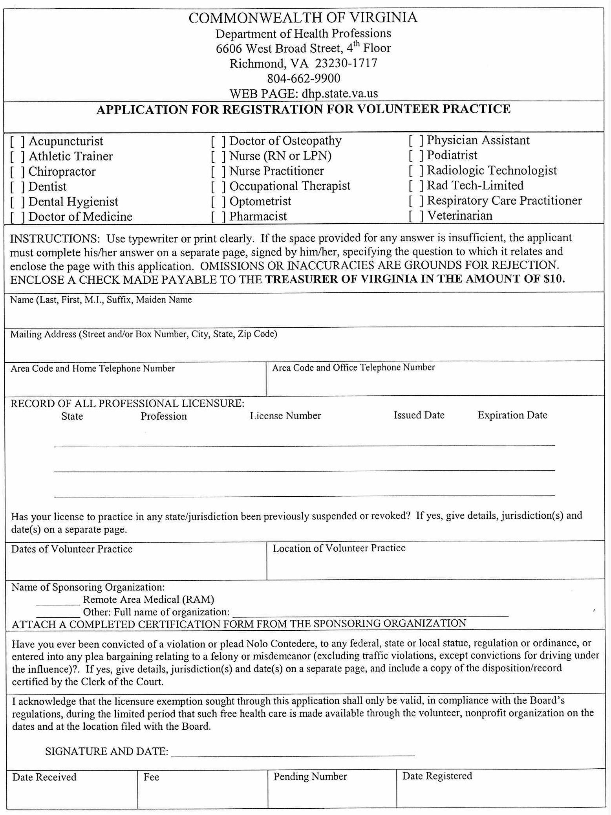
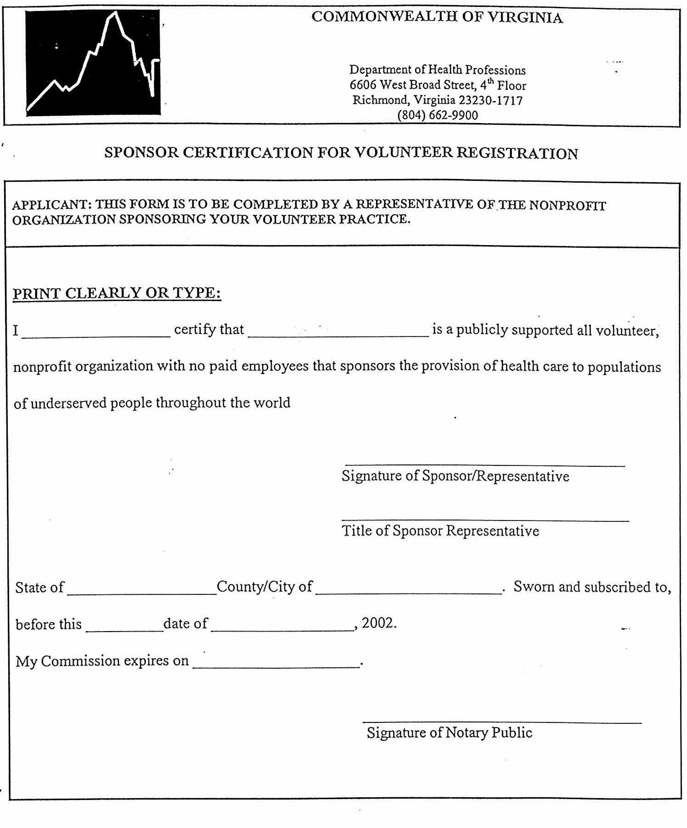
/s/ Mark R. Warner
Governor
Date: July 18, 2002
VA.R. Doc. No. R02-271; Filed July 19, 2002, 11:06 a.m.

