BOARD OF FUNERAL DIRECTORS AND EMBALMERS
Title of Regulation: 18 VAC 65-40. Resident Trainee Program for Funeral Service (amending 18 VAC 65-40-340).
Statutory Authority: §§ 54.1-2400 and Chapter 28 (§ 54.1-2800 et seq.) of the Code of Virginia.
Public Hearing Date: October 10, 2002 - 9 a.m.
Public comments may be submitted until October 11, 2002.
(See Calendar of Events section
for additional information)
Agency Contact: Elaine J. Yeatts, Agency Regulatory Coordinator, Board of Funeral Directors and Embalmers, 6606 W. Broad Street, Richmond, VA 23230, telephone (804) 662-9918, FAX (804) 662-9114 or e-mail elaine.yeatts@dhp.state.va.us.
Basis: Section 54.1-2400 of the Code of Virginia establishes the general powers and duties of health regulatory boards including the responsibility to promulgate regulations, levy fees, administer a licensure and renewal program, and discipline regulated professionals.
The legal authority to promulgate regulations for resident trainees is found in Chapter 28 (§ 54.1-2800 et seq.) of Title 54.1 of the Code of Virginia, which sets forth statutory provisions for the licensure and practice of funeral establishments and funeral service licensees. Section 54.1-2817 of the Code of Virginia specifically addresses resident trainees.
Purpose: After each offering of the funeral examination, the board receives a report on passage or failure by the candidates. Cumulatively, the passage rate is approximately 82%, so the board is satisfied that the examination and training are adequate. The one exception is training and education in preneed. If a trainee is working in a funeral establishment that does not make preneed arrangements, he may not receive any experience or information related to preneed. Yet there are a myriad of federal and state laws and regulations on preneed, and it is a topic covered in the examination. That lack of training has resulted in failure for some candidates and handicapped some new licensees who do not have knowledge in preneed arrangements.
If the resident trainee with inadequate training in preneed becomes a funeral service licensee, it may put the public at risk in its dealing with that person for preneed arrangement. To protect the public safety and welfare in preneed arrangements, the board has determined that a specific requirement for inclusion of information on preneed in the training of funeral service providers is essential.
Substance: This regulatory action amends 18 VAC 65-40-340 to specify that information and training about preneed funeral contracts must be included in the resident trainee program.
Issues: The proposed amendment has some definite advantages to the public. By having licensees appropriately trained in preneed, there is less opportunity for inappropriate handling of preneed funding and misrepresentation of services that will be provided. There are no disadvantages to the public, which is better protected by a requirement for training in preneed.
There are advantages to funeral service establishments, which can be better assured that newly licensed providers will have adequate knowledge and training in preneed arrangements, and to the licensed funeral service providers who are less likely to violate state or federal laws out of ignorance.
Department of Planning and Budget's Economic Impact Analysis: The Department of Planning and Budget (DPB) has analyzed the economic impact of this proposed regulation in accordance with § 2.2-4007 G of the Administrative Process Act and Executive Order Number 25 (98). Section 2.2-4007 G requires that such economic impact analyses include, but need not be limited to, the projected number of businesses or other entities to whom the regulation would apply, the identity of any localities and types of businesses or other entities particularly affected, the projected number of persons and employment positions to be affected, the projected costs to affected businesses or entities to implement or comply with the regulation, and the impact on the use and value of private property. The analysis presented below represents DPB’s best estimate of these economic impacts.
Summary of the proposed regulation. The proposed changes will require the funeral service supervisors to provide training to resident trainees in making preneed funeral arrangements and instruction on rules related to preneed contracts and disclosures.
Estimated economic impact. These regulations contain rules for registration, renewal, reinstatement of funeral service resident trainees and rules for trainees in such programs, training sites, reporting, and supervision of trainees. The proposed change will expand the supervisor’s responsibilities to provide training to resident trainees in preneed funeral arrangements, contracts, and disclosures. The training will include writing preneed contracts, filling out the forms, financing of services, trust requirements, and consumer information disclosures.
Resident trainees are required to take an examination to be a funeral service licensee. The candidates are expected to know federal and state laws related to preneed and are tested, among other subjects, on preneed funeral arrangements, contracts, and disclosures. Some of the trainees, however, may not receive training and education in preneed if the funeral establishments where the trainee is working do not offer preneed funeral services. According to Department of Health Professions (the department), the lack of training may have resulted in failure of some candidates on the funeral exam and handicapped some new licensees who do not have knowledge in preneed services.
With the proposed changes, the supervisor will be required to arrange for preneed training if the preneed training is not currently provided or arranged. Thus, supervisors working at establishments that do not offer preneed services will be affected. The department indicates that of the supervisors who are working at facilities that do not offer preneed services, most are currently arranging for the trainee to receive the preneed training. The number of the cases where preneed training is not arranged is not known but believed to be small relative to the number of facilities that do not offer preneed services.
The supervisors in these cases will likely have several options to arrange for preneed training. A supervisor may be able to arrange for the trainee to work temporarily at an establishment that offers preneed services. The training program is similar to apprenticeship and compensation is offered for the work performed by the trainee. Conversations with a funeral business owner indicate that it is unlikely for other establishments offering preneed services to accept such temporary arrangements. An alternate and probably the most used arrangement is expected to be with companies that offer preneed insurance and trusting services. The department indicates that in some cases these companies already send their representatives to funeral establishments to offer training in preneed services free of charge and believes that there should be no problems with getting a company trainer to come to the facility because the company would have a chance to make contact with a potential funeral director who may choose to do business with them in the future. Although insurance and trust companies are expected to meet the needs of supervisors arranging preneed training, it cannot be ruled out that a supervisor may have to pay a trainer to provide the training.
The costs of the proposed preneed training requirement will depend on the type of the arrangements made. In a most likely scenario where an insurance or trust company trainer provides training, the trainees are expected to receive training free of charge. In this case, there do not seem to be significant costs to the funeral facility. Since the training will be provided voluntarily, there does not seem to be net costs to the insurance or the trust company either. However, regardless of the type of arrangements, the trainee time that will be devoted to preneed education appears to be the main cost associated with this requirement. According to a funeral service provider, it would take about two days to provide preneed education in a classroom setting.
On the other hand, the proposed preneed training is likely to benefit the trainees, the funeral service customers, and the establishments hiring newly licensed providers if the training can be arranged. First, the preneed training may improve some of the candidates’ success on the funeral examination and make it possible for them to get their licenses and start receiving higher compensation. Second, it will likely improve some of the trainees’ performance in dealing with preneed services after they obtain a license to offer funeral services. Customers stand to benefit from this requirement because preneed training may afford additional consumer protection for them. A licensed practitioner with preneed training is less likely to make mistakes in preneed services out of ignorance. Inappropriate handling of preneed funding and misinterpretation of services that will be provided are examples of potential mistakes. Also, if the mistakes are reduced, funeral service providers will be less likely to be out of compliance with federal and state laws and to face civil court cases associated with preneed services.
Businesses and entities affected. The proposed changes will apply to the resident trainees in funeral services and the funeral service licensees who are trainee supervisors. Currently, there are about 156 registered trainees in the Commonwealth. The number of trainee supervisors is not known, but must be less than 156 because a supervisor cannot supervise more than two trainees.
Localities particularly affected. The proposed regulations apply throughout the Commonwealth.
Projected impact on employment. The proposed changes are not expected to have a significant impact on employment.
Effects on the use and value of private property. No significant impact on the use and value of private property is expected.
Agency's Response to the Department of Planning and Budget's Economic Impact Analysis: The Board of Funeral Directors and Embalmers concurs with the analysis of the Department of Planning and Budget for the periodic review of the proposed regulations, 18 VAC 65-40.
Summary:
The proposed changes will require the funeral service supervisors to provide training to resident trainees in making preneed funeral arrangements and instruction on rules related to preneed contracts and disclosures.
18 VAC 65-40-340. Supervisors' responsibilities.
A. The supervisor shall provide the trainee with all applicable laws and regulations or sections of regulations relating to the funeral industry.
B. The supervisor shall provide the trainee with copies of and instruction in the use of all forms and price lists employed by the funeral establishment.
C. The supervisor shall provide the trainee with instruction in all aspects of funeral services and shall allow the trainee under direct supervision to conduct all necessary arrangements for a minimum of 25 funerals.
D. The embalming supervisor shall provide instruction on all necessary precautions, embalming functions, and reporting forms and shall allow the trainee under direct supervision to perform a minimum of 25 embalmings.
E. The supervisor shall provide the trainee with experience in making preneed funeral arrangements and instruction on the laws and regulations pertaining to preneed funeral contracts and disclosures.
NOTICE: The forms used in administering 18 VAC 65-40, Resident Trainee Program for Funeral Service, are listed below. Any amended or added forms are reflected in the listing and are published following the listing.
FORMS
Application for Resident Trainee Program (rev. 7/1/98).
Application for Resident Trainee Program Supervisor (rev. 7/1/98 9/01).
Renewal Notice and Application, C-46454 (rev. 7/1/97 2002).
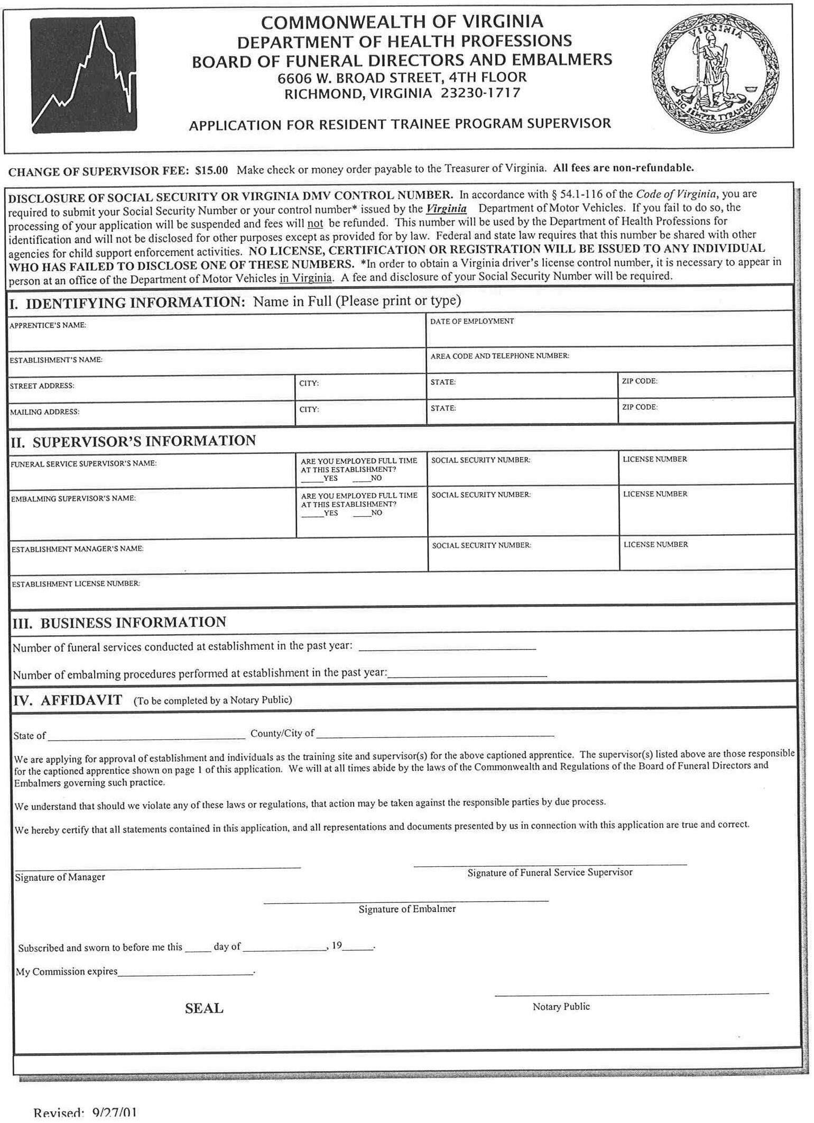
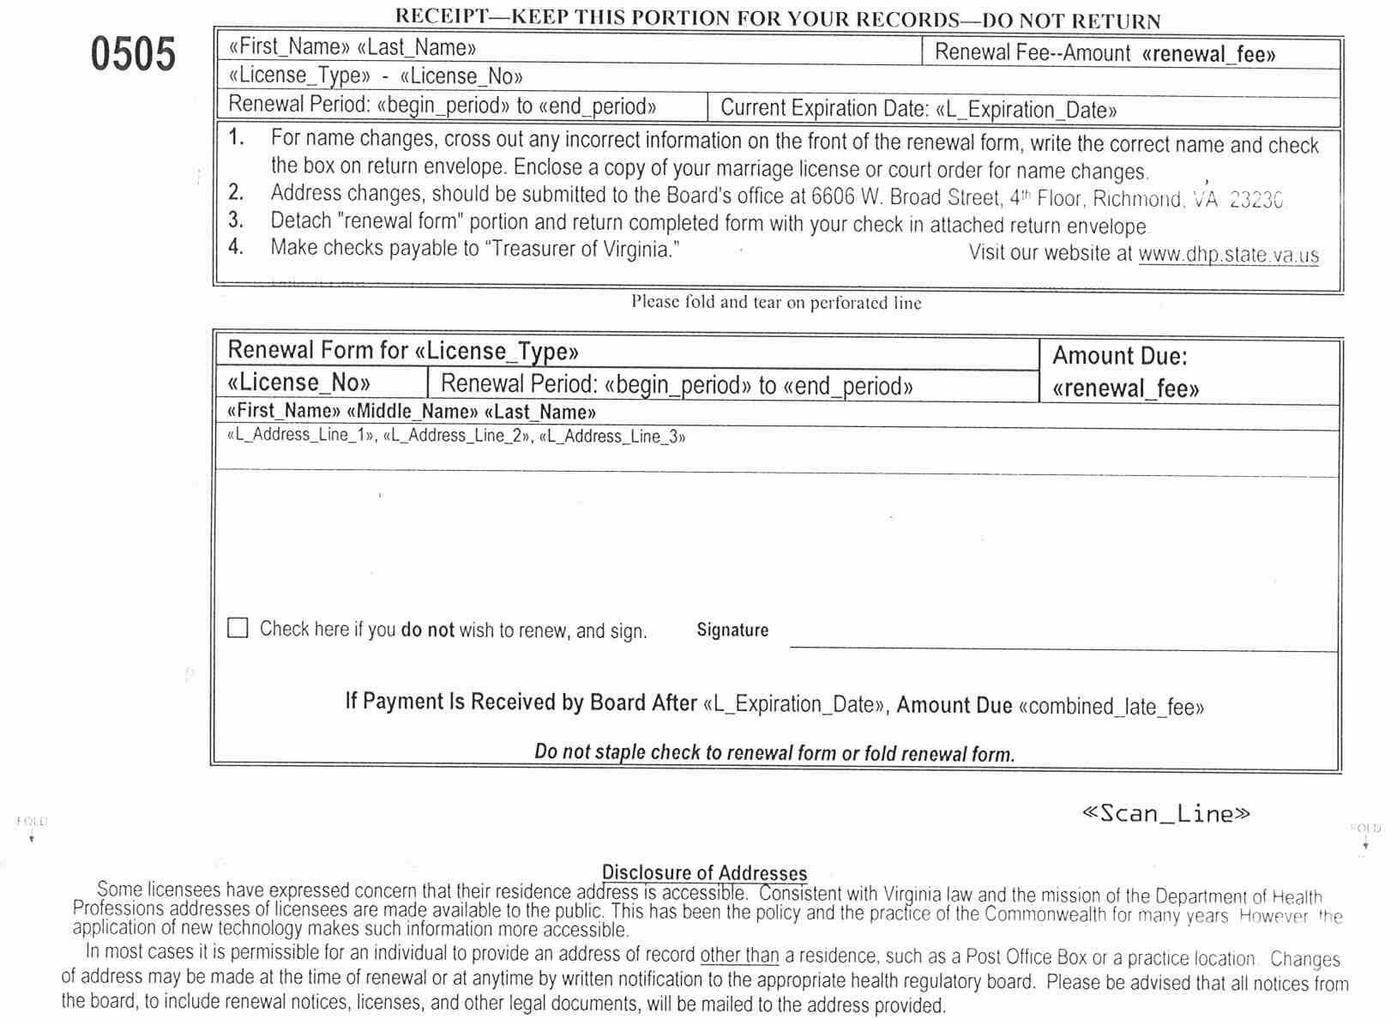

VA.R. Doc. No. R02-47; Filed July 11, 2002, 3:41 p.m.

