BOARD OF NURSING HOME ADMINISTRATORS
Title of Regulation: 18 VAC 95-20. Regulations of the Board of Nursing Home Administrators (amending 18 VAC 95-20-80).
Statutory Authority: §§ 54.1-113 and 54.1-2400 of the Code of Virginia.
Public Hearing Date: October 9, 2002 - 10 a.m.
Public comments may be submitted until October 11, 2002.
(See Calendar of Events section
for additional information)
Agency Contact: Elaine J. Yeatts, Agency Regulatory Coordinator, Board of Nursing Home Administrators, 6606 W. Broad Street, Richmond, VA 23230, telephone (804) 662-9918, FAX (804) 662-9114 or e-mail elaine.yeatts@dhp.state.va.us.
Basis: Section 54.1-2400 of the Code of Virginia establishes the general powers and duties of health regulatory boards including the responsibility to promulgate regulations and levy fees.
The specific statutory mandate for an increase in fees is found in § 54.1-113 of the Code of Virginia.
Purpose: Section 54.1-113 of the Code of Virginia requires that at the end of each biennium, an analysis of revenues and expenditures of each regulatory board be performed. It is necessary that each board has sufficient revenue to cover its expenditures. It is projected that by the close of the 2000-2002 biennium, the Board of Nursing Home Administrators will incur a deficit and that the deficit will continue to grow through the next biennium. Since the fees from licensees will no longer generate sufficient funds to pay operating expenses for the board, a fee increase is essential.
The purpose of the proposed amendments is to establish fees sufficient to cover the administrative and disciplinary activities of the board. Without adequate funding, the licensing of practitioners and preceptors who provide training for those seeking to become administrators could be delayed. The Code of Virginia requires all licensed nursing homes to be under the supervision of a licensed administrator. Sufficient funding is essential to continue the approval of applicants for a training program and for licensure and the investigation of complaints and disciplinary proceedings against practitioners who are accused of substandard care or violations of law and regulation in order to protect the public health and safety.
Substance: 18 VAC 95-20-80 is amended to comply with a statutory mandate for the board to provide sufficient funding to cover expenses related to approvals of administrators-in-training (AIT) and preceptors, licensing, investigations and disciplinary proceedings. Annual renewal fees for a nursing home administrator are increased from $125 to $225 and for a preceptor from $60 to $100. Fees for late renewal and reinstatement are increased proportionately. Application fees for the AIT program and for preceptors are not changed, but the application fee for a nursing home administrator is increased from $150 to $200. Some miscellaneous fees for duplicate licenses and wall certificates are reduced.
Issues: While fee increases proposed by the Board of Nursing Home Administrators should have no specific disadvantage to the consuming public, the ever-increasing shortage of administrators is of concern. As the population ages, there will be an increasing rather than decreasing need for qualified persons to administer those facilities. According to persons in the profession and affiliated with the nursing home industry, there are numerous root causes for the decrease in the supply of administrators – relating to the extraordinary regulatory burden of federal and state laws and rules governing the operation of a nursing home, the availability of similar professional opportunities in less-regulated environments (assisted living facilities) and the profession’s lack of appeal to younger persons. While the increased fee will not enhance the prospects for increasing the number of licensees, the board does not believe that licensure fees alone will result in a reduction in the number of applicants for licensure or the number of licensed persons available to provide administrator services to the public. It is also not anticipated that the proposed fee increases will have any effect on prices for consumers.
There would be disadvantages to the public if the board took no action to address its deficit by increasing its fees to cover expenses. The only alternative currently available under the Code of Virginia would be a reduction in services and staff, which would result in delays in licensing applicants who would be unable to work and delays in approval or disapproval of candidates to sit for examinations. Potentially, the most serious consequence would be a reduction in or reprioritization of disciplinary cases handled by the department and the board. There could be delays in adjudicating cases of substandard practice, resulting in potential danger to patients in the Commonwealth.
Applicants and practitioners licensed by the board will experience increased renewal fees under the proposed regulations. While that is a disadvantage to the licensees, the alternative of reduced services for the board would be unacceptable to applicants, licensees and the general public. As a special-fund agency, renewal fees pay the vast majority of the expenses of board operations, which include inspections, investigation of complaints, adjudication of disciplinary cases, review and approval of applicants, verification of licensure and education to other jurisdictions and entities, and communications with licensees about current practice and regulation.
The consequence of not increasing fees of the board would be a reduction in services and staff, resulting in delays in licensing, reductions or delays in the cases investigated and brought through administrative proceedings to a hearing before the board. The fees charged to applicants and licensees solely fund the board and the Department of Health Professions. If higher fees are not adopted, the agency would have to cut its staff, both within the Board of Nursing Home Administrators and within other divisions of the Department of Health Professions.
Department of Planning and Budget's Economic Impact Analysis: The Department of Planning and Budget (DPB) has analyzed the economic impact of this proposed regulation in accordance with § 2.2-4007 G of the Administrative Process Act and Executive Order Number 25 (98). Section 2.2-4007 G requires that such economic impact analyses include, but need not be limited to, the projected number of businesses or other entities to whom the regulation would apply, the identity of any localities and types of businesses or other entities particularly affected, the projected number of persons and employment positions to be affected, the projected costs to affected businesses or entities to implement or comply with the regulation, and the impact on the use and value of private property. The analysis presented below represents DPB’s best estimate of these economic impacts.
Summary of the proposed regulation. The proposed regulation increases various fees paid by nursing home administrators and preceptors to the Board of Nursing Home Administrators. The purpose of these fee increases is to bring the board into compliance with the board’s interpretation of § 54.1-113 of the Code of Virginia. Section 54.1-113 requires all regulatory boards under the Department of Health Professions to revise their fee schedules if, after the close of any biennium, there is more than a 10% difference between revenues and expenditures. The proposed fee changes are as follows:
Nursing Home Administrators
· Annual renewal of an active license will increase from $125 to $225.
· The penalty for late renewal of a license will increase from $50 to $65.
· Reinstatement of a lapsed license (a license not renewed within one year) will increase from $225 to $315.
Preceptors
· Annual renewal of an active license will increase from $60 to $100.
· The penalty for late renewal of a license will increase from $25 to $35.
· Reinstatement of a lapsed license (a license not renewed within one year) will increase from $110 to $150.
Miscellaneous fees
· Application for licensure will increase from $150 to $200.
· The fee for licensure verification to another jurisdiction will be raised from $10 to $25.
· The cost of obtaining a duplicate license would be reduced from $25 to $15.
· The cost of obtaining a duplicate wall certificate would be reduced from $50 to $25.
Estimated economic impact. There has not been a fee increase for licensees under the Board of Nursing Home Administrators since 1994. However, expenditures for the board have risen due to increases in staff salaries and benefits, expenses associated with new data systems and the health practitioner intervention program, and increases in enforcement activities. Under the current fee structure, the board projects a deficit of $185,000 for the 2002-2004 biennium.1 The level of the proposed fee increases is based on revenue and expenditure projections prepared by DHP for the Board of Nursing Home Administrators. The projections also assumed a continuing decline in the number of licensed nursing home administrators. However, if the number of licensees drops significantly, the board may be faced with additional deficits that would have to be addressed with further fee increases or other alternatives such as eliminating an independent board or sunsetting the licensure requirement.
The effect of the new fee schedule will be an increase in application and licensure costs for all nursing home administrators and preceptors facilities licensed in Virginia. Specifically, renewal fees paid by licensees will increase by approximately $75,000 per year. According to DHP, the proposed fee increases are necessary to cover the administrative and disciplinary activities of the Board of Nursing Home Administrators. Sufficient funding is essential to prevent a delay in application processing, license renewals, and the investigation of complaints and disciplinary proceedings against practitioners who are accused of substandard care or violations of law and regulation, in order to protect the public health and safety of residents of nursing homes in Virginia.
Although the total increase in compliance costs is substantial, from an individual perspective these fees represent a very small portion of the total cost of entry into the nursing home industry (e.g., the total cost of entry includes all education and training expenses). The recent decline in the supply of nursing home administrators is of concern; however, according to persons in the profession and affiliated with the nursing home industry, the root causes include the extraordinary regulatory burden of federal and state laws and rules governing the operation of a nursing home, the availability of similar professional opportunities in less-regulated environments (assisted living facilities) and the profession’s lack of appeal to younger persons. While the increased fee will not enhance the prospects for increasing the number of licensees, the board does not believe that licensure fees alone will result in a reduction in the number of applicants for licensure or the number of licensed persons available to provide administrator services to the public. The proposed fee changes, therefore, are unlikely to have a significant effect on the decision of individuals to enter or exit this profession. For this reason, the proposed regulatory changes should have no economic consequences beyond the anticipated increase in licensing costs.
Businesses and entities affected. There are currently 674 nursing home administrators and 180 preceptors licensed by the Board of Nursing Home Administrators in Virginia.
Localities particularly affected. The proposed fee changes will not affect any particular localities since they apply statewide.
Projected impact on employment. Since the application and licensure renewal fees represent a very small portion of the total cost of entry into the nursing home industry, and the significant decline in the supply of administrators is believed to stem from other factors, no significant impact on employment in Virginia is expected.
Effects on the use and value of private property. The proposed fee changes are not expected to have any significant effects on the use and value of private property in Virginia.
Agency's Response to the Department of Planning and Budget's Economic Impact Analysis: The Board of Nursing Home Administrators concurs with the analysis of the Department of Planning and Budget for the fee increases in proposed regulation 18 VAC 95-20.
Summary:
The proposed amendments increase certain fees for the regulants of the board, including nursing home administrators and preceptors, as necessary to provide sufficient funding for the licensing and disciplinary functions of the board. The annual renewal fee for a nursing home administrator is increased from $125 to $225 and for a preceptor from $60 to $100. The application fee for licensure is increased from $150 to $200, but application fees for preceptors and administrators-in-training remain the same. Other fees are increased correspondingly; and some miscellaneous fees, such as the duplicate license and wall certificate charge, are reduced.
18 VAC 95-20-80. Required fees.
The applicant shall submit all fees below which apply:
1. A.I.T. program application | $185
2. Preceptor application | $125
3. Licensure application | $150 200
4. Verification of licensure requests from other states | $10 25
5. Nursing home administrator license renewal | $125 225
6. Preceptor renewal | $60 100
7. Penalty for nursing home administrator late renewal | $50 65
8. Penalty for preceptor late renewal | $25 35
9. Nursing home administrator reinstatement | $225 315
10. Preceptor reinstatement | $110 150
11. Duplicate license | $25 15
12. Duplicate wall certificates | $50 25
NOTICE: The forms used in administering 18 VAC 95-20, Regulations of the Board of Nursing Home Administrators, are listed below. Any amended or added forms are reflected in the listing and are published following the listing.
FORMS
Application for Licensure (rev. 1/98).
Endorsement Certification Form (rev. 1/98).
Application for Administrator-in-Training (rev. 1/98).
Application for Preceptor Registration (rev. 1/98).
Application for Reinstatement of License (rev. 1/98).
Form Letter and Affidavit of Completion for Required CE Documentation (rev. 10/98).
Renewal Notice and Application (rev. 7/97 2002).
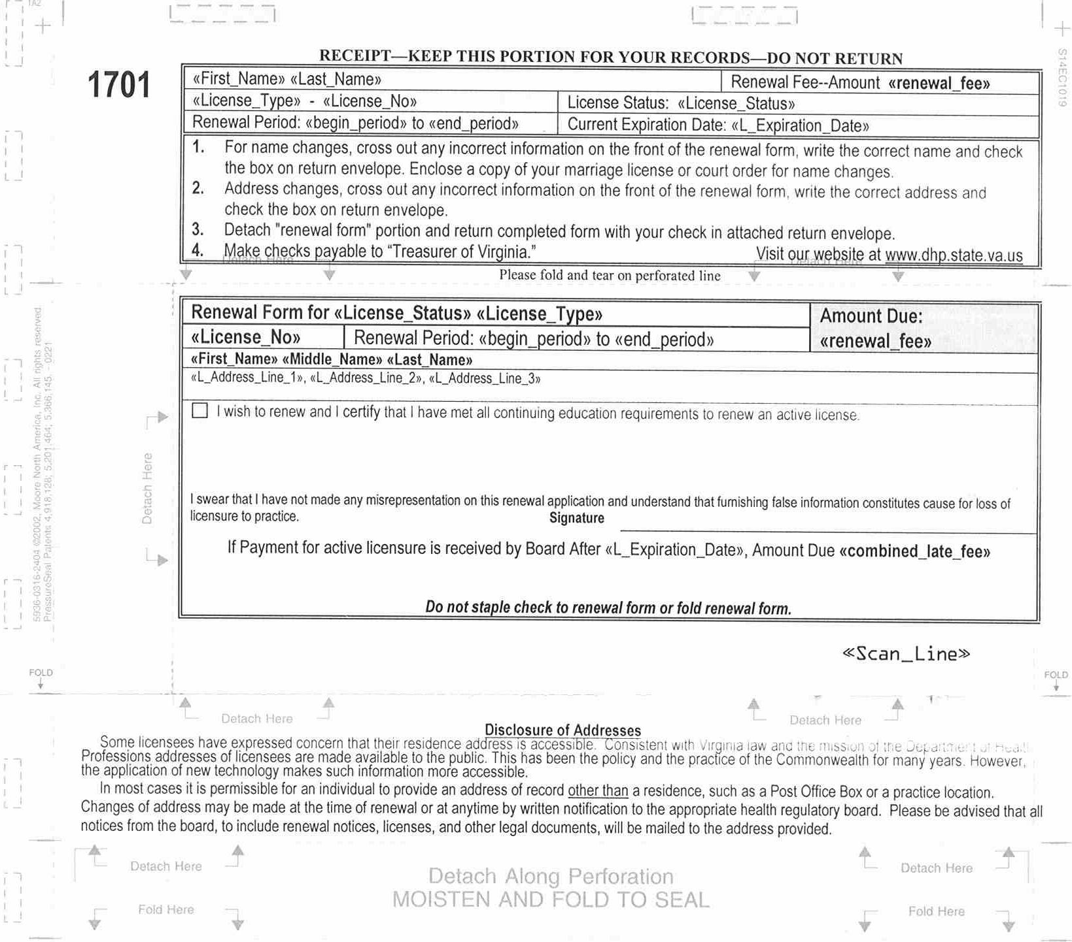
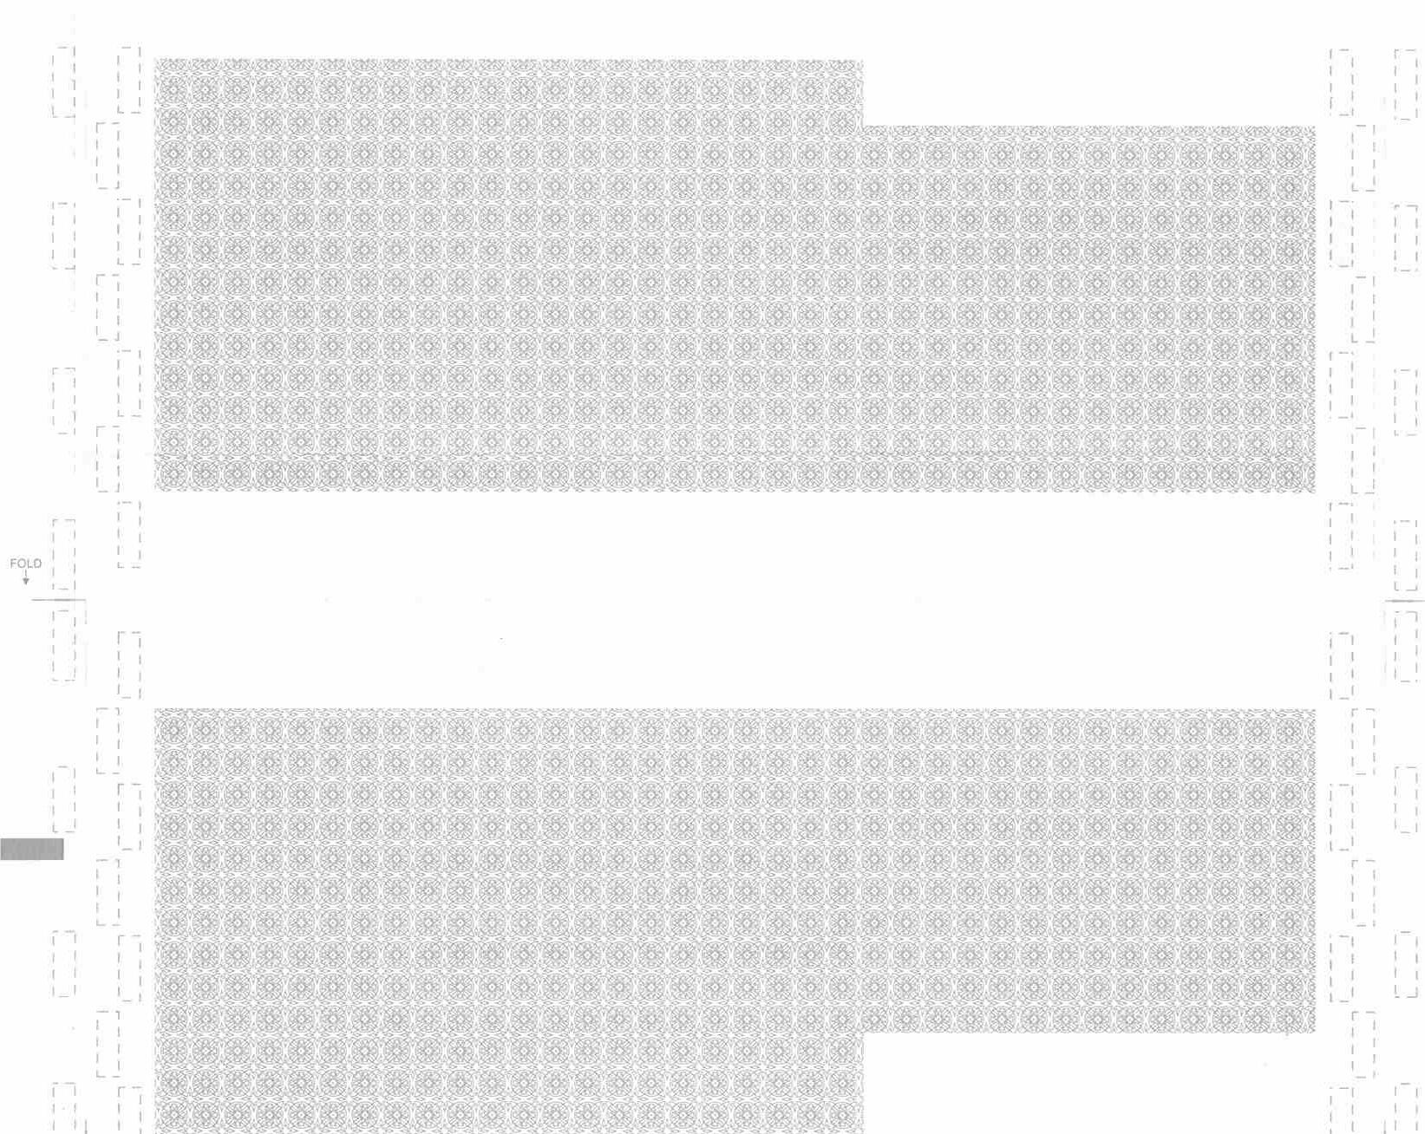
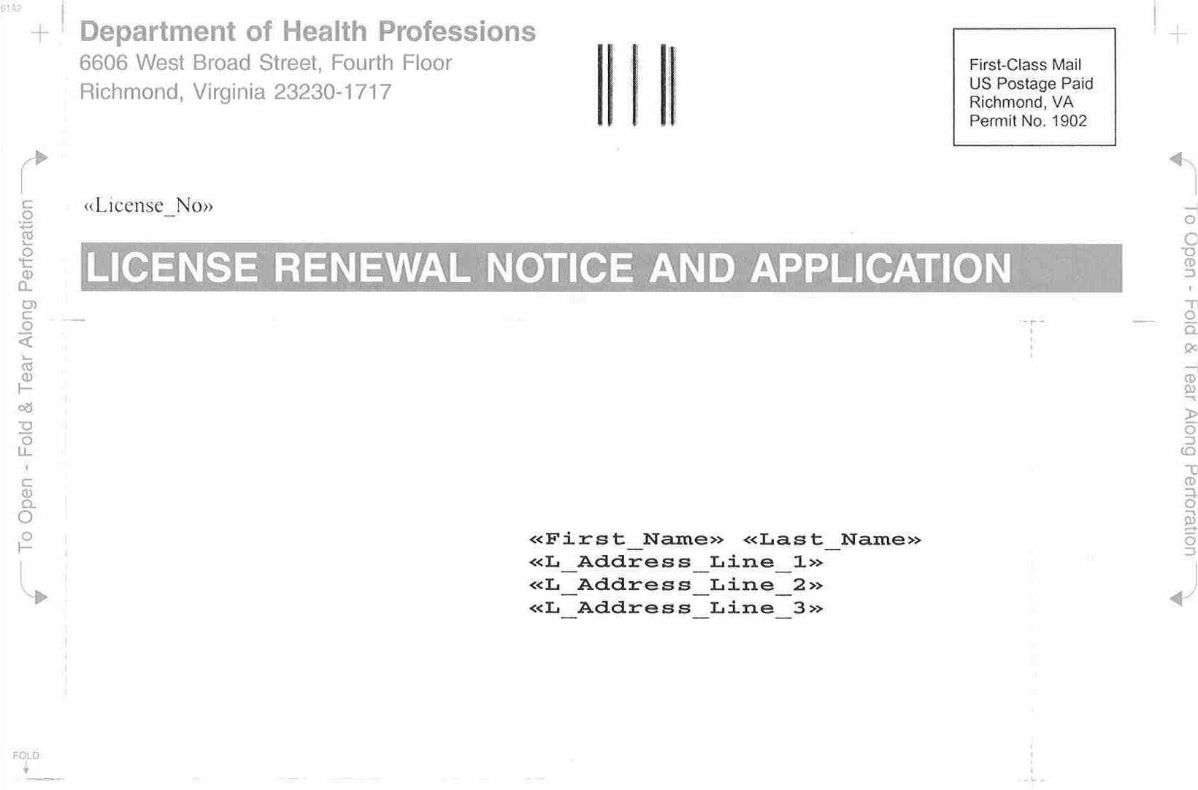
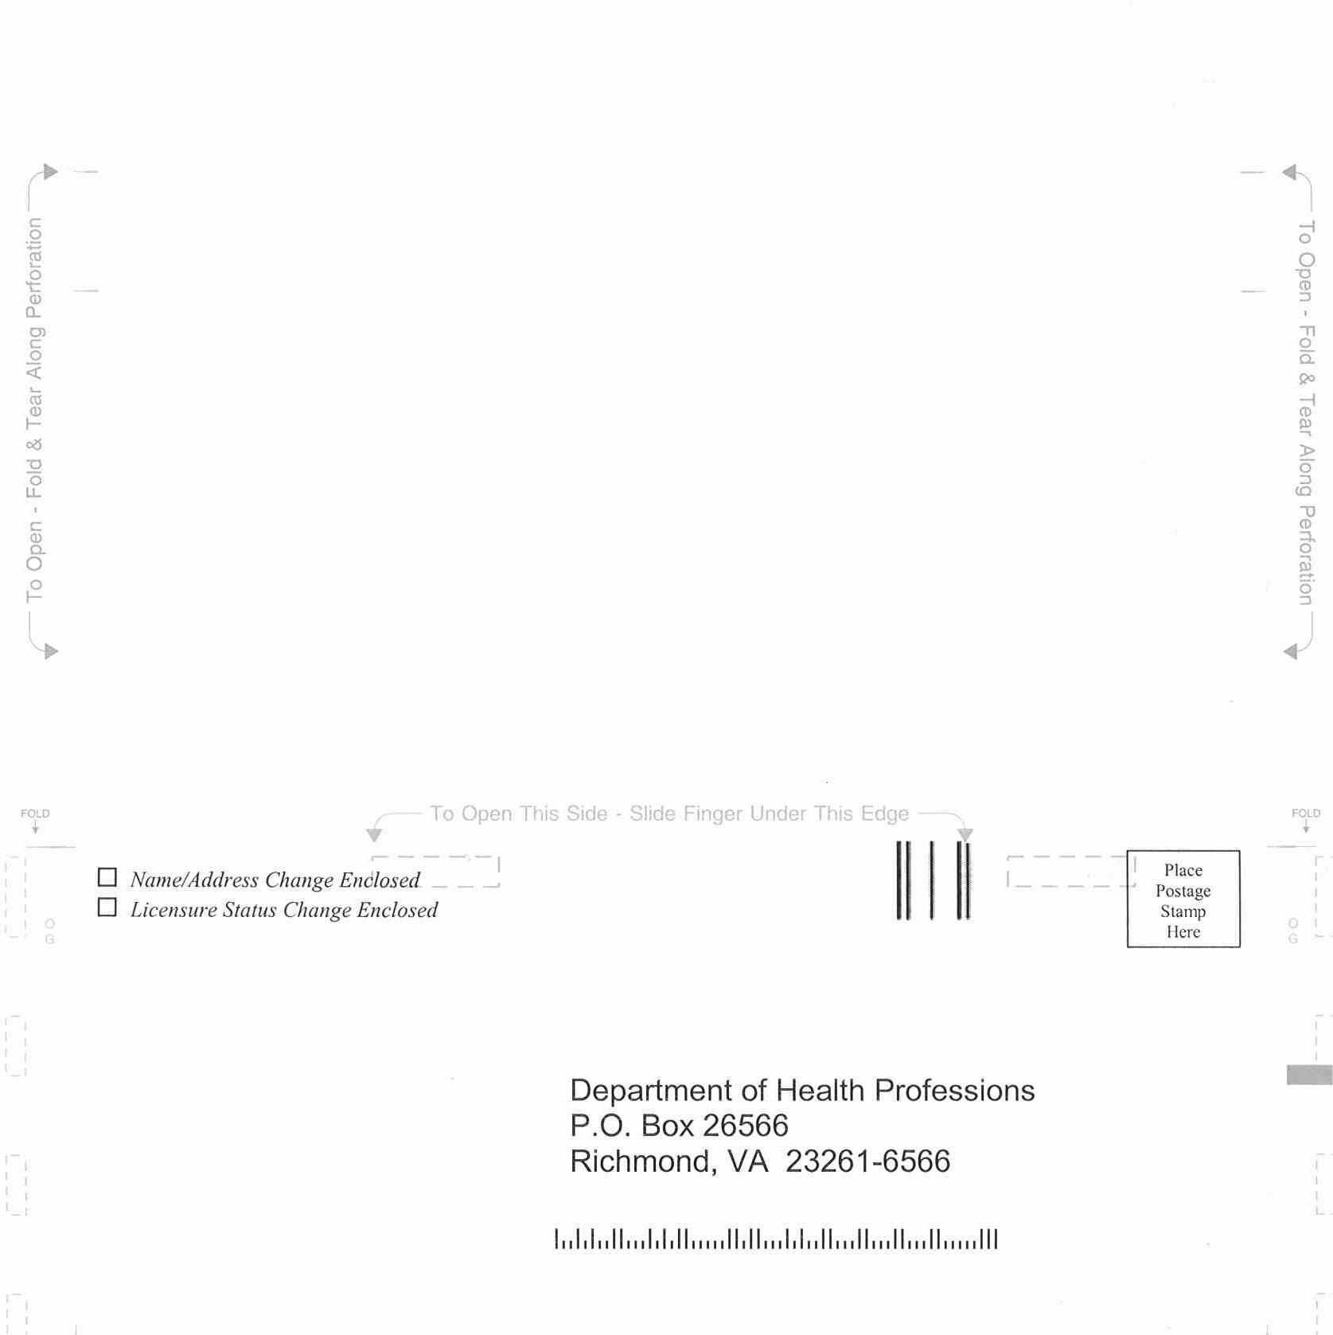
VA.R. Doc. No. R02-20; Filed July 11, 2002, 3:44 p.m.

1 This figure reflects the difference of the projected FY2002-2004 expenditures ($369,994) and the projected revenue under the current fee structure ($242,800) added to the beginning balance of -$57,964.

