STATE WATER CONTROL BOARD
REGISTRAR'S NOTICE: The following regulation filed by the State Water Control Board is exempt from the Administrative Process Act in accordance with § 2.2-4006 A 9 of the Code of Virginia, which exempts general permits issued by the State Water Control Board pursuant to the State Water Control Law (§ 62.1-44.2 et seq.), Chapter 24 (§ 62.1-242 et seq.) of Title 62.1 and Chapter 25 (§ 62.1-254 et seq.) of Title 62.1 of the Code of Virginia if the board (i) provides a Notice of Intended Regulatory Action in conformance with the provisions of § 2.2-4007 B, (ii) following the passage of 30 days from the publication of the Notice of Intended Regulatory Action forms a technical advisory committee composed of relevant stakeholders, including potentially affected citizens groups, to assist in the development of the general permit, (iii) provides notice and receives oral and written comment as provided in § 2.2-4007 F, and (iv) conducts at least one public hearing on the proposed general permit.
Title of Regulation: 9 VAC 25-120. General Virginia Pollutant Discharge Elimination System (VPDES) Permit for Discharges From Petroleum Contaminated Sites and Hydrostatic Tests (amending 9 VAC 25-120-10, 9 VAC 25-120-20, 9 VAC 25-120-50 through 9 VAC 25-120-80; repealing 9 VAC 25-120-31).
Statutory Authority: § 62.1-44.15 of the Code of Virginia.
Public Hearing Date: September 27, 2002 - 10 a.m.
Public comments may be submitted until 4 p.m. on October 31, 2002.
(See Calendar of Events section
for additional information)
Agency Contact: Jon van Soestbergen, P.E., Environmental Manager II, Department of Environmental Quality, P.O. Box 10009, Richmond, VA 23240, telephone (804) 698-4117, FAX (804) 698-4032 or e-mail jvsoest@deq.state.va.us.
Summary:
This proposed regulatory action sets forth guidelines for the permitting of the discharge to surface waters of wastewaters from sites contaminated by petroleum products or resulting from the hydrostatic testing of petroleum and natural gas storage tanks and pipelines. The State Water Control Board proposes to reissue the general permit with limitations and monitoring requirements for the following parameters:
1. For discharge of gasoline contaminated wastewaters to freshwater receiving waters; estimated flow in millions of gallons per day; benzene, maximum 50 micrograms per liter; toluene, maximum 175 micrograms per liter; ethylbenzene, 320 micrograms per liter; total xylenes, 82 micrograms per liter; MTBE, 1,840 micrograms per liter; pH, 6.0 minimum, 9.0 maximum; total recoverable lead is limited based on a formula dependant on hardness; and monitoring is required for hardness. Monitoring frequency is once per month.
2. For discharge of contamination by petroleum products other than gasoline to freshwater receiving waters; estimated flow in millions of gallons per day; naphthalene, 62 micrograms per liter maximum; total petroleum hydrocarbons, 15 milligrams per liter; pH, 6.0 minimum, 9.0 maximum. Monitoring frequency is once per month. Additionally, monitoring once per year is required for semi-volatile organics, volatile organics, and dissolved metals.
3. For discharges of hydrostatic test waters; estimated flow in million gallons per day; pH, 6.0 minimum, 9.0 maximum; total petroleum hydrocarbons, 15 mg/l maximum; total residual chlorine, 0.011 mg/l maximum; monitoring only for total organic carbon and total suspended solids. Monitoring frequency is once per discharge.
4. For discharges of gasoline contaminated wastewaters to saltwater receiving streams; estimated flow in millions of gallons per day; benzene, 50 micrograms per liter; toluene, 500 micrograms per liter; ethylbenzene, 4.3 micrograms per liter; total xylenes, 74 micrograms per liter; MTBE, 440 micrograms per liter; pH, 6.0 minimum, 9.0 maximum; total recoverable lead, 8.5 micrograms per liter. Monitoring frequency is once per month.
5. For discharges of contamination by petroleum products other than gasoline to saltwater receiving waters; estimated flow in millions of gallons per day; naphthalene 23.5 micrograms per liter; total petroleum hydrocarbons, 15 milligrams per liter; pH, 6.0 minimum, 9.0 maximum. Monitoring frequency is once per month. Additionally, monitoring once per year is required for semi-volatile organics, volatile organics, and dissolved metals.
The regulation also sets forth the minimum information requirements for all requests for coverage under the general permit.
CHAPTER 120.
GENERAL VIRGINIA POLLUTANT DISCHARGE ELIMINATION SYSTEM (VPDES) PERMIT FOR DISCHARGES FROM PETROLEUM CONTAMINATED SITES AND HYDROSTATIC TESTS.
9 VAC 25-120-10. Definitions.
The words and terms used in this chapter shall have the meanings defined in the State Water Control Law and 9 VAC 25-31-10 et seq. (VPDES permit regulation) unless the context clearly indicates otherwise, except that for the purposes of this chapter:
"Central wastewater treatment facilities" means any facility that treats (for disposal, recycling, or recovery of materials) or recycles hazardous or nonhazardous waste, hazardous or nonhazardous industrial wastewater, or used material from offsite. This includes both a facility that treats waste received from off-site exclusively, and a facility that treats waste generated on-site as well as waste received from off site.
"Petroleum products" means petroleum-based substances comprised of a complex blend of hydrocarbons derived from crude oil such as motor fuels, jet fuels, distillate fuel oils, residual fuel oils, lubricants, petroleum solvents and used oils. "Petroleum products" does not include hazardous waste as defined by the Virginia Hazardous Waste Regulations, (9 VAC 20-60-10 et seq).
9 VAC 25-120-20. Purpose.
This general permit regulation governs the discharge of wastewaters from sites contaminated by petroleum products. Petroleum-contaminated wastewater and the hydrostatic testing of petroleum and natural gas storage tanks and pipelines. These wastewaters may be discharged from the following activities: excavation dewatering, bailing groundwater monitoring wells, conducting pump aquifer tests to characterize site conditions, hydrostatic tests of natural gas and petroleum storage tanks or pipelines, hydrostatic tests of underground and above ground storage tanks, pumping contaminated groundwater to remove free product from the ground, or discharges resulting from another petroleum product cleanup activity approved by the department. Discharges not associated with petroleum-contaminated water or hydrostatic tests are not covered under this general permit.
9 VAC 25-120-31. Evaluation of chapter and petitions for reconsideration or revision. (Repealed.)
A. Within three years after February 24, 1998, the department shall perform an analysis of this chapter and provide the board with a report on the results. The analysis shall include (i) the purpose and need for the chapter; (ii) alternatives which would achieve the stated purpose of this chapter in a less burdensome and less intrusive manner; (iii) an assessment of the effectiveness of this chapter; (iv) the results of a review of current state and federal statutory and regulatory requirements, including identification and justification of requirements of this chapter which are more stringent than federal requirements; and (v) the results of a review as to whether this chapter is clearly written and easily understandable by affected entities. Upon review of the department's analysis, the board shall confirm the need to (i) continue this chapter without amendment, (ii) repeal this chapter or (iii) amend this chapter. If the board's decision is to repeal or amend this chapter, the board shall authorize the department to initiate the applicable regulatory process to carry out the decision of the board.
B. The board shall receive, consider and respond to petitions by any interested person at any time with respect to reconsideration or revision of this chapter.
9 VAC 25-120-50. Effective date of the permit.
This general permit will become effective on February 24, 1998 2003. This general permit will expire five years from the effective date. This general permit is effective as to any covered owner upon compliance with all the provisions of 9 VAC 25-120-60 and the receipt of this general permit.
9 VAC 25-120-60. Authorization to discharge.
A. Any owner governed by this general permit is hereby authorized to discharge to surface waters within the Commonwealth of Virginia provided that the owner files and receives acceptance by the board of the registration statement of 9 VAC 25-120-70 and complies with the applicable effluent limitations and other requirements of 9 VAC 25-120-80, and provided that:
1. Individual permit. The owner shall not have has not been required to obtain an individual permit according to 9 VAC 25-31-170 B;
2. Prohibited discharge locations. The owner shall not be authorized by this general permit to discharge to state waters designated as public water supplies or specifically named in other board regulations or policies which prohibit such discharges; and
3. Central wastewater treatment facilities. The owner shall not be authorized by this general permit to discharge to surface waters where there are permitted central wastewater treatment facilities reasonably available, as determined by the board.
B. Coverage under Receipt of this general permit does not relieve any owner of the responsibility to comply with any other appropriate federal, state or local statute, ordinance or regulation.
9 VAC 25-120-70. Registration statement.
The owner shall file a complete VPDES general permit registration statement for discharges from petroleum contaminated sites and hydrostatic tests. Any owner proposing a new discharge shall file a complete registration statement at least 30 days prior to the date planned for commencing operation of the new discharge. Any owner of an existing discharge covered by an individual VPDES permit who is proposing to be covered by this general permit shall file the registration statement at least 180 days prior to the expiration date of the individual VPDES permit. Any owner of an existing discharge not currently covered by a VPDES permit who is proposing to be covered by this general permit shall file a complete registration statement. The required registration statement shall contain the following information:
GENERAL VPDES PERMIT REGISTRATION STATEMENT FOR DISCHARGES FROM PETROLEUM CONTAMINATED SITES
1. Legal Name of Facility _____________________________
2. Location of Facility (Address and Telephone Number)
_______________________________________________
_______________________________________________
_______________________________________________
3. Facility Owner
Last Name _______________ First Name _______ M.I. __
4. Address of Owner
Street _______________________________________________
City _____________________ State ________ Zip ______
5. Phone
Home __________________ Work ___________________
6. Nature of the business conducted at the facility
_______________________________________________
7. Type of petroleum products causing or that caused contamination.
_______________________________________________
8. Which activities will result in a point source discharge from the petroleum contaminated site? (Check all that apply)
___ Excavation dewatering
___ Bailing groundwater monitoring wells
___ Pump tests to characterize site conditions
___ Hydrostatic tests of petroleum storage tanks or pipelines
___ Pumping contaminated groundwater to remove petroleum products from the ground
___ Other (specify) ___________________
9. Has a site characterization report for this site been submitted to the Department of Environmental Quality? Yes___ No___
10. Identify the discharge point and the waterbody into which the discharge will occur.
_______________________________________________
11. How often will the discharge occur (e.g., daily, monthly, continuously)? _________________________
12. Estimate how long each discharge will last ________ hours/days.
13. Estimate total volume of wastewater to be discharged ________ gal.
14. Estimate maximum flow rate of the discharge ________ gal/day.
15. Attach a diagram of the proposed wastewater treatment system identifying the individual treatment units.
16. Attach a topographic or other map which indicates the receiving waterbody name, the discharge points, the property boundaries, as well as springs, other surface waterbodies, drinking water wells, and public water supplies, which are identified in the public record or are otherwise known to the applicant, within a 1/2 mile radius of the proposed discharges.
17. Are central wastewater treatment facilities available to this site? Yes___ No___ If yes, has the option of discharging to the central facilities been evaluated? What was the result of that evaluation?
18. Does this facility currently have a permit issued by the board? Yes___ No___
If yes, please provide permit number: ___________________
19. Pollution complaint number (if applicable) _____________
20. Is the material being treated or discharged classified as a hazardous waste under the Virginia Hazardous Waste Regulation, 9 VAC 20-60-10 et seq.? Yes___ No___
Certification:
I certify under penalty of law that this document and all attachments were prepared under my direction or supervision in accordance with a system designed to assure that qualified personnel properly gather and evaluate the information submitted. Based on my inquiry of the person or persons who manage the system or those persons directly responsible for gathering the information, the information submitted is to the best of my knowledge and belief true, accurate, and complete. I am aware that there are significant penalties for submitting false information including the possibility of fine and imprisonment for knowing violations. I do also hereby grant duly authorized agents of the Department of Environmental Quality, upon presentation of credentials, permission to enter the property for the purpose of determining the suitability of the general permit.
Signature:_________________________ Date:___________
Print Name: _______________________________________
Title: _____________________________________________
For department use only:
Registration Statement Accepted/Not Accepted by:_____________________________
Date:__________________
Basin ______ Stream Class ______ Section ______
Special Standards ____________________________
1. Legal name of facility;
2. Location of facility, address, and telephone number;
3. Facility owner name, address, and telephone number;
4. Nature of business conducted at the facility;
5. Type of petroleum or natural gas products causing or that caused the contamination;
6. Identification of activities that will result in a point source discharge from the contaminated site;
7. Whether a site characterization report for the site has been submitted to the Department of Environmental Quality;
8. The location of the discharge point and identification of the waterbody into which the discharge will occur;
9. The frequency with which the discharge will occur (i.e., daily, monthly, continuously);
10. An estimate of how long each discharge will last;
11. An estimate of the total volume of wastewater to be discharged;
12. An estimate of the flow rate of the discharge;
13. A diagram of the proposed wastewater treatment system identifying the individual treatment units;
14. A topographic map or other map that indicates the receiving waterbody name, the discharge points, the property boundaries, as well as springs, other surface waterbodies, drinking water wells, and public water supplies that are identified in the public record or are otherwise known to the applicant within a 1/2 mile radius of the proposed discharges.
15. Whether central wastewater facilities are available to the site, and if so, whether the option of discharging to the central wastewater facility has been evaluated and the results of that evaluation;
16. Whether the facility currently has a permit issued by the board, and if so, the permit number;
17. Any applicable pollution complaint number;
18. A statement as to whether the material being treated or discharged is certified as a hazardous waste under the Virginia Hazardous Waste Regulation (9 VAC 20-60);
19. The following certification:
I certify under penalty of law that this document and all attachments were prepared under my direction or supervision in accordance with a system designed to assure that qualified personnel properly gather and evaluate the information submitted. Based on my inquiry of the person or persons who manage the system or those persons directly responsible for gathering the information, the information submitted is to the best of my knowledge and belief true, accurate, and complete. I am aware that there are significant penalties for submitting false information including the possibility of fine and imprisonment for knowing violations. I do also hereby grant duly authorized agents of the Department of Environmental Quality, upon presentation of credentials, permission to enter the property for the purpose of determining the suitability of the general permit.
The registration statement shall be signed in accordance with 9 VAC 25-31-110.
9 VAC 25-120-80. General permit.
Any owner whose request for coverage under this general permit is accepted by the board shall comply with the requirements of the general permit and be subject to all requirements of 9 VAC 25-31-170 B of the VPDES permit regulation. Not all pages of Part I A of the general permit will apply to every permittee. The determination of which pages apply will be based on the type of contamination at the individual site and the nature of the waters receiving the discharge. Part I B and all pages of Part II apply to all permittees.
General Permit No.: VAG83
Effective Date:
Expiration Date:
GENERAL VPDES PERMIT FOR DISCHARGES FROM PETROLEUM CONTAMINATED SITES AND HYDROSTATIC TESTS
AUTHORIZATION TO DISCHARGE UNDER THE VIRGINIA POLLUTANT DISCHARGE ELIMINATION SYSTEM PERMIT PROGRAM AND THE VIRGINIA STATE WATER CONTROL LAW
In compliance with the provisions of the Clean Water Act, as amended, the State Water Control Law and regulations adopted pursuant thereto, the owner is authorized to discharge to surface waters at the locations identified in the accepted registration statement within the boundaries of the Commonwealth of Virginia, except to designated public water supplies or waters specifically named in other board regulations or policies which prohibit such discharges.
The authorized discharge shall be in accordance with this cover page, Part I--Effluent Limitations and Monitoring Requirements and Part II--Conditions Applicable to All VPDES Permits, as set forth herein.
If there is any conflict between the requirements of a Department of Environmental Quality approved cleanup plan and this permit, the requirements of this permit shall govern.

PART I
A. EFFLUENT LIMITATIONS AND MONITORING REQUIREMENTS.
1. GASOLINE CONTAMINATION--FRESHWATER RECEIVING WATERS.
During the period beginning with the permittee's coverage under this general permit and lasting until the permit's expiration date, the permittee is authorized to discharge to freshwater receiving waterbodies from outfall serial number XXXX. Samples taken in compliance with the monitoring requirements specified below shall be taken at the following location: outfall from the final treatment unit prior to mixing with any other waters.
Such discharges shall be limited and monitored by the permittee as specified below:
EFFLUENT CHARACTERISTICS | DISCHARGE LIMITATIONS |  |  | MONITORING REQUIREMENTS
 | Instantaneous Minimum |  | Instantaneous Maximum | Frequency |  | Sample Type
Flow (MGD) | NA |  | NL | 1/Month |  | Estimate
Benzene (µg/l) | NA |  | 50 | 1/Month |  | Grab*
Toluene (µg/l) | NA |  | 175 | 1/Month |  | Grab*
Ethylbenzene (µg/l) | NA |  | 320 | 1/Month |  | Grab*
Total xylenes (µg/l) | NA |  | 82 | 1/Month |  | Grab*
MTBE (methyl tert-butyl ether) (µg/l) | NA |  | NL | 1/Month |  | Grab*
pH (standard units) | 6.0 |  | 9.0 | 1/Month |  | Grab
Total recoverable lead* (µg/l) | NA | e^{(1.273(In hardness**)) -4.705} |  |  | 1/Month | Grab***
Hardness (mg/l as CaCO₃)* | NL |  | NA | 1/Month |  | Grab***
NL = No Limitation, monitoring required
NA = Not Applicable
* Benzene, Toluene, Ethylbenzene, Total Xylenes and MTBE shall be analyzed according to EPA Method 602 (40 CFR Part 136, 1996) or EPA SW 846 Method 8021B (1995 1998).
** Hardness of the effluent pH may be determined in the field using EPA Method 150.1 (EPA 600/4-87-020) or EPA SW 846 method 9040B.
*** Monitoring for this parameter is required only when contamination results from leaded fuel. Lead analysis shall be according to EPA Method 239.2 (40 CFR Part 136, 1996) or EPA SW 846 Method 7421 (1986 1998). There are no limits for hardness. The minimum hardness concentration that will be used to determine the lead effluent limit is 15 mg/l.
PART I.
A. EFFLUENT LIMITATIONS AND MONITORING REQUIREMENTS.
2. CONTAMINATION BY PETROLEUM PRODUCTS OTHER THAN GASOLINE - FRESHWATER RECEIVING WATERS.
During the period beginning with the permittee's coverage under this general permit and lasting until the permit's expiration date, the permittee is authorized to discharge to freshwater receiving waterbodies from outfall serial number xxxx. Samples taken in compliance with the monitoring requirements specified below shall be taken at the following location: outfall from the final treatment unit prior to mixing with any other waters.
Such discharges shall be limited and monitored by the permittee as specified below:
EFFLUENT CHARACTERISTICS | DISCHARGE LIMITATIONS |  | MONITORING REQUIREMENTS
 | Instantaneous Minimum | Instantaneous Maximum | Frequency | Sample Type
Flow (MGD) | NA | NL | 1/Month | Estimate
Naphthalene (µg/l) | NA | 62 | 1/Month | Grab*
Total petroleum hydrocarbons (mg/l) | NA | 15 | 1/Month | Grab**
pH (standard units) | 6.0 | 9.0 | 1/Month | Grab
Semi-volatile organics*** | NA | NL | 1/Year**** | Grab
Volatile organics*** | NA | NL | 1/Year**** | Grab
Dissolved metals*** | NA | NL | 1/Year**** | Grab
NL = No Limitation, monitoring required
NA = Not Applicable
* Naphthalene analysis shall be according to either analyzed by one of the following methods: EPA Method 610 or 625 (40 CFR Part 136, 1996) or EPA SW 846 Method 8100 or 8270C (1995 1998).
** TPH shall be analyzed using either the Wisconsin Department of Natural Resources modified Diesel Range Organics test method as specified in Wisconsin publication SW-141 (1995), or by EPA Method SW 8015B (1996) for diesel range organics, or by EPA SW Method 1664 (1996) 8270C (1998). If 8270C is used, the lab must report the combination of diesel range organics and polynuclear aromatic hydrocarbons.
*** pH may be determined in the field by EPA method 150.1 (EPA 600/4-87-020) or EPA SW 846 method 9040B.
*** Monitoring for these parameters is required only when contamination is from used oils. The permittee shall report concentrations of all compounds or elements detected by the following analytical methods: Semi-volatile organics according to EPA Method 1625 (40 CFR Part 136, 1996) or EPA SW 846 Method 8270C (1995 1998); Volatile organics according to EPA Method 1624 (40 CFR Part 136, 1996) or EPA SW 846 Method 8260B (1995 1998); Dissolved metals according to EPA Method 200.7 (40 CFR Part 136, 1996) or EPA SW 846 Method 6010B (1995 1998) or other equivalent EPA 40 CFR Part 136 (1997) methods with comparable detection limits and target analyte specificity.
**** The first annual sample shall be collected within 72 hours of commencement of the discharge.
PART I
A. EFFLUENT LIMITATIONS AND MONITORING REQUIREMENTS
3. DISCHARGES OF HYDROSTATIC TEST WATERS – ALL RECEIVING WATERS
During the period beginning with the permittee's coverage under this general permit and lasting until the permit's expiration date, the permittee is authorized to discharge to receiving waterbodies from outfall serial number xxxx. Samples taken in compliance with the monitoring requirements specified below shall be taken at the following location: Outfall from the final treatment unit prior to mixing with any other waters.
Such discharges shall be limited and monitored by the permittee as specified below:
EFFLUENT CHARACTERISTICS | DISCHARGE LIMITATIONS |  | MONITORING REQUIREMENTS
 | Instantaneous Minimum | Instantaneous Maximum | Frequency | Sample Type
Flow (MGD) | NA | NL | 1/discharge | Estimate
pH (standard units)* | 6.0 | 9.0 | 1/discharge | Grab
Total Petroleum Hydrocarbons (TPH, mg/l)** | NA | 15 | 1/discharge | Grab
Total Organic Carbon (TOC, mg/l) | NA | NL | 1/discharge | Grab
Total Residual Chlorine (TRC, mg/l) | NA | 0.011 | 1/discharge | Grab
Total Suspended Solids (TSS) | NA | NL | 1/discharge | Grab
NL = No Limitation, monitoring required
NA = Not Applicable
* pH may be determined in the field by EPA method 150.1 (EPA 600/4-87-020) or EPA SW 846 method 9040B.
** TPH shall be analyzed by the Wisconsin Department of Natural Resources modified Diesel Range Organics test method as specified in Wisconsin publication SW-141 (1995), or by EPA SW 846 Method 8015B (1996) for diesel range organics, or by EPA SW Method 8270C (1998). If 8270C is used, the lab must report the combination of diesel range organics and polynuclear aromatic hydrocarbons.
PART I.
A. EFFLUENT LIMITATIONS AND MONITORING REQUIREMENTS.
3. 4. GASOLINE CONTAMINATION - SALTWATER RECEIVING WATERS.
During the period beginning with the permittee's coverage under this general permit and lasting until the permit's expiration date, the permittee is authorized to discharge to saltwater receiving waterbodies from outfall serial number xxxx. Samples taken in compliance with the monitoring requirements specified below shall be taken at the following location: outfall from the final treatment unit prior to mixing with any other waters.
Such discharges shall be limited and monitored by the permittee as specified below:
EFFLUENT CHARACTERISTICS | DISCHARGE LIMITATIONS |  | MONITORING REQUIREMENTS
 | Instantaneous Minimum | Instantaneous Maximum | Frequency | Sample Type
Flow (MGD) | NA | NL | 1/Month | Estimate
Benzene (µg/l) | NA | 50 | 1/Month | Grab*
Toluene (µg/l) | NA | 500 | 1/Month | Grab*
Ethylbenzene (µg/l) | NA | 4.3 | 1/Month | Grab*
Total xylenes (µg/l) | NA | 74 | 1/Month | Grab*
MTBE (methyl tert-butyl ether) (µg/l) | NA | NL 440 | 1/Month | Grab*
pH (standard units) | 6.0 | 9.0 | 1/Month | Grab
Total recoverable lead* (µg/l) | NA | 8.5 | 1/Month | Grab**
NL = No Limitation, monitoring required
NA = Not Applicable
* Benzene, Toluene, Ethylbenzene, Total Xylenes and MTBE shall be analyzed according to EPA Method 602 (40 CFR Part 136, 1996) or EPA SW 846 Method 8021B (1995 1998).
** pH may be determined in the field using EPA Method 150.1 (EPA 600/4-87-020) or EPA SW 846 Method 9040B.
*** Monitoring for this parameter is required only when contamination results from leaded fuel. Lead analysis shall be performed according to EPA Method 239.2 (40 CFR Part 136, 1996) or EPA SW 846 Method 7421 (1986 1998).
PART I.
A. EFFLUENT LIMITATIONS AND MONITORING REQUIREMENTS.
4. 5. CONTAMINATION BY PETROLEUM PRODUCTS OTHER THAN GASOLINE - SALTWATER RECEIVING WATERS.
During the period beginning with the permittee's coverage under this general permit and lasting until the permit's expiration date, the permittee is authorized to discharge to saltwater receiving waterbodies from outfall serial number xxxx. Samples taken in compliance with the monitoring requirements specified below shall be taken at the following location: outfall from the final treatment unit prior to mixing with any other waters.
Such discharges shall be limited and monitored by the permittee as specified below:
EFFLUENT CHARACTERISTICS | DISCHARGE LIMITATIONS |  | MONITORING REQUIREMENTS
 | Instantaneous Minimum | Instantaneous Maximum | Frequency | Sample Type
Flow (MGD) | NA | NL | 1/Month | Estimate
Naphthalene (µg/l) | NA | 23.5 | 1/Month | Grab*
Total petroleum hydrocarbons (mg/l) | NA | 15 | 1/Month | Grab**
pH (standard units) | 6.0 | 9.0 | 1/Month | Grab
Semi-volatile organics*** | NA | NL | 1/Year**** | Grab
Volatile organics*** | NA | NL | 1/Year**** | Grab
Dissolved metals*** | NA | NL | 1/Year**** | Grab
NL = No Limitation, monitoring required
NA = Not Applicable
* Naphthalene analysis shall be according to either analyzed by one of the following methods: EPA Method 610 or 625 (40 CFR Part 136, 1996), or EPA SW 846 Method Methods 8100 or 8270C (1995 1998).
** TPH shall be analyzed using either the Wisconsin Department of Natural Resources modified Diesel Range Organics test method as specified in Wisconsin publication SW-141 (1995) or EPA SW 846 Method 1664 (1996) 8270C (1998). If 8270C is used, the lab must report the combination of diesel range organics and polynuclear hydrocarbons.
*** pH may be determined in the field using EPA method 150.1 (EPA 600-4-87-020) or EPA SW 846 Method 9040B.
**** Monitoring for these parameters is required only when contamination is from used oils. The permittee shall report concentrations of all compounds or elements detected by the following analytical methods: Semi-volatile organics according to EPA Method 1625 (40 CFR Part 136, 1996) or EPA SW 846 Method 8270C (1995 1998); Volatile organics according to EPA Method 1624 (40 CFR Part 136, 1996) or EPA SW 846 Method 8260B (1995 1998); Dissolved metals according to EPA Method 200.7 (40 CFR Part 136, 1996) or EPA SW 846 Method 6010B (1995) or other equivalent EPA 40 CFR Part 136 (1997) methods with comparable detection limits and target analyte specificity.
***** The first annual sample shall be collected within 72 hours of commencement of the discharge.

PART I.
B. Special conditions.
1. There shall be no discharge of floating solids or visible foam in other than trace amounts.
2. The permittee shall sample each permitted outfall each calendar month in which a discharge occurs. When no discharge occurs from an outfall during a calendar month, the discharge monitoring report for that outfall shall be submitted indicating "No Discharge."
3. O & M Manual. If the permitted discharge is through a treatment works, within 30 days of coverage under this general permit, the permittee shall develop and maintain on site, an Operations and Maintenance (O & M) Manual for the treatment works permitted herein. This manual shall detail practices and procedures which will be followed to ensure compliance with the requirements of this permit. The permittee shall operate the treatment works in accordance with the O & M Manual. The manual shall be made available to the department upon request.
4. Operation schedule. The permittee shall construct, install and begin operating the treatment works described in the registration statement prior to discharging to surface waters. The permittee shall notify the department's regional office within five days after the completion of installation and commencement of operation.
5. Materials storage. Except as expressly authorized by this permit or another permit issued by the board, no product, materials, industrial wastes, or other wastes resulting from the purchase, sale, mining, extraction, transport, preparation, or storage of raw or intermediate materials, final product, by-product or wastes, shall be handled, disposed of, or stored so as to permit a discharge of such product, materials, industrial wastes, or other wastes to state waters.
6. If the permittee discharges to surface waters through a municipal separate storm sewer system, the permittee shall, within 30 days of coverage under this general permit, notify the owner of the municipal separate storm sewer system of the existence of the discharge and provide the following information: the name and location of the facility, a contact person and telephone number; the nature of the discharge; and the number of outfalls.
7. Termination of coverage. Provided that the department agrees that the discharge covered under this general permit is no longer needed, the permittee may request termination of coverage under the general permit, for the entire facility or for specific outfalls, by submitting a request for termination of coverage. This request for termination of coverage shall be sent to the department's regional office with appropriate documentation or references to documentation already in the department's possession. Upon the permittee's receipt of the regional director's approval, coverage under this general permit will be terminated. Termination of coverage under this general permit does not relieve the permittee of responsibilities under other board regulations or directives.
PART II.
CONDITIONS APPLICABLE TO ALL VPDES PERMITS.
A. Monitoring.
1. Samples and measurements taken as required by this permit shall be representative of the monitored activity.
2. Monitoring shall be conducted according to procedures approved under 40 CFR Part 136 or alternative methods approved by the U.S. Environmental Protection Agency, unless other procedures have been specified in this permit.
3. The permittee shall periodically calibrate and perform maintenance procedures on all monitoring and analytical instrumentation at intervals that will ensure accuracy of measurements.
B. Records.
1. Records of monitoring information shall include:
a. The date, exact place, and time of sampling or measurements;
b. The individuals who performed the sampling or measurements;
c. The dates and times analyses were performed;
d. The individuals who performed the analyses;
e. The analytical techniques or methods used; and
f. The results of such analyses.
2. Except for records of monitoring information required by this permit related to the permittee's sewage sludge use and disposal activities, which shall be retained for a period of at least five years, the permittee shall retain records of all monitoring information, including all calibration and maintenance records and all original strip chart recordings for continuous monitoring instrumentation; copies of all reports required by this permit; and records of all data used to complete the registration statement for this permit for a period of at least three years from the date of the sample, measurement, report or request for coverage. This period of retention shall be extended automatically during the course of any unresolved litigation regarding the regulated activity or regarding control standards applicable to the permittee, or as requested by the board.
C. Reporting monitoring results.
1. The permittee shall submit the results of the monitoring required by this permit not later than the 10th day of the month after monitoring takes place unless another reporting schedule is specified elsewhere in this permit. Monitoring results shall be submitted to the department's regional office.
2. Monitoring results shall be reported on a Discharge Monitoring Report (DMR) or on forms provided, approved or specified by the department.
3. If the permittee monitors any pollutant specifically addressed by this permit more frequently than required by this permit using test procedures approved under 40 CFR Part 136 or using other test procedures approved by the U.S. Environmental Protection Agency or using procedures specified in this permit, the results of this monitoring shall be included in the calculation and reporting of the data submitted in the DMR or reporting form specified by the department.
4. Calculations for all limitations which require averaging of measurements shall utilize an arithmetic mean unless otherwise specified in this permit.
D. Duty to provide information. The permittee shall furnish to the department, within a reasonable time, any information which the board may request to determine whether cause exists for modifying, revoking and reissuing, or terminating this permit or to determine compliance with this permit. The board may require the permittee to furnish, upon request, such plans, specifications, and other pertinent information as may be necessary to determine the effect of the wastes from his discharge on the quality of state waters or such other information as may be necessary to accomplish the purposes of the State Water Control Law. The permittee shall also furnish to the department upon request copies of records required to be kept by this permit.
E. Compliance schedule reports. Reports of compliance or noncompliance with, or any progress reports on, interim and final requirements contained in any compliance schedule of this permit shall be submitted no later than 14 days following each schedule date.
F. Unauthorized discharges. Except in compliance with this permit or another permit issued by the board, it shall be unlawful for any person to:
1. Discharge into state waters sewage, industrial wastes, other wastes, or any noxious or deleterious substances; or
2. Otherwise alter the physical, chemical or biological properties of such state waters and make them detrimental to the public health, to animal or aquatic life, to the use of such waters for domestic or industrial consumption, for recreation, or for other uses.
G. Reports of unauthorized discharges. Any permittee who discharges or causes or allows a discharge of sewage, industrial waste, other wastes or any noxious or deleterious substance into or upon state waters in violation of Part II F or who discharges or causes or allows a discharge that may reasonably be expected to enter state waters in violation of Part II F shall notify the department of the discharge immediately upon discovery of the discharge, but in no case later than 24 hours after the discovery. A written report of the unauthorized discharge shall be submitted to the department within five days of discovery of the discharge. The written report shall contain:
1. A description of the nature and location of the discharge;
2. The cause of the discharge;
3. The date on which the discharge occurred;
4. The length of time that the discharge continued;
5. The volume of the discharge;
6. If the discharge is continuing, how long it is expected to continue;
7. If the discharge is continuing, what the expected total volume of the discharge will be; and
8. Any steps planned or taken to reduce, eliminate and prevent a recurrence of the present discharge or any future discharges not authorized by this permit.
Discharges reportable to the department under the immediate reporting requirements of other regulations are exempted from this requirement.
H. Reports of unusual or extraordinary discharges. If any unusual or extraordinary discharge including a bypass or upset should occur from a treatment works and the discharge enters or could be expected to enter state waters, the permittee shall promptly notify, in no case later than 24 hours, the department by telephone after the discovery of the discharge. This notification shall provide all available details of the incident, including any adverse affects on aquatic life and the known number of fish killed. The permittee shall submit the report to the department in writing within five days of discovery of the discharge in accordance with Part II I 2. Unusual and extraordinary discharges include but are not limited to any discharge resulting from:
1. Unusual spillage of materials resulting directly or indirectly from processing operations;
2. Breakdown of processing or accessory equipment;
3. Failure or taking out of service some or all of the treatment works; and
4. Flooding or other acts of nature.
I. Reports of noncompliance. The permittee shall report any noncompliance which may adversely affect state waters or may endanger public health as follows:
1. An oral report shall be provided within 24 hours from the time the permittee becomes aware of the circumstances. The following shall be included as information which shall be reported within 24 hours under this subsection:
a. Any unanticipated bypass; and
b. Any upset which causes a discharge to surface waters.
2. A written report shall be submitted within five days and shall contain:
a. A description of the noncompliance and its cause;
b. The period of noncompliance including exact dates and times and, if the noncompliance has not been corrected, the anticipated time it is expected to continue; and
c. Steps taken or planned to reduce, eliminate, and prevent reoccurrence of the noncompliance.
The board may waive the written report on a case-by-case basis for reports of noncompliance under Part II I if the oral report has been received within 24 hours and no adverse impact on state waters has been reported.
3. The permittee shall report all instances of noncompliance not reported under Part II I 1 or 2, in writing, at the time the next monitoring reports are submitted. The reports shall contain the information listed in Part II I 2.
NOTE: The immediate (within 24 hours) reports required in Part II G, H and I may be made to the department's regional office. Reports may be made by telephone or by FAX. For reports outside normal working hours, leave a message and this shall fulfill the immediate reporting requirement. For emergencies, the Virginia Department of Emergency Services maintains a 24-hour telephone service at 1-800-468-8892.
J. Notice of planned changes.
1. The permittee shall give notice to the department as soon as possible of any planned physical alterations or additions to the permitted facility. Notice is required only when:
a. The permittee plans an alteration or addition to any building, structure, facility, or installation from which there is or may be a discharge of pollutants, the construction of which commenced:
(1) After promulgation of standards of performance under § 306 of the Clean Water Act which are applicable to such source; or
(2) After proposal of standards of performance in accordance with § 306 of the Clean Water Act which are applicable to such source, but only if the standards are promulgated in accordance with § 306 of the Act within 120 days of their proposal;
b. The alteration or addition could significantly change the nature or increase the quantity of pollutants discharged. This notification applies to pollutants which are subject neither to effluent limitations nor to notification requirements specified elsewhere in this permit; or
c. The alteration or addition results in a significant change in the permittee's sludge use or disposal practices, and such alteration, addition, or change may justify the application of permit conditions that are different from or absent in the existing permit, including notification of additional use or disposal sites not reported during the permit application process or not reported pursuant to an approved land application plan.
2. The permittee shall give advance notice to the department of any planned changes in the permitted facility or activity which may result in noncompliance with permit requirements.
K. Signatory requirements.
1. Registration statement. All registration statements shall be signed as follows:
a. For a corporation: by a responsible corporate officer. For the purpose of this section, a responsible corporate officer means (i) a president, secretary, treasurer, or vice-president of the corporation in charge of a principal business function, or any other person who performs similar policy-making or decision-making functions for the corporation or (ii) the manager of one or more manufacturing, production, or operating facilities employing more than 250 persons or having gross annual sales or expenditures exceeding $25 million (in second-quarter 1980 dollars), if authority to sign documents has been assigned or delegated to the manager in accordance with corporate procedures;
b. For a partnership or sole proprietorship: by a general partner or the proprietor, respectively; or
c. For a municipality, state, federal, or other public agency: by either a principal executive officer or ranking elected official. For purposes of this section, a principal executive officer of a public agency includes (i) the chief executive officer of the agency or (ii) a senior executive officer having responsibility for the overall operations of a principal geographic unit of the agency.
2. Reports. All reports required by permits, and other information requested by the board shall be signed by a person described in Part II K 1, or by a duly authorized representative of that person. A person is a duly authorized representative only if:
a. The authorization is made in writing by a person described in Part II K 1;
b. The authorization specifies either an individual or a position having responsibility for the overall operation of the regulated facility or activity such as the position of plant manager, operator of a well or a well field, superintendent, position of equivalent responsibility, or an individual or position having overall responsibility for environmental matters for the company. A duly authorized representative thus may be either a named individual or any individual occupying a named position; and
c. The written authorization is submitted to the department.
3. Changes to authorization. If an authorization under Part II K 2 is no longer accurate because a different individual or position has responsibility for the overall operation of the facility, a new authorization satisfying the requirements of Part II K 2 shall be submitted to the department prior to or together with any reports or information to be signed by an authorized representative.
4. Certification. Any person signing a document under Parts II K 1 or 2 shall make the following certification:
"I certify under penalty of law that this document and all attachments were prepared under my direction or supervision in accordance with a system designed to ensure that qualified personnel properly gather and evaluate the information submitted. Based on my inquiry of the person or persons who manage the system, or those persons directly responsible for gathering the information, the information submitted is, to the best of my knowledge and belief, true, accurate, and complete. I am aware that there are significant penalties for submitting false information, including the possibility of fine and imprisonment for knowing violations."
L. Duty to comply. The permittee shall comply with all conditions of this permit. Any permit noncompliance constitutes a violation of the State Water Control Law and the Clean Water Act, except that noncompliance with certain provisions of this permit may constitute a violation of the State Water Control Law but not the Clean Water Act. Permit noncompliance is grounds for enforcement action; for permit termination, revocation and reissuance, or modification; or denial of a permit renewal application.
The permittee shall comply with effluent standards or prohibitions established under § 307(a) of the Clean Water Act for toxic pollutants and with standards for sewage sludge use or disposal established under § 405(d) of the Clean Water Act within the time provided in the regulations that establish these standards or prohibitions or standards for sewage sludge use or disposal, even if this permit has not yet been modified to incorporate the requirement.
M. Duty to reapply. If the permittee wishes to continue an activity regulated by this permit after the expiration date of this permit, the permittee shall submit a new registration statement at least 180 days before the expiration date of the existing permit, unless permission for a later date has been granted by the board. The board shall not grant permission for registration statements to be submitted later than the expiration date of the existing permit.
N. Effect of a permit. This permit does not convey any property rights in either real or personal property or any exclusive privileges, nor does it authorize any injury to private property or invasion of personal rights, or any infringement of federal, state or local law or regulations.
O. State law. Nothing in this permit shall be construed to preclude the institution of any legal action under, or relieve the permittee from any responsibilities, liabilities, or penalties established pursuant to any other state law or regulation or under authority preserved by § 510 of the Clean Water Act. Except as provided in permit conditions on bypass (Part II U) and upset (Part II V), nothing in this permit shall be construed to relieve the permittee from civil and criminal penalties for noncompliance.
P. Oil and hazardous substance liability. Nothing in this permit shall be construed to preclude the institution of any legal action or relieve the permittee from any responsibilities, liabilities, or penalties to which the permittee is or may be subject under Article 11 (§ 62.1-44.34:14 et seq.) of the State Water Control Law.
Q. Proper operation and maintenance. The permittee shall at all times properly operate and maintain all facilities and systems of treatment and control (and related appurtenances) which are installed or used by the permittee to achieve compliance with the conditions of this permit. Proper operation and maintenance also includes effective plant performance, adequate funding, adequate staffing, and adequate laboratory and process controls, including appropriate quality assurance procedures. This provision requires the operation of back-up or auxiliary facilities or similar systems which are installed by the permittee only when the operation is necessary to achieve compliance with the conditions of this permit.
R. Disposal of solids or sludges. Solids, sludges or other pollutants removed in the course of treatment or management of pollutants shall be disposed of in a manner so as to prevent any pollutant from such materials from entering state waters.
S. Duty to mitigate. The permittee shall take all reasonable steps to minimize or prevent any discharge or sludge use or disposal in violation of this permit which has a reasonable likelihood of adversely affecting human health or the environment.
T. Need to halt or reduce activity not a defense. It shall not be a defense for a permittee in an enforcement action that it would have been necessary to halt or reduce the permitted activity in order to maintain compliance with the conditions of this permit.
U. Bypass.
1. "Bypass" means the intentional diversion of waste streams from any portion of a treatment facility. The permittee may allow any bypass to occur which does not cause effluent limitations to be exceeded, but only if it also is for essential maintenance to ensure efficient operation. These bypasses are not subject to the provisions of Part II U 2 and 3.
2. Notice.
a. Anticipated bypass. If the permittee knows in advance of the need for a bypass, prior notice shall be submitted, if possible, at least 10 days before the date of the bypass.
b. Unanticipated bypass. The permittee shall submit notice of an unanticipated bypass as required in Part II I.
3. Prohibition of bypass.
a. Bypass is prohibited, and the board may take enforcement action against a permittee for bypass, unless:
(1) Bypass was unavoidable to prevent loss of life, personal injury, or severe property damage;
(2) There were no feasible alternatives to the bypass, such as the use of auxiliary treatment facilities, retention of untreated wastes, or maintenance during normal periods of equipment downtime. This condition is not satisfied if adequate back-up equipment should have been installed in the exercise of reasonable engineering judgment to prevent a bypass which occurred during normal periods of equipment downtime or preventive maintenance; and
(3) The permittee submitted notices as required under Part II U 2.
b. The board may approve an anticipated bypass, after considering its adverse effects, if the board determines that it will meet the three conditions listed above in Part II U 3 a.
V. Upset.
1. An upset constitutes an affirmative defense to an action brought for noncompliance with technology-based permit effluent limitations if the requirements of Part II V 2 are met. A determination made during administrative review of claims that noncompliance was caused by upset and before an action for noncompliance is not a final administrative action subject to judicial review.
2. A permittee who wishes to establish the affirmative defense of upset shall demonstrate through properly signed, contemporaneous operating logs or other relevant evidence that:
a. An upset occurred and that the permittee can identify the cause or causes of the upset;
b. The permitted facility was at the time being properly operated;
c. The permittee submitted notice of the upset as required in Part II I; and
d. The permittee complied with any remedial measures required under Part II S.
3. In any enforcement proceeding, the permittee seeking to establish the occurrence of an upset has the burden of proof.
W. Inspection and entry. The permittee shall allow the director or an authorized representative, upon presentation of credentials and other documents as may be required by law, to:
1. Enter upon the permittee's premises where a regulated facility or activity is located or conducted or where records must be kept under the conditions of this permit;
2. Have access to and copy, at reasonable times, any records that must be kept under the conditions of this permit;
3. Inspect at reasonable times any facilities, equipment (including monitoring and control equipment), practices, or operations regulated or required under this permit; and
4. Sample or monitor at reasonable times, for the purposes of ensuring permit compliance or as otherwise authorized by the Clean Water Act and the State Water Control Law any substances or parameters at any location.
For purposes of this section, the time for inspection shall be deemed reasonable during regular business hours, and whenever the facility is discharging. Nothing contained herein shall make an inspection unreasonable during an emergency.
X. Permit actions. Permits may be modified, revoked and reissued, or terminated for cause. The filing of a request by the permittee for a permit modification, revocation and reissuance, or termination, or a notification of planned changes or anticipated noncompliance does not stay any permit condition.
Y. Transfer of permits.
1. Permits are not transferable to any person except after notice to the department. Except as provided in Part II Y 2, a permit may be transferred by the permittee to a new owner or operator only if the permit has been modified or revoked and reissued, or a minor modification made, to identify the new permittee and incorporate such other requirements as may be necessary under the State Water Control Law and the Clean Water Act.
2. As an alternative to transfers under Part II Y 1, this permit may be automatically transferred to a new permittee if:
a. The current permittee notifies the department at least 30 days in advance of the proposed transfer of the title to the facility or property;
b. The notice includes a written agreement between the existing and new permittees containing a specific date for transfer of permit responsibility, coverage, and liability between them; and
c. The board does not notify the existing permittee and the proposed new permittee of its intent to modify or revoke and reissue the permit. If this notice is not received, the transfer is effective on the date specified in the agreement mentioned in Part II Y 2 b.
Z. Severability. The provisions of this permit are severable, and if any provision of this permit or the application of any provision of this permit to any circumstance, is held invalid, the application of such provision to other circumstances, and the remainder of this permit, shall not be affected thereby.
DOCUMENTS INCORPORATED BY REFERENCE
Wisconsin Publication SW-141 (1995).
EPA Method 1664 (1996).
EPA SW 846 Method 6010 (1995).
EPA SW 846 Method 7421 (1986).
EPA SW 846 Method 8021 (1995).
EPA SW 846 Method 8260 (1995).
EPA SW 846 Method 8270 (1995).
Method Cite
150.1 | EPA 600/4-87-020
200.7 | EPA 600/R-94-111; 40 CFR 136, App D, 1996
239.2 | EPA 600/4-79-020; 40 CFR 136, App D, 1996
602 | 40 CFR 136, 1996
610 | 40 CFR 136, 1996
625 | 40 CFR 136, 1996
1624 | 40 CFR 136, 1996
1625 | 40 CFR 136, 1996
6010B | EPA SW 846, Ch. 3.3, (1998)
7421 | EPA SW 846, Ch. 3.3, (1998)
8015B | EPA SW 846, Ch. 4.3.1, (1998)
8021B | EPA SW 846, Ch. 4.3.1, (1998)
8100 | EPA SW 846, Ch. 4.3.1, (1998)
8260B | EPA SW 846, Ch. 4.3.2, (1998)
8270C | EPA SW 846, Ch. 4.3.2, (1998)
9040B | EPA SW 846, Ch. 8.2, (1998)
NOTICE: The forms used in administering 9 VAC 25-120, General Virginia Pollutant Discharge Elimination System (VPDES) Permit for Discharges From Petroleum Contaminated Sites and Hydrostatic Tests, are listed below. Any amended or added forms are reflected in the listing and are published following the listing.
FORMS
General VPDES Permit Registration Statement for Discharges from Petroleum Contaminated Sites eff. 9/97 and Hydrostatic Tests (rev. 2/03).
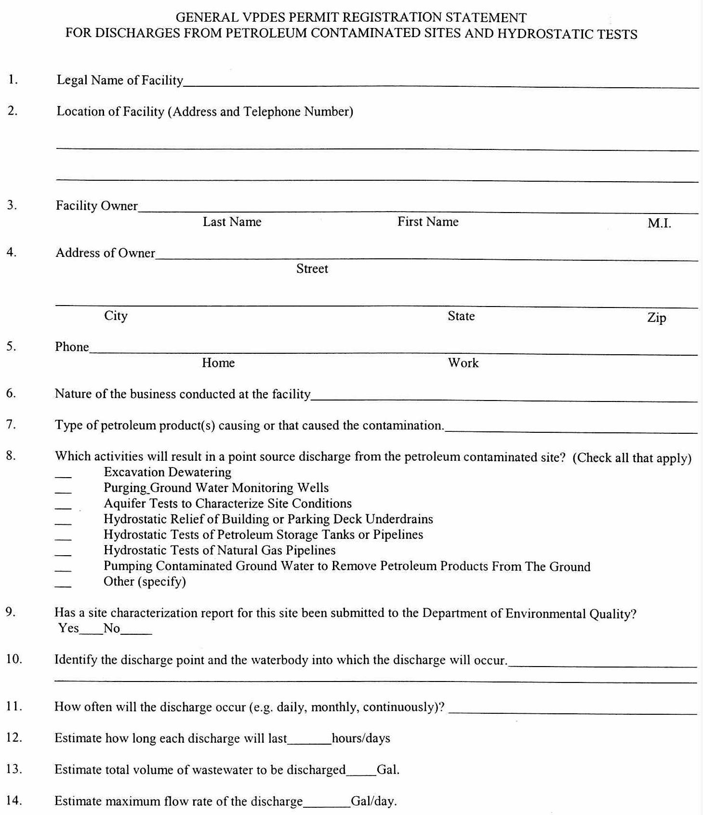
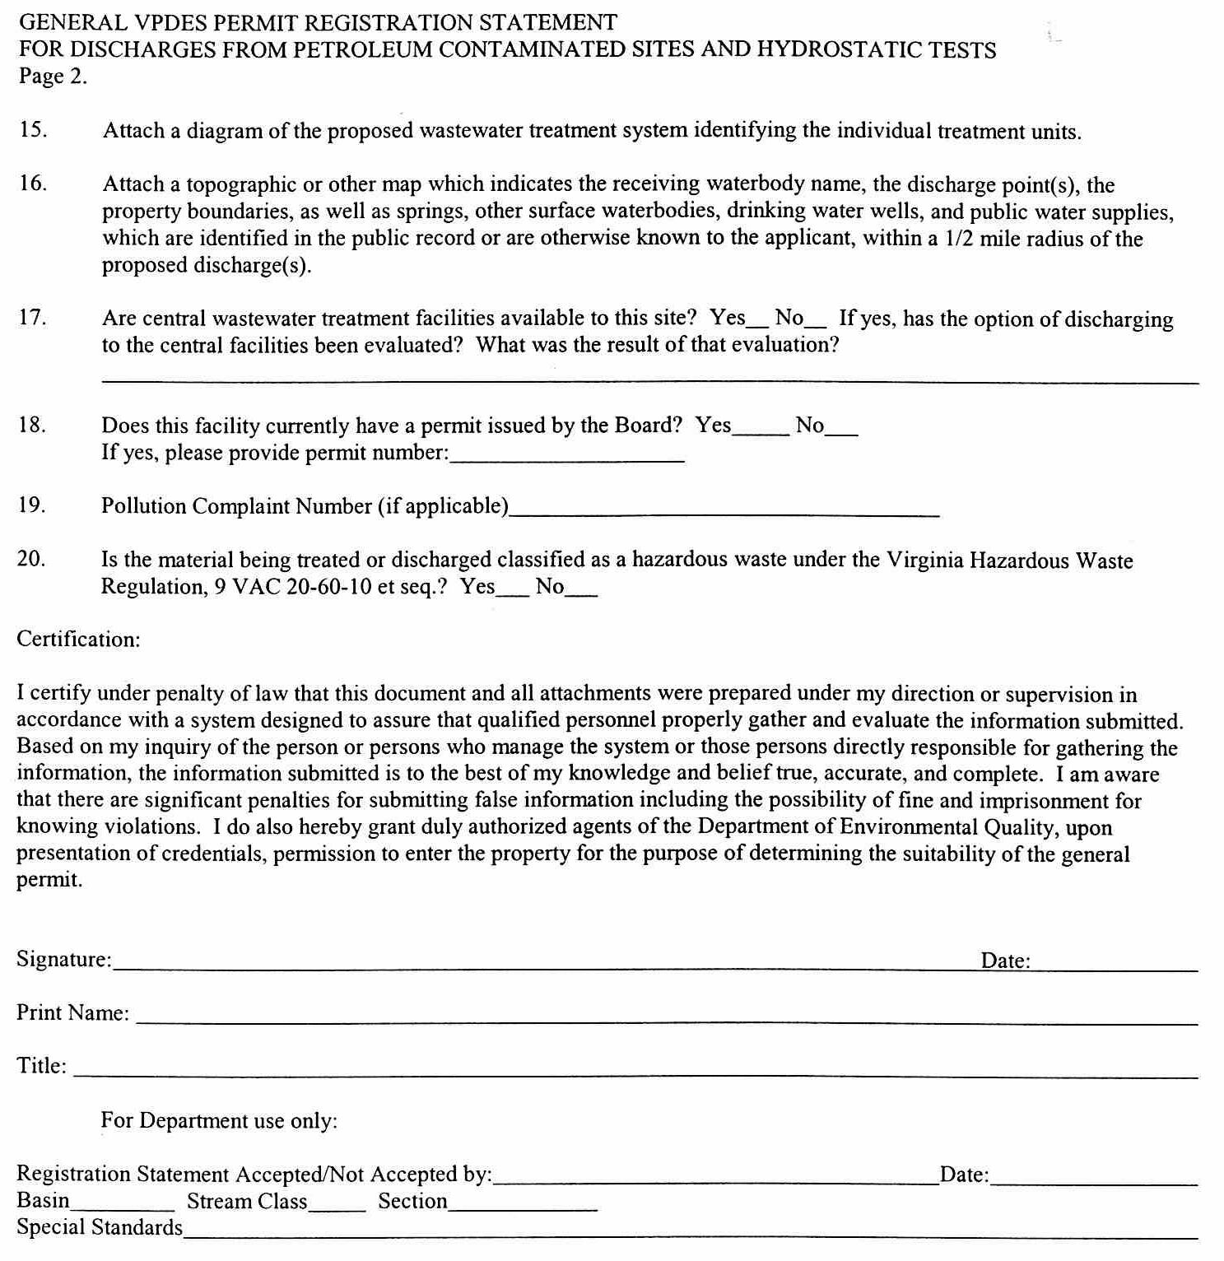
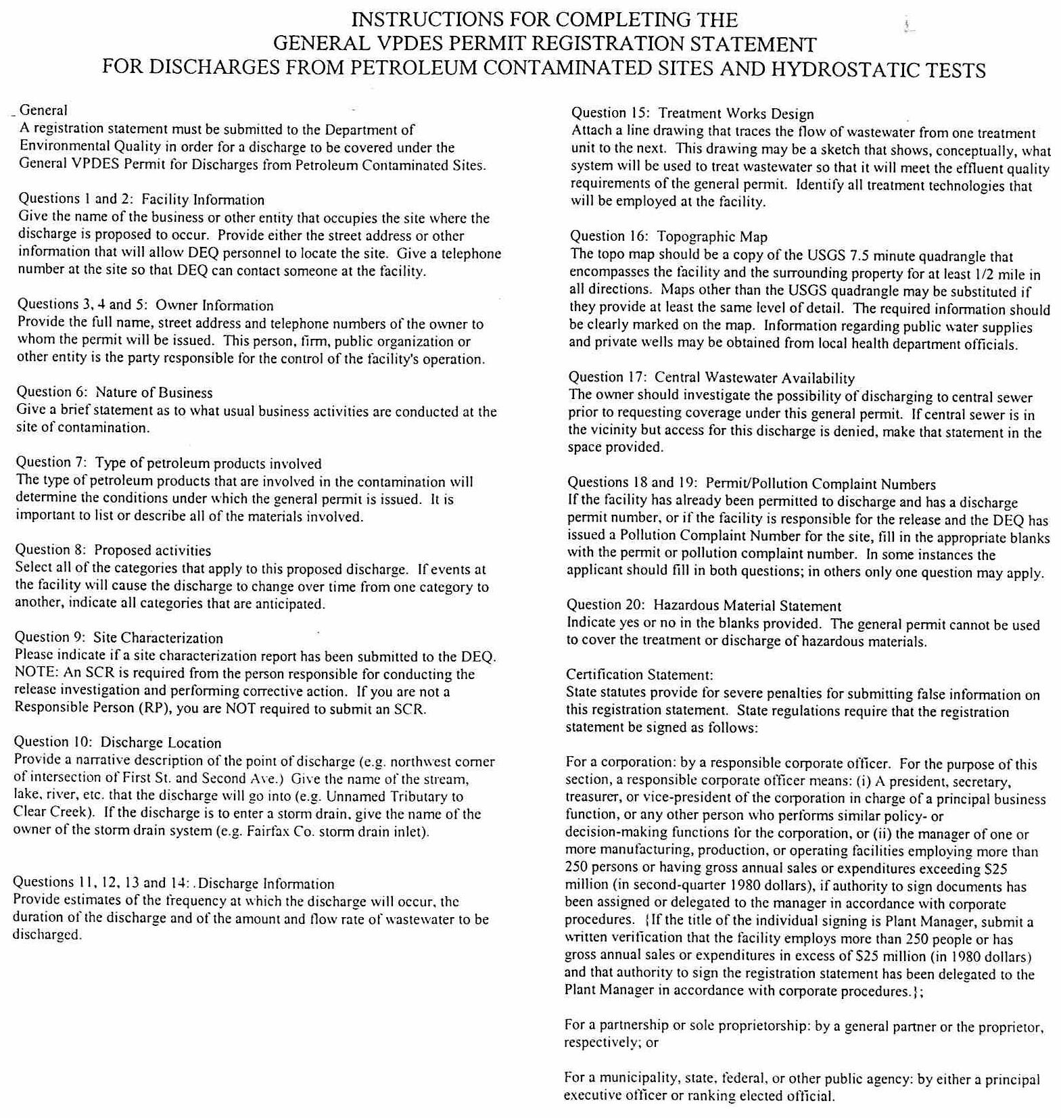

VA.R. Doc. No. R01-265; Filed August 5, 2002, 9:55 a.m.

