STATE BOARD OF AGRICULTURE AND CONSUMER SERVICES
Title of Regulation: 2 VAC 5-360. Regulations for the Enforcement of the Virginia Commercial Feed Act (amending 2 VAC 5-360-10 through 2 VAC 5-360-100; repealing 2 VAC 5-360-110 through 2 VAC 5-360-140).
Statutory Authority: § 3.1-828.4 of the Code of Virginia.
Public Hearing Date: March 13, 2003 - 10 a.m.
Public comments may be submitted until 5 p.m. on December 9, 2002.
(See Calendar of Events section
for additional information)
Agency Contact: J. Alan Rogers, Program Manager, Department of Agriculture and Consumer Services, 1100 Bank Street, Room 402, Richmond, VA 23219, telephone (804) 786-2476, FAX (804) 786-1571 or e-mail jrogers@vdacs.state.va.us.
Basis: Section 3.1-828.4 of the Code of Virginia authorizes the Board of Agriculture and Consumer Services to promulgate regulations necessary for the efficient enforcement of the Commercial Feed Act. The Commercial Feed Act mandates the establishment of investigational procedures, assessments, definitions, records review, manufacturing practices, distribution and storage of regulated products before final sale. The regulation, as currently written, meets the minimum requirements of the state mandate.
Purpose: The regulation is essential to the health and welfare of Virginia citizens. Commercial feed is the primary source of nutrition for animals produced for human consumption. The economic imperative to the animal producer is that the feed ingredients are of a quality and quantity that ensure the animal’s health, growth, and development. Residuals (pesticides/medications) from improper feed ingredients may adulterate the food products used by humans. This regulation helps to ensure a safe food supply.
The regulation assures commercial feed users that the label plainly and conspicuously represents the intended purpose. Label claims represent the percentage of nutrients and ingredients guaranteed and indicate that the feed is free of unsafe drug levels, pesticides and chemical residues. In the absence of this regulation, the commercial feed purchaser would have no reasonable way to determine if the feed will satisfy the nutritional needs of the animal or that the feed contains what the label claims.
The proposed regulatory action will remove obsolete sections and clarify the intent of the regulation making it compatible with the amendments to the Commercial Feed Law enacted by the 1994 General Assembly.
Substance: Delete the following sections that have been replaced or made obsolete by changes to the statute enacted by the 1994 General Assembly:
2 VAC 5-360-110. Cancellation of registration and license.
2 VAC 5-360-120. Additives.
2 VAC 5-360-130. Crude fiber standards.
2 VAC 5-360-140. Application for registration of commercial feeds.
Amend the following sections to clarify the regulation and make the intent and meaning of the regulation compatible with the changes enacted by the 1994 General Assembly.
2 VAC 5-360-10. Definitions.
2 VAC 5-360-20. Brand Names.
2 VAC 5-360-30. Expression of Guarantees.
2 VAC 5-360-40. Ingredient Statement.
2 VAC 5-360-50. Labeling.
2 VAC 5-360-60. Minerals.
2 VAC 5-360-70. Nonprotein nitrogen.
2 VAC 5-360-80. Ingredients.
2 VAC 5-360-90. Methods of sampling and analysis.
2 VAC 5-360-100. Definitions and standards.
Issues: The advantages of the amendment include increased public access to regulated products that are more precisely labeled for the protection of the health of domestic and companion animals. Industry will be able to market products without being burdened by unnecessary regulation. The proposed amended regulation is easier to comprehend by industry and regulators and compliments other states’ regulations, allowing for increased interstate industry competition.
There are no disadvantages to the public or the Commonwealth.
Department of Planning and Budget's Economic Impact Analysis: The Department of Planning and Budget (DPB) has analyzed the economic impact of this proposed regulation in accordance with § 2.2-4007 G of the Administrative Process Act and Executive Order Number 25 (98). Section 2.2-4007 G requires that such economic impact analyses include, but need not be limited to, the projected number of businesses or other entities to whom the regulation would apply, the identity of any localities and types of businesses or other entities particularly affected, the projected number of persons and employment positions to be affected, the projected costs to affected businesses or entities to implement or comply with the regulation, and the impact on the use and value of private property. The analysis presented below represents DPB’s best estimate of these economic impacts.
Summary of the proposed regulation. The Virginia Department of Agriculture and Consumer Services (the agency) proposes to amend the current regulations to incorporate the changes made to the commercial feed industry standards by the Association of American Feed Control Officials (AAFCO) in the last decade and the statutory changes made to Virginia’s Commercial Feed Law in 1994. Some of the proposed amendments are intended to improve the clarity of the regulation as well as providing consistency in naming brands among Virginia and other national or international feed manufacturers. Changes under another category are proposed to provide consistency with national feed labeling and ingredient standards. The final category of the changes will remove feed registration and license cancellation requirements, application requirements for registration, and the requirements on the use of additives and crude fiber in feed production because the Virginia Commercial Feed Law as amended in 1994 supersedes these requirements.
Introduction. These regulations establish standards for commercial feed product brand names, expression of guarantees, ingredients, ingredient statements, and labels. The types of products produced, distributed, and sold in the commercial feed industry include agricultural feeds for cattle, sheep, and horses, foods for traditional pets such as dogs and cats, and foods for specialty pets such as fish, birds, and hamsters.
Virginia’s commercial feed industry is large. The agency estimates that about 5 million tons of agricultural feed reaching a market value of approximately $1 billion have been sold in the Commonwealth every year. Although the sales in the pet food industry are not known, they add to the total market activity. There are over 10,000 commercial feed products produced in Virginia or imported from other states.
Two causes of market failure may be present in the commercial feed industry: asymmetric information and product externalities. Asymmetric information refers to the information discrepancies between the producers and customers regarding the characteristics of a product. The producers of commercial feed have incentives to provide information on labels for customers as long as the information promotes their product. However, not all the characteristics of a product are desirable. Some characteristics may be harmful to animal health and productivity, or may have the potential to contaminate the derived products such as milk or meat from the animals, which may be consumed by humans. Also, most consumers are unlikely to have necessary means to find out about these negative qualities on their own. In the presence of asymmetric information, private market forces may be impaired and fail to produce the best economic outcome. Uninformed or misinformed consumers are unlikely to make the right choices reflecting their preferences among many alternative feeds. Commercial feeds with undesirable characteristics are likely to be over-produced and commercial feeds with desirable characteristics are likely to be under-produced. Thus, asymmetric information can cause misallocation of resources that are not optimal.
Misallocation of resources can also be caused by product externalities. Product externalities exist when market participants do not incur the full costs or benefits of their own consumption and production decisions. For example, a commercial feed may transmit diseases between animals and species. This would impose costs on the public health system. The commercial feed producer who spreads the disease may not incur all of the associated costs and the production of contaminated feed would be more than the optimal level had the producer incurred the full costs. In short, commercial feeds may have negative or positive externalities. When an individual does not incur the full cost (benefit) of his own decisions, his consumption is likely to be more (less) than the socially optimal consumption level. Thus, product externalities can also cause misallocation of resources that are not socially optimal.
Commercial feed labeling has the potential to mitigate the misallocation of resources stemming from asymmetric information and product externalities. Golan, et al (2000)1 identify a list of circumstances from the food labeling research literature when labeling is believed to be appropriate. According to this study, economic theory suggests that labeling is appropriate when no political consensus on regulation exists, consumer preferences differ widely, information on product enhances safety, information is clear and concise, labeling requirement can be enforced, and costs and benefits of consumption are borne by the consumer.
Mandatory disclosure of pertinent information through a regulation may reduce potential asymmetric information and product externality problems and result in better allocation of resources. Well-informed consumers are likely to make better choices among many alternative feeds according to their preferences. Thus, misallocation of resources due to overproduction of commercial feed with undesirable characteristics and due to underproduction of commercial feed with desirable characteristics would be mitigated. This adjustment process is likely to bring the feed production closer to the socially optimum level.
In general, the benefits and costs of human food labeling also apply to commercial feed.2 The costs of labeling include administrative and enforcement costs on the agency and other third parties involved, compliance costs on the commercial feed industry, and the potential transmission of compliance costs to consumers in terms of higher prices. The potential benefits include increasing consumers’ access to information, achieving socially desirable changes in consumption behavior, increasing competition between producers by providing homogeneous information, improving animal health and safety which may have direct impacts on humans through the food chain, and reformulating products to eliminate negative characteristics. These costs and benefits are difficult to quantify and their sizes depend on many specific factors in each case.
One significant factor is the involvement of the third parties in standard setting, certification, testing, and enforcement.3 In commercial feed industry, AAFCO is the dominant entity that sets the standards on the use of terms, format of ingredient statements, expression of guarantees, and ingredient contents that are determined through federal and state agencies, universities, and industry research. The decision making body of AAFCO is made up of state regulatory officials. Each state has one vote in AAFCO rulings. This service is valuable to the producers and the local governments as it may not be economically feasible for each manufacturer or local governments to develop all of their own standards independently. Instead, each AAFCO member contributes to costs of providing this service through membership fees and purchase of publications. This probably results in much lower costs due to sharing of information. The presence of uniform standards has the potential to reduce costly negotiations to establish the quality of a product and allow customers to compare different products based on a uniform set of characteristics.
AAFCO is not a regulatory entity and is not involved in certifications, testing, or enforcement. The state authorities provide these services. Certification, testing, and enforcement of the established standards are administered by the agency. These services are likely to contribute to the benefits of commercial feed labeling. Certification helps ensure that the product information is correct. Also, testing and enforcement services bolster the credibility of claims made in the product labels.
Estimated economic impact. The proposed amendments to the commercial feed regulations are numerous. However, the current language in the regulation that will be changed by this regulatory action has not been enforced and the industry has been in compliance with the proposed rules for more than three years. Thus, no significant economic impact is expected from the proposed regulations at this time. This analysis rather provides information on the costs and benefits of the proposed changes that may have occurred several years ago as the commercial feed industry started complying with the proposed changes.
Brand Names. Some of the changes are intended to improve the clarity of the regulation as well as providing consistency in naming brands among Virginia feed manufacturers and other national or international feed manufacturers.
(1) One group of the proposed changes under this category is adding new language to reinforce the current requirement that the product brand name may not misrepresent the product’s ingredients or mislead the consumer. A brand name of a product made of several ingredients will not be allowed to be dominated by a single ingredient name that may falsely de-emphasize the presence of other ingredients contained in the product. If an ingredient name is desired to be used in the brand name, possibly to affect the consumer preferences, a quantitative guarantee for that ingredient must be provided in the label.
(2) Another group of changes are related to the restricted use of certain terms. For instance, a brand name will not be allowed to contain the term “protein” if the product contains added non-protein nitrogen. Similarly, the animal name will be required to qualify the terms “meat” or “meat by-product” used in the brand name if the meat is derived from an animal other than cattle, swine, sheep, or goat.
(3) Finally, restrictions on a number of terms will be deleted to be consistent with the changes in the national feed industry. One example is removing the requirement that the products with the terms “candy” or “sweet” in the brand name have at least 5% sugar content.
The compliance with the requirements under this category can be achieved by either modifying the brand name to reflect the actual product characteristics as defined in the proposed regulation or by making changes in the production process to be consistent with the brand name. Individual manufacturers are likely to adopt the least cost option.
The main benefit of these changes is to improve the homogeneity in product brand names nationwide. Homogeneous product information is likely to enhance the competition among commercial feed suppliers. Also, greater consistency in brand names will likely allow consumers to compare product brand names uniformly and reduce potential consumer manipulation. The consumers are likely to make better consumption decisions according to their preferences.
Feed Labeling and Ingredient Standards. Changes under this category are proposed to provide consistency in labeling and ingredient standards between Virginia feed manufacturers and other national or international feed manufacturers. These changes include the following:
(1) The units of measure for vitamins A, D and E will be changed from United States Pharmacopoeia (USP) units to International Units (IU) per pound. This is likely to improve the consistency in label information provided by Virginia, national, and international feed manufacturers without imposing significant costs. According to the agency, potential buyers expect to see vitamin contents expressed in terms of IU, as it has been the industry norm since 1950s. This change is likely to allow consumers and producers to easily compare products and to determine efficacy between products.
(2) It will be required that the voluntary guarantees for salt, calcium, and sodium be stated in terms of a range between the minimum and maximum content instead of a point guarantee. The reason for this change is that these minerals interact with each other and may increase or decrease the guaranteed amount. For example, sodium may easily bind with other elements such as chloride and chemically create more salt. Thus, a range may more accurately represent the actual mineral levels and inform the customer about the uncertainty involved.
For manufacturers, this change is likely to afford more flexibility in the production process to meet the stated guarantees and increase compliance. The consistency in presenting this information on the label is likely to promote competition. There may be guarantee analysis costs associated with producing the information in the required format.
Consumers are likely to make better consumption decisions, which may affect health and safety of their animals. Inadequate levels of these minerals can be harmful to the animals. Accurate information on salt, calcium, and sodium contents is useful to the consumers. Salt is a basic elemental need for all animals and affects their overall performance. Inadequate quantity of salt can cause ill effects on animals such as edema, kidney failure, weight loss, and reproductive damage. Similarly, calcium plays an important role in growth and organ development. This mineral affects animal structures such as bone and soft tissue, affects their metabolism, and prevents structural diseases such as rickets. If calcium and phosphorus ratio is unbalanced, other adverse effects may develop. Finally, inappropriate levels of sodium can affect digestion of proteins, energy levels, weight, reproduction, and may have many other adverse effects.
It seems that providing the contents of these minerals in terms of a range instead of a point guarantee has the potential to better inform the consumer about the mineral content uncertainty in the feed product. Thus, informed feed consumption is likely to increase, which would improve animal health and safety. The direction of the changes in consumption behavior is also likely to be socially desirable. However, since this information is pertinent to customers, some manufacturers may have been already providing information on the level of uncertainty involved with the mineral content. Thus, the significance of this change in practice is not known.
(3) The use of collective terms for the grouping of ingredients will be allowed. Official grouping of ingredients is published by AAFCO. This amendment will allow using the same label for different feeds as long as the products use any of the ingredients within the same group. For example, the collective term “plant protein product” covers both corn and soybean. The manufacturer is able to use either corn or soybean as an input, whichever is cheap at the time, without the need to change the label. This change is likely to produce cost savings in label production and allow manufacturers to take advantage of price differentials among the ingredients under the same collective term without additional costs. The manufacturer may also avoid interruptions in supply by substituting one input for the other when a specific ingredient is not available. However, the consumers’ access to information may be compromised, as the exact ingredient information may be pertinent to some of them.
(4) The requirement that the ingredient statement of feed containing inert mineral matter and charcoal include the information on the kind and percentage of ingredients will be deleted. Since this type of feed is not produced any longer, this requirement is obsolete. Thus, this proposed change is unlikely to have any economic impact.
(5) A quantity statement on the label will be required instead of a weight statement. The quantity of some of the products may be stated in terms of other measurements. For instance, the quantity of liquid feed is stated in volumes rather than weight. This change is likely to improve the information content of the label without introducing any significant costs. Thus, consumers are likely to be able to make their decisions based on the measurable quantity that is relevant to the product.
(6) Designation of species and animal classes on the label for feeds will be required. This change intends to prevent the consumption of feed by animals that may be adversely affected. For example, some cow feeds can kill sheep and some diseases could be transmitted between the species through feed mixing. This additional information is likely to reduce the misuse of the feed among different animals, protect their health, prevent disease transmission between different animal classes, and allow consumers to make informed decisions. These consumption decisions are likely to be socially desirable. According to the agency, there is sufficient information readily available from National Academy of Sciences, universities, and other published material to determine the appropriate designation for species and classes. Thus, the compliance costs of this requirement do not seem to be significant.
(7) The maximum fluorine and phosphate contents will be established separately for breeding and dairy cattle, slaughter cattle, sheep, and lambs. Currently, there is no distinction among cattle categories and among sheep categories. The proposed varying standards are developed by AAFCO and are believed to be scientifically more appropriate for different classes of cattle and sheep. Fluorine is important for teeth and bone development. However, the amounts over the animals’ safety levels can cause irreversible harm to bones, teeth, growth, reproduction, lactation, and reduced feed consumption. Phosphorus is also critical for animal development. Inadequate phosphorus consumption has adverse effects on milk production, reproduction, weight gain, and physical performance.
This change is likely to be beneficial for feed consumers. Consumers will be able to make informed purchasing decisions for different classes of cattle and sheep, and possibly avoid many adverse effects on their animals, which would also be socially desirable. There is likely to be additional costs of presenting this information in the required format. However, the significance of this change in practice is not known.
(8) The proposed amendments will allow adulteration of feed by noxious weed seeds that are restricted in use as long as the amounts of weed seeds are in accordance with the applicable seed regulation. Adulteration by noxious weed seeds has the potential to undermine the efforts to control aggressive weeds in agriculture applications. The use of appropriate limits on noxious weed seeds is likely to reduce the need to eradicate weeds that pass through the animals’ digestive tract and grow in the animals’ environment without completely prohibiting their use in feed production. This amendment is simply a clarification of the applicable standards and is not expected to have a significant economic impact.
(9) The proposed amendments will also require that guarantees for microorganisms and enzymes be specified on the label and that microorganisms/enzymes be listed in order of predominance. According to the agency, some products entered the market with little or no research and some contained fraudulent and misleading claims regarding microorganisms/enzymes content. Many claims were made concerning the use of these products in lieu of veterinary drugs or treatments. As a result, animals did not receive proper medical attention. Some animals received under-treatment or were not treated at all. Also, under-treatment for diseases has the potential to develop resistance. Furthermore, there is the chance that unhealthy products from ill animals reach the human food supply. The required information is likely to improve animal health and reduce human exposure to unhealthy animal products. Consumers are likely to be better informed and make socially desirable consumption decisions.
Required disclosure of microorganism and enzyme information may alter the mix of ingredients used in production as the manufacturers determine the optimal amounts of these inputs given more informed consumers. These requirements are also likely to bolster competition. Additionally, including an extra phrase to the label to comply with the proposed requirement will introduce labeling costs to feed producers.
Providing microorganism and enzyme information in order of predominance has the potential to further benefit consumers. For example, a product may claim a desirable feature, a listed ingredient is known to produce, but its predominance may not be of a sufficient amount to actually produce the desired outcome. Without the proposed requirement, it may be difficult to identify these types of products. The listing of the microorganisms and enzymes in order of predominance will likely allow consumers to make more informed decisions and reduce purchase of products that are not likely to produce desired results.
(10) The amendments will prohibit the use of soybean and vegetable meals having been extracted with trichlorethylene or other chlorinated solvents. According to the agency, recent discoveries indicate that these extraction methods leave toxic, even carcinogenic, residues in feeds. The toxic/carcinogenic residues can move through the food chain. These methods are not only harmful to the animals, but also harmful to other animals and humans in the food chain.
Although most consumers are likely to adjust their consumption decisions if this information is available to them, some may not be aware of the potential consequences. Given the consumers’ tendency to avoid such products, rational producers would have incentives to use safer extraction methods. The proposed prohibition of these methods is likely to protect mainly uninformed consumers. Exposure of animals and humans to toxic and carcinogenic residues is likely be reduced and some of the potential social costs may be avoided. On the other hand, the prohibition of these extraction methods is likely to impose significant costs on producers as they may be required to switch to more costly methods.
(11) Sulfurous acids will no longer be used as a significant source of vitamin B1. The agency indicates that sulfurous acids may contain vitamin B1, but animals are unable to absorb these vitamins. Prior to recent scientific evidence in this area, both producers and consumers were under the assumption that sulfurous acids could provide essential amount of vitamin B1. New scientific information is likely to have changed the customer preferences and production decisions even in the absence of regulatory requirements. Consumers may have reduced their consumption of these types of feed while producers may have reduced sulfurous acids in feed production. Thus, the significance of this change in practice cannot be determined.
Overall economic effects of these labeling requirements in this category are similar to the costs and benefits of the proposed brand name provisions. The compliance with the most proposed labeling standards can be achieved by either modifying the label to reflect the actual product characteristics as defined in the proposed labeling requirements or by making changes in the production process to be consistent with the information on the labels. Individual manufacturers are likely to adopt the least cost option. The main benefit of these changes is to improve the homogeneity in commercial feed labels nationwide. Homogeneous product information provided in the labels is also likely to enhance the competition among commercial feed suppliers. Furthermore, greater consistency in label information will likely allow consumers to compare products more effectively. The consumers are likely to make better consumption decisions according to their preferences.
Finally, some of the changes in this category are related to ingredient standards and may have direct effects on animal health and food supply safety. For example, prohibition of toxic/carcinogenic extraction methods, limitations on the use of sulfurous acids, and disclosure of microorganism and enzyme information may have direct effects on animals, which may be transmitted to humans. The proposed ingredient standards have a greater potential to reduce the misallocation of resources stemming from asymmetric information and the negative product externalities. It seems that in most cases, the consumers’ potential reaction to most of the changes are also socially desirable. Thus, these proposed changes have the potential to improve not only consumers’ welfare, but also society’s welfare. On the other hand, required changes in the production process is likely to introduce additional costs on manufacturers.
Statutory Changes. The changes in the final category are proposed because the Virginia Commercial Feed Law as amended in 1994 supersedes the current language. These changes are the following.
(1) Provisions on the cancellation of a registration of commercial feed and of a license to manufacture and distribute commercial feed will be deleted as the amended feed law supersedes the current requirements. The agency is not proposing to amend the regulations to be consistent with the statutory amendments, but rather proposing to remove the current language completely from the regulations, and planning to operate directly under the statutory language. According to the agency, the amendments of 1994 contain, at a minimum, the same cancellation requirements as currently written in the regulations, and a broader set of enforcement actions. There should be no economic impact regarding the current requirements in the regulations since they will still be enforced under the statue. There seems to be potential economic impacts in practice because of broader statutory requirements, however, these changes are not proposed in the regulations. Thus, potential economic impacts due to the changes in the statue are not addressed in this analysis.
(2) Provisions on the commercial feed registration application will be deleted as the amended feed law supersedes the current requirements. Similarly, the agency is not proposing to amend the regulations to be consistent with the statutory amendments, but rather proposing to remove them completely from these regulations, and planning to operate directly under the statutory language. According to the agency, the amendments of 1994 contain similar application requirements, but require submission of only one copy of the product label instead of two copies as currently required. In practice, applicants will be required to provide only one copy of the label with their applications instead of two. This is not expected to produce any significant benefits for the applicants, as the cost savings from a copy of the label is minimal.
(3) The language on the use of additives such as preservatives and artificial color will be deleted as the statute no longer requires the approval of the Virginia Commissioner of Agriculture and Consumer Services and allows companies to use AAFCO approved additives. The agency indicates that the amendments to the feed law in 1994 supersede the current requirements and allow firms to use a greater amount of additives than what the current rule would allow. Since, at a minimum, the statute allows the use of the same additives as the current regulations allow, there should be no economic impact regarding the current requirements in the regulations. There seems to be potential economic impacts in practice because the feed companies will be able to avoid costs associated with research and approval by simply using AAFCO approved standards and because they will be able to use a broader set of additives in the production process. However, these changes are not proposed in the regulations. Thus, potential economic impacts due to the changes in the statue are not addressed in this analysis.
(4) The language that crude fiber standards apply whenever screenings such as nutshells are added to animal feeds will be deleted. According to the agency, the amended statue adopted the national crude fiber standards. More importantly, screenings have not been used in feed production for decades. This requirement is believed to be obsolete and all the effects are likely to already be in place in practice. Thus, this proposed amendment is not expected to have a significant economic impact.
Businesses and entities affected. There are 150 licensed commercial feed manufacturers in Virginia. In addition, there are 780 out-of-state licensed firms. The number of consumers that may be affected is not known.
Localities particularly affected. The proposed regulations apply throughout the Commonwealth.
Projected impact on employment. The proposed regulations are not expected to have any significant impact on current employment because the commercial feed industry has already been in compliance with the proposed requirements, and the requirements have been already enforced by the agency for several years.
Effects on the use and value of private property. Similarly, since the proposed requirements have been complied in practice, no significant impact on the current use and value of private property is expected.
Agency's Response to the Department of Planning and Budget's Economic Impact Analysis: The agency concurs with the economic impact analysis submitted by the Department of Planning and Budget.
Summary:
This regulation establishes labeling guidelines for commercial feed manufacturers as to claims for animal nutrients, including guarantees for crude protein, crude fat, crude fiber, minerals and vitamins; ingredients; methods of sampling and analysis; definitions and standards; and application for and cancellation of registrations and licenses. The regulation serves as a reference and instructional guide for manufacturers and provides compliance expectations for products merchandised within the Commonwealth. The proposed amendments delete obsolete sections and clarify the intent and meaning of the regulation making it compatible with changes to the Commercial Feed Act enacted by the 1994 General Assembly.
CHAPTER 360.
RULES AND REGULATIONS FOR THE ENFORCEMENT OF THE VIRGINIA COMMERCIAL FEED LAW ACT.
2 VAC 5-360-10. Definitions.
A. Words used in the singular form in this chapter shall include the plural, and vice versa, as appropriate.
B. All terms used in this chapter shall have the meaning set forth for such in the law Act. In addition, the following words and terms shall have the following meanings, unless the context clearly indicates otherwise:
"Act" means Chapter 28.1 (§ 3.1-828.1 et seq.) of Title 3.1 of the Code of Virginia, hereinafter known as the Virginia Commercial Feed Act.
"Animal" means any animate being which is not human.
"Adulteration" means a commercial feed is adulterated if:
1. Enough of any harmful or non-nutritive ingredient has been added to endanger animal health when used according to labeling directions.
2. Any part of an essential component has been omitted, removed, or replaced with an inferior substance.
3. The composition or quality of the feed fails to conform to its representation in the labeling.
4. It was prepared or held under unsanitary conditions.
5. It contains any filthy, putrid, decomposed, tainted, unsound or unwholesome substance.
6. Its container is composed of any substance which may cause the feed to endanger animal health.
"Board" means the Virginia Board of Agriculture and Consumer Services.
"Brand" means the term, design, or trademark and other specific designation under which an individual commercial feed is distributed in Virginia.
"Canned animal food" means all materials packed in any airtight container with a moisture content of 70% or more which are distributed for use as food for animals other than humans.
"Commercial feed" means all mixed or unmixed feed including concentrates, supplements, molasses, minerals, mineral mixtures, and all other materials used for their nutritional or physical properties for feeding to animals except those materials exempted by Law the Act.
"Commissioner" means the Virginia Commissioner of Agriculture and Consumer Services or his delegated assistant or agent.
"Distribute" means to offer or expose for sale, sell, or warehouse, exchange, barter, furnish or otherwise supply.
"Distributor" means a person who offers for sale, sells, or barters distributes commercial feeds.
"Feed ingredient" means each of the constituent materials making up a commercial feed.
"Inert mineral matter" means mineral matter that has no nutritional value.
"Label" means a display of written, printed, or graphic matter upon or affixed to the container in which a commercial feed is distributed. The invoice or delivery slip with which a commercial feed is distributed in bulk is the label.
"Labeling" means any written, printed, graphic, electronic, or advertising information pertaining to the commercial feed which is:
1. On the commercial feed or any of its containers,
2. On the invoice or delivery slip, or
3. Accompanying the commercial feed at any time, or
4. Otherwise provided to the consumer.
"Law" means Chapter 28.1 of Title 3.1 of the Code of Virginia, hereinafter known as the Virginia Commercial Feed Law.
"Materials of little or no feeding value" means organic or inorganic materials which, in the proportions present, are recognized by nutritionists as having little or no nutritional value.
"Medicated feed" means a product obtained by mixing a drug, as defined in § 3.1-828.2 of the Code of Virginia, and a commercial feed. It is subject to all provisions of the Virginia Commercial Feed Law Act.
"Misbranding" means a commercial feed is misbranded if:
1. The label does not include:
a. The name and principal address of the manufacturer, distributor, or person responsible for placing the commercial feed on the market.
b. The name, brand or trademark under which the commercial feed is sold.
c. An accurate quantity statement of the net weight of the contents.
d. An accurate statement of the minimum percentage of crude protein.
e. An accurate statement of the minimum percentage of crude fat.
f. An accurate statement of the maximum percentage of crude fiber.
g. An accurate statement of the maximum percentage of moisture for all dog and cat foods.
h. The English name of each ingredient or the statement, "Ingredients as filed with the State," in lieu of the list of ingredients conform to the requirements of 2 VAC 5-360-40.
h. i. Adequate warnings against use under normal or pathological conditions where its use may endanger animal health, or against unsafe use or application as necessary for the protection of animals.
2. Labeling is false or misleading in any particular.
3. It is distributed under the name of another commercial feed.
4. Its container is so made, formed or filled as to be deceptive or misleading as to the amount of contents.
5. Its labeling bears any reference to registration or license under the Law Act.
6. It is represented as containing a feed ingredient, unless such feed ingredient conforms to the definition prescribed by regulation of the board.
7. Any word, statement or other information required by Law the Act is not prominently placed upon the label so conspicuously (as compared with other words, statements, designs, or devices in the labeling) and in such terms as to make it likely to be read and understood by the ordinary individual under customary conditions of purchase and use.
"Official sample" means any sample of feed taken by the commissioner and designated as "Official" by the commissioner.
"Person" means an individual, partnership, association, corporation, firm, agent or authorized group of individuals whether incorporated or not.
"Prohibited noxious-weed seeds" means the seeds of perennial weeds which not only reproduce by seed but which also spread by underground roots and stems; and which, when established, are highly destructive and are not controlled in the Commonwealth by commonly used cultural practices. These include but are not limited to the seeds of Balloonvine-Cardiospermum halicacabum, Field bindweed-Convolulus arvensis, Quackgrass-Agropyron repends, Canada thistle-Cirsium arvense, Johnson grass-Sorghum spp., perennial, and Plumeless thistle, which includes Musk thistle and Curled thistle Carduus spp., Serrated tussock-Nassella trichotoma, and Sicklepod-Senna obtusifolia.
"Restricted noxious-weed seeds" means the seeds of weeds which are very objectionable in fields, lawns and gardens in this Commonwealth and are difficult to control by commonly used cultural practices. These include but are not limited to seeds of Dodder Cuscuta spp., Bermudagrass Cynodon dactylon, Wild onion bulblets, Wild garlic bulblets Allium spp., Wild mustardBrassica spp., Giant foxtail-Setaia faberia, radish-Raphanus, and Annual bluegrass-Poa annua.
"Sell" means sales, barter, or exchange.
"Ton" means a net weight of 2,000 pounds, avoirdupois.
2 VAC 5-360-20. Brand names.
A. The name of a brand shall not tend to mislead the purchaser with respect to any quality of the feed. If the brand name indicates that the feed is made for a specific use, the character of the feed shall conform to that use. A mixture labeled "dairy feed," for example shall be adapted for that purpose.
B. A brand name shall not be derived from one or more ingredients of a mixture to the exclusion of other ingredients. A distinctive name shall not represent any component of a mixture unless all components are included in the name, provided that if any ingredient or combination of ingredients is intended to impart a distinctive characteristic to the product that is of significance to the purchaser, the name of that ingredient or combination of ingredients may be used as a part of the brand name if the ingredient or combination of ingredients is quantitatively guaranteed in the guaranteed analysis, and the brand name is not otherwise false or misleading.
C. The word "vitamin" or a contraction thereof, or any word suggesting vitamin, may be used in the brand name of a feed only in the case of a feed represented solely to be a vitamin supplement, and which is labeled with the minimum vitamin content guaranteed as specified in subsection B of 2 VAC 5-360-30.
D. The term "mineralized" shall not be used in the brand name of a feed except for "trace mineralized salt." When so used, the product shall contain significant amounts of trace minerals which are recognized as essential for the nutrition of animals. The mineral compound source of each mineral except salt (NaC1) shall be stated in the ingredient statement.
E. When the brand name carries a percentage value, it shall be understood to signify minimum crude protein content. If any other percentage values are used in brand names, they shall be followed by the proper description.
F. If the brand name of a feed includes the word "candy," "sweet," or some comparable term, the product shall contain a minimum of 5.0% total sugars, calculated as invert sugar. If molasses is used, the type shall be declared.
G. "Screenings." If screenings, either ground or unground, bolted or unbolted, are added to any unmixed by-product feed, the brand shall be labeled clearly to indicate this fact. The word "Screenings" shall appear as part of the name or brand and shall be printed in the same size and face of type as the rest of the brand name.
H. "Labels for Wheat Bran and Wheat Shorts Containing Screenings." The admixture of any proportion of wheat screenings requires a declaration to that effect in the brand name, which shall be printed in the same size and type face as the rest of the brand name. In no case shall the admixture exceed mill run of screenings.
1. Wheat Bran with Ground Wheat Screenings.
2. Wheat Shorts with Ground Wheat Screenings.
F. The word “protein” shall not be permitted in the brand name of a feed that contains added nonprotein nitrogen.
G. The term “meat” or “meat byproduct” in a brand name shall be qualified in the brand name to designate the animal from which the meat or meat byproduct is derived unless the meat or meat byproduct is made from cattle, swine, sheep or goats.
H. Single ingredient feeds shall have a brand name in accordance with the designated definition of feed ingredients as recognized by the Official Publication of the Association of American Feed Control Officials, Inc., 2002.
2 VAC 5-360-30. Expression of guarantees.
A. The sliding scale method of expressing guarantees (for example, "Protein 15-18%") is prohibited, except as specifically allowed in the law Act or in this chapter.
B. Vitamins, when guaranteed, shall be expressed in milligrams per pound of feed, except that:
1. Vitamin A shall be stated in USP International Units per pound, except for precursors of Vitamin A.
2. Vitamin D, when used in products for poultry feeding, shall be expressed in International Chick Units.
3. Vitamin D for other uses shall be expressed in USP International Units per pound.
4. Vitamin E shall be expressed in USP or International Units per pound of feed.
C. The common feed or mineral guarantees are not required for any product represented solely to be a vitamin supplement which is labeled with a minimum vitamin guarantee as specified in subsection D of 2 VAC 5-360-40.
D. Calcium." When a minimum and maximum percent of calcium is guaranteed, the maximum percent of calcium shall not exceed by more than 20% the minimum percent of calcium. (Example: Calcium minimum, 10%, maximum 12%) provided that in the event that the minimum percent of calcium is 5.0% or less, the maximum percent of calcium may exceed the minimum by 1.0% of calcium. (Example: Calcium minimum 3.0%, maximum 4.0%).
D. When calcium, salt, and sodium guarantees are given in the guaranteed analysis, such shall be stated and conform to the following:
1. When the minimum is below 2.5%, the maximum shall not exceed the minimum by more than 0.5 percentage point.
2. When the minimum is 2.5% but less than 5.0%, the maximum shall not exceed the minimum by more than one percentage point.
3. When the minimum is 5.0% or greater, the maximum shall not exceed the minimum by more than 20% of the minimum and in no case shall the maximum exceed the minimum by more than five percentage points.
E. When stated, guarantees for minimum and maximum total calcium, salt, and sodium; minimum potassium, magnesium, sulfur, phosphorus; and maximum fluorine shall be in terms of percentage. Other minimum mineral guarantees shall be stated in parts per million (ppm) when the concentration is less than 10,000 ppm and in percentage when the concentration is 10,000 ppm (1.0%) or greater. All guaranteed, minerals except salt (NaCl), shall be stated in terms of percentage of the element.
2 VAC 5-360-40. Ingredient statement.
A. The term "dehydrated" may precede the name of any product that has been artificially dried.
B. No reference to quality or grade of an ingredient shall appear in the ingredient statement of a feed.
C. "Inert Mineral Matter and Charcoal." In the case of feeds containing inert grit, other added inert mineral matter or charcoal, the ingredient statement must include the kind and percentage of grit or other added inert mineral matter, charcoal, etc. In case the percentage of inert grit, other mineral matter or charcoal, separately or together, is 5.0% or more, the brand name shall also include the name and percent of such matter, such as "With . . . .% Grit," "With . . . .% Charcoal," and With . . . .% Charcoal and Bentonite," etc.
C. The name of each ingredient or collective term for the grouping of ingredients, when required to be listed, shall be the name as defined in the Official Definitions of Feed Ingredients as published in the Official Publication of the Association of American Feed Control Officials, Inc., 2002, or the common or usual name for ingredients that do not have official definitions or that do not require definitions (example: corn).
D. No declaration of vitamin potency of a feed or feed supplement shall appear in the ingredient statement or any other part of the label, excepting that such statement is a guarantee of minimum vitamin potency of the entire product given in terms as specified in subsection B of 2 VAC 5-360-30.
2 VAC 5-360-50. Labeling.
A. The information required in § 3.1-828.5 of the Code of Virginia, with the exception of the net weight quantity statement, shall appear in its entirety on one side of a label or on one side of the container. However, in case a tag is used, the directions for use and warnings against misuse may appear on the other side of the tag.
B. When ingredients are listed, the names of all feed ingredients shall be shown in letters or type of the same size.
C. When feeds carry label information in more than one position on the container, there shall be no variance with respect to name, ingredients, or guaranteed composition.
D. The term "degermed" must precede the name of any product from which the germ has been wholly or partially removed.
E. All printed or written information attached to or packed with feed must conform in all respects to the information printed on the principal label.
F. Labeling which implies that added enzyme-bearing materials improve the utilization of a product is prohibited unless the claims are substantiated by scientific evidence.
G. The term "Bond Phosphate of Lime," "Bone Phosphate of Lime (BPL)," or "BPL" shall not be used in connection with the labeling of feed ingredients.
H. The label of a commercial feed, other than an individual ingredient or supplement with directions for further mixing, shall designate the species and may designate the animal class for which the feed is intended. For the purpose of this subsection, animal class may include, but is not limited to, weight range, sex, or age of the animal for which the feed is manufactured.
2 VAC 5-360-60. Minerals.
A. When the word "Iodized" is used in connection with a feed ingredient, the ingredient shall contain not less than 0.007% of iodine, uniformly distributed.
B. Phosphatic materials for feeding purposes shall be labeled with a guarantee of the minimum and maximum percentages of calcium (when present), the minimum percentage of phosphorous, and the maximum percentage of fluorine.
C. The fluorine content of any mineral or mineral mixture which is to be used directly for feeding of animals shall not exceed 0.20% for breeding and dairy cattle; 0.30% for slaughter cattle; 0.30% for sheep; 0.35% for sheep lambs; 0.45% for swine; and 0.60% for poultry.
D. Soft phosphate with collodial clay, rock phosphates, or other fluorine-bearing ingredients may be used only in such amounts that will not raise the flourine concentration of the feed total ration (exclusive or roughage) above the following amounts: 0.004% for breeding and dairy cattle; 0.009% for slaughter cattle; 0.006% for sheep; 0.01% for sheep lambs; 0.014 0.015% for swine; and 0.035 0.03% for poultry.
E. Fluorine-bearing ingredients may not be used in any feed that is fed directly to cattle, sheep or goats consuming roughage with or without limited amounts of grain, that result in a daily fluorine intake in excess of 50 milligrams of fluorine per 100 pounds of body weight.
2 VAC 5-360-70. Nonprotein nitrogen.
Urea, ammonium salts of carbonic and phosphoric acids, and ammoniated products defined by the Official Publication of the Association of American Feed Control Officials, Inc., 2002, are acceptable ingredients in proprietary commercial cattle, sheep, and goat feeds only. These materials shall be considered adulterants in proprietary commercial feeds for other animals and for birds. The maximum percentage of equivalent protein from nonprotein nitrogen shall appear immediately below the crude protein in the chemical guarantees guaranteed analysis; and the name of the substance supplying the nonprotein nitrogen shall appear in the ingredient list. If the equivalent protein from nonprotein nitrogen in a feed exceeds 1/3 of the total crude protein, or if more than 8.75% equivalent protein is from nonprotein nitrogen, the label shall bear a statement of proper usage contain adequate directions for use. The label shall also bear contain the following statement in conspicuous type:
WARNING: This feed should be used only in accordance with the directions furnished on the label.
2 VAC 5-360-80. Ingredients.
A. Commercial feed shall not be adulterated with any of the following materials: Chaff or Dust, Cocoa Meal, Moldy Grain, Dirt, Elevator Chaff, Flax Plant Refuse, Coconut Shell, Humus, Peat, Sand, Sawdust, Screening Refuse, Sphagnum Moss, Leather, or any other material of little or no feeding value.
B. A. Commercial feeds shall not be adulterated with any whole or viable prohibited noxious-weed seeds, nor with any whole or viable restricted noxious-weed seeds in amounts exceeding the limits as specified in 2 VAC 5-390-20.
B. Guarantees for microorganisms shall be stated in colony forming units per gram (CFU/g) when directions are for using the product in grams, or in colony forming units per pound (CFU/lb) when directions are for using the product in pounds. A parenthetical statement following the guarantee shall list each species in order of predominance.
C. Guarantees for enzymes shall be stated in units of enzymatic activity per unit weight or volume, consistent with label directions. The source organism for each type of enzymatic activity shall be specified, such as: Protease (Bacillus subtilis) 5.5 mg amino acids liberated/min./milligram. If two or more sources have the same type of activity, they shall be listed in order of predominance based on the amount of enzymatic activity provided.
D. Commercial feeds shall not contain soybean meal, flakes or pellets or other vegetable meals, flakes or pellets that have been extracted with trichlorethylene or other chlorinated solvents.
E. Sulfur dioxide, sulfurous acid, and salts of sulfurous acid shall not be used in or on feeds or feed ingredients that are considered or reported to be a significant source of vitamin B1 (Thiamine).
2 VAC 5-360-90. Methods of sampling and analysis.
Where applicable, the latest printed "Official Methods of Analysis" of the Association of Official Analytical Chemists, Incorporated, of AOAC International (2000), 17th edition, shall be used for the sampling and analysis of commercial feeds.
2 VAC 5-360-100. Definitions and standards.
The definitions, standards, and recommendations of the Association of American Feed Control Officials shall be followed in the administration of the law Act, except where they conflict with the provision of, or with regulations promulgated under the law Act.
2 VAC 5-360-110. Cancellation of registration and license. (Repealed.)
The following causes are sufficient to justify the cancellation of a registration of commercial feed and of a license to manufacture or distribute commercial feed. However, no registration or license shall be cancelled until the registrant, manufacturer, or distributor has been given an opportunity for a hearing by the commissioner when:
1. The brand name of the feed is found to be misleading in any respect.
2. The feed is found to contain enough of a harmful ingredient to endanger animal health when fed according to labeling directions.
3. The ingredients are incorrectly stated on the label.
4. The analyses of samples establish the fact of misbranding or adulteration.
5. Labels on packages contain any statement, design, or device which tends to mislead the purchaser.
6. False, fraudulent, or misleading claims concerning the feed are made by any means.
2 VAC 5-360-120. Additives. (Repealed.)
A. "Preservatives." No added preservative of any kind may be used in the manufacture of a feed until its use, and the condition of its use, has been approved by the commissioner.
B. "Artificial Color." No artificial color may be used in feeds unless the color has been shown to be harmless to animals, and has been approved by the Federal Food and Drug Administration.
No material shall be used to enhance the natural color of a feed or feed ingredient to conceal inferiority.
2 VAC 5-360-130. Crude fiber standards. (Repealed.)
Whenever crude fiber standards are designated in definitions of various grain or cereal products, such standards shall apply also if screenings are added.
2 VAC 5-360-140. Applications for registration of commercial feeds. (Repealed.)
Applications for registration of commercial feeds shall be accompanied by two copies of the proposed label. A statement of claims made or to be made which differ from the label submitted shall be filed with the commissioner before use.
NOTICE: The forms used in administering 2 VAC 5-360, Regulations for the Enforcement of the Virginia Commercial Feed Act, are listed below. Any amended or added forms are reflected in the listing and are published following the listing.
FORMS
Application For Registration of Medicated Feed, eff. 10/13/94.
Application For Registration of Commercial Feeds Sold in Individual Packages of Ten (10) Pounds or Less, eff. 10/13/94.
Application For Registration of Commercial Feeds Sold in Individual Packages of Ten (10) Pounds or Less (Canned Foods), eff. 10/13/94.
Application For Registration of Specialty Pet Food Sold in Individual Packages of One (1) Pound or Less ONLY, eff. 10/13/94.
Application for Registration of Commercial Feeds and Animal Remedies (eff. 12/99).
DOCUMENTS INCORPORATED BY REFERENCE
Official Publication of the Association of American Feed Control Officials, Inc., 2002.
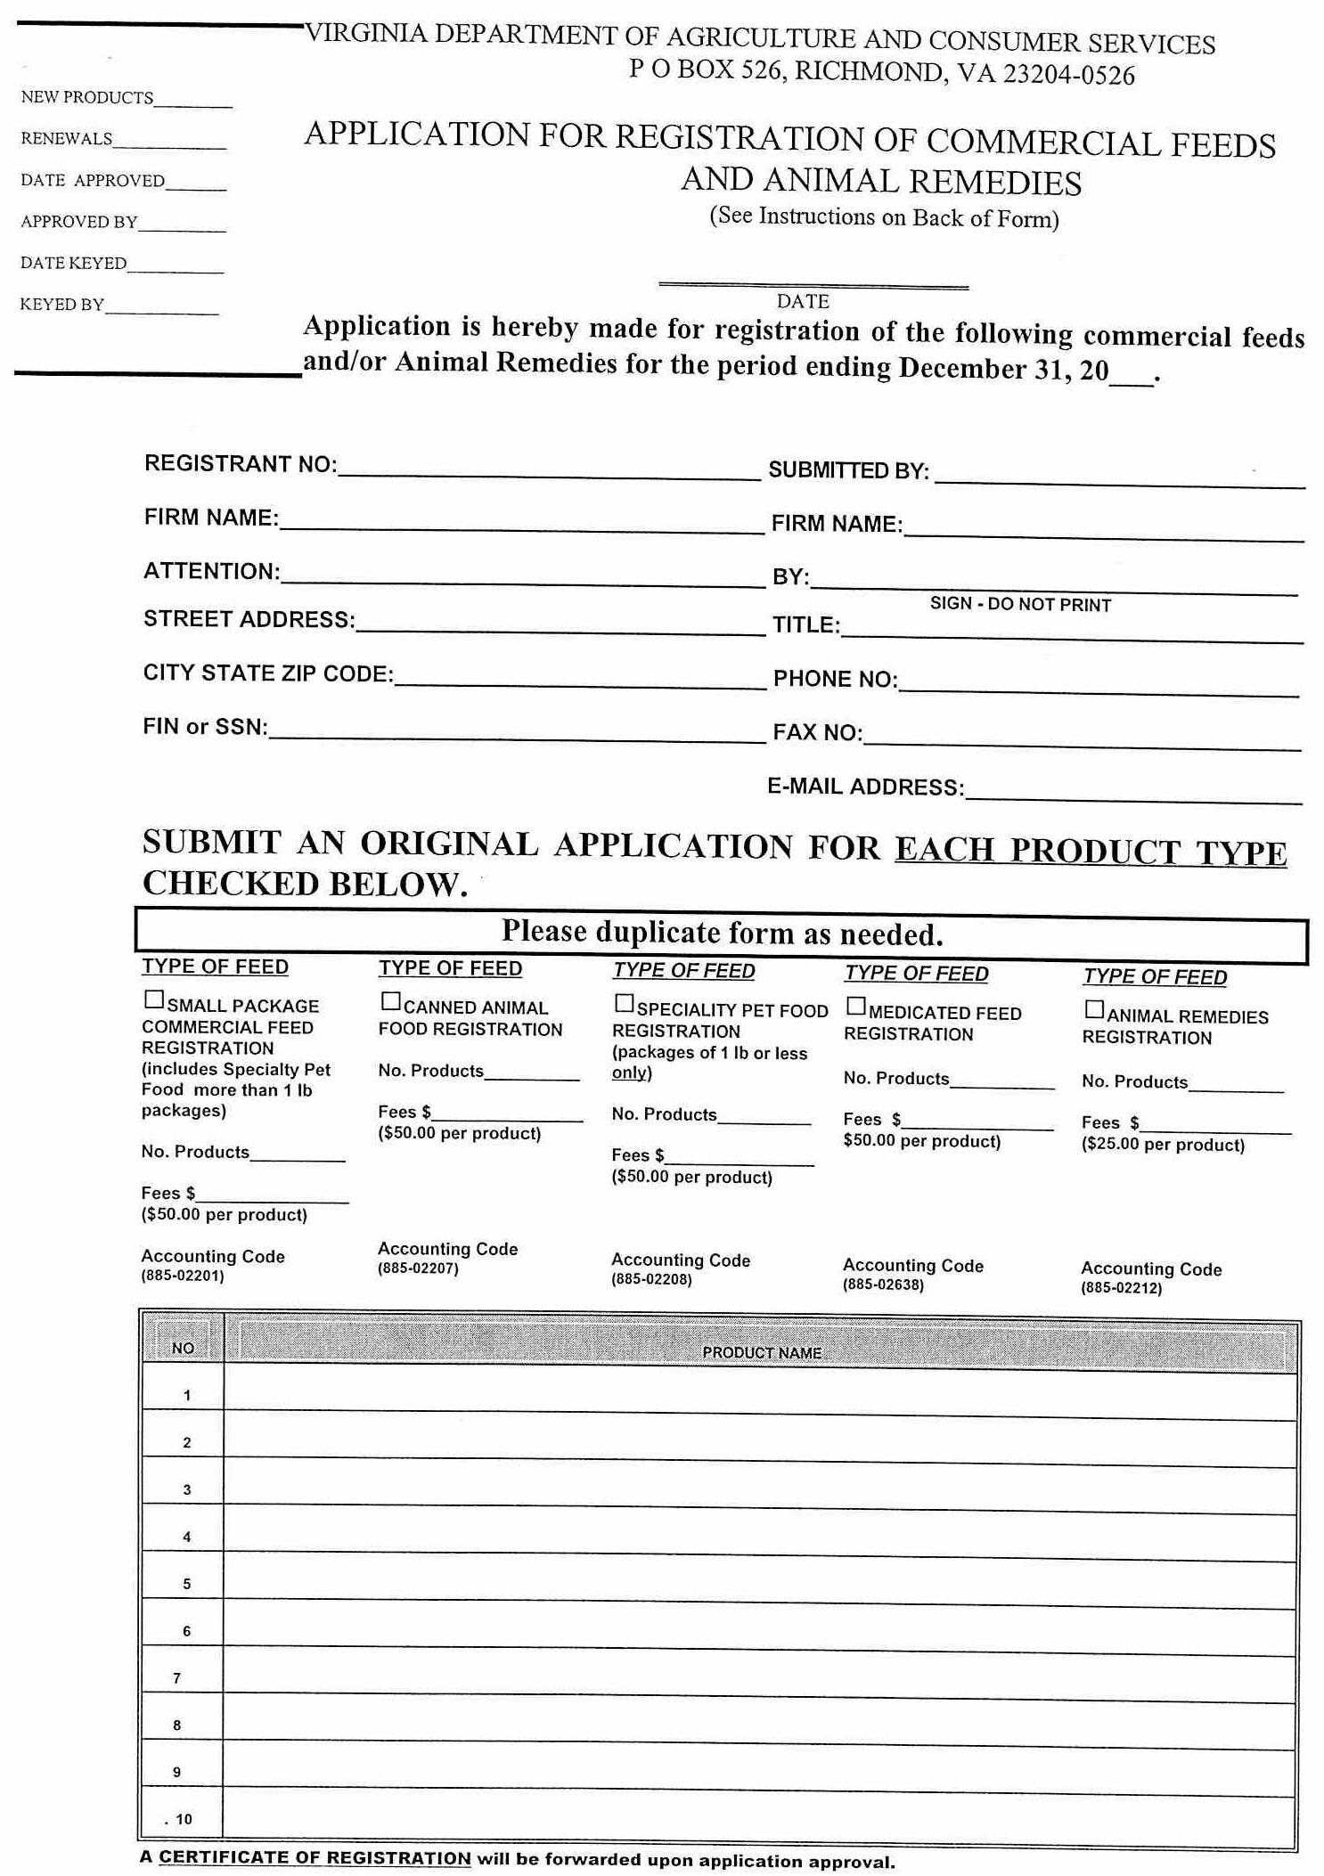
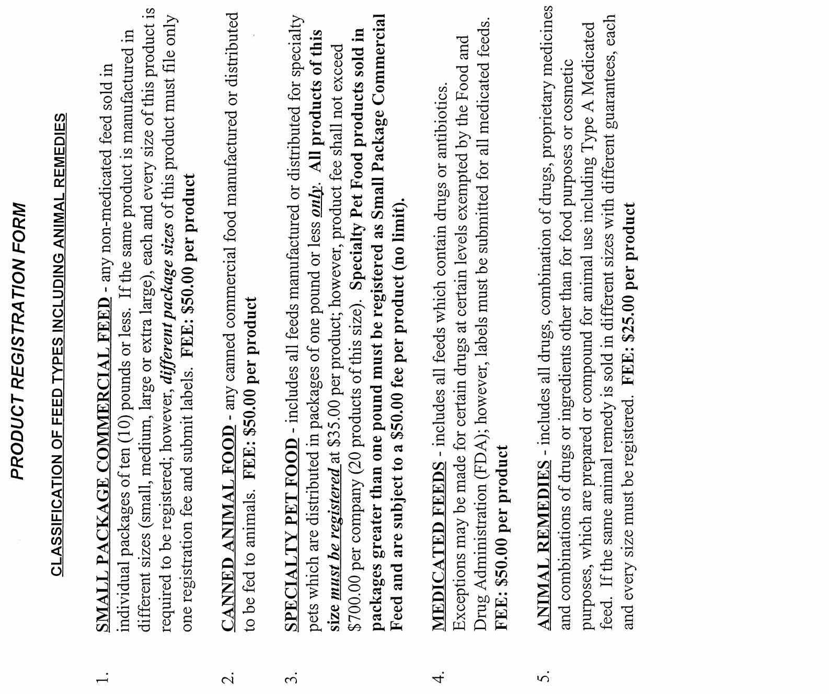
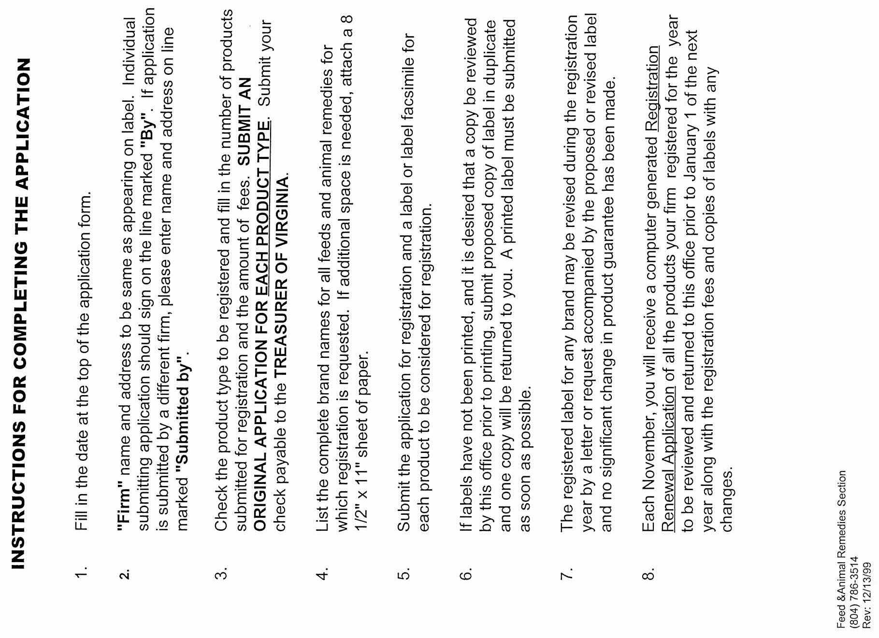
VA.R. Doc. No. R01-109; Filed August 16, 2002, 11:50 a.m.

1 Golan, Elise, et al., 2000, “Economics of food labeling,” U.S. Department of Agriculture, Agricultural Economic Report No. 793.
2 These costs and benefits are identified in Golan, et al. (2000) and are applicable to feed labeling.
3 Golan, et al. (2000).

