STATE BOARD OF AGRICULTURE AND CONSUMER SERVICES
Title of Regulation: 2 VAC 5-440. Rules and Regulations for Enforcement of the Virginia Pest Law - Cotton Boll Weevil Quarantine (amending 2 VAC 5-440-10 through 2 VAC 5-440-60; repealing 2 VAC 5-440-80 and 2 VAC 5-440-90).
Statutory Authority: § 3.1-188.23 of the Code of Virginia.
Public Hearing Date: March 13, 2003 - 10 a.m.
Public comments may be submitted until 5 p.m. on December 9, 2002.
(See Calendar of Events section
for additional information)
Agency Contact: Frank M. Fulgham, Program Manager, Department of Agriculture and Consumer Services, 1100 Bank Street, Room 703, Richmond, VA 23219, telephone (804) 786-3515, FAX (804) 371-7793 or e-mail ffulgham@vdacs.state.va.us.
Basis: The legal authority for this regulation is contained in § 3.1-188.23 of the Code of Virginia. The scope of the mandate is that the Board of Agriculture and Consumer Services must quarantine the Commonwealth or any portion thereof if the board determines that a quarantine is necessary to prevent or retard the spread of a pest into, within, or from the Commonwealth. This requires mandatory participation by all cotton operators in Virginia. Cotton operators must report all cotton acreage at their local USDA - Farm Service Agency office and pay a fee that is based on the reported cotton acreage. Noncommercial cotton shall not be planted unless the grower applies for and receives an exemption from VDACS. Movement of regulated articles must be approved by VDACS.
Purpose: The goal of this regulation is to prevent the reinfestation of Virginia’s cotton crop by the cotton boll weevil. By conducting surveys in cooperation with the Southeastern Boll Weevil Eradication Foundation, VDACS is able to determine the efficacy of this regulation. Since 1997, there have been no boll weevils detected in Virginia.
The eradication of the cotton boll weevil and the enforcement of the quarantine, which ensures that the boll weevil does not reinfest Virginia, provide an alternate crop that enhances the economic conditions for growers in eastern and southern Virginia. Since the eradication of the boll weevil in Virginia, the acreage planted in cotton has increased from approximately 300 acres in 1978 to over 100,000 acres annually. The benefit of the eradication and continued exclusion of the boll weevil has been estimated by researchers at North Carolina State University at approximately $75 per acre per year in increased land values, increased cotton yields, and reduced pesticide use.
The eradication and exclusion of the boll weevil enhances the quality of the environment by eliminating the need for approximately seven pesticide applications per year on cotton. Prior to the eradication of the boll weevil, there were more pesticides applied per acre of cotton than to any other crop.
The eradication and continued exclusion of the boll weevil is also responsible for the resurgence of the industry associated with cotton production. When the cotton boll weevil quarantine was implemented in 1977, there were no cotton gins operating in Virginia. By 1999, the number of cotton gins in Virginia had increased to six. The reemergence of cotton has also been responsible for increases in economic activities for the purchase of cotton equipment and the contracting of services or equipment necessary to produce, gin and market cotton. If the quarantine were not in place, all cotton, lint, seeds or cotton harvesting equipment would have to be fumigated or treated in an approved manner before being transported into a regulated area.
The continued monitoring, required by the Virginia Cotton Boll Weevil Quarantine, is necessary to prevent the reestablishment of the pest and ensure Virginia cotton remains free of the boll weevil. The administration and enforcement of the quarantine will be necessary until the pest is eliminated from the United States and there is no threat of reintroduction. The continued resurgence of the cotton industry with the associated economic benefits is dependent upon the maintenance of a boll-weevil-free Commonwealth.
Setting a fixed date of July 1 of each year for the official reporting of acreage and payment of assessments will allow the cotton growers to better plan their planting activities since they will know the due dates each year. This resolves the problem of uncertainty by growers of when these due dates will occur each year.
Reducing the penalties from $10 per acre to $5.00 per acre will bring the penalties in-line with current program costs. When this regulation was instituted in 1986, a $10 per acre penalty was appropriate since the program costs averaged $8 - $10 per acre. Over the past five years, the program costs have fallen to approximately $3.00 - $5.00 per acre. A penalty of $5.00 per acre is now a more appropriate figure. Using this reduced penalty will prevent the disproportionate penalty fees that are now being assessed.
Eliminating the mandate for destruction of the cotton crop for nonpayment of program costs will allow the commissioner to consider other alternatives for the collection of fees that would not result in the loss of the cotton crop.
Substance: The following are the amendments of substance with respect to the proposed regulatory action:
1. The proposed amendment will reduce penalties assessed on farm operators for the late payment or nonpayment of fees from $10 per acre to $5.00 per acre.
2. The proposed amendment will eliminate the mandate for the destruction of the cotton crop when farm operators are found in violation of the Virginia Cotton Boll Weevil Quarantine for nonpayment of fees and assessments.
3. The proposed amendment establishes the fixed date of July 1 as the official reporting and payment date for acreage assessments rather than requiring the commissioner to set the date annually.
Issues: Currently, there are approximately 500 cotton growers in the state and all would be impacted by the amendments to the quarantine. The cost of the program, which is paid by the grower, would not change, but the penalties for late filing of acreage would be reduced. When this regulation was instituted in 1986, a $10 per acre penalty was appropriate since the program costs averaged $8 - $10 per acre. Over the past five years, the program costs have fallen to approximately $3.00 - $5.00 per acre. A penalty of $5.00 per acre is now a more appropriate figure.
Amending the quarantine to eliminate the mandate for the destruction of the cotton crop for nonpayment of fees will allow the commissioner to pursue alternatives to crop destruction for individuals who do not pay the legally assessed program costs. Currently the only legal recourse in the quarantine is to destroy the cotton crop and bill the grower for the cost of destroying his crop. By pursuing established debt collection procedures, the agency would be assured the grower paid the program costs and the grower would not be faced with the destruction of his crop or significant legal fees.
Establishing the due date for acreage reporting and payment of assessments on July 1 for each year, removes any uncertainty by growers of when these due dates will occur each year. This allows the cotton growers to better plan their planting activities.
There are no disadvantages to the public or the Commonwealth associated with this proposed regulatory action.
Department of Planning and Budget's Economic Impact Analysis: The Department of Planning and Budget (DPB) has analyzed the economic impact of this proposed regulation in accordance with § 2.2-4007 G of the Administrative Process Act and Executive Order Number 25 (98). Section 2.2-4007 G requires that such economic impact analyses include, but need not be limited to, the projected number of businesses or other entities to whom the regulation would apply, the identity of any localities and types of businesses or other entities particularly affected, the projected number of persons and employment positions to be affected, the projected costs to affected businesses or entities to implement or comply with the regulation, and the impact on the use and value of private property. The analysis presented below represents DPB’s best estimate of these economic impacts.
Summary of the proposed regulation. The Virginia Department of Agriculture and Consumer Services (VDACS) proposes to: (i) eliminate the mandate for the destruction of a cotton crop for nonpayment of program fees, (ii) reduce penalties assessed on farm operators for the late payment or nonpayment of fees from $10.00 per acre to $5.00 per acre, and (iii) establish July 1 as the official reporting and payment date for acreage assessments.
Estimated economic impact. Under the current regulations when a farm operator fails to pay fees, VDACS is required to destroy his cotton crop and bill the grower for the cost of destroying his crop. VDACS proposes to amend the regulatory language so that the agency retains the option to destroy the cotton crop and bill the grower for the cost, but also to allow the agency to consider alternative actions aimed at the collection of fees that would not result in the loss of the cotton crop. For example, the agency could pursue traditional debt collection procedures prior to enforcing a threat of crop destruction. In practice, VDACS has only once come close to destroying crops since the program’s inception in 1986.1 In that case the recalcitrant grower eventually relented and paid their assessed fees and penalty just prior to the enforcement of the crop destruction threat. Thus, the proposed language essentially describes the agency’s actual policy as applied. Since the agency has not strictly followed the current language, the proposed change will not likely have a significant impact. To the extent that the language may have been strictly adhered to in the future, the proposed change could be beneficial in that solutions less costly than crop destruction can be reached to encourage payment of fees and penalties.
VDACS has found that the current $10.00 per acre penalty assessed for the late payment or nonpayment of fees generates more revenue than is needed to run the boll weevil eradication and reintroduction prevention program. Thus, the agency proposes to reduce the penalty to $5.00 per acre. The smaller penalty will clearly be beneficial for farm operators who are late paying fees. The lower penalty may increase the probability that farm operators are late paying fees. Assuming that the agency is correct in that the smaller penalty will provide sufficient funds to run the program, this proposed amendment will create a net benefit.
Under the current regulations, VDACS sets the due dates for the official reporting of acreage and payment of assessments on an annual basis. The agency proposes to establish July 1 as the official reporting and payment date for acreage assessments. Setting a fixed date in the regulations for the official reporting of acreage and payment of assessments allows the cotton growers to better plan their planting and financial activities multiple years in advance. Since there is no cost associated with setting a fixed date, this proposed change produces a net benefit.
Businesses and entities affected. The proposed amendments affect the estimated 500 cotton growers2 in the Commonwealth.
Localities particularly affected. The proposed amendments primarily affect cotton growers, who are largely located in southeastern Virginia.
Projected impact on employment. The proposed amendments are unlikely to affect employment.
Effects on the use and value of private property. The reduced penalty for late fee payments may encourage more farm operators to pay their fees late. The reduced penalty may also slightly increase the value of some farms. The establishment of a set date for the official reporting and payment date for acreage assessments may improve or increase planning activities to a small degree.
Agency's Response to the Department of Planning and Budget's Economic Impact Analysis: The agency concurs with the economic impact analysis submitted by the Department of Planning and Budget.
Summary:
This regulation requires all cotton farm operators in Virginia to participate in the eradication program, which includes reporting of acreage planted in cotton and field locations, compliance with all cotton boll weevil regulations, and payment of per-acre fees to support the trapping of all cotton fields. This regulation also restricts the movement of regulated articles, such as seed cotton, gin trash, and used cotton harvesting equipment to prevent the reintroduction of the boll weevil into Virginia by the use of inspections, certificates, permits, compliance agreements, and treatments, if necessary.
The proposed amendments (i) establish the fixed date of July 1 as the official reporting and payment date for acreage assessments rather than requiring the commissioner to set the date annually, (ii) reduce penalties assessed on farm operators for the late payment or nonpayment of fees from $10 per acre to $5.00 per acre, (iii) eliminate the mandate for the destruction of the cotton crop for nonpayment of program fees, (iv) clarify that in addition to eradication, the regulation prevents reintroduction of the boll weevil into Virginia, and (v) combine certain sections to improve upon the clarity and intent of the regulation.
2 VAC 5-440-10. Definitions.
The following words and terms, when used in this chapter, shall have the following meaning, meanings unless the context clearly indicates otherwise:
"Board" means the Board of the Virginia Department of Agriculture and Consumer Services.
"Boll weevil" means the live insect, "Anthonomus grandis grandis" Boheman, in any stage of development.
"Board" means the Board of the Virginia Department of Agriculture and Consumer Services.
"Boll Weevil Eradication and Exclusion Program" means the program conducted by the Virginia Department of Agriculture and Consumer Services and the Southeastern Boll Weevil Eradication Foundation, Inc., to eradicate the boll weevil and subsequently prevent its reintroduction into areas where it has been eradicated.
"Certificate" means a document issued or authorized by an inspector to be issued under this chapter to allow the movement of regulated articles to any destination.
"CFSA" means United States Department of Agriculture, Consolidated Farm Service Agency.
"Compliance agreement" means a written agreement between a grower, dealer, or mover of regulated articles and the Virginia Department of Agriculture and Consumer Services, in which the former agrees to comply with conditions specified in the agreement by the inspector who executes the agreement on behalf of the department, to prevent the spread of the boll weevil.
"Commissioner" means the Commissioner of the Virginia Department of Agriculture and Consumer Services or his designee.
"Compliance agreement" means a written agreement between a grower, dealer, or mover of regulated articles, and the Virginia Department of Agriculture and Consumer Services, United States Department of Agriculture, or both, wherein the former agrees to comply with the requirements of the compliance agreement.
"Cotton" means parts and products of plants of the genus "Gossypium," before processing.
"Cottonseed" means cottonseed from which the lint has been removed.
"Department" means the Virginia Department of Agriculture and Consumer Services.
"FSA" means the United States Department of Agriculture, Farm Service Agency.
"Gin trash" means all of the material produced during the cleaning and ginning of seed cotton, bollies, or snapped cotton, except for the lint, cottonseed, and gin waste.
"Grower" means a farm operator or producer, whether the owner of the land or not.
"Infestation" means the presence of the boll weevil, or the existence of circumstances that make it reasonable to believe that boll weevil is present.
"Inspector" means any employee of the Virginia Department of Agriculture and Consumer Services, or other person authorized by the commissioner to enforce the provisions of the quarantine and regulations.
"Limited permit" means a document issued by an inspector to allow the movement of noncertifiable regulated articles to a specified destination for limited handling, use, processing, or treatment.
"Lint" means all forms of raw ginned cotton, either baled or unbaled, except linters and waste.
"Moved (movement, move)" means shipped; offered for shipment to a common carrier; received for transportation or transported by a common carrier; or carried, transported, moved, or allowed to be moved by any means.
"Person" means any individual, corporation, company, society, or association or other organized group.
"Regulated area" means the entire Commonwealth of Virginia any state or country in which the boll weevil is known to exist or areas where circumstances make it reasonable to believe that the boll weevil is present.
"Scientific permit" means a document issued by the Virginia Department of Agriculture and Consumer Services to authorize movement of regulated articles to a specified destination for scientific purposes.
"Seed cotton" means cotton as it comes from the field prior to ginning.
"Used cotton harvesting equipment" means equipment previously used to harvest, strip, transport or destroy cotton.
2 VAC 5-440-20. Notice of quarantine.
Under the authority of §§ 3.1-188.20 through 3.1-188.31:2 of the Code of Virginia, a quarantine of the Commonwealth of Virginia and all cotton producing states and countries infested with the boll weevil is hereby established to control, eradicate, and prevent the spread or reintroduction of the cotton boll weevil, "Anthonomus grandis grandis" Boheman.
2 VAC 5-440-30. Regulated articles.
A. The following shall not be moved from outside Virginia into this Commonwealth, or between points within Virginia, or interstate any regulated area, in any manner or method, except in compliance with the conditions prescribed in this chapter:
1. The boll weevil, "Anthonomous grandis grandis" Boheman, in any living state of development.
2. Seed cotton.
3. Gin trash.
4. Used cotton harvesting equipment.
5. Any other products, articles, or means of conveyance of any kind not covered by subdivisions 1 through 4 above of this section, when it is determined by an inspector that they present a hazard of spread of the boll weevil and the person in possession is notified.
2 VAC 5-440-40. Requirements for program participation.
A. All cotton farm operators in Virginia are hereby required to participate in the eradication/exclusion program. Participation shall include timely reporting of acreage and field locations, compliance with regulations, and payment of fees. Farm operators within the Commonwealth shall be notified through either the extension offices, VDACS the department, CFSA FSA, or newspapers of their program costs on a per acre basis on or before March 15 April 1 of each year. The following procedures are required for participation in the program:
1. Completing a Cotton Acreage Reporting Form at the CFSA office and the payment of a fee based on the measured or certified acreage. The fee and the reporting date to be set by March 1 of each year by the Commissioner of Agriculture and Consumer Services after consultation with the growers FSA office by July 1 of the current growing season for which participation is required. At this time the farm operator shall pay a nonrefundable fee in an amount sufficient to cover estimated program costs as determined by the commissioner. Those farm operators not reporting their acreage by July 1 will not be considered as program participants and will be subject to a penalty.
2. All fees shall be paid by the farm operator. Fees shall be made payable to Treasurer of Virginia and collected by CFSA FSA.
3. Noncommercial cotton shall not be planted in Virginia unless the grower applies for and receives an exemption to grow cotton. Applications, in writing, shall be made to the State Entomologist Program Manager, Office of Plant and Pest Services, 1100 Bank Street, Room 703, Richmond, VA 23219, stating the conditions under which the grower requests such exemption. The decision whether all or part of these requirements shall be exempted shall be based on the following:
a. Location of growing area,
b. Size of growing area,
c. Pest conditions in the growing area,
d. Accessibility of growing area,
e. Any stipulations set forth in a compliance agreement between the individual and the Department of Agriculture and Consumer Services that are necessary for the effectuation of the program.
B. Farm operators whose CFSA FSA measured acreage exceeds the grower reported acreage by more than 10%, shall be assessed an additional $5.00 per acre on that acreage in excess of the reported acreage. Any person whose reported acreage exceeds the CFSA measured acreage by more than 10% due to emergency or hardship conditions may apply for a waiver of the additional assessment. Any farm operator applying for a waiver of the additional assessment shall make application in writing to the State Entomologist stating the conditions under which the waiver is requested.
C. Failure to pay all fees on or before the date established by the commissioner will result in an additional assessment of $10 per acre. Failure by a farm operator to pay all program costs as of August 1 or upon notification of CFSA measured acreage, whichever is later, shall be a violation of The Virginia Cotton Boll weevil Quarantine. The farm operator when found in violation and upon notification shall completely destroy all cotton not found to be in compliance with the provisions of this section. If such farm operator fails to comply with this chapter, the Commissioner of Agriculture and Consumer Services, through his duly authorized agents, shall proceed to destroy such cotton, and shall compute the actual costs of labor and materials used, and the farm operator shall pay to the commissioner such assessed costs. No damage shall be awarded the grower of such cotton for entering thereon and destroying any cotton when done by the order of the commissioner.
D. C. A farm operator may apply for a waiver requesting delayed payment under conditions of financial hardship. Any farm operator applying for a waiver shall make application in writing to the Program Manager, Office of Plant and Pest Services, 1100 Bank Street, Richmond, VA 23219. This request must be accompanied by a financial statement from a state or federally chartered bank or lending agency supporting such request. The decision of whether to waive all or part of these additional assessments or payment dates shall be made by the State Entomologist program manager and notification given to the farm operator within two weeks after receipt of such application. The decision shall be based on the following: (i) meteorological conditions, (ii) economic conditions, and (iii) any other uncontrollable destructive forces. If a waiver is granted, payment shall be due at the time the cotton is sold, or by December 1, whichever is sooner.
D. Failure to pay all fees on or before July 1 will result in a penalty of $5.00 per acre. Failure by a farm operator to pay all program costs by August 1 shall be a violation of The Virginia Cotton Boll Weevil Quarantine. The farm operator when found in violation and upon notification shall completely destroy all cotton not found to be in compliance with the provisions of this section. If such farm operator fails to comply with these regulations, the Commissioner of Agriculture and Consumer Services, through his duly authorized agents, may proceed to destroy such cotton, and shall compute the actual costs of labor and materials used, and the farm operator shall pay to the commissioner such assessed costs. No damage shall be awarded the grower of such cotton for entering thereon and destroying any cotton when done by the order of the commissioner.
E. Acreage subject to emergency or hardship conditions after all the growers' share of the program have been paid and prior to the initiation of field operations may be considered for a refund. The refund amount will be determined by the actual program cost per acre up to the time of emergency or hardship.
F. The commissioner may purchase growing cotton when he deems it in the best interest of the program. Purchase price shall be based on the CFSA FSA farm established yield for the current year.
2 VAC 5-440-50. Conditions governing the issuance of certificates and permits to allow the movement of regulated articles.
A. Certificates shall be issued by the an authorized inspector for movement of the regulated articles designated in 2 VAC 5-440-30 under any of the following conditions when:
1. In the judgment of the inspector, they have not been exposed to infestation boll weevil in any living stage.
2. They have been examined by the inspector and found to be free of infestation boll weevil in any living stage.
3. They have been treated to destroy boll weevil, under the observation of the inspector, in compliance with according to methods selected by him from procedures known to be effective under the conditions in which applied.
4. Grown, produced, stored, or handled in such manner that, in the judgment of the inspector, no infestation boll weevil would be transmitted.
B. Limited permit. Limited permits may be issued by the an authorized inspector for the movement of noncertified regulated articles specified under 2 VAC 5-440-30 to specified destinations for limited handling, use, processing, or treatment, when he determines that no hazard of spread of the boll weevil exists.
C. Special permits. Special permits may be issued by the Virginia Department of Agriculture and Consumer Services to allow the movement of boll weevil in any living stage and any other regulated articles for scientific purposes, under conditions prescribed in each specific case.
D. Compliance agreement. Compliance agreements may be issued by the an authorized inspector. As a condition of receiving a certificate or limited permit for the movement of regulated articles, any person engaged in purchasing, assembling, exchanging, handling, processing, utilizing, treating, or moving such article may be required to sign a compliance agreement. The agreement shall stipulate that the required safeguards against the establishment and spread of infestation will be maintained and will comply with the conditions governing the maintenance of identity, handling, and subsequent movement of such articles, and the cleaning and treatment of means of conveyance and containers.
E. Use of certificates or permits with shipments. If a certificate or permit is required for the movement of regulated articles, the regulated articles are required to have a certificate or permit attached when offered for movement. If a certificate or permit is attached to the invoice or way-bill, and the articles are adequately described on the certificate, the attachment of a certificate or limited permit to the regulated article will not be required. Certificates or permits attached to the invoice, way-bill or other shipping document, shall be given by the carrier to the consignee at the destination of the shipment, or to an inspector when requested.
F. Assembly of articles for inspection. Persons intending to move any regulated articles shall apply for inspection as far in advance as possible. They shall safeguard the articles from infestation. The articles shall be assembled at a place and in a manner designated by the inspector to facilitate inspection.
G. Disposition of certificates and permits. In all cases, certificates and permits shall be furnished by the carrier to the consignee at the destination of the shipment.
2 VAC 5-440-60. Cancellation of certificates and permits.
Any certificate or permit which has been issued or authorized may be withdrawn by the inspector if determined that the holder has not complied with any condition for the their use of the documents or with any applicable compliance agreement.
2 VAC 5-440-80. Assembly and inspection of regulated articles. (Repealed.)
Persons who desire to move regulated articles shall, as far in advance as possible, request an inspector to examine the articles prior to movement. The articles shall be assembled at a place and in a manner designated by the inspector to facilitate inspection.
2 VAC 5-440-90. Attachment and disposition of certificates or permits. (Repealed.)
A. If a certificate or permit is required for the movement of regulated articles, the certificate or permit shall be securely attached to the outside of the container in which the articles are moved. However, if the certificate or permit is attached to the way-bill or other shipping document, and the regulated articles are adequately described on the certificate, permit, or shipping document, then the certificate or permit need not be attached to each container.
B. In all cases, certificates, or permits shall be given by the carrier to the consignee at the destination of the shipment.
NOTICE: The form used in administering 2 VAC 5-440, Rules and Regulations for Enforcement of the Virginia Pest Law - Cotton Boll Weevil Quarantine, is listed and published below.
FORMS
Boll Weevil Eradication Program Cotton Acreage Reporting Form (rev. 3/99).
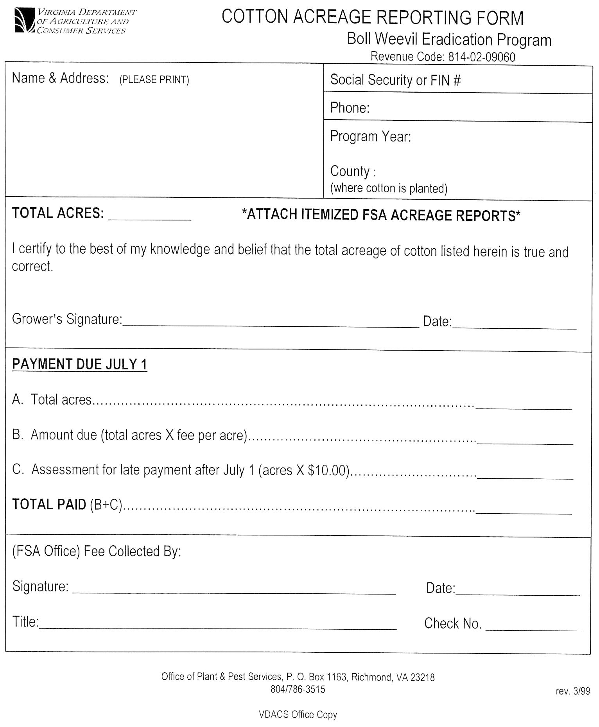
VA.R. Doc. No. R01-110; Filed August 16, 2002, 11:53 a.m.

1 Source: VDACS.
2 Source: VDACS.

