BOARD OF NURSING
Title of Regulation: 18 VAC 90-50. Regulations Governing the Certification of Massage Therapists (amending 18 VAC 90-50-10, 18 VAC 90-50-40, 18 VAC 90-50-50, [ 18 VAC 90-50-60, ] 18 VAC 90-50-70, 18 VAC 90-50-80, and 18 VAC 90-50-90; adding 18 VAC 90-50-75 [ repealing 18 VAC 90-50-60) ].
Statutory Authority: §§ 54.1-2400, 54.1-103 and 54.1-3005 of the Code of Virginia.
Effective Date: January 15, 2002.
Summary:
The amendments address concerns about the competency of certificate holders by requiring recertification by the National Certification Board for Therapeutic Massage and Bodywork (NCBTMB) or the obtaining of at least 25 hours of continuing education in the biennium before renewal. The amendments further specify the requirements for licensure by endorsement, delete outdated "grandfathering" provisions, and incorporate by reference the code of ethics and standards of practice of the NCBTMB.
In response to comment on the proposed regulation, the board reinserted language for provisional certification (18 VAC 90-50-60), which had been repealed in the proposed regulation. The board also deleted in the section on unprofessional conduct (18 VAC 90-50-90) a requirement to practice in accordance with the Standards of Practice of the NCBTMB, as incorporated by reference. The board also retained the Code of Ethics of the NCBTMB, but added an exception to the requirement that massage therapists “follow all policies, procedures, guidelines, regulations, codes and requirements promulgated by the NCBTMB.” To have that requirement in the Code of Ethics was considered excessive and would reinsert the Standards of Practice that the board chose to delete.
Summary of Public Comments and Agency's Response: A summary of comments made by the public and the agency's response may be obtained from the promulgating agency or viewed at the office of the Registrar of Regulations.
Agency Contact: Nancy K. Durrett, R.N., Executive Director, Board of Nursing, Department of Health Professions, 6603 W. Broad Street, Richmond, VA 23230, telephone (804) 662-9909, FAX (804) 662-9512 or e-mail nancy.durrett@dhp.state.va.us.
18 VAC 90-50-10. Definitions.
The following words and terms "board," "certified massage therapist" and "massage therapy," when used in this chapter, shall have the following meanings ascribed to them in § 54.1-3000 of the Code of Virginia. unless the context clearly indicates otherwise:
"Board" means the Board of Nursing.
"Category A" means continuing education courses or programs offered by an organization or individual approved as a provider by the NCBTMB.
"Category B" means continuing education courses, programs or experiences that are related to the clinical practice of massage therapy but which may not be offered by a provider approved by the NCBTMB.
"Certified massage therapist" means a person who meets the qualifications specified in this chapter and who is currently certified by the board. Only someone who is certified by the board as a massage therapist may use any designation tending to imply that he is a certified massage therapist or massage therapist.
"Massage therapy" means the treatment of soft tissues for therapeutic purposes by the application of massage and bodywork techniques based on the manipulation or application of pressure to the muscular structure or soft tissues of the human body. The terms "massage therapy" and "therapeutic massage" do not include the diagnosis or treatment of illness or disease or any service or procedure for which a license to practice medicine, nursing, chiropractic therapy, physical therapy, occupational therapy, acupuncture, or podiatry is required by law.
"NCBTMB" means the National Certification Board for Therapeutic Massage and Bodywork.
18 VAC 90-50-40. Initial certification.
A. An applicant seeking initial certification shall submit a completed application and required fee and verification of meeting the requirements of § 54.1-3029 A or B of the Code of Virginia. as follows:
1. Is at least 18 years old;
2. Has successfully completed a minimum of 500 hours of training from a massage therapy program, having received programmatic approval from the Virginia Board of Education, Division of Proprietary Schools, or been certified or approved by the Virginia Board of Education, Division of Proprietary Schools; the State Council of Higher Education; or an agency in another state, the District of Columbia or a United States territory that approves educational programs, notwithstanding the provisions of § 22.1-320 of the Code of Virginia;
3. Has passed the National Certification Exam for Therapeutic Massage and Bodywork or an exam deemed acceptable to the board leading to national certification; and
4. Has not committed any acts or omissions that would be grounds for disciplinary action or denial of certification as set forth in § 54.1-3007 of the Code of Virginia and 18 VAC 90-50-90.
B. An applicant who does not meet the education and examination requirements of § 54.1-3029 A of the Code of Virginia shall provide satisfactory evidence that the applicant:
1. Is at least 18 years old;
2. Has not committed any acts or omissions that would be grounds for disciplinary action or denial of certification as set forth in this chapter; and
3. Has competed at least 200 hours of training in a massage therapy education program as provided in § 54.1-3029 B of the Code of Virginia and has been practicing massage therapy prior to July 1, 1997, or has completed 20 hours of such training and has at least 10 years of practice in massage therapy, or has passed the National Certification Exam for Therapeutic Massage and Bodywork prior to 1994.
Applicants for certification under the provisions of § 54.1-3029 B of the Code of Virginia shall have met all requirements and paid the required fee prior to July 1, 1998. A completed application shall be postmarked on or before June 30, 1998.
B. No application for certification under provisions of § 54.1-3029 B of the Code of Virginia shall be considered unless submitted prior to July 1, 1998.
C. An applicant who has been licensed or certified in another country and who, in the opinion of the board, meets the educational requirements shall take and pass the national certifying examination as required in subsection A of this section in order to become certified.
18 VAC 90-50-50. Certification by endorsement.
A. A massage therapist who has been licensed or certified in another U.S. jurisdiction with requirements substantially equivalent to those stated in 18 VAC 90-50-40, and who is in good standing or is eligible for reinstatement, if lapsed, shall be eligible to apply for certification by endorsement in Virginia.
B. An applicant for certification by endorsement shall submit a completed application and required fee to the board and shall submit the required form to the appropriate credentialing agency in the state of original licensure or certification for verification. Applicants will be notified by the board after 30 days if the completed verification form has not been received from that state.
C. An applicant who has been licensed or certified in another country shall take a national certifying examination and become nationally certified as required by § 54.1-3029 of the Code of Virginia.
18 VAC 90-50-60. [ Provisional certification. (Repealed.) ]
[ A. An eligible candidate who has filed an application for certification in Virginia may practice massage therapy in Virginia for a period not to exceed 90 days between completion of the education program and the receipt of the results of the candidate's first certifying examination.
B. The designation of "massage therapist" or "certified massage therapist" shall not be used by the applicant during the 90 days of provisional certification.
C. An applicant who fails the certifying examination shall have his provisional certification withdrawn upon the receipt of the examination results and shall not be eligible for certification until he passes such examination and becomes nationally certified. ]
18 VAC 90-50-70. Renewal of certification.
A. Certificate holders born in even-numbered years shall renew their certificates by the last day of the birth month in even-numbered years. Certificate holders born in odd-numbered years shall renew their certificates by the last day of the birth month in odd-numbered years.
B. The certificate holder shall complete the application and return it with the required fee and attest that he has complied with continuing competency requirements of 18 VAC 90-50-75.
C. Failure to receive the application for renewal shall not relieve the certified massage therapist of the responsibility for renewing the certificate by the expiration date.
D. The certificate shall automatically lapse by the last day of the birth month if not renewed; and use of the title "massage therapist" or "certified massage therapist" is prohibited.
18 VAC 90-50-75. Continuing competency requirements.
A. In order to renew a certificate biennially on and after [ (insert date that is two years after the effective date of regulation) January 15, 2005 ], a certified massage therapist shall:
1. Hold current certification by the NCBTMB; or
2. Complete at least 25 hours of continuing education or learning activities with at least one hour in professional ethics. Hours chosen shall be those that enhance and expand the skills and knowledge related to the clinical practice of massage therapy and may be distributed as follows:
a. A minimum of 12.5 of the 25 hours shall be in Category A activities or courses provided by an NCBTMB-approved provider and may include seminars, workshops, home study courses, and continuing education courses.
b. No more than 12.5 of the 25 hours may be Category B activities or courses that may include consultation, independent reading or research, preparation for a presentation or other such experiences that promote continued learning.
B. A massage therapist shall be exempt from the continuing competency requirements for the first biennial renewal following the date of initial certification in Virginia.
C. The massage therapist shall retain in his records the completed form with all supporting documentation for a period of four years following the renewal of an active certificate.
D. The board shall periodically conduct a random audit of certificate holders to determine compliance. The persons selected for the audit shall provide evidence of current NCBTMB certification or the completed continued competency form provided by the board and all supporting documentation within 30 days of receiving notification of the audit.
E. Failure to comply with these requirements may subject the massage therapist to disciplinary action by the board.
F. The board may grant an extension of the deadline for continuing competency requirements, for up to one year, for good cause shown upon a written request from the certificate holder prior to the renewal date.
G. The board may grant an exemption for all or part of the requirements for circumstances beyond the control of the certificate holder, such as temporary disability, mandatory military service, or officially declared disasters.
18 VAC 90-50-80. Reinstatement of lapsed certificates.
A. A massage therapist whose certificate has lapsed may reinstate his certification within one renewal period by attesting to completion of continuing competency requirements for the period and payment of the current renewal fee and the late renewal fee.
B. A massage therapist whose certificate has lapsed for more than one renewal period shall file a reinstatement application, attest to completion of continuing competency requirements for the period in which the certificate has been lapsed, not to exceed four years, and pay the reinstatement fee.
C. A massage therapist whose certificate has been suspended or revoked may apply for reinstatement by filing a reinstatement application and paying the fee for reinstatement after suspension or revocation.
D. The board may require evidence that the massage therapist is prepared to resume practice in a competent manner.
18 VAC 90-50-90. Disciplinary provisions.
The board has the authority to deny, revoke or suspend a certificate issued by it or to otherwise discipline a certificate holder upon proof that the practitioner has violated any of the provisions of § 54.1-3007 of the Code of Virginia or of this chapter or has engaged in the following:
1. Fraud or deceit which shall mean, but shall not be limited to:
a. Filing false credentials;
b. Falsely representing facts on an application for initial certification, or reinstatement or renewal of a certificate; or
c. Misrepresenting one's qualifications including scope of practice.
2. Unprofessional conduct which shall mean, but shall not be limited to:
a. Performing acts which constitute the practice of any other health care profession for which a license or a certificate is required or acts which are beyond the limits of the practice of massage therapy as defined in § 54.1-3000 of the Code of Virginia;
b. Assuming duties and responsibilities within the practice of massage therapy without adequate training or when competency has not been maintained;
c. Failing to acknowledge the limitations of and contraindications for massage and bodywork or failing to refer patients to appropriate health care professionals when indicated;
d. Initiating or engaging in any sexual conduct involving a patient;
e. Falsifying or otherwise altering patient or employer records;
f. Violating the privacy of patients or the confidentiality of patient information unless required to do so by law;
g. Employing or assigning unqualified persons to practice under the title of "massage therapist" or "certified massage therapist"; or
h. Engaging in any material misrepresentation in the course of one's practice as a massage therapist.; or
i. Failing to practice in a manner consistent with [ the standards of practice and ] the code of ethics of the NCBTMB, as incorporated by reference into this chapter [ with the exception of the requirement to follow all policies, procedures, guidelines, regulations, codes, and requirements promulgated by the NCBTMB ].
DOCUMENT INCORPORATED BY REFERENCE
NCBTMB National Certification Examination Candidate Handbook (eff. 8/00).
NOTICE: The forms used in administering 18 VAC 90-50, Regulations Governing the Certification of Massage Therapists, are listed below. Any amended or added forms are reflected in the listing and are published following the listing.
FORMS
Instructions for Filing Application for Certification as a Massage Therapist (rev. [ 10/00 10/02 ]).
Application for Certification -- Massage Therapist (rev. 10/00 [ 4/01 10/02 ]).
Instructions for Filing Application for Certification as a Massage Therapist by Endorsement (rev. [ 10/00 10/02 ]).
Application for Certification by Endorsement -- Massage Therapist (rev. [ 10/00 10/02 ]).
Massage Therapist Certification/Licensure Verification Form (rev. [ 10/00 10/02 ]).
Application for Reinstatement of Certificate as a Massage Therapist (rev. 1/99 [ 4/01 10/02 ]).
Renewal Notice and Application (rev. 10/00 6/02).
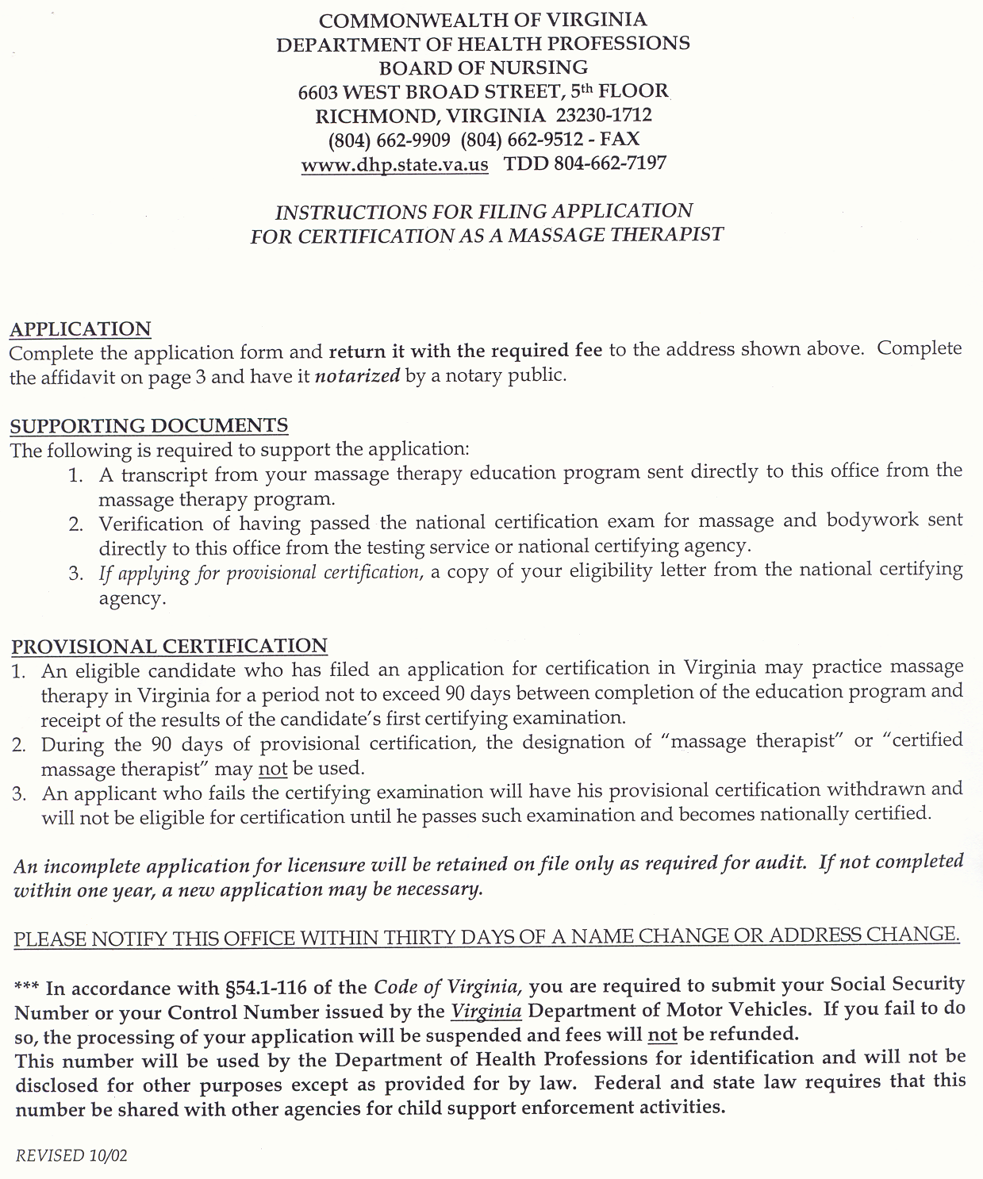
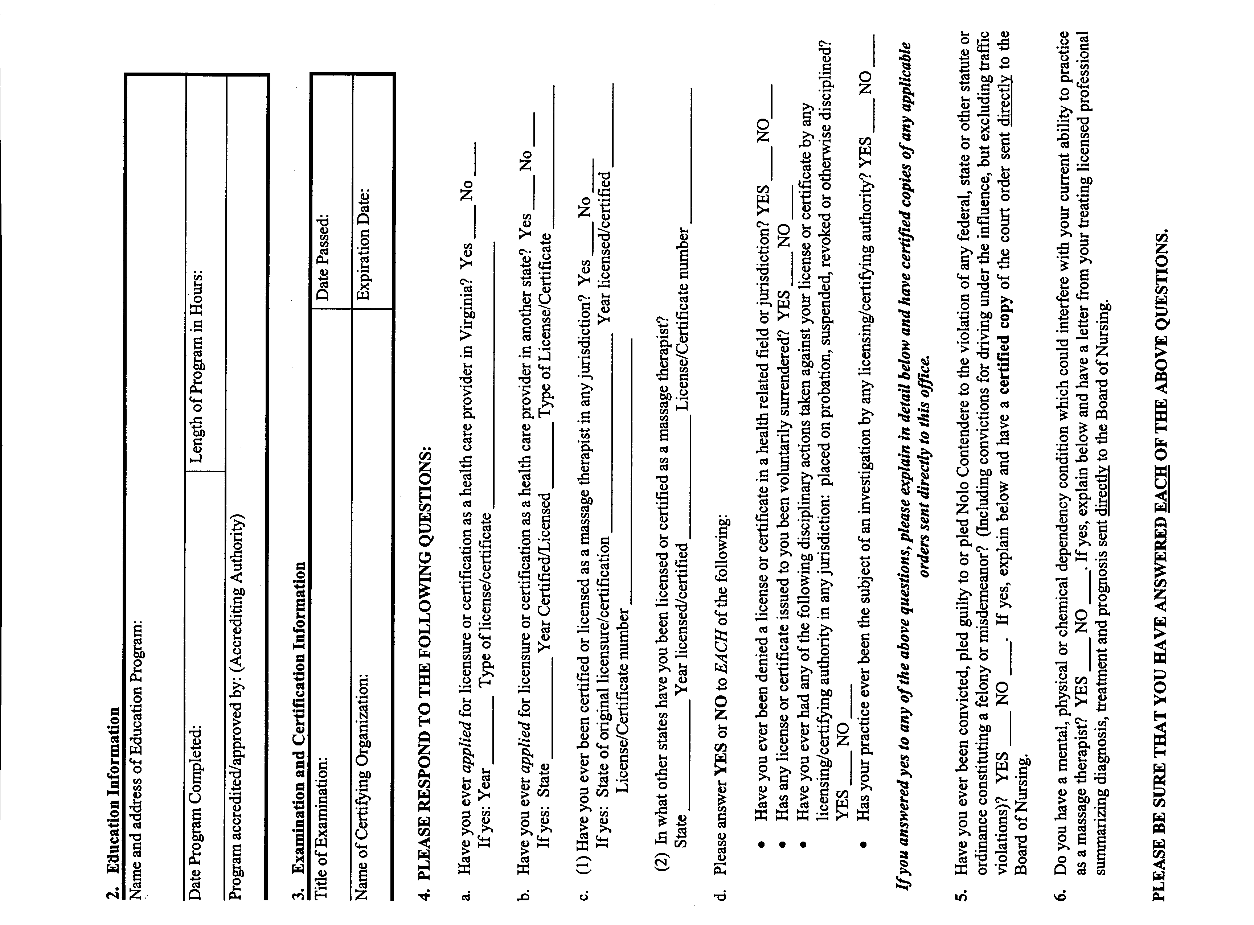
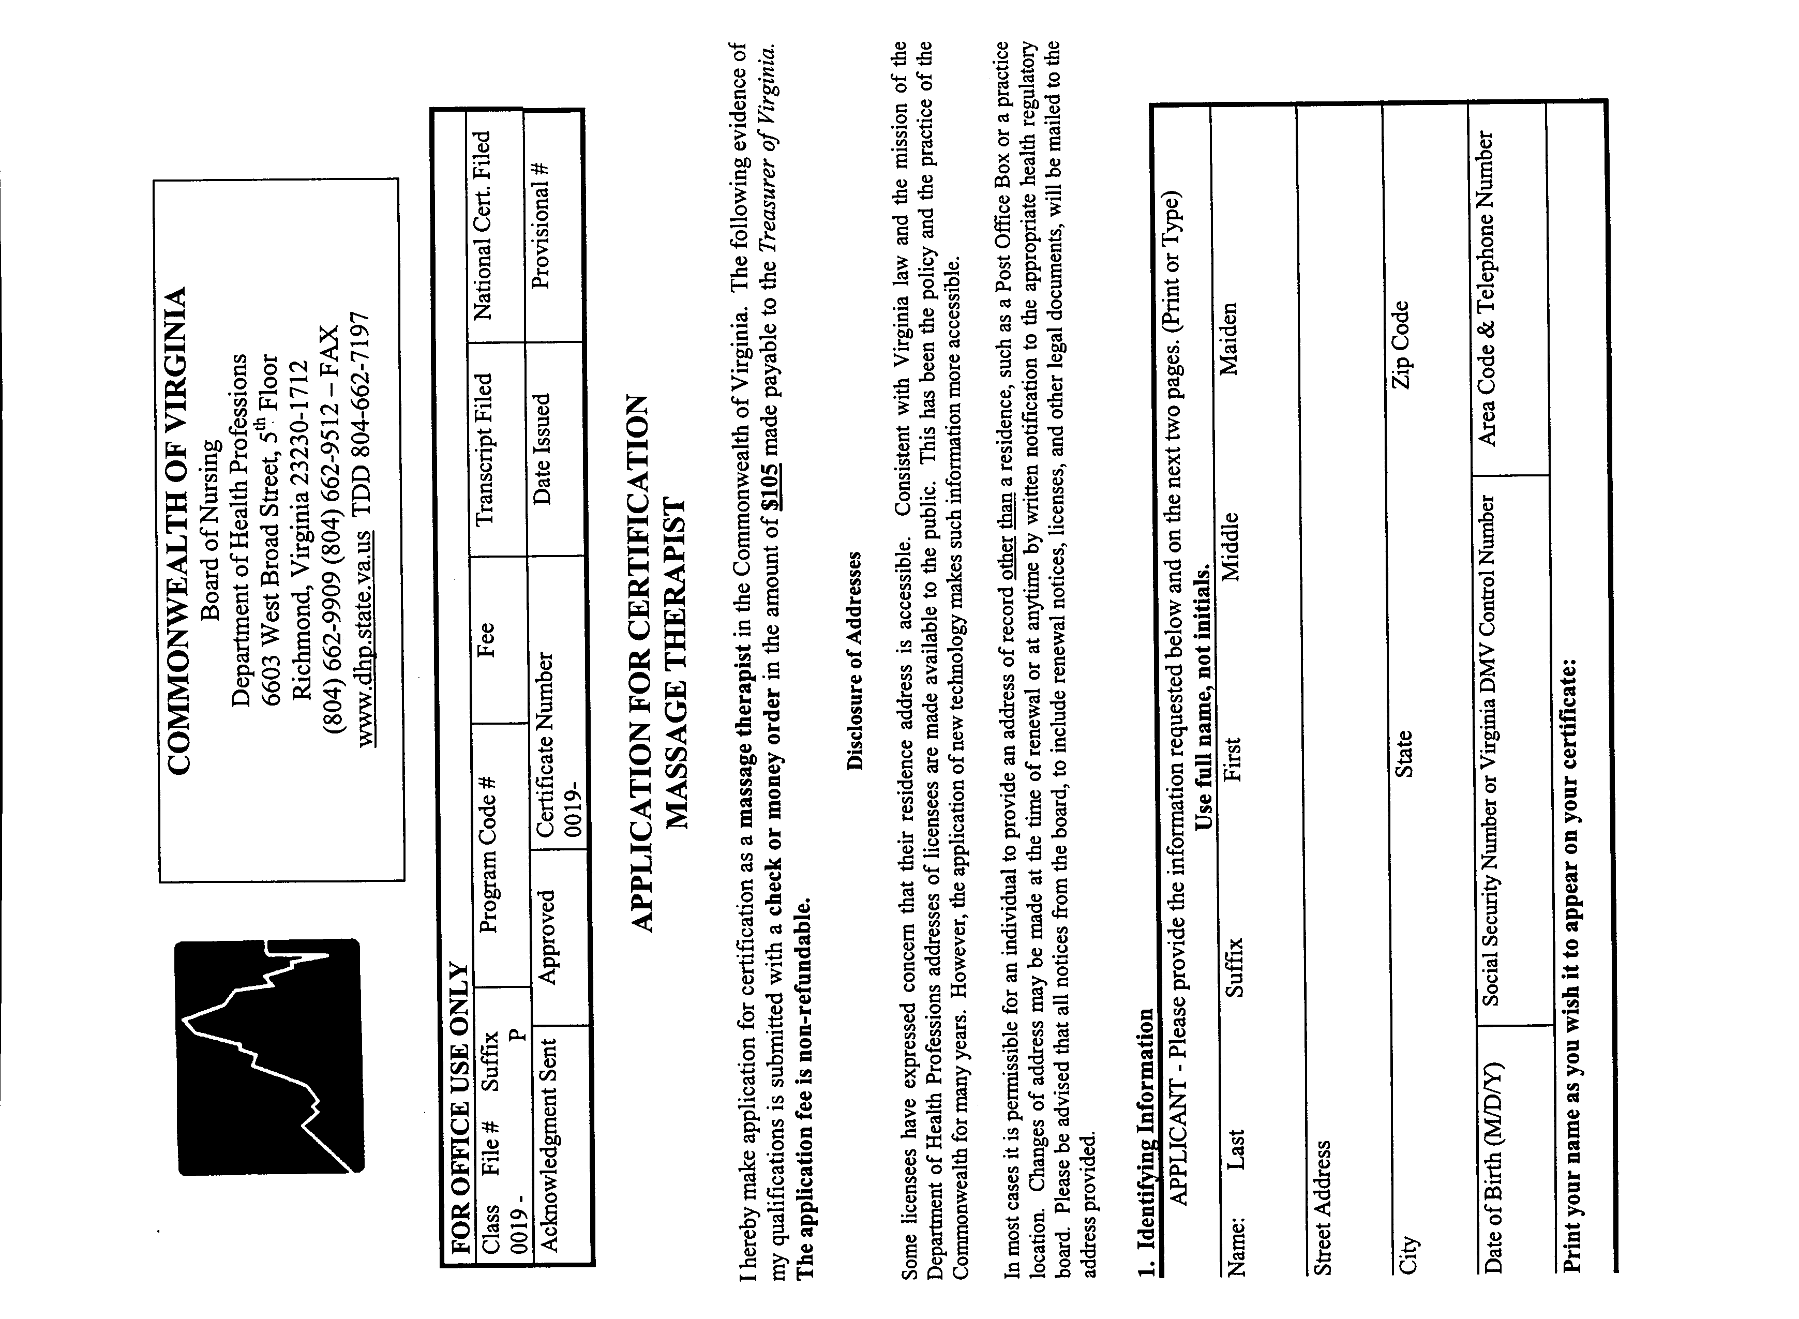
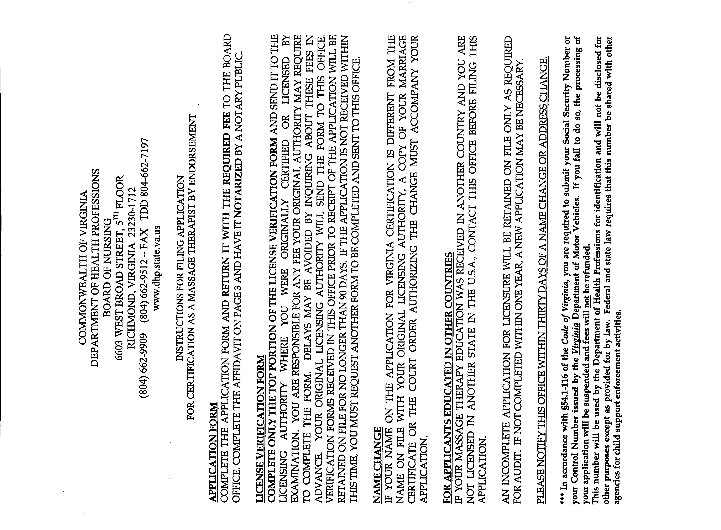
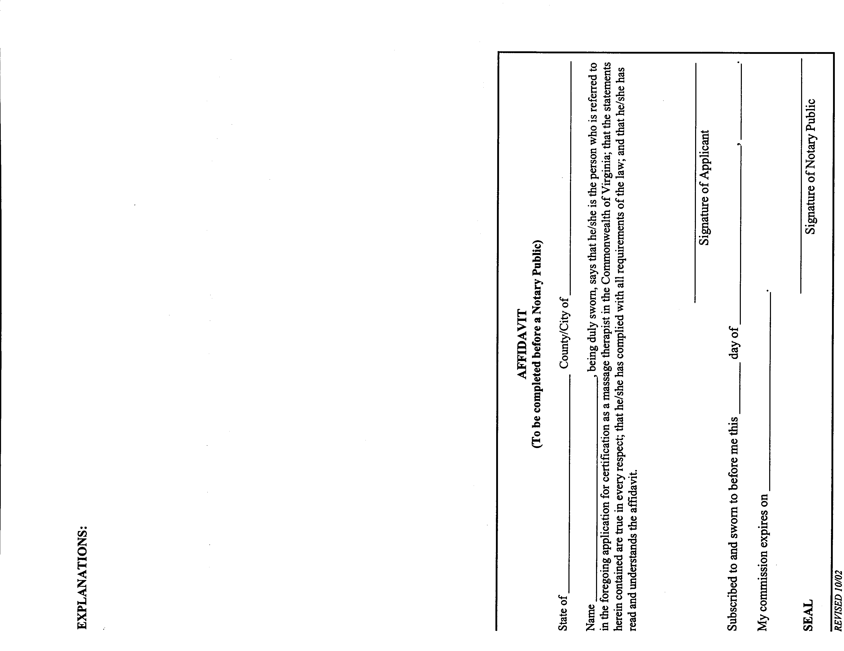
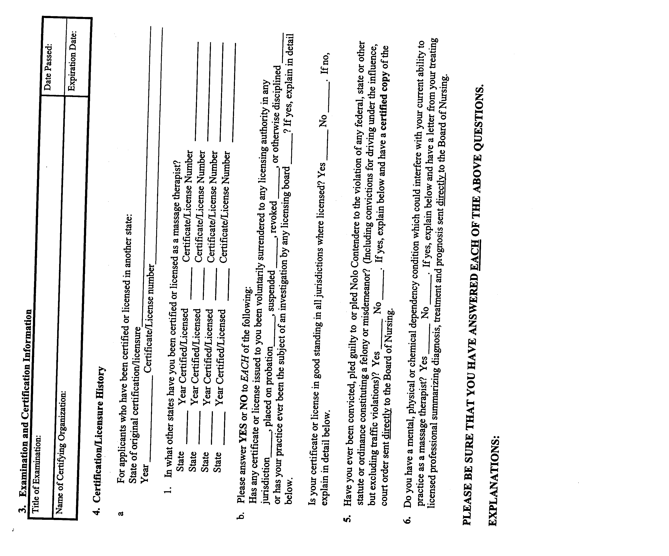
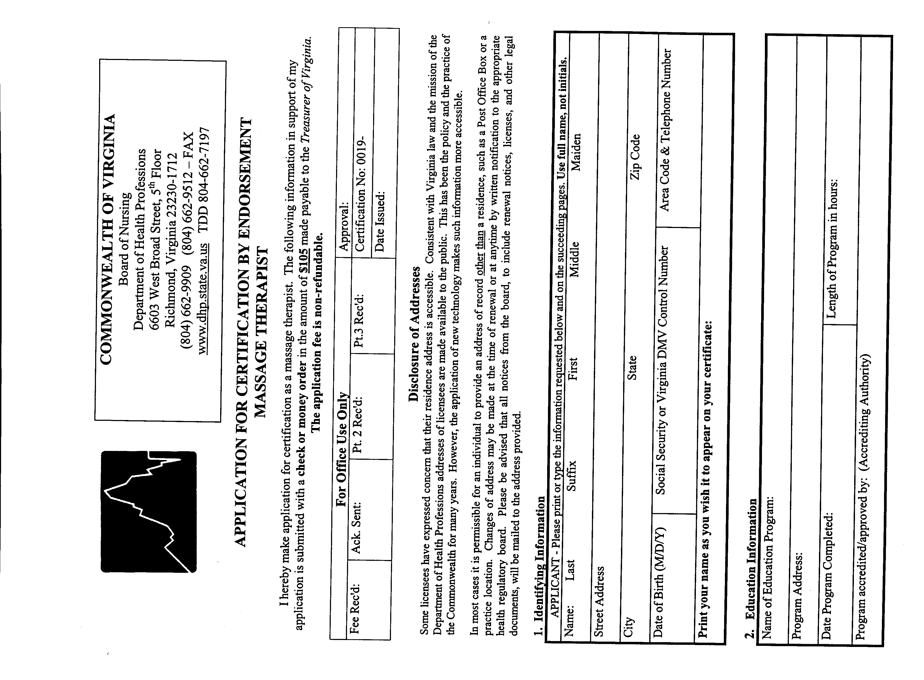
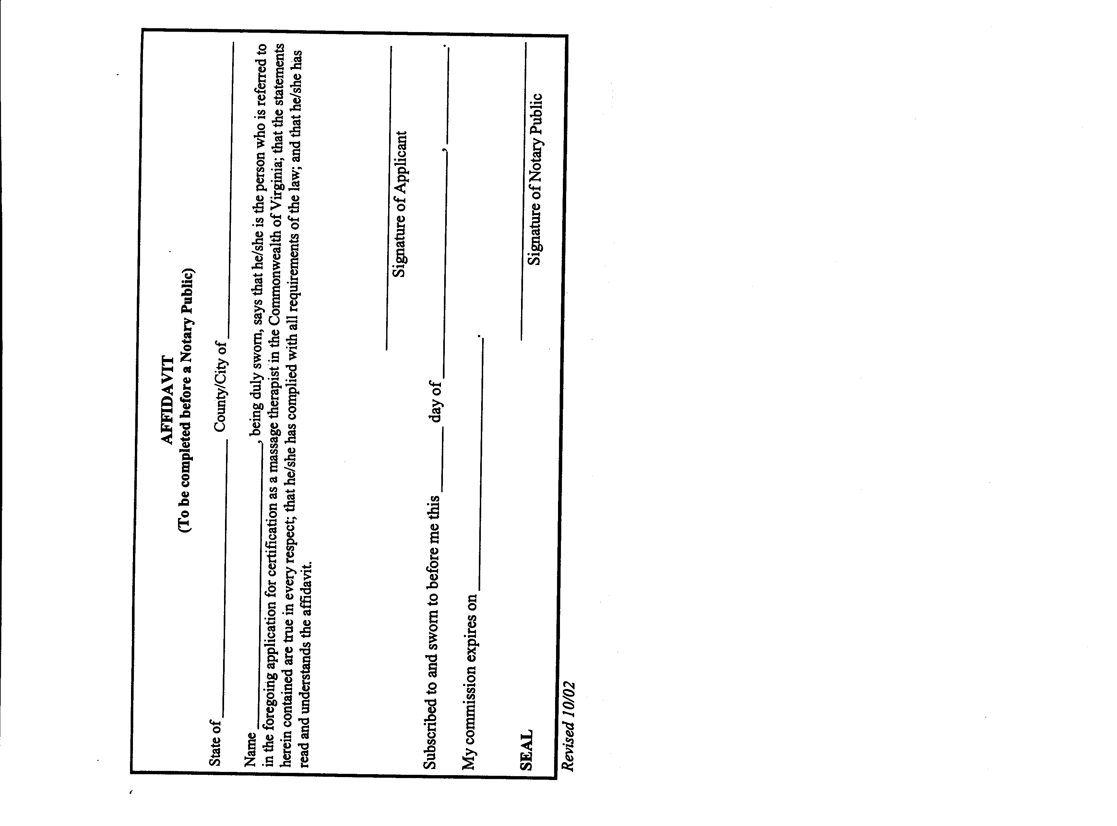
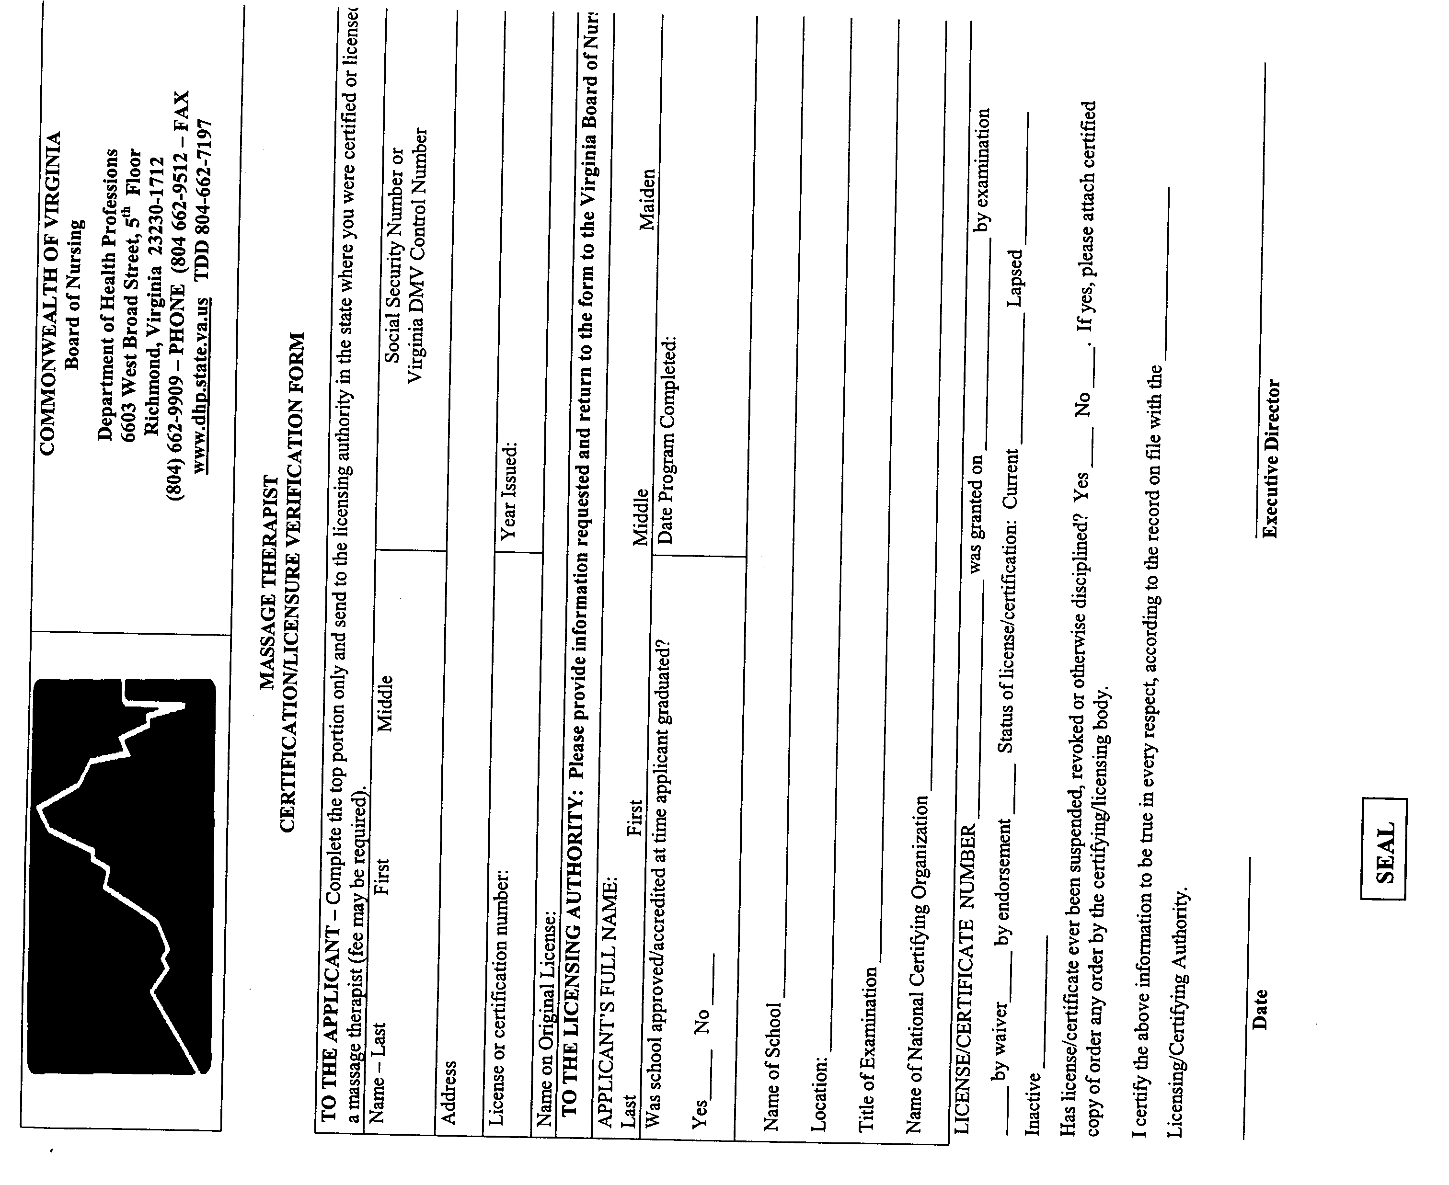
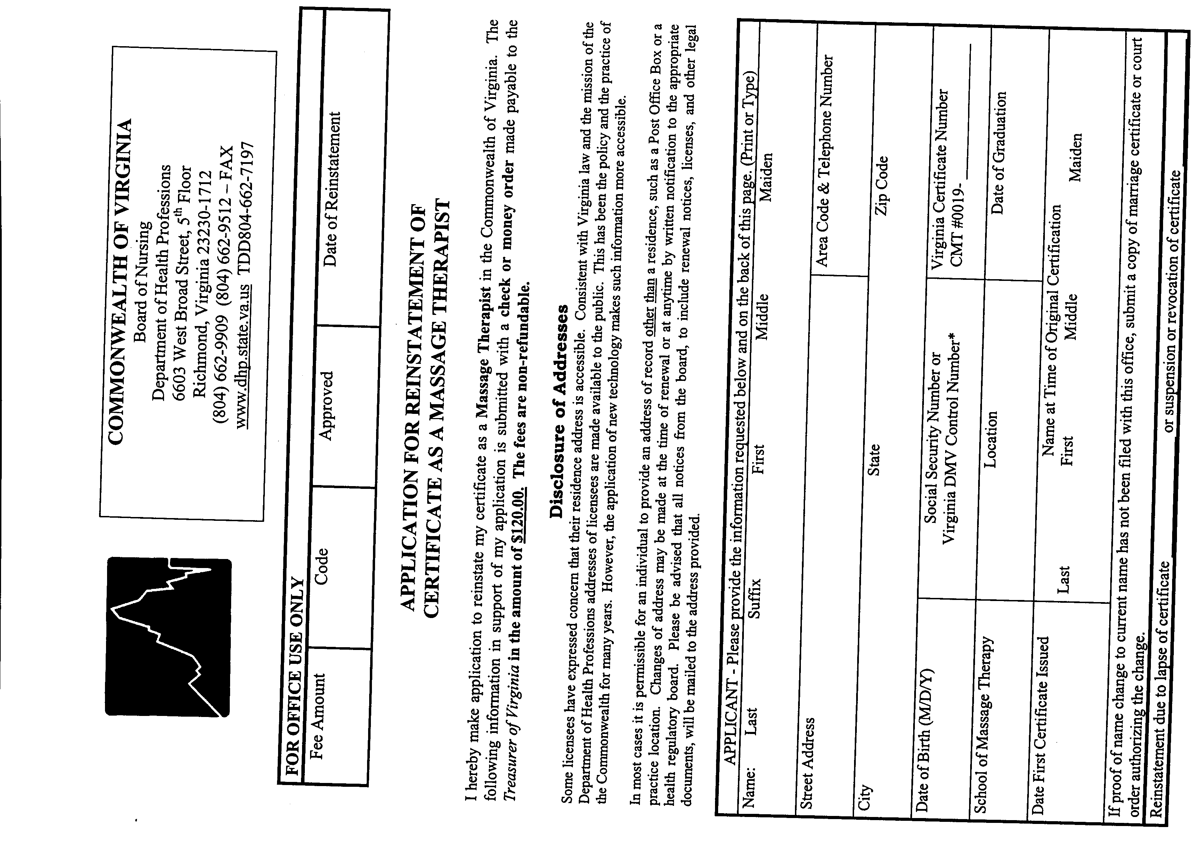
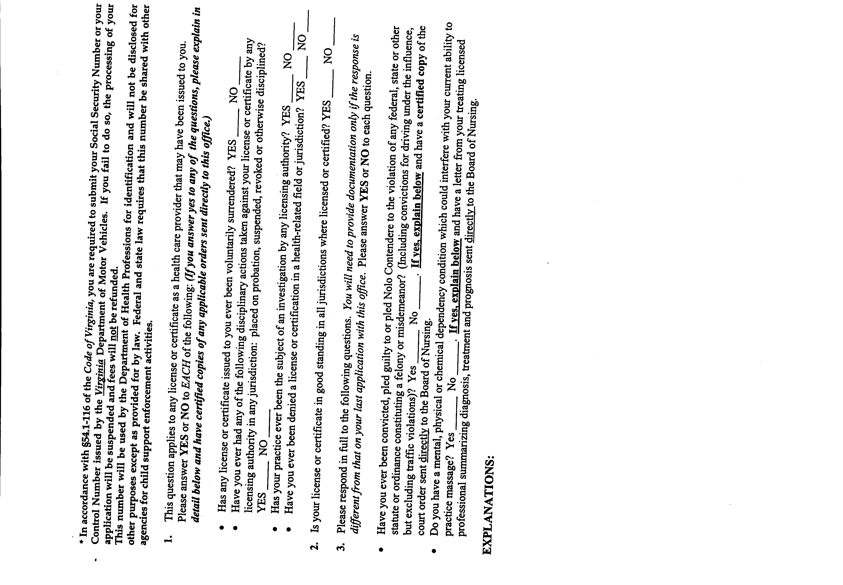
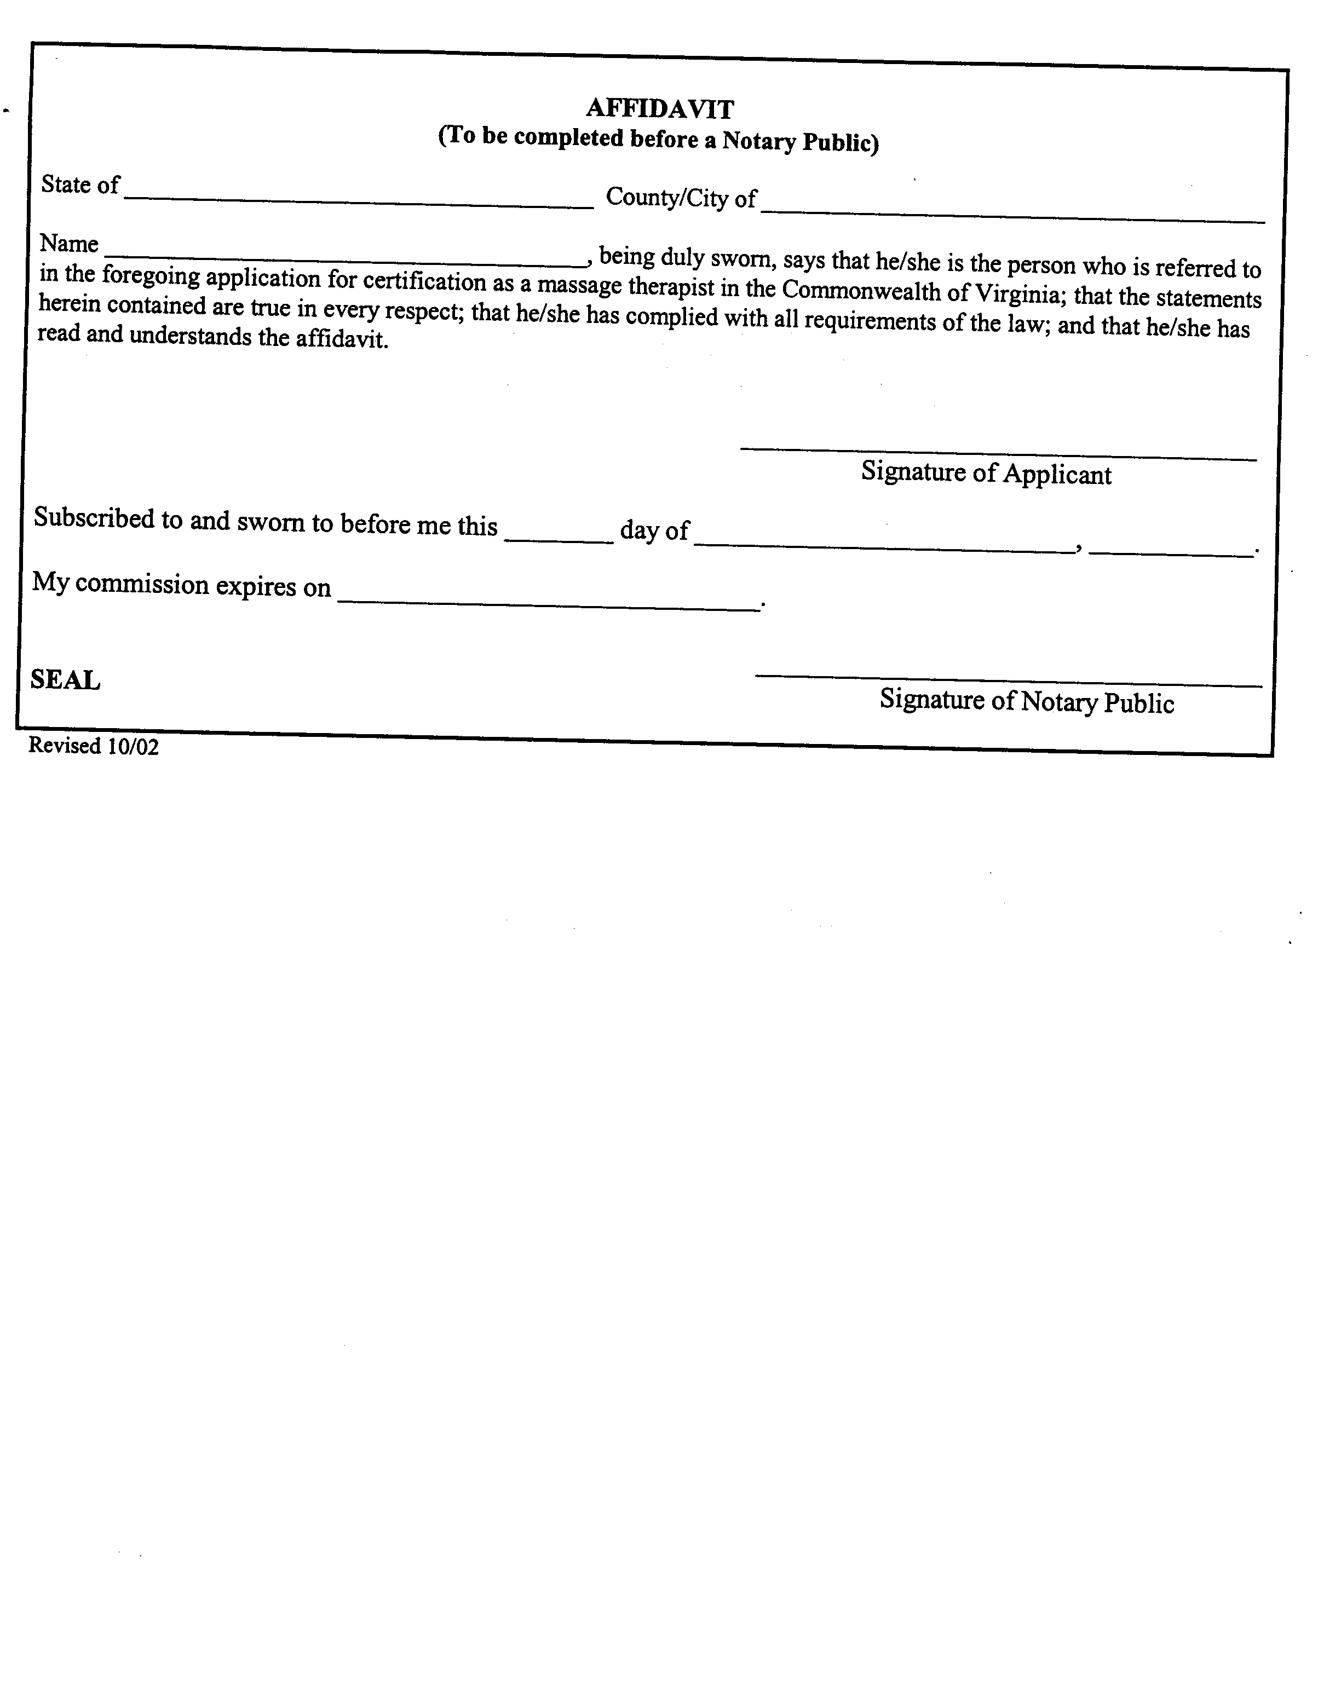
VA.R. Doc. No. R01-188; Filed November 20, 2002, 9:53 a.m.

