TITLE 12. HEALTH
DEPARTMENT OF MEDICAL ASSISTANCE SERVICES
Title of Regulation: 12 VAC 30-120. Waivered Services Elderly or Disabled Consumer Direction Waiver (adding 12 VAC 30-120-900 through 12 VAC 30-120-980; repealing 12 VAC 30-120-10 through 12 VAC 30-120-60 and 12 VAC 30-120-490 through 12 VAC 30-120-550).
Statutory Authority: §§ 32.1-324 and 32.1-325 of the Code of Virginia.
Effective Date: February 22, 2006.
Agency Contact: Teja Stokes, Project Manager, Department of Medical Assistance Services, 600 East Broad Street, Suite 1300, Richmond, VA 23219, telephone (804) 786-0527, FAX (804) 786-1680, or e-mail teja.stokes@dmas.virginia.gov.
Summary of Public Comments and Agency's Response: A summary of comments made by the public and the agency's response may be obtained from the promulgating agency or viewed at the office of the Registrar of Regulations.
Summary:
This regulatory action combines the Elderly and Disabled Waiver with the Consumer-Directed Waiver. The new combined waiver will offer agency-directed personal assistance, agency-directed respite, consumer-directed personal assistance, consumer-directed respite, adult day health care, and personal emergency response systems.
Amendments are made to the proposed regulations to enhance the clarity of the regulatory text and to correct grammar or citations. In addition to these technical changes (i) the definition section is amended, (ii) the local Department of Social Services is added to the list of persons or entities to be notified upon certain events, (iii) language is amended regarding the submission of required information, (iv) the requirement that a request include documentation of the need for increased care is added, (v) a requirement that aides be at least 18 years old is added, (vi) the requirement that primary caregivers live in the home in order to receive respite care services is removed, and (vii) the requirements that all personal care providers have CPR training and an annual flu shot are removed.
REGISTRAR'S NOTICE: The proposed regulation was adopted as published in 22:2 VA.R. 168-215 October 3, 2005, with the changes identified below. Pursuant to § 2.2-4031 A of the Code of Virginia, the adopted regulation is not published at length; however, the sections that have changed since publication of the proposed are set out.
12 VAC 30-120-10 through 12 VAC 30-120-550. [ No change from proposed. ]
PART XI. VIII.
INDIVIDUAL AND FAMILY DEVELOPMENTAL DISABILITIES SUPPORT WAIVER.
PART IX.
ELDERLY OR DISABLED WITH CONSUMER DIRECTION WAIVER.
12 VAC 30-120-900. Definitions.
The following words and terms when used in this part shall have the following meanings unless the context clearly indicates otherwise:
"Activities of daily living" or "ADLs" means tasks such as bathing, dressing, toileting, transferring, and eating/feeding. An individual's degree of independence in performing these activities is a part of determining appropriate level of care and service needs.
"Adult day health care center" or "ADHC" means a DMAS-enrolled provider that offers a community-based day program providing a variety of health, therapeutic, and social services designed to meet the specialized needs of those elderly and disabled individuals at risk of placement in a nursing facility. The ADHC must be licensed by DSS as an ADHC.
"Adult day health care services" means services designed to prevent institutionalization by providing participants with health, maintenance, and coordination of rehabilitation services in a congregate daytime setting.
"Agency-directed services" means services provided by a personal care agency.
"Americans with Disabilities Act" or "ADA" means the United States Code pursuant to 42 USC § 12101 et seq.
"Appeal" means the process used to challenge adverse actions regarding services, benefits, and reimbursement provided by Medicaid pursuant to 12 VAC 30-110 and 12 VAC 30-20-500 through 12 VAC 30-20-560.
"Barrier crime" means those crimes as defined at § [ 37.2-416 32.1-162.9:1 ] of the Code of Virginia.
"CMS" means the Centers for Medicare and Medicaid Services, which is the unit of the U.S. Department of Health and Human Services that administers the Medicare and Medicaid programs.
"Cognitive impairment" means a severe deficit in mental capability that affects an individual’s areas of functioning such as thought processes, problem solving, judgment, memory, or comprehension that interferes with such things as reality orientation, ability to care for self, ability to recognize danger to self or others, or impulse control.
"Consumer-directed services" means services for which the individual or family/caregiver is responsible for hiring, training, supervising, and firing of the personal care aide.
"Consumer-directed (CD) services facilitator" or "facilitator" means the DMAS-enrolled provider who is responsible for supporting the individual and family/caregiver by ensuring the development and monitoring of the Consumer-Directed Services Plan of Care, providing employee management training, and completing ongoing review activities as required by DMAS for consumer-directed personal care and respite services.
"Designated preauthorization contractor" means DMAS or the entity that has been contracted by DMAS to perform preauthorization of services.
"Direct marketing" means either (i) conducting either directly or indirectly door-to-door, telephonic, or other "cold call" marketing of services at residences and provider sites; (ii) using direct mailing; (iii) paying "finders fees"; (iv) offering financial incentives, rewards, gifts, or special opportunities to eligible individuals or family/caregivers as inducements to use the providers’ services; (v) providing continuous, periodic marketing activities to the same prospective individual or family/caregiver, for example, monthly, quarterly, or annual giveaways as inducements to use the providers’ services; or (vi) engaging in marketing activities that offer potential customers rebates or discounts in conjunction with the use of the providers’ services or other benefits as a means of influencing the individual’s or family/caregiver’s use of the providers’ services.
"DMAS" means the Department of Medical Assistance Services.
"DMAS staff" means persons employed by the Department of Medical Assistance Services.
"DRS" means the Department of Rehabilitative Services.
"DSS" means the Department of Social Services.
"Elderly or Disabled with Consumer Direction Waiver" or "EDCD waiver" means the CMS-approved waiver that covers a range of community support services offered to individuals who are elderly or disabled who would otherwise require a nursing facility level of care.
"Fiscal agent" means an agency or division within DMAS or contracted by DMAS to handle employment, payroll, and tax responsibilities on behalf of individuals who are receiving consumer-directed personal care services and respite services.
"Home and community-based waiver services" or "waiver services" means the range of community support services approved by the CMS pursuant to § 1915(c) of the Social Security Act to be offered to persons who are elderly or disabled who would otherwise require the level of care provided in a nursing facility. DMAS or the designated preauthorization contractor shall only give preauthorization for medically necessary Medicaid reimbursed home and community care.
"Individual" means the person receiving the services established in these regulations.
"Instrumental activities of daily living" or "IADLs" means tasks such as meal preparation, shopping, housekeeping and laundry. An individual's degree of independence in performing these activities is a part of determining appropriate level of care and service needs.
"Medication monitoring" means an electronic device, which is only available in conjunction with Personal Emergency Response Systems, that enables certain individuals at high risk of institutionalization to be reminded to take their medications at the correct dosages and times.
"Participating provider" means an entity that meets the standards and requirements set forth by DMAS and has a current, signed provider participation agreement with DMAS.
"Personal care agency" means a participating provider that provides personal care services.
"Personal care aide" means a person who provides personal care services.
"Personal care services" means long-term maintenance or support services necessary to enable the individual to remain at or return home rather than enter a nursing facility. Personal care services are provided to individuals in the areas of activities of daily living, access to the community, monitoring of self-administered medications or other medical needs, and the monitoring of health status and physical condition. Where the individual requires assistance with activities of daily living, and where specified in the plan of care, such supportive services may include assistance with instrumental activities of daily living. Services may be provided in home and community settings to enable an individual to maintain the health status and functional skills necessary to live in the community or participate in community activities.
"Personal emergency response system (PERS)" means an electronic device and monitoring service that enable certain individuals at high risk of institutionalization to secure help in an emergency. PERS services are limited to those individuals who live alone or are alone for significant parts of the day and who have no regular caregiver for extended periods of time, and who would otherwise require extensive routine supervision.
"PERS provider" means a certified home health or a personal care agency, a durable medical equipment provider, a hospital, or a PERS manufacturer that has the ability to provide PERS equipment, direct services (i.e., installation, equipment maintenance, and services calls), and PERS monitoring. PERS providers may also provide medication monitoring.
"Plan of care" means the written plan developed by the provider related solely to the specific services required by the individual to ensure optimal health and safety while remaining in the community.
"Preadmission screening" means the process to: (i) evaluate the functional, nursing, and social supports of individuals referred for preadmission screening; (ii) assist individuals in determining what specific services the individuals need; (iii) evaluate whether a service or a combination of existing community services are available to meet the individuals’ needs; and (iv) refer individuals to the appropriate provider for Medicaid-funded nursing facility or home and community-based care for those individuals who meet nursing facility level of care.
"Preadmission Screening Committee/Team" means the entity contracted with DMAS that is responsible for performing preadmission screening pursuant to § 32.1-330 of the Code of Virginia.'
[ "Primary caregiver" means the primary person who consistently assumes the rule of providing direct care and support of the individual to live successfully in the community without compensation for providing such care. ]
"Respite care agency" or "respite care facility" means a participating provider that renders respite services.
"Respite services" means those short-term personal care services provided to individuals who are unable to care for themselves because of the absence of or need for the relief of those unpaid caregivers who normally provide the care.
"State Plan for Medical Assistance" or "State Plan" means the regulations identifying the covered groups, covered services and their limitations, and provider reimbursement methodologies as provided for under Title XIX of the Social Security Act.
"Uniform Assessment Instrument" or "UAI" means the standardized multidimensional questionnaire that is completed by the Preadmission Screening Team that assesses an individual’s physical health, mental health, and social and functional abilities to determine if the individual meets the nursing facility level of care.
12 VAC 30-120-910. General coverage and requirements for Elderly or Disabled with Consumer Direction Waiver services.
A. EDCD Waiver services populations. Home and community-based waiver services shall be available through a § 1915(c) of the Social Security Act waiver for the following Medicaid-eligible individuals who have been determined to be eligible for waiver services and to require the level of care provided in a nursing facility:
1. Individuals who are elderly as defined by § 1614 of the Social Security Act; or
2. Individuals who are disabled as defined by § 1614 of the Social Security Act.
B. Covered services.
1. Covered services shall include: adult day health care, personal care (both consumer- and agency-directed), respite services (both consumer-directed, agency-directed, and facility-based), and PERS.
2. These services shall be medically appropriate and medically necessary to maintain the individual in the community and prevent institutionalization.
3. A recipient of EDCD Waiver services may receive personal care (agency- and consumer-directed), respite care (agency- and consumer-directed), adult day health care, and PERS services in conjunction with hospice services, regardless of whether the hospice provider receives reimbursement from Medicare or Medicaid for the services covered under the hospice benefit. Services under this waiver will not be available to hospice recipients unless the hospice can document the provision of at least 21 hours per week of homemaker/home health aide services and that the recipient needs personal care-type services that exceed this amount.
4. Under this § 1915(c) waiver, DMAS waives §§ 1902(a)(10)(B) and (C) of the Social Security Act related to comparability of services.
12 VAC 30-120-920. Individual eligibility requirements.
A. The Commonwealth has elected to cover low-income families with children as described in § 1931 of the Social Security Act; aged, blind, or disabled individuals who are eligible under 42 CFR 435.121; optional categorically needy individuals who are aged and disabled who have incomes at 80% of the federal poverty level; the special home and community-based waiver group under 42 CFR 435.217; and the medically needy groups specified in 42 CFR 435.320, 435.322, 435.324, and 435.330.
1. Under this waiver, the coverage groups authorized under § 1902(a)(10)(A)(ii)(VI) of the Social Security Act will be considered as if they were institutionalized for the purpose of applying institutional deeming rules. All recipients under the waiver must meet the financial and nonfinancial Medicaid eligibility criteria and meet the institutional level of care criteria. The deeming rules are applied to waiver eligible individuals as if the individual were residing in an institution or would require that level of care.
2. Virginia shall reduce its payment for home and community-based services provided to an individual who is eligible for Medicaid services under 42 CFR 435.217 by that amount of the individual's total income (including amounts disregarded in determining eligibility) that remains after allowable deductions for personal maintenance needs, deductions for other dependents, and medical needs have been made, according to the guidelines in 42 CFR 435.735 and § 1915(c)(3) of the Social Security Act as amended by the Consolidated Omnibus Budget Reconciliation Act of 1986. DMAS will reduce its payment for home and community-based waiver services by the amount that remains after the following deductions:
a. For individuals to whom § 1924(d) applies (Virginia waives the requirement for comparability pursuant to § 1902(a)(10)(B)), deduct the following in the respective order:
(1) An amount for the maintenance needs of the individual that is equal to the SSI income limit for one individual. Working individuals have a greater need due to expenses of employment; therefore, an additional amount of income shall be deducted. Earned income shall be deducted within the following limits: (i) for individuals employed 20 hours or more per week, earned income shall be disregarded up to a maximum of both earned and unearned income up to 300% of SSI and (ii) for individuals employed at least eight but less than 20 hours per week, earned income shall be disregarded up to a maximum of both earned and unearned income up to 200% of SSI. However, in no case, shall the total amount of income (both earned and unearned) that is disregarded for maintenance exceed 300% of SSI. If the individual requires a guardian or conservator who charges a fee, the fee, not to exceed an amount greater than 5.0% of the individual’s total monthly income, is added to the maintenance needs allowance. However, in no case shall the total amount of the maintenance needs allowance (basic allowance plus earned income allowance plus guardianship fees) for the individual exceed 300% of SSI. (The guardianship fee is not to exceed 5.0% of the individual’s total monthly income.);
(2) For an individual with only a spouse at home, the community spousal income allowance determined in accordance with § 1924(d) of the Social Security Act;
(3) For an individual with a family at home, an additional amount for the maintenance needs of the family determined in accordance with § 1924(d) of the Social Security Act; and
(4) Amounts for incurred expenses for medical or remedial care that are not subject to payment by a third party, including Medicare and other health insurance premiums, deductibles, or coinsurance charges and necessary medical or remedial care recognized under the state law but not covered under the State Plan.
b. For individuals to whom § 1924(d) of the Social Security Act does not apply, deduct the following in the respective order:
(1) An amount for the maintenance needs of the individual that is equal to the SSI income limit for one individual. Working individuals have a greater need due to expenses of employment; therefore, an additional amount of income shall be deducted. Earned income shall be deducted within the following limits: (i) for individuals employed 20 hours or more, earned income shall be disregarded up to a maximum of 300% of SSI and (ii) for individuals employed at least eight but less than 20 hours, earned income shall be disregarded up to a maximum of 200% of SSI. However, in no case, shall the total amount of income (both earned and unearned) that is disregarded for maintenance exceed 300% of SSI. If the individual requires a guardian or conservator who charges a fee, the fee, not to exceed an amount greater than 5.0% of the individual’s total monthly income, is added to the maintenance needs allowance. However, in no case shall the total amount of the maintenance needs allowance (basic allowance plus earned income allowance plus guardianship fees) for the individual exceed 300% of SSI. (The guardianship fee is not to exceed 5.0% of the individual’s total monthly income.);
(2) For an individual with a family at home, an additional amount for the maintenance needs of the family that shall be equal to the medically needy income standard for a family of the same size; and
(3) Amounts for incurred expenses for medical or remedial care that are not subject to payment by a third party including Medicare and other health insurance premiums, deductibles, or coinsurance charges and necessary medical or remedial care recognized under state law but not covered under the State Plan.
B. Assessment and authorization of home and community-based services.
1. To ensure that Virginia’s home and community-based waiver programs serve only Medicaid eligible individuals who would otherwise be placed in a nursing facility, home and community-based waiver services shall be considered only for individuals who are eligible for admission to a nursing facility. Home and community-based waiver services shall be the critical service to enable the individual to remain at home and in the community rather than being placed in a nursing facility.
2. The individual’s eligibility for home and community-based services shall be determined by the Preadmission Screening Team after completion of a thorough assessment of the individual’s needs and available support. If an individual meets nursing facility criteria, the Preadmission Screening Team shall provide the individual and family/caregiver with the choice of Elderly or Disabled with Consumer Direction Waiver services or nursing facility placement.
3. The Preadmission Screening Team shall explore alternative settings or services to provide the care needed by the individual. When Medicaid-funded home and community-based care services are determined to be the critical services necessary to delay or avoid nursing facility placement, the Preadmission Screening Team shall initiate referrals for services.
4. Medicaid will not pay for any home and community-based care services delivered prior to the individual establishing Medicaid eligibility and prior to the date of the preadmission screening by the Preadmission Screening Team and the physician signature on the Medicaid Funded Long-Term Care Services Authorization Form (DMAS-96).
5. Before Medicaid will assume payment responsibility of home and community-based services, preauthorization must be obtained from the designated preauthorization contractor on all services requiring preauthorization. Providers must submit all required information to the designated preauthorization contractor within 10 business days of initiating care [ or within 10 business days of receiving verification of Medicaid eligibility from the local DSS ]. If the provider submits all required information to the designated preauthorization contractor within 10 business days of initiating care, services may be authorized beginning from the date the provider initiated services but not preceding the date of the physician’s signature on the Medicaid Funded Long-Term Care Services Authorization Form (DMAS-96). If the provider does not submit all required information to the designated preauthorization contractor within 10 business days of initiating care, the services may be authorized beginning with the date all required information was received by the designated preauthorization contractor, but in no event preceding the date of the Preadmission Screening Team physician’s signature on the DMAS-96 form.
6. Once services for the individual have been authorized by the designated preauthorization contractor, the provider/services facilitator will submit a Patient Information Form (DMAS-122), along with a written confirmation of level of care eligibility from the designated preauthorization contractor, to the local DSS to determine financial eligibility for the waiver program and any patient pay responsibilities. After the provider/services facilitator has received written notification of Medicaid eligibility by DSS and written enrollment from the designated preauthorization contractor, the provider/services facilitator shall inform the individual or family/caregiver so that services may be initiated.
7. The provider/services facilitator with the most billable hours must request an updated DMAS-122 form from the local DSS annually and forward a copy of the updated DMAS-122 form to all service providers when obtained.
8. Home and community-based care services shall not be offered or provided to any individual who resides in a nursing facility, an intermediate care facility for the mentally retarded, a hospital, an assisted living facility licensed by DSS or an Adult Foster Care provider certified by DSS, or a group home licensed by the Department of Mental Health, Mental Retardation and Substance Abuse Services. Additionally, home and community-based care services shall not be provided to any individual who resides outside of the physical boundaries of the Commonwealth, with the exception of brief periods of time as approved by DMAS or the designated preauthorization contractor. Brief periods of time may include, but are not necessarily restricted to, vacation or illness.
C. Appeals. Recipient appeals shall be considered pursuant to 12 VAC 30-110-10 through 12 VAC 30-110-380. Provider appeals shall be considered pursuant to 12 VAC 30-10-1000 and 12 VAC 30-20-500 through 12 VAC 30-20-560.
12 VAC 30-120-930. General requirements for home and community-based participating providers.
A. Requests for participation will be screened by DMAS or the designated DMAS contractor to determine whether the provider applicant meets these basic requirements for participation and demonstrates the abilities to perform, at a minimum, the following activities:
1. Immediately notify DMAS in writing of any change in the information that the provider previously submitted to DMAS;
2. Assure freedom of choice to individuals in seeking services from any institution, pharmacy, practitioner, or other provider qualified to perform the service or services required and participating in the Medicaid Program at the time the service or services are performed;
3. Assure the individual’s freedom to refuse medical care, treatment, and services;
4. Accept referrals for services only when staff is available to initiate and perform such services on an ongoing basis;
5. Provide services and supplies to individuals in full compliance with Title VI (42 USC § 2000d et seq.) of the Civil Rights Act of 1964 which prohibits discrimination on the grounds of race, color, religion, or national origin; the Virginians with Disabilities Act (§ 51.5-1 et seq. of the Code of Virginia); § 504 of the Rehabilitation Act of 1973 (29 USC § 794), which prohibits discrimination on the basis of a disability; and the Americans with Disabilities Act of 1990 (42 USC § 12101 et seq.), which provides comprehensive civil rights protections to individuals with disabilities in the areas of employment, public accommodations, state and local government services, and telecommunications;
6. Provide services and supplies to individuals of the same quality and in the same mode of delivery as is provided to the general public;
7. Submit charges to DMAS for the provision of services and supplies to individuals in amounts not to exceed the provider’s usual and customary charges to the general public and accept as payment in full the amount established by DMAS payment methodology beginning with the individual’s authorization date for the waiver services;
8. Use only DMAS-designated forms for service documentation. The provider must not alter the DMAS forms in any manner unless approval from DMAS is obtained prior to using the altered forms;
9. Use DMAS-designated billing forms for submission of charges;
10. Not perform any type of direct marketing activities to Medicaid individuals;
11. Maintain and retain business and professional records sufficient to document fully and accurately the nature, scope, and details of the services provided.
a. In general, such records shall be retained for at least six years from the last date of service or as provided by applicable federal and state laws, whichever period is longer. However, if an audit is initiated within the required retention period, the records shall be retained until the audit is completed and every exception resolved. Records of minors shall be kept for at least six years after such minor has reached 18 years of age.
b. Policies regarding retention of records shall apply even if the provider discontinues operation. DMAS shall be notified in writing of the storage location and procedures for obtaining records for review should the need arise. The location, agent, or trustee shall be within the Commonwealth;
12. Furnish information on request and in the form requested to DMAS, the Attorney General of Virginia or his authorized representatives, federal personnel, and the state Medicaid Fraud Control Unit. The Commonwealth’s right of access to provider agencies and records shall survive any termination of the provider agreement;
13. Disclose, as requested by DMAS, all financial, beneficial, ownership, equity, surety, or other interests in any and all firms, corporations, partnerships, associations, business enterprises, joint ventures, agencies, institutions, or other legal entities providing any form of health care services to recipients of Medicaid;
14. Pursuant to 42 CFR 431.300 et seq., 12 VAC 30-20-90, and any other applicable federal or state law, hold confidential and use for authorized DMAS purposes only all medical assistance information regarding individuals served. A provider shall disclose information in his possession only when the information is used in conjunction with a claim for health benefits or the data is necessary for the functioning of DMAS in conjunction with the cited laws;
15. When ownership of the provider changes, notify DMAS in writing at least 15 calendar days before the date of change;
16. Pursuant to §§ 63.2-1509 and 63.2-1606 of the Code of Virginia, if a participating provider knows or suspects that a home and community-based waiver services individual is being abused, neglected, or exploited, the party having knowledge or suspicion of the abuse, neglect, or exploitation must report this immediately from first knowledge to the local DSS adult or child protective services worker as applicable;
17. In addition to compliance with the general conditions and requirements, adhere to the conditions of participation outlined in the individual provider's participation agreements and in the applicable DMAS provider manual. DMAS shall conduct ongoing monitoring of compliance with provider's participation standards and DMAS policies. A provider’s noncompliance with DMAS policies and procedures may result in a retraction of Medicaid payment or termination of the provider agreement, or both; and
18. Meet minimum qualifications of staff. All employees must have a satisfactory work record, as evidenced by references from prior job experience, including no evidence of abuse, neglect, or exploitation of incapacitated or older adults and children. The criminal record check shall be available for review by DMAS staff who are authorized by the agency to review these files. DMAS will not reimburse the provider for any services provided by an employee who has committed a barrier crime as defined herein. Providers are responsible for complying with § 32.1-162.9:1 of the Code of Virginia regarding criminal record checks.
B. For DMAS to approve provider agreements with home and community-based waiver providers, providers must meet staffing, financial solvency, disclosure of ownership, and assurance of comparability of services requirements as specified in the applicable provider manual.
C. The individual shall have the option of selecting the provider of his choice from among those providers who are approved and who can appropriately meet his needs.
D. A participating provider may voluntarily terminate his participation in Medicaid by providing 30 days' written notification.
E. DMAS may terminate at-will a provider’s participation agreement on 30 days' written notice as specified in the DMAS participation agreement. DMAS may immediately terminate a provider’s participation agreement if the provider is no longer eligible to participate in the Medicaid program. Such action precludes further payment by DMAS for services provided to individuals on or after the date specified in the termination notice.
F. A provider shall have the right to appeal adverse actions taken by DMAS. Provider appeals shall be considered pursuant to 12 VAC 30-10-1000 and 12 VAC 30-20-500 through 12 VAC 30-20-560.
G. The Medicaid provider agreement shall terminate upon conviction of the provider of a felony pursuant to § 32.1-325 of the Code of Virginia. A provider convicted of a felony in Virginia or in any other of the 50 states, the District of Columbia or, the U.S. territories, must, within 30 days, notify the Virginia Medicaid Program of this conviction and relinquish the provider agreement.
H. The provider/services facilitator is responsible for the Patient Information Form (DMAS-122). The service provider/services facilitator’s provider shall notify the designated preauthorization contractor [ , the local DSS, ] and DMAS, in writing, when any of the following circumstances occur. Furthermore, it shall be the responsibility of the designated preauthorization contractor to update DMAS, as requested, when any of the following events occur:
1. Home and community-based waiver services are implemented;
2. An individual dies;
3. An individual is discharged from EDCD waiver services;
4. Any other circumstances (including hospitalization) that cause home and community-based waiver services to cease or be interrupted for more than 30 days; or
5. The initial selection by the individual or family/caregiver of a provider/services facilitator to provide services, or a change by the individual or family/caregiver of a provider/services facilitator, if it affects the individual’s patient pay amount.
I. Changes or termination of services.
1. The provider may decrease the amount of authorized care if the revised plan of care is appropriate and based on the needs of the individual. If the individual disagrees with the proposed decrease, the individual has the right to appeal to DMAS. The participating provider is responsible for developing the new plan of care and calculating the new hours of service delivery. The individual or person responsible for supervising the individual’s care shall discuss the decrease in care with the individual or family/caregiver, document the conversation in the individual’s record, and notify the designated preauthorization contractor [ and. The preauthorization contractor will notify ] the individual or family of the change by letter. This letter shall clearly state the individual’s right to appeal.
2. If a change in the individual’s condition necessitates an increase in care, the participating provider must assess the need for increase and, if appropriate, develop a plan of care for services to meet the changed needs. The provider may implement the increase in personal/respite care hours without approval from DMAS, or the designated preauthorization contractor, if the amount of services does not exceed the amount established by DMAS, or the designated preauthorization contractor, as the maximum for the level of care designated for that individual on the plan of care. Any increase to an individual’s plan of care that exceeds the number of hours allowed for that individual’s level of care or any change in the individual’s level of care must be preauthorized by DMAS or the designated preauthorization contractor [ and be accompanied by adequate documentation justifying the increase ].
3. In an emergency situation when the health and safety of the individual or provider personnel is endangered, DMAS, or the designated preauthorization contractor, must be notified prior to discontinuing services. The written notification period shall not be required. If appropriate, the local DSS adult or child protective services department must be notified immediately.
4. In a nonemergency situation, i.e., when the health and safety of the individual or provider personnel is not endangered, the participating provider, other than a PERS provider, shall give the individual or family/caregiver, or both, at least 10 days' written notification plus three days for mailing of the intent to discontinue services. The notification letter shall provide the reasons for and the effective date the provider is discontinuing services. The effective date shall be at least 10 days plus three days for mailing from the date of the notification letter. A PERS provider shall give the individual or family/caregiver at least 14 days' prior written notification of the intent to discontinue services. The letter shall provide the reasons for and the effective date of the action. The effective date shall be at least 14 days from the date of the notification letter.
5. In the case of termination of home and community-based waiver services by DMAS or the designated preauthorization contractor, individuals shall be notified of their appeal rights pursuant to 12 VAC 30-110. DMAS, or the designated preauthorization contractor, has the responsibility and the authority to terminate the receipt of home and community-based care services by the individual for any of the following reasons:
a. The home and community-based care services are no longer the critical alternative to prevent or delay institutional placement;
b. The individual is no longer eligible for Medicaid;
c. The individual no longer meets the nursing facility criteria; or
d. The individual’s environment does not provide for his health, safety, and welfare.
J. DMAS will conduct annual level-of-care reviews for all waiver recipients.
12 VAC 30-120-940. Adult day health care services.
A. This section contains specific requirements governing the provision of adult day health care (ADHC).
B. Adult day health care services may be offered to individuals in an ADHC setting. Adult day health care may be offered either as the sole home and community-based care service or in conjunction with personal care (agency- or consumer-directed), respite care (agency- or consumer-directed), or PERS.
C. Special provider participation conditions. In order to be a participating provider, the adult day health care center shall:
1. Be an adult day care center licensed by DSS. A copy of the current license shall be available to DMAS for verification purposes prior to the applicant's enrollment as a Medicaid provider and shall be available for DMAS review;
2. Adhere to DSS adult day health care center standards;
3. Adhere to and meet the following DMAS special participation standards that are imposed in addition to DSS standards:
a. Provide a separate room or an area equipped with one bed, cot, or recliner for every 12 Medicaid adult day health care participants;
b. Employ sufficient interdisciplinary staff to adequately meet the health, maintenance, and safety needs of each participant;
c. Maintain a minimum staff-to-participant ratio of at least one staff member to every six participants. This includes Medicaid and other participants;
d. Provide at least two staff members awake and on duty at the ADHC at all times when there are Medicaid participants in attendance;
e. In the absence of the director, designate the activities director, registered nurse, or therapist to supervise the program;
f. May include volunteers in the staff-to-participant ratio if these volunteers meet the qualifications and training requirements for compensated employees, and, for each volunteer so counted, include at least one compensated employee in the staff-to-participant ratio;
g. For any center that is co-located with another facility, count only its own separate identifiable staff in the center's staff-to-participant ratio; and
h. Employ the following:
(1) A director who shall be responsible for overall management of the center's programs. The director shall be the provider contact person for DMAS and the designated preauthorization contractor and shall be responsible for responding to communication from DMAS and the designated preauthorization contractor.
(a) The director shall be responsible for assuring the development of the plan of care for adult day health care individuals. The director has ultimate responsibility for directing the center program and supervision of its employees. The director can also serve as the activities director if they meet the qualifications for that position.
(b) The director shall assign himself, the activities director, registered nurse or therapist to act as adult day health care coordinator for each participant and shall document in the participant’s file the identity of the care coordinator. The adult day health care coordinator shall be responsible for management of the participant’s plan of care and for its review with the program aides.
(c) The director shall meet the qualifications specified in the DSS standards for adult day health care for directors.
(2) An activities director who shall be responsible for directing recreational and social activities for the adult day health care participants. The activities director shall:
(a) Have a minimum of 48 semester hours or 72 quarter hours of postsecondary education from an accredited college or university with a major in recreational therapy, occupational therapy, or a related field such as art, music, or physical education; and
(b) Have one year of related experience, which may include work in an acute care hospital, rehabilitation hospital, nursing facility, or have completed a course of study including any prescribed internship in occupational, physical, and recreational therapy or music, dance, art therapy, or physical education.
(3) Program aides who shall be responsible for overall care and maintenance of the participant (assistance with activities of daily living, social/recreational activities, and other health and therapeutic-related activities). Each program aide hired by the provider shall be screened to ensure compliance with qualifications required by DMAS. The aide shall, at a minimum, have the following qualifications:
[ (a) Be at least 10 years of age or older; ]
[ (a) (b) ] Be able to read and write in English to the degree necessary to perform the tasks expected;
[ (b) (c) ] Be physically able to do the work;
[ (c) (d) ] Have satisfactorily completed an educational curriculum related to the needs of the elderly and disabled. Acceptable curriculums are offered by educational institutions, nursing facilities, and hospitals. Training consistent with DMAS training guidelines may also be given by the center's professional staff. Curriculum titles include: Nurses Aide, Geriatric Nursing Assistant, and Home Health Aide. Documentation of successful completion shall be maintained in the aide's personnel file and be available for review by DMAS staff who are authorized by DMAS to review these files. Prior to assigning a program aide to a participant, the ADHC shall ensure that the aide has satisfactorily completed a DMAS-approved training program.
(4) A registered nurse (RN) employed or contracted with the center who shall be responsible for administering to and monitoring the health needs of the participants. The nurse shall be responsible for the planning and implementation of the plan of care involving multiple services where specialized health care knowledge is needed. The nurse shall be present a minimum of eight hours each month at the center. DMAS may require the nurse's presence at the adult day health care center for more than this minimum standard depending on the number of participants in attendance and according to the medical and nursing needs of the participants. Although DMAS does not require that the registered nurse be a full-time staff position, there shall be a registered nurse available, either in person or by telephone, to the center's participants and staff during all times that the center is in operation. The registered nurse shall:
(a) Be registered and licensed as a registered nurse to practice nursing in the Commonwealth; and
(b) Have two years of related clinical experience, which may include work in an acute care hospital, public health clinic, home health agency, rehabilitation hospital, nursing facility, or as an LPN.
D. Service responsibilities of the adult day health care center and staff shall be:
1. Aide responsibilities. The aide shall be responsible for assisting with activities of daily living, supervising the participant, and assisting with the management of the participant’s plan of care.
2. RN responsibilities. The RN shall be responsible for:
a. Providing periodic evaluation of the nursing needs of each participant;
b. Providing the indicated nursing care and treatment; and
c. Monitoring, recording, and administering of prescribed medications or supervising the participant in self-administered medication.
3. Rehabilitation services coordination responsibilities. These services are designed to ensure the participant receives all rehabilitative services deemed necessary to improve or maintain independent functioning, to include the coordination and implementation of physical therapy, occupational therapy, and speech-language therapy. Rendering of the specific rehabilitative therapy is not included in the center's fee for services but must be rendered as a separate service by a rehabilitative provider.
4. Nutrition responsibilities. The center shall provide one meal per day that supplies one-third of the daily nutritional requirements established by the U.S. Department of Agriculture. Special diets and counseling shall be provided to Medicaid participants as necessary.
5. Adult day health care coordination. The designated adult day health care coordinator shall coordinate the delivery of the activities as prescribed in the participants’ plans of care and keep them updated, record 30-day progress notes, and review the participants’ daily records each week. If the individual’s condition changes more frequently, more frequent reviews and recording of progress notes shall be required to reflect the participant’s changing condition.
6. Recreation and social activities responsibilities. The center shall provide planned recreational and social activities suited to the individuals’ needs and designed to encourage physical exercise, prevent deterioration of the individual’s condition, and stimulate social interaction.
E. Documentation required. The ADHC shall maintain all records of each Medicaid participant. These records shall be reviewed periodically by DMAS staff who are authorized by DMAS to review these files. At a minimum, these records shall contain:
1. The Long-Term Care Uniform Assessment Instrument, the Medicaid Funded Long-Term Care Service Authorization Form (DMAS-96), the Screening Team Plan of Care for Medicaid-Funded Long-Term Care form (DMAS-97), the DMAS-101A and the DMAS-101B forms (if applicable), and the most recent patient information from the DMAS-122 form;
2. Interdisciplinary plans of care developed by the ADHC's director, registered nurse, or therapist and relevant support persons, in conjunction with the participant;
3. Documentation of interdisciplinary staff meetings that shall be held at least every three months to reassess each participant and evaluate the adequacy of the adult day health care plan of care and make any necessary revisions;
4. At a minimum, 30-day goal oriented progress notes recorded by the designated adult day health care coordinator. If a participant’s condition and treatment plan changes more often, progress notes shall be written more frequently than every 30 days;
5. The rehabilitative progress report and updated treatment plan from all professional disciplines involved in the participant’s care obtained every 30 days (physical therapy, speech therapy, occupational therapy, home health, and others);
6. Daily records of services provided. The daily record shall contain the specific services delivered by ADHC staff. The record shall also contain the arrival and departure times of the participant and be signed weekly by the director, activities director, registered nurse, or therapist employed by the center. The daily record shall be completed on a daily basis, neither before nor after the date of services delivery. At least once a week, a staff member shall chart significant comments regarding care given to the participant. If the staff member writing comments is different from the staff signing the weekly record, that staff member shall sign the weekly comments. A copy of this record must be given to the participant or family/caregiver weekly; and
7. All correspondence to the individual, DMAS, and the designated preauthorization contractor.
12 VAC 30-120-950. Agency-directed personal care services.
A. This section contains requirements governing the provision of agency-directed personal care services.
B. Service description. Personal care services are comprised of hands-on care of either a supportive or health-based nature and may include, but are not limited to, assistance with activities of daily living, access to the community, monitoring of self-administered medications or other medical needs, and the monitoring of health status and physical condition. Where the individual requires assistance with activities of daily living, and where specified in the plan of care, such supportive services may include assistance with instrumental activities of daily living. This service does not include skilled nursing services with the exception of skilled nursing tasks (e.g., catheterization) that may be delegated pursuant to 18 VAC 90-20-420 through 18 VAC 90-20-460. It may be provided in a home and community setting to enable an individual to maintain the health status and functional skills necessary to live in the community or participate in community activities. Personal care may be offered either as the sole home and community-based care service or in conjunction with adult day health care, respite care (agency-or consumer-directed), or PERS.
C. Criteria. In order to qualify for these services, the individual must demonstrate a need for care with activities of daily living.
1. DMAS will also pay, consistent with the approved plan of care, for personal care that the personal care aide provides to the enrolled individual to assist him at work or postsecondary school. DMAS will not duplicate services that are required as a reasonable accommodation as a part of the Americans with Disabilities Act (ADA) (42 USC §§ 12131 through 12165) or the Rehabilitation Act of 1973.
2. DMAS or the designated preauthorization contractor will review the individual’s needs and the complexity of the disability, as applicable, when determining the services that will be provided to him in the workplace or postsecondary school or both.
3. DMAS will not pay for the personal care aide to assist the enrolled individual with any functions related to the individual completing his job or postsecondary school functions or for supervision time during work or school or both.
4. There shall be a limit of eight hours per 24-hour day for supervision services.
5. The provider must develop an individualized plan of care that addresses the individual’s needs at home and work and in the community.
D. Special provider participation conditions. The personal care provider shall:
1. Operate from a business office.
2. Employ persons who have a satisfactory work record, as evidenced by references from prior job experience, including no evidence of abuse, neglect, or exploitation of incapacitated or older adults and children. Providers are responsible for complying with § 32.1-162.9:1 of the Code of Virginia regarding criminal record checks. The criminal record check shall be available for review by DMAS staff who are authorized by DMAS to review these files.
3. [ Employ Hire employees ] (or contract with) and directly supervise a registered nurse who will provide ongoing supervision of all personal care aides.
a. The registered nurse shall be currently licensed to practice in the Commonwealth as an RN and have at least two years of related clinical nursing experience, which may include work in an acute care hospital, public health clinic, home health agency, rehabilitation hospital, nursing facility, or as a licensed practical nurse (LPN).
b. The registered nurse supervisor shall make an initial home assessment visit on or before the start of care for all individuals admitted to personal care, when an individual is readmitted after being discharged from services, or if he is transferred from another provider, ADHC, or from a consumer-directed services program.
c. The registered nurse supervisor shall make supervisory visits as often as needed, but no fewer visits than provided as follows, to ensure both quality and appropriateness of services:
(1) A minimum frequency of these visits is every 30 days for individuals with a cognitive impairment and every 90 days for individuals who do not have a cognitive impairment, as defined herein. The provider agency shall have the responsibility of determining if 30-day registered nurse supervisory visits are appropriate for the individual.
(2) The initial home assessment visit by the registered nurse shall be conducted to create the plan of care and assess the individual's needs. The registered nurse shall return for a follow-up visit within 30 days after the initial visit to assess the individual's needs and make a final determination that there is no cognitive impairment. This determination must be documented in the individual's record by the registered nurse. Individuals who are determined to have a cognitive impairment will continue to have supervisory visits every 30 days.
(3) If there is no cognitive impairment, the registered nurse may give the individual or family/caregiver the option of having the supervisory visit every 90 days or any increment in between, not to exceed 90 days, or the provider may choose to continue the 30-day supervisory visits based on the needs of the individual. The registered nurse supervisor must document in the individual's record this conversation and the option that was chosen. The individual or the family/caregiver must sign and date this document.
(4) If an individual's personal care aide is supervised by the provider's registered nurse supervisor less frequently than every 30 days and DMAS, or the designated preauthorization contractor, determines that the individual’s health, safety, or welfare is in jeopardy, DMAS, or the designated preauthorization contractor, may require the provider's registered nurse supervisor to supervise the personal care aide every 30 days or more frequently than has been determined by the registered nurse supervisor. This will be documented by the provider and entered in the individual's record.
d. During visits to the individual's home, a registered nurse supervisor shall observe, evaluate, and document the adequacy and appropriateness of personal care services with regard to the individual's current functioning status, and medical and social needs. The personal care aide’s record shall be reviewed and the individual's or family's/caregiver’s satisfaction with the type and amount of services discussed. The registered nurse supervisor’s summary shall note:
(1) Whether personal care services continue to be appropriate;
(2) Whether the plan of care is adequate to meet the individual's needs or if changes are indicated in the plan;
(3) Any special tasks performed by the personal care aide and the personal care aide's qualifications to perform these tasks;
(4) The individual's satisfaction with the services;
(5) Whether the individual has been hospitalized or there has been a change in the medical condition or functional status of the individual;
(6) Other services received by the individual and the amount; and
(7) The presence or absence of the personal care aide in the home during the registered nurse supervisor's visit.
e. A registered nurse supervisor shall be available to the personal care aide for conferences pertaining to individuals being served by the aide and shall be available to the aide by telephone at all times that the aide is providing services to individuals.
f. The registered nurse supervisor shall evaluate the personal care aide's performance and the individual’s needs to identify any insufficiencies in the personal care aide's abilities to function competently and shall provide training as indicated. This shall be documented in the individual's record.
g. If there is a delay in the registered nurses' supervisory visits because the individual was unavailable, the reason for the delay must be documented in the individual's record.
4. Employ and directly supervise personal care aides who provide direct care to individuals. Each aide hired for personal care shall be evaluated by the provider agency to ensure compliance with qualifications required by DMAS. Each personal care aide shall:
[ a. Be at least 18 years of age or older; ]
[ a. b. ] Be able to read and write in English to the degree necessary to perform the expected tasks;
[ b. c. ] Complete a minimum of 40 hours of training consistent with DMAS standards. Prior to assigning an aide to an individual, the provider agency shall ensure that the personal care aide has satisfactorily completed a DMAS-approved training program consistent with DMAS standards;
[ c. d. ] Be physically able to do the work; and
[ d. e. ] Not be (i) the parents of minor children who are receiving waiver services or (ii) spouses of individuals who are receiving waiver services.
Payment may be made for services furnished by other family members when there is objective written documentation as to why there are no other providers or aides available to provide the care. These family members must meet the same requirements as personal care aides who are not family members.
E. Required documentation for individuals' records. The provider shall maintain all records for each individual receiving personal care services. These records shall be separate from those of nonhome and community-based care services, such as companion or home health services. These records shall be reviewed periodically by DMAS. At a minimum, the record shall contain:
1. The most recently updated Long-Term Care Uniform Assessment Instrument, the Medicaid Funded Long-Term Care Service Authorization Form (DMAS-96), the Screening Team Plan of Care for Medicaid-Funded Long-Term Care (DMAS-97), all Provider Agency Plans of Care (DMAS-97A), all Patient Information Forms (DMAS-122), and all DMAS-101A and 101B forms (if applicable);
2. The initial assessment by a registered nurse or a RN supervisor completed prior to or on the date that services are initiated;
3. Registered nurse supervisor’s notes recorded and dated during significant contacts with the personal care aide and during supervisory visits to the individual's home;
4. All correspondence to the individual, DMAS, and the designated preauthorization contractor;
5. Reassessments made during the provision of services;
6. Significant contacts made with family/caregivers, physicians, DMAS, the designated preauthorization contractor, formal, informal services providers and all professionals related to the individual's Medicaid services or medical care;
7. All personal care aides’ records (DMAS-90). The personal care aide record shall contain:
a. The specific services delivered to the individual by the aide and his responses to this service;
b. The personal care aide's daily arrival and departure times;
c. The aide's weekly comments or observations about the individual, including observations of the individual's physical and emotional condition, daily activities, and responses to services rendered; and
d. The personal care aide's and individual's or responsible caregiver's weekly signatures, including the date, to verify that personal care services have been rendered during that week as documented in the record. An employee of the provider cannot sign for the individual unless he is a family/caregiver of the individual. This family member cannot be the same family member who is providing the service. Signatures, times and dates shall not be placed on the personal care aide record prior to the last date that the services are actually delivered; and
8. All of the individual’s progress reports.
12 VAC 30-120-960. Agency-directed respite care services.
A. This section contains requirements governing the provision of agency-directed respite care services.
B. Agency-directed respite care services are comprised of hands-on care of either a supportive or health-related nature and may include, but are not limited to, assistance with activities of daily living, access to the community, monitoring of self-administration of medications or other medical needs, monitoring health status and physical condition, and personal care services provided in a work environment. Where the individual requires assistance with activities of daily living, and where specified in the plan of care, such supportive services may include assistance with instrumental activities of daily living. This service does not include skilled nursing services with the exception of skilled nursing tasks (e.g., catheterization) that may be delegated pursuant to 18 VAC 90-20-420 through 18 VAC 90-20-460.
C. General. Respite care may only be offered to individuals who have a primary caregiver [ living in the home ] who requires temporary relief to avoid institutionalization of the individual. Respite care services may be provided in the individual’s home or place of residence, or a facility licensed as a nursing facility and enrolled in Medicaid. The authorization of respite care (agency-directed and consumer-directed) is limited to a total of 720 hours per calendar year per individual. Reimbursement shall be made on an hourly basis.
D. Special provider participation conditions. To be approved as a respite care provider with DMAS, the respite care provider shall:
1. Operate from a business office.
2. Have employees who have satisfactory work records, as evidenced by references from prior job experience, including no evidence of abuse, neglect, or exploitation of incapacitated or older adults and children. Providers are responsible for complying with § 32.1-162.9:1 of the Code of Virginia regarding criminal record checks. The criminal record check shall be available for review by DMAS staff who are authorized by the agency to review these files. DMAS will not reimburse the provider for any services provided by an employee who has committed a barrier crime.
3. Employ (or contract with) and directly supervise a registered nurse who will provide ongoing supervision of all respite care aides/LPNs.
a. The registered nurse supervisor shall be currently licensed to practice in the Commonwealth as an RN and have at least two years of related clinical nursing experience, which may include work in an acute care hospital, public health clinic, home health agency, rehabilitation hospital, nursing facility, or as an LPN.
b. Based on continuing evaluations of the aide’s/LPN’s performance and the individual’s needs, the registered nurse supervisor shall identify any insufficiencies in the aide's/LPN’s abilities to function competently and shall provide training as indicated.
c. The registered nurse supervisor shall make an initial home assessment visit on or before the start of care for any individual admitted to respite care.
d. A registered nurse supervisor shall make supervisory visits as often as needed to ensure both quality and appropriateness of services.
(1) When respite care services are received on a routine basis, the minimum acceptable frequency of these supervisory visits shall be every 30 to 90 days dependent on the cognitive status of the individual. If an individual is also receiving personal care services, the respite care RN supervisory visit may coincide with the personal care RN supervisory visits.
(2) When respite care services are not received on a routine basis, but are episodic in nature, a registered nurse supervisor shall not be required to conduct a supervisory visit every 30 to 90 days. Instead, a registered nurse supervisor shall conduct the initial home assessment visit with the aide/LPN on or before the start of care and make a second home visit during the second respite care visit. If an individual is also receiving personal care services, the respite care RN supervisory visit may coincide with the personal care RN supervisory visit.
(3) When respite care services are routine in nature and offered in conjunction with personal care, the RN supervisory visit conducted for personal care services may serve as the registered nurse supervisory visit for respite care. However, the registered nurse supervisor shall document supervision of respite care separately from the personal care documentation. For this purpose, the same individual record can be used with a separate section for respite care documentation.
e. During visits to the individual's home, the registered nurse supervisor shall observe, evaluate, and document the adequacy and appropriateness of respite care services with regard to the individual's current functioning status and medical and social needs. The aide's/LPN’s record shall be reviewed along with the individual's or family's satisfaction with the type and amount of services discussed. The registered nurse supervisor shall document in a summary note:
(1) Whether respite care services continue to be appropriate;
(2) Whether the plan of care is adequate to meet the individual's needs or if changes need to be made to the plan of care;
(3) The individual's satisfaction with the services;
(4) Any hospitalization or change in the medical condition or functioning status of the individual;
(5) Other services received by the individual and the amount of the services received; and
(6) The presence or absence of the aide/LPN in the home during the RN supervisory visit.
f. An RN supervisor shall be available to the aide/LPN for conference pertaining to individuals being served by the aide/LPN and shall be available to the aide/LPN by telephone at all times that the aide/LPN is providing services to respite care individuals.
g. If there is a delay in the registered nurse's supervisory visits because the individual is unavailable, the reason for the delay must be documented in the individual's record.
4. Employ and directly supervise aides/LPNs who provide direct care to respite care individuals. Each aide/LPN hired by the provider shall be evaluated by the provider to ensure compliance with qualifications as required by DMAS. Each aide must:
a. Be at least 18 years of age or older;
b. Be physically able to do the work;
c. Be able to read and write in English to the degree necessary to perform the tasks expected;
d. Have completed a minimum of 40 hours of DMAS-approved training consistent with DMAS standards. Prior to assigning an aide to an individual, the provider shall ensure that the aide has satisfactorily completed a training program consistent with DMAS standards; and
e. Be evaluated in his job performance by the registered nurse supervisor.
Respite care aides may not be the parents of [ individuals who are minors or the individuals’ spouses minor children who are receiving waiver services or spouses of individuals who are receiving waiver services ]. Payment may not be made for services furnished by other family members living under the same roof as the individual receiving services unless there is objective written documentation as to why there are no other providers or aides available to provide the care. Family members who are approved to provide paid respite services must meet the qualifications for respite care aides.
5. Employ a licensed practical nurse (LPN) to perform skilled respite care services. Such services shall be reimbursed by DMAS under the following circumstances:
a. The individual has a need for routine skilled care that cannot be provided by unlicensed personnel. These individuals would typically require a skilled level of care if in a nursing facility (e.g., individuals on a ventilator, individuals requiring nasogastric or gastrostomy feedings, etc.);
b. No other individual in the individual's support system is willing and able to supply the skilled component of the individual's care during the caregiver's absence; and
c. The individual is unable to receive skilled nursing visits from any other source that could provide the skilled care usually given by the caregiver.
The provider must document in the individual's record the circumstances that require the provision of services by an LPN. When an LPN is required, the LPN must also provide any of the services normally provided by an aide.
E. Required documentation for individuals' records. The provider shall maintain all records of each individual receiving respite services. These records shall be separated from those of nonhome and community-based care services, such as companion or home health services. These records shall be reviewed periodically by the DMAS staff who are authorized by DMAS to review these files. At a minimum these records shall contain:
1. The most recently updated Long-Term Care Uniform Assessment Instrument, the Medicaid Funded Long-Term Care Service Authorization Form (DMAS-96), the Screening Team Plan of Care for Medicaid-Funded Long-Term Care (DMAS-97), all respite care assessments and plans of care, all aide records (DMAS-90), all LPN skilled respite records (DMAS-90A), all Patient Information Forms (DMAS-122), and all DMAS-101A and DMAS-101B forms, as applicable;
2. The physician’s order for services, obtained prior to the service begin date and updated every six months;
3. The initial assessment by a registered nurse completed prior to or on the date services are initiated;
4. Registered nurse supervisor’s notes recorded and dated during significant contacts with the care aide and during supervisory visits to the individual's home;
5. All correspondence to the recipient, DMAS, and the designated preauthorization contractor;
6. Reassessments made during the provision of services;
7. Significant contacts made with family, physicians, DMAS, the designated preauthorization contractor, formal and informal services providers, and all professionals related to the individual's Medicaid services or medical care; and
8. All respite care records. The respite care record shall contain:
a. The specific services delivered to the individual by the aide or LPN and his response to this service;
b. The daily arrival and departure times of the aide or LPN for respite care services;
c. Comments or observations recorded weekly about the individual. Aide or LPN comments shall include but not be limited to observation of the individual's physical and emotional condition, daily activities, and the individual's response to services rendered;
d. The signatures of the aide or LPN, and the individual, once each week to verify that respite care services have been rendered. Signature, times, and dates shall not be placed on the aide’s record prior to the last date of the week that the services are delivered. If the individual is unable to sign the aide record, it must be documented in his record how or who will sign in his place. An employee of the provider shall not sign for the individual unless he is a family member or legal guardian of the recipient; and
e. All individual progress reports.
Documentation signed by the LPN must be reviewed and signed by the supervising RN.
12 VAC 30-120-970. Personal emergency response system (PERS).
A. Service description. PERS is a service that monitors individual safety in the home and provides access to emergency assistance for medical or environmental emergencies through the provision of a two-way voice communication system that dials a 24-hour response or monitoring center upon activation and via the individual's home telephone line. PERS may also include medication monitoring devices.
B. Standards for PERS equipment. All PERS equipment must be approved by the Federal Communications Commission and meet the Underwriters’ Laboratories, Inc. (UL) safety standard Number 1635 for digital alarm communicator system units and Number 1637 for home health care signaling equipment. The UL listing mark on the equipment will be accepted as evidence of the equipment’s compliance with such standard. The PERS device must be automatically reset by the response center after each activation, ensuring that subsequent signals can be transmitted without requiring manual reset by the recipient.
C. Criteria. PERS services are limited to those individuals ages 14 and older who live alone or are alone for significant parts of the day and who have no regular caregiver for extended periods of time and who would otherwise require extensive routine supervision. PERS may only be provided in conjunction with personal care (agency- or
consumer-directed), respite (agency- or consumer-directed), or adult day health care. An individual may not receive PERS if he has a cognitive impairment as defined in 12 VAC 30-120-900.
1. PERS can be authorized when there is no one else, other than the individual, in the home who is competent and continuously available to call for help in an emergency. If the individual's caregiver has a business in the home, such as, but not limited to, a day care center, PERS will only be approved if the individual is evaluated as being dependent in the categories of "Behavior Pattern" and "Orientation" on the Uniform Assessment Instrument (UAI).
2. Medication monitoring units must be physician ordered. In order to receive medication monitoring services, an individual must also receive PERS services. The physician orders must be maintained in the individual’s file.
D. Services units and services limitations.
1. A unit of service shall include administrative costs, time, labor, and supplies associated with the installation, maintenance, adjustments, and monitoring of the PERS. A unit of service [ is equals ] the one-month rental [ price as of PERS, the price of which is ] set by DMAS. The one-time installation of the unit includes installation, account activation, and individual and caregiver instruction. The one-time installation fee shall also include the cost of the removal of the PERS equipment.
2. PERS service must be capable of being activated by a remote wireless device and be connected to the individual's telephone line. The PERS console unit must provide hands-free voice-to-voice communication with the response center. The activating device must be waterproof, automatically transmit to the response center an activator low battery alert signal prior to the battery losing power, and be able to be worn by the individual.
3. In cases where medication monitoring units must be filled by the provider, the person filling the unit must be a registered nurse, a licensed practical nurse, or a licensed pharmacist. The units can be refilled every 14 days. There must be documentation of this in the individual’s record.
E. Provider requirements. In addition to meeting the general conditions and requirements for home and community-based waiver participating providers as specified in 12 VAC 30-120-930, PERS providers must also meet the following qualifications and requirements:
1. A PERS provider must be either a personal care agency, a durable medical equipment provider, a hospital, a licensed home health provider, or a PERS manufacturer. All such providers shall have the ability to provide PERS equipment, direct services (i.e., installation, equipment maintenance, and service calls), and PERS monitoring;
2. The PERS provider must provide an emergency response center with fully trained operators who are capable of (i) receiving signals for help from an individual's PERS equipment 24 hours a day, 365 or 366 days per year as appropriate; (ii) determining whether an emergency exists; and (iii) notifying an emergency response organization or an emergency responder that the PERS individual needs emergency help;
3. A PERS provider must comply with all applicable Virginia statutes, all applicable regulations of DMAS, and all other governmental agencies having jurisdiction over the services to be performed;
4. The PERS provider has the primary responsibility to furnish, install, maintain, test, and service the PERS equipment, as required, to keep it fully operational. The provider shall replace or repair the PERS device within 24 hours of the individual's notification of a malfunction of the console unit, activating devices, or medication monitoring unit and shall provide temporary equipment while the original equipment is being repaired;
5. The PERS provider must properly install all PERS equipment into a PERS individual's functioning telephone line within seven days of the request unless there is appropriate documentation of why this timeframe cannot be met. The PERS provider must furnish all supplies necessary to ensure that the system is installed and working properly. The PERS provider must test the PERS device monthly, or more frequently if needed, to ensure that the device is fully operational;
6. The PERS installation shall include local seize line circuitry, which guarantees that the unit will have priority over the telephone connected to the console unit should the telephone be off the hook or in use when the unit is activated;
7. A PERS provider must maintain a data record for each PERS individual at no additional cost to DMAS or the individual. The record must document all of the following:
a. Delivery date and installation date of the PERS;
b. Individual/caregiver signature verifying receipt of the PERS device;
c. Verification by a test that the PERS device is operational, monthly or more frequently as needed;
d. Updated and current individual responder and contact information, as provided by the individual or the individual's caregiver; and
e. A case log documenting the individual's utilization of the system, all contacts, and all communications with the individual, caregiver, and responders;
8. The PERS provider must have backup monitoring capacity in case the primary system cannot handle incoming emergency signals;
9. All PERS equipment must be approved by the Federal Communications Commission and meet the Underwriters' Laboratories, Inc. (UL) Safety Standard Number 1635 for digital alarm communicator system units and Safety Standard Number 1637 for home health care signaling equipment. The UL listing mark on the equipment will be accepted as evidence of the equipment's compliance with such standard. The PERS device must be automatically reset by the response center after each activation, ensuring that subsequent signals can be transmitted without requiring a manual reset by the individual;
10. A PERS provider must furnish education, data, and ongoing assistance to DMAS and the designated preauthorization contractor to familiarize staff with the services, allow for ongoing evaluation and refinement of the program, and instruct the individual, caregiver, and responders in the use of the PERS services;
11. The emergency response activator must be activated either by breath, by touch, or by some other means, and must be usable by individuals who are visually or hearing impaired or physically disabled. The emergency response communicator must be capable of operating without external power during a power failure at the individual's home for a minimum period of 24 hours and automatically transmit a low battery alert signal to the response center if the backup battery is low. The emergency response console unit must also be able to self-disconnect and redial the backup monitoring site without the individual resetting the system in the event it cannot get its signal accepted at the response center;
12. PERS providers must be capable of continuously monitoring and responding to emergencies under all conditions, including power failures and mechanical malfunctions. It is the PERS provider's responsibility to ensure that the monitoring agency and the monitoring agency's equipment meets the following requirements. The PERS provider must be capable of simultaneously responding to multiple signals for help from individuals’ PERS equipment. The PERS provider's equipment must include the following:
a. A primary receiver and a backup receiver, which must be independent and interchangeable;
b. A backup information retrieval system;
c. A clock printer, which must print out the time and date of the emergency signal, the PERS individual's identification code, and the emergency code that indicates whether the signal is active, passive, or a responder test;
d. A backup power supply;
e. A separate telephone service;
f. A toll-free number to be used by the PERS equipment in order to contact the primary or backup response center; and
g. A telephone line monitor, which must give visual and audible signals when the incoming telephone line is disconnected for more than 10 seconds;
13. The PERS provider must maintain detailed technical and operation manuals that describe PERS elements, including the installation, functioning, and testing of PERS equipment; emergency response protocols; and recordkeeping and reporting procedures;
14. The PERS provider shall document and furnish within 30 days of the action taken a written report for each emergency signal that results in action being taken on behalf of the individual. This excludes test signals or activations made in error. This written report shall be furnished to the personal care provider, the respite care provider, the CD services facilitation provider, or in cases where the individual only receives ADHC services, to the ADHC provider;
15. The PERS provider is prohibited from performing any type of direct marketing activities to Medicaid individuals; and
16. The PERS provider must obtain and keep on file a copy of the most recently completed Patient Information form (DMAS-122). Until the PERS provider obtains a copy of the DMAS-122 form, the PERS provider must clearly document efforts to obtain the completed DMAS-122 form from the personal care provider, respite care provider, the CD services facilitation provider, or the ADHC provider.
12 VAC 30-120-980. Consumer-directed services: personal care and respite services.
A. Service description.
1. Consumer-directed personal care services and respite care services are comprised of hands-on care of either a supportive or health-related nature and may include, but are not limited to, assistance with activities of daily living, access to the community, monitoring of self-administration of medications or other medical needs, monitoring health status and physical condition, and personal care services provided in a work environment. Where the individual requires assistance with activities of daily living, and where specified in the plan of care, such supportive services may include assistance with instrumental activities of daily living. This service does not include skilled nursing services with the exception of skilled nursing tasks (e.g., catheterization) that may be delegated pursuant to 18 VAC 90-20-420 through 18 VAC 90-20-460.
2. Consumer-directed respite services are specifically designed to provide temporary, periodic, or routine relief to the unpaid [ , live-in, ] primary caregiver of an individual. This service may be provided in the individual’s home or other community settings.
3. DMAS shall either provide for fiscal agent services or contract for the services of a fiscal agent for consumer-directed services. The fiscal agent will be reimbursed by DMAS (if the service is contracted) to perform certain tasks as an agent for the individual/employer who is receiving consumer-directed services. The fiscal agent will handle responsibilities for the individual for employment taxes. The fiscal agent will seek and obtain all necessary authorizations and approvals of the Internal Revenue Services in order to fulfill all of these duties.
4. Individuals choosing consumer-directed services must receive support from a CD services facilitator. This is not a separate waiver service, but is required in conjunction with consumer-directed services. The CD services facilitator is responsible for assessing the individual’s particular needs for a requested CD service, assisting in the development of the plan of care, providing training to the individual and family/caregiver on his responsibilities as an employer, and providing ongoing support of the consumer-directed services. The CD services facilitator cannot be the individual, direct service provider, spouse, or parent of the individual who is a minor child, or a family/caregiver employing the aide.
B. Criteria.
1. In order to qualify for consumer-directed personal care services, the individual must demonstrate a need for personal care services as defined in 12 VAC 30-120-900.
2. Consumer-directed respite services may only be offered to individuals who have an unpaid primary caregiver [ living in the home ] who requires temporary relief to avoid institutionalization of the individual. Respite services are designed to focus on the need of the unpaid primary caregiver for temporary relief and to help prevent the breakdown of the unpaid primary caregiver due to the physical burden and emotional stress of providing continuous support and care to the individual.
3. DMAS will also pay, consistent with the approved plan of care, for personal care that the personal care aide provides to the enrolled individual to assist him at work or postsecondary school. DMAS will not duplicate services that are required as a reasonable accommodation as a part of the Americans with Disabilities Act (ADA) (42 USC §§ 12131 through 12165) or the Rehabilitation Act of 1973.
a. DMAS or the designated preauthorization contractor will review the individual’s needs and the complexity of the disability, as applicable, when determining the services that will be provided to him in the workplace or postsecondary school or both.
b. DMAS will not pay for the personal care aide to assist the enrolled individual with any functions related to the individual completing his job or postsecondary school functions or for supervision time during work or school or both.
4. Individuals who are eligible for consumer-directed services must have, or have a family/caregiver who has, the capability to hire and train their own personal care aides and supervise the aide’s performance. If an individual is unable to direct his own care or is under 18 years of age, a family/caregiver may serve as the employer on behalf of the individual.
5. The individual, or if the individual is unable, a family/caregiver, shall be the employer of consumer-directed services and, therefore, shall be responsible for hiring, training, supervising, and firing personal care aides. Specific employer duties include checking references of personal care aides, determining that personal care aides meet basic qualifications, and maintaining copies of timesheets to have available for review by the CD services facilitator and the fiscal agent on a consistent and timely basis. The individual or family/caregiver must have a backup plan for the provision of services in case the aide does not show up for work as expected or terminates employment without prior notice.
C. Service units and limitations.
1. The unit of services for consumer-directed respite services is one hour. Consumer-directed respite services are limited to a maximum of 720 hours per calendar year. Individuals who receive consumer-directed respite services, agency-directed respite services and/or facility-based respite services may not receive more than 720 hours combined, regardless of service delivery method.
2. The unit of service for consumer-directed personal care services is one hour.
D. Provider qualifications. In addition to meeting the general conditions and requirements for home and community-based services participating providers as specified in 12 VAC 30-120-930, the CD services facilitator must meet the following qualifications:
1. To be enrolled as a Medicaid CD services facilitator and maintain provider status, the CD services facilitator shall have sufficient resources to perform the required activities. In addition, the CD services facilitator must have the ability to maintain and retain business and professional records sufficient to fully and accurately document the nature, scope, and details of the services provided.
2. It is preferred that the CD services facilitator possess, at a minimum, an undergraduate degree in a human services field or be a registered nurse currently licensed to practice in the Commonwealth. In addition, it is preferable that the CD services facilitator have at least two years of satisfactory experience in a human services field working with individuals who are disabled or elderly. The CD services facilitator must possess a combination of work experience and relevant education that indicates possession of the following knowledge, skills, and abilities. Such knowledge, skills and abilities must be documented on the CD services facilitator’s application form, found in supporting documentation, or be observed during a job interview. Observations during the interview must be documented. The knowledge, skills, and abilities include:
a. Knowledge of:
(1) Types of functional limitations and health problems that may occur in individuals who are elderly or individuals with disabilities, as well as strategies to reduce limitations and health problems;
(2) Physical care that may be required by individuals who are elderly or individuals with disabilities, such as transferring, bathing techniques, bowel and bladder care, and the approximate time those activities normally take;
(3) Equipment and environmental modifications that may be required by individuals who are elderly or individuals with disabilities that reduce the need for human help and improve safety;
(4) Various long-term care program requirements, including nursing facility and assisted living facility placement criteria, Medicaid waiver services, and other federal, state, and local resources that provide personal care and respite services;
(5) Elderly or Disabled with Consumer-Direction Waiver requirements, as well as the administrative duties for which the services facilitator will be responsible;
(6) How to conduct assessments (including environmental, psychosocial, health, and functional factors) and their uses in services planning;
(7) Interviewing techniques;
(8) The individual’s right to make decisions about, direct the provisions of, and control his consumer-directed services, including hiring, training, managing, approving time sheets, and firing an aide;
(9) The principles of human behavior and interpersonal relationships; and
(10) General principles of record documentation.
b. Skills in:
(1) Negotiating with individuals, family/caregivers and service providers;
(2) Assessing, supporting, observing, recording, and reporting behaviors;
(3) Identifying, developing, or providing services to individuals who are elderly or individuals with disabilities; and
(4) Identifying services within the established services system to meet the individual’s needs.
c. Abilities to:
(1) Report findings of the assessment or onsite visit, either in writing or an alternative format for individuals who have visual impairments;
(2) Demonstrate a positive regard for individuals and their families;
(3) Be persistent and remain objective;
(4) Work independently, performing position duties under general supervision;
(5) Communicate effectively, orally and in writing; and
(6) Develop a rapport and communicate with individuals from diverse cultural backgrounds.
3. If the CD services facilitator is not a registered nurse, the CD services facilitator must inform the individual’s primary health care provider that services are being provided and request consultation as needed.
4. Initiation of services and service monitoring.
a. For consumer-directed services, the CD services facilitator must make an initial comprehensive home visit to collaborate with the individual and family/caregiver to identify the needs, assist in the development of the plan of care with the individual or family/caregiver, and provide employee management training within seven days of the initial visit. The initial comprehensive home visit is done only once per provider upon the individual’s entry into CD services. If the individual changes CD services facilitator, the new CD services facilitator must complete a reassessment visit in lieu of a comprehensive visit.
b. After the initial visit, the CD services facilitator will continue to monitor the plan of care on an as-needed basis, but in no event less frequently than quarterly for personal care. The CD services facilitator will review the utilization of consumer-directed respite services, either every six months or upon the use of 300 respite services hours, whichever comes first.
c. A CD services facilitator must conduct face-to-face meetings with the individual or family/caregiver at least every six months for respite services and quarterly for personal care to ensure appropriateness of any consumer-directed services received by the individual.
5. During visits with the individual, the CD services facilitator must observe, evaluate, and consult with the individual or family/caregiver, and document the adequacy and appropriateness of consumer-directed services with regard to the individual’s current functioning and cognitive status and medical and social needs. The CD services facilitator’s written summary of the visit must include, but is not necessarily limited to:
a. A discussion with the individual or family/caregiver concerning whether the service is adequate to meet the individual’s needs;
b. Any suspected abuse, neglect, or exploitation and who it was reported to;
c. Any special tasks performed by the aide and the aide’s qualifications to perform these tasks;
d. The individual’s or family/caregiver’s satisfaction with the service;
e. Any hospitalization or change in medical condition, functioning, or cognitive status; and
f. The presence or absence of the aide in the home during the CD services facilitator’s visit.
6. The CD services facilitator must be available to the individual or family/caregiver by telephone.
7. The CD services facilitator must request a criminal record check and a sex offender record check pertaining to the aide on behalf of the individual and report findings of these records checks to the individual or the family/caregiver and the program’s fiscal agent. If the individual is a minor, the aide must also be screened through the DSS Child Protective Services Central Registry. The criminal record check and DSS Child Protective Services Registry finding must be requested by the CD services facilitator prior to beginning CD services. Aides will not be reimbursed for services provided to the individual effective on the date that the criminal record check confirms an aide has been found to have been convicted of a crime as described in § [ 37.2-416 32.1-162.9:1 ] of the Code of Virginia or if the aide has a confirmed record on the DSS Child Protective Services Central Registry.
8. The CD services facilitator shall review copies of timesheets during the face-to-face visits to ensure that the number of plan of care-approved hours are being provided and are not exceeded. If discrepancies are identified, the CD services facilitator must discuss these with the individual or family/caregiver to resolve discrepancies and must notify the fiscal agent.
9. The CD services facilitator must maintain records of each individual. At a minimum these records must contain:
a. Results of the initial comprehensive home visit completed prior to or on the date services are initiated and subsequent reassessments and changes to the supporting documentation;
b. The personal care plan of care goals, objectives, and activities must be reviewed by the provider quarterly, annually, and more often as needed, and modified as appropriate. Respite plan of care goals, objectives, and activities must be reviewed by the provider annually and every six months or when 300 service hours have been used. For the annual review and in cases where the plan of care is modified, the plan of care must be reviewed with the individual;
c. CD services facilitator’s dated notes documenting any contacts with the individual or family/caregiver and visits to the individual’s home;
d. All correspondence to and from the individual, the designated preauthorization contractor, and DMAS;
e. Records of contacts made with the individual, family/caregiver, physicians, formal and informal service providers, and all professionals concerning the individual;
f. All training provided to the aides on behalf of the individual or family/caregiver;
g. All employee management training provided to the individual or family/caregiver, including the individual’s or family/caregiver’s receipt of training on their responsibility for the accuracy of the aide’s timesheets;
h. All documents signed by the individual or the individual’s family/caregiver that acknowledge the responsibilities as the employer; and
i. All copies of the completed Uniform Assessment Instrument (UAI), the Medicaid Funded Long-Term Care Service Authorization Form (DMAS-96), the Screening Team Plan of Care form (DMAS-97), all Consumer-Directed Personal Assistance Plans of Care forms (DMAS-97B), all Patient Information Forms (DMAS-122), the DMAS-95 Addendum, the Outline and Checklist for Consumer-Directed Recipient Comprehensive Training, and the Services Agreement Between the Consumer and the Services Facilitator.
10. For consumer-directed personal care and consumer-directed respite services, individuals or family/caregivers will hire their own personal care aides and manage and supervise their performance. The aide must meet the following requirements:
a. Be 18 years of age or older;
b. Have the required skills to perform consumer-directed services as specified in the individual’s supporting documentation;
c. Be able to read and write in English to the degree necessary to perform the tasks expected;
d. Possess basic math, reading, and writing skills;
e. Possess a valid Social Security number;
f. Submit to a criminal records check and, if the individual is a minor, consent to a search of the DSS Child Protective Services Central Registry. The aide will not be compensated for services provided to the individual if either of these records checks verifies the aide has been convicted of crimes described in § [ 37.2-416 32.1-162.9:1 ] of the Code of Virginia or if the aide has a founded complaint confirmed by the DSS Child Protective Services Central Registry;
g. Be willing to attend training at the individual’s or family/caregiver’s request;
h. Understand and agree to comply with the DMAS Elderly or Disabled with Consumer Direction Waiver requirements; and
i. Receive periodic tuberculosis (TB) screening [ , cardiopulmonary resuscitation (CPR) training and an annual flu shot (unless medically contraindicated) ].
11. Aides may not be the parents of [ individuals who are minors or the individuals’ spouses minor children who are receiving waiver services or the spouse of the indiviudals who are receiving waiver services ] or the family/caregivers that are directing the individual’s care. Payment may not be made for services furnished by other family/caregivers living under the same roof as the individual being served unless there is objective written documentation as to why there are no other providers available to provide the care.
12. Family/caregivers who are reimbursed to provide consumer-directed services must meet the aide qualifications.
13. If the individual is consistently unable to hire and retain the employment of a personal care aide to provide consumer-directed personal care or respite services, the CD services facilitator will make arrangements to have the services transferred to an agency-directed services provider of the individual’s choice or to discuss with the individual or family/caregiver other service options.
14. The CD services facilitator is required to submit to DMAS biannually, for every individual, an individual progress report, the most recently updated UAI, and any monthly visit/progress reports. This information is used to assess the individual’s ongoing need for Medicaid-funded long-term care and appropriateness and adequacy of services rendered.
D. Individual responsibilities.
1. The individual must be authorized for consumer-directed services and successfully complete management training performed by the CD services facilitator before the individual can hire a personal care aide for Medicaid reimbursement. Individuals who are eligible for consumer-directed services must have the capability to hire and train their own personal care aides and supervise aides' performance. Individuals with cognitive impairments who are unable to manage their own care may have a family/caregiver serve as the employer on behalf of the individual.
2. Individuals will acknowledge that they will not knowingly continue to accept consumer-directed personal care services when the service is no longer appropriate or necessary for their care needs and will inform the services facilitator. If consumer-directed services continue after services have been terminated by DMAS or the designated preauthorization contractor, the individual will be held liable for employee compensation.
NOTICE: The forms used in administering 12 VAC 30-120, Waivered Services, are listed below. Any amended or added forms are reflected in the listing and are published following the listing.
FORMS
Virginia Uniform Assessment Instrument (UAI) (1994).
Consent to Exchange Information, DMAS-20 (rev. 4/03).
Provider Aide/LPN Record Personal/Respite Care, DMAS-90 (rev. 12/02).
LPN Skilled Respite Record, DMAS-90A (eff. 7/05).
Personal Assistant/Companion Timesheet, DMAS-91 (rev. 8/03).
Questionnaire to Assess an Applicant's Ability to Independently Manage Personal Attendant Services in the CD-PAS Waiver or DD Waiver, DMAS-95 Addendum (eff. 8/00).
Medicaid Funded Long-Term Care Service Authorization Form, DMAS-96 (rev. 3/03).
Screening Team Plan of Care for Medicaid-Funded Long Term Care, DMAS-97 (rev. 12/02).
Provider Agency Plan of Care, DMAS-97A (rev. 9/02).
Consumer Directed Services Plan of Care, DMAS-97B (rev. 1/98).
Community-Based Care Recipient Assessment Report, DMAS-99 (rev. 4/03).
Consumer-Directed Personal Attendant Services Recipient Assessment Report, DMAS-99B (rev. 8/03).
MI/MR Level I Supplement for EDCD Waiver Applicants, DMAS-101A (rev. 10/04).
Assessment of Active Treatment Needs for Individuals with MI, MR, or RC Who Request Services under the Elder or Disabled with Consumer-Direction Waivers, DMAS-101B (rev. 10/04).
AIDS Waiver Evaluation Form for Enteral Nutrition, DMAS-116 (6/03).
Patient Information Form, DMAS-122 (rev. 12/98).
Technology Assisted Waiver/EPSDT Nursing Services Provider Skills Checklist for Individuals Caring for Tracheostomized and/or Ventilator Assisted Children and Adults, DMAS-259.
Home Health Certification and Plan of Care, CMS-485 (rev. 2/94).
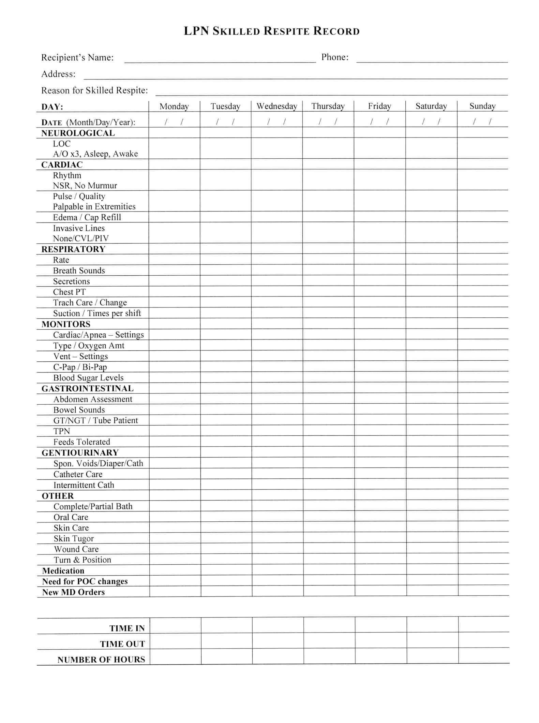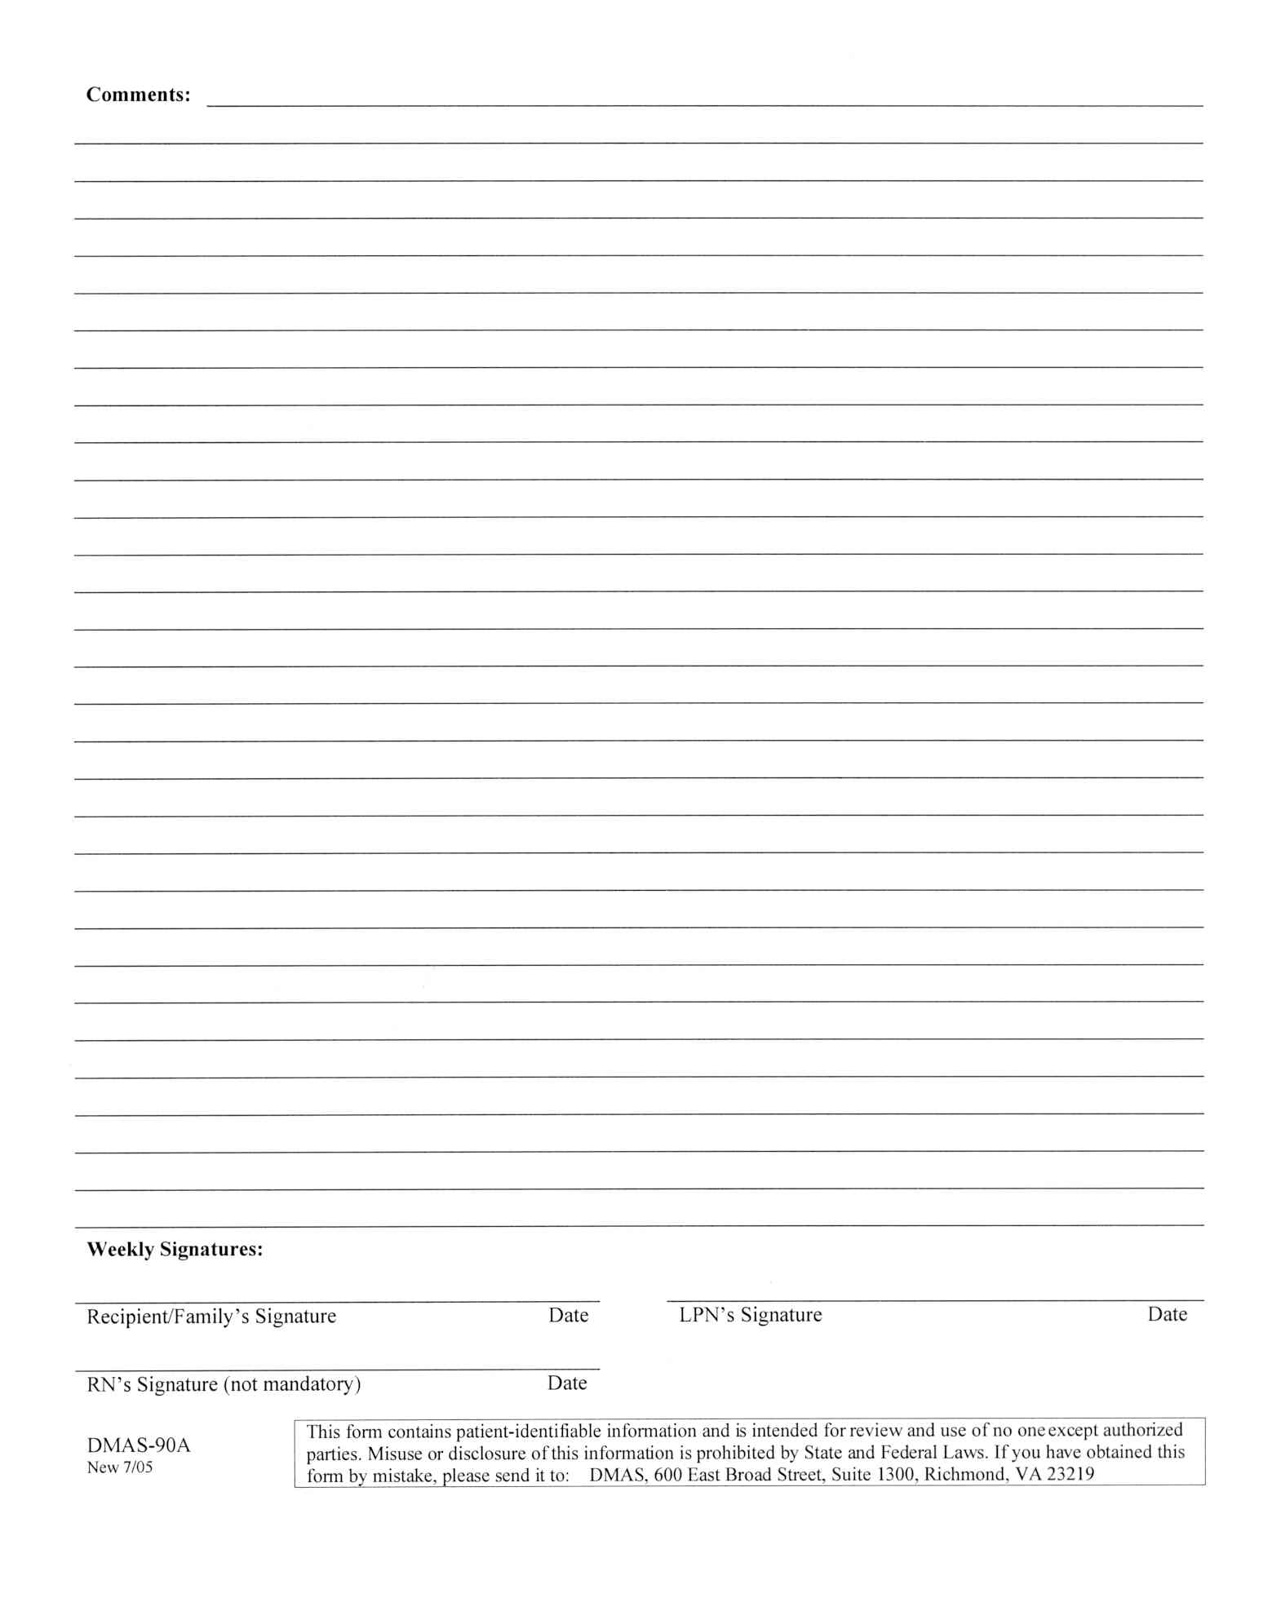
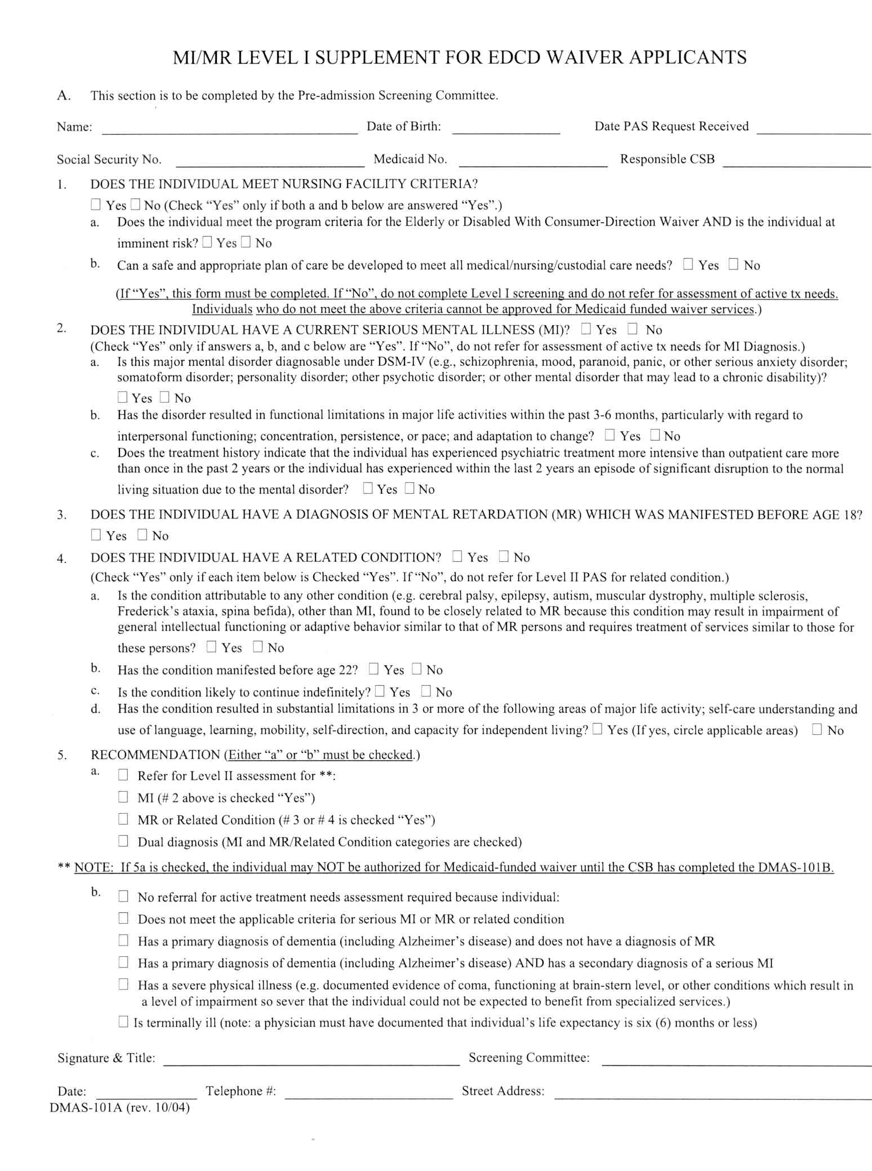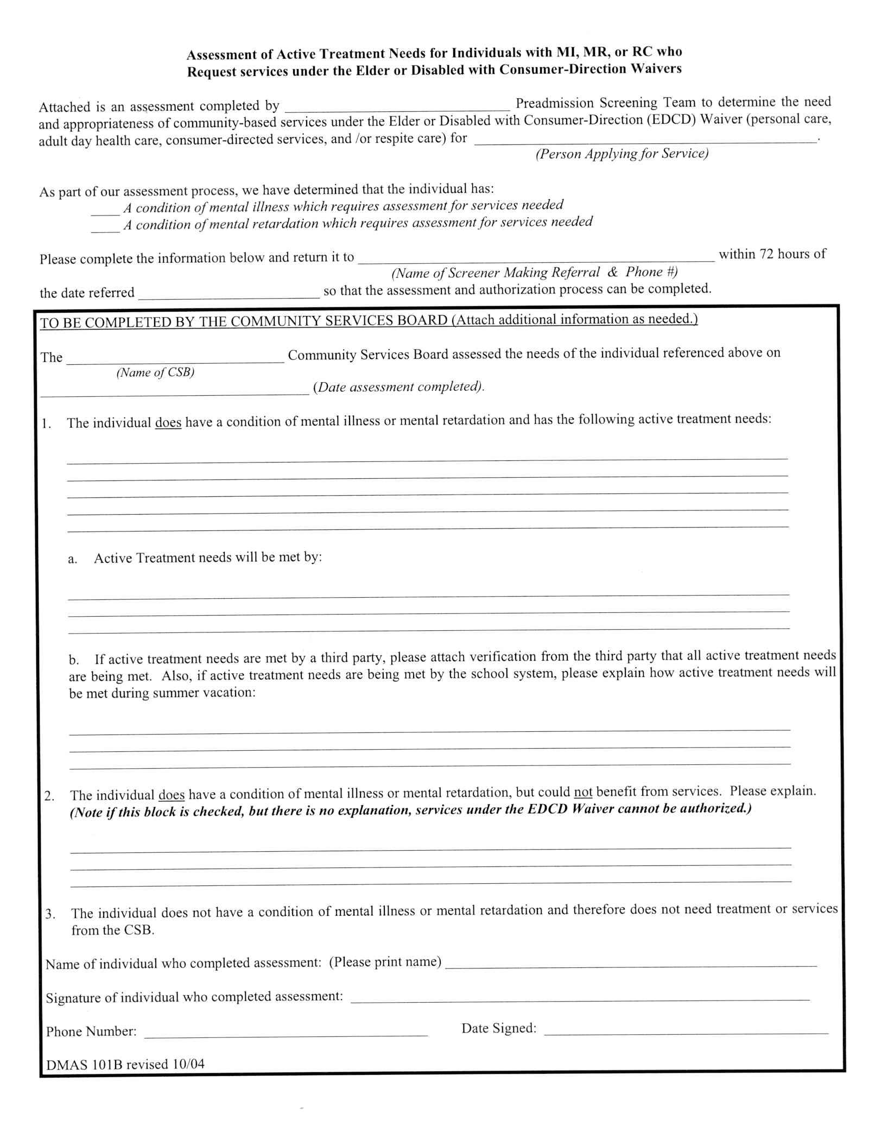
VA.R. Doc. No. R05-117; Filed December 20, 2005, 3:15 p.m.
⬥ –––––––––––––––––– 

