TITLE 14. INSURANCE
STATE CORPORATION COMMISSION
REGISTRAR'S NOTICE: The State Corporation Commission is exempt from the Administrative Process Act in accordance with § 2.2-4002 A 2 of the Code of Virginia, which exempts courts, any agency of the Supreme Court, and any agency that by the Constitution is expressly granted any of the powers of a court of record.
Title of Regulation: 14 VAC 5-30. Rules Governing Life Insurance and Annuity Replacements (amending 14 VAC 5-30-10 through 14 VAC 5-30-40, and 14 VAC 5-30-60 through 90; adding 14 VAC 5-30-51 and 14 VAC 5-30-55; repealing 14 VAC 5-30-50, 14 VAC 5-30-100 and Exhibit A).
Statutory Authority: §§ 12.1-13 and 38.2-223 of the Code of Virginia.
Public Hearing Date: N/A -- Public comments may be submitted until September 1, 2006.
Agency Contact: Jacqueline K. Cunningham, Deputy Director, State Corporation Commission, Life and Health Division, Bureau of Insurance, P.O. Box 1157, Richmond, VA 23218, telephone (804) 371-9074, FAX (804) 371-9944, or
e-mail chaps30_45comments@scc.virginia.gov.
Summary:
The proposed amendments add annuities to the products under the rules governing replacement, and for consistency with the most recent National Association of Insurance Commissioners (NAIC) "Life Insurance and Annuities Replacement Model Regulation." The procedural requirements for insurers and agents have been amended so that they are consistent with the NAIC Model. New forms are also attached to the revised rules.
AT RICHMOND, JUNE 5, 2006
COMMONWEALTH OF VIRGINIA
At the relation of the
STATE CORPORATION COMMISSION
Ex Parte: In the matter of CASE NO. INS-2006-00128
Adopting Revisions to the
Rules Governing Life
Insurance Replacements
ORDER TO TAKE NOTICE
Section 12.1-13 of the Code of Virginia provides that the State Corporation Commission ("Commission") shall have the power to promulgate rules and regulations in the enforcement and administration of all laws within its jurisdiction, and § 38.2-223 of the Code of Virginia provides that the Commission may issue any rules and regulations necessary or appropriate for the administration and enforcement of Title 38.2 of the Code of Virginia.
The rules and regulations issued by the Commission pursuant to § 38.2-223 of the Code of Virginia are set forth in Title 14 of the Virginia Administrative Code.
The Bureau of Insurance ("Bureau") has submitted to the Commission a proposal to revise and amend the "Rules Governing Life Insurance Replacements," which are set out at 14 VAC 5-30-10 through 14 VAC 5-30-100.
The revised and amended Rules adds annuities to the products under the Rules governing replacement and is consistent with the most recent National Association of Insurance Commissioners (NAIC) "Life Insurance and Annuities Replacement Model Regulation." The procedural requirements for insurers and agents have been amended so that they are consistent with the NAIC Model. Sections 50 and 100 are being repealed, and Sections 51 and 55 are being added. New forms are also attached to the Rules.
The Commission is of the opinion that the revised and amended Rules submitted by the Bureau of Insurance should be considered for adoption.
THEREFORE, IT IS ORDERED THAT:
(1) The revised and amended Rules entitled "Rules Governing Life Insurance and Annuity Replacements," which are set out at 14 VAC 5-30-10 through 14 VAC 5-30-100, be attached hereto and made a part hereof.
(2) All interested persons who desire to comment in support of or in opposition to, or to request a hearing to oppose the adoption of the revised and amended Rules shall file such comments or hearing request on or before September 1, 2006, in writing with the Clerk of the Commission, Document Control Center, P.O. Box 2118, Richmond, Virginia 23218 and shall refer to Case No. INS-2006-00128.
(3) The Bureau shall hold at least one meeting during the comment period, in order for interested parties to address questions about the Rules to the Bureau. The first meeting shall be held on July 11, 2006 at 9:00 a.m. in the Training Room located on the 3rd Floor of the State Corporation Commission, 1300 East Main Street, Richmond, Virginia, with subsequent meetings to be scheduled as necessary.
(4) If no request for a hearing on the adoption of the revised and amended Rules is filed on or before September 1, 2006, the Commission, upon consideration of any comments submitted in support of or in opposition to the revised and amended Rules, may adopt the Rules as revised and amended by the Bureau of Insurance.
(5) AN ATTESTED COPY hereof, together with a copy of the revised and amended Rules, shall be sent by the Clerk of the Commission to the Bureau of Insurance in care of Deputy Commissioner Jacqueline K. Cunningham, who forthwith shall give further notice of the adoption of the revised and amended Rules by mailing a copy of this Order, together with the revised and amended Rules, to all companies licensed by the Commission to write life insurance, variable life insurance, annuities, or variable annuities in Virginia.
(6) The Commission's Division of Information Resources forthwith shall cause a copy of this Order, together with the revised and amended Rules, to be forwarded to the Virginia Registrar of Regulations for appropriate publication in the Virginia Register of Regulations.
(7) On or before June 9, 2006, the Commission's Division of Information Resources shall make available this Order and the attached revised and amended Rules on the Commission's website, http://www.scc.virginia.gov/caseinfo.htm.
(8) The Bureau of Insurance shall file with the Clerk of the Commission an affidavit of compliance with the notice requirements of paragraph (5) above.
CHAPTER 30.
RULES GOVERNING LIFE INSURANCE AND ANNUITY REPLACEMENTS.
14 VAC 5-30-10. Purpose.
The purpose of this chapter (14 VAC 5-30-10 et seq.) is to regulate the activities of insurers and agents with respect to the replacement of existing life insurance and annuities and to protect the interests of life insurance policyholders and annuity purchasers by establishing minimum standards of conduct to be observed in the replacement or proposed replacement of existing life insurance financed purchase transactions.
14 VAC 5-30-20. Definitions.
The following words and terms when used in this chapter, should shall have the following meaning unless the context clearly indicates otherwise:
"Agent" means a person defined in § 38.2-1800 of the Code of Virginia.
"Commission" means the State Corporation Commission.
"Conservation" means any attempt by the existing insurer or its agent to discourage a policyowner from the replacement of existing life insurance. A conservation does not include routine administrative procedures such as late payment reminders or late payment or reinstatement offers.
"Direct response insurer" means an insurer that does not utilize an agent in the sale or delivery of the policy.
"Direct-response solicitation" means a solicitation through a sponsoring or endorsing entity or individually, made solely through mail, telephone, the Internet or other mass communication media.
"Existing insurer" means the insurer insurance company whose policy or contract is or is proposed to be replaced will be changed or affected in a manner described within the definition of "replacement."
"Existing life insurance" means any in-force life insurance, including life insurance under a binding or conditional receipt or within the unconditional refund period.
“Existing policy or contract” means an individual life insurance policy (policy) or annuity contract (contract) in force, including a policy under a binding or conditional receipt or a policy or contract that is within an unconditional refund period.
“Financed purchase” means the purchase of a new policy or contract involving the actual or intended use of funds obtained by the withdrawal or surrender of, or by borrowing from values of an existing policy or contract to pay all or part of any premium due on the new policy or contract. For purposes of a regulatory review of an individual transaction only, if a withdrawal, surrender or borrowing involving the policy values of an existing policy is used to pay premiums on a new policy owned by the same policyholder and issued by the same company within four months before or 13 months after the effective date of the new policy, it will be deemed prima facie evidence of the policyholder’s intent to finance the purchase of the new policy with existing policy values. This prima facie standard is not intended to increase or decrease the monitoring obligations contained in 14 VAC 5-30-60 A 5.
"Guaranteed elements" means the premiums, benefits, values, credits or charges under a policy of life insurance or an annuity contract that are guaranteed and determined at issue.
"Illustration" means a presentation or depiction that includes both guaranteed and nonguaranteed elements of a life insurance policy or an annuity contract over a period of years.
"Insurer" means any individual, corporation, association, partnership, reciprocal exchange, interinsurer, Lloyd's, fraternal benefit society, or any other legal entity defined as an "insurer" in the Code of Virginia insurance company required to be licensed under the laws of this Commonwealth.
"Marketing communication" means oral, printed, written, electronic, or other material of any type from any source which is used by an agent or insurer and which is designed to create or has the effect of creating public interest in life insurance or annuities, or in an insurer or agent, or induces or tends to induce the public to purchase, increase, modify, reinstate, borrow on, surrender, replace or retain a policy or contract including, but not limited to:
1. Printed or published material, audiovisual material, mailing envelopes, descriptive literature of an insurer or agent used in direct mail, newspapers, magazines, radio, Internet, telephone and television scripts, billboards or similar displays;
2. Descriptive literature and sales aids of all kinds, authored by the insurer, its agents, or third parties, issued, distributed, or used by an insurer or agent including but not limited to circulars, leaflets, booklets, depictions, illustrations, pictures, form letters, electronic solicitations, pamphlets, brochures, and books or portions thereof;
3. Materials, statements, or communications of any type used for the recruitment, training, and education of an insurer's sales personnel and agents which are designed to be used or are used to induce the public to purchase, increase, modify, reinstate, borrow on, surrender, replace, or retain a policy or contract; and
4. Prepared or extemporaneous sales talks, presentations, and material for use or used by sales personnel or agents.
"Marketing communication" for the purpose of this chapter does not include:
1. Communications or materials used within an insurer's own organization, not used as a sales aid, and not disseminated to the public;
2. Communications with policyholders policy or contract holders other than material urging them to purchase, increase, modify, reinstate, borrow on, surrender, replace, or retain a policy; or
3. A general announcement from a group or blanket policyholder to eligible individuals on an employment or membership list that a policy or program has been written or arranged; provided the announcement clearly indicates that it is preliminary to the issuance of a booklet explaining the proposed coverage.
"Nonguaranteed elements" means the premiums, benefits, values, credits, or charges under a life insurance policy or an annuity contract that are not guaranteed or not determined at issue.
"Policy summary" means:
1. For policies or contracts other than universal life policies, a written statement regarding a policy or contract that shall contain to the extent applicable, but need not be limited to, the following information: current death benefit; annual contract premium; current cash surrender value; current dividend; application of current dividend; and amount of outstanding loan.
2. For universal life policies, a written statement that shall contain at least the following information: the beginning and end date of the current report period; the policy value at the end of the previous report period and at the end of the current report period; the total amounts that have been credited or debited to the policy value during the current report period, identifying each by type (e.g., interest, mortality, expense and riders); the current death benefit at the end of the current report period on each life covered by the policy; the net cash surrender value of the policy as of the end of the current report period; and the amount of outstanding loans, if any, as of the end of the current report period.
"Replacing insurer" means the insurer insurance company that issues or is proposed proposes to issue a new policy or annuity contract that is a replacement of replaces an existing life insurance policy or contract or is a financed purchase.
"Registered contract" means a variable annuity contract or variable life insurance policy subject to the prospectus delivery requirements of the Securities Act of 1933 (15 USC § 77a et seq.).
"Replacement" means any a transaction in which a new life insurance or an annuity has been or policy or contract is to be purchased, and it is known or should be known to the proposing agent, or the proposing insurer if there is no agent is involved, knows or should know that because of such by reason of the transaction, an existing life insurance policy or contract has been or is to be:
1. Lapsed, forfeited, surrendered or partially surrendered, assigned to the replacing insurer, or otherwise terminated;
2. Changed Converted to reduced paid-up or extended term insurance, continued as extended term insurance, or otherwise reduced in value by the use of nonforfeiture benefits or other policy values;
3. Amended to effect either a reduction in benefits or in the term for which coverage would otherwise remain in force; or for which benefits would be paid;
4. Reissued with any reduction in cash value.;
5. Used in a financed purchase.
"Universal life policy" means a life insurance policy in which separately identified interest credits (other than in connection with dividend accumulation, premium deposit funds, or other supplementary accounts) and mortality and expense charges are made to the policy. A universal life policy may provide for other credits and charges, such as charges for the cost of benefits provided by the rider.
14 VAC 5-30-30. Exemptions.
A. Unless otherwise specifically included, this chapter (14 VAC 5-30-10 et seq.) shall not apply to:
1. Replacement of annuity contracts;
2. 1. Credit life insurance;
3. Life insurance issued in connection with a pension, profit-sharing, group, or other benefit plan qualifying for tax deductibility of premiums, provided that:
a. A portion or all of the premium is paid by someone other than the certificate holder, insured, or beneficiary;
b. No individual underwriting is required with respect to any proposed insurance policy, and
c. As to any plan otherwise qualifying for exemption by this subsection, full and complete disclosure of all material facts shall be provided the administrator of the plan subject to replacement.
4. Situations where the replacing insurer and the existing insurer are the same.
2. Group life insurance or group annuities where there is no direct solicitation of individuals by an agent. Direct solicitation shall not include any group meeting held by an agent solely for the purpose of educating or enrolling individuals or, when initiated by an individual member of the group, assisting with the selection of investment options offered by a single insurer in connection with enrolling that individual. Group life insurance or group annuity certificates marketed through direct response solicitation shall be subject to the provisions of 14 VAC 5-30-70;
3. Group life insurance and annuities used to fund prearranged funeral contracts;
4. An application to the existing insurer that issued the existing policy or contract when a contractual change or a conversion privilege is being exercised; or when the existing policy or contract is being replaced by the same insurer;
5. Proposed life insurance that is to replace life insurance under a binding or conditional receipt issued by the same company;
6. a. Policies or contracts used to fund (i) an employee pension or welfare benefit plan that is covered by the Employee Retirement Income Security Act (ERISA) (29 USC § 1001 et seq.); (ii) a plan described by 26 USC §§ 401(a), 401(k) or 403(b) of the Internal Revenue Code, where the plan, for purposes of ERISA, is established or maintained by an employer; (iii) a governmental or church plan defined in 26 USC § 414 of the Internal Revenue Code, a governmental or church welfare benefit plan, or a deferred compensation plan of a state or local government or tax-exempt organization under 26 USC § 457 of the Internal Revenue Code; or (iv) a nonqualified deferred compensation arrangement established or maintained by an employer or plan sponsor.
b. Notwithstanding subdivision a of this subsection, this chapter shall apply to policies or contracts used to fund any plan or arrangement that is funded solely by contributions an employee elects to make, whether on a pretax or after-tax basis, and where the insurer has been notified that plan participants may choose from among two or more insurers and there is a direct solicitation of an individual employee by an agent for the purchase of a policy or contract. As used in this subsection, direct solicitation shall not include any group meeting held by an agent solely for the purpose of educating individuals about the plan or arrangement or enrolling individuals in the plan or arrangement or, when initiated by an individual employee, assisting with the selection of investment options offered by a single insurer in connection with enrolling that individual employee;
7. Where new coverage is provided under a life insurance policy or contract and the cost is borne wholly by the insured’s employer or by an association of which the insured is a member;
8. Existing life insurance that is a nonconvertible term life insurance policy that will expire in five years or less and cannot be renewed;
9. Immediate annuities that are purchased with proceeds from an existing contract. Immediate annuities purchased with proceeds from an existing policy are not exempted from the requirements of this chapter;
10. Structured settlements.
B. Registered contracts shall be exempt from the requirements of 14 VAC 5-30-51 A 2 and 14 VAC 5-30-55 B with respect to the provision of illustrations or policy summaries; however, premium or contract contribution amounts and identification of the appropriate prospectus or offering circular shall be required instead.
14 VAC 5-30-40. Duties of agents.
A. Each An agent who initiates an application shall submit to the insurer to whom an application for life insurance is presented, with or as part of the application: , a statement signed by both the applicant and the agent as to whether the applicant has existing policies or contracts. If no policies or contracts are indicated, the agent's duties with respect to replacement are complete.
1. A statement signed by the applicant as to whether replacement of existing life insurance is involved in the transaction; and
2. A statement signed by the agent as to whether the agent knows replacement is or may be involved in the transaction.
B. Where a replacement is involved, the agent shall:
1. Present to the applicant, not later than at the time of taking the application, a replacement notice as described in Exhibit A or other substantially similar form approved by the Commission. The notice shall be signed by both the applicant and the agent and left with the applicant.
2. Obtain with or as part of each application a list of all existing life insurance to be replaced. Such existing life insurance shall be identified by name of insurer and policy number. If a policy number has not been assigned by the existing insurer, alternative identification, such as an application or receipt number, shall be listed.
3. Leave with the applicant the original or a copy of written or printed marketing communications used for presentation to the applicant.
4. Submit to the replacing insurer with the application a copy of the replacement notice provided pursuant to subdivision B1 of this section and a separate statement containing the information described in subdivision B2 of this section.
C. Each agent who uses a written or printed marketing communication in a conservation shall leave with the applicant the original or a copy of written or printed marketing communications used in the conservation.
B. If policies or contracts are listed indicating existing coverage referred to in subsection A of this section, the agent shall present and read to the applicant, not later than at the time of taking the application, a notice regarding replacements (Form 30-A) or other substantially similar form approved by the commission. However, no approval shall be required when amendments to the notice are limited to the omission of references not applicable to the product being sold or replaced. The notice shall be signed by both the applicant and the agent, attesting that the notice has been read aloud by the agent or that the applicant did not wish the notice to be read aloud (in which case the agent need not have read the notice aloud). The notice shall be left with the applicant.
C. The notice shall list all life insurance policies or annuities proposed to be replaced, properly identified by name of insurer, the insured or annuitant, and policy or contract number if available; and shall include a statement as to whether each policy or contract will be replaced or whether a policy will be used as a source of financing for the new policy or contract. If a policy or contract number has not been issued by the existing insurer, alternative identification, such as an application or receipt number, shall be listed.
D. In connection with a replacement transaction, the agent shall leave with the applicant, at the time an application for a new policy or contract is completed, the original or a copy of all marketing communications. Electronically presented marketing communications shall be provided to the policy or contract owner in printed form no later than at the time of policy or contract delivery.
E. Except as provided in 14 VAC 5-30-51 C, in connection with a replacement transaction, the agent shall submit to the insurer to which an application for a policy or contract is presented, a copy of each document required by this section, a statement identifying any preprinted or electronically presented company-approved marketing communications used, and copies of any individualized marketing communications, including any illustrations related to the specific policy or contract purchased.
14 VAC 5-30-50. Duties of all insurers. (Repealed.)
Each insurer shall:
1. Inform its agents or other personnel responsible for compliance with this chapter of the requirements of this chapter (14 VAC 5-30-10 et seq.).
2. Require with or as a part of each completed application for life insurance or annuity a statement signed by the applicant as to whether such proposed insurance or annuity will replace existing life insurance.
14 VAC 5-30-51. Duties of replacing insurers that use agents.
A. Where a replacement is involved in the transaction, the replacing insurer shall:
1. Verify that the required forms are received and are in compliance with this chapter;
2. Notify any other existing insurer that may be affected by the proposed replacement within five business days of receipt of a completed application indicating replacement or when the replacement is identified, if not indicated on the application, and mail a copy of the available illustration or policy summary for the proposed policy or available disclosure document for the proposed contract within five business days of a request from an existing insurer;
3. Be able to produce copies of the notification regarding replacement required in 14 VAC 5-30-40 B, indexed by agent, for at least five years; and
4. Provide to the policy or contract owner notice of the right to examine the policy or contract for at least 10 days from the delivery of the policy or contract and the right of return to receive an unconditional full refund of all premiums or considerations paid on it, including any policy fees or charges or, in the case of a variable or market value adjustment contract, a payment of the cash surrender value provided under the contract plus the fees and other charges deducted from the gross premiums or considerations or imposed under the contract. The notice may be included in Form 30-A or 30-C.
B. In transactions where the replacing insurer and the existing insurer are the same or subsidiaries or affiliates under common ownership or control, credit shall be allowed for the period of time that has elapsed under the replaced policy’s or contract’s incontestability and suicide period up to the face value of the existing policy or contract. With regard to financed purchases, the credit may be limited to the amount the face value of the existing policy is reduced by the use of existing policy values to fund the new policy or contract.
C. If an insurer prohibits the use of marketing communication other than that approved by the company, as an alternative to the requirements made of an insurer pursuant to 14 VAC 5-30-40 E, the insurer may:
1. Require with each application a statement signed by the agent that:
a. Represents that the agent used only company-approved marketing communications; and
b. States that copies of all marketing communications were left with the applicant in accordance with 14 VAC 5-30-40 D; and
2. Within 10 days of the issuance of the policy or contract:
a. Notify the applicant by sending a letter or by verbal communication with the applicant by a person whose duties are separate from the marketing area of the insurer, that the agent has represented that copies of all marketing communications have been left with the applicant in accordance with 14 VAC 5-30-40 D;
b. Provide the applicant with a toll-free number to contact company personnel involved in the compliance function if compliance did not occur;
c. Stress the importance of retaining copies of the marketing communications for future reference; and
3. Be able to produce a copy of the letter or other verification in the policy file for at least five years after the termination or expiration of the policy or contract.
14 VAC 5-30-55. Duties of the existing insurer.
A. Where a replacement is involved in the transaction, the existing insurer shall retain and be able to produce all replacement notifications received, indexed by replacing insurer, for at least five years.
B. Where a replacement is involved in the transaction, the existing insurer shall send a letter to the policy or contract owner advising of the right to receive information regarding the existing policy or contract values including, if available, an illustration, or policy summary if an illustration cannot be produced within five business days of receipt of a notice that an existing policy or contract is being replaced. The information shall be provided within five business days of receipt of the request from the policy or contract owner.
C. Where a replacement is involved in the transaction and upon receipt of a request to borrow, surrender or withdraw any policy or contract values, the existing insurer shall send a notice, advising the policy or contract owner that the release of policy or contract values may affect the guaranteed elements, nonguaranteed elements, face amount or surrender value of the policy or contract from which the values are released. The notice shall be sent separate from the check if the check is sent to anyone other than the policy or contract owner. In the case of consecutive automatic premium loans, the insurer is only required to send the notice at the time of the first loan.
14 VAC 5-30-60. Duties of insurers that use agents.
A. Each insurer that uses an agent in a life insurance or annuity sale shall maintain a system of supervision and control to insure compliance with the requirements of this chapter that shall include at least the following:
1. Require with or as part of each completed application for life insurance or annuity, a statement signed by the agent as to whether he or she knows replacement is or may be involved in the transaction.
2. Where a replacement is involved:
a. Require from the agent with the application for life insurance or annuity (i) a list of all of the applicant's existing life insurance to be replaced and (ii) a copy of the replacement notice provided the applicant pursuant to subdivision B1 of 14 VAC 5-30-40. Such existing life insurance shall be identified by name of insurer and policy number. If a policy number has not been assigned by the existing insurer, alternative identification, such as an application or receipt number, shall be listed.
b. Send to the existing insurer a written communication advising of the replacement or proposed replacement and including the name of the insured and the identification information with respect to the existing life insurance to be replaced that it obtained pursuant to subdivision 2a of this section. This written communication shall be made within three working days of the date the application is received in the replacing insurer's home or regional office, or the date the proposed policy is issued, whichever is sooner.
1. Inform its agents of the requirements of this chapter and incorporate the requirements of this chapter into all relevant agent training manuals prepared by the insurer;
2. Provide to each agent a written statement of the company’s position with respect to the acceptability of replacements providing guidance to its agents as to the appropriateness of these transactions;
3. A system to review the appropriateness of each replacement transaction that the agent does not indicate is in accord with subdivision A 2 of this section;
4. Procedures to confirm that the requirements of this chapter have been met; and
5. Procedures to detect transactions that are replacements of existing policies or contracts by the existing insurer, but that have not been reported by the applicant or agent. Compliance with this chapter may include, but shall not be limited to, systematic customer surveys, interviews, confirmation letters, or programs of internal monitoring.
B. Each insurer shall have the capacity to monitor each agent’s life insurance policy and annuity contract replacements for that insurer, and shall produce, upon request, and make such records available to the commission. The capacity to monitor shall include the ability to produce records for each agent’s:
1. Life replacements, including financed purchases, as a percentage of the agent’s total annual sales for life insurance;
2. Number of lapses of policies by the agent as a percentage of the agent’s total annual sales for life insurance;
3. Annuity contract replacements as a percentage of the agent’s total annual annuity contract sales;
4. Number of transactions that are unreported replacements of existing policies or contracts by the existing insurer detected by the company’s monitoring system as required by subdivision A 5 of this section; and
5. Replacements, indexed by replacing agent and existing insurer.
C. Each insurer shall require with or as a part of each application for life insurance or an annuity a signed statement by both the applicant and the agent as to whether the applicant has existing policies or contracts.
D. Each insurer shall require a completed notice regarding replacements (Form 30-A) with each application for life insurance or an annuity that indicates an existing policy or contract.
E. When the applicant has existing policies or contracts, each insurer shall be able to produce copies of any marketing communication required by 14 VAC 5-30-40 E, the illustrations related to the specific policy or contract that is purchased, and the agent’s and applicant’s signed statements with respect to financing and replacement for at least five years after the termination or expiration of the proposed policy or contract.
F. Each insurer shall ascertain that the marketing communication and illustrations required by 14 VAC 5-30-40 E meet the requirements of this chapter and are complete and accurate for the proposed policy or contract.
G. If an application does not meet the requirements of this chapter, each insurer shall notify the agent and applicant and fulfill the outstanding requirements.
H. Each insurer shall maintain records in paper, photograph, microprocess, magnetic, mechanical or electronic media, or by any process that accurately reproduces the actual document.
14 VAC 5-30-70. Duties of replacing insurers that are with respect to direct response insurers solicitations.
Each replacing insurer that is a direct response insurer shall:
1. If the insurer did not propose the replacement, send to the applicant with the policy a replacement notice as described in Exhibit A or other substantially similar form approved by the Commission.
A. In the case of an application that is initiated as a result of a direct response solicitation, the insurer shall require, with or as part of each completed application for a policy or contract, a statement asking whether the applicant, by applying for the proposed policy or contract, intends to replace, discontinue or change an existing policy or contract. If the applicant indicates a replacement or change is not intended or if the applicant fails to respond to the statement, the insurer shall send the applicant, with the policy or contract, a notice regarding replacement (Form 30-B), or other substantially similar form approved by the commission.
2. B. If the insurer has proposed the replacement or if the applicant indicates a replacement is intended and the insurer continues with the replacement, the insurer shall:
a. Provide to applicants or prospective applicants with or as a part of the application a replacement notice as described in Exhibit A or other substantially similar form approved by the Commission.
b. Request from the applicant with or as a part of the application, a list of all existing life insurance to be replaced. Such existing life insurance shall be identified by name of insurer.
c. Comply with the requirements of subdivision 2b of 14 VAC 5-30-60 if the applicant furnishes the names of the existing insurers.
1. Provide to the applicant or prospective applicant with the policy or contract a notice (Form 30-C), or other substantially similar form approved by the commission. In these instances the insurer may delete the references to the agent, including the agent’s signature, and references not applicable to the product being sold or replaced, without having to obtain approval of the form from the commission. The insurer’s obligation to obtain the applicant’s signature shall be satisfied if it can demonstrate that it has made a diligent effort to secure a signed copy of this notice. The requirement to make a diligent effort shall be deemed satisfied if the insurer includes in the mailing a self-addressed postage prepaid envelope with instructions for the return of the signed notice; and
2. Comply with the requirements of 14 VAC 5-30-51 A 2, if the applicant furnishes the names of the existing insurers, and the requirements of 14 VAC 5-30-51 A 3, A 4 and B.
14 VAC 5-30-80. Penalties.
A. Any An insurer, agent, representative, officer, or employee of an insurer failing to comply with the requirements of this chapter (14 VAC 5-30-10 et seq.) shall be subject to such penalties as may be appropriate under the insurance laws of Virginia.
B. This chapter (14 VAC 5-30-10 et seq.) does not prohibit the use of additional material other than that which is required that is not in violation of this chapter (14 VAC 5-30-10 et seq.) or any other Virginia statute or regulation.
C. Policyowners B. Policy and contract owners have the right to replace existing life insurance policies or contracts after indicating in or as part of the application for life insurance or annuity new coverage that such replacement is not their intention. However, patterns of such action by policyowners policy or contract owners who purchase the replacing policies from the same agent shall be deemed prima facie evidence of the agent's knowledge that replacement was intended in connection with the sale of those policies identified transactions, and such these patterns of action shall be deemed prima facie evidence of the agent's intent to violate this chapter (14 VAC 5-30-10 et seq.).
C. Where it is determined that the requirements of this chapter have not been met, the replacing insurer shall provide to the policyowner an in-force illustration if available, or policy summary for the replacement policy or available disclosure document for the replacement contract and the appropriate notice regarding replacements (Form 30-A or 30-C).
14 VAC 5-30-90. Severability.
If any section or portion of a section provision of this chapter (14 VAC 5-30-10 et seq.), or the applicability thereof its application to any person or circumstance, is for any reason held to be invalid by a court, the remainder of this chapter (14 VAC 5-30-10 et seq.), or and the applicability application of such provision the provisions to other persons, or circumstances shall not be affected thereby.
14 VAC 5-30-100. Relationship to other rules and regulations. (Repealed.)
If any portion of this chapter (14 VAC 5-30-10 et seq.) is inconsistent with any provision of any other regulation dealing with life insurance or annuity marketing practices or disclosure, said inconsistent portion shall be interpreted to be consistent with such other regulations.
EXHIBIT A.
REPLACING YOUR LIFE INSURANCE POLICY?
Are you thinking about buying a new policy and discontinuing or changing an existing policy? If you are, your decision could be a good one or a mistake. You will not know for sure unless you make a careful comparison of your existing policy and the proposed policy.
Make sure you understand the facts. You should ask the company or agent that sold you your existing policy to give you information about it.
Hear both sides before you decide. This way you can be sure you are making a decision that is in your best interest.
We are required by Virginia law to notify your existing company that you may be replacing their policy.
Applicant's Signature
Date
Agent's Signature
FORMS
NOTICE: The forms used in administering 14 VAC 5-30, Rules Governing Life Insurance and Annuity Replacements are listed below. Any amended or added forms are reflected in the listing and are published following the listing.
Form 30-A, Important Notice: Replacement of Life Insurance or Annuities (agent) (eff. 7/06).
Form 30-B, Notice Regarding Replacement (eff. 7/06).
Form 30-C, Important Notice: Replacement of Life Insurance or Annuities (no agent) (eff. 7/06).

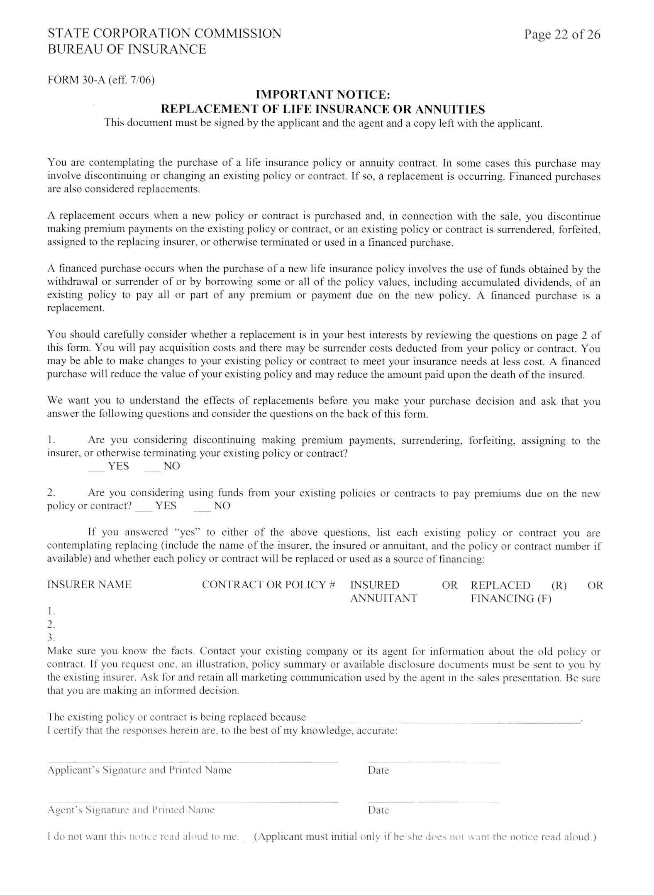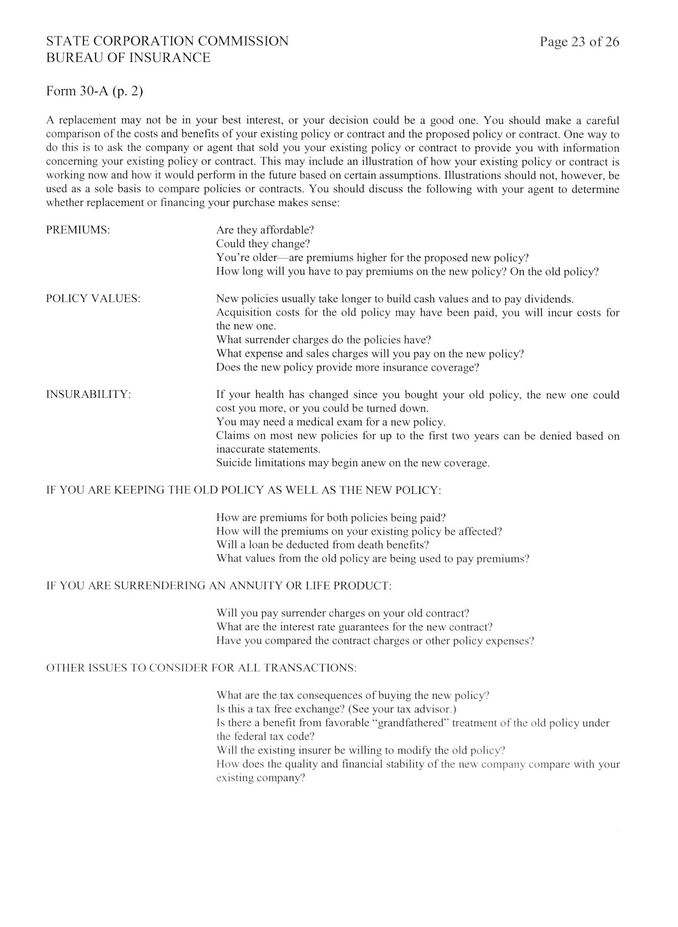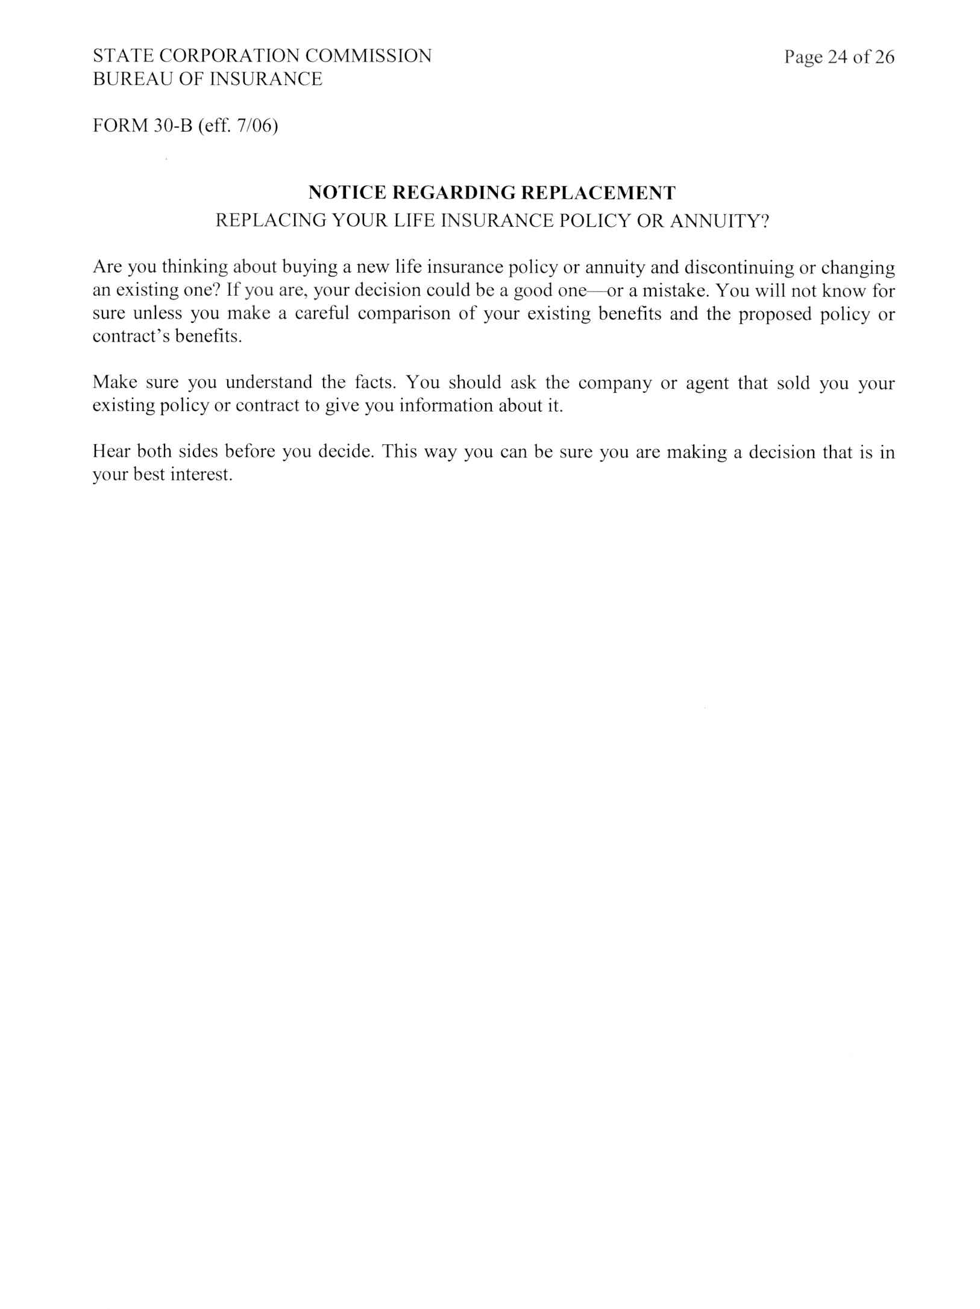
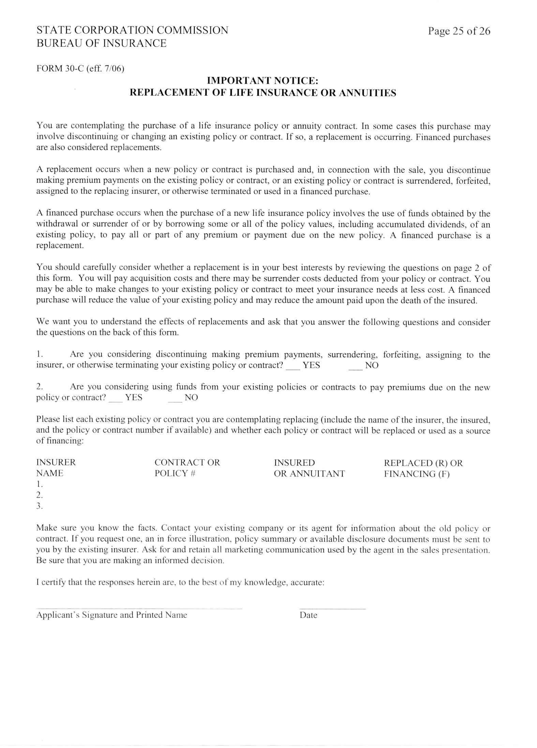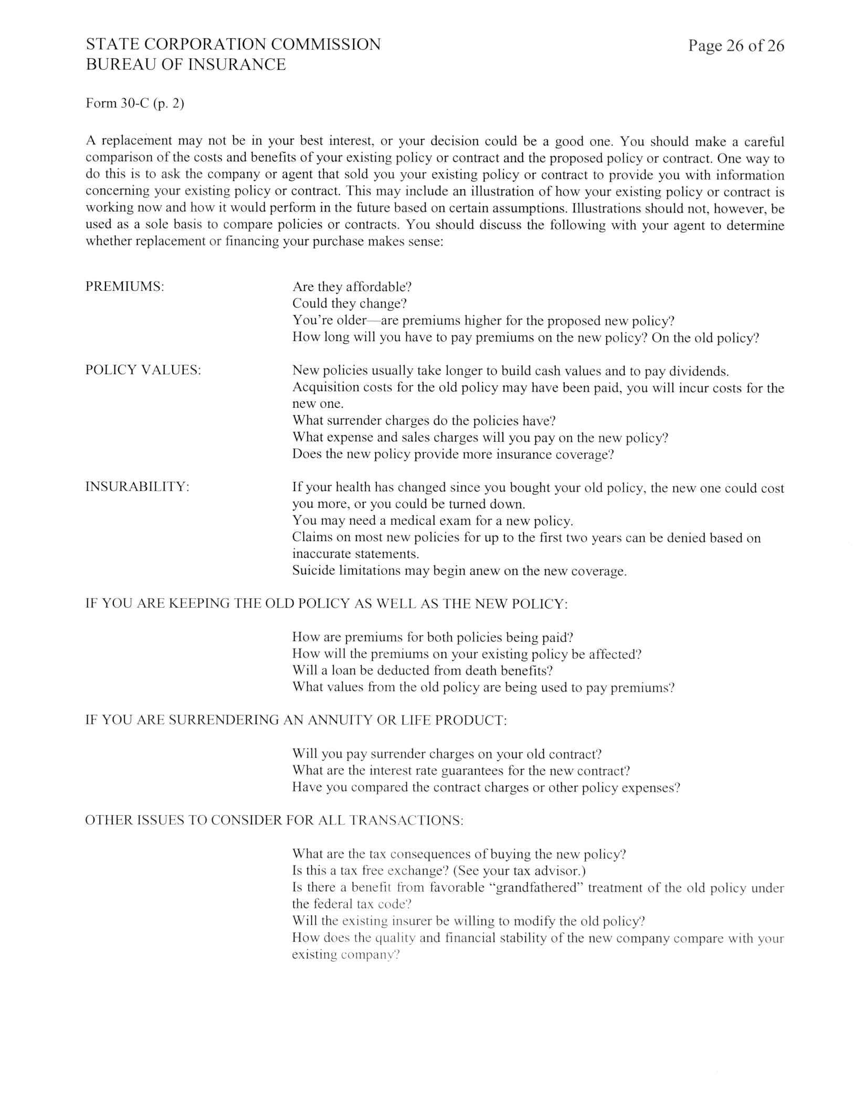
VA.R. Doc. No. R06-262; Filed June 6, 2006, 4:40 p.m.

