TITLE 2. AGRICULTURE
BOARD OF AGRICULTURE AND CONSUMER SERVICES
REGISTRAR'S NOTICE: The following regulatory action is exempt from the Administrative Process Act in accordance with § 2.2-4002 A 13 of the Code of Virginia, which excludes the Commissioner of Agriculture and Consumer Services and the Board of Agriculture and Consumer Services in promulgating regulations pursuant to § 3.1-884.21:1, which includes (i) any regulation under the federal acts as it pertains to this article, amending it as necessary for intrastate applicability and (ii) any regulation containing provisions no less stringent than those contained in federal regulation. The Board of Agriculture and Consumer Services will receive, consider and respond to petitions by any interested person at any time with respect to reconsideration or revision.
Title of Regulation: 2 VAC 5-210. Rules and Regulations Pertaining to Meat and Poultry Inspection Under the Virginia Meat and Poultry Products Inspection Act (amending 2 VAC 5-210-10, 2 VAC 5-210-20, 2 VAC 5-210-30 and 2 VAC 5-210-60; adding 2 VAC 5-210-41; repealing 2 VAC 5-210-40 and 2 VAC 5-210-50).
Statutory Authority: § 3.1-884.21:1 of the Code of Virginia.
Effective Date: July 19, 2006.
Agency Contact: Richard Hackenbracht, DVM, Program Manager, Department of Agriculture and Consumer Services, Office of Meat and Poultry Services, P.O. Box 1163, Richmond, VA 23218, telephone (804) 786-4569, FAX (804) 786-1003, or richard.hackenbracht@vdacs.virginia.gov.
Summary:
The amendments provide (i) requirements for additives used in the preparation and processing of meat and poultry products, (ii) requirements for producers of ready-to-eat products to address the pathogen Listeria monocytogenes, (iii) requirements for labeling products that have added solutions due to processing procedures, and (iv) requirements for providing due process to inspected establishments in the event that regulatory control action is taken.
Forms used by the Office of Meat and Poultry Services have been updated to reflect changes in the office’s name and to clarify the information requested in the forms.
2 VAC 5-210-10. Adoption by reference.
The following rules and regulations governing the meat and poultry inspection of the United States Department of Agriculture specified in this part, as contained in Title 9, Chapter III, Subchapters A, B and C, and E, CFR, dated January 1, 1997 2006, with amendments and with administrative changes therein as needed to make them appropriate and applicable to intrastate operations and transactions subject to the Virginia Meat and Poultry Products Inspection Act, are hereby adopted by reference.
2 VAC 5-210-20. Definitions.
The following words and terms, when used in this part, shall have the following meaning, meanings unless the context clearly indicates otherwise:
"Act" means the Virginia Meat and Poultry Products Inspection Act (§ 3.1-884.17 et seq. of the Code of Virginia).
"Administrator" means the Director of the Division of Consumer Protection Animal and Food Industry Services, or any other officer or employee of the department to whom authority has heretofore been delegated or may hereafter be delegated to act in his stead.
"Commerce" means commerce within the Commonwealth of Virginia.
"Department" means the Virginia Department of Agriculture and Consumer Services.
"Federal" means "Virginia."
"Federally inspected and passed" means Virginia inspected and passed.
"Interstate" means intrastate.
"Program" means the Office of Meat and Poultry Services, Virginia Department of Agriculture and Consumer Services.
"Secretary" means the Commissioner of Agriculture and Consumer Services.
"Food Safety Inspection Service" means the Virginia meat and poultry inspection program.
"United States" or "U.S." means "Virginia."
"U.S. Brands and Legends" means "Virginia Brands and Legends."
2 VAC 5-210-30. Mandatory meat inspection and poultry products inspection and voluntary inspection and certification.
Subchapter A - Mandatory meat inspection Agency organization and terminology; mandatory meat and poultry products inspection and voluntary inspection and certification.
Part 302. Application of inspection and other requirements.
Part 303. Exemptions.
Any establishment, firm, person or corporation operating under Section 303.1(a)(2) of this subchapter is required to apply for and receive a permit of exemption in accordance with requirements set forth by the Commissioner of Agriculture and Consumer Services or his delegate.
Part 304. Application for inspection; grant or refusal of inspection.
Part 305. Official numbers; inauguration of inspection; withdrawal of inspection; reports of violation.
Part 306. Assignment and authorities of program employees.
Part 307. Facilities for inspection.
Part 308. Sanitation.
Part 309. Ante-mortem inspection.
Part 310. Post-mortem inspection.
Part 311. Disposal of diseased or otherwise adulterated carcasses and parts.
Part 312. Official marks, devices and certificates.
Part 313. Humane slaughter of livestock.
Part 314. Handling and disposal of condemned or other inedible products at official establishments.
Part 315. Rendering or other disposal of carcasses and parts passed for cooking.
Part 316. Marking products and their containers.
Part 317. Labeling, marking devices, and containers.
Part 318. Entry into official establishments; reinspection and preparation of products.
Part 319. Definitions and standards of identity or composition.
Part 320. Records, registration, and reports.
Part 325. Transportation.
Part 329. Detention; seizure and condemnation; criminal offenses.
Part 335. Rules of practice governing proceedings under the federal Meat Inspection Act.
2 VAC 5-210-40. Adopted inspection and certification standards.
Subchapter B - Voluntary inspection and certification service.
Part 350. Special services relating to meat and other products.
Part 352. Exotic animals; voluntary inspection.
Part 354. Voluntary inspection of rabbits and edible products thereof.
Part 355. Certified products for dogs, cats, and other carnivora; inspection, certification, and identification as to class, quality, quantity, and condition.
Part 362. Voluntary poultry inspection regulations.
2 VAC 5-210-50. Adopted poultry inspection standards.
Subchapter C - Mandatory poultry products inspection.
Part 381. Poultry products inspection regulations.
Subpart B. Administration; application of inspection and other requirements. Deleting Section 381.5-Publications.
Subpart C. Exemptions.
Subpart D. Application for inspection; grant or refusal of inspection.
Subpart E. Inauguration of inspection; official establishment numbers; separation of establishments and other requirements; withdrawal of inspection.
Subpart F. Assignment and authorities of program employees; appeals.
Subpart G. Facilities for inspection; overtime and holiday service; billing establishments.
Subpart H. Sanitation.
Subpart I. Operating procedures.
Subpart J. Ante-mortem inspection.
Subpart K. Post-mortem inspection; disposition of carcasses and parts.
Subpart L. Handling and disposal of condemned or other inedible products at official establishments.
Subpart M. Official marks, devices, and certificates; export certificates; certification procedures.
Except as otherwise required in this subchapter all referrals and instructions relative to export or import are deleted from adoption.
Subpart N. Labeling and containers.
Subpart O. Entry of articles into official establishments; processing inspection and other reinspections; processing requirements.
Subpart P. Definitions and standards of identity or
Subpart Q. Records, registration, and reports. composition.
Subpart S. Transportation; exportation; or sale of poultry or poultry products.
Subpart U. Detention; seizure and condemnation; criminal offenses.
Subpart W. Rules of practice governing proceedings under the Poultry Products Inspection Act.
Subpart X. Canning and canned products.
Subpart Y. Nutrition labeling.
Part 416. Sanitation.
Part 417. Hazard Analysis and Critical Control Point (HACCP) Systems.
2 VAC 5-210-41. Regulatory requirements.
Subchapter E - Regulatory requirements under the federal Meat Inspection Act and the Poultry Products Inspection Act.
Part 424. Preparation and processing operations.
Part 430. Requirements for specific classes of product.
Part 441. Consumer protection standards: raw products.
Part 500. Rules of practice.
2 VAC 5-210-60. Hourly charge.
In setting the hourly charge to be made by the Virginia Bureau Office of Meat and Poultry Inspection Services, the Department of Agriculture and Consumer Services may charge for voluntary, overtime, and holiday inspection, and administrative costs associated therewith. The amount charged will be sufficient to pay: (i) the salaries and benefits of inspection personnel providing voluntary, overtime, and holiday inspection services; and (ii) that portion of the salaries and benefits of any other employee or employees attributable to administrative services associated with voluntary, overtime, or holiday inspection.
NOTICE: The forms used in administering 2 VAC 5-210, Rules and Regulations Pertaining to Meat and Poultry Inspection Under the Virginia Meat and Poultry Products Inspection Act, are listed below. Any amended or added forms are reflected in the listing and are published following the listing.
FORMS
Application for Permit of Exemption Under the Virginia Meat and Poultry Productions Products Inspection Act, Form VDACS-03072, eff. 2/93 4/06.
Application for State Meat and Poultry Inspection, Form VDACS-03090, eff. 5/94 2/06.
Regular and Overtime Work Hours Agreement, Form VDACS-03091, eff. 2/93 12/96.
Application/Approval for Voluntary Reimbursable Inspection Service, Form VDACS-03140, eff. 2/93 6/06.

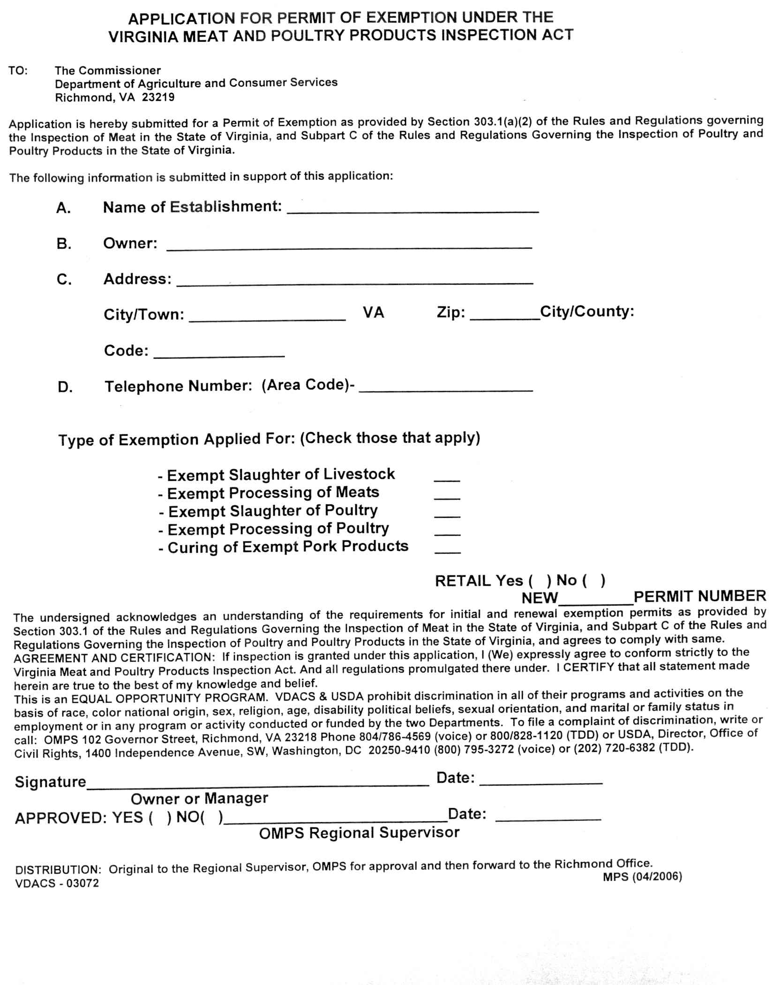
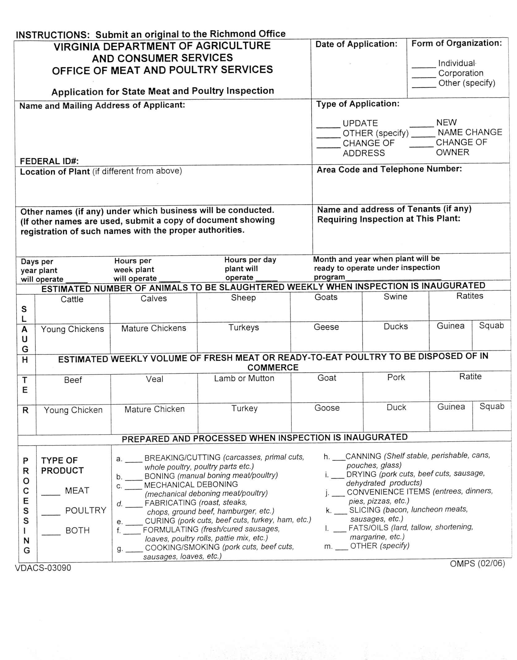
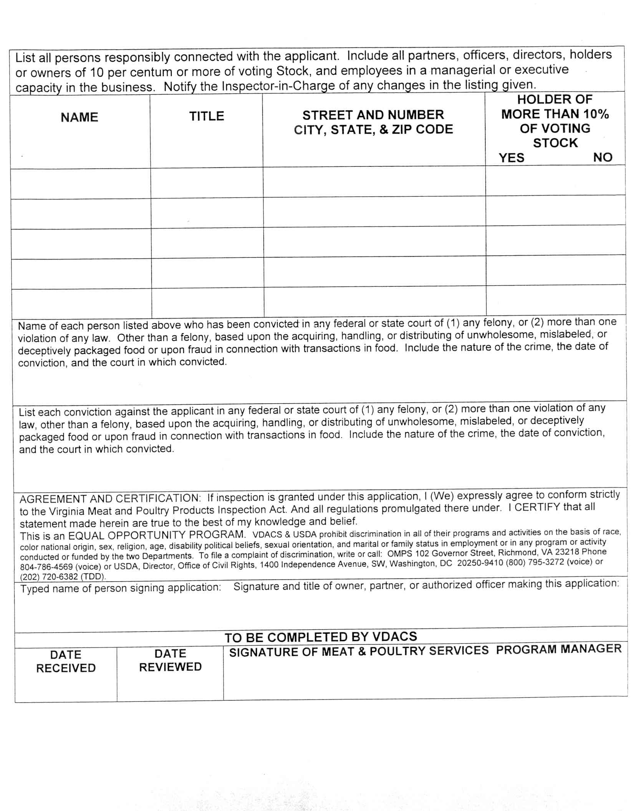
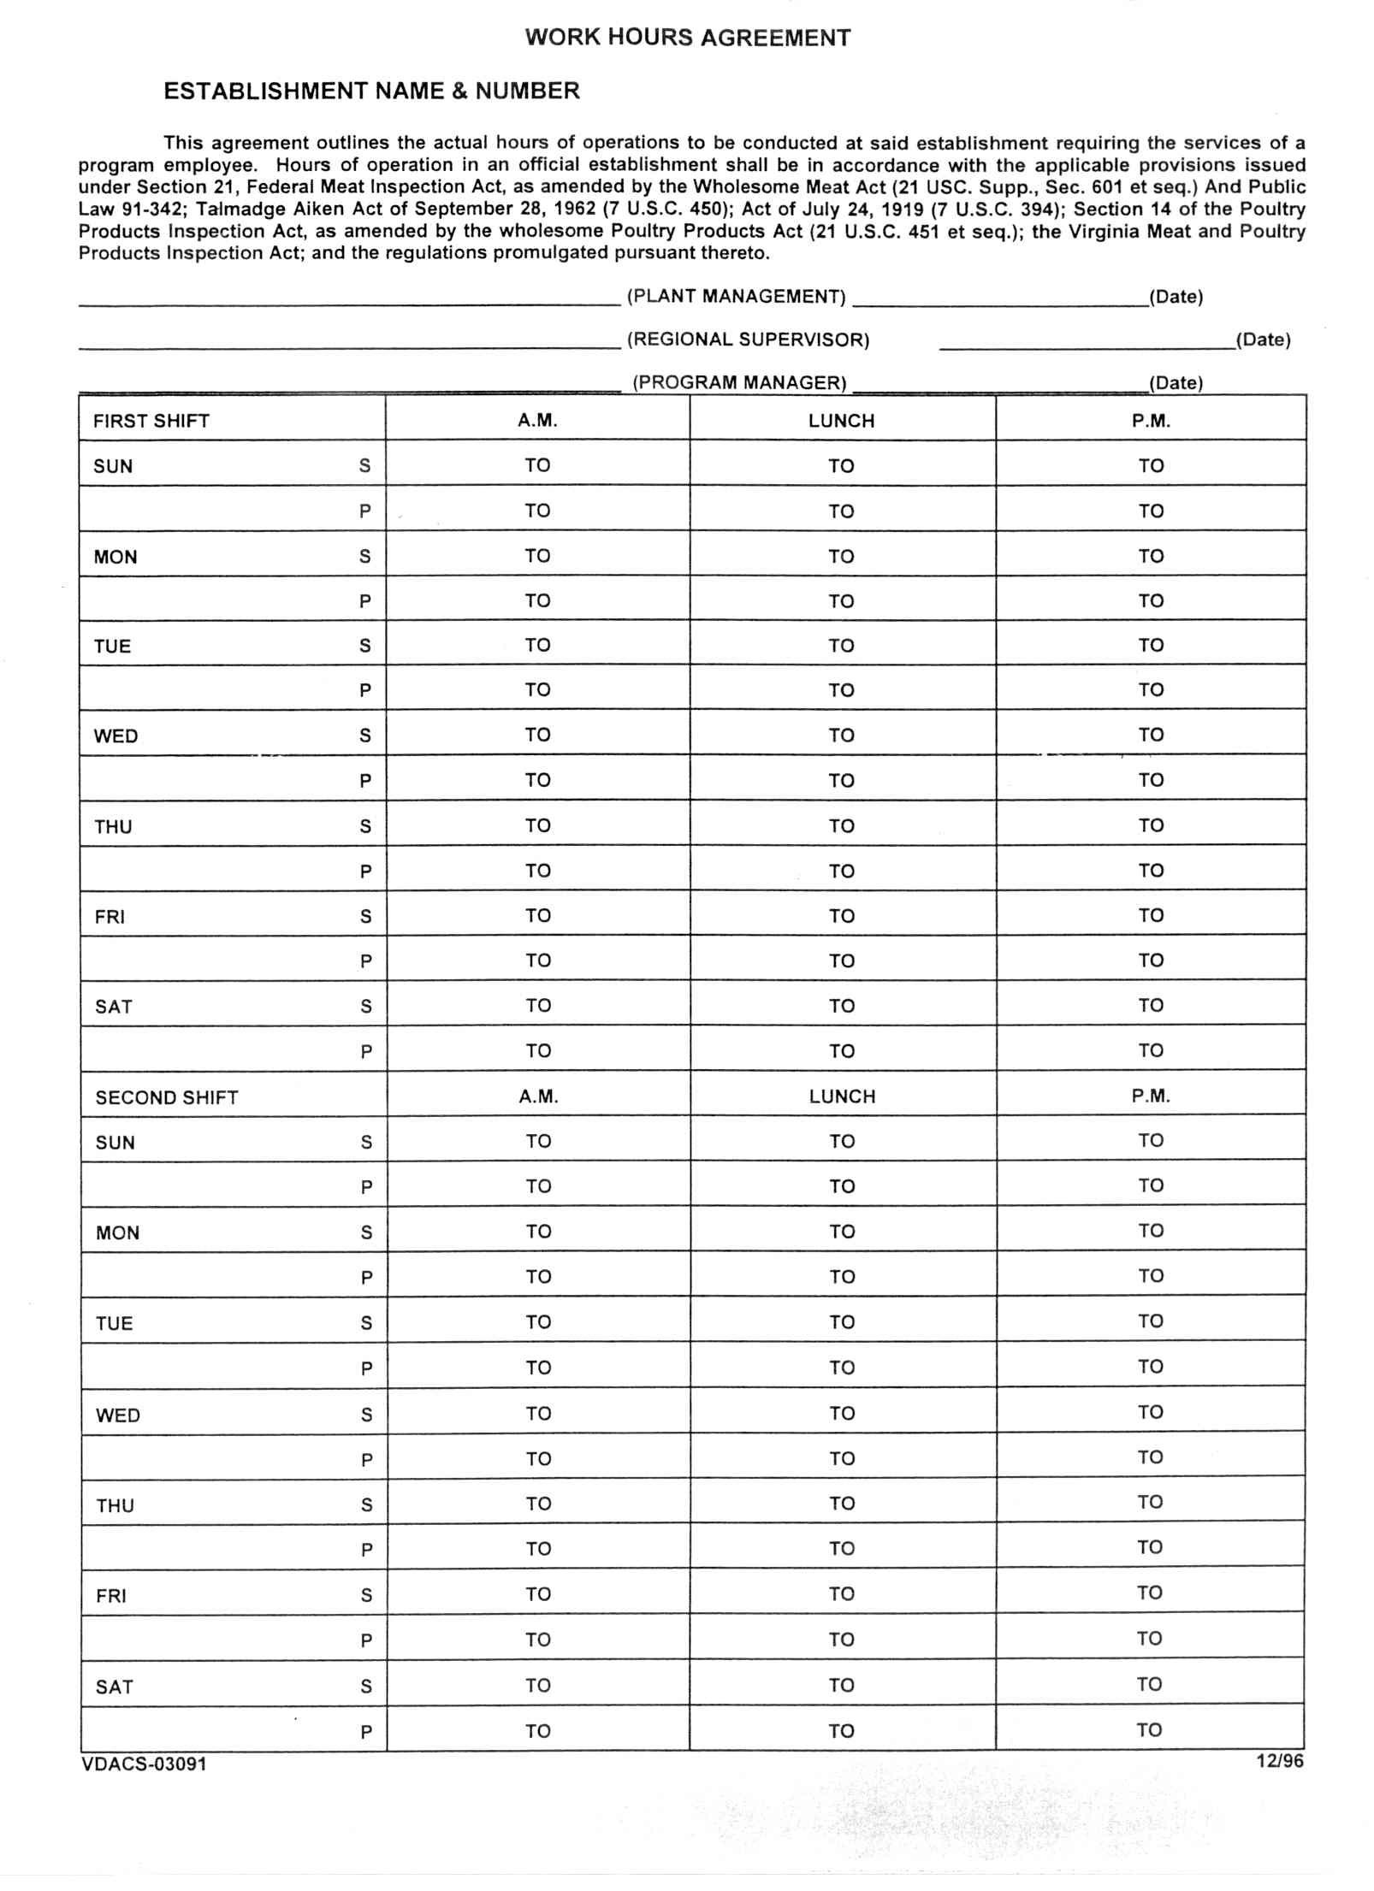
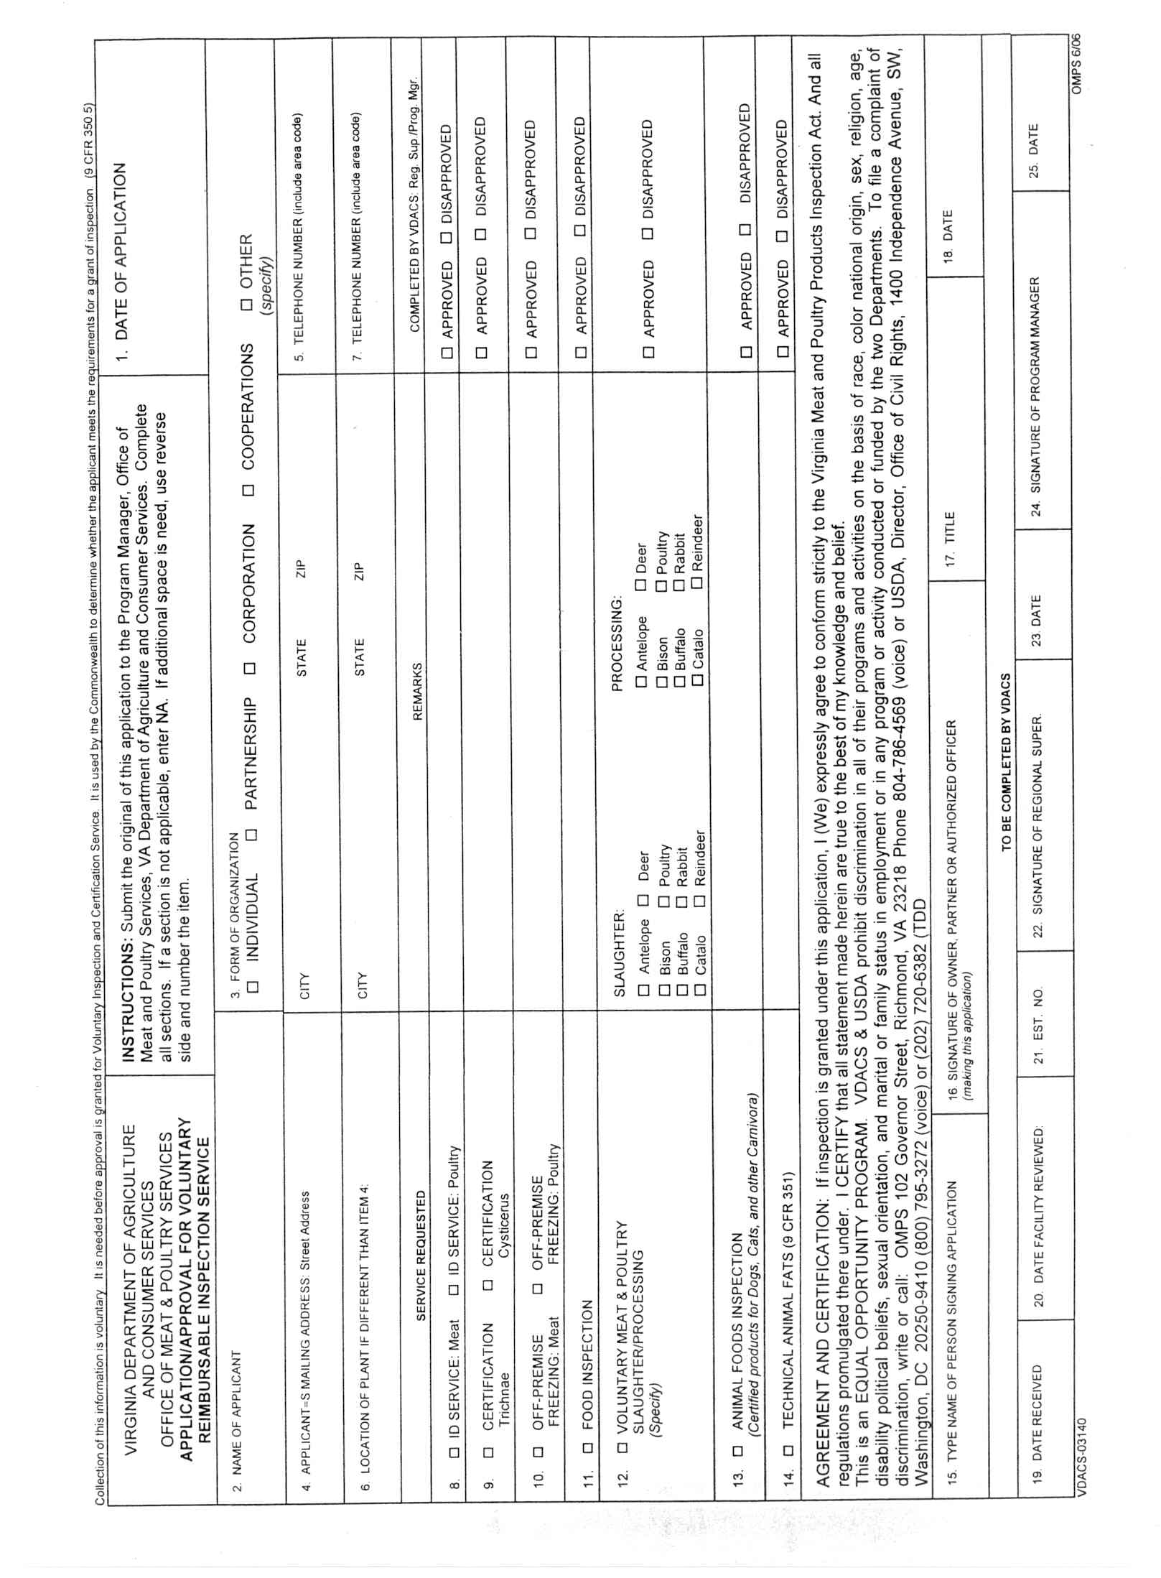
VA.R. Doc. No. R06-298; Filed July 19, 2006, 9:58 a.m.

