TITLE 18. PROFESSIONAL AND OCCUPATIONAL LICENSING
BOARD FOR BARBERS AND COSMETOLOGY
Final Regulation
Title of Regulation: 18 VAC 41-60. Body-Piercing Regulations (adding 18 VAC 41-60-10 through 18 VAC 41-60-220).
Statutory Authority: § 54.1-201 of the Code of Virginia.
Effective Date: April 1, 2007.
Agency Contact: William H. Ferguson, II, Executive Director, Board for Barbers and Cosmetology, 3600 West Broad Street, Richmond, VA 23230, telephone (804) 367-8590, FAX (804) 367-6295, or email barbercosmo@dpor.virginia.gov.
Summary:
The regulation establishes licensing requirements for the practice of body piercing. The regulations include (i) definitions of words and terms relative to the practice of providing body-piercing services; (ii) general requirements for obtaining a license to provide services as a body piercer or body piercer ear only; (iii) requirements for becoming a body-piercing apprenticeship sponsor; (iv) general requirements for obtaining a license to operate a body-piercing salon or body-piercing ear only salon; (v) fees for initial, renewal, and reinstatement applications for body piercers, body-piercing salons, body piercers ear only, or body-piercing ear only salons; (vi) sanitation and safety standards for salons that address disinfection and storage of implements, sanitation of equipment and safety standards pertaining to the use of chemical products, the proper handling of blood spills, and client health guidelines; (vii) measures to be taken to ensure that clients are qualified to receive piercing services in compliance with § 18.2-371.3 of the Code of Virginia pertaining to minimum age; and (viii) requirements for obtaining certain disclosures and maintenance of records of notification to the client pertaining to risks associated with receiving piercing services.
Changes made since the proposed include: (i) amending the criminal history disclosure requirements to ensure compliance with § 54.1-204 of the Code of Virginia, (ii) reducing work experience requirements for application by waiver of exam and for qualifications of an apprenticeship sponsor, (iii) adding educational requirements to the apprenticeship curriculum, (iv) reducing minimum requirements for number and type of body-piercing performances required in an apprenticeship program, (v) adding probation as an option for disciplinary action by the board, and (vi) adding clarifying language throughout the regulation based on public comments received by the board.
Summary of Public Comments and Agency's Response: A summary of comments made by the public and the agency's response may be obtained from the promulgating agency or viewed at the office of the Registrar of Regulations.
CHAPTER 60.
BODY-PIERCING REGULATIONS
PART I.
GENERAL.
18 VAC 41-60-10. Definitions.
The following words and terms when used in this chapter shall have the following meanings [ , ] unless the context clearly indicates otherwise. All terms defined in Chapter 7 (§ 54.1-700 et seq.) of Title 54.1 of the Code of Virginia are incorporated in this chapter.
"Apprenticeship program" means an approved body-piercing training program conducted by an approved apprenticeship sponsor.
"Apprenticeship sponsor" means an individual approved to conduct body-piercing apprenticeship training who meets the qualifications in 18 VAC 41-60-70.
"Aseptic technique" means a hygienic practice that prevents and hinders the direct transfer of microorganisms, regardless of pathogenicity, from one person or place to another person or place.
"Body piercer ear only" means any person who uses only a mechanized, presterilized ear-piercing system that penetrates the outer perimeter or lobe of the ear or both for compensation.
"Body piercing ear only" means the use of a mechanized, presterilized ear-piercing system that penetrates the outer perimeter or lobe of the ear or both.
"Body-piercing ear only salon" means any place in which a fee is charged for the act of using a mechanized, presterilized ear-piercing system that penetrates the outer perimeter or lobe of the ear or both.
"Endorsement" means a method of obtaining a license by a person who is currently licensed in another state.
"Gratuitous services" as used in § 54.1-701.5 of the Code Virginia means providing body-piercing services without receiving compensation or reward, or obligation. Gratuitous services do not include services provided at no charge when goods are purchased.
"Licensee" means any person, partnership, association, limited liability company, or corporation holding a license issued by the Board for Barbers and Cosmetology.
"Reinstatement" means having a license restored to effectiveness after the expiration date has passed.
"Renewal" means continuing the effectiveness of a license for another period of time.
"Sterilization area" means a separate room or area separate from workstations with restricted client access in which body-piercing instruments are cleaned, disinfected, and sterilized.
"Temporary location" means a fixed location at which body piercing is performed for a specified length of time of not more than seven days in conjunction with a single event or celebration.
PART II.
ENTRY.
18 VAC 41-60-20. General requirements.
A. In order to receive a license as a body piercer in compliance with § 54.1-703 of the Code of Virginia, an applicant must meet the following qualifications:
1. The applicant shall be in good standing as a body piercer in every jurisdiction where licensed, certified, or registered. The applicant shall disclose to the board at the time of application for licensure any disciplinary action taken in another jurisdiction in connection with the applicant's practice as a body piercer. The applicant shall disclose to the board at the time of application for licensure whether he has been previously licensed in Virginia as a body piercer.
2. The applicant shall disclose his physical address. A post office box is not acceptable.
3. The applicant shall sign, as part of the application, a statement certifying that the applicant has read and understands the Virginia body-piercing license laws and the board’s body-piercing regulations.
4. In accordance with § 54.1-204 of the Code of Virginia, [ the each ] applicant shall [ not have been convicted disclose a conviction, ] in any jurisdiction [ , ] of [ a any ] misdemeanor or felony [ which directly relates to the profession of body piercing. The board shall have the authority to determine, based upon all the information available, including the applicant’s record of prior convictions, if the applicant is unfit or unsuited to engage in the profession of body piercing. The board will decide each case by taking into account the totality of the circumstances ]. Any plea of nolo contendere shall be considered a conviction for [ the purposes this purpose ] of this section. [ The applicant shall provide a certified copy of a final order, decree or case decision by a court or regulatory agency with the lawful authority to issue such order, decree or case decision, and such copy shall be admissible as prima facie evidence of such conviction. This record shall be forwarded by the applicant to the board within 10 days after all appeal rights have expired. The record of a conviction certified or authenticated in such form as to be admissible in evidence under the laws of the jurisdiction where convicted shall be admissible as prima facie evidence of such guilt. The board, at its discretion, may deny licensure or certification to any applicant in accordance with § 54.1-204 of the Code of Virginia. ]
5. The applicant shall provide evidence satisfactory to the board that the applicant has passed the board-approved examination, administered either by the board or by a designated testing service.
6. Persons who (i) make application [ within one year after the effective date of this chapter between April 1, 2007, and March 31, 2008 ]; (ii) have completed [ five three ] years of documented work experience within the preceding [ eight five ] years as a body piercer; and (iii) have completed a minimum of five hours of health education including but not limited to blood borne disease, sterilization, and aseptic techniques related to body piercing and first aid and CPR that is acceptable to the board are not required to complete subdivision 5 of this subsection.
B. Eligibility to sit for board-approved body-piercer examination.
1. Training in the Commonwealth of Virginia. Any person completing an approved body-piercing apprenticeship program in a Virginia licensed body-piercing salon shall be eligible to sit for the examination.
2. Training outside of the Commonwealth of Virginia, but within the United States and its territories. Any person completing a body-piercing training or apprenticeship program that is substantially equivalent to the Virginia program but is outside of the Commonwealth of Virginia must submit to the board documentation of the successful completion of training or apprenticeship to be eligible for examination. [ If less than required hours of body-piercing training or body-piercing apprenticeship was completed, an applicant must submit (i) documentation acceptable to the board verifying the completion of a substantially equivalent body-piercing training or body-piercing apprenticeship or documentation of three years of work experience within the preceding five years as a body piercer and (ii) documentation of completion of a minimum of five hours of health education to include but not limited to blood borne disease, sterilization, and aseptic techniques related to body piercing and first aid and CPR that is acceptable to the board in order to be eligible for examination. ]
C. In order to receive a license as a body piercer ear only, an applicant must meet the following qualifications:
1. The applicant shall have completed a minimum of three hours of health education to include but not limited to blood borne disease and first aid that is acceptable to the board and provide verification of training on a mechanized, presterilized ear-piercing system that penetrates the outer perimeter or lobe of the ear or both [ and aftercare of piercing ].
2. The applicant shall be in good standing in every jurisdiction where licensed, certified, or registered. The applicant shall disclose to the board at the time of application for licensure any disciplinary action taken in another jurisdiction in connection with the applicant's licensed, certified, or registered practice. The applicant shall disclose to the board at the time of application for licensure whether he has been previously licensed in Virginia in any profession regulated by the board.
3. The applicant shall disclose his physical address. A post office box is not acceptable.
4. The applicant shall sign, as part of the application, a statement certifying that the applicant has read and understands the Virginia body-piercing license laws and the board’s body-piercing regulations.
5. In accordance with § 54.1-204 of the Code of Virginia, [ the each ] applicant shall [ not have been convicted disclose a conviction, ] in any jurisdiction [ , ] of [ a any ] misdemeanor or felony [ which directly relates to the profession of body piercing. The board shall have the authority to determine, based upon all the information available, including the applicant’s record of prior convictions, if the applicant is unfit or unsuited to engage in the profession of body piercing. The board will decide each case by taking into account the totality of the circumstances ]. Any plea of nolo contendere shall be considered a conviction for [ the purposes this purpose ] of this section. [ The applicant shall provide a certified copy of a final order, decree or case decision by a court or regulatory agency with the lawful authority to issue such order, decree or case decision, and such copy shall be admissible as prima facie evidence of such conviction. This record shall be forwarded by the applicant to the board within 10 days after all appeal rights have expired. The record of a conviction certified or authenticated in such form as to be admissible in evidence under the laws of the jurisdiction where convicted shall be admissible as prima facie evidence of such guilt. The board, at its discretion, may deny licensure or certification to any applicant in accordance with § 54.1-204 of the Code of Virginia. ]
18 VAC 41-60-30. License by endorsement.
Upon proper application to the board, any person currently licensed to practice as a body piercer in any other state or jurisdiction of the United States and who has completed a training or apprenticeship program and an examination that is substantially equivalent to that required by this chapter may be issued a body-piercer license without an examination. The applicant must also meet the requirements set forth in 18 VAC 41-60-20 A 1 through A 4.
18 VAC 41-60-40. Examination requirements and fees.
A. Applicants for initial licensure shall pass an examination approved by the board. The examinations may be administered by the board or by a designated testing service.
B. Any candidate failing to appear as scheduled for examination shall forfeit the examination fee.
18 VAC 41-60-50. Reexamination requirements.
Any applicant who does not pass a reexamination within one year of the initial examination date shall be required to submit a new application and examination fee.
18 VAC 41-60-60. Examination administration.
A. The examinations may be administered by the board or the designated testing service.
B. The applicant shall follow all procedures established by the board with regard to conduct at the examination. Such procedures shall include any written instructions communicated prior to the examination date and any instructions communicated at the site, either written or oral, on the date of the examination. Failure to comply with all procedures established by the board and the testing service with regard to conduct at the examination may be grounds for denial of application.
C. The fee for examination or reexamination is subject to contracted charges to the board by an outside vendor. These contracts are competitively negotiated and bargained for in compliance with the Virginia Public Procurement Act (§ 2.2-4300 et seq. of the Code of Virginia). Fees may be adjusted and charged to the candidate in accordance with these contracts. The fee shall not exceed $225 per candidate.
18 VAC 41-60-70. General requirements for a body-piercing apprenticeship sponsor.
A. Upon filing an application with the Board for Barbers and Cosmetology, any person meeting the qualifications set forth in this section may be eligible to sponsor a body-piercing apprentice if the person:
1. Holds a current Virginia body-piercing license;
2. Provides documentation of legally practicing body piercing for at least [ seven five ] years; and
3. Provides documentation indicating that he is in good standing in all jurisdictions where the practice of body piercing is regulated.
B. Apprenticeship sponsors shall be required to maintain a body-piercer license.
C. Apprenticeship sponsors shall ensure compliance with the 1500-hour Body-Piercing Apprenticeship Program and Body-Piercing Apprenticeship Standards.
18 VAC 41-60-80. Salon license.
A. Any individual wishing to operate a body-piercing salon or body-piercing ear only salon shall obtain a salon license in compliance with § 54.1-704.1 of the Code of Virginia.
B. A body-piercing salon license or body-piercing ear only salon license shall not be transferable and shall bear the same name and address of the business. Any changes in the name, address, or ownership of the salon shall be reported to the board in writing within 30 days of such changes. New owners shall be responsible for reporting such changes in writing to the board within 30 days of the changes.
C. In the event of a closing of a body-piercing salon or body-piercing ear only salon, the board must be notified by the owners in writing within 30 days of the closing, and the license must be returned by the owners to the board.
D. Any individual wishing to operate body-piercing salon in a temporary location must have a body-piercing salon license issued by the board.
PART III.
FEES.
18 VAC 41-60-90. Fees.
The following fees apply:
FEE TYPE | AMOUNT DUE | WHEN DUE
Individuals:
Application | $55 | With application
License by endorsement | $55 | With application
Renewal: | $55 | With renewal card prior to expiration date
Reinstatement | $110*  *includes $55 renewal fee and $55 reinstatement fee | With reinstatement application
Salons:
Application | $90 | With application
Renewal | $90 | With renewal card prior to expiration date
Reinstatement | $180*  *includes $90 renewal fee and $90 reinstatement fee | With reinstatement application
18 VAC 41-60-100. Refunds.
All fees are nonrefundable and shall not be prorated.
PART IV.
RENEWAL/REINSTATEMENT.
18 VAC 41-60-110. License renewal required.
All body-piercer, body-piercer ear only, body-piercing salon and body-piercing ear only salon licenses shall expire two years from the last day of the month in which they were issued.
18 VAC 41-60-120. Continuing education requirement.
All licensed body piercers shall be required to satisfactorily complete a minimum of five hours of health education to include but not limited to blood borne disease, sterilization, and aseptic techniques related to body piercing and first aid and CPR during their licensed term. All licensed body piercers ear only shall be required to satisfactorily complete a minimum of three hours of health education to include but not limited to blood borne disease and first aid during their licensed term. Documentation of training completion shall be provided at the time of renewal along with the required fee.
18 VAC 41-60-130. Notice of renewal.
The Department of Professional and Occupational Regulation will mail a renewal notice to the licensee outlining the procedures for renewal. Failure to receive this notice, however, shall not relieve the licensee of the obligation to renew. If the licensee fails to receive the renewal notice, a copy of the old license may be submitted as evidence of intent to renew, along with the required fee.
18 VAC 41-60-140. Failure to renew.
A. When a body piercer or body piercer ear only fails to renew their license within 30 days following its expiration date, the licensee shall meet the renewal requirements prescribed in 18 VAC 41-60-130 and apply for reinstatement of the license by submitting to the Department of Professional and Occupational Regulation a reinstatement application along with the required renewal and reinstatement fees.
B. When a body piercer or body piercer ear only fails to renew his license within two years following the expiration date, reinstatement is no longer possible. To resume practice, the former body-piercer licensee shall apply for licensure as a new applicant, shall meet all current application requirements, shall pass the board’s current examination and shall receive a new license. To resume practice, the former body-piercer ear only licensee shall apply for licensure as a new applicant, shall meet all current application requirements, and shall receive a new license.
C. When a body-piercing salon or body-piercing ear only salon fails to renew its license within 30 days following the expiration date [ , it ] shall be required to apply for reinstatement of the license by submitting to the Department of Professional and Occupational Regulation a reinstatement application along with the required renewal and reinstatement fees.
D. When a body-piercing salon or body-piercing ear only salon fails to renew its license within two years following the expiration date, reinstatement is no longer possible. To resume practice, the former licensee shall apply for licensure as a new applicant and shall meet all current application requirements.
E. The date a renewal fee is received by the Department of Professional and Occupational Regulation, or its agent, will be used to determine whether the requirement for reinstatement of a license is applicable and an additional fee is required.
F. When a license is reinstated, the licensee shall have the same license number and shall be assigned an expiration date two years from the previous expiration date of the license.
G. A licensee who reinstates his license shall be regarded as having been continuously licensed without interruption. Therefore, a licensee shall be subject to the authority of the board for activities performed prior to reinstatement.
H. A licensee who fails to reinstate his license shall be regarded as unlicensed from the expiration date of the license forward. Nothing in this chapter shall divest the board of its authority to discipline a licensee for a violation of the law or regulations during the period of time for which the individual was licensed.
PART V.
BODY-PIERCING APPRENTICESHIP PROGRAMS.
18 VAC 41-60-150. Applicants for board approval.
A. Any person desiring to enroll in the body-piercing apprenticeship program shall be required to provide documentation of satisfactory completion of a minimum of five hours of health education to include but not limited to blood borne disease, sterilization, and aseptic techniques related to body piercing, and first aid and CPR.
B. Any body piercer desiring approval to perform the duties of an apprenticeship sponsor and offer the board’s body-piercing apprenticeship program shall meet the requirements in 18 VAC 41-60-70.
[ C. All apprenticeship training shall be conducted in a body-piercing salon that has met the requirements of 18 VAC 41-60-80. ]
18 VAC 41-60-160. Body-piercing apprenticeship curriculum requirements.
Body-piercing apprenticeship curriculum requirements are set out in this section:
1. Microbiology:
a. Microorganisms, viruses, bacteria, fungi;
b. Transmission cycle of infectious diseases; and
c. Characteristics of antimicrobial agents.
2. Immunization;
a. Types of immunizations;
b. Hepatitis A – G transmission and immunization;
c. HIV/AIDS;
d. Tetanus, streptococcal, zoonotic, tuberculosis, pneumococcal, and influenza;
e. Measles, mumps, and rubella;
f. Vaccines and immunization; and
g. General preventative measures to be taken to protect the body piercer and client.
3. Sanitation and disinfection:
a. Definition of terms:
(1) Sterilization;
(2) Disinfection and disinfectant;
(3) Sterilizer or sterilant;
(4) Antiseptic;
(5) Germicide;
(6) Decontamination; and
(7) Sanitation;
b. The use of steam sterilization equipment and techniques;
c. The use of chemical agents, antiseptics, disinfectants, and fumigants;
d. The use of sanitation equipment;
e. Pre-service sanitation procedure; and
f. Post-service sanitation procedure.
4. Safety:
a. Proper needle handling and disposal;
b. How to avoid overexposure to chemicals;
c. The use of Material Safety Data Sheets;
d. Blood spill procedures;
e. Equipment and instrument storage; and
f. First aid and CPR.
5. Blood borne pathogen standards:
a. OSHA and CDC blood borne pathogen standards;
b. Control Plan for blood borne pathogens;
c. Exposure Control Plan for Body Piercers;
d. Overview of compliance requirements; and
e. Disorders and when not to service a client.
6. Professional standards:
a. History of body piercing;
b. Ethics;
c. Recordkeeping:
(1) Client health history;
(2) Consent forms; and
(3) [ HIPPA HIPAA ] Standards [ . (Health Insurance Portability and Accountability Act of 1996 Privacy Rule); ]
d. Preparing station, making appointments, salon ethics:
(1) Maintaining professional appearance, notifying clients of schedule changes; and
(2) Promoting services of the salon and establishing clientele [ . ; ]
e. Salon management:
(1) Licensing requirements; and
(2) Taxes; [ and
f. Supplies:
(1) Usages;
(2) Ordering; and
(3) Storage. ]
7. Body piercing:
a. Client consultation;
b. Client health [ form information ];
c. Client disclosure form;
d. Client preparation;
e. Sanitation and safety precautions;
f. Implement selection and use;
g. Proper use of equipment; [ and ]
h. Material selection and use [ ;
i. Grade of jewelry; and
j. Metals to use ].
[ 8. Body-piercing procedures:
a. Ear lobe;
b. Helix - ear;
c. Concha - ear;
d. Tragus - ear;
e. Tongue;
f. Navel;
g. Eyebrow;
h. Lip;
i. Septum;
j. Nostril;
k. Male nipple;
l. Female nipple;
m. Monroe (face cheek);
n. Prince Albert (male genitalia);
o. Frenum (male genitalia);
p. Clitorial hoods (female genitalia); and
q. Labias (female genitalia).
9. Virginia body-piercing laws and regulations. ]
18 VAC 41-60-170. Body-piercing hours of instruction and performances.
A. Curriculum requirements specified in 18 VAC 41-60-160 shall be taught over a minimum of 1,500 hours as follows:
1. 350 hours shall be devoted to theory pertaining to subdivisions 1, 2, 4, 5, and 6 of 18 VAC 41-60-160;
2. 150 hours shall be devoted to theory pertaining to subdivision 3 of 18 VAC 41-60-160; and
3. The remaining 1,000 hours shall be devoted to practical training and the following performances pertaining to subdivision 7 of 18 VAC 41-60-160:
Body-Piercing Performances
ear lobe | [ 20 minimum of 5 ]
helix - ear | [ 15 minimum of 5 ]
concha - ear | [ 15 minimum of 5 ]
tragus - ear | [ 15 minimum of 5 ]
tongue | [ 20 minimum of 5 ]
navel | [ 15 minimum of 5 ]
eyebrow | [ 15 minimum of 5 ]
lip | [ 15 minimum of 5 ]
septum | [ 15 minimum of 5 ]
nostril | [ 20 minimum of 5 ]
[ male nipple | 10
female nipple | 10
Monroe (face cheek) | 12
Prince Albert (male genitalia) | 12
Frenum (male genitalia) | 12
clitorial hoods (female genitalia) | 12
labias (female genitalia) | 12
additional piercings of choice | minimum of 50 ]
Total | [ 250 100 ]
B. An approved body-piercing apprenticeship program may conduct an assessment of an apprentice’s competence in the theory and practical requirements for body piercing and, based on the assessment, give a maximum of 500 hours of credit towards the requirements in subdivisions A 1 and A 3 of this section. No credit shall be allowed for the 150 hours required in subdivision A 2 of this section.
PART VI.
STANDARDS OF PRACTICE.
18 VAC 41-60-180. Display of license.
A. Each body-piercing salon owner or body-piercing ear only salon owner shall ensure that all current licenses issued by the board shall be displayed in the reception area of the salon in plain view of the public. Duplicate licenses shall be posted in a like manner in every salon location where the licensee provides services.
B. Each body-piercing salon or body-piercing ear only salon owner shall ensure that no licensee performs any service beyond the scope of practice for the applicable license.
C. Each body-piercing salon or body-piercing ear only salon owner shall offer to licensees the full series of Hepatitis B vaccine.
D. Each body-piercing salon or body-piercing ear only salon owner shall maintain a record for each licensee of:
1. Proof of completion of the full series of Hepatitis B vaccine;
2. Proof of immunity by blood titer; or
3. Written declaration of refusal of the owner’s offer of a full series of Hepatitis B vaccine.
E. All licensees shall operate under the name in which the license is issued.
18 VAC 41-60-190. Physical facilities.
A. A body-piercing salon or body-piercing ear only salon must be in a permanent building, which must be in a location permissible under local zoning codes, if any. If applicable, the body-piercing salon or body-piercing ear only salon shall be separated from any living quarters by complete floor to ceiling partitioning and shall contain no access to living quarters.
B. The body-piercing salon, body-piercing ear only salon, or temporary location shall be maintained in a clean and orderly manner.
C. A body-piercing salon, body-piercing ear only salon, or temporary location shall have a blood spill clean-up kit in the work area.
D. Work surfaces in a body-piercing salon, body-piercing ear only salon, or temporary location shall be cleaned with an EPA-registered, hospital grade disinfectant. Surfaces that come in contact with blood or other body fluids shall be immediately disinfected with an EPA-registered germicide solution. Appropriate personal protective equipment shall be worn during cleaning and disinfecting procedures.
E. In a body-piercing salon, body-piercing ear only salon, or temporary location, cabinets or containers for the storage of instruments, single-use articles, and other utensils shall be provided for each operator and shall be maintained in a sanitary manner.
F. In a body-piercing salon, body-piercing ear only salon, or temporary location, bulk single-use articles shall be commercially packaged and handled in such a way as to protect them from contamination.
G. In a body-piercing salon, body-piercing ear only salon, or temporary location, all materials applied to the human skin shall be from single-use articles or transferred from bulk containers to single use containers and shall be disposed of after each use.
H. In a body-piercing salon or body-piercing ear only salon, the walls, ceilings, and floors shall be kept in good repair. The body-piercing area shall be constructed of smooth, hard, surfaces that are nonporous, free of open holes or cracks, light colored, and easily cleaned. New physical facilities shall not include any dark-colored surfaces in the body-piercing area. Existing physical facilities with dark-colored surfaces in the body-piercing area shall replace the dark-colored surfaces with light-colored surfaces whenever the facilities are extensively remodeled or upon relocation of the business.
I. A body-piercing salon, body-piercing ear only salon, or temporary location shall have adequate lighting of at least 50 foot-candles of illumination in the body-piercing and sterilization areas.
J. In a body-piercing salon, body-piercing ear only salon, or temporary location, adequate mechanical ventilation shall be provided.
K. A body-piercing salon, body-piercing ear only salon, or temporary location shall be equipped with hand-cleaning facilities for its personnel with unobstructed access to the body-piercing or body-piercing ear only area such that the body piercer or body piercer ear only can return to the area without having to touch anything with his hands. Hand-cleaning facilities shall be equipped either with hot and cold or tempered running water under pressure and liquid germicidal soap or with a sanitizing solution to clean hands. Hand-cleaning facilities shall be equipped with single-use towels or mechanical hand drying devices and a covered refuse container. Such facilities shall be kept clean and in good repair. All facilities must have running water and soap accessible for cleaning of hands contaminated by body fluids.
L. Animals are not permitted in the body-piercing salon, body-piercing ear only salon, or temporary location except for guide or service animals accompanying persons with disabilities or nonmammalian animals in enclosed glass containers such as fish aquariums, which shall be outside of the body-piercing or sterilization areas. No animals are allowed in the body-piercing, body-piercing ear only or sterilization areas.
M. In a body-piercing salon, body-piercing ear only salon, or temporary location, the use of tobacco products and consumption of alcoholic beverages shall be prohibited in the body-piercing, body-piercing ear only or sterilization areas.
N. In a body-piercing salon, body-piercing ear only salon, or temporary location, no food or drink will be stored or consumed in the body-piercing, body-piercing ear only, or sterilization areas.
O. In a body-piercing salon, body-piercing ear only salon, or temporary location, if body-piercing or body-piercing ear only is performed where cosmetology services are provided, it shall be performed in an area that is separate and enclosed.
[ P. All steam sterilizers shall be biological spore tested at least monthly.
Q. Biological spore tests shall be verified through an independent laboratory.
R. Biological spore test records shall be retained for a period of three years and made available upon request.
S. Steam sterilizers shall be used only for instruments used by the salon’s employees. ]
18 VAC 41-60-200. Body piercer and body piercer ear only responsibilities.
A. All body piercers and body piercers ear only shall provide to the owner [ one of the following ]:
1. Proof of completion of the full series of Hepatitis B vaccine;
2. Proof of immunity by blood titer; or
3. Written declaration of refusal of the owner's offer of a full series of Hepatitis B vaccine.
B. All body piercers and body piercers ear only shall wear clean outer garments, maintain a high degree of personal cleanliness, and conform to hygienic practices while on duty.
C. All body piercers and body piercers ear only shall clean their hands thoroughly using hot or tempered water with a liquid germicidal soap or use sanitizing solution to clean hands before and after body piercing and as necessary to remove contaminants.
D. All body piercers and body piercers ear only must wear single-use examination gloves while assembling instruments and [ another pair of single-use examination gloves ] while providing piercing services.
E. Each time there is an interruption in the service, each time the gloves become torn or perforated [ or become contaminated ], or whenever the ability of the gloves to function as a barrier is compromised:
1. Gloves [ should shall ] be removed and disposed of; and
2. Hands shall be cleaned and a fresh pair of gloves used.
F. Body piercers and body piercers ear only shall use standard precautions while providing piercing services. A body piercer or body piercer ear only diagnosed with a communicable disease shall provide to the department a written statement from a health care practitioner that the body piercer’s condition no longer poses a threat to public health.
G. Body piercers and body piercers ear only with draining lesions on their hands or face will not be permitted to work until cleared by a health-care professional.
H. The area of the client’s skin to be pierced shall be cleaned with an approved germicidal soap [ or antiseptic product ] according to label directions.
I. The external skin of the client to be pierced shall be cleaned with an approved germicidal soap [ or antiseptic product ] according to the label directions. In the case of oral piercings, the operator shall provide the individual with antiseptic mouthwash in a single-use cup and shall ensure that the individual utilizes the mouthwash provided. In the case of a lip, labret or cheek piercing, procedures described in this subsection for both skin and oral piercings shall be followed.
J. If shaving is required, razors shall be single-use and disposed of in a puncture-resistant container.
K. Each body piercer or body piercer ear only performing any piercing procedures in the salon shall have the education, training and experience, or any combination thereof, to practice aseptic technique and prevent the transmission of blood borne pathogens. All procedures shall be performed using aseptic technique.
L. [ A set of An ] individual, [ sterilized needles single-use, pre-sterilized piercing needle ] shall be used for each client. [ Single use Single-use ] disposable instruments shall be disposed of in a puncture-resistant container.
M. Used, nondisposable instruments shall be kept in a separate, puncture-resistant container until brush scrubbed in hot water soap and then sterilized by autoclaving. Contaminated instruments shall be handled with disposable gloves.
N. Used instruments that are ultrasonically cleaned shall be rinsed under running hot water prior to being placed in the used instrument container [ ; . ]
O. Used instruments that are not ultrasonically cleaned prior to being placed in the used instrument container shall be kept in a germicidal or soap solution until brush scrubbed in hot water and soap and sterilized by autoclaving.
P. The ultrasonic unit shall be sanitized daily with a germicidal solution.
Q. Nondisposable instruments shall be sterilized and shall be handled and stored in a manner to prevent contamination. Instruments to be sterilized shall be sealed in bags made specifically for the purpose of autoclave sterilization and shall include the date of sterilization. If nontransparent bags are utilized, the bag shall also list the contents.
R. Autoclave sterilization bags with a color code indicator that changes color upon proper sterilization shall be utilized during the autoclave sterilization process.
S. Instruments shall be placed in the autoclave in a manner to allow live steam to circulate around them.
T. Contaminated disposable and [ single use single-use ] items shall be disposed of in accordance with [ federal and ] state regulations regarding disposal of biological hazardous materials.
[ U. The manufacturer's written instruction of the autoclave shall be followed. ]
18 VAC 41-60-210. Body-piercing client qualifications, disclosures, and records.
A. Except as permitted in § 18.2-371.3 of the Code of Virginia, a client must be a minimum of 18 years of age and shall present at the time of the body piercing a valid, government-issued, positive identification card including, but not limited to, a driver’s license, passport, or military identification. The identification must contain a photograph of the individual and a printed date of birth.
B. The body piercer shall verify and document in the permanent client record the client’s age, date of birth, and the type of identification provided.
C. No person may be body pierced who appears to be under the influence of alcohol or drugs.
D. Body piercing shall not be performed on any skin surface that manifests any evidence of unhealthy conditions such as rashes, boils, infections, or abrasions.
E. Before receiving a body piercing, each client and client’s parent or guardian, if applicable, shall be informed verbally and in writing, using the client disclosure form prescribed by the board, about the possible risk and dangers associated with the application of each body piercing. Signatures of the client, the client’s parent or guardian, if applicable, and the body piercer shall be required on the client disclosure form to acknowledge receipt of both the verbal and written disclosures. [ Each client and client's parent or guardian, if applicable, shall be informed verbally and in writing of aftercare for each piercing. ]
F. The body-piercing salon or temporary location shall maintain proper records for each client. The information shall be permanently recorded and made available for examination by the department or authorized agent. Records shall be maintained at the body-piercing salon for at least two years following the date of the last entry. The temporary location client records shall be maintained by the license holder. The permanent records shall include the following:
1. The name, address, and telephone number of the client;
2. The date body piercing was performed;
3. The client’s age, date of birth, and a copy of the positive identification provided to the body piercer;
4. The specific type of jewelry used for the piercing and, when available, the manufacturer’s catalogue or identification number for the type of jewelry used;
5. The location on the body where the body piercing was performed;
6. The name of the body piercer;
7. A statement that the client has received a copy of applicable written care instructions and that the client has read and understands the instructions; and
8. The signature of the client and, if applicable, parent or guardian.
18 VAC 41-60-220. Grounds for license revocation or suspension [ or probation ]; denial of application, renewal or reinstatement; or imposition of a monetary penalty.
A. The board may, in considering the totality of the circumstances, fine any licensee and suspend [ , place on probation ] or revoke or refuse to renew or reinstate any license, or deny any application issued under the provisions of Chapter 7 (§ 54.1-700 et seq.) of Title 54.1 of the Code of Virginia and the regulations of the board if the board finds that:
1. The licensee is incompetent or negligent in practice, or incapable mentally or physically, as those terms are generally understood in the profession, to practice as a body piercer or body piercer ear only;
2. The licensee or applicant is convicted of fraud or deceit in the practice body piercing or body piercing ear only;
3. The licensee or applicant obtained, renewed or reinstated a license by false or fraudulent representation;
4. The licensee or applicant violates or induces others to violate, or cooperates with others in violating, any of the provisions of this chapter or Chapter 7 (§ 54.1-700 et seq.) of Title 54.1 of the Code of Virginia or any local ordinance or regulation governing standards of health and sanitation of the establishment in which body piercers or body piercers ear only may practice or offer to practice;
5. The licensee or applicant fails to produce, upon request or demand of the board or any of its agents, any document, book, record, or copy thereof in a licensee's or owner's possession or maintained in accordance with this chapter;
6. A licensee fails to notify the board of a change of name or address in writing within 30 days of the change for each and every license. The board shall not be responsible for the licensee's failure to receive notices, communications and correspondence caused by the licensee's failure to promptly notify the board in writing of any change of name or address or for any other reason beyond the control of the board;
7. The licensee or applicant publishes or causes to be published any advertisement that is false, deceptive, or misleading;
8. The licensee or applicant fails to notify the board in writing within 30 days of the suspension, revocation, or surrender of a license, certificate, or permit in connection with a disciplinary action in any other jurisdiction or of any license, certificate, or permit which has been the subject of disciplinary action in any other jurisdiction; [ or ]
9. [ In accordance with § 54.1-204 of the Code of Virginia, the The ] licensee or applicant has been convicted [ or found guilty ] in any jurisdiction of [ a any ] misdemeanor or felony [ that directly relates to the profession of body piercing. The board shall have the authority to determine, based upon all the information available, including the applicant’s record of prior convictions, if the applicant is unfit or unsuited to engage in the profession of body piercing or body piercing - ear only. The board will decide each case by taking into account the totality of the circumstances. ] Any plea of nolo contendere shall be considered a conviction for the [ purposes purpose ] of this section. [ The applicant shall provide a certified copy of a final order, decree or case decision by a court or regulatory agency with the lawful authority to issue such order, decree or case decision, and such copy shall be admissible as prima facie evidence of such conviction. This record shall be forwarded by the applicant to the board within 10 days after all appeal rights have expired. The record of a conviction certified or authenticated in such form as to be admissible in evidence under the laws of the jurisdiction where convicted shall be admissible as prima facie evidence of such guilt; or
10. The licensee, certificate holder, temporary license holder, or applicant fails to notify the board in writing within 30 days that the licensee, certificate holder, temporary license holder, or applicant has pleaded guilty or nolo contendere or was convicted and found guilty of any misdemeanor or felony. ]
B. In addition to subsection A of this section, the board may, in considering the totality of the circumstances, revoke, suspend [ , place on probation ] or refuse to renew or reinstate the license of any body-piercing salon [ or body-piercing ear only salon ] or impose a fine as permitted by law, or both, if the board finds that:
1. The owner or operator of the body-piercing salon or body-piercing ear only salon fails to comply with the facility requirements of body-piercing salons [ or body-piercing ear only salons ] provided for in this chapter or in any local ordinances; or
2. The owner or operator allows a person who has not obtained a license to practice as a body piercer or body piercer ear only unless the person is duly enrolled as an apprentice.
C. In addition to subsection A of this section, the board may, in considering the totality of the circumstances, revoke, suspend [ , place on probation ] or refuse to renew or reinstate the license of any licensee or impose a fine as permitted by law, or both, if the board finds that the licensee fails to take sufficient measures to prevent transmission of communicable or infectious diseases or fails to comply with any local, state or federal law or regulation governing the standards of health and sanitation for the practice of body piercing or body piercing ear only.
NOTICE: The forms used in administering 18 VAC 41-60, Body-Piercing Regulations, are listed below. Any amended or added forms are reflected in the listing and are published following the listing.
FORMS
Salon, Shop & Parlor License Application, [ 1213SLSH 12SLSHP ] ([ 12/05 eff. 4/07 ]).
[ Body-Piercer License Application, 1241LIC (eff. 4/07). ]
Body-Piercer Examination & License Application, 1241EX ([ 12/05 eff. 4/07 ]).
[ Body-Piercer Ear Only License Application, 1245LIC (eff. 4/07).
[ Body-Piercer Apprenticeship Completion Form, 1244BPAC (12/05).
Body-Piercing Apprentice Certification Application, 1244BPAC (eff. 4/07). ]

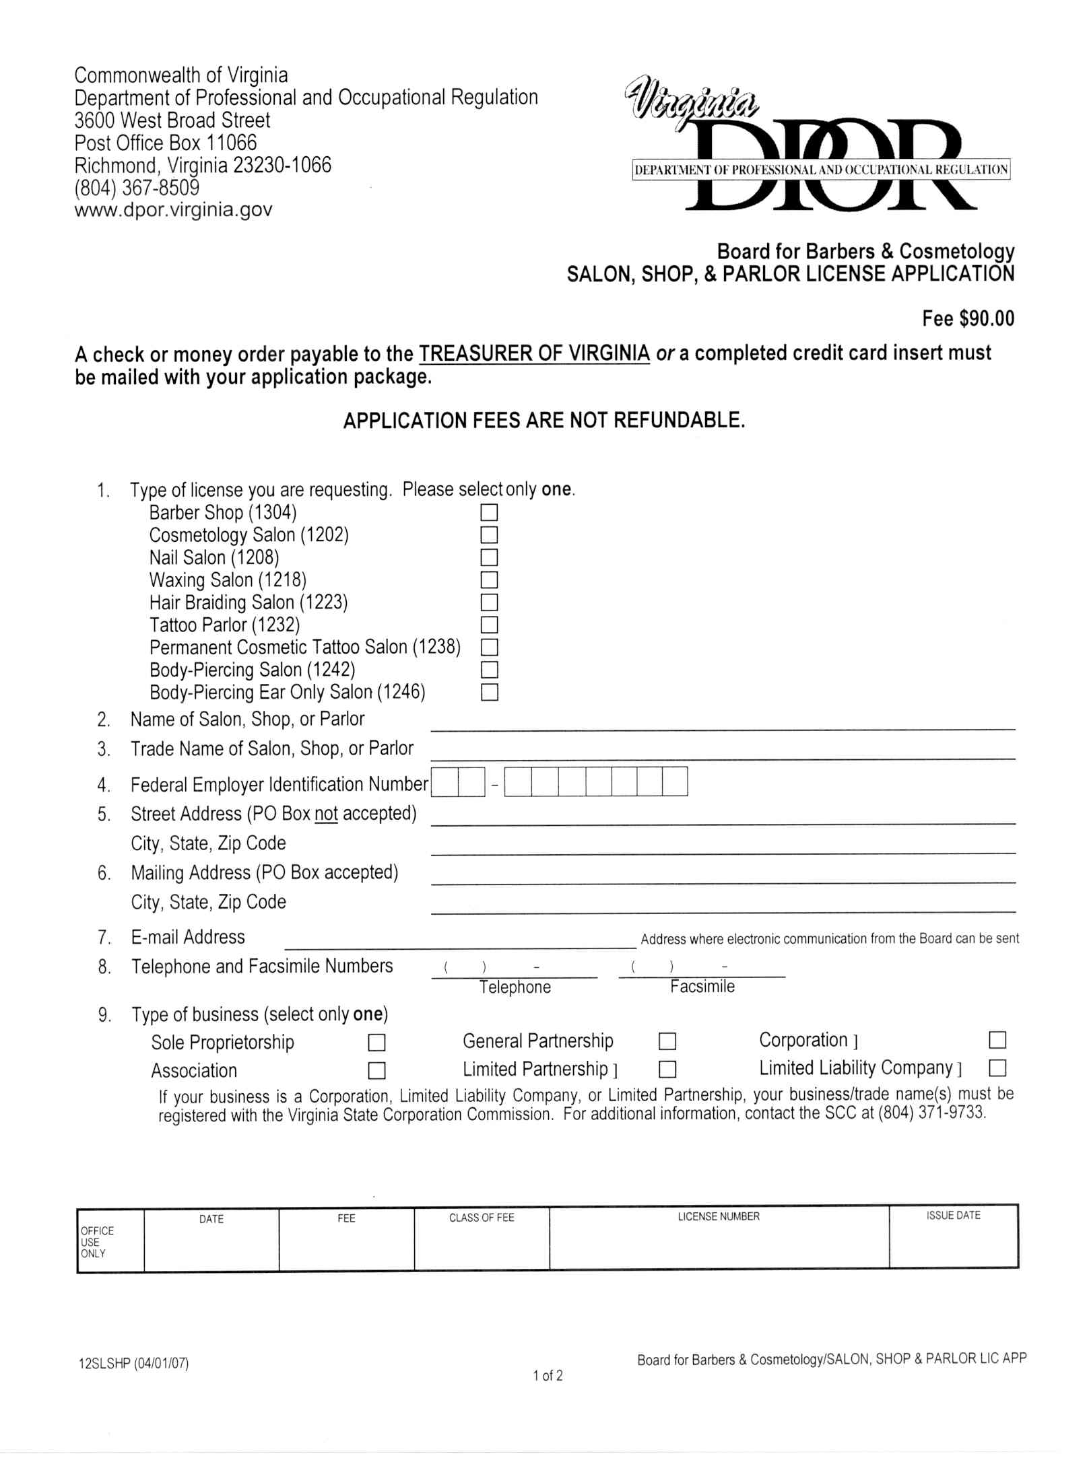
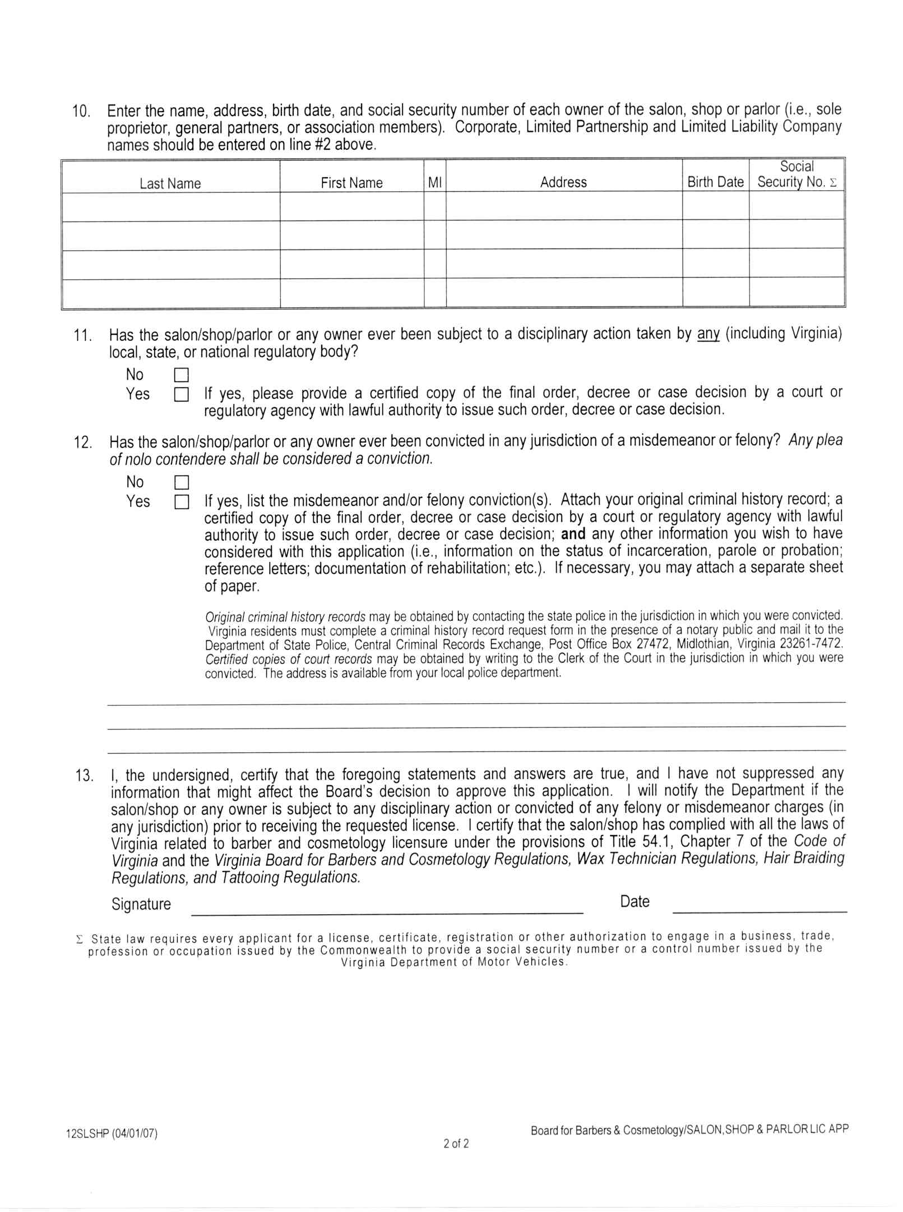
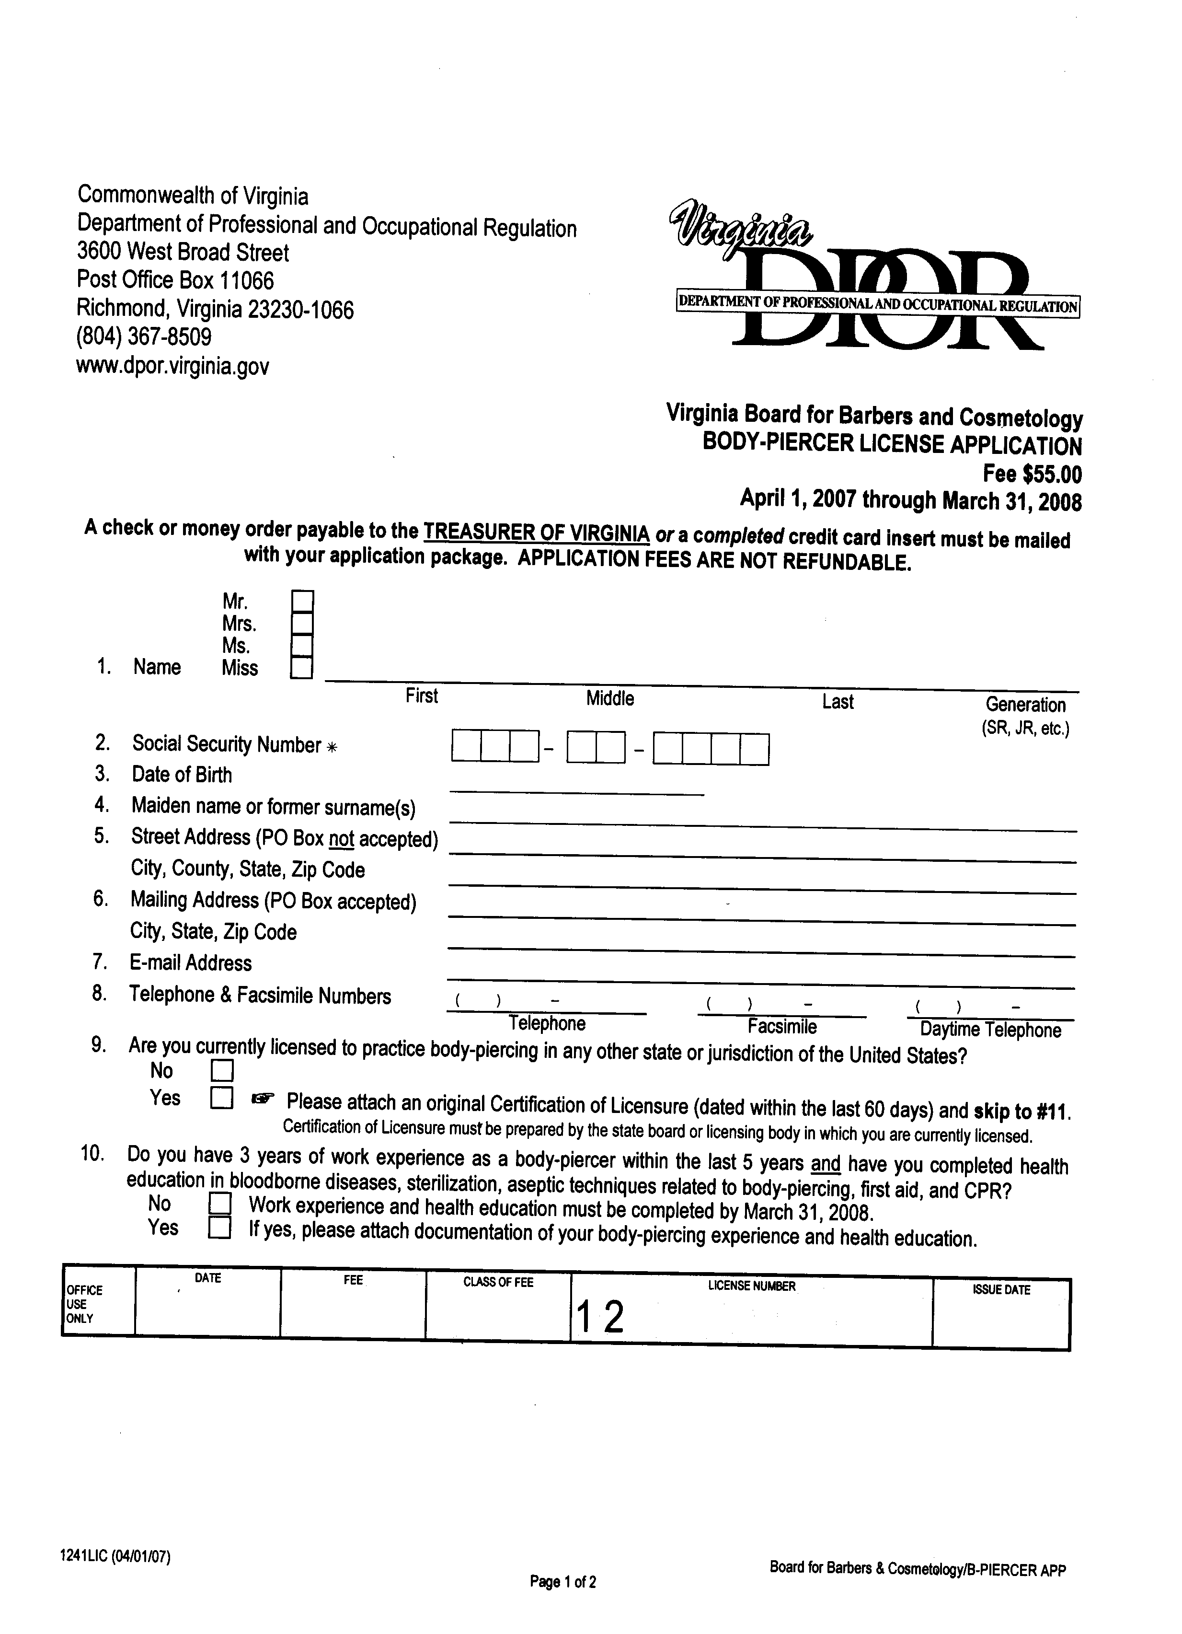
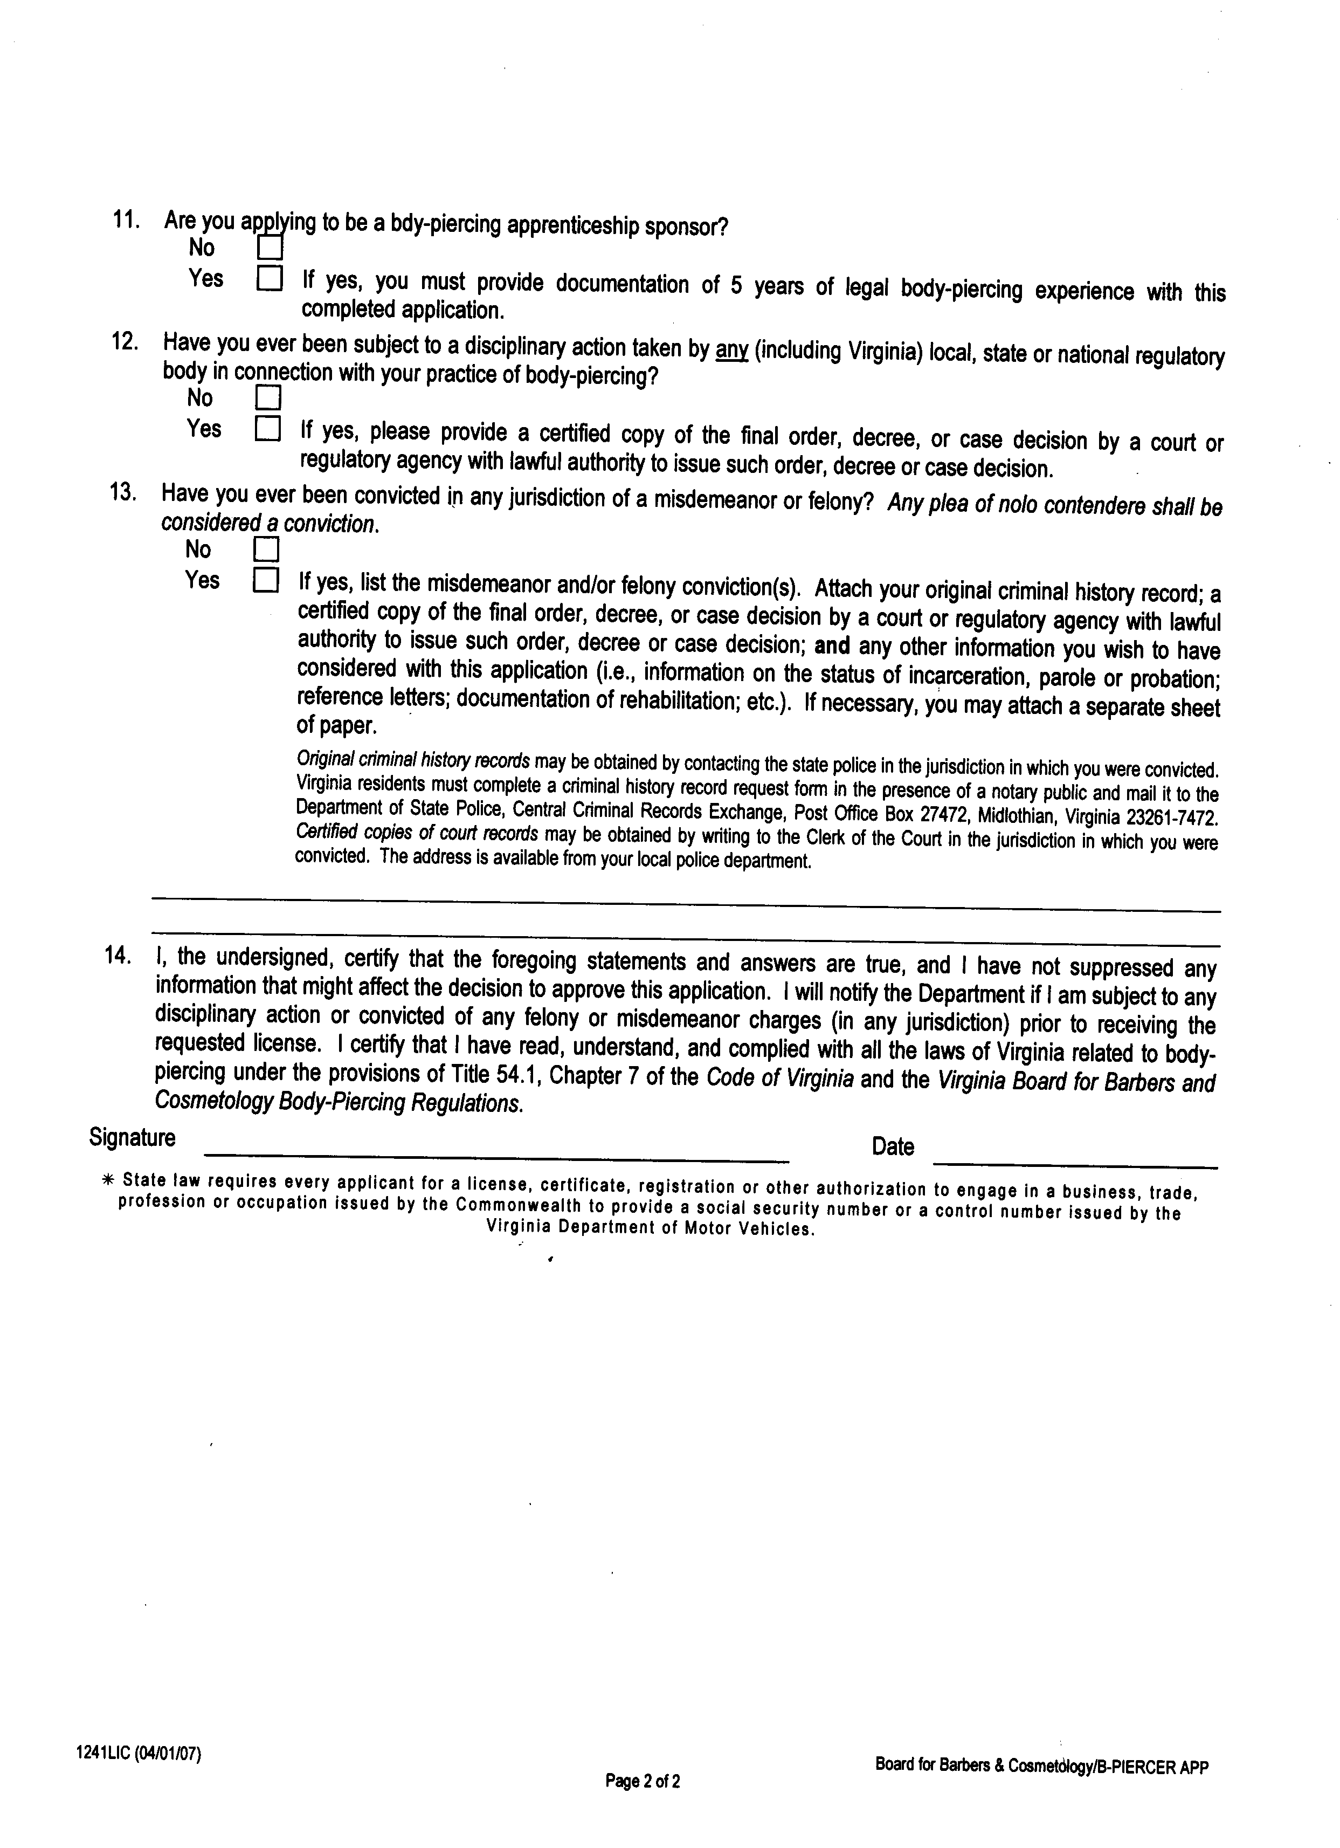
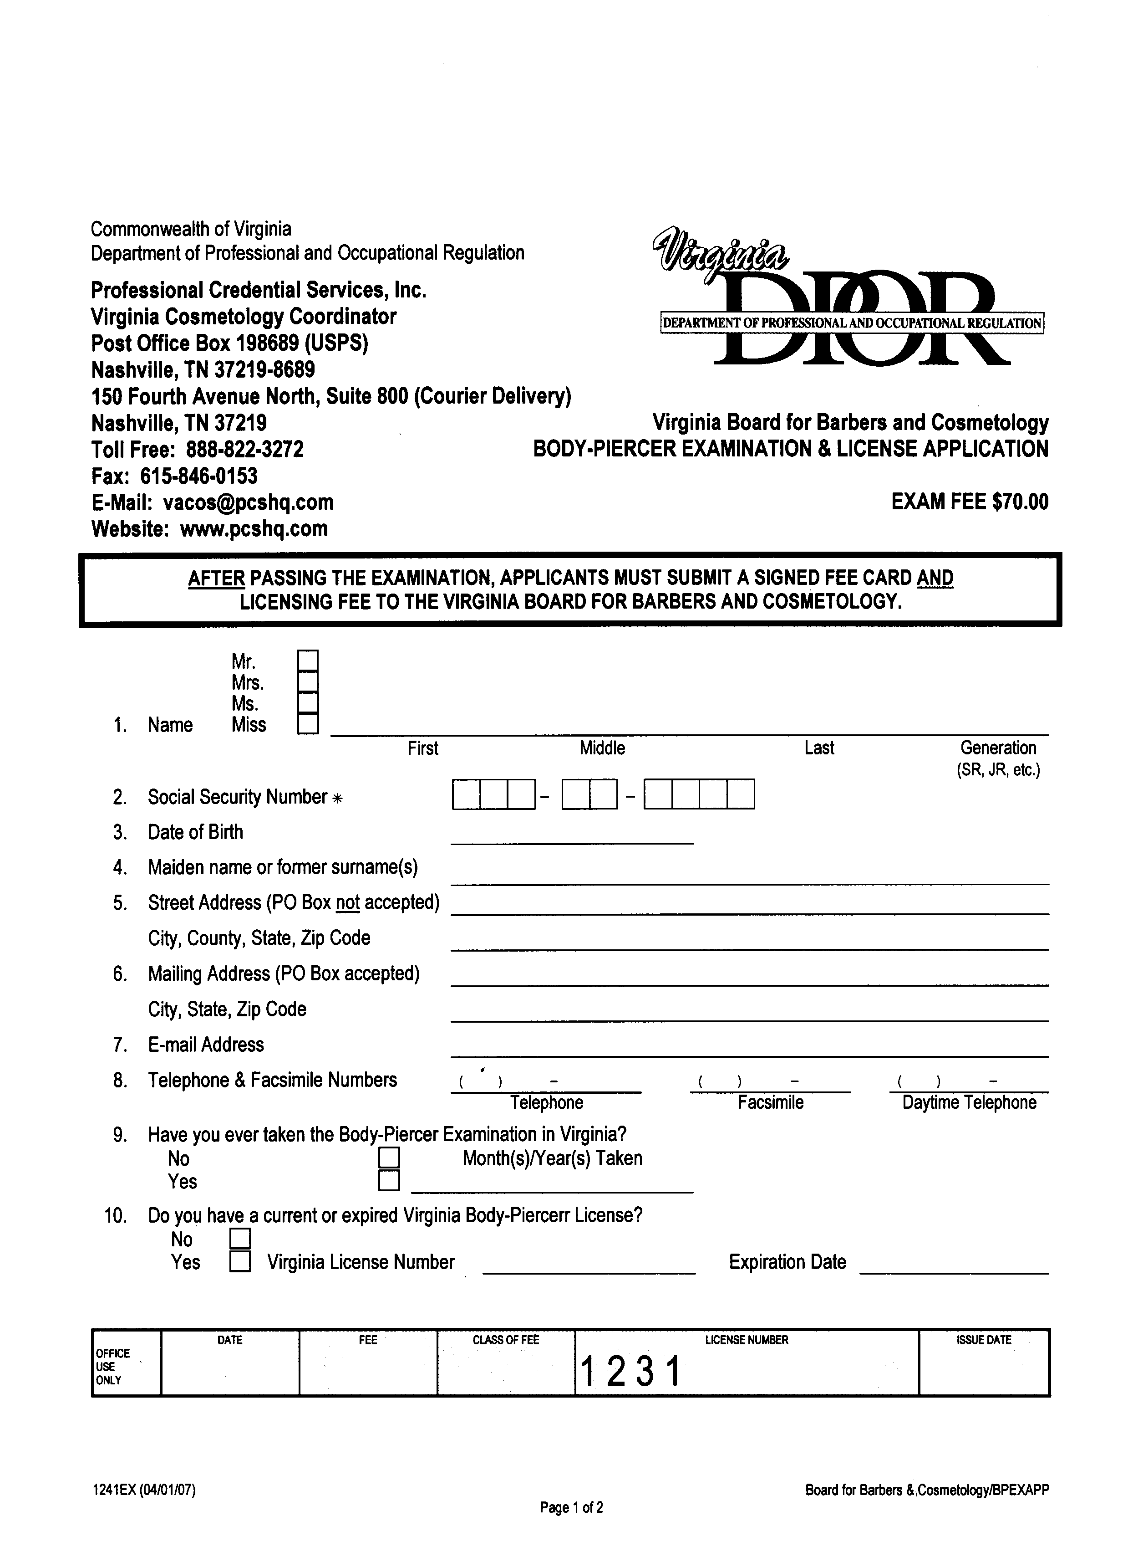
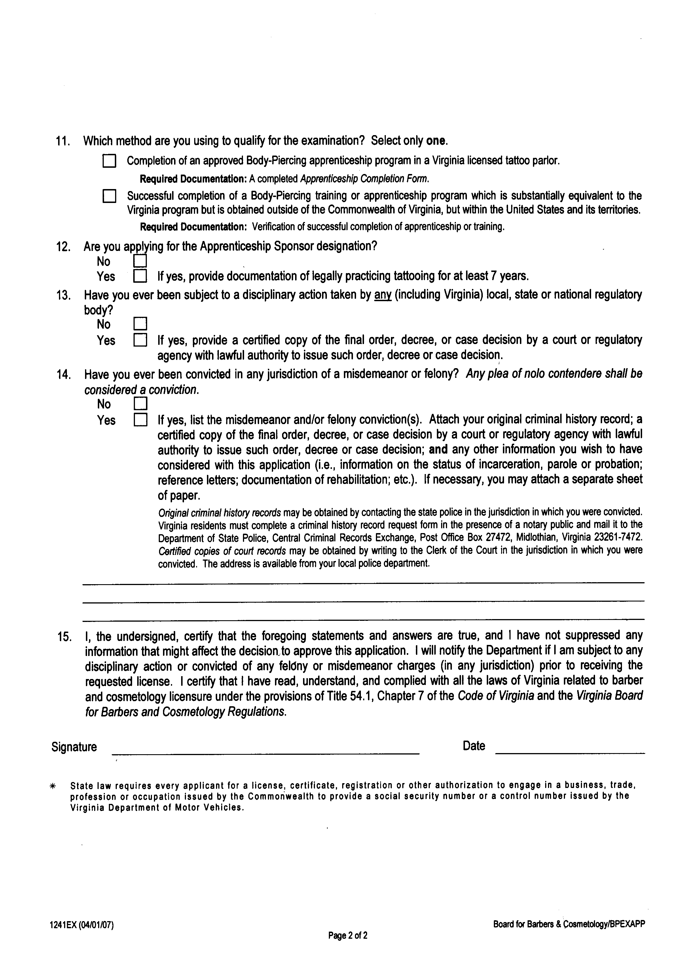
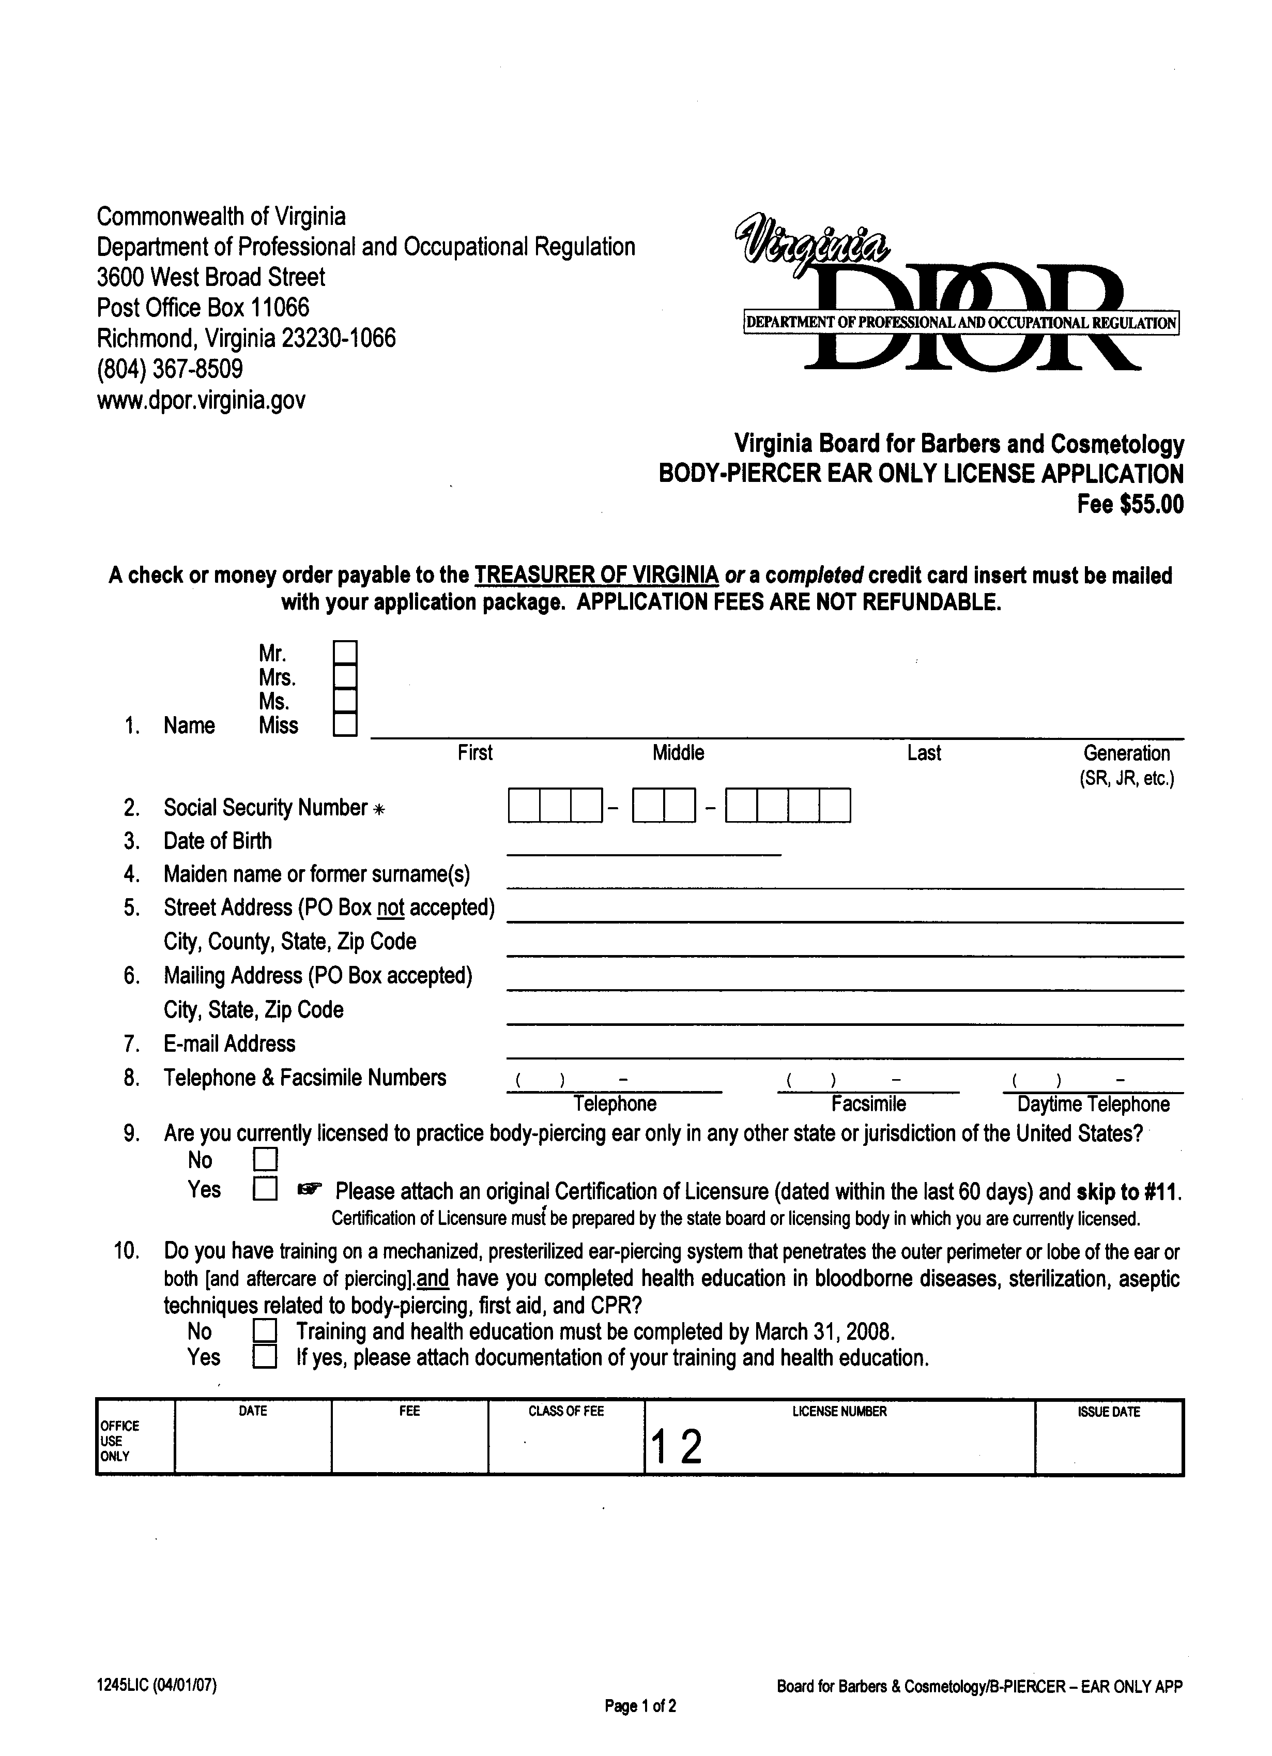
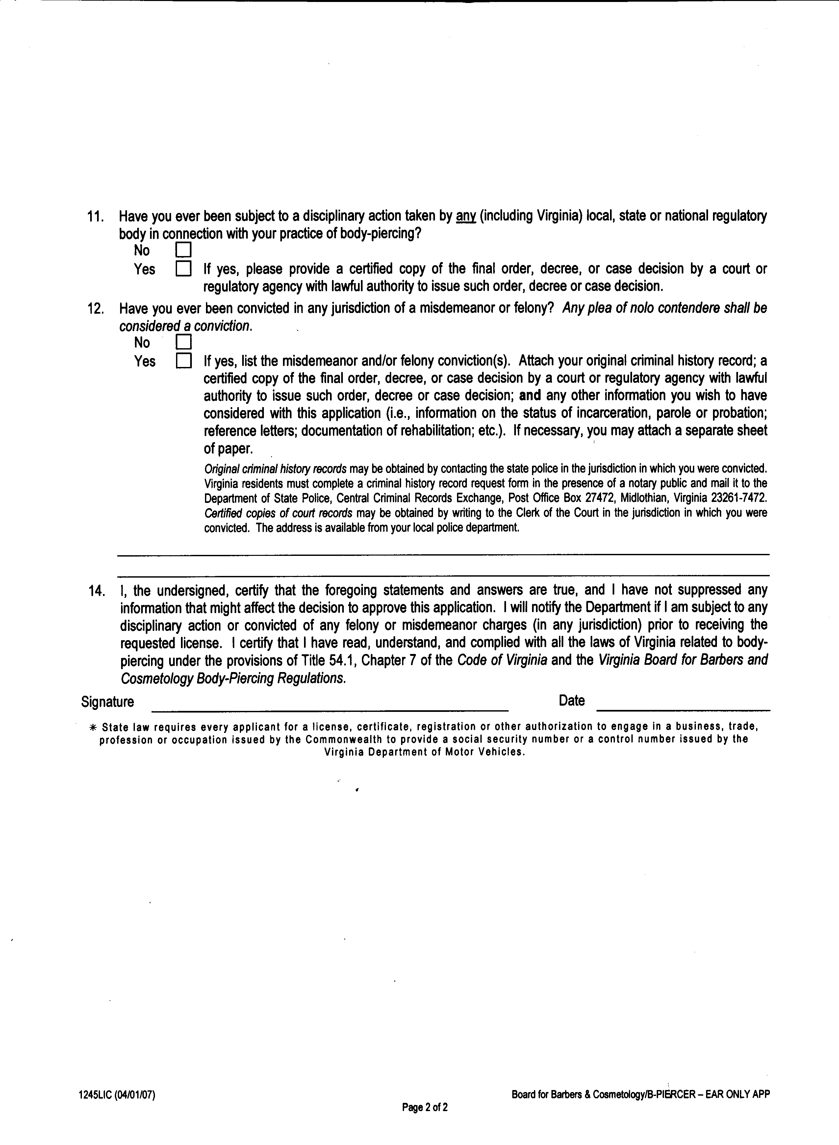
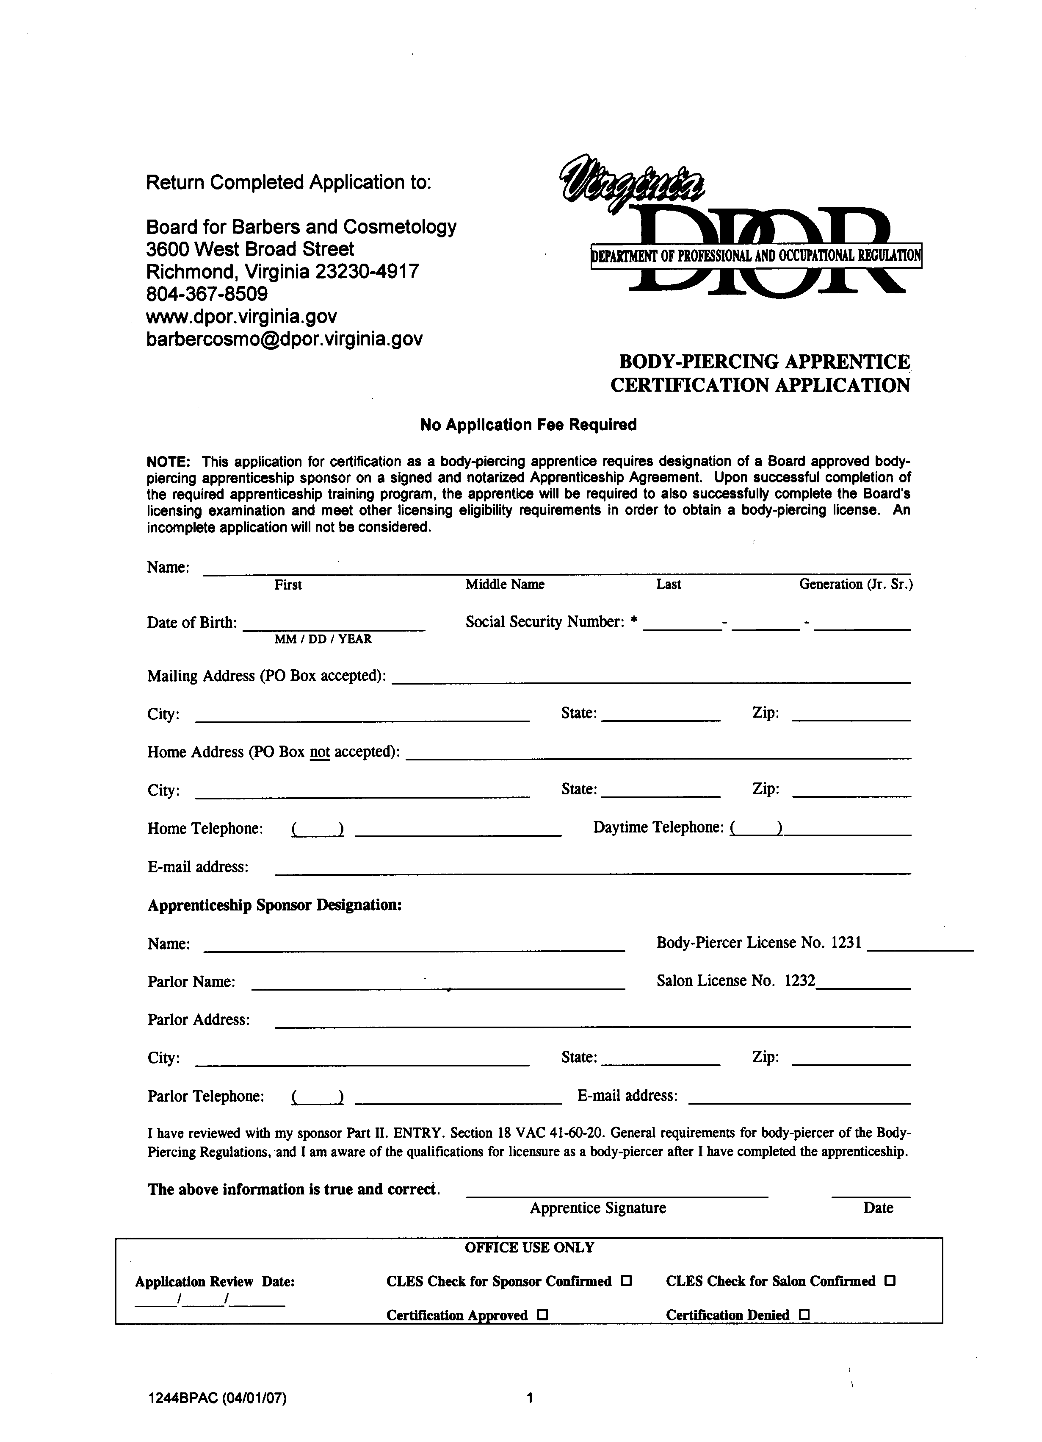
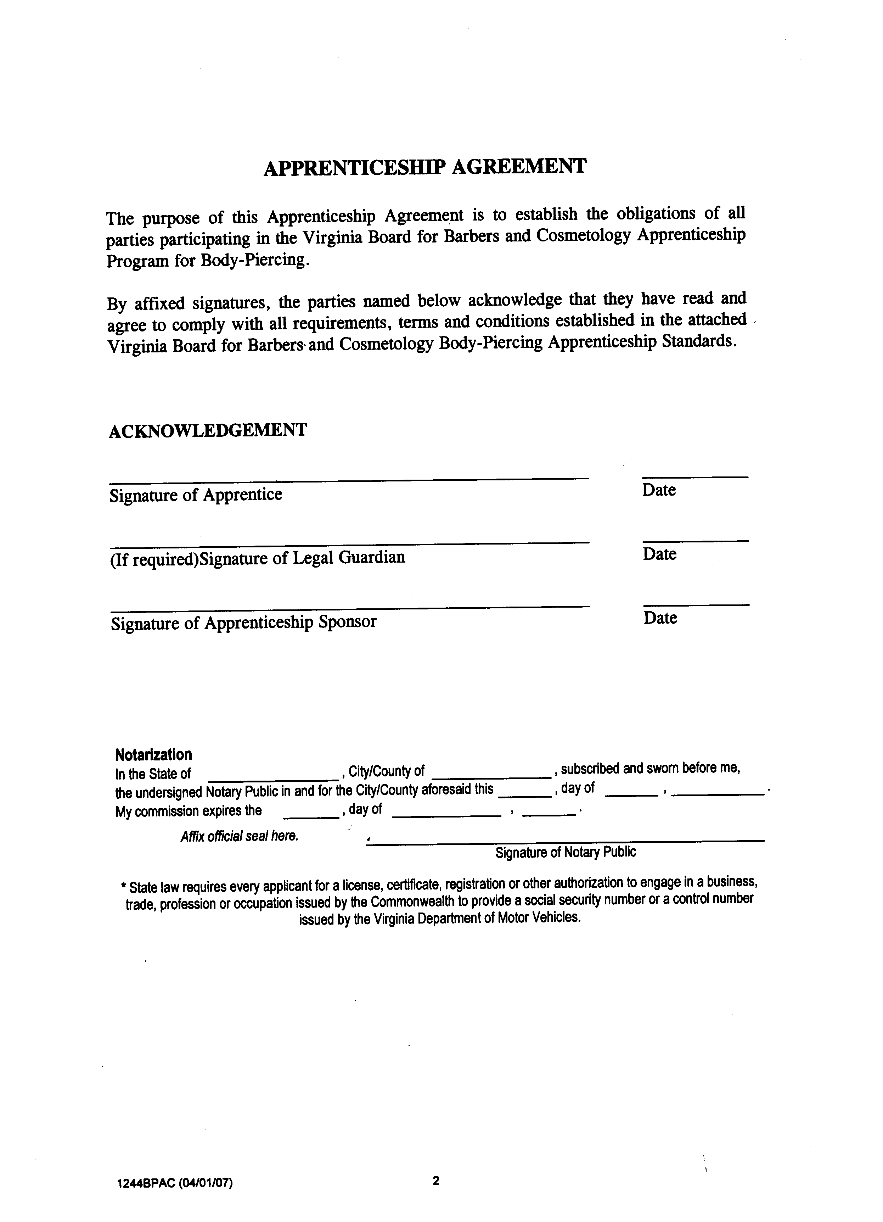
VA.R. Doc. No. R02-327; Filed January 31, 2007, 11:19 a.m.

