TITLE 13. HOUSING
BOARD OF HOUSING AND COMMUNITY DEVLOPMENT
Proposed Regulation
REGISTRAR'S NOTICE: The Board of Housing and Community Development is claiming an exemption from the Administrative Act pursuant to § 2.2-4006 A 13 of the Code of Virginia, which excludes regulations adopted by the Board of Housing and Community Development pursuant to the Statewide Fire Prevention Code (§ 27-94 et seq. of the Code of Virginia) and the Uniform Statewide Building Code (§ 36-97 et seq. of the Code of Virginia), provided the board (i) provides a Notice of Intended Regulatory Action in conformance with the provisions of § 2.2-4007 B, (ii) publishes the proposed regulation and provides an opportunity for oral and written comments as provided in § 2.2-4007 F, and (iii) conducts at least one public hearing as provided in §§ 2.2-4009 and 36-100 prior to the publishing of the proposed regulations.
Title of Regulation: 13 VAC 5-63. Virginia Uniform Statewide Building Code (amending 13 VAC 5-63-10, 13 VAC 5-63-20, 13 VAC 5-63-30, 13 VAC 5-63-40, 13 VAC 5-63-120, 13 VAC 5-63-130, 13 VAC 5-63-150, 13 VAC 5-63-190, 13 VAC 5-63-210, 13 VAC 5-63-220, 13 VAC 5-63-230, 13 VAC 5-63-240, 13 VAC 5-63-245, 13 VAC 5-63-250, 13 VAC 5-63-260, 13 VAC 5-63-270, 13 VAC 5-63-280, 13 VAC 5-63-310, 13 VAC 5-63-320, 13 VAC 5-63-330, 13 VAC 5-63-360, 13 VAC 5-63-400, 13 VAC 5-63-430, 13 VAC 5-63-434, 13 VAC 5-63-436, 13 VAC 5-63-437, 13 VAC 5-63-438, 13 VAC 5-63-440, 13 VAC 5-63-450, 13 VAC 5-63-470, 13 VAC 5-63-480, 13 VAC 5-63-500, 13 VAC 5-63-520; adding 13 VAC 5-63-335; repealing 13 VAC 5-63-225, 13 VAC 5-63-265, 13 VAC 5-63-432, 13 VAC 5-63-550).
Statutory Authority: § 36-98 of the Code of Virginia.
Public Hearing Date: July 24, 2007 - 10 a.m.
Public comments may be submitted until August 11, 2007.
(See Calendar of Events section for additional information)
Agency Contact: Vernon Hodge, Technical Services Manager, Department of Housing and Community Development, 501 North Second Street, Richmond, VA 23219, telephone (804) 371-7174, FAX (804) 371-7092, or email vernon.hodge@dhcd.virginia.gov.
Summary:
The proposed amendments to the regulation are categorized into three groups. The first group is amendments necessary to incorporate the newest editions of the nationally recognized model codes and standards into the regulation. These changes are located in 13 VAC 5-63-10, 13 VAC 5-63-210 G, 13 VAC 5-63-400 and 13 VAC 5-63-450. The newest editions of the model codes are the 2006 editions.
The second group of amendments is general clarifications and correlation changes. These amendments are to more closely match legislative language, to coordinate the application of the regulations with the other building and fire regulations of the board and to remove provisions in the existing USBC that have been successfully added to the latest model codes through the code changes process of the model code organization, thus eliminating the need for those changes in the USBC. This group of changes is located in 13 VAC 5-63-20, 13 VAC 5-63-30, 13 VAC 5-63-40, 13 VAC 5-63-210, 13 VAC 5-63-220, 13 VAC 6-63-240, 13 VAC 5-63-245, 13 VAC 5-63-250, 13 VAC 5-63-265, 13 VAC 5-63-270, 13 VAC 5-63-280, 13 VAC 5-63-310, 13 VAC 5-63-320, 13 VAC 5-63-330, 13 VAC 5-63-360, 13 VAC 5-63-400, 13 VAC 5-63-430, 13 VAC 5-63-432, 13 VAC 5-63-434, 13 VAC 5-63-436, 13 VAC 5-63-438, 13 VAC 5-63-450, 13 VAC 5-63-480, 13 VAC 5-63-520 and 13 VAC 5-63-550.
The third group of amendments consists of a number of changes that were considered by committees or by client groups to reach a degree of consensus enabling their inclusion in the proposed regulation. This group of amendments is summarized by section number as follows:
13 VAC 5-63-30 L limits the instances where building permits can be withheld to the functional design requirements of other departments or agencies.
13 VAC 5-63-130 J establishes minimum criteria for third-party inspector policies of the local building departments.
13 VAC 5-63-150 C requires the building owner to request documentation of the existence of violations after the statute of limitations time period expires.
13 VAC 5-63-190 E and 13 VAC 5-63-500 E change the time frame for filing an appeal of the local building department’s application of the code to 30 days for construction issues and 14 days for maintenance issues.
13 VAC 5-63-210 F permits bed and breakfast-type occupancies having up to 10 occupants total to be classified as a single-family dwelling.
13 VAC 5-63-210 K 22 maintains the standards for concrete and masonry foundation walls for single-family dwellings consistent with the existing provisions instead of using the newest model code provisions.
13 VAC 5-63-210 K 28 establishes new standards for wall bracing in single-family dwelling construction that facilitate ease in application.
13 VAC 5-63-320 B removes a prohibition from the use of plumbing drainage piping in exposed ceiling areas in food service establishments.
13 VAC 5-63-335 establishes standards for the construction of public swimming pools.
PART I.
CONSTRUCTION.
13 VAC 5-63-10. Chapter 1 Administration; Section 101 General.
A. Section 101.1 Short title. The Virginia Uniform Statewide Building Code, Part I, Construction, may be cited as the Virginia Construction Code. The term "USBC" shall mean the Virginia Construction Code unless the context in which the term is used clearly indicates it to be an abbreviation for the entire Virginia Uniform Statewide Building Code or for a different part of the Virginia Uniform Statewide Building Code.
B. Section 101.2 Incorporation by reference. Chapters 2 - 35 of the 2003 2006 International Building Code, published by the International Code Council, Inc., are adopted and incorporated by reference to be an enforceable part of the USBC. The term "IBC" means the 2003 2006 International Building Code, published by the International Code Council, Inc. Any codes and standards referenced in the IBC are also considered to be part of the incorporation by reference, except that such codes and standards are used only to the prescribed extent of each such reference. In addition, any provisions of the appendices of the IBC specifically identified to be part of the USBC are also considered to be part of the incorporation by reference.
Note 1: The IBC references the whole family of International Codes including the following major codes:
2003 2006 International Plumbing Code
2003 2006 International Mechanical Code
2002 2005 National Electrical Code
2003 2006 International Fuel Gas Code
2003 2006 International Energy Conservation Code
2003 2006 International Residential Code
Note 2: The International Residential Code is applicable to the construction of detached one- and two-family dwellings and townhouses as set out in Section 310.
C. Section 101.3 Numbering system. A dual numbering system is used in the USBC to correlate the numbering system of the Virginia Administrative Code with the numbering system of the IBC. IBC numbering system designations are provided in the catchlines of the Virginia Administrative Code sections. Cross references between sections or chapters of the USBC use only the IBC numbering system designations. The term "chapter" is used in the context of the numbering system of the IBC and may mean a chapter in the USBC, a chapter in the IBC or a chapter in a referenced code or standard, depending on the context of the use of the term. The term "chapter" is not used to designate a chapter of the Virginia Administrative Code, unless clearly indicated.
D. Section 101.4 Arrangement of code provisions. The USBC is comprised of the combination of (i) the provisions of Chapter 1, Administration, which are established herein, (ii) Chapters 2 - 35 of the IBC, which are incorporated by reference in Section 101.2, and (iii) the changes to the text of the incorporated chapters of the IBC that are specifically identified. The terminology "changes to the text of the incorporated chapters of the IBC that are specifically identified" shall also be referred to as the "state amendments to the IBC." Such state amendments to the IBC are set out using corresponding chapter and section numbers of the IBC numbering system. In addition, since Chapter 1 of the IBC is not incorporated as part of the USBC, any reference to a provision of Chapter 1 of the IBC in the provisions of Chapters 2 - 35 of the IBC is generally invalid. However, where the purpose of such a reference would clearly correspond to a provision of Chapter 1 established herein, then the reference may be construed to be a valid reference to such corresponding Chapter 1 provision.
E. Section 101.5 Use of terminology and notes. The term "this code," or "the code," where used in the provisions of Chapter 1, in Chapters 2 - 35 of the IBC or in the state amendments to the IBC means the USBC, unless the context clearly indicates otherwise. The term "this code" or "the code" where used in a code or standard referenced in the IBC means that code or standard, unless the context clearly indicates otherwise. The use of notes in Chapter 1 is to provide information only and shall not be construed as changing the meaning of any code provision. Notes in the IBC, in the codes and standards referenced in the IBC and in the state amendments to the IBC may modify the content of a related provision and shall be considered to be a valid part of the provision, unless the context clearly indicates otherwise.
F. Section 101.6 Order of precedence. The provisions of Chapter 1 of this code supersede any conflicting provisions of Chapters 2 - 35 of the IBC and any conflicting provisions of the codes and standards referenced in the IBC. In addition, the state amendments to the IBC supersede any conflicting provisions of Chapters 2 - 35 of the IBC and any conflicting provisions of the codes and standards referenced in the IBC. Further, the provisions of Chapters 2 - 35 of the IBC supersede any conflicting provisions of the codes and standards referenced in the IBC.
G. Section 101.7 Administrative provisions. The provisions of Chapter 1 establish administrative requirements, which include but are not limited to provisions relating to the scope of the code, enforcement, fees, permits, inspections and disputes. Any provisions of Chapters 2 - 35 of the IBC or any provisions of the codes and standards referenced in the IBC that address the same subject matter and impose differing requirements are deleted and replaced by the provisions of Chapter 1. Further, any administrative requirements contained in the state amendments to the IBC shall be given the same precedence as the provisions of Chapter 1. Notwithstanding the above, where administrative requirements of Chapters 2 - 35 of the IBC or of the codes and standards referenced in the IBC are specifically identified as valid administrative requirements in Chapter 1 of this code or in the state amendments to the IBC, then such requirements are not deleted and replaced.
Note: The purpose of this provision is to eliminate overlap, conflicts and duplication by providing a single standard for administrative, procedural and enforcement requirements of this code.
H. Section 101.8 Definitions. The definitions of terms used in this code are contained in Chapter 2 along with specific provisions addressing the use of definitions. Terms may be defined in other chapters or provisions of the code and such definitions are also valid.
Note: The order of precedence outlined in Section 101.6 may be determinative in establishing how to apply the definitions in the IBC and in the referenced codes and standards.
13 VAC 5-63-20. Section 102 Purpose and scope.
A. Section 102.1 Purpose. In accordance with § 36-99 of the Code of Virginia, the purpose of the USBC is to protect the health, safety and welfare of the residents of the Commonwealth of Virginia, provided that buildings and structures should be permitted to be constructed at the least possible cost consistent with recognized standards of health, safety, energy conservation and water conservation, including provisions necessary to prevent overcrowding, rodent or insect infestation, and garbage accumulation; and barrier-free provisions for the physically handicapped and aged.
B. Section 102.2 Scope. This section establishes the scope of the USBC in accordance with § 36-98 of the Code of Virginia. The USBC shall supersede the building codes and regulations of the counties, municipalities and other political subdivisions and state agencies. This code also shall supersede the provisions of local ordinances applicable to single-family residential construction that (i) regulate dwelling foundations or crawl spaces, (ii) require the use of specific building materials or finishes in construction, or (iii) require minimum surface area or numbers of windows; however, this code shall not supersede proffered conditions accepted as a part of a rezoning application, conditions imposed upon the grant of special exceptions, special or conditional use permits or variances, conditions imposed upon a clustering of single-family homes and preservation of open space development through standards, conditions, and criteria established by a locality pursuant to subdivision 8 of § 15.2-2242 of the Code of Virginia or subdivision A 12 of § 15.2-2286 of the Code of Virginia, or land use requirements in airport or highway overlay districts, or historic districts created pursuant to § 15.2-2306 of the Code of Virginia, or local flood plain regulations adopted as a condition of participation in the National Flood Insurance Program.
Note: Requirements relating to functional design are contained in Section 103.11 of this code.
C. Section 102.2.1 Invalidity of provisions. To the extent that any provisions of this code are in conflict with Chapter 6 (§ 36-97 et seq.) of Title 36 of the Code of Virginia or in conflict with the scope of the USBC, those provisions are considered to be invalid to the extent of such conflict.
D. Section 102.3 Exemptions. The following are exempt from this code:
1. Equipment and related wiring installed by a provider of publicly regulated utility service or a franchised cable television operator and electrical equipment and related wiring used for radio, broadcast or cable television, telecommunications or information service transmission. The exemption shall apply only if under applicable federal and state law the ownership and control of the equipment and wiring is by the service provider or its affiliates. Such exempt equipment and wiring shall be located on either public rights-of-way or private property for which the service provider has rights of occupancy and entry; however, the structures, including their service equipment, housing or supporting such exempt equipment and wiring shall be subject to the USBC. The installation of equipment and wiring exempted by this section shall not create an unsafe condition prohibited by the USBC.
2. Manufacturing and processing machines, including all of the following service equipment associated with the manufacturing or processing machines.
2.1. Electrical equipment connected after the last disconnecting means.
2.2. Plumbing piping and equipment connected after the last shutoff valve or backflow device and before the equipment drain trap.
2.3. Gas piping and equipment connected after the outlet shutoff valve.
3. Parking lots and sidewalks, which are not part of an accessible route.
4. Nonmechanized playground or recreational equipment such as swing sets, sliding boards, climbing bars, jungle gyms, skateboard ramps, and similar equipment when such equipment is not regulated by the VADR where no admission fee is charged for its use or for admittance to areas where the equipment is located.
5. Industrialized buildings subject to the Virginia Industrialized Building Safety Regulations (13 VAC 5-91) and manufactured homes subject to the Virginia Manufactured Home Safety Regulations (13 VAC 5-95); except, the applicable requirements of this code affecting site preparation, footings, foundations, proper anchoring and utility connections of the unit remain in full force and effect, including requirements for issuing permits and certificates of occupancy as provided for in Section 421.
6. Manufactured homes, except the applicable requirements of this code affecting site preparation, skirting installation, footings, foundations, proper anchoring and utility connections of the manufactured home remain in full force and effect, including requirements for issuing permits and certificates of occupancy.
7. 6. Farm buildings and structures, except for a building or a portion of a building located on a farm that is operated as a restaurant as defined in § 35.1-1 of the Code of Virginia and licensed as such by the Virginia Board of Health pursuant to Chapter 2 (§ 35.1-11 et seq.) of Title 35.1 of the Code of Virginia. However, farm buildings and structures lying within a flood plain or in a mudslide-prone area shall be subject to flood-proofing regulations or mudslide regulations, as applicable.
13 VAC 5-63-30. Section 103 Application of code.
A. Section 103.1 General. In accordance with § 36-99 of the Code of Virginia, the USBC shall prescribe building regulations to be complied with in the construction and rehabilitation of buildings and structures, and the equipment therein.
B. Section 103.2 When applicable to new construction. Construction for which a permit application is submitted to the local building department after November 16, 2005 (insert effective date) , shall comply with the provisions of this code, except for permit applications submitted during a one-year period after November 16, 2005 (insert effective date). The applicant for a permit during such one-year period shall be permitted to choose whether to comply with the provisions of this code or the provisions of the code in effect immediately prior to November 16, 2005 (insert effective date). This provision shall also apply to subsequent amendments to this code based on the effective date of such amendments. In addition, when a permit has been properly issued under a previous edition of this code, this code shall not require changes to the approved construction documents, design or construction of such a building or structure, provided the permit has not been suspended or revoked.
C. Section 103.3 Change of occupancy. No change shall be made in the existing occupancy classification of any structure when the current USBC requires a greater degree of structural strength, fire protection, means of egress, ventilation or sanitation. When such a greater degree is required, the owner or the owner's agent shall make written application to the local building department for a new certificate of occupancy and shall obtain the new certificate of occupancy prior to the use of the structure under the new occupancy classification. When impractical to achieve compliance with this code for the new occupancy classification, the building official shall consider modifications upon application and as provided for in Section 106.3.
Exception: This section shall not be construed to permit noncompliance with any applicable flood load or flood-resistant construction requirements of this code.
D. Section 103.4 Additions. Additions to buildings and structures shall comply with the requirements of this code for new construction and an existing building or structure plus additions shall comply with the height and area provisions of Chapter 5. Further, this code shall not require changes to the design or construction of any portions of the building or structure not altered or affected by an addition, unless the addition has the effect of lowering the current level of safety.
Exception: This section shall not be construed to permit noncompliance with any applicable flood load or flood-resistant construction requirements of this code.
E. Section 103.5 Reconstruction, alteration or repair. The following criteria is applicable to reconstruction, alteration or repair of buildings or structures provided the reconstruction, alteration or repair does not adversely affect the performance of the building or structure, cause the building or structure to become unsafe or lower existing levels of health and safety.
1. Parts of the building or structure not being reconstructed, altered or repaired shall not be required to comply with the requirements of this code applicable to newly constructed buildings or structures.
2. The installation of material or equipment, or both, that is neither required nor prohibited shall only be required to comply with the provisions of this code relating to the safe installation of such material or equipment.
3. Material or equipment, or both, may be replaced in the same location with material or equipment of a similar kind or capacity.
Exception: This section shall not be construed to permit noncompliance with any applicable flood load or flood-resistant construction requirements of this code.
F. Section 103.6. Use of rehabilitation code. Compliance with Part II of the Virginia Uniform Statewide Building Code, also known as the "Virginia Rehabilitation Code," shall be an acceptable alternative to compliance with this code for the rehabilitation of such existing buildings and structures within the scope of that code. For the purposes of this section, the term "rehabilitation" shall be as defined in the Virginia Rehabilitation Code.
G. Section 103.7. Retrofit requirements. The local building department shall enforce the provisions of Section 3411, which require certain existing buildings to be retrofitted with fire protection systems and other safety equipment. Retroactive fire protection system requirements contained in the International Fire Code shall not be applicable unless required for compliance with the provisions of Section 3411.
H. Section 103.8 Nonrequired equipment. The following criteria for nonrequired equipment is in accordance with § 36-103 of the Code of Virginia. Building owners may elect to install partial or full fire alarms or other safety equipment that was not required by the edition of the USBC in effect at the time a building was constructed without meeting current requirements of the code, provided the installation does not create a hazardous condition. Permits for installation shall be obtained in accordance with this code. In addition, as a requirement of this code, when such nonrequired equipment is to be installed, the building official shall notify the appropriate fire official or fire chief.
I. Section 103.8.1 Reduction in function or discontinuance of nonrequired fire protection systems. When a nonrequired fire protection system is to be reduced in function or discontinued, it shall be done in such a manner so as not to create a false sense of protection. Generally, in such cases, any features visible from interior areas shall be removed, such as sprinkler heads, smoke detectors or alarm panels or devices, but any wiring or piping hidden within the construction of the building may remain. Approval of the proposed method of reduction or discontinuance shall be obtained from the building official.
J. Section 103.9 Equipment changes. Upon the replacement or new installation of any fuel-burning appliances or equipment in existing buildings, an inspection or inspections shall be conducted to ensure that the connected vent or chimney systems comply with the following:
1. Vent or chimney systems are sized in accordance with either the International Residential Code, the International Mechanical Code or the International Fuel Gas Code, depending on which is applicable based on the fuel source and the occupancy classification of the structure.
2. Vent or chimney systems are clean, free of any obstruction or blockages, defects or deterioration and are in operable condition.
Where not inspected by the local building department, persons performing such changes or installations shall certify to the building official that the requirements of Items 1 and 2 of this section are met.
K. Section 103.10 Use of certain provisions of referenced codes. The following provisions of the IBC and of other indicated codes or standards are to be considered valid provisions of this code. Where any such provisions have been modified by the state amendments to the IBC, then the modified provisions apply.
1. Special inspection requirements in Chapters 2 - 35.
2. Chapter 34, Existing Structures, except that Section 3410, Compliance Alternatives, shall not be used to comply with the retrofit requirements identified in Section 103.7 and shall not be construed to permit noncompliance with any applicable flood load or flood-resistant construction requirements of this code.
3. Testing requirements and requirements for the submittal of construction documents in any of the ICC codes referenced in Chapter 35.
4. Section R301.2 of the International Residential Code authorizing localities to determine climatic and geographic design criteria.
5. Flood load or flood-resistant construction requirements in the IBC or the International Residential Code, including, but not limited to, any such provisions pertaining to flood elevation certificates that are located in Chapter 1 of those codes. Any required flood elevation certificate pursuant to such provisions shall be prepared by a land surveyor licensed in Virginia or an RDP.
L. Section 103.11 Functional design. The following criteria for functional design is in accordance with § 36-98 of the Code of Virginia. The USBC shall not supersede the regulations of other state agencies that require and govern the functional design and operation of building related activities not covered by the USBC, including but not limited to (i) public water supply systems, (ii) waste water treatment and disposal systems, (iii) solid waste facilities, nor shall state agencies be prohibited from requiring, pursuant to other state law, that buildings and equipment be maintained in accordance with provisions of this code. In addition, as established by this code, the building official may refuse to issue a permit until the applicant has supplied certificates of functional design approval from the appropriate state agency or agencies. For purposes of coordination, the locality may require reports to the building official by other departments or agencies indicating compliance with their regulations applicable to the functional design of a building or structure as a condition for issuance of a building permit or certificate of occupancy. Such reports shall be based upon review of the plans or inspection of the project as determined by the locality. All enforcement of these conditions shall not be the responsibility of the building official, but rather the agency imposing the condition.
Note: Identified state agencies with functional design approval are listed in the "Related Laws Package," which is available from DHCD.
M. Section 103.12 Amusement devices and inspections. In accordance with § 36-98.3 of the Code of Virginia, to the extent they are not superseded by the provisions of § 36-98.3 of the Code of Virginia and the VADR, the provisions of the USBC shall apply to amusement devices. In addition, as a requirement of this code, inspections for compliance with the VADR shall be conducted either by local building department personnel or private inspectors provided such persons are certified as amusement device inspectors under the VCS.
N. Section 103.13 State buildings and structures. This section establishes the application of the USBC to state-owned buildings and structures in accordance with § 36-98.1 of the Code of Virginia. The USBC shall be applicable to all state-owned buildings and structures, with the exception that §§ 2.2-1159, 2.2-1160 and 2.2-1161 of the Code of Virginia shall provide the standards for ready access to and use of state-owned buildings by the physically handicapped.
Any state-owned building or structure for which preliminary plans were prepared or on which construction commenced after the initial effective date of the USBC, shall remain subject to the provisions of the USBC that were in effect at the time such plans were completed or such construction commenced. Subsequent reconstruction, renovation or demolition of such building or structure shall be subject to the pertinent provisions of this code.
Acting through the Division of Engineering and Buildings, the Virginia Department of General Services shall function as the building official for state-owned buildings. The department shall review and approve plans and specifications, grant modifications, and establish such rules and regulations as may be necessary to implement this section. It shall provide for the inspection of state-owned buildings and enforcement of the USBC and standards for access by the physically handicapped by delegating inspection and USBC enforcement duties to the State Fire Marshal's Office, to other appropriate state agencies having needed expertise, and to local building departments, all of which shall provide such assistance within a reasonable time and in the manner requested. State agencies and institutions occupying buildings shall pay to the local building department the same fees as would be paid by a private citizen for the services rendered when such services are requested by the department. The department may alter or overrule any decision of the local building department after having first considered the local building department's report or other rationale given for its decision. When altering or overruling any decision of a local building department, the department shall provide the local building department with a written summary of its reasons for doing so.
Notwithstanding any provision of this code to the contrary, roadway tunnels and bridges owned by the Virginia Department of Transportation shall be exempt from this code. The Virginia Department of General Services shall not have jurisdiction over such roadway tunnels, bridges and other limited access highways; provided, however, that the Department of General Services shall have jurisdiction over any occupied buildings within any Department of Transportation rights-of-way that are subject to this code.
Except as provided in § 23-38.109 D of the Code of Virginia, and notwithstanding any provision of this code to the contrary, at the request of a public institution of higher education, the Virginia Department of General Services, as further set forth in this provision, shall authorize that institution of higher education to contract with a building official of the locality in which the construction is taking place to perform any inspection and certifications required for the purpose of complying with this code. The department shall publish administrative procedures that shall be followed in contracting with a building official of the locality. The authority granted to a public institution of higher education under this provision to contract with a building official of the locality shall be subject to the institution meeting the conditions prescribed in § 23-38.88 B of the Code of Virginia.
Note: In accordance with § 36-98.1 of the Code of Virginia, roadway tunnels and bridges shall be designed, constructed and operated to comply with fire safety standards based on nationally recognized model codes and standards to be development developed by the Virginia Department of Transportation in consultation with the State Fire Marshal and approved by the Virginia Commonwealth Transportation Board. Emergency response planning and activities related to the standards approved by the Commonwealth Transportation Board shall be developed by the Department of Transportation and coordinated with the appropriate local officials and emergency service providers. On an annual basis, the Department of Transportation shall provide a report on the maintenance and operability of installed fire protection and detection systems in roadway tunnels and bridges to the State Fire Marshal.
13 VAC 5-63-40. Section 104 Enforcement, generally.
A. Section 104.1 Scope of enforcement. This section establishes the requirements for enforcement of the USBC in accordance with § 36-105 of the Code of Virginia. Enforcement of the provisions of the USBC for construction and rehabilitation shall be the responsibility of the local building department. Whenever a county or municipality does not have such a building department, the local governing body shall enter into an agreement with the local governing body of another county or municipality or with some other agency, or a state agency approved by DHCD for such enforcement. For the purposes of this section, towns with a population of less than 3,500 may elect to administer and enforce the USBC; however, where the town does not elect to administer and enforce the code, the county in which the town is situated shall administer and enforce the code for the town. In the event such town is situated in two or more counties, those counties shall administer and enforce the USBC for that portion of the town that is situated within their respective boundaries.
The local governing body shall inspect and enforce this code for elevators except for elevators in single and two-family homes and townhouses. Such inspection and enforcement shall be carried out by an agency or department designated by the local governing body.
Upon a finding by the local building department, following a complaint by a tenant of a residential rental unit that is the subject of such complaint, that there may be a violation of the unsafe structures provisions of the code, Part III of the Virginia Uniform Statewide Building Code, also known as the “Virginia Maintenance Code,” the local building department shall enforce such provisions.
If the local building department receives a complaint that a violation of the USBC Virginia Maintenance Code exists that is an immediate and imminent threat to the health or safety of the owner or tenant of a residential dwelling unit or a nearby residential dwelling unit, and the owner or tenant of the residential dwelling unit that is the subject of the complaint has refused to allow the local building official or his agent to have access to the subject dwelling, the local building official or his agent may present sworn testimony to a court of competent jurisdiction and request that the court grant the local building official or his agent an inspection warrant to enable the building official or his agent to enter the subject dwelling for the purpose of determining whether violations of the USBC Virginia Maintenance Code exist. The local building official or his agent shall make a reasonable effort to obtain consent from the owner or tenant of the subject dwelling prior to seeking the issuance of an inspection warrant under this section.
Note: The maintenance requirements for elevators and the provisions regulating existing unsafe buildings and structures are contained in Part III of the Virginia Uniform Statewide Building Code, also known as the "Virginia Maintenance Code." The local governing body shall inspect and enforce the provisions of the Virginia Maintenance Code for elevators except for elevators in single and two-family homes and townhouses. Such inspection and enforcement shall be carried out by an agency or department designated by the local governing body.
B. Section 104.1.1 Rental inspections. In accordance with § 36-105.1:1 of the Code of Virginia, this section is applicable to rental inspection programs. For purposes of this section:
"Dwelling unit" means a building or structure or part thereof that is used for a home or residence by one or more persons who maintain a household.
"Owner" means the person shown on the current real estate assessment books or current real estate assessment records.
"Residential rental dwelling unit" means a dwelling unit that is leased or rented to one or more tenants. However, a dwelling unit occupied in part by the owner thereof shall not be construed to be a residential rental dwelling unit unless a tenant occupies a part of the dwelling unit which has its own cooking and sleeping areas, and a bathroom, unless otherwise provided in the zoning ordinance by the local governing body.
The local governing body may adopt an ordinance to inspect residential rental dwelling units for compliance with the USBC and to promote safe, decent and sanitary housing for its citizens, in accordance with the following:
1. Except as provided for in subdivision 3 of this subsection, the dwelling units shall be located in a rental inspection district established by the local governing body in accordance with this section; and
2. The rental inspection district is based upon a finding by the local governing body that (i) there is a need to protect the public health, safety and welfare of the occupants of dwelling units inside the designated rental inspection district; (ii) the residential rental dwelling units within the designated rental inspection district are either (a) blighted or in the process of deteriorating or (b) the residential rental dwelling units are in the need of inspection by the building department to prevent deterioration, taking into account the number, age and condition of residential dwelling rental units inside the proposed rental inspection district; and (iii) the inspection of residential rental dwelling units inside the proposed rental inspection district is necessary to maintain safe, decent and sanitary living conditions for tenants and other residents living in the proposed rental inspection district. Nothing in this section shall be construed to authorize a locality-wide rental inspection district and a local governing body shall limit the boundaries of the proposed rental inspection district to such areas of the locality that meet the criteria set out in this subsection; or
3. An individual residential rental dwelling unit outside of a designated rental inspection district is made subject to the rental inspection ordinance based upon a separate finding for each individual dwelling unit by the local governing body that (i) there is a need to protect the public health, welfare and safety of the occupants of that individual dwelling unit; (ii) the individual dwelling unit is either (a) blighted or (b) in the process of deteriorating; or (iii) there is evidence of violations of the USBC that affect the safe, decent and sanitary living conditions for tenants living in such individual dwelling unit.
For purposes of this section, the local governing body may designate a local government agency other than the building department to perform all or part of the duties contained in the enforcement authority granted to the building department by this section.
Before adopting a rental inspection ordinance and establishing a rental inspection district or an amendment to either, the governing body of the locality shall hold a public hearing on the proposed ordinance. Notice of the hearing shall be published once a week for two successive weeks in a newspaper published or having general circulation in the locality.
Upon adoption by the local governing body of a rental inspection ordinance, the building department shall make reasonable efforts to notify owners of residential rental dwelling units in the designated rental inspection district, or their designated managing agents, and to any individual dwelling units subject to the rental inspection ordinance, not located in a rental inspection district, of the adoption of such ordinance, and provide information and an explanation of the rental inspection ordinance and the responsibilities of the owner thereunder.
The rental inspection ordinance may include a provision that requires the owners of dwelling units in a rental inspection district to notify the building department in writing if the dwelling unit of the owner is used for residential rental purposes. The building department may develop a form for such purposes. The rental inspection ordinance shall not include a registration requirement or a fee of any kind associated with the written notification pursuant to this subdivision. A rental inspection ordinance may not require that the written notification from the owner of a dwelling unit subject to a rental inspection ordinance be provided to the building department in less than 60 days after the adoption of a rental inspection ordinance. However, there shall be no penalty for the failure of an owner of a residential rental dwelling unit to comply with the provisions of this subsection, unless and until the building department provides personal or written notice to the property owner, as provided in this section. In any event, the sole penalty for the willful failure of an owner of a dwelling unit who is using the dwelling unit for residential rental purposes to comply with the written notification requirement shall be a civil penalty of up to $50. For purposes of this subsection, notice sent by regular first class mail to the last known address of the owner as shown on the current real estate tax assessment books or current real estate tax assessment records shall be deemed compliance with this requirement.
Upon establishment of a rental inspection district in accordance with this section, the building department may, in conjunction with the written notifications as provided for above, proceed to inspect dwelling units in the designated rental inspection district to determine if the dwelling units are being used as a residential rental property and for compliance with the provisions of the USBC that affect the safe, decent and sanitary living conditions for the tenants of such property.
If a multifamily development has more than 10 dwelling units, in the initial and periodic inspections, the building department shall inspect only a sampling of dwelling units, of not less than two and not more than 10% of the dwelling units, of a multifamily development, that includes all of the multifamily buildings that are part of that multifamily development. In no event, however, shall the building department charge a fee authorized by this section for inspection of more than 10 dwelling units. If the building department determines upon inspection of the sampling of dwelling units that there are violations of the USBC that affect the safe, decent and sanitary living conditions for the tenants of such multifamily development, the building department may inspect as many dwelling units as necessary to enforce the USBC, in which case, the fee shall be based upon a charge per dwelling unit inspected, as otherwise provided in the fee schedule established pursuant to this section.
Upon the initial or periodic inspection of a residential rental dwelling unit subject to a rental inspection ordinance, the building department has the authority under the USBC to require the owner of the dwelling unit to submit to such follow-up inspections of the dwelling unit as the building department deems necessary, until such time as the dwelling unit is brought into compliance with the provisions of the USBC that affect the safe, decent and sanitary living conditions for the tenants.
Except as provided for above, following the initial inspection of a residential rental dwelling unit subject to a rental inspection ordinance, the building department may inspect any residential rental dwelling unit in a rental inspection district, that is not otherwise exempted in accordance with this section, no more than once each calendar year.
Upon the initial or periodic inspection of a residential rental dwelling unit subject to a rental inspection ordinance for compliance with the USBC, provided that there are no violations of the USBC that affect the safe, decent and sanitary living conditions for the tenants of such residential rental dwelling unit, the building department shall provide, to the owner of such residential rental dwelling unit, an exemption from the rental inspection ordinance for a minimum of four years. Upon the sale of a residential rental dwelling unit, the building department may perform a periodic inspection as provided above, subsequent to such sale. If a residential rental dwelling unit has been issued a certificate of occupancy within the last four years, an exemption shall be granted for a minimum period of four years from the date of the issuance of the certificate of occupancy by the building department. If the residential rental dwelling unit becomes in violation of the USBC during the exemption period, the building department may revoke the exemption previously granted under this section.
A local governing body may establish a fee schedule for enforcement of the USBC, which includes a per dwelling unit fee for the initial inspections, follow-up inspections and periodic inspections under this section.
The provisions of this section shall not in any way alter the rights and obligations of landlords and tenants pursuant to the applicable provisions of Chapter 13 (§ 55-217 et seq.) or Chapter 13.2 (§ 55-248.2 et seq.) of Title 55 of the Code of Virginia.
The provisions of this section shall not alter the duties or responsibilities of the local building department under § 36-105 of the Code of Virginia to enforce the Building Code.
Unless otherwise provided for in § 36-105.1:1 of the Code of Virginia, penalties for violation of this section shall be the same as the penalties provided for violations of other sections of the USBC.
C. B. Section 104.2 Interagency coordination. When any inspection functions under this code are assigned to a local agency other than the local building department, such agency shall coordinate its reports of inspection with the local building department.
D. C. 104.3 Transfer of ownership. If the local building department has initiated an enforcement action against the owner of a building or structure and such owner subsequently transfers the ownership of the building or structure to an entity in which the owner holds an ownership interest greater than 50%, the pending enforcement action shall continue to be enforced against the owner.
13 VAC 5-63-120. Section 112 Workmanship, materials and equipment.
A. Section 112.1 General. It shall be the duty of any person performing work covered by this code to comply with all applicable provisions of this code and to perform and complete such work so as to secure the results intended by the USBC.
B. Section 112.2 Alternative methods or materials. In accordance with § 36-99 of the Code of Virginia, where practical, the provisions of this code are stated in terms of required level of performance so as to facilitate the prompt acceptance of new building materials and methods. When generally recognized standards of performance are not available, this section and other applicable requirements of this code provide for acceptance of materials and methods whose performance is substantially equal in safety to those specified on the basis of reliable test and evaluation data presented by the proponent. In addition, as a requirement of this code, the building official shall require that sufficient technical data be submitted to substantiate the proposed use of any material, equipment, device, assembly or method of construction.
C. Section 112.3 Documentation and approval. In determining whether any material, equipment, device, assembly or method of construction complies with this code, the building official shall approve items listed by nationally recognized testing laboratories (NRTL), when such items are listed for the intended use and application, and in addition, may consider the recommendations of RDPs. Approval shall be issued when the building official finds that the proposed design is satisfactory and complies with the intent of the provisions of this code and that the material, equipment, device, assembly or method of construction offered is, for the purpose intended, at least the equivalent of that prescribed by the code in quality, strength, effectiveness, fire resistance, durability and safety. Such approval is subject to all applicable requirements of this code and the material, equipment, device, assembly or method of construction shall be installed in accordance with the conditions of the approval and their listings. In addition, the building official may revoke such approval whenever it is discovered that such approval was issued in error or on the basis of incorrect information, or where there are repeated violations of the USBC.
D. Section 112.3.1 Conditions of listings. Where conflicts between this code and conditions of the listing or the manufacturer's installation instructions occur, the provisions of this code shall apply.
Exception: Where a code provision is less restrictive than the conditions of the listing of the equipment or appliance or the manufacturer's installation instructions, the conditions of the listing and the manufacturer's installation instructions shall apply.
E. Section 112.4 Used material and equipment. Used materials, equipment and devices may be approved provided they have been reconditioned, tested or examined and found to be in good and proper working condition and acceptable for use by the building official.
13 VAC 5-63-130. Section 113 Inspections.
A. Section 113.1 General. In accordance with § 36-105 of the Code of Virginia, any building or structure may be inspected at any time before completion, and shall not be deemed in compliance until approved by the inspecting authority. Where the construction cost is less than $2,500, however, the inspection may, in the discretion of the inspecting authority, be waived. The building official shall coordinate all reports of inspections for compliance with the USBC, with inspections of fire and health officials delegated such authority, prior to the issuance of an occupancy permit.
B. Section 113.1.1 Equipment required. Any ladder, scaffolding or test equipment necessary to conduct or witness a requested inspection shall be provided by the permit holder.
C. Section 113.1.2 Duty to notify. When construction reaches a stage of completion that requires an inspection, the permit holder shall notify the building official.
D. Section 113.1.3 Duty to inspect. Except as provided for in Section 113.7, the building official shall perform the requested inspection in accordance with Section 113.6 when notified in accordance with Section 113.1.2.
E. Section 113.2 Prerequisites. The building official may conduct a site inspection prior to issuing a permit. When conducting inspections pursuant to this code, all personnel shall carry proper credentials.
F. Section 113.3 Minimum inspections. The following minimum inspections shall be conducted by the building official when applicable to the construction or permit:
1. Inspection of footing excavations and reinforcement material for concrete footings prior to the placement of concrete.
2. Inspection of foundation systems during phases of construction necessary to assure compliance with this code.
3. Inspection of preparatory work prior to the placement of concrete.
4. Inspection of structural members and fasteners prior to concealment.
5. Inspection of electrical, mechanical and plumbing materials, equipment and systems prior to concealment.
6. Inspection of energy conservation material prior to concealment.
7. Final inspection.
G. Section 113.4 Additional inspections. The building official may designate additional inspections and tests to be conducted during the construction of a building or structure and shall so notify the permit holder.
H. Section 113.5 In-plant and factory inspections. When required by the provisions of this code, materials, equipment or assemblies shall be inspected at the point of manufacture or fabrication. The building official shall require the submittal of an evaluation report of such materials, equipment or assemblies. The evaluation report shall indicate the complete details of the assembly including a description of the assembly and its components, and describe the basis upon which the assembly is being evaluated. In addition, test results and other data as necessary for the building official to determine conformance with the USBC shall be submitted. For factory inspections, an identifying label or stamp permanently affixed to materials, equipment or assemblies indicating that a factory inspection has been made shall be acceptable instead of a written inspection report, provided the intent or meaning of such identifying label or stamp is properly substantiated.
I. Section 113.6 Approval or notice of defective work. The building official shall either approve the work in writing or give written notice of defective work to the permit holder. Upon request of the permit holder, the notice shall reference the USBC section that serves as the basis for the defects and such defects shall be corrected and reinspected before any work proceeds that would conceal such defects. A record of all reports of inspections, tests, examinations, discrepancies and approvals issued shall be maintained by the building official and shall be communicated promptly in writing to the permit holder. Approval issued under this section may be revoked whenever it is discovered that such approval was issued in error or on the basis of incorrect information, or where there are repeated violations of the USBC.
J. Section 113.7 Approved inspection agencies. The building official may accept reports of inspections and tests from approved individuals or approved inspection agencies, which satisfy approved in accordance with the building official's written policy required by Section 113.7.1. The individual or inspection agency shall meet the qualifications and reliability requirements established by the written policy. Under circumstances where the building official is unable to make the inspection or test required by Section 113.3 or 113.4 within two working days of a request or an agreed upon date or if authorized for other circumstances in the building official's written policy, the building official shall accept reports for review. Such The building official shall approve the report from such approved individuals or agencies unless there is cause to reject it. Failure to approve a report shall be in writing within two working days of receiving it stating the reason for the rejection. Reports of inspections conducted by approved third-party inspectors or agencies shall be in writing, shall indicate if compliance with the applicable provisions of the USBC have been met and shall be certified by the individual inspector or by the responsible officer when the report is from an agency.
Note: Photographs, videotapes or other sources of pertinent data or information may be considered as constituting such reports and tests.
K. Section 113.7.1 Third-party inspectors. Each building official charged with the enforcement of the USBC shall have a written policy establishing the minimum acceptable qualifications for third-party inspectors. The policy shall include the format and time frame required for submission of reports, any prequalification or preapproval requirements before conducting a third-party inspection and any other requirements and procedures established by the building official.
L. Section 113.7.2 Qualifications. In determining third-party inspector qualifications, the building official may consider such items as DHCD inspector certification, other state or national certifications, state professional registrations, related experience, education and any other factors that would demonstrate competency and reliability to conduct inspections.
M. Section 113.8 Final inspection. Upon completion of a building or structure and before the issuance of a certificate of occupancy, a final inspection shall be conducted to ensure that any defective work has been corrected and that all work complies with the USBC and has been approved, including any work associated with modifications under Section 106.3. The approval of a final inspection shall be permitted to serve as the new certificate of occupancy required by Section 116.1 in the case of additions or alterations to existing buildings or structures that already have a certificate of occupancy.
13 VAC 5-63-150. Section 115 Violations.
A. Section 115.1 Violation a misdemeanor; civil penalty. In accordance with § 36-106 of the Code of Virginia, it shall be unlawful for any owner or any other person, firm or corporation, on or after the effective date of any code provisions, to violate any such provisions. Any locality may adopt an ordinance that establishes a uniform schedule of civil penalties for violations of specified provisions of the code that are not abated or remedied promptly after receipt of a notice of violation from the local enforcement officer.
Note: See the full text of § 36-106 of the Code of Virginia for additional requirements and criteria pertaining to legal action relative to violations of the code.
B. Section 115.2 Notice of violation. The building official shall issue a written notice of violation to the responsible party if any violations of this code or any directives or orders of the building official have not been corrected or complied with in a reasonable time. The notice shall reference the code section upon which the notice is based and direct the discontinuance and abatement of the violation or the compliance with such directive or order. The notice shall be issued by either delivering a copy to the responsible party by mail to the last known address or delivering the notice in person or by leaving it in the possession of any person in charge of the premises, or by posting the notice in a conspicuous place if the person in charge of the premises cannot be found. The notice of violation shall indicate the right of appeal by referencing the appeals section. When the owner of the building or structure, or the permit holder for the construction in question, or the tenants of such building or structure, are not the responsible party to whom the notice of violation is issued, then a copy of the notice shall also be delivered to the such owner, permit holder or tenants.
C. Section 115.2.1 Notice not to be issued under certain circumstances. When violations are discovered more than two years after the certificate of occupancy is issued or the date of initial occupancy, whichever occurred later, or more than two years after the approved final inspection for an alteration or renovation, a notice of violation shall only be issued upon advice from the legal counsel of the locality that action may be taken to compel correction of the violation. When compliance can no longer be compelled by prosecution under § 36-106 of the Code of Virginia, the building official , when requested by the building owner, shall document in writing the existence of the violation and noting the edition of the USBC the violation is under.
D. Section 115.3 Further action when violation not corrected. If the responsible party has not complied with the notice of violation, the building official shall submit a written request to the legal counsel of the locality to institute the appropriate legal proceedings to restrain, correct or abate the violation or to require the removal or termination of the use of the building or structure involved. In cases where the locality so authorizes, the building official may issue or obtain a summons or warrant. Compliance with a notice of violation notwithstanding, the building official may request legal proceedings be instituted for prosecution when a person, firm or corporation is served with three or more notices of violation within one calendar year for failure to obtain a required construction permit prior to commencement of work subject to this code.
Note: See § 19.2-8 of the Code of Virginia concerning the statute of limitations for building code prosecutions.
E. Section 115.4 Penalties and abatement. Penalties for violations of the USBC shall be as set out in § 36-106 of the Code of Virginia. The successful prosecution of a violation of the USBC shall not preclude the institution of appropriate legal action to require correction or abatement of a violation.
13 VAC 5-63-190. Section 119 Appeals.
A. Section 119.1 Establishment of appeals board. In accordance with § 36-105 of the Code of Virginia, there shall be established within each local building department a LBBCA. Whenever a county or a municipality does not have such a LBBCA, the local governing body shall enter into an agreement with the local governing body of another county or municipality or with some other agency, or a state agency approved by DHCD for such appeals resulting therefrom. Fees may be levied by the local governing body in order to defray the cost of such appeals. In addition, as an authorization in this code, separate LBBCAs may be established to hear appeals of different enforcement areas such as electrical, plumbing or mechanical requirements. Each such LBBCA shall comply with the requirements of this section.
B. Section 119.2 Membership of board. The LBBCA shall consist of at least five members appointed by the locality for a specific term of office established by written policy. Alternate members may be appointed to serve in the absence of any regular members and as such, shall have the full power and authority of the regular members. Regular and alternate members may be reappointed. Written records of current membership, including a record of the current chairman and secretary shall be maintained in the office of the locality. In order to provide continuity, the terms of the members may be of different length so that less than half will expire in any one-year period.
C. Section 119.3 Officers and qualifications of members. The LBBCA shall annually select one of its regular members to serve as chairman. When the chairman is not present at an appeal hearing, the members present shall select an acting chairman. The locality or the chief executive officer of the locality shall appoint a secretary to the LBBCA to maintain a detailed record of all proceedings. Members of the LBBCA shall be selected by the locality on the basis of their ability to render fair and competent decisions regarding application of the USBC and shall to the extent possible, represent different occupational or professional fields relating to the construction industry. At least one member should be an experienced builder; at least one member should be an RDP, and at least one member should be an experienced property manager. Employees or officials of the locality shall not serve as members of the LBBCA.
D. Section 119.4 Conduct of members. No member shall hear an appeal in which that member has a conflict of interest in accordance with the State and Local Government Conflict of Interests Act (§ 2.2-3100 et seq. of the Code of Virginia). Members shall not discuss the substance of an appeal with any other party or their representatives prior to any hearings.
E. Section 119.5 Right of appeal; filing of appeal application. The owner of a building or structure, the owner's agent or any other person involved in the design or construction of a building or structure may appeal a decision of the building official concerning the application of the USBC to such building or structure and may also appeal a refusal by the building official to grant a modification to the provisions of the USBC pertaining to such building or structure. The applicant shall submit a written request for appeal to the LBBCA within 90 30 calendar days of the receipt of the decision being appealed. The application shall contain the name and address of the owner of the building or structure and in addition, the name and address of the person appealing, when the applicant is not the owner. A copy of the building official's decision shall be submitted along with the application for appeal and maintained as part of the record. The application shall be marked by the LBBCA to indicate the date received. Failure to submit an application for appeal within the time limit established by this section shall constitute acceptance of a building official's decision.
Note: To the extent that a decision of a building official pertains to amusement devices there may be a right of appeal under the VADR.
F. Section 119.6 Meetings and postponements. The LBBCA shall meet within 30 calendar days after the date of receipt of the application for appeal, except that a longer time period shall be permitted if agreed to by all the parties involved in the appeal. A notice indicating the time and place of the hearing shall be sent to the parties in writing to the addresses listed on the application at least 14 calendar days prior to the date of the hearing, except that a lesser time period shall be permitted if agreed to by all the parties involved in the appeal. When a quorum of the LBBCA is not present at a hearing to hear an appeal, any party involved in the appeal shall have the right to request a postponement of the hearing. The LBBCA shall reschedule the appeal within 30 calendar days of the postponement, except that a longer time period shall be permitted if agreed to by all the parties involved in the appeal.
G. Section 119.7 Hearings and decision. All hearings before the LBBCA shall be open meetings and the appellant, the appellant's representative, the locality's representative and any person whose interests are affected by the building official's decision in question shall be given an opportunity to be heard. The chairman shall have the power and duty to direct the hearing, rule upon the acceptance of evidence and oversee the record of all proceedings. The LBBCA shall have the power to uphold, reverse or modify the decision of the official by a concurring vote of a majority of those present. Decisions of the LBBCA shall be final if no further appeal is made. The decision of the LBBCA shall be by resolution signed by the chairman and retained as part of the record of the appeal. Copies of the resolution shall be sent to all parties by certified mail. In addition, the resolution shall contain the following wording:
"Any person who was a party to the appeal may appeal to the State Review Board by submitting an application to such Board within 21 calendar days upon receipt by certified mail of this resolution. Application forms are available from the Office of the State Review Board, 501 North Second Street, Richmond, Virginia 23219, (804) 371-7150."
H. Section 119.8 Appeals to the State Review Board. After final determination by the LBBCA in an appeal, any person who was a party to the appeal may further appeal to the State Review Board. In accordance with § 36-98.2 of the Code of Virginia for state-owned buildings and structures, appeals by an involved state agency from the decision of the building official for state-owned buildings or structures shall be made directly to the State Review Board. The application for appeal shall be made to the State Review Board within 21 calendar days of the receipt of the decision to be appealed. Failure to submit an application within that time limit shall constitute an acceptance of the building official's decision. For appeals from a LBBCA, a copy of the building official's decision and the resolution of the LBBCA shall be submitted with the application for appeal to the State Review Board. Upon request by the office of the State Review Board, the LBBCA shall submit a copy of all pertinent information from the record of the appeal. In the case of appeals involving state-owned buildings or structures, the involved state agency shall submit a copy of the building official's decision and other relevant information with the application for appeal to the State Review Board. Procedures of the State Review Board are in accordance with Article 2 (§ 36-108 et seq.) of Chapter 6 of Title 36 of the Code of Virginia. Decisions of the State Review Board shall be final if no further appeal is made.
13 VAC 5-63-210. Chapter 3 Use and occupancy classification.
A. Change Section 302.3.2 of the IBC to read:
302.3.2 Separated uses. Each portion of the building shall be individually classified as to use and shall be completely separated from adjacent areas by fire barrier walls or horizontal assemblies or both having a fire-resistance rating determined in accordance with Table 302.3.2 for uses being separated. Each fire area shall comply with this code based on the use of that space. Each fire area shall comply with the height limitations of Section 503 based on the use of that space and the type of construction classification. The height, in both feet and stories, of each fire area shall be measured from the grade plane, and for fire areas above other fire areas, stories of intervening fire areas shall be included. In each story, the building area shall be such that the sum of the ratios of the floor area of each use divided by the allowable area for each use shall not exceed one.
Exception: Except for Group H and I-2 areas, where the building is equipped throughout with an automatic sprinkler system, installed in accordance with Section 903.3.1.1, the fire-resistance ratings in Table 302.3.3 shall be reduced by one hour but to not less than one hour and to not less than that required for floor construction according to the type of construction.
B. A. Change exception 15 of Section 307.9 307.1 of the IBC to read:
15. The storage of black powder, smokeless propellant and small arms primers in Groups M, R-3 and R-5 and special industrial explosive devices in Groups B, F, M and S, provided such storage conforms to the quantity limits and requirements prescribed in the International Fire Code, as amended in Section 307.9.1 307.9.
C. B. Add Section 307.9.1 307.9 to the IBC to read:
307.9.1 307.9 Amendments. The following changes shall be made to the International Fire Code for the use of Exception 15 in Section 307.9 307.1:
1. Change Section 314.1 of the IFC to read as follows:
314.1 General. Indoor displays constructed within any building or structure shall comply with Sections 314.2 through 314.5.
2. Add new Section 314.5 to the IFC to read as follows:
314.5 Smokeless powder and small arms primers. Vendors shall not store, display or sell smokeless powder or small arms primers during trade shows inside exhibition halls except as follows:
1. The amount of smokeless powder each vender may store is limited to the storage arrangements and storage amounts established in Section 3306.5.2.1.
2. Smokeless powder shall remain in the manufacturer's original sealed container and the container shall remain sealed while inside the building. The repackaging of smokeless powder shall not be performed inside the building. Damaged containers shall not be repackaged inside the building and shall be immediately removed from the building in such manner to avoid spilling any powder.
3. There shall be at least 50 feet separation between vendors and 20 feet from any exit.
4. Small arms primers shall be displayed and stored in the manufacturer's original packaging and in accordance with the requirements of Section 3306.5.2.3.
3. Change Exception 4 and add Exceptions 10 and 11 to Section 3301.1 of the IFC as follows:
4. The possession, storage and use of not more than 15 pounds (6.75 kg) of commercially manufactured sporting black powder, 20 pounds (9 kg) of smokeless powder and any amount of small arms primers for hand loading of small arms ammunition for personal consumption.
10. The display of small arms primers in Group M when in the original manufacturer's packaging.
11. The possession, storage and use of not more than 50 pounds (23 kg) of commercially manufactured sporting black powder, 100 pounds (45 kg) of smokeless powder, and small arms primers for hand loading of small arms ammunition for personal consumption in Group R-3 or R-5, or 200 pounds (91 kg) of smokeless powder when stored in the manufacturer's original containers in detached Group U structures at least 10 feet (3048 mm) from inhabited buildings and are accessory to Group R-3 or R-5.
4. Change the definition of Smokeless Propellants in Section 3302.1 of the IFC as follows:
SMOKELESS PROPELLANTS. Solid propellants, commonly referred to as smokeless powders, or any propellants classified by DOTn as smokeless propellants in accordance with NA3178 (Smokeless Powder for Small Arms), used in small arms ammunition, firearms, cannons, rockets, propellant-actuated devices and similar articles.
5. Change Section 3306.4 of the IFC to read as follows:
3306.4 Storage in residences. Propellants for personal use in quantities not exceeding 50 pounds (23 kg) of black powder or 100 pounds (45 kg) of smokeless powder shall be stored in original containers in occupancies limited to Group R-3 and R-5 or 200 pounds (91 kg) of smokeless powder when stored in the manufacturer's original containers in detached Group U structures at least 10 feet (3048 mm) from inhabited buildings and are accessory to Group R-3 or R-5. In other than Group R-3 or R-5, smokeless powder in quantities exceeding 20 pounds (9 kg) but not exceeding 50 pounds (23 kg) shall be kept in a wooden box or cabinet having walls of at least one inch (25 mm) nominal thickness or equivalent.
6. Delete Sections 3306.4.1 and 3306.4.2 of the IFC.
7. Change Section 3306.5.1.1 of the IFC to read as follows:
3306.5.1.1 Smokeless propellant. No more than 100 pounds (45 kg) of smokeless propellants in containers of eight pounds (3.6 kg) or less capacity shall be displayed in Group M occupancies.
8. Delete Section 3306.5.1.3 of the IFC.
9. Change Section 3306.5.2.1 of the IFC as follows:
3306.5.2.1 Smokeless propellant. Commercial stocks of smokeless propellants shall be stored as follows:
1. Quantities exceeding 20 pounds (9 kg), but not exceeding 100 pounds (45 kg) shall be stored in portable wooden boxes having walls of at least one inch (25 mm) nominal thickness or equivalent.
2. Quantities exceeding 100 pounds (45 kg), but not exceeding 800 pounds (363 kg), shall be stored in storage cabinets having walls at least one inch (25 mm) nominal thickness or equivalent. Not more than 400 pounds (182 kg) shall be stored in any one cabinet, and cabinets shall be separated by a distance of at least 25 feet (7620 mm) or by a fire partition having a fire-resistance rating of at least one hour.
3. Storage of quantities exceeding 800 pounds (363 kg), but not exceeding 5,000 pounds (2270 kg) in a building shall comply with all of the following:
3.1. The storage is inaccessible to unauthorized personnel.
3.2. Smokeless propellant shall be stored in nonportable storage cabinets having wood walls at least one inch (25 mm) nominal thickness or equivalent and having shelves with no more than 3 feet (914 mm) of vertical separation between shelves.
3.3. No more than 400 pounds (182 kg) is stored in any one cabinet.
3.4. Cabinets shall be located against walls with at least 40 feet (12 192 mm) between cabinets. The minimum required separation between cabinets may be reduced to 20 feet (6096 mm) provided that barricades twice the height of the cabinets are attached to the wall, midway between each cabinet. The barricades must extend a minimum of 10 feet (3048 mm) outward, be firmly attached to the wall, and be constructed of steel not less than 0.25 inch thick (6.4 mm), 2-inch (51 mm) nominal thickness wood, brick, or concrete block.
3.5. Smokeless propellant shall be separated from materials classified as combustible liquids, flammable liquids, flammable solids, or oxidizing materials by a distance of 25 feet (7620 mm) or by a fire partition having a fire-resistance rating of 1 hour.
3.6. The building shall be equipped throughout with an automatic sprinkler system installed in accordance with Section 903.3.1.1.
4. Smokeless propellants not stored according to Item 1, 2, or 3 above shall be stored in a Type 2 or 4 magazine in accordance with Section 3304 and NFPA 495.
10. Change Section 3306.5.2.3 of the IFC to read as follows:
3306.5.2.3 Small arms primers. Commercial stocks of small arms primers shall be stored as follows:
1. Quantities not to exceed 750,000 small arms primers stored in a building shall be arranged such that not more than 100,000 small arms primers are stored in any one pile and piles are at least 15 feet (4572 mm) apart.
2. Quantities exceeding 750,000 small arms primers stored in a building shall comply with all of the following:
2.1. The warehouse or storage building shall not be accessible to unauthorized personnel.
2.2. Small arms primers shall be stored in cabinets. No more than 200,000 small arms primers shall be stored in any one cabinet.
2.3. Shelves in cabinets shall have vertical separation of at least 2 feet (610 mm).
2.4. Cabinets shall be located against walls of the warehouse or storage room with at least 40 feet (12 192 mm) between cabinets. The minimum required separation between cabinets may be reduced to 20 feet (6096 mm) provided that barricades twice the height of the cabinets are attached to the wall, midway between each cabinet. The barricades shall be firmly attached to the wall, and shall be constructed of steel not less than 0.25 inch thick (6.4 mm), two-inches (51 mm) nominal thickness wood, brick, or concrete block.
2.5. Small arms primers shall be separated from materials classified as combustible liquids, flammable liquids, flammable solids, or oxidizing materials by a distance of 25 feet (7620 mm) or by a fire partition having a fire-resistance rating of one hour.
2.6. The building shall be protected throughout with an automatic sprinkler system installed in accordance with Section 903.3.1.1.
3. Small arms primers not stored in accordance with Item 1 or 2 of this section shall be stored in a magazine meeting the requirements of Section 3304 and NFPA 495.
D. Add an exception to Section 308.2 of the IBC to read:
Exception: Group homes licensed by the Virginia Department of Mental Health, Mental Retardation and Substance Abuse Services or the Virginia Department of Social Services that house no more than eight persons with one or more resident counselors shall be classified as Group R-2, R-3, R-4 or R-5. Not more than five of the persons may require physical assistance from staff to respond to an emergency situation.
E. Change Section 308.5.2 of the IBC to read:
308.5.2 Child care facility. A facility other than family day homes under Section 310.4 that provides supervision and personal care on less than a 24-hour basis for more than five children 2-1/2 years of age or less shall be classified as Group I-4.
Exception: A child day care facility that provides care for more than five but no more than 100 children 2-1/2 years or less of age, when the rooms where such children are cared for are located on the level of exit discharge and each of these child care rooms has an exit door directly to the exterior, shall be classified as Group E.
F. Change occupancy classification “R-1” and add a new occupancy classification "R-5" to Section 310 of the IBC to read:
R-1 Residential occupancies containing sleeping units where the occupants are primarily transient in nature, including:
Boarding houses (transient)
Hotels (transient)
Motels (transient)
Bed and breakfasts and other transient boarding facilities with 10 or fewer occupants are permitted to be classified as Group R-3 or R-5.
R-5 Residential occupancies in detached one- and two-family dwellings and multiple single-family dwellings ( , townhouses) not more than three stories high with separate means of egress and their accessory structures within the scope of the International Residential Code, also referred to as the “IRC.”
G. Add Section 310.3 to the IBC to read:
310.3 Group R-5. The construction of Group R-5 structures shall comply with the International Residential Code, also referred to as the “IRC.” The amendments to the IRC set out in Section 310.6 shall be made to the IRC for its use as part of this code. In addition, all references to Section 101.2 in the IBC relating to the construction of one- and two-family dwellings and multiple single-family dwellings (townhouses) not more than three stories in height such structures subject to the IRC shall be considered to be references to this section.
H. Add Section 310.3.1 to the IBC to read:
310.3.1 Additional requirements. Methods of construction, materials, systems, equipment or components for Group R-5 structures not addressed by prescriptive or performance provisions of the IRC shall comply with applicable IBC requirements.
I. Add Section 310.4 to the IBC to read:
310.4 Family day homes. Family day homes where program oversight is provided by the Virginia Department of Social Services shall be classified as Group R-2, R-3 or R-5.
Note: Family day homes may generally care for up to 12 children. See the DHCD Related Laws Package for additional information.
J. Add Section 310.5 to the IBC to read:
310.5 Radon-resistant construction in Group R-3 and R-4 structures. Group R-3 and R-4 structures shall be subject to the radon-resistant construction requirements in Appendix F in localities enforcing such requirements pursuant to Section R324 R325 of the IRC.
K. Add Section 310.6 to the IBC to read:
310.6 Amendments to the IRC. The following changes shall be made to the IRC for its use as part of this code:
1. Change Section R301.2.1 to read:
R301.2.1 Wind limitations. Buildings and portions thereof shall be limited by wind speed, as defined in Figure R301.2(1), and construction methods in accordance with this code. Basic wind speeds shall be determined from Table R301.2(4). Where different construction methods and structural materials are used for various portions of a building, the applicable requirements of this section for each portion shall apply. Where loads for wall coverings, curtain walls, roof coverings, exterior windows, skylights, garage doors and exterior doors are not otherwise specified, the loads listed in Table R301.2(2) adjusted for height and exposure per using Table R301.2(3), shall be used to determine design load performance requirements for wall coverings, curtain walls, roof coverings, exterior windows, skylights, garage doors and exterior doors. Asphalt shingles shall be designed for wind speeds in accordance with Section R905.2.6. Wind speeds for localities in special wind regions, near mountainous terrain, and near gorges shall be based on elevation. Areas at 4,000 feet in elevation or higher shall use 110 V mph (48.4 m/s) and areas under 4,000 feet in elevation shall use 90 V mph (39.6 m/s). Gorge areas shall be based on the highest recorded speed per locality or in accordance with local jurisdiction requirements determined in accordance with Section 6.5.4 of ASCE 7. Wind speed considerations for roof coverings shall be as set out in Section R905.
2. Change the first sentence in Section R302.1 to read:
R302.1 Exterior walls. Exterior walls with a fire separation distance of less than five feet (1524 mm) shall not have less than a one-hour fire-resistive rating with exposure from both sides.
3. Change Section R302.2 to read:
R302.2 Openings. Openings shall not be permitted in the exterior wall of a dwelling or accessory building with a fire separation distance less than three feet (914 mm). Openings in excess of 25% of the area of the entire wall surface, which shall include bay windows, shall not be permitted in the exterior wall of a dwelling or an accessory building with a fire separation distance between three feet (914 mm) and five feet (1524 mm). The building face of a bay window shall not be considered a separate wall with respect to the computation of the 25% opening limitations. This distance shall be measured perpendicular to the line used to determine the fire separation distance.
Exceptions:
1. Openings shall be permitted in walls that are perpendicular to the line used to determine the fire separation distance.
2. Foundation vents installed in compliance with this code are permitted.
4. 2. Add an exception to Section R303.8 to read:
Exception: Seasonal structures not used as a primary residence for more than 90 days per year, unless rented, leased or let on terms expressed or implied to furnish heat, shall not be required to comply with this section.
5. 3. Add Section R303.8.1 to read:
R303.8.1 Nonowner occupied required heating. Every dwelling unit or portion thereof which is to be rented, leased or let on terms either expressed or implied to furnish heat to the occupants thereof shall be provided with facilities in accordance with Section R303.8 during the period from October 15 to May 1.
6. 4. Add Section R303.9 to read:
R303.9 Insect screens. Every door, window and other outside opening required for ventilation purposes shall be supplied with approved tightly fitted screens of not less than 16 mesh per inch (16 mesh per 25 mm) and every swinging screen door used for insect control shall have a self-closing device.
7. 5. Add Section R306.5 to read:
R306.5 Water supply sources and sewage disposal systems. The water and drainage system of any building or premises where plumbing fixtures are installed shall be connected to a public or private water supply and a public or private sewer system. Where applicable, water supply sources and sewage disposal systems shall be regulated by the Virginia Department of Health.
8. 6. Change Section R310.1 to read:
R310.1 Emergency escape and rescue required. Basements and each sleeping room designated on the construction documents shall have at least one openable emergency escape and rescue opening. Such opening shall be directly to the exterior of the building or to a deck, screen porch or egress court, all of which shall provide access to a public street, public alley or yard. Where emergency escape and rescue openings are provided, they shall have a sill height of not more than 44 inches (1118 mm) above the floor. Where a door opening having a threshold below the adjacent ground elevation serves as an emergency escape and rescue opening and is provided with a bulkhead enclosure, the bulkhead enclosure shall comply with Section R310.3. The net clear opening dimensions required by this section shall be obtained by the normal operation of the emergency escape and rescue opening from the inside, except that tilt-out or removable sash designed windows shall be permitted to be used. Emergency escape and rescue openings with a finished height below the adjacent ground elevation shall be provided with a window well in accordance with Section R310.2.
Exceptions:
1. Dwelling units equipped throughout with an approved automatic sprinkler system installed in accordance with NFPA 13, 13R or 13D.
2. Basements used only to house mechanical equipment and not exceeding total floor area of 200 square feet (18.58 m²).
9. 7, Change Section R310.1.1 to read:
R310.1.1 Minimum opening area. All emergency escape and rescue openings shall have a minimum net clear opening of 5.7 square feet (0.530 m²), including the tilting or removal of the sash as the normal operation to comply with sections R310.1.2 and R310.1.3.
Exception: Grade floor openings shall have a minimum net clear opening of 5 square feet (0.465 m²).
10. Change Section R311.4.3 to read:
R311.4.3 Landings at doors. There shall be a floor or landing on each side of each exterior door. The width of each landing shall not be less than the door served. Every landing shall have a minimum dimension of 36 inches (914 mm) measured in the direction of travel.
Exception: Where a stairway of two or fewer risers is located on the exterior side of a door, other than the required exit door, a landing is not required for the exterior side of the door.
11. Add Section R311.4.3.1 to read:
R311.4.3.1 Elevation of landing. The floors or landings at both sides of any exterior door shall not be more than 1-1/2 inches (38 mm) lower than the top of the threshold.
Exception: The floor or landing at the exterior side of any exterior door shall have a rise no greater than permitted in Section R311.5.3 provided the door, other than an exterior storm or screen door, does not swing over the landing.
12. 8. Change Section R311.5.3.1 to read:
R311.5.3.1 Riser height. The maximum riser height shall be 8-1/4 inches (210 mm). The riser shall be measured vertically between the leading edges of the adjacent treads. The greatest riser height within any flight of stairs shall not exceed the smallest by more than 3/8 inch (9.5 mm).
13. 9. Change Section R311.5.3.2 to read:
R311.5.3.2 Tread depth. The minimum tread depth shall be 9 inches (229 mm). The tread depth shall be measured horizontally between the vertical planes of the foremost projection of adjacent treads and at a right angle to the tread's leading edge. The greatest tread depth within any flight of stairs shall not exceed the smallest by more than 3/8 inch (9.5 mm). Winder treads shall have a minimum tread depth of 10 inches (254 mm) measured as above at a point 12 inches (305 mm) from the side where the treads are narrower. Winder treads shall have a minimum tread depth of 6 inches (152 mm) at any point. Within any flight of stairs, the greatest winder tread depth at the 12 inch (305 mm) walk line shall not exceed the smallest by more than 3/8 inch (9.5 mm).
14. 10. Change Section R311.5.5 to read:
R311.5.5 Stairway walking surface. The walking surface of treads and landings of stairways shall be level or sloped no steeper than one unit vertical in 48 inches horizontal (two-percent slope).
15. Change Item 2 of Section R314.2.6 to read:
2. The maximum thickness of the trim is 0.5 inch (12.7 mm) and the maximum width is 8 inches (204 mm).
16. Change the first sentence in Section R319.1 to read:
R319.1 Location required. In areas subject to decay damage as established by Table R301.2(1), the following locations shall require the use of an approved species and grade of lumber, pressure treated in accordance with AWPA U1 for the species, product, preservative and end use or of the decay-resistant heartwood or redwood, black locust or cedars. Preservatives shall conform to AWPA P1/13, P2, P3 or P5.
17. 11. Add Section R324 R325 Radon-Resistant Construction.
18. 12. Add Section R324.1 R325.1 to read:
R324.1 R325.1 Local enforcement of radon requirements. Following official action under Article 7 (§ 15.2-2280 et seq.) of Chapter 22 of Title 15.2 of the Code of Virginia by a locality in areas of high radon potential, as indicated by Zone 1 on the U.S. EPA Map of Radon Zones (IRC Figure AF101), such locality shall enforce the provisions contained in Appendix F.
Exemption: Buildings or portions thereof with crawl space foundations which are ventilated to the exterior, shall not be required to provide radon-resistant construction.
19. 13. Add Section R325 R326 Swimming Pools, Spas and Hot Tubs.
20. 14. Add Section R325.1 R326.1 to read:
R325.1 R326.1 Use of Appendix G for swimming pools, spas and hot tubs. In addition to other applicable provisions of this code, swimming pools, spas and hot tubs shall comply with the provisions in Appendix G.
21. 15. Add Section R326 R327 Patio Covers.
22. 16. Add Section R326.1 R327.1 to read:
R326.1 R327.1 Use of Appendix H for patio covers. Patio covers shall comply with the provisions in Appendix H.
23. 17. Add Section R327 R328 Sound Transmission.
24. 18. Add Section R327.1 R328.1 to read:
R327.1 R328.1 Sound transmission between dwelling units. Construction assemblies separating dwelling units shall provide airborne sound insulation as required in Appendix K.
25. 19. Add Section R327.2 R328.2 to read:
R327.2 R328.2 Airport noise attenuation. This section applies to the construction of the exterior envelope of detached one- and two-family dwellings and multiple single-family dwellings (townhouses) not more than three stories high with separate means or egress within airport noise zones when enforced by a locality pursuant to § 15.2-2295 of the Code of Virginia. The exterior envelope of such structures shall comply with Section 1207.4 of the state amendments to the IBC.
26. 20. Change Section R401.4 to read:
R401.4 Soil tests. In areas proven by quantifiable data created by sound soil science methodologies to have expansive, compressible, shifting or unknown soil characteristics, the building official shall determine whether to require a soil test to determine the soil's characteristics at a particular location. This test shall be made by an approved agency using an approved method.
27. 21. Change Section R403.1 to read:
R403.1 General. All exterior walls shall be supported on continuous solid or fully grouted masonry or concrete footings, wood foundations, or other approved structural systems which shall be of sufficient design to accommodate all loads according to Section R301 and to transmit the resulting loads to the soil within the limitations as determined from the character of the soil. Footings shall be supported on undisturbed natural soils or engineered fill.
Exception: One-story detached accessory structures used as tool and storage sheds, playhouses and similar uses, not exceeding 256 square feet (23.7824 m2) of building area, provided all of the following conditions are met:
1. The building height is not more than 12 feet.
2. The maximum height from the finished floor level to grade does not exceed 18 inches.
3. The supporting structural elements in direct contact with the ground shall be placed level on firm soil and when such elements are wood they shall be approved pressure preservative treated suitable for ground contact use.
4. The structure is anchored to withstand wind loads as required by this code.
5. The structure shall be of light-frame construction whose vertical and horizontal structural elements are primarily formed by a system of repetitive wood or light gauge steel framing members, with walls and roof of light weight material, not slate, tile, brick or masonry.
22. Change Section R404.1 to read as follows and delete Tables R404.1(1), R404.1(2) and R404.1(3):
R404.1 Concrete and masonry foundation walls. Concrete and masonry foundation walls shall be selected and constructed in accordance with the provisions of Section R404 or in accordance with ACI 318, ACI 332, NCMA TR68-A or ACI 530/ASCE 5/TMS 402 or other approved structural standards.
28. 23. Add Section R502.2.1.1 R502.2.2.1 to read:
R502.2.1.1 R502.2.2.1 Deck ledger connection to band joist. For residential applications and a total design load of 50 psf, the connection between a pressure preservative treated southern pine (or approved decay-resistant species) deck ledger and a two-inch nominal band joist bearing on a sill plate or wall plate shall be constructed with 1/2-inch lag screws or bolts with washers per Table R502.2.1.1 R502.2.2.1.
29. 24. Add Table R502.2.1.1 R502.2.2.1 to read:
Table R502.2.1.1 R502.2.2.1
Fastener Spacing for a Residential Southern Pine Deck Ledger and a 2-inch Nominal Solid-Sawn Band Joist (50 psf total load)^{c}
Joist Span (ft) | 6’ and less | 6’-1” to 8’ | 8’-1” to 10’ | 10’-1” to 12’ | 12’-1” to 14’ | 14’-1” to 16’ | 16’-1” to 18’
 | On-Center Spacing of Fasteners^{d,e}
½”x 4” Lag Screw^{a,b} | 30 | 23 | 18 | 15 | 13 | 11 | 10
½” Bolt with washers | 36 | 36 | 34 | 29 | 24 | 21 | 19
a. The maximum gap between the face of the ledger board and face of the house band joist shall be ½ inch.
b. The tip of the lag screw shall fully extend beyond the inside face of the band joist.
c. Ledgers shall be flashed to prevent water from contacting the house band joist.
d. Lag screws and bolts shall be staggered as set out in Section R502.2.1.1.1 R502.2.2.1.1 .
e. Deck ledger shall be 2x8 PPT No. 2 Southern Pine (minimum) or other approved method and material as established by standard engineering practice.
30. 25. Add Section R502.2.1.1.1 R502.2.2.1.1 to read:
R502.2.1.1.1 R502.2.2.1.1 Placement of lag screws or bolts in residential deck ledgers. The lag screws or bolts shall be placed two inches in from the bottom or top of the deck ledgers and two inches in from the ends. The lag screws or bolts shall be staggered from the top to the bottom along the horizontal run of the deck ledger.
31. 26. Change Section R506.2.1 to read:
R506.2.1 Fill. Fill material shall be free of vegetation and foreign material and shall be natural nonorganic material that is not susceptible to swelling when exposed to moisture. The fill shall be compacted to assure uniform support of the slab, and except where approved, the fill depth shall not exceed 24 inches (610 mm) for clean sand or gravel and 8 inches (203 mm) for earth.
Exception: Material other than natural material may be used as fill material when accompanied by a certification from an RDP and approved by the building official.
32. 27. Change Section R506.2.2 to read:
R506.2.2 Base. A 4-inch-thick (102 mm) base course consisting of clean graded sand, gravel or crushed stone passing a 2-inch (51 mm) sieve shall be placed on the prepared subgrade when the slab is below grade.
Exception: A base course is not required when the concrete slab is installed on well drained or sand-gravel mixture soils classified as Group I according to the United Soil Classification System in accordance with Table R405.1. Material other than natural material may be used as base course material when accompanied by a certification from an RDP and approved by the building official.
28. Replace Section R602.10, including all subsections, with the following:
R602.10 Wall bracing. The use of this section is subject to the following clarification of cross-references:
1. In Sections R301.2.2.1.1 and R301.2.2.4.1, delete the references to Table R602.10.1.
2. In Section R301.3, delete the exception to Item 1.
3. References to Table R602.10.1 in all other provisions of the IRC except those in Items 1 and 2 above shall be references to Table R602.10.1.2 of this section.
4. In Section R403.1.6, delete the sentence that reads, “In Seismic Design Categories D₀, D₁ and D₂, anchor bolts shall be spaced at 6 feet (1829 mm) on center and located within 12 inches (304 mm) of the ends of each plate section at interior braced wall lines when required by Section R602.10.9 to be supported on a continuous foundation.” In addition, all references to Figure R602.10.5 in Section R403.1.6 shall be references to Figure R602.10.4.1.2(1) of this section.
5. Change the reference in Section R502.2.1 from Section R602.10.8 to Section R602.10.5 of this section.
All exterior walls and interior braced wall lines, where required by Section R602.10.1.5, shall be braced in accordance with this section. Where a building, or portion thereof, does not comply with one or more of the bracing requirements in this section, those portions shall be designed and constructed in accordance with accepted engineering practice. For structures in areas where the wind speed from Table R301.2(1) is 110 mph or greater, an engineered design is required.
All methods of bracing used shall be identified and located on the construction documents.
R602.10.1 Braced wall lines. Braced wall lines, both interior and exterior, shall be provided with braced wall panels in the percentage and location specified in this section.
R602.10.1.1 Braced wall panels. Braced wall panels shall be in accordance with one of the following: intermittent bracing methods as specified in Section R602.10.2, the intermittent narrow methods as specified in Section R602.10.3, or the continuous sheathing methods as specified in R602.10.4. Bracing shall be permitted to vary as follows:
1. Variation in bracing methods from braced wall line to braced wall line within a story is permitted, except that continuous sheathing shall conform to the additional requirements of Section R602.10.4.
2. Variation in intermittent bracing methods within a braced wall line is permitted for single-family dwellings in Seismic Design Categories A, B and C and townhouses in Seismic Design Categories A and B. The required percentage of bracing for the braced wall line with mixed methods shall use the higher bracing percentage, per Table R602.10.1.2, of all methods used.
R602.10.1.2 Percentage of bracing. The percentage of bracing along each braced wall line shall be in accordance with Table R602.10.1.2 and shall be the greater of that required by the Seismic Design Category or the design wind speed.
Table R602.10.1.2^{a,b}
Minimum Required Percentage of Wall Bracing
Seismic Design Category (SDC) or Wind Speed | Floor |  | Minimum Required Percentage of Full-Height Bracing per Wall Line^{c}
Seismic Design Category (SDC) or Wind Speed |  |  | Method 3 and Continuous Sheathing^{d} | Methods 2, 4, 5e, 6, 7, 8
SDC A, B, 100 mph |  | One-story house or top floor of a two- or three-story house | 16% | 16%
 |  | First floor of a two-story or second floor of a three-story house | 16% | 25%
 |  | First floor of a three-story house | 25% | 35%
SDC C, < 110 mph |  | One-story house or top floor of a two- or three-story house | 16% | 25%
SDC C, < 110 mph |  | First floor of a two-story or second floor of a three-story house | 30% | 45%
SDC C, < 110 mph |  | First floor of a three-story house | 45% | 60%
a. Foundation cripple wall panels shall be braced in accordance with Section R602.10.7.
b. Methods of bracing shall be as described in Section R602.10.2.
c. Method 1 bracing is exempt from % bracing requirement.
d. Continuous sheathing shall be described in Section R602.10.4.
e. For Method 5, the percentage required shall be doubled for one-sided applications.
R602.10.1.3 Braced wall panel location. Braced wall panels shall be located at least every 25 feet (7620 mm) on center and shall begin no more than 12.5 feet (3810 mm) from each end of a braced wall line per Figure R602.10.1.3(1) but not less than the percentages given in Table R602.10.1.2. Braced wall panels may be offset out-of-plane up to 4 feet (1219 mm) provided that the total out-to-out offset in any braced wall line is not more than 8 feet (2438 mm) as shown in Figure R602.10.1.3(2).

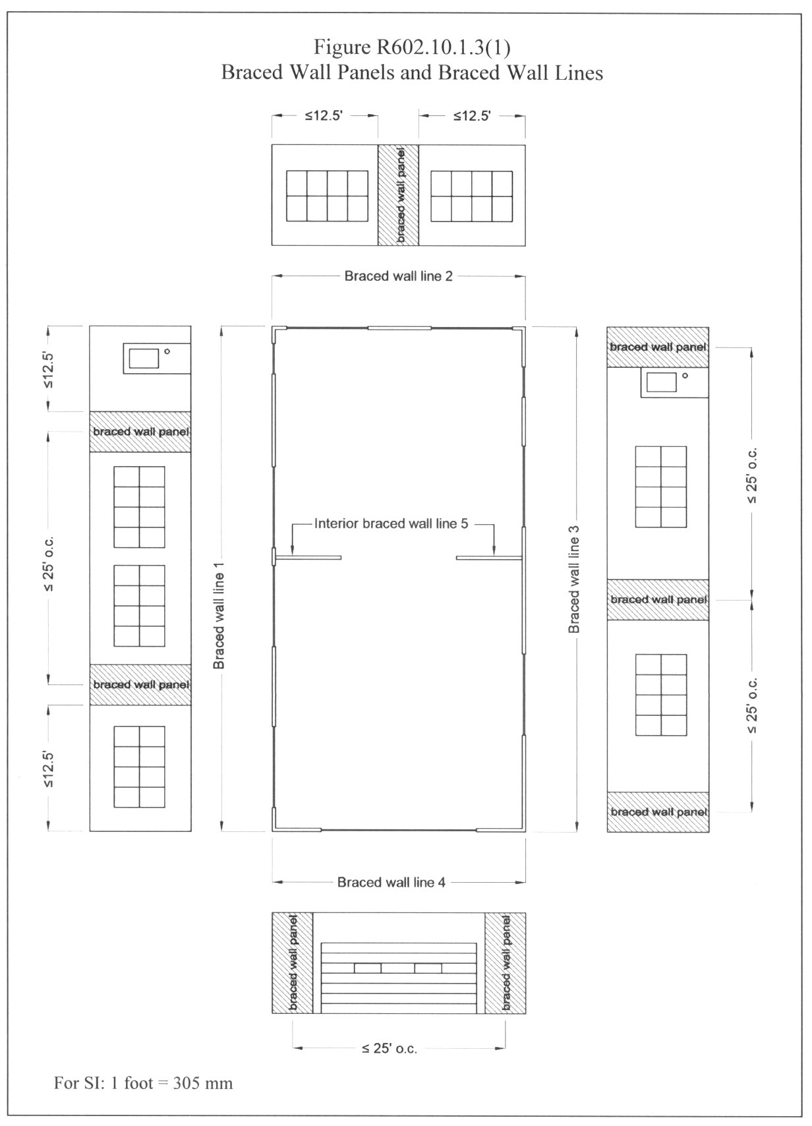

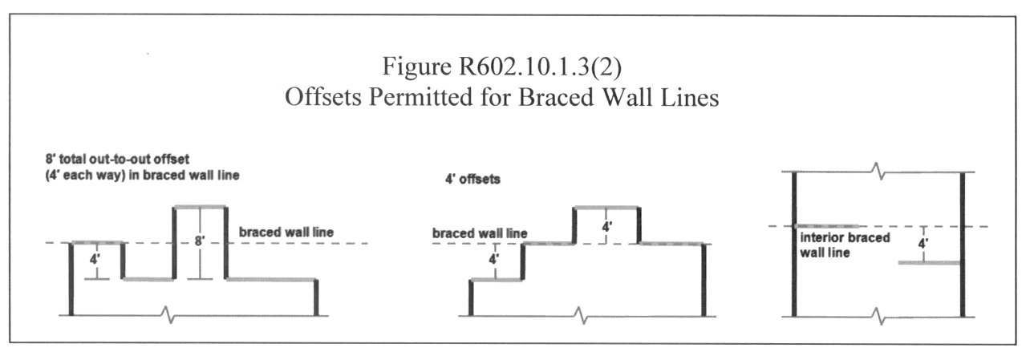

R602.10.1.4 Angled walls. Braced wall lines shall be permitted to angle out of plane for a maximum diagonal length of 8 feet (2438 mm). Where the angled wall occurs at a corner, the length of the braced wall line shall be measured from the projected corner as shown in Figure R602.10.1.4, and the first braced wall panel shall begin no more than 12.5 feet (3813 mm) from the projected corner. Where the diagonal length is greater than 8 feet (2438 mm), it shall be considered its own braced wall line.

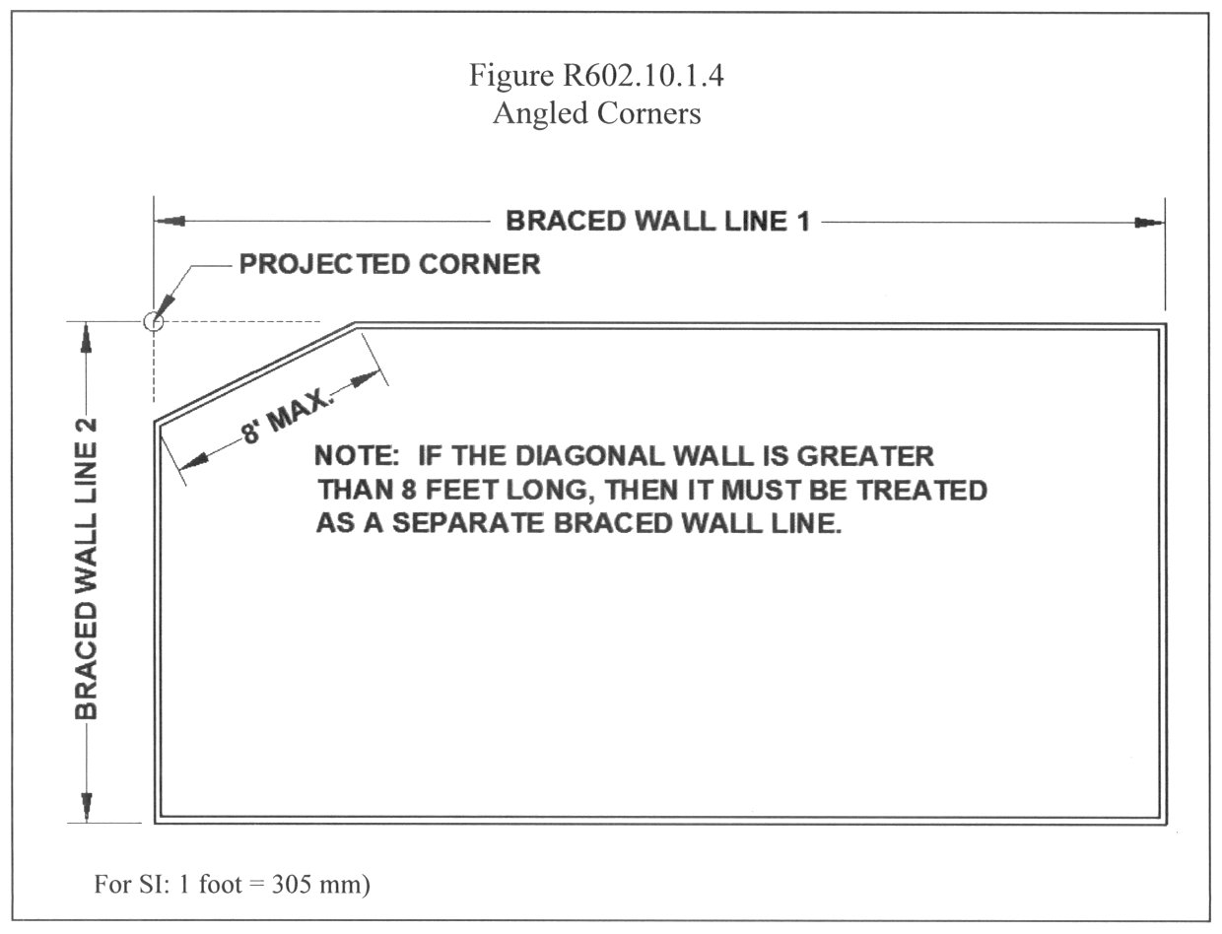

R602.10.1.5 Braced wall line spacing and interior braced wall lines. Spacing of braced wall lines shall not exceed 35 feet (10,668 mm) on center unless an interior braced wall line is provided. Interior braced wall lines shall intersect at perpendicular interior or exterior braced wall lines.
Exception: Spacing of braced wall lines may extend to 50 feet (15,240 mm) where the wall bracing provided equals or exceeds the percentage of bracing required by Table R602.10.1.2 multiplied by a factor equal to 1.4.
R602.10.2 Intermittent Bracing Methods. Intermittent braced wall panels shall comply with this section. The location of each panel shall be identified on the construction drawings.
R602.10.2.1 Intermittent braced wall panel construction methods. Intermittent braced wall panels shall be constructed in accordance with one of the following methods:
1. Nominal 1 inch by 4 inch (19.1 mm by 88.9 mm) continuous diagonal braces shall be let in to the top and bottom plates and the intervening studs or approved metal strap devices shall be installed in accordance with the manufacturer’s specifications. The let-in bracing shall be placed at an angle not more than 60 degrees (1.06 rad) or less than 45 degrees (0.79 rad) from the horizontal. This method is prohibited in the first floor of a three-story house in Seismic Design Categories A, B, and C and in the first story of a two-story house or second story of a three-story house in Seismic Design Category C.
2. Wood boards of 5/8 inch (15.9 mm) net minimum thickness shall be applied diagonally on studs spaced a maximum of 24 inches (610 mm) on center in accordance with Table R602.3(1).
3. Wood structural panel sheathing with a thickness not less than 3/8 inch (9.5 mm) shall be installed in accordance with Tables R602.3(3) and R602.3(1).
4. One-half-inch (12.7 mm) or 25/32 inch (19.8 mm) thick structural fiberboard sheathing shall be applied vertically or horizontally on studs spaced a maximum of 16 inches (406 mm) on center in accordance with Table R602.3(1).
5. Gypsum board with minimum 1/2 inch (12.7 mm) thickness shall be placed on studs spaced a maximum of 24 inches (610 mm) on center and fastened at panel edges including top and bottom plates as specified in Table R602.3(1) for sheathing. For interior gypsum board, fasteners in accordance with Table R702.3.5 shall be permitted, but fastener spacing shall comply with Table R602.3(1).
6. Particleboard wall sheathing panels shall be installed in accordance with Table R602.3(4) and Table R602.3(1).
7. Portland cement plaster on studs spaced a maximum of 16 inches (406 mm) on center shall be installed in accordance with Section R703.6.
8. Hardboard panel siding shall be installed in accordance with Table R703.4.
R602.10.2.2 Braced Wall Panel Interior Finish Material. Braced wall panels shall have 1/2 inch (12.7 mm) thick gypsum board installed on the side of the wall opposite the bracing material and fastened in accordance with Table R702.3.5.
Exceptions:
1. Wall panels that are braced in accordance with Method 5.
2. When an approved interior finish material with an in-plane shear resistance equivalent to gypsum board is installed.
3. For Methods 2, 3, 4, 6, 7, and 8, interior gypsum board may be partially or entirely omitted provided the minimum required percentage of bracing in Table R602.10.1.2 is multiplied by a factor of 1.5.
R602.10.2.3 Minimum length of intermittent braced wall panels. The minimum length of intermittent braced wall panels shall comply with Table R602.10.2.3. Each panel shall cover at least three studs where studs are spaced 16 inches (406 mm) on center and at least two studs where studs are spaced 24 inches (610 mm) on center.
Table R602.10.2.3
Minimum Required Length of Intermittent Braced Wall Panels^{a,b}
Bracing Method | Height of Intermittent Braced Wall Panel
Bracing Method | 8' | 9' | 10' | 11' | 12'
2, 3, 4, 5^{c}, 6, 7, 8 | 48" | 48" | 48" | 53" | 58"
For SI 1 foot = 305 mm, 1 inch = 25.4 mm
a. Interpolation shall be permitted.
b. Does not apply to Method 1. Panel length is determined by the angle of the brace.
c. Gypsum board applied to both sides of the braced wall panel; where the gypsum board is applied to one side, the required length shall be doubled.
602.10.2.4 Contributing length of intermittent braced wall panels. For Methods 2 - 8, the length of a braced wall panel for purposes of determining compliance with the percentage of bracing required by Table R602.10.1.2 shall be equal to the actual length of the panel when it is greater than or equal to the required length in Table R602.10.2.3.
Exception: For Methods 2, 3, 4, 6, 7 and 8, partial credit shall be permitted for panels between 36 inches (914 mm) and 48 inches (1220 mm) to count towards the required percentage of bracing in Table R602.10.1.2 based on the contributing lengths in Table R602.10.2.4.
Table R602.10.2.4
Contributing Lengths for Braced Wall Panels Less Than 48 Inches in Actual Width
Actual Length of Braced Wall Panel | Contributing Length of Braced Wall Panel^{a,b}
Actual Length of Braced Wall Panel | 8' Wall Height | 9' Wall Height | 10' Wall Height
48" | 48" | 48" | 48"
42" | 36" | 36" | N/A
36" | 27" | N/A | N/A
For SI: 1 inch = 25.4 mm
a. Interpolation shall be permitted.
b. Partial credit is prohibited for walls greater than 10 feet in height.
R602.10.2.5 Adhesive attachment of sheathing in Seismic Design Category C. Adhesive attachment of wall sheathing shall not be permitted in Seismic Design Category C.
R602.10.3 Intermittent narrow methods. As an alternative to the bracing methods in Section R602.10.2, braced wall panels constructed in accordance with this section shall be permitted.
R602.10.3.1 Alternate braced wall panels. Alternate braced wall panels constructed in accordance with Figure R602.10.3.1 shall be permitted to replace any intermittent braced wall panel. The height, length and tie-down force of each panel shall be in accordance with Table R602.10.3.1.
For purposes of determining compliance with the percentage of panel bracing required by Table R602.10.1.2, the lengths of the alternate braced wall panels are permitted to contribute 48 inches (1219 mm).

EDITOR'S NOTE: Figures R602.10.1.3(1), R602.10.1.3(2), R602.10.1.4, R602.10.3.1, R602.10.3.2, R602.10.4.1.2(1), R602.10.4.1.2(2), R602.10.4.1.2(3), R602.10.4.1.2(4), R602.10.4.1.2(5) and R602.10.4.2 in this section are new text.

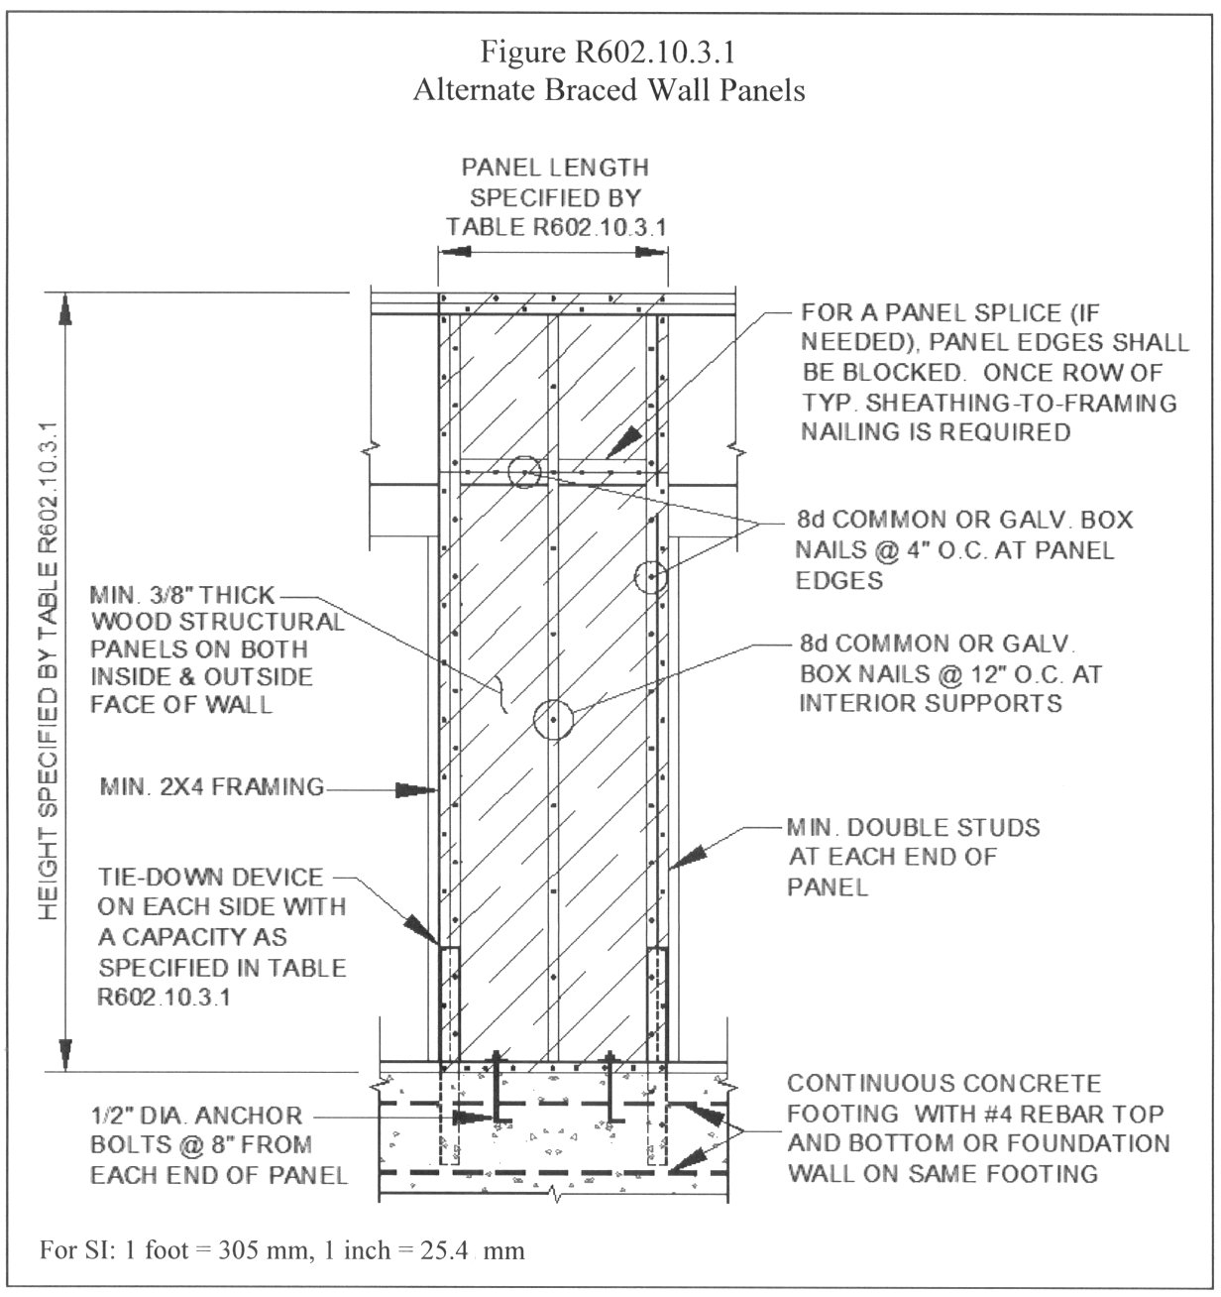

Table R602.10.3.1
Minimum Lengths and Tie-Down Forces of Alternate Braced Wall Panels
 |  |  | Height of Alternate Braced Wall Panel
Requirement |  |  | 8' | 9' | 10' | 11' | 12'
Panel Length |  |  | 28" | 32" | 34" | 38" | 42"
Tie-down capacity, lbs |  | One-story house | 1,800 | 1,800 | 1,800 | 2,000 | 2,200
Tie-down capacity, lbs |  | First floor of a two-story house | 3,000 | 3,000 | 3,000 | 3,300 | 3,600
For SI: 1 inch = 25.4 mm, 1 foot = 305 mm, 1 pound = 4.45 N
R602.10.3.2 Portal frame braced wall panel adjacent to an opening. Portal frame braced wall panels constructed in accordance with Figure R602.10.3.2 are permitted to replace any intermittent braced wall panel for use adjacent to a window or door opening with a full-length header. Each panel constructed in accordance with Figure R602.10.3.2 shall have a length and height in accordance with in Table R602.10.3.2.
For purposes of determining compliance with the percentage of panel bracing required by Table R602.10.1.2, braced wall panels constructed in accordance with Section R602.10.3.2 shall use the actual length of the panel when it is greater than or equal to the required length of Table R602.10.3.2.
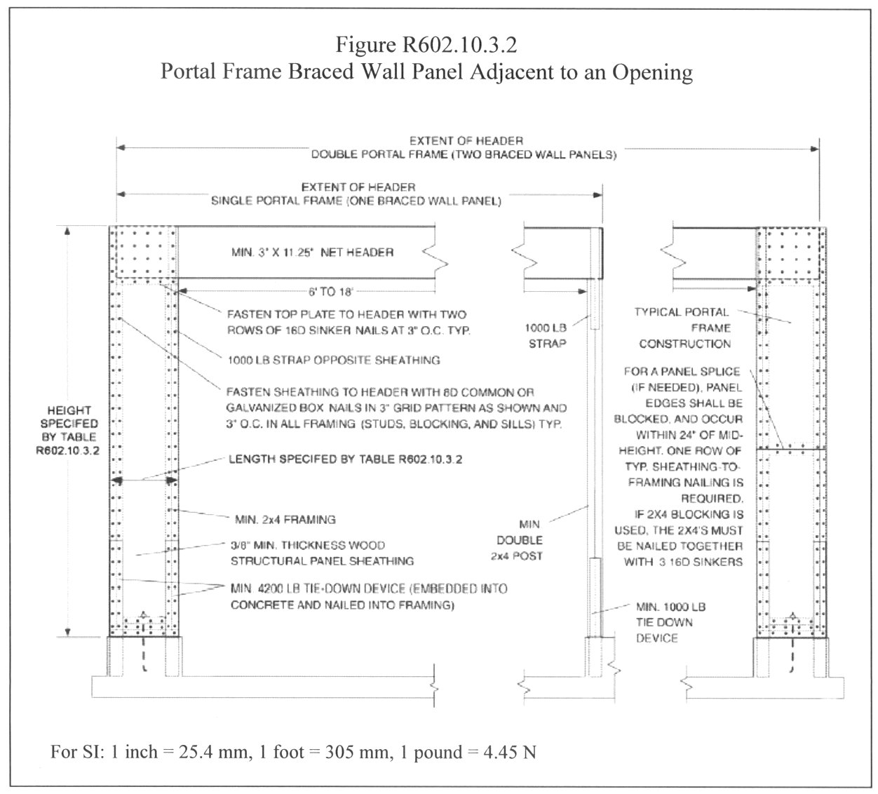

Table R602.10.3.2
Length of Portal Frame Braced Wall Panel for Intermittent Bracing
Floor |  | Height of Portal Frame Braced Wall Panel
 |  | 8' | 9' | 10' | 11' | 12'
 | One-story house | 16" | 16" | 16" | 18" | 20"
 | First floor of a two-story house | 24" | 24" | 24" | 27" | 29"
For SI: 1 inch = 25.4 mm, 1 foot = 305 mm
R602.10.4 Continuous sheathing method. Braced wall lines with continuous sheathing constructed in accordance with this section shall be permitted.
R602.10.4.1 Requirements for braced wall lines with continuous sheathing. Braced wall lines with continuous sheathing shall have wood structural panels with a thickness not less than 3/8 inches (9.5 mm) applied to all exterior sheathable surfaces of the braced wall line, including areas above and below openings. Wood structural panels shall be installed in accordance with Tables R602.3(1) and R602.3(3). The interior side of the braced wall line shall have 1/2 inch (12.7 mm) thick gypsum board installed in accordance with Section R602.10.2.2. Different bracing methods shall not be permitted along a braced wall line with continuous sheathing.
R602.10.4.1.1 Length of braced wall panels with continuous sheathing. Braced wall panels within a braced wall line with continuous sheathing shall be full-height with a length in accordance with Table R602.10.4.1.1.
For purposes of determining compliance with the percentage of panel bracing required by Table R602.10.1.2, the length of the braced wall panel shall be equal to its actual length provided the length is greater than or equal to the required length in Table R602.10.4.1.1.
Table R602.10.4.1.1
Length Requirements for Braced Wall Panels in a Braced Wall Line With Continuous Sheathingª
Adjacent Clear Opening Height | Wall Height
Adjacent Clear Opening Height | 8' | 9' | 10' | 11' | 12'
64" | 24" | 27" | 30" | 33" | 36"
68" | 26" | 27" | 30" | 33" | 36"
72" | 28" | 27" | 30" | 33" | 36"
76" | 29" | 30" | 30" | 33" | 36"
80" | 31" | 33" | 30" | 33" | 36"
84" | 35" | 36" | 33" | 36" | 36"
88" | 39" | 39" | 36" | 38" | 36"
92" | 44" | 42" | 39" | 41" | 36"
96" | 48" | 45" | 42" | 43" | 39"
100" |  | 48" | 45" | 47" | 42"
104" |  | 51" | 48" | 48'' | 44"
108" |  | 54" | 51" | 51" | 47"
112" |  |  | 54" | 53" | 50"
116" |  |  | 57" | 56" | 53"
120" |  |  | 60" | 58" | 55"
124" |  |  |  | 61" | 58"
128" |  |  |  | 63" | 61"
132" |  |  |  | 66" | 64"
136" |  |  |  |  | 66"
140" |  |  |  |  | 69"
144" |  |  |  |  | 72"
Garage Door Opening When Supporting Roof Load Only^{b} | 24" | 27" | 30" | 33" | 36"
For SI: 1 inch = 25.4 mm, 1 foot = 305 mm
a. Interpolation shall be permitted.
b. Applies to one wall of a garage only.
R602.10.4.1.2 Braced wall panel location and corner construction. A braced wall panel shall be located at each end of a braced wall line with continuous sheathing. Full-height wall panels complying with the length requirements of Table R602.10.4.1.1 shall be located at least every 25 feet (7620 mm) on center. A minimum 24-inch (610 mm) wood structural panel corner return shall be provided at both ends of a braced wall line with continuous sheathing in accordance with Figures R602.10.4.1.2 (1) and R602.10.4.1.2(2). In lieu of the corner return, a tie-down device with a minimum uplift design value of 800 lb (3560 N) shall be fastened to the corner stud and to the foundation or framing below in accordance with Figure R602.10.4.1.2(3).
Exception: The first braced wall panel shall be permitted to begin 12.5 feet (3813 mm) from each end of the braced wall line provided one of the following is satisfied:
1. A minimum 24 inch (610 mm) long, full-height wood structural panel is provided at both sides of a corner constructed in accordance with Figures R602.10.4.1.2(1) and R602.10.4.1.2(4); or
2. The braced wall panel closest to the corner shall have a tie-down device with a minimum uplift design value of 800 lb (3560 N) fastened to the stud at the edge of the braced wall panel closest to the corner and to the foundation or framing below in accordance with Figure R602.10.4.1.2(5).

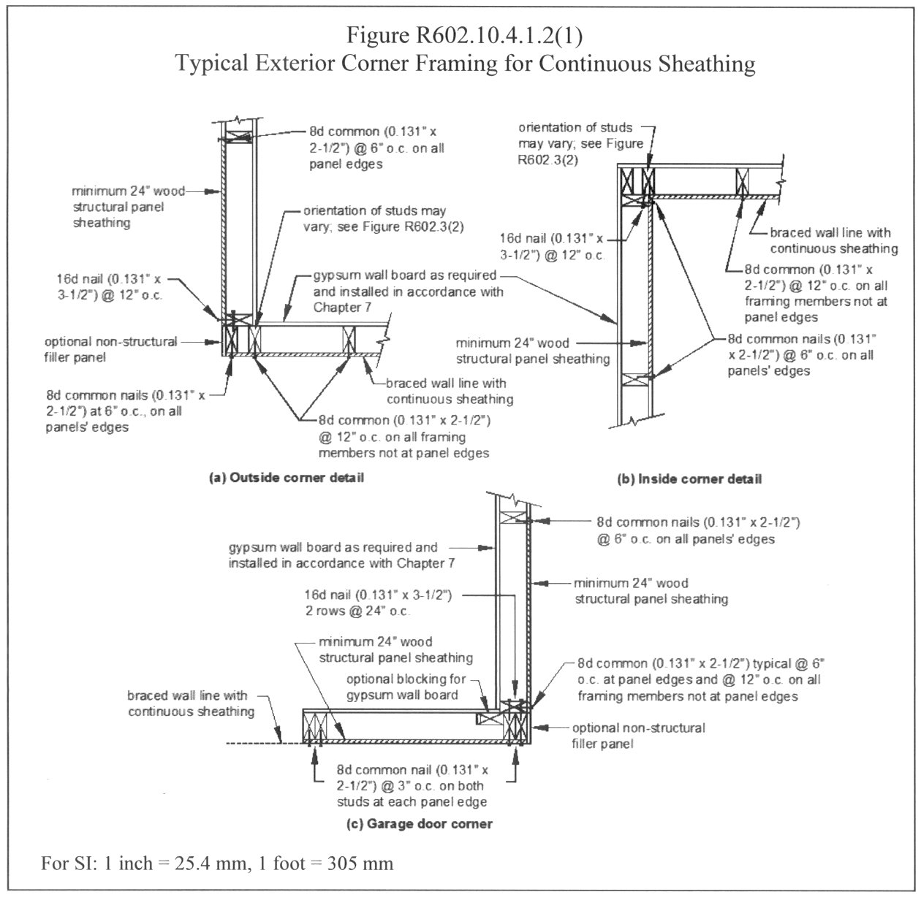

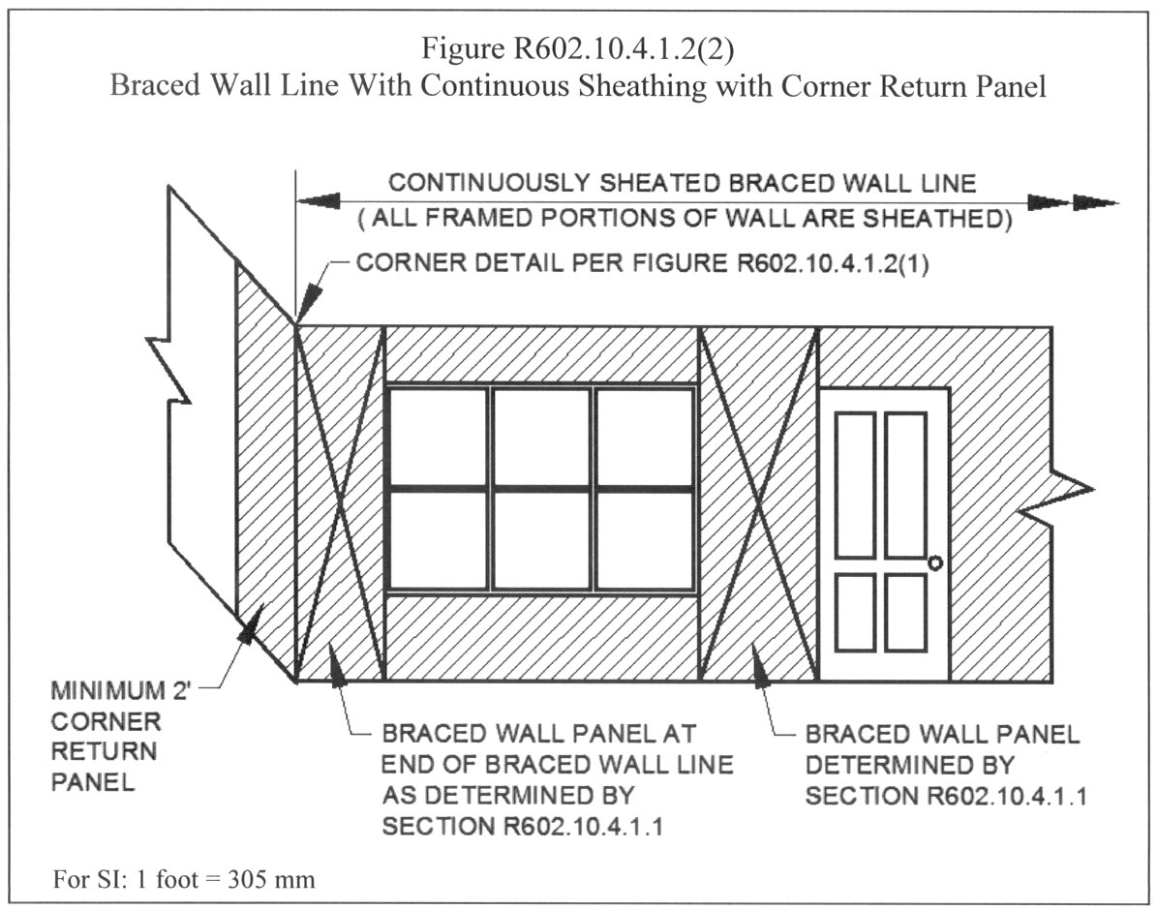

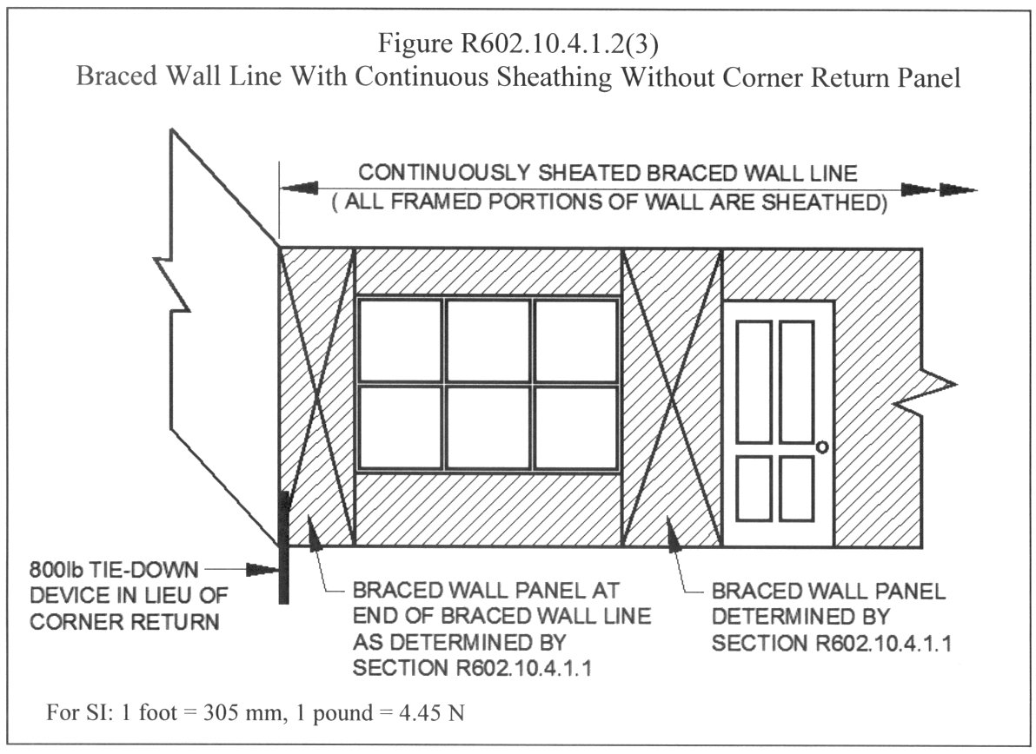

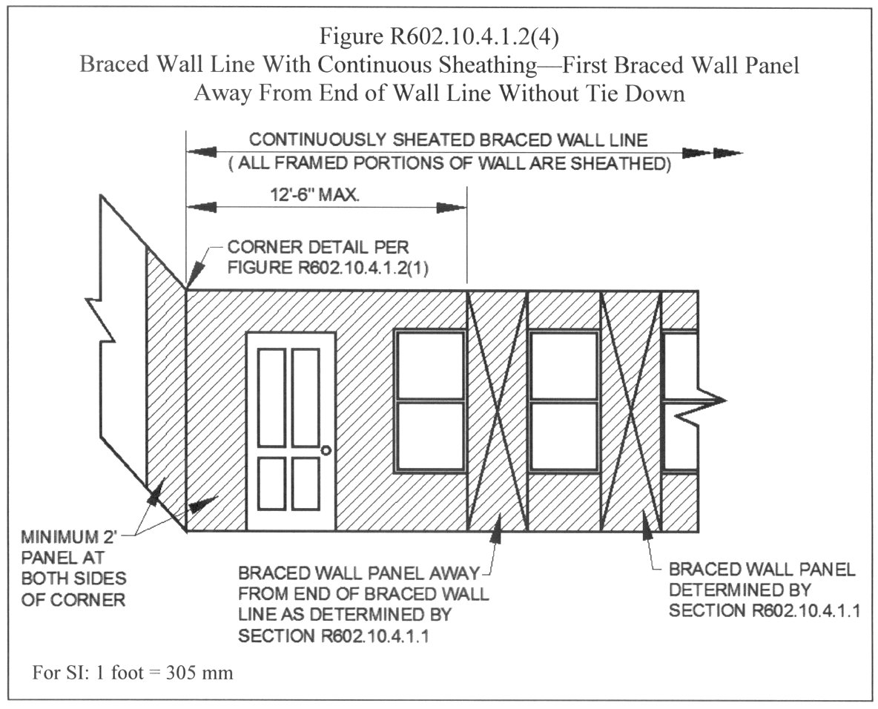

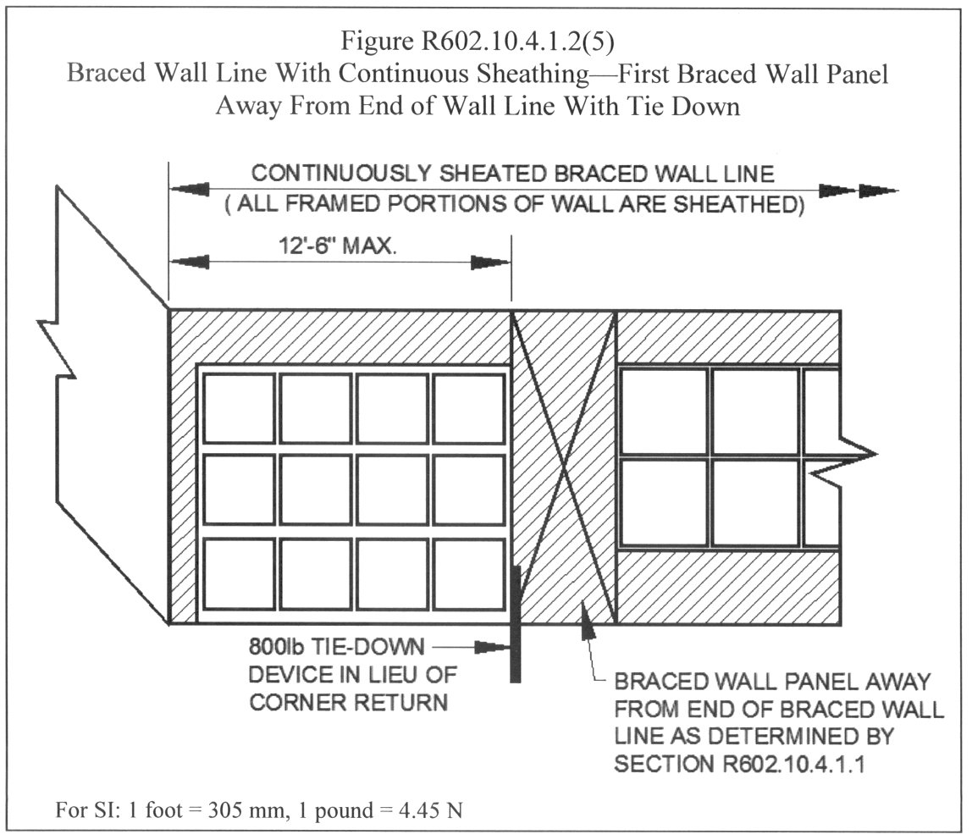

R602.10.4.2 Portal frame braced wall panel used with continuous sheathing. Portal frame braced wall panels constructed in accordance with Figure R602.10.4.2 are permitted in a braced wall line with continuous sheathing. Each panel shall have a length and height in accordance with Table R602.10.4.2. Wall height shall be measured from the top of the header to the bottom of the wall segment bottom plate.
For purposes of determining compliance with the percentage of panel bracing required by Table R602.10.1.2, the length of the full height sheathing segment shall be equal to actual length of the panel when it is greater than or equal to the required length in Table R602.10.4.2.
Table R602.10.4.2
Length of Portal Frame Braced Wall Panel for Continuous Sheathingª
 | Wall Height
 | 8' | 9' | 10' | 11' | 12'
Length of Portal Frame Braced Wall Panel | 16" | 18" | 20" | 22" | 24"
For SI: 1 inch = 25.4 mm, 1 foot = 305 mm
a. Interpolation shall be permitted.
R602.10.5 Braced wall panel support. Braced wall panels shall be supported on floor framing or foundation as follows:
1. Where joists are perpendicular to braced wall lines above or below, blocking shall be provided between the joists at braced wall panel locations to permit fastening of wall plates in accordance with Table R602.3(1).

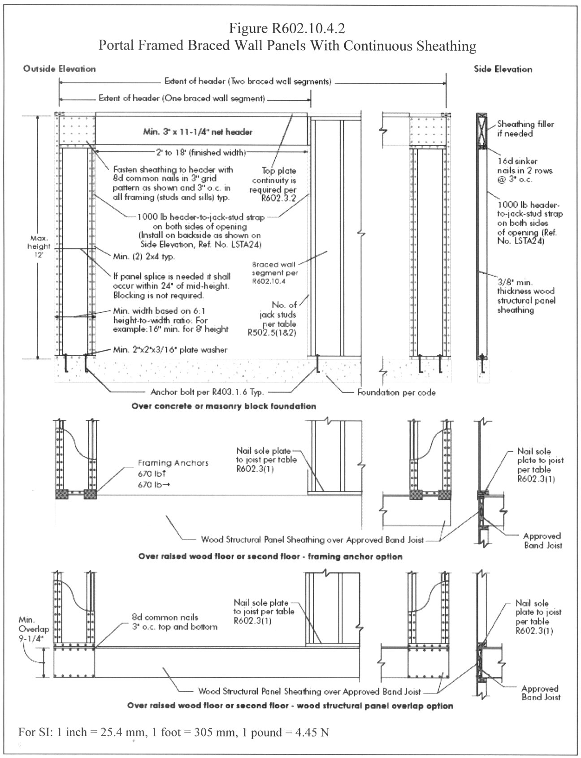

2. Where joists are parallel to braced wall lines above or below, a rim joist or other parallel framing member shall be provided at the wall to permit fastening of wall plates per Table R602.3(1).
3. Braced wall panels shall be permitted to be supported on cantilevered floor joists meeting the cantilever limits of Section R502.3.3 provided joists are blocked at the nearest bearing wall location.
4. Elevated post or pier foundations supporting braced wall panels shall be designed in accordance with accepted engineering practice.
5. Interior braced wall lines shall be treated as load bearing walls and supported in accordance with Section R502.4.
R602.10.6 Panel joints. All vertical joints of braced wall panel sheathing shall occur over, and be fastened to common studs. Horizontal joints in braced wall panels shall occur over, and be fastened to common blocking of a minimum 1-1/2 inch (38 mm) thickness.
Exception: Where the bracing percentage provided is at least twice the minimum percentage required by Table R602.10.1(1) blocking at horizontal joints shall not be required in braced wall panels constructed using Methods 3, 4, 5, 6, or 8.
R602.10.7 Cripple wall bracing. Cripple walls shall be braced with a percentage and type of bracing as required for the wall above in accordance with Table R602.10.1.2 with the following modifications for cripple wall bracing:
1. The bracing percentage as determined from Table R602.10.1.2 shall be multiplied by a factor of 1.15; and
2. The wall panel spacing shall be decreased to 18 feet (5486 mm) instead of 25 feet (7620 mm).
Cripple walls shall be permitted to be redesignated as the first story walls for purposes of determining wall bracing requirements. If the cripple walls are redesignated, the stories above the redesignated story shall be counted as the second and third stories respectively.
33. Change Figure R602.10.5 as follows:
1. Outside Corner Detail.
1.1. 8d nails are required on both sides of the outside corner nailed through the panel and into the corner framing member.
1.2. Figure R602.3(2) governs the placement of the corner framing members.
1.3. The 16d nails shown connecting the framing members on the inside of the corner may be omitted.
1.4. The spacing of the 16d nails connecting the framing members on the outside corner shall be 12 inches on center.
2. Inside Corner Detail.
2.1. Figure R602.3(2) governs the placement of the corner framing members.
2.2. The 16d nail shown connecting the framing members on the outside of the corner may be omitted.
2.3. The spacing of the 16d nails connecting the framing members on the inside corner shall be 12 inches on center.
34. Delete Exception 1 of Section M1501.3 and renumber Exception 2 as Exception 1.
35. 29. Add Section M1801.1.1 to read:
M1801.1.1 Equipment changes. Upon the replacement or new installation of any fuel-burning appliances or equipment in existing buildings, an inspection or inspections shall be conducted to ensure that the connected vent or chimney systems comply with the following:
1. Vent or chimney systems are sized in accordance with this code.
2. Vent or chimney systems are clean, free of any obstruction or blockages, defects or deterioration and are in operable condition.
Where not inspected by the local building department, persons performing such changes or installations shall certify to the building official that the requirements of Items 1 and 2 of this section are met.
36. Add Section M2201.7 to read:
M2201.7 Tanks abandoned or removed. All exterior above-grade fill piping shall be removed when tanks are abandoned or removed.
37. 30. Change Section P2602.1 to read:
P2602.1 General. The water and drainage system of any building or premises where plumbing fixtures are installed shall be connected to a public or private water supply and a public or private sewer system. Where applicable, water supply sources and sewage disposal systems shall be regulated by the Virginia Department of Health.
38. 31. Change Section P2903.5 to read:
P2903.5 Water hammer. The flow velocity of the water distribution system shall be controlled to reduce the possibility of water hammer. A water-hammer arrestor shall be installed where quick-closing valves are utilized, unless otherwise approved. Water hammer arrestors shall be installed in accordance with manufacturer's specifications. Water hammer arrestors shall conform to ASSE 1010.
39. Change the trap size as shown in the following category of Table P3201.7:
Plumbing Fixture | Trap Size Minimum (inches)
Shower | 1-1/2
40. 32. Add Section G2425.1.1 to read:
G2425.1.1 Equipment changes. Upon the replacement or new installation of any fuel-burning appliances or equipment in existing buildings, an inspection or inspections shall be conducted to ensure that the connected vent or chimney systems comply with the following:
1. Vent or chimney systems are sized in accordance with this code.
2. Vent or chimney systems are clean, free of any obstruction or blockages, defects or deterioration and are in operable condition.
Where not inspected by the local building department, persons performing such changes or installations shall certify to the building official that the requirements of Items 1 and 2 of this section are met.
41. 33. Add Section E3501.8 to read:
E3501.8 Energizing service equipment. The building official shall give permission to energize the electrical service equipment of a one- or two-family dwelling unit when all of the following requirements have been approved:
1. The service wiring and equipment, including the meter socket enclosure, shall be installed and the service wiring terminated.
2. The grounding electrode system shall be installed and terminated.
3. At least one receptacle outlet on a ground fault protected circuit shall be installed and the circuit wiring terminated.
4. Service equipment covers shall be installed.
5. The building roof covering shall be installed.
6. Temporary electrical service equipment shall be suitable for wet locations unless the interior is dry and protected from the weather.
42. Change Chapter 43 of the IRC as follows:
AWPA C1-00 | Deleted
AWPA C2-01 | Deleted
AWPA C3-99 | Deleted
AWPA C4-99 | Deleted
AWPA C9-00 | Deleted
AWPA C15-00 | Deleted
AWPA C18-99 | Deleted
AWPA C22-96 | Deleted
AWPA C23-00 | Deleted
AWPA C24-96 | Deleted
AWPA C28-99 | Deleted
AWPA C31-01 | Deleted
AWPA U1-02 | USE CATEGORY SYSTEM: User Specification for Treated Wood except Section 7 Commodity Specification H | R319.1, R402.1.2, R504.3, Table R905.8.5
AWPA P5-02 | Standard for Waterborne Preservatives | R319.1, R323.1.7
13 VAC 5-63-220. Chapter 4 Special detailed requirements based on use and occupancy.
A. Change Section 404.4 of the IBC to read:
404.4 Smoke control. A smoke control system shall be installed in accordance with Section 909.
Exceptions:
1. Smoke control is not required for floor openings meeting the requirements of Section 707.2, Exception 2, 7, 8 or 9.
2. Smoke control is not required for floor openings meeting the requirements of Section 1019.1, Exception 8 or 9.
3. Smoke control is not required for atriums that connect only two stories.
B. A. Add Section 407.8 to the IBC to read:
407.8 Special locking arrangement. Means of egress doors shall be permitted to contain locking devices restricting the means of egress in areas in which the clinical needs of the patients require restraint of movement, where all of the following conditions are met:
1. The locks release upon activation of the fire alarm system or the loss of power.
2. The building is equipped with an approved automatic sprinkler system in accordance with Section 903.3.1.1.
3. A manual release device is provided at a nursing station responsible for the area.
4. A key-operated switch or other manual device is provided adjacent to each door equipped with the locking device. Such switch or other device, when operated, shall result in direct interruption of power to the lock - independent of the control system electronics.
5. All staff shall have keys or other means to unlock the switch or other device or each door provided with the locking device.
C. B. Change Section 408.3.5 of the IBC to read:
408.3.5 Sallyports. A sallyport shall be permitted in a means of egress where there are provisions for continuous and unobstructed passage through the sallyport during an emergency egress condition. A sallyport is a security vestible with two or more doors where the intended purpose is to prevent continuous and unobstructed passage by allowing the release of only one door at a time.
D. C. Add Section 415.1.1 to the IBC to read:
415.1.1 Flammable and combustible liquids. Notwithstanding the provisions of this chapter, the storage, handling, processing, and transporting of flammable and combustible liquids shall be in accordance with the mechanical code and the fire code listed in Chapter 35 of this code. Regulations governing the installation, repair, upgrade, and closure of underground and aboveground storage tanks under the Virginia State Water Control Board regulations 9 VAC 25-91 and 9 VAC 25-580 are adopted and incorporated by reference to be an enforceable part of this code. Where differences occur between the provisions of this code and the incorporated provisions of the State Water Control Board regulations, the provisions of the State Water Control Board regulations shall apply.
E. Add IBC Section 419 Site Work for 421 Manufactured Homes and Industrialized Buildings.
F. Add Section 419.1 421.1 to the IBC to read:
419.1 421.1 General. The provisions of this section shall apply to the installation or erection of manufactured homes subject to the Virginia Manufactured Home Safety Regulations (13 VAC 5-95) and industrialized buildings subject to the Virginia Industrialized Building Safety Regulations (13 VAC 5-91).
G. Add Section 419.2 421.2 to the IBC to read:
419.2 421.2 Site work for manufactured homes. Construction work associated with the The installation of a manufactured home or industrialized building shall comply is generally subject to the requirements of the Virginia Manufactured Home Safety Regulations (13 VAC 5-95). Under those regulations, the building official is responsible for assuring that the installation complies with the manufacturer’s installation instructions and any special conditions or limitations of use stipulated by the label. To the extent that any aspect of the installation is not provided for in the manufacturer’s installation instructions , then the installation shall comply with applicable requirements of this code. In the case where the manufacturer’s installation instructions for a manufactured homes home are not available, the NCSBCS/ANSI A225.1 standard, 1994 edition, may be substituted for the manufacturer’s installation instructions. Foundations, stoops, decks, porches, alterations and additions associated with manufactured homes are subject to the requirements of this code and all administrative requirements of this code for permits, inspections and certificates of occupancy are also applicable. The requirements of the International Residential Code shall be permitted to be used for the technical requirements for such construction work. In addition, Appendix E of the International Residential Code entitled, "Manufactured Housing used as Dwellings," shall be an acceptable alternative to this code for construction work associated with the installation of manufactured homes and for additions, alterations and repairs to manufactured homes.
H. Add Section 419.3 421.3 to the IBC to read:
419.3 421.3 Wind load requirements for manufactured homes. Manufactured homes shall be anchored to withstand the wind loads established by the federal regulation for the area in which the manufactured home is installed. For the purpose of this code, Wind Zone II of the federal regulation shall include the cities of Chesapeake, Norfolk, Portsmouth, and Virginia Beach.
I. Add Section 419.4 421.4 to the IBC to read:
419.4 421.4 Skirting requirements for manufactured homes. As used in this section, "skirting" means a weather-resistant material used to enclose the space from the bottom of the manufactured home to grade. Manufactured homes installed or relocated shall have skirting installed within 60 days of occupancy of the home. Skirting materials shall be durable, suitable for exterior exposures and installed in accordance with the manufacturer's installation instructions. Skirting shall be secured as necessary to ensure stability, to minimize vibrations, to minimize susceptibility to wind damage and to compensate for possible frost heave. Each manufactured home shall have a minimum of one opening in the skirting providing access to any water supply or sewer drain connections under the home. Such openings shall be a minimum of 18 inches (457 mm) in any dimension and not less than three square feet (.28 m) in area. The access panel or door shall not be fastened in a manner requiring the use of a special tool to open or remove the panel or door. On-site fabrication of the skirting by the owner or installer of the home shall be acceptable, provided that the material meets the requirements of this code.
J. Add Section 421.5 to the IBC to read:
421.5 Site work for industrialized buildings. Site work for the erection and installation of an industrialized building is generally subject to the requirements of the Virginia Industrialized Building Safety Regulations (13 VAC 5-91) and the building official has certain enforcement responsibilities under those regulations. To the extent that any aspect of the erection or installation of an industrialized building is not covered by those regulations, this code shall be applicable. In addition, all administrative requirements of this code for permits, inspections and certificates of occupancy are also applicable. The requirements of the International Residential Code shall be permitted to be used for any construction work that is subject to this code where the industrialized building would be classified as a Group R-5 building.
K. Add Section 421.6 to the IBC to read:
421.6 Relocated industrialized buildings; alterations and additions. Industrialized buildings constructed prior to January 1, 1972, shall be subject to Section 117 when relocated. Alterations and additions to existing industrialized buildings shall be subject to pertinent provisions of this code. Building officials shall be permitted to require the submission of plans and specifications for the model to aid in the evaluation of the proposed alteration or addition. Such plans and specifications shall be permitted to be submitted in electronic or other available format acceptable to the building official.
13 VAC 5-63-225. Chapter 5 General building heights and areas. (Repealed.)
Add Exception 3 to Section 507.2 of the IBC to read:
3. Group A-1, A-2 and A-3 occupancies are permitted provided:
3.1. All assembly occupancies are separated from other spaces as required for separated uses in Section 302.3.2.
3.2. Each Group A tenant does not exceed the maximum allowable height and area under Section 503.
3.3. All required exits shall discharge directly to the exterior.
13 VAC 5-63-230. Chapter 7 Fire-resistant-rated construction.
A. Add Section 701.2 to the IBC to read:
701.2 Fire-resistance assembly marking. Concealed fire walls, vertical fire separation assemblies, fire barriers, fire partitions and smoke barriers shall be designated above ceilings and on the inside of all ceiling access doors which provide access to such fire rated assemblies by signage having letters no smaller than one inch (25.4 mm) in height. Such signage shall indicate the fire-resistance rating of the assembly and the type of assembly and be provided at horizontal intervals of no more than eight feet (2438 mm).
Note: An example of suggested formatting for the signage would be "ONE HOUR FIRE PARTITION."
B. Add exceptions 12 14 and 13 15 to Section 707.2 of the IBC to read:
12. 14. Noncombustible shafts connecting communicating floor levels in Group I-3 occupancies where the area complies with Section 408.5. Where additional stories are located above or below, the shaft shall be permitted to continue with fire and smoke damper protection provided at the fire resistance rated floor/ceiling assembly between the noncommunicating stories.
13. 15. A floor opening that complies with Section 408 in an occupancy in Group I-3.
C. Delete Section Sections 707.14.1 and 707.14.2 of the IBC, including all subsections of Section 707.14.2.
D. Add exception 4 to Section 715.3.3 715.4.3 of the IBC to read:
4. Horizontal sliding doors in smoke barriers that comply with Section 408.3 are permitted in smoke barriers in occupancies in Group I-3.
E. Add an exception to Section 715.4.4 715.5.4 of the IBC to read:
Exception: Security glazing protected on both sides by an automatic sprinkler system shall be permitted in doors and windows in smoke barriers in Group I-3 occupancies. Individual panels of glazing shall not exceed 1,296 square inches (0.84 m2), shall be in a gasketed frame and installed in such a manner that the framing system will deflect without breaking (loading) glazing before the sprinkler system operates. The sprinkler system shall be designed to wet completely the entire surface of the affected glazing when actuated.
F. Change Section 716.5.3.1 716.5.3 of the IBC to read:
716.5.3.1 716.5.3 Penetrations of shaft enclosures. Shaft enclosures that are permitted to be penetrated by ducts and air transfer openings shall be protected with approved fire and smoke dampers installed in accordance with their listing.
Exceptions:
1. Fire and smoke dampers are not required where steel exhaust subducts extend at least 22 inches (559 mm) vertically in exhaust shafts provided there is a continuous airflow upward to the outside.
2. Fire dampers are not required where penetrations are tested in accordance with ASTM E 119 as part of the fire-resistance rated assembly.
3. Fire and smoke dampers are not required where ducts are used as part of an approved smoke-control system in accordance with Section 909.
4. Fire and smoke dampers are not required where the penetrations are in parking garage exhaust or supply shafts that are separated from other building shafts by not less than two-hour fire-resistance-rated construction.
5. Smoke dampers are not required where the building is equipped throughout with an automatic sprinkler system in accordance with Section 903.3.1.1.
13 VAC 5-63-240. Chapter 9 Fire protection systems.
A. Change the following definition in Section 902 of the IBC to read:
Automatic fire-extinguishing system. An approved system of devices and equipment which automatically detects a fire and discharges an approved fire-extinguishing agent onto or in the area of a fire and shall include among other systems an automatic sprinkler system, unless otherwise expressly stated.
B. Change Exception Item 2 of Section 903.2.1.3 of the IBC to read:
2. In Group A-3 occupancies other than churches, the fire area has an occupant load of 300 or more.
C. Change Section 903.2 7 of the IBC to read:
903.2.7 Group R. An automatic sprinkler system installed in accordance with Section 903.3 shall be provided throughout all buildings with a Group R fire area, except in the following Group R-2 occupancies when the necessary water pressure or volume, or both, for the system is not available:
Exceptions:
1. Buildings which do not exceed two stories, including basements which are not considered as a story above grade, and with a maximum of 16 dwelling units per fire area. Each dwelling unit shall have at least one door opening to an exterior exit access that leads directly to the exits required to serve that dwelling unit.
2. Buildings where all dwelling units are not more than two stories above the lowest level of exit discharge and not more than one story below the highest level of exit discharge of exits serving the dwelling unit and a two-hour fire barrier is provided between each pair of dwelling units. Each bedroom of a dormitory or boarding house shall be considered a dwelling unit under this exception.
D. Add Section 903.3.1.2.2 to the IBC to read:
903.3.1.2.2 Attics. Sprinkler protection shall be provided for attics in buildings of Type III, IV or V construction in the following occupancies.
1. Group R-2 that are designed or developed and marketed to senior citizens, 55 years of age or older.
2. Group I-1.
E. Add an exception to Section 905.2 of the IBC to read:
Exception: The residual pressure of 100 psi for 2-1/2 inch hose connection and 65 psi for 1-1/2 inch hose connection is not required in buildings equipped throughout with an automatic sprinkler system in accordance with Section 903.3.1.1 and where the highest floor level is not more than 150 feet above the lowest level of fire department vehicle access.
F. Change Section 906.1 of the IBC to read:
906.1 General. Portable fire extinguishers shall be provided in occupancies and locations as required by the International Fire Code, except that portable fire extinguishers shall not be required to be installed in Group R-2 occupancies.
G. Change Section 907.2.1.1 of the IBC to read:
907.2.1.1 System initiation in Group A occupancies with a occupant load of 1,000 or more and in certain night clubs. Activation of the fire alarm in Group A occupancies with an occupant load of 1,000 or more and in night clubs with an occupant load of 300 or more shall initiate a signal using an emergency voice and alarm communications system in accordance with NFPA 72.
Exception: Where approved, the prerecorded announcement is allowed to be manually deactivated for a period of time, not to exceed three minutes, for the sole purpose of allowing a live voice announcement from an approved, constantly attended location.
H. Change Section 907.2.9 of the IBC to read:
907.2.9 Group R-2. A manual fire alarm system shall be installed in Group R-2 occupancies.
Exceptions:
1. A fire alarm system is not required in buildings not over two stories in height where all dwelling units or sleeping rooms and contiguous attic and crawl spaces are separated from each other and public or common areas by at least one-hour fire partitions and each dwelling unit or sleeping room has an exit directly to a public way, exit court or yard.
2. Manual fire alarm boxes are not required throughout the building when the following conditions are met:
2.1. The building is equipped throughout with an automatic sprinkler system in accordance with Section 903.3.1.1 or 903.3.1.2.
2.2. The notification appliances will activate upon sprinkler flow, and
2.3. At least one manual fire alarm box is installed at an approved location.
I. Add Section 907.9.1.1.1 to the IBC to read:
907.9.1.1.1 Location of appliances in Group I-3 occupancies. Wall-mounted visible alarm notification appliances in Group I-3 occupancies shall be permitted to be a maximum of 120 inches (3048 mm) above the floor or ground, measured to the bottom of the appliance and shall otherwise comply with Section 702.3.3.1 of ICC A117.1.
J. I. Change Section 909.6 of the IBC to read:
909.6 Pressurization method. When approved by the building official, the means of controlling smoke shall be permitted by pressure differences across smoke barriers. Maintenance of a tenable environment is not required in the smoke-control zone of fire origin.
K. Add footnote "c" to Table 910.3 to read:
c. Smoke and heat vents are not required when storage areas are protected by early-suppression fast-response (ESFR) sprinklers installed in accordance with NFPA 13 or NFPA 231.
13 VAC 5-63-245. Chapter 10 Means of egress.
A. Change Section 1004.1 of the IBC to read:
1004.1 Design occupant load. In determining means of egress requirements, the number of occupants for whom means of egress facilities shall be provided shall be determined in accordance with this section. Where occupants from accessory areas egress through a primary space, the calculated occupant load for the primary space shall include the total occupant load of the primary space plus the number of occupants egressing through it from the accessory area.
B. Delete Section 1004.1.1 of the IBC and renumber Section 1004.1.2 and Table 1004.1.2 to Section 1004.1.1 and Table 1004.1.1.
C. Add Section 1004.1.2 to the IBC to read:
1004.1.2 Areas without fixed seating. The numbers of occupants computed at the rate of one occupant per unit of area as prescribed in Table 1004.1.1. For areas without fixed seating, the occupant load shall not be less than that number determined by dividing the floor area under consideration by the occupant per unit area factor assigned to the occupancy as set forth in Table 1004.1.1. Where an intended use is not listed in Table 1004.1.1, the building official shall establish a use based on a listed use that most nearly resembles the intended use.
Exception: Where approved by the building official, the actual number of occupants for whom each occupied space, floor or building is designed, although less than those determined by calculation, shall be permitted to be used in the determination of the design occupant load.
D. Delete Section 1004.1.3 of the IBC.
E. Change the reference in Section 1004.2 of the IBC to Table 1004.1.2 to a reference to Table 1004.1.1.
F. Change Section 1004.9 of the IBC to read:
1004.9 Multiple occupancies. Where a building contains two or more occupancies, the means of egress requirements shall apply to each portion of the building based on the occupancy of that space. Where two or more occupancies utilize portions of the same means of egress system, those egress components shall meet the more stringent requirements of all occupancies that are served.
Exception: A 750 square feet or less room or space used for assembly purposes by less than 50 persons and which is accessory to another group shall be included as a part of that main group.
G. A. Change Item 2 of Section 1008.1.8.3 of the IBC to read:
2. In buildings in occupancy Groups B, F, M and S, the main exterior door or doors are permitted to be equipped with key-operated locking devices from the egress side provided:
2.1. The locking device is readily distinguishable as locked.
2.2. A readily visible durable sign is posted on the egress side on or adjacent to the door stating: THIS DOOR TO REMAIN UNLOCKED WHEN BUILDING IS OCCUPIED. The sign shall be in letters one inch (25 mm) high on a contrasting background.
2.3. The use of the key-operated locking device is revokable by the building official for due cause.
H. B. Change Section 1008.1.8.6 of the IBC to read:
1008.1.8.6 Delayed egress locks. Approved, listed, delayed egress locks shall be permitted to be installed on doors serving any occupancy including Group A-3, airport facilities, except Group A, E and H occupancies in buildings which are equipped throughout with an automatic sprinkler system in accordance with Section 903.3.1.1 or an approved automatic smoke or heat detection system installed in accordance with Section 907, provided that the doors unlock in accordance with the items 1 through 6 below. A building occupant shall not be required to pass through more than one door equipped with a delayed egress lock before entering an exit.
1. The doors unlock upon actuation of the automatic sprinkler system or automatic fire detection system.
2. The doors unlock upon loss of power controlling the lock or lock mechanism.
3. The door locks shall have the capability of being unlocked by a signal from the fire command center.
4. The initiation of an irreversible process which will release the latch in not more than 15 seconds when a force of not more than 15 pounds (67 N) is applied for 1 second to the release device. Initiation of the irreversible process shall activate an audible signal in the vicinity of the door. Once the door lock has been released by the application of force to the releasing device, relocking shall be by manual means only.
Exception: Where approved, a delay of not more than 30 seconds is permitted.
5. A sign shall be provided on the door located above and within 12 inches (305 mm) of the release device reading: PUSH UNTIL ALARM SOUNDS. DOOR CAN BE OPENED IN 15 SECONDS.
Exception: Where approved, such sign shall read: PUSH UNTIL ALARM SOUNDS. DOOR CAN BE OPENED IN 30 SECONDS.
6. Emergency lighting shall be provided at the door.
I. C. Add Section 1008.1.8.8 to the IBC to read:
1008.1.8.8 Locking arrangements in correctional facilities. In occupancies in Groups A-3, A-4, B, E, F, I, M and S within penal facilities, doors in means of egress serving rooms or spaces occupied by persons whose movements must be controlled for security reasons shall be permitted to be locked if equipped with egress control devices which shall unlock manually and by at least one of the following means:
1. Actuation of an automatic fire suppression system required by Section 903.2.
2. Actuation of a key-operated manual alarm station required by Section 907.2.
3. A signal from a central control station.
J. D. Add Section 1008.1.10 to the IBC to read:
1008.1.10 Locking certain residential sliding doors. In dwelling units of Group R-2 buildings, exterior sliding doors which are one story or less above grade, or shared by two dwelling units, or are otherwise accessible from the outside, shall be equipped with locks. The mounting screws for the lock case shall be inaccessible from the outside. The lock bolt shall engage the strike in a manner that will prevent it from being disengaged by movement of the door.
Exception: Exterior sliding doors which are equipped with removable metal pins or charlie bars.
K. E. Add Section 1008.1.11 to the IBC to read:
1008.1.11 Door viewers in certain residential buildings. Entrance doors to dwelling units of Group R-2 buildings shall be equipped with door viewers with a field of vision of not less than 180 degrees.
Exception: Entrance doors having a vision panel or side vision panels.
L. F. Change Exception 5 of Section 1009.3 of the IBC to read:
5. 4. In occupancies in Group R-3, as applicable in Section 101.2, occupancies; within dwelling units in occupancies of Group R-2, as applicable in Section 101.2, occupancies; and in occupancies in Group U, which occupancies that are accessory to an occupancy in a Group R-3, as applicable in Section 101.2, occupancy or accessory to individual dwelling units in Group R-2 occupancies; the maximum riser height shall be 8.25 inches (210 mm) and ; the minimum tread depth shall be nine 9 inches (229 mm), ; the minimum winder tread depth at the walk line shall be 10 inches (254 mm), ; and the minimum winder tread depth shall be six 6 inches (152 mm). A nosing not less than 0.75 inch (19.1 mm) but not more than 1.25 inches (32 mm) shall be provided on stairways with solid risers where the tread depth is less than 11 inches (279 mm).
M. G. Add exception 7 6 to Section 1009.3 of the IBC to read:
7. 6. Stairways in penal facilities serving guard towers, observation stations and control rooms not more than 250 square feet (23 m2) in area shall be permitted to have risers not exceeding 8 inches (203 mm) in height and treads not less than 9 inches (229 mm) in depth.
N. Change H. Add Exception 5 to Item 2 of Section 1013.2 1014.2 of the IBC to read:
1013.2 Egress through intervening spaces. Egress from a room or space shall not pass through adjoining or intervening rooms or areas, except where such adjoining rooms or areas are accessory to the area served; are not a high-hazard occupancy; and provide a discernible path of egress travel to an exit. A maximum of one exit access is permitted to pass through kitchens, store rooms, closets or spaces used for similar purposes provided such a space is not the only means of exit access. An exit access shall not pass though a room that can be locked to prevent egress. Means of egress from dwelling units or sleeping areas shall not lead through other sleeping areas, toilet rooms or bathrooms.
Exceptions:
1. Means of egress are not prohibited through a kitchen area serving adjoining rooms constituting part of the same dwelling unit or guestroom.
2. Means of egress are not prohibited through rooms or spaces in a high-hazard occupancy where such rooms or spaces are the same occupancy group.
5. A maximum of one exit access is permitted to pass through kitchens, store rooms, closets or spaces used for similar purposes provided such a space is not the only means of exit access.
O. I. Change exception 2 of Section 1014.2.1 1015.2.1 of the IBC to read:
2. Where a building is equipped throughout with an automatic sprinkler system in accordance with Section 903.3.1.1 or 903.3.1.2, the separation distance of the exit doors or exit access doorways shall not be less than one-fourth of the length of the maximum overall diagonal dimension of the area served.
P. J. Change Table 1016.1 1017.1 of the IBC to read:
Table 1016.1 1017.1 .
Corridor Fire-Resistance Rating.
Occupancy | Occupant Load Served By Corridor | Required Fire-Resistance Rating (hours)
 | Occupant Load Served By Corridor | Without sprinkler system | With sprinkler system^{b}
H-1, H-2, H-3 | All | 1 | 1
H-4, H-5 | Greater than 30 | 1 | 1
A, B, E, F, M, S, U | Greater than 30 | 1 | 0
R | Greater than 10 | 1 | 0.5
I-2ª, I-4 | All | Not Permitted | 0
I-1, I-3 | All | Not Permitted | 0
a. For requirements for occupancies in Group I-2, see Section 407.3.
b. Buildings equipped throughout with an automatic sprinkler system in accordance with Sections 903.3.1.1 or 903.3.1.2.
13 VAC 5-63-250. Chapter 11 Accessibility.
A. Add an exception to Section 1101.2 of the IBC to read:
Exception: Wall-mounted visible alarm notification appliances in Group I-3 occupancies shall be permitted to be a maximum of 120 inches (3048 mm) above the floor or ground, measured to the bottom of the appliance. Such appliances shall otherwise comply with all applicable requirements.
B. Add Section 1106.8 to the IBC to read:
1106.8 Identification of accessible parking spaces. In addition to complying with applicable provisions of this chapter, all accessible parking spaces shall be identified by above grade signs. A sign or symbol painted or otherwise displayed on the pavement of a parking space shall not constitute an above grade sign. All above grade parking space signs shall have the bottom edge of the sign no lower than four feet (1219 mm) nor higher than seven feet (2133 mm) above the parking surface. All disabled parking signs shall include the following language: PENALTY, $100-500 Fine, TOW-AWAY ZONE. Such language may be placed on a separate sign and attached below existing above grade disabled parking signs, provided that the bottom edge of the attached sign is no lower than four feet above the parking surface.
C. Change Item 1 of Section 1110.1 of the IBC to read:
1. Accessible parking spaces required by Section 1106.1.
13 VAC 5-63-260. Chapter 12 Interior environment.
A. Add the following definitions to Section 1202.1 of the IBC:
Day-night average sound level (Ldn). A 24-hour energy average sound level expressed in dBA, with a 10 decibel penalty applied to noise occurring between 10 p.m. and 7 a.m.
Sound transmission class (STC) rating. A single number characterizing the sound reduction performance of a material tested in accordance with ASTM E90-90, "Laboratory Measurement of Airborne Sound Transmission Loss of Building Partitions."
B. Add Section 1203.4.4 to the IBC to read:
1203.4.4 Insect screens in occupancies other than Group R. Every door, window and other outside opening for natural ventilation serving structures classified as other than a residential group containing habitable rooms, food preparation areas, food service areas, or any areas where products to be included or utilized in food for human consumption are processed, manufactured, packaged, or stored, shall be supplied with approved tightly fitting screens of not less than 16 mesh per inch (16 mesh per 25 mm) and every swinging screen door used for insect control shall have a self-closing device.
Exception: Screen doors shall not be required for out swinging doors or other types of openings which make screening impractical, provided other approved means, such as air curtains or insect repellent fans are provided.
C. Add Section 1203.4.5 to the IBC to read:
1203.4.5 Insect screens in Group R occupancies. Every door, window and other outside opening required for natural ventilation purposes which serves a structure classified as a residential group shall be supplied with approved tightly fitted screens of not less than 16 mesh per inch (16 mesh per 25 mm) and every swinging screen door used for insect control shall have a self-closing device.
D. Change Section 1207.1 of the IBC to read:
1207.1 Scope. Sections 1207.2 and 1207.3 shall apply to common interior walls, partitions and floor/ceiling assemblies between adjacent dwelling units or between dwelling units and adjacent public areas such as halls, corridors, stairs or service areas. Section 1207.4 applies to the construction of the exterior envelope of Group R occupancies within airport noise zones and to the exterior envelope of Group A, B, E, I and M occupancies in any locality in whose jurisdiction a United States Master Jet Base is located or any adjacent locality when such requirements are enforced by a locality pursuant to § 15.2-2295 of the Code of Virginia.
E. Add Section 1207.4 to the IBC to read:
1207.4 Airport noise attenuation standards. Where the Ldn is determined to be 65 dBA or greater, the minimum STC rating of structure components shall be provided in compliance with Table 1207.4. As an alternative to compliance with Table 1207.4, structures shall be permitted to be designed and constructed so as to limit the interior noise level to no greater than 45 Ldn. Exterior structures, terrain and permanent plantings shall be permitted to be included as part of the alternative design. The alternative design shall be certified by an RDP.
F. Add Table 1207.4 to the IBC to read:
Table 1207.4.
Airport Noise Attenuation Standards.
Ldn | STC of exterior walls and roof/ceiling assemblies | STC of doors and windows
65-69 | 39 | 25
70-74 | 44 | 33
75 or greater | 49 | 38
13 VAC 5-63-265. Chapter 13 Energy efficiency. (Repealed.)
Add Section 1301.1.2 to the IBC to read:
1301.1.2 Changes to the International Energy Conservation Code. The following changes shall be made to the International Energy Conservation Code:
1. Change the referenced standards in Chapter 10 of the International Energy Conservation Code as follows:
Standard reference number | Title | Referenced in code section umber
ASHRAE 90.1-2004 | Energy Standard for Buildings | 701.1, 801.2 802.1, 802.2
13 VAC 5-63-270. Chapter 16 Structural design.
A. Change Section 1609.3 of the IBC to read:
1609.3 Basic wind speed. The basic wind speed, in mph, for the determination of the wind loads shall be determined by Figure 1609 or by ASCE 7 Figure 6-1 when using the provisions of ASCE 7. Wind speeds for localities in special wind regions, near mountainous terrains, and near gorges shall be based on elevation. Areas at 4,000 feet in elevation or higher shall use 110 V mph (48.4 m/s) and areas under 4,000 feet in elevation shall use 90 V mph (39.6 m/s). Gorge areas shall be based on the highest recorded speed per locality or in accordance with local jurisdiction requirements determined in accordance with Section 6.5.4 of ASCE 7.
In nonhurricane-prone regions, when the basic wind speed is estimated from regional climatic data, the basic wind speed shall be not less than the wind speed associated with an annual probability of 0.02 (50-year mean recurrence interval), and the estimate shall be adjusted for equivalence to a three-second gust wind speed at 33 feet (10 m) above ground in exposure Category C. The data analysis shall be performed in accordance with Section 6.5.4 6.5.4.2 of ASCE 7.
B. Add Section 1612.1.1 to the IBC to read:
1612.1.1 Elevation of manufactured homes. New or replacement manufactured homes to be located in any flood hazard zone shall be placed in accordance with the applicable elevation requirements of this code.
Exception: Manufactured homes installed on sites in an existing manufactured home park or subdivision shall be permitted to be placed no less than 36 inches (914 mm) above grade in lieu of being elevated at or above the base flood elevation provided no manufactured home at the same site has sustained flood damage exceeding 50% of the market value of the home before the damage occurred.
C. Change the second paragraph of Section 1615.1 of the IBC to read:
The mapped maximum considered earthquake spectral response acceleration at short periods (S subs ) and at one-second period (S sub1 ) shall be determined from Figures 22-1 and 22-2 of ASCE 7. Where a site is between contours, straight-line interpolation or the value of the higher contour shall be used. Any references in this code to Figures 1615(1) through (10) shall be considered to be references to Figures 22-1 and 22-2 of ASCE 7.
D. Change the exception to Section 1616.3 of the IBC to read:
Exception: The seismic design category is permitted to be determined from Table 1616.3(1) alone when all of the following apply:
1. In each of the two orthogonal directions, the approximate fundamental period of the structure, T suba , determined in accordance with Section 9.5.5.3.2 of ASCE 7, is less than 0.8 T subs where T subs is determined in accordance with Section 1615.1.4,
2. In each of the two orthogonal directions, the fundamental period of the structure, T, use to calculate the story drift is less than T subs ,
3. Equation 9.5.5.2.1-1 of ASCE 7 is used to determine the seismic response coefficient, C subs , and
4. The diaphragms are rigid as defined in Section 1602 or for diaphragms that are flexible, the distance between vertical elements of the seismic force-resisting system does not exceed 40 feet.
13 VAC 5-63-280. Chapter 17 Structural test tests and special inspections.
A. Change Section 1704.1 of the IBC to read:
1704.1. General. Where application is made for construction as described in this section, the owner or the RDP in responsible charge acting as the owner's agent shall employ one or more special inspectors to provide inspections during construction on the types of work listed under Section 1704. The special inspector shall be a qualified person who shall demonstrate competence, to the satisfaction of the building official, for inspection of the particular type of construction or operation requiring special inspection. These inspections are in addition to the inspections specified in Section 113.3.
Exceptions:
1. Special inspections are not required for work of a minor nature or as warranted by conditions in the jurisdiction as approved by the building official.
2. Special inspections are not required for building components unless the design involves the practice of professional engineering or architecture as defined by the laws of this Commonwealth and regulations governing the professional registration and certification of engineers and architects.
3. Unless otherwise required by the building official, special inspections are not required for occupancies in Groups R-3, R-4 or R-5 and occupancies in Group U that are accessory to a residential occupancy including, but not limited to, those listed in Section 312.1.
B. Change Section 1704.1.1 of the IBC to read:
1704.1.1 Building permit requirement Statement of special inspections. The permit applicant shall submit a statement of special inspections prepared by the RDP in responsible charge in accordance with Section 111.1. This statement shall include a complete list of materials and work requiring special inspections by this section, the inspections to be performed and a list of the individuals, approved agencies or firms intended to be retained for conducting such inspections be in accordance with Section 1705.
Exceptions:
1. A statement of special inspections is not required for structures designed and constructed in accordance with the conventional construction provisions of Section 2308.
2. The statement of special inspections is permitted to be prepared by a qualified person approved by the building official for construction not designed by a registered design professional.
C. Add a Change category "11" to Table 1704.4 of the IBC to read:
Verification and inspection | Continuous | Periodic | Referenced Standard | IBC Reference
11. Inspection of concrete Inspect formwork for shape, location and dimensions of the concrete member being formed, shoring and reshoring. | - | X | ACI 318: 6.1, 6.2 | 1906
13 VAC 5-63-310. Chapter 28 Mechanical systems.
A. Change Section 2801.1 of the IBC to read:
2801.1 Scope. Mechanical appliances, equipment and systems shall be constructed and installed in accordance with this chapter, the International Mechanical Code and the International Fuel Gas Code. Masonry chimneys, fireplaces and barbecues shall comply with the International Mechanical Code and Chapter 21 of this code.
Exception: This code shall not govern the construction of water heaters, boilers and pressure vessels to the extent which they are regulated by the Virginia Boiler and Pressure Vessel Regulations (16 VAC 25-50). However, the building official may require the owner of a structure to submit documentation to substantiate compliance with those regulations.
B. Add IBC Section 2802 Heating Facilities.
C. Add Section 2802.1 to the IBC to read:
2802.1 Required heating in dwelling units. Heating facilities shall be required in every dwelling unit or portion thereof which is to be rented, leased or let on terms, either expressed or implied, to furnish heat to the occupants thereof. The heating facilities shall be capable of maintaining the room temperature at 65°F (18°C) during the period from October 15 to May 1 during the hours between 6:30 a.m. and 10:30 p.m. of each day and not less than 60°F (16°C) during other hours when measured at a point three feet (914 mm) above the floor and three feet (914 mm) from the exterior walls. The capability of the heating system shall be based on the outside design temperature required for the locality by this code.
D. Add Section 2802.2 to the IBC to read:
2802.2 Required heating in nonresidential structures. Heating facilities shall be required in every enclosed occupied space in nonresidential structures. The heating facilities shall be capable of producing sufficient heat during the period from October 1 to May 15 to maintain a temperature of not less than 65°F (18°C) during all working hours. The required room temperature shall be measured at a point three feet (914 mm) above the floor and three feet (914 mm) from the exterior walls.
Processing, storage and operation areas that require cooling or special temperature conditions and areas in which persons are primarily engaged in vigorous physical activities are exempt from these requirements.
E. Add Section 2803.1 to the IBC to read:
2803.1 Changes to the International Mechanical Code. The following changes change shall be made to the International Mechanical Code:
1. Add the following to the end of Section 510.1 of the International Mechanical Code:
For the purposes of the provisions of Section 510, a laboratory shall be defined as a facility where the use of chemicals is related to testing, analysis, teaching, research or development activities. Chemicals are used or synthesized on a non-production basis, rather than a manufacturing process.
2. Add an exception to Section 510.2 of the International Mechanical Code to read:
Exception: Laboratories, as defined in Section 510.1, except where the concentrations listed in Item 1 are exceeded or a vapor, gas, fume, mist or dust with a health-hazard rating of 1, 2, 3 or 4 is present in concentrations exceeding 1 percent of the median lethal concentration of the substance for acute inhalation toxicity.
3. Change Section 510.4 of the International Mechanical Code to read:
510.4 Independent system. Hazardous exhaust systems shall be independent of other types of exhaust systems. Incompatible materials, as defined in the International Fire Code, shall not be exhausted through the same hazardous exhaust system. Hazardous exhaust systems shall not share common shafts with other duct systems, except where such systems are hazardous exhaust systems originating in the same fire area.
Exception: The provision of this section shall not apply to laboratory exhaust systems where all of the following conditions apply:
1. All of the hazardous exhaust ductwork and other laboratory exhaust within both the occupied space and the shafts is under negative pressure while in operation.
2. The hazardous exhaust ductwork manifolded together within the occupied space must originate within the same fire area.
3. Each control branch has a flow regulating device.
4. Percloric acid hoods and connected exhaust shall be prohibited from manifolding.
5. Radioisotope hoods are equipped with filtration or carbon beds, or both, where required by the RDP.
6. Biological safety cabinets are filtered.
7. Provision is made for continuous maintenance of negative static pressure in the ductwork.
Contaminated air shall not be recirculated to occupied areas unless the contaminants have been removed. Air contaminated with explosive or flammable vapors, fumes or dusts; flammable, highly toxic or toxic gases; or radioactive material shall not be recirculated.
4. Add Exception 3 to Section 510.7 of the International Mechanical Code to read:
3. For laboratories, as defined in Section 510.1, automatic fire protection systems shall not be required in laboratory hoods or exhaust systems.
5. Change Section 604.3 of the International Mechanical Code to read:
604.3 Coverings and linings. Coverings and linings, including adhesives when used, shall have a flame spread index not more than 25 and a smoke-developed index not more than 50, when tested in accordance with ASTM E 84, using the specimen preparation and mounting procedures of ASTM E 2231. Duct coverings and linings shall not flame, glow, smolder or smoke when tested in accordance with ASTM C 411 at the temperature to which they are exposed in service. The test temperature shall not fall below 250°F (121°C).
6. 1. Add Section 801.1.1 to the International Mechanical Code to read:
801.1.1 Equipment changes. Upon the replacement or new installation of any fuel-burning appliances or equipment in existing buildings, an inspection or inspections shall be conducted to ensure that the connected vent or chimney systems comply with the following:
1. Vent or chimney systems are sized in accordance with this code.
2. Vent or chimney systems are clean, free of any obstruction or blockages, defects or deterioration and are in operable condition.
Where not inspected by the local building department, persons performing such changes or installations shall certify to the building official that the requirements of Items 1 and 2 of this section are met.
7. Change Section 1204.1 of the International Mechanical Code to read:
1204.1 Insulation characteristics. Pipe insulation installed in buildings shall conform to the requirements of the International Energy Conservation Code, shall be tested in accordance with ASTM E 84, using the specimen preparation and mounting procedures of ASTM E 2231, and shall have a maximum flame spread index of 25 and a smoke-developed index not exceeding 450. Insulation installed in an air plenum shall comply with Section 602.2.1.
Exception: The maximum flame spread index and smoke-developed index shall not apply to one- and two-family dwellings.
8. Add Section 1301.5 to the International Mechanical Code to read:
1301.5 Tanks abandoned or removed. All exterior above-grade fill piping shall be removed when tanks are abandoned or removed. Tank abandonment shall be in accordance with the International Fire Code.
9. Change the referenced standards in Chapter 15 of the International Mechanical Code as follows:
Standard reference number | Title | Referenced in code section number
ASTM E 2231-02 | Standard Practice for Specimen Preparation and Mounting of Pipe and Duct Insulation Materials to Assess Surface Burning Characteristics. | 604.3, 1204.1
F. Add Section 2804.1 to the IBC to read:
2804.1 Changes to the International Fuel Gas Code. The following changes shall be made to the International Fuel Gas Code:
1. Change Section 301.1 of the International Fuel Gas Code to read:
301.1 Scope. This code shall apply to the installation of fuel gas piping systems, fuel gas utilization equipment, and related accessories as follows:
1. Coverage of piping systems shall extend from the point of delivery to the connections with gas utilization equipment. (See "point of delivery.")
2. Systems with an operating pressure of 125 psig (862 kPa gauge) or less.
Piping systems for gas-air mixtures within the flammable range with an operating pressure of 10 psig (69 kPa gauge) or less.
LP-Gas piping systems with an operating pressure of 20 psig (140 kPa gauge) or less.
3. Piping systems requirements shall include design, materials, components, fabrication, assembly, installation, testing and inspection.
4. Requirements for gas utilization equipment and related accessories shall include installation, combustion and ventilation air and venting.
This code shall not apply to the following:
1. Portable LP-Gas equipment of all types that are not connected to a fixed fuel piping system.
2. Installation of farm equipment such as brooders, dehydrators, dryers, and irrigation equipment.
3. Raw material (feedstock) applications except for piping to special atmosphere generators.
4. Oxygen-fuel gas cutting and welding systems.
5. Industrial gas applications using gases such as acetylene and acetylenic compounds, hydrogen, ammonia, carbon monoxide, oxygen, and nitrogen.
6. Petroleum refineries, pipeline compressor or pumping stations, loading terminals, compounding plants, refinery tank farms, and natural gas processing plants.
7. Integrated chemical plants or portions of such plants where flammable or combustible liquids or gases are produced by chemical reactions or used in chemical reactions.
8. LP-Gas installations at utility gas plants.
9. Liquefied natural gas (LNG) installations.
10. Fuel gas piping in power and atomic energy plants.
11. Proprietary items of equipment, apparatus, or instruments such as gas generating sets, compressors, and calorimeters.
12. LP-Gas equipment for vaporization, gas mixing, and gas manufacturing.
13. Temporary LP-Gas piping for buildings under construction or renovation that is not to become part of the permanent piping system.
14. Installation of LP-Gas systems for railroad switch heating.
15. Installation of LP-Gas and compressed natural gas (CNG) systems on vehicles.
16. Except as provided in Section 401.1.1, gas piping, meters, gas pressure regulators, and other appurtenances used by the serving gas supplier in the distribution of gas, other than undiluted LP-Gas.
17. Building design and construction, except as specified herein.
2. Add Section 404.8.3 to the International Fuel Gas Code to read:
404.8.3 Coating application. Joints in gas piping systems shall not be coated prior to testing and approval.
3. Add Section 501.1.1 to the International Fuel Gas Code to read:
501.1.1 Equipment changes. Upon the replacement or new installation of any fuel-burning appliances or equipment in existing buildings, an inspection or inspections shall be conducted to ensure that the connected vent or chimney systems comply with the following:
1. Vent or chimney systems are sized in accordance with this code.
2. Vent or chimney systems are clean, free of any obstruction or blockages, defects or deterioration and are in operable condition.
Where not inspected by the local building department, persons performing such changes or installations shall certify to the building official that the requirements of Items 1 and 2 of this section are met.
13 VAC 5-63-320. Chapter 29 Plumbing systems.
A. Change Section 2901.1 of the IBC to read:
2901.1 Scope. The provisions of this chapter and the International Plumbing Code shall govern the design and installation of all plumbing systems and equipment, except that water supply sources and sewage disposal systems are regulated and approved by the Virginia Department of Health. The approval of pumping and electrical equipment associated with such water supply sources and sewage disposal systems shall, however, be the responsibility of the building official.
B. Add Section 2901.1.1 to the IBC to read:
2901.1.1 Changes to the International Plumbing Code. The following change changes shall be made to the International Plumbing Code:
1. Delete Sections 311 and 311.1.
2. Delete Section 702.9.
13 VAC 5-63-330. Chapter 30 Elevators and conveying equipment.
A. Change Section 3001.2 of the IBC to read:
3001.2 Referenced standards. Except as otherwise provided for in this code, the design, construction, installation, alteration and repair of elevators and conveying systems and their components shall conform to ASME A17.1, ASME A90.1, ASME B20.1, ALI ALCTV. In addition, ASCE 24 shall apply to construction in flood hazard areas established in Section 1612.3.
B. Change Section 3002.4 of the IBC to read:
3002.4 Elevator car to accommodate ambulance stretcher. In buildings four or more stories in height where an elevator or Where elevators are provided in buildings four or more stories above grade plane or four or more stories below grade plane, at least one of the elevators elevator shall be capable of providing provided for fire department personnel emergency access to all floors and shall have the . The elevator car shall be of such a size and arrangement to accommodate a 24-inch by 76-inch 84-inch (610 mm by 1930 2134 mm) ambulance stretcher in the horizontal, open position. The elevator and shall be identified by the international symbol for emergency medical services (star of life). The symbol shall not be less than three inches (76 mm) high and shall be placed inside on both sides of the hoistway door frame on the designated and alternate landing floors required to be established by ASME A17.1.
Exception: Elevators in multistory dwelling units or guest rooms.
13 VAC 5-63-335. Chapter 31 Special construction.
A. Change Section 3109 to read:
Section 3109. Swimming Pools, Swimming Pool Enclosures and Safety Devices
B. Change Section 3109.3 to read:
3109.3 Public swimming pools. Public swimming pools shall be designed and constructed in conformance with ANSI/NSPI-1 or ANSI/NSPI-2, as applicable, and shall be completely enclosed by a fence at least 4 feet (1290 mm) in height or a screen enclosure. Openings in the fence shall not permit the passage of a 4-inch-diameter (102 mm) sphere. The fence or screen enclosure shall be equipped with self-closing and self-latching gates.
13 VAC 5-63-360. Chapter 35 Referenced standards.
Change the referenced standards in Chapter 35 of the IBC as follows (standards not shown remain the same):
Standard reference number | Title | Referenced in code section number
ANSI/NSPI-1 2003 | American National Standard for Public Swimming Pools | 3109.3
ANSI/NSPI-2 1999 | American National Standard for Public Spas | 3109.3
ASCE/SEI 7-05 (in addition to ASCE/SEI 7-02) | Minimum Design Loads for Buildings and Other Structures (Figures 22-1 and 22-2 only) | 1615.1
ASME A17.1-2000 (replacing A17.1-00) | Safety Code for Elevators and Escalators – with A17.1a 2002 and A17.1b 2003 Addenda | 1007.4, 1607.8.1, 3001.2, 3001.4, 3002.5, 3003.2, 3409.7.2
ASTM E329-02 | Standard Specification for Agencies Engaged in the Testing and/or Inspection of Materials Used in Construction | 111.2
ICC/ANSI A117.1-03 (replacing A117.1-98) | Accessible and Usable Buildings and Facilities | 406.2.2, 907.9.1.3, 1007.6.5, 1010.1, 1010.6.5, 1010.9, 1011.3, 1101.2, 1102.1, 1103.2.13, 1106.6, 1107.2, 1109.2.2, 1109.3, 1109.4, 1109.8, 1109.15, 3001.3, 3409.5, 3409.7.2, 3409.7.3
NFPA 70-02 NFPA 70-05 | National Electrical Code | 2701.1
PART II.
REHABILITATION.
13 VAC 5-63-400. Chapter 1 Administration; Section 101 General.
A. Section 101.1 Short title. The Virginia Uniform Statewide Building Code, Part II, Rehabilitation, may be cited as the Virginia Rehabilitation Code.
B. Section 101.2 Incorporation by reference. Chapters 2 - 14 15 of the 2003 2006 International Existing Building Code, published by the International Code Council, Inc., are adopted and incorporated by reference to be an enforceable part of the Virginia Rehabilitation Code. The term "IEBC" means the 2003 2006 International Existing Building Code, published by the International Code Council, Inc. Any codes and standards referenced in the IEBC are also considered to be part of the incorporation by reference, except that such codes and standards are used only to the prescribed extent of each such reference.
C. Section 101.3 Numbering system. A dual numbering system is used in the Virginia Rehabilitation Code to correlate the numbering system of the Virginia Administrative Code with the numbering system of the IEBC. IEBC numbering system designations are provided in the catch-lines of the Virginia Administrative Code sections and cross references between sections or chapters of the Virginia Rehabilitation Code use only the IEBC numbering system designations. The term "chapter" is used in the context of the numbering system of the IEBC and may mean a chapter in the Virginia Rehabilitation Code, a chapter in the IEBC or a chapter in a referenced code or standard, depending on the context of the use of the term. The term "chapter" is not used to designate a chapter of the Virginia Administrative Code, unless clearly indicated.
D. Section 101.4 Arrangement of code provisions. The Virginia Rehabilitation Code is comprised of the combination of (i) the provisions of Chapter 1, Administration, which are established herein, (ii) Chapters 2 - 14 15 of the IEBC, which are incorporated by reference in Section 101.2, and (iii) the changes to the text of the incorporated chapters of the IEBC that are specifically identified. The terminology "changes to the text of the incorporated chapters of the IEBC that are specifically identified" shall also be referred to as the "state amendments to the IEBC." Such state amendments to the IEBC are set out using corresponding chapter and section numbers of the IEBC numbering system. In addition, since Chapter 1 of the IEBC is not incorporated as part of the Virginia Rehabilitation Code, any reference to a provision of Chapter 1 of the IEBC in the provisions of Chapters 2 - 14 15 of the IEBC is generally invalid. However, where the purpose of such a reference would clearly correspond to a provision of Chapter 1 established herein, then the reference may be construed to be a valid reference to such corresponding Chapter 1 provision.
E. Section 101.5 Use of terminology and notes. The term "this code," or "the code," where used in the provisions of Chapter 1, in Chapters 2 - 14 15 of the IEBC or in the state amendments to the IEBC means the Virginia Rehabilitation Code, unless the context clearly indicates otherwise. The term "this code," or "the code," where used in a code or standard referenced in the IEBC means that code or standard, unless the context clearly indicates otherwise. The term "USBC" where used in this code means Part I of the Virginia Uniform Statewide Building Code, also known as the "Virginia Construction Code," unless the context clearly indicates otherwise. In addition, where the phrase "of the International Building Code under which the building was constructed" is used in the IEBC, it shall be construed to mean the USBC or other code that was in effect when the building was built. Further, the use of notes in Chapter 1 is to provide information only and shall not be construed as changing the meaning of any code provision. Notes in the IEBC, in the codes and standards referenced in the IEBC and in the state amendments to the IEBC may modify the content of a related provision and shall be considered to be a valid part of the provision, unless the context clearly indicates otherwise.
F. Section 101.6 Order of precedence. The provisions of Chapter 1 of this code supersede any conflicting provisions of Chapters 2 - 14 15 of the IEBC and any conflicting provisions of the codes and standards referenced in the IEBC. In addition, the state amendments to the IEBC supersede any conflicting provisions of Chapters 2 - 14 15 of the IEBC and any conflicting provisions of the codes and standards referenced in the IEBC. Further, the provisions of Chapters 2 - 14 15 of the IEBC supersede any conflicting provisions of the codes and standards referenced in the IEBC.
G. Section 101.7 Administrative provisions. The provisions of Chapter 1 establish administrative requirements, which include but are not limited to provisions relating to the scope and enforcement of the code. Any provisions of Chapters 2 - 14 15 of the IEBC or any provisions of the codes and standards referenced in the IEBC that address the same subject matter to a lesser or greater extent are deleted and replaced by the provisions of Chapter 1. Further, any administrative requirements contained in the state amendments to the IEBC shall be given the same precedence as the provisions of Chapter 1. Notwithstanding the above, where administrative requirements of Chapters 2 - 14 15 of the IEBC or of the codes and standards referenced in the IEBC are specifically identified as valid administrative requirements in Chapter 1 of this code or in the state amendments to the IEBC, then such requirements are not deleted and replaced.
Note: The purpose of this provision is to eliminate overlap, conflicts and duplication by providing a single standard for administrative, procedural and enforcement requirements of this code.
H. Section 101.8 Definitions. The definitions of terms used in this code are contained in Chapter 2 along with specific provisions addressing the use of definitions. Terms may be defined in other chapters or provisions of the code and such definitions are also valid.
13 VAC 5-63-430. Chapter 2 Definitions.
A. Change Section 201.3 of the IEBC to read:
201.3 Terms defined in other codes. Where terms are not defined in this code and are defined in the other International Codes, such terms shall have the meanings ascribed to them in those codes, except that terms that are not defined in this code and that are defined in the Virginia Construction Code shall take precedence over other definitions.
B. Change the following definitions definition in Section 202 of the IEBC to read:
Existing building. A building for which a legal certificate of occupancy has been issued under any edition of the USBC and that has been occupied for its intended use; or, a building built prior to the initial edition of the USBC.
Work area. That portion or portions of a building consisting of all spaces where provisions of this code are applicable. Except when involving change in occupancy, work area excludes other portions of the building where incidental work entailed by the intended work must be performed and portions of the building where work not initially intended by the owner is specifically required by this code.
13 VAC 5-63-432. Chapter 4 Repairs. (Repealed.)
Change Section 410.1 of the IEBC to read:
410.1 Materials. Existing plumbing materials and supplies shall be allowed to be repaired and replaced with like material.
Exceptions:
1. Sheet and tubular copper and brass trap and tailpiece fittings less than the minimum wall thickness of.027 inch (0.69 mm).
2. Solder having more than 0.2-percent lead in the repair of potable water systems.
3. Water closets having a concealed trap seal or an unventilated space or having walls that are not thoroughly washed at each discharge in accordance with ASME A112.19.2M.
4. The following types of joints shall be prohibited:
4.1. Cement or concrete joints.
4.2. Mastic or hot-pour bituminous joints.
4.3. Joints made with fittings not approved for the specific installation.
4.4. Joints between different diameter pipes made with elastomeric rolling O-rings.
4.5. Solvent-cement joints between different types of plastic pipe.
4.6. Saddle-type fittings.
5. The following types of traps are prohibited.
5.1. Traps that depend on moving parts to maintain the seal.
5.2. Bell traps.
5.3. Crown-vented traps.
5.4. Traps not integral with a fixture and that depend on interior partitions for the seal, except those traps constructed of an approved material that is resistant to corrosion and degradation.
13 VAC 5-63-434. Chapter 6 7 Alterations - Level 2.
A. Change Section 604.2.1 704.2.1 of the IEBC to read:
604.2.1 704.2.1 High-rise buildings. In high-rise buildings, work areas that include either exits or corridors shared by more than one tenant or exits or corridors that serve an occupant load greater than 30 shall be provided with automatic sprinkler protection in the entire work area where the work area is located on a floor that has a sufficient sprinkler water supply system from an existing standpipe or a sprinkler riser serving that floor.
B. Change Section 604.2.2 704.2.2 of the IEBC to read:
604.2.2 704.2.2 Groups A, E, F-1, H, I, M, R-1, R-2, R-4, S-1 and S-2. In buildings with occupancies in Groups A, E, F-1, H, I, M, R-1, R-2, R-4, S-1 and S-2, work areas that include either exits or corridors shared by more than one tenant or exits or corridors that serve an occupant load greater than 30 shall be provided with automatic sprinkler protection where all of the following conditions occur:
1. The work area is required to be provided with automatic sprinkler protection in accordance with the International Building Code as applicable to new construction;
2. The work area exceeds 50 percent of the floor area; and
3. The building has sufficient municipal water supply for design of a fire sprinkler system available to the floor without installation of a new fire pump.
Exception: Work areas in Group R occupancies three stories or less in height.
C. Change Section 604.2.3 704.2.3 of the IEBC to read:
604.2.3 704.2.3 Windowless stories. Work located in a windowless story, as determined in accordance with the International Building Code, shall be sprinklered where the work area is required to be sprinklered under the provisions of the International Building Code for newly constructed buildings and the building has a sufficient municipal water supply available without installation of a new fire pump.
D. Change Section 604.2.4 704.2.4 of the IEBC to read:
604.2.4 704.2.4 Other required suppression systems. In buildings and areas listed in Table 903.2.13 of the International Building Code, work areas that include either exits or corridors shared by more than one tenant or exit or corridors serving an occupant load greater than 30 shall be provided with sprinkler protection under the following conditions:
1. The work area is required to be provided with automatic sprinkler protection in accordance with the International Building Code applicable to new construction; and
2. The building has sufficient municipal water supply for design of a fire sprinkler system available to the floor without installation of a new fire pump.
E. Change Section 604.2.5 704.2.5 of the IEBC to read:
604.2.5 704.2.5 Supervision. Fire sprinkler systems required by this section shall be supervised by one of the following methods:
1. Approved central station system in accordance with NFPA 72;
2. Approved proprietary system in accordance with NFPA 72; or
3. Approved remote station system of the jurisdiction in accordance with NFPA 72.
4. When approved by the code official, approved local alarm service that will cause the sounding of an alarm in accordance with NFPA 72.
Exception: Supervision is not required for the following:
1. Underground gate valve with roadway boxes.
2. Halogenated extinguishing systems.
3. Carbon dioxide extinguishing systems.
4. Dry and wet chemical extinguishing systems.
5. Automatic sprinkler systems installed in accordance with NFPA 13R where a common supply main is used to supply both domestic and automatic sprinkler systems and a separate shutoff valve for the automatic sprinkler system is not provided.
F. Change Exception 2 of Section 605.2 705.2 to read:
2. Means of egress conforming to the requirements of the International Building Code under which the building was constructed shall be considered compliant means of egress.
G. Change Item 7 of Section 605.3.1.1 705.3.1.1 of the IEBC to read:
7. In Group R-2, H-4, H-5 and I occupancies and in rooming houses and childcare centers, a single exit is permitted in a one-story building with a maximum occupant load of 10 and the exit access travel distance does not exceed 75 feet (22 860 mm). In dwelling units within Group R-2 buildings, an occupant load of 12 shall be permitted to be substituted for the occupant load established above and, in addition, staff of such family day homes shall not be counted for the purposes of establishing occupant loads.
13 VAC 5-63-436. Chapter 7 8 Alterations - Level 3.
A. Change Section 704.1 804.1 of the IEBC to read:
704.1 804.1 Automatic sprinkler systems. In buildings with occupancies in Groups A, E, F-1, H, I, M, R-1, R-2, R-4 and S, work areas that include either exits or corridors shared by more than one tenant or exits or corridors that serve an occupant load greater than 30 shall be provided with automatic sprinkler protection when the work area is required to be provided with automatic sprinkler protection in accordance with the International Building Code as applicable to new construction Automatic sprinkler systems shall be provided in all work areas when required by Section 704.2 or by this section.
B. Change Section 704.1.2 804.1.2 of the IEBC to read:
704.1.2 804.1.2 Rubbish and linen chutes. Rubbish and linen chutes located in the work area shall be provided with sprinkler protection where protection or other approved fire suppression systems of the rubbish or linen chute would be required under the provisions of the International Building Code for new construction.
C. Change Section 704.2 of the IEBC to read:
704.2 Fire alarm and detection systems. Fire alarm and detection systems complying with Sections 604.4.1 and 604.4.3 shall be provided throughout the building in accordance with the International Building Code.
Exception: For a change of occupancy, fire alarm and detection systems shall be provided with and wherever required by the International Building Code for new construction.
D. Change Section 705.1 of the IEBC to read:
705.1 General. The means of egress shall comply with the requirements of Section 605 except as specifically required in Sections 705.2 and 705.3.
Exception: For a change of occupancy, fire alarm and detection systems shall be provided with and wherever required by the International Building Code for new construction.
13 VAC 5-63-437. Chapter 8 9 Change of occupancy.
A. Change Section 801.1 of the IEBC to read:
801.1 Repair and alteration with no change of occupancy classification. Any change of occupancy that does not involve a change of occupancy classification as described in the International Building Code shall conform to the applicable requirements for work as classified in Chapter 3 and to the requirements of Sections 802 through 811.
Exceptions:
1. As modified in Section 1005 for historic buildings.
2. As permitted in Chapter 12.
B. Change Section 804.1 of the IEBC to read:
804.1 General. Fire protection requirements of Section 812 shall apply where a building or portions thereof undergo a change of occupancy where the hazard from the fire load is increased.
C. Change Section 805.1 of the IEBC to read:
805.1 General. Means of egress in portions of buildings undergoing a change of occupancy where such change of occupancy increases the occupant load shall comply with Section 812.
D. Change Section 806.1 of the IEBC to read:
806.1 General. Accessibility in portions of buildings undergoing a change of occupancy shall comply with Section 812.5.
E. Delete the exception to Section 812.1.1 of the IEBC.
F. Change the exception to Section 812.1.2 to read:
Exception: Requirements for fire protection, fire alarm and detection systems and means of egress shall be in accordance with Chapter 7.
G. Delete the exception to Section 812.2.1 of the IEBC.
H. Change Exception 4 of Section 812.4.1.1 912.4.1 of the IEBC to read:
4. Existing corridor walls constructed on both sides of wood lath and plaster on both sides in good condition or constructed of 1/2-inch-thick (12.7 mm) gypsum wallboard on both sides shall be permitted. Such walls shall either terminate at the underside of a ceiling of equivalent construction or shall extend to the underside of the floor or roof next above.
13 VAC 5-63-438. Chapter 10 11 Historic buildings.
Change Section 1001.2 1101.2 of the IEBC to read:
1001.2 1101.2 Report. The code official shall be permitted to require that an historic building undergoing repair, alteration or change of occupancy be investigated and evaluated by an RDP or other qualified person or agency as a condition of determining compliance with this code.
13 VAC 5-63-440. Chapter 12 13 Performance compliance alternatives methods .
A. Change Section 1201.2 1301.2 of the IEBC to read:
1201.2 1301.2 Applicability. Work involving rehabilitation, additions, alterations or changes of occupancy shall be made to conform to the requirements of this chapter or the provisions of Chapters 4 through 10 12. The provisions in Sections 1201.2.1 1301.2.1 through 1201.2.5 1301.2.5 shall apply to existing occupancies that will continue to be, or are proposed to be, in Groups A, B, E, F, M, R, S and U. These provisions shall not apply to buildings with occupancies in Group H or I.
B. Add an exception to Section 1201.2.1 1301.2.1 of the IEBC to read:
Exception: Plumbing, mechanical and electrical systems in buildings undergoing a change of occupancy shall be subject to any applicable requirements of Section 103.3 of the Virginia Construction Code.
PART III.
MAINTENANCE.
13 VAC 5-63-450. Chapter 1 Administration; Section 101 General.
A. Section 101.1 Short title. The Virginia Uniform Statewide Building Code, Part III, Maintenance, may be cited as the Virginia Maintenance Code.
B. Section 101.2 Incorporation by reference. Chapters 2 - 8 of the 2003 2006 International Property Maintenance Code, published by the International Code Council, Inc., are adopted and incorporated by reference to be an enforceable part of the Virginia Maintenance Code. The term "IPMC" means the 2003 2006 International Property Maintenance Code, published by the International Code Council, Inc. Any codes and standards referenced in the IPMC are also considered to be part of the incorporation by reference, except that such codes and standards are used only to the prescribed extent of each such reference.
C. Section 101.3 Numbering system. A dual numbering system is used in the Virginia Maintenance Code to correlate the numbering system of the Virginia Administrative Code with the numbering system of the IPMC. IPMC numbering system designations are provided in the catch-lines of the Virginia Administrative Code sections and cross references between sections or chapters of the Virginia Maintenance Code use only the IPMC numbering system designations. The term "chapter" is used in the context of the numbering system of the IPMC and may mean a chapter in the Virginia Maintenance Code, a chapter in the IPMC or a chapter in a referenced code or standard, depending on the context of the use of the term. The term "chapter" is not used to designate a chapter of the Virginia Administrative Code, unless clearly indicated.
D. Section 101.4 Arrangement of code provisions. The Virginia Maintenance Code is comprised of the combination of (i) the provisions of Chapter 1, Administration, which are established herein, (ii) Chapters 2 - 8 of the IPMC, which are incorporated by reference in Section 101.2, and (iii) the changes to the text of the incorporated chapters of the IPMC which are specifically identified. The terminology "changes to the text of the incorporated chapters of the IPMC which are specifically identified" shall also be referred to as the "state amendments to the IPMC." Such state amendments to the IPMC are set out using corresponding chapter and section numbers of the IPMC numbering system. In addition, since Chapter 1 of the IPMC is not incorporated as part of the Virginia Maintenance Code, any reference to a provision of Chapter 1 of the IPMC in the provisions of Chapters 2 - 8 of the IPMC is generally invalid. However, where the purpose of such a reference would clearly correspond to a provision of Chapter 1 established herein, then the reference may be construed to be a valid reference to such corresponding Chapter 1 provision.
E. Section 101.5 Use of terminology and notes. The term "this code," or "the code," where used in the provisions of Chapter 1, in Chapters 2 - 8 of the IPMC or in the state amendments to the IPMC means the Virginia Maintenance Code, unless the context clearly indicates otherwise. The term "this code," or "the code," where used in a code or standard referenced in the IPMC means that code or standard, unless the context clearly indicates otherwise. The term "USBC" where used in this code means Part I of the Virginia Uniform Statewide Building Code, also known as the "Virginia Construction Code," unless the context clearly indicates otherwise. In addition, the use of notes in Chapter 1 is to provide information only and shall not be construed as changing the meaning of any code provision. Notes in the IPMC, in the codes and standards referenced in the IPMC and in the state amendments to the IPMC may modify the content of a related provision and shall be considered to be a valid part of the provision, unless the context clearly indicates otherwise.
F. Section 101.6 Order of precedence. The provisions of Chapter 1 of this code supersede any conflicting provisions of Chapters 2 - 8 of the IPMC and any conflicting provisions of the codes and standards referenced in the IPMC. In addition, the state amendments to the IPMC supersede any conflicting provisions of Chapters 2 - 8 of the IPMC and any conflicting provisions of the codes and standards referenced in the IPMC. Further, the provisions of Chapters 2 - 8 of the IPMC supersede any conflicting provisions of the codes and standards referenced in the IPMC.
G. Section 101.7 Administrative provisions. The provisions of Chapter 1 establish administrative requirements, which include but are not limited to provisions relating to the scope of the code, enforcement, fees, permits, inspections and disputes. Any provisions of Chapters 2 - 8 of the IPMC or any provisions of the codes and standards referenced in the IPMC which address the same subject matter to a lesser or greater extent are deleted and replaced by the provisions of Chapter 1. Further, any administrative requirements contained in the state amendments to the IPMC shall be given the same precedence as the provisions of Chapter 1. Notwithstanding the above, where administrative requirements of Chapters 2 - 8 of the IPMC or of the codes and standards referenced in the IPMC are specifically identified as valid administrative requirements in Chapter 1 of this code or in the state amendments to the IPMC, then such requirements are not deleted and replaced.
Note: The purpose of this provision is to eliminate overlap, conflicts and duplication by providing a single standard for administrative, procedural and enforcement requirements of this code.
H. Section 101.8 Definitions. The definitions of terms used in this code are contained in Chapter 2 along with specific provisions addressing the use of definitions. Terms may be defined in other chapters or provisions of the code and such definitions are also valid.
Note: The order of precedence outlined in Section 101.6 may be determinative in establishing how to apply the definitions in the IPMC and in the referenced codes and standards.
13 VAC 5-63-470. Section 103 Application of code.
A. Section 103.1 General. This code prescribes regulations for the maintenance of all existing buildings and structures and associated equipment, including regulations for unsafe buildings and structures.
B. Section 103.2 Maintenance requirements. Buildings and structures shall be maintained and kept in good repair in accordance with the requirements of this code and when applicable in accordance with the USBC under which such building or structure was constructed. No provision of this code shall require alterations to be made to an existing building or structure or to equipment unless conditions are present which meet the definition of an unsafe structure or a structure unfit for human occupancy.
C. 103.2.1 Maintenance of nonrequired fire protection systems. Nonrequired fire protection systems shall be maintained to function as originally installed. If any such systems are to be reduced in function or discontinued, approval shall be obtained from the building official in accordance with Section 103.8.1 of the Virginia Construction Code.
D. Section 103.3 Continued approval. Notwithstanding any provision of this code to the contrary, alterations shall not be required to be made to existing buildings or structures which are occupied in accordance with a certificate of occupancy issued under any edition of the USBC.
E. Section 103.4 Rental Inspections. In accordance with § 36-105.1:1 of the Code of Virginia, these provisions are applicable to rental inspection programs. For purposes of this section:
“Dwelling unit” means a building or structure or part thereof that is used for a home or residence by one or more persons who maintain a household.
“Owner” means the person shown on the current real estate assessment books or current real estate assessment records.
“Residential rental dwelling unit” means a dwelling unit that is leased or rented to one or more tenants. However, a dwelling unit occupied in part by the owner thereof shall not be construed to be a residential rental dwelling unit unless a tenant occupies a part of the dwelling unit that has its own cooking and sleeping areas, and a bathroom, unless otherwise provided in the zoning ordinance by the local governing body.
The local governing body may adopt an ordinance to inspect residential rental dwelling units for compliance with this code and to promote safe, decent and sanitary housing for its citizens, in accordance with the following:
1. Except as provided for in subdivision 3 of this subsection, the dwelling units shall be located in a rental inspection district established by the local governing body in accordance with this section; and
2. The rental inspection district is based upon a finding by the local governing body that (i) there is a need to protect the public health, safety and welfare of the occupants of dwelling units inside the designated rental inspection district; (ii) the residential rental dwelling units within the designated rental inspection district are either (a) blighted or in the process of deteriorating or (b) the residential rental dwelling units are in the need of inspection by the building department to prevent deterioration, taking into account the number, age and condition of residential dwelling rental units inside the proposed rental inspection district; and (iii) the inspection of residential rental dwelling units inside the proposed rental inspection district is necessary to maintain safe, decent and sanitary living conditions for tenants and other residents living in the proposed rental inspection district. Nothing in this section shall be construed to authorize a localitywide rental inspection district and a local governing body shall limit the boundaries of the proposed rental inspection district to such areas of the locality that meet the criteria set out in this subsection; or
3. An individual residential rental dwelling unit outside of a designated rental inspection district is made subject to the rental inspection ordinance based upon a separate finding for each individual dwelling unit by the local governing body that (i) there is a need to protect the public health, welfare and safety of the occupants of that individual dwelling unit; (ii) the individual dwelling unit is either (a) blighted or (b) in the process of deteriorating; or (iii) there is evidence of violations of this code that affect the safe, decent and sanitary living conditions for tenants living in such individual dwelling unit.
For purposes of this section, the local governing body may designate a local government agency other than the building department to perform all or part of the duties contained in the enforcement authority granted to the building department by this section.
Before adopting a rental inspection ordinance and establishing a rental inspection district or an amendment to either, the governing body of the locality shall hold a public hearing on the proposed ordinance. Notice of the hearing shall be published once a week for two successive weeks in a newspaper published or having general circulation in the locality.
Upon adoption by the local governing body of a rental inspection ordinance, the building department shall make reasonable efforts to notify owners of residential rental dwelling units in the designated rental inspection district, or their designated managing agents, and to any individual dwelling units subject to the rental inspection ordinance, not located in a rental inspection district, of the adoption of such ordinance, and provide information and an explanation of the rental inspection ordinance and the responsibilities of the owner thereunder.
The rental inspection ordinance may include a provision that requires the owners of dwelling units in a rental inspection district to notify the building department in writing if the dwelling unit of the owner is used for residential rental purposes. The building department may develop a form for such purposes. The rental inspection ordinance shall not include a registration requirement or a fee of any kind associated with the written notification pursuant to this subdivision. A rental inspection ordinance may not require that the written notification from the owner of a dwelling unit subject to a rental inspection ordinance be provided to the building department in less than 60 days after the adoption of a rental inspection ordinance. However, there shall be no penalty for the failure of an owner of a residential rental dwelling unit to comply with the provisions of this subsection, unless and until the building department provides personal or written notice to the property owner, as provided in this section. In any event, the sole penalty for the willful failure of an owner of a dwelling unit who is using the dwelling unit for residential rental purposes to comply with the written notification requirement shall be a civil penalty of up to $50. For purposes of this subsection, notice sent by regular first-class mail to the last known address of the owner as shown on the current real estate tax assessment books or current real estate tax assessment records shall be deemed compliance with this requirement.
Upon establishment of a rental inspection district in accordance with this section, the building department may, in conjunction with the written notifications as provided for above, proceed to inspect dwelling units in the designated rental inspection district to determine if the dwelling units are being used as a residential rental property and for compliance with the provisions of this code that affect the safe, decent and sanitary living conditions for the tenants of such property.
If a multifamily development has more than 10 dwelling units, in the initial and periodic inspections, the building department shall inspect only a sampling of dwelling units, of not less than two and not more than 10% of the dwelling units, of a multifamily development, that includes all of the multifamily buildings that are part of that multifamily development. In no event, however, shall the building department charge a fee authorized by this section for inspection of more than 10 dwelling units. If the building department determines upon inspection of the sampling of dwelling units that there are violations of this code that affect the safe, decent and sanitary living conditions for the tenants of such multifamily development, the building department may inspect as many dwelling units as necessary to enforce these provisions, in which case, the fee shall be based upon a charge per dwelling unit inspected, as otherwise provided in the fee schedule established pursuant to this section.
Upon the initial or periodic inspection of a residential rental dwelling unit subject to a rental inspection ordinance, the building department has the authority under these provisions to require the owner of the dwelling unit to submit to such follow-up inspections of the dwelling unit as the building department deems necessary, until such time as the dwelling unit is brought into compliance with the provisions of this code that affect the safe, decent and sanitary living conditions for the tenants.
Except as provided for above, following the initial inspection of a residential rental dwelling unit subject to a rental inspection ordinance, the building department may inspect any residential rental dwelling unit in a rental inspection district, that is not otherwise exempted in accordance with this section, no more than once each calendar year.
Upon the initial or periodic inspection of a residential rental dwelling unit subject to a rental inspection ordinance for compliance with these provisions, provided that there are no violations of this code that affect the safe, decent and sanitary living conditions for the tenants of such residential rental dwelling unit, the building department shall provide, to the owner of such residential rental dwelling unit, an exemption from the rental inspection ordinance for a minimum of four years. Upon the sale of a residential rental dwelling unit, the building department may perform a periodic inspection as provided above, subsequent to such sale. If a residential rental dwelling unit has been issued a certificate of occupancy within the last four years, an exemption shall be granted for a minimum period of four years from the date of the issuance of the certificate of occupancy by the building department. If the residential rental dwelling unit becomes in violation of this code during the exemption period, the building department may revoke the exemption previously granted under this section.
A local governing body may establish a fee schedule for enforcement of these provisions, which includes a per dwelling unit fee for the initial inspections, follow-up inspections and periodic inspections under this section.
The provisions of this section shall not in any way alter the rights and obligations of landlords and tenants pursuant to the applicable provisions of Chapter 13 (§ 55-217 et seq.) or Chapter 13.2 (§ 55-248.2 et seq.) of Title 55 of the Code of Virginia.
The provisions of this section shall not alter the duties or responsibilities of the local building department under § 36-105 of the Code of Virginia to enforce the USBC.
Unless otherwise provided for in § 36-105.1:1 of the Code of Virginia, penalties for violation of this section shall be the same as the penalties provided for violations of other sections of the USBC.
13 VAC 5-63-480. Section 104 Enforcement, generally.
A. Section 104.1 Scope of enforcement. In accordance with § 36-105 of the Code of Virginia, the local governing body may also inspect and enforce the provisions of the USBC for existing buildings and structures, whether occupied or not. Such inspection and enforcement shall be carried out by an agency or department designated by the local governing body.
Note: Generally, official action must be taken by the local government to enforce the Virginia Maintenance Code. Consultation with the legal counsel of the jurisdiction when initiating or changing such action is advised.
B. Section 104.1.1 Rental inspections. Rental inspection programs in localities enforcing this code shall be in accordance with Section 104.1.1 of the Virginia Construction Code.
C. B. Section 104.1.2 Transfer of ownership. If the local building department has initiated an enforcement action against the owner of a building or structure and such owner subsequently transfers the ownership of the building or structure to an entity in which the owner holds an ownership interest greater then than 50%, the pending enforcement action shall continue to be enforced against the owner.
D. C. Section 104.2 Fees. In accordance with § 36-105 of the Code of Virginia, fees may be levied by the local governing body in order to defray the cost of enforcement and appeals.
E. D. Section 104.3 State buildings. In accordance with § 36-98.1 of the Code of Virginia, this code shall be applicable to state-owned buildings and structures. Acting through the Division of Engineering and Buildings, the Department of General Services shall function as the building official for state-owned buildings.
F. E. Section 104.4 Local enforcing agency. In jurisdictions enforcing this code, the local governing body shall designate the agency within the local government responsible for such enforcement and appoint a code official. The local governing body may also utilize technical assistants to assist the code official in the enforcement of this code. A permanently appointed code official shall not be removed from office except for cause after having been afforded a full opportunity to be heard on specific and relevant charges by and before the appointing authority. DHCD shall be notified by the appointing authority within 30 days of the appointment or release of a permanent or acting code official and within 60 days after retaining or terminating a technical assistant.
Note: Code officials and technical assistants are subject to sanctions in accordance with the VCS.
G. F. Section 104.4.1 Qualifications of code official and technical assistants. The code official shall have at least five years of building experience as a licensed professional engineer or architect, building, fire or trade inspector, contractor, housing inspector or superintendent of building, fire or trade construction or at lease five years of building experience after obtaining a degree in architecture or engineering, with at least three years in responsible charge of work. Any combination of education and experience that would confer equivalent knowledge and ability shall be deemed to satisfy this requirement. The code official shall have general knowledge of sound engineering practice in respect to the design and construction of structures, the basic principles of fire prevention, the accepted requirements for means of egress and the installation of elevators and other service equipment necessary for the health, safety and general welfare of the occupants and the public. The local governing body may establish additional qualification requirements.
A technical assistant shall have at least three years of experience and general knowledge in at least one of the following areas: building construction, building, fire or housing inspections, plumbing, electrical or mechanical trades, fire protection, elevators or property maintenance work. Any combination of education and experience which would confer equivalent knowledge and ability shall be deemed to satisfy this requirement. The locality may establish additional certification requirements.
H. G. Section 104.4.2 Certification of code official and technical assistants. An acting or permanent code official shall be certified as a code official in accordance with the VCS within one year after being appointed as acting or permanent code official. A technical assistant shall be certified in the appropriate subject area within 18 months after becoming a technical assistant. When required by a locality to have two or more certifications, a technical assistant shall obtain the additional certifications within three years from the date of such requirement.
Exception: A code official or technical assistant in place prior to April 1, 1995, shall not be required to meet the certification requirements in this section while continuing to serve in the same capacity in the same locality.
I. H. Section 104.4.3 Noncertified code official. Except for a code official exempt from certification under the exception to Section 104.4.2, any acting or permanent code official who is not certified as a code official in accordance with the VCS shall attend the core module of the Virginia Building Code Academy or an equivalent course in an individual or regional code academy accredited by DHCD within 180 days of appointment. This requirement is in addition to meeting the certification requirement in Section 104.4.2.
J. I. Section 104.4.4 Continuing education requirements. Code officials and technical assistants shall attend periodic training courses designated by DHCD.
K. J. Section 104.4.5 Conflict of interest. The standards of conduct for code officials and technical assistants shall be in accordance with the provisions of the State and Local Government Conflict of Interests Act, Chapter 31 (§ 2.2-3100 et seq.) of Title 2.2 of the Code of Virginia.
L. K. Section 104.4.6 Records. The local enforcing agency shall retain a record of applications received, permits, certificates, notices and orders issued, fees collected and reports of inspections in accordance with The Library of Virginia's General Schedule Number Six.
M. L. Section 104.5 Powers and duties, generally. The code official shall enforce this code as set out herein and as interpreted by the State Review Board and shall issue all necessary notices or orders to ensure compliance with the code.
N. M. Section 104.5.1 Delegation of authority. The code official may delegate powers and duties except where such authority is limited by the local government. When such delegations are made, the code official shall be responsible for assuring that they are carried out in accordance with the provisions of this code.
O. N. Section 104.5.2 Issuance of modifications. Upon written application by an owner or an owner's agent, the code official may approve a modification of any provision of this code provided the spirit and intent of the code are observed and public health, welfare and safety are assured. The decision of the code official concerning a modification shall be made in writing and the application for a modification and the decision of the code official concerning such modification shall be retained in the permanent records of the local enforcing agency.
P. O. Section 104.5.2.1 Substantiation of modification. The code official may require or may consider a statement from a professional engineer, architect or other person competent in the subject area of the application as to the equivalency of the proposed modification.
Q. P. Section 104.5.3 Inspections. The code official may inspect buildings or structures to determine compliance with this code and shall carry proper credentials when performing such inspections.
R. Q. Section 104.5.4 Notices, reports and orders. Upon findings by the code official that violations of this code exist, the code official shall issue a correction notice or notice of violation to the owner or the person responsible for the maintenance of the structure.
S. R. Section 104.5.4.1 Correction notice. The correction notice shall be a written notice of the defective conditions. The correction notice shall require correction of the violation or violations within a reasonable time unless an emergency condition exists as provided under the unsafe building provisions of Section 105. Upon request, the correction notice shall reference the code section that serves as the basis for the defects and shall state that such defects shall be corrected and reinspected in a reasonable time designated by the code official.
T. S. Section 104.5.4.2 Notice of violation. If the code official determines there are violations of this code other than those for unsafe structures, unsafe equipment or structures unfit for human occupancy under Section 105, the code official may issue a notice of violation to be communicated promptly in writing to the owner or the person responsible for the maintenance or use of the building or structure in lieu of a correction notice as provided for in Section 104.5.4.1. In addition, the code official shall issue a notice of violation for any uncorrected violation remaining from a correction notice established in Section 104.5.4.1. A notice of violation shall be issued by the code official before initiating legal proceedings unless the conditions violate the unsafe building conditions of Section 105 and the provisions established therein are followed. The code official shall provide the section numbers to the owner for any code provision cited in the notice of violation. The notice shall require correction of the violation or violations within a reasonable time unless an emergency condition exists as provided under the building provisions of Section 105. The owner or person to whom the notice of violation has been issued shall be responsible for contacting the code official within the time frame established for any reinspections to assure the violations have been corrected. The code official will be responsible for making such inspection and verifying the violations have been corrected. In addition, the notice of violation shall indicate the right of appeal by referencing the appeals section of this code.
Note: Work done to correct violations of this code is generally subject to the permit, inspection and approval provisions of the Virginia Construction Code.
U. T. Section 104.5.5 Coordination of inspections. The code official shall coordinate inspections and administrative orders with any other state or local agencies having related inspection authority and shall coordinate those inspections required by the Virginia Statewide Fire Prevention Code (13 VAC 5-51) for maintenance of fire protection devices, equipment and assemblies so that the owners and occupants will not be subjected to numerous inspections or conflicting orders.
Note: The Fire Prevention Code requires the fire official to coordinate such inspections with the code official.
V. U. Section 104.5.6 Further action when violation not corrected. If the responsible party has not complied with the notice of violation, the code official shall submit a written request to the legal counsel of the locality to institute the appropriate legal proceedings to restrain, correct or abate the violation or to require the removal or termination of the use of the building or structure involved. In cases where the locality so authorizes, the code official may issue or obtain a summons or warrant.
W. V. Section 104.5.7 Penalties and abatement. Penalties for violations of this code shall be as set out in § 36-106 of the Code of Virginia. The successful prosecution of a violation of the code shall not preclude the institution of appropriate legal action to require correction or abatement of a violation.
13 VAC 5-63-500. Section 106 Appeals.
A. Section 106.1 Establishment of appeals board. In accordance with § 36-105 of the Code of Virginia, there shall be established within each local enforcing agency a LBBCA. Whenever a county or a municipality does not have such a LBBCA, the local governing body shall enter into an agreement with the local governing body of another county or municipality or with some other agency, or a state agency approved by DHCD for such appeals resulting therefrom. Fees may be levied by the local governing body in order to defray the cost of such appeals. The LBBCA for hearing appeals under the Virginia Construction Code shall be permitted to serve as the appeals board required by this section.
B. Section 106.2 Membership of board. The LBBCA shall consist of at least five members appointed by the locality for a specific term of office established by written policy. Alternate members may be appointed to serve in the absence of any regular members and as such, shall have the full power and authority of the regular members. Regular and alternate members may be reappointed. Written records of current membership, including a record of the current chairman and secretary shall be maintained in the office of the locality. In order to provide continuity, the terms of the members may be of different length so that less than half will expire in any one-year period.
C. Section 106.3 Officers and qualifications of members. The LBBCA shall annually select one of its regular members to serve as chairman. When the chairman is not present at an appeal hearing, the members present shall select an acting chairman. The locality or the chief executive officer of the locality shall appoint a secretary to the LBBCA to maintain a detailed record of all proceedings. Members of the LBBCA shall be selected by the locality on the basis of their ability to render fair and competent decisions regarding application of the USBC and shall to the extent possible, represent different occupational or professional fields relating to the construction industry. At least one member should be an experienced builder; at least one member should be an RDP, and at least one member should be an experienced property manager. Employees or officials of the locality shall not serve as members of the LBBCA.
D. Section 106.4 Conduct of members. No member shall hear an appeal in which that member has a conflict of interest in accordance with the State and Local Government Conflict of Interests Act (§ 2.2-3100 et seq. of the Code of Virginia). Members shall not discuss the substance of an appeal with any other party or their representatives prior to any hearings.
E. Section 106.5 Right of appeal; filing of appeal application. The owner of a building or structure, the owner's agent or any other person involved in the use of a building or structure may appeal a decision of the code official concerning the application of the this code to such building or structure and may also appeal a refusal by the code official to grant a modification to the provisions of this code pertaining to such building or structure. The applicant shall submit a written request for appeal to the LBBCA within 21 14 calendar days of the receipt of the decision being appealed. The application shall contain the name and address of the owner of the building or structure and, in addition, the name and address of the person appealing, when the applicant is not the owner. A copy of the code official's decision shall be submitted along with the application for appeal and maintained as part of the record. The application shall be marked by the LBBCA to indicate the date received. Failure to submit an application for appeal within the time limit established by this section shall constitute acceptance of a code official's decision.
F. Section 106.6 Meetings and postponements. The LBBCA shall meet within 30 calendar days after the date of receipt of the application for appeal, except that a longer time period shall be permitted if agreed to by all the parties involved in the appeal. A notice indicating the time and place of the hearing shall be sent to the parties in writing to the addresses listed on the application at least 14 calendar days prior to the date of the hearing, except that a lesser time period shall be permitted if agreed to by all the parties involved in the appeal. When a quorum of the LBBCA is not present at a hearing to hear an appeal, any party involved in the appeal shall have the right to request a postponement of the hearing. The LBBCA shall reschedule the appeal within 30 calendar days of the postponement, except that a longer time period shall be permitted if agreed to by all the parties involved in the appeal.
G. Section 106.7 Hearings and decision. All hearings before the LBBCA shall be open meetings and the appellant, the appellant's representative, the locality's representative and any person whose interests are affected by the code official's decision in question shall be given an opportunity to be heard. The chairman shall have the power and duty to direct the hearing, rule upon the acceptance of evidence and oversee the record of all proceedings. The LBBCA shall have the power to uphold, reverse or modify the decision of the official by a concurring vote of a majority of those present. Decisions of the LBBCA shall be final if no further appeal is made. The decision of the LBBCA shall be by resolution signed by the chairman and retained as part of the record of the appeal. Copies of the resolution shall be sent to all parties by certified mail. In addition, the resolution shall contain the following wording:
"Any person who was a party to the appeal may appeal to the State Review Board by submitting an application to such Board within 21 calendar days upon receipt by certified mail of this resolution. Application forms are available from the Office of the State Review Board, 501 North Second Street, Richmond, Virginia 23219, (804) 371-7150."
H. Section 106.8 Appeals to the State Review Board. After final determination by the LBBCA in an appeal, any person who was a party to the appeal may further appeal to the State Review Board. In accordance with § 36-98.2 of the Code of Virginia for state-owned buildings and structures, appeals by an involved state agency from the decision of the code official for state-owned buildings or structures shall be made directly to the State Review Board. The application for appeal shall be made to the State Review Board within 21 calendar days of the receipt of the decision to be appealed. Failure to submit an application within that time limit shall constitute an acceptance of the code official's decision. For appeals from a LBBCA, a copy of the code official's decision and the resolution of the LBBCA shall be submitted with the application for appeal to the State Review Board. Upon request by the Office of the State Review Board, the LBBCA shall submit a copy of all pertinent information from the record of the appeal. In the case of appeals involving state-owned buildings or structures, the involved state agency shall submit a copy of the code official's decision and other relevant information with the application for appeal to the State Review Board. Procedures of the State Review Board are in accordance with Article 2 (§ 36-108 et seq.) of Chapter 6 of Title 36 of the Code of Virginia. Decisions of the State Review Board shall be final if no further appeal is made.
13 VAC 5-63-520. Chapter 3 General requirements.
A. Delete Section 302.1 of the IPMC.
B. Change Section 302.2 of the IPMC to read:
302.2 Grading and drainage. All premises shall be graded and maintained to protect the foundation walls or slab of the structure from the accumulation and drainage of surface or stagnant water in accordance with the Virginia Construction Code.
C. Change Section 302.3 of the IPMC to read:
Sidewalks and driveways. All sidewalks, walkways, stairs, driveways, parking spaces and similar spaces regulated under the Virginia Construction Code shall be kept in a proper state of repair, and maintained free from hazardous conditions. Stairs shall comply with the requirements of Sections 305 and 702.
D. Delete Section 302.4 of the IPMC.
E. Change Section 302.5 of the IPMC to read:
302.5 Rodent harborage. All structures and adjacent premises shall be kept free from rodent harborage and infestation where such harborage or infestation adversely affects the structures.
F. Delete Sections 302.8 and 302.9 of the IPMC.
G. Change Section 304.7 of the IPMC to read:
304.7 Roofs and drainage. The roof and flashing shall be sound, tight and not have defects that admit rain. Roof drainage shall be adequate to prevent dampness or deterioration in the walls or interior portion of the structure. Roof drains, gutters and downspouts shall be maintained in good repair and free from obstructions. Roof water shall be discharged in a manner to protect the foundation or slab of buildings and structures from the accumulation of roof drainage.
H. Change Section 304.14 of the IPMC to read:
304.14 Insect screens. During the period from April 1 to December 1, every door, window and other outside opening required for ventilation of habitable rooms, food preparation areas, food service areas or any areas where products to be included or utilized in food for human consumption are processed, manufactured, packaged or stored, shall be supplied with approved tightly fitting screens of not less than 16 mesh per inch (16 mesh per 25 mm) and every swinging screen door used for insect control shall have a self-closing device in good working conditions condition.
Exception: Screens shall not be required where other approved means, such as air curtains or insect repellant fans, are employed.
I. Delete Sections 304.18, 304.18.1, 304.18.2 and 304.18.3 of the IPMC.
J. Add Section 305.7 to the IPMC to read:
305.7 Lead-based paint. Interior and exterior painted surfaces of dwellings and child care facilities, including fences and outbuildings, that contain lead levels equal to or greater than 1.0 milligram per square centimeter or in excess of 0.50% lead by weight shall be maintained in a condition free from peeling, chipping and flaking paint or removed or covered in an approved manner. Any surface to be covered shall first be identified by approved warning as to the lead content of such surface.
K. Change Section 307.1 of the IPMC to read as follows and delete the remaining provisions of Section 307:
307.1 Accumulation of rubbish and garbage. The interior of every structure shall be free from excessive accumulation of rubbish or garbage.
L. Change Section 308.1 of the IPMC to read:
308.1 Infestation. This section shall apply to the extent that insect and rodent infestation adversely affects a structure. All structures shall be kept free from insect and rodent infestation. All structures in which insects or rodents are found shall be promptly exterminated by approved processes that will not be injurious to human health. After extermination, proper precautions shall be taken to prevent reinfestation.
13 VAC 5-63-550. Chapter 8 Referenced standards. (Repealed.)
Add a referenced standard in Chapter 8 of the IMPC as follows:
Standard reference number | Title | Referenced in code section number
ASME A17.1-00 | Safety Code for Elevators and Escalators – with Addenda A17.1b-2003 | 606.3
DOCUMENTS INCORPORATED BY REFERENCE
International Building Code - 2003 2006 Edition, International Code Council, Inc., 5203 Leesburg Pike, Suite 708, Falls Church, VA 22041-3401.
International Existing Building Code - 2003 2006 Edition, International Code Council, Inc.
International Property Maintenance Code - 2003 2006 Edition, International Code Council, Inc.
ACI 318 - 05, Building Code Requirements for Structural Concrete, American Concrete Institute, 38800 Country Club Drive, Farmington Hills, MI 48333.
ACI 332 - 04, Requirements for Residential Concrete Construction, American Concrete Institute, 38800 Country Club Drive, Farmington Hills, MI 48333.
ACI 530/ASCE 5/TMS 402 - 05, Specifications for Masonry Structures, American Concrete Institute, 38800 Country Club Drive, Farmington Hills, MI 48333; American Society of Civil Engineers, 1801 Alexander Bell Drive, Reston, VA 20191; or The Masonry Society, 3970 Broadway, Suite 201-D, Boulder, CO 80304.
ANSI/NSPI-1 2003, American National Standard for Public Swimming Pools, National Spa and Pool Institute, 2111 Eisenhower Avenue, Alexandria, VA 22314.
ANSI/NSPI-2 1999, American National Standard for Public Spas, National Spa and Pool Institute, 2111 Eisenhower Avenue, Alexandria, VA 22314.
ASTM C411-97, Standard Test Method for Hot-Surface Performance of High-Temperature Thermal Insulation, American Society of Testing Materials International, 100 Barr Harbor Dr., P.O. Box C700, West Conshocken, PA 19428-2959.
ASTM E84-01, Standard Test Method for Surface Burning Characteristics of Building Materials, American Society of Testing Materials International, 100 Barr Harbor Dr., P.O. Box C700, West Conshocken, PA 19428-2959.
ASTM E329-02, Standard Specification for Agencies Engaged in the Testing and/or Inspection of Materials Used in Construction, American Society of Testing Materials International, 100 Barr Harbor Dr., P.O. Box C700, West Conshocken, PA 19428-2959.
ASTM E2231-02, Standard Practice for Specimen Preparation and Mounting of Pipe and Duct Insulation Materials to Assess Surface Burning Characteristics, American Society of Testing Materials International, 100 Barr Harbor Dr., P.O. Box C700, West Conshocken, PA 19428-2959.
ASTM D1557-00, Standard Test Methods for Laboratory Compaction Characteristics of Soil Using Modified Effort (56,000 ft-lbf/ft³(2,700 kN-m/m³)), ASTM International.
ASTM E90-90, Standard Test Method for Laboratory Measurement of Airborne Sound Transmission Loss of Building Partitions, ASTM International.
CAN/CSA-B64.10-01, Manual for the Selection and Installation of Backflow Prevention Devices/Manual for the Maintenance and Field Testing of Backflow Prevention Devices, June 2003, National Standards of Canada.
ASME A17.1- 2000, Safety Code for Elevators and Escalators, with A17.1a- 2002 and A17.1b- 2003 Addenda, American Society of Mechanical Engineers.
ASME A90.1-97, Safety Standard for Belt Manlifts, American Society of Mechanical Engineers, Three Park Avenue, New York, NY 10016-5990.
ASME A112.19.2M-98, Vitreous China Plumbing Fixtures, American Society of Mechanical Engineers, Three Park Avenue, New York, NY 10016-5990.
ASME B20.1-00, Safety Standard for Conveyors and Related Equipment, American Society of Mechanical Engineers, Three Park Avenue, New York, NY 10016-5990.
ASSE 1010-98, Performance Requirements for Water Hammer Arrestors, American Society of Sanitary Engineering, 901 Canterbury Road, Suite A, Westlake, OH 44145.
ASSE 5010-1013-1, Field Test Procedure for a Reduced Pressure Principle Assembly Using a Differential Pressure Gauge, 1991, American Society of Sanitary Engineering.
ASSE 5010-1015-1, Field Test Procedure for a Double Check Valve Assembly Using a Duplex Gauge, 1991, American Society of Sanitary Engineering.
ASSE 5010-1015-2, Field Test Procedure for a Double Check Valve Assembly Using a Differential Pressure Gauge -High- and Low-Pressure Hose Method, 1991, American Society of Sanitary Engineering.
ASSE 5010-1015-3, Field Test Procedure for a Double Check Valve Assembly Using a Differential Pressure Gauge -High Pressure Hose Method, 1991, American Society of Sanitary Engineering.
ASSE 5010-1015-5, Field Test Procedure for a Double Check Valve Assembly Using a Site Tube, 1991, American Society of Sanitary Engineering.
ASSE 5010-1020-1, Field Test Procedures for a Pressure Vacuum Breaker Assembly, 1991, American Society of Sanitary Engineering.
ASSE 5010-1047-1, Field Test Procedure for a Reduced Pressure Detector Assembly Using a Differential Pressure Gauge, 1991, American Society of Sanitary Engineering.
ASSE 5010-1048-1, Field Test Procedure for a Double Check Detector Assembly Using a Duplex Gauge, 1991, American Society of Sanitary Engineering.
ASSE 5010-1047-1, Field Test Procedure for a Double Check Detector Assembly Using a Differential Pressure Gauge -High- and Low-Pressure Hose Method, 1991, American Society of Sanitary Engineering.
ASSE 5010-1048-3, Field Test Procedure for a Double Check Detector Assembly Using a Differential Pressure Gauge -High-Pressure Hose Method, 1991, American Society of Sanitary Engineering.
ASSE 5010-1048-4, Field Test Procedure for a Double Check Detector Assembly Using a Site Tube, 1991, American Society of Sanitary Engineering.
ANSI/ALI ALCTV-98, Standard for Automobile Lifts-Safety Requirements for Construction, Testing and Validation (ANSI), Automotive Lift Institute, P.O. Box 33116, Indialantic, FL 32903-3116.
NCMA TR68-A-75, Design and Construction of Plain and Reinforced Concrete Masonry and Basement and Foundation Walls, National Concrete Masonry Association, 2302 Horse Pen Road, Herndon, VA 20171.
SEI/ASCE 7-02, Minimum Design Loads for Buildings and Other Structures, American Society of Civil Engineers/Structural Engineering Institute, 1801 Alexander Bell Drive, Reston, VA 20191-4400.
SEI/ASCE 7-05 (Figures 22-1 and 22-2 only), Minimum Design Loads for Buildings and Other Structures, American Society of Civil Engineers/Structural Engineering Institute, 1801 Alexander Bell Drive, Reston, VA 20191-4400.
SEI/ASCE 24-98, Flood Resistant Design and Construction, American Society of Civil Engineers/Structural Engineering Institute, 1801 Alexander Bell Drive, Reston, VA 20191-4400.
ASHRAE 90.1-2004, Energy Standard for Buildings Except Low-Rise Residential Buildings, American Society of Heating, Refrigerating and Air-Conditioning Engineers, Inc., 1791 Tullie Circle, NE, Atlanta, GA 30329-2305.
AWPA P1/P13-01, Standard for Creosote Preservative, American Wood-Preservers' Association, P. O. Box 5690, Grandbury, TX 76049.
AWPA P2-01, Standard for Creosote Solutions, American Wood-Preservers' Association, P. O. Box 5690, Grandbury, TX 76049.
AWPA P3-01, Standard for Creosote-Petroleum Solution, American Wood-Preservers' Association, P. O. Box 5690, Grandbury, TX 76049.
AWPA P5-02, Standard for Waterborne Preservatives, American Wood-Preservers' Association, P. O. Box 5690, Grandbury, TX 76049.
AWPA U1-02, Specification for Treated Wood except Section 7 Commodity Specification H, American Wood-Preservers' Association, P. O. Box 5690, Grandbury, TX 76049.
NFPA 70-02 NFPA 70-05 , National Electrical Code, National Fire Protection Association, Batterymarch Park, Quincy, MA 02269.
NFPA 72-99 NFPA 72-02 , National Fire Alarm Code, National Fire Protection Association, Batterymarch Park, Quincy, MA 02269.
NFPA 495-96 NFPA 495-01 , Explosive Materials Code, National Fire Protection Association, Batterymarch Park, Quincy, MA 02269.
VA.R. Doc. No. R07-125; Filed May 22, 2007, 2:18 p.m.

