DEPARTMENT FOR THE DEAF AND HARD-OF-HEARING
Title of Regulation: 22 VAC 20-30-10 et seq. Regulations Governing Interpreter Services for the Deaf and Hard of Hearing (amending 22 VAC 20-30-10 through 22 VAC 20-30-60 and 22 VAC 20-30-80 through 22 VAC 20-30-140; adding 22 VAC 20-30-150; repealing 22 VAC 20-30-70).
Statutory Authority: §§ 63.1-85.4 and 63.1-85.4:1 of the Code of Virginia.
Effective Date: October 1, 2001.
Summary:
The amendments add a statement of fees, add provisions for a grievance procedure, provide for separate interpreting and transliterating assessments, add provisions for a grievance procedure, and clarify confidentiality.
Summary of Public Comments and Agency's Response: A summary of comments made by the public and the agency's response may be obtained from the promulgating agency or viewed at the office of the Registrar of Regulations.
Agency Contact: Copies of the regulation may be obtained from Leslie G. Hutcheson, Department for the Deaf and Hard-of-Hearing, 1602 Rolling Hills Drive, Suite 203, Richmond, VA 23229-5012, telephone (804) 662-9703.
REGISTRAR'S NOTICE: The proposed regulation was adopted as published in 17:8 VA.R. 1184-1191 January 1, 2001, with the additional changes shown below. Therefore, pursuant to § 9-6.14:22 A of the Code of Virginia, the text of the final regulation is not set out at length; however, the changes from the proposed regulation are printed below.
22 VAC 20-30-10. Definitions.
The following words and terms, when used in this chapter, shall have the following meanings, unless the context clearly indicates otherwise:
"ASL" [ (or " ] American Sign Language [ ) " ] means the visual-manual language predominantly used by members of the deaf community.
"Assessment team" refers to the group of individuals who serve on the panel for Virginia Quality Assurance Screenings.
"Candidate" refers to any person who has applied to take the Virginia Quality Assurance Screening.
"Certified interpreter" refers to an advanced level interpreter who holds valid certification issued by the Registry of Interpreters for the Deaf, Inc., or the National Association of the Deaf, or a cued speech transliterator certified by the [ National Cued Speech Association Testing, Evaluation, and Certification Unit, Inc ].
"Closed screening" means a screening which may be offered to a group who has requested a screening for at least eight candidates within that group. Candidates on the waiting list to be screened may not be notified of closed screenings.
"Code of Ethics" means the guidelines for interpreters as established by the national Registry of Interpreters for the Deaf, Inc., and the Code of Conduct of the National Cued Speech Association TEC Unit.
"Consumer" refers to any individual: deaf, hard of hearing or hearing who is a recipient of interpreter services.
"Coordinator" refers to the Coordinator of the Virginia Quality Assurance Screening in the Department for the Deaf and Hard of Hearing.
"Cued speech" means a phonemically-based system used in conjunction with speech reading, comprised of handshapes representing consonant sounds and positions about the face representing vowel sounds.
"Deaf" refers to any person who has a hearing loss such that with or without amplification is unable to receive information in an auditory fashion and whose primary means of receiving communication is through visual input such as lip reading, sign language, finger spelling, cued speech, reading or writing.
"Department" means the Virginia Department for the Deaf and Hard of Hearing.
"Director" refers to the Director of the Virginia Department for the Deaf and Hard of Hearing.
"Directory" means the listing of qualified interpreters for the deaf and hard of hearing as compiled by the department.
"Expressive" means to convey a spoken message into a visual equivalent.
"Hard of hearing" refers to any person who has a hearing loss such that hearing is difficult but the understanding of spoken communication through the ear alone, with or without a hearing aid, is not precluded.
"Hearing" refers to any person who is able to comprehend conversational speech without an assistive device.
"Interpret" means to accurately convey messages without personal interjection between two or more parties using two languages.
"Interpreter" refers to any person who facilitates communication conveys messages between two or more parties using different languages or different forms of the same language and refers to sign language interpreter/transliterators and oral and cued speech transliterators. When the term is used to specifically identify an interpreter who interprets using ASL, this text will so indicate.
"Interpreting (ASL)" means the specific process of interpreting ASL vocabulary, structure, and grammatical components and does not include oral or cued speech transliterating or forms of manual communication using an English-based structure. The term is used specifically herein when discussing components of the VQAS assessment process.
"Manually-coded English" means any form of manual communication which that utilizes specified handshapes to represent English syntax.
“National Association of the Deaf” [ or " ] (NAD [ ) " ] means the national membership organization that contracts with states to provide sign language interpreter evaluations.
[ "National Cued Speech Association" (NCSA) means the national training, evaluation, and certification unit of cued speech transliterators. ]
"Oral" means a communication mode which that is dependent upon speech reading speechreading and spoken communication.
"Panel" refers to the people selected to serve on an assessment team of the Virginia Quality Assurance Screening.
"Panelist" refers to any person who has satisfied the requirements for serving as a member of the assessment team for quality assurance screenings during live panel rating sessions.
"Qualified interpreter," as defined in § 63.1-85.4:1 of the Code of Virginia, refers to an interpreter who currently holds at least one of the following credentials:
1. Certification from any national organization whose certification process has been recognized by the Department for the Deaf and Hard of Hearing; or
2. A current screening level awarded by the Virginia Quality Assurance Screening Program of the Department for the Deaf and Hard of Hearing; or
3. A screening level or recognized evaluation from any other state when (i) the credentials meet the minimum requirements of Virginia Quality Assurance Screening and (ii) the credentials are valid and current in the state issued.
"Rater" refers to any person who has satisfied the requirements for serving as a member of the assessment team for rating videotapes of candidates who participate in the Virginia Quality Assurance Screening.
"Receptive" means to convey a visual message into a spoken equivalent.
“Results letter” means the letter sent to a candidate notifying the candidate of his scores on an assessment and any level awarded as a result of those scores.
"RID" [ ( or " ] Registry of Interpreters for the Deaf, Inc. [ ) " ] means the national membership organization of the interpreting profession.
“Scores” means the [ raw segment composite ] scores for any individual on the Code of Ethics or skills assessment.
"Screening" means the Virginia Quality Assurance Screening.
"Screening level" means the level of competency awarded to an interpreter who has successfully satisfied the minimum standards established for VQAS based on the compilation of scores assigned by raters.
[ "Service provider" refers to the a person requesting interpreter services who may or may not also be the consumer. ]
"Transliterate" means to accurately convey messages without personal interjection between two or more parties using different forms of the same language, such as written or spoken English and a manually-coded form of English or cued speech.
"VQAS" [ means or " ] Virginia Quality Assurance Screening [ , which " means the process that ] is designed to assess interpreting and transliterating skills of interpreters who facilitate communication between persons who are deaf or hard of hearing and persons who are hearing, and is administered by the Virginia Department for the Deaf and Hard of Hearing.
[ "Working days" means Monday through Friday, 12 months of the year, exclusive of federal and state holidays. ]
PART II.
ADMINISTRATION OF INTERPRETER SERVICES. DIRECTORY OF QUALIFIED INTERPRETERS.
22 VAC 20-30-20. [ No change from proposed. ]
22 VAC 20-30-30. [ No change from proposed. ]
22 VAC 20-30-40. [ Appeal Appeals ] procedure.
If an interpreter desires to contest the department's decision to exclude that interpreter's request to be listed as a qualified interpreter, that interpreter must file a written appeal with the director within 30 working days of the determination. The director, or designee, shall provide an informal conference with that interpreter within 30 working days from the date the request for appeal was received. The final decision will be determined by the director who will provide written notification of that decision within 30 working days of the conference.
22 VAC 20-30-50. [ No change from proposed. ]
22 VAC 20-30-60 through 22 VAC 20-30-100. [ No change from proposed. ]
22 VAC 20-30-110. VQAS assessment process.
A. The agency may offer the following general assessments:
1. Code of Ethics Assessment.
2. Skills assessments in the following areas, each consisting of receptive, interactive and expressive components:
a. Sign Language Interpreting Skills Assessment;
b. Sign Language Transliterating Skills Assessment;
c. Sign Language Receptive Skills Assessment; and
d. Cued Speech Transliterating Skills Assessment.
B. The Code of Ethics Assessment shall assess a candidate’s general knowledge and application of the Code of Ethics. The Code of Ethics Assessment shall be administered in writing or on videotape in the presence of a proctor. A score of 90% or higher is considered passing on the Code of Ethics Assessment.
A candidate shall not be eligible to participate in any skills assessment until a score of 90% or higher on the Code of Ethics has been achieved.
C. The Sign Language Interpreting Assessment shall assess a candidate’s expressive, interactive, and receptive abilities using ASL vocabulary, structure and components. The assessment shall be administered on videotape.
D. The Sign Language Transliterating Skills Assessment shall assess a candidate’s expressive, interactive and receptive abilities [ using a form of manually-coded English demonstrated by a sign product and spoken product that uses English structure ]. The assessment shall be administered on videotape.
E. The Sign Language Receptive Skills Assessment shall assess a candidate’s receptive abilities using ASL. The assessment shall be administered on videotape. Only candidates who are deaf or hard of hearing may participate in this assessment.
F. The Cued Speech Transliterating Skills Assessment shall assess a candidate’s conversational expressive and receptive abilities using cued speech hand shapes and mouth movements. The assessment shall be administered on videotape.
G. Each candidate's performance will be assessed either by a screening panel present during the assessment or skills assessment shall be videotaped and rated by individual raters. Panelists/raters Raters will assess only the segments for which they have been specifically trained.
A. Assessment team.
1. A screening panel or individual ratings Rating shall consist of at least one panelist/rater who is hearing and one panelist/rater who is deaf or hard of hearing.
2. All panelists/raters shall be fluent in the language mode being assessed and shall have successfully completed rater training as administered by the agency.
3. Raters shall score each assessment using criteria established in agency policy and procedure.
B. Screening components. Each screening is comprised of two major categories:
1. Part I - Code of Ethics: (General knowledge and application). Shall be administered prior to the other category orally (in front of a live panel, on videotape, or both) or in writing (in the presence of a monitor).
NOTE: A candidate may not participate in a performance assessment until 90% competency has been demonstrated on Part I, the Code of Ethics assessment.
2. Part II - Skills Assessment.
a. Sign Language Assessment. Interpreting (ASL) Performance: (Expressive and receptive abilities using ASL vocabulary, structure, and components) and Transliterating (English) Performance (Expressive and receptive abilities using a form of manually-coded English). The assessment may be administered in front of a live panel, on videotape, or both.
b. Cued Speech. Transliterating Performance: Expressive and receptive abilities using cued speech hand shapes and mouth movements. The assessment may be administered in front of a live panel, on videotape, or both.
C. H. Awarding of screening levels will be based upon the composite scores of all raters for each component of an assessment. The lowest composite score on any component of the assessment will determine the level awarded, if any.
Each panelist/rater will independently assess a candidate's performance and assign a raw score for the required competencies within each category (Parts I and II). Raw scores will be totaled for each part, converted to percentages, and averaged with the other panelists'/raters' scores. Parts I and II will be scored independently of each other by the department. Depending on the results, a candidate may:
1. Not receive any level at that time;
2. Receive a level for Interpreting (ASL) only;
3. Receive a level for Transliterating Sign Language only;
4. Receive a level for both Interpreting (ASL) and Transliterating Sign Language; or
5. Receive a level for Transliterating Cued Speech only.
D. I. Criteria for screening levels.
1. A screening level of I, II, III, or IV will be awarded to candidates who satisfy the minimum competency requirements. (Refer to 22 VAC 20-30-110 B Screening Components.) These minimum requirements are:
1. a. 90% Code of Ethics (Part I); and
2. Performance b. Skills assessment scores (Part II Interpreting or Transliterating):
a. (1) 95% - Level IV
b. (2) 80% - Level III
c. (3) 65% - Level II
d. 50% - Level I
2. A candidate receiving performance scores between 50% and 64.9% (formerly Level 1) will receive designation as a novice interpreter. Novice interpreter is not a VQAS level and candidates receiving this designation will not be eligible for inclusion in the Directory of Qualified Interpreters.
E. J. The department will notify candidates in writing of the status of their screening results within 90 working days of the screening date.
22 VAC 20-30-120 through 22 VAC 20-30-140. [ No change from proposed. ]
22 VAC 20-30-150. Consumer grievance procedure.
A. The Virginia Department for the Deaf and Hard of Hearing affords any resident of Virginia who has a complaint pertaining to [ the quality of interpreter services provided an alleged violation of the Code of Ethics ] by an interpreter holding a current VQAS Screening Level the right to a review and a fair hearing.
B. Before requesting a fair hearing, clients of VDDHH may make every effort to resolve the dispute through frank discussions with the interpreter whose actions are in dispute. It is normally expected that [ virtually all most ] grievances can be handled in this manner. If, however, the grievance is not resolved, the complainant should proceed.
C. Complaints that cannot be resolved through informal discussion and that involve an alleged violation of the Code of Ethics may proceed to the VDDHH complaint process. Complaints must be received within 30 days of the date of the alleged violation.
D. VDDHH shall make available a VQAS Interpreter Consumer Complaint Form that includes the tenets of the Code of Ethics. This form shall be used for all formal complaints.
E. When a complaint is received by the department alleging that an interpreter with a current VQAS level acted in violation of the Code of Ethics, the department may:
1. Determine whether the complaint has merit to be forwarded to a formal hearing.
2. If forwarded, form a grievance panel of at least three individuals, one of whom must be deaf or hard of hearing, one of whom must be a qualified interpreter, and one of whom must be a VDDHH staff member. All panelists must have received training in the understanding and application of the Code of Ethics. The panel shall convene within 90 calendar days of the date the complaint is received.
F. The grievance panel shall have the following responsibilities:
1. To determine by a majority at a formal hearing, through testimony (provided by the complainant, the defendant and any other interested and involved parties) and by reviewing any applicable evidence submitted by the parties involved, whether the alleged action did occur and if it occurred whether it was in violation of the Code of Ethics, was not in violation of the Code of Ethics, or that the testimony and evidence presented is insufficient to make a determination.
2. If the panel finds by a majority that a violation has occurred, to determine if the infraction was intentional or nonintentional and the degree of harm caused by the action and to make a recommendation to the department of appropriate action to be taken in accordance with agency policy and procedure.
3. To interpret the application of appropriate agency policies and procedures in the case. It does not have the [ prerogative authority ] to formulate or change policies or procedures.
G. The only actions the grievance panel may recommend are the following:
1. Removing the interpreter from the directory;
2. Voiding the interpreter's contract with the agency;
3. Requiring additional training as a condition of continued validity of current VQAS screening Levels; and
4. Suspending or revoking current VQAS level designations.
[ Note: ] An interpreter whose VQAS Level has been revoked may not apply for screening for a new level for a period of one year from the date of the revocation and may be required to provide evidence of additional training prior to reentering the screening process.
NOTICE: The forms used in administering 22 VAC 20-30-10 et seq., Regulations Governing Interpreter Services for the Deaf and Hard-of-Hearing, are listed below. Any amended or added forms are reflected in the listing and are published following the listing.
FORMS
[ Interpreter Services Consumer Complaint Process Information and Instructions, 751-005-04 (eff. 10/01). ]
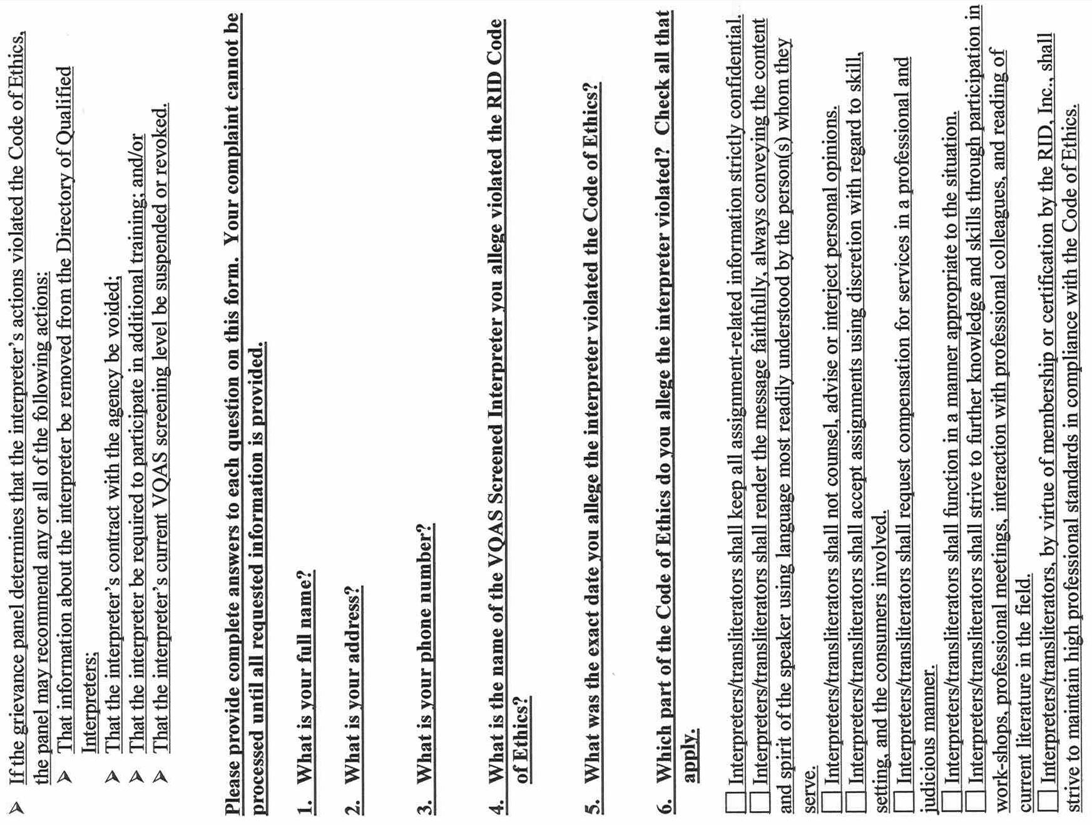
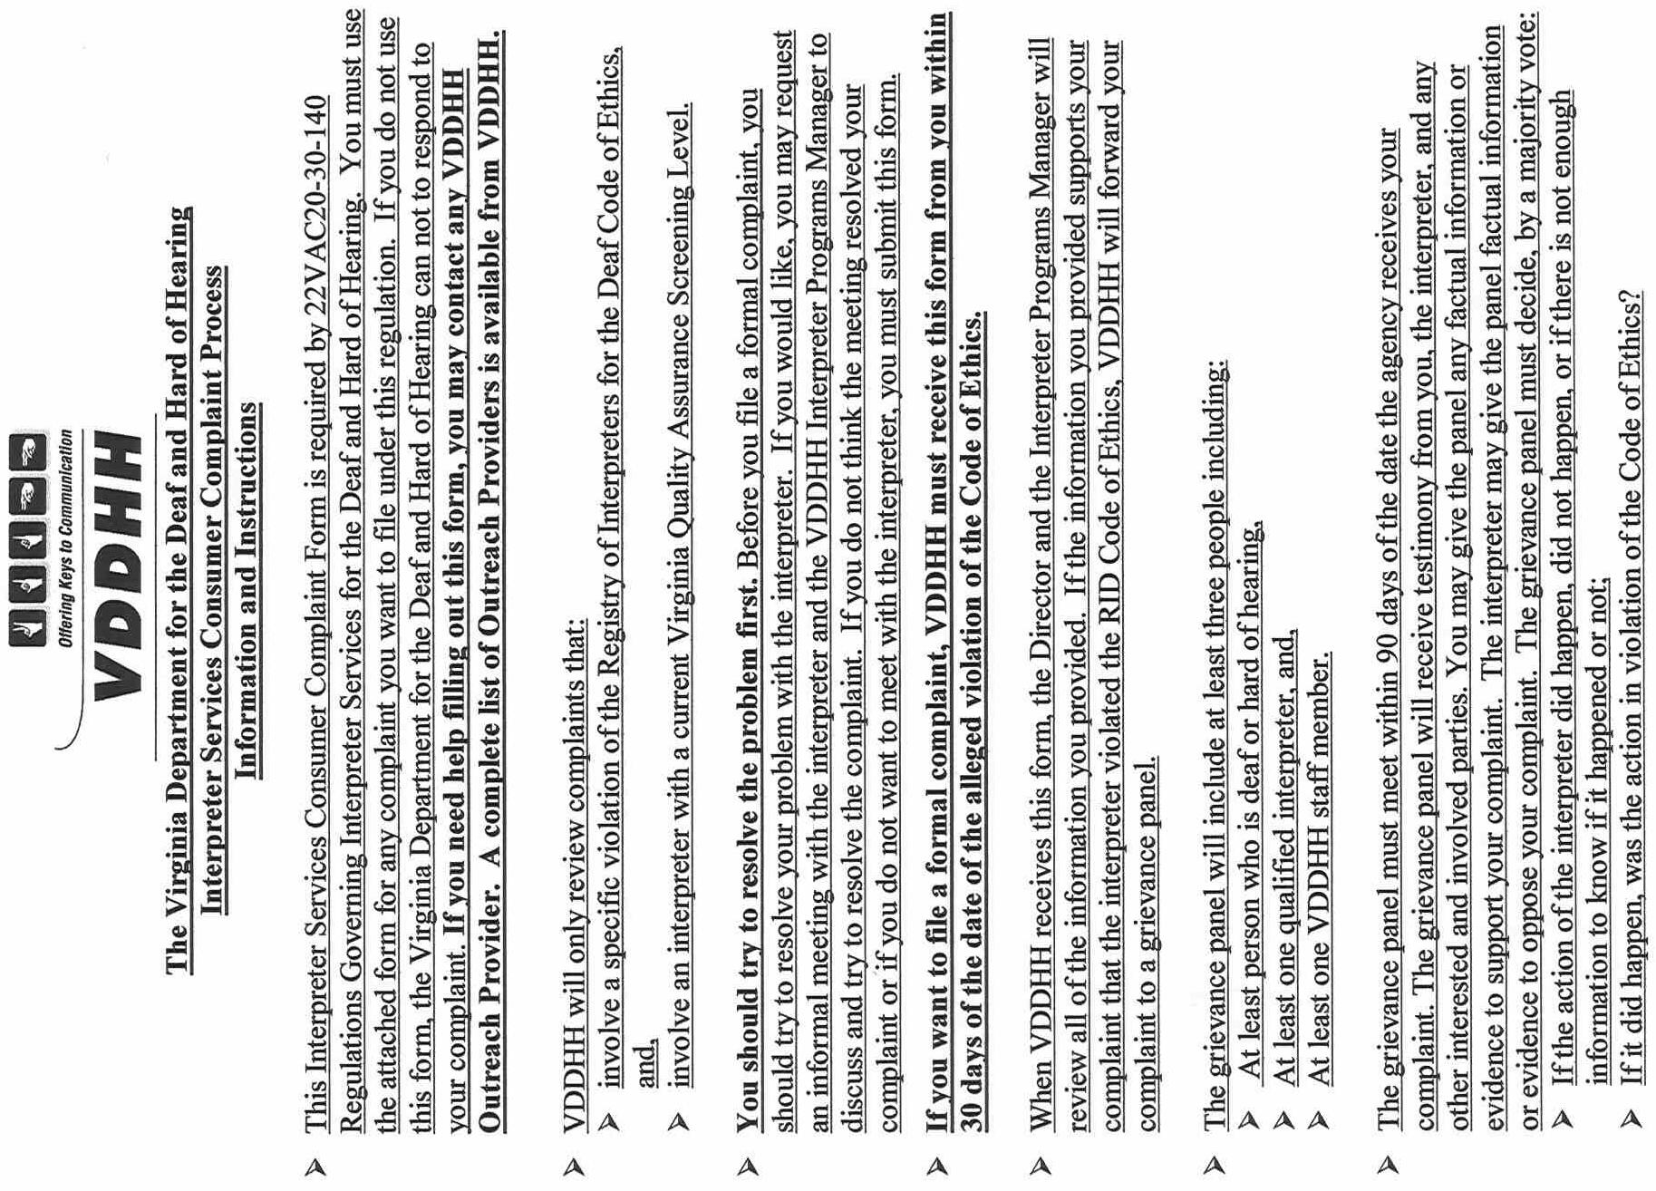
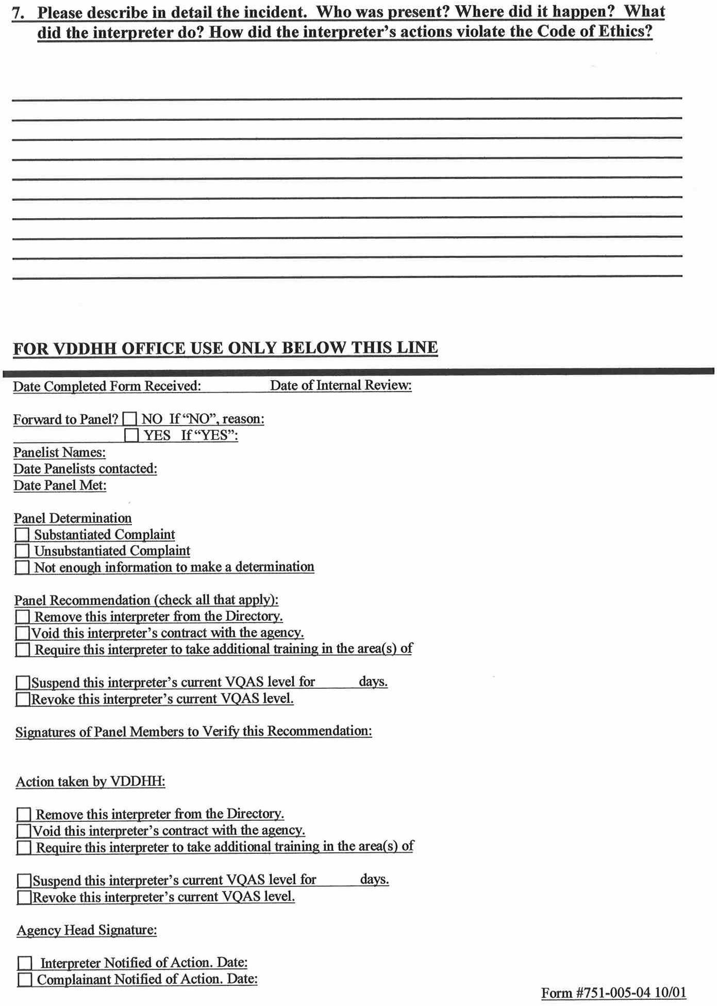
VA.R. Doc. No. R00-12; Filed June 29, 2001, 3:33 p.m.

