BOARD OF MEDICINE
Title of Regulation: 18 VAC 85-110-10 et seq. Regulations Governing the Practice of Licensed Acupuncturists (amending 18 VAC 85-110-100).
Statutory Authority: §§ 54.1-2400 and 54.1-2956.9 of the Code of Virginia.
Public Hearing Date: August 3, 2001 - 9:30 a.m.
Public comments may be submitted until September 28, 2001.
(See Calendar of Events section
for additional information)
Agency Contact: William L. Harp, M.D., Executive Director, Board of Medicine, 6606 W. Broad Street, 4th Floor, Richmond, VA 23230-1717, telephone (804) 662-9908.
Basis: Chapter 24 (§ 54.1-2400 et seq.) of Title 54.1 of the Code of Virginia establishes the general powers and duties of health regulatory boards including the responsibility to promulgate regulations, levy fees, administer a licensure and renewal program, and discipline regulated professionals. Section 54.1-2956.9 of the Code of Virginia gives the Board of Medicine authority to regulate the licensure of acupuncturists.
The legal authority to promulgate the proposed amendments is in the second enactment clause of Chapter 814 of the 2000 Acts of Assembly, which states: "That the Board of Medicine, in consultation with the Advisory Board on Acupuncture, shall promulgate regulations, including education and training requirements for doctors of medicine, osteopathy, chiropractic and podiatry who utilize acupuncture, and including the requirement for a standard form recommending a diagnostic examination for provision to the patient by the acupuncturist, to implement the provisions of this act within 280 days of enactment."
Purpose: The Code of Virginia requires the licensed acupuncturist to either get written documentation that the patient has received a diagnostic examination by a licensed practitioner of medicine, osteopathy, chiropractic or podiatry or to provide a written recommendation for such an examination to the patient. The enactment clause requires the board to promulgate regulations for this requirement, including a standard form to be signed by the patient.
While the Code of Virginia no longer requires that a person get a medical examination and referral prior to receiving acupuncture, concerns remain that a medical problem will go undiagnosed and untreated during the course of acupuncture treatment. Therefore, the requirement for a written recommendation for an examination by a physician will provide a measure of protection for a patient's safety and health.
Substance: Regulations for licensed acupuncturists are amended to specify a form which must be provided by a licensed acupuncturist to a patient who has not received a diagnostic examination from a physician within the past six months.
Issues: There have been no issues related to the written recommendation form; the Code of Virginia requires that such a form be given to acupuncture patients. Many licensed acupuncturists already utilize such a form for their own protection and their concerns about their patients. Based on discussions by the Advisory Committee on Acupuncture related to the composition of the form, the most important information and signature lines have been placed at the top of the form with the information intended for the acupuncturist at the bottom. Since licensed acupuncturists are not required to be fluent in English and the patient may not understand English, the instructions provide that the licensee has an obligation to either provide the form in the language of the patient or ensure that it has been translated for their understanding.
There are no disadvantages to the public; the public is better protected by the requirement for a disclosure form that will ensure the patient is aware of the need for a diagnostic examination by a doctor.
There are no disadvantages to the agency, since there are no additional tasks or responsibilities involved in compliance with these amendments.
Department of Planning and Budget's Economic Impact Analysis: The Department of Planning and Budget (DPB) has analyzed the economic impact of this proposed regulation in accordance with § 9-6.14:7.1 G of the Administrative Process Act and Executive Order Number 25 (98). Section 9-6.14:7.1 G requires that such economic impact analyses include, but need not be limited to, the projected number of businesses or other entities to whom the regulation would apply, the identity of any localities and types of businesses or other entities particularly affected, the projected number of persons and employment positions to be affected, the projected costs to affected businesses or entities to implement or comply with the regulation, and the impact on the use and value of private property. The analysis presented below represents DPB’s best estimate of these economic impacts.
Summary of the proposed regulation. Section 54.1-2956.9 of the Code of Virginia requires that, prior to performing any acupuncture procedure, an acupuncturist not licensed to practice medicine, osteopathy, chiropractic, or podiatry must either (i) obtain written documentation that the patient has received a diagnostic evaluation by a licensed medical practitioner with regard to the ailment or condition to be treated or (ii) provide a written recommendation for such an examination to the patient. The proposed regulatory action requires use of a standardized form for recommending a diagnostic evaluation and specifies that the form must be signed by the patient, that one copy be maintained in the patient’s file, and that another copy be provided to the patient.
Estimated economic impact. The existing requirement that patients be made aware of the need for a diagnostic examination by a licensed physician arises from concerns that a medical problem may go undiagnosed and untreated during the course of acupuncture treatment.
Currently, there is no required standard form for the written recommendations. Pursuant to Chapter 814 of the 2000 Acts of Assembly, the proposed regulations require the use of a standard form specified by the Board of Medicine for written recommendations. The specific form developed by the board requires the signatures of both the patient and the acupuncturist, explains why the form is required, provides instructions to the acupuncturist explaining how many copies of the form are required, how it should be filled out, and what to do when the patient does not understand English. The Department of Health Professions (DHP) indicates that the specific form developed by the board is similar to what most acupuncturists have been using in practice. The degree of similarity between the proposed standard form and the forms that have been used in practice is unknown. Especially, DHP does not know whether the forms used in practice included signatures of the patient and the physician. Because similar forms have been used in practice, the proposed changes are not expected to have significant economic impact in many cases.
In some cases, the proposed changes may result in small costs and benefits. The proposed regulations require all the patients and the physicians to devote some time to fill out and sign the form. Some of the patients and physicians may not have been filling out a specific type of information or signing the form but are required to do so under the proposed regulations. This may cost some physicians and patients a small amount of time. The loss of about 10 to 20 seconds per additional person may add up to a non-negligible amount of time that could be used elsewhere. In addition, for those practitioners who do not already maintain this documentation, there are likely to be very small compliance costs associated with copying the required form and maintaining a copy in the patient’s file. On the other hand, the proposed regulations may provide some benefits since the signatures of both the patient and the acupuncturist on the form will make it possible to determine if the patient received the required information should there be a disagreement. No such disagreements have been reported to date.¹
Businesses and entities affected. The proposed changes will affect 108 licensed acupuncturists in Virginia and their patients. However, the number of patients receiving acupuncture treatment is unknown.
Localities particularly affected. All localities in Virginia will be potentially affected.
Projected impact on employment. The proposed regulatory change is not expected to have any significant impact on employment.
Effects on the use and value of private property. The proposed regulatory change is not expected to significantly affect the use and value of private property.
Agency's Response to the Department of Planning and Budget's Economic Impact Analysis: The Board of Medicine concurs with the analysis of the Department of Planning and Budget.
Summary:
The proposed amendment requires a standard form that recommends a diagnostic examination by a physician be provided to the patients of acupuncturists.
18 VAC 85-110-100. General requirements.
Prior to performing acupuncture, a licensed acupuncturist shall obtain written documentation that the patient has received a diagnostic examination within the past six months by a licensed doctor of medicine, osteopathy, chiropractic, or podiatry acting within the scope of his practice or shall provide to the patient a written recommendation for such a diagnostic examination on a form specified by the board and signed by the patient. One copy of the signed form shall be maintained in the patient's chart and another copy provided to the patient.
NOTICE: The forms used in administering 18 VAC 85-110-10 et seq., Regulations Governing the Practice of Licensed Acupuncturists, are listed below. Any amended or added forms are reflected in the listing and are published following the listing.
FORMS
Instructions for Completing the Application for Licensed Acupuncturist, American Graduates (rev. 8/99).
Instructions for Completing the Application for Licensed Acupuncturist, Non-American Graduates (rev. 8/99).
Application for a License to Practice as an Acupuncturist (rev. 7/98).
Form #A, Claims History Sheet (rev. 1/98).
Form #B, Activity Questionnaire (rev. 1/98).
Form #C, Clearance from Other State Boards (rev. 1/98).
Verification of NCCAOM Certification (rev. 7/98).
Renewal Notice and Application (rev. 2/00).
Recommendation for a Diagnostic Examination (eff. 2001).
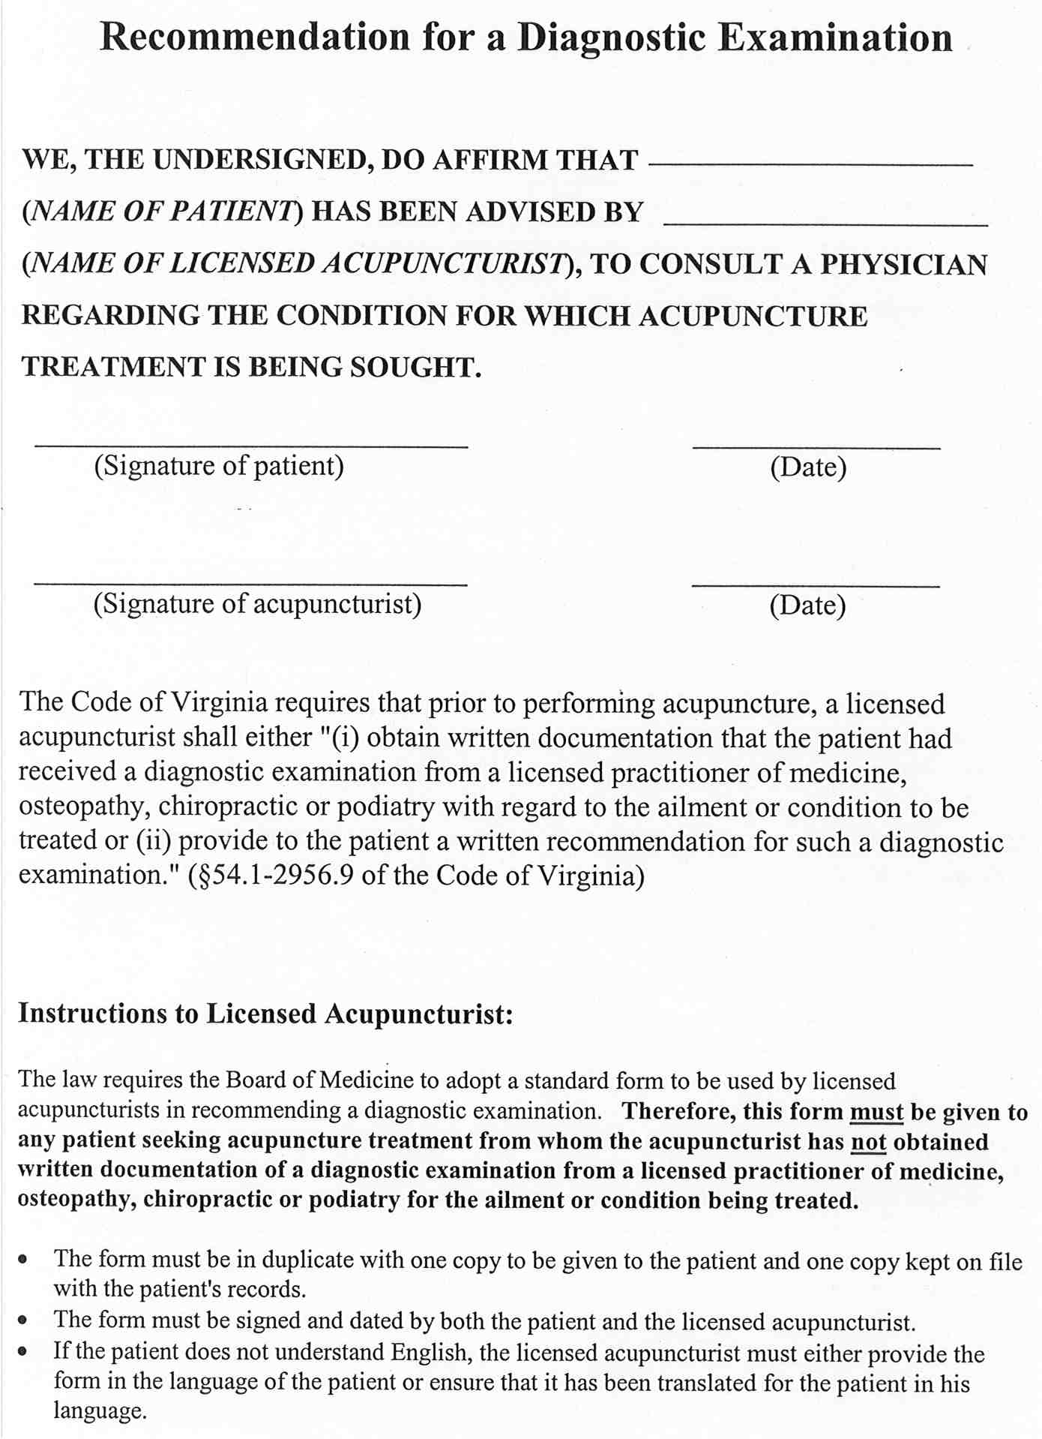
VA.R. Doc. No. R01-52; Filed July 10, 2001, 11:20 a.m.

1 Source: DHP

