COMMONWEALTH TRANSPORTATION BOARD
Title of Regulation: 24 VAC 30-71. Minimum Standards of Entrances to State Highways (amending 24 VAC 30-71-10, 24 VAC 30-71-70, 24 VAC 30-71-80, 24 VAC 30-71-90, 24 VAC 30-71-100, 24 VAC 30-71-110, 24 VAC 30-71-120, 24 VAC 30-71-130, 24 VAC 30-71-150, 24 VAC 30-71-160, and 24 VAC 30-71-170).
Statutory Authority: § 33.1-12, 33.1-197, and 33.1-198 of the Code of Virginia.
Public Hearing Date: December 16, 2002 - 7 p.m.
Public comments may be submitted until January 17, 2003.
(See Calendar of Events section
for additional information)
Agency Contact: Steve D. Edwards, Transportation Engineer Senior, Mobility Management Division, Department of Transportation, 1100 Bank Street, Richmond, VA 23219, telephone (804) 786-0121, FAX (804) 225-2448 or e-mail Steve.Edwards@VirginiaDOT.org.
Basis: In general terms, § 33.1-12 of the Code of Virginia vests the Commonwealth Transportation Board (CTB) with the powers and duties to regulate traffic operations on systems of state highways not in conflict with the laws of this Commonwealth.
Specific statutory authority for promulgating the existing regulation is set forth in §§ 33.1-197 and 33.1-198 of the Code of Virginia, which grant the commissioner the authority to issue permits for connections over shoulders of highways for (i) intersecting private roads and (ii) intersecting commercial establishment entrances.
Given the general authority granted the CTB to make regulations at its discretion, and the specific authority granted the commissioner concerning the issuance of permits, as well as the specific reference to the regulation by title, the General Assembly clearly intended that VDOT have broad control over the types of entrances installed under these statutes. Providing safe ingress and egress for entrance users is a responsibility of the Commonwealth of Virginia and the Department of Transportation. The granting of commercial entrance installations is based on user types, traffic volumes, horizontal and vertical alignments and sight distances, and posted or the 85th percentile operating speeds. VDOT must be able to review permits applied for under this regulation to ensure that deviations are justified from safety and infrastructure integrity standpoints, and the variables mentioned above are taken into account.
Purpose: The rationale for the amendments is to (i) implement public input with which VDOT concurs that is intended to improve the clarity or usefulness of the regulation and (ii) make routine updates to referenced material associated with the regulation.
VDOT believes that such amendments are essential to fulfilling the goals set for the regulation, namely to (i) protect the public's health, safety, and welfare with the least possible cost and intrusiveness to the citizens and businesses of the Commonwealth and (ii) determine whether the regulation is written clearly and understandably.
VDOT is obligated to ensure that the health and safety of VDOT and non-VDOT workers, pedestrians and motorists using the highways of the Commonwealth are preserved. The regulation provides a framework whereby uniform standards are established to control the use of highway rights-of-way when it is necessary to provide access to commercial, private, and industrial properties abutting state roads. These controls not only protect through traffic from indiscriminate interferences, they also promote safe and convenient connections to public highways.
Permits are required when work is performed on or crossing any right-of-way under VDOT’s jurisdiction. Permits are also required when modifications are needed for an existing entrance due to a change in the land use, or some other change that causes higher volumes of use. These requirements allow VDOT to ensure that work is performed with due regard to worker and motorist safety, as well as sound civil engineering principles. Therefore, both safety and preservation of the highway infrastructure are maintained.
VDOT believes that the protection of public safety and welfare is enhanced by making the proposed changes, especially since many of them came from the regulated public itself. Officials from Prince William County contributed several suggestions, most of which VDOT agreed to implement. These suggestions dealt primarily with adding to the list of defined terms, and adding descriptive technical terms (such as roundabouts) when discussing entrance requirements.
For example, modifying definitions to make them consistent with those used by other divisions will eliminate potential confusion. Providing additional information on accessibility to electronic documents associated with the regulation will improve the ease of use, since users can obtain the material more quickly.
Substance: The structure of the regulation has not been affected. The substantive changes deal with updates to the documents associated with the regulation and the revised or additional wording to promote clarity. The wording revisions occur primarily in the "Definitions" section and sections dealing with design issues (such as 24 VAC 30-71-70 and 24 VAC 30-71-100).
Issues: VDOT believes that the nature of the proposed revisions do not impose any disadvantages to the public or the Commonwealth. The changes are intended to provide users with a regulation that is easier to use and understand and, since many of the changes are from public comment, the regulated parties should be satisfied with the results. VDOT will collect additional public input during the amendment process, and determine if additional changes are appropriate prior to final adoption by the CTB.
Fiscal Impact:
A. Projected costs for implementation/enforcement: The proposed revised regulation is not anticipated to impose additional implementation or enforcement costs to the Commonwealth since it is currently being administered as part of daily field operations. It is anticipated that the proposed regulation will cost the Virginia Department of Transportation approximately $10,000 to amend, print and distribute. No additional personnel will be needed to enforce the proposed amended regulation, since existing staff currently administers the regulation. These employees handle other duties (e.g., land use permit-related tasks, hauling permit-related tasks, reviewing subdivision plans, etc.) as well, so they would still be necessary even if the regulation did not exist. The "Minimum Standards of Entrances to State Highways" refers to forms used for the "Land Use Permit Manual," (24 VAC 30-150), so it has no forms of its own. Instructions for accessing these forms electronically from VDOT’s Internet site are included as part of this submission.
The fee structure for entrance permits is included in the "Land Use Permit Manual" (24 VAC 30-150), which is to be revised under the Administrative Process Act. Permit fees vary, depending on the type of work involved; there is a $40 minimum charge plus whatever additive charges are appropriate. For example, a private entrance permit requiring permit surety would require a $40 rate. If work on a private, commercial, street or road tie-in, median crossover, or subdivision entrance required more than one opening, an additive charge of $5 per opening or crossover would be assessed, provided the work was not performed in conjunction with a blanket permit.
Since the proposed revisions to 24 VAC 30-71 do not change the cost of any fees or change the surety bond requirements, it would be premature to discuss the fee structure further at this time. It is anticipated that the revisions to the "Minimum Standards of Entrances to State Highways" will not affect the number of entrance permits issued - 19,476 entrance permits were issued in 2001. In contrast, 88,528 total land use permits were issued in 2001, which indicates entrance permits constitute a significant share of the entire annual activity.
1. Fund source/fund detail: VDOT’s funds come primarily from the Transportation Trust Fund (a nongeneral fund), comprised of the Highway Maintenance and Operating Fund (HMO) and the Transportation Trust Fund (TTF). The HMO is derived from a mixture of state and federal revenue sources (fuel and hauling permit fees, tolls, road taxes, special-purpose federal funds, etc.), and is spent on administrative and support services (such as computer and physical plant services), highway system maintenance, and specialized activities undertaken by other state agencies (Departments of State Police, Rail and Public Transportation, Motor Vehicles, Old Dominion University, etc.). The Transportation Trust Fund is established by statute (§ 33.1-23.03:1 of the Code of Virginia), and is comprised of funds designated by the General Assembly. Revenues from this fund are spent on highways and other transportation modes, and specialized transportation programs and matching funds. For 2001, these funds totaled $1.2 and 2.0 billion, respectively. The Virginia Transportation Act of 2000 for the first time made an appropriation of approximately $545 million for highway projects, but this money will not be used in support of the regulation.
2. Budget activity with a cross-reference to program and subprogram: Funding for Land Use permit activities comes from Program #60300, Subprogram #09 (Construction Management).
3. One-time costs/expenditures: Based on typical costs for public hearings by VDOT’s Location and Design Division, overall staff and administrative costs for a single public hearing to collect input for this regulation could range from $1,500 to $4,000, depending on the number of newspapers used, and the frequency of the ad. Only one public hearing is planned. Ongoing costs include expenses to print copies of the manual, etc. The regulation will be printed in-house, so there will be no outside printing costs.
B. Projected costs of regulation on localities: There should be no direct costs to localities, since they are generally self-insured, and need not secure bonds for work on CTB right-of-way. They also generally do not perform their own installations, so any permit costs would be directly borne by the contractor performing the work. Permit fees would, therefore, constitute part of the administrative costs to perform the installation. Local public works employees use the "Minimum Standards of Entrances to State Highways" as one of many engineering guides in evaluating their own facilities.
C. Description of those affected by regulation: This regulation would affect individuals who wish to install driveways to connect their homes to the highway, business owners, developers, etc., that construct or modify entrances connecting their businesses or subdivisions to the highway. Since there is an approximate one-to-one relationship between the number of permits issued and the affected parties, there are currently almost 20,000 parties that are affected by the regulation throughout the Commonwealth.
Department of Planning and Budget's Economic Impact Analysis: The Department of Planning and Budget (DPB) has analyzed the economic impact of this proposed regulation in accordance with § 2.2-4007 G of the Administrative Process Act and Executive Order Number 21 (02). Section 2.2-4007 G requires that such economic impact analyses include, but need not be limited to, the projected number of businesses or other entities to whom the regulation would apply, the identity of any localities and types of businesses or other entities particularly affected, the projected number of persons and employment positions to be affected, the projected costs to affected businesses or entities to implement or comply with the regulation, and the impact on the use and value of private property. The analysis presented below represents DPB’s best estimate of these economic impacts.
Summary of the proposed regulation. The proposed regulations will update with the most recent versions the technical documents containing standards of entrances to state highways incorporated by reference. The only substantive change among these is allowing the use of superpave mix in the referenced materials. The proposed amendments will also improve the clarity of the regulation by adding and revising definitions, adding explanations, descriptions, and new terms to the current language in a number of places. Among these changes, the clarification that Virginia Department of Transportation (the department) has discretion to modify the details of private subdivision entrance designs may introduce some economic effects.
Estimated economic impact. These regulations contain minimum standards of entrances to state highways. The entrance design and construction standards are highly technical and are published in seven different documents amounting to over a thousand pages. The standards in these documents are incorporated in the regulations by reference. The proposed changes will update the referenced material with their most recent versions.1 In addition to updating these documents, metric sight distances along major roads at intersections with minor roads, crossovers or median openings, and commercial entrances will be provided in a table rather than referencing another technical document as currently done.2 The department indicates that the most recent version of standards of entrances to state highways are currently enforced and the proposed changes will not have any impact on the implementation of these regulations. In addition, the department indicates that there are only minor differences between old and new versions of the referenced material, which are generally related to the clarity of the language. Thus, no significant economic impact is expected from implementation of the proposed changes at this time since they are already enforced in practice and most of the changes are not substantive. However, by producing consistency between the referenced standards in the regulation and the standards enforced in practice, most of the proposed regulations are expected to improve the clarity of the regulations and reduce potential confusions the highway entrance permit applicants may encounter.
The department indicates that the only substantive change between the two versions of the referenced documents is allowing the use of "superpave mix" in the most recent pavement design guidelines. It is indicated that the current Marshall mix design is restrictive and does not allow contractors the flexibility to design mixes that facilitate the use of new materials that are functional and more durable than, or at least as durable as, the current materials used in pavements. On the other hand, the superpave mix design is a system or a menu of mix design options that contractors can use to determine the characteristics of components in a mix such as liquid asphalt, binder, or the aggregate that is most appropriate for a given location. It also evaluates placement and performance characteristics such as fatigue, thermal cracking, etc. to develop a durable mix and provide the desired levels of safety and other factors inherent in the design specifications. In short, the permit applicants can choose a pavement mix that is appropriate for the location taking into factors such as traffic volume, percentage of trucks, climate, and geography. According to the agency, the superpave mix design resulted from a five-year research project sponsored by the Federal Highway Administration. The study evaluated asphalt performance to determine if improvements in traditional methods could be developed.
The proposed change to allow the use of superpave mix on highway entrances is expected to benefit permit applicants. The applicants will be afforded an option to use the superpave mix design in addition to current designs available to them. They are likely to opt to use this option only if it produces net benefits. It costs about $1,250 to build a typical private entrance using regular pavement while it costs about $1,350 if the superpave mix is used.3 Cost savings from increased durability such as savings in premature repair or replacement costs over the life of the entrance are expected to outweigh the higher costs of superpave to some degree. Thus, if the use of superpave mix is cost efficient for applicants, contractors are likely to inform their customers, and the customers are likely to take advantage of this new option. Although the increased flexibility in choosing pavement design for applicants has the potential to increase monitoring costs to ensure that the performance standards for pavement are met, the department believes that current monitoring practices will be sufficient to ensure compliance with the required standards. The size of aggregate benefits from being able to utilize the superpave option depends on the total number of cases. The department has ongoing efforts to publicize the superpave concept to municipalities, contractors, developers and other interested parties, but does not know in how many cases the superpave option may be selected.
Most of the other proposed changes are related to the regulatory language and include updating the reference to the Code of Virginia to take into account most recent code changes, adding a new definition, revision of two definitions, and adding explanations, descriptions, or new terms to the current language in a number of places to improve the clarity, and providing additional information on where to obtain electronic and print copies of referenced documents. Similar to most referenced materials, the department indicates that most of these changes will not affect the way these regulations are currently implemented, but mainly clarify the rules contained in them. Thus, no significant economic effects are expected from most of the changes other than reducing the chance for potential confusions.
However, one of the changes under this category may be significant. The change is related to a recent disagreement between the department and an entrance permit applicant. The disagreement was over the discretion of the engineer representing the department, when based on sound engineering principles, to modify the details of the generic private subdivision road/street entrance design included in the regulations. The engineer’s discretion is noted in the other 14 design illustrations in the regulation, but not in the private subdivision design illustration. The applicant argued before the court that the engineer did not have the discretion to change the size of the design specified in the regulations because the engineer’s discretion was not noted. The court determined that the engineer had authority to amend the details shown only for those illustrations explicitly bearing the provision. Since the proposed change will add a provision to indicate that the engineer can modify the design, the chances of having to approve unsafe sight distance and road geometry configurations which may lead to increased likelihood of crashes, injuries, and deaths will likely be lower. This proposed change is also likely to benefit the department by reducing the chances of having a dispute with an entry permit applicant and consequently reducing potential litigation costs. The entrance applicants on the other hand may incur some additional costs because of required modifications to the designs, or because they may not be able to obtain a permit if site conditions do not allow required modifications for safe entrances.
Businesses and entities affected. The proposed regulations apply to permit applicants who wish to construct a connection to a public highway. The permit applicants may include residential and commercial developers, business owners constructing or modifying their facilities, private homeowners installing driveways, and municipalities. The number of permits issued is positively related to the level of economic activity. For example, during economic expansions more homes and commercial/industrial facilities are built and more permit applications are received to connect them to the state highways. Although variability is inherent in the number of affected entities due to the level of economic activity, the department issued 3,025 highway entrance permits in the last year, which is the best available estimate at this time for the number of affected entities.
Localities particularly affected. The proposed regulations apply to all localities throughout Virginia.
Projected impact on employment. No significant impact on employment is expected.
Effects on the use and value of private property. The proposed option to use superpave mix has the potential to positively contribute relatively small amounts to the value of private homes and commercial/industrial facilities if durability of the connection to state highways is improved. Increase in value should approximately reflect the expected cost savings from reduced repair and maintenance over the life of the pavement minus additional construction costs.
Similarly, modified designs by engineers may improve the safety of an entrance to a state highway. In these cases, the value of the affected property is expected to reflect the discounted value of the reduced likelihood of accidents the owner may involve less the additional costs that must be incurred to comply with the approved design.
Agency's Response to the Department of Planning and Budget's Economic Impact Analysis: The Virginia Department of Transportation concurs with the economic impact analysis prepared by the Department of Planning and Budget.
Summary:
The proposed amendments update the technical documents containing standards of entrances to state highways incorporated by reference with the most recent versions. The only substantive change among these is allowing the use of superpave mix in the referenced materials. The proposed amendments improve the clarity of the regulation by adding and revising definitions, adding explanations, descriptions, and new terms to the current language in a number of places; and clarify that the Virginia Department of Transportation has discretion to modify the details of private subdivision entrance designs.
24 VAC 30-71-10. Definitions.
The following words and terms when used in this chapter shall have the following meanings unless the content clearly indicates otherwise:
"Accessible route" means a continuous unobstructed, stable, firm and slip-resistant path connecting all accessible elements of a facility (may include parking access aisles, curb ramps, crosswalks at vehicular ways, walks, ramps and lifts) that can be approached, entered and used by persons with mobility impairments. An accessible route shall, to the maximum extent feasible, coincide with the route for the general public and shall be a minimum of three feet (0.9 meter) wide.
"Board" means the Commonwealth Transportation Board, Commonwealth of Virginia.
"Central office" means the office in downtown Richmond that contains the administrative functions, including preconstruction activities, and executes command responsibility and control over all Virginia Department of Transportation activities.
"Clear zone" means the unobstructed, relatively flat area provided beyond the edge of the traveled way for the recovery of errant vehicles. The width of the clear zone is influenced by the type of facility, traffic volume, speed, horizontal alignment and embankment and is detailed in the department's Road Design Manual, English (revised October 1996) or metric (revised September 1996) measurement versions (effective July 1998).
"Commercial entrance" means an entrance serving all entities other than an individual private residence. (See private entrance.)
"Commissioner" means the Commonwealth Transportation Commissioner, who is also Vice-Chairman of the Commonwealth Transportation Board.
"Commonwealth" means the Commonwealth of Virginia.
"Crossover" or "median opening" means a state-maintained area located between opposing traffic, usually paved, to provide for crossing, left turn or U-turn maneuvers, on four- or more lane divided highways.
"Department" means the Virginia Department of Transportation (VDOT).
"Design speed" means the maximum safe speed that can be maintained over a specified section of highway when conditions are so favorable that the design features of the highway govern, as defined in the American Association of State Highway Transportation Officials' 1994 edition of A Policy on Geometric Design of Highways and Streets.
"District office" means the office in each of the nine construction districts located throughout the state that implements the construction and maintenance operations of the Virginia Department of Transportation.
"Engineer" means the engineer representing the Virginia Department of Transportation.
"Operating speed" means the highest overall speed at which a driver can travel on a given highway under favorable weather conditions and under prevailing traffic conditions without at any time exceeding the safe speed as determined by the design speed on a section-by-section basis, as defined in the American Association of State Highway Transportation Officials' 1994 edition of A Policy on Geometric Design of Highways and Streets.
"Private entrance" means an entrance serving an individual that serves up to two private residence residences and is used for the exclusive benefit of the occupant.
"Private subdivision road or street" means a road or street that serves more than one two individual property properties, is privately owned and maintained, and requires a commercial entrance permit.
"Right-of-way" means that property within the entire area of every way or place of whatever nature within the system of state highways under the ownership, control or jurisdiction of the board, which that is open or which that is to be open within the future for the use of the public for purposes of travel in the Commonwealth. The area set out above includes not only the traveled portion but the entire area inside and outside the traveled portion, from boundary line to boundary line, and also parking and recreation areas which that are under the ownership, control or jurisdiction of the board.
"Sight distance" means, for crossovers and commercial entrances, the distance measured between the height of the driver's eye (3.5 feet) (1.07 meter) and the height of a 4.25-foot (1.30 meter) object without horizontal or vertical obstruction to the line of sight.
"System of state highways" means all highways and roads under the ownership, control, or jurisdiction of the board including, but not limited to, the primary, secondary, and interstate systems.
24 VAC 30-71-70. Location.
To prevent undue interference with free traffic movements, entrance locations shall be avoided within intersectional functional intersection areas, traffic circles or roundabouts, railroad grade crossings, interchanges or similar areas of traffic congestion. It is essential that designs allow unimpeded traffic movements entering or exiting. Parking and storage spaces shall be located a reasonable distance from the entrance location to prevent interference with vehicles attempting to enter or exit the facility.
To reduce the number of points of access to state highways, joint use entrances are recommended if agreement can be reached by the owners. For a joint use entrance to be approved by the department, a copy of the property owner's recorded agreement shall be submitted to the department.
24 VAC 30-71-80. Construction.
The type and depth of pavement shall be clearly indicated on the permit application. The pavement of entrances, turn lanes, and tapers shall be of stable material which that is at least comparable to the pavement of the adjacent roadway.
On-site parking shall be designed so as not to interfere with sight distance and to prevent vehicular overhang on state right-of-way. Interior curbing should be set a minimum of two feet (0.61 meter) outside or beyond the right-of-way line and should extend the entire length of the parking area. When parking areas abut curbing sections with sidewalk, parked vehicles shall be kept a sufficient distance from the curbing by the use of parking bumpers, or other means, to prevent vehicle overhang over the sidewalk. The engineer shall determine the need for additional curbing along the right-of-way to the adjacent property line.
Mountable curb (standard CG-3 or CG-7 in the English (revised April 1995 effective February 2001) or metric (revised September effective January 1997) measurement versions of the Road and Bridge Standards, Volumes I and II) is required when constructed within the clear zone of a road posted for a speed limit greater than 40 miles per hour (60 kilometers per hour) in rural areas and 45 miles per hour (70 kilometers per hour) in urban and suburban areas. However, mountable curb is not recommended adjacent to sidewalks, due to potential encroachment of a vehicle onto the sidewalk.
All curbing and entrance gutters used to construct commercial entrances shall be installed in accordance with the Virginia Department of Transportation's Road and Bridge Standards, English (revised April 1995 effective February 2001) or metric (revised September effective January 1997) measurement versions, and all material shall meet the department's certification.
The property owner or developer of commercial or industrial entrances or subdivision road entrances shall be responsible for the entire construction of the entrance in accordance with the provisions of the required permit.
24 VAC 30-71-90. Drainage.
Entrances shall be constructed so as not to impair drainage within the state's right-of-way, and so that surface water shall drain from the state roadway.
Where deemed necessary by the engineer, copies of a complete drainage layout, based on a drainage study by a qualified engineer, shall be furnished by the permittee, along with his plans. This layout shall include the ultimate development and clearly show how the permittee proposes to handle the drainage and run-off from his development.
Pipe ends of culverts shall be reviewed independently by the engineer and grading or treatment at pipe ends shall be done in such a manner as to minimize any hazard the pipe end ends or structures may present to an out-of-control vehicle.
24 VAC 30-71-100. Crossovers or median openings.
Crossovers or median openings between the main through lanes shall not be permitted at entrances being constructed under provisions of a permit unless determined necessary by the department, and then only in accordance with the current policy on crossovers or median openings as outlined in this chapter and the department's Road Design Manual, English (revised October 1996) or metric (revised September 1996) measurement versions (effective July 1998). All crossover or median opening locations shall be approved by the district traffic engineer.
Crossovers or median openings that do not meet the standards as outlined in the department's Road Design Manual, English (revised October 1996) or metric (revised September 1996) measurement versions (effective July 1998), shall be reviewed by the state traffic engineer and the state location and design engineer.
If the department determines that a crossover or median opening is permissible, the permittee shall be responsible for the entire cost and construction, including turn lanes, traffic signal system, or both, as deemed necessary by the engineer.
24 VAC 30-71-110. Auxiliary lanes, right turn lanes and left turn lanes.
The need for auxiliary lanes, right turn lanes and left turn lanes shall be jointly determined by the district traffic engineer and resident engineer in accordance with the department's latest design and construction criteria included in the English (revised October 1996) or metric (revised September 1996) measurement versions (effective July 1998) of the Road Design Manual.
24 VAC 30-71-120. Curb ramps for persons with mobility impairments.
Ramps in curb sections to aid the physically handicapped shall be provided as required in § 15.1-381 15.1-2021 of the Code of Virginia. A The standard drawing of the for depressed curb ramp (CG-12) is as shown in the Road and Bridge Standards, English (revised April 1995 effective February 2001) or metric (September effective January 1997) measurement versions, shall be utilized in the design.
24 VAC 30-71-130. Sight distances.
The following shall be utilized to evaluate sight distance. Vertical sight distance shall be determined from a target mounted 4.25 feet (1.30 meters) above the grade of the vehicle path simulating a vehicle entering or exiting the entrance traveling the through lanes of the roadway. The sight distance shall be measured from an eye height of 3.5 feet (1.07 meters) to the target. Horizontal sight distance shall be determined from an eye height of 3.5 feet (1.07 meters) with the object being 4.25 feet (1.30 meters). For more information on sight distance, see the 1994 edition of A Policy on Geometric Design of Highways and Streets published by the American Association of State Highway Transportation Officials.
On a typical two lane road with a horizontal curve, numerous objects restrict sight distance. These include, but are not limited to, cut slopes, buildings, vegetation, and vehicles. Landscaping in these areas shall conform to the Chief Engineer’s memorandum entitled "Guidance for Planting in the Clear Zone and Landscaping for VDOT Projects" dated October 31, 2000, pending completion of an updated VDOT Environmental Division's Planting Guidelines Manual, effective 1990. It is possible to have sight distance in the winter and not in the spring or summer due to the growth of vegetation. These obstructions should be considered when reviewing a commercial entrance permit. A divided highway may have similar problems. It is important to obtain the desirable commercial entrance sight distance from the entrance as well as the left turn position into the entrance. Any waiver of the required sight distance may only be granted by the chief engineer or the assistant commissioner for operations after a traffic engineering investigation has been conducted.
Table 1 shows specific information about sight distances and speeds along major roads:

Table 1
Sight Distances Along Major Roads at Intersections with Minor Road and Roads, Crossovers or Median Openings, and Commercial Entrances
(English measurements)
Height of Eye (3.5 ft.) | Height of Object (4.25 ft.)
Speed Limit*  Miles per hour (mph) | 25 mph | 30 mph | 35 mph | 40 mph | 45 mph | 50 mph | 55 mph
Two and Three Lane Road or Four Lane Divided Highways not at Crossovers | 250 ft. | 300 ft. | 350 ft. | 400 ft. | 450 ft. | 500 ft. | 550 ft.
Four Lane** Undivided and Four Lane Divided Highways at Crossovers | 300 ft. | 350 ft. | 425 ft. | 475 ft. | 525 ft. | 600 ft. | 650 ft.
Sight Distances Along Major Roads at Intersections with Minor Roads, Crossovers or Median Openings, and Commercial Entrances
(Metric Measurements)
Height of Eye (1.07 m.) | Height of Object (1.30 m.)
Design speed (km/h)* | 40 | 50 | 60 | 70 | 80 | 90
Two Lane Major Road | 75 m. | 95 m. | 115 m. | 135 m. | 150 m. | 170 m.
Four Lane Major Road | 85 m. | 110 m. | 130 m. | 150 m. | 175 m. | 195 m.
Four Lane Major Road**  (Divided – 5.4 m. Median) | 95 m. | 115 m. | 140 m. | 165 m. | 185 m. | 210 m.
* Where the operating speed on the respective segment of highway is determined to be lower than the legal speed limit, and, in the judgment of the engineers, the operating speed shall not create hazards for either a driver at a connection or on the major roadway and the legal speed limit cannot and, in all probability, shall not be obtained in the foreseeable future as a result of improvement or reconstruction, the sight distance requirements for the operating speed may then be applied. The operating speed shall be determined by a traffic engineering study at the location in question. In all cases when the operating speed is used in lieu of the speed limit, full documentation of its determination shall be attached to the permit assembly.
** For median widths greater than 60 feet (18 meters), each roadway can be considered as a separate two, three, or four lane roadway. (See the 1994 edition of A Policy on Geometric Design of Highways and Streets.)

24 VAC 30-71-150. Developer participation in traffic signal cost.
The following guidelines have been developed in an effort to obtain an equitable method of determining developer responsibility for participation in funding traffic signal work necessitated by land development:
1. Where the proposed development will generate sufficient traffic to warrant signalization, the total cost for design, materials, timing plans, and installation shall be borne by the developer.
2. Where development-generated traffic and existing highway traffic must be combined to meet the requirements for either the major or minor movements for any hour or hours, the developer shall bear 50% of the total cost for design materials, timing plans, and installation.
3. Where an existing traffic signal must be modified to accommodate traffic movements to or from the development, the developer shall bear the total cost for any design, materials, timing plans, installation, and relocation required to accommodate the development traffic.
For large developments, such as regional shopping centers and corporate complexes, the department reserves the right to require that the developer design or have designed the traffic signal, including timing plans, and to install or have installed a complete working installation traffic signal system. Designs and installations shall be in accordance with the current departmental specifications and standards and shall be approved by the engineer.
24 VAC 30-71-160. Commercial/private entrance design illustrations.
The details set forth in the illustrations contained in this section may be reduced or modified if approved by the district administrator or engineer.
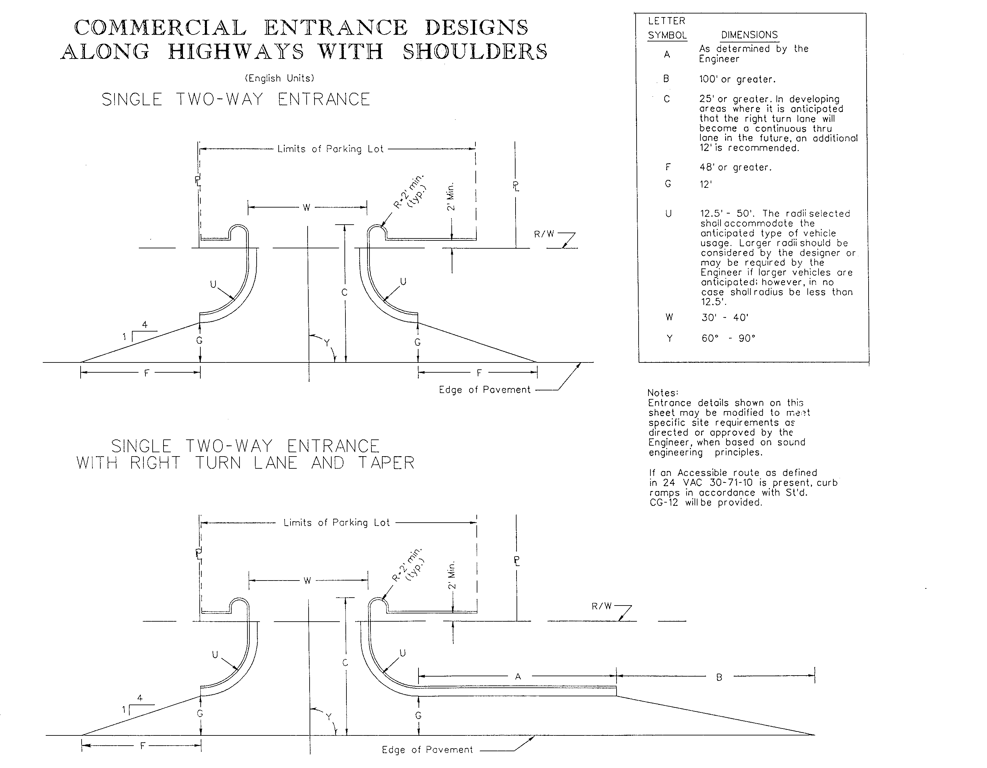
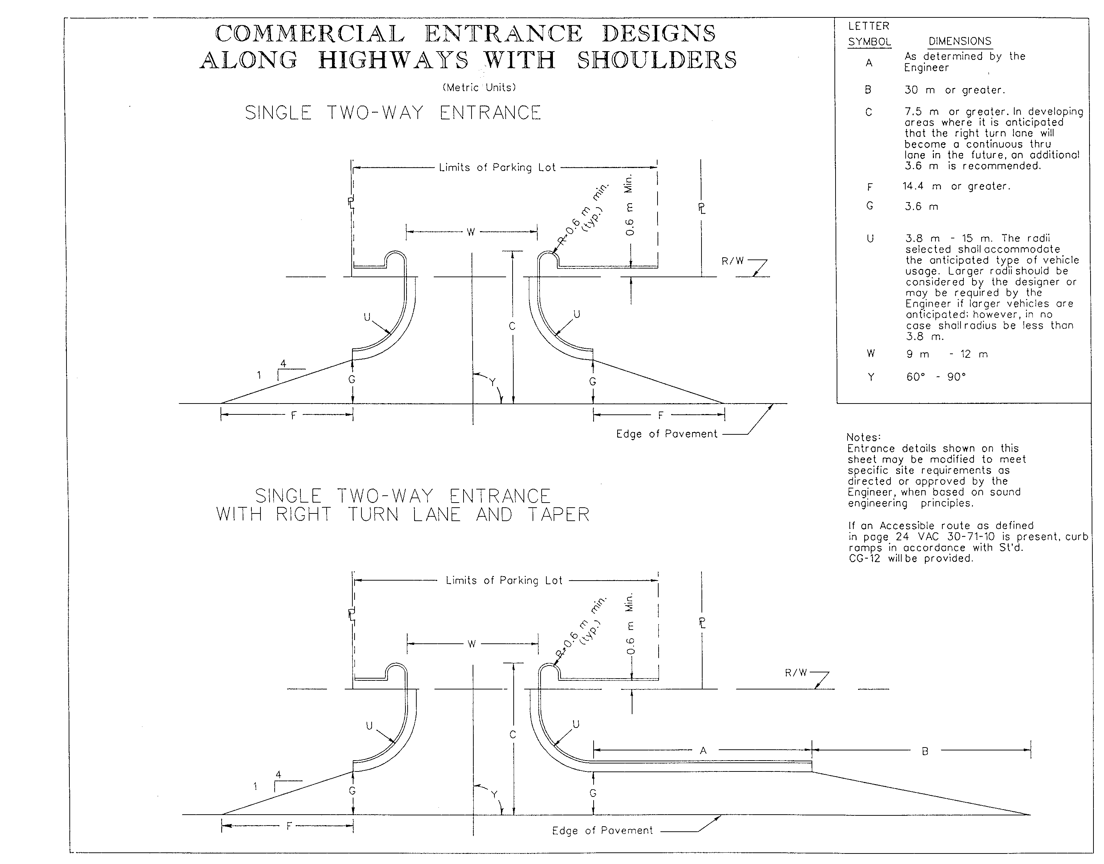
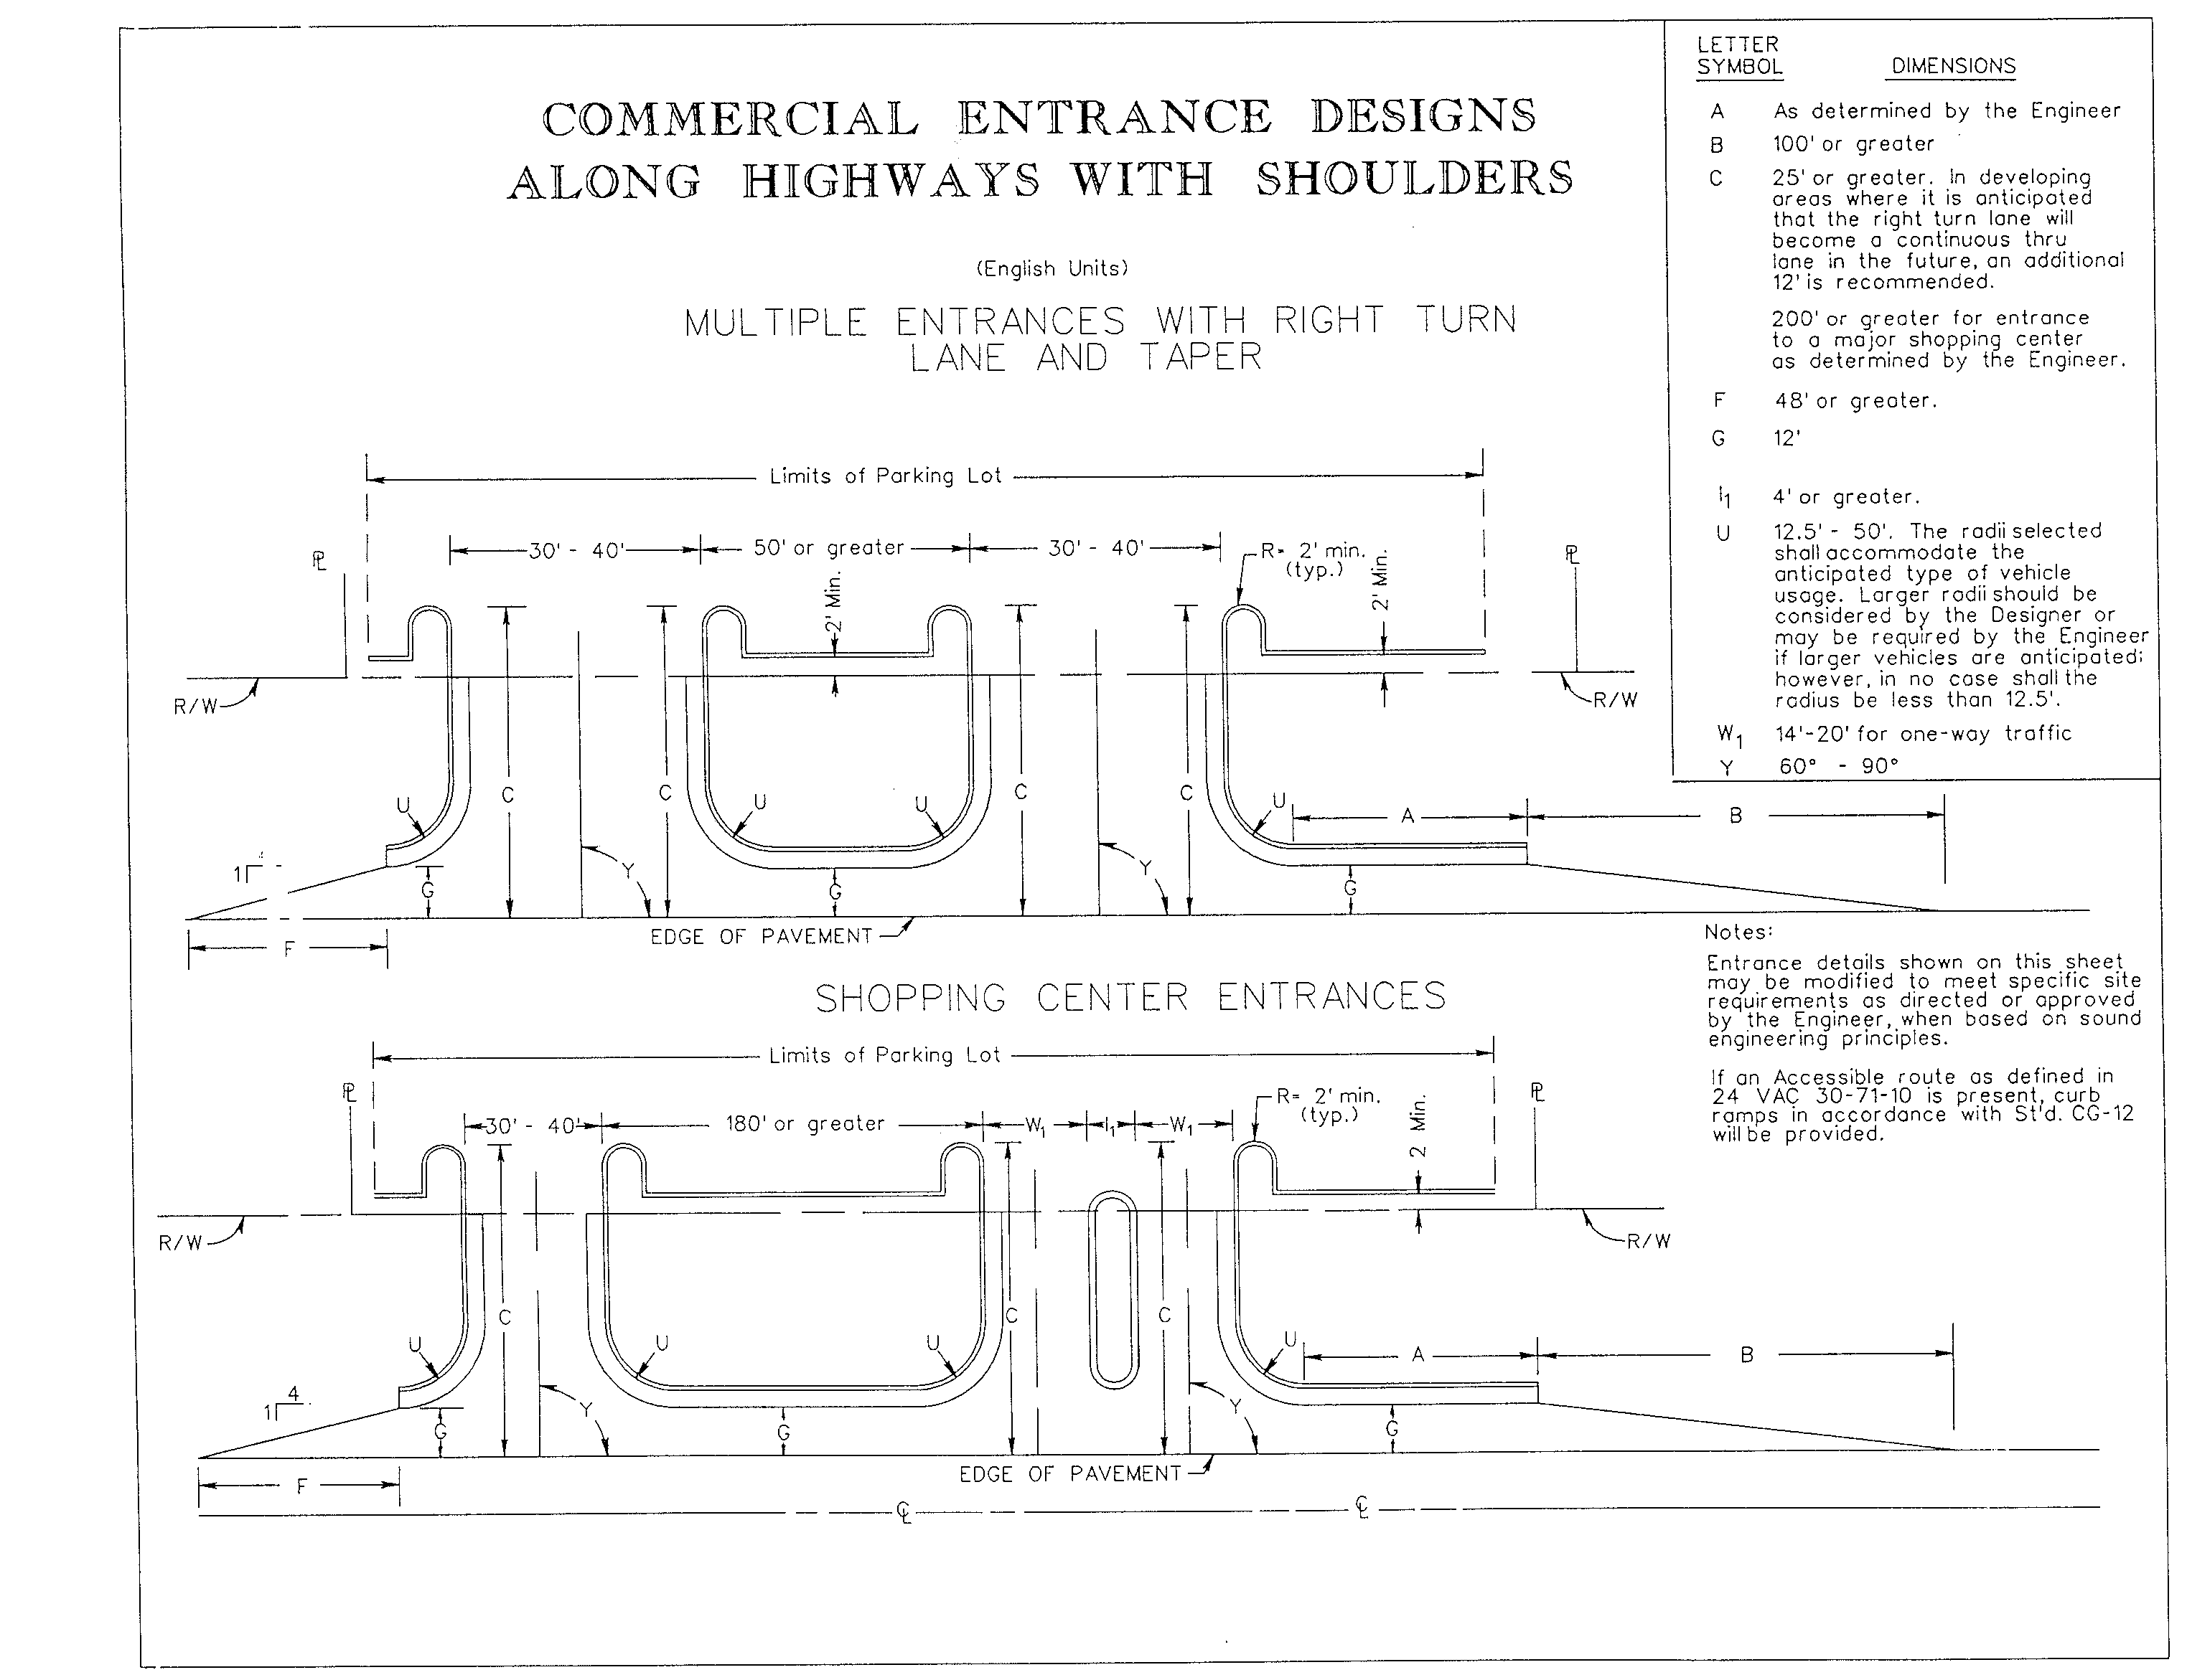
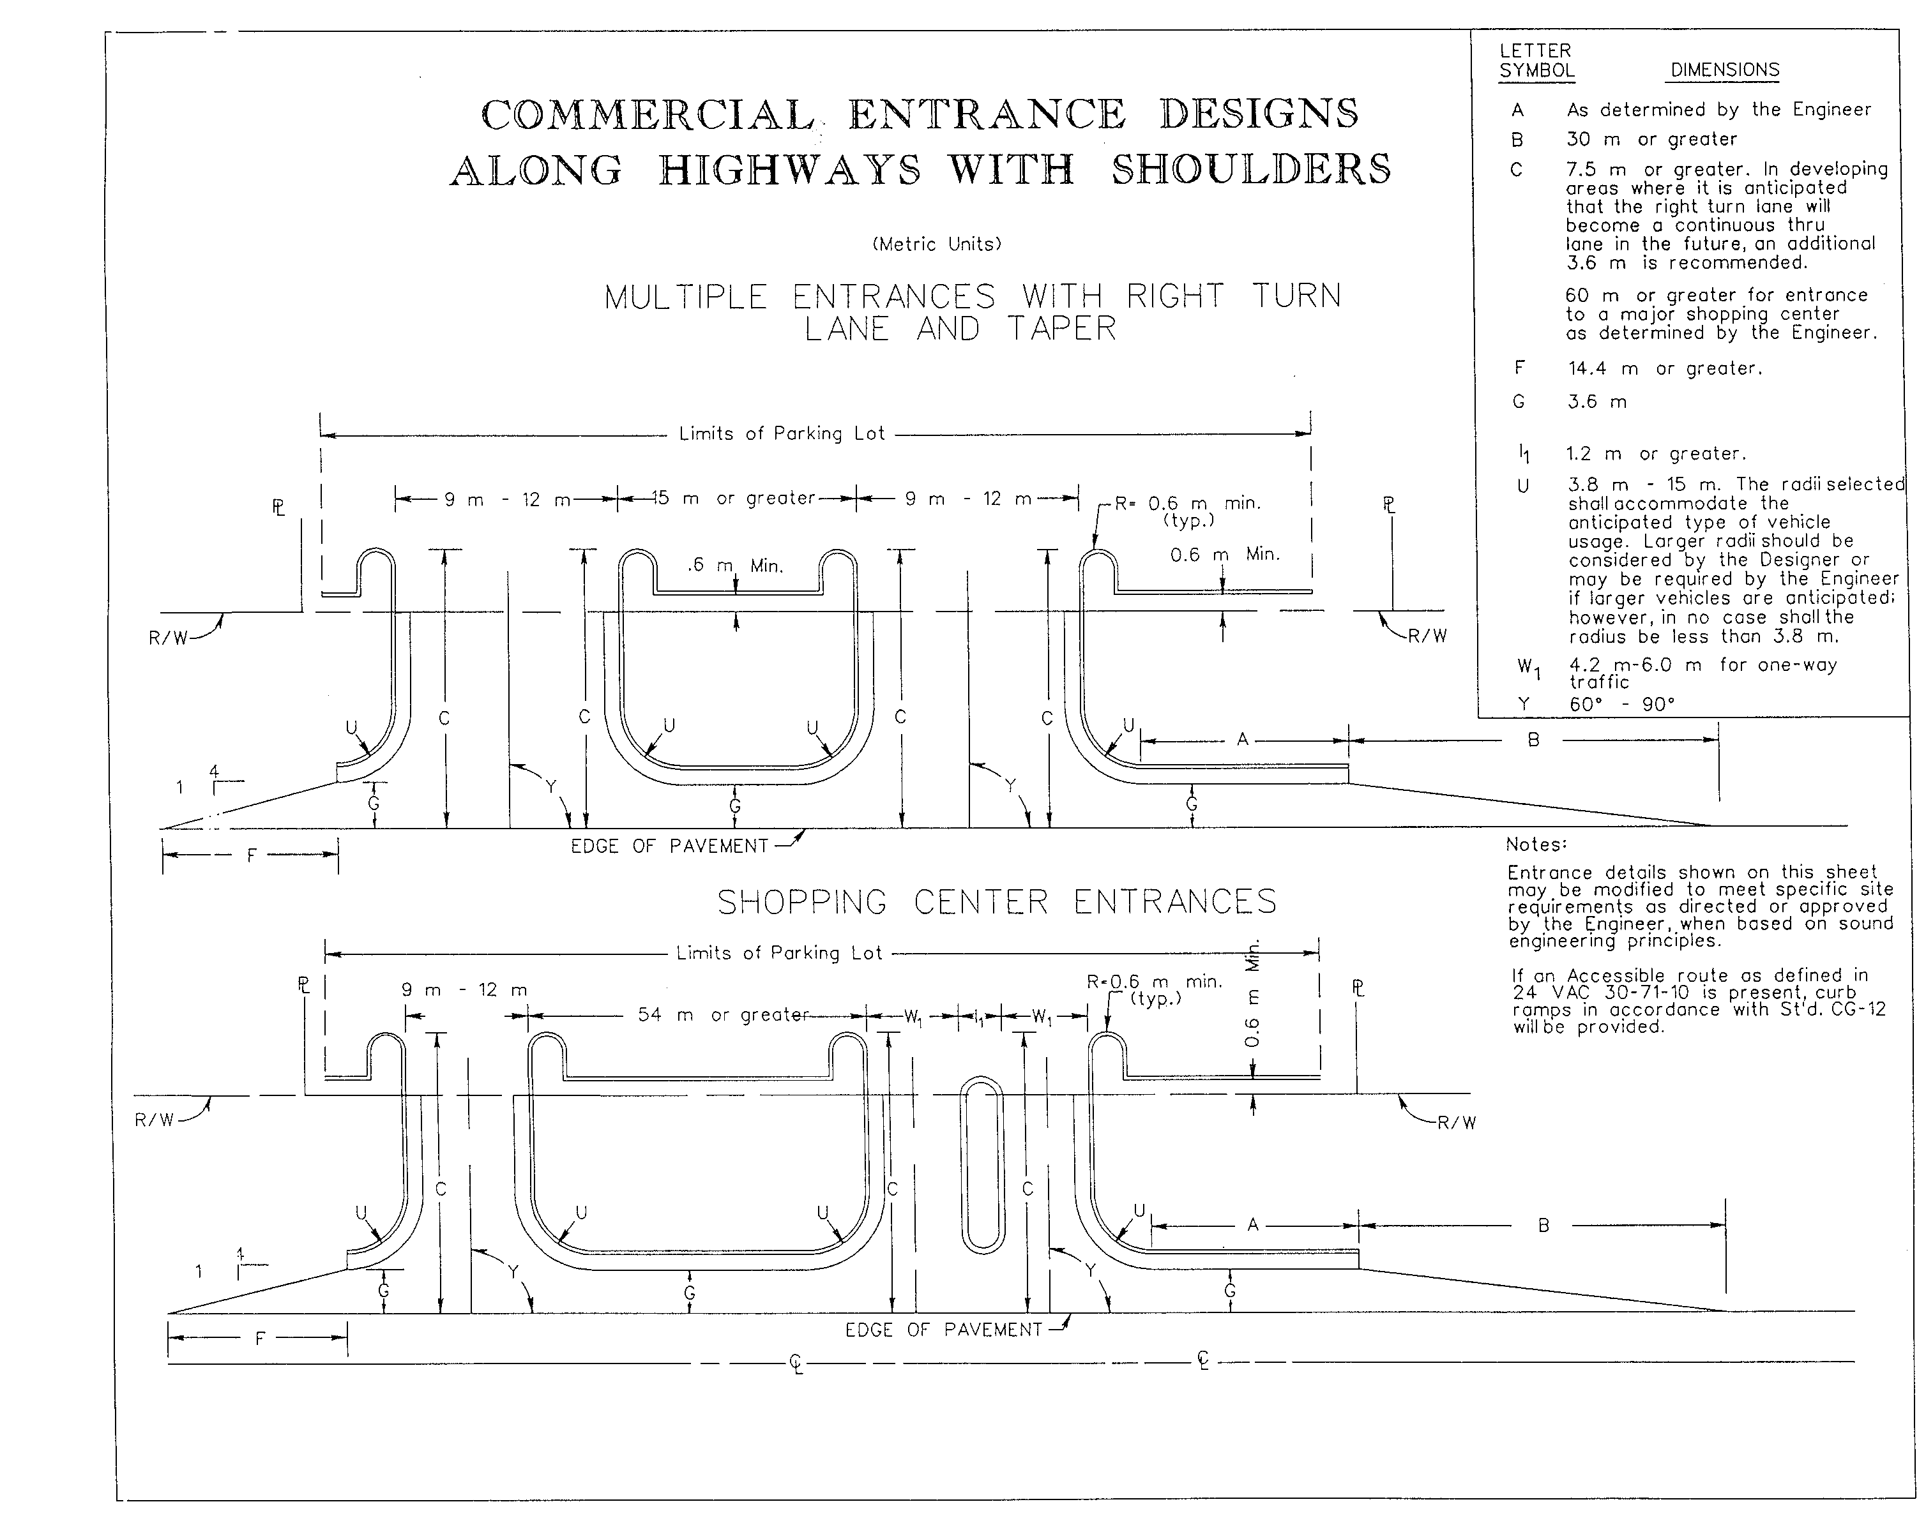
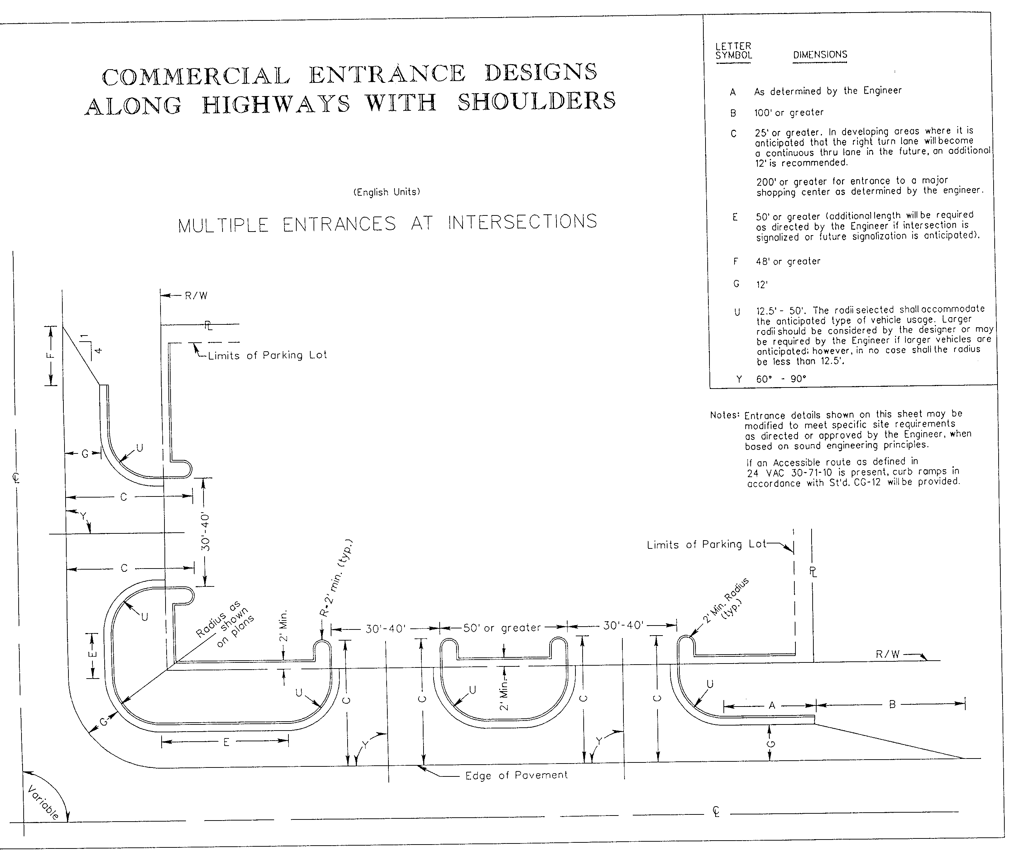
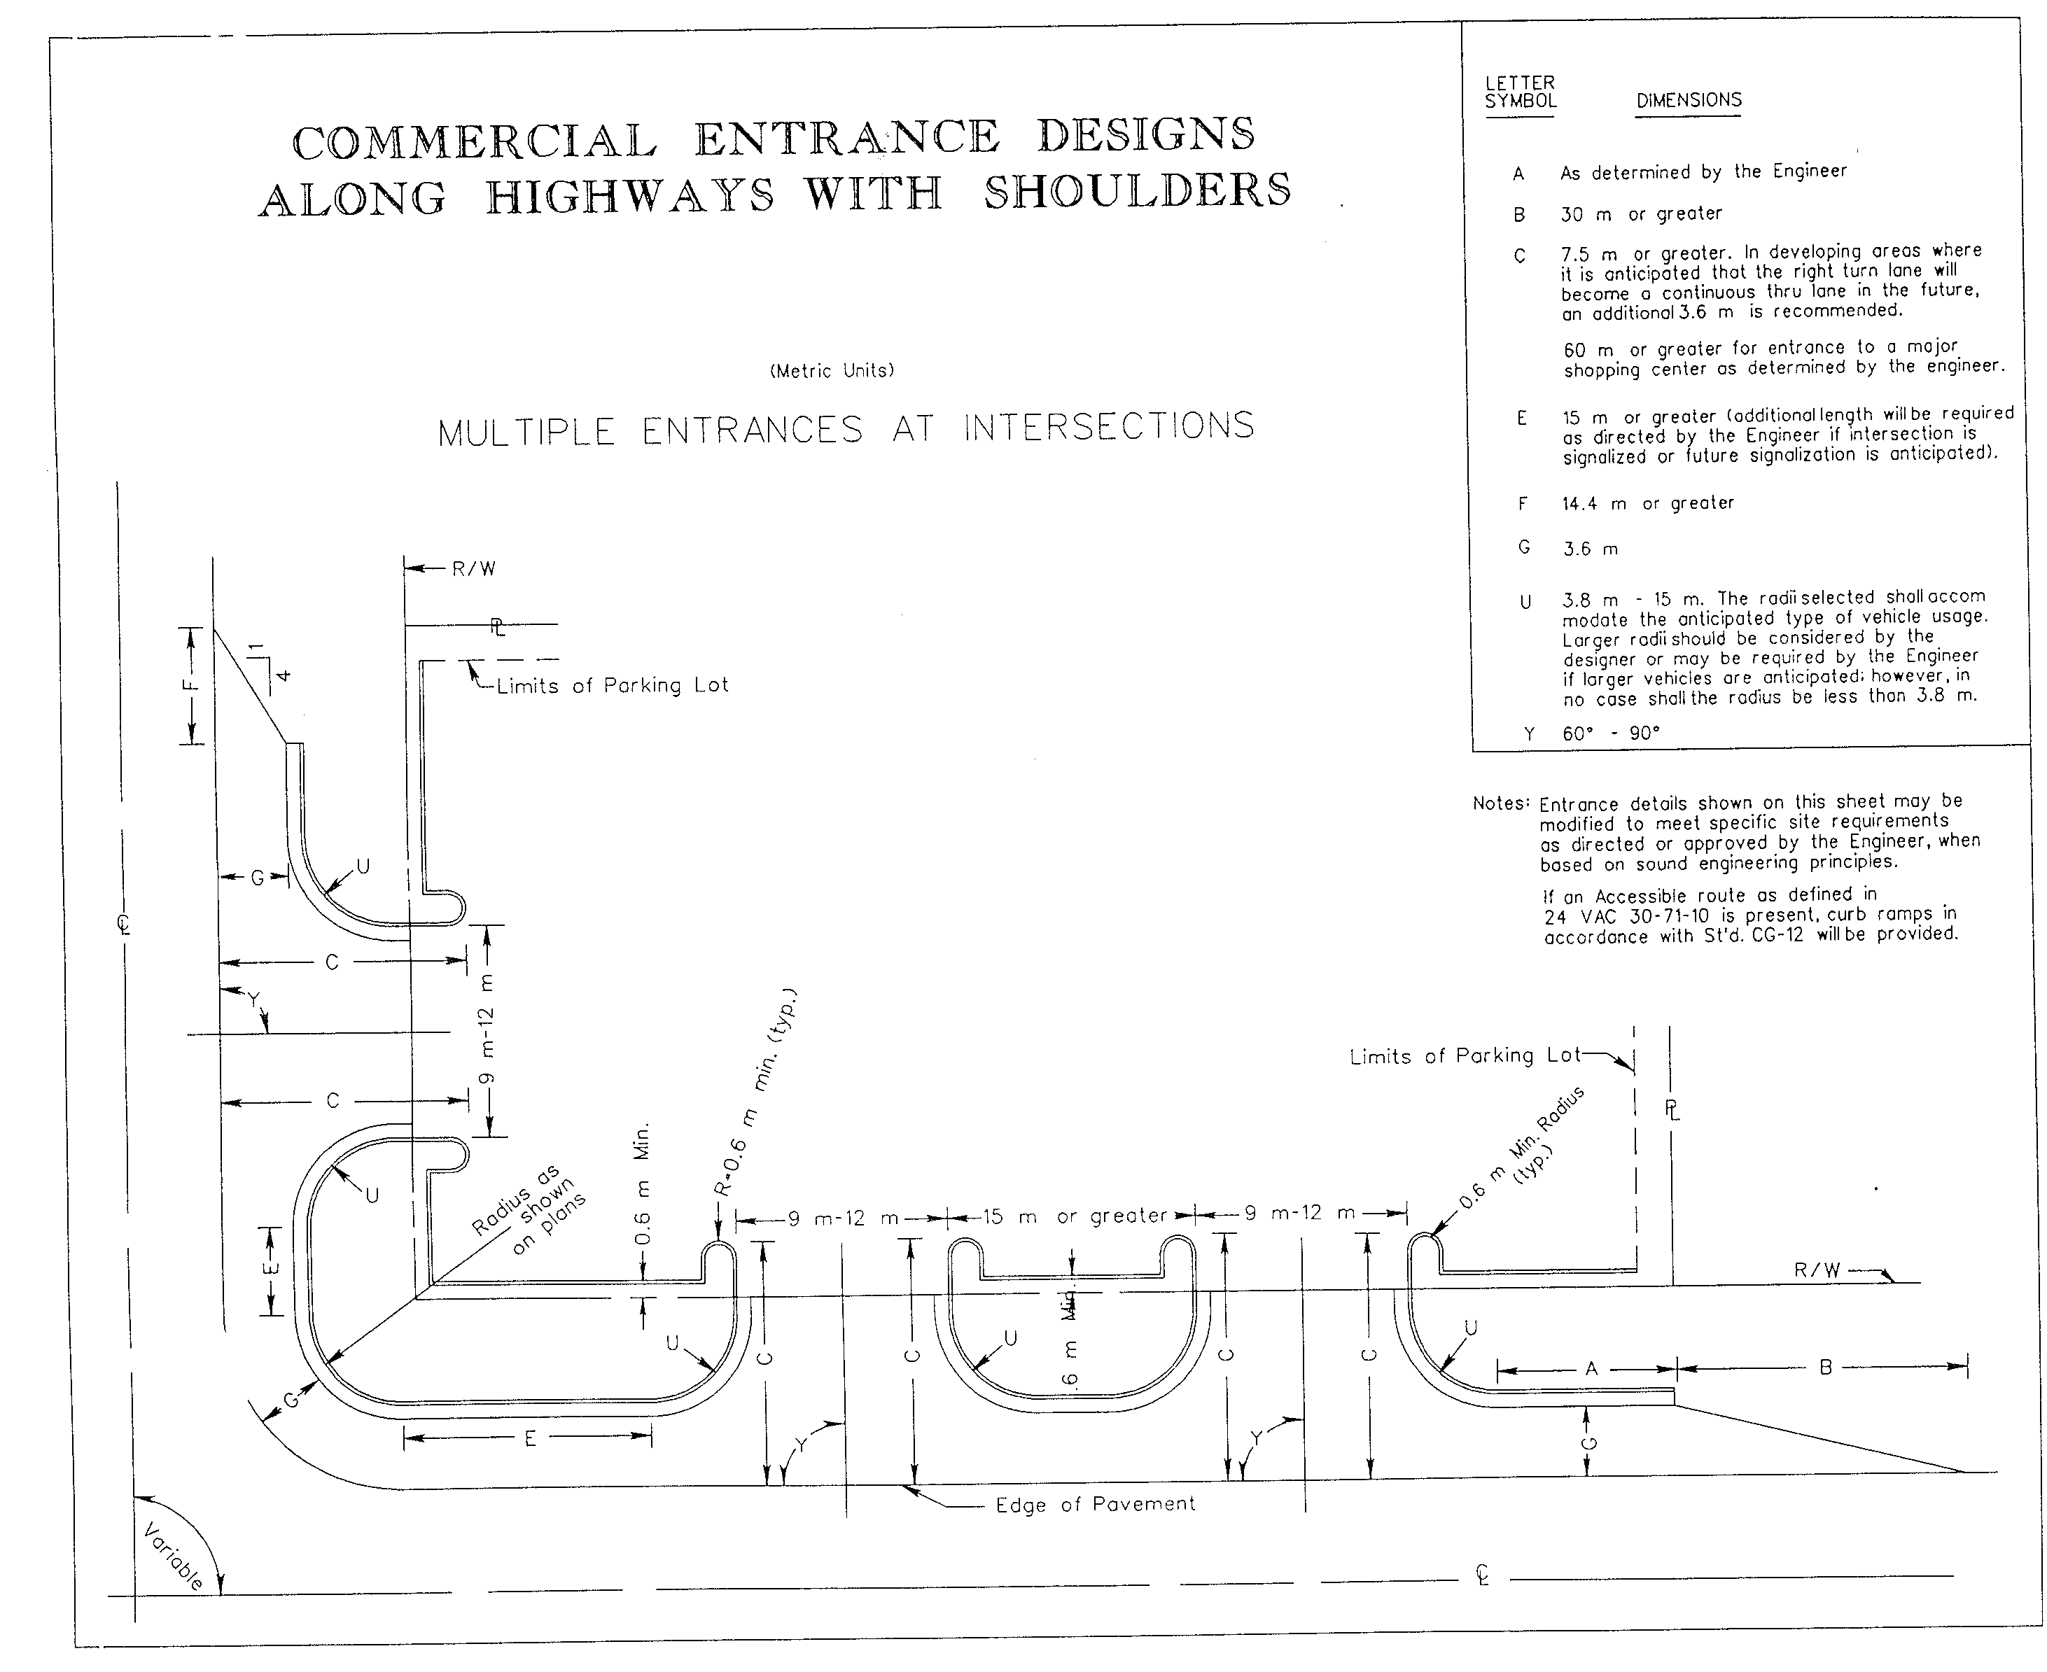
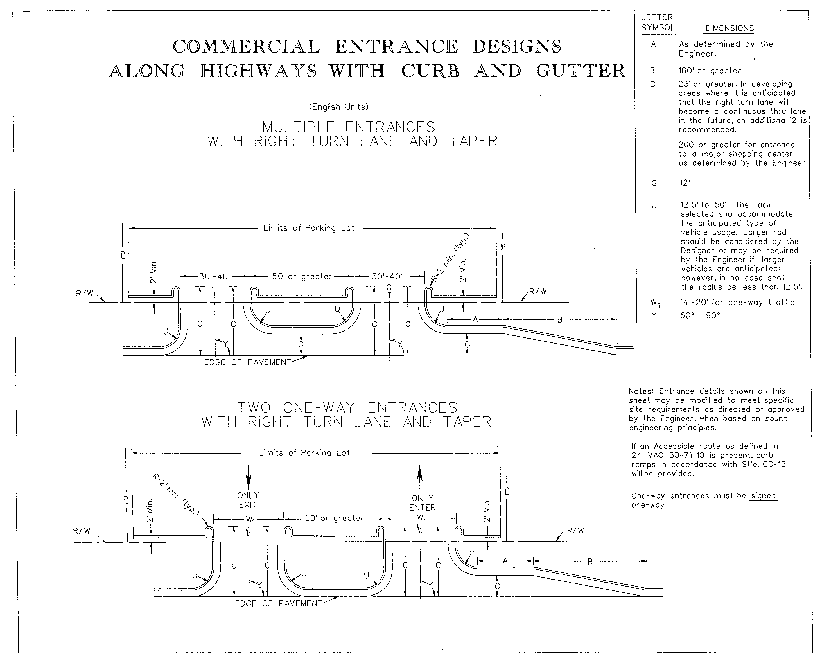
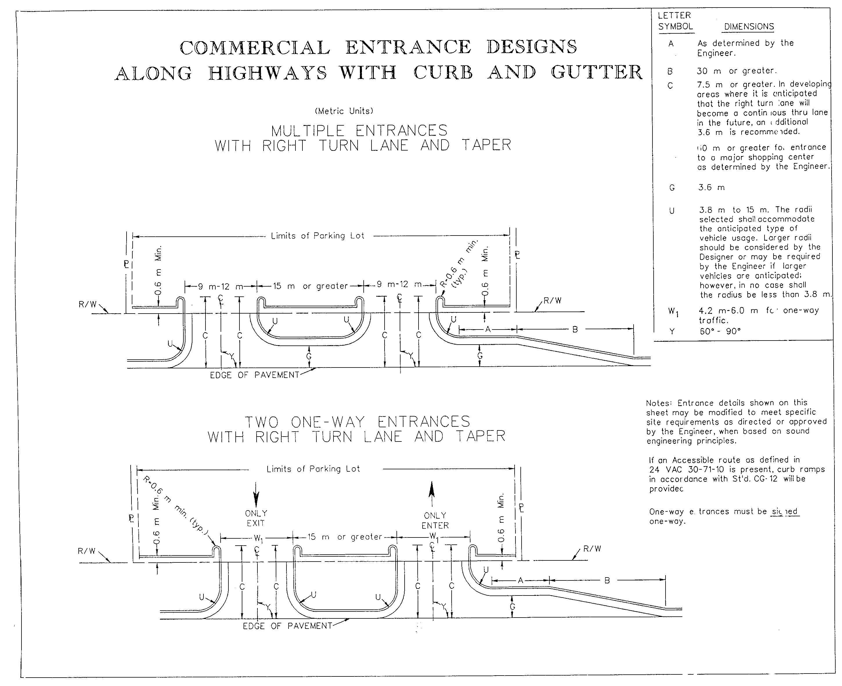
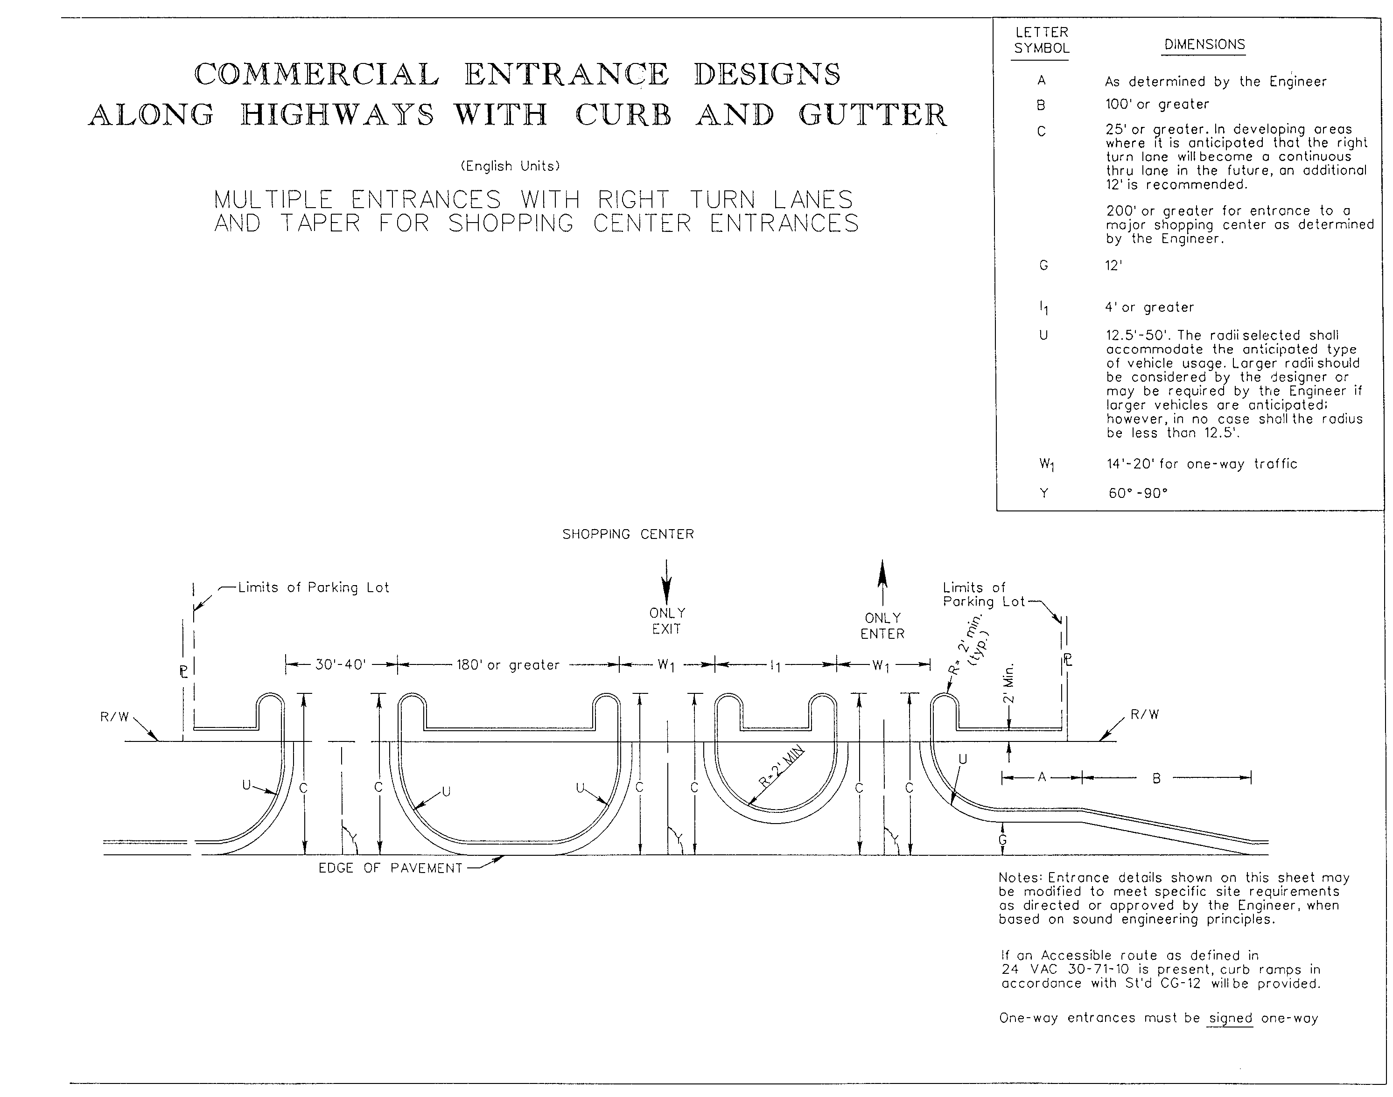
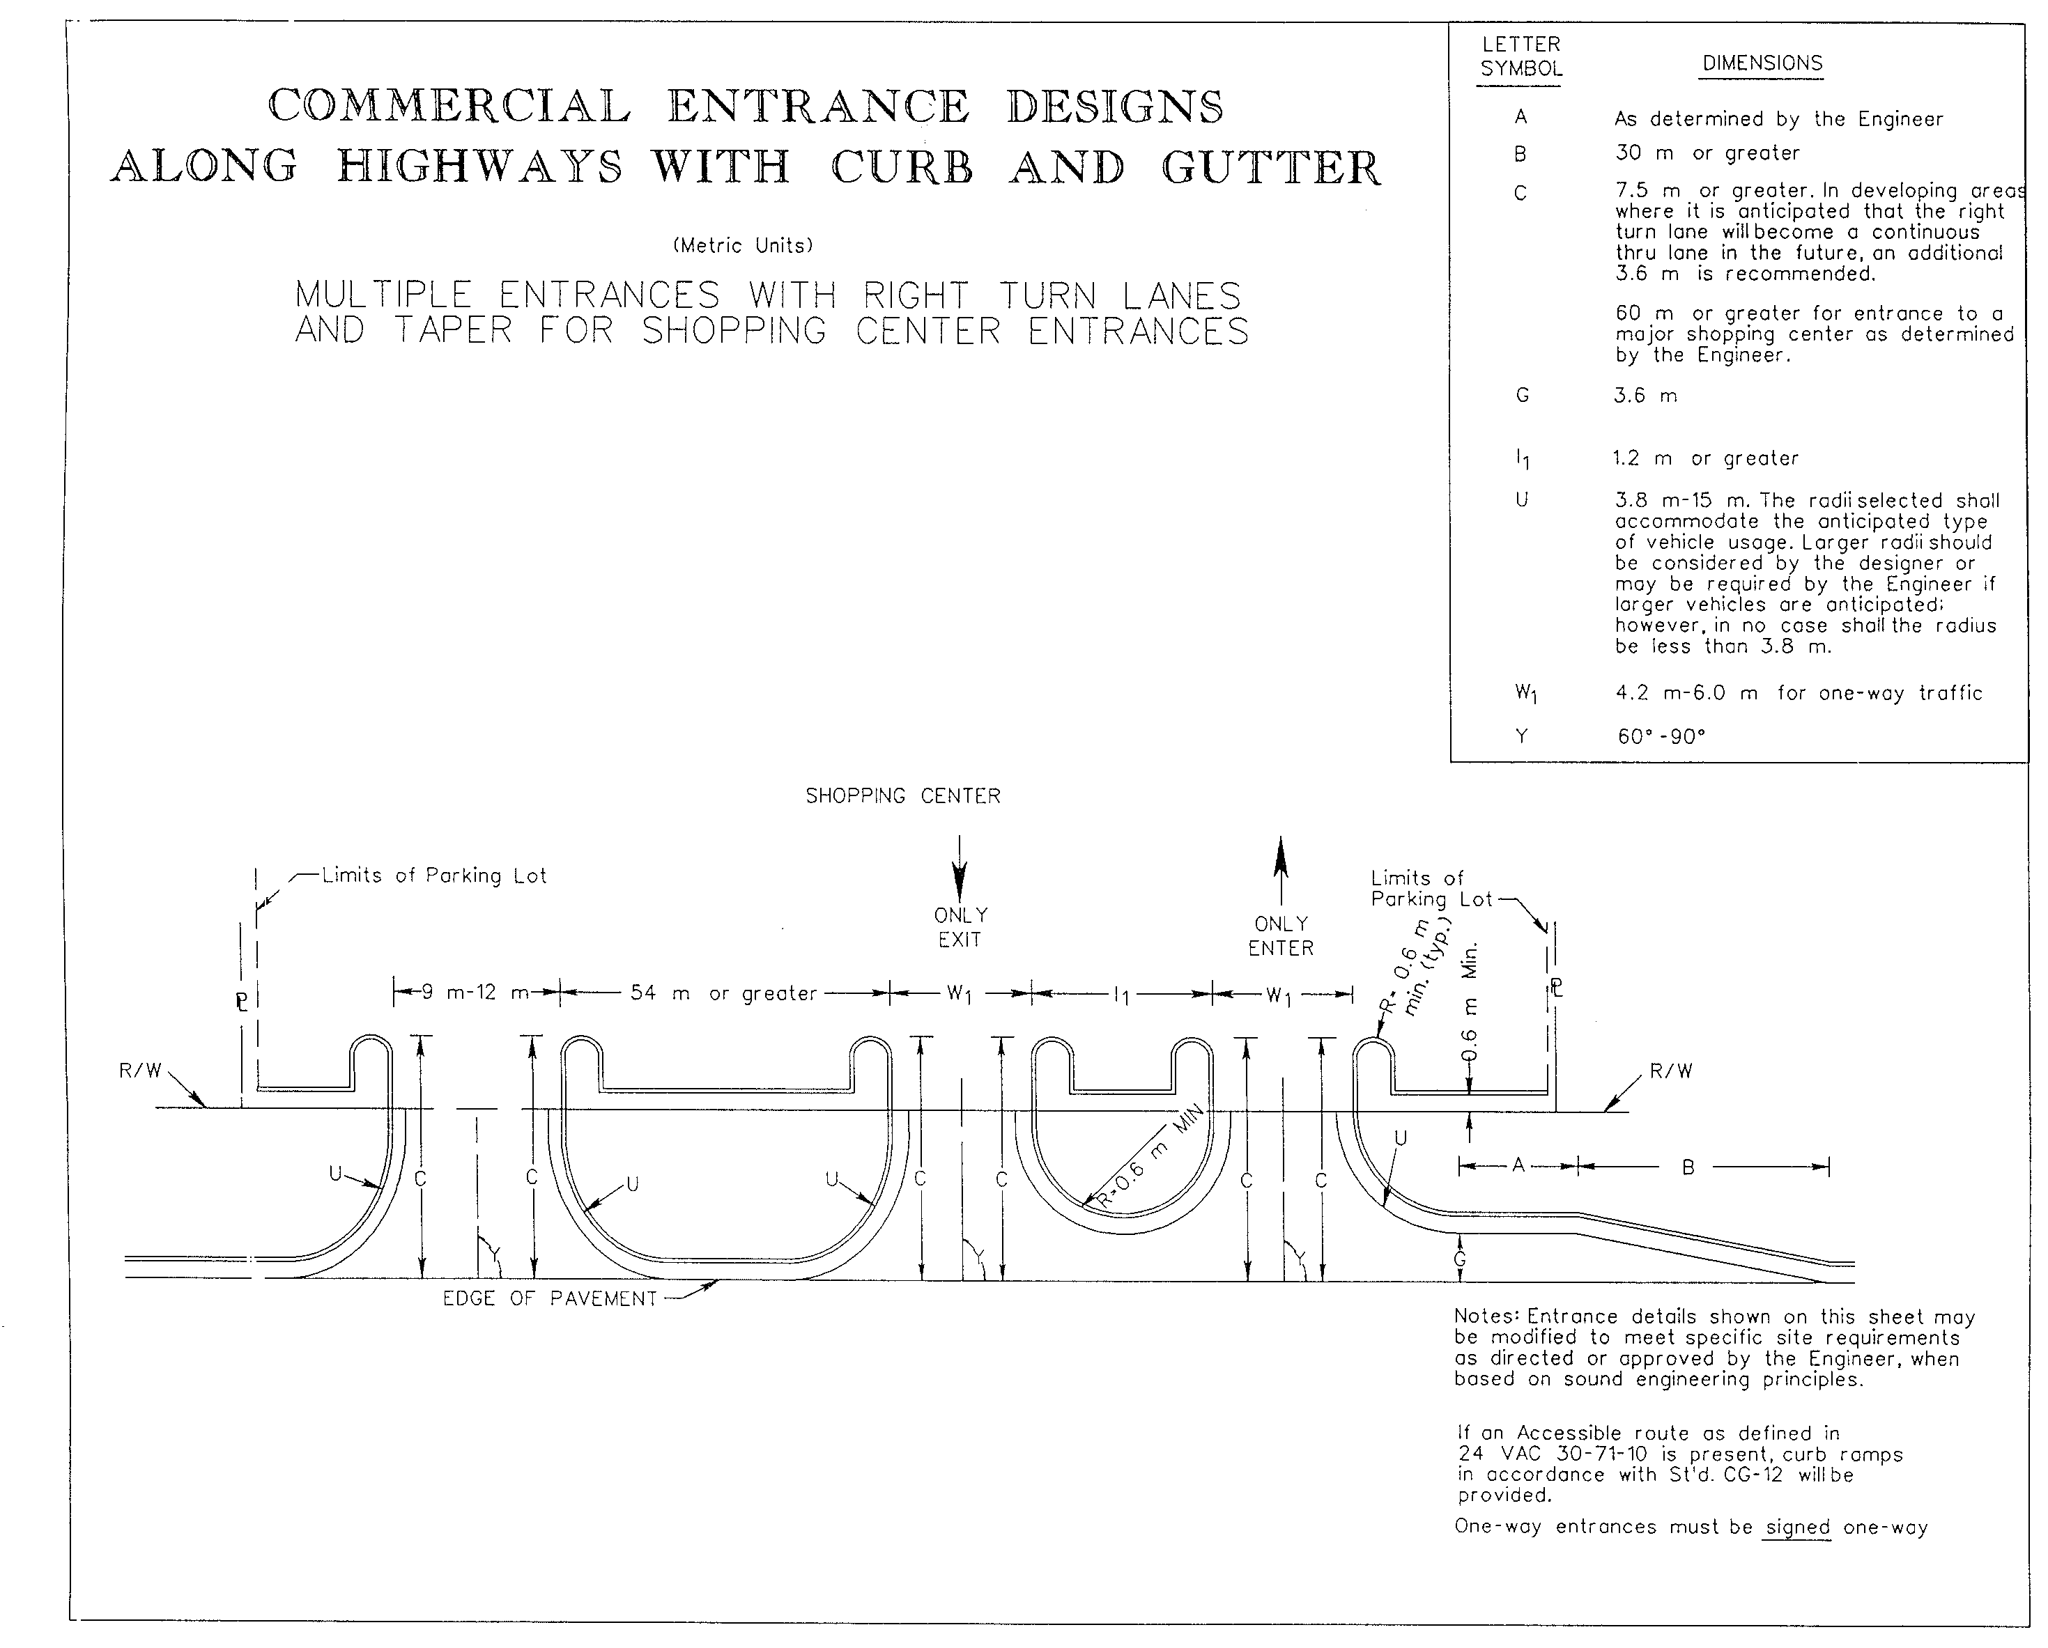
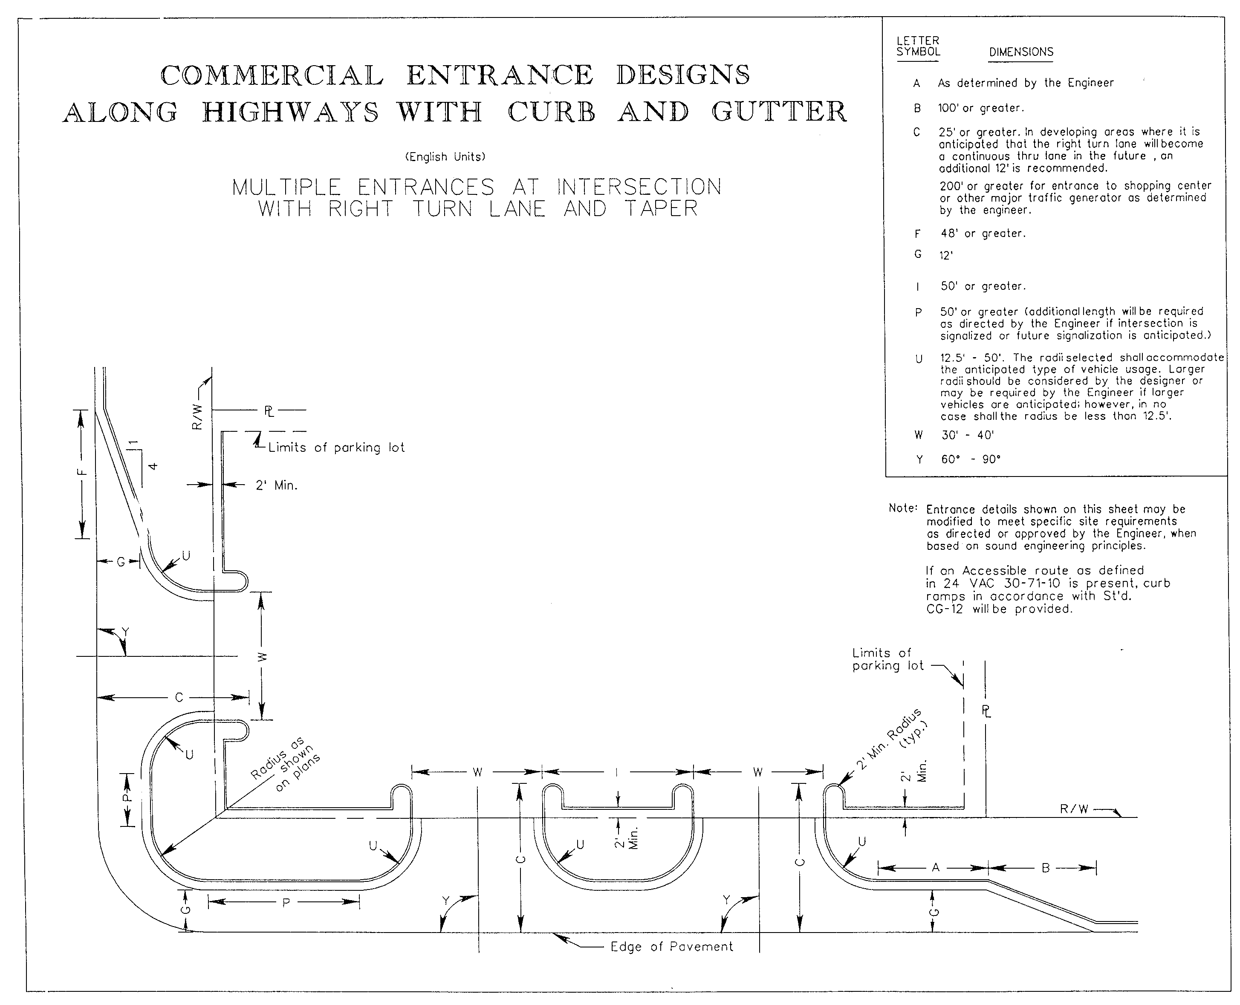
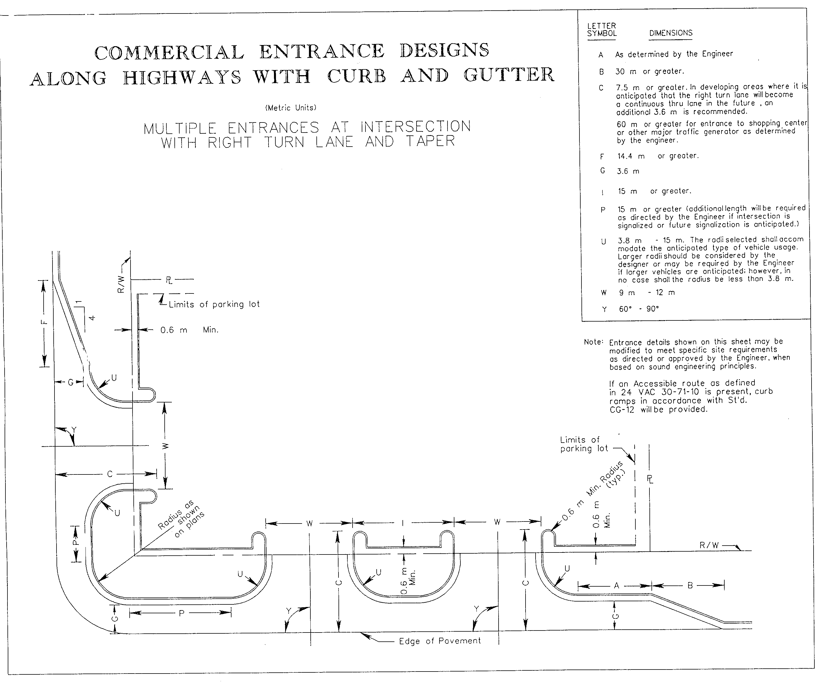
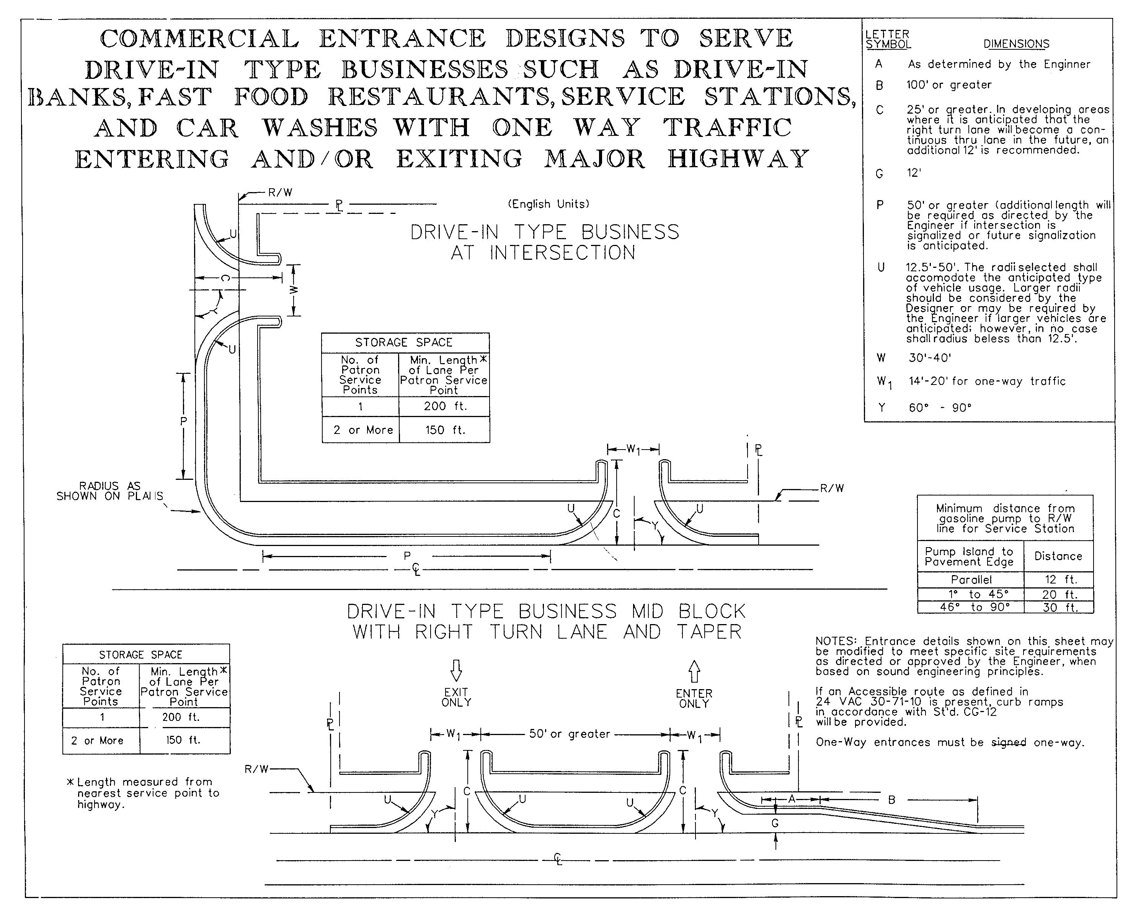
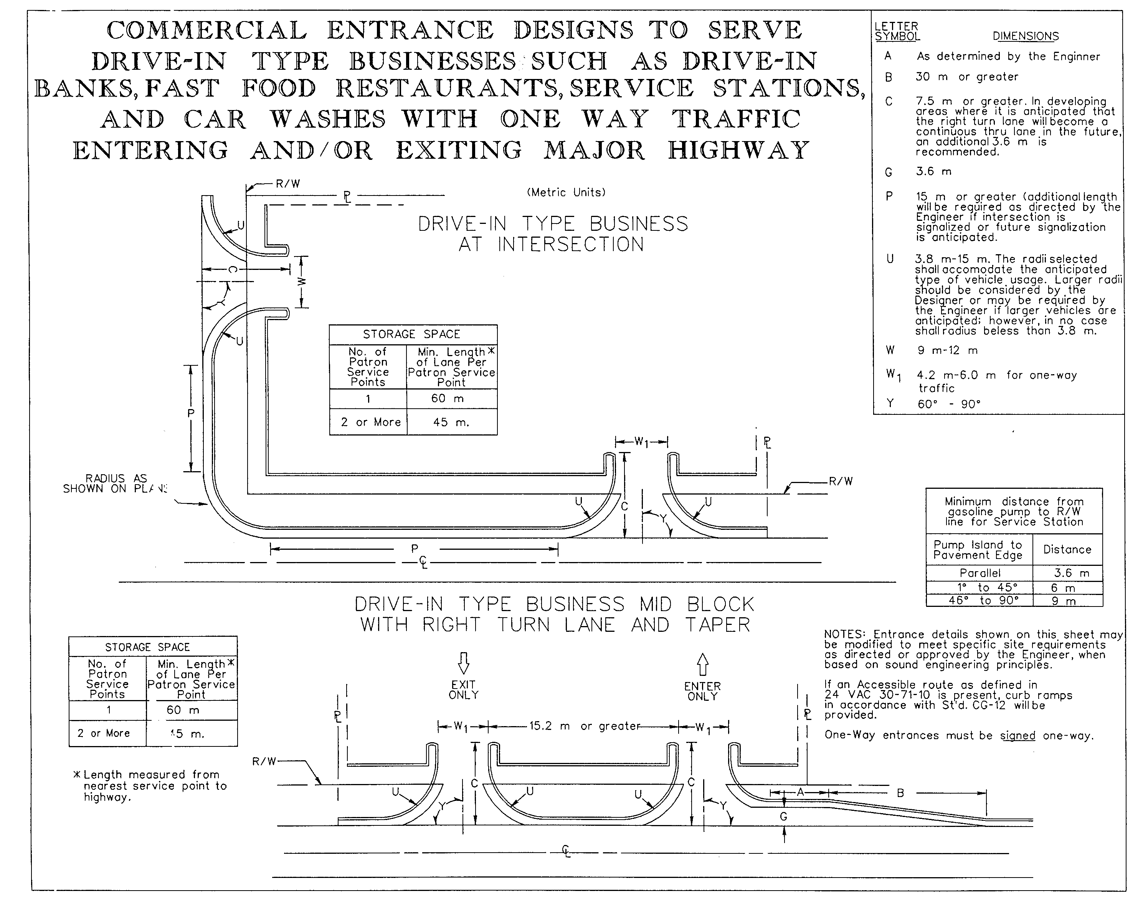
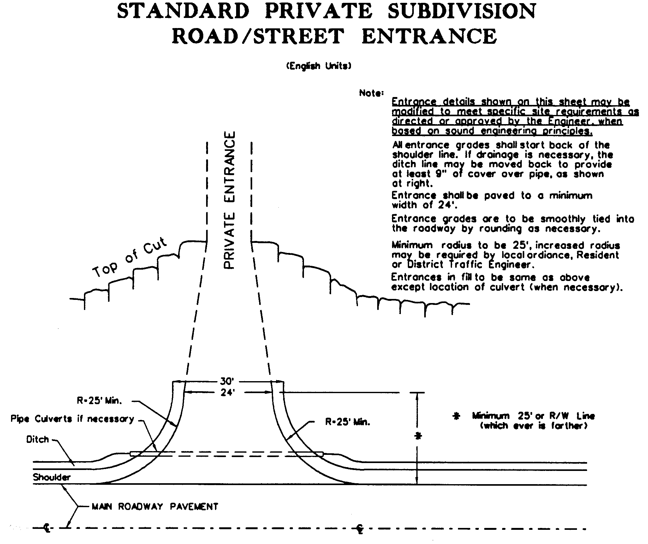
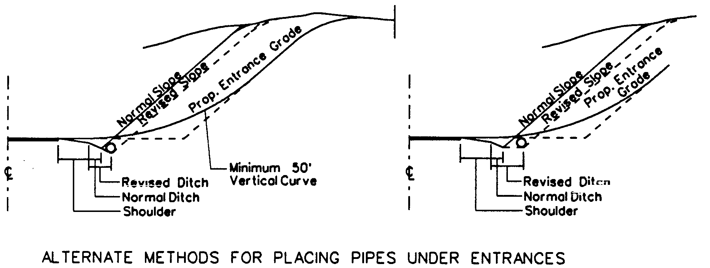
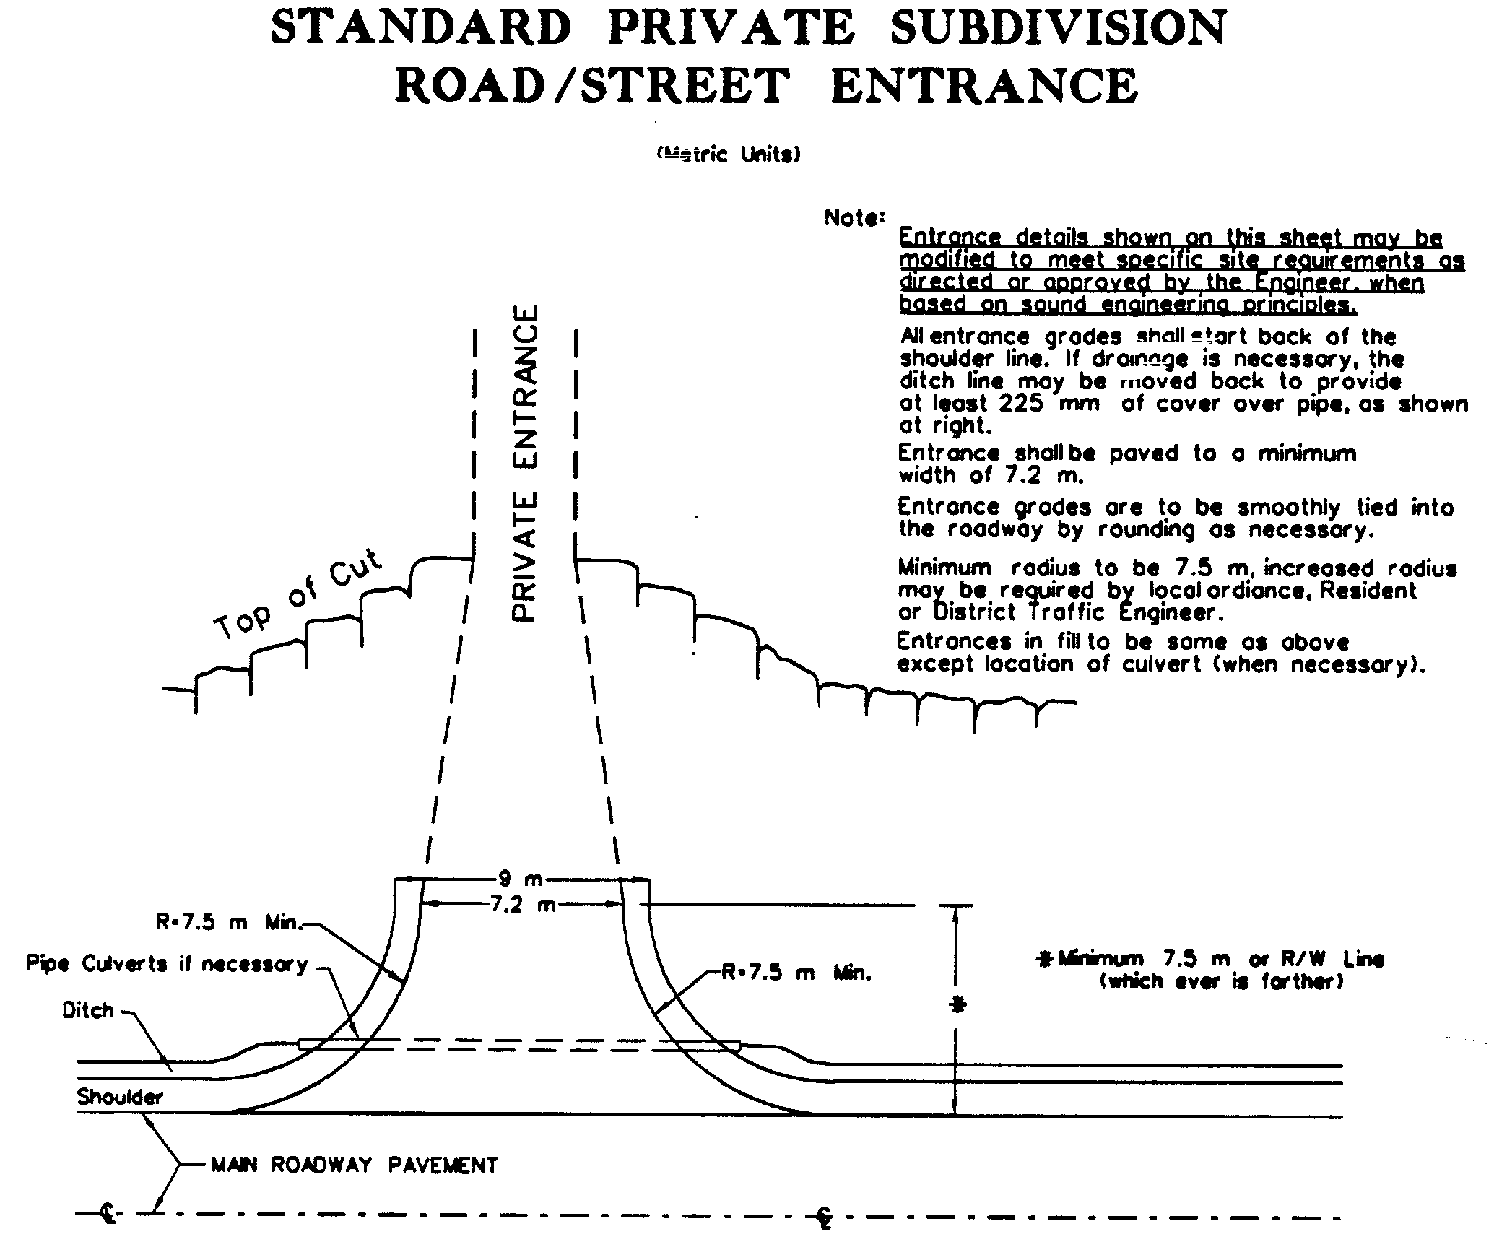
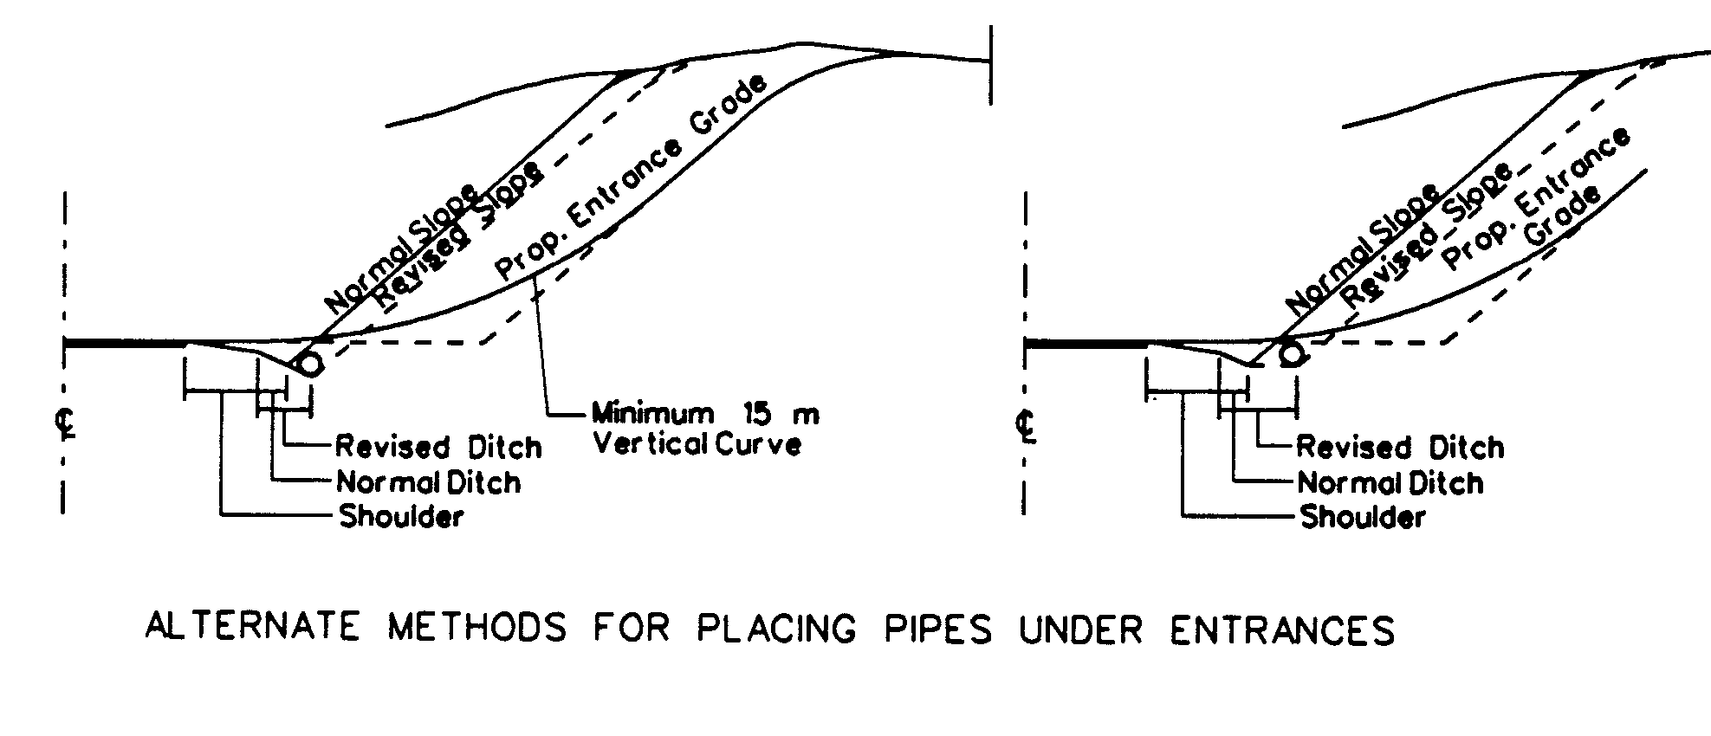
24 VAC 30-71-170. Listing of Documents incorporated by reference.
Information pertaining to the availability and cost of any of these publications should be directed to the department's division indicated, by writing to the Virginia Department of Transportation, 1401 East Broad Street, Richmond, Virginia 23219.
1. Guidelines for Planting along Virginia's Roadways (1990), Environmental Division (VDOT)
2. 24 VAC 30-90-10 et seq., Subdivision Street Requirements (1996), Secondary Roads Division (VDOT)
3. 24 VAC 30-150-10 et seq., Land Use Permit Manual (1983), Maintenance Division (VDOT)
4. A Policy on Geometric Design of Highways and Streets (1994), Location and Design Division (VDOT)
5. Road and Bridge Standards, (revised April 1995) (English measurements), Road and Bridge Standards, (revised September 1997) (metric measurements) Location and Design Division (VDOT)
6. Pavement Design Guide for Subdivision and Secondary Roads in Virginia (revised January 1996), Materials Division (VDOT)
7. Road Design Manual, revised October 1996 (English measurements) Road Design Manual, revised September 1996 (metric measurements), Location and Design Division (VDOT)
8. Road and Bridge Specifications (1994), (English measurements) Road and Bridge Specifications (effective 1997) (metric measurements), Construction Division (VDOT)
A. The document entitled, "A Policy on Geometric Design of Highways and Streets," 1994, American Association of State Highway & Transportation Officials, is incorporated by reference and made a part of this chapter.
This document may be obtained from the American Association of State Highway & Transportation Officials, 444 North Capitol Street N.W., Suite 249, Washington, DC 20001; E-mail address: info@aashto.org.
B. The following VDOT documents are incorporated by reference and made a part of this chapter:
1. Chief engineer’s memorandum entitled, "Guidance for Planting in the Clear Zone and Landscaping for VDOT Projects" dated October 31, 2000, Environmental Division;
2. Road and Bridge Standards (English measurements), effective February 2001, Location and Design Division;
3. Road and Bridge Standards (metric measurements), effective January 1997, Location and Design Division;
4. Pavement Design Guide for Subdivision and Secondary Roads in Virginia, effective September 2000, Materials Division;
5. Road Design Manual (English and metric measurements), effective July 1998, Location and Design Division;
6. Road and Bridge Specifications (English measurements), effective 2002, Construction Division;
7. Road and Bridge Specifications (metric measurements), effective 1997, Construction Division.
The documents identified in this subsection may be obtained by writing to the attention of the division noted by each document at the Virginia Department of Transportation, 1401 E. Broad Street, Richmond, Virginia 23219, or via the Internet at http://virginiadot.org/business/default.asp.
C. VDOT regulations referenced throughout this chapter may be obtained from the Virginia Department of Transportation, 1401 E. Broad Street, Richmond, Virginia 23219, or by accessing the Virginia Administrative Code website at http://leg1.state.va.us/000/reg/TOC24030.HTM.
NOTICE: The forms used in administering 24 VAC 30-71, Minimum Standards of Entrances to State Highways, are listed below. Any amended or added forms are reflected in the listing and are published following the listing.
FORMS
Entrance Permit Application, MP-253, 1989 (rev. 3/02).
Land Use Permit Surety Bond, MP-20 (rev. 4/99).
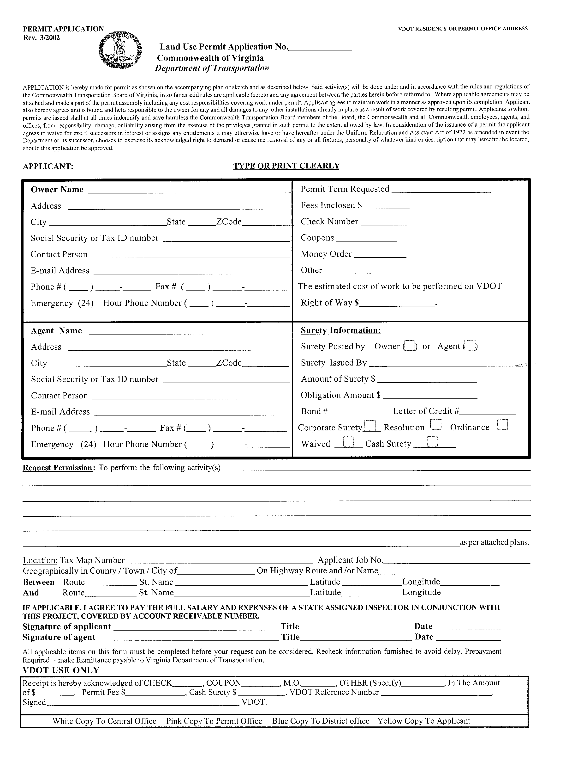
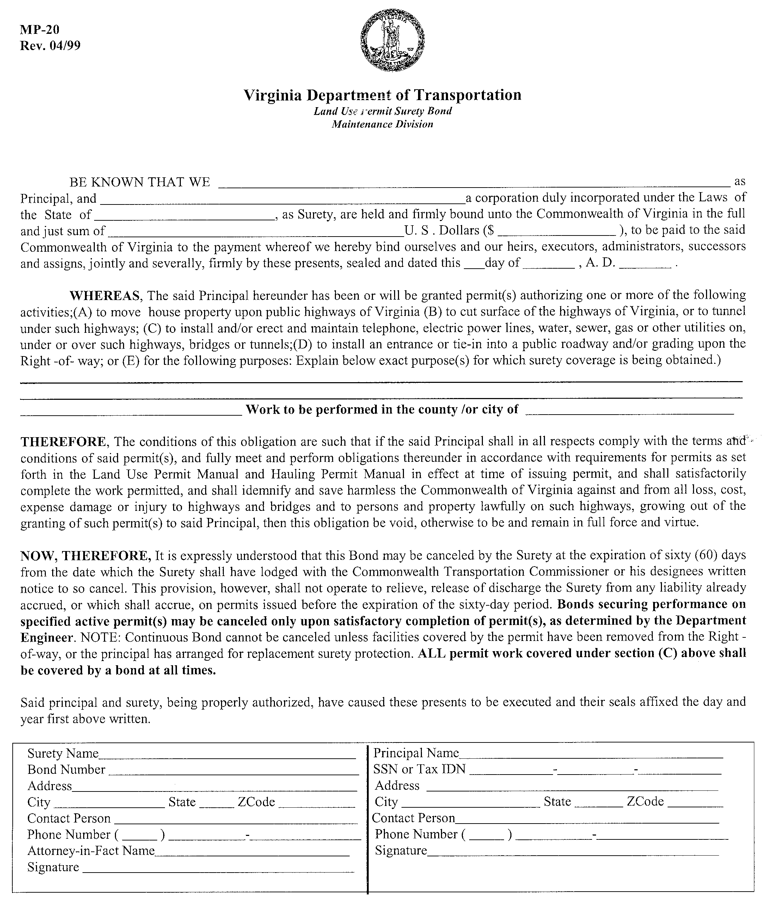
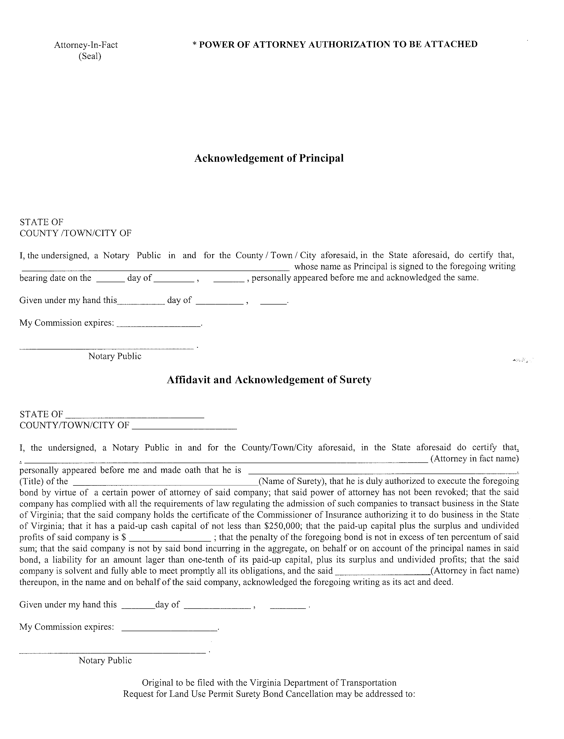
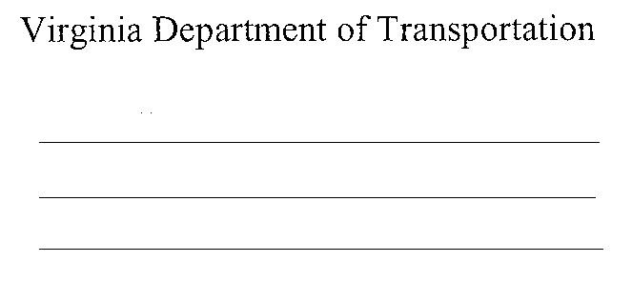
VA.R. Doc. No. R02-36; Filed October 22, 2002, 2:36 p.m.

1 The most recent versions of these documents are the following: Road and Bridge Standards (English measurements), effective February 2001, Location and Design Division; Road and Bridge Standards (metric measurements), effective January 1997, Location and Design Division; Pavement Design Guide for Subdivision and Secondary Roads in Virginia, effective September 2000, Materials Division; Road Design Manual (English and metric measurements), effective July 1998, Location and Design Division; Road and Bridge Specifications (English measurements), effective 2002, Construction Division; Road Bridge Specifications (metric measurements), effective 1997, Construction Division; Chief Engineer’s memorandum entitled, “Guidance for Planting in the Clear Zone and Landscaping for VDOT Projects” dated October 31, 2000, Environmental Division.
2 Currently, metric sight distances are referenced in the 1994 edition of A Policy on Geometric Design of Highways and Streets, published by the American Association of State Highway and Transportation Officials.
3 Source: Virginia Department of Transportation.

