BOARD OF ACCOUNTANCY
REGISTRAR'S NOTICE: The following regulatory action is exempt from the Administrative Process Act in accordance with § 54.1-4422 of the Code of Virginia, which provides that during a 24-month period beginning July 1, 2001, regulations adopted by the Board of Accountancy and approved by the Governor regarding the fee for licenses and certificates are exempt from the Administrative Process Act. The Board of Accountancy will receive, consider and respond to petitions by any interested person at any time with respect to reconsideration or revision.
Title of Regulation: 18 VAC 5-21. Board of Accountancy Regulations (amending 18 VAC 5-21-20).
Statutory Authority: §§ 54.1-4402, 54.1-4403, and 54.1-4410 of the Code of Virginia.
Effective Date: March 26, 2003.
Agency Contact: Nancy Taylor Feldman, Executive Director, Department of Professional and Occupational Regulation, 3600 West Broad Street, Suite 696, Richmond, VA 23230-4916, telephone (804) 367-8505, FAX (804) 367-2174, or e-mail boa@boa.state.va.us.
Summary:
The amendments increase the CPA certificate reinstatement fee and the registration certificate reinstatement fee from $60 to $250.
18 VAC 5-21-20. Fees.
A. All fees are nonrefundable and the date of receipt by the board or its agent is the date that will be used to determine whether it is on time.
B. The following fees shall apply:
Initial examination application fee | $25
Original CPA certificate application | $24
CPA certificate by endorsement application | $24
Registration certificate application | $24
CPA certificate renewal | $24
Registration certificate renewal | $24
CPA certificate late renewal | $25
Registration certificate late renewal | $25
CPA certificate reinstatement | $60 $250
Registration certificate reinstatement | $60 $250
Noninteractive processing fee | $ 5
If the renewal fee is not received by the board within 30 days after the expiration date printed on the CPA certificate or the registration certificate, the regulant shall pay the renewal and the late renewal fees. Regulants applying for reinstatement shall pay all unpaid renewal fees in addition to the late renewal and the reinstatement fees.
C. The late filing fee for CPA certificate holders who fail to complete or report their CPE as required by this chapter shall be:
1. If received by the board up to four months late, $25.
2. If received by the board more than four months late but not more than six months late, $50.
3. If received by the board more than six months late, $75.
D. The fee for a replacement wall certificate shall be $25.
E. A fee of $25 will be charged in addition to the fees established in this section for submitting a check to the board which is dishonored by the institution upon which it is drawn.
F. A noninteractive processing fee will be assessed when the online payment option is not chosen by the applicant or regulant.
G. The fee for the examination provided for in 18 VAC 5-21-30 C shall consist of the contract charges. An administrative fee of $25 will be assessed at the time of initial application for examination. No administrative fee will be assessed for re-examination. Examination service contracts shall be established through competitive negotiation in compliance with the Virginia Public Procurement Act (§ 11-35 2.2-4300 et seq. of the Code of Virginia). The examination fee shall not exceed $1,000.
NOTICE: The forms used in administering 18 VAC 5-21, Board of Accountancy Regulations, are listed below. Any amended or added forms are reflected in the listing and are published following the listing.
FORMS
Original CPA Certificate Application, 03CERT (11/27/00 11/00).
CPA Certificate by Endorsement Application, 03ENDPKG (11/27/00 11/00 ).
Firm Registration Certificate Application, 03FIRM (10/4/99 10/99 ).
Reinstatement – Employment/CPE Supplement Form, BOA-005 (eff. 1/03).
CPA Certificate Reinstatement Application, 03CRTREI BOA-006 (10/4/99 rev. 1/03).
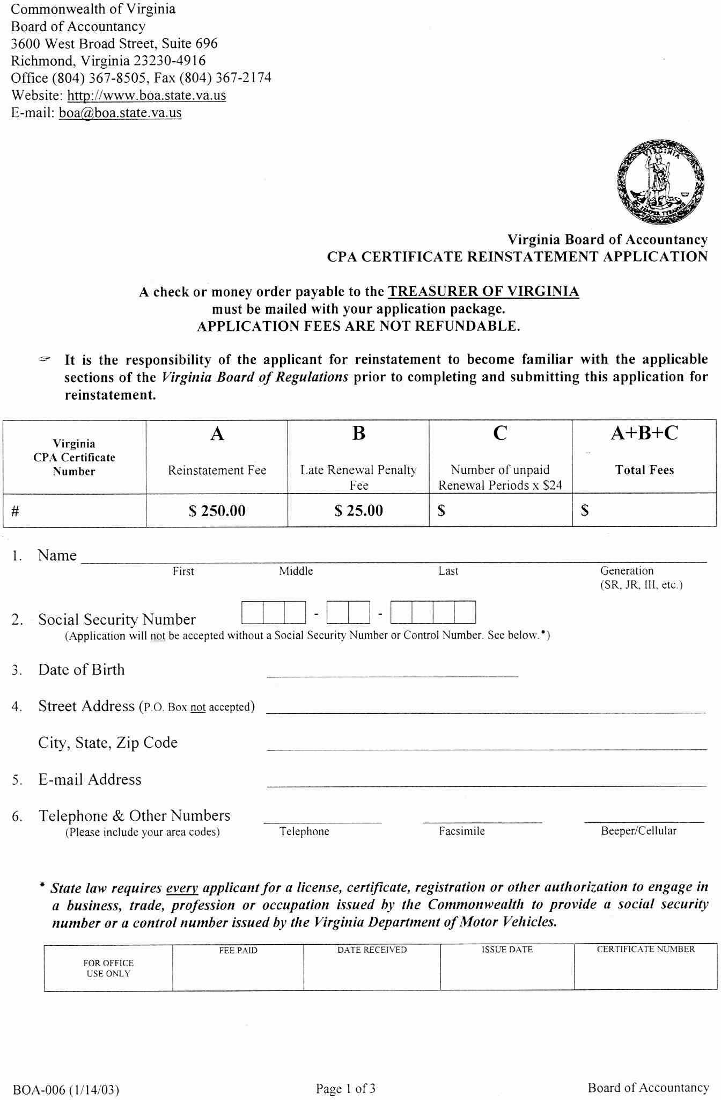
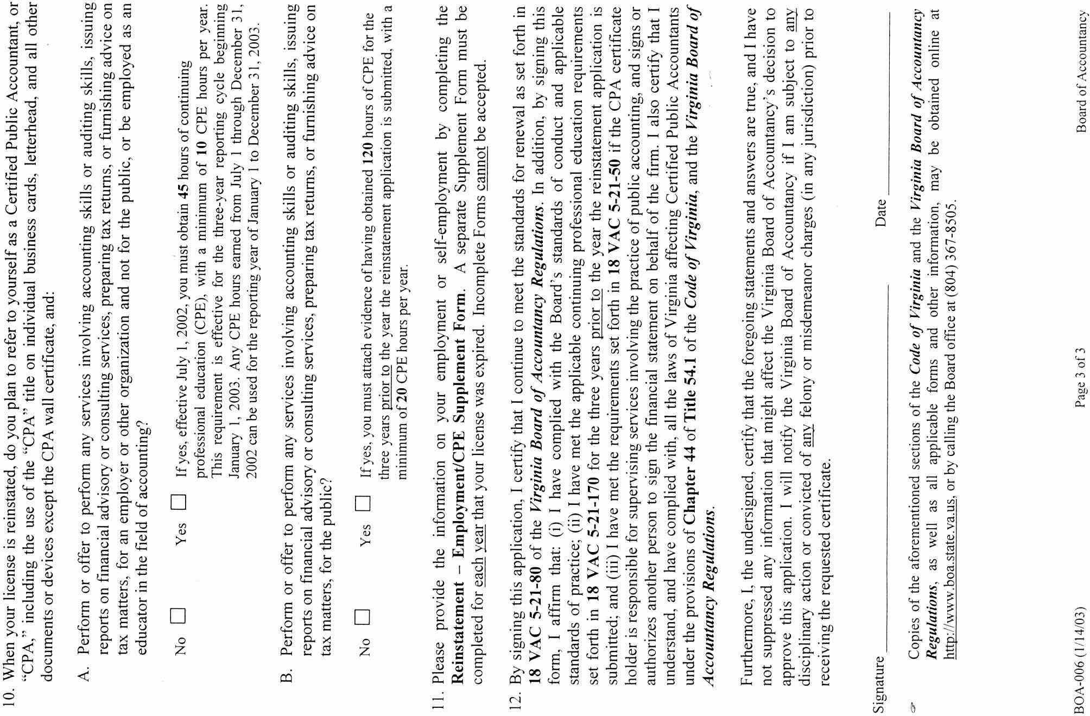

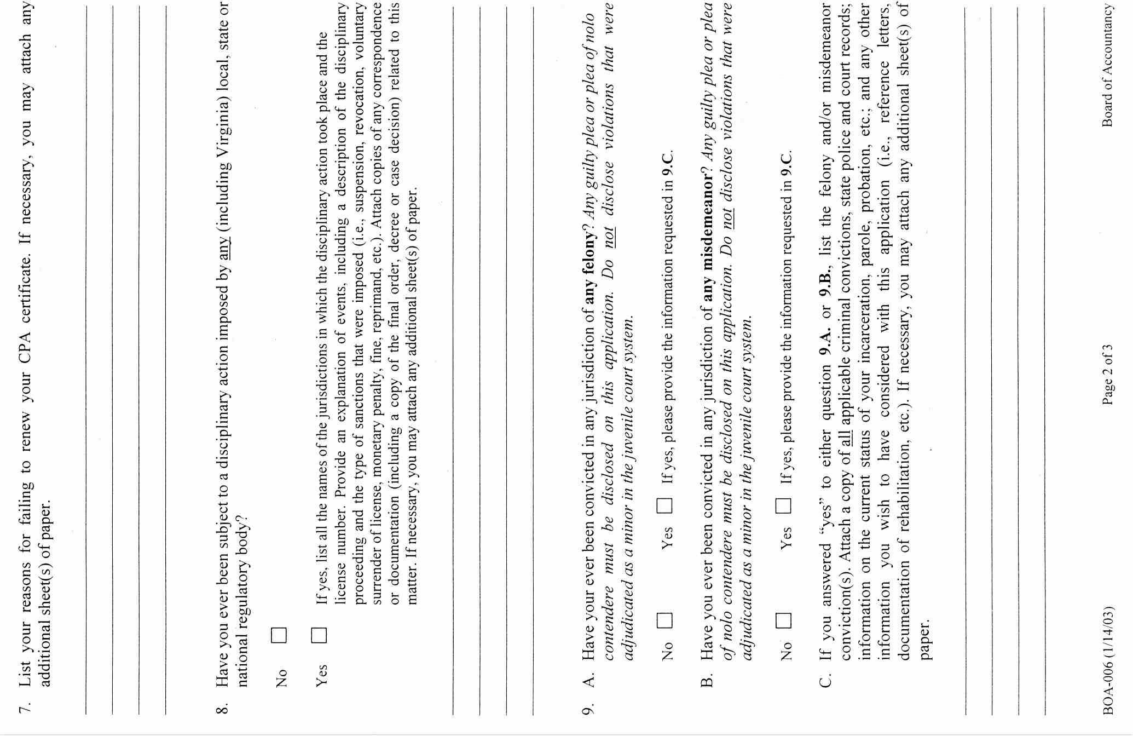
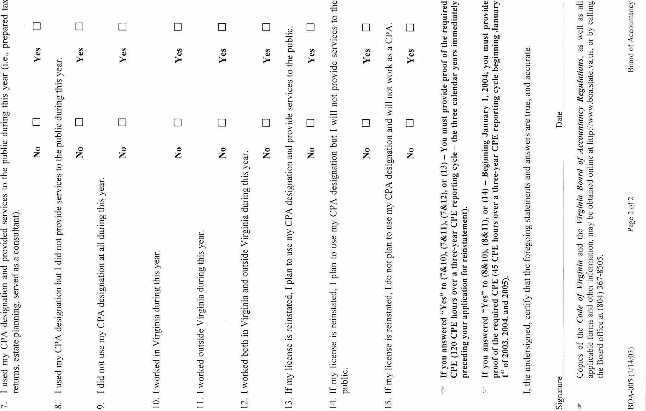

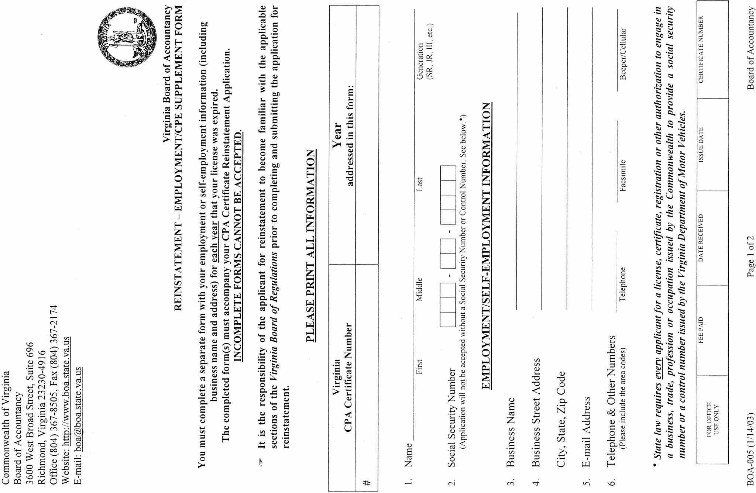
VA.R. Doc. No. R03-123; Filed January 31, 2003, 10:28 a.m.

