BOARD FOR PROFESSIONAL SOIL SCIENTISTS AND WETLAND PROFESSIONALS
Title of Regulation: 18 VAC 145-30. Wetland Delineators Certification Regulations (adding 18 VAC 145-30-10 through 18 VAC 145-30-160).
Statutory Authority: §§ 54.1-201 and 54.1-2203 of the Code of Virginia.
Public Hearing Date: October 10, 2003 - 10 a.m.
Public comments may be submitted until October 24, 2003.
(See Calendar of Events section
for additional information)
Agency Contact: Mark N. Courtney, Executive Director, Department of Professional and Occupational Regulations, 3600 West Broad Street, Richmond, VA 23230-4917, telephone (804) 367-8514, FAX (804) 367-2475, or e-mail SoilScientist@dpor. state.va.us.
Basis: The board’s authority to promulgate regulations for certified professional wetland delineators is found in §§ 54.1-201 and 54.1-2203 of the Code of Virginia. The provisions of § 54.1-2203 shall become effective on July 1, 2004. These two sections mandate the board to promulgate regulations for the certification of professional wetland delineators concerning qualifications of applicants, examination of applicants and the proper conduct of certified professional wetland delineators.
Purpose: These regulations are necessary to implement Chapter 784 of the Acts of the 2002 General Assembly and to create the regulatory program for the certification of professional wetland delineators mandated to protect the health, welfare and safety of the public when dealing with persons practicing as a certified professional wetland delineator.

Substance:
The regulations include:
1. Definitions of terms to be used in the regulations;
2. Entry standards for those seeking to practice as a certified professional wetland delineators;
3. Renewal and reinstatement standards for regulants;
4. Standards of practice and conduct; and
5. Grounds for disciplinary action against regulants.
Issues: The advantage to the public is that the public will now have a way of identifying wetland delineators who have met the standards set forth by the board for certification. The only potential disadvantage is that the cost of the voluntary certification program may be passed on from the certificate holders to the public; however, the cost of the program is relatively small. No disadvantages to the public or Commonwealth have been identified.

Fiscal Impact:

 | FY 2003 | FY 2004 | FY 2005 | FY 2006
Fund | NGF (0900) | NGF (0900) | NGF (0900) | NGF (0900)
Program/ Subprogram | 560 44 | 560 44 | 560 44 | 560 44

Impact of Regulatory Changes:
One-Time Costs | 700 | 700 | 0 | 0
Ongoing Costs | 1,000 | 10,500 | 10,500 | 11,088
Total Fiscal Impact | 1,700 | 11,200 | 10,500 | 11,088
FTE | 0.00 | 0.00 | 0.00 | 0.00
Description of Costs:
One-Time: Costs associated with additional board meetings to develop regulations and establish the new program.
Ongoing: Costs represent only the additional expenses associated with the new wetlands professionals program. They include travel and per diem for additional board members, staff support for program activities, enforcement activities, legal services, and administrative costs.
Cost to Localities: None anticipated.
Description of Individuals, Businesses, or Other Entities Impacted:
Estimated Number of Regulants: The department expects approximately 100 individuals to obtain certification as wetlands professionals. There are currently approximately 100 soil scientist regulants.
Projected Cost to Regulants: The average total cost to regulants will be approximately $260 per biennium, or $130 annually. This represents a completely new cost to individuals who become certified as wetlands professionals. Soil scientists currently pay $175 per biennium for their licensing fees. This change will increase the average total costs by about $85 per biennium, or less than $45 annually.
Department of Planning and Budget's Economic Impact Analysis: The Department of Planning and Budget (DPB) has analyzed the economic impact of this proposed regulation in accordance with § 2.2-4007 H of the Administrative Process Act and Executive Order Number 21 (02). Section 2.2-4007 H requires that such economic impact analyses include, but need not be limited to, the projected number of businesses or other entities to whom the regulation would apply, the identity of any localities and types of businesses or other entities particularly affected, the projected number of persons and employment positions to be affected, the projected costs to affected businesses or entities to implement or comply with the regulation, and the impact on the use and value of private property. The analysis presented below represents DPB’s best estimate of these economic impacts.
Summary of the proposed regulation. Chapter 784 of the Acts of the 2002 General Assembly created a certification designation for wetland delineators, amended the Virginia Board for Professional Soil Scientists to become the Virginia Board for Professional Soil Scientists and Wetland Professionals, and changed the board’s membership to reflect the new certification program. The proposed new regulations set forth: (i) definitions, (ii) qualification standards for the wetland delineator certification, (iii) renewal and reinstatement standards, (iv) standards of practice and conduct, and (v) grounds for disciplinary action. Wetland delineator certification will first become effective on July 1, 2004. With few exceptions, as noted in the text that follows, the board has little discretion in the implementation of this regulation, since most of the specific provisions are contained in the statutory language.
Estimated economic impact. Currently the Commonwealth does not certify wetland delineators. The proposed certification for wetland delineators is optional; individuals will be able to continue to work as wetland delineators without certification. On the other hand, the existence of the state certification program will give certified delineators a decided competitive advantage over noncertified delineators, allowing certified delineators to charge a higher price for their services. This competitive advantage arises for two reasons. First, the certification is likely to be taken as a signal of quality in a field where actual skills are costly to observe. Second, many of the firms needing to hire a delineator may be subject to legal sanction if the wetland delineation is not carried out properly. In that case, hiring a noncertified delineator may be taken as evidence that the firm did not take adequate care and may increase the firm’s risk of legal liability. If certification does become a de facto standard of care, then hiring noncertified delineators is no longer a realistic option, even if the firm judges that the skills of a noncertified delineator are greater than those of the available certified delineators.
These rules will restrict the supply of certified delineators and will increase the cost of using their services. They will also lower the wages for noncertified delineators. To evaluate the economic impact of this certification program, it is necessary to ask whether the certification standards will actually increase the quality of wetlands delineation work carried out in Virginia and whether any increase in quality, if it does occur, is worth the additional cost that will be imposed on the users of these services who may feel that they have little choice but to use the certified delineators.
Section § 54.1-2206.2.A of the Code of Virginia requires that individuals meet the following requirements for wetland delineator certification: achieve a score acceptable to the Board for Professional Social Scientists and Wetland Professionals (board) on an examination on the principles and practice of wetland delineation, provide three written references from wetland professionals with at least one from a certified wetland delineator, and satisfy one of the following criteria:
1. Hold a bachelor’s degree from an accredited institution of higher education in a wetland science, biology, biological engineering, civil and environmental engineering, ecology, soil science, geology, hydrology or any similar biological, physical, natural science or environmental engineering curriculum that has been approved by the board; have successfully completed a course of instruction in state and federal wetland delineation methods that has been approved by the board; and have at least four years of experience in wetland delineation under the supervision of a certified wetland delineator, the quality of which demonstrates to the board that the applicant is competent to practice as a certified professional wetland delineator;
2. Have a record of at least six years of experience in wetland delineation under the supervision of a certified professional wetland delineator, the quality of which demonstrates to the board that the applicant is competent to practice as a certified professional wetland delineator; or
3. Have a record of at least four years of experience in wetland science research or as a teacher of wetlands curriculum in an accredited institution of higher education, the quality of which demonstrates to the board that the applicant is competent to practice as a certified professional wetland delineator.
Section 54.1-2206.2 B waives the requirement for a reference from and supervision by a certified professional wetland delineator for the first two years of the program, i.e., July 1, 2004 to June 30, 2006. Further, § 54.1-2206 B waives the examination requirement for individuals with at least ten years of experience who submit complete applications during that two-year period, but not after.1
The proposed regulations reiterate these requirements and waivers. In effect, these requirements will allow individuals with ten years of experience to qualify for certification during July 1, 2004 to June 30, 2006 (fiscal years 2005 and 2006, FY05 and 06) without passing an exam, being required to take any courses, or having had supervised experience, but will essentially prevent any individuals who are not wetland science researchers or teachers from becoming certified during July 1, 2006 to June 30, 2008 (FY07 and 08). This is the case because individuals who are not wetland science researchers or teachers are required to be supervised by a certified wetland delineator for at least four years before they are permitted to take a qualifying examination if they are applying for certification after June 30, 2006. But, the certification program starts on July 1, 2004; thus, no one who did not complete their experience requirement before July 1, 2006 will be able to receive four years or more of supervision by a certified wetland delineator prior to July 1, 2008. What is worse, those individuals who already have substantial delineation experience by July 1, 2006, but have not completed their experience requirements will find that their experience does not count toward certification. This is not only costly to those individuals seeking certification. It will create an artificial shortage of wetlands delineators and will significantly raise the price for certified delineators for several years.
After the two-year blackout period during FY07 and 08, applicants who have a bachelor’s degree in a board-approved field, have acquired a minimum number of course credits in three field areas proposed by the board (see discussion below), have successfully completed a course of instruction in state and federal wetland delineation methods that has been approved by the board, and have at least four years of experience in wetland delineation under the supervision of a certified wetland delineator, will be permitted to take a board-approved examination which they need to pass in order to obtain certification.
After June 30, 2006, individuals who do not satisfy the bachelor degree requirement in a board-approved field or have not acquired the minimum number of course credits in three field areas proposed by the board, will not be permitted to take the qualification exam until July 1, 2010, or thereafter. This is the case because a certified wetland delineator must supervise these individuals for at least six years before they are permitted to take a qualifying examination and, as described above, there will be no certified wetland delineators prior to July 1, 2004.
Ignoring for a moment the substance of the certification standards, the timing of the implementation of these standards will induce a shortage of certified delineators for several years following the July 1, 2004, implementation date. With the exception of researchers in colleges and universities, no new delineators can get certified during FY07 and 08. In addition, only those practitioners who have completed their experience requirement by July 1, 2006 can use their prior experience to count towards the experience requirements for certification. Thus, while few new certified delineators will become available during FY07 and 08, the next few years will also have significantly reduced rates of certification. Those candidates for certification who would have become certified during those years had their experience been counted, will have to start over in earning experience.
A wetlands delineator (without a qualifying bachelor’s degree) that began work on June 15, 2000 could quality for certification by June 30, 2006, with six years of qualifying experience. However, if this same individual had instead begun employment only one month later, on July 15, 2000, she would not have a full six years of experience by the June 30, 2006 deadline. At best, assuming she could acquire a certified supervisor on July 1, 2004 (the earliest possible date), she would need to wait four additional years (until July 2010) before qualifying for certification. This result is not only inequitable; it is not based on policy-relevant differences between the two candidates. It wastes valuable resources with no prospect of a commensurate gain.
The shortage of certified delineators can be expected to artificially raise the rates charged by certified delineators, to lower the wages of those who need extensive apprentice periods, and to increase costs of those purchasing delineator services.
The proposed regulations specify the type of experience it will approve for certification qualification. For non-researchers and non-teachers, successful applicants must have experience "as a wetlands professional" that satisfies one of the following two requirements:
(1)… the preparation of no less than ten reports, which must be no more than ten years old at time of receipt by the board office, delineating wetlands in accordance with applicable state and federal regulations which include the proper identification of vegetation, soil and hydrology indicators. At least six of the ten reports must be for non-tidal wetlands. At least three of the reports must have confirmation letters from the applicable state or federal regulatory body certifying that they are correct;
Or,
(2) … the inspection, review or confirmation of no less than ten reports, which must be no more than ten years old at time of receipt by the board office, delineating wetlands in accordance with applicable state and federal regulations which include the proper identification, soil and hydrology indicators. At least six of the ten reports must be for non-tidal wetlands.
The statute provides that, for those applicants seeking certification after at least 6 years of experience, there are no coursework requirements. For those with 10 years of experience prior to July 1, 2006, there are no exam requirements nor any coursework requirements.
The second experience path involving "the inspection, review or confirmation of no less than ten reports" is language chosen by the board to implement a statutory provision aimed at allowing skilled staff at agencies such as the Department of Environmental Quality, who have had the responsibility for implementing wetlands regulations, to be granted grandfathered status. Under this language, one can obtain certification as a wetlands delineator without any test or coursework and having experience that amounts to having inspected, reviewed or confirmed ten wetlands delineation reports over the previous ten years. And there is no requirement that this inspection and review work be evaluated for quality, completeness, accuracy, or technical merit. It is easy to envision cases where such experience could be of very little value in determining how qualified an individual is to make technically sound evaluations of wetlands, and yet the certification will be granted nonetheless.
The design of the experience requirements does not appear to be closely related to the purpose of the certification provisions.2 It is unclear why the number of “years of experience” is a relevant factor at all. As recognized in the regulation, years of experience are not directly related to the amount of wetlands delineation work actually carried out during this period. It seems likely that a person having completed five studies in three years would be a much more qualified individual than one who reviewed ten studies in ten years. Yet, the latter person can be certified while the former cannot.
The grandfathering of all delineators who have ten years of experience before July 1, 2006 is particularly troublesome. As already mentioned, these delineators are certified without passing an examination, without course requirements, and without restrictive supervision rules. And yet, these grandfathered certified delineators are the only people who will be available to supervise new candidates for certification.
If the certification standards are intended to serve as a signal of minimum competency, then these grandfathering provisions will do substantial damage to any value that the program might otherwise have. Outside of academic researchers, the only certified wetland delineators available for the first four years of the program (FY04 through FY07) have not demonstrated the level of background or competency considered essential for anyone applying later. This renders the certification highly suspect for the first four years of the program and beyond.
That these grandfathered delineators will be the only people available for supervision of new delineators leads to the likelihood that candidates for certification may be supervised by existing delineators with not only less training but even less actual experience than the candidate. For example, a candidate with a degree in hydrogeology (even an advanced degree) may have four years of supervision by someone with no degree requirement whatsoever. Or a grandfathered delineator who did three studies during the previous ten years may supervise a candidate who has completed five studies during two initial years of supervision. In either case, the grandfathered delineator would not have had to demonstrate even minimal competence by passing the exam required of all other certified delineators.
As currently designed, this proposed government certification program will provide a very inaccurate signal of quality. Individuals who have worked for ten years or more as a delineator prior to July 1, 2006, will be able to obtain certification without an objective demonstration of their abilities. They may be certified without passing a qualification examination and without taking and passing field related courses. Highly trained delineators who may be able to easily pass a qualification exam will not be permitted to become certified from July 1, 2006, to June 30, 2008. Delineators who can pass the qualifying exam and have a bachelor’s degree in a relevant field, but who do not have the minimum number of credits in all three of the general fields proposed by the board, will not be permitted to become certified from July 1, 2006, to June 30, 2010. Thus, individuals who may not be able to pass a qualifying exam and who have not taken and passed field related courses could be certified, while highly-skilled, highly-trained delineators who could easily demonstrate their abilities in an objective manner are prevented from obtaining certification. This situation is not just costly to those delineators who are prevented from obtaining certification. It is costly to the public. As discussed in the first paragraph of this section, many purchasers of wetland delineator services will primarily or perhaps exclusively consider certified providers due to liability concerns and absence of knowledge of delineators’ abilities outside of the certification signal.
In the context of wetlands regulation, the hiring of a certified delineator as opposed to an uncertified one may be seen as part of the regulatory program. The use of certified delineators may become essential in demonstrating to regulators that all feasible steps have been taken to comply with the law. It is critical then that the certification program be rationally designed to aid regulatory compliance rather than hinder it. This program appears likely to produce certifications that are not indicative of actual minimum competencies. In addition, the structure of this certification program will generate a significant shortage of certified delineators at a time when demand for these services will be in ever greater demand. This artificially generated shortage is likely to be very costly but is not necessary and could be avoided by modest changes to the design of the program.
Businesses and entities affected. The Department of Professional and Occupational Regulation expects approximately 100 individuals to obtain certification as wetland delineators. Organizations and individuals that hire wetland delineators will be affected as well.
Localities particularly affected. All Virginia localities are potentially affected. Areas with relatively large amounts of wetlands and areas with relatively large amounts of proposed land development will be particularly affected.
Projected impact on employment. The certification program will increase work for delineators who can become certified, and will reduce work for delineators who are unable to become certified. By increasing the cost of obtaining certified delineators, this proposal will increase costs for a number of businesses and could have a small negative effect on employment.
Effects on the use and value of private property. Land developers will likely pay higher fees to delineators. This will reduce by a small amount the value of developing some properties.
Agency's Response to the Department of Planning and Budget's Economic Impact Analysis: Disagree - §§ 54.1-2203 and 54.1-2206.1 (effective July 1, 2004) of the Code of Virginia require the regulations for the professional wetland delineator certification program to be in place by July 1, 2004. The Department of Planning and Budget (DPB) did not approve the proposed regulations for this program due to concerns with the underlying statutes of the program. The content of the statutes is established by the General Assembly and not the board; the proposed regulations the board has adopted are, therefore, constrained by what the statutes permit. Almost all of the entry standards are specified by statute (Chapter 22 of Title 54.1) so the board has very little discretion in crafting the entry standards. There is one issue that DPB notes in the EIA regarding experience via "inspection, review or confirmation" in proposed regulation 18 VAC 145-30-50.2 with which we agree: the provisions of this regulation should be revised and we will raise this issue with the board when it considers final regulations. All other issues raised in the EIA are statutorily mandated.

Summary:
The proposed regulations implement Chapter 784 of the 2002 Acts of Assembly, which established certification standards for wetlands professionals. The proposed regulations establish (i) requirements for entry, renewal, and reinstatement; (ii) minimum standards for certification; (iii) standards of conduct and practice; (iv) grounds for disciplinary actions; and (v) fees.

CHAPTER 30.
REGULATIONS GOVERNING CERTIFIED PROFESSIONAL WETLAND DELINEATORS.

PART I.
GENERAL.

18 VAC 145-30-10. Definitions.
All terms defined in Chapter 22 (§ 54.1-2200 et seq.) of Title 54.1 of the Code of Virginia are incorporated in this chapter.
The following words and terms when used in this chapter shall have the following meanings unless the context clearly indicates otherwise:
"Tidal wetlands" means those wetlands defined by § 28.2-1300 of the Code of Virginia.
"Nontidal wetlands" means wetlands except those defined by § 28.2-1300 of the Code of Virginia.

PART II.
ENTRY.

18 VAC 145-30-20. Qualifications for certification.
Applicants for certification shall meet the requirements specified in Chapter 22 (§ 54.1-2200 et seq.) of Title 54.1 of the Code of Virginia, as amended, and this chapter.

18 VAC 145-30-30. Receipt of application.
The date the completely documented application and fee are received in the board’s office shall determine if the application has been received by the established deadline.

18 VAC 145-30-40. Qualification for examination.
A. In order to qualify for the examination, an applicant shall provide three written references that comply with subsection B of this section and satisfy one of the following criteria:
1. Hold a bachelor's degree from an accredited institution of higher education in a wetland science, biology, biological engineering, civil and environmental engineering, ecology, soil science, geology, hydrology or any similar biological, physical, natural science or environmental engineering curriculum that has been approved by the board; have successfully completed a course of instruction in state and federal wetland delineation methods that has been approved by the board; and have at least four years of experience in wetland delineation under the supervision of a certified professional wetland delineator, the quality of which demonstrates to the board that the applicant is competent to practice as a certified professional wetland delineator;
2. Have a record of at least six years of experience in wetland delineation under the supervision of a certified professional wetland delineator, the quality of which demonstrates to the board that the applicant is competent to practice as a certified professional wetland delineator; or
3. Have a record of at least four years of experience in wetland science research or as a teacher of wetlands curriculum in an accredited institution of higher education, the quality of which demonstrates to the board that the applicant is competent to practice as a certified professional wetland delineator.
B. Every applicant shall provide three written references, on a form provided by the board, from wetland professionals with at least one from a certified professional wetland delineator. Individuals who provide references shall not be related to the applicant and shall have known the applicant for at least one year. Individuals who provide references may not also verify experience, including research or teaching experience.
C. Notwithstanding the requirements of subsections A and B of this section, the requirement for a reference from and supervision by a certified professional wetland delineator shall be waived provided a complete application is received by the board on or before June 30, 2006.
18 VAC 145-30-50. Qualifying experience in wetland delineation.
An applicant shall demonstrate experience in one of the following areas:
1. For those individuals applying pursuant to the provisions of 18 VAC 145-30-40 A 1 or A 2, the experience in wetland delineation must be as a wetland professional and include the preparation of no less than 10 reports, which must be no more than 10 years old at the time of receipt by the board office, delineating wetlands in accordance with applicable state and federal regulations that include the proper identification of vegetation, soil and hydrology indicators. At least six of the 10 reports must be for nontidal wetlands. At least three of the reports must have confirmation letters from the applicable state or federal regulatory body certifying that they are correct;
2. For those individuals applying pursuant to the provisions of 18 VAC 145-30-40 A 1 or A 2, the experience in wetland delineation must be as a wetland professional and include the inspection, review or confirmation of no less than 10 reports, which must be no more than 10 years old at the time of receipt by the board office, delineating wetlands in accordance with applicable state and federal regulations that include the proper identification of vegetation, soil and hydrology indicators. At least six of the 10 reports must be for nontidal wetlands, or
3. For those individuals applying pursuant to the provisions of 18 VAC 145-30-40 A 3, the experience as a wetland science researcher must include the preparation of a minimum of three field studies focused on wetland delineation practice and issues, and the experience as a teacher of wetlands curriculum must have been acquired in an accredited institution of higher education as a field or laboratory instructor of quarter or semester length classes for a minimum of six semester hours, or equivalent, within the past 10 years prior to the receipt of the application by the board office.

18 VAC 145-30-60. Course requirements.
The education required pursuant to 18 VAC 145-30-40 A 1 must include the following:
1. For a bachelors degree in any similar biological, physical, natural science or environmental engineering curriculum to be approved by the board, it shall, at a minimum, contain the following:
a. Fifteen semester hours, or equivalent, in biological sciences including courses such as general biology, botany or zoology; general ecology; plant, animal, aquatic or wetlands ecology; invertebrate zoology; taxonomy; marine science; fisheries biology; plant physiology, plant taxonomy, plant pathology, plant morphology; relevant environmental sciences, and similar courses;
b. Fifteen semester hours, or equivalent, in physical sciences including courses in soils, chemistry, hydrology, physics, geology, sedimentology, oceanography, coastal processes, environmental engineering, and similar courses; and
c. Six semester hours, or equivalent, in quantitative sciences including courses in math, computer sciences, basic statistics, popular dynamics, experimental statistics, and similar courses.
2. The applicant must have successfully completed a course of instruction, of a minimum of 40 hours, in state and federal wetland delineation methods that includes the proper identification of vegetation, soil and hydrology indicators and a field component.

18 VAC 145-30-70. Examination.
A. Once approved by the board, an applicant shall be eligible to sit for a board-approved examination.
B. An applicant must meet all eligibility requirements as of the date the completely documented application and fee is received by the board’s office. For examination candidates, the completely documented application and fee must be received by the board’s office at least 90 days prior to the examination.
C. A candidate approved to take an examination shall do so within one year of the date of approval or submit a new application and fee in accordance with these regulations. If an applicant should not pass the board-approved examination within one year of being approved, the applicant shall be required to submit a new application and fee in accordance with this chapter in order to take the examination.

18 VAC 145-30-80. Waiver from examination.
An applicant may be granted a Virginia certificate without examination, provided that:
1. The applicant holds an unexpired professional wetland delineator certificate or equivalent issued on the basis of equivalent requirements for certification in Virginia, by a regulatory body of another state, territory or possession of the United States and is not, nor has been, the subject of any disciplinary proceeding before such regulatory body, and such other regulatory body recognizes the certificates issued by this board shall have the requirement for the examination waived provided all other requirements of Chapter 22 (§ 54.1-2200 et seq.) of Title 54.1 of the Code of Virginia, and this chapter are satisfied; or
2. Applicants who submit a complete application so that it is received by the board on or before June 30, 2006, and are found to be qualified pursuant to § 54.1-2206 B of the Code of Virginia (as it becomes effective July 1, 2004) shall have the requirement for the examination waived provided all other requirements of Chapter 22 (§ 54.1-2200 et seq.) of Title 54.1 of the Code of Virginia and this chapter are satisfied.

PART III.
FEES, RENEWAL AND REINSTATEMENT REQUIREMENTS.

18 VAC 145-30-90. Fees.
All fees required by the board are nonrefundable and shall not be prorated.

Fee Type | Amount
Application | $300
Renewal fee | $260
Late renewal fee | $25
Reinstatement fee | $300
18 VAC 145-30-100. Expiration.
Certificates issued under this chapter shall expire two years from the last day of the month in which they were issued, as indicated on the certificate.

18 VAC 145-30-110. Renewal.
A. The department shall mail a renewal notice to the certificate holder at the last known address of record at least 30 days prior to expiration. Failure to receive this notice does not relieve the certificate holder from the requirement to renew the certificate. If the certificate holder fails to receive the renewal notice, a copy of the certificate shall be submitted with the required fee in lieu of the renewal notice.
B. If the renewal fee is not received by the department within 30 calendar days following the expiration date noted on the certificate, a late renewal fee of $25 shall be required in addition to the regular renewal fee. If the certificate is renewed after 30 days from the expiration date and prior to 180 days of the expiration date, the effective date of the renewal shall be the original renewal date. No certificate may be renewed more than 180 days following the date of expiration noted on the certificate.
C. The date a fee is received by the department or its agent shall determine whether a late renewal fee or the requirement for reinstatement or reapplication is applicable.
D. A certificate suspended by board order shall not be renewed until the period of suspension has ended and all terms and conditions of the board's order have been met. Individuals renewing certificates within 30 days after the suspension is lifted will not be required to pay a late fee.

18 VAC 145-30-120. Reinstatement.
A. If the renewal fee and late renewal fee are not received by the department within 180 days following the expiration date noted on the certificate, the certificate holder shall no longer be considered a certificate holder and will be required to apply for certificate reinstatement. The applicant shall meet the current eligibility standards for certification as a Virginia certified professional wetland delineator. The board may require examination or reexamination. The fee for reinstatement shall include the regular renewal fee plus the reinstatement fee.
B. If the reinstatement application and fee are not received by the department within one year following the expiration date noted on the certificate, the applicant shall apply as a new applicant and shall meet all current entry requirements as may be required by the board.

18 VAC 145-30-130. Denial of application or renewal.
The board may, in its discretion, refuse to grant, renew or reinstate a certificate of any person for any of the reasons specified in Chapters 1, 2 or 22 of Title 54.1 of the Code of Virginia and this chapter including, but not limited to, Part IV (18 VAC 145-30-140 et seq.) of this chapter.

PART IV.
STANDARDS OF PRACTICE AND CONDUCT.

18 VAC 145-30-140. Standards of practice and conduct.
A Virginia certified professional wetland delineator:
1. Shall not submit any false statements, make any misrepresentations or fail to disclose any facts requested concerning any application for certification or recertification.
2. Shall not engage in any fraud, deceit or misrepresentation in advertising, in soliciting or in providing professional services.
3. Shall not knowingly sign any plans, drawings, blueprints, surveys, reports, specifications, maps or other documents not prepared or reviewed and approved by the certificate holder.
4. Shall not knowingly represent a client or employer on a project on which the certificate holder represents or has represented another client or employer without making full disclosure thereof.
5. Shall express a professional opinion only when it is founded on adequate knowledge of established facts at issue and based on a background of technical competence in the subject matter.
6. Shall not knowingly misrepresent factual information in expressing a professional opinion.
7. Shall immediately notify the client or employer and the appropriate regulatory agency if the certificate holder's professional judgment is overruled and not adhered to when advising appropriate parties of any circumstances of a substantial threat to the public health, safety, or welfare.
8.Shall exercise reasonable care when rendering professional services and shall apply the technical knowledge, skill and terminology ordinarily applied by practicing wetland professionals.
9. Shall sign and date all plans, drawings, blueprints, surveys, reports, specifications, maps or other documents prepared or reviewed and approved by the certificate holder. The certified wetland professional delineator shall also indicate that he is a Virginia Certified Wetland Professional Delineator on all plans, drawings, blueprints, surveys, reports, specifications, maps or other documents prepared or reviewed and approved by the certificate holder and include his certificate number.
18 VAC 145-30-150. Grounds for suspension, revocation or other disciplinary action.
The board has the power to fine any certificate holder, and to suspend or revoke any certificate issued under the provisions of Chapter 22 (§ 54.1-2200 et seq.) of Title 54.1 of the Code of Virginia, and the regulations of the board, where the certificate holder has been found to have violated or cooperated with others in violating any provision of Chapters 1, 2 or 22 of Title 54.1 of the Code of Virginia, or any regulation of the board.

18 VAC 145-30-160. Change of address.
A certificate holder shall keep the department informed of his current mailing address. Change of address shall be reported to the department in writing within 30 calendar days of the change.
NOTICE: The forms used in administering 18 VAC 145-30, Wetland Delineators Certification Regulations, are listed and published below.

FORMS
Professional Wetland Delineator Certification Application, 34WDCERT.
Experience Log, 34WDEXP.
Reference Form, 34WDREF.
VA.R. Doc. No. R02-264; Filed July 24, 2003, 11:56 a.m.
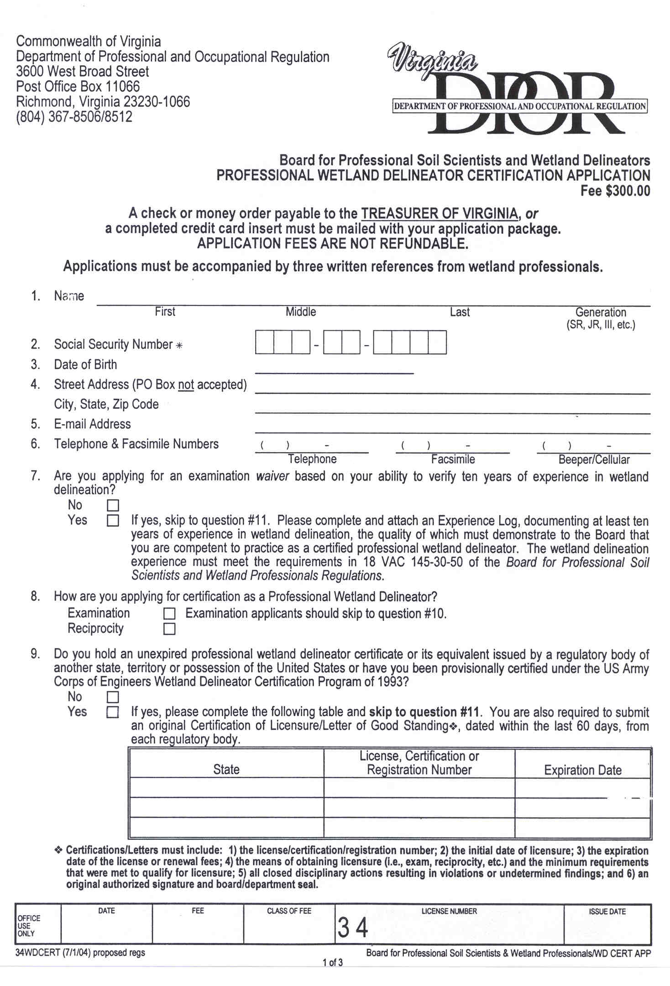
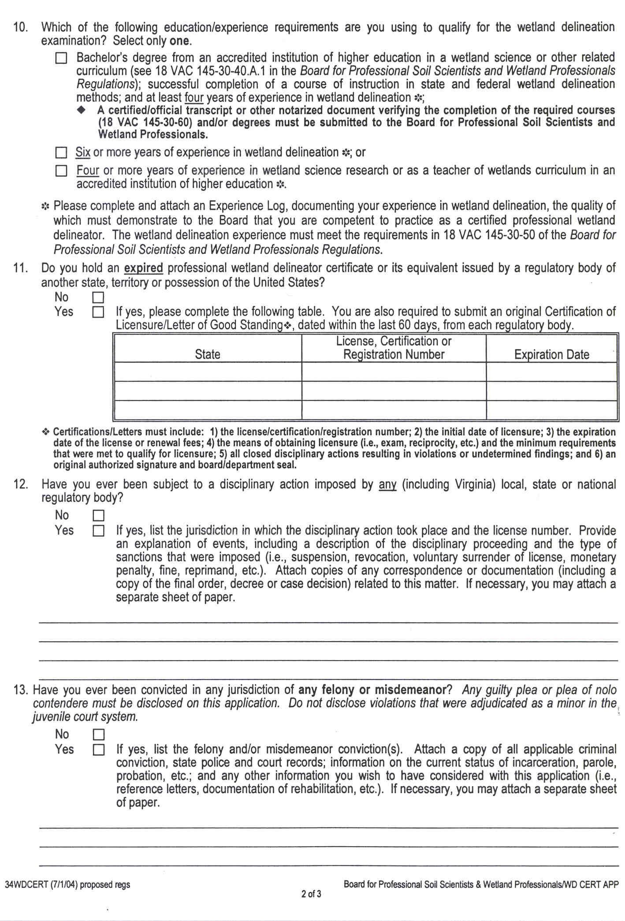
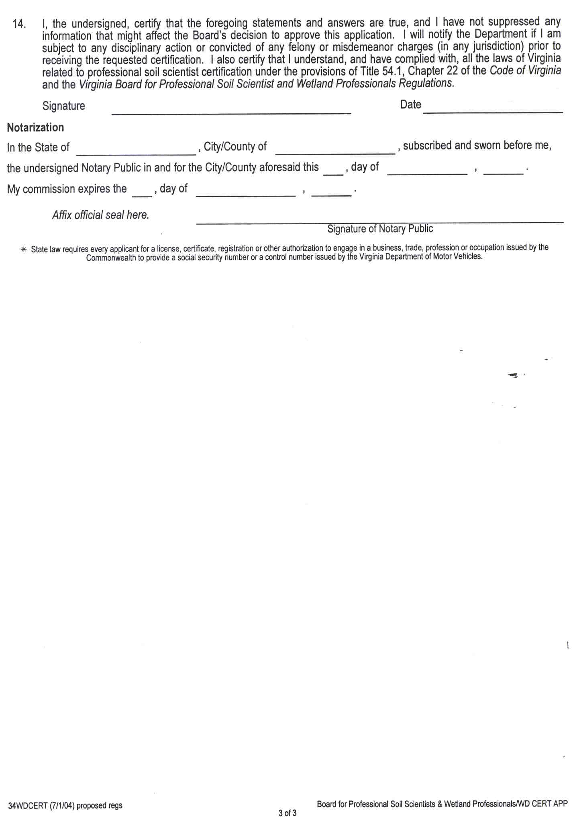
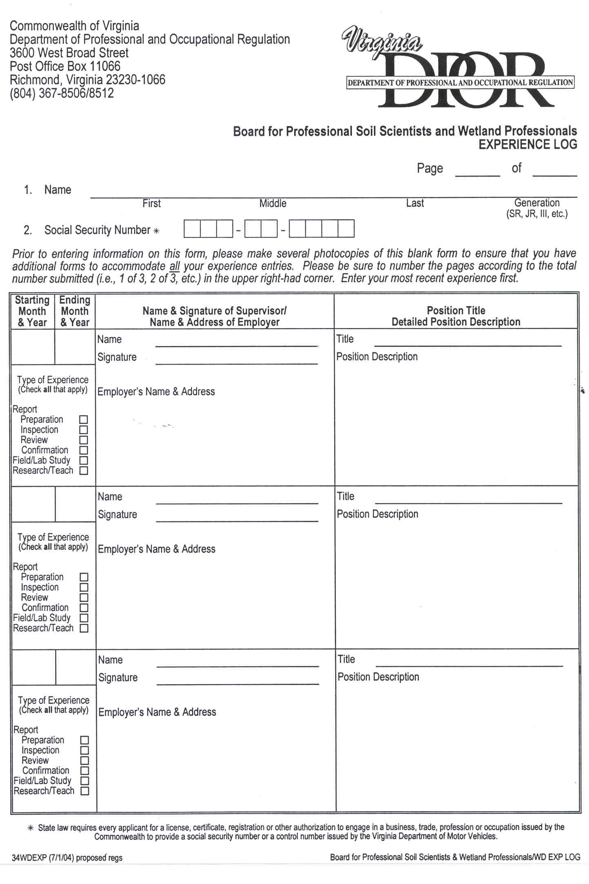
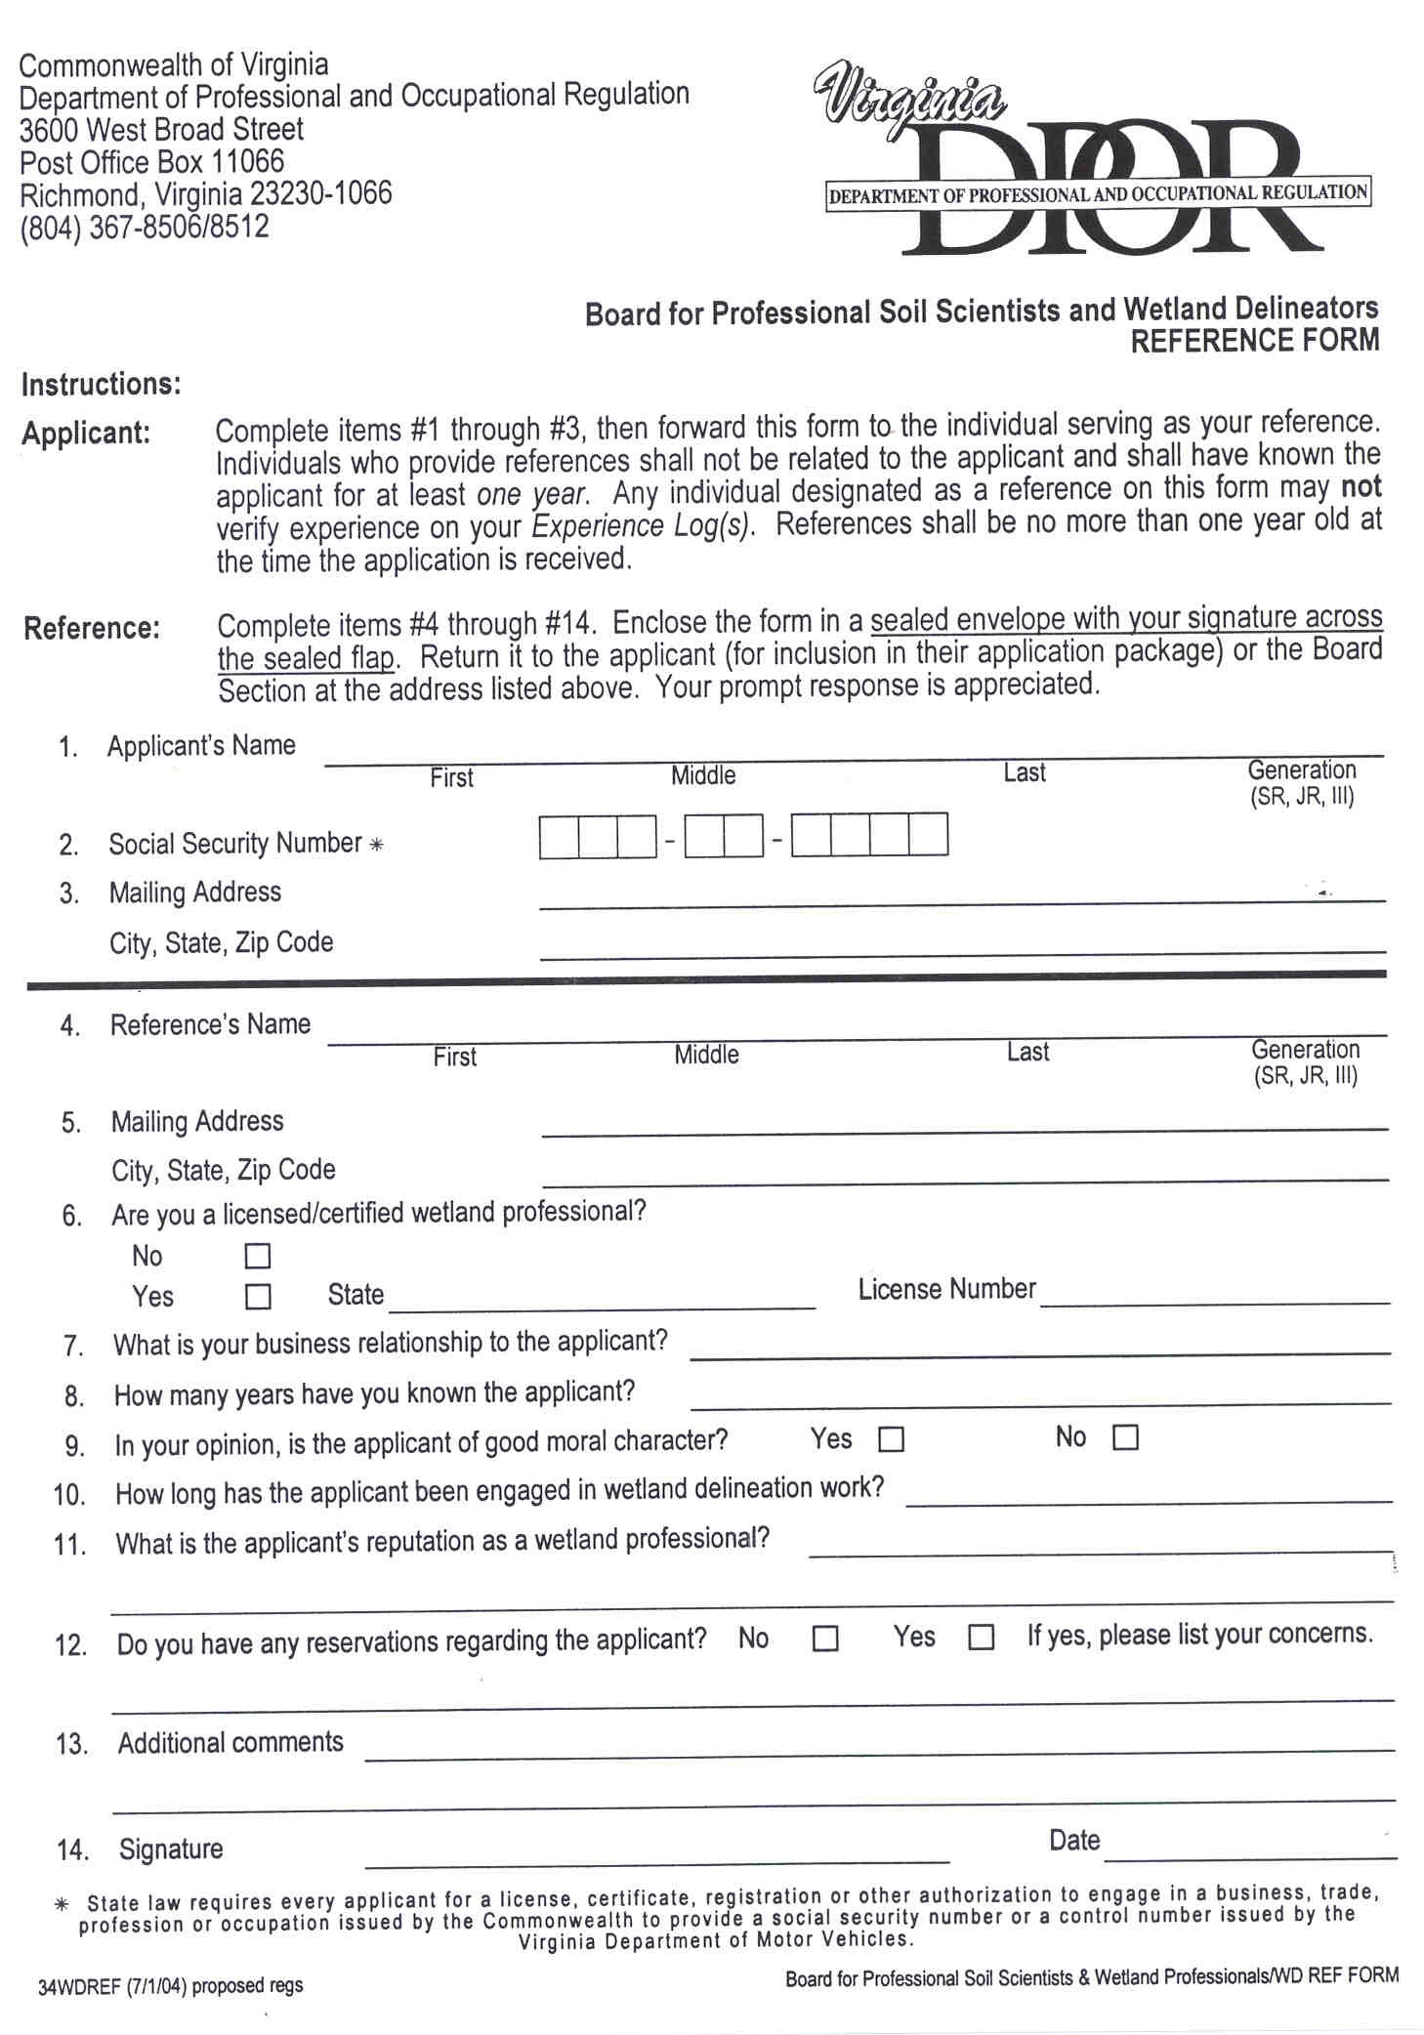

1 Sections 54.1-2206.2.A-2206.B waive the examination requirement for an individual who "holds an unexpired certificate or its equivalent issued by a regulatory body of another state, territory or possession of the United States or has been provisionally certified under the U.S. Army Corps of Engineers Wetland Delineator Program of 1993 and is not the subject of any disciplinary proceeding before such a regulatory body, which could result in the suspension or revocation of his certificate..."
2 The statutory framework is very specific about the years of experience requirements and leaves the board with little or no flexibility concerning these requirements.

