TITLE 18. PROFESSIONAL AND OCCUPATIONAL LICENSING
FAIR HOUSING BOARD
Title of Regulation: 18 VAC 62-20. Fair Housing Board Certification Regulations (adding 18 VAC 62-20-10 through 18 VAC 62-20-180).
Statutory Authority: § 54.1-2344 of the Code of Virginia.
Effective Dates: February 2, 2004, through February 1, 2005.
Agency Contact: Christine Martine, Executive Director, Department of Professional and Occupational Regulations, 3600 West Broad St., Richmond, VA 23230, telephone (804) 367-8552, FAX (804) 367-6946, or e-mail fhcertification@dpor.virginia.gov.
Preamble:
This is an emergency situation pursuant to § 2.2-4011(ii) of the Code of Virginia. Chapter 575 of the Acts of the 2003 General Assembly, which was the result of SB1102, requires regulations to be effective within 280 days of enactment.
The new regulation establishes an education-based certification program for persons subject to the Fair Housing Law who are involved in the business or activity of selling or renting dwellings.
The regulations provide:
1. Definitions of terms to be used in the regulations;
2. Entry standards for those seeking certification by the Fair Housing Board;
3. Renewal standards for certificate holders;
4. Standards of conduct; and
5. Requirements for courses, instructors and providers.
CHAPTER 20.
FAIR HOUSING CERTIFICATION REGULATIONS.
PART I.
GENERAL.
18 VAC 62-20-10. Applicability.
This chapter is applicable to persons subject to the Fair Housing Law who are in the business of selling or renting dwellings as defined in this chapter, except those individuals who hold a valid license issued by the Real Estate Board.
18 VAC 62-20-20. Definitions.
The following words and terms when used in this chapter, unless a different meaning is provided or is plainly required by the context, shall have the following meanings:
"Board" means the Fair Housing Board.
"Certificate holder" means any person in the business of selling or renting dwellings holding a valid certificate issued by the board.
"Certification" means the process by which the board issues a certificate to a person certifying completion of the entry requirements established by this chapter.
"Hour" means 50 minutes.
"Person in the business of selling or renting dwellings" means any person who (i) within the preceding 12 months, has participated as principal in three or more transactions involving the sale or rental of any dwelling or any interest therein; (ii) within the preceding 12 months, has participated as agent, other than in the sale of his own personal residence, in providing sales or rental facilities or sales or rental services in two or more transactions involving the sale or rental of any dwelling or any interest therein; or (iii) is the owner of any dwelling designed or intended for occupancy by or occupied by, five or more families.
"Provider" means an accredited university, college, community college or high school offering adult distributive education courses, or a school offering fair housing related courses.
"Proprietary school" means (i) a privately owned school, (ii) a real estate professional association or (iii) other entities, not under the authority of the Department of Education, but approved by the Fair Housing Board to teach fair housing courses.
PART II.
ENTRY REQUIREMENTS.
18 VAC 62-20-30. Qualifications for certification.
Every applicant for fair housing certification shall have the following qualifications:
1. The applicant shall complete two hours of fair housing training approved by the board or the Real Estate Board.
2. The applicant shall have taken the two-hour fair housing training within two years of the date of application.
3. If the applicant has in the last five years been found in a court or an administrative body of competent jurisdiction to have violated the Virginia Fair Housing Act, the Fair Housing Laws of any jurisdiction of the United States including without limitation Title VIII of the Civil Rights Act of 1968 (82 Stat. 73), or the Civil Rights Act of 1866 (14 Stat. 27), there being no appeal there from or the time for appeal having elapsed then the applicant shall disclose said violations and complete an additional two hours of training in other applicable federal and state discrimination laws and regulations.
18 VAC 62-20-40. Application fees.
A. All applications fees are nonrefundable and the date of actual receipt by the board or its agent is the date that will be used to determine whether it is timely received.
B. The application fee for certification shall be $50.
PART III.
RENEWAL OF CERTIFICATION.
18 VAC 62-20-50. Renewal required.
Certificates issued under this chapter shall expire two years from the last day of the month in which they were issued, as indicated on the certificate.
18 VAC 62-20-60. Qualification for renewal.
A. As a condition of renewal, all certificate holders shall be required to satisfactorily complete two hours of fair housing training approved by the board or the Real Estate Board.
B. As a condition of renewal, all certificate holders shall have taken the two-hour fair housing training within two years of the date of renewal application.
C. Each certificate holder desiring to renew the certificate shall return to the board the renewal application form and the appropriate fee as outlined in 18 VAC 62-20-80.
D. If the certificate holder has in the last two years been found in a court or an administrative body of competent jurisdiction to have violated the Virginia Fair Housing Act, the Fair Housing Laws of any jurisdiction of the United States including without limitation Title VIII of the Civil Rights Act of 1968 (82 Stat. 73), or the Civil Rights Act of 1866 (14 Stat. 27), there being no appeal therefrom or the time for appeal having elapsed then the certificate holder shall disclose said violations and complete an additional two hours of training in other applicable federal and state discrimination laws and regulations.
18 VAC 62-20-70. Procedures for renewal.
The board will mail a renewal notice to the certificate holder at the last known address. Failure of the certificate holder to receive these notices does not relieve the certificate holder of the obligation to renew.
18 VAC 62-20-80. Failure to renew.
A. If the requirements for renewal of a certificate, including receipt of the fee by the board, are not completed by the certificate holder within 30 days of the expiration date noted on the certificate, a late renewal fee shall be required in addition to the renewal fee.
B. If the requirements for renewal of a certificate, including receipt of the fee by the board, are not completed by the certificate holder within six months of the expiration date noted on the certificate, the certificate holder shall apply as a new applicant.
18 VAC 62-20-90. Fees for renewal.
A. All fees for renewal are nonrefundable, and the date of actual receipt by the board or its agent is the date that will be used to determine whether it is timely received.
B. Renewals are as follows:

Renewal fee | $50
Late renewal fee | $50
18 VAC 62-20-100. Board discretion to deny renewal.
The board may deny renewal of a certificate for the same reasons as it may refuse initial certification.
PART IV.
STANDARDS OF CONDUCT.
18 VAC 62-20-110. Maintenance of certificates.
A. A certificate holder shall at all times keep the board informed of his current address. Changes of address shall be reported to the board in writing within 30 calendar days after such change. A physical address is required; a post office box is not acceptable. The board shall not be responsible for the certificate holder’s failure to receive notices, communications and correspondence caused by the certificate holder’s failure to promptly notify the board of any change of address.
B. A certificate holder shall notify the board in writing of a name change within 30 calendar days of any change in the certificate holder’s legal name. Such notification shall be accompanied by a copy of a marriage certificate, divorce decree, court order or other documentation that verifies the name change.
C. Proof of certification shall be accessible in the place of business.
PART V.
EDUCATION.
18 VAC 62-20-120. Proprietary school standards, course requirements, instructor requirements.
A. Every applicant to the board for a proprietary school approval shall submit evidence of financial responsibility to ensure that these schools protect the public health, safety and welfare.
B. Every applicant to the board for approval as an instructor shall have the following qualifications:
1. The applicant shall be a qualified expert in a field related to fair housing who will teach only in the area of his expertise. Each applicant will be required to state his area of expertise and furnish proof of his expertise including, but not limited to, educational transcripts, professional certificates and letters of reference which will verify the applicant’s expertise.
2. The applicant shall disclose whether in the last five years he has been found in a court or an administrative body of competent jurisdiction to have violated the Virginia Fair Housing Act, the Fair Housing Laws of any jurisdiction of the United States including without limitation Title VIII of the Civil Rights Act of 1968 (82 Stat. 73), or the Civil Rights Act of 1866 (14 Stat. 27), there being no appeal therefrom or the time for appeal having elapsed.
C. Providers of fair housing courses shall submit all subjects to the board for approval prior to initially offering the course. The board shall approve each course based on the relevance of the subject to fair housing. Those providers that propose to offer courses must submit the course along with any required documentation on an application provided by the board.
D. All instructors shall provide each student with a document that the student may use as proof of course completion. The document shall contain the number of hours completed.
18 VAC 62-20-130. School renewal, procedures.
A. Approval of a proprietary school shall expire two years from the last day of the month in which it was issued, as indicated on the proprietary school approval.
B. The board will mail a renewal notice to the proprietary school at the last known address. Failure of the proprietary school to receive the notice does not relieve the proprietary school of the obligation to renew.
C. If the renewal requirements are not completed within 30 days of the expiration date noted on the proprietary school approval, the proprietary school shall no longer offer board-approved courses.
18 VAC 62-20-140. Course renewal, procedures.
A. Approval of a course shall expire two years from the last day of the month in which it was issued, as indicated on the approval document.
B. The board will mail a renewal notice to the course provider at the last known address. Failure of the course provider to receive the notice does not relieve the course provider of the obligation to renew.
C. If the renewal requirements are not completed within 30 days of the expiration date noted on the course approval, the course shall no longer be offered as a board-approved course.
18 VAC 60-20-150. Instructor renewal, procedures.
A. Approval of an instructor shall expire two years from the last day of the month in which it was issued, as indicated on the approval document.
B. The board will mail a renewal notice to the instructor at the last known address. Failure of the instructor to receive the notice does not relieve the instructor of the obligation to renew.
C. If the requirements for renewal of an approved instructor, including receipt of the fee by the board, are not completed within 30 days of the expiration date on the approval document, a reinstatement fee shall be required. Approval as an instructor may be reinstated for up to one year following the expiration date with payment of the reinstatement fee. After one year, the approval as an instructor shall not be reinstated under any circumstances and the instructor must meet all current requirements and apply as a new applicant.
18 VAC 62-20-160. Fees.
A. The application fee for approval for a proprietary school shall be $100.
B. The renewal fee for proprietary school approval shall be $100.
C. The application for approval as an instructor shall be $100.
D. The renewal fee for an instructor shall be $100.
E. The reinstatement fee for an instructor shall be $50.
18 VAC 62-20-170. Posting of instructor approval.
Copies of the instructor approval shall be available at the location where a course is taught.
18 VAC 62-20-180. Withdrawal of approval.
The board may withdraw approval of any proprietary school, approved instructor or course for the following reasons:
1. The proprietary school, instructor or course no longer meets the standards established by the board.
2. Where the instructor has been found to have violated or cooperated with others in violating any provision of Chapter 5.1 (§ 36-96.1 et seq.) of Title 36 of the Code of Virginia, the Fair Housing Laws of any jurisdiction of the United States including without limitation Title VIII of the Civil Rights Act of 1968 (82 Stat. 73), or the Civil Rights Act of 1866 (14 Stat. 27).
/s/ Mark R. Warner
Governor
Date: January 6, 2004
NOTICE: The forms used in administering 18 VAC 62-20, Fair Housing Board Certification Regulations, are listed and printed below.
FORMS
Fair Housing Board Certification Application, 0232CERT (eff. 1/30/04).
Fair Housing Board, Proprietary School Certification Application, 0232SCHL (eff. 1/30/04).
Fair Housing Board, Fair Housing Course Approval Application, 0232CRS (eff. 1/30/04).
Fair Housing Board, Instructor Application, 0232INST (eff. 1/30/04).

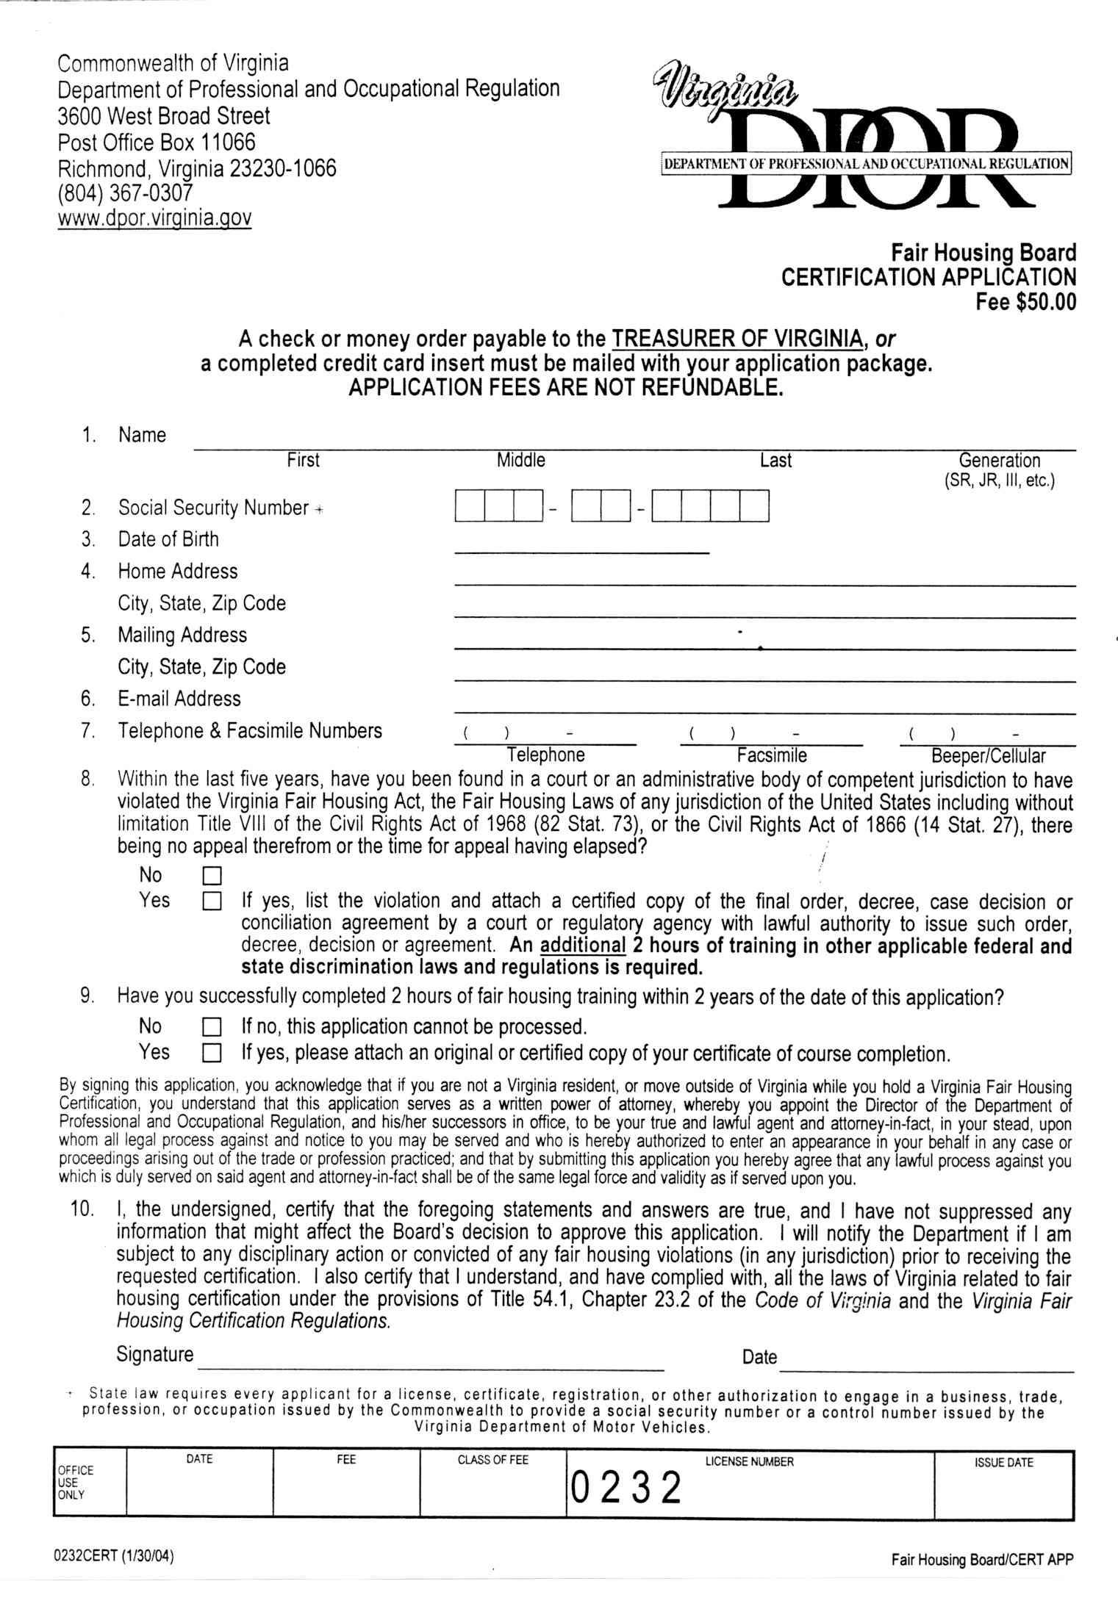
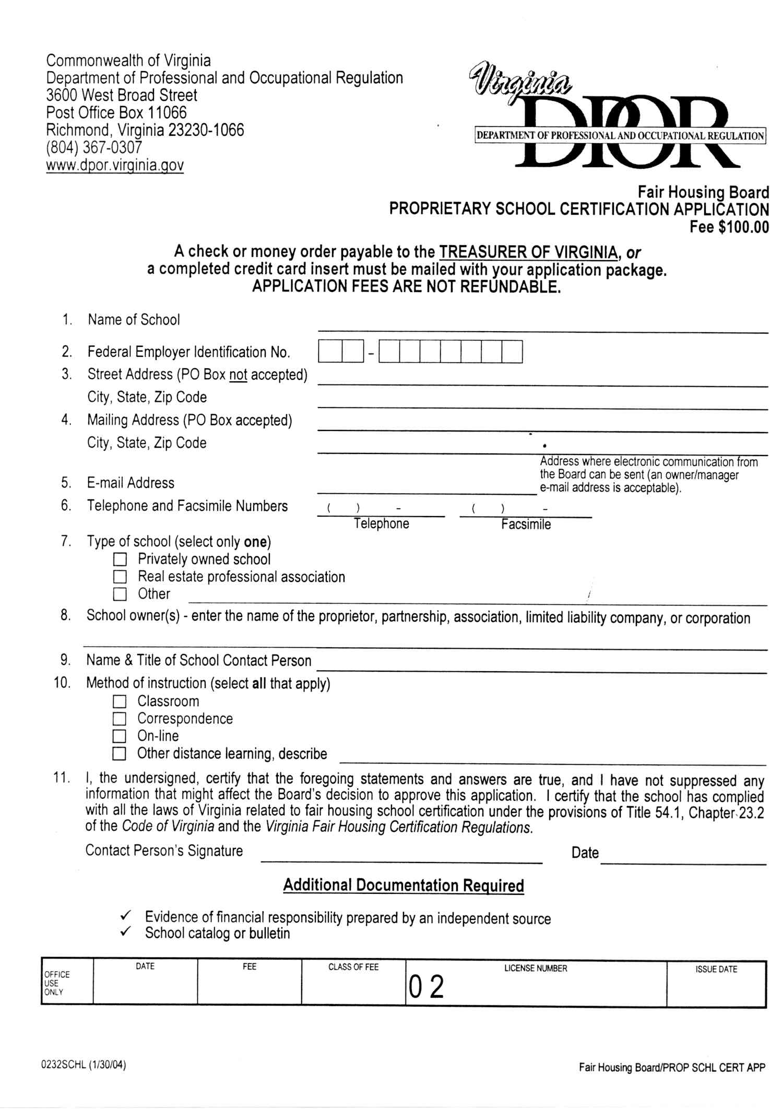
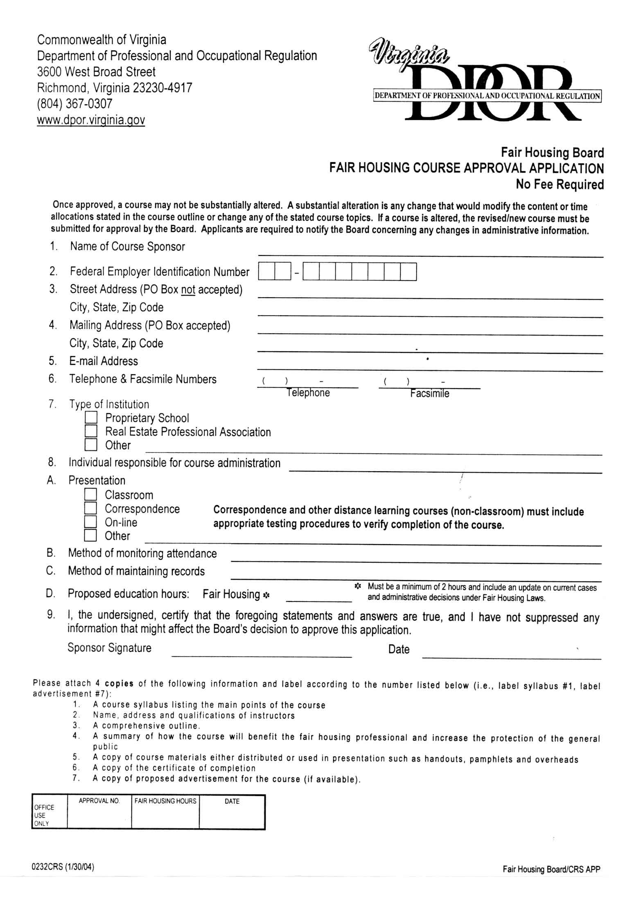
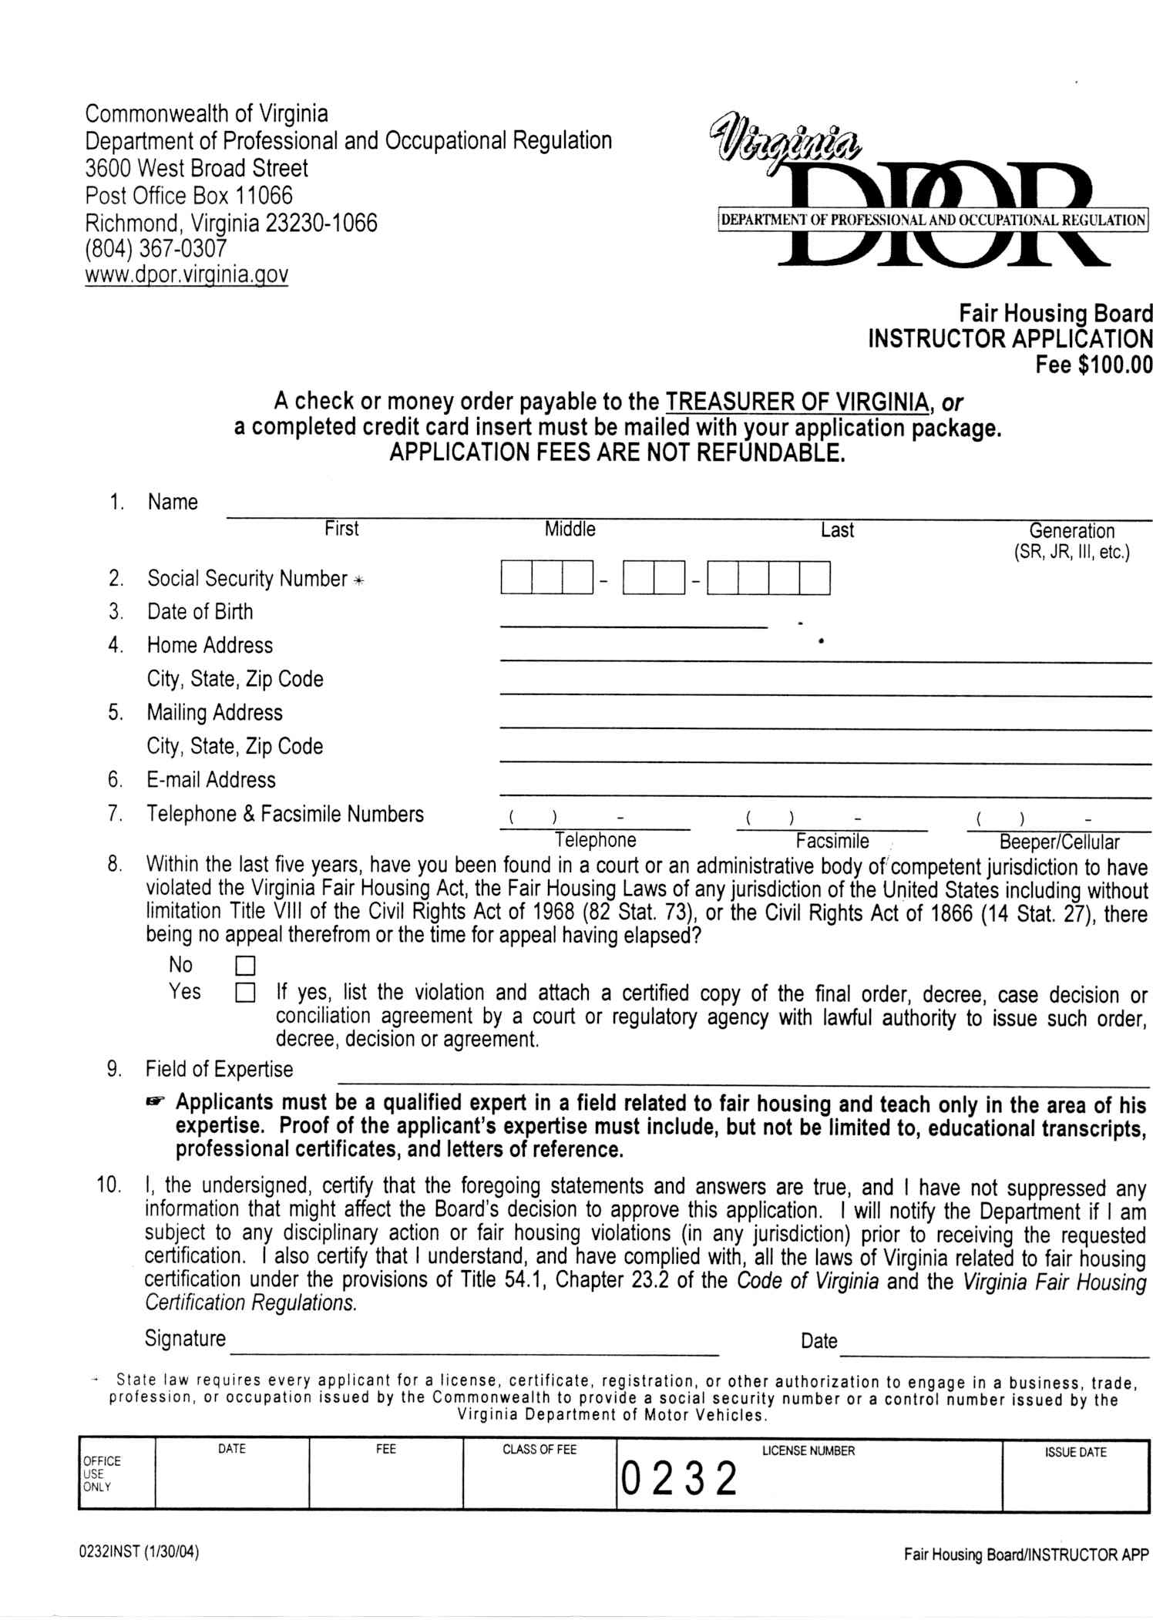
VA.R. Doc. No. R04-109; Filed February 2, 2004, 1:47 p.m.

