BOARD FOR PROFESSIONAL SOIL SCIENTISTS AND WETLAND PROFESSIONALS
Title of Regulation: 18 VAC 145-30. Wetland Delineators Certification Regulations (adding 18 VAC 145-30-10 through 18 VAC 145-30-160).
Statutory Authority: §§ 54.1-201 and 54.1-2203 of the Code of Virginia.
Effective Date: July 14, 2004.
Agency Contact: Mark N. Courtney, Executive Director, Department of Professional and Occupational Regulations, 3600 West Broad Street, Richmond, VA 23230-4917, telephone (804) 367-8514, FAX (804) 367-2475, or e-mail SoilScientist@dpor.virginia.gov.

Summary:
The regulations implement Chapter 784 of the 2002 Acts of Assembly, which established certification standards for wetlands professionals. The regulations establish (i) requirements for entry, renewal, and reinstatement; (ii) minimum standards for certification; (iii) standards of conduct and practice; (iv) grounds for disciplinary actions; and (v) fees.
The substantive changes made to the proposed regulation (i) clarify the experience requirements in 18 VAC 145-30-50; (ii) increase the number of delineations that have been reviewed from 10 to 30 for individuals applying pursuant to 18 VAC 145-30-40 A 1 or 2 and include the requirement that the review be performed as an employee of a federal, state or local governmental body that is authorized to review or approve such delineations and that a portion of the reviews must include field verifications; (iv) reduce the required length of the course in state and federal wetland delineation methods from 40 hours to 32 hours (18 VAC 145-30-60 B); (v) require an examination candidate to notify the department in writing if he is unable to take the examination at the scheduled time; and (vi) include a provision from § 54.1-2206 B of the Code of Virginia (effective July 1, 2004) that was inadvertently omitted through which an applicant could gain a certificate without examination (18 VAC 145-30-80).
Other nonsubstantive clarifying changes were made.
Summary of Public Comments and Agency's Response: A summary of comments made by the public and the agency's response may be obtained from the promulgating agency or viewed at the office of the Registrar of Regulations.

CHAPTER 30.
REGULATIONS GOVERNING CERTIFIED PROFESSIONAL WETLAND DELINEATORS.

PART I.
GENERAL.

18 VAC 145-30-10. Definitions.
All terms defined in Chapter 22 (§ 54.1-2200 et seq.) of Title 54.1 of the Code of Virginia are incorporated in this chapter.
The following words and terms when used in this chapter shall have the following meanings unless the context clearly indicates otherwise:
"Tidal wetlands" means those wetlands defined by § 28.2-1300 of the Code of Virginia.
"Nontidal wetlands" means wetlands except those defined by § 28.2-1300 of the Code of Virginia.

PART II.
ENTRY.

18 VAC 145-30-20. Qualifications for certification.
Applicants for certification shall meet the requirements specified in Chapter 22 (§ 54.1-2200 et seq.) of Title 54.1 of the Code of Virginia, as amended, and this chapter.

18 VAC 145-30-30. Receipt of application.
The date the completely documented application and fee are received in the board’s office shall determine if the application has been received by the established deadline.

18 VAC 145-30-40. Qualification for examination.
A. In order to qualify for the examination, an applicant shall provide three written references that comply with subsection B of this section and satisfy one of the following criteria:
1. Hold a bachelor's degree from an accredited institution of higher education in a wetland science, biology, biological engineering, civil and environmental engineering, ecology, soil science, geology, hydrology or any similar biological, physical, natural science or environmental engineering curriculum that has been approved by the board; have successfully completed a course of instruction in state and federal wetland delineation methods that has been approved by the board; and have at least four years of experience in wetland delineation [ , which meets the requirements of subdivision 1 or 2 of 18 VAC 145-30-50, ] under the supervision of a certified professional wetland delineator, the quality of which demonstrates to the board that the applicant is competent to practice as a certified professional wetland delineator;
2. Have a record of at least six years of experience in wetland delineation [ , which meets the requirements of subdivision 1 or 2 of 18 VAC 145-30-50, ] under the supervision of a certified professional wetland delineator, the quality of which demonstrates to the board that the applicant is competent to practice as a certified professional wetland delineator; or
3. Have a record of at least four years of experience in wetland science research or as a teacher of wetlands curriculum in an accredited institution of higher education, [ which meets the requirements of subdivision 3 of 18 VAC 145-30-50, and ] the quality of which demonstrates to the board that the applicant is competent to practice as a certified professional wetland delineator.
B. Every applicant shall provide three written references, on a form provided by the board, from wetland professionals with at least one from a certified professional wetland delineator. Individuals who provide references shall not be related to the applicant and shall have known the applicant for at least one year. Individuals who provide references may not also verify experience, including research or teaching experience.
C. Notwithstanding the requirements of subsections A and B of this section, the requirement for a reference from and supervision by a certified professional wetland delineator shall be waived provided a complete application is received by the board on or before June 30, 2006.
18 VAC 145-30-50. Qualifying experience in wetland delineation.
An applicant shall demonstrate experience in one of the following areas:
1. For those individuals applying pursuant to the provisions of 18 VAC 145-30-40 A 1 or A 2, the experience in wetland delineation must be as a wetland professional and include the preparation of no less than 10 [ reports delineations ], which must be no more than 10 years old at the time of receipt by the board office, delineating wetlands in accordance with applicable state and federal regulations that include the proper identification of vegetation, soil and hydrology indicators. At least six of the 10 [ reports delineations ] must be for nontidal wetlands. [ At least three of the reports must have confirmation letters from the applicable state or federal regulatory body certifying that they are correct ];
2. For those individuals applying pursuant to the provisions of 18 VAC 145-30-40 A 1 or A 2, the experience in wetland delineation must be as a wetland professional and include the inspection, review or confirmation of no less than [ 10 reports 30 delineations as an employee of a federal, state or local governmental body that is authorized to review or approve such delineations ], which must be no more than 10 years old at the time of receipt by the board office, delineating wetlands in accordance with applicable state and federal regulations that include the proper identification of vegetation, soil and hydrology indicators. [ Such experience must include the performance of field verifications of a portion of those wetland delineations that were inspected, reviewed or confirmed. ] At least six of the [ 10 reports 30 delineations ] must be for nontidal wetlands [ , ; ] or
3. For those individuals applying pursuant to the provisions of 18 VAC 145-30-40 A 3, the experience as a wetland science researcher must include the preparation of a minimum of three field studies focused on wetland delineation practice and issues, [ which includes the proper identification of vegetation, soil and hydrology indicators, ] and the experience as a teacher of wetlands curriculum must have been acquired in an accredited institution of higher education as a field or laboratory instructor of quarter or semester length classes for a minimum of six semester hours, or equivalent, within the past 10 years prior to the receipt of the application by the board office [ , and the curriculum must have included the proper identification of vegetation, soil and hydrology indicators ].

18 VAC 145-30-60. Course requirements.
The education required pursuant to 18 VAC 145-30-40 A 1 must include the following:
1. For a bachelors degree in any similar biological, physical, natural science or environmental engineering curriculum to be approved by the board, it shall, at a minimum, contain the following:
a. Fifteen semester hours, or equivalent, in biological sciences including courses such as general biology, botany or zoology; general ecology; plant, animal, aquatic or wetlands ecology; invertebrate zoology; taxonomy; marine science; fisheries biology; plant physiology, plant taxonomy, plant pathology, plant morphology; relevant environmental sciences, and similar courses;
b. Fifteen semester hours, or equivalent, in physical sciences including courses in soils, chemistry, hydrology, physics, geology, sedimentology, oceanography, coastal processes, environmental engineering, and similar courses; and
c. Six semester hours, or equivalent, in quantitative sciences including courses in math, computer sciences, basic statistics, [ popular population ] dynamics, experimental statistics, and similar courses.
2. The applicant must have successfully completed a course of instruction, of a minimum of [ 40 32 ] hours, in state and federal wetland delineation methods that includes the proper identification of vegetation, soil and hydrology indicators and a field component.

18 VAC 145-30-70. Examination.
A. Once approved by the board, an applicant shall be eligible to sit for a board-approved examination.
B. An applicant must meet all eligibility requirements as of the date the completely documented application and fee is received by the board’s office. For examination candidates, the completely documented application and fee must be received by the board’s office at least 90 days prior to the examination.
C. A candidate approved to take an examination shall do so within one year of the date of approval or submit a new application and fee in accordance with these regulations. If an applicant should not pass the board-approved examination within one year of being approved, the applicant shall be required to submit a new application and fee in accordance with this chapter in order to take the examination.
[ D. A candidate who is unable to take the examination at the time scheduled must notify the department in writing prior to the date of the examination; such a candidate will be rescheduled for the next examination without an additional fee. Failure to so notify the department will result in forfeiture of the examination or reexamination fee.
E. Candidates will be notified of passing or failing the examination. ]

18 VAC 145-30-80. Waiver from examination.
An applicant [ may shall ] be granted a Virginia certificate without examination, provided that:
1. The applicant holds an unexpired professional wetland delineator certificate or equivalent issued on the basis of equivalent requirements for certification in Virginia, by a regulatory body of another state, territory or possession of the United States [ or has been provisionally certified under the U.S. Army Corps of Engineers Wetland Delineator Certification Program of 1993 ] and is not, nor has been, the subject of any disciplinary proceeding before such regulatory body, and such other regulatory body recognizes the certificates issued by this board [ shall have the requirement for the examination waived, ] provided all other requirements of Chapter 22 (§ 54.1-2200 et seq.) of Title 54.1 of the Code of Virginia [ , ] and this chapter are satisfied; or
2. Applicants who submit a complete application so that it is received by the board on or before June 30, 2006, and are found to be qualified pursuant to § 54.1-2206 B of the Code of Virginia ( [ as it becomes ] effective July 1, 2004) [ shall have the requirement for the examination waived, ] provided all other requirements of Chapter 22 (§ 54.1-2200 et seq.) of Title 54.1 of the Code of Virginia and this chapter are satisfied.

PART III.
FEES, RENEWAL AND REINSTATEMENT REQUIREMENTS.

18 VAC 145-30-90. Fees.
All fees required by the board are nonrefundable and shall not be prorated.

Fee Type | Amount
Application | $300
Renewal fee | $260
Late renewal fee | $25
Reinstatement fee | $300
[ Examination fee | $150 ]
18 VAC 145-30-100. Expiration.
Certificates issued under this chapter shall expire two years from the last day of the month in which they were issued, as indicated on the certificate.

18 VAC 145-30-110. Renewal.
A. The department shall [ mail send ] a renewal notice to the certificate holder at the last known address of record at least 30 days prior to expiration. Failure to receive this notice does not relieve the certificate holder from the requirement to renew the certificate. If the certificate holder fails to receive the renewal notice, a copy of the certificate shall be submitted with the required fee in lieu of the renewal notice.
B. If the renewal fee is not received by the department within 30 calendar days following the expiration date noted on the certificate, a late renewal fee of $25 shall be required in addition to the regular renewal fee. If the certificate is renewed after 30 days from the expiration date and prior to 180 days of the expiration date, the effective date of the renewal shall be the original renewal date. No certificate may be renewed more than 180 days following the date of expiration noted on the certificate.
C. The date a fee is received by the department or its agent shall determine whether a late renewal fee or the requirement for reinstatement or reapplication is applicable.
D. A certificate suspended by board order shall not be renewed until the period of suspension has ended and all terms and conditions of the board's order have been met. Individuals renewing certificates within 30 days after the suspension is lifted will not be required to pay a late fee.

18 VAC 145-30-120. Reinstatement.
A. If the renewal fee and late renewal fee are not received by the department within 180 days following the expiration date noted on the certificate, the certificate holder shall no longer be considered a certificate holder and will be required to apply for certificate reinstatement. The applicant shall meet the current eligibility standards for certification as a Virginia certified professional wetland delineator. The board may require examination or reexamination. The fee for reinstatement shall include the regular renewal fee plus the reinstatement fee.
B. If the reinstatement application and fee are not received by the department within one year following the expiration date noted on the certificate, the applicant shall apply as a new applicant and shall meet all current entry requirements as may be required by the board.

18 VAC 145-30-130. Denial of application or renewal.
The board may, in its discretion, refuse to grant, renew or reinstate a certificate of any person for any of the reasons specified in Chapters 1, 2 or 22 of Title 54.1 of the Code of Virginia and this chapter including, but not limited to, Part IV (18 VAC 145-30-140 et seq.) of this chapter.

PART IV.
STANDARDS OF PRACTICE AND CONDUCT.

18 VAC 145-30-140. Standards of practice and conduct.
A Virginia certified professional wetland delineator:
1. Shall not submit any false statements, make any misrepresentations or fail to disclose any facts requested concerning any application for certification or recertification.
2. Shall not engage in any fraud, deceit or misrepresentation in advertising, in soliciting or in providing professional services.
3. Shall not knowingly sign any plans, drawings, blueprints, surveys, reports, specifications, maps or other documents not prepared or reviewed and approved by the certificate holder.
4. Shall not knowingly represent a client or employer on a project on which the certificate holder represents or has represented another client or employer without making full disclosure thereof.
5. Shall express a professional opinion only when it is founded on adequate knowledge of established facts at issue and based on a background of technical competence in the subject matter.
6. Shall not knowingly misrepresent factual information in expressing a professional opinion.
7. Shall immediately notify the client or employer and the appropriate regulatory agency if the certificate holder's professional judgment is overruled and not adhered to when advising appropriate parties of any circumstances of a substantial threat to the public health, safety, or welfare.
8. Shall exercise reasonable care when rendering professional services and shall apply the technical knowledge, skill and terminology ordinarily applied by practicing wetland professionals.
9. Shall sign and date all plans, drawings, blueprints, surveys, reports, specifications, maps or other documents prepared or reviewed and approved by the certificate holder. The certified wetland professional delineator shall also indicate that he is a Virginia Certified Wetland Professional Delineator on all plans, drawings, blueprints, surveys, reports, specifications, maps or other documents prepared or reviewed and approved by the certificate holder and include his certificate number.
18 VAC 145-30-150. Grounds for suspension, revocation or other disciplinary action.
The board has the power to fine any certificate holder, and to suspend or revoke any certificate issued under the provisions of Chapter 22 (§ 54.1-2200 et seq.) of Title 54.1 of the Code of Virginia, and the regulations of the board, where the certificate holder has been found to have violated or cooperated with others in violating any provision of Chapters 1, 2 or 22 of Title 54.1 of the Code of Virginia, or any regulation of the board.

18 VAC 145-30-160. Change of address.
A certificate holder shall keep the department informed of his current mailing address. Change of address shall be reported to the department in writing within 30 calendar days of the change.
NOTICE: The forms used in administering 18 VAC 145-30, Wetland Delineators Certification Regulations, are listed and published below.

FORMS
Professional Wetland Delineator Certification Application, [ 34WDCERT 3402CERT, (Rev. 7/04) ].
Experience Log, [ 34WDEXP 3402EXP, (Rev. 7/04) ].
Reference Form, [ 34WDREF 3402REF, (Rev. 7/04) ].
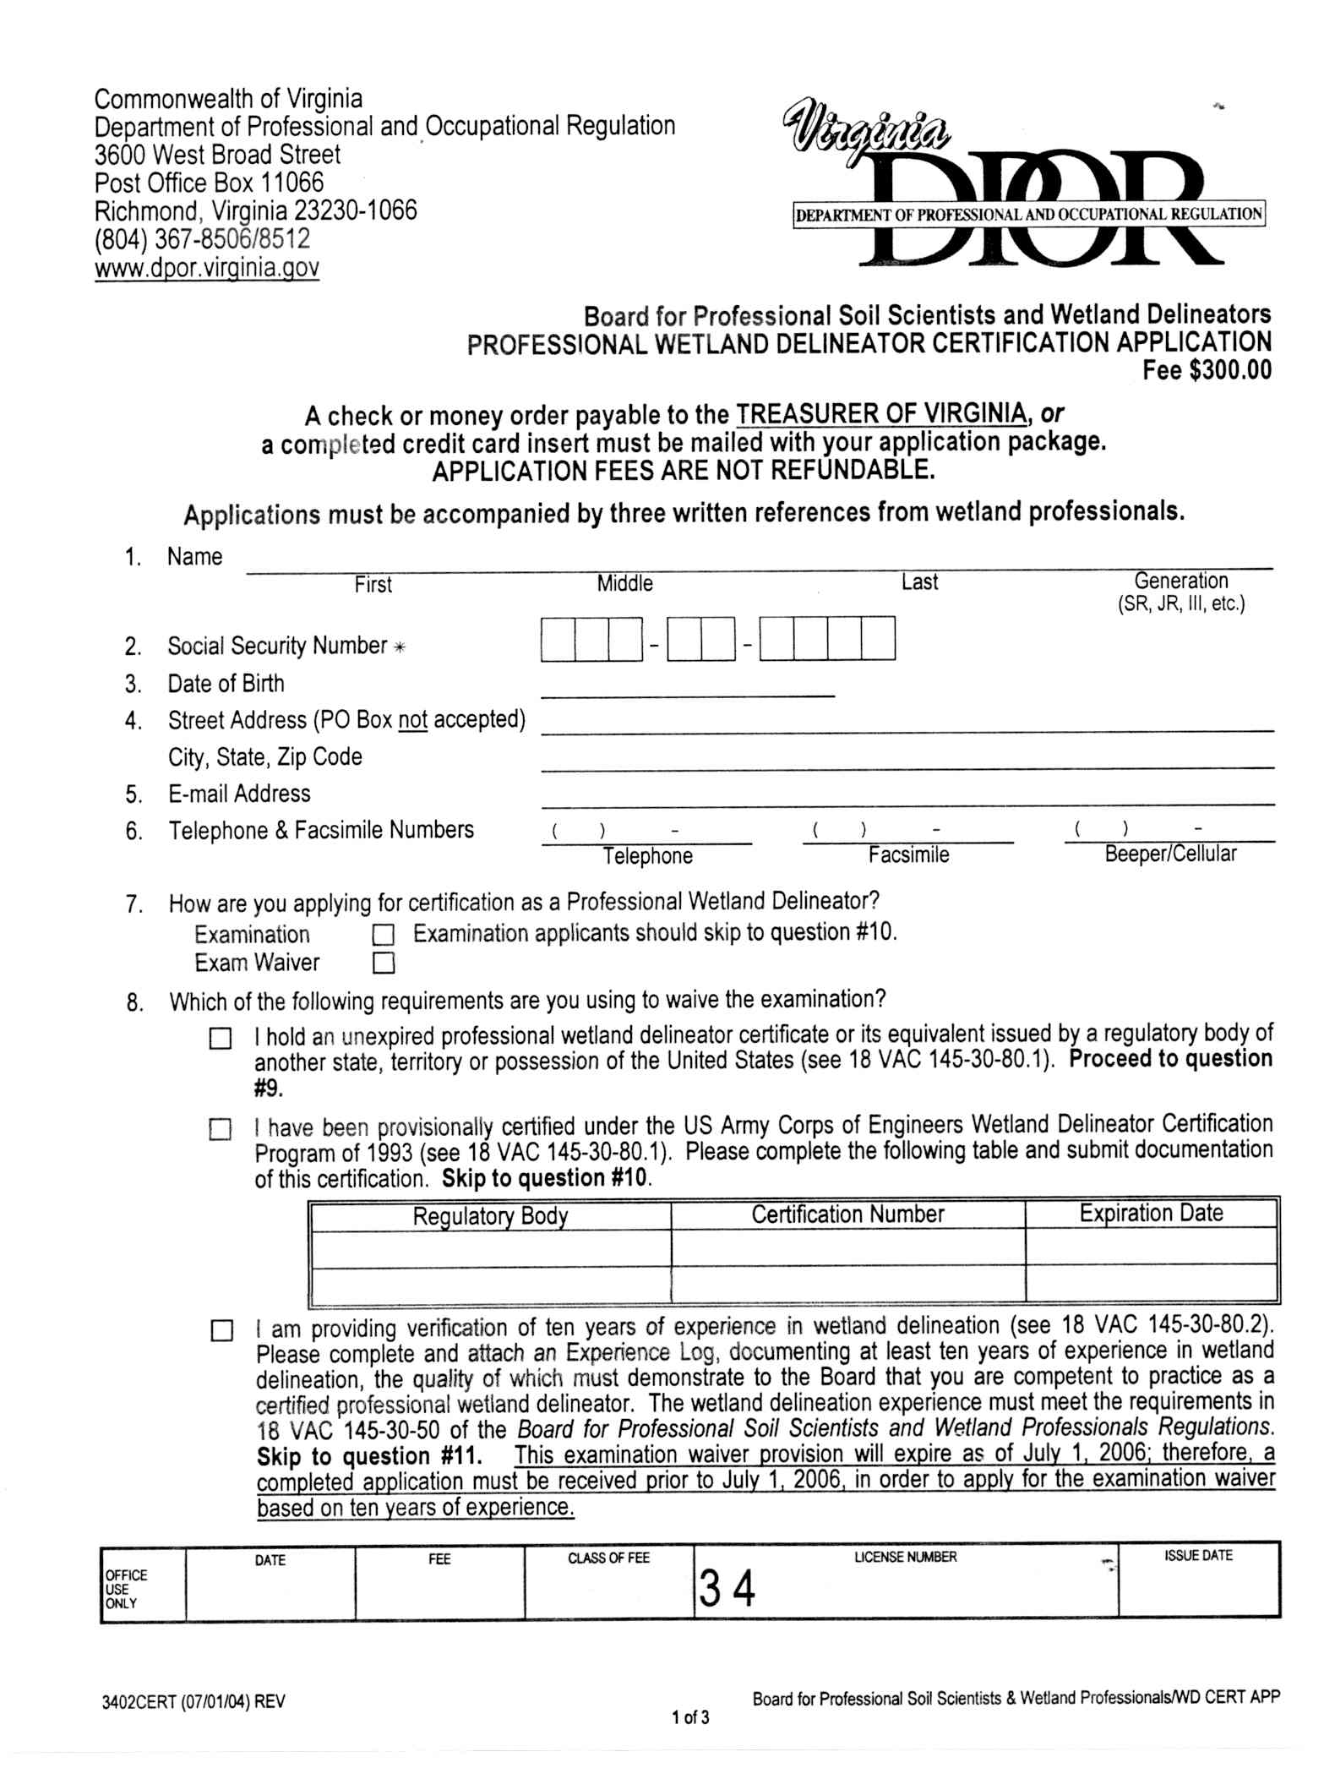
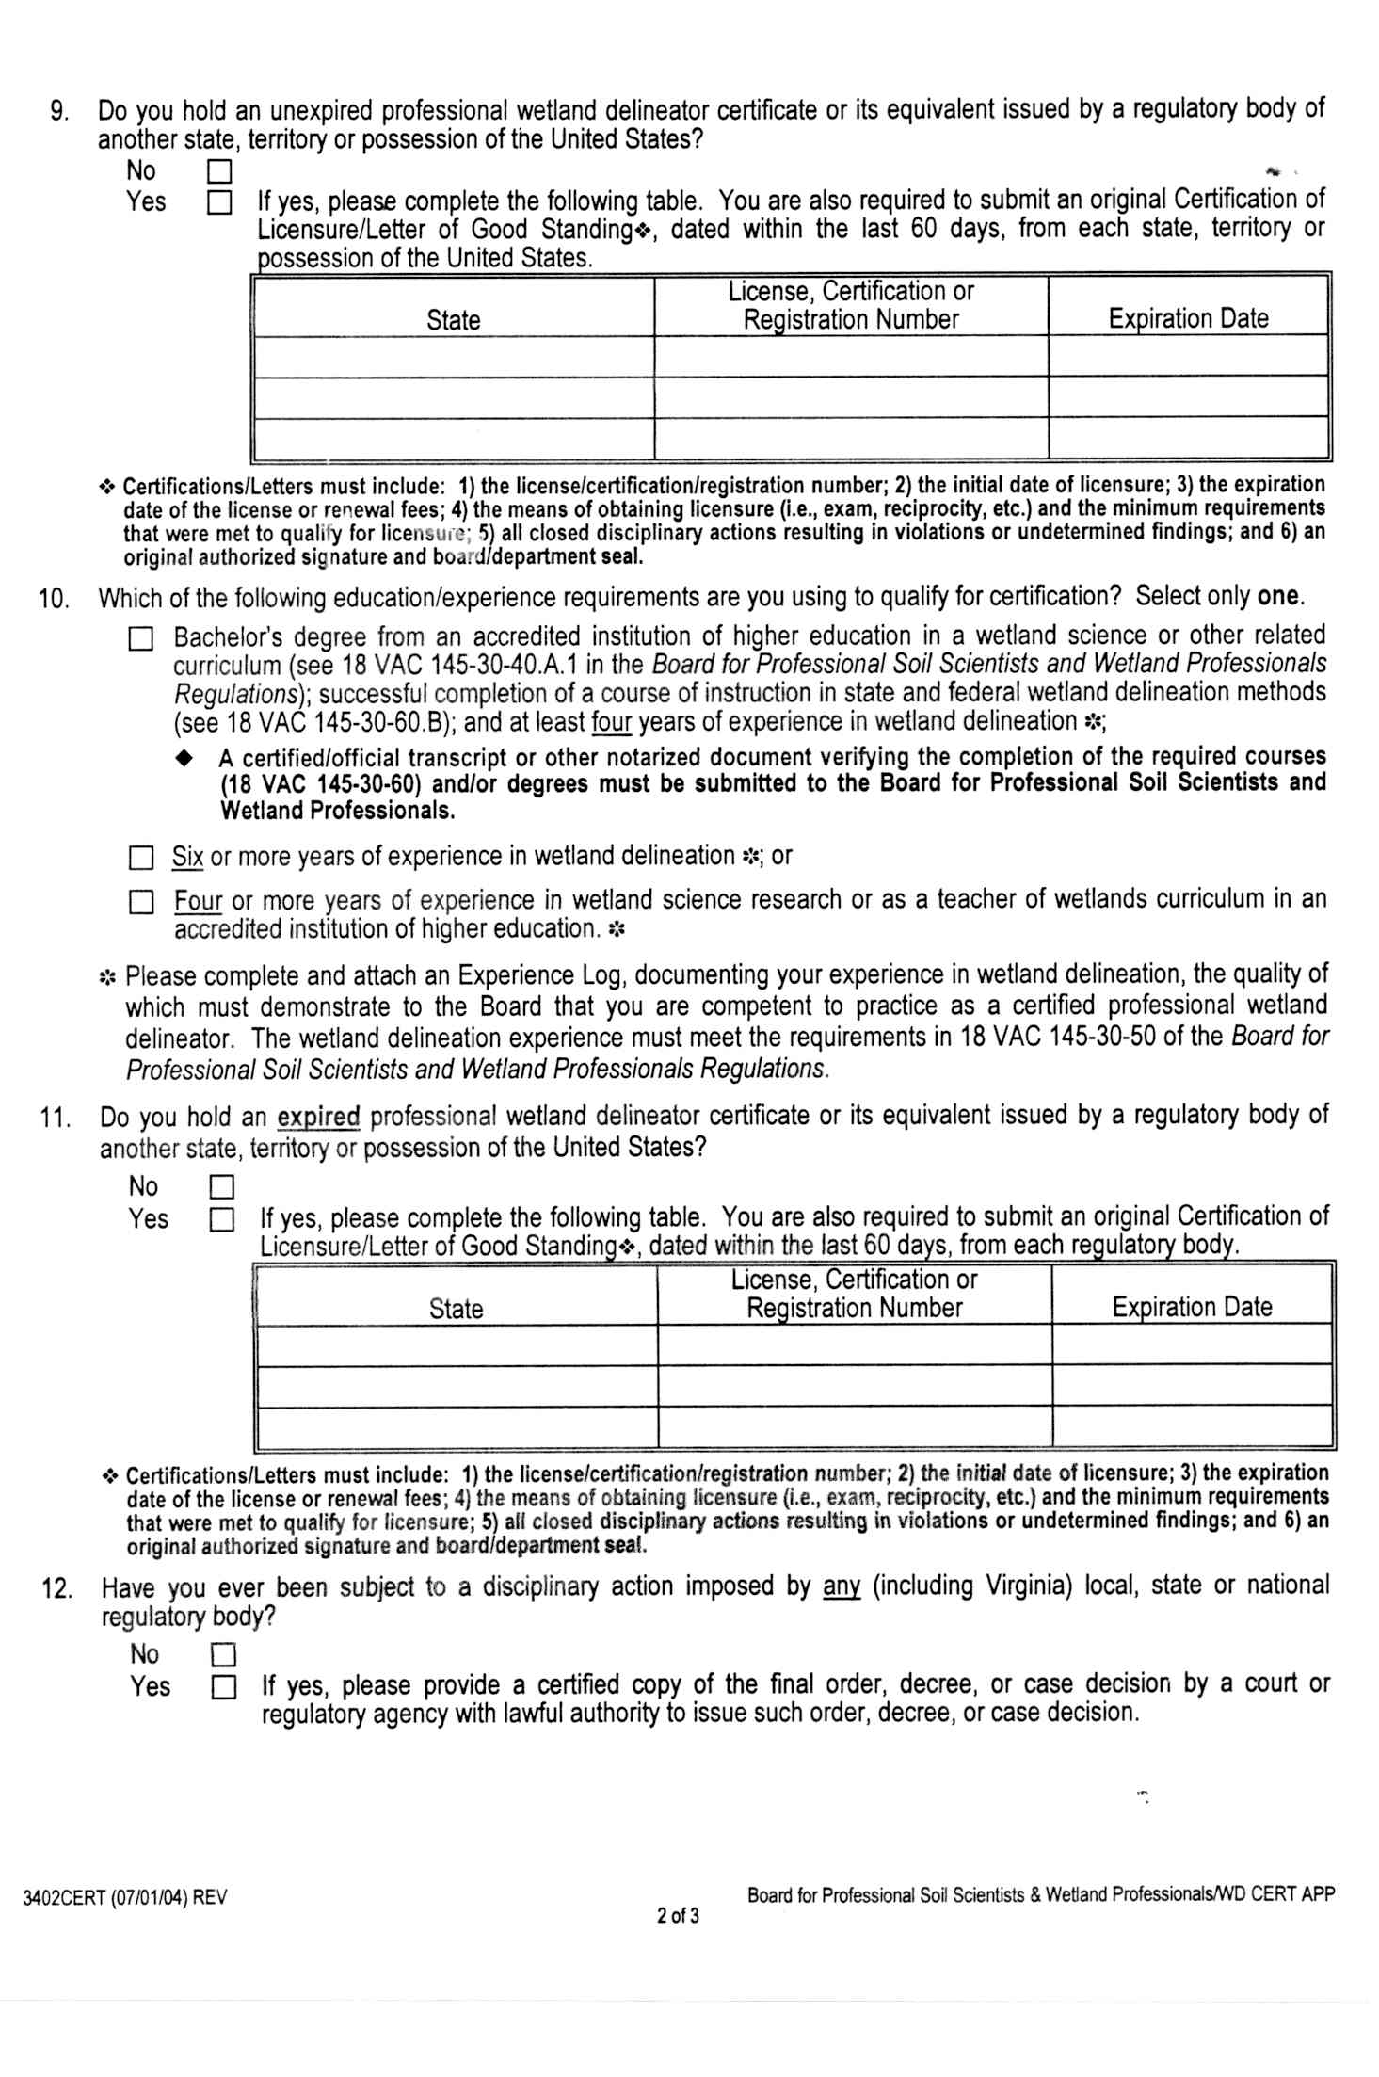
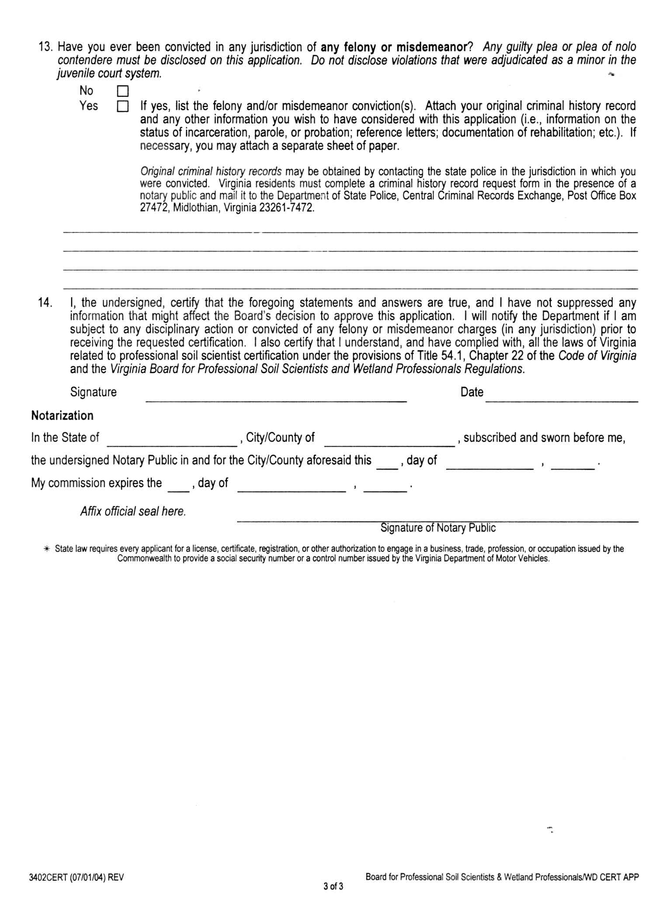

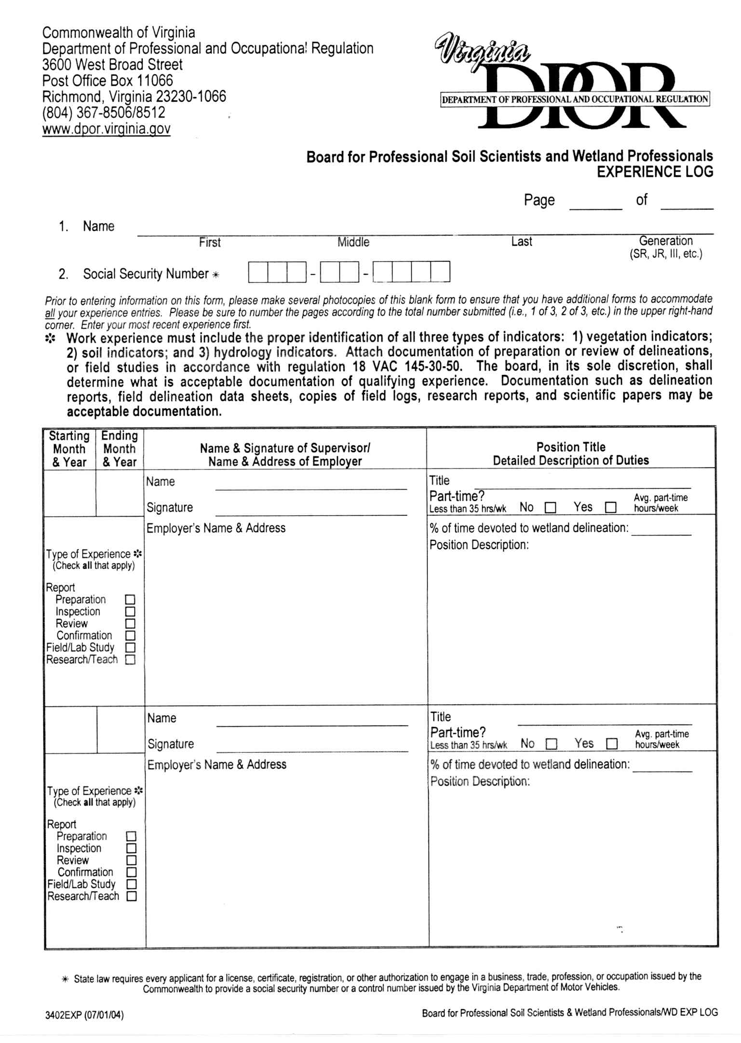
VA.R. Doc. No. R02-264; Filed May 26, 2004, 9:34 a.m.

