TITLE 18. PROFESSIONAL AND OCCUPATIONAL LICENSING
BOARD FOR GEOLOGY
Title of Regulation: 18 VAC 70-20. Rules and Regulations for the Virginia Board for Geology (amending 18 VAC 70-20-10, 18 VAC 70-20-30, 18 VAC 70-20-50 through 18 VAC 70-20-90, 18 VAC 70-20-110, 18 VAC 70-20-140, 18 VAC 70-20-150; adding 18 VAC 70-20-105; and repealing 18 VAC 70-20-20).
Statutory Authority: §§ 54.1-201 and 54.1-1402 of the Code of Virginia.
Public Hearing Date: September 23, 2004 - 10 a.m.
Public comments may be submitted until October 8, 2004.
(See Calendar of Events section
for additional information)
Agency Contact: Tom Perry, Regulatory Boards Administrator, Department of Professional and Occupational Regulation, 3600 West Broad Street, Richmond, VA 23230, telephone (804) 367-8595, FAX (804) 367-6128, or e-mail geology@dpor.virginia.gov.
Basis: These amendments to the board’s current regulations implement § 54.1-1402 of the Code of Virginia, which mandates that the Board for Geology establish regulations necessary for the reasonable administration of Chapter 14 of Title 54.1 of the Code of Virginia.
Purpose: The board proposes to delete the section providing for a board vote on the qualifications of each applicant for certification because it is redundant to the board’s statutory authority. Removing a redundancy will have no impact on public protection. The board may be able to identify tasks appropriate for delegation to staff, which could result in faster service to applicants and fewer board meetings.
The section establishing the dollar amount of the certification examination and providing authority for the board to establish the certification examination fee in accordance with the terms of a contract competitively negotiated and bargained for in compliance with the Virginia Public Procurement Act is being amended to delete the examination dollar amount as no longer necessary. Public protection is assured through compliance with the Virginia Public Procurement Act and by removing language that is outdated. A confusing redundancy will be eliminated.
The section establishing entry standards for certification is being amended to include the education and experience requirements. Currently, the board uses the standards established under its statutory authority found in § 54.1-1403 of the Code of Virginia. The proposed education and experience standards will be the subject of public comment and may be modified by the board in response to that pubic comment within the limits of its statutory authority. The current regulations are silent on this issue. Clear and specific standards are essential to protect the health, safety and welfare of Virginia’s citizens.
The section establishing certification by reciprocity standards is being amended to focus the regulation’s attention on the standards met by an applicant to qualify for a license in another jurisdiction rather than on just the examination. Examinations can be difficult, if not impossible, to evaluate from the standpoint of substantial equivalency. Focusing on the examination exclusively ignores the other entry standards that should also be evaluated in order to determine that the applicant has met an entry standard in the other jurisdiction that is substantially equivalent to Virginia’s. Clear and specific standards that provide for a full evaluation of applicant qualifications are essential to protect the health, safety and welfare of Virginia’s citizens.
A new section is being added to assure that applicants and regulants notify the board of any change in name or address. Regulatory programs work only if those regulated can be reliably identified and located to investigate any allegation of regulations violation filed by a member of the public. The current regulation is silent; therefore, the board has no effective means of assuring that its records are accurate and up to date. Those failing to comply may be subject to disciplinary action. Identifying and being able to contact those regulated is essential to the operation of any regulatory program that protects the health, safety and welfare of Virginia’s citizens.
Other amendments have been proposed to add to clarity.
Substance: The definition section (18 VAC 70-20-10) is being amended to add three definitions that will add to clarity.
The section requiring a majority vote (18 VAC 70-20-20) of the board to issue a geology certification is being repealed as redundant to the Code of Virginia and to enable delegation of some tasks to staff.
The fee section (18 VAC 70-20-30) is being amended to delete language establishing a specific fee for the certification examination. The remaining language mandates that the examination fee be set through a contact with a vendor in compliance with the Virginia Public Procurement Act. The public is protected through the board’s compliance with the Virginia Public Procurement Act in setting the examination fee.
The reinstatement section (18 VAC 70-20-50) is being amended to remove language requiring a reinstatement applicant to give the reasons that he allowed his certificate to expire as a condition of reinstatement. A certificate may not have been renewed for any number of reasons not related to public protection. The remaining language enabling the board to require requalification, reexamination or both before reinstating is sufficient to assure only qualified individuals have their certificate reinstated.
The section establishing entry standards (18 VAC 70-20-80) is being amended to include the education and experience requirements used by the board currently under its statutory authority found in § 54.1-1403 of the Code of Virginia. These are based on the standards currently provided to individuals requesting eligibility information and currently used by the board in determining eligibility.
The waiver of examination section (18 VAC 70-20-90) is being amended to more precisely focus on the examination waiver authority granted to the board by § 54.1-1404 of the Code of Virginia.
A new section is being added (18 VAC 70-20-105) to require certificate holders to report a change in their name or address to the board within 30 days. The current regulations are silent on this matter. Efficient regulation is not possible without the correct names and addresses of regulants.
The disciplinary section (18 VAC 70-20-140) is being amended to accurately reflect the enabling statute’s requirement for a formal hearing as opposed to an informal fact finding in order for the board to take disciplinary actions; to include fraud or deceit in renewing as well as applying for a certificate as a ground for disciplinary action; and to clarify that gross, rather than ordinary, negligence is a ground for disciplinary action. An amendment is also made to make clear that the conviction of a felony that would adversely affect the practice of geology is a ground for disciplinary action.
Issues: No disadvantages to the public or the Commonwealth have been identified.
The primary advantages to the public, both those seeking geologist certification and those seeking the services of a certified geologist, are the clarification of entry standards for applicants to sit for the examination and for applications for examination waiver; the potential to streamline board operations by delegating tasks to DPOR staff; the authority to maintain current names and addresses of those certified to practice; and the citation of the board’s authority under the Code of Virginia to deny certification to those with criminal records.
Department of Planning and Budget's Economic Impact Analysis: The Department of Planning and Budget (DPB) has analyzed the economic impact of this proposed regulation in accordance with § 2.2-4007 H of the Administrative Process Act and Executive Order Number 21 (02). Section 2.2-4007 H requires that such economic impact analyses include, but need not be limited to, the projected number of businesses or other entities to whom the regulation would apply, the identity of any localities and types of businesses or other entities particularly affected, the projected number of persons and employment positions to be affected, the projected costs to affected businesses or entities to implement or comply with the regulation, and the impact on the use and value of private property. The analysis presented below represents DPB’s best estimate of these economic impacts.
Summary of the proposed regulation. The Board for Geology (board) proposes to (i) insert language from the Code of Virginia directly into the regulations to help inform the public, (ii) eliminate a requirement that effectively requires the board to meet and vote on every certification application, (iii) eliminate the requirement that reinstatement applicants state why they let their certification expire, (iv) amend the language describing when reinstated certificates expire, (v) specify course subject areas within the geological sciences, (vi) specify areas of work considered to be geology work, (vii) specify the numbers of hours of work necessary to constitute a work year, and (viii) specify that the board may discipline an individual who used fraud or deceit to renew his certification.
Estimated economic impact. The current regulations require that "In determining the qualifications of an applicant for certification, a majority vote of members of the board shall be required." The board proposes to remove this language from the regulations. This will permit the board to delegate clear-cut decisions on applicant qualifications to Department of Professional and Occupational Regulation (department) staff. This may allow the board to meet one or two fewer times per year. The board currently meets four times per year. The department estimates that board meetings cost on average $886. The costs of board meetings are paid through fees for certificate holders. Thus, this proposal could potentially save Virginia geologists up to $1,772 per year.
Under the current regulations, a certification reinstatement applicant must state why she let her certification expire. The board proposes to eliminate this requirement. The board makes certification reinstatement decisions based on the applicant’s qualifications at the time of reinstatement application, and does not in practice use the explanation for certification expiration as a consideration. There will be no cost to eliminating this requirement, and the applicant will save the time associated with formulating and explaining why her certification expired without renewal.
The current regulations state that reinstated certifications "shall be assigned an expiration date two years from the previous expiration date of the certification." If more than two years have passed since the previous expiration date of the certification, then the reinstated certification will be immediately out of date (expired). To prevent this from happening, the board proposes to amend the regulations to state that the reinstated certifications "shall expire on August 31 of the odd-numbered year following the date of reinstatement." According to the department, reinstated certifications have been dated this way in practice. The proposal to amend the determination of expiration dates for reinstated certifications will create a net benefit, since otherwise reinstated certifications could never be made current (assuming that the regulations were followed in practice).
Section 54.1-1403 of the Code of Virginia states that in order to be eligible for certification as a professional geologist, the applicant must "Have a baccalaureate or higher degree from an accredited college or university with either a major in geology, engineering geology, geological engineering, or related geological sciences; or have completed at least thirty semester hours or the equivalent in geological science courses leading to a major in geology." 1 The current regulations do not specify what course subjects qualify as geological science courses that lead to a major in geology.
The proposed regulations state that at least 12 of the required 30 semester hours be completed in four of seven subjects listed. The seven subjects are stratigraphy, structural geology, mineralogy, paleontology, petrology, geomorphology, and field geology. According to the department, this represents what the board has required in practice. Thus, the proposed additional language is useful for clarity, but does not otherwise have a significant impact.
Section 54.1-1403 of the Code of Virginia further requires the following for certification eligibility:
at least seven years of geological work which shall include either a minimum of three years of geological work under the supervision of a qualified or certified professional geologist, or a minimum of three years of experience in responsible charge of geological work. The adequacy of the position and the required supervision and experience shall be determined by the Board in accordance with standards set forth in its regulations.
The current regulations do not set forth standards for required supervision and experience. The board proposes to define "supervision" to mean "quality control review of all significant data collection, interpretation and conclusions," and "responsible charge" to mean "the direct control and supervision of the practice of geology." These definitions are consistent with how the board has interpreted the terms in practice. Thus, expressing the definitions directly in the regulations is beneficial for the sake of clarity, but otherwise will not have a significant impact.
The board also proposes to require that the geology work experience “include, but not be limited to, one or more …” of seven listed areas2 of geology. The proposed regulations include work descriptions for each area. This proposed requirement is quite flexible. In effect, it just requires that some of the seven years of work experience be within one of the seven listed categories. The proposed additional language will not likely have a significant effect beyond providing clarity since: (i) the board already determines whether an applicant’s work experience qualifies as geology work, and (ii) given the broad nature of the seven work area descriptions, it appears unlikely that a geologist would be unable to find an activity description that matches part of her work experience.
The current regulations are silent in terms of how many days or hours constitute a year of work. The board proposes to specify that:
A year of full-time employment is a minimum of 1,760 hours or 220 workdays in a 12-month period. More than 1,760 hours or 220 workdays during a 12-month period shall not be considered as more than one year of full-time experience. Partial credit may be given for actual hours of work or workdays experience if the applicant works as a geologist less than full time.
Expressing how much work time comprises a work year in the regulations is beneficial for clarity and consistency. The public can be better assured that applicants will be treated equally in terms of amount of qualifying work experience, and will become more aware of how much work per year is needed in practice to meet the board’s certification standard.
The current regulations state that the board may suspend, revoke, or refuse to renew the certification of any geologist who is found to have committed fraud or deceit in obtaining certification. The current regulations do not specify that the board may take disciplinary action if the geologist is found to have committed fraud or deceit in renewing certification. The board proposes to add language to allow disciplinary action to be taken if fraud or deceit is found to have been committed in certification renewal, as well as in initial certification. This has been the board’s intent all along. By inserting the new language the board may lessen the probability that a geologist who has obtained certification renewal through fraud or deceit may successfully avoid board discipline through a court challenge to the board’s legal right to enforce discipline in renewal cases. According to the department, this situation has yet to occur. It is not likely to occur in the future either, since: (i) certification is not required in order to receive payment for geological services in Virginia, and (ii) individuals may use the title of geologist without certification. Lacking certification only restricts an individual from calling herself a “Virginia certified professional geologist.” Thus, this proposed amendment will likely not have any impact.
Businesses and entities affected. The proposed regulations affect the 8503 professional geologists certified in Virginia.
Localities particularly affected. The proposed regulations affect all Virginia localities.
Projected impact on employment. The proposed changes are not projected to significantly affect employment.
Effects on the use and value of private property. The proposed changes are unlikely to significantly affect the use and value of private property.
Agency's Response to the Department of Planning and Budget's Economic Impact Analysis: The agency agrees with the Department of Planning and Budget’s Economic Impact Analysis.
Summary:
The proposed amendments (i) delete language redundant to the statutory authority of the Board for Geology; (ii) amend the language establishing the fee for the certification examination; (iii) amend the qualifications for certification to more clearly articulate the requirements that must be fulfilled prior to qualifying for certification; (iv) amend the certification by reciprocity standards; (v) add a section requiring the board to be notified in the event of a change in name or address of a regulant; and (vi) amend the grounds for certification denial or disciplinary action as the result of a criminal conviction.
18 VAC 70-20-10. Definitions.
The following words and terms when used in this chapter, shall have the following meaning meanings unless the context clearly indicates otherwise:
"Board" means the Board for Geology.
"Geologist" means a person engaged in the public practice of geology.
"Geology" means the science dealing with (i) the earth and its history in general; (ii) the investigation, prediction, evaluation, and location of materials and structures which compose the earth; (iii) the natural processes that cause changes in the earth; and (iv) the application of knowledge of the earth, its processes, and its constituent rocks, minerals, liquids, gases and other natural materials.
"Practice of geology" means the performance of any service or work for the general public wherein the principles and methods of geology are applied.
"Qualified geologist" means an uncertified person who possesses all the qualifications specified in § 54.1-1403 of the Code of Virginia for certification.
"Related geological science degree" means a degree that shall include, but not be limited to, a degree in economic geology or petroleum geology.
"Responsible charge" means the direct control and supervision of the practice of geology.
"Supervision" means quality control review of all significant data collection, interpretation and conclusions.
"Virginia certified professional geologist" means a person who possesses all qualifications specified in this chapter for certification and whose competence has been attested by the board through certification.
18 VAC 70-20-20. Determining qualifications for applicants. (Repealed.)
In determining the qualifications of an applicant for certification, a majority vote of members of the board shall be required.
18 VAC 70-20-30. Fees.
All fees for application, examination, renewal, and reinstatement shall be established by the board pursuant to § 54.1-201 of the Code of Virginia. All fees are nonrefundable and shall not be prorated.
1. The application fee for certification shall be $40.
2. The fee for renewal of certification shall be $80.
3. The fee for taking the examination or reexamination for certification shall be $100. The fee for examination or reexamination is subject to contracted charges to the department by an outside vendor. These contracts are competitively negotiated and bargained for in compliance with the Virginia Public Procurement Act (§ 11-35 2.2-4300 et seq. of the Code of Virginia). Fees may be adjusted and charged to the candidate in accordance with this contract.
4. The penalty fee for late renewal shall be $25 in addition to the renewal fee.
5. The reinstatement fee shall be $160.
6. The fee for duplicate wall certificates shall be $25.
7. The fee for paying any of the above fees with a check or other instrument not honored by the bank or other financial institution upon which it is drawn shall be $25.
18 VAC 70-20-50. Reinstatements.
If the certificate holder fails to renew the certificate within six months following the expiration date, the certificate holder will be required to apply for reinstatement of the certificate. The applicant will be required to present reasons that the certificate was allowed to expire, and the board may grant reinstatement of the certificate, or require requalification or reexamination, or both. The application fee for reinstatement of a certificate shall be an amount equal to twice the renewal fee.
18 VAC 70-20-60. Status of certification during the period prior to reinstatement.
A. Reinstated certifications shall continue to have the same certification number and shall be assigned an expiration date two years from the previous expiration date of the certification expire on August 31 of the odd-numbered year following the date of reinstatement.
B. Reinstated certifications shall be regarded as having been continuously licensed without interruption. Therefore, the holder of the reinstated certification shall remain under the disciplinary authority of the board during this entire period and may be held accountable for his activities during this period.
C. Certifications which are not renewed or reinstated shall be regarded as expired from the date of the expiration forward.
18 VAC 70-20-70. Use of seal.
A certified professional geologist may apply a rubber stamp or preprinted seal to final and complete cover sheets and to each original sheet of plans or drawings prepared or reviewed and approved by the regulant. The seal may be applied to the cover sheet of technical reports and specifications prepared or reviewed and approved by the regulant.
1. All seal imprints on final documents shall be signed.
2. Application of the seal and signature indicates shall indicate acceptance of responsibility for work shown thereon.
3. The seal shall conform in detail and size to the design illustrated below:

* The number referred to is the number, usually three or four digits, as shown on the wall certificate and is the license renewal number issued each biennium as indicated on the licensee's pocket card. The number will not change every two years, but is permanent.
18 VAC 70-20-80. Qualifications for certification.
A. Each applicant for certification as a certified professional geologist in Virginia shall meet the education, experience and examination requirements as specified in § 54.1-1403 of the Code of Virginia. :
1. Make application on forms provided by the board;
2. Be of ethical character;
3. Hold a baccalaureate or higher degree from an accredited college or university with a major in geology, engineering geology, geological engineering or a related geological science. In the absence of one of the aforementioned degrees, each applicant shall provide evidence of the satisfactory completion of 30 semester hours (or the equivalent) of geological science courses including, but not limited to, the following subjects:
a. Stratigraphy;
b. Structural geology;
c. Mineralogy;
d. Paleontology;
e. Petrology;
f. Geomorphology; and
g. Field geology.
At least 12 semester hours must have been completed in four of the seven subjects listed in this subsection.
4. Provide the board with written documentation that demonstrates that the courses satisfactorily completed by the applicant are equivalent to those required by this section.
5. Have at least seven years of geological work that shall include either a minimum of three years of geological work under the supervision of a qualified or certified professional geologist, or a minimum of three years of experience in responsible charge of geological work. The work shall include, but not be limited to, one or more of the following areas:
a. Mineralogy.
(1) Identify and classify major rock types.
(2) Identify mineral assemblages.
(3) Determine probable genesis and sequence of mineral assemblages.
(4) Identify minerals on the basis of chemical composition.
(5) Predict subsurface mineral characteristics on the basis of exposures and drillholes.
b. Petrography/petrology.
(1) Identify and classify major rock types.
(2) Determine physical properties of rocks.
(3) Determine chemical properties of rocks.
(4) Determine types or degrees of rock alteration.
(5) Determine suites of rock types.
c. Geochemistry.
(1) Establish analytical objectives and approaches.
(2) Evaluate geochemical data.
(3) Construct models based on results of geochemical analysis.
(4) Make recommendations based upon results of geochemical analyses.
d. Hydrogeology.
(1) Design and interpret hydrologic testing programs.
(2) Utilize chemical data to evaluate hydrogeologic conditions.
(3) Apply geophysical methods to analyze hydrogeologic conditions.
(4) Determine physical and chemical properties of aquifers and vadose zones.
(5) Determine groundwater flow systems.
(6) Evaluate groundwater resources.
(7) Evaluate groundwater quality.
(8) Design wells and drilling programs.
(9) Develop groundwater resource management plans.
(10) Plan and evaluate remedial action programs.
e. Engineering geology.
(1) Provide geological information and interpretations for engineering design.
(2) Identify and evaluate potential seismic and other geologic hazards.
(3) Provide geologic consultation during and after construction.
(4) Develop and interpret engineering geology maps and sections.
(5) Evaluate materials resources.
(6) Define and establish site selection and evaluation criteria.
(7) Design and implement field and laboratory programs.
(8) Describe and sample soils for geologic analysis and materials properties testing.
f. Mining geology.
(1) Formulate exploration programs.
(2) Implement field investigations on prospects.
(3) Perform geologic interpretations for mineral reserves.
(4) Perform economic analyses/appraisals.
(5) Provide geologic interpretations for mine development and production activities.
(6) Provide geologic interpretations for mine abandonments, closures, or restorations.
g. Petroleum geology.
(1) Formulate exploration programs.
(2) Implement field investigations on prospects.
(3) Perform geologic interpretations of physical properties and hydrocarbon reserves.
(4) Perform petroleum economic analyses/appraisals.
(5) Provide geologic interpretations for development and production activities.
(6) Provide geologic interpretations for abandonments, closures, or restorations.
B. Each year of full-time undergraduate study in the geological sciences shall count as one-half year of experience up to a maximum of two years, and each year of full-time graduate study shall count as a year of experience up to a maximum of three years. Credit for undergraduate and graduate study shall in no case exceed a total of four years toward meeting the requirements for at least seven years of geological work. The board may consider in lieu of the above-described geological work, the cumulative total of geological work or geological research of persons occupying research or post-graduate positions as well as those teaching geology courses at the college or university level, provided such work or research can be demonstrated to be of a sufficiently responsible nature to be equivalent to the geological work required above.
C. A year of full-time employment is a minimum of 1,760 hours or 220 workdays in a 12-month period. More than 1,760 hours or 220 workdays during a 12-month period shall not be considered as more than one year of full-time experience. Partial credit may be given for actual hours of work or workdays experience if the applicant works as a geologist less than full time.
D. Each applicant shall successfully pass an appropriate examination approved by the board and designed to demonstrate that the applicant has the necessary knowledge and skill to exercise the responsibilities of the public practice of geology.
18 VAC 70-20-90. Certification by reciprocity Waiver of examination.
Any person certified, registered or licensed in another state, jurisdiction or territory of the United States may be granted a Virginia certificate without written examination, provided that:
1. The applicant meets all the requirements for certification in Virginia; and
2. The applicant holds a currently valid license in good standing in another jurisdiction based upon successful completion of a comparable exam.
The board may waive the examination requirement for any applicant who makes written application, otherwise meets the requirements of Chapter 14 (§ 54.1-1400 et seq.) of Title 54.1 of the Code of Virginia and also meets one of the following conditions:
1. Provides evidence of at least 12 years of geological work that includes the geological work as specified in 18 VAC 70-20-80; or
2. Provides evidence of an unexpired certificate of registration, certification or license to engage in the practice of geology issued on the basis of comparable requirements by a proper authority of a state, territory or possession of the United States or the District of Columbia.
18 VAC 70-20-105. Change of address or name.
Each certified professional geologist shall notify the board, in writing, of any change of address or name. This notification shall be sent to the board within 30 days after such change of address or name.
18 VAC 70-20-110. Compliance with other laws.
A certified professional geologist:
1. Shall comply with all federal, state, and local building, fire, safety, real estate, or mining codes, as well as any other laws, codes, ordinances, or regulations pertaining to the practice of geology.
2. Shall not violate any state or federal criminal statute involving, including fraud, misrepresentation, embezzlement, bribery, theft, forgery, or breach of fiduciary duty relating to his professional practice.
3. Shall immediately notify the client or employer and the appropriate regulatory agency if his professional judgment is overruled and not adhered to in circumstances of a serious threat to the public health, safety, or welfare. If appropriate remedial action is not taken within a reasonable amount of time after making the report, he shall notify the appropriate governmental authority of the specific nature of the public threat.
4. Shall give written notice to the board, and shall cooperate with the board and the department in furnishing any further information or assistance needed, if he knows or believes that another geologist/firm may be violating any of the provisions of Chapter 14 (§ 54.1-1400 et seq.) of Title 54.1 of the Code of Virginia, or this chapter.
18 VAC 70-20-140. Grounds for suspension, revocation, or denial to renew or grant certification.
A. The board may suspend, revoke, or refuse to renew the certification of any geologist who, after a formal hearing as provided for in the Administrative Process Act (§ 9-6.14:1 2.2-4000 et seq. of the Code of Virginia), is found to have committed:
1. Fraud or deceit in obtaining or renewing certification (See § 54-1.20(5) subdivision 5 of § 54.1-111 of the Code of Virginia); or
2. Any violation of Part III - Standards of Practice and Conduct, other regulations of the board, or governing statutes of the board; or
3. An act or acts of gross negligence, incompetence, or misconduct in the practice of geology as a certified professional geologist.; or
4. Any conviction of a felony that in the opinion of the board would adversely affect the practice of geology.
B. A person shall not be refused a certificate based solely on the prior conviction of a crime unless that conviction directly relates to the geology profession.
18 VAC 70-20-150. Reissuance of certificate after revocation.
An individual whose certificate has been revoked in accordance with 18 VAC 70-20-140 above shall file a new application and obtain approval of the board to regain the certificate.
NOTICE: The forms used in administering 18 VAC 70-20, Rules and Regulations of the Virginia Board for Geology, are listed below. Any amended or added forms are reflected in the listing and are published following the listing.
FORMS
Application for Certification as a Virginia Certified Professional Geologist Certification Application (rev. 6/00).
Applicant Check-Off Form.
Verification of Degree Granted and Course Work Completed.
Verification of Registration.
Experience Log (eff. 5/02).
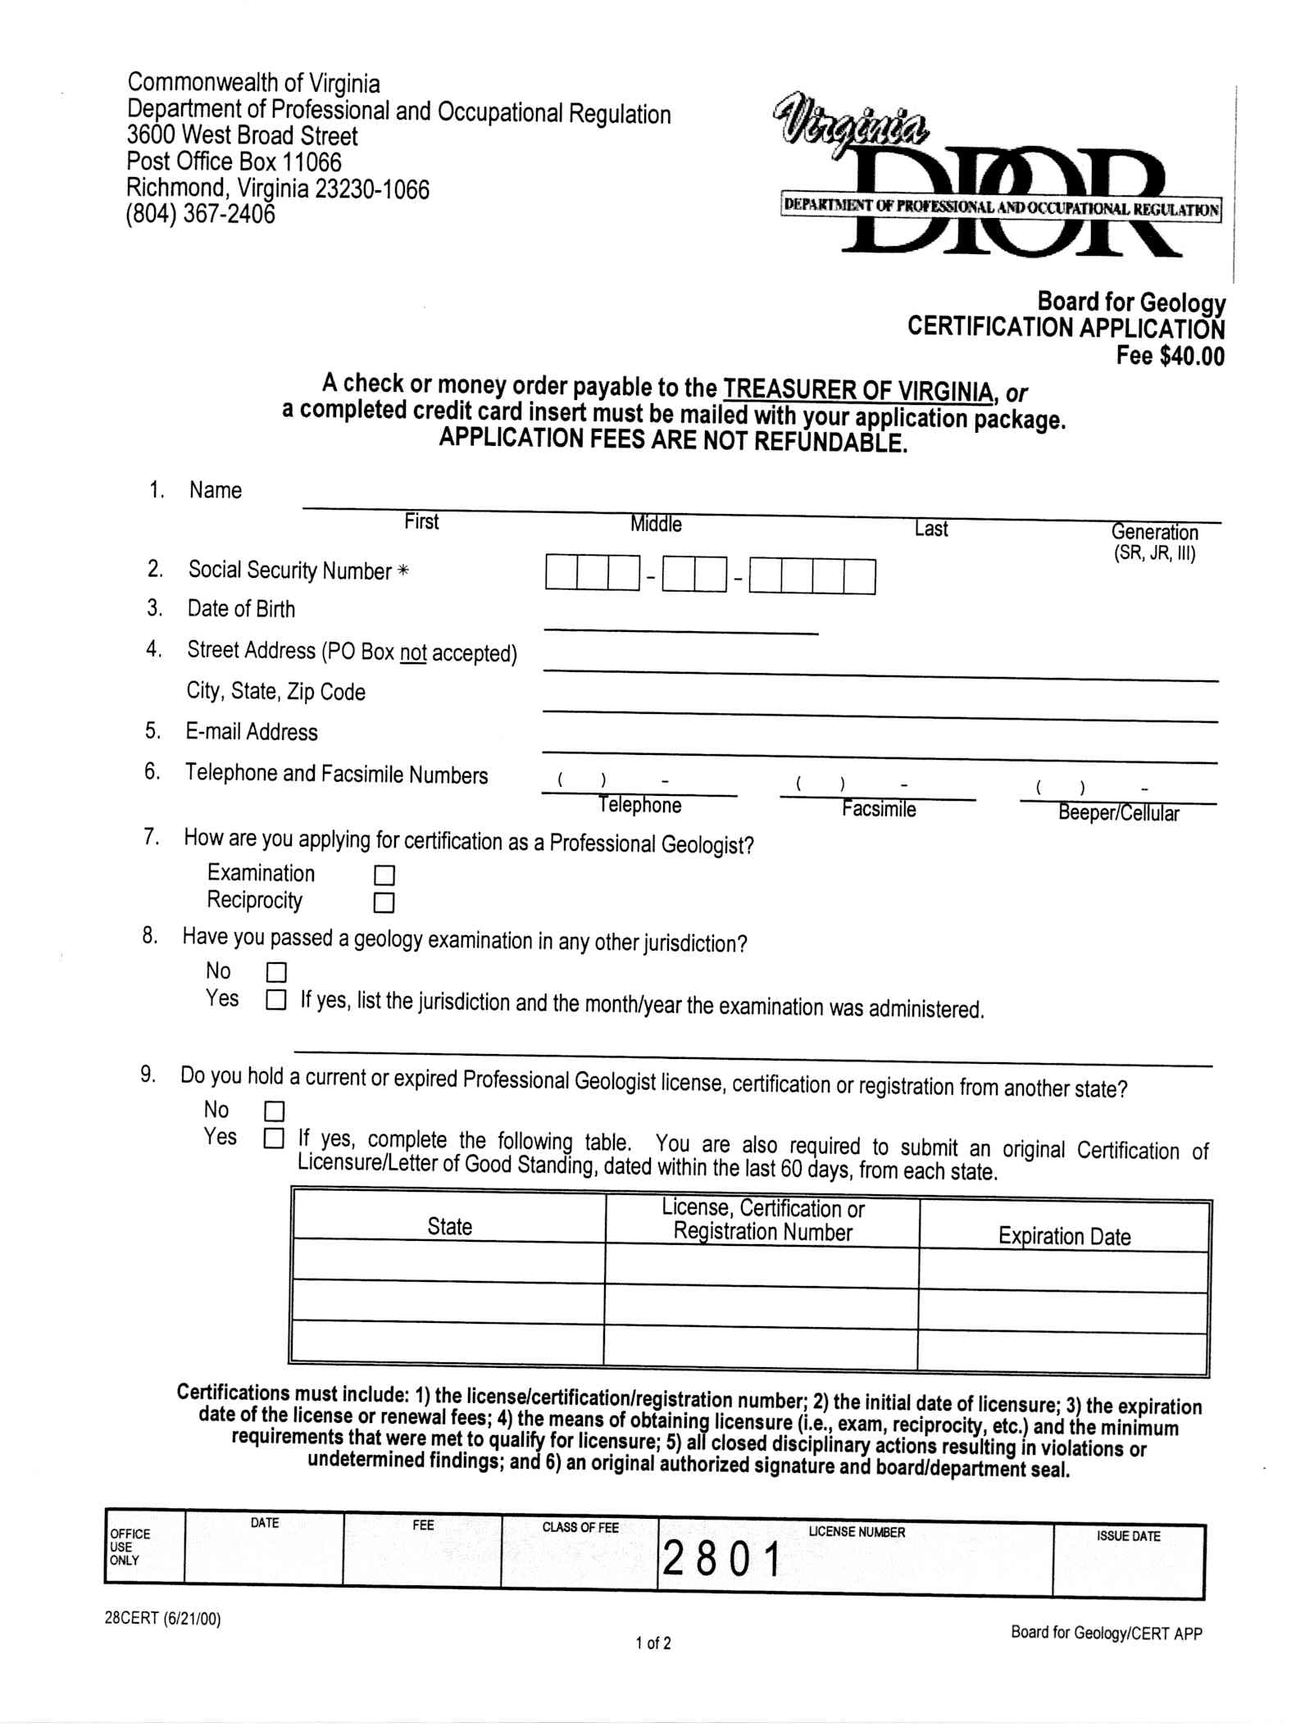
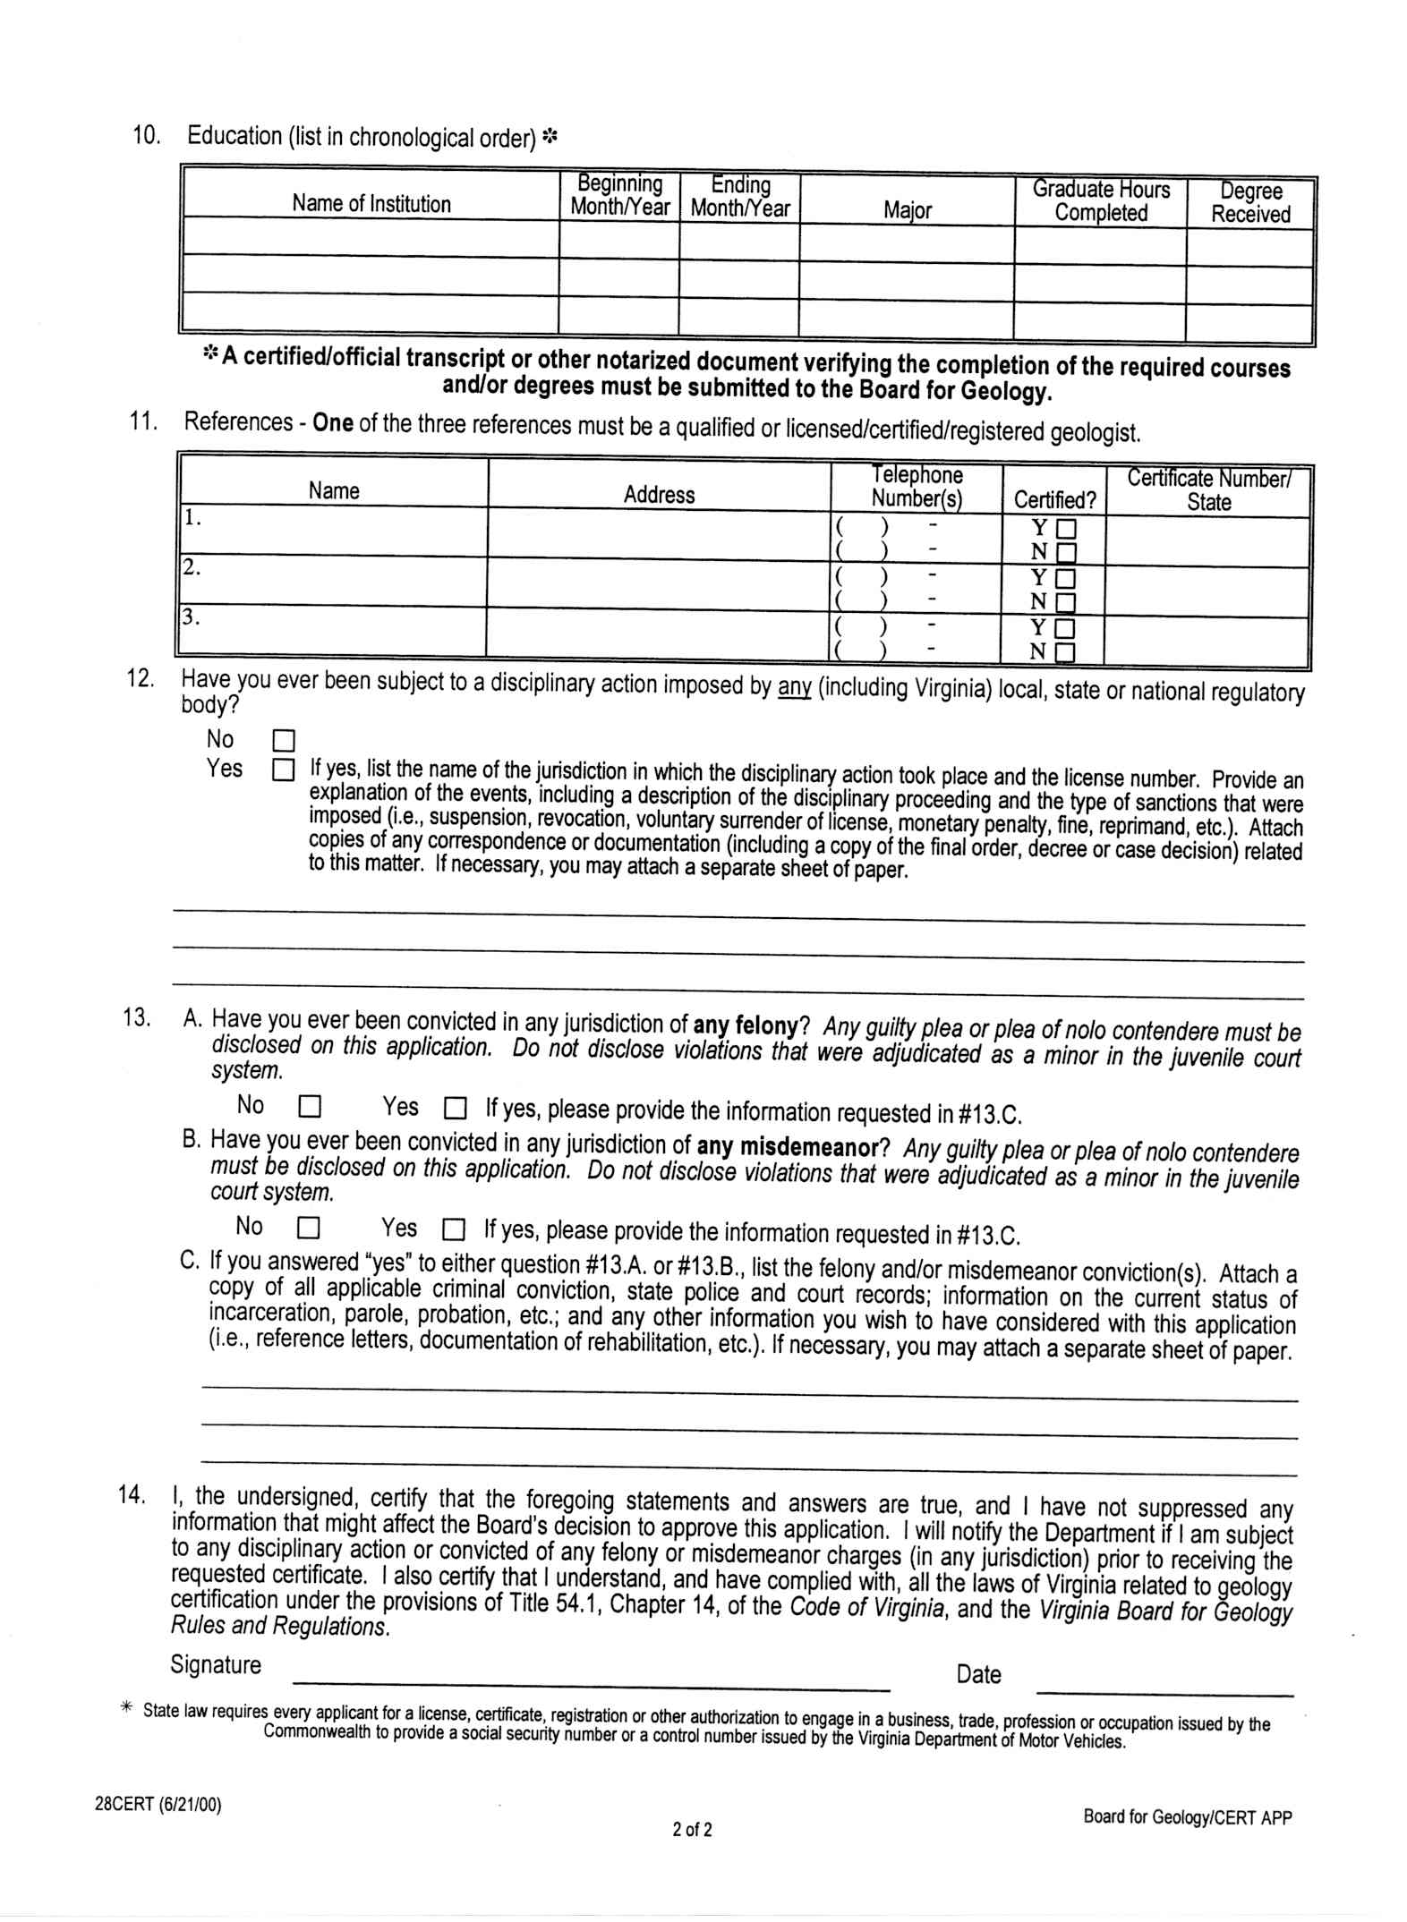
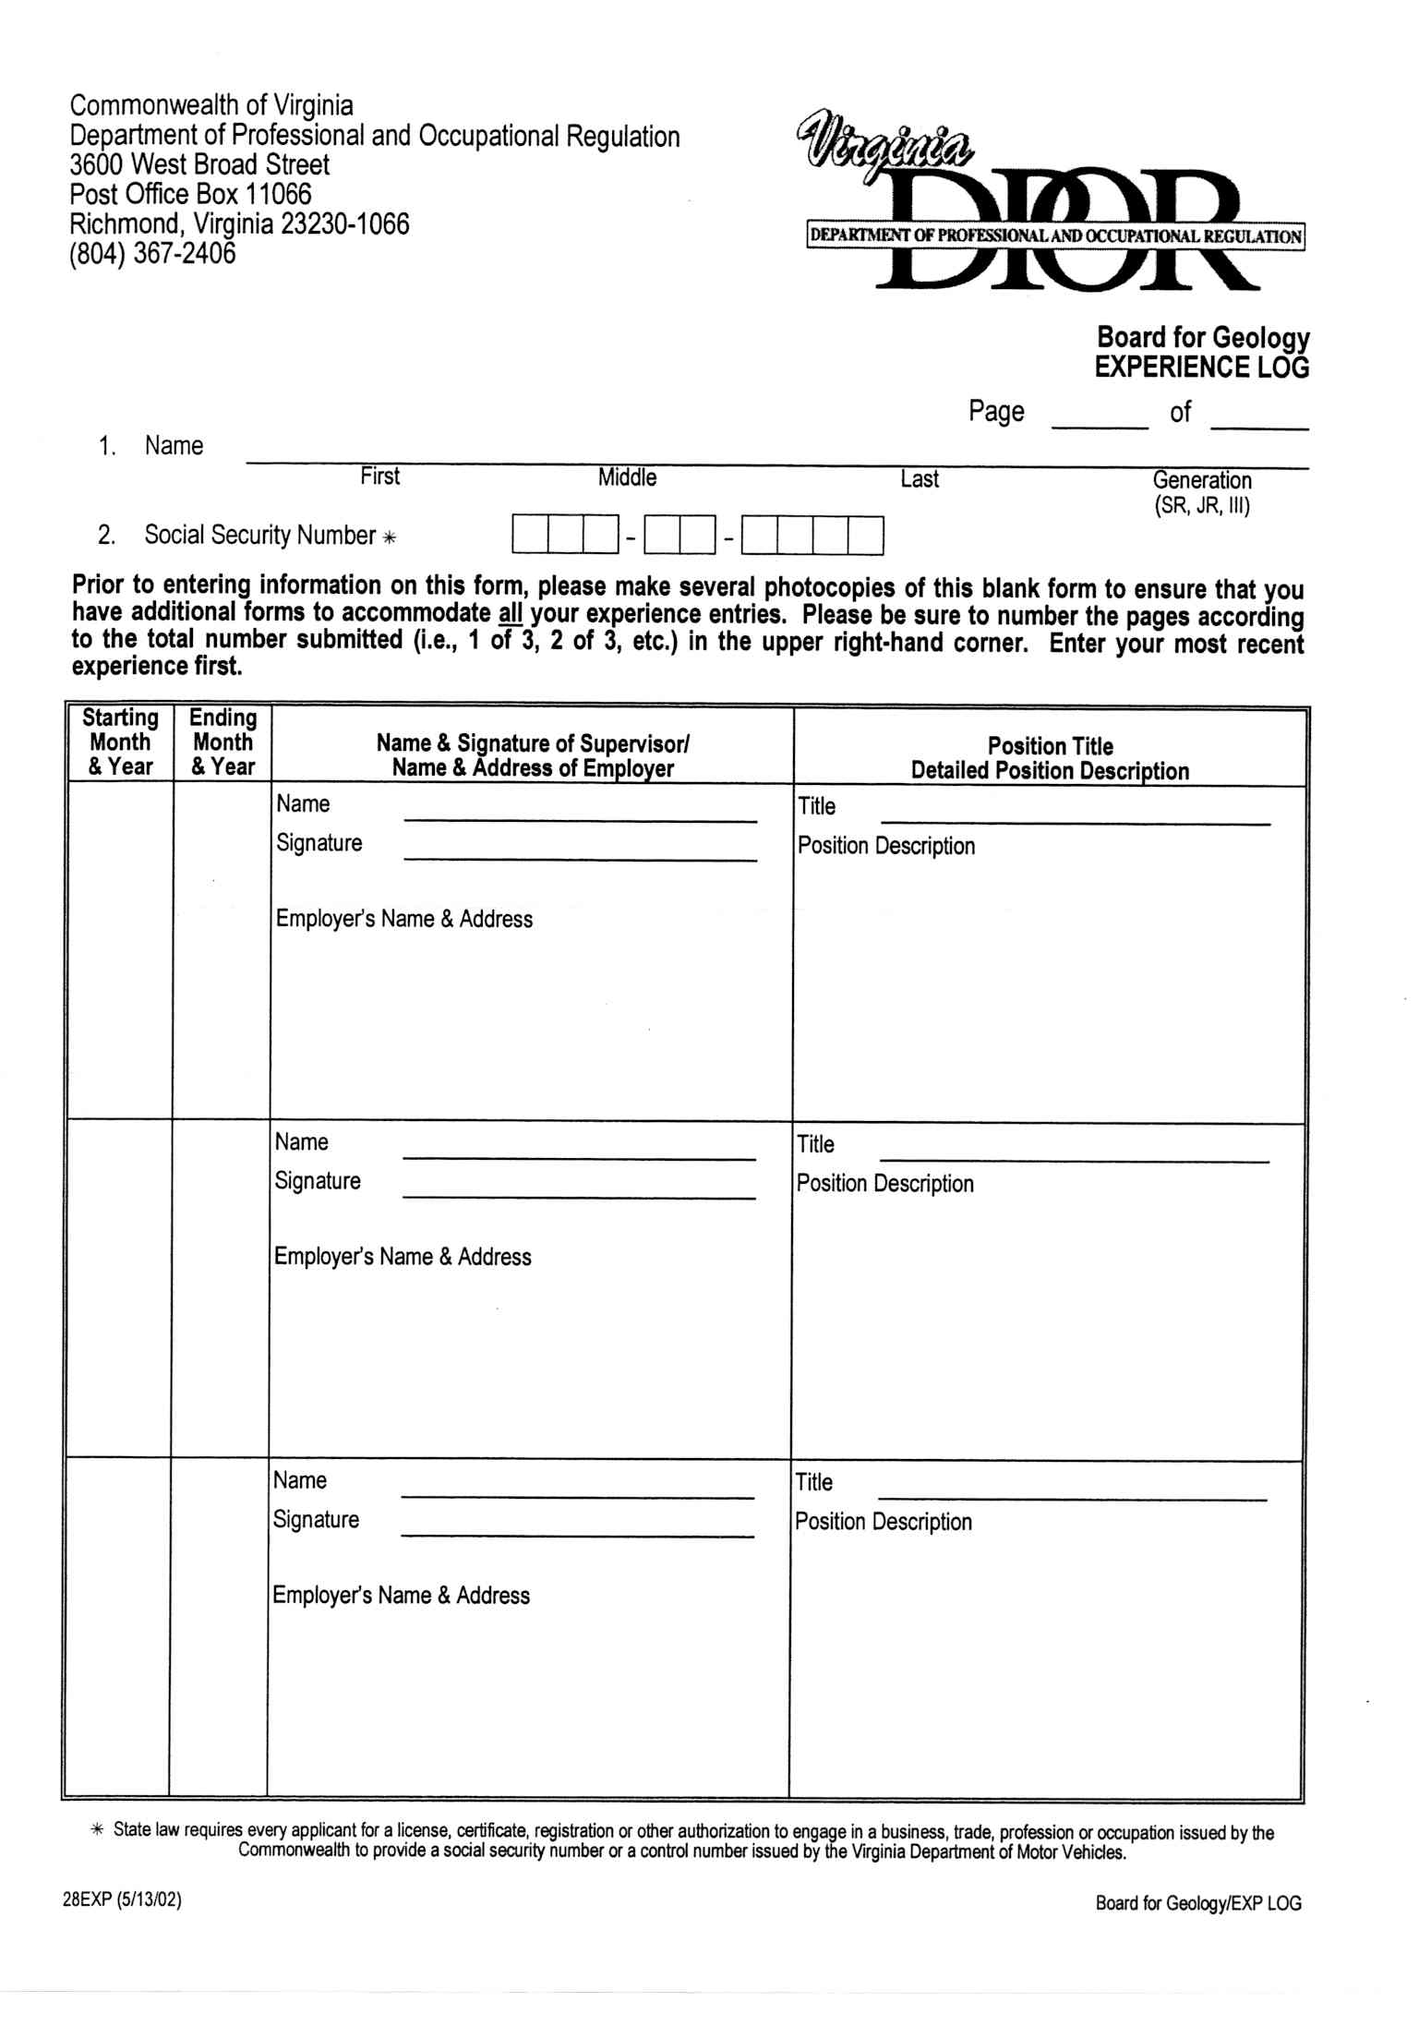
VA.R. Doc. No. R03-195; Filed July 19, 2004, 1:32 p.m.

1 There are additional eligibility requirements.
2 Work areas: 1) mineralogy, 2) petrography/petrology, 3) geochemistry, 4) hydrogeology, 5) engineering geology, 6) mining geology, and 7) petroleum geology.
3 Source: Department of Professional and Occupational Regulation

