TITLE 2. AGRICULTURE
PESTICIDE CONTROL BOARD
Title of Regulation: 2 VAC 20-40. Rules and Regulations Governing Licensing of Pesticide Businesses by the Department of Agriculture and Consumer Services Operating Under Authority of the Virginia Pesticide Control Act (amending 2 VAC 20-40-10, 2 VAC 20-40-20, 2 VAC 20-40-40, 2 VAC 20-40-60 through 2 VAC 20-40-110; repeal 2 VAC 20-40-120).
Statutory Authority: § 3.1-249.30 of the Code of Virginia.
Public Hearing Date: October 14, 2004 - 9 a.m.
Public comments may be submitted until November 1, 2004.
(See Calendar of Events section
for additional information)
Agency Contact: W. Wayne Surles, Program Manager, P.O. Box 1163, Richmond, VA 23218, telephone (804) 371-6558, FAX (804) 371-8598, toll-free 1-800-552-9963, or e-mail wsurles@vdacs.state.va.us.
Basis: Section 3.1-249.30 of the Code of Virginia authorizes the Pesticide Control Board to promulgate regulations in regards to pesticide businesses as follows: "…the Board may promulgate regulations… including but not limited to the following: 1. Licensing of businesses that manufacture, sell, store, recommend for use, mix or apply pesticides. … 3. Requiring reporting and recordkeeping related to licensing and registration. … 5. Revoking, suspending or denying licenses (business), registration (products), and certification or certificate (applicators or technicians)."
Purpose: The purpose of the proposed action is to review the regulation for effectiveness and continued need. The regulation establishes standards and procedures in regards to pesticide businesses as defined in § 3.1-249.27 of the Virginia Pesticide Control Act.
The need for the regulation is to (i) protect the public's health, safety and welfare with the least possible cost and intrusiveness to the citizens and businesses of the Commonwealth; (ii) establish standards for the licensure of pesticide businesses (and for the denial, suspension, or revocation of the license); and (iii) establish recordkeeping requirements for licensed pesticide businesses, as a means of ensuring that pesticides are stored and used safely.
The regulation is necessary to protect the health, safety and welfare of citizens because it ensures that all businesses applying pesticides for compensation employ an individual who is knowledgeable of (i) pesticide laws and regulations, (ii) potential hazards of pesticides to man and the environment and (iii) the safe distribution, use and disposal of pesticides. In addition, the regulation requires that pesticide businesses (i) maintain a minimum amount of liability insurance and (ii) keep and maintain records of the sale of restricted use pesticides and the application of all (restricted and nonrestricted use) pesticides to protect the citizens of the Commonwealth from any pesticide misapplications or accidents.
Substance: Substantive changes to existing sections include:
1. Deleting the definition of bond to be compatible with 1993 amendments to the Pesticide Control Act in § 3.1-249.49 of the Code of Virginia.
2. Modifying the definition of pest management consultant to include anyone making any pesticide recommendations commercially in Virginia.
3. Defining a pesticide business location to clarify what is a separate outlet or location of a pesticide business.
4. Changing the renewal date for pesticide business licenses to be compatible with the 1993 amendments to the Pesticide Control Act in § 3.1-249.47 that deleted references to the renewal of pesticide business licenses 60 days prior to their expiration.
5. Deleting the recordkeeping requirement by commercial applicators for the application of restricted use pesticides.
6. Deleting surety bond and self-insurance as evidence of financial responsibility to be compatible with 1993 amendments to the Pesticide Control Act in § 3.1-249.49.
New substantive provisions require that pesticide businesses keep records of all pesticide applications.
Issues: The primary advantage of the proposed amendments to the public is that their health and safety will be better protected by the pesticide application recordkeeping requirements for pesticide businesses. Requiring pesticide businesses to keep records of all pesticide applications will ensure that the pesticides are properly applied, as the records will be available for inspection by state enforcement personnel. The recordkeeping requirement will be a disadvantage to the minority of pesticide businesses that currently do not keep records of general use pesticide applications. It is estimated that only 20% of licensed pesticide businesses do not keep these records. The main advantage to the agency is that pesticide application records for all pesticide applications, not solely restricted pesticide applications, will be available for inspection whenever an inspection is conducted or an investigation is conducted in response to a complaint. Another matter pertinent to the regulated community is that there will be less confusion regarding what constitutes a pesticide business location and the licensure requirements for a location.
There are no disadvantages to the public or the Commonwealth of Virginia.
Department of Planning and Budget's Economic Impact Analysis: The Department of Planning and Budget (DPB) has analyzed the economic impact of this proposed regulation in accordance with § 2.2-4007 H of the Administrative Process Act and Executive Order Number 21 (02). Section 2.2-4007 H requires that such economic impact analyses include, but need not be limited to, the projected number of businesses or other entities to whom the regulation would apply, the identity of any localities and types of businesses or other entities particularly affected, the projected number of persons and employment positions to be affected, the projected costs to affected businesses or entities to implement or comply with the regulation, and the impact on the use and value of private property. The analysis presented below represents DPB’s best estimate of these economic impacts.
Summary of the proposed regulation. Section 3.1-249.30 of the Code of Virginia provides the Virginia Pesticide Control Board with the authority to promulgate regulations, including but not limited to, the licensing of businesses that manufacture, store, recommend for use, mix, or apply pesticides, reporting and recordkeeping requirements related to licensing and registration, and revoking, suspending, or denying licenses to businesses, registration for products, and certification to commercial applicators or technicians.
The proposed regulation requires licensed pesticide businesses to keep records of restricted and general use pesticide applications. The proposed regulation also makes changes to the existing regulation in order to make it compatible with the 1993 amendments to the Pesticide Control Act. These changes include removing the provision allowing licensed pesticide businesses to use surety bonds and self-insurance when demonstrating financial responsibility and not requiring that licensed pesticide businesses renew their license two months prior to expiration in order to avoid being assessed late fees.
The proposed regulation also updates references, adds clarifying language, removes redundant language, and includes changes that that make the regulation consistent with the Code of Virginia and with current practice.
Estimated economic impact. The proposed regulation requires licensed pesticide businesses to maintain records relating to pesticide applications of restricted use and general use pesticides. Under the existing regulation, businesses were only required to keep records of restricted use pesticide applications. The proposed change extends the recordkeeping requirement to general use pesticide applications.
According to the Virginia Department of Agriculture and Consumer Services (VDACS), there are approximately 2,179 licensed pesticide businesses. Of these, about 1,925 apply pesticides. VDACS estimates that approximately 16% (or 308) of these businesses do not currently maintain records relating to general use pesticide applications. Assuming that the hourly wage is $10 and that each record takes one minute to create (assumptions made by VDACS), the cost of generating one record is $0.17. Moreover, assuming an average of 10 pesticide applications a day and 254 workdays a year, the proposed change will cost approximately $132,994 a year or $431 per year for each licensed pesticide business not currently complying with these requirements.
The proposed change is also likely to produce some economic benefits. By requiring licensed pesticide businesses to maintain records on general use pesticide applications, the proposed change will make it easier for the agency to investigate complaints relating to such applications. According to VDACS, there have been complaints regarding general use pesticide applications that the agency has been unable to investigate thoroughly. The additional recordkeeping requirement is intended to address the problem. By better ensuring that general use pesticides are applied in a manner that is not dangerous to public health or the environment, the proposed change is likely to produce economic benefits.
The net economic impact of the proposed change will depend on whether the additional cost to businesses not currently complying with the proposed recordkeeping requirement is greater than or less than the benefits of being able to ensure that general use pesticides are being applied in a manner that does not endanger public health or the environment. It will cost businesses approximately $431 per year in order to comply with the requirement. A precise estimate of the benefits to public health and the environment from the proposed change is not available at this time.
The proposed regulation also makes changes to the existing regulation that make it compatible with the 1993 amendments to the Pesticide Control Act. These changes include removing the provision in the existing regulation allowing licensed pesticide businesses to use surety bonds and self-insurance to demonstrate financial responsibility and not requiring that licensed pesticide businesses renew their license two months prior to expiration in order to avoid being assessed late fees. These changes are not likely to produce a significant economic impact as they have been required under the Code of Virginia since 1993. The proposed changes simply make the regulation consistent with current practice.
The remaining changes include changes that update references, add clarifying language, remove redundant language, and that make the regulation consistent with the Code of Virginia and with current practice. These changes are intended to improve understanding and implementation of the regulation and to the extent that they do so, they are likely to produce some economic benefits.
Businesses and entities affected. The proposed regulation will affect all licensed pesticide businesses that apply general use pesticides. These businesses will now be required to maintain records relating to their application of general use pesticides. VDACS estimates that it will cost such businesses an additional $431 a year to meet the new recordkeeping requirements.
According to VDACS, there are approximately 2,179 licensed pesticide businesses, of which 1,925 apply pesticides. The proposed change is expected to impact approximately 16% (or 308) of licensed pesticide businesses that apply pesticides.
Localities particularly affected. The proposed regulation applies to all localities in the Commonwealth. However, it is not likely to impose any additional costs on localities.
Projected impact on employment. The proposed regulation is not likely to have a significant impact on employment.
Effects on the use and value of private property. The proposed regulation requires all licensed pesticide businesses that apply pesticides to maintain records relating to applications of general use pesticides. For businesses not currently complying with this requirement, the proposed change is likely to impose additional costs, raising operating costs and lowering the asset value of these businesses.
Agency's Response to the Department of Planning and Budget's Economic Impact Analysis: The agency concurs with the economic impact analysis submitted by the Department of Planning and Budget.
Summary:
The proposed amendments (i) define a pesticide business location; (ii) modify the date for a late fee assessment in regards to pesticide business license renewal; (iii) modify the proof of financial responsibility; and (iv) modify recordkeeping requirements for pesticide businesses.
2 VAC 20-40-10. Definition of terms.
The following words and terms, when used in thIs chapter, shall have the following meanings, unless the context clearly indicates otherwise. An asterisk following a definition denotes that the definition has been taken from Article 1 (§ 3.1-249.27 et seq.) of Chapter 14.1 of Title 3.1 of the Code of Virginia.
"Act" means the Virginia Pesticide Control Act.
"Board" means the Pesticide Control Board.*
"Bond" means a written instrument issued or executed by a bonding, surety, or insurance company licensed to do business in the Commonwealth, or otherwise approved by the board, guaranteeing the fulfillment of the agreement between the licensee and the customer.*
"Bulk pesticide" means any registered pesticide concentrate which is transported or held in an individual container in undivided quantities of greater than 55 U.S. gallons liquid measure or greater than 100 pounds net dry weight.
"Certification" or "certified" means the recognition granted by the Pesticide Control Board to an applicator upon satisfactory completion of board approved requirements.*
"Commercial applicator" means any applicator person who has completed the requirements for certification as determined by the board, including appropriate training and time in service, to apply for a certification, and who uses to use or supervises supervise the use of any pesticide for any purpose or on any property other than as provided in the definition of private applicator.*
"Commissioner" means the Commissioner of Agriculture and Consumer Services.*
"Department" means the Department of Agriculture and Consumer Services.*
"EPA" means the United States Environmental Protection Agency.
"FIFRA" means The Federal Insecticide, Fungicide, and Rodenticide Act as amended, and herein incorporated by reference.
"Licensed" or "licensee" means those businesses which, upon meeting the requirements established by the Pesticide Control Board, are issued a license to engage in the sale, storage, distribution, recommend the use, or application of pesticides in Virginia in exchange for compensation.*
"Limited quantities" means purchases, at cost, for resale, of less than $50,000 annually per outlet of products containing nonrestricted use pesticide active ingredients.
"Pest management consultant" means any person, who may or may not apply pesticides himself, who has obtained a business license in accordance with the requirements listed below, and who is authorized by this chapter to provide technical advice, supervision or aid, or recommendations for restricted use pesticide application commercially in Virginia.
"Pesticide" means (i) any substance or mixture of substances intended for preventing, destroying, repelling, or mitigating any insects, rodents, fungi, bacteria, weeds, or other forms of plant or animal life or viruses or bacteria, except viruses on or in living man or other animals, which the commissioner shall declare to be a pest, (ii) any substance or mixture of substances intended for use as a plant regulator, defoliant, or desiccant, and (iii) any substance which is intended to become an active ingredient thereof in any substance defined in clauses (i) and (ii) of this definition.*
"Pesticide business" means any person engaged in the business of distributing, applying, or recommending the use of a product,; or storing, selling, or offering for sale pesticides for distribution directly to the user. The term "pesticide business" does not include (i) wood treaters not for hire; (ii) seed treaters not for hire; (iii) operations that produce agricultural products unless the owners or operators of such operations described in clauses (i), (ii), and (iii) of this definition are engaged in the business of selling or offering for sale pesticides, or distributing pesticides to persons outside of that agricultural producing operation in connection with commercial transactions; or (iv) businesses exempted by regulations adopted by the board.*
“Pesticide business location” means any fixed location of a pesticide business with either a telephone that is used to transact business or give advice, or where products, supplies or business mail is delivered. Residences of service technicians who are employed by a licensed pesticide business are exempt, if no business solicitation is conducted from that location.
"Private applicator" means an applicator who uses or supervises the use of any pesticide which is classified for restricted use for purposes of producing any agricultural commodity on property owned or rented by him or his employer or, if applied without compensation other than trading of personal services between producers of agricultural commodities, on the property of another person.*
"Restricted use pesticide" or "pesticide classified for restricted use" means any pesticide classified as restricted by the Administrator of the United States Environmental Protection Agency.*
2 VAC 20-40-20. General requirements for all pesticide businesses; exemptions.
A. Any person or business operating in Virginia, which, in exchange for compensation, sells, stores, distributes, mixes, applies or recommends for use pesticides, shall obtain a valid pesticide business license pursuant to this chapter. Each separate outlet or location of a pesticide business location shall be licensed.
B. Exempted from the provisions of this chapter are the following:
1. Merchants of limited quantities of nonrestricted use pesticides who sell pesticides primarily intended for limited household use;
2. Federal, state and local governmental agencies;
3. Certified applicators not for hire; including, but not limited to, employees of golf courses, hotels, apartment complexes, and office complexes those who use or supervise the use of pesticides as part of their job duties only on property owned or leased by themselves or their employer; and
4. Providers of janitorial, cleaning or sanitizing services if the providers use no pesticides other than sanitizers, disinfectants and germicides.
C. Application for a pesticide business license is made by submitting to the department (i) a completed application form and (ii) a check or money order in the amount of the annual business license fee established by the board.
D. Each applicant for a pesticide business license, or an employee designated by the applicant, shall demonstrate to the commissioner his knowledge of (i) pesticide laws and regulations; (ii) potential hazards of pesticides to man and the environment; and (iii) safe distribution, use, and disposal of pesticides by passing a written examination prior to his being issued a business license. If the applicant is already certified as a commercial applicator, he shall be exempt from the initial examination requirement.
E. All licensed pesticide businesses shall maintain written records pertaining to their operations, as required in this chapter.
F. All licensed pesticide business locations or outlets which sell restricted use pesticides, or distribute restricted use pesticides for purposes of selling, shall have a certified commercial applicator present who shall bear immediate responsibility for the correct and safe operation of the location or outlet. Each business shall notify the department of the name of the commercial applicator assigned to each location or outlet, and shall also notify the department promptly within three business days of any change in the applicator assignments during the license period.
G. All licensed pesticide businesses which that store, repack and distribute bulk pesticides shall meet the requirements established by the board for the storage, repackaging and distribution of bulk pesticides.
H. All pesticide business licenses shall expire at midnight on March 3l of each year. Licensees shall renew their licenses annually by application to the department and payment of the annual fee on or before close of business January March 31. The department shall charge a 20% penalty in addition to the regular fee for renewal applications filed after January March 31.
2 VAC 20-40-40. Business licensing requirements for pest management consultants.
A. Any person or business which recommends any pesticide for use commercially in Virginia shall obtain a valid pesticide business license issued pursuant to 2 VAC 20-40-20 A of this chapter. This provision shall exclude sales personnel of a licensed pesticide business, company training, technical and sales representatives certified in the demonstration pesticide applicator category, and governmental employees while performing in an official capacity.
B. The specialty categories for a pest management consultant shall conform to the commercial applicator categories established pursuant to the Act. The pest management consultant shall meet the requirements of the specific category or subcategory in which he is making recommendations for pesticide use prior to being issued a business license.
2 VAC 20-40-60. Recordkeeping of restricted use pesticide sales by licensed pesticide businesses.
Pesticide businesses which that sell restricted use pesticides shall maintain a record of each restricted use pesticide sold. Each sales record shall contain the following:
1. Name, address, certified applicator number or business license number, and certificate or license expiration date of the person to whom the restricted use pesticide was sold or delivered;
2. Date of sale;
3. Brand or common product name;
4. EPA registration number; and
5. Quantity of pesticide sold or delivered.
B. The restricted use pesticide sales record keeping requirement may be satisfied by invoices, if (i) such invoices are kept separate from the licensee's other sales records, and (ii) the invoices contain the above information.
2 VAC 20-40-70. Recordkeeping of pesticide applications by commercial applicators pesticide businesses.
Commercial applicators Pesticide businesses shall maintain a record of each restricted use pesticide applied. This shall apply to both general use and restricted use pesticides. Each record shall contain the:
1. Name, address, and telephone number of customer and address or location, if different, of site of application;
2. Name and certification number (or certification number of the supervising certified applicator) of the person making the application;
3. Day, month and year of application;
4. Type of plants, crop, animals, or sites treated and principal pests to be controlled;
5. Acreage, area, or number of plants or animals treated;
6. Brand name or common product name;
7. EPA registration number;
8. Amount of pesticide concentrate and amount of diluent used, by weight or volume, in mixture applied; and
9. Type of application equipment used.
2 VAC 20-40-80. Evidence of financial responsibility required of a licensed pesticide business.
A. Prior to being issued a pesticide business license, a business shall furnish evidence of financial responsibility, consisting either of: (i) a surety bond to the benefit of the board from a person authorized to do business in Virginia; (ii) a liability insurance policy from a person authorized to do business in Virginia, or a certification thereof, protecting persons who may suffer legal damages as a result of the use of any pesticide by the applicant; or (iii) a plan of self-insurance which meets the requirements set forth below and is approved by the board.
B. If the evidence of financial responsibility consists of a surety bond, the bond shall be in an amount specified in subsection E of this section, and shall cover liability arising out of handling, storage, application, use or misuse, or disposal of any pesticide; it shall also cover liability relating to completed operations.
C. If the evidence of financial responsibility consists of a B. The liability insurance policy, the shall meet the following conditions shall be met:
1. The certificate of insurance shall include the name of the insurance company, policy number, insurance amount, type of coverage afforded, any exclusions relating to damage arising from the use of pesticides, and expiration date of the policy. The policy shall cover liability arising out of the handling, storage, application, use or misuse, or disposal of any pesticide; it shall also cover liability relating to completed operations.
2. The policy shall be in an amount specified in subsection E C of this section.
3. The licensee shall forward a current certificate of insurance to the board at each insurance renewal date.
D. If the evidence of financial responsibility consists of a plan of self-insurance, the following conditions shall be met:
1. The self-insurer shall submit a written proposal of self-insurance to the board for approval. The proposal shall include a master self-insurance and security agreement and a balance sheet and income statement which reflects the actual financial condition of the business as of the last complete calendar or fiscal year preceding the date of the proposal. These documents shall be certified by a certified public accountant.
2. The self-insurer shall post collateral with the board in the amount of at least $400,000. The collateral shall consist of the following: (i) negotiable instruments of the United States Government; (ii) escrow deposits established for the sole purpose of providing security for self-insurance purposes; (iii) irrevocable letters of credit; or (iv) other security approved upon petition to the board.
3. If the self-insurer is unable to fulfill his obligations under the Act, he may petition the board to release the collateral posted. If such a withdrawal is necessary, the self-insurer shall replace the security within 72 hours from the time of withdrawal in order to retain his certificate as a self-insurer.
4. A certificate of self-insurance, to be issued by the board, shall be renewed annually following appropriate review by the board. If his financial responsibility furnished no longer complies with this section, the self-insurer shall immediately provide other evidence of financial responsibility.
E. C. The amount of financial responsibility as provided for in this section shall be a minimum of (i) $200,000 for property damage, subject to a $1,000 deductible provision in the case of licensees holding liability insurance policies, and $200,000 for personal injury; or (ii) a combined single limit of $400,000 with a $1,000 deductible. The board may require additional evidence of financial responsibility based upon annual gross revenue of the applicant, if self-employed, or his employer's business, if not, and an assessment of the risks of the applicant or his employer's business to persons, property, and the environment. The licensee shall maintain at least the minimum coverage at all times during the license period, and shall notify the board at least 10 days prior to any reduction at the request of the licensee or cancellation of such financial responsibility by the surety or insurer. If the deductible of an applicant for a business license is greater than $1,000, evidence of financial responsibility shall be furnished to the board to satisfy the difference between the applicant's deductible and the $1,000 deductible. This evidence may consist of a financial statement or a personal bond.
2 VAC 20-40-90. Revocation of a business license.
In addition to the violative acts listed under § 3.1-249.63 B of the Act, the following are grounds for revocation by the board of a business license:
1. Failure to (i) submit records to the commissioner upon written request; or (ii) to permit any person designated by the commissioner to have access to, and to copy such records of business transactions as may be essential to carrying out the purposes of the Act.
2. Operation of a pesticide business location or outlet without a certified commercial applicator assigned to the location or outlet as required by this chapter.
3. Failure of a self-insurer to provide, within 72 hours, other evidence of financial responsibility if the financial responsibility previously furnished no longer complies with the requirements of the Act or regulations promulgated thereunder.
4. 3. Interference with the commissioner or his duly authorized agents in carrying out the duties imposed by the Act.
5. 4. Conduct by a licensee, as determined during the course of a hearing, which has or might have resulted at any time in substantial danger to, or in unreasonable adverse effects on, the public health, safety, or the environment.
6. 5. Failure of a licensee to notify the department of any change in financial responsibility as specified in 2 VAC 20-40-80 E of this chapter C.
7. 6. Multiple violations of the Act or regulations pursuant thereto within a three-year period.
2 VAC 20-40-100. Summary suspension by commissioner.
A. The commissioner may suspend the pesticide business license of any person, without a hearing, simultaneously with the institution of proceedings for a hearing, if he finds there is a substantial danger to the public health, safety, or the environment which that warrants this action. Situations which that may warrant suspension include, but are not limited to, the following:
1. Operating a pesticide business or pesticide business outlet without a certified commercial applicator on site as required by this chapter, when absence of the applicator presents a substantial danger to the public health, safety, or the environment, as determined by the commissioner.
2. Refusal by a pesticide business, after receipt of a written request, to permit the commissioner or his agent access to and to copy records of business transactions, when such refusal presents a substantial danger to the public health, safety, or the environment, as determined by the commissioner.
B. The commissioner shall institute proceedings for a hearing pursuant to § 9-6.14:12 § 2.2-4020 of the Code of Virginia simultaneously with any summary suspension. Subject to any provision of procedure or chapter of the board for the processing of violations not inconsistent with this chapter:
1. The hearing shall be held within 60 days after the suspension; and
2. The hearing officer conducting the hearing shall have the authority to consider and address all matters relating to the summary suspension, including but not limited to the withdrawing, sustaining, or modifying thereof.
The commissioner or a conference officer appointed by the commissioner shall offer the person whose license has been summarily suspended (hereinafter "the respondent") an opportunity to appear in an informal conference, authorized by § 9-6.14:11 § 2.2-4019 of the Code of Virginia, to be held within three days after the summary suspension. The informal conference may consider, subject to any provision of the board for the processing of violations, all matters relating to the summary suspension, including but not limited to the withdrawal, sustaining, or modifying thereof. Nothing in this section authorizing consideration of matters by an informal conference shall be construed to deny a respondent's right to a hearing.
C. No person may operate a pesticide business at any time when his license is suspended.
2 VAC 20-40-110. Denial of license by the commissioner.
A. The commissioner shall deny a business license to any applicant who does not submit all the information required on the license application form, or who does not fully comply with all requirements for licensing set forth in this chapter.
B. The commissioner may, after notice to a pesticide business applicant and after opportunity for hearing, deny a pesticide business license to an applicant who has violated the pesticide law or regulations of any state or competent authority so as to evidence a disregard for proper and safe pesticide use; or if his license has been denied, suspended, nullified, withdrawn, revoked, or otherwise terminated by any state or other competent authority.
C. Any applicant for a pesticide business license shall not engage in the activity for which he is requesting a license until it shall have been issued by the commissioner shall have issued it.
2 VAC 20-40-120. Regulations superseded or repealed. (Repealed.)
The provisions of this chapter supersede 2 VAC 20-20-230, "Records," and 2 VAC 20-20-260, "Evidence of Financial Responsibility," of Chapter 20, Rules and Regulations for Enforcement of the Virginia Pesticide Law, which are hereby repealed.
NOTICE: The forms used in administering 2 VAC 20-40, Rules and Regulations Governing Licensing of Pesticide Businesses by the Department of Agriculture and Consumer Services Operating Under Authority of the Virginia Pesticide Control Act, are listed below. Any amended or added forms are reflected in the listing and are published following the listing.
FORMS
Application for Virginia Pesticide Business License, Form VDACS-07209, eff. 10/91 rev. 2/02.
Certificate of Insurance, Form VDACS-07214, eff. 7/1/93 rev. 4/96.
Request to take the Virginia Pesticide Business License Examination, eff. 11/98.

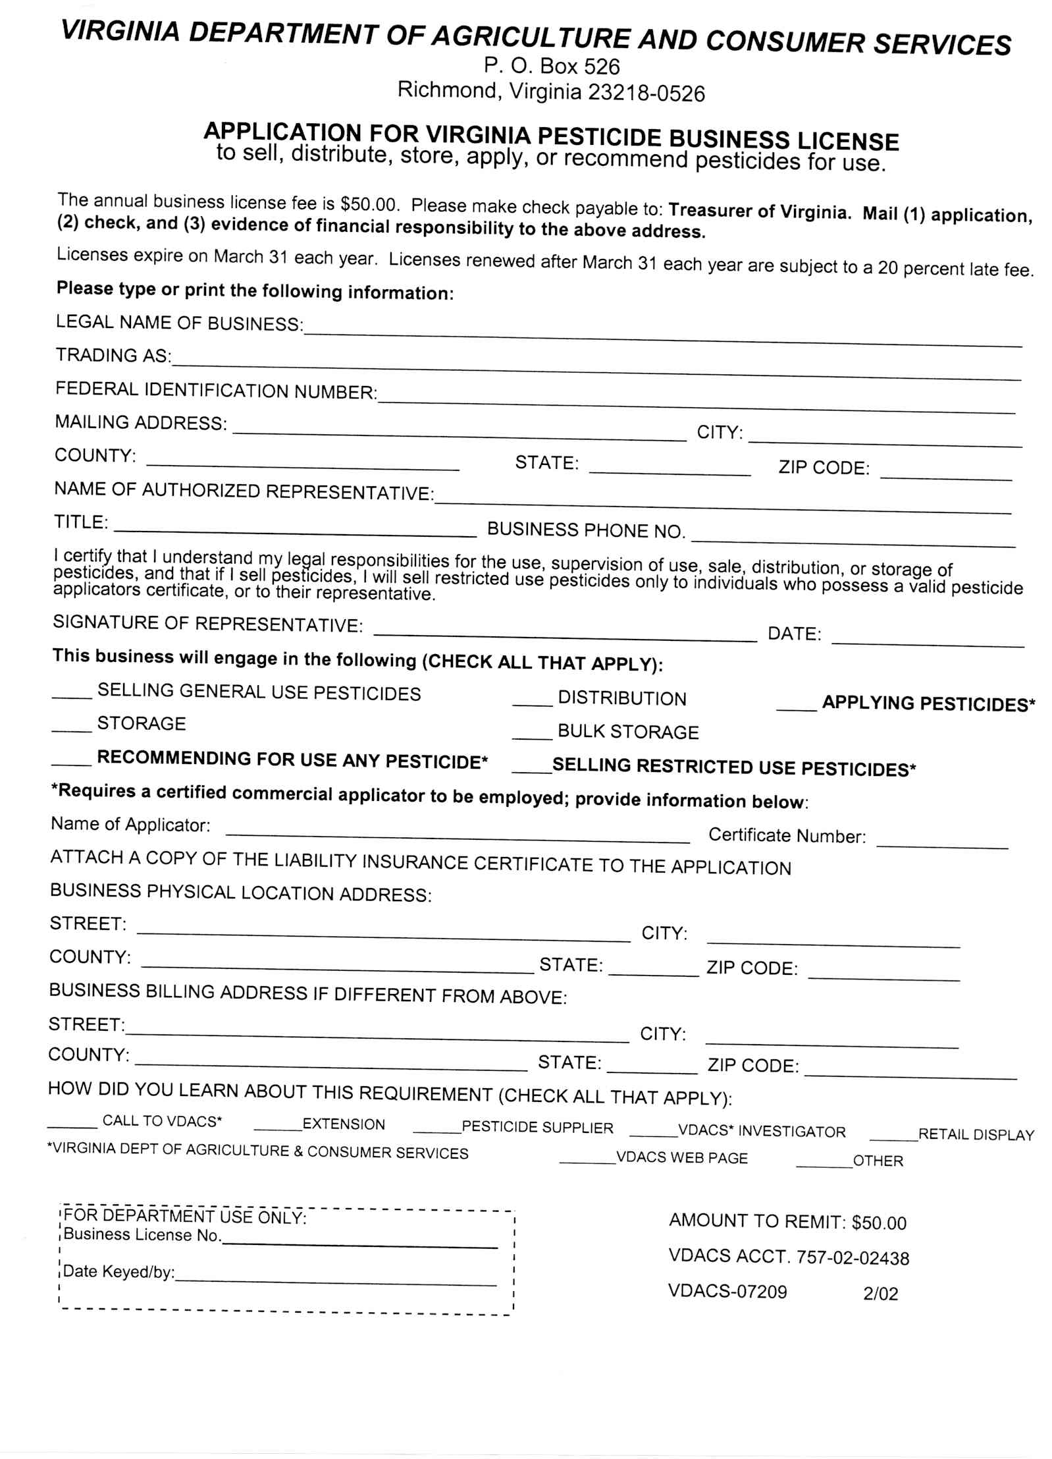
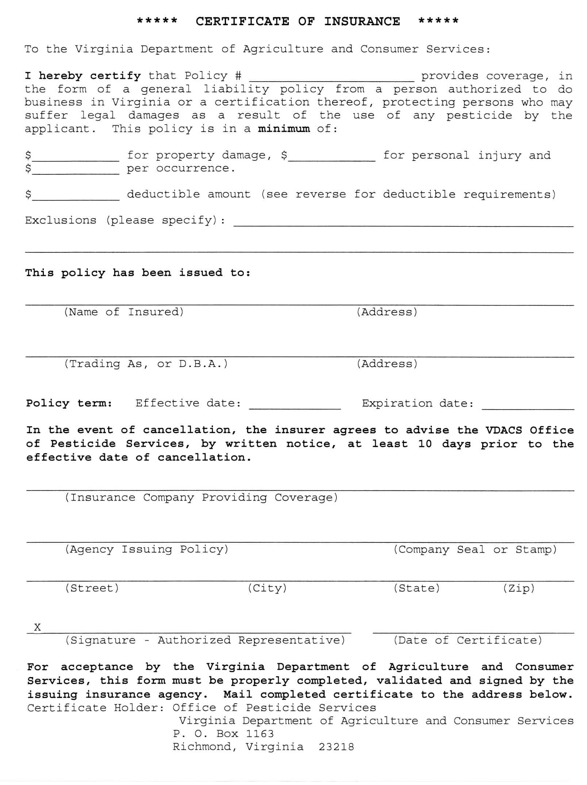
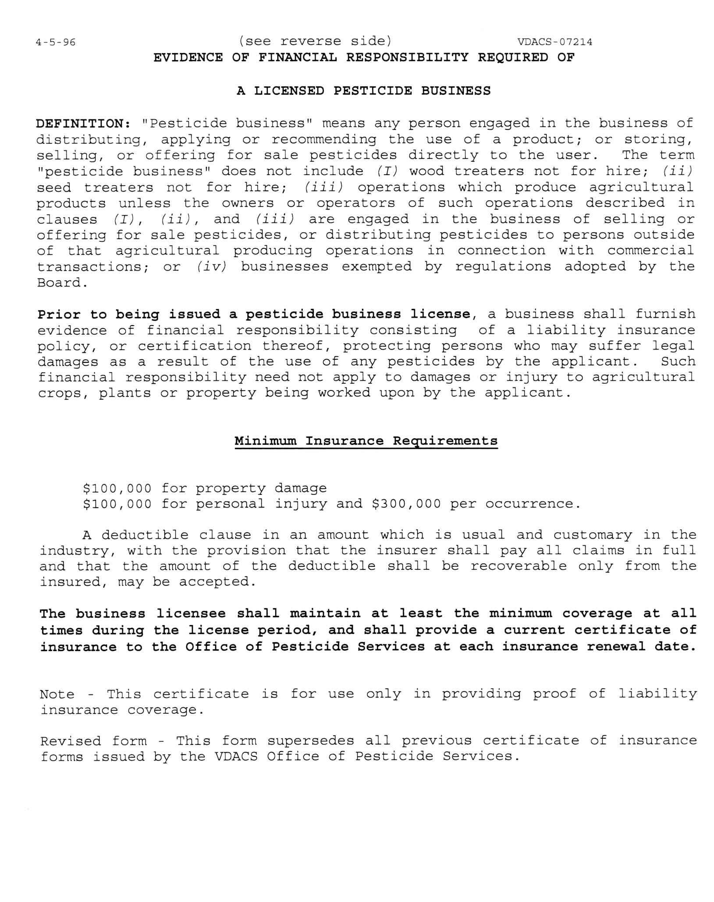

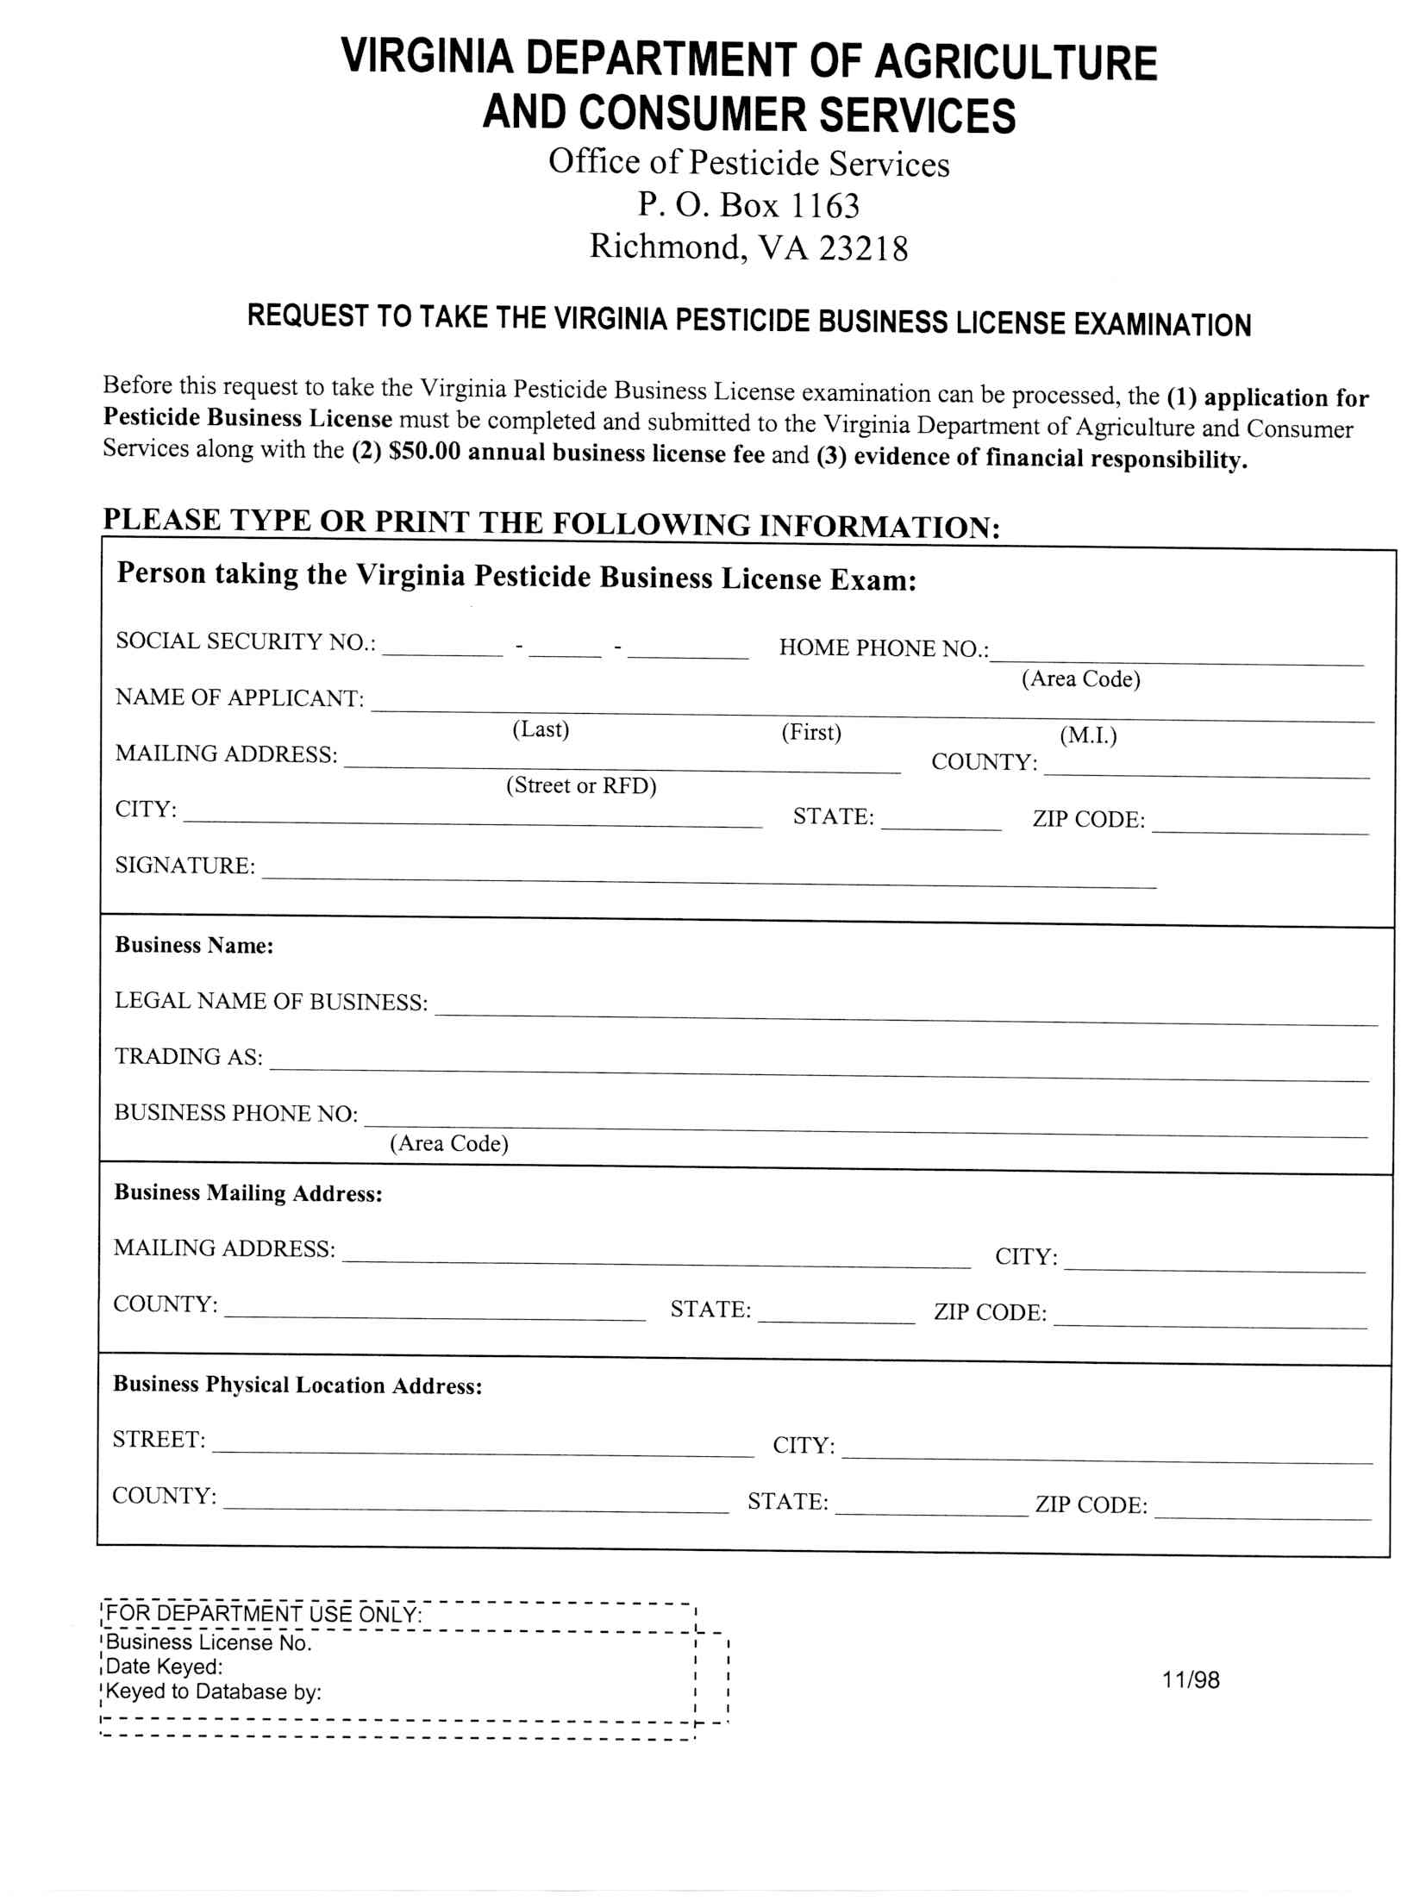
VA.R. Doc. No. R02-299; Filed July 16, 2004, 11:00 a.m.

