TITLE 18. PROFESSIONAL AND OCCUPATIONAL LICENSING
BOARD OF OPTOMETRY
REGISTRAR'S NOTICE: The Board of Optometry is claiming an exemption from the Administrative Process Act in accordance with § 2.2-4002 A 14 of the Code of Virginia, which exempts the Board of Optometry from the Administrative Process Act when specifying therapeutic pharmaceutical agents, treatment guidelines, and diseases and abnormal conditions of the human eye and its adnexa for TPA-certification of optometrists pursuant to Article 5 (§ 54.1-3222 et seq.) of Chapter 32 of Title 54.1.
Title of Regulation: 18 VAC 105-20. Regulations Governing the Practice of Optometry (adding 18 VAC 105-20-46 and 18 VAC 105-20-47).
Statutory Authority: § 54.1-3223 of the Code of Virginia.
Effective Date: December 8, 2004.
Agency Contact: Elizabeth Carter, Ph.d., Executive Director, Board of Optometry, 6603 West Broad Street, 5th Floor, Richmond, VA 23230, telephone (804) 662-9910, FAX (804) 662-7098, or e-mail elizabeth.carter@dhp.virginia.gov.
Summary:
The amendments set forth the treatment guidelines for the use of therapeutic pharmaceutical agents (TPA) by TPA-certified optometrists and specify the categories of drugs that may be procured, administered and prescribed to treat diseases and abnormal conditions of the human eye and its adnexa.
No changes have been made since publication of the reproposed regulation in 21:4 VA.R. 391-392 November 1, 2004.
Summary of Public Comments and Agency's Response: A summary of comments made by the public and the agency's response may be obtained from the promulgating agency or viewed at the office of the Registrar of Regulations.
18 VAC 105-20-46. Treatment guidelines for TPA certification TPA-certified optometrists.
A. TPA-certified optometrists may treat diseases and abnormal conditions of the following structures of the human eye and its adnexa that may be appropriately treated with medically appropriate pharmaceutical agents as referenced in 18 VAC 105-20-47:. The adnexa is defined as conjoined, subordinate or immediately associated anatomic parts of the human eye, including eyelids and eyebrows.
1. Lids and adnexa;
2. Lacrimal system;
3. Cornea;
4. Conjunctiva; and
5. Episclera.
B. In addition, the following may be treated:
1. Glaucoma (excluding the treatment of congenital and infantile glaucoma). Treatment of angle closure shall follow the definition and protocol prescribed in subsection C of this section.
2. Ocular-related post-operative care in cooperation with patient's surgeon.
3. Ocular trauma to the above tissues as in subsection A of this section.
4. Uveitis.
5. Anaphylactic shock (limited to the administration of intramuscular epinephrine).
C. The definition and protocol for treatment of angle closure glaucoma shall be as follows:
1. As used in this chapter, angle closure glaucoma shall mean a closed angle in the involved eye with significantly increased intraocular pressure, and corneal microcystic edema;
2. Treatment shall be limited to the initiation of immediate emergency care with appropriate pharmaceutical agents as prescribed by this chapter;
2. 3. Once the diagnosis of acute angle closure glaucoma has been established by the optometrist, the ophthalmologist to whom the patient is to be referred should be contacted immediately;
3. 4. If there are no medical contraindications, an oral osmotic agent may be administered as well as an oral carbonic anhydrase inhibitor and any other medically accepted, Schedule III, IV or VI, oral antiglaucomic agent as may become available; and
4. 5. Proper topical medications as appropriate may also be administered by the optometrist.
D. An oral Schedule VI immunosuppressive agent shall only be used when (i) the condition fails to appropriately respond to any other treatment regimen; (ii) such agent is prescribed in consultation with a physician; and (iii) treatment with such agent includes monitoring of systemic effects.
18 VAC 105-20-47. Therapeutic pharmaceutical agents.
A. A TPA-certified optometrist, acting within the scope of his practice, may procure, administer and prescribe medically appropriate therapeutic pharmaceutical agents (or any therapeutically appropriate combination thereof) to treat diseases and abnormal conditions of the human eye and its adnexa within the following categories:
1. Oral analgesics - Schedule III, IV and VI narcotic and nonnarcotic agents.
2. Topically administered Schedule VI agents:
a. Alpha-adrenergic blocking agents;
b. Anesthetic (including esters and amides);
c. Anti-allergy (including antihistamines and mast cell stabilizers);
d. Anti-fungal;
e. Anti-glaucoma (including carbonic anhydrase inhibitors and hyperosmotics);
f. Anti-infective (including antibiotics and antivirals);
g. Anti-inflammatory;
h. Cycloplegics and mydiratics;
i. Decongestants; and
j. Immunosuppressive agents.
3. Orally administered Schedule VI agents:
a. Aminocaproic acids (including antifibrinolytic agents);
b. Anti-allergy (including antihistamines and leukotriene inhibitors);
c. Anti-fungal;
d. Anti-glaucoma (including carbonic anhydrase inhibitors and hyperosmotics);
e. Anti-infective (including antibiotics and antivirals);
f. Anti-inflammatory (including steroidal and nonsteroidal);
g. Decongestants; and
h. Immunosuppressive agents.
B. Schedule I, II and V drugs are excluded from the list of therapeutic pharmaceutical agents.
C. Over-the-counter topical and oral medications for the treatment of the eye and its adnexa may be procured for administration, administered, prescribed or dispensed.

NOTICE: The forms used in administering 18 VAC 105-20, Regulations Governing the Practice of Optometry, are listed below. Any amended or added forms are reflected in the listing and are published following the listing.
[ FORMS
Optometry Licensure Applicant Application Instructions for Licensure/TPA Certification (rev. 11/02 12/04).
Form A, Application for a License to Practice Optometry or TPA Certification (rev. 11/02 7/04).
Diagnostic Pharmaceutical Agents Endorsement Application (rev. 11/02).
Professional Designation Application (rev. 11/02).
Professional Designation Application Letter (rev. 12/02).
Application for Reinstatement (rev. 11/02).
License Renewal Notice and Application, 0601, Optometrist (rev. 12/02).
License Renewal Notice and Application, 0603, Professional Designation (rev. 12/02).
Clearance from Other State Boards (eff. 11/02).
Application for Registration for Volunteer Practice (eff. 12/02).
Sponsor Certification for Volunteer Registration (eff. 01/03).
Form C, Graduate Optometric Programs Approved and Postgraduate TPA Optometric Programs Approved (eff. 2/00).
Form D, Certificate of Training (rev. 11/02). ]
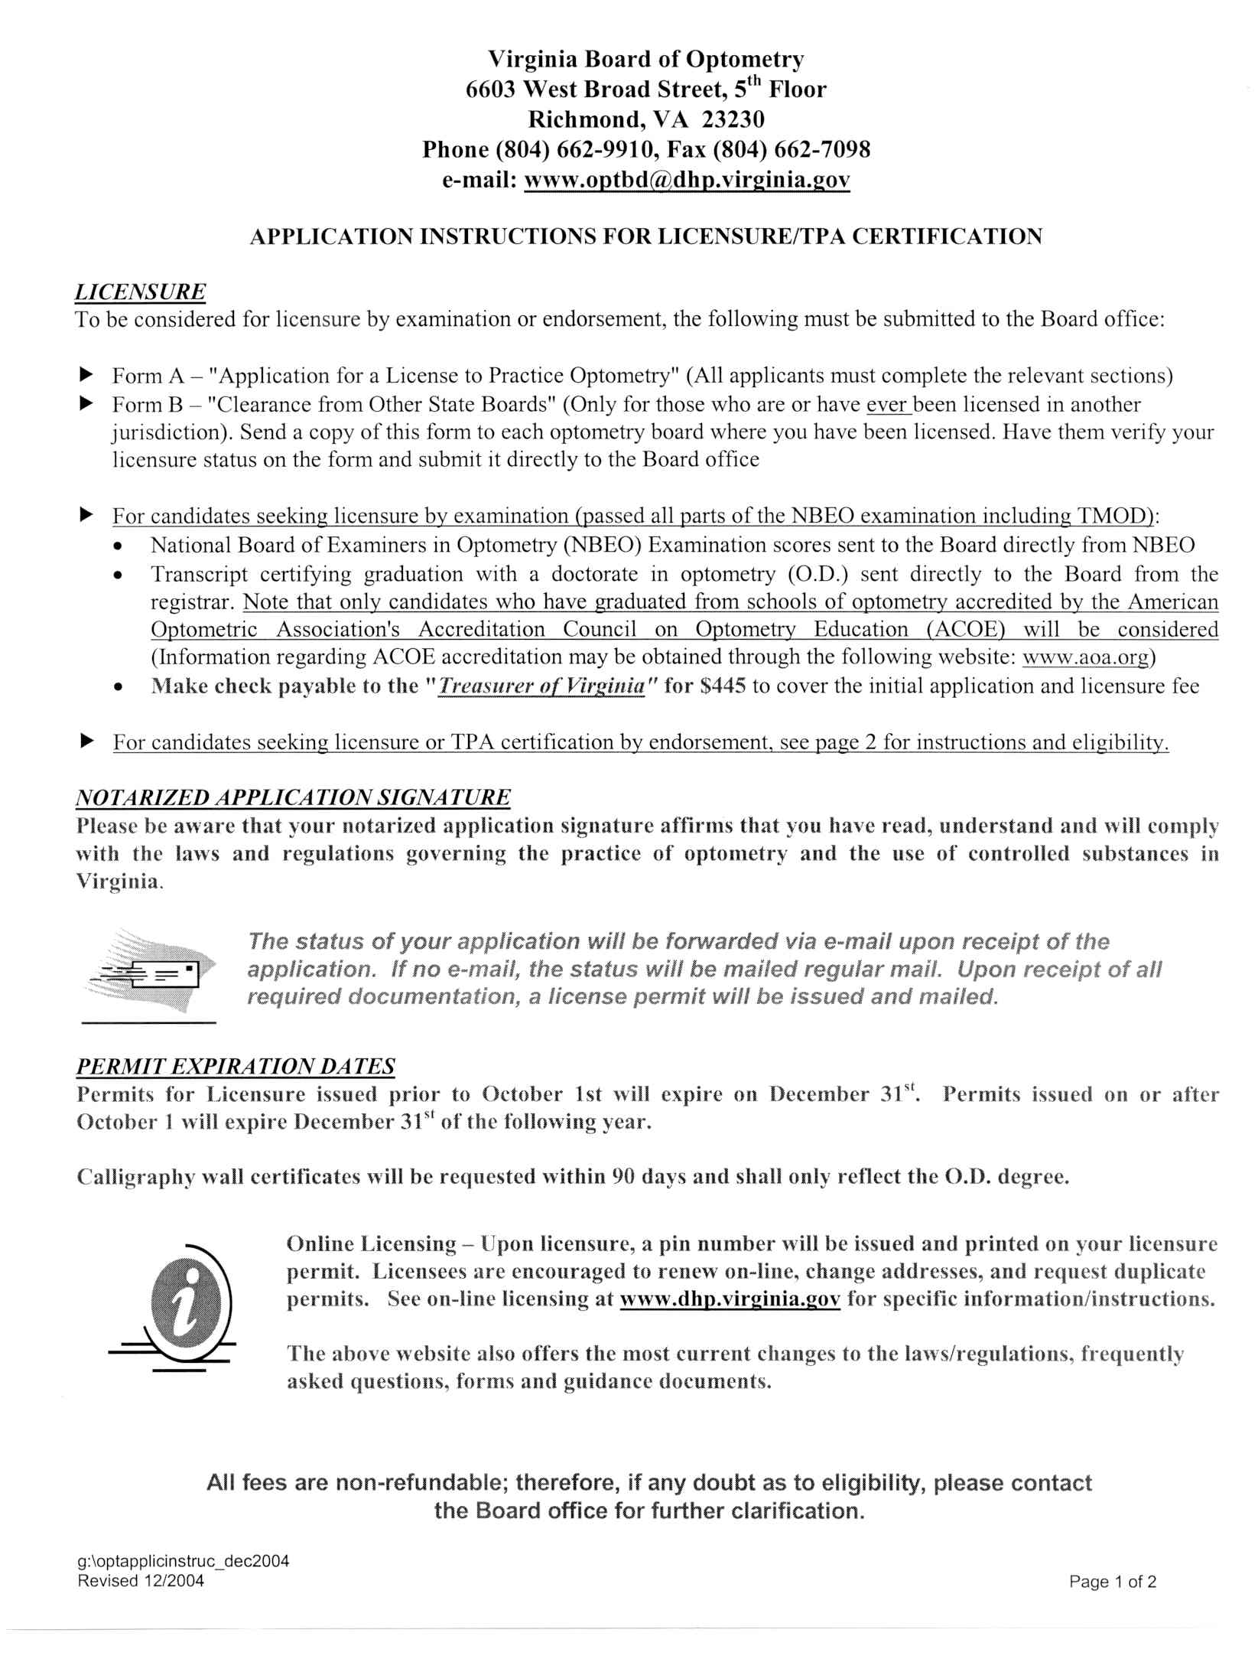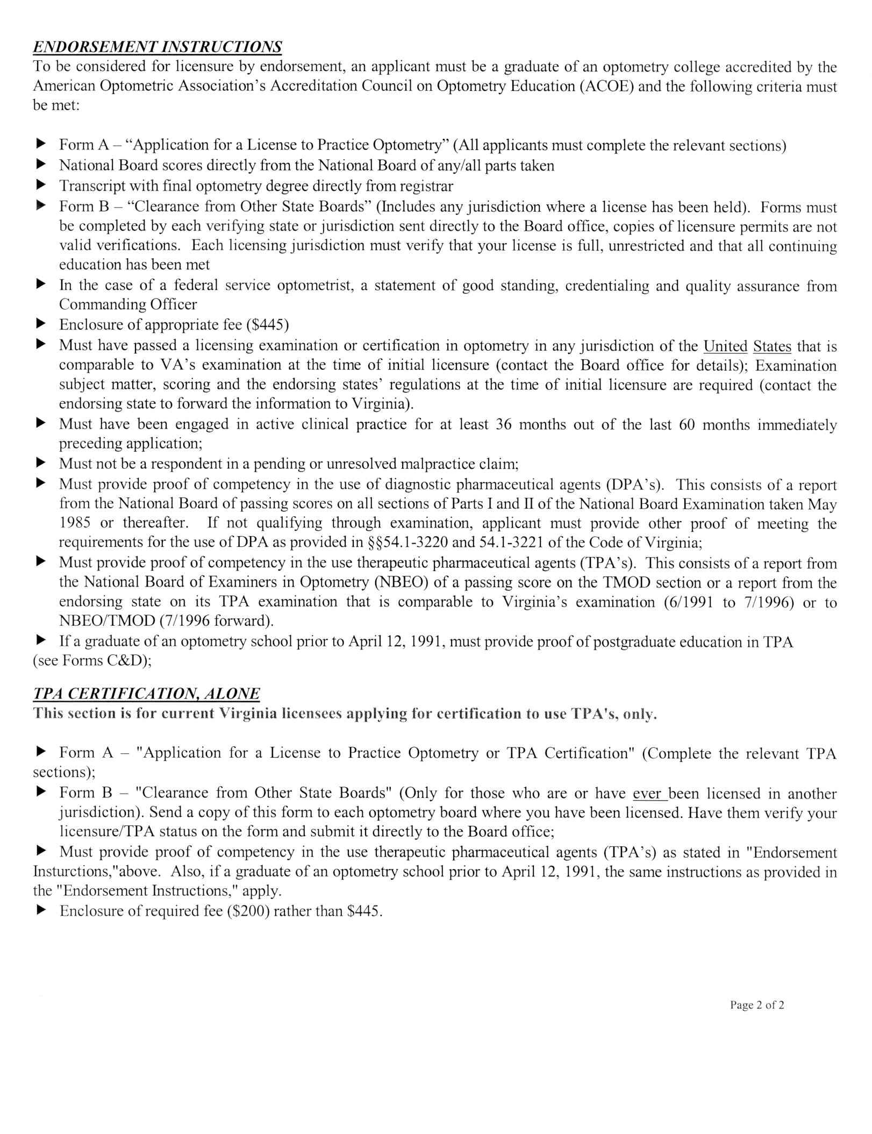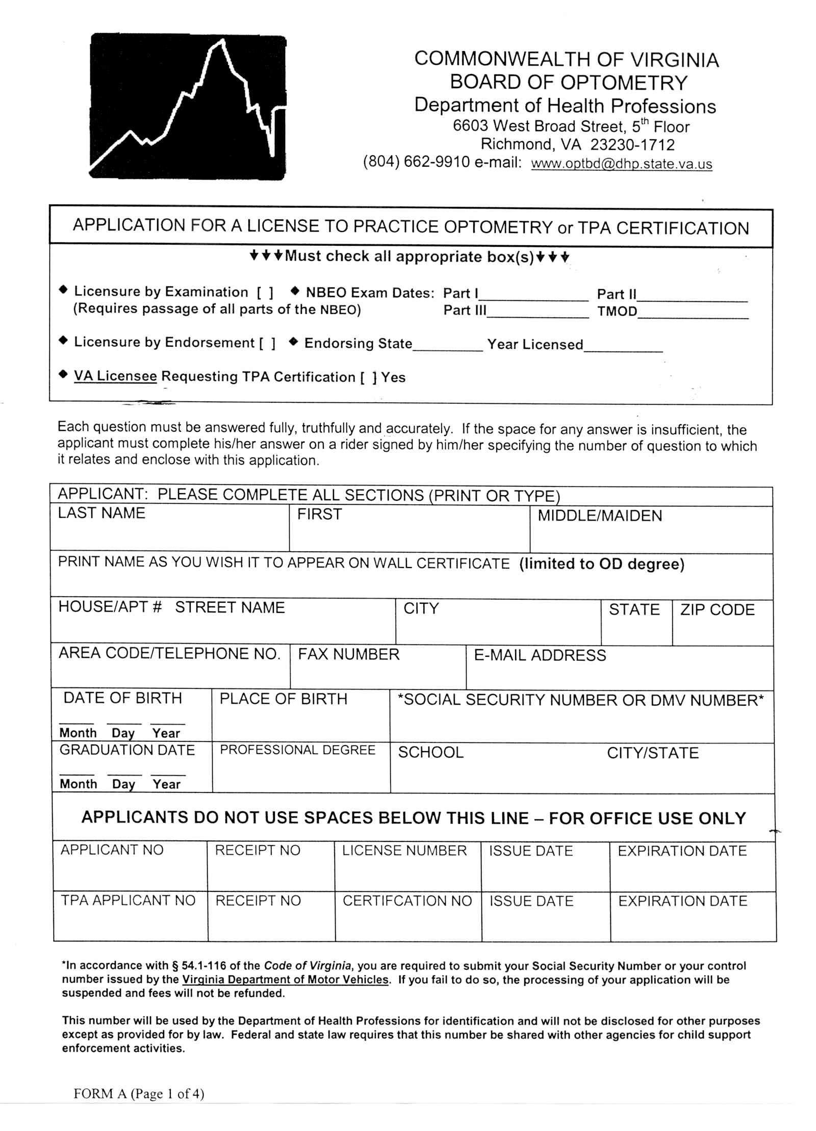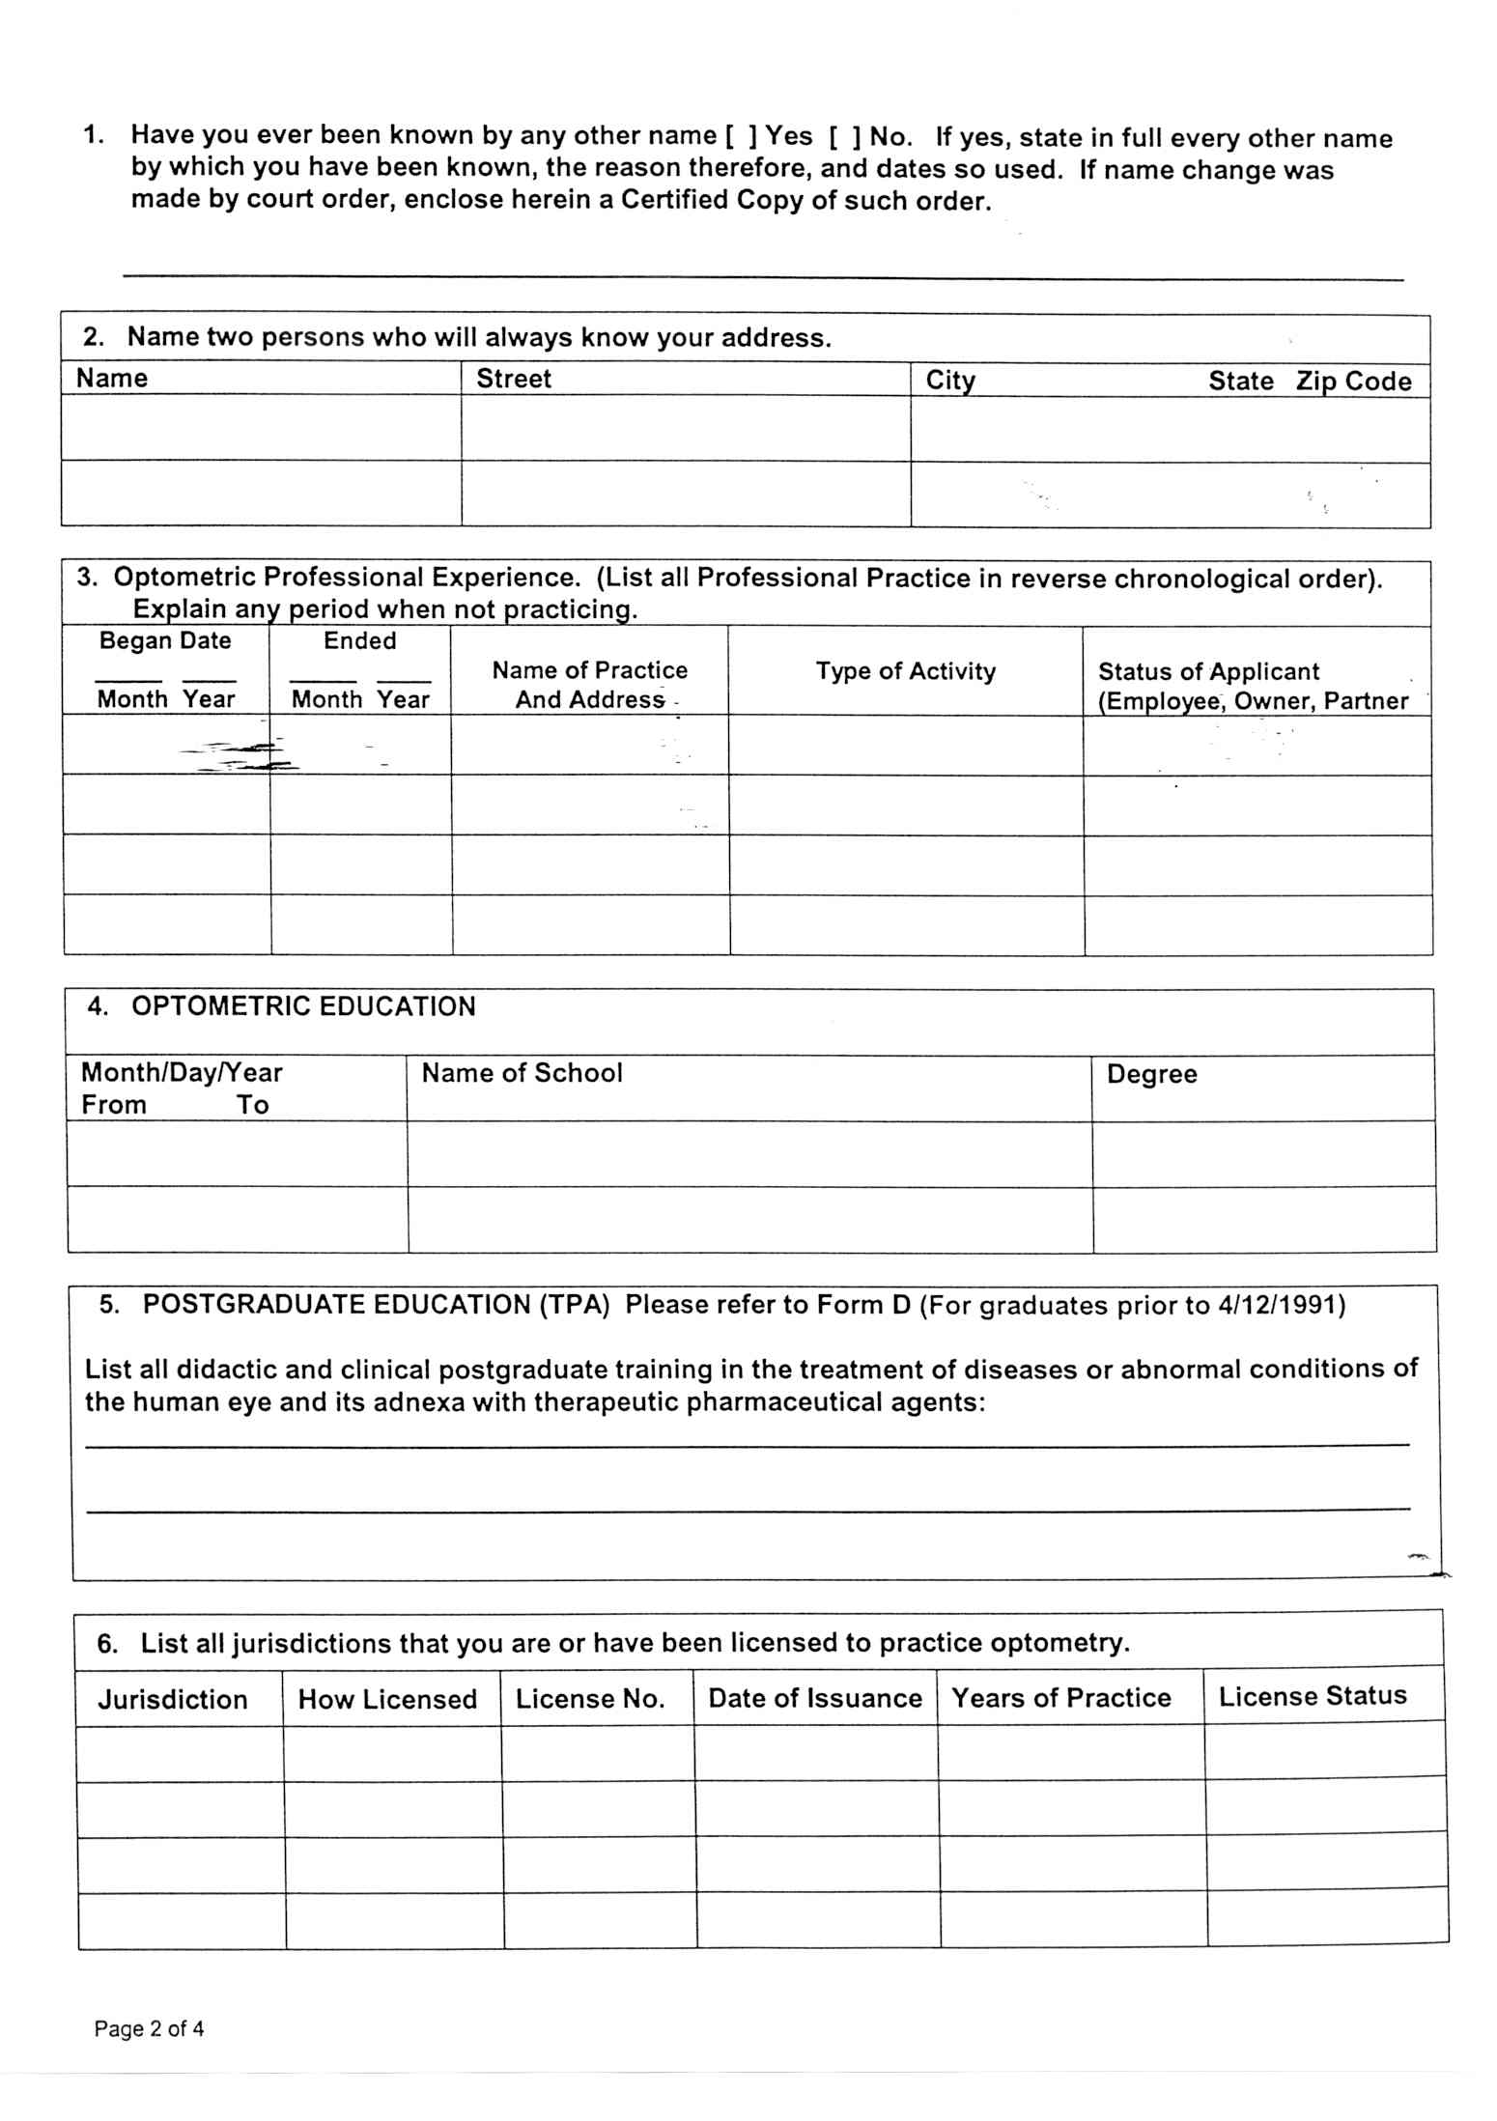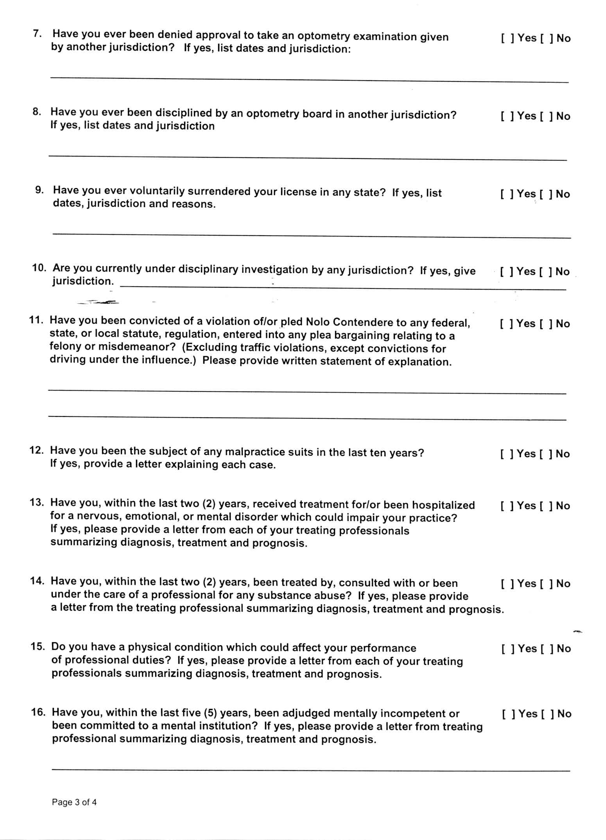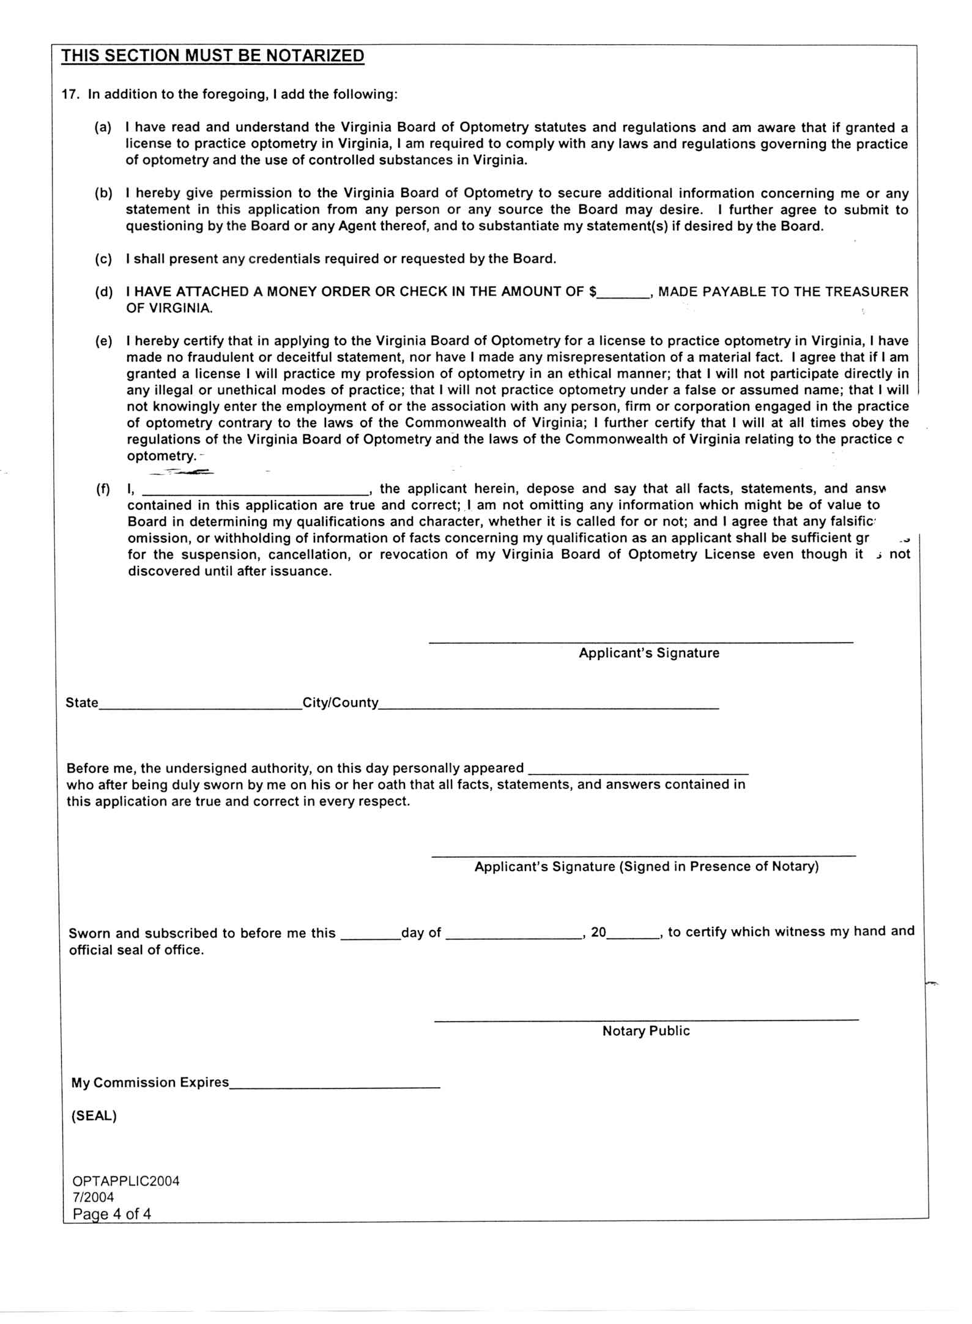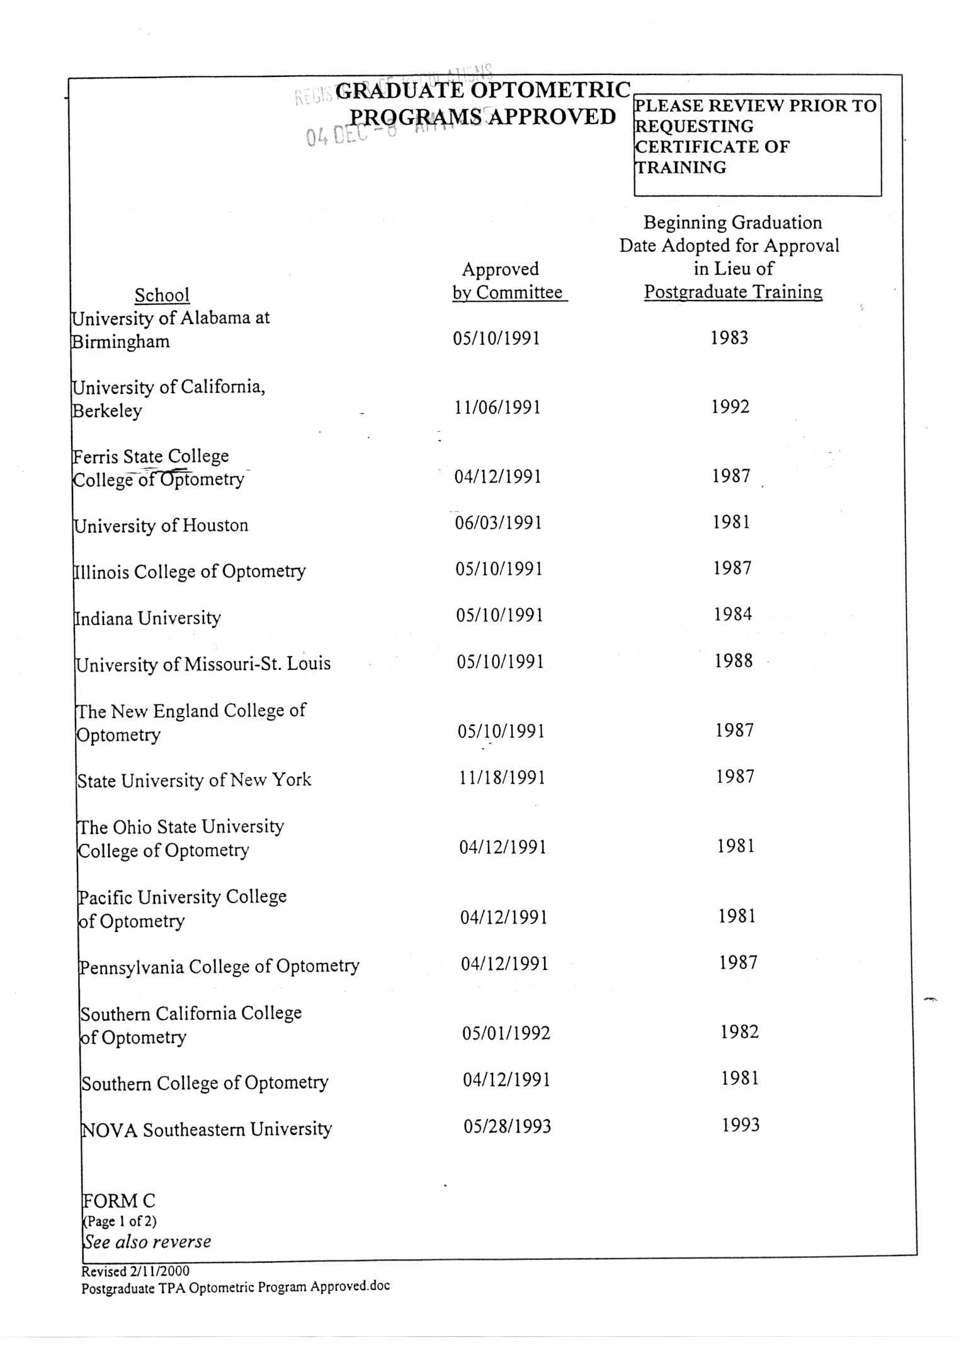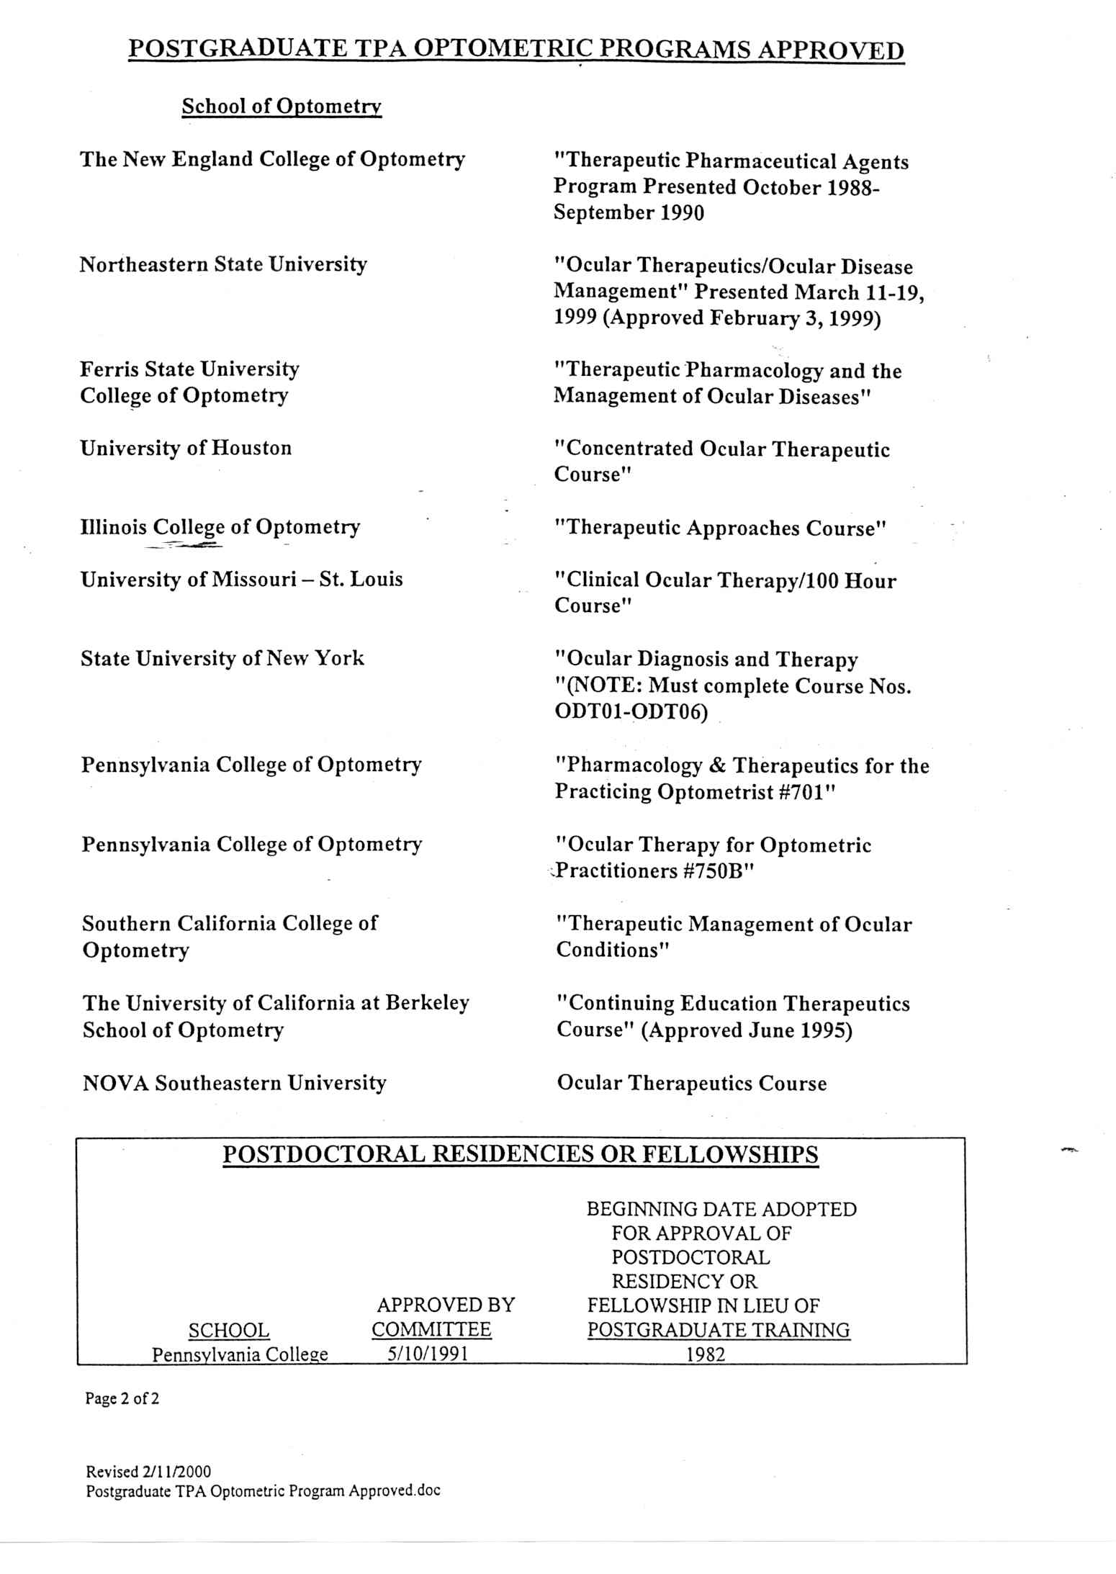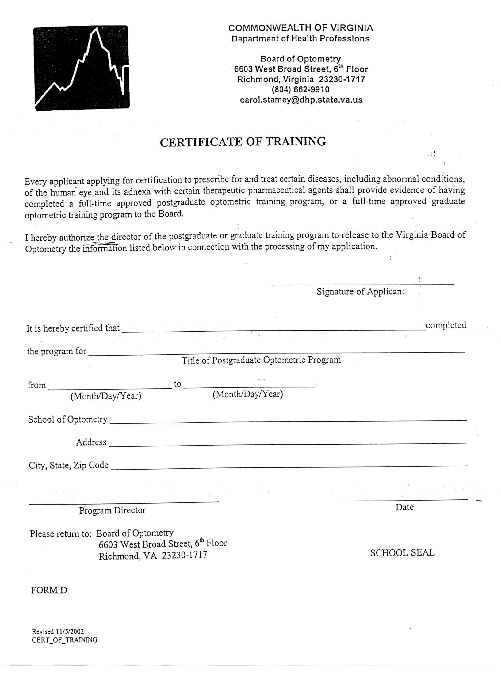
VA.R. Doc. No. R04-280; Filed December 8, 2004, 11:24 a.m.

