TITLE 18. PROFESSIONAL AND OCCUPATIONAL LICENSING
JOINT BOARDS OF NURSING AND MEDICINE
'Title of Regulation: 18 VAC 90-30. Regulations Governing the Licensure of Nurse Practitioners (amending 18 VAC 90-30-80, 18 VAC 90-30-100 and 18 VAC 90-30-110).
Statutory Authority: §§ 54.1-2400 and 54.1-3005 of the Code of Virginia.
Public Hearing Date: January 25, 2005 - 1:30 p.m.
Public comments may be submitted until March 11, 2005.
(See Calendar of Events section
for additional information)
Agency Contact: Jay P. Douglas, R.N., Executive Director, Board of Nursing, Alcoa Building, 6603 West Broad Street, 5th Floor, Richmond, VA 23230-1712, telephone (804) 662-9909, FAX (804) 662-9512, or e-mail jay.douglas@dhp.virginia.gov.
Basis: Section 54.1-2400 of the Code of Virginia provides the Boards of Nursing and Medicine the authority to promulgate regulations to administer the regulatory system. The specific legal mandate to promulgate the regulation for implementation of the Nurse Licensure Compact is found in § 54.1-3005 of the Code of Virginia.
Purpose: In 2003, the General Assembly enacted Chapter 249, which created the authorization for Virginia’s membership in the Nurse Licensure Compact effective January 1, 2005. Sections 54.1-3030 through 54.1-3040 provide the legal basis for the Compact and specific statutory language for participation and administration. Amended rules will ensure that persons who are seeking license, renewal or reinstatement as nurse practitioners will be able to do so, whether they hold a license as a registered nurse or a multistate licensure privilege to practice in Virginia as a registered nurse.
The amendments are essential to conform the nurse practitioner regulations to the implementation of the Nurse Licensure Compact and ensure that there is no disruption in the ability of nurse practitioners to become licensed or to renew their licenses. Amended rules are necessary to protect the health and safety of the public by ensuring that all nurses who provide care to patients in Virginia, whether they hold a license or a multistate privilege, will be held to the same standards of conduct.
Substance: Proposed regulations include a multistate licensure privilege as an acceptable alternative to the license as a registered nurse for initial licensure as a nurse practitioner and renewal or reinstatement of licensure in Virginia.
Issues: There are no disadvantages to the public; the proposed rules will ensure that nurses practicing in Virginia under a multistate licensure privilege are held to the same standards as those practicing with a Virginia license. Likewise, any limitation or monitoring required by a disciplinary order would be imposed equally. There may be some advantage to the public in that access to health care may be improved by the availability of nurses who reside in other states but will come into Virginia to work. However, the Compact also makes it easier for Virginia nurses to go to other Compact states to work, so the result may not create a net gain for health care in the state.
There are no specific advantages or disadvantages to the agency or the Commonwealth. Rules to implement the specific provisions of law will give guidance to the board and its licensees on questions about declaration of a home state, limitations on practice and access to information.
Department of Planning and Budget's Economic Impact Analysis: The Department of Planning and Budget (DPB) has analyzed the economic impact of this proposed regulation in accordance with § 2.2-4007 H of the Administrative Process Act and Executive Order Number 21 (02). Section § 2.2-4007 H requires that such economic impact analyses include, but need not be limited to, the projected number of businesses or other entities to whom the regulation would apply, the identity of any localities and types of businesses or other entities particularly affected, the projected number of persons and employment positions to be affected, the projected costs to affected businesses or entities to implement or comply with the regulation, and the impact on the use and value of private property. The analysis presented below represents DPB’s best estimate of these economic impacts.
Summary of the proposed regulation. The Board of Nursing (board) proposes to amend these regulations to enable individuals with a registered nurse (RN) license from a Nurse Licensure Compact state to meet the Virginia nurse practitioner license’s RN requirement.
Estimated economic impact. In order to become a licensed nurse practitioner in Virginia, one must also be a licensed registered nurse (RN). The current regulations specify that the RN license be issued by Virginia. The board proposes to amend these regulations so that the RN license can be from any state that participates in the Nurse Licensure Compact (compact). Currently the following states have entered the compact: Arizona, Arkansas, Deleware, Idaho, Iowa, Maine, Maryland, Mississippi, Nebraska, New Mexico, North Carolina, North Dakota, South Dakota, Tennessee, Texas, Utah and Wisconsin.1 Virginia is in the process of joining. All compact states require that their nurses pass the same National Council of State Boards of Nursing (NCSBN) examinations and have graduated from an accredited nursing program in order to obtain licensure. Thus, the minimum demonstrated knowledge and abilities necessary for RN licensure should be similar for the compact states.
By permitting nurses with RN licensure in other compact states to pursue nurse practitioner licensure in Virginia, the potential supply of individuals with the skills and desire to become practicing nurse practitioners in Virginia increases. This may especially apply to RNs who live close to Virginia’s border with Maryland, North Carolina, or Tennessee, and all compact states. To the extent that the supply of nurse practitioners may increase, the proposed amendments will be beneficial for Virginia. Areas that have relative few physicians and nurse practitioners compared to their population could benefit in particular by gaining nurse practitioner services.
Businesses and entities affected. There are currently approximately 4,600 licensed nurse practitioners in the Commonwealth.2 The proposed amendments may moderately increase that number. Their patients will be affected.
Localities particularly affected. The proposed amendments affect all Virginia localities, but may affect localities near Maryland, North Carolina, or Tennessee in particular.
Projected impact on employment. The proposed amendments may moderately increase the number of nurse practitioners working in the Commonwealth.
Effects on the use and value of private property. The proposed amendments may moderately increase the amount of nurse practitioner services offered in Virginia.
Agency's Response to the Department of Planning and Budget's Economic Impact Analysis: The Board of Nursing concurs with the analysis of the Department of Planning and Budget for the proposed regulation, 18 VAC 90-30, Regulations Governing the Licensure of Nurse Practitioners, relating to implementation of the Nurse Licensure Compact.
Summary:
The proposed amendments provide that individuals with a registered nurse license from a state that has entered into the Nurse Licensure Compact is qualified to seek licensure, renewal or reinstatement as a nurse practitioner in Virginia.
18 VAC 90-30-80. Qualifications for initial licensure.
A. An applicant for initial licensure as a nurse practitioner shall:
1. Be currently licensed as a registered nurse in Virginia or hold a current multistate licensure privilege as a registered nurse;
2. Submit evidence of completion of an educational program designed to prepare nurse practitioners that is an approved program as defined in 18 VAC 90-30-10;
3. Submit evidence of professional certification by an agency identified in 18 VAC 90-30-90 as an agency accepted by the boards;
4. File the required application; and
5. Pay the application fee prescribed in 18 VAC 90-30-50.
B. Provisional licensure may be granted to an applicant who satisfies all requirements of this section with the exception of subdivision A 3 of this section only until the release of the results of the first national certifying examination for which he is eligible following his application.
18 VAC 90-30-100. Renewal of licensure.
A. Licensure of a nurse practitioner shall be renewed:
1. Biennially at the same time the license to practice as a registered nurse in Virginia is renewed; or
2. If licensed as a nurse practitioner with a multistate licensure privilege to practice in Virginia as a registered nurse, a licensee born in even-numbered years shall renew his license by the last day of the birth month in even-numbered years and a licensee born in odd-numbered years shall renew his license by the last day of the birth month in odd-numbered years.
B. The application for renewal of the license shall be mailed by the committee to the last known address of each nurse practitioner.
C. The licensed nurse practitioner shall complete the application and return it with his signature attesting to compliance with continuing competency requirements prescribed in 18 VAC 90-30-105 and the license renewal fee prescribed in 18 VAC 90-30-50.
18 VAC 90-30-110. Reinstatement of license.
A. A licensed nurse practitioner whose license has lapsed may be reinstated within one renewal period by payment of the current renewal fee and the late renewal fee.
B. An applicant for reinstatement of license lapsed for more than one renewal period shall:
1. File the required application and reinstatement fee;
2. Be currently licensed as a registered nurse in Virginia or hold a current multistate licensure privilege as a registered nurse; and
3. Provide evidence of current professional certification or, if applicable, licensure or certification in another jurisdiction.
C. An applicant for reinstatement of license following suspension or revocation shall:
1. Petition for a reinstatement and pay the reinstatement fee;
2. Present evidence that he is currently licensed as a Registered Nurse in Virginia or hold a current multistate licensure privilege as a registered nurse; and
3. Present evidence that he is competent to resume practice as a licensed nurse practitioner in Virginia.
The committee shall act on the petition pursuant to the Administrative Process Act, § 9-6.14:1 2.2-4000 et seq. of the Code of Virginia.
NOTICE: The forms used in administering 18 VAC 90-30, Regulations Governing the Licensure of Nurse Practitioners, are listed below. Any amended or added forms are reflected in the listing and are published following the listing.
FORMS
Instructions for Licensure -Nurse Practitioner (rev. 10/02).
Application for Licensure as a Nurse Practitioner (rev. 10/02).
Renewal Notice and Application, Nurse Practitioner, 0024 (rev. 1/03).
Application for Reinstatement of License as a Nurse Practitioner (eff. 10/02).

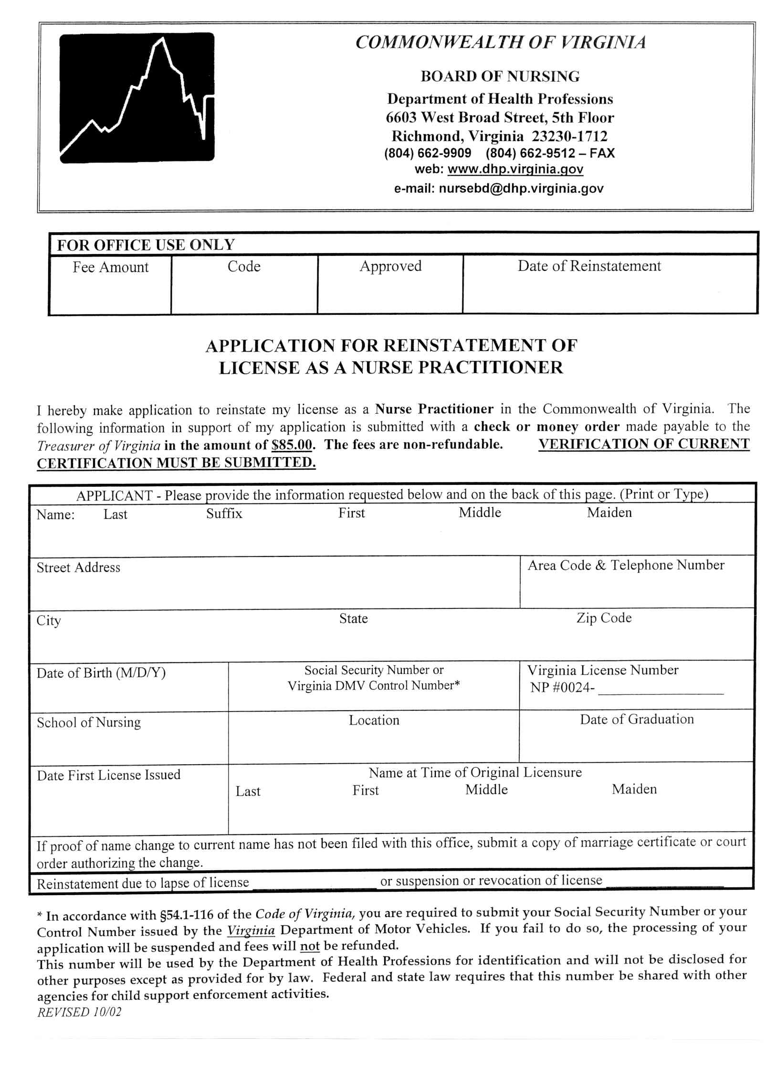

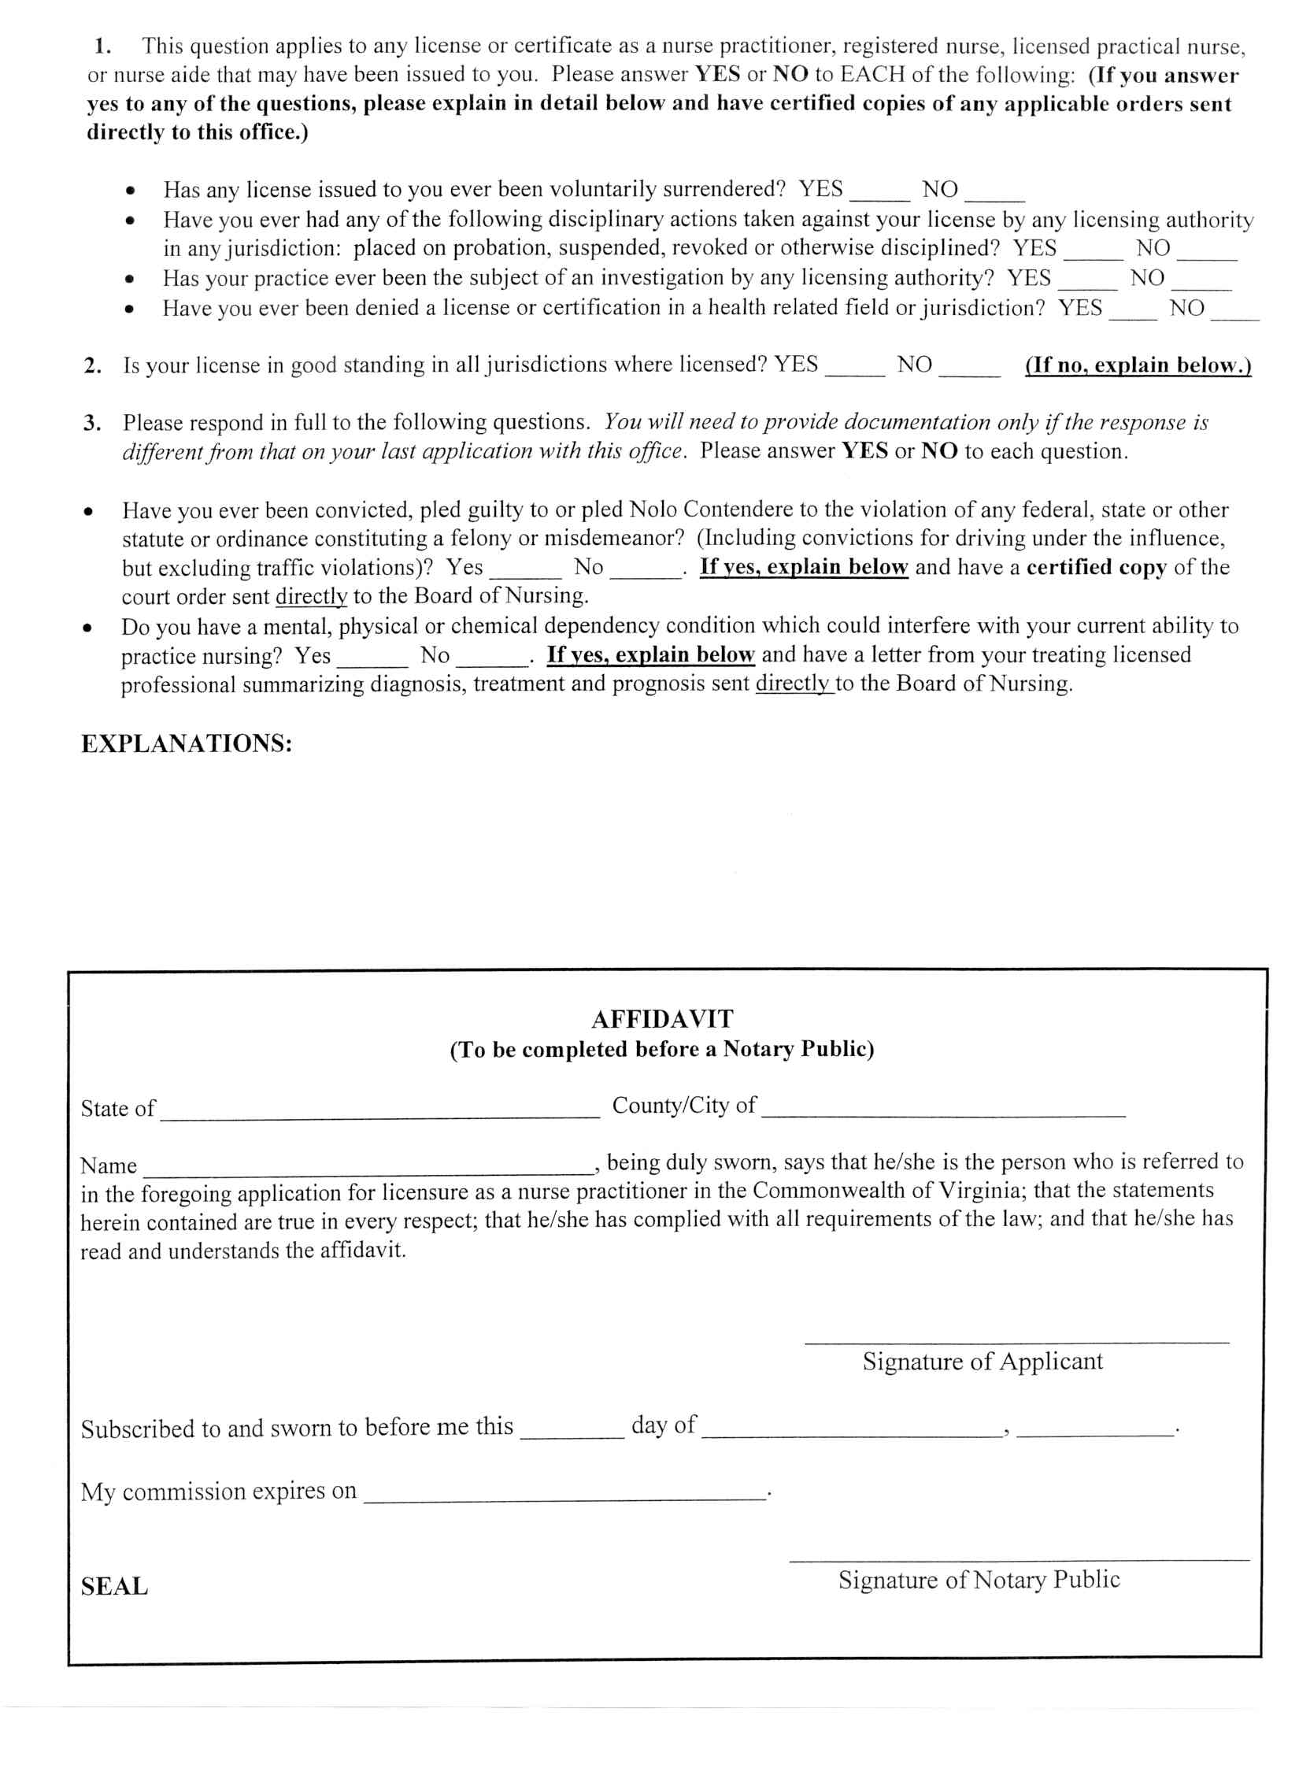
VA.R. Doc. No. R04-237; Filed December 21, 2004, 10:43 a.m

1 Source: Department of Health Professions and http://ncsbn.org/nlc/index.asp on November 5, 2004.
2 Source: Department of Health Professions

