TITLE 18. PROFESSIONAL AND OCCUPATIONAL LICENSING
BOARD OF PHARMACY
Title of Regulation: 18 VAC 110-30. Regulations for Practitioners of the Healing Arts to Sell Controlled Substances (amending 18 VAC 110-30-10, 18 VAC 110-30-15, 18 VAC 110-30-20, 18 VAC 110-30-30, 18 VAC 110-30-40, 18 VAC 110-30-50, 18 VAC 110-30-80, 18 VAC 110-30-110, 18 VAC 110-30-130, 18 VAC 110-30-150, 18 VAC 110-30-170 through 18 VAC 110-30-220, 18 VAC 110-30-240, 18 VAC 110-30-260, 18 VAC 110-30-270; repealing 18 VAC 110-30-35).
Statutory Authority: §§ 54.1-2400 and 54.1-3307 of the Code of Virginia.
Public Hearing Date: June 22, 2005 - 8:45 a.m.
Public comments may be submitted until August 12, 2005.
(See Calendar of Events section
for additional information)
Agency Contact: Elizabeth Scott Russell, RPh, Executive Director, Department of Health Professions, 6603 West Broad Street, 5th Floor, Richmond, VA 23230-1712, telephone (804) 662-9911, FAX (804) 662-9313, or e-mail elizabeth.russell@dhp.virginia.gov.
Basis: Chapter 24 (§ 54.1-2400 et seq.) of Title 4.1 of the Code of Virginia establishes the general powers and duties of health regulatory boards including the responsibility to promulgate regulations in accordance with the Administrative Process Act (§ 2.2-4000 et seq.). The specific statutory authority for the Board of Pharmacy to regulate the practice of pharmacy including the dispensing of controlled substances is found in § 54.1-3307 of the Code of Virginia.
The authority for the board to issue licenses to physicians to dispense drugs is found in § 54.1-3304.
Purpose: Amendments to regulations governing the practice of pharmacy, adopted in response to an extensive periodic review, became effective on August 25, 2004. Since physicians are licensed under these regulations to store, dispense and sell controlled substances, certain requirements should be comparable, while others are unique to regulations for physicians selling drugs to their patients. Some requirements that should be similar for pharmacists and physicians are now dissimilar with the change to the pharmacy regulations, so there is a need to amend 18 VAC 110-30 accordingly. Other requirements are now outdated with changes to the law, such as the registration of pharmacy technicians, or with changes in pharmacy practice. The goal of this action is to conform and update requirements for physicians selling drugs in their practice.
The board has determined that the regulation is necessary for the protection of public health, safety and welfare in that it specifies requirements for the security, integrity and efficacy of prescription drugs and for the physician to make patients aware of their freedom to choose another provider to fill their prescriptions. The regulation has not been challenged for a lack of clarity, but is now inconsistent with rules governing pharmacies and should be amended accordingly.
Substance: The substantive provisions and changes are as follows:
Fees and renewal/reinstatement requirements. Fees are amended for consistency with similar fees for similar activities by a pharmacist or a pharmacy. Renewal and reinstatement requirements are also amended for consistency in the timing and amount of fee. A fee is added to cover the approximate cost of conducting a reinspection, if required.
Acts to be performed by the licensee. Amendments to this section will allow practitioners to utilize the services of registered pharmacy technicians or other licensed health care practitioners who have been specifically trained in the acts performed by a technician to supervise a person who can assist in the preparation, packaging and labeling of prescriptions. In situations in which the practitioner is using a registered nurse or physician assistant to assist in preparation of prescriptions, the amended regulation requires specific training for those tasks normally performed by a registered pharmacy technician and would specify that a training manual and documentation of training be made available for inspectors.
In addition, compounding of a controlled substance can only be performed by the licensee in the current rules; an amendment would expand that activity to allow compounding under a registered pharmacy technician under the practitioner’s supervision.
Inspection and notice required. Consistent with newly amended language in 18 VAC 110-20, the board will require that if an applicant substantially fails to meet the requirements for issuance of a license and a reinspection is required, or if the applicant is not ready for the inspection on the established date and fails to notify the inspector or the board at least 24 hours prior to the inspection, the applicant must pay a reinspection fee prior to a reinspection being conducted. Without an inspection of the facility, there is no assurance that drugs are being stored under proper conditions to protect the drugs’ integrity, that expired drugs are not being dispensed or that drugs are being packaged and labeled appropriately. These and other standards necessary for patient health and safety are examined during an inspection.
Minimum equipment. The listing of the equipment the licensee must maintain is amended to delete reference materials no longer required in a pharmacy and to include a general requirement for other equipment, supplies, and references consistent with the practitioner's scope of practice and with the public safety. In addition, the specific requirement for a laminar flow hood will be replaced with a general requirement for equipment necessary for sterile compounding of controlled substances consistent with USP standards and provisions of § 54.1-3410.2 of the Code of Virginia (enacted by the 2003 General Assembly).
Selling area enclosures. Amendments recognize newer technology in gaining access to a secured area. Rather than specifying the security of the "door keys" only, the regulation will also refer to "other means of entry" or "other means of opening the locking device." Consistent with the pharmacy regulations, the executive director for the board should be able to approve other methods of securing the emergency keys or access codes to the enclosed area in lieu of the licensee's signature across a seal, as is currently required.
Sign and written prescription requirements. Requirements in this section are intended to ensure that the licensee provides a patient with a written prescription whether or not he intends to sell the controlled substance to the patient and that the patient is informed that he has a right to obtain the controlled substance from a pharmacy rather than from the practitioner. Amendments: (i) specify that the sign advising patients of their right to choose may be displayed in the patient examining room(s), (ii) provide for electronic maintenance of the prescription records, and (iii) provide alternative methods for transferring the patient’s prescription to a pharmacy.
Automated data processing records of sale. Amendments are necessary to conform and update rules related to automated data processing records for consistency with new regulations for pharmacies. Rules will allow an electronic image of a prescription to be maintained in an electronic database provided it preserves and provides an exact image of the prescription that is clearly legible and made available within 48 hours of a request by a person authorized by law to have access to prescription information. Also, if the pharmacy system's automated data processing system fields are automatically populated by an electronic transmission, the automated record can constitute the prescription and a hard copy or electronic image is not required.
Repackaging of controlled substances; records required; labeling requirements. Rules for determining the expiration date on a prescription are amended for consistency with the pharmacy regulations, which require conformity to USP guidelines for any repackaged or reconstituted units.
Special packaging. Rather than requiring a signed release from a patient requesting nonspecial packaging, documentation of such a release can be obtained from the patient or the patient's authorized agent and maintained for two years from the date of dispensing.
Returning of controlled substances. Amendments for the return of controlled substances are necessary to track changes in the Code, which permit certain returns and transfer. The regulations are amended for consistency with pharmacy regulations and provisions of § 54.1-3411.1 of the Code of Virginia.
Issues: The primary advantage to the public is consistency in regulation between a permitted pharmacy and a physician’s practice in which drugs are being stored, compounded, prepared and dispensed. Without the same precautions related to labeling, preparation of a prescription, storage, recordkeeping and supervision, patients receiving prescription medication through a physician’s practice would not have the same assurances of the drug integrity and efficacy. Amended rules will also ensure that patients understand their right to have a prescription filled elsewhere and that a prospective drug review and counseling will occur before a drug is dispensed. There are no disadvantages to the public.
There are no disadvantages to the agency. There may be an advantage in having a regulation that is consistent with rules for the practice of pharmacy, and the board will be able to recover some of its costs for inspections by institution of a reinspection fee.
Department of Planning and Budget's Economic Impact Analysis: The Department of Planning and Budget (DPB) has analyzed the economic impact of this proposed regulation in accordance with § 2.2-4007 H of the Administrative Process Act and Executive Order Number 21 (02). Section 2.2-4007 H requires that such economic impact analyses include, but need not be limited to, the projected number of businesses or other entities to whom the regulation would apply, the identity of any localities and types of businesses or other entities particularly affected, the projected number of persons and employment positions to be affected, the projected costs to affected businesses or entities to implement or comply with the regulation, and the impact on the use and value of private property. The analysis presented below represents DPB’s best estimate of these economic impacts.
Summary of the proposed regulation. Following a periodic review of these regulations, the Board of Pharmacy (board) proposes to make several amendments to these regulations, including: (i) amending fees for consistency with similar fees for similar activities by a pharmacist or a pharmacy, (ii) amending renewal and reinstatement requirements for consistency with pharmacist and pharmacy requirements, (iii) adding a required reinspection of storage and selling area for reinstated licensees, (iv) adding a fee to cover the approximate cost of conducting a reinspection, if required, (v) eliminating a restriction on limited-use licenses, (vi) eliminating the inactive license, (vii) specifying qualifications of nonlicensee permitted in storage and selling area, (viii) allowing compounding to be performed by registered pharmacy technicians under the licensee’s supervision, (ix) requiring that the licensee conduct a prospective drug review and offer counsel prior to dispensing, (x) amending the list of required minimum equipment and resources, (xi) requiring that a conspicuous sign be posted in every examination room notifying patients of their right to choose where to have their prescription filled, (xii) permitting electronic storage of records, and (xiii) clarifying language.
Estimated economic impact. License renewal, late fees, and reinstatement. Currently, a practitioner who fails to renew his license on or before its expiration date may renew the license if he pays a $30 late fee and the $90 annual renewal fee within 60 days after the expiration date. After the 60 days, the licensee must apply for reinstatement, pay a $70 delinquent fee, and pay all back renewal fees.
The proposed regulations allow licensees one year from the expiration date to renew a late license. During that year the licensee may simply pay the $30 late fee in addition to the $90 renewal fee. Thus, those individuals who seek to renew their license from 31 days after its expiration to one year after its expiration save $40 in fees and the time and effort it takes to apply for reinstatement.
After the one year, the licensee must apply for reinstatement and pay a $210 reinstatement fee, but is not required to pay all back renewal fees. An individual who seeks to reinstate two years after expiration will also be $40 better off under the proposed regulations.1 (See table below.) An individual who seeks to reinstate three years after expiration will be $130 better off under the proposed regulations.2 An individual who seeks to reinstate four years after expiration will be $220 better off under the proposed regulations.3 An individual who seeks to reinstate five years after expiration will be $310 better off under the proposed regulations.4 Thus, the fee savings under the proposed regulations versus the current regulations increase the longer the license was expired.

 | Current | Proposed
On-time | $90 | $90
Within 60 days after expiration date | $120 | $120
61 days to one year after expiration date | $160 | $120
Up to two years after expiration date | $250 | $210
Up to three years after expiration date | $340 | $210
Up to four years after expiration date | $430 | $210
Up to five years after expiration date | $520 | $210
Reinspection. Under the current regulations if an applicant fails their site inspection, but successfully completes all other aspects of their permit application, the applicant must still submit a new permit application with a $270 fee and wait 14 days to reschedule an inspection. The board proposes to amend the regulations to allow the applicant to schedule a reinspection without resubmitting a full permit application. The reinspection fee is set at $150. This will save the time and cost of redoing the initial part of the application process for both the applicant and the Department of Health Professions (department). In addition to saving $120 in fees, the facility will likely be able to be reinspected sooner, potentially permitting it to begin operations and earning revenue sooner. This amendment produces a net benefit since there is no downside to the change in procedure.
The current regulations do not specify a requirement that applicants for reinstatement have their storage and selling area reinspected. Under the proposed regulations, a licensee applying for reinstatement must have their storage and selling area reinspected and pay the $150 reinspection fee unless another practitioner at the same location has held an active license to sell controlled substances during that period. For those licensees applying for reinstatement that do not have another practitioner at the same location who has held an active license during the period that the applicant’s license was expired, the total fees for reinstatement will be $360.5 The table below compares the required fees for renewal and reinstatement under the current regulations, with the required fees for renewal and reinstatement under the proposed regulations when the applicant has a continually licensed colleague at the same location, and with the required fees for renewal and reinstatement under the proposed regulations when the applicant does not have a continually licensed colleague at the same location.

 | Current | Proposed with a licensed colleague | Proposed without a licensed colleague
On-time | $90 | $90 | $90
Within 60 days after expiration date | $120 | $120 | $120
61 days to one year after expiration date | $160 | $120 | $120
Up to two years after expiration date | $250 | $210 | $360
Up to three years after expiration date | $340 | $210 | $360
Up to four years after expiration date | $430 | $210 | $360
Up to five years after expiration date | $520 | $210 | $360
In terms of fees, an individual without a continually licensed colleague at the same location who seeks to reinstate two years after expiration will be $110 worse off under the proposed regulations.6 An individual who seeks to reinstate three years after expiration will be $20 worse off under the proposed regulations.7 An individual who seeks to reinstate four years after expiration will be $70 better off under the proposed regulations.8 An individual who seeks to reinstate five years after expiration will be $160 better off under the proposed regulations.9 Thus, for individuals without a continually licensed colleague at the same location who seek to renew or reinstate their license between one year and one day after expiration and three years after expiration, the required fees are higher under the proposed regulations. Individuals without a continually licensed colleague at the same location who seek to renew or reinstate their license either 61 days to one year after expiration, or more than three years after expiration, will encounter lower fees under the proposed regulations.
Limited-use license. Both the current and proposed regulations permit the board to issue a limited-use license when the scope, degree, or type of services provided to the patient is of a limited nature. The issued license is based on conditions of use requested by the applicant or imposed by the board in cases where certain requirements of regulations may be waived. Under the current regulations possessors of limited-use licenses can only sell controlled substances that have been received prepackaged in ready to dispense quantities and containers needing only the addition of required labeling. The board proposes to eliminate this limitation.
Limited-use licenses can vary in detail and are approved by the board on a case-by-case basis. Repealing the language that restricts limited-use licensees to only selling controlled substances that are received prepackaged in ready to dispense quantities and containers provides the board with the flexibility to permit other type of sales for some limited-use licensees where qualifications and conditions indicate no undue safety risk. The removal of this restriction can potentially reduce costs for affected limited-use licensees. The board retains the right to create and approve limited-use licenses where the licensee is not permitted to sell nonprepackaged controlled substances. This proposed amendment should provide a net benefit since costs can be lowered without significant addition to health risks, assuming that the board can accurately judge when the introduced risks are minimal.
Inactive license. Licensees who intend to cease selling controlled substances are required to notify the board 10 days prior to cessation. Under the current regulations, the individual chooses to either place his license on inactive status, or to surrender the license. An individual with an inactive license is not permitted to engage in the sale of controlled substances. The inactive license may be reactivated through application to the board. There is no reactivation fee beyond the standard licensing fee.
The board proposes to eliminate inactive status. In its stead, the board proposes to state that "a licensee who has surrendered his license pursuant to (cessation) may request that it be made current again at anytime within the same renewal year without having to pay an additional fee, …" In practice, the proposed change will not change behavior beyond that the designation "inactive license" will not be used.
Compounding and assistance. The current regulations permit one nonlicensee in the storage and selling area at any given time for the purpose of assisting the licensee in the preparation, packaging, and labeling of a controlled substance. The board proposes to specify that the nonlicensee be a registered pharmacy technician, or a licensed nurse or physician assistant who has received training in technician tasks consistent with training required for pharmacy technicians. The department is not aware of any practitioner seller of controlled substances who uses anyone other than a nurse to assist in the storage and selling area for preparation, packaging and labeling of a controlled substance. Thus, in practice, the proposal to specify that the assistant be either a registered pharmacy technician, or a licensed nurse or physician assistant will likely have little impact.
The current regulations state, "Any compounding of a controlled substance shall be personally performed by the licensee." The board proposes to permit a registered pharmacy technician under the supervision of the licensee to compound controlled substances. Registered pharmacy technicians are deemed competent to assist in this field. Permitting registered pharmacy technicians to compound can result in the faster processing of prescriptions. The time that the licensee would have spent compounding can be productively used on other activities. Given the profession’s relative wage rates, spending a pharmacy technician’s time on compounding rather than a physician’s time can be considered a cost saving.10 Since, as stated above, the department is not aware of any practitioner seller of controlled substances who uses anyone other than a nurse to assist in the storage and selling area for preparation, packaging and labeling of a controlled substance, this proposed will initially not have a significant impact. Since compounding will become less expensive to conduct under the proposed regulations, it may occur more often going forward.
Prospective drug review and counseling. Pharmacists are required to conduct a prospective drug review before each new prescription is dispensed. Such reviews "include screening for potential drug therapy problems due to therapeutic duplication, drug-disease contraindications, drug-drug interactions, including serious interactions with nonprescription or over-the-counter drugs, incorrect drug dosage or duration of drug treatment, drug-allergy interactions, and clinical abuse or misuse."11 The pharmacist is also required to offer counsel to counsel any person who presents a new prescription for filling.
The current regulations do not address prospective drug review and counseling for doctors licensed to sell controlled substances. The board proposes to explicitly state that licensees must conduct a prospective drug review and offer counsel. It is hoped that licensees are already doing this. Failure to check for potential drug therapy problems due to therapeutic duplication, drug-disease contraindications, drug-drug interactions, drug-allergy interactions, etc., can lead to seriously adverse health outcomes. Despite the high wages earned by licensees (see footnote 10), it seems likely that the cost of the time spent conducting prospective drug reviews is outweighed by the benefit of reduced adverse health outcomes. Thus, to the extent that explicitly stating this requirement increases the frequency that licensees conduct prospective drug reviews and offer counsel, this proposed new language will create a net benefit.
Required minimum equipment or resources. The board proposes changes to the list of required equipment. The current regulations require that licensees keep current copies of the Virginia Drug Control Act, board regulations, and the Virginia Voluntary Formulary. Since these documents are readily retrievable through the Internet at no cost, the board proposes to eliminate the requirement that copies are kept in the dispensing area. Eliminating this requirement saves the expenses incurred by the Department of Health Professions (department) for copying and mailing the documents to the licensees. Lower expenses will in the long run result in lower fees than otherwise would be charged.
The current regulations specify that a laminar flow hood be present if sterile products are prepared. The board proposes to allow more flexibility in the type of equipment used for sterile product preparation. Potentially this could result in cost savings for affected licenses. The current regulations also require that prescription balances, sensitive to 15 milligrams, and weights or an electronic scale be present, if the licensee is engaged in extemporaneous compounding. The board proposes to only require this weighing equipment if the licensee is engaged in "dispensing activities that require the weighing of components." Some extemporaneous compounding can occur where weighing is not necessary. Thus, this proposed change could save licensees the cost of purchasing, maintaining, and providing space for weight-measuring equipment. The department estimates that balances and weights or an electronic scale used for pharmacy sell for between $700 to $1200. Since department staff are not aware of any physicians preparing sterile products for dispensing or engaged in extemporaneous compounding, the proposed amendment is not likely to have a significant impact.
Notification of dispensing choice. The current regulations require that licensees conspicuously display a sign in the public area of the office that advises patients of their right to choose where they have their prescriptions filled. The board proposes to further require that such signs be also conspicuously posted in every patient examination room. The reasoning is that patients may be more likely to notice the signs in the exam rooms. It will cost licensees a small amount to produce and post the additional signs. Some patients may prefer to purchase their prescriptions outside the licensee’s office due to lower prices or other reasons. These patients in particular will value knowing that they may purchase the drugs elsewhere. To the extent that more patients learn about their right of purchase location, this proposal will likely produce a net benefit.
Electronic storage of records. The board proposes to allow electronic storage of Schedule II through VI drugs sold, rather than hard copies. This proposal has the potential to produce significant savings that result from not having to file and store thousands of hard copy prescription records. Valuable physical space could be used for productive purposes other than paper storage. Worker filing time will also be saved. As long as the electronic data is adequately backed-up, so that the risk of loss of that data is minimal, this proposed amendment produces a net benefit.
Businesses and entities affected. The proposed amendments affect the 227 doctors of medicine, osteopathic medicine or podiatry with active licenses to sell controlled substances, the four individuals with inactive licenses, as well as their employers and potential employers, their patients and potential patients, and future doctors that may become interested in becoming licensed to sell controlled substances.
Localities Particularly Affected. The proposed regulations affect all Virginia localities.
Projected impact on employment. Currently, the department is not aware of any practitioner seller of controlled substances who uses anyone other than a nurse to assist in the storage and selling area for preparation, packaging, and labeling of a controlled substance. There is a small probability that the proposal to permit a registered pharmacy technician under the supervision of the licensee to compound controlled substances will encourage the hiring of pharmacy technicians.
Effects on the use and value of private property. The proposed amendments to the timing and amounts of late fees and reinstatements will in most instances lower costs for affected licensees. The proposal to allow an applicant to schedule a reinspection without resubmitting a full permit application will save him $120 in fees, and will likely enable his facility to be reinspected sooner, potentially permitting it to begin operations and earning revenue sooner. Repealing the language that restricts limited-use licensees to only selling controlled substances that are received prepackaged in ready to dispense quantities and containers can potentially reduce costs for affected limited-use licenses. Permitting registered pharmacy technicians to compound can result in the faster processing of prescriptions, allowing the licensee to use her time more productively. Allowing electronic storage of records in lieu of hard copies can produce significant savings for licensees. These licensees will have their net worth correspondingly affected.
Agency's Response to the Department of Planning and Budget's Economic Impact Analysis: The Board of Pharmacy concurs with the analysis of the Department of Planning and Budget for the proposed regulation, 18 VAC 110-30, Regulations for Practitioners of the Healing Arts to Sell Controlled Substances, relating to a periodic review and revision of requirements.
Summary:
The amendments eliminate unnecessary requirements for equipment and security, increase the initial license application fee and the reinstatement fee for a license expired for more than a year, add a facility reinspection fee, allow electronic transmission and storage of records, amend a burdensome reinstatement requirement and clarify rules for repackaging and storage. In addition, amendments are updated for consistency with changes in the Code of Virginia changes requiring registration and training of pharmacy technicians and counseling of patients.
18 VAC 110-30-10. Definitions.
The following words and terms when used in this chapter shall have the following meanings, unless the context clearly indicates otherwise.
"Board" means the Virginia Board of Pharmacy.
"Controlled substance" means a drug, substance or immediate precursor in Schedules I through VI of the Drug Control Act.
"Licensee" means a practitioner who is licensed by the Board of Pharmacy to sell controlled substances.
"Personal supervision" means the licensee must be physically present and render direct, personal control over the entire service being rendered or acts being performed. Neither prior nor future instructions shall be sufficient nor shall supervision be rendered by telephone, written instructions, or by any mechanical or electronic methods.
"Practitioner" means a doctor of medicine, osteopathy osteopathic medicine or podiatry who possesses a current active license issued by the Board of Medicine.
"Sale" means barter, exchange, or gift, or offer thereof, and each such transaction made by any person, whether as an individual, proprietor, agent, servant or employee. It does not include the gift of manufacturer's samples to a patient.
"Special packaging" means packaging that is designed or constructed to be significantly difficult for children under five years of age to open or obtain a toxic or harmful amount of the controlled substance contained therein within a reasonable time and not difficult for normal adults to use properly, but does not mean packaging which all such children cannot open or obtain a toxic or harmful amount within a reasonable time.
"U.S.P.-N.F." means the United States Pharmacopeia-National Formulary.
18 VAC 110-30-15. Fees.
A. Unless otherwise provided, fees listed in this section shall not be refundable.
B. Fee for initial license for a practitioner of the healing arts to sell controlled substances.
1. The application fee for initial licensure shall be $200 $240.
2. The application fee for reinstatement of a license that has been revoked or suspended indefinitely shall be $500.
C. Renewal of license for a practitioner of the healing arts to sell controlled substances.
1. The annual fee for renewal of an active license shall be $90.
2. The annual fee for renewal of an inactive license shall be $45.
3. The late fee for renewal of a license within 60 days one year after the expiration date is $30 in addition to the annual renewal fee.
4. The delinquent fee for reinstatement of a lapsed license is $70 in addition to all unpaid renewal fees expired for more than one year shall be $210.
D. The fee for reinspection of any facility shall be $150.
18 VAC 110-30-20. Application for licensure.
A. Prior to engaging in the sale of controlled substances, a practitioner shall make application on a form provided by the board and be issued a license.
B. In order to be eligible for a license to sell controlled substances, a practitioner shall possess a current, active license to practice medicine issued by the Virginia Board of Medicine. Any disciplinary action taken by the Board of Medicine against the practitioner's license to practice medicine shall constitute grounds for the board to deny, restrict, or place terms on the license to sell.
C. For good cause shown, the board may issue a limited-use license, when the scope, degree or type of services provided to the patient is of a limited nature. The license to be issued shall be based on conditions of use requested by the applicant or imposed by the board in cases where certain requirements of regulations may be waived. The following conditions shall apply:
1. A policy and procedure manual detailing the type and volume of controlled substances to be sold and safeguards against diversion must accompany the application. The application shall list the regulatory requirements for which a waiver is requested and a brief explanation as to why each requirement should not apply to that practice; and
2. The issuance and continuation of such license shall be subject to continuing compliance with the conditions set forth by the board; and.
3. Application for a limited-use license is contingent on the practitioner selling only controlled substances which have been received prepackaged in ready-to-dispense quantities and containers needing only the addition of required labeling.
18 VAC 110-30-30. Renewal of license.
A. A license so issued shall be valid until December 31 of the year of issue. Renewal of the license shall be made on or before December 31 of each year.
B. If a practitioner fails to renew his license to sell within the Commonwealth by the renewal date, he must pay the renewal fee plus the late fee. He may renew his license by payment of these fees for 60 days one year from the date of expiration.
C. Failure to renew the license to sell within 60 days one year following expiration shall cause the license to lapse. The selling of controlled substances with a lapsed license shall be illegal and may subject the practitioner to disciplinary action by the board. To reinstate a lapsed license, a practitioner shall submit an application for reinstatement and pay the reinstatement fee, plus the reinspection fee if a reinspection is required as set forth in subsection D of this section. Reinstatement is at the discretion of the board and may be granted by the executive director on the board's behalf upon submission of a reinstatement application, payment of all unpaid renewal fees, and the delinquent fee provided no grounds exist to deny said reinstatement.
D. Prior to reinstatement of a license that has been lapsed for more than one year, a reinspection of the storage and selling area shall be conducted unless another practitioner at the same location has held an active license to sell controlled substances during that period. A practitioner seeking reinstatement shall not stock drugs until approved by the board or its authorized agent.
E. The selling of controlled substances without a current, active license is unlawful and shall constitute grounds for disciplinary action by the board.
18 VAC 110-30-35. Inactive status. (Repealed.)
A. A licensee who intends to cease selling controlled substances may take inactive status. An inactive license may be reactivated by applying to the board for reactivation and paying any unpaid portion of the current renewal fee for an active license.
B. A licensee with inactive status shall not engage in the sale of controlled substances. Engaging in the sale of controlled substances with an inactive license shall constitute grounds for disciplinary action by the board.
18 VAC 110-30-40. Acts to be performed by the licensee.
A. The selection of the controlled substance from the stock, any preparation or packaging of a controlled substance or the preparation of a label for a controlled substance to be transferred to a patient shall be the personal responsibility of the licensee.
1. Any compounding of a controlled substance shall be personally performed by the licensee or a registered pharmacy technician under the supervision of the licensee.
2. Only one person who is not a licensee may be present in the storage and selling area at any given time for the purpose of assisting the licensee in the preparation, packaging and labeling of a controlled substance. A licensee may supervise one person who may be present in the storage and selling area to assist in performance of pharmacy technician tasks, as set forth in § 54.1-3321 of the Code of Virginia, provided such person is either:
a. A pharmacy technician registered with the board; or
b. A licensed nurse or physician assistant who has received training in technician tasks consistent with training required for pharmacy technicians.
3. Unless using one of the board-approved training courses for pharmacy technicians, a licensee who uses a nurse or physician assistant to perform pharmacy technician tasks shall develop and maintain a training manual and shall document that such licensee has successfully completed general training in the following areas:
a. The entry of prescription information and drug history into a data system or other recordkeeping system;
b. The preparation of prescription labels or patient information;
c. The removal of the drug to be dispensed from inventory;
d. The counting or measuring of the drug to be dispensed to include pharmacy calculations;
e. The packaging and labeling of the drug to be dispensed and the repackaging thereof;
f. The stocking or loading of automated dispensing devices or other devices used in the dispensing process, if applicable; and
g. Applicable laws and regulations related to dispensing.
4. A licensee who employs or uses pharmacy technicians, licensed nurses or physician assistants to assist in the storage and selling area shall develop and maintain a site-specific training program and manual for training to work in that practice. The program shall include training consistent with that specific practice to include, but not be limited to, training in proper use of site-specific computer programs and equipment, proper use of other equipment used in the practice in performing technician duties, and pharmacy calculations consistent with the duties in that practice.
5. A licensee shall maintain documentation of successful completion of the site-specific training program for each pharmacy technician, nurse or physician assistant for the duration of the employment and for a period of two years from date of termination of employment. Documentation for currently employed persons shall be maintained on site or at another location where the records are readily retrievable upon request for inspection. After employment is terminated, such documentation may be maintained at an off-site location where it is retrievable upon request.
B. Prior to the dispensing, the licensee shall:
1. Conduct a prospective drug review and offer to counsel a patient in accordance with provisions of § 54.1-3319 of the Code of Virginia; and
2. Inspect the prescription product to verify its accuracy in all respects, and place his initials on the record of sale as certification of the accuracy of, and the responsibility for, the entire transaction.
C. If the record of sale is maintained in an automated data processing system as provided in 18 VAC 110-30-200, the licensee shall personally place his initials with each entry of a sale as a certification of the accuracy of, and the responsibility for, the entire transaction.
18 VAC 110-30-50. Licensees ceasing to sell controlled substances; inventory required prior to disposal.
A. Any licensee who intends to cease selling controlled substances shall notify the board 10 days prior to cessation and surrender his license, and his license will be placed on an inactive expired status or may be surrendered.
B. Any Schedule II through V controlled substances shall be inventoried and may be disposed of by transferring the controlled substance stock to another licensee or other person authorized by law to possess such drugs or by destruction as set forth in this chapter.
C. The licensee or other responsible person shall inform the board of the name and address of the licensee to whom the controlled substances are transferred.
D. A licensee who has surrendered his license pursuant to this section may request that it be made current again at any time within the same renewal year without having to pay an additional fee, provided the licensee is selling from the same location or from another location that has been inspected and approved by the board.
18 VAC 110-30-80. Inspection and notice required.
A. The area designated for the storage and selling of controlled substances shall be inspected by an agent of the board prior to the issuance of the first license to sell controlled substances from that site. Inspection prior to issuance of subsequent licenses at the same location shall be conducted at the discretion of the board.
B. Applications for licenses which indicate a requested inspection date, or requests which are received after the application is filed, shall be honored provided a 14-day notice to the board is allowed prior to the requested inspection date.
C. Requested inspection dates which do not allow a 14-day notice to the board may be adjusted by the board to provide 14 days for the scheduling of the inspection.
D. At the time of the inspection, the controlled substance selling and storage area shall comply with 18 VAC 110-30-90, 18 VAC 110-30-100, 18 VAC 110-30-110, 18 VAC 110-30-120 and 18 VAC 110-30-130.
E. If an applicant substantially fails to meet the requirements for issuance of a license and a reinspection is required, or if the applicant is not ready for the inspection on the established date and fails to notify the inspector or the board at least 24 hours prior to the inspection, the applicant shall pay a reinspection fee as specified in 18 VAC 110-30-15 prior to a reinspection being conducted.
E. F. No license shall be issued to sell controlled substances until adequate safeguards against diversion have been provided for the controlled substance storage and selling area and approved by the board or its authorized agent the inspector or board staff.
G. The licensee shall notify the board of any substantive changes to the approved selling and storage area including moving the location of the area, making structural changes to the area, or making changes to the alarm system for the area prior to the changes being made and pay a reinspection fee. An inspection shall be conducted prior to approval of the new or altered selling and storage area.
18 VAC 110-30-110. Minimum equipment.
The licensee shall be responsible for maintaining the following equipment in the designated area:
1. A current dispensing information reference source, either hard copy or electronic;
2. A refrigerator with a monitoring thermometer, located in the selling area, if any controlled substances requiring refrigeration are maintained;
3. A current copy of the Virginia Drug Control Act and board regulations;
4. A current copy of the Virginia Voluntary Formulary;
5. A laminar flow hood 3. Equipment consistent with requirements of § 54.1-3410.2 of the Code of Virginia and USP-NF standards, if sterile products are to be prepared; and
6. 4. Prescription balances, sensitive to 15 milligrams, and weights or an electronic scale, if the licensee is engaged in extemporaneous compounding. dispensing activities that require the weighing of components; and
5. Other equipment, supplies, and references consistent with the practitioner's scope of practice and with the public safety.
18 VAC 110-30-130. Selling area enclosures.
A. The controlled substance selling and storage area of the licensee shall be provided with enclosures subject to the following conditions:
1. The enclosure shall be construed in such a manner that it protects the controlled substance stock from unauthorized entry and from pilferage at all times whether or not the licensee is on duty;
2. The enclosure shall be of sufficient height as to prevent anyone from reaching over to gain access to the controlled substances;
3. Entrances to the enclosed area must have a door which extends from the floor and which is at least as high as the adjacent counters or adjoining partitions; and
4. Doors to the area must have locking devices which will prevent entry in the absence of the licensee.
B. The door keys or other means of entry and alarm access code to the selling and storage area shall be subject to the following requirements:
1. Only the licensee shall be in possession of the alarm access code and any keys or other means of entry to the locking device on the door to such enclosure;
2. The selling and storage area must be locked when the licensee is not present and engaged in preparation or selling of drugs; and
3. The licensee may place a key or other means of opening the locking device and the alarm access code in a sealed envelope or other sealed container with the licensee's signature across the seal in a safe or vault within the office or other secured place for use by another licensee. In lieu of the licensee's signature across a seal, the executive director for the board may approve other methods of securing the emergency keys or access codes to the enclosed area.
C. The controlled substance selling and storage area is restricted to the licensee and one person designated by the licensee. The designated person may be present in the selling and storage area only during the hours when the licensee is on duty to render personal supervision.
18 VAC 110-30-150. Expired controlled substances; security.
Any controlled substance which has exceeded the expiration date shall not be dispensed or sold and shall be separated from the stock used for selling and may but shall be maintained in a designated the selling and storage area with the unexpired stock prior to the disposal of the expired controlled substances.
18 VAC 110-30-170. Sign and written prescription requirements.
A. The licensee shall provide the patient with a written prescription whether or not he intends to sell the controlled substance to the patient.
B. A. The licensee shall conspicuously display a sign in the public area of the office and in each patient examination room advising patients of their right to choose where they have their prescriptions filled.
C. B. The licensee after delivery of the written prescription to the patient shall, in each case, advise the patient patients of their right to obtain the controlled substance from him or from a pharmacy.
C. If the patient chooses to obtain the controlled substance from a pharmacy, the licensee shall either provide the patient with a written prescription or transmit the prescription orally, electronically or by fax to a pharmacy of his choice.
D. If the patient chooses to purchase the controlled substance from the licensee, the licensee shall either:
1. Have the patient sign the written prescription shall be returned and return it to the licensee and signed by the patient. If the licensee chooses to use the hard copy prescription as his record of sale, he shall record all information and file as required by 18 VAC 110-30-190. If the licensee chooses to record the sale in book form or maintain it in an automated data system, he shall mark the prescription void, file chronologically, and maintain for a period of two years; or
2. In lieu of a written prescription, have the patient sign a separate waiver form to be maintained for at least two years with the dispensing records according to date of dispensing. The waiver form may not be kept in the patient’s chart.
18 VAC 110-30-180. Manner of maintaining inventory records for licensees selling controlled substances.
Each licensee shall maintain the inventories and records of controlled substances as follows:
1. Inventories and records of all controlled substances listed in Schedule II shall be maintained separately from all other records of the licensee;
2. Inventories and records of controlled substances listed in Schedules III, IV and V may be maintained separately or with records of Schedule VI controlled substances but shall not be maintained with other records of the licensee;
3. All records of Schedule II through V controlled substances shall be maintained at the same location as the stock of controlled substances to which the records pertain except that records maintained in an off-site database shall be retrieved and made available for inspection within 48 hours of a request by the board or an authorized agent;
4. In the event that an inventory is taken as the result of a theft of controlled substances pursuant to § 54.1-3404 of the Drug Control Act of the Code of Virginia, the inventory shall be used as the opening inventory within the current biennial period. Such an inventory does not preclude the taking of the required inventory on the required biennial inventory date; and
5. All inventories required by § 54.1-3404 of the Code of Virginia shall be signed and dated by the person taking the inventory and shall indicate whether the inventory was taken prior to the opening of business or after close of business; and
5. 6. All records required by this section shall be filed chronologically.
18 VAC 110-30-190. Manner of maintaining records for Schedule II through VI controlled substances sold.
A. A hard copy prescription shall be placed on file for every new prescription dispensed and be maintained for two years from date of last refill. All prescriptions shall be filed chronologically from date of initial dispensing. In lieu of a hard copy prescription, a licensee may have an alternative record of all drugs sold maintained for two years from date of dispensing or of refilling an order. Such record shall be in chronological order by date of initial dispensing with refills listed with initial dispensing information or by date of dispensing.
B. The hard copy prescription or records of sale for Schedule II controlled substances shall be maintained as follows:
1. They shall be maintained separately from other records; and
2. They shall be maintained in chronological order and shall show the selling date, a number which identifies the sale, the name and address of the patient, the name and strength of the controlled substance, the initials of the licensee, and the quantity sold.
B. C. The hard copy prescription or records of sale for Schedule III through V controlled substances shall be maintained as follows:
1. They shall be maintained in the manner set forth in subsection A of this section; and
2. The hard copy prescription or records of sale for Schedule III through V controlled substances may be maintained separately from other selling records or may be maintained with selling records for Schedule VI controlled substances provided the Schedule III through V controlled substance records are readily retrievable from the selling records for Schedule VI controlled substances. The records shall be deemed readily retrievable if a red "C" is placed uniformly on the record entry line for each Schedule III through V controlled substance sold. However, if the licensee employs an automated data processing system or other electronic recordkeeping system for prescriptions that permits identification by prescription number and retrieval of original documents by prescriber's name, patient's name, drug dispensed, and date filled, then the requirement to mark the hard copy record with a red "C" is waived.
18 VAC 110-30-200. Automated data processing records of sale.
A. An automated data processing system may be used for the storage and retrieval of the sale of controlled substances instead of manual recordkeeping requirements, subject to the following conditions:
1. Any computerized system shall also provide retrieval via computer monitor display or printout of the sale of all controlled substances during the past two years, the listing to be in chronological order and shall include all information required by the manual method; and
2. If the system provides a printout of each day's selling activity, the printout shall be verified, dated and signed by the licensee. The licensee shall verify that the data indicated is correct and then sign the document in the same manner as he would sign a check or legal document (e.g., J.H. Smith or John H. Smith). In place of such printout, the licensee shall maintain a bound log book, or separate file, in which the licensee shall sign a statement each day, in the manner previously described, attesting to the fact that the selling information entered into the computer that day under his initials has been reviewed by him and is correct as shown; and.
3. A hard copy prescription shall be placed on file chronologically and maintained for a period of two years.
B. Any computerized system shall have the capability of producing a printout of any selling data which the practitioner is responsible for maintaining under the Drug Control Act and such printout shall be provided within 48 hours of a request of an authorized agent.
18 VAC 110-30-210. Repackaging of controlled substances; records required; labeling requirements.
A. A licensee repackaging controlled substances shall maintain adequate control records for a period of one year or until the expiration, whichever is greater. The records shall show the name of the controlled substances repackaged, strength, if any, quantity prepared, initials of the licensee supervising the process, the assigned control number, or the manufacturer's or distributor's name and control number, and an expiration date.
B. The controlled substance name, strength, if any, the assigned control number, or the manufacturer's or distributor's name and control number, and an appropriate expiration date determined by the licensee in accordance with USP-NF guidelines shall appear on any subsequently repackaged or reconstituted units as follows: .
1. If U.S.P.-N.F. Class B or better packaging material is used for oral unit dose packages, an expiration date not to exceed six months or the expiration date shown on the original manufacturing bulk containers, whichever is less, shall appear on the repackaged units;
2. If it can be documented that the repackaged unit has a stability greater than six months, an appropriate expiration date may be assigned; and
3. If U.S.P.-N.F. Class C or less packaging material is used for oral, solid medication, an expiration date not to exceed 30 days shall appear on the repackaged units.
18 VAC 110-30-220. Labeling of prescription as to content and quantity.
Any controlled substances sold by a licensee shall bear on the label of the container, in addition to other requirements, the following information:
1. The name and address of the practitioner and the name of the patient;
2. The date of the dispensing;
3. The drug name and strength, when strength is applicable:
a. For any drug product possessing a single active ingredient, the generic name of the drug shall be included on the label.
b. If a generic drug is dispensed when a prescription is written for a brand name drug, the label shall contain the generic name followed by the words "generic for" followed by the brand name of the drug prescribed, and in accordance with § 32.1-87 A of the Code of Virginia, the label shall also contain the generic's brand name or the manufacturer or distributor of the drug dispensed; and
4. The number of dosage units or, if liquid, the number of millimeters dispensed.
18 VAC 110-30-240. Special packaging.
A. Each controlled substance sold to a person in a household shall be sold in special packaging, except when otherwise requested by the purchaser, or when such controlled substance is exempted from such requirements promulgated pursuant to the Poison Prevention Packaging Act of 1970, 15 USC §§ 1471-1476.
B. Each licensee may have a sign posted near the compounding and selling area advising the patients that nonspecial packaging may be requested.
C. If nonspecial packaging is requested, a signed release of such request shall be obtained pursuant to § 54.1-3427 of the Code of Virginia from the patient or the patient's authorized agent and maintained for two years from the date of dispensing.
18 VAC 110-30-260. Returning of controlled substances.
Controlled substances shall not be accepted for return or exchange by any licensee for resale after such controlled substances have been taken from the premises where sold, unless such controlled substances are in the manufacturer's original sealed container or in a unit-dose container which meets the U.S.P.-N.F. Class A or Class B container requirement, have not been stored under conditions whereby they may have become contaminated, in which official compendium storage requirements can be assured and provided such return or exchange is consistent with federal law and regulation.
18 VAC 110-30-270. Grounds for disciplinary action.
In addition to those grounds listed in § 54.1-3316 of the Code of Virginia, the board may revoke, suspend, refuse to issue or renew a license to sell controlled substances or may deny any application if it finds that the licensee or applicant has had his license to practice medicine, osteopathy osteopathic medicine or podiatry suspended or revoked in Virginia or in any other state or no longer holds a current active license to practice medicine in the Commonwealth of Virginia.
NOTICE: The forms used in administering 18 VAC 110-30, Regulations for Practitioners of the Healing Arts to Sell Controlled Substances, are listed below. Any amended or added forms are reflected in the listing and are published following the listing.
FORMS
Application for a License to Sell Controlled Substances by a Practitioner of the Healing Arts (rev. 10/02 8/04).
Renewal Notice (rev. 4/05).
License Renewal Notice and Application (rev. 1999 4/05).

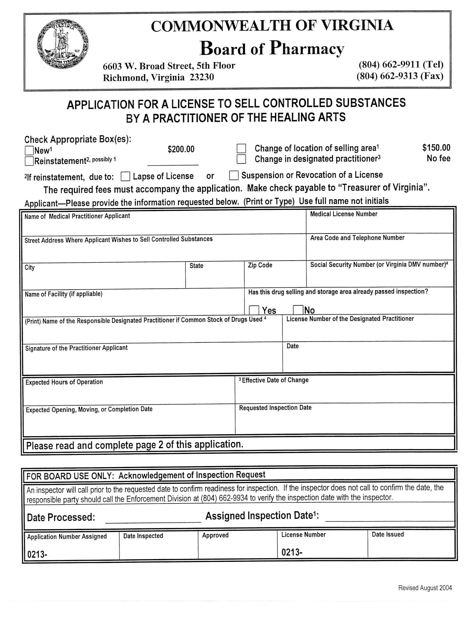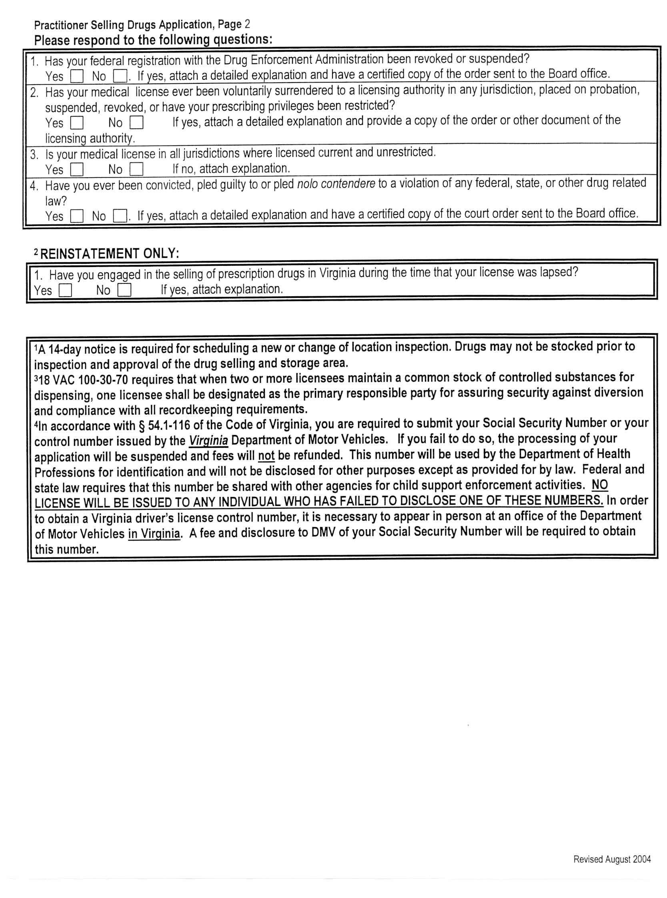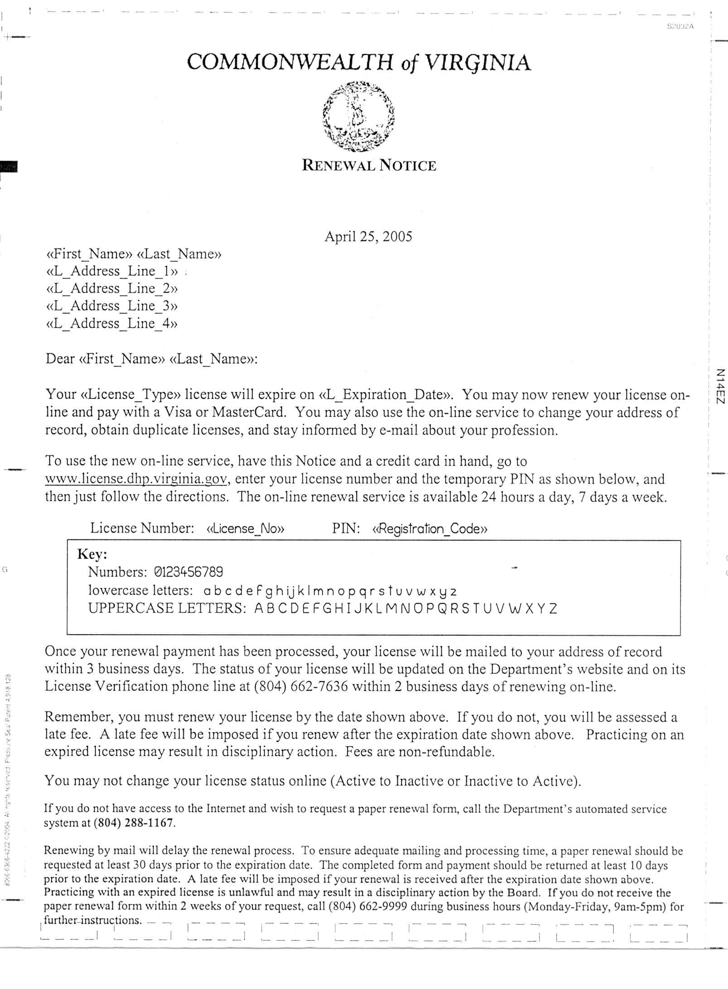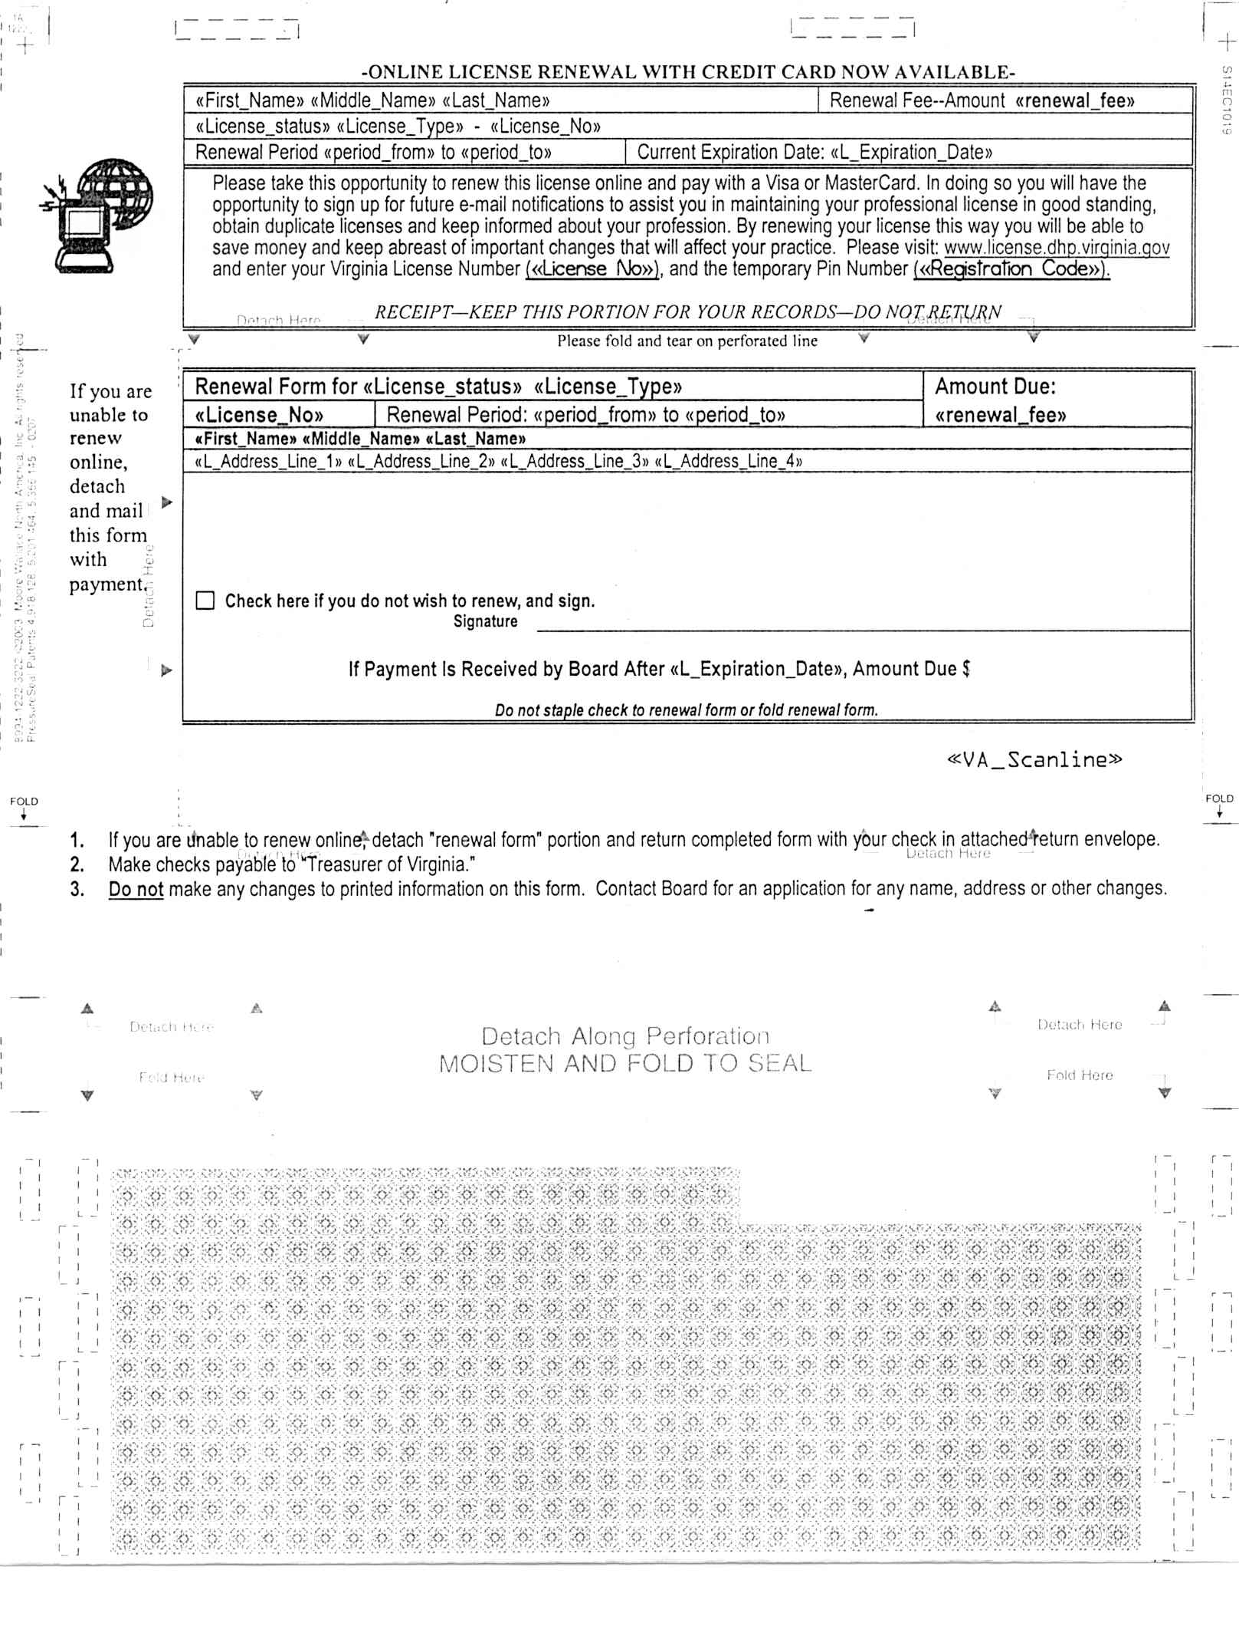
VA.R. Doc. No. R05-45; Filed May 20, 2005, 2:39 p.m.

1 Fees for reinstatement after two years under the current regulations: ($180 in back fees) + ($70 delinquent fee) = $250. Fees for reinstatement after two years under the proposed regulations: $210. $250 - $210 = $40.
2 Fees for reinstatement after three years under the current regulations: ($270 in back fees) + ($70 delinquent fee) = $340. Fees for reinstatement after three years under the proposed regulations: $210. $340 - $210 = $130.
3 Fees for reinstatement after four years under the current regulations: ($360 in back fees) + ($70 delinquent fee) = $430. Fees for reinstatement after four years under the proposed regulations: $210. $430 - $210 = $220.
4 Fees for reinstatement after five years under the current regulations: ($450 in back fees) + ($70 delinquent fee) = $520. Fees for reinstatement after four years under the proposed regulations: $210. $520 - $210 = $310.
5 $360 = $210 reinstatement fee + $150 reinspection fee
6 Fees for reinstatement after two years under the current regulations: ($180 in back fees) + ($70 delinquent fee) = $250. Fees for reinstatement after two years under the proposed regulations: ($210 reinstatement fee) + ($150 reinspection fee) = $360. $250 - $360 = -$110.
7 Fees for reinstatement after three years under the current regulations: ($270 in back fees) + ($70 delinquent fee) = $340. Fees for reinstatement after three years under the proposed regulations: ($210 reinstatement fee) + ($150 reinspection fee) = $360. $340 - $360 = -$20.
8 Fees for reinstatement after four years under the current regulations: ($360 in back fees) + ($70 delinquent fee) = $430. Fees for reinstatement after four years under the proposed regulations: ($210 reinstatement fee) + ($150 reinspection fee) = $360. $430 - $360 = $70.
9 Fees for reinstatement after four years under the current regulations: ($450 in back fees) + ($70 delinquent fee) = $520. Fees for reinstatement after four years under the proposed regulations: ($210 reinstatement fee) + ($150 reinspection fee) = $360. $520 - $360 = $160.
10 November 2003 U.S. Bureau of Labor Statistics National Occupational Employment and Wage Estimates (mean annual salary): Family and General Practitioners ($139,860), Internists ($159,820), Podiatrists ($107,390), Pharmacy Technicians ($24,540).
11 Source: § 54.1-3319 of the Code of Virginia.

