TITLE 18. PROFESSIONAL AND OCCUPATIONAL LICENSING
BOARD FOR BARBERS AND COSMETOLOGY
Title of Regulation: 18 VAC 41-50. Tattooing Regulations (adding 18 VAC 41-50-10 through 18 VAC 41-50-220).
Statutory Authority: § 54.1-201 of the Code of Virginia.
Public Hearing Date: October 17, 2005 - 10 a.m.
Public comments may be submitted until October 21, 2005.
(See Calendar of Events section
for additional information)
Agency Contact: William H. Ferguson, II, Executive Director, Board for Barbers and Cosmetology, 3600 West Broad Street, Richmond, VA 23230, telephone (804) 367-8590, FAX (804) 367-6295 or e-mail william.ferguson@dpor.virginia.gov.
Basis: The proposed regulatory action to promulgate regulations governing the licensure and practice of tattooing under the Board for Barbers and Cosmetology is mandated by Chapter 869 of the 2002 Acts of Assembly.
Section 54.1-201 provides the board the authority to promulgate regulations to administer the regulatory system.
Purpose: The board proposes to promulgate regulations governing the licensure and practice of tattooing as directed by Chapter 869 of the 2002 Acts of Assembly.
The proposed regulatory action is necessary to ensure minimal competence of tattooing practitioners. This regulatory action will establish qualifications for licensure, standards of practice, and requirements for maintaining licensure as a tattooer or tattoo parlor in the Commonwealth of Virginia. This regulatory action will establish fees necessary to administer the licensure program.
As directed by the 2002 General Assembly, this regulatory action is required to protect the health, safety and welfare of citizens of the Commonwealth in that it will provide for and ensure that licensees have met qualifications that demonstrate competency that protects the health, safety and welfare of citizens of the Commonwealth and that health and sanitary standards and safety are adequate in parlors where tattooing services are being provided.
Substance: The proposed regulations contain provisions for the licensing of tattooers under the Board for Barbers and Cosmetology as directed by Chapter 869 of the 2002 Acts of Assembly. In addition to establishing the requirements for licensure, these regulations will ensure competency and integrity of all licensees and provide for and ensure that health and sanitation standards are adequate in facilities where tattoo services are provided.
These regulatory requirements include (i) definitions of words and terms relative to the practice of providing tattooing services that will ensure that licensees understand the scope and limitations of their profession; (ii) general requirements for obtaining a license to provide services as a tattooer; (iii) requirements for becoming a tattooing apprenticeship sponsor; (iv) general requirements for obtaining a license to operate a tattoo parlor; (v) fees for initial, renewal, and reinstatement applications for tattooers and tattoo parlors; (vi) sanitation and safety standards for tattoo parlors that address disinfection and storage of implements, sanitation of equipment, and safety standards pertaining to the use of chemical products, the proper handling of blood spills, and client health guidelines; (vii) measures to be taken to ensure that clients are qualified to receive tattooing services in compliance with § 18.2-371.3 of the Code of Virginia pertaining to minimum age; and (viii) requirements for obtaining certain disclosures and maintenance of records of notification to the client pertaining to risks associated with receiving tattooing services.
Issues: The primary advantage of the proposed regulatory action is that it will establish the licensing requirements for the practice of tattooing. The proposed regulatory action will be an advantage to the public in that it will provide clear and effective regulations to ensure competency and integrity and prevent deceptive or misleading practices by individuals providing tattooing services.
There are no disadvantages to the public or the Commonwealth with regard to regulations governing the licensure and practice of tattooing practitioners.
Department of Planning and Budget's Economic Impact Analysis: The Department of Planning and Budget (DPB) has analyzed the economic impact of this proposed regulation in accordance with § 2.2-4007 H of the Administrative Process Act and Executive Order Number 21 (02). Section 2.2-4007 H requires that such economic impact analyses include, but need not be limited to, the projected number of businesses or other entities to whom the regulation would apply, the identity of any localities and types of businesses or other entities particularly affected, the projected number of persons and employment positions to be affected, the projected costs to affected businesses or entities to implement or comply with the regulation, and the impact on the use and value of private property. The analysis presented below represents DPB’s best estimate of these economic impacts.
Summary of the proposed regulation. Pursuant to Chapter 869 of the 2002 Acts of Assembly, the Board for Barbers and Cosmetology (board) proposes to establish Tattooing Regulations. The proposed regulations address: (i) requirements for obtaining a tattooer license; (ii) requirements for a tattooing apprenticeship sponsor; (iii) tattoo parlor licensure; (iv) fees; (v) license renewal; (vi) client qualifications, disclosures, and records; and (vii) grounds for licensure revocation, etc.
Estimated economic impact. Currently tattooists and tattoo parlors are not licensed or certified by the Commonwealth. Pursuant to Chapter 869 of the 2002 Acts of Assembly, the board proposes to establish regulations that require that providers of tattooing services be licensed and detail how licensure may be obtained. Licensure of tattoo artists and tattoo parlors can be beneficial to the public in that transmission of disease and occurrences of injury may be reduced due to required instruction concerning disease transmission and safety procedures, and physical facility and operations requirements that are designed to minimize such risks. The U.S. Food and Drug Administration (FDA) considers tattooing to bear a strong risk of infection; the FDA currently prohibits persons who obtain a tattoo from donating blood for one year, due to the infection risk.1
Also, clients will receive their tattoos from either an experienced artist, or from a new artist who is supervised and trained by an experienced artist. Without licensure the artist could be someone with very little experience who is receiving no supervision or training. The requirement that tattooists be either experienced or supervised and trained by someone who is experienced may reduce the frequency that inexperience-related substandard tattoos are provided by professionals.
On the other hand, introducing required licensure will likely reduce the supply of tattooing services and increase the market prices for those services. As will be detailed below, the costs for an individual to offer tattooing services, who has not become licensed via a "grandfather clause," will increase significantly with the introduction of the licensure requirement. Some potential tattoo artists who would have chosen to sell their services without the licensure requirement will likely chose not to sell tattooing services if they must face the time and dollar costs associated with obtaining licensure. Reduced competition for those that do offer services will likely result in higher market prices for those services.2
Fewer professional practitioners offering services and higher prices may encourage more individuals, particularly teenagers, to obtain tattoos from friends or other amateurs. According to a recent article in the journal Contemporary Pediatrics,
Teenagers often obtain tattoos from friends or other amateurs or tattoo themselves using straight pins, pencils, or pens and mascara, charcoal, or dirt as pigments. … These types of tattoos carry a high risk of infection and reactions to the materials used as pigments.3
To the extent that potential higher prices and reduced numbers of professionals induce some price sensitive and distance sensitive4 individuals to obtain their tattoos from friends or other amateurs rather than from professionals, the benefit of potential reduced unsanitary and unsafe practices by professionals may be partially offset.
Tattooer licensure. Section 54.1-703 of the Code of Virginia requires that no person may engage in tattooing without a valid license issued by the board.5 The board proposes three methods by which individuals can become licensed tattooists in Virginia:6 (i) passing a board-approved examination, (ii) holding current licensure in another U.S. jurisdiction that has substantially equivalent licensure requirements, or (iii) qualifying under a "grandfather clause." In order to become eligible to sit for a board-approved tattooist licensure examination, the applicant must first successfully complete a board-approved apprenticeship program. In order to become eligible to enroll in a board-approved apprenticeship program, the applicant must first satisfactorily complete a course in health education to include but not limited to blood-borne disease, sterilization, and aseptic techniques related to tattooing, first aid, and CPR.
The proposed regulations specify that an approved apprenticeship program must consist of:7
1. At least 350 hours devoted to theory pertaining to microbiology, immunization, safety, blood borne pathogen standards, and professional standards.
2. At least 150 hours devoted to theory pertaining to sanitation and disinfection.
3. At least 1,000 hours devoted to practical training, including at least 100 performances.
All of the above training must be provided by an approved apprenticeship sponsor. To become an approved apprenticeship sponsor, individuals must hold a current Virginia tattooer license and have had at least seven years of legal practice as a tattooist. No demonstration of knowledge or skill through testing or otherwise is required to become an apprenticeship sponsor. Initially most approved apprenticeship sponsors will have received their Virginia tattooer license via the "grandfather clause." Potentially a small number of sponsors may obtain Virginia licensure via holding current licensure in another U.S. jurisdiction that has substantially equivalent licensure requirements.
The "grandfather clause" states that persons who (i) apply for licensure between July 1, 2004, and July 1, 2005, (ii) have completed five years of documented work experience as a tattooer, and (iii) have completed health education to include bloodborne disease, sterilization, and aseptic techniques related to tattooing and first aid and CPR that is acceptable to the board, are not required to take the licensure examination. Since individuals that obtain licensure through this method are not required to take the licensure examination, they consequently do not need to complete an apprenticeship either.8
In a 2001 study published in the journal Public Health Reports,9 researchers found that "Tattooists have an understanding of the risks associated with exposure to blood, but this knowledge is not fully operationalized in the workplace. Interventions should focus on needle disposal, handwashing, cross-contamination, and cleaning prior to sterilization. Tattooists with (at least) 10 years of experience are most in need of intervention." Thus this study found that tattooists with 10 years or more of experience were more likely to practice in an unsafe manner than less experienced practitioners.
Since most initial apprenticeship sponsors will have obtained their license via the "grandfather clause" that does not require the passing of an examination or any other demonstration of knowledge or skill, and the available research does not provide confidence that all or most experienced tattooists are competent to teach proper procedures to mitigate health and safety risks, the potential benefit of requiring licensure applicants to complete an apprenticeship program may not be large.
Tattoo parlor licensure. Section 54.1-704.1 of the Code of Virginia prohibits tattoo parlors from operating without a board-issued license. In order for a tattoo parlor to be licensed, its physical facilities and operations must meet numerous requirements designed to minimize the transmission of disease and occurrences of injury. Requirements include (but are not limited to):
1. General cleanliness.
2. Physical facilities kept in good repair.
3. Blood spill clean-up kit in the work area.
4. Disinfecting of surfaces that come in contact with blood with an EPA registered germicide solution.
5. Cabinets for the storage of instruments, dyes, pigments, single use articles, carbon stencils, and other utensils for each tattooer.
6. Disposal of all materials applied to the human skin after each use.
7. Tattooing area be constructed of smooth, hard surfaces that are non-porous, free of open holes or cracks, light colored, and easily cleaned.
8. Lighting of at least 50 foot-candles of illumination in the tattooing and sterilization areas.
9. Adequate mechanical ventilation.
10. Hand-cleaning facilities with unobstructed access to the tattooing area such that the tattooer can return to the tattooing area without having to touch anything with his hands. The hand-cleaning facilities must be equipped with: (i) hot and cold (or tempered) running water under pressure and liquid germicidal soap, or with a sanitizing solution to clean hands, (ii) single-use towels or mechanical hand drying devices, and (iii) a covered refuse container.
11. Animals in the tattooing or sterilization areas.
12. No use of tobacco or alcoholic beverages in the tattooing or sterilization areas.
Compliance with each of these proposed requirements will likely reduce the probability of either disease transmission or injury occurring during the operation of the tattoo parlor. No accurate estimates of the reduced probability of disease transmission or injury are currently available. Thus, a useful comparison of the estimated value of such a reduced probability of disease transmission or injury to the costs of complying with the requirements cannot be currently made.
Fees. In order to pay for the administrative costs of licensing and otherwise regulating tattooists and tattoo parlors, the board must assess fees. The proposed fees are listed in the following table.

Licensure Fee Type | Amount Due
Individual:
Initial | $55
Renewal | $55
Reinstatement | $110 (includes $55 renewal fee and $55 reinstatement fee)
Parlor:
Initial | $90
Renewal | $90
Reinstatement | $180 (includes $90 renewal fee and $90 reinstatement fee)
Individual and parlor licenses expire two years from the last day of the month in which they are issued. The fee for examination or reexamination is subject to contracted charges to the board by an outside vendor. These contracts are competitively negotiated and bargained for in compliance with the Virginia Public Procurement Act (§ 2.2-4300 et seq. of the Code of Virginia). Fees may be adjusted and charged to the candidate in accordance with these contracts. The fee shall not exceed $225 per candidate.
Businesses and entities affected. The department estimates that 500 individuals and entities will seek licensure as a tattooer or a tattoo parlor. Purchasers and potential purchasers of tattooing services are affected as well.
Localities particularly affected. All Virginia localities are affected by these proposed regulations.
Projected impact on employment. The costs imposed by the proposed regulations will likely discourage some individuals from pursuing tattooing as a profession. Thus, total employment in this profession is likely to be lower than it would be without licensure.
Effects on the use and value of private property. The proposed requirement for a lengthy apprenticeship will likely discourage some individuals from pursuing tattooing as a profession. The fees charged to practitioners and parlors may discourage entry of tattooers and tattoo parlors as well. On the other hand, the reduced competition should enable practicing tattooers and tattoo parlors to charge higher prices for their services. This will tend to increase the value of already existing businesses, and may very well exceed the increased costs of paying licensure fees and other costs associated with licensure (such as meeting some physical facility requirement that would not have been met without licensure requirements, for example).
References.
Kleiner, M. M., "Occupational licensing," The Journal of Economic Perspectives, Fall 2000, 14:4.
Martel, S., and J. E. Anderson, "Decorating the ‘human canvas’: Body art and your patients; tattoos and body piercing have caught on as teenage, and even preteen, fashion statements. Here’s how to help your patients avoid the pitfalls of this form of self-expression," Contemporary Pediatrics, August 2002 v19 i8 p86 (10).
Raymond, M. J., P.L. Pirie and L.I. Halcon, "Infection control among professional tattooists in Minneapolis and St. Paul, MN," Public Health Reports, May-June 2001, 16.
Agency Response to Department of Planning and Budget’s Economic Impact Analysis. Tattooers and tattoo parlors are currently licensed. On July 1, 2004, §§ 54.1-703 and 54.1-704.1 of the Code of Virginia, requiring license for tattooing and tattoo parlors, and Emergency Tattooing Regulations went into effect. Tattooers and tattoo parlors are currently licensed in accordance with statutes and emergency regulations.
Tattooing Regulations are not introducing required licensure. Chapter 869 of the 2002 Acts of Assembly mandated a separate licensing category for tattooing practitioners as well as the parlors where these services are provided under the Board for Barbers and Cosmetology. These statutes are found in Title 54.1, Chapter 7 of the Code of Virginia and went into effect on July 1, 2004. The proposed regulatory action to promulgate regulations governing the licensure and practice of tattooing under the Board for Barbers and Cosmetology is mandated by Chapter 869 of the 2002 Acts of Assembly.
Summary:
The proposed regulations establish (i) requirements for obtaining a license to provide services as a tatooer; (ii) requirements for becoming a tattooing apprenticeship sponsor; (iii) requirements for obtaining a license to operate a tattoo parlor; (iv) fees for initial, renewal, and reinstatement applications for tattooers and tattoo parlors; (v) license renewal requirements; (vi) sanitation and safety standards for tattoo parlors that address disinfection and storage of implements, sanitation of equipment, and safety standards pertaining to the use of chemical products, the proper handling of blood spills, and client health guidelines; (vii) measures to be taken to ensure that clients are qualified to receive tattooing services in compliance with § 18.2-371.3 of the Code of Virginia pertaining to minimum age; and (viii) requirements for obtaining certain disclosures and maintenance of records of notification to the client pertaining to risks associated with receiving tattooing services.
CHAPTER 50.
TATTOOING REGULATIONS.
PART I.
GENERAL.
18 VAC 41-50-10. Definitions.
The following words and terms when used in this chapter shall have the following meanings unless the context clearly indicates otherwise. All terms defined in Chapter 7 (§ 54.1-700 et seq.) of Title 54.1 of the Code of Virginia are incorporated in this chapter.
"Apprenticeship program" means an approved tattooing training program conducted by an approved apprenticeship sponsor.
"Apprenticeship sponsor" means an individual approved to conduct tattooing apprenticeship training who meets the qualifications in 18 VAC 41-50-70.
"Aseptic technique" means a hygienic practice that prevents and hinders the direct transfer of microorganisms, regardless of pathogenicity, from one person or place to another person or place.
"Endorsement" means a method of obtaining a license by a person who is currently licensed in another state.
"Gratuitous services" as used in § 54.1-701.5 of the Code Virginia means providing tattooing services without receiving compensation or reward, or obligation. Gratuitous services do not include services provided at no charge when goods are purchased.
"Licensee" means any person, partnership, association, limited liability company, or corporation holding a license issued by the Board for Barbers and Cosmetology as defined in § 54.1-700 of the Code of Virginia.
"Reinstatement" means having a license restored to effectiveness after the expiration date has passed.
"Renewal" means continuing the effectiveness of a license for another period of time.
"Sterilization area" means a separate room or area separate from workstations with restricted client access in which tattooing instruments are cleaned, disinfected, and sterilized.
"Temporary location" means a fixed location at which tattooing is performed for a specified length of time of not more than seven days in conjunction with a single event or celebration.
PART II.
ENTRY.
18 VAC 41-50-20. General requirements for tattooer.
A. In order to receive a license as a tattooer in compliance with § 54.1-703 of the Code of Virginia, an applicant must meet the following qualifications:
1. The applicant must be in good standing as a tattooer in every jurisdiction where licensed, certified, or registered. The applicant shall disclose to the board at the time of application for licensure any disciplinary action taken in another jurisdiction in connection with the applicant's practice as a tattooer. The applicant shall disclose to the board at the time of application for licensure whether he has been previously licensed in Virginia as a tattooer.
2. The applicant shall disclose his physical address. A post office box is not acceptable.
3. The applicant shall sign, as part of the application, a statement certifying that the applicant has read and understands the Virginia tattooing license laws and the board’s tattooing regulations.
4. In accordance with § 54.1-204 of the Code of Virginia, the applicant must not have been convicted in any jurisdiction of a misdemeanor or felony that directly relates to the profession of tattooing. The board shall have the authority to determine, based upon all the information available, including the applicant’s record of prior convictions, if the applicant is unfit or unsuited to engage in the profession of tattooing. The board will decide each case by taking into account the totality of the circumstances. Any plea of nolo contendere shall be considered a conviction for the purposes of this section. The applicant shall provide a certified copy of a final order, decree or case decision by a court or regulatory agency with the lawful authority to issue such order, decree or case decision, and such copy shall be admissible as prima facie evidence of such conviction. This record shall be forwarded by the applicant to the board within 10 days after all appeal rights have expired.
5. The applicant shall provide evidence satisfactory to the board that the applicant has passed the board approved examination, administered either by the board or by a designated testing service.
6. Persons who (i) make application [within one year after the effective date of this chapter]; (ii) have completed five years of documented work experience within the preceding eight years as a tattooer; and (iii) have completed a minimum of five hours of health education to include but not limited to bloodborne disease, sterilization, and aseptic techniques related to tattooing and first aid and CPR that is acceptable to the board are not required to complete subdivision 5 of this subsection.
B. Eligibility to sit for board-approved examination.
1. Training in the Commonwealth of Virginia. Any person completing an approved tattooing apprenticeship program in a Virginia licensed tattoo parlor shall be eligible to sit for the examination.
2. Training outside of the Commonwealth of Virginia, but within the United States and its territories. Any person completing a tattooing training or apprenticeship program that is substantially equivalent to the Virginia program but is outside of the Commonwealth of Virginia must submit to the board documentation of the successful completion of training or apprenticeship to be eligible for examination.
18 VAC 41-50-30. License by endorsement.
Upon proper application to the board, any person currently licensed to practice as a tattooer in any other state or jurisdiction of the United States and who has completed a training or apprenticeship program and an examination that is substantially equivalent to that required by this chapter may be issued a tattooer license without an examination. The applicant must also meet the requirements set forth in 18 VAC 41-50-20 A 1 through A 4.
18 VAC 41-50-40. Examination requirements and fees.
A. Applicants for initial licensure shall pass an examination approved by the board. The examinations may be administered by the board or by a designated testing service.
B. Any candidate failing to appear as scheduled for examination shall forfeit the examination fee.
18 VAC 41-50-50. Reexamination requirements.
Any applicant who does not pass a reexamination within one year of the initial examination date shall be required to submit a new application and examination fee.
18 VAC 41-50-60. Examination administration.
A. The examinations may be administered by the board or the designated testing service.
B. The applicant shall follow all procedures established by the board with regard to conduct at the examination. Such procedures shall include any written instructions communicated prior to the examination date and any instructions communicated at the site, either written or oral, on the date of the examination. Failure to comply with all procedures established by the board and the testing service with regard to conduct at the examination may be grounds for denial of application.
C. The fee for examination or reexamination is subject to contracted charges to the board by an outside vendor. These contracts are competitively negotiated and bargained for in compliance with the Virginia Public Procurement Act (§ 2.2-4300 et seq. of the Code of Virginia). Fees may be adjusted and charged to the candidate in accordance with these contracts. The fee shall not exceed $225 per candidate.
18 VAC 41-50-70. General requirements for a tattooing apprenticeship sponsor.
A. Upon filing an application with the Board for Barbers and Cosmetology, any person meeting the qualifications set forth in this section may be eligible to sponsor a tattooing apprentice if the person:
1. Holds a current Virginia tattooer license;
2. Provides documentation of legally practicing tattooing for at least seven years; and
3. Provides documentation indicating that he is in good standing in all jurisdictions where the practice of tattooing is regulated.
B. Apprenticeship sponsors shall be required to maintain a tattooer license.
C. Apprenticeship sponsors shall ensure compliance with the 1500 hour tattooing apprenticeship program and tattooing apprenticeship standards.
18 VAC 41-50-80. Parlor license.
A. Any individual wishing to operate a tattoo parlor shall obtain a tattoo parlor license in compliance with § 54.1-704.1 of the Code of Virginia.
B. A tattoo parlor license shall not be transferable and shall bear the same name and address of the business. Any changes in the name, address, or ownership of the parlor shall be reported to the board in writing within 30 days of such changes. New owners shall be responsible for reporting such changes in writing to the board within 30 days of the changes.
C. In the event of a closing of a tattoo parlor, the board must be notified by the owners in writing within 30 days of the closing, and the license must be returned by the owners to the board.
D. Any individual wishing to operate a tattoo parlor in a temporary location must have a tattoo parlor license issued by the board.
PART III.
FEES.
18 VAC 41-50-90. Fees.
The following fees apply:
FEE TYPE | AMOUNT DUE | WHEN DUE
Individuals:
Application | $55 | With application
License by Endorsement | $55 | With application
Renewal | $55 | With renewal card prior to expiration date
Reinstatement | $110*  *includes $55 renewal fee and $55 reinstatement fee | With reinstatement application
Parlors:
Application | $90 | With application
Renewal | $90 | With renewal card prior to expiration date
Reinstatement | $180*  *includes $90 renewal fee and $90 reinstatement fee | With reinstatement application
18 VAC 41-50-100. Refunds.
All fees are nonrefundable and shall not be prorated.
PART IV.
RENEWAL/REINSTATEMENT.
18 VAC 41-50-110. License renewal required.
All tattooer licenses and tattoo parlor licenses shall expire two years from the last day of the month in which they were issued.
18 VAC 41-50-120. Continuing education requirement.
All licensed tattooers shall be required to satisfactorily complete a minimum of five hours of health education to include but not limited to bloodborne disease, sterilization, and aseptic techniques related to tattooing, first aid and CPR during their licensed term. Documentation of training completion shall be provided at the time of renewal along with the required fee.
18 VAC 41-50-130. Notice of renewal.
The Department of Professional and Occupational Regulation will mail a renewal notice to the licensee outlining the procedures for renewal. Failure to receive this notice, however, shall not relieve the licensee of the obligation to renew. If the licensee fails to receive the renewal notice, a copy of the old license may be submitted as evidence of intent to renew, along with the required fee.
18 VAC 41-50-140. Failure to renew.
A. When a tattooer fails to renew his license within 30 days following its expiration date, the licensee shall meet the renewal requirements prescribed in 18 VAC 41-50-130, and apply for reinstatement of the license by submitting to the Department of Professional and Occupational Regulation a reinstatement application along with the required renewal and reinstatement fees.
B. When a tattooer fails to renew his license within two years following the expiration date, reinstatement is no longer possible. To resume practice, the former licensee shall apply for licensure as a new applicant, shall meet all current application requirements, shall pass the board’s current examination and shall receive a new license.
C. When a tattoo parlor fails to renew its license within 30 days following the expiration date, it shall be required to apply for reinstatement of the license by submitting to the Department of Professional and Occupational Regulation a reinstatement application along with the required renewal and reinstatement fees.
D. When a tattoo parlor fails to renew its license within two years following the expiration date, reinstatement is no longer possible. To resume practice, the former licensee shall apply for licensure as a new applicant and shall meet all current application requirements.
E. The date a renewal fee is received by the Department of Professional and Occupational Regulation, or its agent, will be used to determine whether the requirement for reinstatement of a license is applicable and an additional fee is required.
F. When a license is reinstated, the licensee shall have the same license number and shall be assigned an expiration date two years from the previous expiration date of the license.
G. A licensee who reinstates his license shall be regarded as having been continuously licensed without interruption. Therefore, a licensee shall be subject to the authority of the board for activities performed prior to reinstatement.
H. A licensee who fails to reinstate his license shall be regarded as unlicensed from the expiration date of the license forward. Nothing in this chapter shall divest the board of its authority to discipline a licensee for a violation of the law or regulations during the period of time for which the individual was licensed.
PART V.
APPRENTICESHIP PROGRAMS.
18 VAC 41-50-150. General requirements.
A. Any person desiring to enroll in the tattooing apprenticeship program shall be required to provide documentation of satisfactory completion of a minimum of five hours of health education to include but not limited to bloodborne disease, sterilization, and aseptic techniques related to tattooing, and first aid and CPR.
B. Any tattooer desiring approval to perform the duties of an apprenticeship sponsor and offer the board’s tattooing apprenticeship program shall meet the requirements of 18 VAC 41-50-70.
18 VAC 41-50-160. Apprenticeship curriculum requirements.
Apprenticeship curriculum requirements are as follows:
1. Microbiology.
a. Microorganisms, viruses, bacteria, fungi;
b. Transmission cycle of infectious diseases; and
c. Characteristics of antimicrobial agents.
2. Immunization.
a. Types of immunizations;
b. Hepatitis A – G transmission and immunization;
c. HIV/AIDS;
d. Tetanus, streptococcal, zoonotic, tuberculosis, pneumococcal, and influenza;
e. Measles, mumps, and rubella;
f. Vaccines and immunization; and
g. General preventative measures to be taken to protect the tattooist and client.
3. Sanitation and disinfection.
a. Definition of terms.
(1) Sterilization;
(2) Disinfection and disinfectant;
(3) Sterilizer or sterilant;
(4) Antiseptic;
(5) Germicide;
(6) Decontamination; and
(7) Sanitation.
b. The use of steam sterilization equipment and techniques;
c. The use of chemical agents, antiseptics, disinfectants, and fumigants;
d. The use of sanitation equipment;
e. Preservice sanitation procedure; and
f. Post-service sanitation procedure.
4. Safety.
a. Proper needle handling and disposal;
b. How to avoid overexposure to chemicals;
c. The use of Material Safety Data Sheets;
d. Blood spill procedures;
e. Equipment and instrument storage; and
f. First aid and CPR.
5. Bloodborne pathogen standards.
a. OSHA and CDC bloodborne pathogen standards;
b. Control plan for bloodborne pathogens;
c. Exposure control plan for tattooers;
d. Overview of compliance requirements; and
e. Disorders and when not to service a client.
6. Professional standards.
a. History of tattooing;
b. Ethics;
c. Record keeping:
(1) Client health history;
(2) Consent forms; and
(3) HIPPA Standards.
d. Preparing station, making appointments, parlor ethics:
(1) Maintaining professional appearance, notifying clients of schedule changes; and
(2) Promoting services of the parlor and establishing clientele.
e. Parlor management:
(1) Licensing requirements; and
(2) Taxes.
7. Tattooing.
a. Client consultation;
b. Client health form;
c. Client disclosure form;
d. Client preparation;
e. Sanitation and safety precautions;
f. Implement selection and use;
g. Proper use of equipment; and
h. Material selection and use.
18 VAC 41-50-170. Hours of instruction and performances.
A. Curriculum requirements specified in 18 VAC 41-50-160 shall be taught over a minimum of 1500 hours as follows:
1. 350 hours shall be devoted to theory pertaining to subdivisions 1, 2, 4, 5 and 6 of 18 VAC 41-50-160;
2. 150 hours shall be devoted to theory pertaining to subdivision 3 of 18 VAC 41-50-160; and
3. The remaining 1000 hours shall be devoted to practical training and a total of 100 performances pertaining to subdivision 7 of 18 VAC 41-50-160.
B. An approved tattooing apprenticeship program may conduct an assessment of an apprentice’s competence in the theory and practical requirements for tattooing and, based on the assessment, give a maximum of 700 hours of credit towards the requirements in subdivisions A 1 and A 3 of this section. No credit shall be allowed for the 150 hours required in subdivision A 2 of this section.
PART VI.
STANDARDS OF PRACTICE.
18 VAC 41-50-180. Display of license.
A. Each tattoo parlor owner shall ensure that all current licenses issued by the board shall be displayed in the reception area of the parlor or in plain view of the public. Duplicate licenses shall be posted in a like manner in every parlor or location where the licensee provides services.
B. Each parlor owner shall ensure that no licensee performs any service beyond the scope of practice for the applicable license.
C. Each parlor owner shall offer to licensees the full series of Hepatitis B vaccine.
D. Each parlor owner shall maintain a record for each licensee of:
1. Proof of completion of the full series of Hepatitis B vaccine;
2. Proof of immunity by blood titer; or
3. Written declaration of refusal of the owner’s offer of a full series of Hepatitis B vaccine.
E. All licensees shall operate under the name in which the license is issued.
18 VAC 41-50-190. Physical facilities.
A. A parlor must be in a permanent building or portion of a building, which must be in a location permissible under local zoning codes, if any. If applicable, the parlor shall be separated from any living quarters by complete floor to ceiling partitioning and shall contain no access to living quarters.
B. The parlor or temporary location shall be maintained in a clean and orderly manner.
C. All facilities shall have a blood spill clean-up kit in the work area.
D. Work surfaces shall be cleaned with an EPA registered, hospital grade disinfectant. Surfaces that come in contact with blood or other body fluids shall be immediately disinfected with an EPA registered germicide solution. Appropriate personal protective equipment shall be worn during cleaning and disinfecting procedures.
E. Cabinets for the storage of instruments, dyes, pigments, single-use articles, carbon stencils and other utensils shall be provided for each operator and shall be maintained in a sanitary manner.
F. Bulk single-use articles shall be commercially packaged and handled in such a way as to protect them from contamination.
G. All materials applied to the human skin shall be from single-use articles or transferred from bulk containers to single-use containers and shall be disposed of after each use.
H. The walls, ceilings, and floors shall be kept in good repair. The tattooing area shall be constructed of smooth, hard surfaces that are nonporous, free of open holes or cracks, light colored, and easily cleaned. New parlors shall not include any dark-colored surfaces in the tattooing area. Existing parlors with dark-colored surfaces in the tattooing area shall replace the dark-colored surfaces with light-colored surfaces whenever the facilities are extensively remodeled or upon relocation of the business.
I. Parlors and temporary locations shall have adequate lighting of at least 50-foot candles of illumination in the tattooing and sterilization areas.
J. Adequate mechanical ventilation shall be provided in the parlor.
K. Each parlor or temporary location shall be equipped with hand-cleaning facilities for its personnel with unobstructed access to the tattooing area such that the tattooer can return to the area without having to touch anything with his hands. Hand-cleaning facilities shall be equipped either with hot and cold or tempered running water under pressure and liquid germicidal soap or with a sanitizing solution to clean hands. Hand-cleaning facilities shall be equipped with single-use towels or mechanical hand drying devices and a covered refuse container. Such facilities shall be kept clean and in good repair. All facilities must have running water and soap accessible for cleaning of hands contaminated by body fluids.
L. Animals are not permitted in the parlor or temporary location except for guide or service animals accompanying persons with disabilities, or nonmammalian animals in enclosed glass containers such as fish aquariums, which shall be outside of the tattooing or sterilization areas. No animals are allowed in the tattooing or sterilization areas.
M. Use of tobacco products and consumption of alcoholic beverages shall be prohibited in the tattooing or sterilization areas.
N. No food or drink will be stored or consumed in the tattooing or sterilization areas except for client’s use in order to sustain optimal physical condition; such food and drink must be individually packaged.
O. If tattooing is performed where cosmetology services are provided, it shall be performed in an area that is separate and enclosed.
18 VAC 41-50-200. Tattooer responsibilities
A. All tattooers shall provide to the owner:
1. Proof of completion of the full series of Hepatitis B vaccine;
2. Proof of immunity by blood titer; or
3. Written declaration of refusal of the owner's offer of a full series of Hepatitis B vaccine.
B. All tattooers shall wear clean outer garments, maintain a high degree of personal cleanliness, and conform to hygienic practices while on duty.
C. All tattooers shall clean their hands thoroughly using hot or tempered water with a liquid germicidal soap or use sanitizing solution to clean hands before and after tattooing and as necessary to remove contaminants.
D. All tattooers must wear single-use examination gloves while assembling tattooing instruments and while tattooing.
E. Each time there is an interruption in the service, each time the gloves become torn or perforated, or whenever the ability of the gloves to function as a barrier is compromised.
1. Gloves should be removed and disposed of; and
2. Hands shall be cleaned and a fresh pair of gloves used.
F. Tattooers shall use standard precautions while tattooing. A tattooer diagnosed with a communicable disease shall provide to the department a written statement from a health care practitioner that the tattooer’s condition no longer poses a threat to public health.
G. Tattooers with draining lesions on their hands or face will not be permitted to work until cleared by a health-care professional.
H. The area of the client’s skin to be tattooed shall be cleaned with an approved germicidal soap according to label directions.
I. Tattooing inks and dyes shall be placed in a single-use disposable container for each client. Following the procedure, the unused contents and container will be properly disposed of.
J. If shaving is required, razors shall be single-use and disposed of in a puncture resistant container.
K. Each tattooer performing any tattooing procedures in the parlor shall have the education, training and experience, or any combination thereof, to practice aseptic technique and prevent the transmission of bloodborne pathogens. All procedures shall be performed using aseptic technique.
L. A set of individual, sterilized needles shall be used for each client. Single-use disposable instruments shall be disposed of in a puncture resistant container.
M. Used, nondisposable instruments shall be kept in a separate, puncture resistant container until brush scrubbed in hot water soap and then sterilized by autoclaving. Contaminated instruments shall be handled with disposable gloves.
N. Used instruments that are ultrasonically cleaned shall be rinsed under running hot water prior to being placed in the used instrument container;
O. Used instruments that are not ultrasonically cleaned prior to being placed in the used instrument container shall be kept in a germicidal or soap solution until brush scrubbed in hot water and soap and sterilized by autoclaving.
P. The ultrasonic unit shall be sanitized daily with a germicidal solution.
Q. Nondisposable instruments shall be sterilized and shall be handled and stored in a manner to prevent contamination. Instruments to be sterilized shall be sealed in bags made specifically for the purpose of autoclave sterilization and shall include the date of sterilization. If nontransparent bags are utilized, the bag shall also list the contents.
R. Autoclave sterilization bags with a color code indicator that changes color upon proper sterilization shall be utilized during the autoclave sterilization process.
S. Instruments shall be placed in the autoclave in a manner to allow live steam to circulate around them.
T. Contaminated disposable and single-use items shall be disposed of in accordance with state regulations regarding disposal of biological hazardous materials.
18 VAC 41-50-210. Client qualifications, disclosures, and records.
A. Except as permitted in § 18.2-371.3 of the Code of Virginia, a client must be a minimum of 18 years of age and shall present at the time of the tattooing a valid, government issued, positive identification card including, but not limited to, a driver’s license, passport, or military identification. The identification must contain a photograph of the individual and a printed date of birth.
B. The tattooer shall verify and document in the permanent client record the client’s age, date of birth, and the type of identification provided.
C. No person may be tattooed who appears to be under the influence of alcohol or drugs.
D. Tattooing shall not be performed on any skin surface that manifests any evidence of unhealthy conditions such as rashes, boils, infections, or abrasions.
E. Before receiving a tattoo, each client and client’s parent or guardian, if applicable, shall be informed verbally and in writing, using the client disclosure form prescribed by the board, about the possible risk and dangers associated with the application of each tattoo. Signatures of both the client and the tattooer shall be required on the client disclosure form to acknowledge receipt of both the verbal and written disclosures.
F. The tattoo parlor or temporary location shall maintain proper records for each client. The information shall be permanently recorded and made available for examination by the department or authorized agent. Records shall be maintained at the tattoo parlor for at least two years following the date of the last entry. The temporary location client records shall be maintained by the license holder. The permanent records shall include the following:
1. The name, address, and telephone number of the client;
2. The date tattooing was performed;
3. The client’s age, date of birth, and a copy of the positive identification provided to the tattooer;
4. The specific color or colors of the tattoo and, when available, the manufacturer’s catalogue or identification number of each color used;
5. The location on the body where the tattooing was performed;
6. The name of the tattooer;
7. A statement that the client has received a copy of applicable written care instructions, and that the client has read and understands the instructions; and
8. The signature of the client and if applicable parent or guardian.
18 VAC 41-50-220. Grounds for license revocation or suspension; denial of application, renewal or reinstatement; or imposition of a monetary penalty.
A. The board may, in considering the totality of the circumstances, fine any licensee and suspend or revoke or refuse to renew or reinstate any license, or deny any application issued under the provisions of Chapter 7 (§ 54.1-700 et seq.) of Title 54.1 of the Code of Virginia and the regulations of the board if the board finds that:
1. The licensee is incompetent, negligent in practice, or incapable mentally or physically, as those terms are generally understood in the profession, to practice as a tattooer;
2. The licensee or applicant is convicted of fraud or deceit in the practice of tattooing;
3. The licensee or applicant obtained, renewed or reinstated a license by false or fraudulent representation;
4. The licensee or applicant violates or induces others to violate, or cooperates with others in violating, any of the provisions of this chapter or Chapter 7 (§ 54.1-700 et seq.) of Title 54.1 of the Code of Virginia or any local ordinance or regulation governing standards of health and sanitation of the establishment in which tattooers may practice or offer to practice;
5. The licensee or applicant fails to produce, upon request or demand of the board or any of its agents, any document, book, record, or copy thereof in a licensee's or owner's possession or maintained in accordance with this chapter;
6. A licensee fails to notify the board of a change of name or address in writing within 30 days of the change for each and every license. The board shall not be responsible for the licensee's failure to receive notices, communications and correspondence caused by the licensee's failure to promptly notify the board in writing of any change of name or address or for any other reason beyond the control of the board;
7. The licensee or applicant publishes or causes to be published any advertisement that is false, deceptive, or misleading;
8. The licensee or applicant fails to notify the board in writing within 30 days of the suspension, revocation, or surrender of a license, certificate, or permit in connection with a disciplinary action in any other jurisdiction or of any license, certificate, or permit which has been the subject of disciplinary action in any other jurisdiction; or
9. In accordance with § 54.1-204 of the Code of Virginia, the licensee or applicant has been convicted in any jurisdiction of a misdemeanor or felony that directly relates to the profession of tattooing. The board shall have the authority to determine, based upon all the information available, including the applicant’s record of prior convictions, if the applicant is unfit or unsuited to engage in the profession of tattooing. The board will decide each case by taking into account the totality of the circumstances. Any plea of nolo contendere shall be considered a conviction for the purposes of this section. The applicant shall provide a certified copy of a final order, decree or case decision by a court or regulatory agency with the lawful authority to issue such order, decree or case decision, and such copy shall be admissible as prima facie evidence of such conviction. This record shall be forwarded by the applicant to the board within 10 days after all appeal rights have expired.
B. In addition to subsection A of this section, the board may, in considering the totality of the circumstances, revoke, suspend or refuse to renew or reinstate the license of any tattoo parlor or impose a fine as permitted by law, or both, if the board finds that:
1. The owner or operator of the tattoo parlor fails to comply with the facility requirements of tattoo parlors provided for in this chapter or in any local ordinances; or
2. The owner or operator allows a person who has not obtained a license to practice as a tattooer unless the person is duly enrolled as an apprentice.
C. In addition to subsection A of this section, the board may, in considering the totality of the circumstances, revoke, suspend or refuse to renew or reinstate the license of any licensee or impose a fine as permitted by law, or both, if the board finds that the licensee fails to take sufficient measures to prevent transmission of communicable or infectious diseases or fails to comply with any local, state or federal law or regulation governing the standards of health and sanitation for the practice of tattooing.
NOTICE: The forms used in administering 18 VAC 41-50, Tattooing Regulations, are listed below. Any amended or added forms are reflected in the listing and are published following the listing.
FORMS
Salon, Shop and Parlor License Application, 1213SLSH (7/1/04).
Tattooer License Application, 1231 LIC (7/1/04).
Tattooer Apprentice Certification Application, 1234TAC (8/1/05).
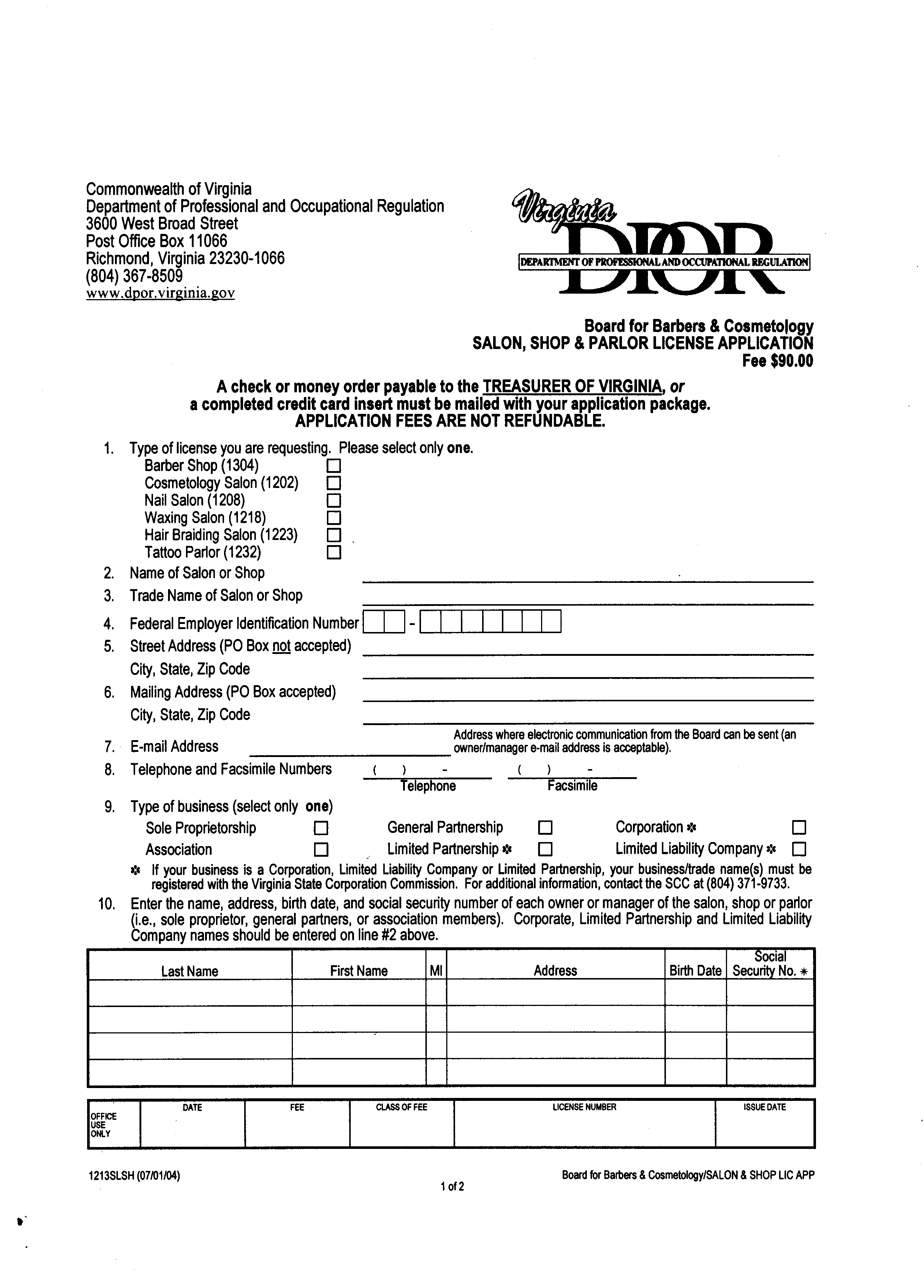
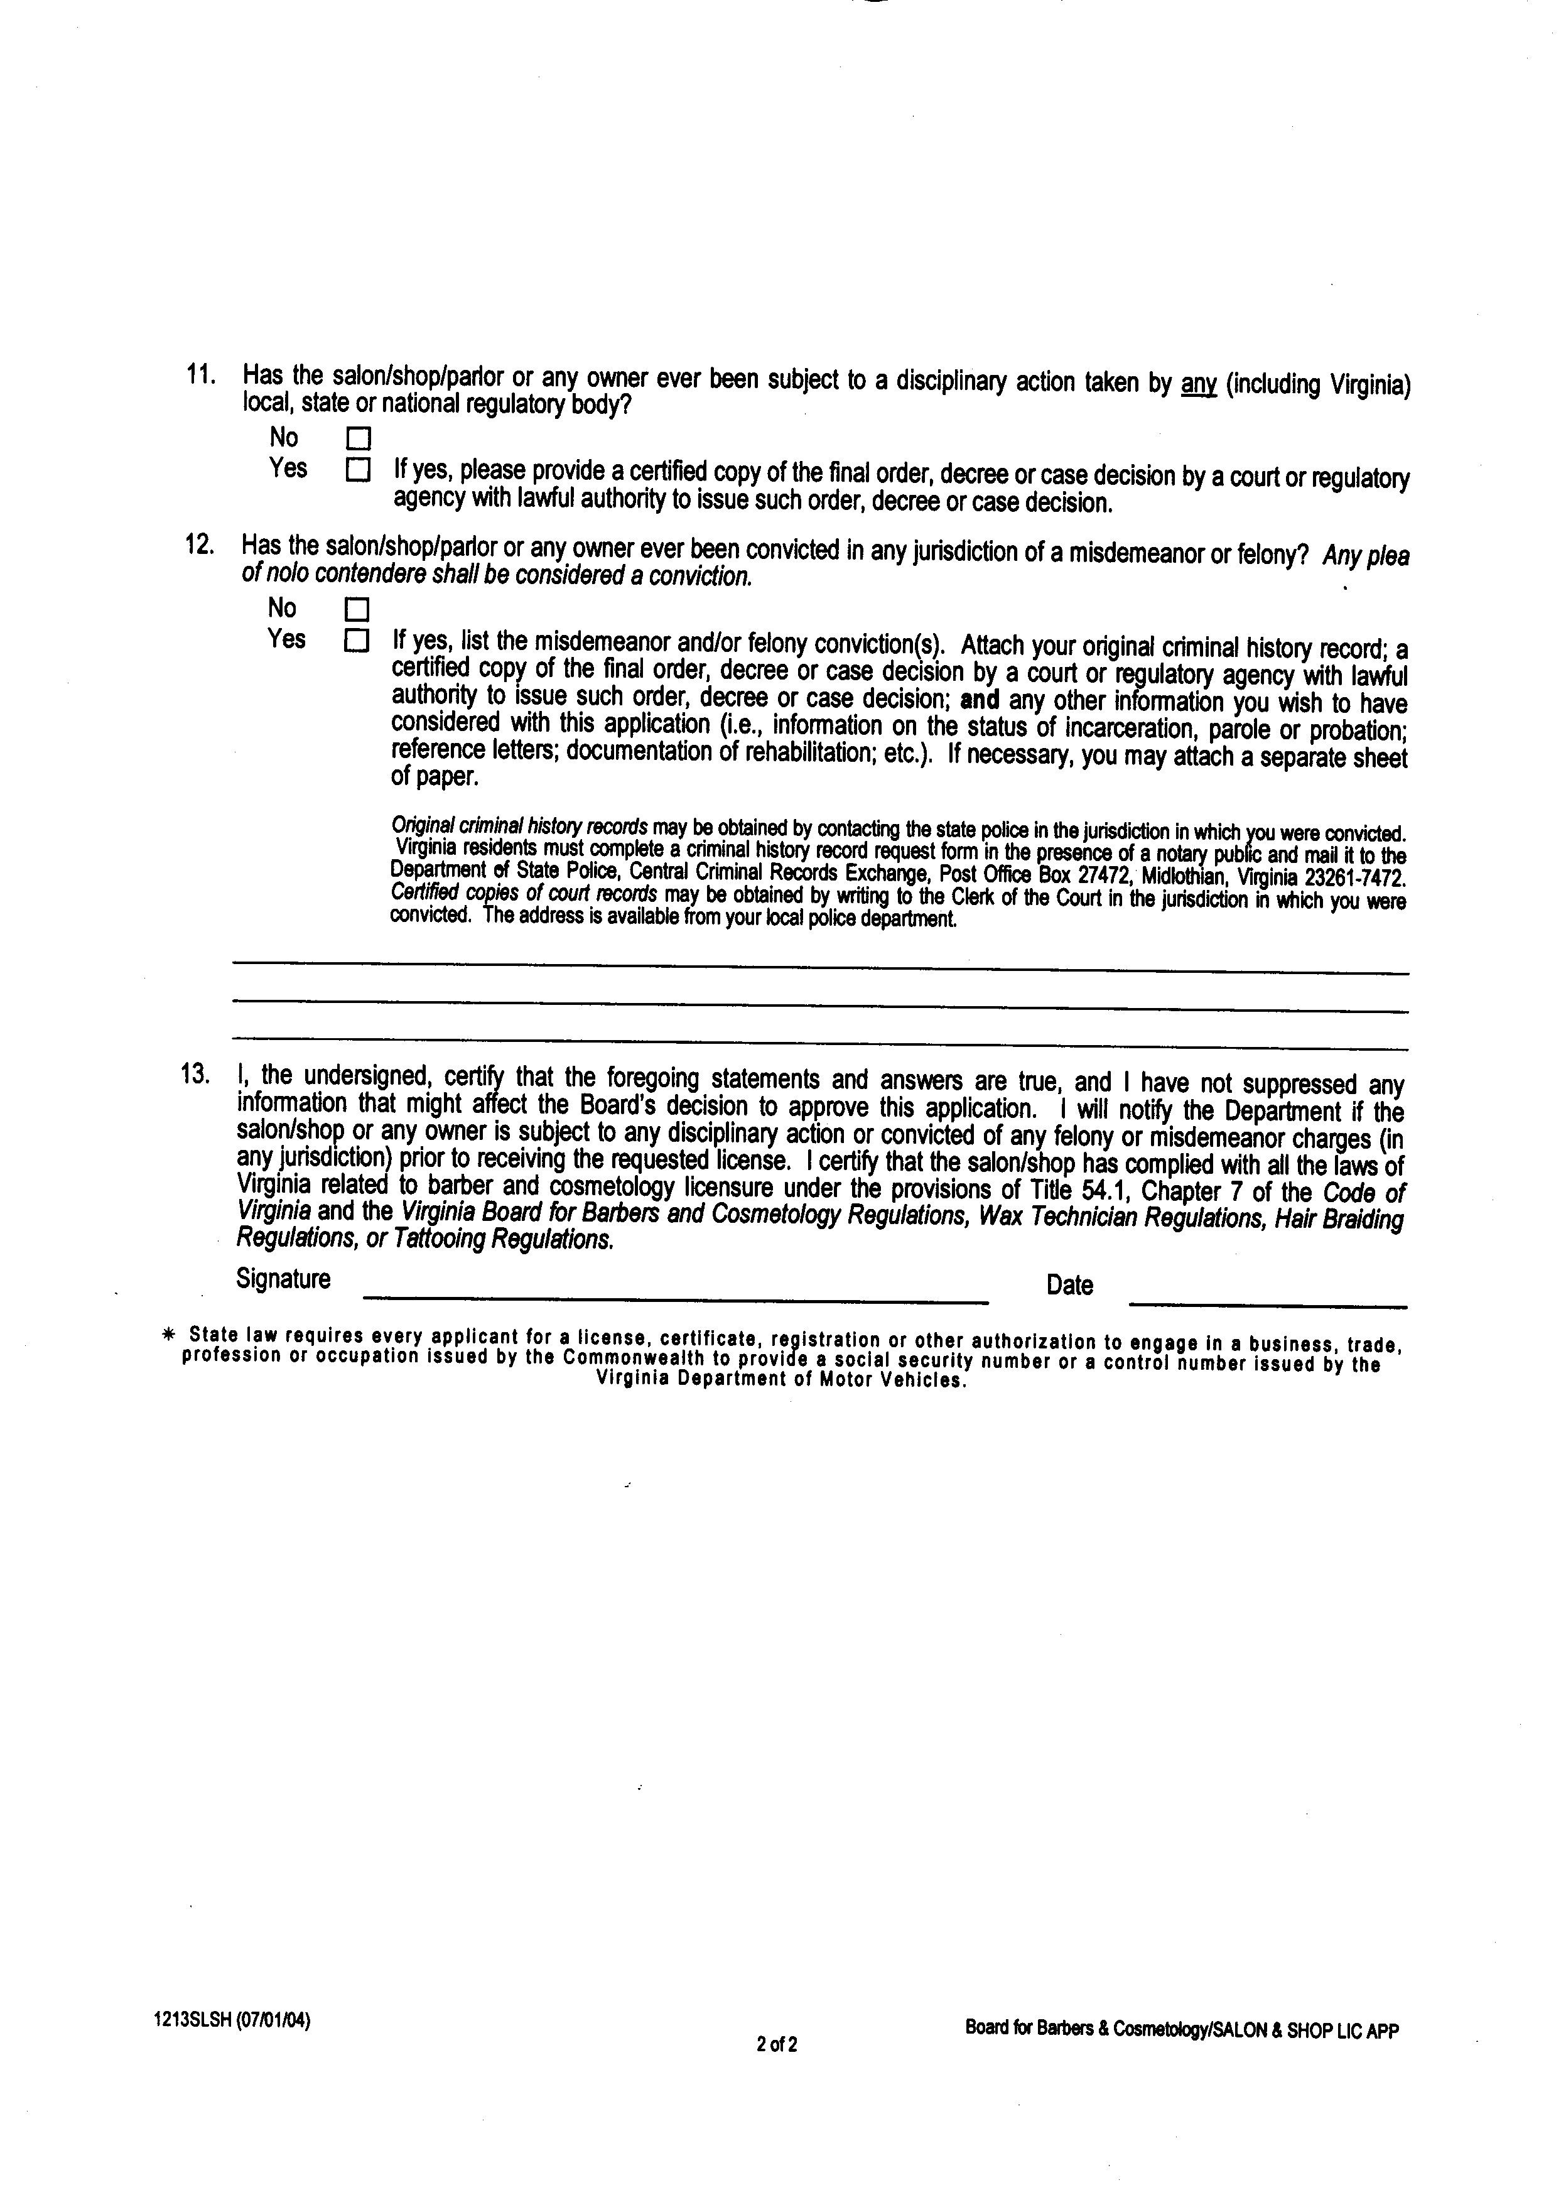
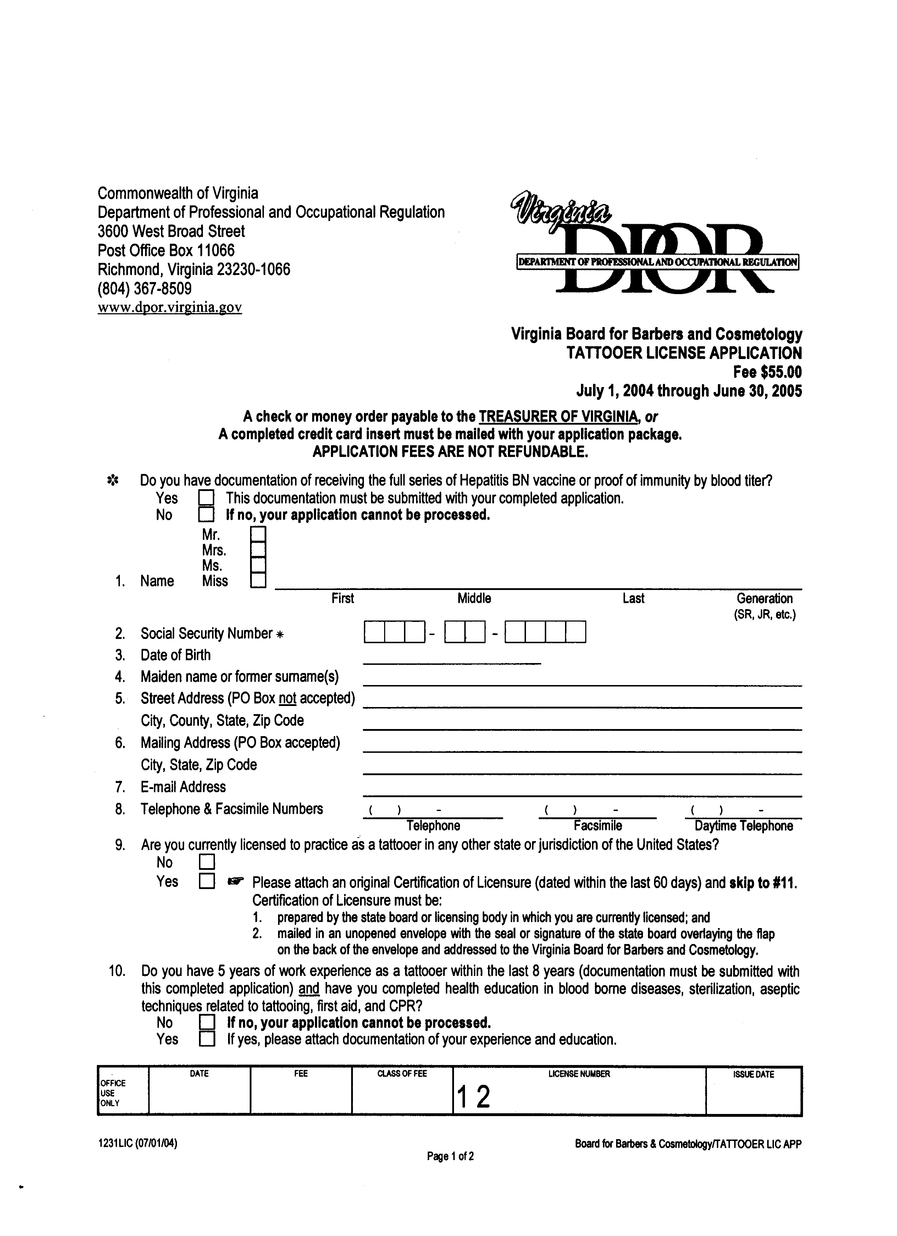
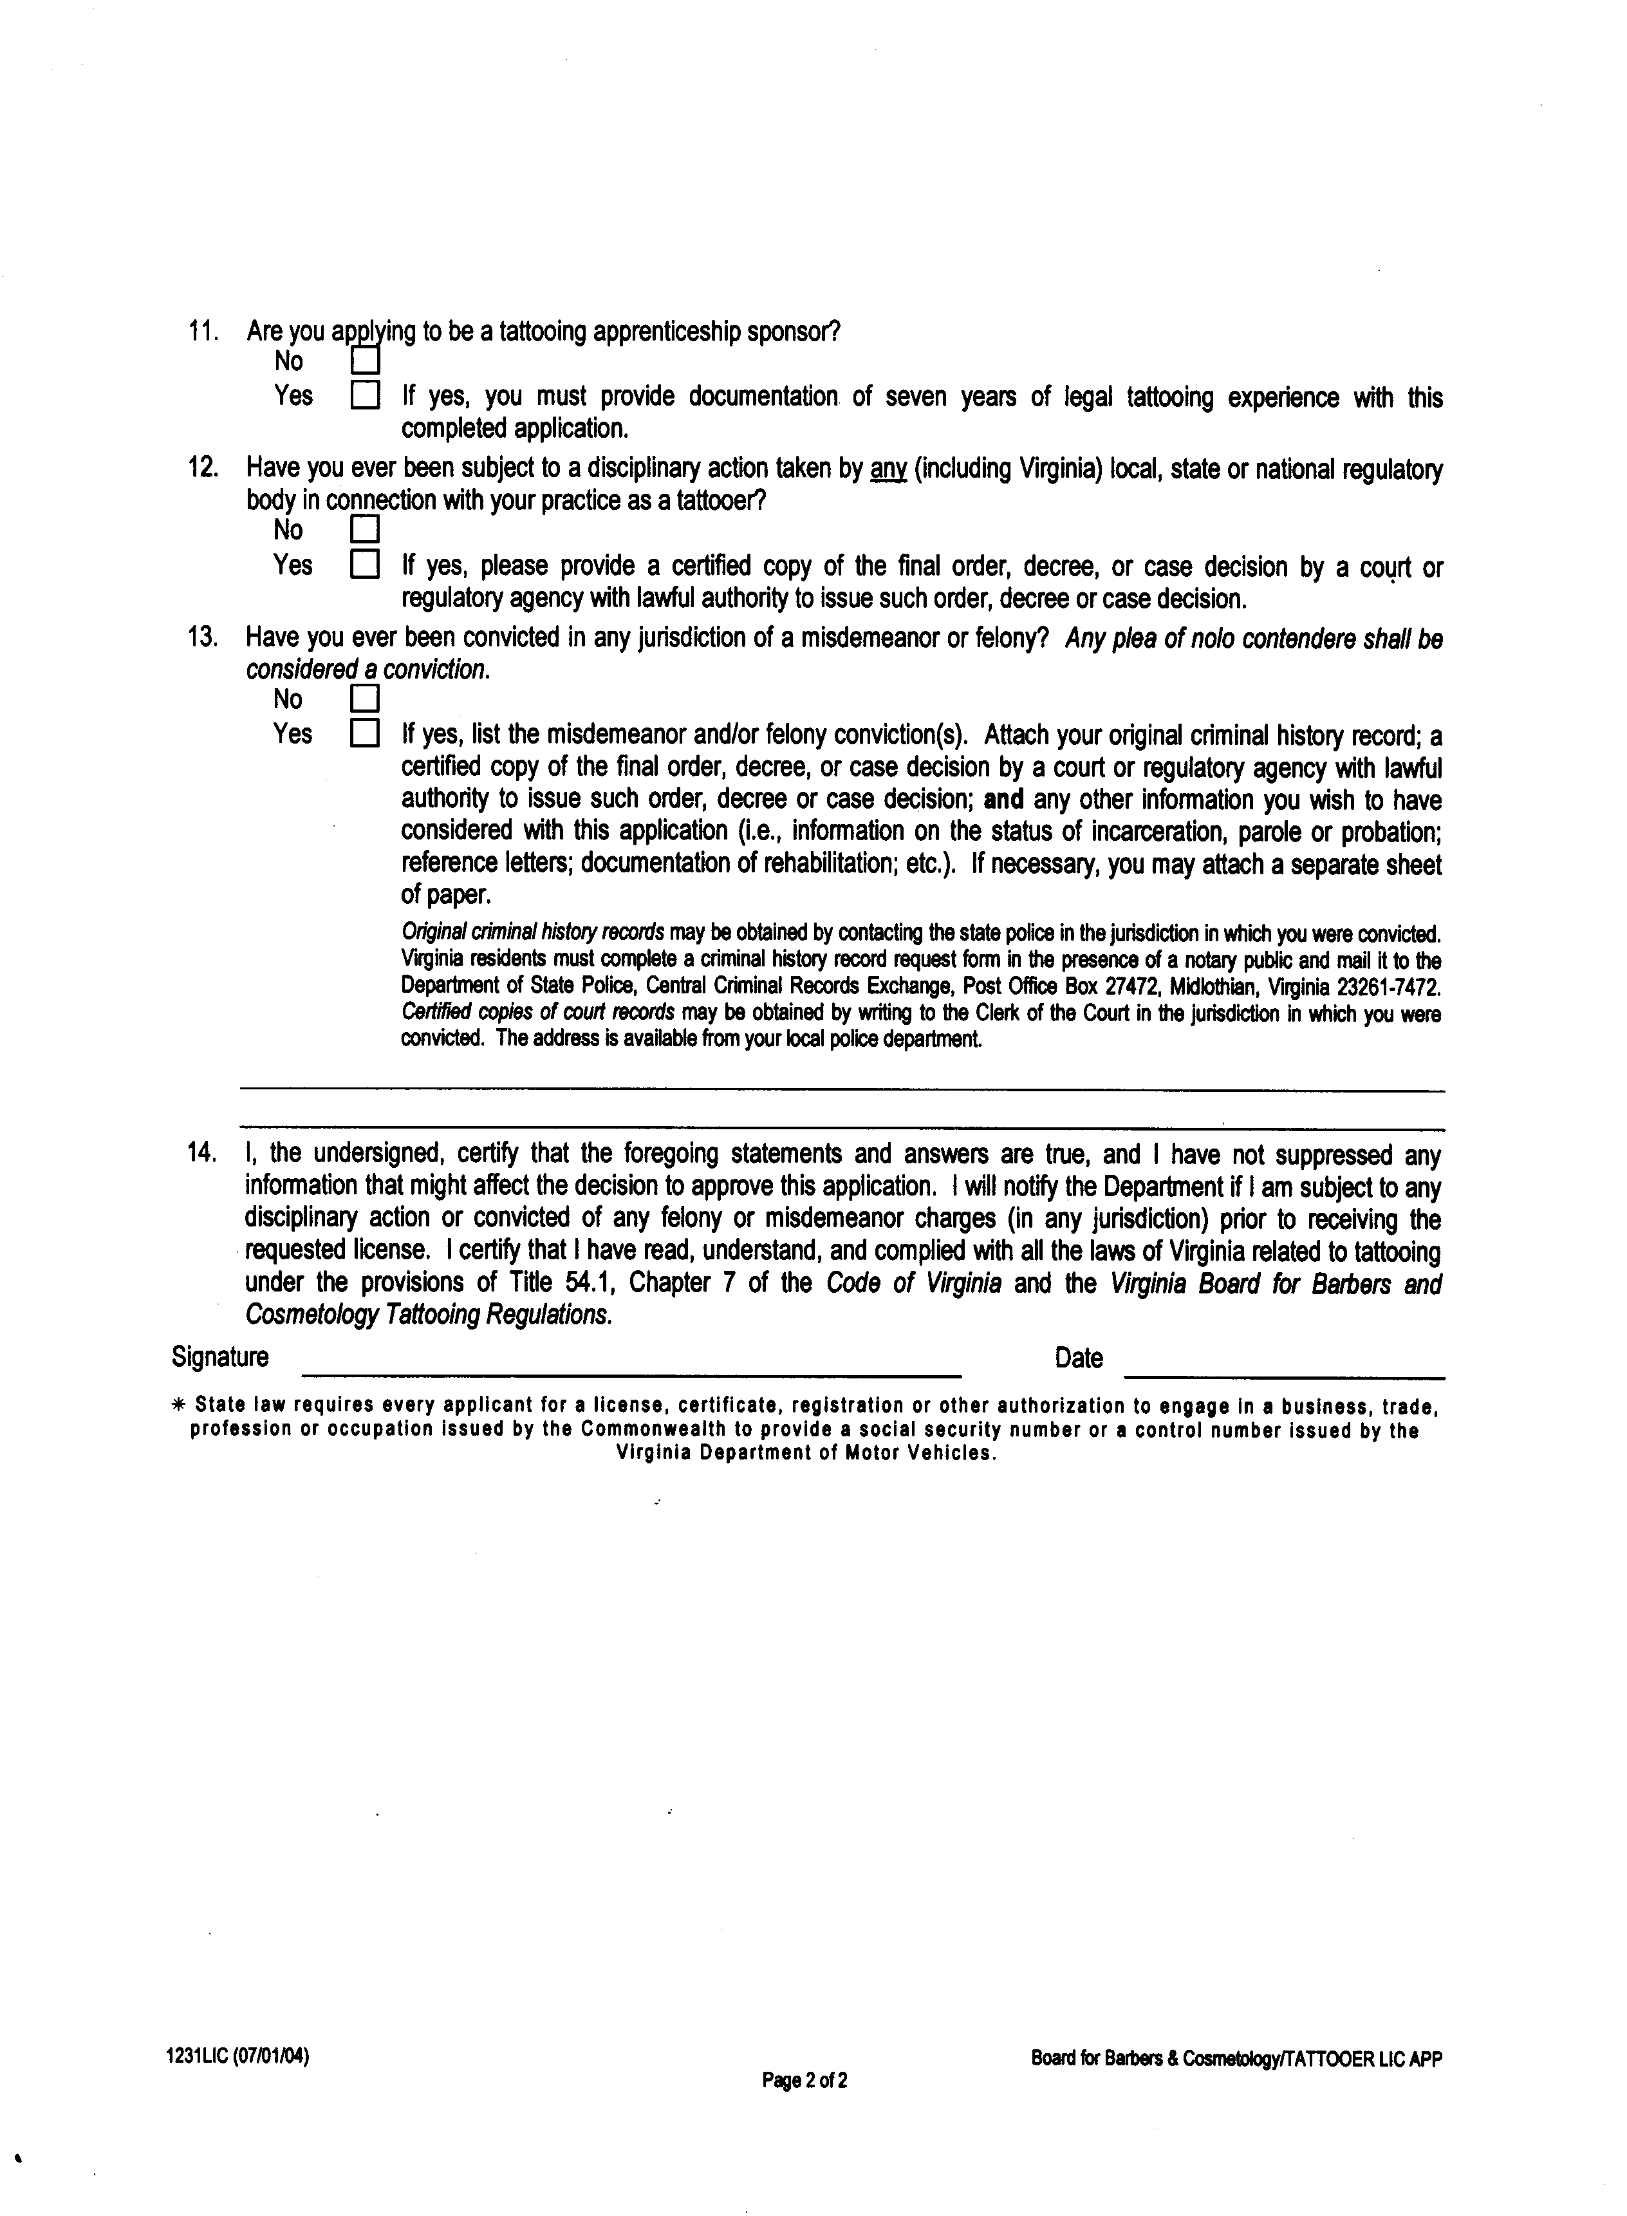
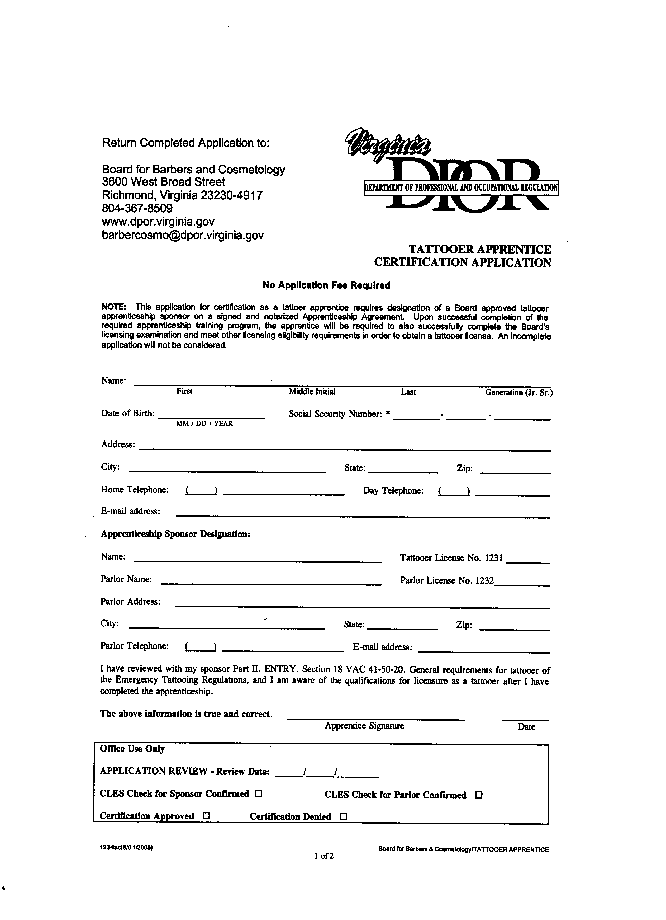
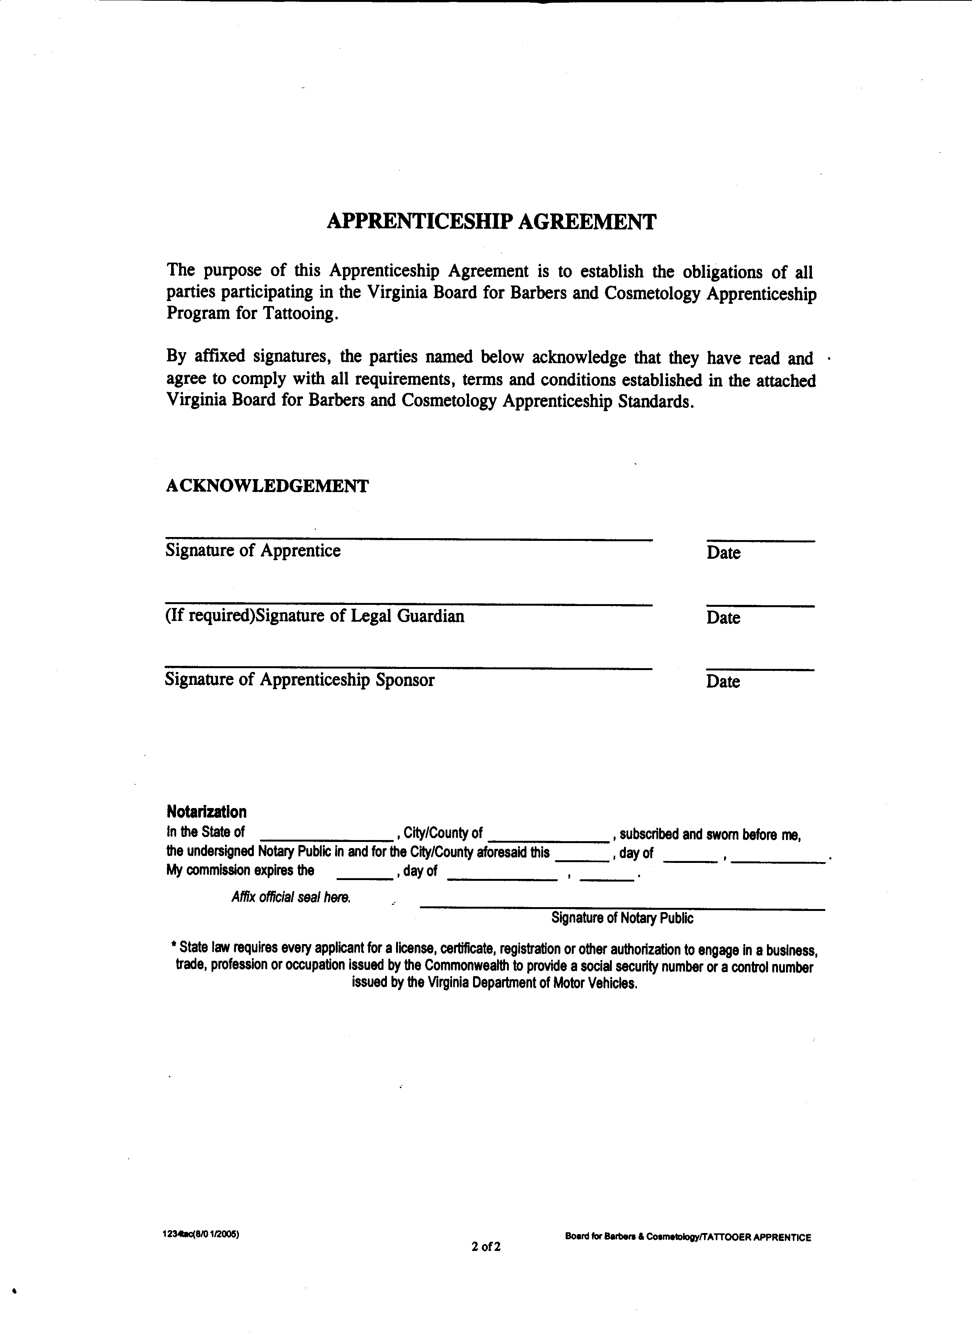
VA.R. Doc. No. R05-327; Filed August 2, 2005, 3:23 p.m.

1 Source: Martel, S., and J. E. Anderson (2002).
2 Source: Kleiner, M. M. (2000).
3 Source: Martel, S., and J. E. Anderson (2002).
4 A reduced supply in professional tattoo artists will result in fewer tattoo parlors and increased average distance to a tattoo parlor for potential clients.
5 Section 54.1-701 of the Code of Virginia states that “The provisions of this chapter shall not apply to: 1. Persons authorized by the laws of the Commonwealth to practice medicine and surgery or osteopathy or chiropractic; 2. Registered nurses licensed to practice in the Commonweal …” Read literally, § 54.1-701 exempts physicians, registered nurses and others from the requirement that they obtain a license issued by the board in order to engage in tattooing or body-piercing for pay (§ 54.1-703). The Department of Professional and Occupational Regulation has interpreted the General Assembly’s intent to be that no person shall engage in tattooing for pay without a tattooing license.
6 Applicants must also: 1) have received the full series of Hepatitis B vaccine or provide proof of immunity by blood titer, 2) be in good standing as a tattooer in every jurisdiction where licensed, certified, or registered, 3) disclose their physical address, 4) certify that they have read and understood the Virginia tattooing license laws and the board’s tattooing regulations, and 5) not have been convicted in any jurisdiction of a misdemeanor or felony which directly relates to the profession of tattooing.
7 The proposed regulations also specify that a combined maximum of 700 hours of credit may granted towards the theory pertaining to microbiology, immunization, safety, blood borne pathogen standards, and professional standards requirements and the practical training requirements for an apprentice who is assessed to already possess competence in those areas.
8 For those who apply after July 1, 2005, completion of an apprenticeship program and a passing grade on the licensure examination are required. In addition, before July 1, 2005, even those people who are highly knowledgeable and skilled in safely working with needles (a nurse, for example) must complete an apprenticeship program since they do not have the requisite work experience in the field of tattooing.
9 Source: Raymond, M. J., P.L. Pirie and L.I. Halcon (2001).

